E
International Union for the Protection of New Varieties of Plants

Technical Committee  Fifty-Fourth Session  Geneva, October 29 and 30, 2018 | TC/54/18 Corr.  Original: English  Date: August 27, 2018
Data Processing for the Assessment of Distinctness and for Producing Variety Descriptions
Document prepared by the Office of the Union
Disclaimer: this document does not represent UPOV policies or guidance

EXECUTIVE SUMMARY

The purpose of this document is to present developments concerning the possible new guidance for document TGP/8 on “Data Processing for the Assessment of Distinctness and for Producing Variety Descriptions” describing different methods used by UPOV members for measured quantitative characteristics.

The TC is invited to:

(a) recall that, at its fifty-second session, it agreed that the guidance on “Different forms that variety descriptions could take and the relevance of scale levels”, as reproduced in Annex I to this document, should be used as an introduction to future guidance to be developed on data processing for the assessment of distinctness and for producing variety descriptions;

(b) note that the TC-EDC, at its meeting in March 2018, had agreed that summary information on developments concerning the possible development of new guidance for document TGP/8 on “Data Processing for the Assessment of Distinctness and for Producing Variety Descriptions” should be reported to the TWPs, at their sessions in 2018, under document “TGP documents” and that developments on this matter should be considered by the TC, at its fifty-fourth session;

(c) consider the summary of different approaches used by members of the Union to convert observations into notes for producing variety descriptions of measured characteristics as set out in Annex II to this document;

(d) consider whether to amend document TGP/8 to include guidance on converting observations into notes, as set out in Annexes I to V to this document; and

(e) note that the TWC, at its thirty-sixth session, had agreed that discussions on genotype-by-environment interaction should be continued on the basis of a paper to be prepared by Finland and Italy, taking into consideration other types of characteristics and not only measured quantitative characteristics.

The structure of this document is as follows:
EXECUTIVE SUMMARY 1
background 2
DevelopmentS in 2017 3
Technical Working Party on Automation and Computer Programs 3
Practical exercise: table of notes attributed to candidate varieties using different methods 3
Short descriptions of methods to transform measurements into notes 3
Developments in 2018 4
Consideration by the Enlarged Editorial Committee 4
Technical Working Party on Automation and Computer Programs 4
Proposal 5

ANNEX I “Different forms that variety descriptions could take and the relevance of scale levels”, document prepared by an expert from Germany
ANNEX II “Compilation of explanations on methods for producing varieties descriptions for measured characteristics, and clarification of differences”, document prepared by an expert from the United Kingdom
ANNEX III “Short explanation on the French methods for producing varieties descriptions for measured characteristics”, document prepared by an expert from France
ANNEX IV “Short explanation on the Japanese methods for assessment table for producing variety descriptions”, document prepared by an expert from Japan
appendix to annex IV “Introduction to using fundamental assessment table system for quantitative characteristics in Japan”
ANNEX V “Short explanation on measured, quantitative characteristics for United Kingdom veg & herbage”, document prepared by an expert from the United Kingdom

The following abbreviations are used in this document:

CAJ: Administrative and Legal Committee
TC: Technical Committee
TC-EDC: Enlarged Editorial Committee
TWA: Technical Working Party for Agricultural Crops
TWC: Technical Working Party on Automation and Computer Programs
TWF: Technical Working Party for Fruit Crops
TWO: Technical Working Party for Ornamental Plants and Forest Trees
TWPs: Technical Working Parties
TWV: Technical Working Party for Vegetables

background

The Technical Committee (TC), at its forty-eighth session, held in Geneva from March 26 to 28, 2012, considered document TC/48/19 Rev, Annex III: “TGP/8 PART I: DUS Trial Design and data analysis, New Section 6 – Data processing for the assessment of distinctness and for producing variety Descriptions” in conjunction with Annex VIII: “TGP/8 PART II: Techniques used in DUS Examination, New Section 13 - Methods for data processing for the assessment of distinctness and for producing variety descriptions”. It agreed that the information provided in Annex VIII of document TC/48/19 Rev. and at the UPOV DUS Seminar, held in Geneva in March 2010, together with the method provided by Japan and the method used in France for producing variety descriptions for herbage crops, as presented at the TWC at its twenty-sixth session (see documents TWC/26/15, TWC/26/15 Add. and TWC/26/24), provided a very important first step in developing common guidance on data processing for the assessment of distinctness and for producing variety descriptions, but concluded that the information as presented in Annex VIII of document TC/48/19 Rev. would not be appropriate for inclusion in document TGP/8. It agreed that the Office of the Union should summarize the different approaches set out in Annex VIII of document TC/48/19 Rev. with regard to aspects in common and aspects where there was divergence. As a next step, on the basis of that summary, consideration could be given to developing general guidance. The TC agreed that the section should include examples to cover the range of variation of characteristics. It further agreed that the detailed information on the methods should be made available via the UPOV website, with references in document TGP/8 (see document TC/48/22 “Report on the Conclusions” paragraph 52).

At their sessions in 2012, the TWPs received a presentation prepared by the Office of the Union on “Summary of different approaches of transformation of measurements into notes for Variety Description”, as reproduced in the Annex I of document TC/50/25 “Revision of document TGP/8: Part II: Selected Techniques Used in DUS Examination, New Section: Data Processing for the Assessment of Distinctness and for Producing Variety Descriptions”.

The TWC, at its thirtieth session, held in Chisinau, Republic of Moldova, from June 26 to 29, 2012, agreed that the experts from Finland, Italy and the United Kingdom should support the Office of the Union to summarize the different approaches for further developing common guidance on data processing for the assessment of distinctness and for producing variety descriptions. It also agreed that experts from the United Kingdom in cooperation with experts from France and Germany should conduct a practical exercise. The exercise would be to process a common data set to produce variety descriptions in order to determine the aspects in common and where there was divergence among the methods (see document TWC/30/41 “Report”, paragraphs 42 and 43).

The TC, at its fifty-second session, held in Geneva from March 14 to 16, 2016, agreed with the TWC and the TWA that the guidance on “Different forms that variety descriptions could take and the relevance of scale levels”, as reproduced in Annex I to this document, should be used as an introduction to future guidance to be developed on data processing for the assessment of distinctness and for producing variety descriptions.

Developments prior to 2017 concerning a possible new section for document TGP/8 “Data Processing for the Assessment of Distinctness and for Producing Variety Descriptions” are reported in document TC/53/18 “Revision of document TGP/8: Selected techniques used in DUS examination, New Section: Data Processing for the Assessment of Distinctness and for Producing Variety Descriptions”.

DevelopmentS in 2017

Technical Working Party on Automation and Computer Programs

Practical exercise: table of notes attributed to candidate varieties using different methods

The TWC, at its thirty-fifth session, held in Buenos Aires, Argentina, from November 14 to 17, 2017, considered document TWC/35/9 “Comparison of methods used for producing variety descriptions: results of the practical exercise” and the revised information provided by an expert from France in relation to the comparison of methods used for producing variety descriptions. The TWC agreed that the document provided a useful comparison of methods for the future guidance on converting observations into notes. The TWC agreed that the table of notes attributed to candidate varieties using the different methods as provided in document TWC/35/9 should replace that of document TWP/1/15, Annex II (see document TWC/35/21 “Report”, paragraphs 52 to 54).

Short descriptions of methods to transform measurements into notes

The TWC considered documents TWC/35/10 “Guidance for development of variety descriptions: the Italian experience”, TWC/35/12 “Short explanation on the Japanese methods for assessment table for producing variety descriptions”, TWC/35/14 “Reasons and situations when the approaches described in the United Kingdom practical exercise (TWC/30/32) would/would not be appropriate for transforming observations into notes on measured, quantitative characteristics”, and TWC/35/15 “Short explanation on some United Kingdom methods for data processing for the assessment of distinctness and for producing variety descriptions for quantitative characteristics” and reviewed the explanations provided by the participants in the practical exercise to be considered as a possible basis for guidance for revision of document TGP/8 (see document TWC/35/21 “Report”, paragraphs 55 to 62).

The TWC noted the explanation by the expert from Italy that the method described in document TWC/35/10 was still under development and agreed that it should be included in the draft guidance at a future stage.

The TWC agreed to invite Germany to provide a short description of their method to transform measurements into notes and provide examples when these methods might be used, such as for particular characteristics, types of propagation or different situations.
The TWC agreed that the explanation provided by the expert from the United Kingdom in document TWC/35/14, paragraph 5 should be amended to read as follows:

“Equal-spaced states would be used if:
[…]
- where the range of values is continuous”

The TWC noted that explanations provided by the participants in the practical exercise presented information in different ways. The TWC agreed to request the expert from the United Kingdom to prepare a document for the thirty-sixth session of the TWC compiling all explanations received using the same format and clarifying the differences.

The TWC considered document TWC/35/5 “Characteristics, genotype by environment interaction (GEI) and DUS trials” which was a summary of the presentation in document TWC/34/17 “Genotype by environment interaction (GEI) - DUS Test and data transformation into notes”, made by experts from Finland and Italy. The TWC agreed that document TWC/35/5 provided relevant information for future guidance on transformation of observations into notes and agreed to request the expert from the United Kingdom to take that information into consideration when preparing the document compiling the explanations of methods received and clarifying the differences.

The TWC considered the report on the work done by Germany on “Variability of assessment data over years in apple”, on the basis of the presentation reproduced in document TWP/1/15, Annex VI. The TWC noted that the variety descriptions were produced on the basis of assessing the same trees in different years. The TWC agreed that the growing trial needed appropriate management in order for the replications over years to be considered as independent growing cycles and to produce consistent descriptions.

Developments in 2018

Consideration by the Enlarged Editorial Committee

The Council, at its thirty-fourth extraordinary session, held in Geneva on April 6, 2017, decided to organize a single set of sessions from 2018, in the period of October/November (see document C(Extr.)/34/6 “Report on the decisions”, paragraphs 12 to 14). From 2018, the meetings of the TC would take place on October/November instead of March/April. The TC-EDC would meet twice a year; once in the period of March/April and once in conjunction with the TC sessions later in the year.

Based on the recommendation of the Consultative Committee, the Council decided to adopt the proposals of the TC, at its fifty-third session, to use contingency measures in the transitional period until the fifty-fourth session of the TC, to be held in October 2018; for TGP documents, the TC-EDC would consolidate comments made by the TWPs at their sessions in 2017 and, in the absence of consensus between the TWPs, to formulate proposals for further consideration by the TWPs at their sessions in 2018.

The TC-EDC, at its meeting held in Geneva on March 26 and 27, 2018, considered document TC-EDC/Mar18/15 “Data Processing for the Assessment of Distinctness and for Producing Variety Descriptions” (see document TC-EDC/Mar18/11 “Report”, paragraphs 26 to 28).

The TC-EDC noted the developments at the TWC, at its thirty-fifth session, and that a document compiling the descriptions of methods to transform measurements into notes would be presented to the TWC, at its thirty-sixth session, using the same format and clarifying the differences between the methods.

The TC-EDC agreed that summary information on developments concerning the possible development of new guidance for document TGP/8 on “Data Processing for the Assessment of Distinctness and for Producing Variety Descriptions” should be reported to the TWPs, at their sessions in 2018, under document “TGP documents”. The TC-EDC agreed that developments on this matter should be considered by the TC, at its fifty-fourth session.

Technical Working Party on Automation and Computer Programs

The TWC, at its thirty-sixth session, held in Hanover, Germany, from July 2 to 5, 2018, considered document TWC/36/2 “Compilation of explanations on methods for producing varieties descriptions for measured characteristics, and clarification of differences” and received a presentation by an expert from the United Kingdom, a copy of which would be provided as document TWC/36/2 Add. (see document TWC/36/15 “Report”, paragraphs 20 to 23).

The TWC agreed that document TWC/36/2 was an appropriate summary of the different approaches used by members of the Union and that it clarified the differences between the methods.

The TWC agreed to propose that document TWC/36/2 be considered by the Technical Committee as the basis for the possible development of general guidance on different approaches used for converting observed data into notes. The content of document TWC/36/2 is reproduced in Annexes II to V of this document.

The TWC noted that one of the differences between the approaches was how genotype-by-environment interaction was managed. The TWC agreed that discussions on genotype-by-environment interaction should be continued and agreed to invite a paper to be prepared by Italy and Finland taking into consideration other types of characteristics and not only measured quantitative characteristics.

Proposal

On the basis of the proposals by the TC-EDC, at its meeting held in March 2018, and the TWC, at its thirty-sixth session, it is proposed that the TC consider the summary of different approaches used by members of the Union to convert observations into notes for producing variety descriptions of measured characteristics for possible inclusion in document TGP/8, on the basis of Annexes II to V of this document.

The TC is invited to:

(a) recall that, at its fifty-second session, it agreed that the guidance on “Different forms that variety descriptions could take and the relevance of scale levels”, as reproduced in Annex I to this document, should be used as an introduction to future guidance to be developed on data processing for the assessment of distinctness and for producing variety descriptions;

(b) note that the TC-EDC, at its meeting in March 2018, had agreed that summary information on developments concerning the possible development of new guidance for document TGP/8 on “Data Processing for the Assessment of Distinctness and for Producing Variety Descriptions” should be reported to the TWPs, at their sessions in 2018, under document “TGP documents” and that developments on this matter should be considered by the TC, at its fifty-fourth session;

(c) consider the summary of different approaches used by members of the Union to convert observations into notes for producing variety descriptions of measured characteristics as set out in Annex II to this document;

(d) consider whether to amend document TGP/8 to include guidance on converting observations into notes, as set out in Annexes I to V to this document; and

(e) note that the TWC, at its thirty-sixth session, agreed that discussions on genotype-by-environment interaction should be continued on the basis of a paper to be prepared by Finland and Italy, taking into consideration other types of characteristics and not only measured quantitative characteristics.

[Annexes follow]

DIFFERENT FORMS THAT VARIETY DESCRIPTIONS COULD TAKE
AND THE RELEVANCE OF SCALE LEVELS

Variety descriptions can be based on different data depending on the purpose of the description. Different variety descriptions may be used for the assessment of distinctness or in the official document which forms the basis for granting protection. When variety descriptions are used for the assessment of distinctness it is important to take into account on which data the descriptions for different varieties are based. Special attention has to be given to the potential influence of years and locations.

The different forms of variety descriptions and their relevance for the assessment of distinctness can be classified according to the different process levels to look at a characteristic. The process levels are defined in document TGP/8: Part I: DUS trial design and data analysis. Section 2 (New): Data to be recorded (see TC/50/5, Annex II) as follows:

Table 5: Definition of different process levels to consider characteristics

Process level | Description of the process level
1 | characteristics as expressed in trial
2 | data for evaluation of characteristics
3 | variety description

The process levels relevant for the assessment of distinctness are level 2 and 3. Any comparison between varieties in the same trial (same year(s), same location) is carried out on the actual data recorded in the trial. This approach relates to process level 2. If varieties are not grown in the same trial, they have to be compared on the basis of variety descriptions which relates to process level 3. In general, the identification of similar varieties to be included in the growing trial ("Management of variety collection") relates to process level 3, whereas data evaluation within the growing trial relates to process level 2.

Process level | Measurements  (QN) | Visual assessment  (QN/QL/PQ) | Remark
2 | Values | Notes | Basis for comparison within the same trial
3 | Transformation into notes  Notes | Same Notes as in Process level 1  Notes | Notes resulting from one year and location
 | "Mean variety description"  If varieties are assessed in several trials/years/locations mean descriptions can be established. |  | Basis for management of variety collection

In general, quantitative characteristics are influenced by the environment. An efficient way to reduce the environmental influence is the transformation of actual measurements into notes. The notes represent a standardized description of varieties in relation to example varieties (see TGP/7). In addition, the comparability of variety descriptions for varieties not tested in the same trial can be improved by calculating a mean description over several growing cycles. In particular, the mean description over several growing cycles at the same location can provide a representative description related to the location. The calculation of a mean description over different locations should only be considered if the effects of the locations are very well known and variety x location interactions can be excluded for all characteristics. The calculation of mean descriptions over locations should be restricted to the cases where these conditions are fulfilled.

If variety descriptions from different growing trials are used for the assessment of distinctness - that means for the management of variety collections - it is important to take into account the origin of the different variety descriptions of the candidate variety and the varieties of common knowledge. The comparability of variety descriptions is influenced by many factors, for example:

- Description based on a single year or a mean over several years?
- Description based on the same location or different locations?
- Are the effects of the different location known?
- Varieties described in relation to the same variety collection or a variety collection which might cover a different range of variation?

The potential bias of variety descriptions due to environmental effects between candidate varieties and varieties in the variety collection have to be taken into account in the process of distinctness testing, and in particular, for the identification of varieties of common knowledge to be included in the growing trial.

[Annex II follows]

Compilation of explanations on methods for producing varietIES descriptions for measured characteristics, and clarification of differences

- This document provides a compilation of explanations on methods for producing variety descriptions for measured characteristics, and a clarification of differences.

Introduction

- For crops with measured quantitative characteristics that vary within varieties, distinctness is determined in general by comparison of variety means through statistical analysis, and based on data from trials in a number of years or growing cycles. Because the data on the characteristics are quantitative, the variety means also are quantitative, e.g. measured in millimeters, and so are not on a 0 to 9 scale. To produce a variety description for a variety, the variety means for these characteristics are converted or transformed to notes.

- This document describes the different methods used by some member states to transform variety means into notes for measured quantitative characteristics. It also clarifies the differences between the methods.

- The explanations of methods received from member states to transform measurements into notes for measured quantitative characteristics are compiled in Annexes III to V of this document. A summary of these methods is included in the table below.

COUNTRY |  | Method: description | Example varieties | Crop expert judgment | Equal-spaced state
France | Method 1 | Combined use of example varieties and reference collection | X | X
 | Method 2 | Adjusted means from COY program + linear regression method calibrated with example varieties | X | X
Italy# |  | Average range of historical means + median used as "reference point" + partitioning into equal spaced states + calibration with crop expert judgment and example varieties | X | X | X
Germany* |  | Adjusted mean from COY program + partitioning based on example varieties and crop expert judgment | X | X
Japan |  | Adjusted Full Assessment Table (FAT) : states determined with historical data of example varieties | X |  | X
United Kingdom | Method 1 | Range of expression of the over-year means for the reference collection varieties (for the past 10 years) divided into equal spaced states |  |  | X
 | Method 2 | Crop experts define delineating varieties, in conjunction with example varieties, whose over-year means are used to delineate each state | X | X
* method not considered here as explanation of method not yet received
# method not considered here as method under development

- This is effectively done by:

- Calculation of the range of expression of the characteristic. This is then divided into states, each state relating to a note. To do this, characteristic values equivalent to the limits of the states/notes are calculated.
- Comparison of each candidate variety’s mean with these limits in order to decide the candidate variety’s note.

- The methods differ according to:

- The numbers of varieties and years used in the calculations and when subdividing the range of expression
- How the characteristic values equivalent to the limits of the states/notes are calculated.

- These are summarized in the table below. An equation for the characteristic value equivalent to the upper limit of state/note i is given for each method.

- In all methods, the aim is to produce notes for a candidate variety that are unchanging over time relative to the notes of other varieties. This is needed because these methods are used on crops and characteristics where varieties produce different values over years and locations due to genotype by environment interaction (GEI). The use of one permanent location for DUS trials as the official testing location helps mitigate this effect, as does the use of means over several years – the more years used, the less the influence of GEI effect on the description. This applies both to the means used to calculate the range of expression and divide it into states, and also to the candidate means. The more years used to calculate and divide the range of expression, and the more years contributing to the candidate variety’s mean, the less likely the candidate variety’s note is to change over time relative to the notes of other varieties. Further, the calculation of a candidate variety’s mean over years allows it to be adjusted for year effects, and so make it more comparable with other varieties’ means.

COUNTRY |  | Method: description | Calculations (range of expression of the characteristic, and the characteristic values equivalent to the limits of the states/notes) are based on | Equation for the characteristic value U_{i} equivalent to the upper limit of state/note i | Number of years the candidate variety’s mean is based on
France | Method 1 | Combined use of example varieties and reference collection | Range and limits based on current-year means of all reference varieties given each note in the previous year | $$U_{i}=\frac{{\overline{x}}_{i,n-1}}{2}+\frac{{\overline{x}}_{i+1,n-1}}{2}$$  Where ${\overline{x}}_{i,n-1}$is the current-year mean of all reference varieties given note i the previous year | current year
 | Method 2 | Adjusted means from COY program + linear regression method calibrated with example varieties | Range based on 5-year means for a set of example varieties. Limits based on coefficients of regression of their notes on these. | $$U_{i}=\frac{i+\frac{1}{2}-\hat{a}}{\hat{b}}$$Where $\hat{a}$ is the intercept from the regression of notes for a set of example varieties on their 5-year means  And $\hat{b}$ is the slope from the regression of notes for a set of example varieties on their 5-year means | 2 (3?) years
Japan |  | Adjusted Full Assessment Table (FAT) : states determined with historical data of example varieties | Range based on 10-year means of example varieties. Limits adjusted proportional to the current year mean of an example variety relative to its 10 year mean | $$U_{i}=U_{i.}×\frac{{\overline{x}}_{A,n}}{{\overset{̿}{x}}_{A}}$$  Where $U_{i.}$ is the characteristic value equivalent to the upper limit of state/note i in the fundamental assessment table (FAT)  And ${\overline{x}}_{A,n}$ is the current year mean of example variety A  And ${\overset{̿}{x}}_{A}$ is the 10 year mean of example variety A | current year
United Kingdom | Method 1 | Range of expression of the over-year means for the reference collection varieties (for the past 10 years) divided into equal spaced states | Range and limits based on means over any years where reference varieties have been tested | $$U_{i}={\overline{x}}_{min}+\frac{i×({\overline{x}}_{max}-{\overline{x}}_{min})}{N}$$  Where ${\overline{x}}_{max}$ is the maximum over year reference variety mean  And ${\overline{x}}_{min}$ is the minimum over year reference variety mean  And $N$ is the number of notes | 2 (3?) years
 | Method 2 | Crop experts define delineating varieties whose over-year means are used to delineate each state | Range and limits based on 10-year means of (delineating) reference varieties | $$U_{i}={\overline{x}}_{i}$$  Where ${\overline{x}}_{i}$ is the 10-year mean of the delineating reference variety for note i | 2 or 3 years

[Annex III follows]

SHORT EXPLANATION ON THE FRENCH METHODS FOR PRODUCING VARIETIES DESCRIPTIONS FOR MEASURED CHARACTERISTICS

Document prepared by an expert from France

In France, two main methods have been developed to produce varieties descriptions from measurements. The first one is used mainly on agricultural and vegetable crops and the second one mainly on herbage and some other agricultural crops. A third method can be used only on very stable characteristics observed under controlled conditions: variety description produced according to a fixed scale.

Method 1

Method 1 is based on experience on reference collection varieties and on example varieties. It can only be used for species with a living reference collection.

The first step is to determine the range of notes of the year. To do that, for example for note 5, we calculate the mean of year n of all the reference varieties which were noted 5 the year n-1. This mean becomes the middle of note 5 for year n. Then we determine the limits of notes by this simple formula:

Max (Note 5) = Middle note 5 + [Middle note 6 – Middle note 5] / 2

The main interest of this method is the fact that more reference varieties than only example varieties are taken into account. It increases the power of the transformation of measures into notes. It also takes into account the environmental effect of the considered year. This method is used in France on several species such as maize, oilseed rape or flax.

Method 2

Method 2 is based on a regression calculation from a set of example varieties to determine the notes of candidate varieties.

Means of example varieties are used to set the following regression model:

Y = a + Bx

Y is the note of the example variety

X is the mean of the measurement for this example variety (depending on the specie, the mean can be the arithmetic mean or the adjusted mean using COY analysis).

An equation is then obtained for each measured characteristic, which allows to calculate the notes of each candidate variety.

The choice of example varieties is crucial in this method and it can be difficult to find good example varieties for all the notes. However, it is a reliable method which shows a good stability of descriptions and notes and takes into account the environmental conditions of the year.

This method is used in France mainly on herbage and sunflower.

Example for the characteristic flowering time of sunflower:

Example varieties

In any methods, the crop expert judgment is fundamental to validate the transformation each year and he/she can perform adjustments if needed.

[Annex IV follows]

SHORT EXPLANATION ON THE JAPANESE METHODS FOR ASSESSMENT TABLE FOR PRODUCING VARIETY DESCRIPTIONS

Document prepared by an expert from Japan
- The measured data for QN characteristics in DUS growing trial are transformed to numerical notes based on the assessment table. The assessment table are developed by the measurement data of respective example variety which are allocated in the specific notes, are precisely defined each range of notes. In case of major crops as we have accumulated measured data from long standing DUS growing trials which have been carried out under the same places, similar circumstances and same condition for the crops growing.
- Under these circumstances, the fundamental assessment table (FAT) are developed by these accumulated measured data of the example variety. The FAT is corrected by the growing degree calculated by the comparison with current years measured data of example variety.

[Appendix follows]

INTRODUCTION TO USING FUNDAMENTAL ASSESSMENT TABLE SYSTEM FOR QUANTITATIVE CHARACTERISTICS IN JAPAN

- Assessment Table

Assessment Table had been working to transform measured data into numerical note in DUS test. Each note was allocated “Range” by their measured data of example varieties.

Table 1: Example of Assessment Table for characteristic ‘Length of leaf blade’
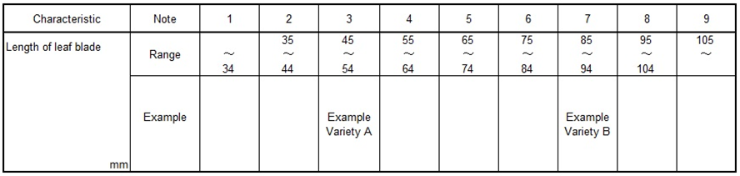

As growing of these example varieties have been affected by the yearly climatic situation or other environmental elements, their actual measured data for QN characteristics have tendency of fluctuation in some extent. Usually registered varieties have been used as similar varieties for DUS growing trials, in the case of registered variety as note 3, registered variety doesn’t always keep their original states when the variety registered by applying above Assessment Table because of fluctuating for the distance of measured data between example variety A and B.

To keep the evaluation unchangeably, the Assessment Table had been improved based on the accumulated measured data of example varieties.

- Fundamental Assessment Table (FAT) System
2.1. FUNDAMENTAL ASSESSMENT TABLE (FAT)
FAT is developed by more than 10 years’ average as “Trial Mean” of data of example varieties which are allocated “Median” of the Range of Note.

Following table is set by 10 years’ average of example varieties.

Table 2: Example FAT for characteristic ‘Length of leaf blade’
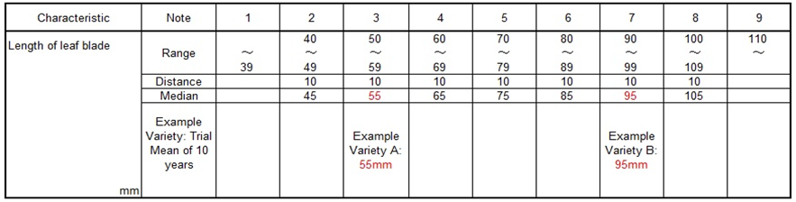

FAT is the assessment table which involved 10 years’ error as principle table, usually FAT is converted by current year’s data of example varieties before the evaluation of the note for QN characteristics.

Current trial data should always be assessed by transforming FUNDAMENTAL ASSESSMENT TABLE (FAT) to CURRENT ASSESSMENT TABLE (CAT).
2.2. Transforming CURRENT ASSESSMENT TABLE (CAT)
To transform from FAT to CAT, it is used “Growth Score” as followings.
2.2.1. Growth Score
Example
10 years’ average as “Trial Mean” of leaf length is 55mm with example variety A
“Current years’ Mean” of leaf length is 52mm with example variety A.
Current Mean of 52mm / Trial Mean of 55mm = 0.95 =“Growth Score”
2.2.2. Multiplying “Growth Score”
CAT is developed by multiplying “Growth Score” to FAT for adjustment to the current growth level.

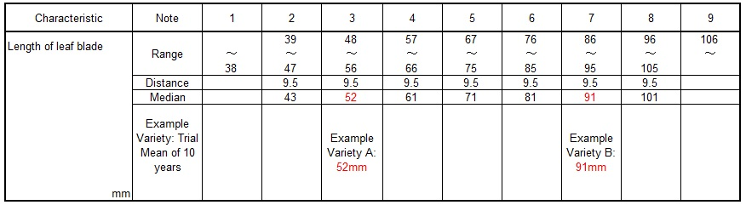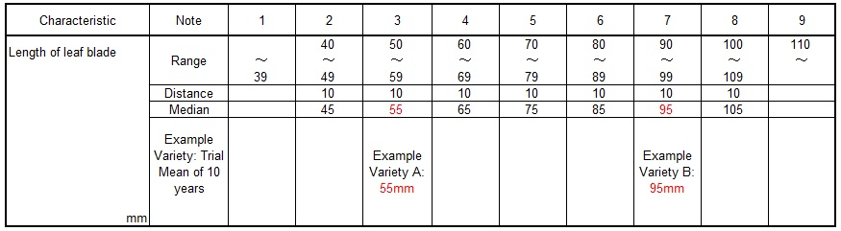
FAT is multiplied Growth Score 0.95
CAT is produced with reflected growth level of the trial (0.95)

2.3 Relevance of FAT and CAT
Following graph explains relation between FAT and CAT. FAT is always retained 1.00 Growth Score. Current trial Growth Score to be scored year by year.

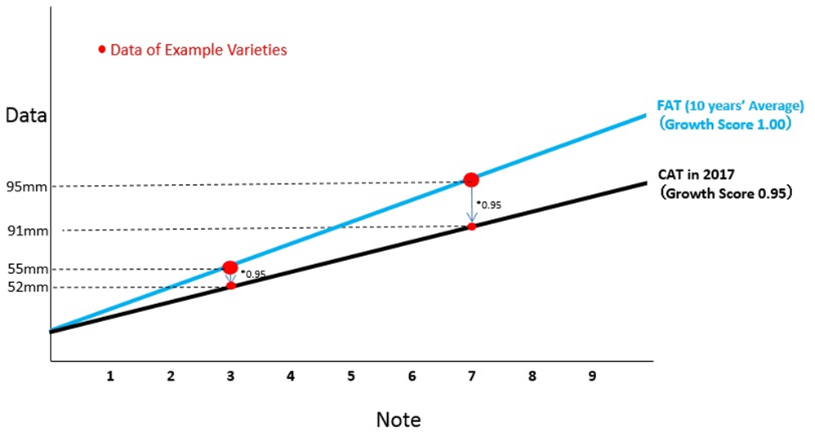

[Annex V follows]

Short explanation on some United Kingdom methods for Data Processing for the Assessment of Distinctness and for Producing Variety Descriptions for measured quantitative characters

Document prepared by experts from the United Kingdom

- These two methods are only for characteristics which are measured and quantitative.

Method 1: The equal spaced notes method using field peas as an example:

Over-year variety means are calculated from the yearly trial means. Trial means from all years where the reference collection varieties have been tested are used for peas. The over-year means are calculated using a fitted constants analysis; this allows for varieties not being present in every year. Finally, the over-year means are converted to notes. For peas this is done so that the states are equally spaced.

Method 2: The delineating varieties method using herbage as an example:

Over-year variety means are calculated from the yearly trial means. Trial means from the past 10 years’ trials are used for herbage crops. The over-year means are calculated using a fitted constants analysis; this allows for varieties not being present in every year. Finally, the over-year means are converted to notes. For herbage crops this is done by use of delineating varieties chosen by crop expert judgement and are based on the notes for example varieties. Delineating varieties differ from example varieties. A delineating variety defines each upper (or lower) intervening limit of the states within the range of expression. By contrast, an example variety usually represents the typical or mid-interval expression of each state within the range of expression.

- Both methods use over-year means to minimise any observed variation in varieties due to differences in years. In effect, reference varieties (including example varieties) remain the same note year on year.

- For greater detail of these two methods and worked examples, see TWC/30/32. Please note that the worked examples are based on an artificial data set in order to illustrate the method.

[End of Annex V and of document]

