E
International Union for the Protection of New Varieties of Plants

Technical Committee  Fifty-Fourth Session  Geneva, October 29 and 30, 2018 | TC/54/16 Add.  Original: English  Date: November 14, 2018
addendum to
Procedure for the adoption of draft Test Guidelines
Document prepared by the Office of the Union
Disclaimer: this document does not represent UPOV policies or guidance
The Annex to this document contains a copy of a presentation on “Procedure for the adoption of draft Test Guidelines” made at the fifty-fourth session of the Technical Committee.

[Annex follows]

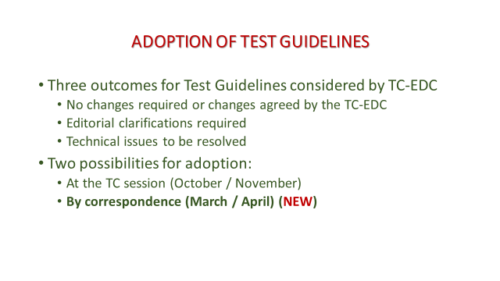

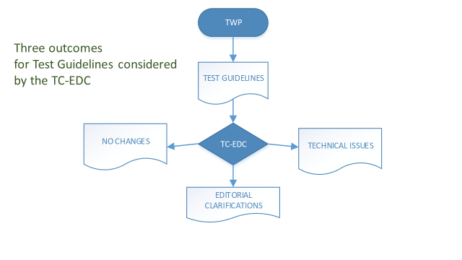

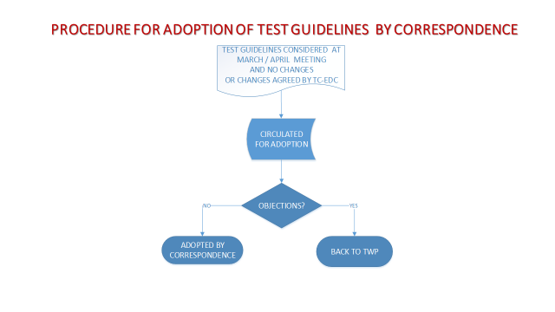

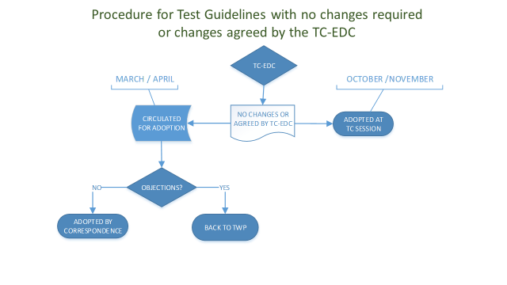

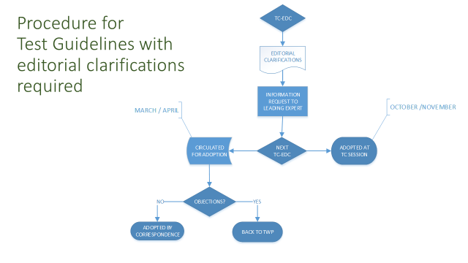

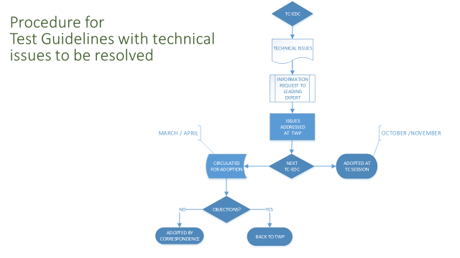

[End of Annex and of document]

