E
International Union for the Protection of New Varieties of Plants

Technical Committee  Fifty-Third Session  Geneva, April 3 to 5, 2017 | TC/53/23 Add.  Original: English  Date: March 8, 2017
addendum to DOCUMENT TC/53/23
Development of calculated thresholds for excluding varieties of common knowledge from the second growing cycle when COYD is used
Document prepared by experts from the United Kingdom
Disclaimer: this document does not represent UPOV policies or guidance
The Annex to this document contains a copy of a presentation on “Thresholds for excluding varieties of common knowledge from the second growing cycle when COYD is used” (in English only) to be made at the fifty-third session of the Technical Committee.

[Annex follows]

thresholds for Excluding varieties of common knowledge from the second growing cycle when COYD is used
(in english only)

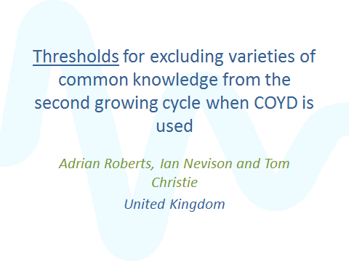

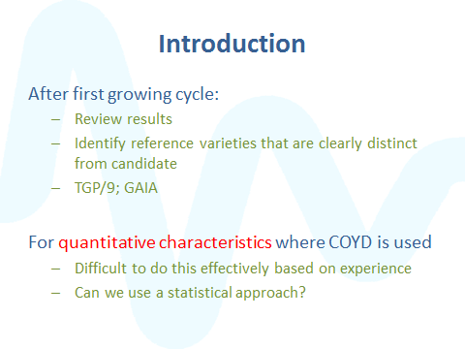

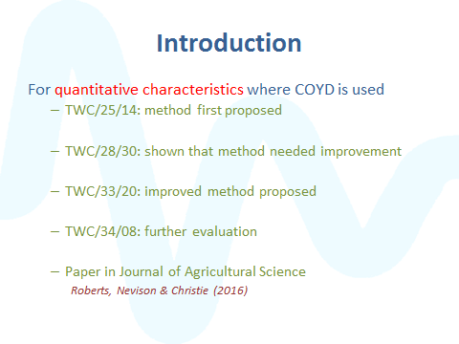
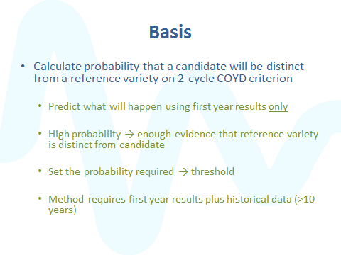
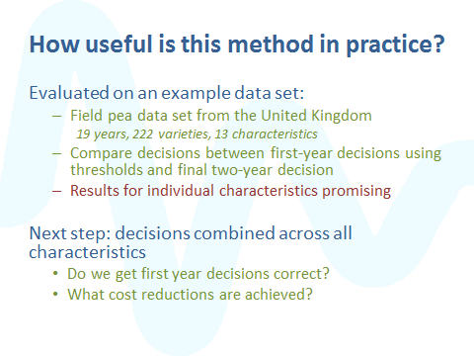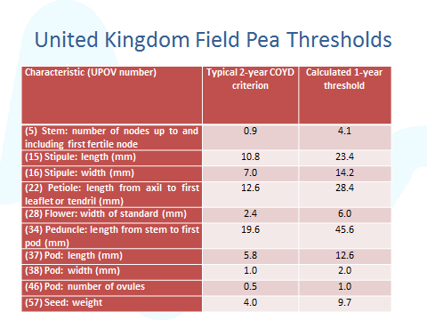
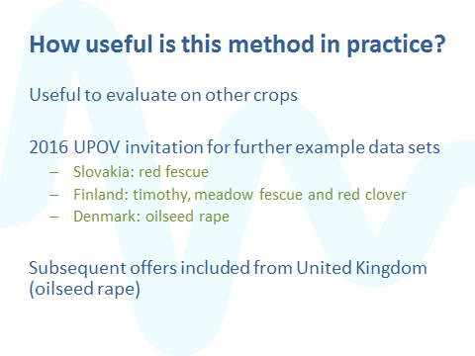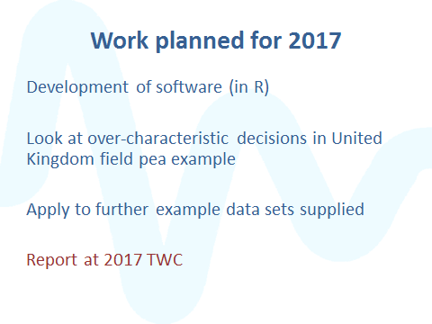

[End of Annex and of document]

