E
International Union for the Protection of New Varieties of Plants

Technical Committee  Fifty-Third Session  Geneva, April 3 to 5, 2017 | TC/53/21  Original: English  Date: March 1, 2017
Number of growing cycles
Document prepared by the Office of the Union
Disclaimer: this document does not represent UPOV policies or guidance

EXECUTIVE SUMMARY

The purpose of this document is to report on the consideration of the number of growing cycles in DUS examination.

The TC is invited to:

(a) consider the presentations made by experts to the TWPs, at their sessions in 2016, simulating the impact of using different numbers of growing cycles on DUS decisions using actual data, as set out in the Annexes to this document; and

(b) note the offers by members of the Union to make presentations to the TWPs, at their sessions in 2017, on the impact of using different numbers of growing cycles on DUS decisions using actual data.

The structure of this document is as follows:

EXECUTIVE SUMMARY 1
Background 2
Presentations to the TWPs at their sessions in 2016 2
Technical Working Party on Automation and Computer Programs 2
Technical Working Party for Ornamental Plants and Forest Trees 3
Technical Working Party for Vegetables 3
Technical Working Party for Agricultural Crops 3
Technical Working Party for Fruit Crops 4
simulations on the impact of using different numbers of growing cycles on DUS decisions using actual data presented to the TWPs at their sessions in 2016 4
ANNEX I Number of growing cycles in DUS examination: simulation of impact on DUS decisions
ANNEX II Minimum number of growing cycles
ANNEX III The impact of using different numbers of growing cycles on DUS decisions of vegetatively propagated ornamental varieties
ANNEX IV Minimum number of growing cycles for DUS examination
ANNEX V Number of growing cycles in DUS examination for fruit species
ANNEX VI Variability of assessment data over years in apple
ANNEX VII Interpreting variety descriptions for apple: environmental influence on quantitative characteristics

The following abbreviations are used in this document:

TC: Technical Committee
TC-EDC: Enlarged Editorial Committee
TWA: Technical Working Party for Agricultural Crops
TWC: Technical Working Party on Automation and Computer Programs
TWF: Technical Working Party for Fruit Crops
TWO: Technical Working Party for Ornamental Plants and Forest Trees
TWPs: Technical Working Parties
TWV: Technical Working Party for Vegetables

Background

The TC, at its fifty-second session, held in Geneva from March 14 to 16, 2016, received the following presentations on variety descriptions and the role of plant material, including minimum number of growing cycles for DUS examination (in order of presentation):

Variety descriptions and the role of plant material, including minimum number of growing cycles for DUS examination | France (Mr. Richard Brand)
Development and use of variety descriptions | Germany (Ms. Beate Rücker)
Minimum number of growing cycles | Netherlands (Mr. Kees van Ettekoven)
Using variety descriptions and length of testing – A New Zealand perspective | New Zealand (Mr. Chris Barnaby)

The TC considered the discussion on the number of growing cycles in DUS examination and agreed to invite members of the Union to simulate the impact of using different numbers of growing cycles on DUS decisions using actual data and to report on their results at the TWP sessions in 2016 and at the fifty-third session of the TC (see document TC/52/29 Rev. “Revised Report”, paragraph 204).

Presentations to the TWPs at their sessions in 2016

On April 12, 2016, by means of Circular E-16/095, the TC and TWP experts were invited to make presentations to the TWPs, at their sessions in 2016, to simulate the impact of using different numbers of growing cycles on DUS decisions using actual data and to report on their results at the TWP sessions in 2016 and at the fifty-third session of the TC.

Technical Working Party on Automation and Computer Programs

The TWC considered documents TWC/34/15, TWC/34/15 Add. and TWC/34/21 (see document TWC/34/32 “Report”, paragraphs 106 to 112).

The TWC received a presentation by the expert from Finland on “Number of growing cycles in DUS examination - simulation of impact on DUS decisions”, a copy of which is reproduced in document TWC/34/15 Add. and by an expert from the Netherlands on “Minimum number of growing cycles”, a copy of which is reproduced in the Annex to document TWC/34/21¹ .

The TWC noted that for some members DNA tests were being considered for reducing the number of growing cycles while retaining decisions based on a growing trial.

The TWC noted the experience of an expert of Argentina that, in the case of vegetatively propagated and self-pollinated crops, a second growing cycle would not be necessary in cases where distinctness was confirmed with clear differences between varieties (e.g. disease resistance characteristics) in a first growing cycle.

The TWC welcomed the offers by France, Germany and the Netherlands to simulate the impact of using different numbers of growing cycles on DUS decisions using actual data to be reported to the TWC at its thirty-fifth session.

The TWC noted that, for cross-pollinated varieties, for some UPOV members a third growing cycle was used to examine distinctness, such as in meadow fescue, red clover, timothy, turnip rape and white fescue in Finland.

Technical Working Party for Ornamental Plants and Forest Trees

The TWO considered documents TWO/49/15 and TWO/49/15 Add. (see document TWO/49/25 Rev. “Revised Report”, paragraphs 53 to 56).

The TWO received a presentation by an expert from Germany, as reproduced in the Annex to document TWO/49/15 Add.¹. The TWO noted the results of the simulation on the impact of using two growing cycles on DUS decisions using actual data for vegetatively propagated ornamental varieties and noted that decisions did not differ from those taken after one growing cycle.

The TWO noted the conclusion that a variety description was linked to the circumstances of the DUS examination, for example because the observed notes for some quantitative characteristics could fluctuate between growing cycles. The TWO agreed that for vegetatively propagated ornamental varieties DUS examination was usually based on side-by-side comparison between candidate and most similar varieties facilitating decisions on DUS after a single growing cycle.

Technical Working Party for Vegetables

The TWV considered documents TWV/50/15 and TWV/50/15 Add. (see document TWV/50/25 “Report”, paragraphs 76 to 81).

The TWV received presentations on “Minimum number of growing cycles”, by an expert from France and by an expert from the Netherlands, copies of which are provided in document TWV/50/15 Add. ¹.

The TWV agreed that it was necessary to consider the minimum number of growing cycles on a case by case basis in order to design a DUS examination in the most efficient and effective way. It noted that the quality of information provided by the applicants in the Technical Questionnaire could affect the choice of minimum number of growing cycles and agreed that possibilities might be explored to provide guidance (e.g. on photographs) and incentives for applicants to provide accurate and reliable data, for example by offering the prospect of a reduced number of growing cycles. The potential of molecular data to improve the selection of similar varieties was also considered as a possible means of reducing the minimum number of growing cycles in some situations. It was also noted that a second growing cycle for a particular variety might not be required if a variety was very clearly distinct from all varieties of common knowledge after a single growing cycle, although a second cycle might be required for uniformity, stability and description purposes (see TGP/7/4, chapter 4.1.2).

The TWV agreed that a reduction of the number of the cycles in DUS examination might have an impact on the accuracy of the variety description and that increase of the use of reduced number of growing cycles could have an important increase on the examination cost per cycle.

The TWV noted that the United Kingdom planned to simulate the impact of using different numbers of growing cycles on DUS decisions using actual data and to report on their results at the fifty-third session of the TC. On January 25, 2017, the expert from the United Kingdom informed the Office of the Union that it would not be possible to report on the results of the simulation to the TC at its fifty-third session.

Technical Working Party for Agricultural Crops

The TWA considered documents TWA/45/15 and TWA/45/15 Add. (see document TWA/45/25 “Report”, paragraphs 59 to 62).

The TWA noted that the TC, at its fifty-second session, had agreed to invite members of the Union to simulate the impact of using different numbers of growing cycles on DUS decisions using actual data and to report on their results at the TWP sessions in 2016 and at the fifty-third session of the TC. The TWA agreed that the simulation of impact of using different numbers of growing cycles on DUS decisions should take into consideration the quality of variety descriptions.

The TWA received a presentation by an expert from the Netherlands, as reproduced in the Annex to document TWA/45/15 Add.¹.

The TWA welcomed the offers from France, Germany, the Netherlands, Poland and the United Kingdom to simulate the impact of using different numbers of growing cycles on DUS decisions and the quality of variety descriptions using actual data and to report on their results at the TWA at its forty-sixth session.

Technical Working Party for Fruit Crops

The TWF considered document TWF/47/15 (see document TWF/47/15 “Report”, paragraphs 74 to 80).

The TWF received a presentation on the “Number of growing cycles in DUS Examination for fruit species” by an expert from France. A copy of this presentation is provided in Annex I to document TWF/47/15 Add.¹

The TWF received a presentation on “Variability of assessment data over years in apple” by an expert from Germany. A copy of this presentation is provided in Annex II to document TWF/47/15 Add.¹.

The TWF received a presentation on “Interpreting Variety Descriptions for Apple – Environmental influence on Quantitative Characters” by an expert from New Zealand. A copy of this presentation is provided in Annex III to document TWF/47/15 Add.¹.

The TWF agreed on the importance of the variety collections, in order to have reliable data when comparing varieties during DUS examination.

The TWF agreed that some characteristics are more efficient than others to examine distinctness.

simulations on the impact of using different numbers of growing cycles on DUS decisions using actual data presented to the TWPs at their sessions in 2016

The following simulations on the impact of using different numbers of growing cycles on DUS decisions using actual data presented to the TWPs, at their sessions in 2016, are reproduced as Annexes to this document (in English only):

Presentation title: | Reference documents:
Number of growing cycles in DUS examination: simulation of impact on DUS decisions (Annex I to this document)  Presentation by an expert from Finland | TWC/34/15 Add.
Minimum number of growing cycles (Annex II to this document)  Presentation by an expert from the Netherlands | TWC/34/21; TWV/50/15 Add.; and TWA/45/15 Add.
The impact of using different numbers of growing cycles on DUS decisions of vegetatively propagated ornamental varieties (Annex III to this document)  Presentation by an expert from Germany | TWO/49/15 Add.
Minimum number of growing cycles for DUS examination (Annex IV to this document)  Presentation by an expert from France | TWV/50/15 Add.
Number of growing cycles in DUS examination for fruit species (Annex V to this document)  Presentation by an expert from France | TWF/47/15 Add.
Variability of assessment data over years in apple (Annex VI to this document)  Presentation by an expert from Germany | TWF/47/15 Add.
Interpreting variety descriptions for apple: Environmental influence on quantitative characteristics (Annex VII to this document)  Presentation by an expert from New Zealand | TWF/47/15 Add.

The TC is invited to:

(a) consider the presentations made by experts to the TWPs, at their sessions in 2016, simulating the impact of using different numbers of growing cycles on DUS decisions using actual data, as set out in the Annexes to this document; and

(b) note the offers by members of the Union to make presentations to the TWPs, at their sessions in 2017, on the impact of using different numbers of growing cycles on DUS decisions using actual data.

[Annexes follow]

Number of growing cycles in DUS examination -simulation of impact on DUS decisions (in english only)

Presentation by an expert from Finland at the thirty-fourth session of the Technical Working Party on Automation and Computer Programs

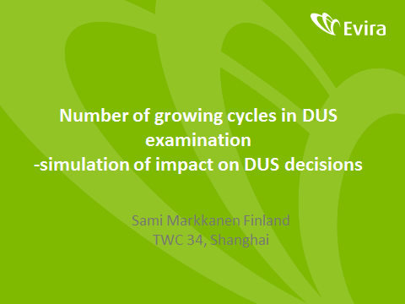

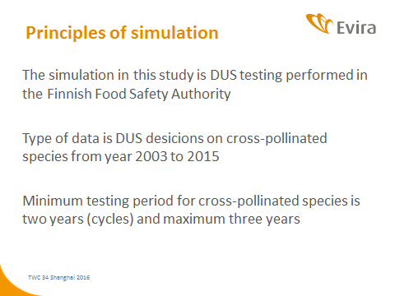

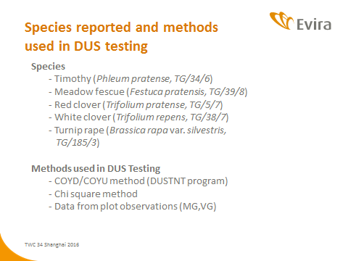

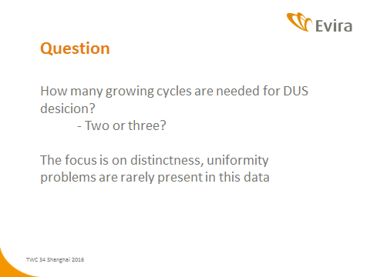

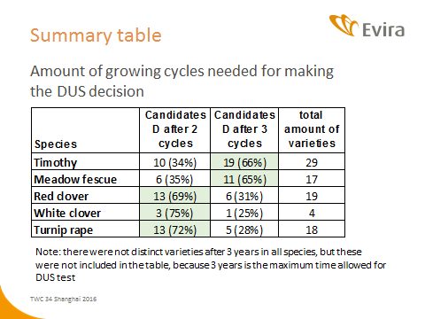

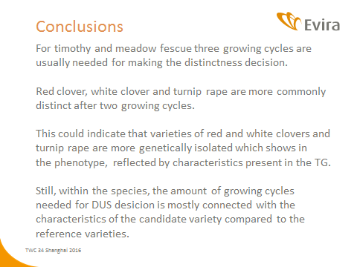

[Annex II follows]

MINIMUM NUMBER OF GROWING CYCLES (IN ENGLISH ONLY)

Presentation by an expert from the Netherlands at the thirty-fourth session of the Technical Working Party on Automation and Computer Programs, at the fiftieth session of the Technical Working Party for Vegetables and at the forty-fifth session of the Technical Working Party for Agricultural Crops

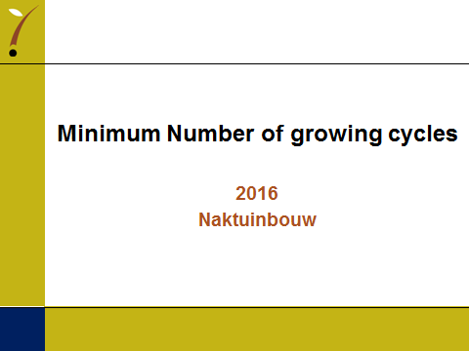

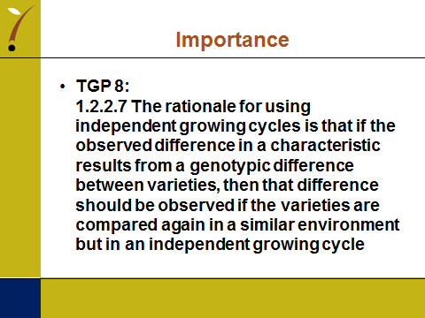

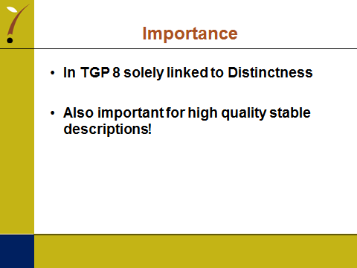

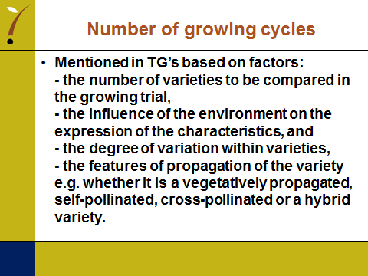

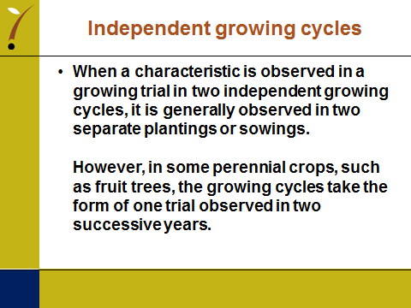

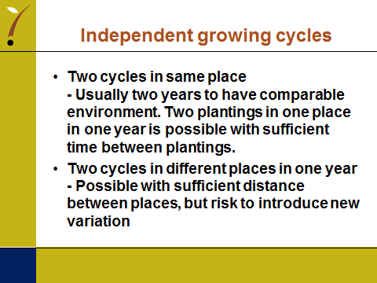

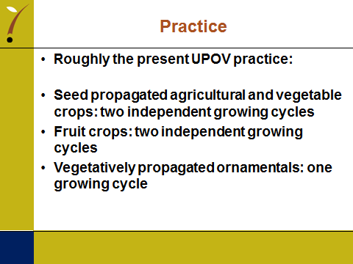

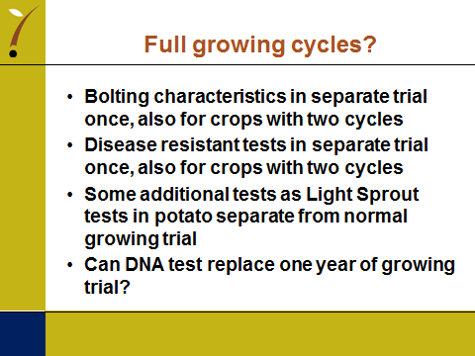

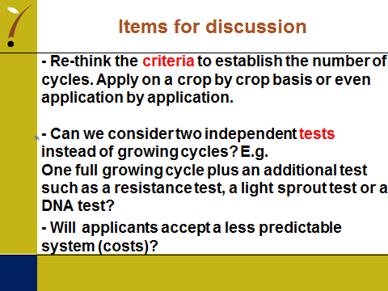

[Annex III follows]

THE IMPACT OF USING DIFFERENT NUMBERS OF GROWING CYCLES ON DUS DECISIONS
OF VEGETATIVELY PROPAGATED ORNAMENTAL VARIETIES (in english only)

Presentation by an expert from Germany at the forty-ninth session of the Technical Working Party for Ornamental Plants and Forest Trees

TWO/49/15

NUMBER OF GROWING CYCLES IN DUS EXAMINATION

The Impact Of Using Different Numbers Of Growing Cycles On DUS Decisions

Of Vegetatively Propagated Ornamental Varieties

Presentation by Andrea Menne, Germany

2

In most of the TGs for ornamental varieties one year of testing is recommended.

For the DUS test one year of testing is in most cases sufficient for vegetatively propagated ornamental varieties, because

- The differences between the varieties are big compared to environmental effects and the variation within varieties.

- The decision on distinctness is based on a side-by-side visual comparison in the growing trial.

- The detection of off-types is normally not influenced by the environment.

But: The growing cycle may have an impact on the variety description due to differences in the expression of characteristics between growing cycles.

3

Example: Pelargonium variety, description of 2013 and 2014

 | One note difference compared to 2013 |  | 2 notes difference compared to 2013

 | Characteristic | State of Expression | 2013 |  | 2014
1 | Plant: growth type | upright | 1 |  | 1
2 | Plant: height of foliage | medium to tall | 6 | tall to very tall | 8
4 | Plant: width | medium to broad | 6 |  | 6
5 | Stem: color | green | 2 |  | 2
6 | Stem: anthocyanin coloration | medium to strong | 4 | medium | 3
7 | Leaf blade: length | long | 7 | medium to long | 6
8 | Leaf blade: width | medium to broad | 6 |  | 6
9 | Leaf blade: depth of sinus | shallow to medium | 4 | medium | 5
10 | Leaf blade: undulation of margin | medium | 5 | weak to medium | 4
11 | Leaf blade: base | slightly open | 3 | slightly open to closed | 4
12 | Leaf blade: variegation | absent | 1 |  | 1
13 | Leaf blade: main color | dark green | 6 |  | 6
16 | Leaf blade: conspicuous. of zone | medium to strong | 6 |  | 6
17 | Leaf blade: position of zone | in middle | 2 |  | 2
18 | Leaf blade: relative size of zone | small | 1 |  | 1
19 | Peduncle: length | medium to long | 6 |  | 6

4

 | Characteristic | State of Expression | 2013 |  | 2014
20 | Peduncle: anthocyanin coloration | strong to very strong | 8 |  | 8
21 | Inflorescence: height | tall to very tall | 8 | medium to tall | 6
22 | Inflorescence: width | broad | 7 | medium | 5
23 | Inflorescence: no of open flowers | medium to many | 6 |  | 6
24 | Inflorescence: length of largest fl. | short to medium | 4 | medium | 5
25 | Inflorescence: width of largest flower | medium to broad | 6 |  | 6
26 | Inflorescence: length of pedicel | long | 7 | medium to long | 6
27 | Pedicel: anthocyanin coloration | strong | 7 | strong to very strong | 8
28 | Pedicel: swelling | absent | 1 |  | 1
29 | Flower: type | double | 2 |  | 2
31 | Flower: number of petals | medium | 5 |  | 5
32 | Flower: cross section in lateral view | flat | 2 |  | 2
33 | Flower: presence of stripes | absent | 1 |  | 1
36 | Sepal: reflexing | absent or weak | 1 |  | 1
37 | Sepal: anthocyanin coloration | medium | 5 | medium to strong | 6
38 | Upper petal: width | medium | 5 | medium to broad | 6
39 | Upper petal: shape | spatulate | 4 |  | 4
40 | Upper petal: margin at apex | entire | 1 |  | 1
41 | Upper petal: color of margin | red | 50A | red | 46C
42 | Upper petal: color of middle | red | 50A | red | 46C

5

 | Characteristic | State of Expression | 2013 |  | 2014
43 | Upper petal: color of lower side | red | 43B | red | 43A
44 | Upper petal: conspicuou. of marking | absent or very weak | 1 |  | 1
45 | Upper petal: type of marking | stripes only | 1 |  | 1
48 | Upper petal: zone at base | absent | 1 |  | 1
51 | Lower petal: color of margin | red | 46C | red | 50A
52 | Lower petal: color of middle | red | 50A | red | 50A
53 | Lower petal: color of lower side | red | 46C | red | 43B
54 | Lower petal: conspicuou. of marking | absent or very weak | 1 |  | 1
57 | Lower petal: zone at base | absent | 1 |  | 1
60 | Inner petal: colour of upper side | red | 46C | red | 46C

- Out of 46 characteristics only 3 deviate from one year to the next by two notes.

- 10 characteristics deviate by one note.

6

Consequences

- When taking a decision on distinctness the expert needs to be aware which characteristics are sensitive to the environment.

Environmental effects have to be considered for:

(a) The comparison of similar varieties in the same growing trial (side-by-side comparison).

(b) The exclusion of clearly distinct varieties from the growing trial (comparison with descriptions in the variety collection).

(c) The test for stability/identity (comparison side-by-side with previous sample or with description).

It is very important to emphasize that the variety description is linked to the year of testing.

Question: Are all varieties in the same trial reacting in the same way on the environmental conditions?

7

Example: Two varieties of Impatiens New Guinea Group

 | One note difference compared to 2010 |  | 2 notes difference compared to 2010

 |  |  | Variety | One |  |  | Variety | Two
 |  | Characteristic | 2010 | 2012 | 2013 |  | 2010 | 2012 | 2013
1 | QN | Plant: height of foliage | 5 | 5 | 5 |  | 6 | 7 | 5
2 | QN | Plant: width | 3 | 5 | 5 |  | 6 | 6 | 6
3 | QN | Shoot: anthocyanin coloration | 6 | 6 | 6 |  | 8 | 8 | 8
4 | QN | Petiole: length | 3 | 5 | 4 |  | 4 | 5 | 4
5 | QN | Petiole: anthocyanin coloration | 3 | 3 | 3 |  | 6 | 6 | 6
6 | QN | Leaf blade: length | 5 | 5 | 5 |  | 6 | 5 | 6
7 | QN | Leaf blade: width | 4 | 5 | 5 |  | 4 | 5 | 5
8 | QN | Leaf blade: length/width ratio | 6 | 5 | 6 |  | 6 | 6 | 7
11 | QN | Leaf blade: anthocyanin coloration | 3 | 2 | 2 |  | 2 | 2 | 2
15 | QN | Pedicel: length | 4 | 4 | 4 |  | 6 | 6 | 6
16 | QN | Pedicel: anthocyanin coloration | 5 | 5 | 5 |  | 8 | 8 | 8
18 | QN | Flower: width | 6 | 6 | 6 |  | 7 | 7 | 6
26 | QN | Upper petal: width | 6 | 7 | 7 |  | 7 | 7 | 7
27 | QN | Lateral petal: width | 5 | 5 | 5 |  | 5 | 4 | 4
28 | QN | Lower petal: length | 5 | 6 | 6 |  | 6 | 6 | 6
24 | QN | Flower: size of eye zone | 4 | 4 | 4 |  | 4 | 4 | 4

8

 |  |  | Variety | One |  |  | Variety | Two
 |  | Characteristic | 2010 | 2012 | 2013 |  | 2010 | 2012 | 2013
12 | QL | Leaf blade: color of lower side between veins | 1 | 1 | 1 |  | 1 | 1 | 1
14 | QL | Leaf blade: color of veins on lower side | 2 | 2 | 2 |  | 2 | 2 | 2
17 | QL | Flower: type | 1 | 1 | 1 |  | 1 | 1 | 1
19 | QL | Flower: number of colors | 1 | 1 | 1 |  | 1 | 1 | 1
23 | QL | Flower: eye zone | 9 | 9 | 9 |  | 9 | 9 | 9
20 | PQ | Flower: main color of upper side | N30A | N30A | N30A |  | N30A | N30A | N30A
25 | PQ | Flower: main color of eye zone | 46B | 46B | 45A |  | 46B | 46B | 45A

9

General Observations

- In particular, the state of expression of quantitative characteristics can be more variable over the years.

- Some quantitative characteristics react more sensitive to the environment than others.

- Not all varieties react in the same way to changes of the environment.

- If a variety is observed in one growing period only, the possible variation in the state of expression is unknown.

Besides the growing conditions during the testing period also other factors can influence the expression of the plant characteristics, e.g. the conditions under which the mother plants were kept, or the position on the mother plant where the cutting was taken.

[End of document]

[Annex IV follows]

MINIMUM NUMBER OF GROWING CYCLES FOR DUS EXAMINATION (in english only)

Presentation by an expert from France at the fiftieth session of the Technical Working Party for Vegetables

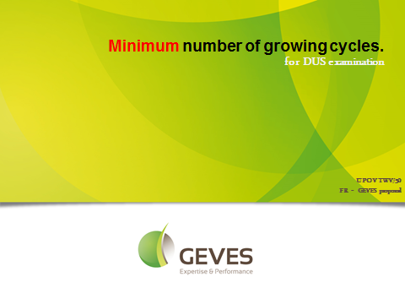

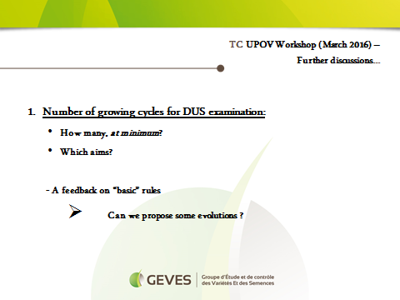

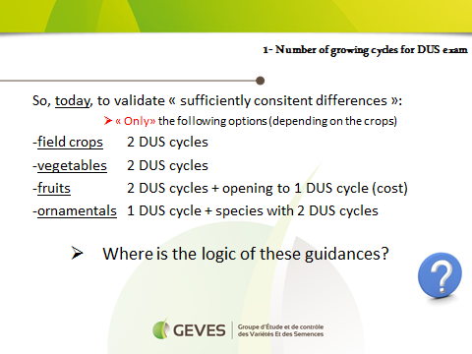

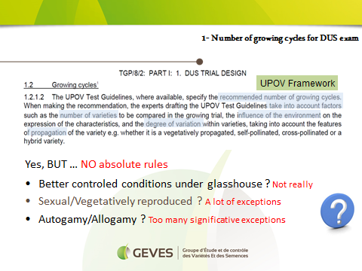

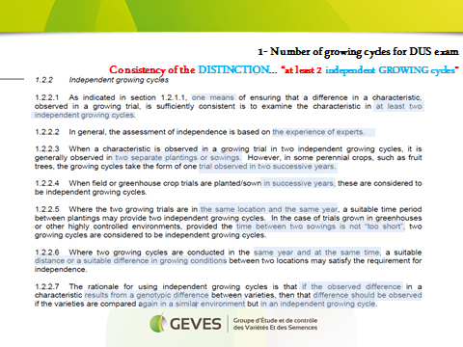

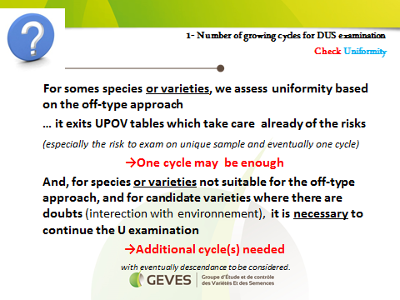

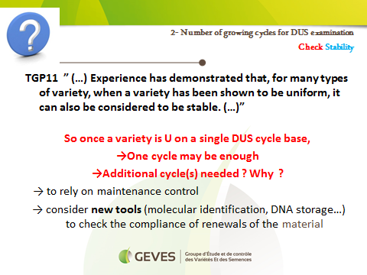

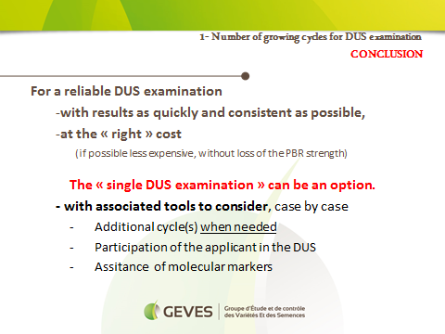

[Annex V follows]

Number of growing cycles in DUS examination for fruit species (in English only)

Presentation by an expert from France at the forty-seventh session of the Technical Working Party for Fruit Crops

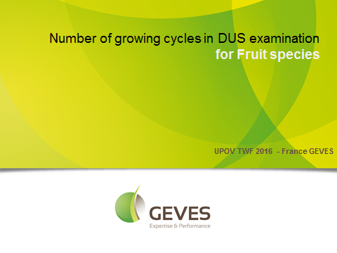

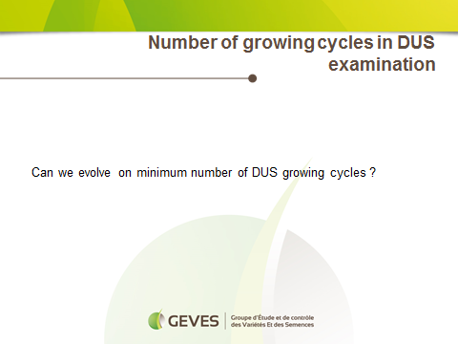

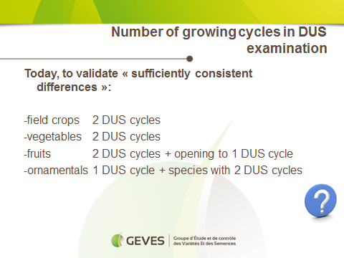

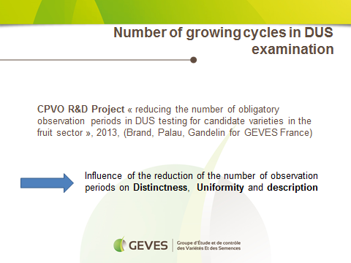

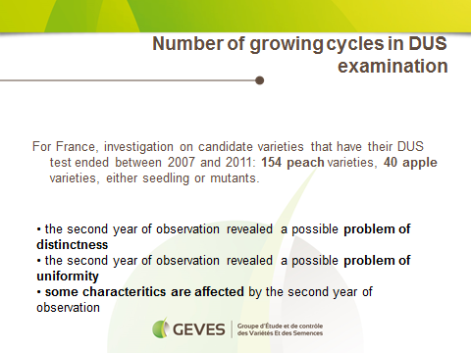

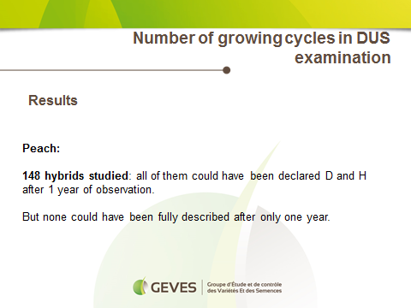

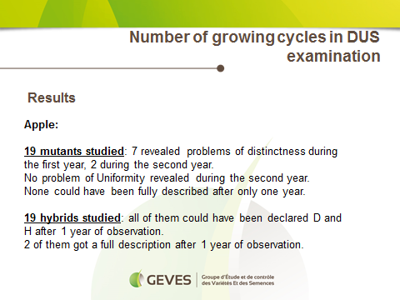

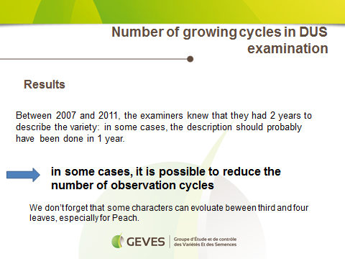

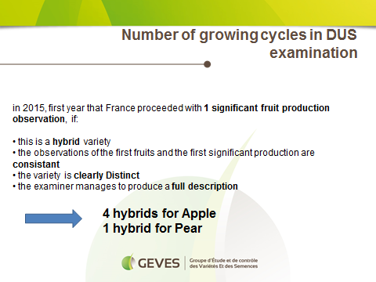

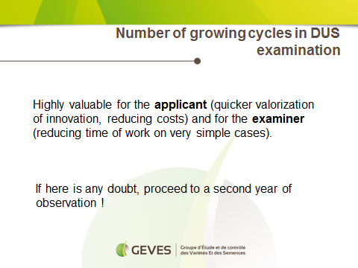

[Annex VI follows]

Variability of assessment data over years in apple (in English only)

Presentation by an expert from Germany at the forty-seventh session of the Technical Working Party for Fruit Crops

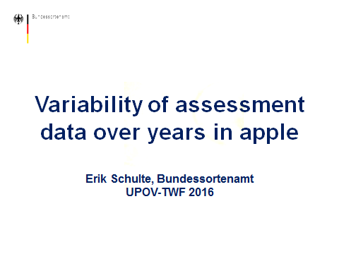

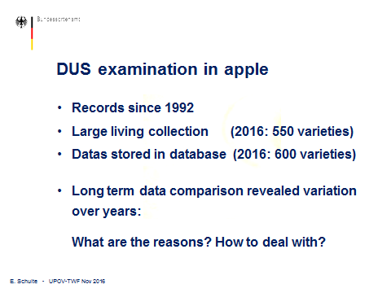

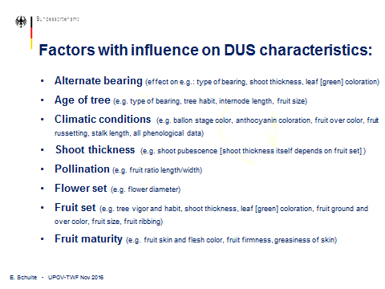

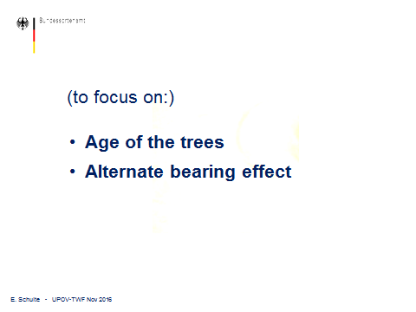

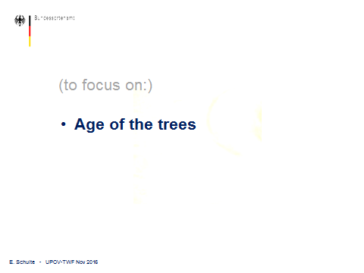

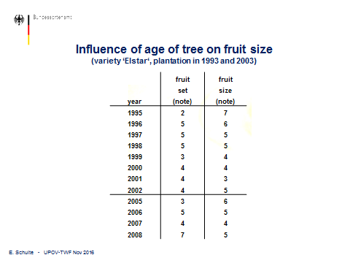

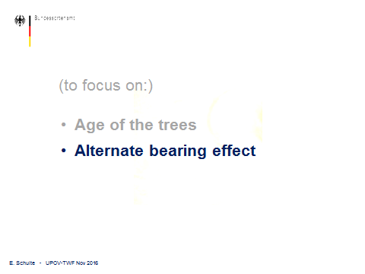

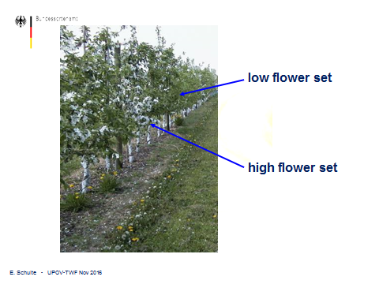

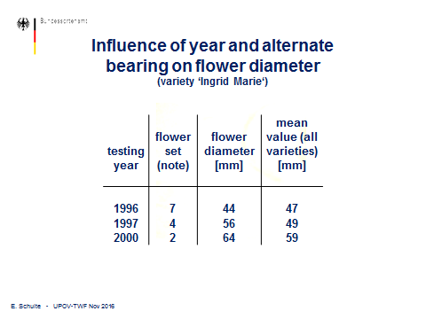

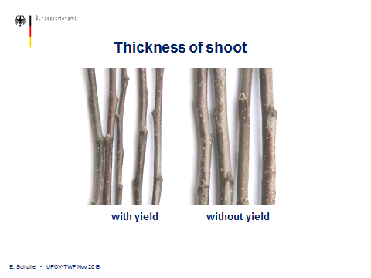

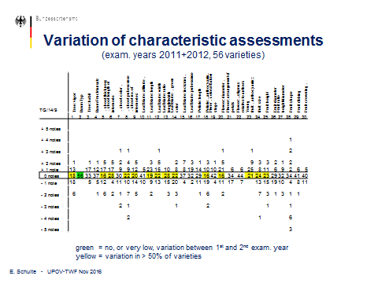

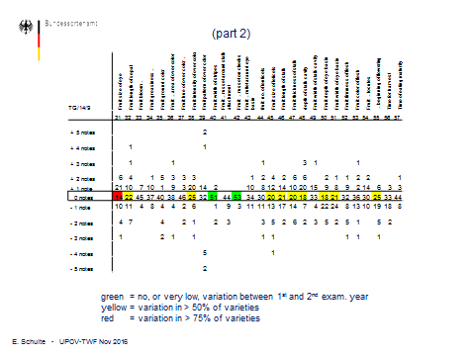
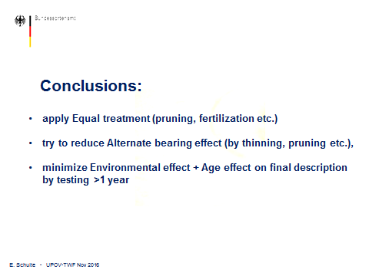

[Annex VII follows]

Interpreting variety descriptions for apple: Environmental influence on quantitative characteristics (in English only)

Presentation by an expert from New Zealand at the forty-seventh session of the Technical Working Party for Fruit Crops

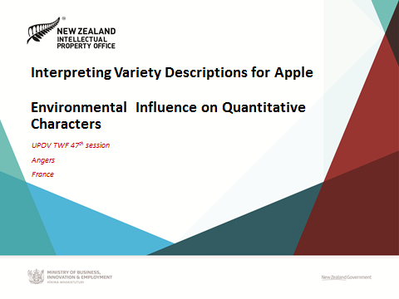

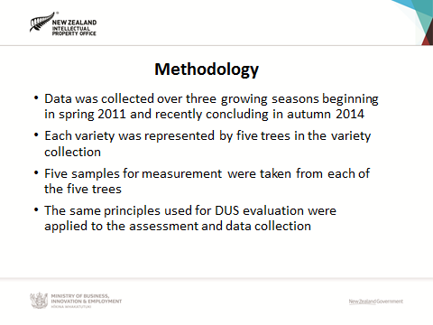

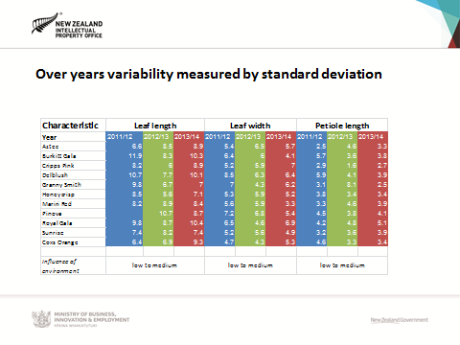

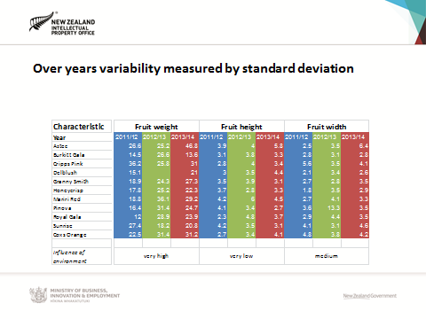

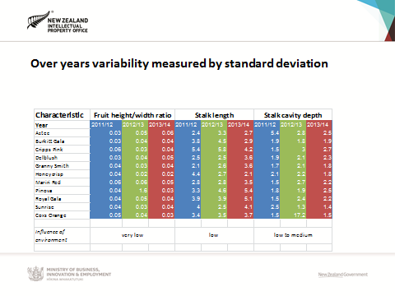
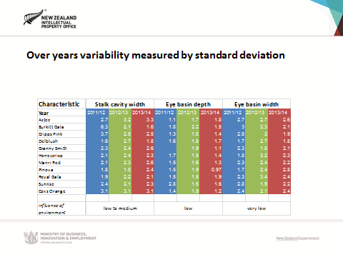
[End of Annex VII and of document]

A copy of this presentation is presented as an annex to this document: see paragraph 32.
1 A copy of this presentation is presented as an annex to this document: see paragraph 32.
1 A copy of this presentation is presented as an annex to this document: see paragraph 32.

