E
International Union for the Protection of New Varieties of Plants

Technical Committee  Fifty-Third Session  Geneva, April 3 to 5, 2017 | TC/53/20  Original: English  Date: February 22, 2017
Cooperation in examination
Document prepared by the Office of the Union
Disclaimer: this document does not represent UPOV policies or guidance

executive summary

The purpose of this document is to present the results of a survey of the current situation of members of the Union with regard to cooperation in examination, as a starting point for discussion on possibilities to facilitate cooperation that might exist.

The TC is invited to consider the results of the survey of the current situation of members of the Union with regard to cooperation in examination, as set out in the Annex to this document, as a starting point for discussion on possibilities to facilitate cooperation that might exist.

Background

At its fifty-second session, held in Geneva, from March 14 to 16, 2016, the Technical Committee (TC), as a result of the discussion under agenda item 3 “Discussion on quality parameters for DUS examination”, noted that there may be obstacles to cooperation in examination, including exchange of DUS reports, and agreed to explore the situation further. As a starting point for discussion, the TC agreed that it would be useful for the Office of the Union to conduct a survey of the current situation of members of the Union and to report the results to the TC at its fifty-third session (see document TC/52/29 Rev. “Revised Report”, paragraph 207).

On November 18, Circular E-16/276 “UPOV Survey: Cooperation in DUS Examination” was issued to designated persons to the Council and TC of members of the Union.

Survey results

Complete responses to Circular E-16/276 were received from 28 members of the Union, namely:

African Intellectual Property Organization (OAPI) | Latvia
Belarus | Mexico
Costa Rica | Netherlands
Croatia | New Zealand
Czech Republic | Norway
Denmark | Panama
Ecuador | Portugal
Estonia | Republic of Moldova
European Union | Russian Federation
Finland | Serbia
France | Sweden
Germany | Turkey
Israel | United Kingdom
Kenya | United States of America

The responses to the survey are presented in the Annex to this document.

The TC is invited to consider the results of the survey of the current situation of members of the Union with regard to cooperation in examination, as set out in the Annex to this document, as a starting point for discussion on possibilities to facilitate cooperation that might exist.

[Annex follows]

Comment report

Lists all the questions in the survey and displays all the free text responses to these questions, if applicable

Table of contents

Question 1: *UPOV Member on behalf of whom you are completing this survey 3
Question 2: *Name 3
Question 3: *Job title 3
Question 4: *Organization 3
Question 5: *E-mail address 4
Question 6: *Acknowledgement 4
Question 7: In general, which of the following options best describes the way in which your authority uses DUS reports provided by another UPOV member? 5
Question 8: Please describe the use of existing DUS reports by your authority: 7
Question 9: If your authority uses existing DUS reports, which of the following criteria must normally be met to use existing DUS reports? 9
Question 10: Is the information in the GENIE database on use of existing DUS reports by your authority complete and accurate? 12
Question 11: Are there any practical measures that might facilitate the use of existing DUS reports by your authority? 13
Question 12: Situation: No other UPOV member has an existing DUS report for a variety which is the subject of an application with your authority, but your authority is aware of an application for the same variety with another UPOV member for which a DUS examination has, is being, or will be organized: In the situation above, to avoid the need for a DUS examination by your authority and if requested by the applicant, would your authority request the other UPOV member to provide the DUS report at the end of the DUS examination? 14
Question 13: If your authority requests DUS reports in the situation described in Question 12, which of the following criteria must normally be met? 15
Question 14: Situation: No other UPOV member has an existing DUS report for a variety which is the subject of an application with your authority and there is no application with another UPOV member. In the situation above, would your authority request another UPOV member to conduct the DUS examination on its behalf? 17
Question 15: If your authority requests another UPOV member to conduct a DUS examination on its behalf in the situation described in Question 14, which of the following criteria must normally be met? 18
Question 16: Is the information in the GENIE database on requests for DUS examinations by your authority complete and accurate? 20
Question 17: Will your authority accept a DUS report of another UPOV member via the applicant (assuming that it is acceptable in all other respects)? 21
Question 18: If your authority accepts a DUS report from another UPOV member, how is the fee paid? 22
Question 19: Are there any practical measures that might facilitate requests for DUS examinations by your authority from other UPOV members? 23
Question 20: Please describe the provision of existing DUS reports by your authority to other UPOV members: 24
Question 21: If your authority provides existing DUS reports, which of the following criteria are used in deciding whether to provide existing DUS reports? 26
Question 22: Is the information in the GENIE database on provision of existing DUS reports by your authority complete and accurate? 28
Question 23: Are there any practical measures that might facilitate provision of existing DUS reports by your authority? 29
Question 24: Situation: A DUS report has not yet been produced by your authority for a variety which is the subject of an application with your authority; however, your authority is conducting, or is going to conduct, a DUS examination. In the situation above, would your authority agree, in advance, to provide the DUS report to another UPOV member at the end of the DUS examination? 30
Question 25: If your authority provides DUS examination reports in the situation described in Question 24, which of the following criteria must normally be met? 32
Question 26: In the situation in Question 24, would your authority agree, in advance, to complete a DUS examination and provide a DUS report to another UPOV member, even if the application was discontinued in your territory before the DUS examination was completed? 33
Question 27: If your authority provides DUS examination reports in the situation described in Question 26, which of the following criteria must normally be met? 34
Question 28: If your authority has not received an application for a variety concerned but your authority has the necessary expertise and conditions for conducting the DUS examination, would your authority conduct a DUS examination on behalf of another UPOV member, if so requested? 35
Question 29: If your authority conducts DUS examinations on behalf of UPOV members for varieties for which it has not received an application, which of the following criteria must normally be met? 37
Question 30: Is the information in the GENIE database on conduct of DUS examinations and provision of DUS reports by your authority on behalf of other UPOV members complete and accurate? 39
Question 31: Are there any practical measures that might facilitate the conduct of DUS examinations by your authority on behalf of other UPOV members? 40
Question 32: Please describe any restrictions on the use of DUS reports you provide to the authority of another UPOV member 41
Question 33: Will your authority provide the DUS report to the applicant for use in an application with another UPOV member? 42
Question 35: How confident are you that you know all the options for cooperation between UPOV members in DUS examination? 44
Question 36: In your experience, how easy is it to arrange cooperation in DUS examination with other UPOV members? 45

Question 1:
*UPOV Member on behalf of whom you are completing this survey
(in the alphabetical order of the English names of the Members)

Frequency table
Items | Absolute  frequency | Relative  frequency | Adjusted relative  frequency
African Intellectual Property Organization (OAPI) | 1 | 3.57% | 3.57%
Belarus | 1 | 3.57% | 3.57%
Costa Rica | 1 | 3.57% | 3.57%
Croatia | 1 | 3.57% | 3.57%
Czech Republic | 1 | 3.57% | 3.57%
Denmark | 1 | 3.57% | 3.57%
Ecuador | 1 | 3.57% | 3.57%
Estonia | 1 | 3.57% | 3.57%
European Union | 1 | 3.57% | 3.57%
Finland | 1 | 3.57% | 3.57%
France | 1 | 3.57% | 3.57%
Germany | 1 | 3.57% | 3.57%
Israel | 1 | 3.57% | 3.57%
Kenya | 1 | 3.57% | 3.57%
Latvia | 1 | 3.57% | 3.57%
Mexico | 1 | 3.57% | 3.57%
Netherlands | 1 | 3.57% | 3.57%
New Zealand | 1 | 3.57% | 3.57%
Norway | 1 | 3.57% | 3.57%
Panama | 1 | 3.57% | 3.57%
Portugal | 1 | 3.57% | 3.57%
Republic of Moldova | 1 | 3.57% | 3.57%
Russian Federation | 1 | 3.57% | 3.57%
Serbia | 1 | 3.57% | 3.57%
Sweden | 1 | 3.57% | 3.57%
Turkey | 1 | 3.57% | 3.57%
United Kingdom | 1 | 3.57% | 3.57%
United States of America | 1 | 3.57% | 3.57%
Sum: | 28 | 100% | 100%
Not answered: | 0 | 0% | -
Total answered: 28

Question 2:
*Name

Question 3:
*Job title

Question 4:
*Organization

Question 5:
*E-mail address

Question 6:
*Acknowledgement
I understand that, for the purposes of this survey, the following terms are used: • “DUS report” means the information in document TGP/5 “Experience and Cooperation in DUS Testing”, Section 6: UPOV Report on Technical Examination and UPOV Variety Description (see http://www.upov.int/edocs/tgpdocs/en/tgp_5_section_6.pdf ) • “Existing DUS report” means a DUS report resulting from a DUS examination that has already been completed by a UPOV member

Question 7:
In general, which of the following options best describes the way in which your authority uses DUS reports provided by another UPOV member?
(more than one box can be ticked):

The DUS report is used as the basis for the DUS decision without the need for further information
The DUS report is used as the basis for the DUS decision, but a description of the variety grown in the territory of your authority must also be produced
The variety description attached to the DUS report is used as the basis for the DUS examination
The variety description attached to the DUS report is used as a complement to the DUS examination
The variety description is included in the variety collection
Other

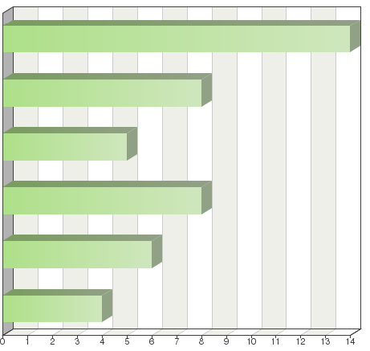

Frequency table
Choices | Absolute  frequency | Relative  frequency  by choice | Adjusted relative  frequency | Relative  frequency
The DUS report is used as the basis for the DUS decision without the need for further information | 14 | 31.11% | 50% | 50%
The DUS report is used as the basis for the DUS decision, but a description of the variety grown in the territory of your authority must also be produced | 8 | 17.78% | 28.57% | 28.57%
The variety description attached to the DUS report is used as the basis for the DUS examination | 5 | 11.11% | 17.86% | 17.86%
The variety description attached to the DUS report is used as a complement to the DUS examination | 8 | 17.78% | 28.57% | 28.57%
The variety description is included in the variety collection | 6 | 13.33% | 21.43% | 21.43%
Other: | 4 | 8.89% | 14.29% | 14.29%
Sum: | 45 | 100% | - | -
Not answered: | 0 | - | 0% | -
Total answered: 28

Other (details)

See remark

The Costa Rican authority does not carry out DUS examinations. It accepts the examinations made by another authority or receives the application when the examination is not yet ready or is being conducted by another authority.

Comments

All the varieties, species and genera listed in Regulation 31 of The Ministry of Agriculture and Food Production of the Republic of Belarus (enclosed), undergo DUS trial in the territory of Belarus. Our authority as a rule compares our results of DUS-trials and morphological description of the variety with DUS-reports, received from other UPOV members’ authorities.
If there are considerable differences, DUS-trials are prolonged for the 3rd year. All the differences are discussed with the Applicant and a reasonable agreement is reached. Our authority also may reject DUS reports, received from the other UPOV member authority in case: - DUS-trials were carried out under old test UPOV guidelines, national guidelines not based on UPOV guidelines- In description provided, too few morphological characteristics are described Our Organization (SE "State Inspection for Testing and Protection of Plant Varieties") carries out DUS-trials and determines all morphological characteristics, recommended by UPOV. CPVO test guidelines accompanied by our national test guidelines. Regulation of The Ministry of Agriculture and Food Production of the Republic of Belarus 23rd, June 2014 31 The List of species and genera, varieties of which are subject to state variety testing carried out by SE "State Inspection for Testing and Protection of Plant Varieties" 1 Triticum aestivum L. emend Fiori et Paol. 2 Triticum durum Desf. 3 Secale cereale L. 4 xTriticosecale VVittm. 5 Hordeum vulgare L. sensu lata 6 Fagopyrum esculentum Moench 7 Zea mays L. 8 Avena nuda L. 9 Avena sativa L. 10 Pisum sativum L. sensu lata 11 Lupinus luteus L. 12 Lupinus angustifolius L. 13 Glycine max (L.) Merr. 14 Cucumis sativus L. 15 Brassica oleracea L. var. capitata L. f. alba DC. 16 Brassica oleracea L. var. capitata L.f. rubra (L.) Theil. 17
Brassica oleracea L. var. sabauda L. 18 Brassica oleracea L. convar. botrytis (L.) Alef. var. botrytis 19 Brassica oleracea L. var. cymosa Ouch. 20 Brassica oleracea L. var. gemmifera DC. 21 Brassica oleracea L. var. gongylodes L. 22 Brassica pekinensis (Lour.) Rupr. 23 Allium cepa L. 24 Daucus carota L. 25 Capsicum annuum L. 26 Petroselinum crispum (Mill.) Nyman ex A. W. Hill27 Raphanus sativus L. 28 Brassica rapa L. 29 Lactuca sativa L. 30 Beta vulgaris L. ssp. vulgaris var. conditiva Alef. 31 Solanum lycoprsicum L. 32 Cucurbita pepo L. 33 Anethum graveolens L. 34 Phaseolus L. 35 Allium sativum L. 36 Solanum tuberosum L. sensu lata 37 Beta vulgaris L. ssp. vulgaris var. alba DC. 38 Linum usitatissimum L. 39 Brassica napus L. ssp. oleifera (Metzg.) Sinsk 40 Brassica campestris L. ssp. campestris 41 Fragaria L. 42 Ribes rubrum L. 43 Ribes nigrum L.

Remark: The DUS report including the variety description (in positive case) is used for the DUS decision without need for further information only in case if the description was produced on the basis of DUS test in similar agro climatic conditions by the Authority entrusted by the CPVO and we not perform DUS test of the species in question ourselves.

For most species there is no growing trial in NZ and the DUS report is accepted. For some species, available plant material of the candidate variety is checked for compatibility with the DUS report. In a few cases, there may be uncertainty regarding whether an identified similar variety nationally has been considered in the DUS report, the report (and candidate plants if available) are used to check against the possible similar variety.

The DUS report and the variety description are used as the basis for the DUS decision if the DUS test has been conducted by an authority which is entrusted by the CPVO Administrative Council for the species in question and under the condition that it provides a sufficient basis to take such decision. "Entrustment" means that the authority which conducted the DUS test, either on behalf of the CPVO or in the framework of a national procedure, fulfil the quality requirements checked in the framework of the CPVO Quality Audit System. In some cases, further information may be requested before taking a decision. In isolated cases, we take over reports from overseas without a description in the EU

The DUS test is carried out on the basis of the description contained in the technical form, as well as guidelines.

DUS report in general, positive or negative, is taken to make a decision on fulfill the criteria of the DUS and the DUS description, as an integral part of a positive DUS report, originally is included in the reference collection, but after making "In House Description" in the reference collection is used the description made in our institution.

Based on the DUS report provided by other offices of countries that are members of UPOV, the technical opinion in which the right is granted or denied is prepared. Based on distinctness, uniformity and stability.

The Costa Rican authority considers it sufficient to have the report of the DUS result to decide to grant a title or right and almost always accepts the accompanying variety description. A variety description prepared on Costa Rican soil is requested only when it is considered that the characteristics could vary substantially with environment.

Question 8:
Please describe the use of existing DUS reports by your authority:

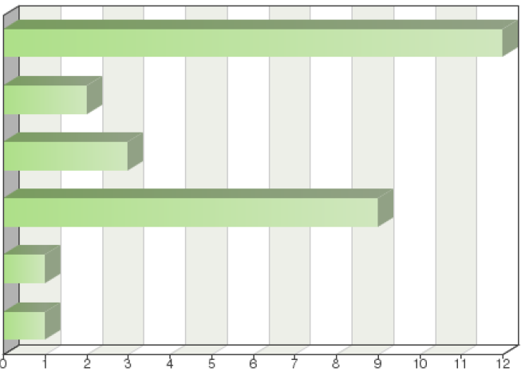
My authority will use existing DUS reports from any UPOV member, for any crop/species
My authority will use existing DUS reports from any UPOV member, for selected crops/species
My authority will use existing DUS reports from selected UPOV members, for any crop/species
My authority will use existing DUS reports from selected UPOV members, for selected crops/species
My authority does not use existing DUS reports
Other

Frequency table
Choices | Absolute  frequency | Relative  frequency  by choice | Relative  frequency | Adjusted  relative frequency
My authority will use existing DUS reports from any UPOV member, for any crop/species | 12 | 42.86% | 42.86% | 42.86%
My authority will use existing DUS reports from any UPOV member, for selected crops/species | 2 | 7.14% | 7.14% | 7.14%
My authority will use existing DUS reports from selected UPOV members, for any crop/species | 3 | 10.71% | 10.71% | 10.71%
My authority will use existing DUS reports from selected UPOV members, for selected crops/species | 9 | 32.14% | 32.14% | 32.14%
My authority does not use existing DUS reports | 1 | 3.57% | 3.57% | 3.57%
Other: | 1 | 3.57% | 3.57% | 3.57%
Sum: | 28 | 100% | - | -
Not answered: | 0 | - | 0% | -
Total answered: 28

Other (details)

Consideration on case by case

Comments

The climatic and daylight conditions must be similar Ill the conditions in Norway.

For all the varieties, species and genera listed in Regulation 31 of The Ministry of Agriculture and Food Production of the Republic of Belarus (enclosed) the existing DUS reports will be used only in case they respond to the data received from DUS trials carried out in Belarus.

A key element in deciding on species is the existence of a UPOV test guideline. A key element on deciding on the UPOV member is experience recorded in GENIE

See explanation above on “entrustment'

When the OAPI is unable to perform a DUS test, it is necessary to obtain an existing examination report to process the application.

Existing DUS reports are used by my department when they originate from an EU country for a species for which the country is accredited by the QAS system of the CPVO and when the applicant explicitly wishes to use an existing DUS report in that country.

We only acknowledge CPVO entrusted offices.

Question 9:
If your authority uses existing DUS reports, which of the following criteria must normally be met to use existing DUS reports?
(more than one box can be ticked):

There are no particular criteria
It must be the DUS report from the UPOV member in which the application was first made
UPOV Test Guidelines must be the basis for the DUS examination
The providing authority must use most of the characteristics that are examined by your authority
There is a written agreement (2) with the providing authority
The providing authority must have a quality assurance scheme that is recognized by your authority
The DUS trial must be located in a particular region
Your authority must have a detailed knowledge of the DUS trial arrangements of the providing authority
Your authority must have the possibility to visit the trial site
The DUS trial must be grown under certain conditions (e.g. in a greenhouse)
Your authority must have a detailed knowledge of the variety collection used by the providing authority
There must be a common database of varieties of common knowledge
There must be sufficient breeding activity in the UPOV member providing the DUS report
There must be no cost to your authority (3) (either the providing authority makes no charge, or the applicant pays the charge)
Other
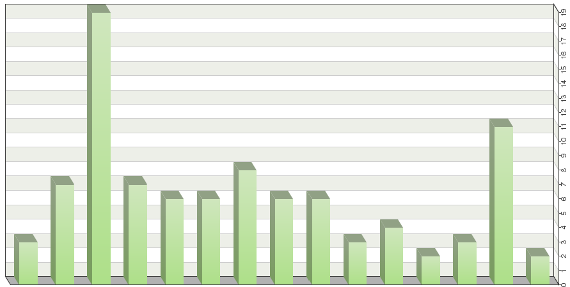

Frequency table
Choices | Absolute  frequency | Relative  frequency  by choice | Relative  frequency | Adjusted  relative  frequency
There are no particular criteria | 3 | 3.23% | 10.71% | 10.71%
It must be the DUS report from the UPOV member in which the application was first made | 7 | 7.53% | 25% | 25%
UPOV Test Guidelines must be the basis for the DUS examination | 19 | 20.43% | 67.86% | 67.86%
The providing authority must use most of the characteristics that are examined by your authority. | 7 | 7.53% | 25% | 25%
There is a written agreement (2) with the providing authority | 6 | 6.45% | 21.43% | 21.43%
The providing authority must have a quality assurance scheme that is recognized by your authority | 6 | 6.45% | 21.43% | 21.43%
The DUS trial must be located in a particular region. | 8 | 8.6% | 28.57% | 28.57%
Your authority must have a detailed knowledge of the DUS trial arrangements of the providing authority | 6 | 6.45% | 21.43% | 21.43%
Your authority must have the possibility to visit the trial site | 6 | 6.45% | 21.43% | 21.43%
The DUS trial must be grown under certain conditions (e.g. in a greenhouse) | 3 | 3.23% | 10.71% | 10.71%
Your authority must have a detailed knowledge of the variety collection used by the providing authority | 4 | 4.3% | 14.29% | 14.29%
There must be a common database of varieties of common knowledge | 2 | 2.15% | 7.14% | 7.14%
There must be sufficient breeding activity in the UPOV member providing the DUS report | 3 | 3.23% | 10.71% | 10.71%
There must be no cost to your authority (3) (either the providing authority makes no charge, or the applicant pays the charge) | 11 | 11.83% | 39.29% | 39.29%
Other: | 2 | 2.15% | 7.14% | 7.14%
Sum: |  | 100% | - | -
Not answered: | 0 | - | 0% | -
Total answered: 28

Other (details)

Consideration on case by case

Comments

1. Check that the providing authority included all VCK including the ones that grow in the requesting authority. 2. Check that the climatic and environmental conditions are consistent with those in the requesting authority.

Usually the UPOV member state is also making examinations under CPVO guidelines.

Possible restrictions related to the region will be covered by the variety collection used in the testing Country. Otherwise the region is important for many field crops.

A written agreement with the providing authority is preferable.

It is useful to have some knowledge of the DUS trial arrangements and growing trial in the supplying authority. A list of factors to consider is available at https://www.iponz.govt.nz/about-ip/pvr/technical-guidance/currentluse-of-foreign-test­ reports-for-dus-testing-in-new-zealand/

The authority must fulfill the CPVO entrustment requirements checked via the Quality Audit Service of the CPVO. In specific cases a common database replaces individually held reference collections. The details are retained in the entrustment requirements.

We only use CPVO entrusted data, and CPVO have a QAS system that provides for all the above. We do not ask for detailed knowledge of the reference collection, but will, for clarification, on similar variety differences.

The Institute of Agricultural Research of Panama (IDIAP) has their rates for the preparation of the test or if it is for approval of the relevant study.

Question 10:
Is the information in the GENIE database on use of existing DUS reports by your authority complete and accurate?
(see http://www.upov.int/genie/fr/index.jsp)

Yes
No (please provide details)
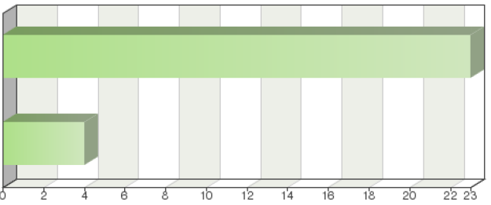

Frequency table
Choices | Absolute  frequency | Relative  frequency | Adjusted relative  frequency
Yes | 23 | 82.14% | 85.19%
No (please provide details) | 4 | 14.29% | 14.81%
Sum: | 27 | 96.43% | 100%
Not answered: | 1 | 3.57% | -
Total answered: 27

No (details)

Must update in certain crops

List should be updated with data from 2015 and 2016

Comments

We are members of EU, and under CPVO cooperation.

In specific cases we use DUS reports from additional authorities/for other crops. Information on Exchange on a Routine Basis is complete.

Checked at least annually.

There is a lot of information in the data base that should be updated. Will be updated in the next questionnaire.

In cases where the CPVO does not find an authority willing /able to conduct a DUS test on behalf of the CPVO, the look into the GENIE DB helps to see where experience exist and whom to contact

Since we do not conduct DUS tests, we cannot confirm whether or not the GENIE database is full and accurate.

Changes and updates sent, if at all possible, to the UPOV office in 2016

The technicians of the Institute must have knowledge of the database

Question 11:
Are there any practical measures that might facilitate the use of existing DUS reports by your authority?

No
Yes (please provide details)
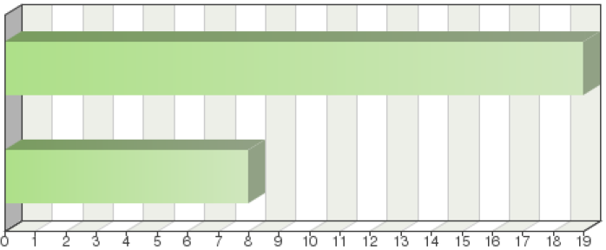

Frequency table
Choices | Absolute  frequency | Relative  frequency | Adjusted relative  frequency
No | 19 | 67.86% | 70.37%
Yes (please provide details) | 8 | 28.57% | 29.63%
Sum: | 27 | 96.43% | 100%
Not answered: | 1 | 3.57% | -
Total answered: 27

Yes (details)

Possibility of purchasing existing DU test reports

Existing DUS reports should provide most of the data needed in the U.S. exhibit C crop form

Comments

We in general accept DUS test reports from respected authorities such as Naktuinbouw and GEVES or accredited to CPVO without require further information.

The availability of information in the report regarding similar varieties and reference/example varieties used in the trial would be helpful. Often this section of the report is blank.

Since the CPVO uses DUS reports from entrusted examination offices only (with very few exceptions), with which designation agreements are signed stipulating the cooperation and procedures, any practical measure facilitating that exchange would be subject of said agreement.

The system currently used in the EU is satisfactory. If the same system is developed outside the EU, there are always geographical considerations to take into account, and for the reference collection.

Our office conducts searches, such that it is possible to find a competent authority specialized in a specific species.

CPVO Entrustment

It must have a database where the different tests performed are registered.

A bilateral agreement is not necessary. Sometimes we work with a memorandum of understanding. Better knowledge regarding the variety collection and Guidelines used by the providing authority would be useful.

Question 12:
Situation: No other UPOV member has an existing DUS report for a variety which is the subject of an application with your authority, but your authority is aware of an application for the same variety with another UPOV member for which a DUS examination has, is being, or will be organized: In the situation above, to avoid the need for a DUS examination by your authority and if requested by the applicant, would your authority request the other UPOV member to provide the DUS report at the end of the DUS examination?

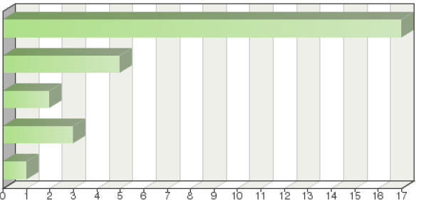
Same answer as for Question 8
Yes, always
For selected UPOV members, for any crop/species
For selected UPOV members, for selected crops/species
No. My authority requires the applicant to provide all necessary information

Frequency table
Choices | Absolute  frequency | Relative  frequency | Adjusted relative  frequency
Same answer as for Question 8 | 17 | 60.71% | 60.71%
Yes, always | 5 | 17.86% | 17.86%
For selected UPOV members, for any crop/species | 2 | 7.14% | 7.14%
For selected UPOV members, for selected crops/species | 3 | 10.71% | 10.71%
No. My authority requires the applicant to provide all necessary information | 1 | 3.57% | 3.57%
Sum: | 28 | 100% | 100%
Not answered: | 0 | 0% | -
Total answered: 28

Comments

If DUS examination is being, or will be organized my authority conducts its own DUS examinations for species including in mentioned above Ministry Regulation List. For other species not included in Ministry Regulation List my authority requires the applicant to provide contacts of responsible UPOV member authority that is being, or wiII organize DU s trials.

Please see explanation on entrustment given above

The DUS report from the UPOV member would be supplementary information in support of the applicant's information. We would request the applicant to obtain and provide that information.

If the applicant applies for PBR for the first time in Kenya and we have no technical capacity to carry out the DUS test then we Kenya will take over the test report from the authority of a UPOV member state where the DUS was or is being done or is planned to be done.

The Office can do it on request; it purchases from members specialized in DUS testing and the applicant must pay the costs for the purchase of the test.

Question 13:
If your authority requests DUS reports in the situation described in Question 12, which of the following criteria must normally be met?
(more than one box can be ticked):
Same answer as for Question 9 | 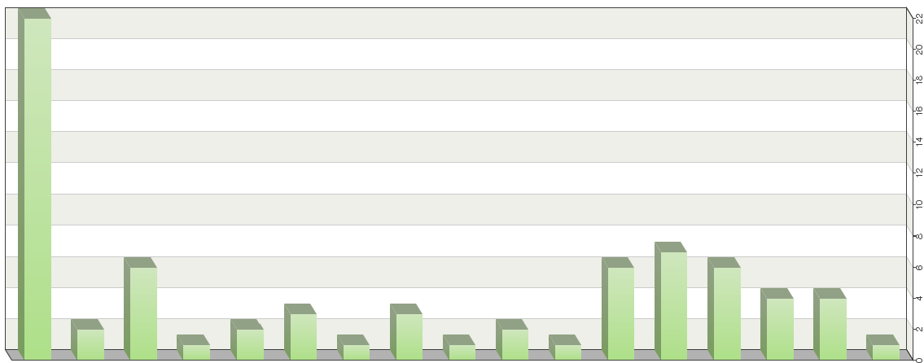
There are no particular criteria
UPOV Test Guidelines must be the basis for the DUS examination
There is a written agreement (2) with the providing authority
The providing authority must have a quality assurance scheme that is recognized by your authority
The DUS trial must be located in a particular region
Your authority must have a detailed knowledge of the DUS trial arrangements of the providing authority
Your authority must have the possibility to visit the trial site
The DUS trial must be grown under certain conditions (e.g. in a greenhouse)
Your authority must have a detailed knowledge of the variety collection used by the providing authority
There must be a common database of varieties of common knowledge
There must be no cost to your authority (3) (either the providing authority makes no charge, or the applicant pays the charge)
The providing authority must provide interim reports
The providing authority must commit itself to complete the DUS examination and provide the DUS report even if the application with the providing authority is discontinued before the DUS examination was completed
Your authority must have the ownership of the DUS report and variety description
The providing authority must agree to perform further trials if required in connection with the application concerned
Other

Frequency table
Choices | Absolute  frequency | Relative  frequency  by choice | Relative  frequency | Adjusted relative  frequency
Same answer as for Question 9 | 22 | 30.56% | 78.57% | 78.57%
There are no particular criteria | 2 | 2.78% | 7.14% | 7.14%
UPOV Test Guidelines must be the basis for the DUS examination | 6 | 8.33% | 21.43% | 21.43%
There is a written agreement (2) with the providing authority | 1 | 1.39% | 3.57% | 3.57%
The providing authority must have a quality assurance scheme that is recognized by your authority | 2 | 2.78% | 7.14% | 7.14%
The DUS trial must be located in a particular region | 3 | 4.17% | 10.71% | 10.71%
Your authority must have a detailed knowledge of the DUS trial arrangements of the providing authority | 1 | 1.39% | 3.57% | 3.57%
Your authority must have the possibility to visit the trial site | 3 | 4.17% | 10.71% | 10.71%
The DUS trial must be grown under certain conditions (e.g. in a greenhouse) | 1 | 1.39% | 3.57% | 3.57%
Your authority must have a detailed knowledge of the variety collection used by the providing authority | 2 | 2.78% | 7.14% | 7.14%
There must be a common database of varieties of common knowledge | 1 | 1.39% | 3.57% | 3.57%
There must be no cost to your authority (3) (either the providing authority makes no charge, or the applicant pays the charge) | 6 | 8.33% | 21.43% | 21.43%
The providing authority must provide interim reports | 7 | 9.72% | 25% | 25%
The providing authority must commit itself to complete the DUS examination and provide the DUS report even if the application with the providing authority is discontinued before the DUS examination was completed | 6 | 8.33% | 21.43% | 21.43%
Your authority must have the ownership of the DUS report and variety description | 4 | 5.56% | 14.29% | 14.29%
The providing authority must agree to perform further trials if required in connection with the application concerned | 4 | 5.56% | 14.29% | 14.29%
Other: | 1 | 1.39% | 3.57% | 3.57%
Sum: | 72 | 100% | - | -
Not answered: |  | - | 0% | -
Total answered: 28

Comments

Comments are the same as for question 12

The providing authority must provide interim report only in case of some DUS problem in previous years. The providing authority must commit itself to complete the DUS examination and provide the DUS report even if the application with the providing authority is discontinued before the DUS examination was completed - only on the additional request of the requesting (my) authority.

If a DUS test triggered on a national procedure is stopped, the agreement with the authority is that it informs the CPVO and the DUS test is continued on behalf of the CPVO by that same authority.

Question 14:
Situation: No other UPOV member has an existing DUS report for a variety which is the subject of an application with your authority and there is no application with another UPOV member. In the situation above, would your authority request another UPOV member to conduct the DUS examination on its behalf?

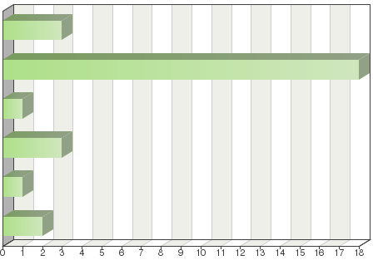
Yes, always
Yes, if my authority does not have the necessary expertise or conditions for conducting the DUS examination
No. My authority always conducts its own DUS examinations for all applications
No. My authority requires the applicant to provide all necessary information
No. The applicant must conduct the DUS examination in the territory of my authority
Other

Frequency table

Choices | Absolute  frequency | Relative  frequency | Adjusted relative  frequency
Yes, always | 3 | 10.71% |  | 10.71%
Yes, if my authority does not have the necessary expertise or conditions for conducting the DUS examination | 18 | 64.29% |  | 64.29%
No. My authority always conducts its own DUS examinations for all applications | 1 | 3.57% |  | 3.57%
No. My authority requires the applicant to provide all necessary information | 3 | 10.71% |  | 10.71%
No. The applicant must conduct the DUS examination in the territory of my authority | 1 | 3.57% |  | 3.57%
Other: | 2 | 7.14% |  | 7.14%
Sum: | 28 | 100% |  | 100%
Not answered: | 0 | 0% |  | -
Total answered: 28

Comments

No. For species and genera under Regulation Ministry List my authority carries DUS trials itself. And for other species and genera out of List, we ask the Applicant to provide all necessary information.

Would be considered but nationally we have no authority to compel a national breeder to send his material off shore for testing. lf the breeder already has material in that territory this would increase the possibility.

The CPVO sends a request to an entrusted authority for the species in question requesting to conduct the DU s test on behalf of the CPVO.

And if there is an existing bilateral agreement

The breeder is also allowed to perform DUS for himself if there is no country willing to do so or a qualified national or foreign institution.

Question 15:
If your authority requests another UPOV member to conduct a DUS examination on its behalf in the situation described in Question 14, which of the following criteria must normally be met?
(more than one box can be ticked):

Same answer as for Question 13 | 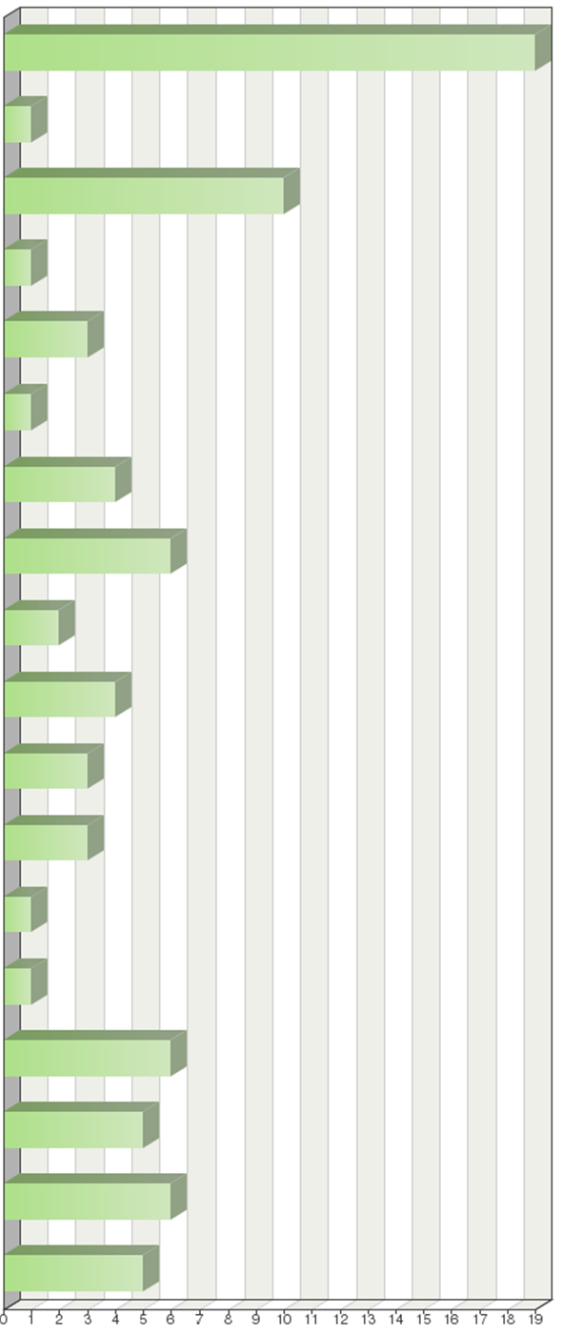
There are no particular criteria
UPOV Test Guidelines must be the basis for the DUS examination
The providing authority must use most of the characteristics that are
examined by your authority
There is a written agreement (2) with the providing authority
The providing authority must not use a “breeder-testing” system
The providing authority must have a quality assurance scheme that is recognized by your authority
The DUS trial must be located in a particular region
Your authority must have a detailed knowledge of the DUS trial arrangements of the providing authority
Your authority must have the possibility to visit the trial site
The DUS trial must be grown under certain conditions (e.g. in a greenhouse)
Your authority must have a detailed knowledge of the variety collection used by the providing authority
There must be a common database of varieties of common knowledge
There must be sufficient breeding activity in the UPOV member providing the DUS report
There must be no cost to your authority (3) (either the providing authority makes no charge, or the applicant pays the charge)
The providing authority must provide interim reports
Your authority must have the ownership of the DUS report and variety description
The providing authority must agree to perform further trials if required in connection with the application concerned

Frequency table
Choices | Absolute  frequency | Relative  frequency  by choice | Relative  frequency | Adjusted relative  frequency
Same answer as for Question 13 | 19 | 23.46% | 67.86% | 67.86%
There are no particular criteria | 1 | 1.23% | 3.57% | 3.57%
UPOV Test Guidelines must be the basis for the DUS examination | 10 | 12.35% | 35.71% | 35.71%
The providing authority must use most of the characteristics that are  examined by your authority | 1 | 1.23% | 3.57% | 3.57%
There is a written agreement (2) with the providing authority | 3 | 3.7% | 10.71% | 10.71%
The providing authority must not use a “breeder-testing” system | 1 | 1.23% | 3.57% | 3.57%
The providing authority must have a quality assurance scheme that is recognized by your authority | 4 | 4.94% | 14.29% | 14.29%
The DUS trial must be located in a particular region | 6 | 7.41% | 21.43% | 21.43%
Your authority must have a detailed knowledge of the DUS trial arrangements of the providing authority | 2 | 2.47% | 7.14% | 7.14%
Your authority must have the possibility to visit the trial site | 4 | 4.94% | 14.29% | 14.29%
The DUS trial must be grown under certain conditions (e.g. in a greenhouse) | 3 | 3.7% | 10.71% | 10.71%
Your authority must have a detailed knowledge of the variety collection used by the providing authority | 3 | 3.7% | 10.71% | 10.71%
There must be a common database of varieties of common knowledge | 1 | 1.23% | 3.57% | 3.57%
There must be sufficient breeding activity in the UPOV member providing the DUS report | 1 | 1.23% | 3.57% | 3.57%
There must be no cost to your authority (3) (either the providing authority makes no charge, or the applicant pays the charge) | 6 | 7.41% | 21.43% | 21.43%
The providing authority must provide interim reports | 5 | 6.17% | 17.86% | 17.86%
Your authority must have the ownership of the DUS report and variety description | 6 | 7.41% | 21.43% | 21.43%
The providing authority must agree to perform further trials if required in connection with the application concerned | 5 | 6.17% | 17.86% | 17.86%
Sum: | 81 | 100% | - | -
Not answered: | 0 | - | 0% | -
Total answered: 28

Comments

Comments are the same as for question 14

A factor in foreign testing is the security of the breeder's plant material in the off shore territory. If the breeder has no intention of protecting in that territory, the breeder may not be happy about sending the material and PVRO may have no legal authority to require the breeder to do so.

The DUS test must be conducted on the basis of a CPVO Technical Protocol, if it does not exist, on the basis of the UPOV­ TG but observing ALL characteristics (not only* as a minimum), if no UPOV-TG exists, on the basis of a national TP agreed with CPVO.

Question 16:
Is the information in the GENIE database on requests for DUS examinations by your authority complete and accurate?
(see http://www.upov.int/genie/en/index.jsp)

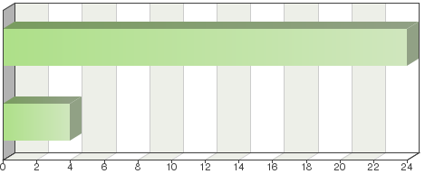

Yes
No (please provide details)

Frequency table
Choices | Absolute  frequency | Relative  frequency | Adjusted relative  frequency
Yes | 24 | 85.71% | 85.71%
No (please provide details) | 4 | 14.29% | 14.29%
Sum: | 28 | 100% | 100%
Not answered: | 0 | 0% | -
Total answered: 28

No (details)

Must update in certain crops

See answer Q 10

List should be updated with data from 2015 and 2016

Comments

There is one incorrect piece of information that will be corrected in next questionnaire.

We only use GENlE in case we have no DUS capacities for the species in question in the EU and in case no earlier technical examination has been carried out for the variety in question. In such cases, the information is accurate.

Question 17:
Will your authority accept a DUS report of another UPOV member via the applicant (assuming that it is acceptable in all other respects)?

Yes
No
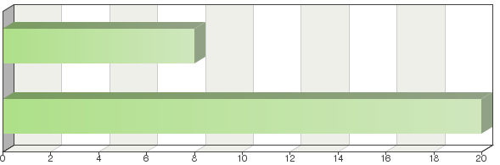

Frequency table
Choices | Absolute  frequency | Relative  frequency | Adjusted relative  frequency
Yes | 8 | 28.57% | 28.57%
No | 20 | 71.43% | 71.43%
Sum: | 28 | 100% | 100%
Not answered: | 0 | 0% | -
Total answered: 28

Comments

Our authority prefers to get DUS report directly from the relevant authorities so as to prevent and infringements or fake documentations

No, we request a copy of the DUS-report from the authority that conducted the DUS-test

Our authority requests DUS-reports directly from UPOV member authority that is responsible for DUS trials.

In our view the cooperation is an inter authority relationship, not with the breeder.

The report will be ordered from the DUS examination office.

The CPVO exchanges DUS reports only between authorities

The breeder is not allowed to perform the DUS test.

If the original DUS report and variety description is attached

Providing it is from a CPVO entrusted office.

It is the Kenyan Authority that writes Ill an authority (Selected) that is a UPOV member requesting for the test reports

Experience suggests that information is more reliable when communication is established between authorities

Question 18:
If your authority accepts a DUS report from another UPOV member, how is the fee paid?

Your authority pays the fee to the other UPOV member
Your authority requires the applicant to pay the fee to the other UPOV member
Other
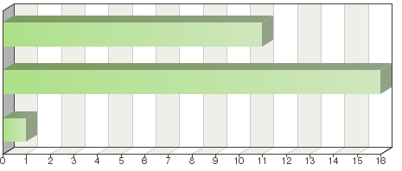

Frequency table
Choices | Absolute  frequency | Relative  frequency | Adjusted relative  frequency
Your authority pays the fee to the other UPOV member | 11 | 39.29% | 39.29%
Your authority requires the applicant to pay the fee to the other UPOV member | 16 | 57.14% | 57.14%
Other: | 1 | 3.57% | 3.57%
Sum: | 28 | 100% | 100%
Not answered: | 0 | 0% | -
Total answered: 28

Other (details)

(Not used)

Comments

The applicant must pay us for the cost we have.

My authority requires the applicant to pay the fee Ill the other UPOV member unless is treated by other way in an administrative agreement.

The first option is the standard situation. The second option is applied for specific situations; e.g. the acquiring authority is on another continent

Question 19:
Are there any practical measures that might facilitate requests for DUS examinations by your authority from other UPOV members?

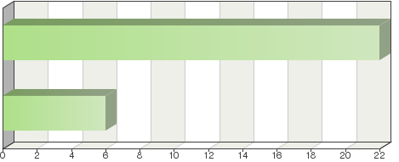
No
Yes (please provide details)

Frequency table
Choices | Absolute  frequency | Relative  frequency | Adjusted relative  frequency
No | 22 | 78.57% | 78.57%
Yes (please provide details) | 6 | 21.43% | 21.43%
Sum: | 28 | 100% | 100%
Not answered: | 0 | 0% | -
Total answered: 28

Yes (details)

The possibility of buying the test report for a flat fee

Comments

The current UPOV modeI report request form is ok

Our office requests tests from the respective competent authorities according to the experience of each country with a given species. In addition, as a practical measure, it is suggested that a database be established in all UPOV member countries, to provide each country with information on tests already performed.

Only if it is from a CPVO Entrusted Office.

Existing procedures are easy to comply with and shipping routes are appropriate and efficient.

If no bilateral agreement, we prefer to work with a memo of understanding. But (also) that is not an obligation.

Question 20:
Please describe the provision of existing DUS reports by your authority to other UPOV members:

My authority will provide existing DUS reports to any UPOV member, for any crop/species
My authority will provide existing DUS reports to any UPOV member, for selected crops/species
My authority does not provide existing DUS reports to other UPOV members
Other
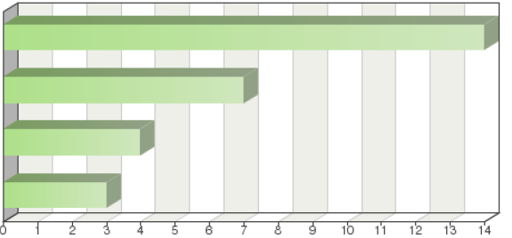

Frequency table
Choices | Absolute  frequency | Relative  frequency | Adjusted relative  frequency
My authority will provide existing DUS reports to any UPOV member, for any crop/species | 14 | 50% | 50%
My authority will provide existing DUS reports to any UPOV member, for selected crops/species | 7 | 25% | 25%
My authority does not provide existing DUS reports to other UPOV members | 4 | 14.29% | 14.29%
Other: | 3 | 10.71% | 10.71%
Sum: | 28 | 100% | 100%
Not answered: | 0 | 0% | -
Total answered: 28

Other (details)

Does not perform DUS.

Comments

We provide existing DUS reports as long as somebody pays.

It is the responsibility of the receiving authority to decide if our testing conditions are appropriate for their requirements.

Selected crops are the ones mentioned in Regulation Ministry List mentioned above

The CPVO provides TE reports to any requesting national PBR authority (even not UPOV member)

My service does not conduct research, but works with recognized research centers.

Our country is beginning to conduct DUS testing, so it has not yet offered any DUS testing to another UPOV member office.

Our authority does not carry out DUS examination since 2012

UK is a CPVO Entrusted Office.

My authority can only provide DUS test reports under request to other UPOV member states of crops species that we have capacity and technical knowledge to carry out the DUS examination

The authority of my country requires applicants to provide DUS reports as the ownership of such reports limits their supply to other authorities.

Our authority does not perform DUS testing and so they cannot to provide to anyone

The office is willing to provide the DUS report if so requested by a member country for the crops on which the test was performed

Until now no DUS Report was requested

Question 21:
If your authority provides existing DUS reports, which of the following criteria are used in deciding whether to provide existing DUS reports?
(more than one box can be ticked):

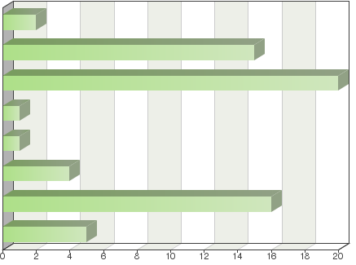
There are no particular criteria
Your authority retains ownership of the DUS report and variety description
The authority of the other UPOV member must make the request to your authority
There is a written agreement with the receiving authority
The receiving UPOV member must be in a particular region
There is an established custom and practice of providing DUS reports over many years
There must be payment of a fee for providing the DUS report
Other

Frequency table
Choices | Absolute  frequency | Relative  frequency  by choice | Relative  frequency | Adjusted relative  frequency
There are no particular criteria | 2 | 3.12% | 7.14% | 7.14%
Your authority retains ownership of the DUS report and variety description | 15 | 23.44% | 53.57% | 53.57%
The authority of the other UPOV member must make the request to your authority | 20 | 31.25% | 71.43% | 71.43%
There is a written agreement with the receiving authority | 1 | 1.56% | 3.57% | 3.57%
The receiving UPOV member must be in a particular region | 1 | 1.56% | 3.57% | 3.57%
There is an established custom and practice of providing DUS reports over many years | 4 | 6.25% | 14.29% | 14.29%
There must be payment of a fee for providing the DUS report | 16 | 25% | 57.14% | 57.14%
Other: | 5 | 7.81% | 17.86% | 17.86%
Sum: | 64 | 100% | - | -
Not answered: | 0 | - | 0% | -
Total answered: 28

Other (details)

OAPI is not a research center.

It does not provide DUS reports

It does not perform DUS

(Not applicable)

Comments

See also remark on Q 20

A written agreement with the receiving authority is preferable.

Our country has not yet provided a DUS test. However, it is important to maintain cooperation on testing for reports that our country might produce in future.

The authority of my country requires applicants to provide DUS reports as the ownership of such reports limits their supply to other authorities.

Question 22:
Is the information in the GENIE database on provision of existing DUS reports by your authority complete and accurate?
(see http://www.upov.int/genie/en/index.jsp)

Yes
No (please provide details)

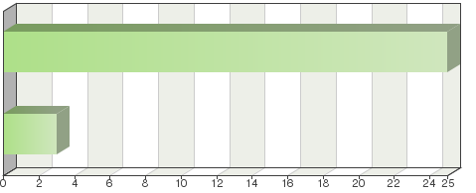

Frequency table
Choices | Absolute  frequency | Relative  frequency | Adjusted relative  frequency
Yes | 25 | 89.29% | 89.29%
No (please provide details) | 3 | 10.71% | 10.71%
Sum: | 28 | 100% | 100%
Not answered: | 0 | 0% | -
Total answered: 28

No (details)

Must update for certain crops

List should be updated with data from 2015 and 2016

Comments

There is a lot of information in the data base that should be updated. Will be updated in the next questionnaire.

We provide to UPOV the whole list of species we have in contracts with examination offices although for some of these species, we may not have received any application

Question 23:
Are there any practical measures that might facilitate provision of existing DUS reports by your authority?

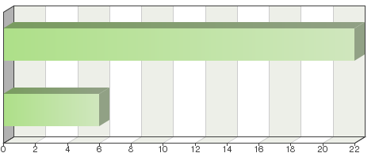
No
Yes (please provide details)

Frequency table
Choices | Absolute  frequency | Relative  frequency | Adjusted relative  frequency
No | 22 | 78.57% | 78.57%
Yes (please provide details) | 6 | 21.43% | 21.43%
Sum: | 28 | 100% | 100%
Not answered: | 0 | 0% | -
Total answered: 28

Yes (details)

The possibility of purchasing DUS test reports.

Comments

Ensure that the request is from the authority and adequate information (the UPOV request model form) is supplied

Does not perform DUS

A bilateral agreement is not necessary; sometimes there is a memo of understanding

Question 24:
Situation: A DUS report has not yet been produced by your authority for a variety which is the subject of an application with your authority; however, your authority is conducting, or is going to conduct, a DUS examination. In the situation above, would your authority agree, in advance, to provide the DUS report to another UPOV member at the end of the DUS examination?

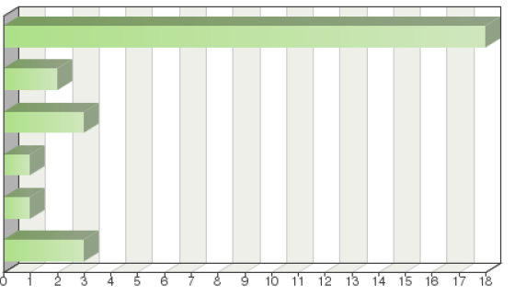
Same as for Question 20
Yes, always
For any UPOV member, for selected crops
For selected UPOV members, for any crop/species
No
Other

Frequency table
Choices | Absolute  frequency | Relative  frequency | Adjusted relative  frequency
Same as for Question 20 | 18 | 64.29% | 64.29%
Yes, always | 2 | 7.14% | 7.14%
For any UPOV member, for selected crops | 3 | 10.71% | 10.71%
For selected UPOV members, for any crop/species | 1 | 3.57% | 3.57%
No | 1 | 3.57% | 3.57%
Other: | 3 | 10.71% | 10.71%
Sum: | 28 | 100% | 100%
Not answered: | 0 | 0% | -
Total answered: 28

Other (details)

OAPI is not a research center.

Our authority does not carry out DUS examination since 2012

Does not perform DUS

Comments

We do not perform DUS-examination for any species any more.

Comments are the same as for question 20

We agree, in advance, to provide the DUS report to another UPOV member at the end of the DUS examination only in case when the DUS examination has already started.

For any crop for which the DUS test has been conducted by an entrusted authority

Our authority does not carry out DUS examination since 2012

Only with a CPVO entrusted office.

Question 25:
If your authority provides DUS examination reports in the situation described in Question 24, which of the following criteria must normally be met?
(more than one box can be ticked):
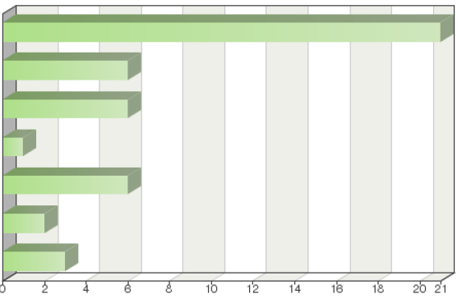
Same as for Question 21

Your authority retains ownership of the DUS report and variety description
The authority of the other UPOV member must make the request to your authority
There is an established custom and practice of providing DUS reports over many years
There must be payment of a fee for providing the DUS report
A fee must be paid for the cost of the DUS examination
Other

Frequency table
Choices | Absolute  frequency | Relative  frequency  by choice | Relative  frequency | Adjusted relative  frequency
Same as for Question 21 | 21 | 46.67% | 75% | 75%
Your authority retains ownership of the DUS report and variety description | 6 | 13.33% | 21.43% | 21.43%
The authority of the other UPOV member must make the request to your authority | 6 | 13.33% | 21.43% | 21.43%
There is an established custom and practice of providing DUS reports over many years | 1 | 2.22% | 3.57% | 3.57%
There must be payment of a fee for providing the DUS report | 6 | 13.33% | 21.43% | 21.43%
A fee must be paid for the cost of the DUS examination | 2 | 4.44% | 7.14% | 7.14%
Other: | 3 | 6.67% | 10.71% | 10.71%
Sum: | 45 | 100% | - | -
Not answered: | 0 | - | 0% | -
Total answered: 28

Other (details)

Our authority does not carry out DUS examination since 2012

Does not perform DUS

Comments

See question 24
The breeder pays for the examination
Comments are the same as for question 24
Our authority does not carry out DUS examination since 2012
Only with a CPVO entrusted office
Question 26:
In the situation in Question 24, would your authority agree, in advance, to complete a DUS examination and provide a DUS report to another UPOV member, even if the application was discontinued in your territory before the DUS examination was completed?

Same as for Question 20

Yes, always
For any UPOV member, for selected crops
For selected UPOV members, for selected crops/species
No
Other
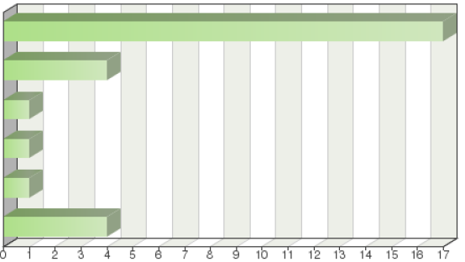

Frequency table
Choices | Absolute  frequency | Relative  frequency | Adjusted relative  frequency
Same as for Question 20 | 17 | 60.71% | 60.71%
Yes, always | 4 | 14.29% | 14.29%
For any UPOV member, for selected crops | 1 | 3.57% | 3.57%
For selected UPOV members, for selected crops/species | 1 | 3.57% | 3.57%
No | 1 | 3.57% | 3.57%
Other: | 4 | 14.29% | 14.29%
Sum: | 28 | 100% | 100%
Not answered: | 0 | 0% | -
Total answered: 28

Other (details)

Our authority does not carry out DUS examination since 2012

Does not perform DUS

Comments

See question 24

If the breeder withdraws the examination, no DUS report will be written.

My authority continues in the DUS examination only on the basis of additional request of the requesting authority.

This is very theoretical and needs to be discussed: Only for entrusted authorities where the DUS test would need to be continued based on a national procedure and on their request.

Our authority does not carry out DUS examination since 2012

Question 27:
If your authority provides DUS examination reports in the situation described in Question 26, which of the following criteria must normally be met?
(more than one box can be ticked):

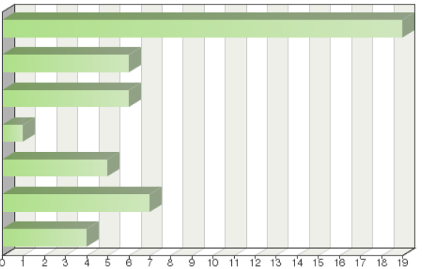
Same as for Question 21
Your authority retains ownership of the DUS report and variety description
The authority of the other UPOV member must make the request to your authority
There is a written agreement with the receiving authority
There must be payment of a fee for providing the DUS report
A fee must be paid for the cost of the DUS examination
Other

Frequency table
Choices | Absolute  frequency | Relative  frequency  by choice |  | Relative  frequency | Adjusted relative  frequency
Same as for Question 21 | 19 | 39.58% | 67.86% |  | 67.86%
Your authority retains ownership of the DUS report and variety description | 6 | 12.5% | 21.43% |  | 21.43%
The authority of the other UPOV member must make the request to your authority | 6 | 12.5% | 21.43% |  | 21.43%
There is a written agreement with the receiving authority | 1 | 2.08% | 3.57% |  | 3.57%
There must be payment of a fee for providing the DUS report | 5 | 10.42% | 17.86% |  | 17.86%
A fee must be paid for the cost of the DUS examination | 7 | 14.58% | 25% |  | 25%
Other: | 4 | 8.33% | 14.29% |  | 14.29%
Sum: | 48 | 100% | - |  | -
Not answered: | 0 | - | 0% |  | -
Total answered: 28

Other (details)

Our authority does not carry out DUS examination since 2012

Does not do DUS

Comments

See question 24
The DUS will be withdrawn.
Comments are the same as for question 20
As above, rather theoretical
Our authority does not carry out DUS examination since 2012
Question 28:
If your authority has not received an application for a variety concerned but your authority has the necessary expertise and conditions for conducting the DUS examination, would your authority conduct a DUS examination on behalf of another UPOV member, if so requested?

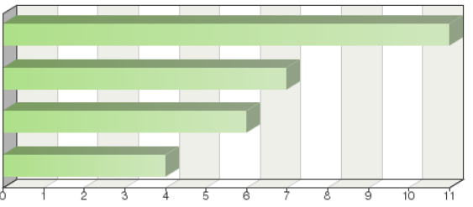
Same as for Question 20
For any UPOV member, for selected crops/species
No
Other

Frequency table
Choices | Absolute  frequency | Relative  frequency | Adjusted relative  frequency
Same as for Question 20 | 11 | 39.29% | 39.29%
For any UPOV member, for selected crops/species | 7 | 25% | 25%
No | 6 | 21.43% | 21.43%
Other: | 4 | 14.29% | 14.29%
Sum: | 28 | 100% | 100%
Not answered: | 0 | 0% | -
Total answered: 28

Other (details)

See comments

Does not perform DUS

Comments

We do not perform any DUS examinations for any species

We will perform the test on behalf of another authority if our variety collection and our growing conditions are suitable for the variety in question and if we have sufficient capacity to do the test.

Comments are the same as for question 20

Only for species for which the DUS test is set up regularly or for which we have received more requests for the DUS technical examination. We try to avoid the DUS examination with few number of candidate varieties which are not subject of our application.

Yes, but this would depend on whether plant material of the candidate is present in NZ. Importation of plant material can be very complex, lengthy and costly and PVRO has no role in importation policy or management.

In principle we conduct DUS examinations for all UPOV members for species we test, but only for varieties which are adapted to our growing conditions.

The CPVO would advise the requesting authority to contact directly one of its entrusted authorities and organize the DUS test bilaterally amongst them.

Currently, the authority of my country performs tests to obtain the DUS information for specific crops, to provide the to the Community Plant Variety Office.

We had to analyze the situation in detail

Question 29:
If your authority conducts DUS examinations on behalf of UPOV members for varieties for which it has not received an application, which of the following criteria must normally be met?
(more than one box can be ticked):
Same as for Question 21

There are no particular criteria
Your authority retains ownership of the DUS report and variety description
The authority of the other UPOV member must make the request to your authority
There is a written agreement with the receiving authority
There is an established custom and practice of providing DUS reports over
many years
There must be payment of a fee for providing the DUS report
A fee must be paid for the cost of the DUS examination
Other

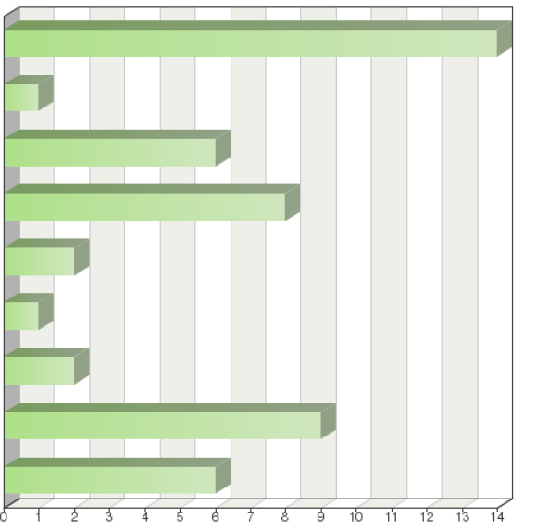

Frequency table
Choices | Absolute  frequency | Relative  frequency  by choice | Relative  frequency |  | Adjusted relative  frequency
Same as for Question 21 | 14 | 28.57% |  | 50% | 50%
There are no particular criteria | 1 | 2.04% |  | 3.57% | 3.57%
Your authority retains ownership of the DUS report and variety description | 6 | 12.24% |  | 21.43% | 21.43%
The authority of the other UPOV member must make the request to your authority | 8 | 16.33% |  | 28.57% | 28.57%
There is a written agreement with the receiving authority | 2 | 4.08% |  | 7.14% | 7.14%
There is an established custom and practice of providing DUS reports over many years | 1 | 2.04% |  | 3.57% | 3.57%
There must be payment of a fee for providing the DUS report | 2 | 4.08% |  | 7.14% | 7.14%
A fee must be paid for the cost of the DUS examination | 9 | 18.37% |  | 32.14% | 32.14%
Other: | 6 | 12.24% |  | 21.43% | 21.43%
Sum: | 49 | 100% |  | - | -
Not answered: | 0 | - |  | 0% | -
Total answered: 28

Other (details)

Not applicable

Our authority does not carry out DUS examination since 2012

Does not perform DUS

Comments

We do not perform any DUS examinations for any species

There has always been an application.

Comments are the same as for question 20

Dependent on national availability of plant material. Importation would lengthen considerable the testing time.

Our authority does not carry out DUS examination since 2012

Question 30:
Is the information in the GENIE database on conduct of DUS examinations and provision of DUS reports by your authority on behalf of other UPOV members complete and accurate?
(see http://www.upov.int/genie/en/index.jsp)

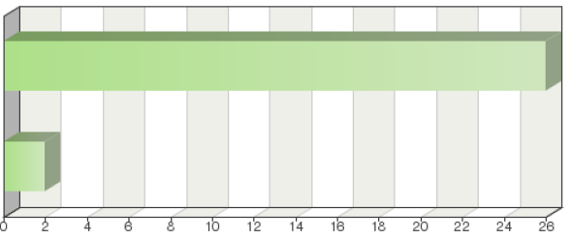

Yes
No (please provide details)

Frequency table
Choices | Absolute  frequency | Relative  frequency | Adjusted relative  frequency
Yes | 26 | 92.86% | 92.86%
No (please provide details) | 2 | 7.14% | 7.14%
Sum: | 28 | 100% | 100%
Not answered: | 0 | 0% | -
Total answered: 28

No (details)

Must update this section

Comments

There is one piece of information in the data base that should be updated. Will be updated in the next questionnaire.

Please see comment 28

Question 31:
Are there any practical measures that might facilitate the conduct of DUS examinations by your authority on behalf of other UPOV members?

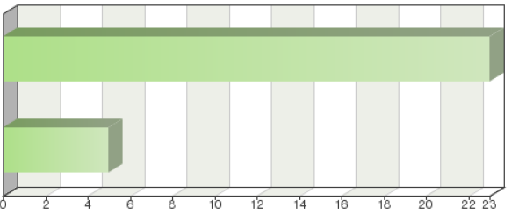

No
Yes (please provide details)

Frequency table
Choices | Absolute  frequency | Relative  frequency | Adjusted relative  frequency
No | 23 | 82.14% | 82.14%
Yes (please provide details) | 5 | 17.86% | 17.86%
Sum: | 28 | 100% | 100%
Not answered: | 0 | 0% | -
Total answered: 28

Comments

We only make DUS for sugar beets, inbreed lines (patent) and hybrids.

A bilateral is not obliged. Sometimes there is a memo of understanding

Question 32:
Please describe any restrictions on the use of DUS reports you provide to the authority of another UPOV member
(more than one box can be ticked):

There are no restrictions
The DUS report must only be used for the purpose of examination of an
application in the other authority
The DUS report and the variety description must not be published
The DUS report must not be published, but the variety description and other
information may be published
Other
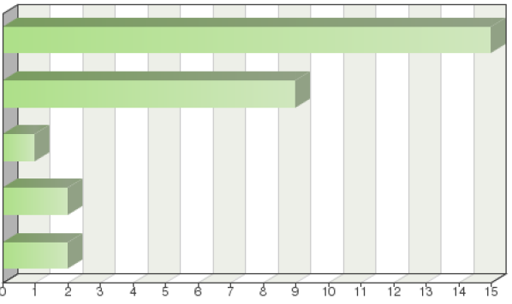

Frequency table
Choices | Absolute  frequency | Relative  frequency  by choice |  | Relative  frequency | Adjusted relative  frequency
There are no restrictions | 15 | 51.72% | 53.57% |  | 53.57%
The DUS report must only be used for the purpose of examination of an application in the other authority | 9 | 31.03% | 32.14% |  | 32.14%
The DUS report and the variety description must not be published | 1 | 3.45% | 3.57% |  | 3.57%
The DUS report must not be published, but the variety description and other information may be published | 2 | 6.9% | 7.14% |  | 7.14%
Other: | 2 | 6.9% | 7.14% |  | 7.14%
Sum: | 29 | 100% | - |  | -
Not answered: | 0 | - | 0% |  | -
Total answered: 28

Other (details)

OAPI does not provide DUS reports

Not applicable because we do not perform DUS

Question 33:
Will your authority provide the DUS report to the applicant for use in an application with another UPOV member?

Yes, with no conditions
Yes, with conditions (please provide details in comments box below)
No
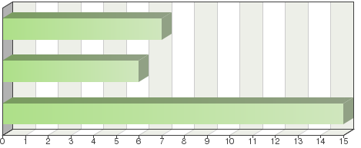

Frequency table
Choices | Absolute  frequency | Relative  frequency | Adjusted relative  frequency
Yes, with no conditions | 7 | 25% |  | 25%
Yes, with conditions (please provide details in comments box below) | 6 | 21.43% |  | 21.43%
No | 15 | 53.57% |  | 53.57%
Sum: | 28 | 100% |  | 100%
Not answered: | 0 | 0% |  | -
Total answered: 28

Comments

When an applicant needs DUS test results first of all he or she is required to submit an official petition to our authority for the request.

The request must come from another UPOV member or CPVO.

The applicant has to pay a fee.

My authority will provide DUS report to the Applicant if another UPOV Member authority will officially request my authority about it.

A variety description can be provided but not a DUS test report.

The CPVO would advise the applicant to ask the authority to directly contact the CPVO. The CPVO exchanges reports only with authorities.

My service must not agree to provide the DUS report to another applicant, because the second applicant can obtain one at the same cost from the research center that performed the test.

The DUS report must only be used for the purpose of examination of an application in the other authority

If it concerns existing DUS reports, they are owned by the breeders who file the application.

Will be sent from one authority to another free of charge only if the applicant or breeder has performed the DUS or paid for it to be performed.

Question 34:
If your authority provides a DUS report to another UPOV member, how is the fee paid to your authority?

There is no fee
Your authority requires the fee to be received from the other UPOV member
The fee can be received from the other UPOV member or from the applicant
Your authority requires the fee to be received from the applicant
Other
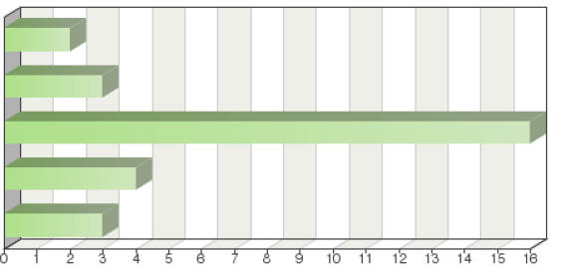

Frequency table
Choices | Absolute  frequency | Relative  frequency | Adjusted relative  frequency
There is no fee | 2 | 7.14% |  | 7.14%
Your authority requires the fee to be received from the other UPOV member | 3 | 10.71% |  | 10.71%
The fee can be received from the other UPOV member or from the applicant | 16 | 57.14% |  | 57.14%
Your authority requires the fee to be received from the applicant | 4 | 14.29% |  | 14.29%
Other: | 3 | 10.71% |  | 10.71%
Sum: | 28 | 100% |  | 100%
Not answered: | 0 | 0% |  | -
Total answered: 28

Other (details)

Our service does not provide DUS reports.
(Not applicable)

Comments

If the examination was performed by another UPOV member, a request is sent to the member who performed the examination. If the DUS was performed by the applicant, no fee is charged. The shipping costs are covered by the applicant.

In the case of the office the applicant pays the fee but the procedures are performed by the office for the member who performed and is selling the test.

Question 35:
How confident are you that you know all the options for cooperation between UPOV members in DUS examination?

Not at all confident
Fairly confident
Very confident
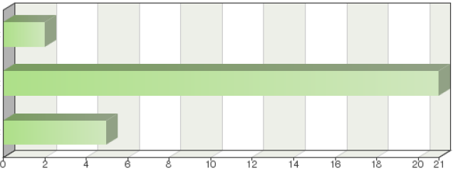

Frequency table
Choices | Absolute  frequency | Relative  frequency | Adjusted relative  frequency
Not at all confident | 2 | 7.14% |  | 7.14%
Fairly confident | 21 | 75% |  | 75%
Very confident | 5 | 17.86% |  | 17.86%
Sum: | 28 | 100% |  | 100%
Not answered: | 0 | 0% |  | -
Total answered: 28

Comments

Members who participate in the TC and TWPs, for the most part, effectively and informally exchange information and look at options for cooperation. TC, TWPs are key opportunities for cooperation.

Very confident for CPVO entrusted offices.

Question 36:
In your experience, how easy is it to arrange cooperation in DUS examination with other UPOV members?

Not at all easy
Fairly easy
Very easy
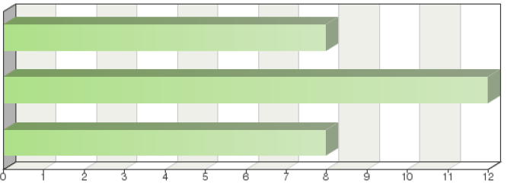

Frequency table
Choices | Absolute  frequency | Relative  frequency | Adjusted relative  frequency
Not at all easy | 8 | 28.57% |  | 28.57%
Fairly easy | 12 | 42.86% |  | 42.86%
Very easy | 8 | 28.57% |  | 28.57%
Sum: | 28 | 100% |  | 100%
Not answered: | 0 | 0% |  | -
Total answered: 28

Comments

Our authority accepts DUS-reports from any UPOV member authority without any problems. (If all previously mentioned requirements are met.)

This depends a little on the authority. Some are receptive while others are less so. Those that are not may have the impression that a formal arrangement or a two way arrangement is necessary. Language and easy communication can be an issue.

Yes, because we have not encountered major difficulties in obtaining DUS test reports from other UPOV members.

It depends on the country. There are experienced countries who know the system well and others that are new to cooperation, and yet others that do not cooperate at all.

Our experience is that - outside the EU - it is not that easy

[End of annex and of document]

