E
International Union for the Protection of New Varieties of Plants

Technical Committee  Fifty-Third Session  Geneva, April 3 to 5, 2017 | TC/53/16  Original: English  Date: February 9, 2017
Revision of document TGP/8: Part II: Selected Techniques Used in DUS Examination, Section 9: the Combined-Over-Years Uniformity Criterion (COYU)
Document prepared by the Office of the Union
Disclaimer: this document does not represent UPOV policies or guidance

EXECUTIVE SUMMARY

The purpose of this document is to report on developments concerning the method of calculation of the Combined-Over-Years Uniformity Criterion (COYU).

The TC is invited to note that:

(a) the Office of the Union issued UPOV Circular E-16/098 to invite UPOV members’ experts to provide to the United Kingdom, by May 27, 2016, data sets including at least 100 candidate varieties, with a possibility that data for those 100 varieties could be derived from several years;

(b) the TWC received a report by an expert of the United Kingdom that a data set on red fescue had been submitted by Slovakia and that Denmark had agreed to submit a data set on spring and winter canola later in 2016;

(c) the TWC received offers from China and France to submit data sets on maize and fescue, respectively;

(d) the TWC agreed to invite the expert from the United Kingdom to report on progress during the thirty-fifth session of the TWC;

(e) the TWO noted that COYU was not commonly used for DUS examination of ornamental plants;

(f) the TWV received offers by the experts from France and the United Kingdom to provide data on pea and field pea, respectively;

(g) the TWA received a report by the expert from Denmark that the software provided by the United Kingdom had been tested and that a data set on oilseed rape varieties would be provided to support the development of probability levels for the new method of calculation of COYU; and

(h) the expert from the United Kingdom had no new developments to report to the TC and would report on the progress of development of the new method of calculation of COYU to the TWC, at its thirty-fifth session.

The following abbreviations are used in this document:

TC: Technical Committee
TWA: Technical Working Party for Agricultural Crops
TWC: Technical Working Party on Automation and Computer Programs
TWF: Technical Working Party for Fruit Crops
TWO: Technical Working Party for Ornamental Plants and Forest Trees
TWPs: Technical Working Parties
TWV: Technical Working Party for Vegetables
The structure of this document is as follows:

EXECUTIVE SUMMARY 1
BACKGROUND 2
DEVELOPMENTS IN 2016 2
Technical Committee 2
Technical Working Parties 2

ANNEX: Combined Over-Years Uniformity (COYU) Criterion (English only)

BACKGROUND

The background to this matter is provided in document TC/52/17 “Revision of document TGP/8: Part II: Selected Techniques Used in DUS Examination, Section 9: The Combined-Over-Years Uniformity Criterion (COYU)”.

DEVELOPMENTS IN 2016

Technical Committee

The TC, at its fifty-second session, held in Geneva, from March 14 to 16, 2016, considered document TC/52/17 and received a presentation by an expert from the United Kingdom, a copy of which is provided in document TC/52/17 Add. (see document TC/52/29 Rev. “Revised Report”, paragraphs 105 to 110).

The TC noted that experts from Finland, France, Germany, Kenya and the United Kingdom had participated in the exercise to test the software module on the new method for calculation of COYU.

The TC noted that the TWC had agreed that the new method for calculation of COYU worked well in practice and had agreed to request the expert from the United Kingdom to provide guidance on extrapolation when the candidate had a level of expression outside that seen in the reference varieties.

The TC agreed to request members of the Union to provide larger data sets to the United Kingdom for developing probability levels for the new method that would match results obtained using the previous probability levels. Such data sets should include at least 100 candidate varieties, with a possibility that data for those 100 varieties could be derived from several years. The TC noted that the Office of the Union would issue a circular inviting contributions of data sets.

The TC noted that the TWC had agreed to invite experts from China and France to join in the next steps of the practical exercise and to provide their data sets for use in the testing.

The TC noted that the TWC had proposed to invite the TWA to provide large data sets from field crops in order to identify suitable probability levels on the new method for calculation of COYU.

Technical Working Parties

At their sessions in 2016, the TWC, TWO, TWV, TWA and TWF considered documents TWC/34/10, TWO/49/10, TWV/50/10, TWA/45/10 and TWF/47/10 “Revision of document TGP/8: Part II: Selected Techniques Used in DUS Examination, Section 9: The Combined-Over-Years Uniformity Criterion (COYU)”, respectively (see documents TWC/34/32 “Report”, paragraph 30, TWO/49/25 “Report”, paragraph 24, TWV/50/25 “Report”, paragraph 29, TWA/45/25 “Report”, paragraph 28 and TWF/47/25 “Report”, paragraph 29, respectively).

The TWC, TWO, TWV, TWA and TWF noted that the Office of the Union had issued UPOV Circular E-16/098 to invite UPOV members’ experts to provide to the United Kingdom, by May 27, 2016, data sets including at least 100 candidate varieties, with a possibility that data for those 100 varieties could be derived from several years (see documents TWC/34/32, paragraph 32, TWO/49/25, paragraph 26, TWV/50/25, paragraph 31, TWA/45/25, paragraph 30 and TWF/47/25, paragraph 31, respectively).

The TWC noted the report by an expert of the United Kingdom that a data set on red fescue had been submitted by Slovakia and that Denmark had agreed to submit a data set on spring and winter canola later in 2016 (see document TWC/34/32, paragraph 33).

The TWO, TWV, TWA and TWF noted the report by an expert of the United Kingdom on the results and further progress, including contribution of data sets, made at the thirty-fourth session of the TWC, reproduced in the Annex to this document (see documents TWO/49/25, paragraph 27, TWV/50/25, paragraph 32, TWA/45/25, paragraph 31 and TWF/47/25, paragraph 32, respectively).

The TWC welcomed the offers from China and France to submit data sets on maize and fescue, respectively. The TWC noted the invitation for submission of other data sets with 100 candidates from as many crops as possible for developing probability levels for the new method. The TWC agreed to invite the expert from the United Kingdom to report on progress during the thirty-fifth session of the TWC (see document TWC/34/32, paragraph 34).

The TWO noted that COYU was not commonly used for DUS examination of ornamental plants (see document TWO/49/25, paragraph 24).

The TWV noted the offer made from the expert from the expert of France and the United Kingdom to provide data on pea and field pea, respectively (see document TWV/50/25, paragraph 33).

The TWA noted the report from the expert from Denmark that the software provided by the United Kingdom had been tested and that a data set on oilseed rape varieties would be provided to support the development of probability levels for the new method of calculation of COYU (see document TWA/45/25, paragraph 32).

The expert from the United Kingdom informed the Office of the Union that further progress on the development of the new method was not expected before the fifty-third session of the TC and that further developments would be reported to the TWC, at its thirty-fifth session, to be held in Buenos Aires, on November 2017.

The TC is invited to note that:

(a) the Office of the Union issued UPOV Circular E-16/098 to invite UPOV members’ experts to provide to the United Kingdom, by May 27, 2016, data sets including at least 100 candidate varieties, with a possibility that data for those 100 varieties could be derived from several years;

(b) the TWC received a report by an expert of the United Kingdom that a data set on red fescue had been submitted by Slovakia and that Denmark had agreed to submit a data set on spring and winter canola later in 2016;

(c) the TWC received offers from China and France to submit data sets on maize and fescue, respectively;

(d) the TWC agreed to invite the expert from the United Kingdom to report on progress during the thirty-fifth session of the TWC;

(e) the TWO noted that COYU was not commonly used for DUS examination of ornamental plants;

(f) the TWV received offers by the experts from France and the United Kingdom to provide data on pea and field pea, respectively;

(g) the TWA received a report by the expert from Denmark that the software provided by the United Kingdom had been tested and that a data set on oilseed rape varieties would be provided to support the development of probability levels for the new method of calculation of COYU; and

(h) the expert from the United Kingdom had no new developments to report to the TC and would report on the progress of development of the new method of calculation of COYU to the TWC, at its thirty-fifth session.

[Annex follows]

COMBINED OVER-YEARS UNIFORMITY (COYU) CRITERION
(IN ENGLISH ONLY)

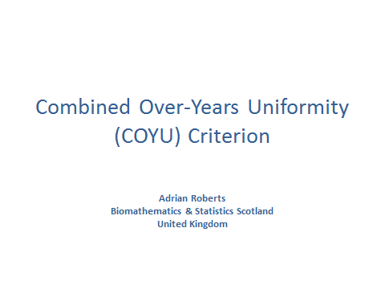

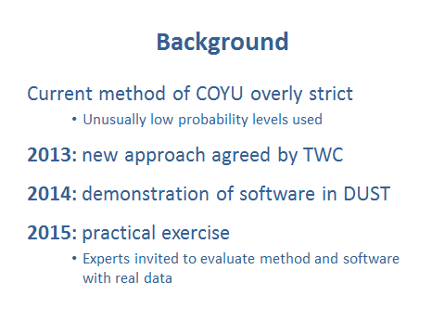

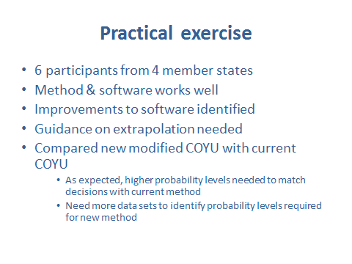

[End of Annex and of document]

