E
International Union for the Protection of New Varieties of Plants

Technical Committee  Fifty-Third Session  Geneva, April 3 to 5, 2017 | TC/53/13  Original: English  Date: March 14, 2017
Preparatory workshops
Document prepared by the Office of the Union
Disclaimer: this document does not represent UPOV policies or guidance

EXECUTIVE SUMMARY

The purpose of this document is to provide a report on the preparatory workshops held in 2016 and to present proposals for 2017.

The TC is invited to:

(a) note the report of the preparatory workshops held in 2016; and

(b) consider the proposed program for preparatory workshops for 2017, as set out in paragraphs 12 to 14 of this document.

The following abbreviations are used in this document:

TC: Technical Committee
TWA: Technical Working Party for Agricultural Crops
TWC: Technical Working Party on Automation and Computer Programs
TWF: Technical Working Party for Fruit Crops
TWO: Technical Working Party for Ornamental Plants and Forest Trees
TWV: Technical Working Party for Vegetables
BMT: Working Group on Biochemical and Molecular Techniques, and DNA-Profiling in Particular
TWP: Technical Working Party

BACKGROUND

At its thirty-eighth session, held in Geneva from April 15 to 17, 2002, the Technical Committee (TC) agreed, on the basis of document TC/38/12, to the holding of a preparatory workshop before each Technical Working Party (TWP) meeting, with the aim of helping some of the delegates to participate more actively at the meeting. At its fifty-second session, held in Geneva, from March 14 to 16, 2016, the TC noted the report of the preparatory workshops held in 2015. It approved the proposed program for 2016, as set out in document TC/52/13 (see document TC/52/29 Rev. “Revised Report”, paragraphs 185 to 188).

The structure of this document is as follows:

EXECUTIVE SUMMARY 1
BACKGROUND 1
Report on the Preparatory Workshops and associated activities held in 2016 2
Program for the Preparatory Workshops in 2017 4

Report on the Preparatory Workshops and associated activities held in 2016

In 2016, the preparatory workshops were held on the day preceding the first day of the TWP session and were organized in a similar way for the TWA, TWF, TWO, TWV, covering the following items:

- Introduction to UPOV and the role of UPOV Technical Working Parties (TWPs)
- Overview of the General Introduction (document TG/1/3 and TGP documents)
- Characteristics as the Basis for DUS Examination and Selection of Characteristics.
- Guidance on drafting Test Guidelines (document TGP/7)
- Subject of the Test Guidelines, Material Required and Method of Examination;
- Method of Observation (MS, MG, VS, VG);
- Types of Expression (QL, PQ, QN), notes and distinctness;
- Shape and Color Characteristics;
- Example Varieties;
- The process for developing UPOV Test Guidelines, including: TG Template; Additional Standard Wording; and Guidance Notes;
- Agenda for the TWP Session
- Feedback from participants

The preparatory workshop for the TWC covered the following items:

- Introduction to UPOV and the role of UPOV Technical Working Parties (TWPs)
- Overview of the General Introduction (document TG/1/3 and TGP documents)
- Overview of DUS examination and Test Guidelines
(a) Method of observation and type of record (MS, MG, VS, VG)
(b) Types of expression of characteristics (QL, PQ and QN) and types of scales of data
- The UPOV online resources
(a) Databases (UPOV Code, GENIE, PLUTO and UPOV Lex)
(b) Other resources (UPOV Electronic Application Form project, Test Guidelines Template)
- Agenda for the TWC session
- Feedback from participants

The preparatory Workshop for the BMT covered the following items:

- Introduction to UPOV
- Overview of the Technical Working Parties (TWPs)
- Guidance for DUS Examination
- Role of the TWPs and BMT
- Situation in UPOV Concerning the Possible Use of Molecular Techniques in the DUS Examination
- The Concept of Essentially Derived Varieties
- The Role of UPOV in Variety Identification
- The UPOV Website
- Agenda for the BMT Session

The preparatory workshops took the form of a half-day event.

The table below summarizes the participation in the preparatory workshops from 2003 to 2016. The participants include experts who made presentations at the preparatory workshop.

 | Participation
 | 2003 | 2004 | 2005 | 2006 | 2007 | 2008 | 2009 | 2010 | 2011 | 2012 | 2013 | 2014 | 2015 | 2016
Members of the Union  number of participants /  (number of members of the Union) | 55  (23) | 69  (20) | 130  (25) | 136  (19) | 167  (22) | 162  (31) | 95  (21) | 117  (25) | 115  (24) | 114  (26) | 125 (27) | 132  (26) | 103  (21) | 145  (30)
Observer States  number of participants /  (number of States) | 10  (9) | 2  (1) | 3  (3) | - | 3  (1) | 3  (2) | - | - | 15  (6) | 8  (4) | 12  (4) | 15  (5) | 24  (10) | -
Observer Organizations  number of participants /  (number of Organizations) | 3 | 2 | 5  (3) | 2  (2) | 4  (2) | 25  (2) | 3  (2) | 10  (2) | 5  (2) | 2  (2) | 4  (2) | 2  (2) | 3  (3) | 5  (3)

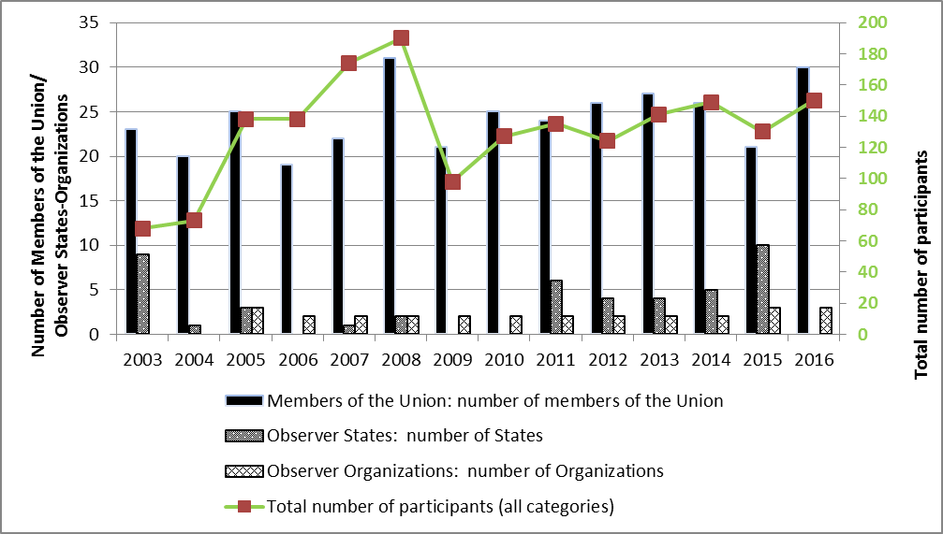

Graph 1: participation in the preparatory workshops from 2003 to 2016- total number of participants and Members of the Union compare to Observer States and Observer Organizations

With regard to the individual preparatory workshops held in 2016, the numbers of participants were as follows (including local participants):

TWA (Mexico): | 21
TWC (China): | 8
TWF (European Union): | 21
TWO (Republic of Korea): | 28
TWV (Czech Republic): | 19
BMT (Russian Federation): | 48

Program for the Preparatory Workshops in 2017

It is proposed to hold half-day preparatory workshops in association with the sessions of TWA, TWF, TWO and TWV in 2017, according to the following program:

- Introduction to UPOV and the role of UPOV Technical Working Parties (TWPs)
- Overview of the General Introduction (document TG/1/3 and TGP documents)
- Characteristics as the Basis for DUS Examination and Selection of Characteristics.
- Guidance on drafting Test Guidelines (document TGP/7)
- Subject of the Test Guidelines, Material Required and Method of Examination;
- Method of Observation (MS, MG, VS, VG);
- Types of Expression (QL, PQ, QN), notes and distinctness;
- Shape and Color Characteristics;
- Example Varieties;
- The process for developing UPOV Test Guidelines, including: Web-based TG Template; Additional Standard Wording; and Guidance Notes;
- Agenda for the TWP Session
- Feedback from participants

It is proposed to hold a half-day preparatory workshop in association with the 2017 session of the TWC, according to the following program:

- Introduction to UPOV and the role of UPOV Technical Working Parties (TWPs);
- Overview of the General Introduction (document TG/1/3 and TGP documents)
- Overview of DUS trials and Test Guidelines;
    - Method of Observation and type of record (MS, MG, VS, VG);
    - Types of Expression of Characteristics (QL, PQ and QN) and Types of Scales of Data;
- UPOV online resources
    - Databases (UPOV Code, GENIE, PLUTO and UPOV Lex)
    - Other resources (UPOV Electronic Application Form project, Web-based Test Guidelines Template)
- Agenda for the TWC Session
- Feedback from participants

It is proposed to hold a half-day preparatory Workshop in association with the 2017 session of the BMT, according to the following program:

- Introduction to UPOV
- Overview of the Technical Working Parties (TWPs)
- Guidance for DUS Examination
- Role of the TWPs and BMT
- Situation in UPOV Concerning the Possible Use of Molecular Techniques in the DUS Examination
- The Concept of Essentially Derived Varieties
- The Role of UPOV in Variety Identification
- The UPOV Website
- Agenda for the BMT Session

The TC is invited to:

- note the report of the preparatory workshops held in 2016;

- consider the proposed program for preparatory workshops for 2017, as set out in paragraphs 12 to 14 of this document.

[End of document]

