E
TC/52/28 Add.
ORIGINAL: English
DATE: May 2, 2016
INTERNATIONAL UNION FOR THE PROTECTION OF NEW VARIETIES OF PLANTS
Geneva
Technical Committee
Fifty-Second Session
Geneva, March 14 to 16, 2016
addendum to document tc/52/28
REVISION OF DOCUMENT TGP/7: DRAFTER’S KIT FOR TEST GUIDELINES
Document prepared by the Office of the Union
Disclaimer: this document does not represent UPOV policies or guidance
The Annex to this document contains a copy of a presentation by the Office of the Union on a revision of document TGP/7: Drafter’s Kit for Test Guidelines and the web-based TG Template (in English only) made at the fifty-second session of the Technical Committee, held in Geneva, from March 14 to 16, 2016.

[Annex follows]

Revision of document TGP/7: Drafter’s Kit for Test Guidelines AND
WEB-BASED TG TEMPLATE

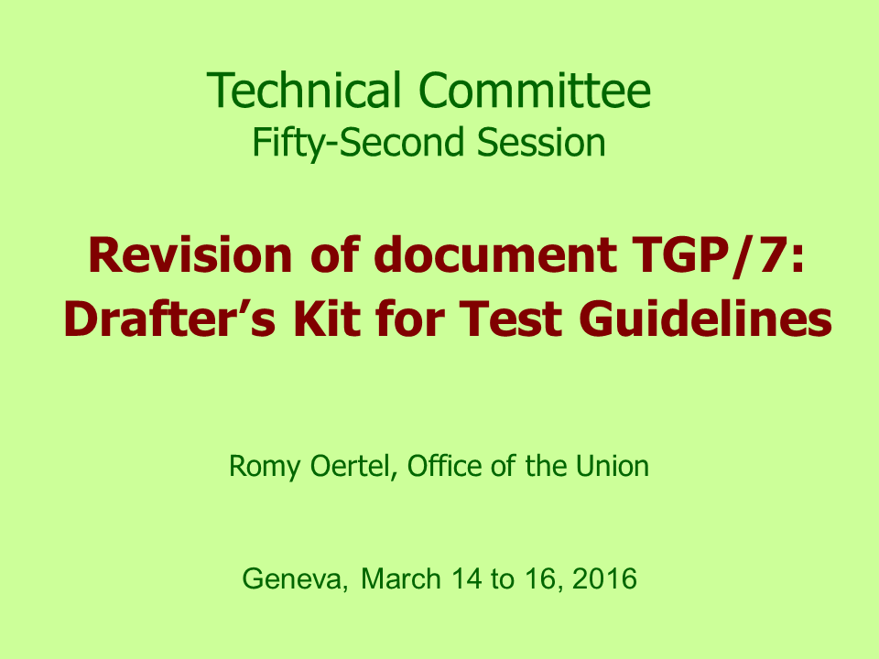

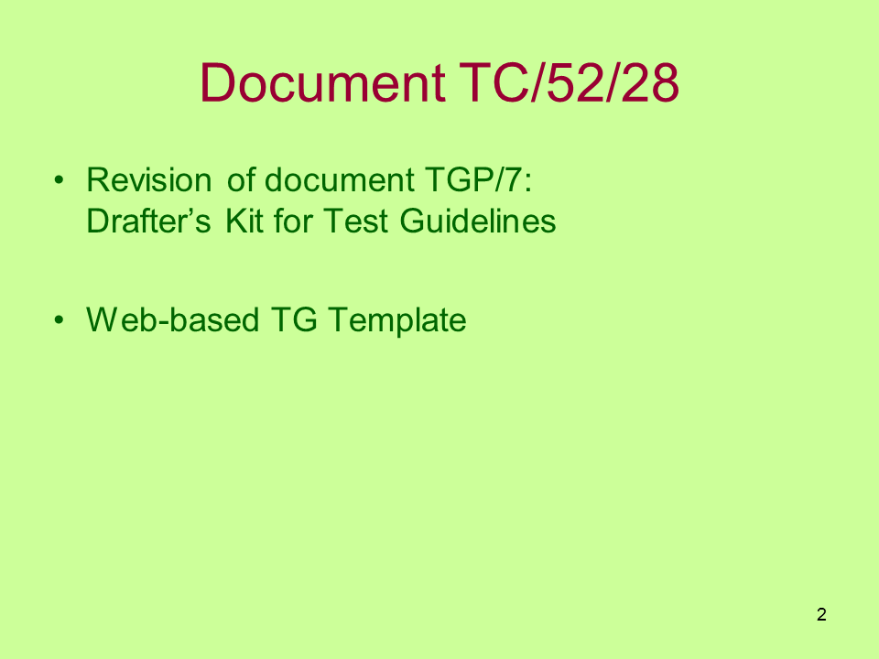

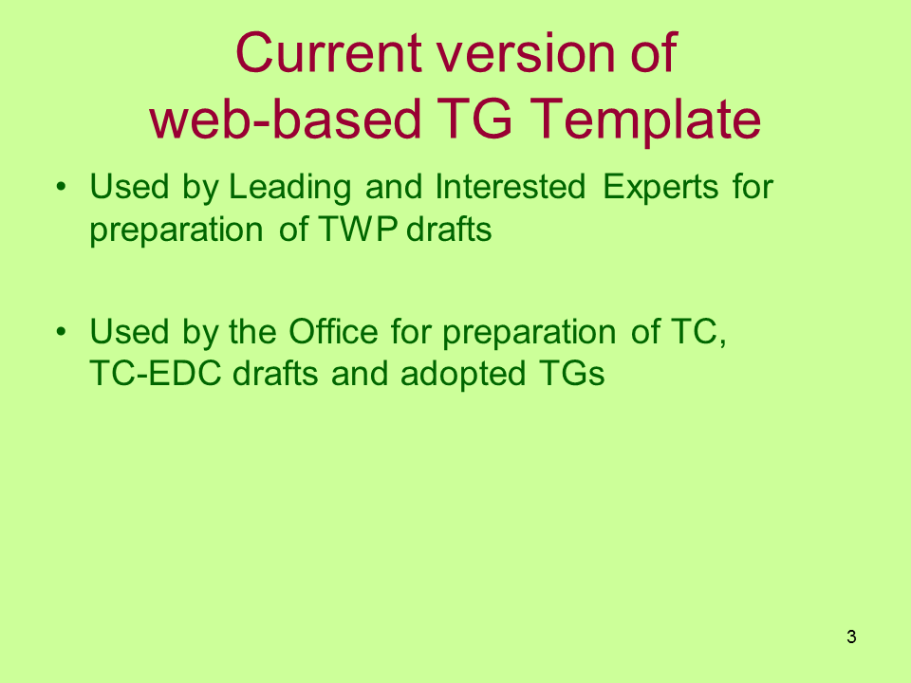

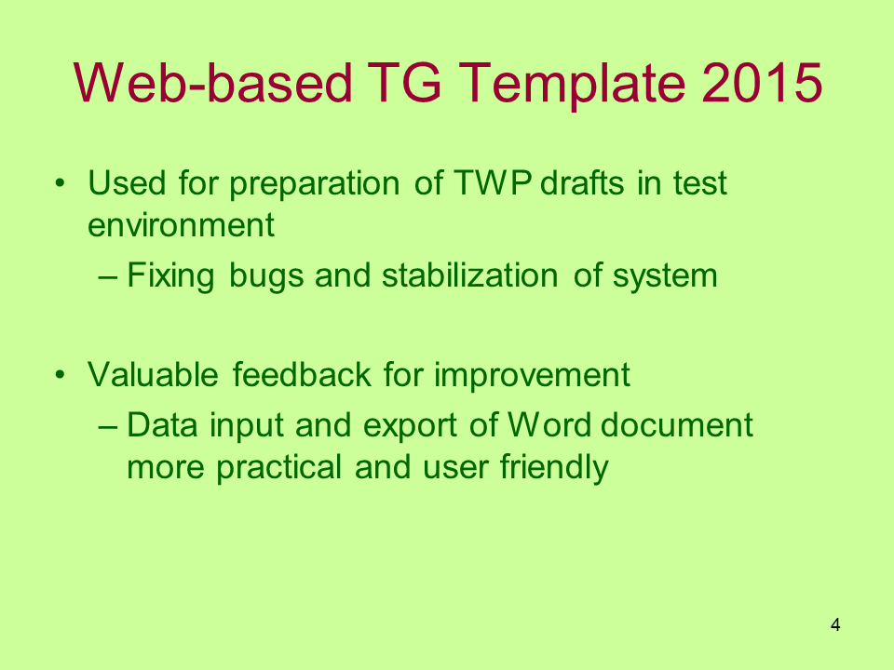

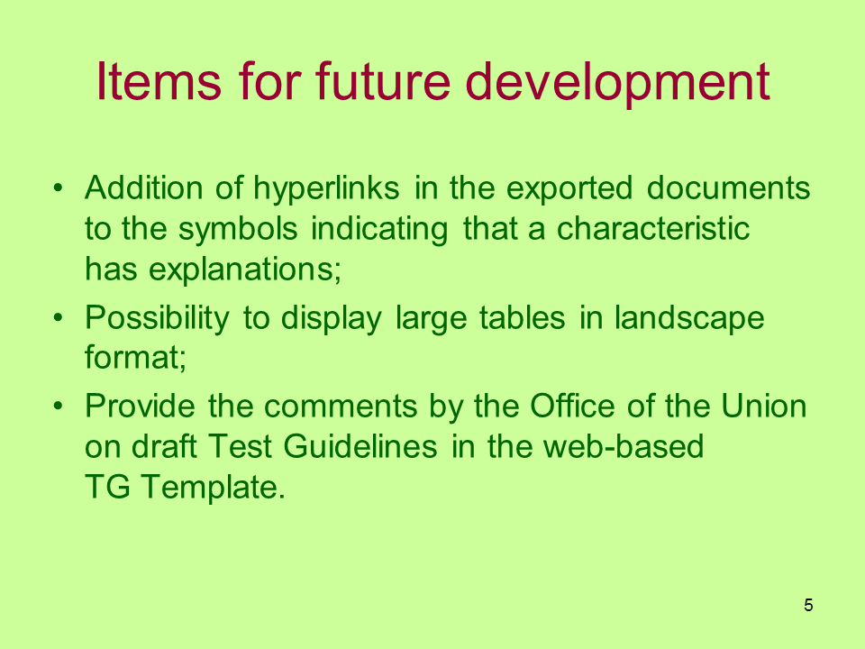

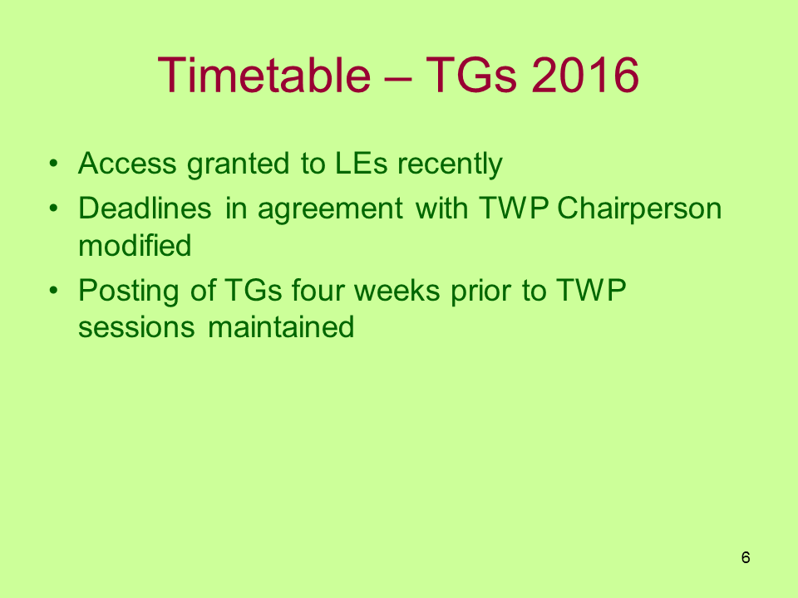

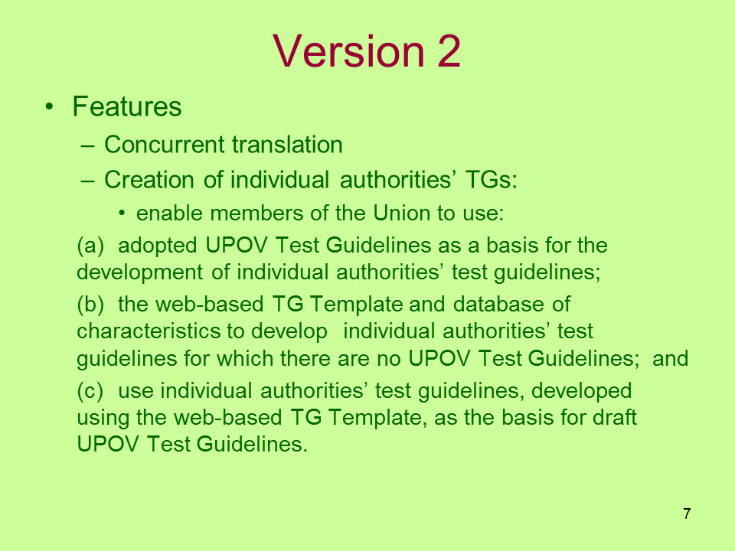

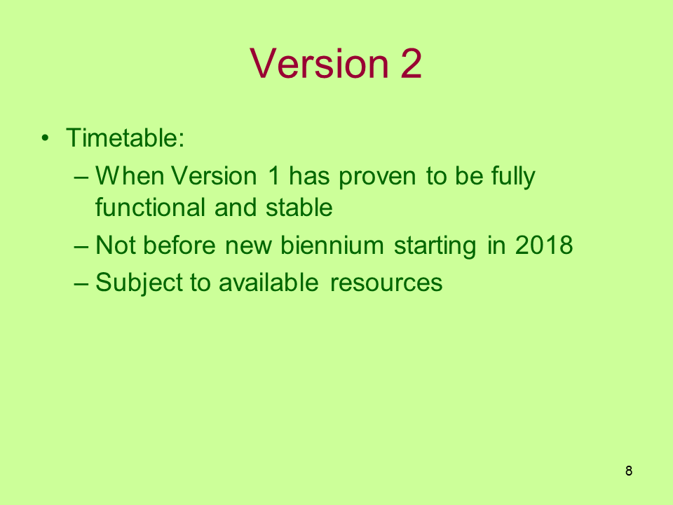

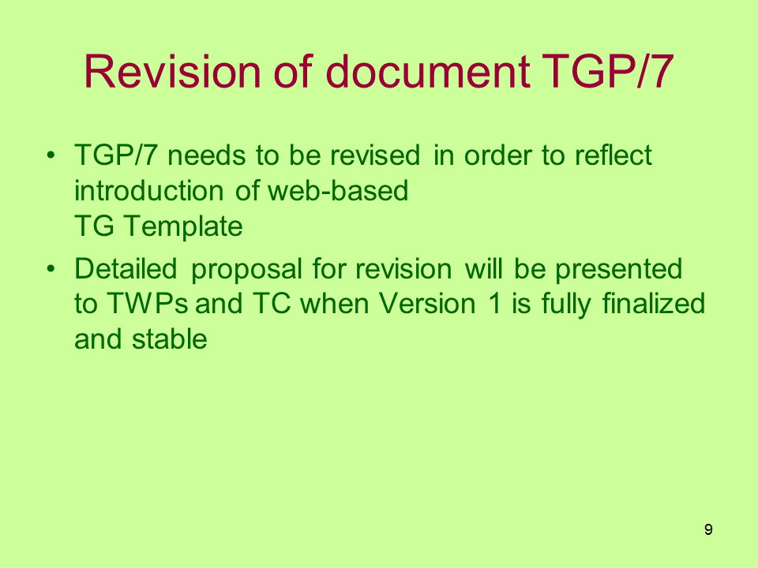

[End of Annex and of document]

