E
TC/52/20 Add.
ORIGINAL: English
DATE: March 2, 2016
INTERNATIONAL UNION FOR THE PROTECTION OF NEW VARIETIES OF PLANTS
Geneva
Technical Committee
Fifty-Second Session
Geneva, March 14 to 16, 2016
addendum to document tc/52/20

Revision of document TGP/10: New section: Assessing Uniformity by Off-Types
on the Basis of More than One growing cycle or on the basis of Sub-Samples
Document prepared by the Office of the Union
Disclaimer: this document does not represent UPOV policies or guidance
The Annex to this document contains a copy of a presentation by experts from Germany and the United Kingdom on assessing uniformity by off-types on the basis of more than one growing cycle
(in English only) to be made at the fifty-second session of the Technical Committee, to be held in Geneva, from March 14 to 16, 2016.

[Annex follows]

ASSESSING UNIFORMITY BY OFF-TYPES ON THE BASIS OF MORE THAN ONE GROWING CYCLE
RISKS, BENEFITS AND COSTS

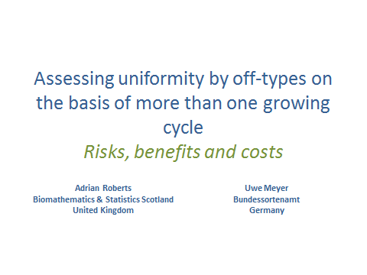

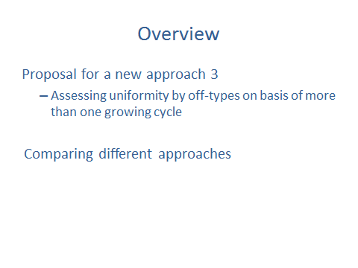

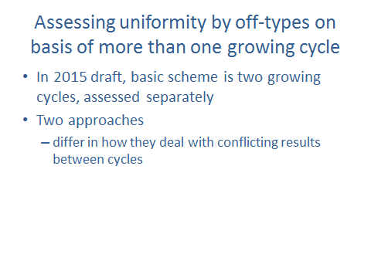

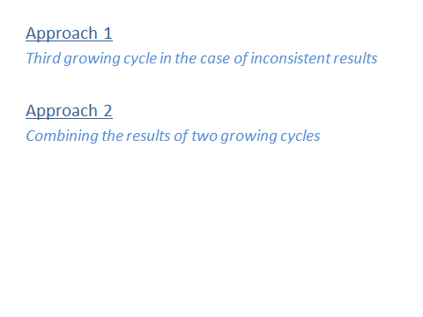

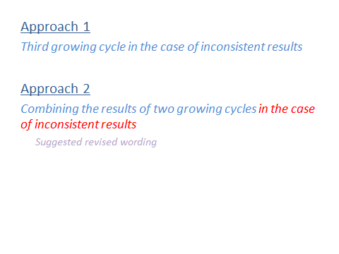

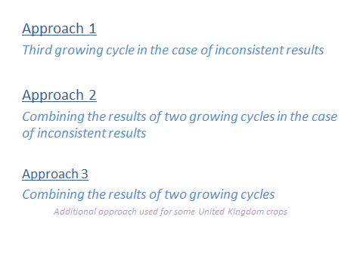

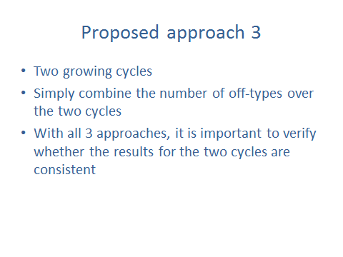

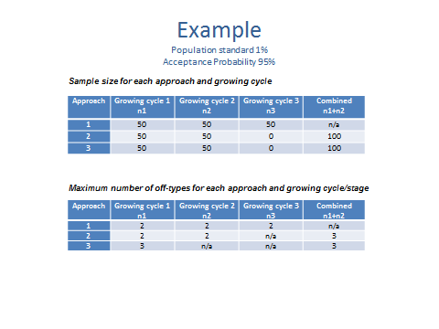

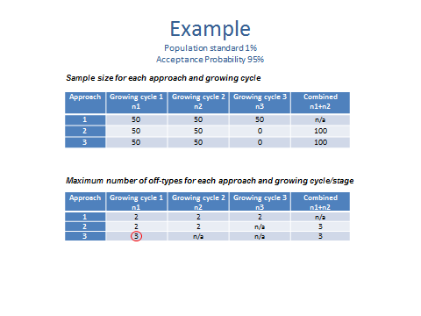

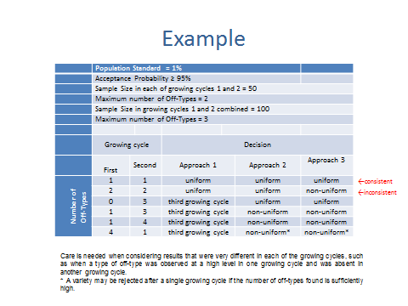

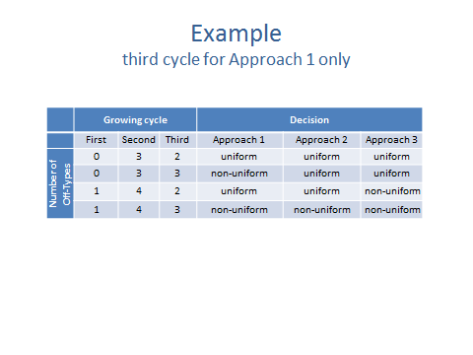

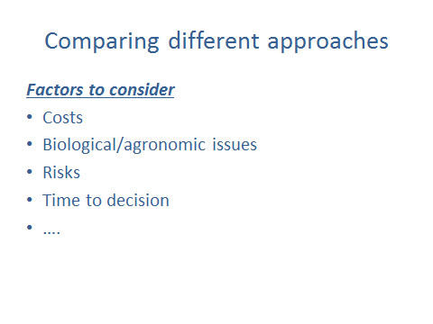

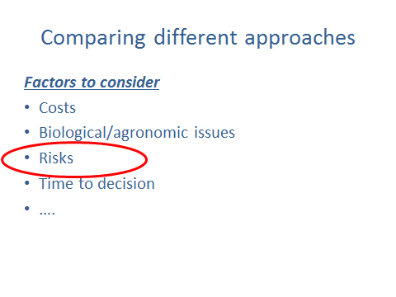

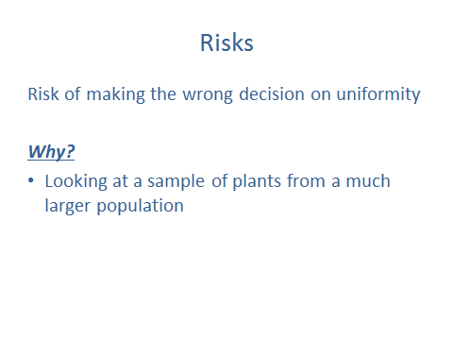

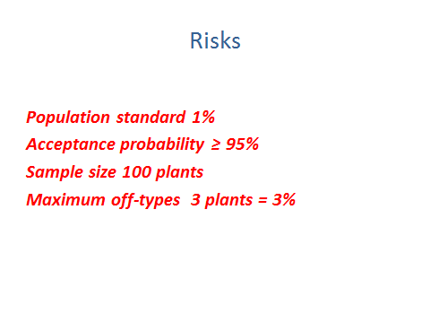

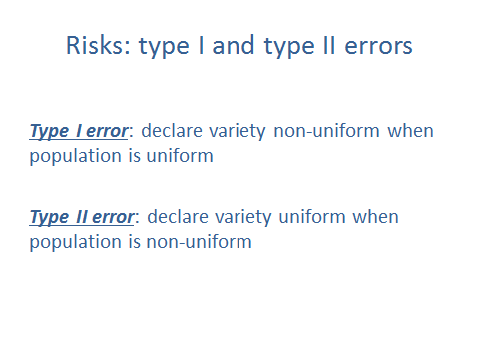

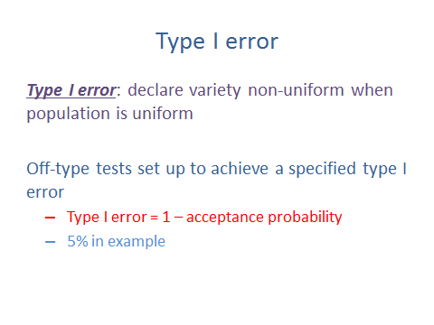

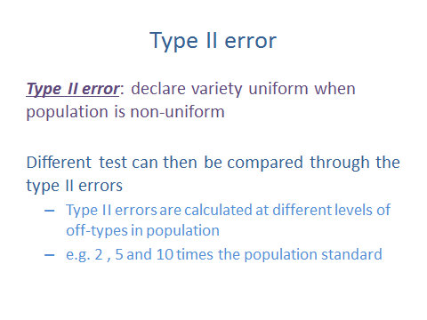

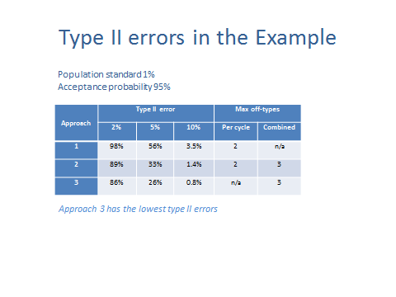

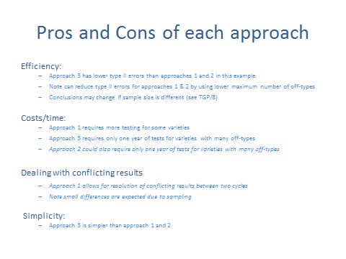

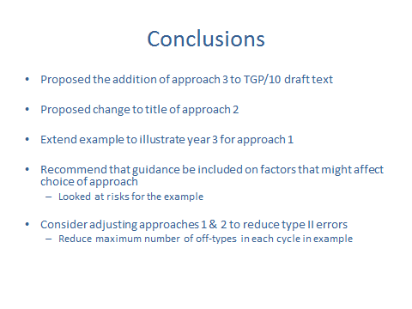

[End of Annex and of document]

