E
TG/ALOE(proj.5)
ORIGINAL: English
DATE: 2015-01-31
INTERNATIONAL UNION FOR THE PROTECTION OF NEW VARIETIES OF PLANTS
Geneva
DRAFT

 | ALOE  UPOV Code: ALOEE  Aloe L. | *

GUIDELINES
FOR THE CONDUCT OF TESTS
FOR DISTINCTNESS, UNIFORMITY AND STABILITY

prepared by an expert from South Africa

to be considered by the

Technical Committee at its fifty-first session,
to be held in Geneva from March 23 to 25, 2015

Disclaimer: this document does not represent UPOV policies or guidance

Alternative Names:*

Botanical name | English | French | German | Spanish
Aloe L. | Aloe | Aloès | Aloe | Aloe, Sábila

The purpose of these guidelines (“Test Guidelines”) is to elaborate the principles contained in the General Introduction (document TG/1/3), and its associated TGP documents, into detailed practical guidance for the harmonized examination of distinctness, uniformity and stability (DUS) and, in particular, to identify appropriate characteristics for the examination of DUS and production of harmonized variety descriptions.

ASSOCIATED DOCUMENTS
These Test Guidelines should be read in conjunction with the General Introduction and its associated TGP documents.
TABLE OF CONTENTS PAGE

1. Subject of these Test Guidelines 3
2. Material Required 3
3. Method of Examination 3
3.1 Number of Growing Cycles 3
3.2 Testing Place 3
3.3 Conditions for Conducting the Examination 3
3.4 Test Design 3
3.5 Additional Tests 3
4. Assessment of Distinctness, Uniformity and Stability 4
4.1 Distinctness 4
4.2 Uniformity 5
4.3 Stability 5
5. Grouping of Varieties and Organization of the Growing Trial 5
6. Introduction to the Table of Characteristics 6
6.1 Categories of Characteristics 6
6.2 States of Expression and Corresponding Notes 6
6.3 Types of Expression 6
6.4 Example Varieties 6
6.5 Legend 7
7. Table of Characteristics/Tableau des caractères/Merkmalstabelle/Tabla de caracteres 8
8. Explanations on the Table of Characteristics 17
8.1 Explanations covering several characteristics 17
8.2 Explanations for individual characteristics 18
9. Literature 26
10. Technical Questionnaire 27

Subject of these Test Guidelines

These Test Guidelines apply to all varieties of Aloe L..

Material Required

2.1 The competent authorities decide on the quantity and quality of the plant material required for testing the variety and when and where it is to be delivered. Applicants submitting material from a State other than that in which the testing takes place must ensure that all customs formalities and phytosanitary requirements are complied with.

2.2 The material is to be supplied in the form of plants capable of expressing all relevant characteristics of the variety during the first growing cycle.

2.3 The minimum quantity of plant material, to be supplied by the applicant, should be:

10 plants.

2.4 The plant material supplied should be visibly healthy, not lacking in vigor, nor affected by any important pest or disease.

2.5 The plant material should not have undergone any treatment which would affect the expression of the characteristics of the variety, unless the competent authorities allow or request such treatment. If it has been treated, full details of the treatment must be given.

Method of Examination

3.1 Number of Growing Cycles

The minimum duration of tests should normally be a single growing cycle.

3.2 Testing Place

Tests are normally conducted at one place. In the case of tests conducted at more than one place, guidance is provided in TGP/9 “Examining Distinctness”.

3.3 Conditions for Conducting the Examination

3.3.1 The tests should be carried out under conditions ensuring satisfactory growth for the expression of the relevant characteristics of the variety and for the conduct of the examination.

3.3.2 Because daylight varies, color determinations made against a color chart should be made either in a suitable cabinet providing artificial daylight or in the middle of the day in a room without direct sunlight. The spectral distribution of the illuminant for artificial daylight should conform with the CIE Standard of Preferred Daylight D 6500 and should fall within the tolerances set out in the British Standard 950, Part I. These determinations should be made with the plant part placed against a white background. The color chart and version used should be specified in the variety description.

3.4 Test Design

3.4.1 Each test should be designed to result in a total of at least 10 plants.

3.4.2 The design of the tests should be such that plants or parts of plants may be removed for measurement or counting without prejudice to the observations which must be made up to the end of the growing cycle.

3.5 Additional Tests

Additional tests, for examining relevant characteristics, may be established.

Assessment of Distinctness, Uniformity and Stability

4.1 Distinctness

4.1.1 General Recommendations

It is of particular importance for users of these Test Guidelines to consult the General Introduction prior to making decisions regarding distinctness. However, the following points are provided for elaboration or emphasis in these Test Guidelines.

4.1.2 Consistent Differences

The differences observed between varieties may be so clear that more than one growing cycle is not necessary. In addition, in some circumstances, the influence of the environment is not such that more than a single growing cycle is required to provide assurance that the differences observed between varieties are sufficiently consistent. One means of ensuring that a difference in a characteristic, observed in a growing trial, is sufficiently consistent is to examine the characteristic in at least two independent growing cycles.

4.1.3 Clear Differences

Determining whether a difference between two varieties is clear depends on many factors, and should consider, in particular, the type of expression of the characteristic being examined, i.e. whether it is expressed in a qualitative, quantitative, or pseudo-qualitative manner. Therefore, it is important that users of these Test Guidelines are familiar with the recommendations contained in the General Introduction prior to making decisions regarding distinctness.

4.1.4 Number of Plants / Parts of Plants to be Examined

Unless otherwise indicated, for the purposes of distinctness, all observations on single plants should be made on 5 plants or parts taken from each of 5 plants and any other observations made on all plants in the test, disregarding any off-type plants. In the case of observations of parts taken from single plants, the number of parts to be taken from each of the plants should be 1.

4.1.5 Method of Observation

The recommended method of observing the characteristic for the purposes of distinctness is indicated by the following key in the second column of the Table of Characteristics (see document TGP/9 “Examining Distinctness”, Section 4 “Observation of characteristics”):

MG: single measurement of a group of plants or parts of plants
MS: measurement of a number of individual plants or parts of plants
VG: visual assessment by a single observation of a group of plants or parts of plants
VS: visual assessment by observation of individual plants or parts of plants

Type of observation: visual (V) or measurement (M)

“Visual” observation (V) is an observation made on the basis of the expert’s judgment. For the purposes of this document, “visual” observation refers to the sensory observations of the experts and, therefore, also includes smell, taste and touch. Visual observation includes observations where the expert uses reference points (e.g. diagrams, example varieties, side-by-side comparison) or non-linear charts (e.g. color charts). Measurement (M) is an objective observation against a calibrated, linear scale e.g. using a ruler, weighing scales, colorimeter, dates, counts, etc.

Type of record: for a group of plants (G) or for single, individual plants (S)

For the purposes of distinctness, observations may be recorded as a single record for a group of plants or parts of plants (G), or may be recorded as records for a number of single, individual plants or parts of plants (S). In most cases, “G” provides a single record per variety and it is not possible or necessary to apply statistical methods in a plant-by-plant analysis for the assessment of distinctness.

In cases where more than one method of observing the characteristic is indicated in the Table of Characteristics (e.g. VG/MG), guidance on selecting an appropriate method is provided in document TGP/9, Section 4.2.

4.2 Uniformity

4.2.1 It is of particular importance for users of these Test Guidelines to consult the General Introduction prior to making decisions regarding uniformity. However, the following points are provided for elaboration or emphasis in these Test Guidelines:

4.2.2 For the assessment of uniformity, a population standard of 1% and an acceptance probability of at least 95% should be applied. In the case of a sample size of 10 plants, 1 off-type is allowed.

4.3 Stability

4.3.1 In practice, it is not usual to perform tests of stability that produce results as certain as those of the testing of distinctness and uniformity. However, experience has demonstrated that, for many types of variety, when a variety has been shown to be uniform, it can also be considered to be stable.

4.3.2 Where appropriate, or in cases of doubt, stability may be further examined by testing a new plant stock to ensure that it exhibits the same characteristics as those shown by the initial material supplied.

Grouping of Varieties and Organization of the Growing Trial

5.1 The selection of varieties of common knowledge to be grown in the trial with the candidate varieties and the way in which these varieties are divided into groups to facilitate the assessment of distinctness are aided by the use of grouping characteristics.

5.2 Grouping characteristics are those in which the documented states of expression, even where produced at different locations, can be used, either individually or in combination with other such characteristics: (a) to select varieties of common knowledge that can be excluded from the growing trial used for examination of distinctness; and (b) to organize the growing trial so that similar varieties are grouped together.

5.3 The following have been agreed as useful grouping characteristics:

(a) Leaf: spots on upper side (characteristic 11)
(b) Leaf: color of marginal zone of upper side (characteristic 13)
(c) Leaf: marginal teeth (characteristic 14)
(d) Inflorescence: branching (characteristic 18)
(e) Terminal raceme: type (characteristic 25)
(f) Outer perianth segment: main color of outer side (characteristic 41) with the following groups:
Gr. 1: white
Gr. 2: green
Gr. 3: yellow
Gr. 4: orange
Gr. 5: pink
Gr. 6: red

5.4 Guidance for the use of grouping characteristics, in the process of examining distinctness, is provided through the General Introduction and document TGP/9 “Examining Distinctness”.

Introduction to the Table of Characteristics

6.1 Categories of Characteristics

6.1.1 Standard Test Guidelines Characteristics

Standard Test Guidelines characteristics are those which are approved by UPOV for examination of DUS and from which members of the Union can select those suitable for their particular circumstances.

6.1.2 Asterisked Characteristics

Asterisked characteristics (denoted by *) are those included in the Test Guidelines which are important for the international harmonization of variety descriptions and should always be examined for DUS and included in the variety description by all members of the Union, except when the state of expression of a preceding characteristic or regional environmental conditions render this inappropriate.

6.2 States of Expression and Corresponding Notes

6.2.1 States of expression are given for each characteristic to define the characteristic and to harmonize descriptions. Each state of expression is allocated a corresponding numerical note for ease of recording of data and for the production and exchange of the description.

6.2.2 In the case of qualitative and pseudo-qualitative characteristics (see Chapter 6.3), all relevant states of expression are presented in the characteristic. However, in the case of quantitative characteristics with 5 or more states, an abbreviated scale may be used to minimize the size of the Table of Characteristics. For example, in the case of a quantitative characteristic with 9 states, the presentation of states of expression in the Test Guidelines may be abbreviated as follows:

State | Note
small | 3
medium | 5
large | 7

However, it should be noted that all of the following 9 states of expression exist to describe varieties and should be used as appropriate:

State | Note
very small | 1
very small to small | 2
small | 3
small to medium | 4
medium | 5
medium to large | 6
large | 7
large to very large | 8
very large | 9

6.2.3 Further explanation of the presentation of states of expression and notes is provided in document TGP/7 “Development of Test Guidelines”.

6.3 Types of Expression

An explanation of the types of expression of characteristics (qualitative, quantitative and pseudo-qualitative) is provided in the General Introduction.

6.4 Example Varieties

Where appropriate, example varieties are provided to clarify the states of expression of each characteristic.

6.5 Legend

(*) Asterisked characteristic – see Chapter 6.1.2

QL Qualitative characteristic – see Chapter 6.3
QN Quantitative characteristic – see Chapter 6.3
PQ Pseudo-qualitative characteristic – see Chapter 6.3

MG, MS, VG, VS – see Chapter 4.1.5

(a)-(f) See Explanations on the Table of Characteristics in Chapter 8.1

(+) See Explanations on the Table of Characteristics in Chapter 8.2.

Table of Characteristics/Tableau des caractères/Merkmalstabelle/Tabla de caracteres

 |  | English | français | deutsch | español | Example Varieties  Exemples  Beispielssorten  Variedades ejemplo | Note/  Nota
(+) | VG/MS | Plant: height | Plante : hauteur | Pflanze: Höhe | Planta: altura
QN |  | very short | très basse | sehr niedrig | muy baja | Lemon Drops | 1
 |  | short | basse | niedrig | baja | Bushwhacker | 3
 |  | medium | moyenne | mittel | media | Bloody Mary | 5
 |  | tall | haute | hoch | alta | Charles | 7
 |  | very tall | très haute | sehr hoch | muy alta | Majesty | 9
(+) | VG/MS | Plant: width | Plante : largeur | Pflanze: Breite | Planta: anchura
QN |  | very narrow | très étroite | sehr schmal | muy estrecha | Bountiful Bronny | 1
 |  | narrow | étroite | schmal | estrecha | Orange Express | 3
 |  | medium | moyenne | mittel | media | Bloody Mary | 5
 |  | broad | large | breit | ancha | Charles | 7
 |  | very broad | très large | sehr breit | muy ancha | Etam, Majesty | 9
 | VG/MS | Plant: number of inflorescences | Plante : nombre d’inflorescences | Pflanze: Anzahl Blütenstände | Planta: número de inflorescencias
QN |  | very few | très peu nombreuses | sehr wenige | muy bajo | Ice Cap | 1
 |  | few | peu nombreuses | wenige | bajo | Tangerine Tree | 3
 |  | medium | moyennes | mittel | medio | Erik the Red | 5
 |  | many | nombreuses | viele | alto | Havenga’s Pride | 7
 |  | very many | très nombreuses | sehr viele | muy alto | Porcupine | 9
(*) | VG/MS | Leaf: length | Feuille : longueur | Blatt: Länge | Hoja: longitud
QN | (a) | very short | très courte | sehr kurz | muy corta | Mountain Gem | 1
 |  | short | courte | kurz | corta | Egoli | 3
 |  | medium | moyenne | mittel | media | Turkish Delight | 5
 |  | long | longue | lang | larga | Charles | 7
 |  | very long | très longue | sehr lang | muy larga | Majesty | 9
(*) | VG/MS | Leaf: width | Feuille : largeur | Blatt: Breite | Hoja: anchura
QN | (a) | very narrow | très étroite | sehr schmal | muy estrecha | Peri-Peri | 1
 |  | narrow | étroite | schmal | estrecha | Ice Cap | 3
 |  | medium | moyenne | mittel | media | Turkish Delight | 5
 |  | broad | large | breit | ancha | Majestic | 7
 |  | very broad | très large | sehr breit | muy ancha | Lake Kyle | 9
(*)  (+) | VG | Leaf: ratio length/width | Feuille : rapport longueur/largeur | Blatt: Verhältnis Länge/Breite | Hoja: relación longitud/anchura
QN | (a) | low | bas | klein | baja | Freckles, Koeleman’s Red | 1
 |  | medium | moyen | mittel | media | Pink Lady | 3
 |  | high | élevé | groß | alta | Ice Cap | 5
(+) | VG | Leaf: thickness | Feuille : épaisseur | Blatt: Dicke | Hoja: grosor
QN | (a) | thin | mince | dünn | delgada | Electra | 1
 |  | medium | moyenne | mittel | media | Ice Cap | 2
 |  | thick | épaisse | dick | gruesa | Lake Kyle | 3
(+) | VG | Leaf: curvature | Feuille : courbure | Blatt: Biegung | Hoja: curvatura
QN | (a) | strongly incurved | fortement incurvée | stark aufgebogen | muy curvada hacia arriba | Mountain Gem | 1
 |  | moderately incurved | modérément incurvée | mäßig aufgebogen | moderadamente curvada hacia arriba | Ice Cap | 3
 |  | straight | plate | gerade | recta | Twice as Nice | 5
 |  | moderately recurved | modérément retombante | mäßig zurückgebogen | moderadamente curvada hacia abajo | Lemon Drops | 7
 |  | strongly recurved | fortement retombante | stark zurückgebogen | muy curvada hacia abajo | Curvacious | 9
(+) | VG | Leaf: width of apex | Feuille : largeur du sommet | Blatt: Breite der Spitze | Hoja: anchura del ápice
QN | (a) | narrow | étroite | schmal | estrecho | Ice Cap | 1
 |  | medium | moyenne | mittel | medio | Pink Lady | 2
 |  | broad | large | breit | ancho | Koeleman’s Orange | 3
(*) | VG | Leaf: main color of upper side | Feuille : couleur principale de la face supérieure | Blatt: Hauptfarbe der Oberseite | Hoja: color principal del haz
PQ | (a) | yellow green | vert-jaune | gelbgrün | verde amarillento | Tammy | 1
 | (b) | light green | vert clair | hellgrün | verde claro | Charles | 2
 |  | medium green | vert moyen | mittelgrün | verde medio | Ice Cap | 3
 |  | dark green | vert foncé | dunkelgrün | verde oscuro | Twice as Nice | 4
 |  | red green | vert-rouge | rotgrün | verde rojizo | Popcorn | 5
 |  | brown green | vert-brun | braungrün | verde amarronado | Eiffel | 6
 |  | blue green | vert-bleu | blaugrün | verde azulado | High Rise | 7
 |  | blue grey | gris-bleu | blaugrau | gris azulado | Southern Cross | 8
(*)  (+) | VG | Leaf: spots on upper side | Feuille : taches sur la face supérieure | Blatt: Flecken auf der Oberseite | Hoja: lunares en el haz
PQ | (a) | absent | aucune | fehlend | ausentes | Twice as Nice | 1
 |  | whitish | blanchâtres | weißlich | blanquecinos | Lemon Drops | 2
 |  | greenish | verdâtres | grünlich | verdosos | Ice Cap | 3
 |  | yellowish | jaunâtres | gelblich | amarillentos | Guineafowl | 4
(*)  (+) | VG | Leaf: stripes on upper side | Feuille : stries sur la face supérieure | Blatt: Streifen auf der Oberseite | Hoja: rayas en el haz
QL | (a) | absent | absentes | fehlend | ausentes | Egoli | 1
 |  | present | présentes | vorhanden | presentes | Baby Cloud | 9
(*) | VG | Leaf: color of marginal zone of upper side | Feuille : couleur du bord de la feuille sur la face supérieure | Blatt: Farbe der Randzone der Oberseite | Hoja: color de la zona del borde del haz
PQ | (a) | green | vert | grün | verde | Tricolor | 1
 |  | yellow | jaune | gelb | amarillo | Eden Award | 2
 |  | pinkish orange | orange rosâtre | blaßrosaorange | naranja rosado | Electra | 3
 |  | red | rouge | rot | rojo | Colourburst | 4
 |  | brown | brun | braun | marrón | Eiffel | 5
(*)  (+) | VG | Leaf: marginal teeth | Feuille : dents sur le bord | Blatt: Randzähne | Hoja: dientes del borde
QN | (a) | absent or very small | aucunes ou très petites | fehlend or sehr klein | ausentes o muy pequeños | Yellow Gem | 1
 |  | small | petites | klein | pequeños | Sensation | 3
 |  | medium | moyennes | mittel | medios | High Rise | 5
 |  | large | grandes | groß | grandes | Octopus | 7
 |  | very large | très grandes | sehr groß | muy grandes | Cerise Pink | 9
(*) | VG | Leaf: color of marginal teeth | Feuille : couleur des dents sur le bord | Blatt: Farbe der Randzähne | Hoja: color de los dientes del borde
PQ | (a) | whitish | blanchâtre | weißlich | blanquecino | Rooiklip | 1
 |  | greenish | verdâtre | grünlich | verdoso | Bright Spark, Gemini | 2
 |  | yellowish | jaunâtre | gelblich | amarillento | Reitz Rocket | 3
 |  | orange | orange | orange | naranja | Starfish, Winter White | 4
 |  | pinkish | rosâtre | blaßrosa | rosado | Ice Cap | 5
 |  | reddish | rougeâtre | rötlich | rojizo | Southern Cross | 6
 |  | brownish | brunâtre | bräunlich | amarronado | Sabre 2 | 7
(*)  (+) | VG | Leaf: spines or white tubercles | Feuille : épines ou tubercules blancs | Blatt: Stacheln oder weiße Tuberkel | Hoja: protuberancias blancas o espinas
PQ | (a) | absent | aucun | fehlend | ausentes | Ice Cap | 1
 |  | on upper side only | sur la face supérieure seulement | nur auf der Oberseite | sólo en el haz | Orange Express | 2
 |  | on upper and lower side | sur les faces supérieure et inférieure | auf der Ober- und Unterseite | en el haz y el envés | Mountain Gem | 3
 |  | on lower side only | sur la face inférieure seulement | nur auf der Unterseite | sólo en el envés |  | 4
(*) | VG | Leaf: distribution of spines or white tubercles on lower side | Feuille : répartition des épines et des tubercules blancs sur la face inférieure | Blatt: Verteilung der Stacheln oder weißen Tuberkel auf der Unterseite | Hoja: distribución de las protuberancias blancas o espinas en el envés
QL | (a) | only along midrib | le long de la nervure médiane seulement | nur entlang der Mittelrippe | solo a lo largo del nervio central | Geisha | 1
 |  | over entire leaf | sur toute la feuille | über das gesamte Blatt | en toda la hoja | Rooiklip | 2
(*)  (+) | VG | Inflorescence: branching | Inflorescence : ramification | Blütenstand: Verzweigung | Inflorescencia: ramificación
QL |  | absent | aucune | fehlend | ausente | Ice Cap | 1
 |  | primary | primaire | einfach | primaria | Twice as Nice | 2
 |  | secondary | secondaire | doppelt | secundaria | Koeleman’s Orange | 3
 |  | tertiary | tertiaire | dreifach | terciaria | Coral Red | 4
(*) | VG/MS | Inflorescence: number of racemes | Inflorescence : nombre de grappes | Blütenstand: Anzahl Blütentrauben | Inflorescencia: número de racimos
QN |  | one | une | eine | uno | Rooiklip | 1
 |  | two | deux | zwei | dos | Bountiful Bronny | 2
 |  | three to five | trois à cinq | drei oder fünf | de tres a cinco | Goldibells | 3
 |  | six to ten | cinq à dix | sechs bis zehn | de seis a diez | Etam | 4
 |  | more than ten | plus de dix | über zehn | más de diez | Lake Kyle | 5
(*)  (+) | VG/MS | Inflorescence: length | Inflorescence : longueur | Blütenstand: Länge | Inflorescencia: longitud
QN |  | very short | très courte | sehr kurz | muy corta |  | 1
 |  | short | courte | kurz | corta | Twice as Nice | 3
 |  | medium | moyenne | mittel | media | Royal Claret | 5
 |  | long | longue | lang | larga | Firechief | 7
 |  | very long | très longue | sehr lang | muy larga | Erik the Red | 9
(+) | VG/MS | Peduncle: length | Pédoncule : longueur | Blütenstandsstiel: Länge | Pedúnculo: longitud
QN |  | very short | très court | sehr kurz | muy corto | Porcupine | 1
 |  | short | court | kurz | corto | Twice as Nice | 3
 |  | medium | moyen | mittel | medio | High Rise | 5
 |  | long | long | lang | largo | Fire Chief | 7
 |  | very long | très long | sehr lang | muy largo | Erik the Red | 9
(*) | VG | Peduncle: color | Pédoncule : couleur | Blütenstandsstiel: Farbe | Pedúnculo: color
PQ |  | greenish only | verdâtre seulement | nur grünlich | solo verdoso | Twice as Nice | 1
 |  | greenish and reddish | verdâtre et rougeâtre | grünlich und rötlich | verdoso y rojizo | Ice Cap | 2
 |  | reddish only | rougeâtre seulement | nur rötlich | solo rojizo | Orange Jade | 3
 |  | brownish | brunâtre | bräunlich | amarronado | Lemon Drops | 4
(*)  (+) | VG | Lateral raceme: attitude | Grappe latérale : port | Seitliche Blütentraube: Haltung | Racimo lateral: porte
QN |  | erect | dressée | aufgerichtet | erecto | Ruby Blaze | 1
 |  | semi-erect | demi-dressée | halbaufgerichtet | semierecto | Red Parade | 2
 |  | horizontal | horizontale | waagerecht | horizontal | Red Horizon | 3
(+) | VG | Terminal raceme: length of flowering part | Étage terminal : longueur de la partie florifère | Terminale Blütentraube: Länge des blühenden Teils | Racimo terminal: longitud de la parte en floración
QN |  | very short | très courte | sehr kurz | muy corta | Little Joker | 1
 |  | short | courte | kurz | corta | Goldibells | 3
 |  | medium | moyenne | mittel | media | Twice as Nice | 5
 |  | long | longue | lang | larga | Eiffel | 7
 |  | very long | très longue | sehr lang | muy larga | Tusker | 9
(*)  (+) | VG | Terminal raceme: type | Étage terminal : type | Terminale Blütentraube: Typ | Racimo terminal: tipo
PQ |  | capitate | capité | kopfförmig | capitada | Baby Cloud | 1
 |  | corymbose-capitate | corymbe-capité | doldentraubig | corimboso-capitada | Lemon Drops | 2
 |  | capitate to conical | capité à conique | kopfförmig bis kegelförmig | capitada a cónica | Little Joker | 3
 |  | conical | conique | kegelförmig | cónica | Orange Jade | 4
 |  | conico-cylindrical | cylindro-conique | kegelförmig-zylindrisch | cónico-cilíndrica | Hilko | 5
 |  | cylindrical | cylindrique | zylindrisch | cilíndrica | Southern Cross | 6
(*)  (+) | VG | Terminal raceme: ratio length/width | Étage terminal : rapport longueur/largeur | Terminale Blütentraube: Verhältnis Länge/Breite | Racimo terminal: relación longitud/anchura
QN |  | low | bas | klein | baja |  | 1
 |  | medium | moyen | mittel | media | Goldibells | 3
 |  | high | élevé | groß | alta | Havenga’s Pride | 5
 |  | very high | très élevé | sehr groß | muy alta | Eiffel | 7
 |  | extremely high | extrêmement élevé | äußerst groß | extremadamente alta |  | 9
(*)  (+) | VG | Terminal raceme: density of flowers | Étage terminal : densité des fleurs | Terminale Blütentraube: Dichte der Blüten | Racimo terminal: densidad de flores
QN |  | sparse | lâche | locker | laxa | Ice Cap | 3
 |  | medium | moyenne | mittel | media | Twice as Nice | 5
 |  | dense | dense | dicht | densa | Lake Kyle, Winter Festival | 7
 | VG | Terminal raceme: size of flower bracts | Étage terminal : taille des bractées | Terminale Blütentraube: Größe der Blütendeckblätter | Racimo terminal: tamaño de las brácteas florales
QN | (e) | very small | très petites | sehr klein | muy pequeñas | Ice Cap | 1
 |  | small | petites | klein | pequeñas | Little Joker | 3
 |  | medium | moyennes | mittel | medias | Bushwhacker | 5
 |  | large | grandes | groß | grandes | Mountain Gem | 7
 | VG | Immature flower bud: main color of pedicel | Bouton floral immature : couleur principale du pédicelle | Unreife Blütenknospe: Hauptfarbe des Blütenstiels | Botón floral inmaduro: color principal del pedicelo
PQ | (b) | greenish | verdâtre | grünlich | verdoso | Turkish Delight | 1
 | (c) | yellowish | jaunâtre | gelblich | amarillento | Andsaff | 2
 |  | orange | orange | orange | naranja | Lemon Drops | 3
 |  | reddish | rougeâtre | rötlich | rojizo | Little Joker | 4
 |  | brownish | brunâtre | bräunlich | amarronado | Ice Cap | 5
(*) | VG | Immature flower bud: main color | Bouton floral immature : couleur principale | Unreife Blütenknospe: Hauptfarbe | Botón floral inmaduro: color principal
PQ | (b)  (c) | RHS Colour Chart (indicate reference number) | Code RHS des couleurs (indiquer le numéro de référence) | RHS-Farbkarte (Nummer angeben) | Carta de colores RHS (indíquese el número de referencia)
 | VG | Immature flower bud: secondary color | Bouton floral immature : couleur secondaire | Unreife Blütenknospe: Sekundärfarbe | Botón floral inmaduro: color secundario
PQ | (b)  (c) | RHS Colour Chart (indicate reference number) | Code RHS des couleurs (indiquer le numéro de référence) | RHS-Farbkarte (Nummer angeben) | Carta de colores RHS (indíquese el número de referencia)
 | VG | Mature flower bud: main color of pedicel | Bouton floral mature : couleur principale du pédicelle | Reife Blütenknospe: Hauptfarbe des Blütenstiels | Botón floral maduro: color principal del pedicelo
PQ | (b) | greenish | verdâtre | grünlich | verdoso | Ice Cap | 1
 | (d) | yellowish | jaunâtre | gelblich | amarillento | Lemon Drops | 2
 |  | orange | orange | orange | naranja | Bushwhacker | 3
 |  | reddish | rougeâtre | rötlich | rojizo | Little Joker | 4
 |  | brownish | brunâtre | bräunlich | amarronado | Andgol | 5
(*) | VG | Mature flower bud: main color | Bouton floral mature : couleur principale | Reife Blütenknospe: Hauptfarbe | Botón floral maduro: color principal
PQ | (b)  (d) | RHS Colour Chart (indicate reference number) | Code RHS des couleurs (indiquer le numéro de référence) | RHS-Farbkarte (Nummer angeben) | Carta de colores RHS (indíquese el número de referencia)
 | VG | Mature flower bud: secondary color | Bouton floral mature : couleur secondaire | Reife Blütenknospe: Sekundärfarbe | Botón floral maduro: color secundario
PQ | (b)  (d) | RHS Colour Chart (indicate reference number) | Code RHS des couleurs (indiquer le numéro de référence) | RHS-Farbkarte (Nummer angeben) | Carta de colores RHS (indíquese el número de referencia)
(+) | VG/MS | Pedicel: length | Pédicelle : longueur | Blütenstiel: Länge | Pedicelo: longitud
QN | (e) | short | courte | kurz | corto | Ice Cap | 1
 |  | medium | moyenne | mittel | medio | Emerald | 2
 |  | long | longue | lang | largo | Porcupine | 3
(*) | VG | Pedicel: main color | Pédicelle : couleur principale | Blütenstiel: Hauptfarbe | Pedicelo: color principal
PQ | (b) | greenish | verdâtre | grünlich | verdoso | Ice Cap | 1
 | (e) | yellowish | jaunâtre | gelblich | amarillento | Lemon Drops | 2
 |  | orange | orange | orange | naranja | Bushwhacker | 3
 |  | reddish | rougeâtre | rötlich | rojizo | Little Joker | 4
 |  | brownish | brunâtre | bräunlich | amarronado | Andgol | 5
(*)  (+) | VG | Flower: basal swelling | Fleur : gonflement de la base | Blüte: basale Schwellung | Flor: hinchazón basal
QN | (e) | weak | faible | gering | débil | Leo8544 | 1
 |  | medium | moyen | mittel | media | Pink Lady | 3
 |  | strong | fort | stark | fuerte | Yellow maculata | 5
(+) | VG/MS | Perianth: length | Périanthe : longueur | Blütenhülle: Länge | Perianto: longitud
QN | (e) | very short | très courte | sehr kurz | muy corto | Albiflora | 1
 |  | short | courte | kurz | corto | Ice Cap | 3
 |  | medium | moyenne | mittel | medio | Porcupine | 5
 |  | long | longue | lang | largo | Bushwhacker | 7
(+) | VG/MS | Perianth: diameter | Périanthe : diamètre | Blütenhülle: Durchmesser | Perianto: diámetro
QN | (e) | small | petit | klein | pequeño | Geisha | 1
 |  | medium | moyen | mittel | medio | Ice Cap | 2
 |  | large | grand | groß | grande | Bushwhacker | 3
 | VG | Outer perianth segment: recurving of apex | Enveloppe extérieure du périanthe : incurvation au sommet | Äußeres Blütenhüllensegment: Rückbiegung der Spitze | Segmento externo del perianto: recurvado del ápice
QN | (e) | absent or weak | nulle ou faible | fehlend oder schwach | ausente o débil | Orange Express | 1
 |  | medium | moyenne | mittel | medio | Ice Cap | 2
 |  | strong | forte | stark | fuerte | Winter Bells | 3
(*) | VG | Outer perianth segment: main color of outer side | Enveloppe extérieure du périanthe : couleur principale de la face extérieure | Äußeres Blütenhüllensegment: Hauptfarbe der Außenseite | Segmento externo del perianto: color principal de la cara externa
PQ | (b)  (e) | RHS Colour Chart (indicate reference number) | Code RHS des couleurs (indiquer le numéro de référence) | RHS-Farbkarte (Nummer angeben) | Carta de colores RHS (indíquese el número de referencia)
 | VG | Outer perianth segment: secondary color of outer side | Enveloppe extérieure du périanthe : couleur secondaire de la face extérieure | Äußeres Blütenhüllensegment: Sekundärfarbe der Außenseite | Segmento externo del perianto: color secundario de la cara externa
PQ | (b)  (e) | RHS Colour Chart (indicate reference number) | Code RHS des couleurs (indiquer le numéro de référence) | RHS-Farbkarte (Nummer angeben) | Carta de colores RHS (indíquese el número de referencia)
(*) | VG | Inner perianth segment: main color of apex of inner side | Enveloppe intérieure du périanthe : principale couleur du sommet de la face intérieure | Inneres Blütenhüllensegment: Hauptfarbe der Spitze der Innenseite | Segmento interno del perianto: color principal del ápice de la cara interna
PQ | (b) | white | blanc | weiß | blanco |  | 1
 | (e) | green | vert | grün | verde | Ice Cap | 2
 |  | yellow | jaune | gelb | amarillo | Twice as Nice | 3
 |  | red | rouge | rot | rojo |  | 4
 |  | purple | violet | purpurn | púrpura | Koeleman’s Red | 5
 |  | brown | brun | braun | marrón | Koeleman’s Orange | 6
(+) | VG | Stamen: protrusion in relation to apex of perianth segments | Étamines : protubérance par rapport au sommet des enveloppes du périanthe | Staubgefäß: Überstand im Vergleich zur Spitze des Blütenhüllen-segments | Estambre: protuberancia con respecto al ápice de los segmentos del perianto
QN | (f) | absent or weak | nulle ou faible | fehlend oder gering | ausente o débil | Emerald | 1
 |  | medium | moyenne | mittel | media | Ice Cap | 2
 |  | strong | forte | stark | fuerte | Leo8544 | 3
(*) | VG | Filament: anthocyanin coloration | Filament : pigmentation anthocyanique | Staubfaden: Anthocyanfärbung | Filamento: pigmentación antociánica
QN | (f) | absent or weak | nulle ou faible | fehlend oder gering | ausente o débil | Bekkies, Ice Cap | 1
 |  | medium | moyenne | mittel | media | Majesty | 2
 |  | strong | forte | stark | fuerte | Red Parade | 3
(+) | MG | Time of beginning of flowering | Époque de début de floraison | Zeitpunkt des Blühbeginns | Época de inicio de la floración
QN |  | early | précoce | früh | temprana | Lemon Drops | 3
 |  | medium | moyenne | mittel | media | Geisha | 5
 |  | late | tardive | spät | tardía | Lake Kyle | 7

Explanations on the Table of Characteristics

8.1 Explanations covering several characteristics

Unless otherwise indicated, observations should be made at the time of full flowering.

Characteristics containing the following key in the second column of the Table of Characteristics should be examined as indicated below:

- Observations on the leaf should be made on fully developed leaves from the middle part of the leaf rosette.
- The main color is the color with the largest surface area. The secondary color is the color with the second largest surface area. In cases where the area of the main and secondary color are too similar to reliably decide which color has the largest area, the darker color is considered to be the main color.
- Observations on the immature flower bud should be made on buds in the upper third of the raceme. Color observations should disregard the green apex.
- Observations on the mature flower bud should be made when the flower bud is fully expanded, prior to reflexing of the outer perianth segments. Color observations should disregard the green apex.
- Observations on the flower, flower parts and bracts should be made on fresh fully open flowers.
- Observations on the stamens should be made shortly after dehiscence of the anthers.

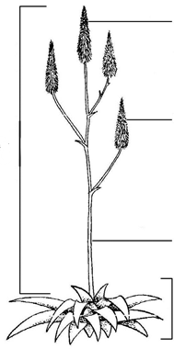  Inflorescence  Leaf rosette  Peduncle  Terminal raceme  Lateral raceme | 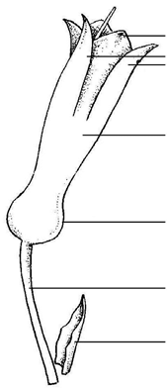  Flower bract  Pedicel  Basal swelling  Perianth  Outer perianth segment  Inner perianth segment
Plant parts | Flower parts

8.2 Explanations for individual characteristics

Ad. 1: Plant: height
Ad. 2: Plant: width

Observations should exclude the inflorescence.

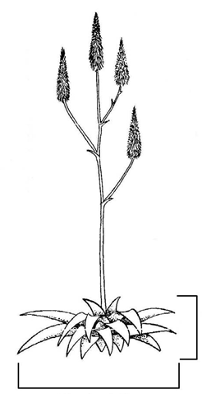
Plant width
Plant height

Ad. 6: Leaf: ratio length/width

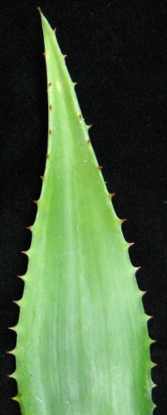 | 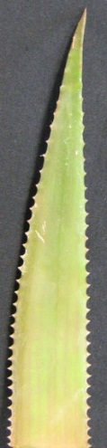 | 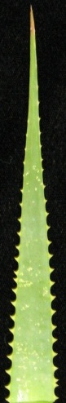
1 | 3 | 5
low | medium | high

Ad. 7: Leaf: thickness

To be observed at the base of the leaf.

Ad. 8: Leaf: curvature

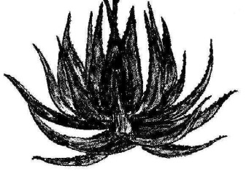 | 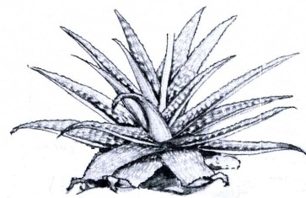 | 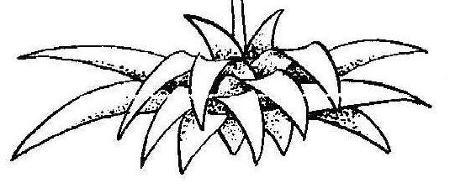
3 | 5 | 7
moderately incurved | straight | moderately recurved

Ad. 9: Leaf: width of apex

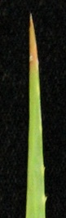 | 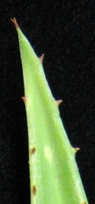 | 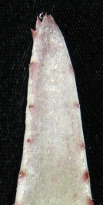
1 | 2 | 3
narrow | medium | broad

Ad. 11: Leaf: spots on upper side

For this characteristic, the term spots include speckles, spots, and blotches, but exclude spines and white tubercles

Ad. 12: Leaf: stripes on upper side

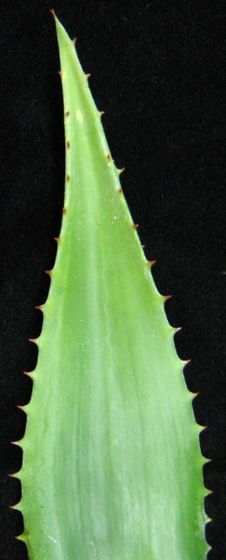 | 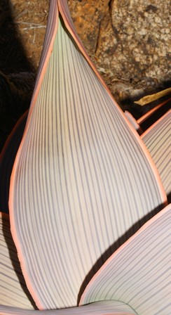
1 | 9
absent | present

Ad. 14: Leaf: marginal teeth
Ad. 16: Leaf: spines or white tubercles
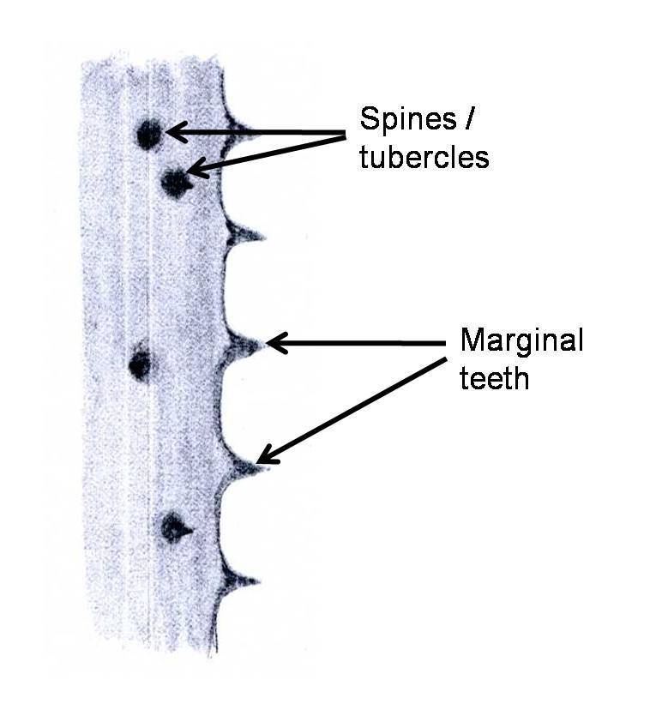

Ad. 18: Inflorescence: branching

 | 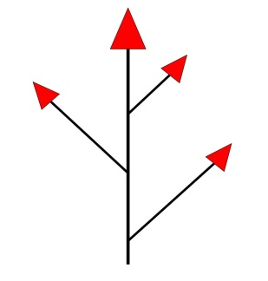 | 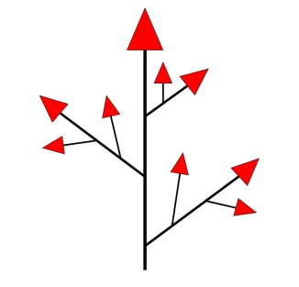 | 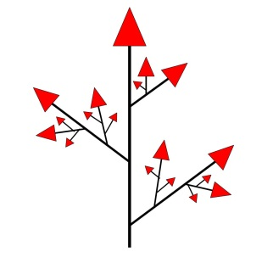
1 | 2 | 3 | 4
absent | primary | secondary | tertiary

Ad. 20: Inflorescence: length
Ad. 21: Peduncle: length

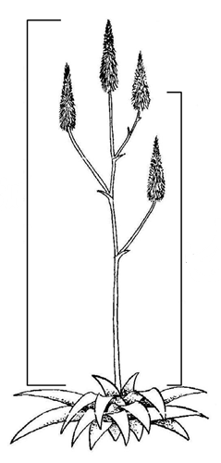
Peduncle: length
Inflorescence:
length

Ad. 23: Lateral raceme: attitude

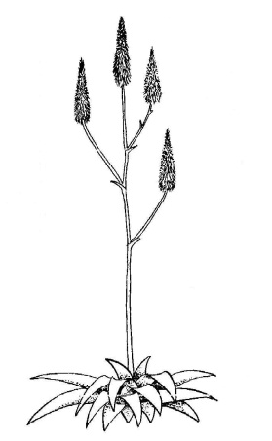 | 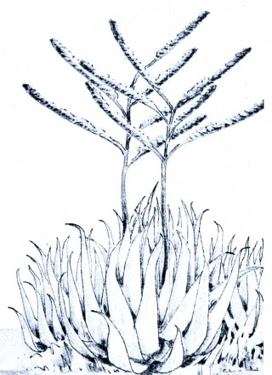 | 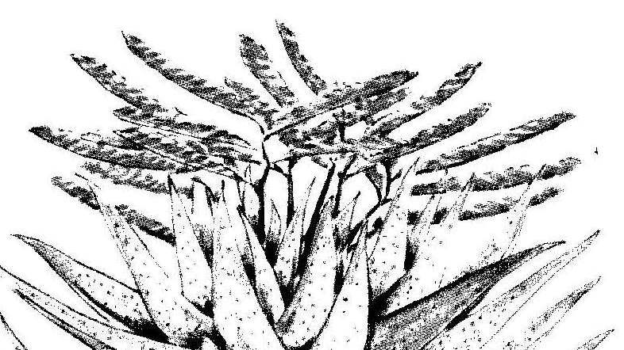
1 | 2 | 3
erect | semi-erect | horizontal

Ad. 24: Terminal raceme: length of flowering part

The flowering part includes open flowers and buds.

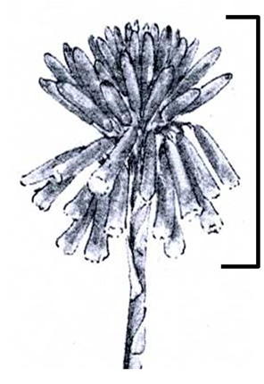
Length of flowering part

Ad. 25: Terminal raceme: type

To be observed when 20% of the flowers have opened.

Capitate – a head-like inflorescence type; usually broader than long.

Corymbose – a racemose (indeterminate) inflorescence type, in which the branches or the pedicels start from different points but all reach to about the same level.

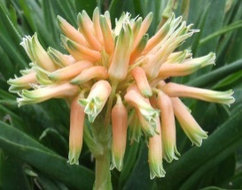 | 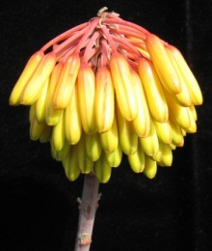 | 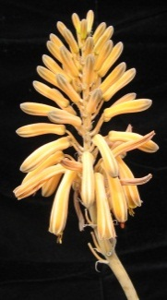 | 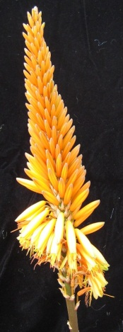 | 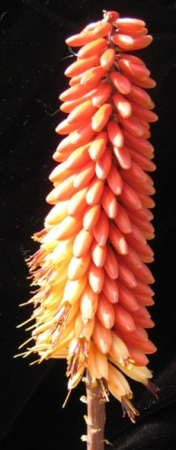 | 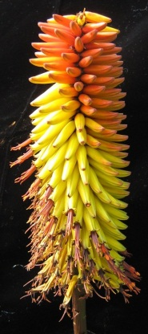
1 | 2 | 3 | 4 | 5 | 6
capitate | corymbose-capitate | capitate to conical | conical | conico-cylindrical | cylindrical

Ad. 26: Terminal raceme: ratio length/width

Raceme width

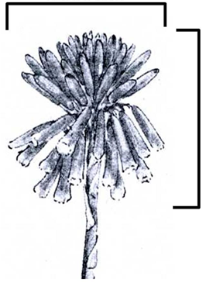
Raceme length

Ad. 27: Terminal raceme: density of flowers

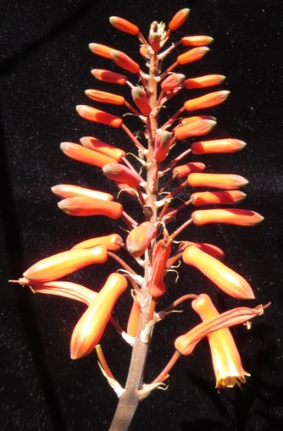 | 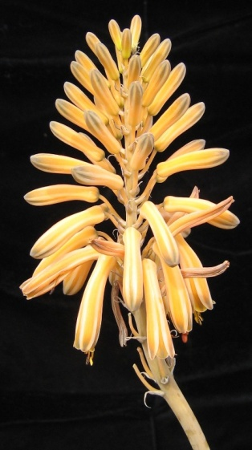 | 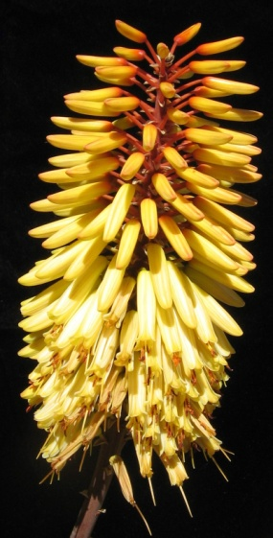
3 | 5 | 7
sparse | medium | dense

Ad. 35: Pedicel: length

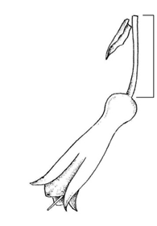
Pedicel length

Ad. 37: Flower: basal swelling

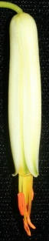 | 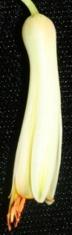 | 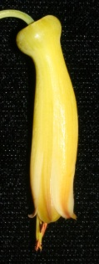
1 | 3 | 5
weak | medium | strong

Ad. 38: Perianth: length
Ad. 39: Perianth: diameter

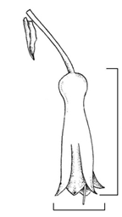
Perianth length
Perianth diameter

Ad. 44: Stamen: protrusion in relation to apex of perianth segments

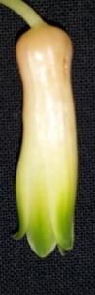 | 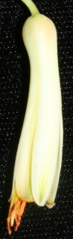 | 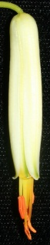
1 | 2 | 3
absent or weak | medium | strong

Ad. 46: Time of beginning of flowering

The time of beginning of flowering is when 50% of the plants have at least one open flower.

Literature

Van Wyk, B., Smith, G., 2003: Guide to the Aloes of South Africa. Briza Publications. Pretoria, ZA, 304 pp.

Technical Questionnaire

TECHNICAL QUESTIONNAIRE |  |  |  | Page {x} of {y} |  | Reference Number:
 |  |  |  |  |  | Application date:
 |  |  |  |  |  | (not to be filled in by the applicant)
TECHNICAL QUESTIONNAIRE
to be completed in connection with an application for plant breeders’ rights

1. Subject of the Technical Questionnaire
1.1 Genus |  |  | Aloe L.
1.2 Species (please complete) |  |  |  |  |  |  |  |  |  | [ ]
1.2.1 Common name
1.3 Hybrid |  |  |  |  |  |  |  |  |  | [ ]
Species (please complete)
2. Applicant
Name
Address
Telephone No.
Fax No.
E-mail address
Breeder (if different from
applicant)
3. Proposed denomination and breeder’s reference
Proposed denomination
(if available)
Breeder’s reference
#4. Information on the breeding scheme and propagation of the variety

4.1 Breeding scheme
Variety resulting from:

4.1.1 Crossing

(a) controlled cross [ ]
(please state parent varieties)

(…………………..…………………………) x (……………..…………..………………..…)
female parent male parent

(b) partially known cross [ ]
(please state known parent variety(ies))

(…………………..……………………....…) x (……………..………………..…………..…)
female parent male parent

(c) unknown cross [ ]
4.1.2 Mutation [ ]
(please state parent variety)

4.1.3 Discovery and development [ ]
(please state where and when discovered and how developed)

4.1.4 Other [ ]
(please provide details)

4.2 Method of propagating the variety

4.2.1 Vegetative propagation

(a) cuttings [ ]

(b) in vitro propagation [ ]

(c) other (state method) [ ]

4.2.2 Other [ ]
(please provide details)

5. Characteristics of the variety to be indicated (the number in brackets refers to the corresponding characteristic in Test Guidelines; please mark the note which best corresponds).

 | Characteristics |  |  |  |  |  | Example Varieties |  |  |  | Note
5.1  (11) | Leaf: spots on upper side
 | absent |  |  |  |  |  | Twice as Nice |  |  |  | 1[ ]
 | whitish |  |  |  |  |  | Lemon Drops |  |  |  | 2[ ]
 | greenish |  |  |  |  |  | Ice Cap |  |  |  | 3[ ]
 | yellowish |  |  |  |  |  | Guineafowl |  |  |  | 4[ ]
5.2  (13) | Leaf: color of marginal zone of upper side
 | green |  |  |  |  |  | Tricolor |  |  |  | 1[ ]
 | yellow |  |  |  |  |  | Eden Award |  |  |  | 2[ ]
 | pinkish orange |  |  |  |  |  | Electra |  |  |  | 3[ ]
 | red |  |  |  |  |  | Colourburst |  |  |  | 4[ ]
 | brown |  |  |  |  |  | Eiffel |  |  |  | 5[ ]
5.3  (14) | Leaf: marginal teeth
 | absent or very small |  |  |  |  |  | Yellow Gem |  |  |  | 1[ ]
 | very small to small |  |  |  |  |  |  |  |  |  | 2[ ]
 | small |  |  |  |  |  | Sensation |  |  |  | 3[ ]
 | small to medium |  |  |  |  |  |  |  |  |  | 4[ ]
 | medium |  |  |  |  |  | High Rise |  |  |  | 5[ ]
 | medium to large |  |  |  |  |  |  |  |  |  | 6[ ]
 | large |  |  |  |  |  | Octopus |  |  |  | 7[ ]
 | large to very large |  |  |  |  |  |  |  |  |  | 8[ ]
 | very large |  |  |  |  |  | Cerise Pink |  |  |  | 9[ ]
 | Characteristics |  |  |  |  |  | Example Varieties |  |  |  | Note
5.4  (18) | Inflorescence: branching
 | absent |  |  |  |  |  | Ice Cap |  |  |  | 1[ ]
 | primary |  |  |  |  |  | Twice as Nice |  |  |  | 2[ ]
 | secondary |  |  |  |  |  | Koeleman’s Orange |  |  |  | 3[ ]
 | tertiary |  |  |  |  |  | Coral Red |  |  |  | 4[ ]
5.5  (25) | Terminal raceme: type
 | capitate |  |  |  |  |  | Baby Cloud |  |  |  | 1[ ]
 | corymbose-capitate |  |  |  |  |  | Lemon Drops |  |  |  | 2[ ]
 | capitate to conical |  |  |  |  |  | Little Joker |  |  |  | 3[ ]
 | conical |  |  |  |  |  | Orange Jade |  |  |  | 4[ ]
 | conico-cylindrical |  |  |  |  |  | Hilko |  |  |  | 5[ ]
 | cylindrical |  |  |  |  |  | Southern Cross |  |  |  | 6[ ]
5.6  (41) | Outer perianth segment: main color of outer side
 | white |  |  |  |  |  | Ivory Tower |  |  |  | 1[ ]
 | green |  |  |  |  |  |  |  |  |  | 2[ ]
 | yellow |  |  |  |  |  | Porcupine, Sunbird |  |  |  | 3[ ]
 | orange |  |  |  |  |  | Orange Express |  |  |  | 4[ ]
 | pink |  |  |  |  |  |  |  |  |  | 5[ ]
 | red |  |  |  |  |  | Erik the Red |  |  |  | 6[ ]
6. Similar varieties and differences from these varieties

Please use the following table and box for comments to provide information on how your candidate variety differs from the variety (or varieties) which, to the best of your knowledge, is (or are) most similar. This information may help the examination authority to conduct its examination of distinctness in a more efficient way.

Denomination(s) of variety(ies) similar to your candidate variety |  | Characteristic(s) in which your candidate variety differs from the similar variety(ies) |  |  | Describe the expression of the characteristic(s) for the similar variety(ies) |  |  | Describe the expression of the characteristic(s) for your candidate variety
Example |  | Leaf: marginal teeth |  |  | medium |  |  | large
Comments:

#7. Additional information which may help in the examination of the variety

7.1 In addition to the information provided in sections 5 and 6, are there any additional characteristics which may help to distinguish the variety?

Yes [ ] No [ ]

(If yes, please provide details)

7.2 Are there any special conditions for growing the variety or conducting the examination?

Yes [ ] No [ ]

(If yes, please provide details)

7.3 Other information

7.4 A representative color image of the variety should accompany the Technical Questionnaire.

8. Authorization for release

(a) Does the variety require prior authorization for release under legislation concerning the protection of the environment, human and animal health?

Yes [ ] No [ ]

(b) Has such authorization been obtained?

Yes [ ] No [ ]

If the answer to (b) is yes, please attach a copy of the authorization.

9. Information on plant material to be examined or submitted for examination

9.1 The expression of a characteristic or several characteristics of a variety may be affected by factors, such as pests and disease, chemical treatment (e.g. growth retardants or pesticides), effects of tissue culture, different rootstocks, scions taken from different growth phases of a tree, etc.

9.2 The plant material should not have undergone any treatment which would affect the expression of the characteristics of the variety, unless the competent authorities allow or request such treatment. If the plant material has undergone such treatment, full details of the treatment must be given. In this respect, please indicate below, to the best of your knowledge, if the plant material to be examined has been subjected to:

(a) Microorganisms (e.g. virus, bacteria, phytoplasma) Yes [ ] No [ ]

(b) Chemical treatment (e.g. growth retardant, pesticide) Yes [ ] No [ ]

(c) Tissue culture Yes [ ] No [ ]

(d) Other factors Yes [ ] No [ ]

Please provide details for where you have indicated “yes”.

10. I hereby declare that, to the best of my knowledge, the information provided in this form is correct:

Applicant’s name

Signature Date

[End of document]

* These names were correct at the time of the introduction of these Test Guidelines but may be revised or updated. [Readers are advised to consult the UPOV Code, which can be found on the UPOV Website (www.upov.int), for the latest information.]
# Authorities may allow certain of this information to be provided in a confidential section of the Technical Questionnaire.
# Authorities may allow certain of this information to be provided in a confidential section of the Technical Questionnaire.

