E
TC/51/35
ORIGINAL: English
DATE: February 6, 2015
INTERNATIONAL UNION FOR THE PROTECTION OF NEW VARIETIES OF PLANTS
Geneva
Technical Committee
Fifty-First Session
Geneva, March 23 to 25, 2015
Correction of the Test Guidelines for Carrot (Document TG/49/8)
Document prepared by the Office of the Union
Disclaimer: this document does not represent UPOV policies or guidance
At its forty-eighth session held in Paestum, Italy, from June 23 to 27, 2014, the Technical Working Party for Vegetables (TWV) considered a correction of the Test Guidelines for Carrot on the basis of documents TG/49/8 and TWV/48/41 “Correction of the Test Guidelines for Carrot (Document TG/49/8)” (see document TWV/48/43 “Report”, paragraph 105).

The TWV agreed with the proposal for the correction of the Test Guidelines for Carrot (document TG/49/8).

Chapter 4.2 of the Test Guidelines for Carrot reads as follows:

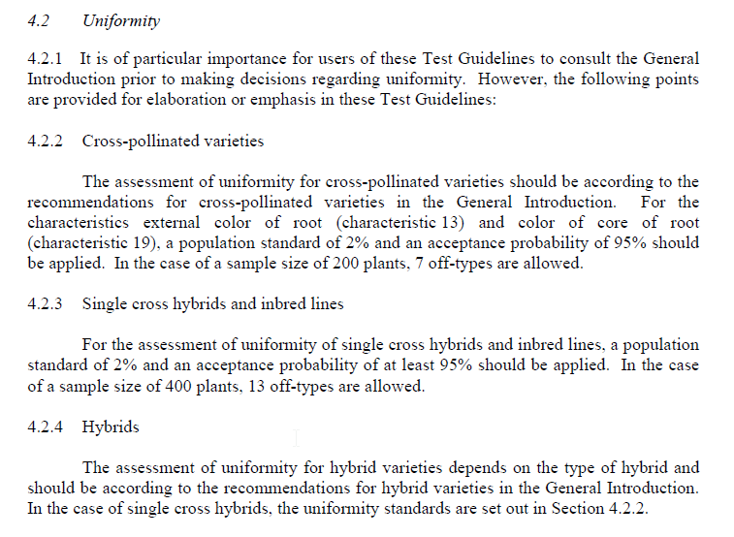
It is proposed to correct the reference in the last sentence of Section 4.2.4 to read as follows:

“4.2.4 Hybrids

The assessment of uniformity for hybrid varieties depends on the type of hybrid and should be according to the recommendations for hybrid varieties in the General Introduction. In the case of single cross hybrids, the uniformity standards are set out in Section 4.2.2 4.2.3.”

[End of document]

