E
TC/51/23
ORIGINAL: English
DATE: January 22, 2015
INTERNATIONAL UNION FOR THE PROTECTION OF NEW VARIETIES OF PLANTS
Geneva
Technical Committee
Fifty-First Session
Geneva, March 23 to 25, 2015

Revisions of document tgp/9: “examining distinctness”:
section 1.6: “schematic overview of TGP DOCUMENTS CONCERNING DISTINCTNESS”; section 2.5: “photographs”;
section 4.3.2: “Single record for a group of plants or parts of plants (G)” and 4.3.4: “Schematic Summary”
Document prepared by the Office of the Union
Disclaimer: this document does not represent UPOV policies or guidance

Executive summary

The purpose of this document is to present proposals for the revision of document TGP/9 “Examining distinctness”, Section 1.6 “Schematic overview of TGP documents concerning distinctness”, Section 2.5 “Photographs”, Section 4.3.2 “Single record for a group of plants or parts of plants (G)” and Section 4.3.4 “Schematic Summary”.

The TC is invited to consider the:

- proposal for revision of the flow diagram in TGP/9, Section 1.6 “Schematic overview of TGP documents concerning distinctness”, as set out in Annexes I and II to this document;

- proposed guidance on photographs for inclusion in document TGP/9, Section 2.5 “Photographs”, as set out in paragraph 16; and

- proposed example of a single record for a group of plants (MG) taken on plant parts for inclusion in document TGP/9, Section 4.3.2 “Single record for a group of plants or parts of plants (G)” and Section 4.3.4 “Schematic Summary”, as set out in paragraphs 23 and 24 and Annex IV to this document.

The structure of this document is as follows:

Executive summary 1
PURPOSE 3
section 1.6 Schematic overview of TGP documents concerning distinctness 3
Comments by the Technical Working Parties in 2014 3

Section 2.5 “photographs” 4
Comments by the Technical Working Parties in 2014 5

Section 4.3.2 “Single record for a group of plants or parts of plants (G)” and Section 4.3.4 “Schematic Summary” 5
Comments by the Technical Working Parties in 2014 6

ANNEX I: SCHEMATIC OVERVIEW OF TGP DOCUMENTS CONCERNING DISTINCTNESS
ANNEX II: SCHEMATIC OVERVIEW OF TGP DOCUMENTS
ANNEX III: EXAMPLES OF CHARACTERISTICS USING SINGLE MEASUREMENT (MG) FOR PLANT PARTS
ANNEX IV: SCHEMATIC SUMMARY OF SINGLE RECORD FOR A GROUP OF PLANTS OR PARTS OF PLANTS

The following abbreviations are used in this document:

CAJ: Administrative and Legal Committee
TC: Technical Committee
TC-EDC: Enlarged Editorial Committee
TWA: Technical Working Party for Agricultural Crops
TWC: Technical Working Party on Automation and Computer Programs
TWF: Technical Working Party for Fruit Crops
TWO: Technical Working Party for Ornamental Plants and Forest Trees
TWV: Technical Working Party for Vegetables
TWPs: Technical Working Parties

PURPOSE

The purpose of this document is to present proposals for the revision of document TGP/9 “Examining distinctness”, Section 1.6 “Schematic overview of TGP documents concerning distinctness”, Section 2.5 “Photographs”, Section 4.3.2 “Single record for a group of plants or parts of plants (G)” and Section 4.3.4 “Schematic Summary”.

section 1.6 Schematic overview of TGP documents concerning distinctness

The TC, at its fiftieth session held in Geneva, from April 7 to 9, 2014, considered the revision of the flow diagram in TGP/9 and agreed that it should be reviewed in conjunction with other possible changes to be introduced in documents TGP/4 “Constitution and Maintenance of Variety Collections” and TGP/9 “Examining Distinctness” resulting from the adoption of document TGP/15 “Guidance on the Use of Biochemical and Molecular Markers in the Examination of Distinctness, Uniformity and Stability (DUS)” (see document TC/50/36 “Report on the Conclusions”, paragraph 72) .

On the above basis, and taking into account revisions to other TGP documents, the TWPs, at their sessions in 2014, were invited to consider amending the flow diagram in document TGP/9 as follows:

Box “Forms of variety collection:” to read: “Varieties or living plant material not included in the variety collection”
Box “Data analysis Methods:” to read: “COYD; 2x1%; Chi-Square Test; Fisher’s Exact Test”

In addition, in order to simplify the diagram, the TWPs, at their sessions in 2014, were invited to consider deleting the boxes for documents TGP/6 “Arrangements for DUS Testing” and TGP/7 “Development of Test Guidelines” and to create a new diagram to provide an overview of the relevant TGP documents, set out in Annexes I and II, respectively.

Comments by the Technical Working Parties in 2014

At their sessions in 2014, the TWO, TWF, TWC, TWV and TWA considered documents TWO/47/22, TWF/45/22, TWV/48/22, TWC/32/22 and TWA/43/22, respectively, which contained proposals for the revision of document TGP/9 “Examining distinctness”, Section 1.6 “Schematic overview of TGP documents concerning distinctness”, as set out in paragraphs 7 and 8.

General | The TWO considered document TWO/47/22 and agreed with the proposed revision of the flow diagram in TGP/9, Section 1.6 “Schematic overview of TGP documents concerning distinctness”, as set out in document TWO/47/22, paragraph 7 and Annexes I and II (see document TWO/47/28 “Report”, paragraph 59). | TWO
 | The TWC considered document TWC/32/22.  The TWC agreed with the proposed revision of the flow diagram in TGP/9, Section 1.6 “Schematic overview of TGP documents concerning distinctness”, as set out in document TWC/32/22, paragraph 7 and Annexes I and II (see document TWC/31/32 “Report”, paragraphs 60 and 61). | TWC
 | The TWV considered document TWV/48/22 and agreed with the revision of the flow diagram in TGP/9, Section 1.6 “Schematic overview of TGP documents concerning distinctness”, as set out in document TWV/48/22, Annex I (see document TWV/47/34 “Report”, paragraph 63). | TWV
Annex II, TGP/3 box | The TWA considered document TWA/43/22 and the revision of the flow diagram in TGP/9, Section 1.6 “Schematic overview of TGP documents concerning distinctness”, as set out in Annexes I and II to document TWA/43/22.  The TWA noted that reference to document TGP/3 “Elaborating the notion of varieties of common knowledge” had not been included in the new schematic in Annex II of document TWA/43/22 and agreed that it should be consistent between the two schematics (see document TWA/43/27 “Report”, paragraphs 55 and 56). | TWA
Annex II, TGP/5 box | The TWF considered document TWF/45/22 and agreed with the revision of the flow diagram in TGP/9, Section 1.6 “Schematic overview of TGP documents concerning distinctness”, as set out in Annex I to document TWF/45/22. With regard to the Annex II to document TWF/45/22, the TWF proposed to extend the box for TGP/5 to supplementary procedures (see document TWF/44/31 “Report”, paragraph 50). | TWF
 | With regard to Annex II to document TWV/48/22, the TWV agreed with the proposal made by the TWF at its forty-fifth session to extend the box for TGP/5 to supplementary procedures. The TWV also suggested to clarify the term “supplementary procedures” (see document TWV/47/34 “Report”, paragraph 64). | TWV

Proposal

Annexes I and II to this document, as amended on the basis of the comments made by the TWPs at their sessions in 2014, provide a proposal for revision of the schematic overview of TGP documents.

The TC is invited to consider the proposal for revision of the flow diagram in TGP/9, Section 1.6 “Schematic overview of TGP documents concerning distinctness”, as set out in Annexes I and II to this document.

Section 2.5 “photographs”

The TC, at its forty-ninth session held in Geneva, from March 18 to 20, 2013, agreed to the new Additional Standard Wording (ASW 16) and Guidance Note (GN 35) for “providing photographs with the Technical Questionnaire” for inclusion in a future revision of document TGP/7 “Development of Test Guidelines” (see document TC/49/41 “Report on the Conclusions”, paragraphs 45 to 47). The new ASW 16 and GN 35 were adopted by the Council at its forty-eighth ordinary session, held in Geneva on October 16, 2014.

The TC, at its fiftieth session held in Geneva, from April 7 to 9, 2014, agreed to request an expert from Germany to develop guidance on the use of photographs for the analysis of distinctness for inclusion in document TGP/9. The new guidance would make reference to the complete guidance available in document TGP/7, GN 35 “Providing Photographs with the Technical Questionnaire” (see document TC/50/36 “Report on the Conclusions”, paragraph 42).

The following amendment to document TGP/9: Section 2.5 “Photographs” was proposed by the expert from Germany:

“2.5 Photographs

“2.5.1 Photographs can provide useful information as a basis to exclude varieties in the variety collection from the growing trial used for the examination of distinctness. In particular, photographs may provide information on characteristics not included in the TQ. This may, for example, concern shapes, plant structures or color patterns which are not easy for applicants to describe by means of Notes in the Table of Characteristics and, therefore, might not be included as characteristics in Section 5 of the TQ. In addition, the information provided in photographs on characteristics included in the TQ may be more discriminatory than that provided in Section 5 of the TQ and may allow more varieties to be excluded from the growing trial.

“2.5.2 Document TGP/7 indicates that, where useful for the DUS examination, the UPOV Test Guidelines may require that a representative color photograph of the variety accompanies the information provided in the Technical Questionnaire. In such cases, it is recommended that guidance be provided by the authority to enhance the usefulness of the photograph (e.g. to include a metric scale and a color scale in the picture, to define what parts of the plant should be included, to specify the light conditions and the background color, etc). However, the use of photographs for selecting varieties for the growing trial should take into account that, despite such guidance and the best endeavors of the breeder, photographs may not always accurately reflect the characteristics of the variety.”

“2.5.3 The suitability of photographs for the identification of similar varieties is strongly influenced by the quality of the photographs taken by the authority for the varieties in the reference collection and the photograph of the candidate variety provided by the applicant with the Technical Questionnaire. Comprehensive guidance for taking suitable photographs is provided in document TGP/7, GN 35. The guidance was developed in particular for the applicants to provide suitable photographs of the candidate variety. The same instructions are important and useful for the authorities to take photographs of the varieties in the variety collection under standardized conditions.”

Comments by the Technical Working Parties in 2014

At their sessions in 2014, the TWO, TWF, TWC, TWV and TWA considered documents TWO/47/22, TWF/45/22, TWV/48/22, TWC/32/22 and TWA/43/22, respectively, and agreed with the proposed guidance for the revision of document TGP/9 “Examining distinctness”, Section 2.5 “Photographs” as presented in paragraph 13 of this document and in the respective documents (see document TWO/47/28 “Report”, paragraph 60, document TWF/45/32 “Report”, paragraph 51, document TWC/32/28 “Report”, paragraph 62, document TWV/48/43 “Report”, paragraphs 65 and 66, and document TWA/43/27 “Report”, paragraph 57).

Proposal

On basis of the guidance proposed by the expert from Germany and comments by the TWPs, at their sessions in 2014, it is proposed to amendment document TGP/9: Section 2.5 “Photographs” to include a new paragraph, as follows:

“2.5.3 The suitability of photographs for the identification of similar varieties is strongly influenced by the quality of the photographs taken by the authority for the varieties in the reference collection and the photograph of the candidate variety provided by the applicant with the Technical Questionnaire. Comprehensive guidance for taking suitable photographs is provided in document TGP/7, GN 35. The guidance was developed in particular for the applicants to provide suitable photographs of the candidate variety. The same instructions are important and useful for the authorities to take photographs of the varieties in the variety collection under standardized conditions.”

The TC is invited to consider the proposed guidance on photographs for inclusion in document TGP/9, Section 2.5 “Photographs”, as set out in paragraph 16 of this document.

Section 4.3.2 “Single record for a group of plants or parts of plants (G)” and Section 4.3.4 “Schematic Summary”

The TC, at its fiftieth session held in Geneva, from April 7 to 9, 2014, agreed that examples and illustrations to explain a single measurement (MG) on plant parts should be compiled by the Office of the Union and presented to the TWPs for inclusion in a future revision of document TGP/9, Subsections 4.3.2 and 4.3.4 (see document TC/50/36 “Report on the Conclusions”, paragraph 71).

Annex III to this document provides examples of characteristics using single measurement (MG) for plant parts from Test Guidelines adopted in 2013 and 2014.

The TWPs, at their sessions in 2014, were invited to consider adding the following example of single record for a group of plants (MG) taken on plant parts for inclusion in a future revision of document TGP/9, Subsection 4.3.2:

“Example (MG)

“Measurement (MG): “Leaf blade: width” in Hosta (vegetatively propagated) in a trial consisting of plants grown in pots: a leaf from a representative plant is measured.”

A suitable illustration would be provided for inclusion in Subsection 4.3.4.

Comments by the Technical Working Parties in 2014

The TWO, TWF, TWC, TWV and TWA considered documents TWO/47/22, TWF/45/22, TWC/32/22, TWV/48/22 and the proposed example of a single record for a group of plants (MG) taken on plant parts for inclusion in a future revision of document TGP/9, Section 4.3.2 “Single record for a group of plants or parts of plants (G)” and Section 4.3.4 “Schematic Summary”, as set out in paragraphs 18 and 19 of this document.
General | The TWO noted that in order to obtain a single record for a group of plants (MG) taken on plant parts of vegetatively propagated plants the DUS examiner would visually assess the plants and confirm they are uniform before proceeding further. The approach is the same as in the “Plant: height” example but organs are removed to conduct the assessment. A typical plant is used to record the measurement. The TWO noted that no variety mean was calculated and that the measurement was used for comparing data with other varieties in the variety collection (see document TWO/47/28 “Report”, paragraph 93). | TWO
 | The TWF noted the comment from the expert from Germany in relation to the method of observation MG in current adopted Test Guidelines for fruit species, where all morphological characteristics are indicated as VG/MS, while phenological characteristics indicated as MG. In the case of assessments made on organs taken from all over the plot without noting the individual plants, (e.g. taking a representative fruit sample after harvest), the method of observation should be indicated as MG. In a number of existing Test Guidelines for fruit crops, the method of observation should therefore be reconsidered.  The TWF agreed that the comment made by the TWO at its forty-seventh session, to declare a single plant as representative for the entire plot, as soon as uniformity aspects has been found sufficiently fulfilled, is not so applicable in the fruit sector.  The TWF agreed that MS should only be considered where each individual plant is measured. In case of several measurements taken for a group of plants or a few groups of plants within the same sample, it should be considered as MG (see document TWF/45/32 “Report”, paragraphs 55 to 57). | TWF
 | The TWC noted the proposed example of a single record for a group of plants (MG) taken on plant parts for inclusion in a future revision of document TGP/9, Subsections 4.3.2 “Single record for a group of plants or part of plants (G)” and 4.3.4 “Schematic summary”, as set out in document TWC/32/22, paragraphs 16 and 17 (see document TWC/32/28 “Report”, paragraph 63). | TWC
Example | The TWO, TWF, TWV and TWA agreed that the example of a single record for a group of plants (MG) taken on plant parts for inclusion in a future revision of document TGP/9, Section 4.3.2 “Single record for a group of plants or parts of plants (G)” and Section 4.3.4 “Schematic Summary” should read as follows (see documents TWO/47/28 “Report”, paragraph 94; TWF/45/32 “Report”, paragraph 53; TWV/48/43 “Report”, paragraph 68; and TWA/43/27 “Report”, paragraphs 58 and 59):  “Example (MG)  “Measurement (MG): “Leaf blade: width” in Hosta (vegetatively propagated): a representative measurement in the plot.” | TWO
Illustration | The TWO and TWF agreed that a suitable illustration should be provided for inclusion in document TGP/7, Subsection 4.3.4 (see documents TWO/47/28 “Report”, paragraph 95; and TWF/45/32 “Report”, paragraph 54). | TWO
 | The TWV noted the comment made by TWO at its forty-seventh session that a suitable illustration should be provided for inclusion in document TGP/7, Subsection 4.3.4 but agreed that this approach was not applicable in the vegetable sector and, therefore, could not help in providing a suitable illustration (see document TWV/48/43 “Report”, paragraph 69) | TWV

Proposal

On basis of the comments by the TWPs at their sessions in 2014, the following example of a “single record for a group of plants (MG) taken on plant parts” is proposed for inclusion in a future revision of document TGP/9, Section 4.3.2 “Single record for a group of plants or parts of plants (G)” and Section 4.3.4 “Schematic Summary”:

“Example (MG)

“Measurement (MG): ‘Leaf blade: width” in Hosta (vegetatively propagated): a representative measurement in the plot.’”

An illustration is proposed for inclusion in Subsection 4.3.4, as presented in Annex IV to this document.

The TC is invited to consider the proposed example of a single record for a group of plants (MG) taken on plant parts for inclusion in document TGP/9, Section 4.3.2 “Single record for a group of plants or parts of plants (G)” and Section 4.3.4 “Schematic Summary”, as set out in paragraphs 23 and 24 and Annex IV to this document.

[Annexes follow]

SCHEMATIC OVERVIEW OF TGP DOCUMENTS CONCERNING DISTINCTNESS

Variety descriptions
Living plant material
Cooperation in maintenance
SELECTING VARIETIES FOR THE GROWING TRIAL
MAINTENANCE OF VARIETY COLLECTIONS
GENERAL INTRODUCTION
notion of Varieties
of Common Knowledge

TGP/4

Forms of variety collection:
- descriptions
- living plant material
Range of the variety collection
Varieties or living plant material not included in the variety collection

Constitution of variety collections

TGP/8
TGP/9

Types of varieties
Grouping varieties on the basis of characteristics
Characteristics in combination
Photographs
Parent formula (Hybrids)
Guidance
Methods:
- parent formula (hybrids)
- GAIA

DUS trial design
GROWING
TRIAL ORGANIZATIONNN

Grouping similar varieties

Validation of data and assumptions
Examining DUS in bulk samples
OBSERVATION
OF CHARACTERISTICS
Methods of observation (V/M)
Type of record(s) (G/S)
Recommendations in UPOV Test Guidelines

Data analysis methods:
- COYD
- 2x1%
- Chi-Square Test
- Fisher’s Exact Test
- Match Approach

Side-by-side visual comparison
Notes / single variety records
Statistical analysis of growing trial data
ASSESSING DISTINCTNESS IN THE GROWING TRIAL

Publication of variety descriptions
Cooperation between members of the Union
Use of randomized “blind” testing
Advice of plant experts

SUPPLEMENTARY PROCEDURES

SCHEMATIC OVERVIEW OF TGP DOCUMENTS

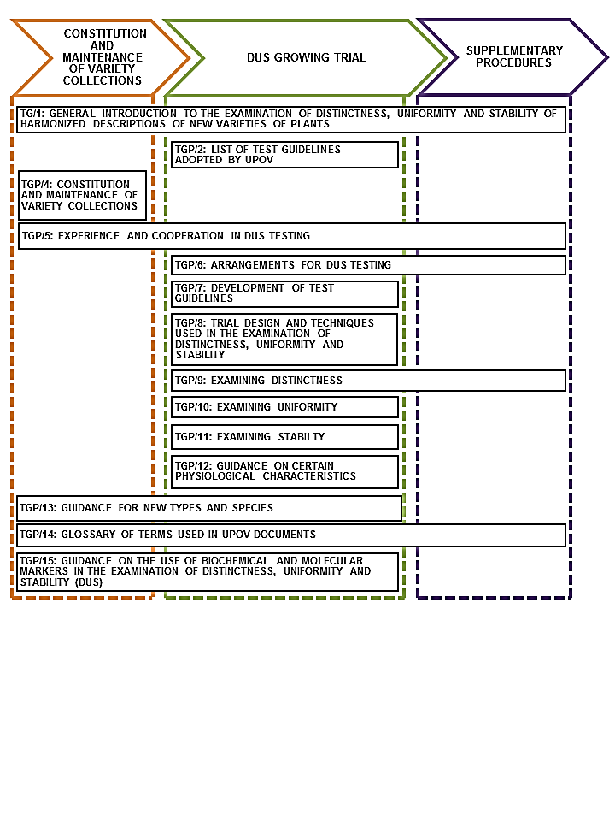[Annex III follows]

EXAMPLES OF CHARACTERISTICS USING SINGLE MEASUREMENT (MG) FOR PLANT PARTS

Document TG/HOSTA(proj.9)

4.  (*) | VG/MG/MS | Petiole: length | Pétiole : longueur | Blattstiel: Länge | Pecíolo: longitud
QN | (a) | very short | très court | sehr kurz | muy corto | Desert Mouse | 1
 |  | short | court | kurz | corto | Time Tunnel | 3
 |  | medium | moyen | mittel | medio | Earth Angel | 5
 |  | long | long | lang | largo | Blue Circle | 7
 |  | very long | très long | sehr lang | muy largo | Big Boy, Flower Power, Green Acres | 9
9.  (*) | VG/MG/MS | Leaf blade: width | Limbe : largeur | Blattspreite: Breite | Limbo: anchura
QN | (a) | very narrow | très étroit | sehr schmal | muy estrecho | Desert Mouse | 1
 |  | narrow | étroit | schmal | estrecho | Secret Ambition | 3
 |  | medium | moyen | mittel | medio | Risky Business | 5
 |  | broad | large | breit | ancho |  | 7
 |  | very broad | très large | sehr breit | muy ancho | Big Boy,  Sum and Substance | 9

Document TG/286/1 Hebe

8.  (*) | VG/  MG | Stem: length of internodes | Tige : longueur des entre-nœuds | Trieb: Internodienlänge | Tallo: longitud de los entrenudos
QN | (c) | very short | très courts | sehr kurz | muy corta | Karo Golden Esk | 1
 |  | short | courts | kurz | corta | Beverley Hills | 3
 |  | medium | moyens | mittel | media | Wiri Desire | 5
 |  | long | longs | lang | larga | Moonlight | 7

Document TG/288/1 Dianella

3.  (+) | VG/  MG | Stem: internode length | Tige : longueur de l’entre-nœud | Stengel: Internodienlänge | Tallo: longitud del entrenudo
QN | (a) | very short | très court | sehr kurz | muy corto | TAS300 | 1
 |  | short | court | kurz | corto | TR20 | 3
 |  | medium | moyen | mittel | medio |  | 5
 |  | long | long | lang | largo | Goddess | 7
 |  | very long | très long | sehr lang | muy largo |  | 9

Ad. 3: Stem: internode length

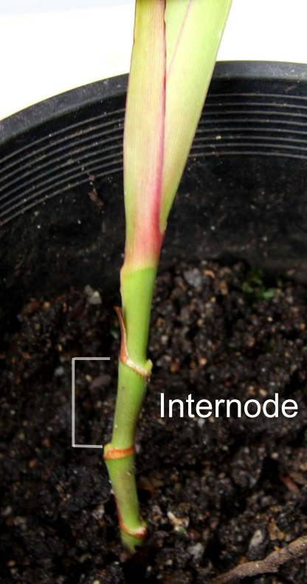

27. | VG/  MG | Perianth: diameter | Périanthe : diamètre | Blütenhülle: Durchmesser | Perianto: diámetro
QN | (c) | small | petit | klein | pequeño |  | 1
 |  | medium | moyen | mittel | medio |  | 2
 |  | large | grand | groß | grande |  | 3

[Annex IV follows]
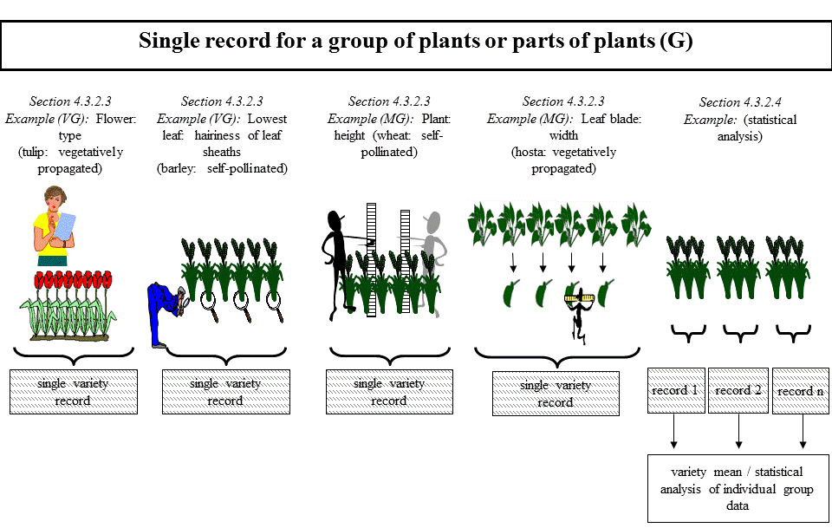

Reference to document UPOV/TGP/15 “Guidance on the Use of Biochemical and Molecular Markers in the Examination of Distinctness, Uniformity and Stability (DUS)” corrected from document TC/50/36 “Report on the Conclusions”, paragraph 72.

