E
TC/51/17
ORIGINAL: English
DATE: March 3, 2015
INTERNATIONAL UNION FOR THE PROTECTION OF NEW VARIETIES OF PLANTS
Geneva
Technical Committee
Fifty-first Session
Geneva, March 23 to 25, 2015
Revision of document TGP/8: Part II: Selected Techniques Used in DUS Examination, Section 9: THE COMBINED-OVER-YEARS UNIFORMITY CRITERION (COYU)
Document prepared by the Office of the Union
Disclaimer: this document does not represent UPOV policies or guidance
The purpose of this document is to report on developments concerning the method of calculation of COYU.

The following abbreviations are used in this document:

TC: Technical Committee
TC-EDC: Enlarged Editorial Committee
TWA: Technical Working Party for Agricultural Crops
TWC: Technical Working Party on Automation and Computer Programs
TWF: Technical Working Party for Fruit Crops
TWO: Technical Working Party for Ornamental Plants and Forest Trees
TWPs: Technical Working Parties
TWV: Technical Working Party for Vegetables

BACKGROUND

The background to this matter is provided in document TC/50/22 “Revision of document TGP/8: Part II: Selected Techniques Used in DUS Examination, Section 9: The Combined-Over-Years Uniformity Criterion (COYU)”.

DEVELOPMENTS IN 2014

Technical Committee

The TC, at its fiftieth session, held in Geneva, from April 7 to 9, 2014, considered document TC/50/22 and received a presentation by Mr. Adrian Roberts, United Kingdom, on “Proposed Improvements to COYU”. It noted that a copy of the presentation was made available as an addendum to document TC/50/22 (see document TC/50/36 “Report on the Conclusions”, paragraph 48).

The TC noted the developments in the work concerning the proposals to address the bias in the present method of calculation of COYU, as set out in document TC/50/22, paragraphs 8 to 21 (see document TC/50/36, paragraph 49).

The TC agreed that the development of a demonstration module in DUST should be continued and demonstrated to the TWC at its session in 2014. The TC agreed that a practical exercise should be conducted using real data to compare decisions made using the current and the proposed improved method (see document TC/50/36, paragraph 50).

The TC requested the Office of the Union to issue a new circular inviting further information on the extent and modalities of use of the current COYU method, in advance of the thirty-second session of the TWC (see document TC/50/36, paragraph 51).

Technical Working Parties

At their sessions in 2014, the TWO, TWF, TWC, TWV and TWA considered documents TWO/47/16, TWF/45/16, TWC/32/16, TWC/32/16 Add., TWV/48/16 and TWA/43/16 “Revision of document TGP/8: Part II: Selected Techniques Used in DUS Examination, Section 9: The Combined-Over-Years Uniformity Criterion (COYU)”, respectively.

The TWO, TWF, TWV and TWA noted the developments concerning the method of calculation of COYU, including the development of a demonstration module in DUST and the practical exercise that would be conducted using real data to compare decisions made using the current and the proposed improved method (see documents TWO/47/28 “Report”, paragraph 42, TWF/45/32 “Report”, paragraph 33, TWV/48/43 “Report”, paragraph 38 and TWA/43/27 “Report”, paragraph 35).

The TWC received a presentation by an expert from the United Kingdom on the method for improving the calculation of COYU, including a demonstration version of a module for the DUST software in the Annex for document TWC/32/16 Add. “Addendum to Development of the Combined-Over-Year Uniformity Criterion” (see document TWC/32/28 “Report”, paragraph 13). A copy of the Annex to document TWC/32/16 Add is reproduced in the Annex to this document.

The TWC agreed to request the experts from China, Czech Republic, Finland, France, Germany, Kenya, Netherlands and Poland to test the new software on COYU (see document TWC/32/28, paragraph 14).

The TWC also agreed to invite other users of the COYU method to test the new software and agreed that an invitation should be developed by the Leading Expert and sent by the Office of the Union to the users of the DUST software package (see document TWC/32/28, paragraph 15).

The TWC agreed that the software module for calculation of COYU developed using the “R” software should be sent to the interested experts that use other systems than DUST (e.g. SAS and GenStat) for testing of the new method (see document TWC/32/28, paragraph 16).

The TWC agreed that participants should seek to define probability levels to match decisions using the previous COYU method for continuity in decisions and that the test should be run for rejection probabilities of 1, 2 and 5% levels. The TWC agreed that participants should assess whether the results were consistent in all crops (see document TWC/32/28, paragraph 17).

The TWC agreed with the timetable for the development of the new software package for the COYU method, as follows (see document TWC/32/28, paragraph 18):

• By the end of July 2014, the UPOV Office with assistance from the expert of the United Kingdom would invite participants for the practical exercise.
• By the end of September 2014, the expert of the United Kingdom would develop further the DUST module demonstrated at the thirty-second session of the TWC for evaluation by the participants and would prepare code for “R” software for participants that prefer this option to the DUST module.
• By early October 2014, the expert of the United Kingdom would send details of the practical exercise, including access to software, to the participants.
• By March 15, 2015, participants of the practical exercise should send a report on their experiences to the expert of the United Kingdom.
• The expert of the United Kingdom would compile a report on the practical exercise and the development of DUST module for the thirty-third session of the TWC.

On July 21, 2014, circular E 14/193 “TWC/32: Participation in Practical Exercise (COYU)” was sent to the TC and the TWC members. The Czech Republic, Finland, France, Germany, Kenya, Poland and United Kingdom replied that they wished to participate in the exercise. The expert of the United Kingdom developed software modules for calculation of COYU with a guidance document for the exercise: for participants using the “R” software, the module for “R” software and the guidance document were distributed on October 15, 2014, followed by a revised guidance document on October 21, 2014; and for “DUSTNT” software users, a version with a module for the exercise and guidance document were distributed on December 5.

The TC is invited to note:

(a) that participants of the exercise to test the software on the new method for the calculation of COYU should:
(i) seek to define probability levels to match decisions using the previous COYU method;

(ii) run the test for rejection probabilities of 1, 2 and 5% levels; and

(iii) assess whether the results are consistent in all crops;

(b) that the expert from the United Kingdom distributed the software module for calculation of COYU and the guidance document to the participants of the exercise;

(c) that the experts from Czech Republic, France, Finland, Germany, Kenya, Poland and United Kingdom will participate in the exercise to test the new software on COYU; and

(d) that a report on the practical exercise and the development of DUST module will be presented at the thirty-third session of the TWC.

[Annex follows]

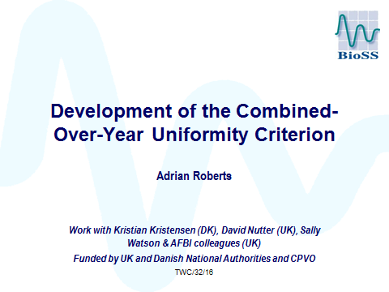

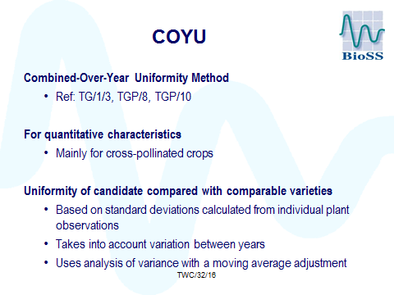

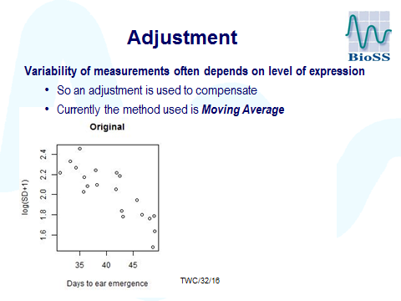

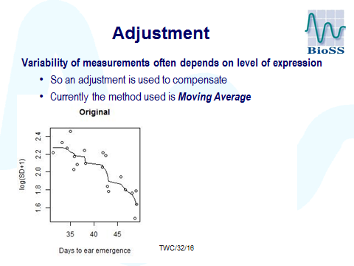

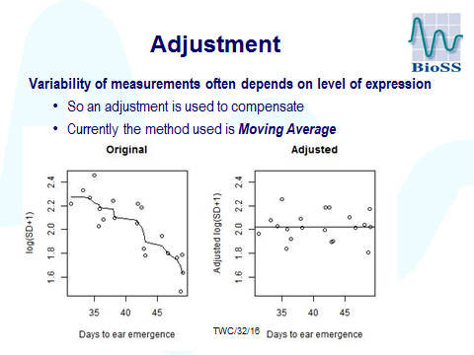

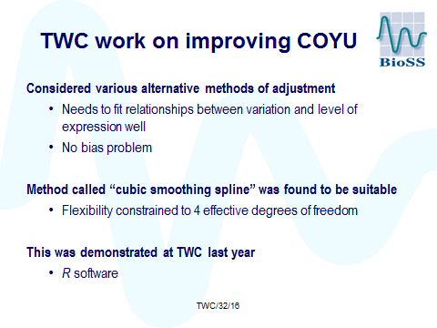

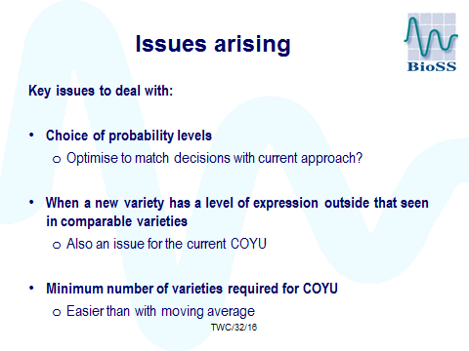

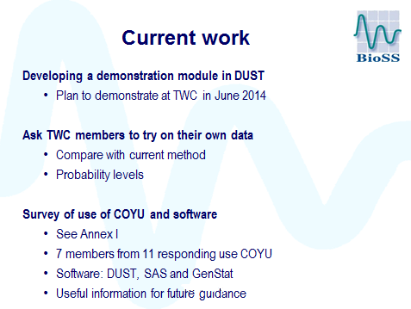

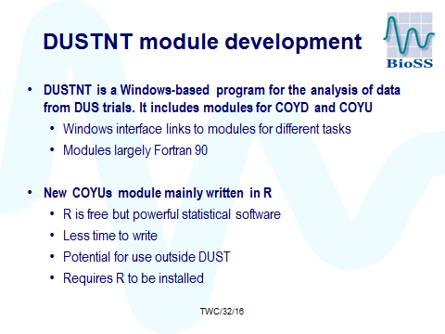

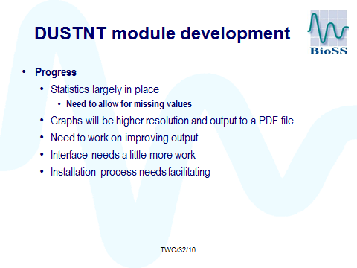

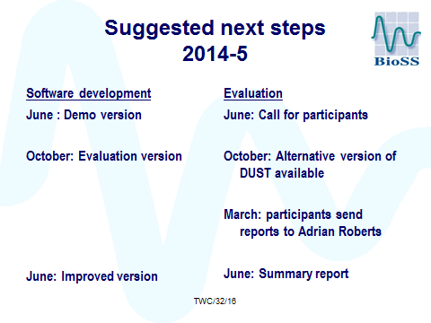

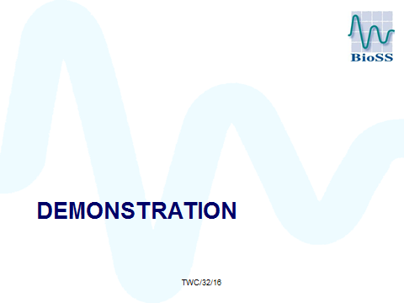

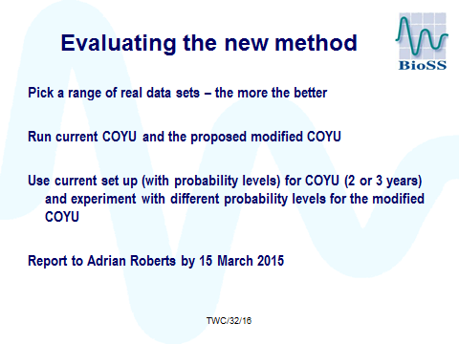

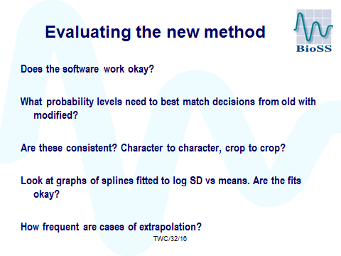

[End of Annex and of document]

