 |  | E  TC/50/7  ORIGINAL: English  DATE: January 30, 2014
INTERNATIONAL UNION FOR THE PROTECTION OF NEW VARIETIES OF PLANTS
Geneva
Technical Committee
Fiftieth Session
Geneva, April 7 to 9, 2014
Variety description databases
Document prepared by the Office of the Union
Disclaimer: this document does not represent UPOV policies or guidance
1 The purpose of this document is to report on developments concerning variety description databases.

2 The following abbreviations are used in this document:

TC: Technical Committee
TC-EDC: Enlarged Editorial Committee
TWA: Technical Working Party for Agricultural Crops
TWC: Technical Working Party on Automation and Computer Programs
TWF: Technical Working Party for Fruit Crops
TWO: Technical Working Party for Ornamental Plants and Forest Trees
TWPs: Technical Working Parties
TWV: Technical Working Party for Vegetables

3 The structure of this document is as follows:

Background 1
Developments in 2013 2
ANNEX: REFERENCE COLLECTION AND GROUPING CHARACTERISTICS- EXAMPLE OF THE PEA SPECIES

Background

4 At its forty-fifth session, held in Geneva from March 30 to April 1, 2009, the Technical Committee (TC) noted from the developments reported in document TC/45/9 “Publication of Variety Descriptions” that members of the Union were developing databases containing morphological and/or molecular data and, where considered appropriate, were collaborating in the development of databases for the management of variety collections, particularly on a regional basis. The TC agreed that it could be beneficial to offer the possibility for members of the Union to report on that work in a coherent way to the TC, the Technical Working Parties (TWPs) and the Working Group on Biochemical and Molecular Techniques and DNA Profiling in Particular (BMT). On that basis, the TC agreed to replace the agenda item “Publication of variety descriptions” with an item for “Variety description databases” on the agendas of the forthcoming sessions of the TC, TWPs and the BMT. In that respect, it recalled the importance of the list of criteria for consideration for the use of descriptions obtained from different locations and sources as set out in document TC/45/9, paragraph 3. The TC also agreed that the information presented would not need to be related to the publication of descriptions (see document TC/45/16 “Report”, paragraph 173).

Developments in 2013

5 The Annex to this document contains a presentation on “Reference Collection and Grouping Characteristics; Example of the Pea Species”, prepared by experts from France, on the basis of replies from the Questionnaire on Variety Description for Pea (Partial Revision) circulated to UPOV members.

Technical Committee

6 The TC, at its forty-ninth session in Geneva from March 18 to 20, 2013, considered document TC/49/9 “Variety Description Databases” and received a presentation by Mr. François Boulineau (France) (see document TC/49/41 “Report on the Conclusions”, paragraphs 100 to 103).

7 The TC noted the developments on variety description databases, as set out in document TC/49/9.

8 The TC noted that the results of the study on Pea would be presented to the TWA and the TWV in order to:

(i) select characteristics to be used as grouping characteristics according to their qualities (discriminating power, distortion, use);

(ii) develop a procedure to improve the pea database; and

(iii) consider making the pea database available to all examination offices.

9 The TC agreed that the results of the study should be presented to other TWPs for their comments on the approach for managing variety collections and noted that the TWF would consider the results of the model study on Apple, as presented in document TC/41/9 “Publication of Variety Descriptions” (see document TC/49/41 “Report on the Conclusions”, paragraphs 100 to 103).

Technical Working Party for Agricultural Crops

10 The TWA, at its forty-second session, held in Kyiv, Ukraine, from June 17 to 21, 2013 considered document TWA/42/6 “Variety description databases” and document TWA/42/25 “Pea database study”. The TWA noted the report on the Pea Database study as presented in document TWA/42/25 and the approach for managing variety collections of Pea as presented in the Annex to document TWA/42/25.

11 The TWA welcomed the results of the study on the Pea Database and noted that it presented a good method for improvement of Test Guidelines (see document TWA/42/31 “Report” paragraphs 105 to 108).

Technical Working Party for Vegetables

12 The TWV, at its forty-seventh session, held in Nagasaki, Japan, from May 20 to 24, 2013 considered document TWV/47/6 “Variety description databases” and document TWV/47/25 “Pea database study”. The TWV noted the report on the Pea Database study as presented in document TWV/47/25 and the approach for managing variety collections of pea as presented in the Annex to document TWV/47/25.

13 The TWV requested the expert from France to make a presentation, at its forty-eighth session, on the GEMMA software being used by the Group for Study and Control of Varieties and Seeds (GEVES) in a Community Plant Variety Office of the European Union (CPVO) Research and Development project. This software is seen as being adapted for the development of such a common database (see document TWV/47/34 “Report” paragraphs 109 to 112).

Technical Working Party on Automation and Computer Programs

14 The TWC, at its thirty-first session, held in Seoul, from June 4 to 7, 2013 considered document TWC/31/6 “Variety description databases” and document TWC/31/25 “Pea database study”. The TWC noted the developments on variety description databases and congratulated the experts from France on the study on the Pea Database. The TWC agreed on the possible use of image analysis for reducing distortion in some characteristics, while noting that image analysis had its own sources of distortion.

15 The TWC welcomed the offer from China to make a presentation on variation of variety descriptions over years in different locations, to be presented the TWC at its thirty-second session (see document TWC/31/32 “Report” paragraphs 63 to 65).

16 The TWC also considered document TWC/31/2 “Molecular Techniques” and received a presentation from experts from China on the research on the construction of DNA fingerprint database in Maize and suggested that the information be made available to the BMT. A copy of the presentation is provided in document TWC/31/2 Add..

Technical Working Party for Fruit Crops

17 The TWF, at its forty-fourth session, held in Napier, New Zealand, from April 29 to May 3, 2013, considered document TWF/44/6 “Variety description databases” and document TWF/44/25 “Pea database study”. The TWF noted the report on the Pea Database study as presented in document TWF/44/25 and the approach for managing variety collections as presented in the Annex to document TWF/44/25.

18 The TWF noted that an expert from the European Union would prepare a document on the development of a database for Peach, in a similar way to the database being developed for Pea, which would be presented at the forty-fifth session of the TWF in 2014. The TWF noted that it would be necessary to clarify in the study the different objectives of creating databases, in order to identify the characteristics for which information was required, with a view to limiting costs and work load (see document TWF/44/31 “Report” paragraphs 94 to 97).

Technical Working Party for Ornamental Plants and Forest Trees

19 The TWO, at its forty-sixth session, held in Melbourne, Australia, from April 22 to 26, 2013, considered document TWO/46/6 “Variety description databases” and document TWO/46/25 “Pea database study”. The TWO noted the developments on variety description databases.

20 The TWO agreed that the approach for managing variety collections as used in the Pea database provided a useful tool for the development of Test Guidelines, selection of grouping characteristics and identifying varieties that would be used in the DUS trials. The TWO noted the approach for managing variety collections as presented in the Annex to document TWO/46/25 (see document TWO46/29 “Report” paragraphs 90 to 95).

21 The TWO requested an expert from Australia to lead an initial study on the viability of the development of a database for a crop of interest to the TWO, in a similar way to the database being developed for Pea, which would be presented at the forty-seventh session of the TWO. The TWO recognized the need to clearly define the scope and objectives in developing such a database. Experts from the European Union and the Netherlands would participate in the initial study.

22 The TC is invited to note the developments on variety description databases, as set out in paragraphs 10 to 21 of this document and, in particular, that:

- the TWV has requested an expert from France to make a presentation, at its forty-eighth session, on the GEMMA software being used by the Group for Study and Control of Varieties and Seeds (GEVES) in a Community Plant Variety Office of the European Union (CPVO) Research and Development project;

- the TWC has invited an expert from China to make a presentation on variation of variety descriptions over years in different locations, at its thirty-second session;

- the TWC has suggested the information presented by experts from China, at its thirty-first session, on the research on the construction of DNA fingerprint database in Maize, should be made available to the BMT;

- the TWF has invited an expert from the European Union to present the development of a database for Peach, at its forty-fifth session; and

- the TWO has requested an expert from Australia to lead an initial study on the viability of the development of a database, in a similar way to the database being developed for Pea, at its forty-seventh session.

[Annex follows]

REFERENCE COLLECTION AND GROUPING CHARACTERISTICS
EXAMPLE OF THE PEA SPECIES

Background

The Technical Working Party for Vegetables (TWV), at its forty-fifth session held in Monterey, United States of America, from July 25 to 29, 2011, considered document TWV/45/24 “Partial Revision of the Test Guidelines for Pea (document TG/7/10)”, presented by Mr. François Boulineau (France), in conjunction with documents TWV/45/6 “Variety Descriptions Databases” and TWV/45/13 “Concept of a Database Containing Pea Variety Descriptions”. It agreed that Mr. Boulineau should seek variety descriptions from members of the Union for the 2,400 (approximate) varieties of common knowledge that he had identified, to examine if the following characteristics were sufficiently reliable for use as grouping characteristics:

Current grouping characteristics:

Plant: anthocyanin coloration (characteristic 1)
Stem: number of nodes up to and including first fertile node (characteristic 5)
Leaf: leaflets (characteristic 8)
Stipule: flecking (characteristic 20)
Pod: parchment (characteristic 39)
Excluding varieties with pod parchment: entire: Pod: thickened wall (characteristic 40)
Only varieties with Pod: thickened wall: absent: Pod: shape of distal part (characteristic 41)
Pod: color (characteristic 43)
Immature seed: intensity of green color (characteristic 47)
Seed: type of starch grains (characteristic 49)
Seed: color of cotyledon (characteristic 52)
Only varieties with plant anthocyanin coloration present: Seed: marbling of testa (characteristic 53)
Only varieties with plant anthocyanin coloration present: Seed: violet or pink spots on testa (characteristic 54)
Seed: hilum color (characteristic 55)
Resistance to Fusarium oxysporum f. sp. pisi (characteristic 58.1)

Potential grouping characteristic:

Stem: fasciation (characteristic 3)
Stem: length (characteristic 4)
Foliage: color (characteristic 6)
Leaf: leaflets (characteristic 8)
Time of flowering (characteristic 24
Only varieties with stem fasciation absent: Plant: maximum number of flowers per node (characteristic 25)
Only varieties with plant anthocyanin coloration present: Flower: color of wing (characteristic 26)
Pod: length (characteristic 37)
Pod: width (characteristic 38)
Only varieties with Pod: thickened wall absent: Pod: shape of distal part (characteristic 41)
Pod: curvature (characteristic 42)
Only varieties with pod color green (Char. 43: state 2): intensity of green color (characteristic 44)
Excluding varieties with pod parchment: entire: Pod: suture strings (characteristic 45)
Seed: shape (characteristic 48)
Seed: weight (characteristic 57)
Resistance to Erysiphe pisi Syd. (characteristic 59)
Resistance to Ascochyta pisi, Race C (characteristic 60)

Circular E_12/079 - Questionnaire on Variety Descriptions for Pea (Partial Revision)

The TWV agreed that a circular should be prepared by Mr. Boulineau and issued by the Office of the Union to the Technical Committee representative for the following members of the Union, on the basis that they had indicated practical experience in the DUS examination of Pea:

Argentina; Austria; Bulgaria; Canada; China; Czech Republic; Denmark; Estonia; European Union (Community Plant Variety Office (CPVO)); France; Germany; Hungary; Japan; Kenya; Netherlands; New Zealand; Poland; Portugal; Republic of Korea; Republic of Moldova; Romania; Russian Federation; Slovakia; South Africa; Spain; Ukraine; United Kingdom; United States of America;

The TWV agreed that the contributors of variety descriptions should be invited to indicate the status of the variety descriptions provided and, in particular, if they constituted the “official” description of the variety concerned.

UPOV members contribution:
Following the propositions made during TWV/45, concerning the reference collection and the grouping characteristics of pea varieties, two Excel files have been sent.

- Excel File: Pea_Theoretical collection(V31jan2012) which is a compilation of varieties that are considered to be relevant for inclusion in the reference collection. According to the origin of each variety, some information is given on its administrative situation:
Yellow: varieties from the EU list (European Common Catalogue)
Green: varieties from the CPVO database
Blue: varieties from PLUTO, the UPOV Plant Variety Database
Orange: varieties from the OECD list
Pink: varieties under PMA (Provisional Market Authorization) in the EU system

On the right side of this file, three columns were proposed to be completed by UPOV members:
x Relevant variety for the reference collection: According to the administrative information or the knowledge of the variety, should this variety appear in the reference collection ?
(Y: yes; N: no)
y Available description: Does the country have a description (at least for grouping characteristics) of this variety ? ?(Y: yes; N: no)
z Reference collection: Is this variety in the reference collection of the country, (seeds available)? (Y: yes; N: no)

- Excel File: Pea_Grouping characteristics which concerns the descriptions for grouping characteristics proposed to be included in the pea guideline. When an available description exists, the country is invited to complete this file.

If the UPOV member consider that any other varieties are relevant for the reference collection, it is pleased to add them at the end of the file.

Completed Excel files have been sent to Mr. François BOULINEAU at francois.boulineau@geves.fr and Ms. Stéphanie CHRISTIEN at stephanie.christien@geves.fr, with a copy to the Office of the Union (upov.mail@upov.int).

Results

Replies to the questionnaire
The Pea theoretical collection is composed of more than 3,100 well known varieties.
7,511 descriptions (complete or partial) were received, concerning 2,524 varieties, which represents more tan 80% of the varieties present in the theoretical collection.

14 UPOV members sent information:
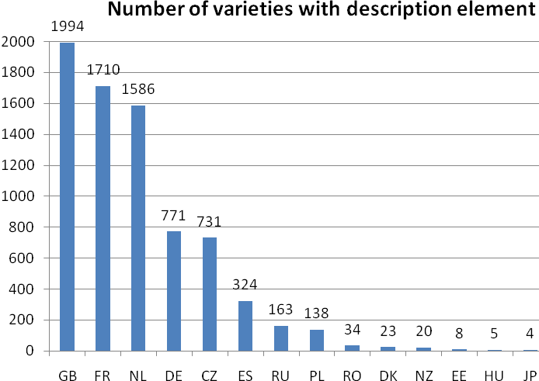

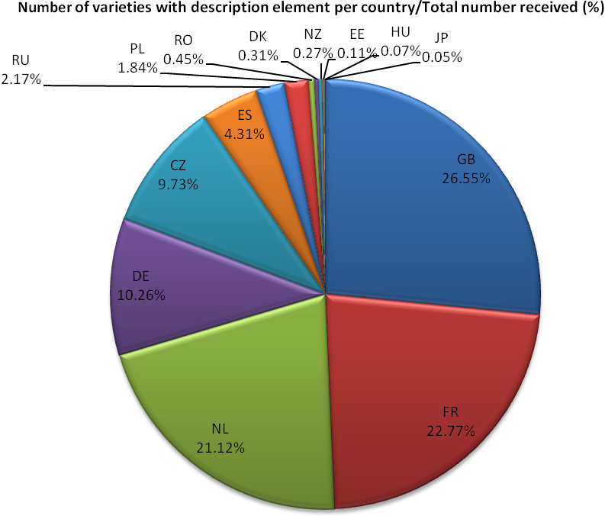
Properties of individual characteristics
Three indicators have been defined:
- Use of the characteristic
Number of times the characteristic is described for the described varieties

- Discriminating power of the characteristic
Percentage of excluded varieties on the basis of the characteristic

- Distortion of the characteristic
Percentage of distortion for a characteristic corresponds to percentage of varieties for which different levels of expression of the observed characteristic have been recorded (depending on examination conditions, climate, stress, recorder, mistakes, etc.)
- For qualitative or pseudo-qualitative characteristics: number of varieties with different notes among the varieties described for this characteristic;
- For quantitative characteristics: number of descriptions with a note not included in the interval [note medium + or - 1.5] among the descriptions received for the characteristic.

Use of the characteristic

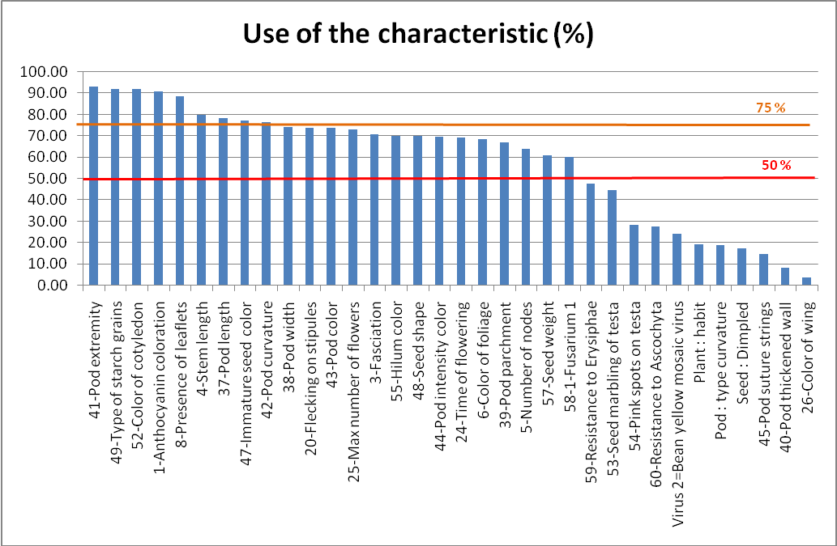

Discriminating power of the characteristic
Qualitative and Pseudo-qualitative characteristics

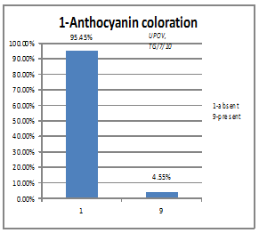 | 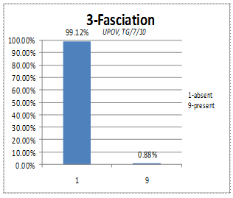
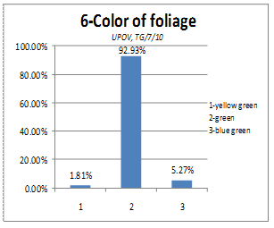 | 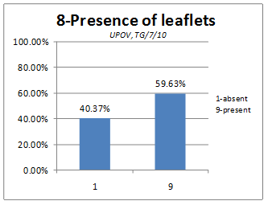
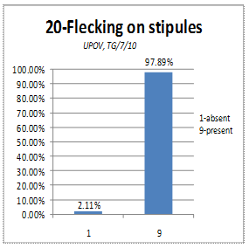 | 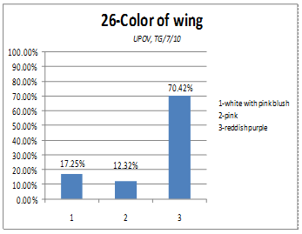
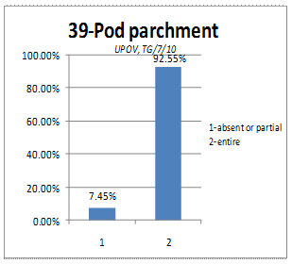 | 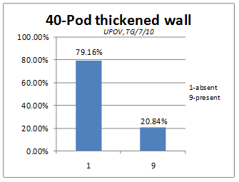
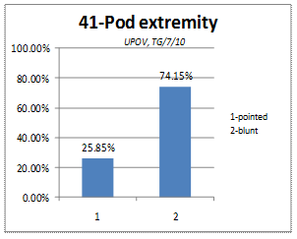 | 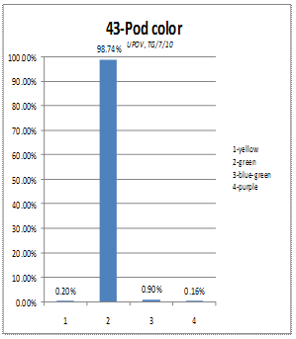
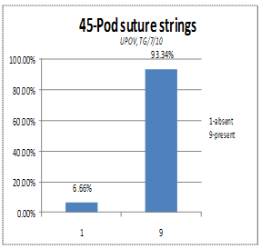 | 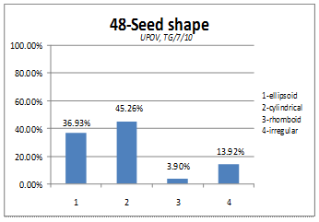
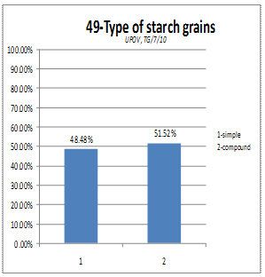 | 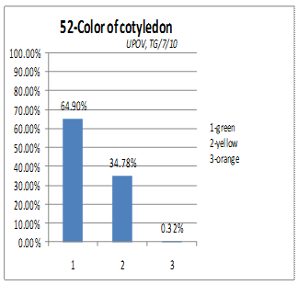
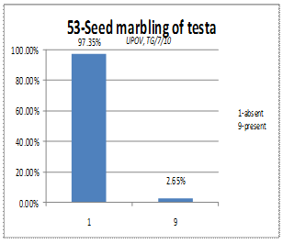 | 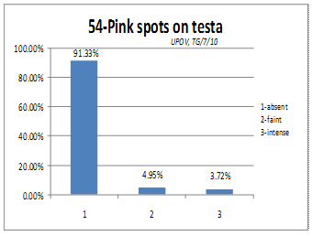
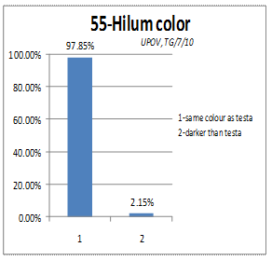 | 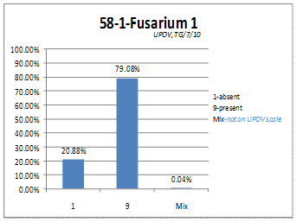
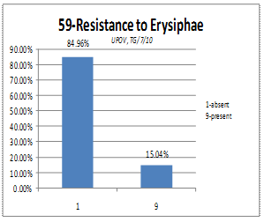 | 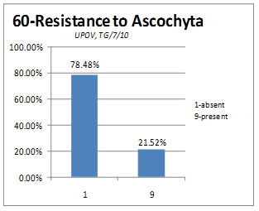
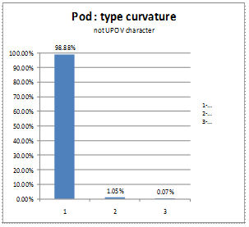 | 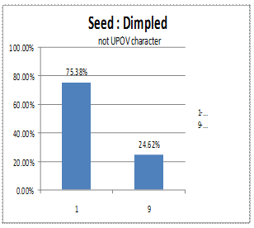
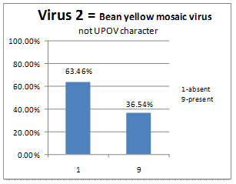

Quantitative characteristics
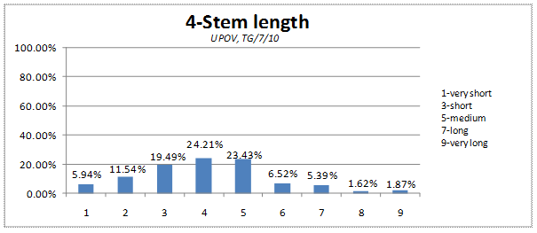
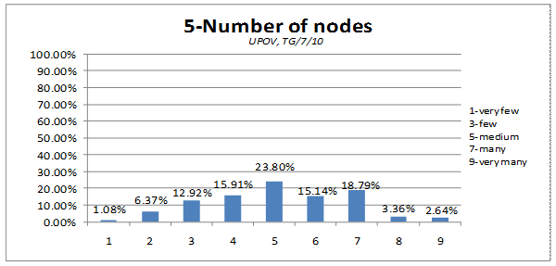
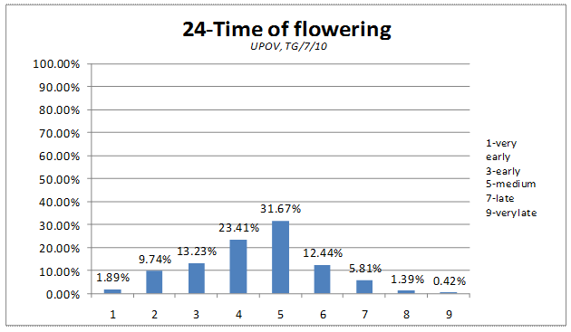
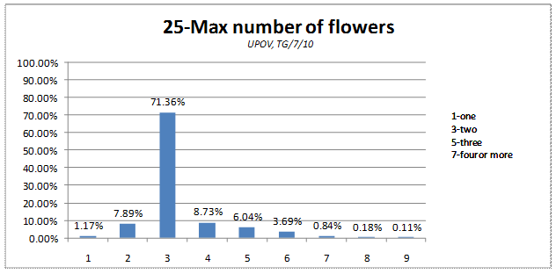
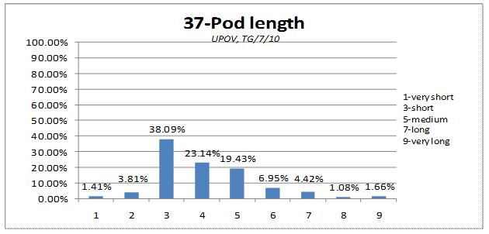
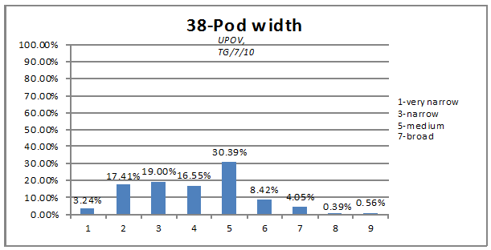
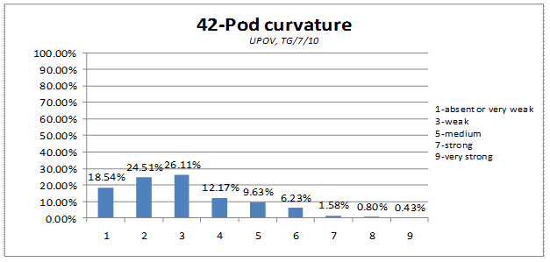
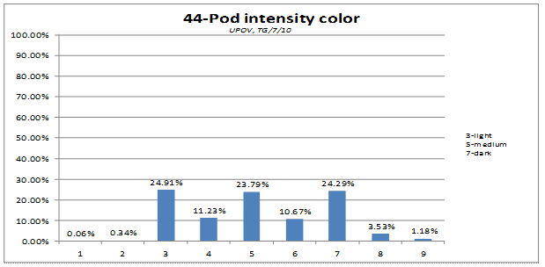
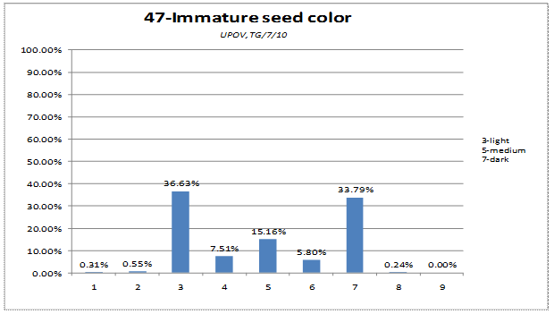
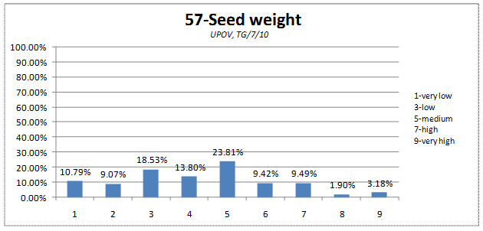
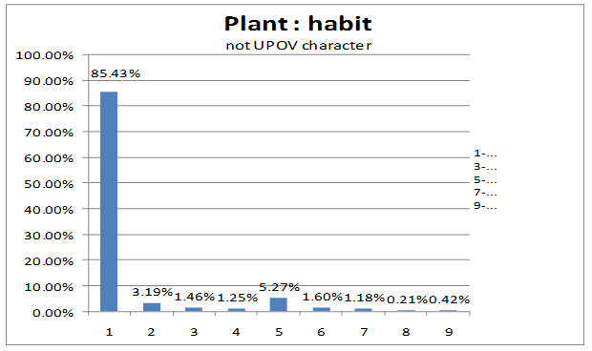

Distortion of the characteristic
Qualitative and Pseudo-qualitative characteristics
Characteristic | Distortion (%)
Pod : type curvature | 0.36%
3-Fasciation | 0.42%
60-Resistance to Ascochyta | 0.62%
53-Seed marbling of testa | 0.72%
1-Anthocyanin coloration | 0.81%
55-Hilum color | 1.03%
8-Presence of leaflets | 1.38%
43-Pod color | 1.86%
20-Flecking on stipules | 2.04%
45-Pod suture strings | 2.39%
54-Pink spots on testa | 2.39%
59-Resistance to Erysiphae | 2.42%
40-Pod thickened wall | 3.15%
49-Type of starch grains | 3.66%
Virus 2= Bean yellow mosaic virus | 4.22%
6-Color of foliage | 5.06%
41-Pod extremity | 5.13%
58-1-Fusarium 1 | 5.99%
39-Pod parchment | 6.17%
52-Color of cotyledon | 7.12%
26-Color of wing | 9.36%
Seed : Dimpled | 12.46%
48-Seed shape | 31.51%
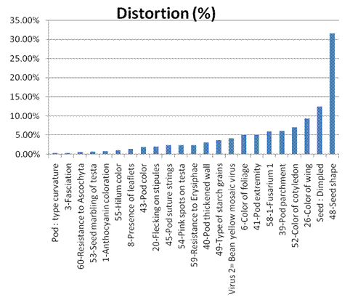
Quantitative characteristics

Characteristics | Distortion (%)
25-Max number of flowers | 2.83%
24-Time of flowering | 4.81%
Plant : habit | 5.00%
57-Seed weight | 5.32%
37-Pod length | 7.08%
44-Pod intensity color | 7.21%
42-Pod curvature | 7.88%
47-Immature seed color | 10.01%
5-Number of nodes | 12.98%
4-Stem length | 17.18%
38-Pod width | 19.23%

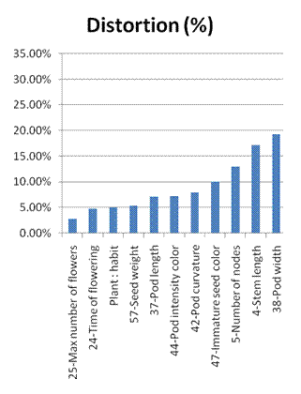
On the basis of the three indicators, each characteristic can be defined as follow

For official grouping characteristics (mentioned in the TG/7/10)
Characteristic | Use | Discriminating power | Distortion (%)
1-Anthocyanin coloration | 90.97 | 95/5 | 0.81%
5-Number of nodes | 64.12 | 55 (notes 4-5-6) | 12.98%
8-Presence of leaflets | 88.75 | 60/40 | 1.38%
20-Flecking on stipules | 73.81 | 98/2 | 2.04%
39-Pod parchment | 67.17 | 92.5/7.5 | 6.17%
40-Pod thickened wall | 8.24 | 80/20 | 3.15%
41-Pod extremity | 93.06 | 76/24 | 5.13%
43-Pod color | 73.72 | 98/2 | 1.86%
47-Immature seed color | 77.30 | 33 (notes 4-5-6) | 10.01%
49-Type of starch grains | 92.12 | 52/48 | 3.66%
52-Color of cotyledon | 91.88 | 65/35 | 7.12%
53-Seed marbling of testa | 44.76 | 97/3 | 0.72%
54-Pink spots on testa | 28.25 | 91/9 | 2.39%
55-Hilum color | 70.14 | 98/2 | 1.03%
58-1-Fusarium 1 | 60.19 | 80/20 | 5.99%

For candidate grouping characteristics
Characteristic | Use | Discriminating power | Distortion (%)
3-Fasciation | 70.71 | 99/1 | 0.42%
4-Stem length | 79.84 | 54 (notes 4-5-6) | 17.18%
6-Color of foliage | 68.51 | 93/7 | 5.06%
24-Time of flowering | 69.15 | 68 (notes 4-5-6) | 4.81%
25-Max number of flowers | 72.93 | 18 (notes 4-5-6) | 2.83%
26-Color of wing | 3.78 | 70/30 | 9.36%
37-Pod length | 78.58 | 49 (notes 4-5-6) | 7.08%
38-Pod width | 74.34 | 55 (notes 4-5-6) | 19.23%
42-Pod curvature | 76.70 | 28 (notes 4-5-6) | 7.88%
44-Pod intensity color | 69.84 | 46 (notes 4-5-6) | 7.21%
45-Pod suture strings | 14.79 | 93/7 | 2.39%
48-Seed shape | 70.02 | 37/45/4/14 | 31.51%
57-Seed weight | 61.06 | 47 (notes 4-5-6) | 5.32%
59-Resistance to Erysiphae | 47.61 | 85/15 | 2.42%
60-Resistance to Ascochyta | 27.47 | 78/22 | 0.62%
Plant: habit | 19.19 | 70 (notes 4-5-6) | 5.00%
Pod: type curvature | 19.05 | 99/1 | 0.36%
Seed: Dimpled | 17.36 | 75/25 | 12.46%
Virus 2= Bean yellow mosaic virus | 24.38 | 63/37 | 4.22%

[End of Annex and of document]

