E
TC/50/33
ORIGINAL: English
DATE: March 13, 2014
INTERNATIONAL UNION FOR THE PROTECTION OF NEW VARIETIES OF PLANTS
Geneva
Technical Committee
Fiftieth Session
Geneva, April 7 to 9, 2014
PARTIAL REVISION OF THE test guidelines for Peach
(Document TG/53/7)
Document prepared by the Office of the Union
Disclaimer: this document does not represent UPOV policies or guidance
At its forty-fourth session held in Napier, New Zealand, from April 29 to May 3, 2013, the Technical Working Party for Fruit Crops (TWF) considered the partial revision of the Test Guidelines for Peach on the basis of documents TG/53/7 and TWF/44/29 (see document TWF/44/31 “Report”, paragraph 75) and proposes that the Test Guidelines for Peach be amended as follows (number of characteristics based on document TG/53/7):

Cover page: Alternative names

Current wording:

Botanical name | English | French | German | Spanish
Prunus persica (L.) Batsch,  Persica vulgaris Mill.,  Prunus L. subg. Persica | Peach | Pêcher | Pfirsich | Durazno,  Melocotonero

Proposed new wording:

Botanical name | English | French | German | Spanish
Prunus persica (L.) Batsch,  Persica vulgaris Mill.,  Prunus L. subg. Persica | Peach | Pêcher | Pfirsich | Duraznero,  Melocotonero

Chapter 2.3

Current wording:

The minimum quantity of plant material, to be supplied by the applicant, should be:

5 grafted trees.

Proposed new wording:

The minimum quantity of plant material, to be supplied by the applicant, should be:

3 grafted trees.

Chapter 3.4.1

Current wording:

Each test should be designed to result in a total of at least 5 trees.

Proposed new wording:

Each test should be designed to result in a total of at least 3 trees.

Chapter 3.5 “Number of Plants / Parts of Plants to be Examined”

Current wording:

Unless otherwise indicated, all observations should be made on 5 plants or parts taken from each of 5 plants. In the case of parts of plants, the number to be taken from each of the plants should be 2.

Proposed new wording:

Unless otherwise indicated, all observations should be made on 3 plants or parts taken from each of 3 plants. In the case of parts of plants, the number to be taken from each of the plants should be at least 5.

Chapter 4

To add explanation of method of observation as Chapter 4.1.4 and to read:

“4.1.4 Method of Observation

The recommended method of observing the characteristic for the purposes of distinctness is indicated by the following key in the second column of the Table of Characteristics (see document TGP/9 ‘Examining Distinctness’, Section 4 ‘Observation of characteristics’):

MG: single measurement of a group of plants or parts of plants
MS: measurement of a number of individual plants or parts of plants
VG: visual assessment by a single observation of a group of plants or parts of plants
VS: visual assessment by observation of individual plants or parts of plants

Type of observation: visual (V) or measurement (M)

‘Visual’ observation (V) is an observation made on the basis of the expert’s judgment. For the purposes of this document, ‘visual’ observation refers to the sensory observations of the experts and, therefore, also includes smell, taste and touch. Visual observation includes observations where the expert uses reference points (e.g. diagrams, example varieties, side-by-side comparison) or non-linear charts (e.g. color charts). Measurement (M) is an objective observation against a calibrated, linear scale e.g. using a ruler, weighing scales, colorimeter, dates, counts, etc.

Type of record: for a group of plants (G) or for single, individual plants (S)

For the purposes of distinctness, observations may be recorded as a single record for a group of plants or parts of plants (G), or may be recorded as records for a number of single, individual plants or parts of plants (S). In most cases, ‘G’ provides a single record per variety and it is not possible or necessary to apply statistical methods in a plant-by-plant analysis for the assessment of distinctness.

In cases where more than one method of observing the characteristic is indicated in the Table of Characteristics (e.g. VG/MG), guidance on selecting an appropriate method is provided in document TGP/9, Section 4.2.”

Chapter 4.2.2

Current wording:

For the assessment of uniformity, a population standard of 1% and an acceptance probability of at least 95% should be applied. In the case of a sample size of 5 plants, no off-types are allowed.

Proposed new wording:

For the assessment of uniformity, a population standard of 1% and an acceptance probability of at least 95% should be applied. In the case of a sample size of 3 plants, no off-types are allowed.

Chapter 5.3 “Grouping Characteristics”

- Tree: size (characteristic 1)
- Flowering shoot: presence of anthocyanin coloration (characteritic 6)
- Flower: type (characteristic 9)
- Anthers: pollen (characteristic 17)
Ovary: pubescence (characteristic 18)
- Leaf blade: red mid-vein on the lower side (characteristic 28)
- Petiole: nectaries (characteristic 30)
- Petiole: shape of nectaries (characteristic 31)
- Fruit: shape (in ventral view) (characteristic 33)
- Fruit: pubescence of skin (characteristic 44)
- Fruit: carotenoid coloration of flesh (characteristic 51)
- Fruit: acidity (characteristic 57) with the following groups:
- low
- medium
- high
- Fruit: flesh type (TQ characteristic), with the following groups:
- melting
- non-melting (pavies)
- stony hard
Stone: adherence to flesh (characteristic 64)
- Time of beginning of flowering (characteristic 67)
(n) Time of maturity for consumption (characteristic 68)

Chapter 6.5 “Legend”

Current wording:

(*) Asterisked characteristic – see Chapter 6.1.2

QL Qualitative characteristic – see Chapter 6.3
QN Quantitative characteristic – see Chapter 6.3
PQ Pseudo-qualitative characteristic – see Chapter 6.3

(a)-(g) See Explanations on the Table of Characteristics in Chapter 8.1
(+) See Explanations on the Table of Characteristics in Chapter 8.2

Proposed new wording:

(*) Asterisked characteristic – see Chapter 6.1.2

QL Qualitative characteristic – see Chapter 6.3
QN Quantitative characteristic – see Chapter 6.3
PQ Pseudo-qualitative characteristic – see Chapter 6.3

MG, MS, VG, VS – see Chapter 4.1.4

(a)-(g) See Explanations on the Table of Characteristics in Chapter 8.1
(+) See Explanations on the Table of Characteristics in Chapter 8.2

Chapter 7 “Table of Characteristics”

Amendments to method of observation: (number of characteristics based on document TG/53/7)

Method of observation | Characteristics
VG | 1, 2, 4, 5, 8, 9, 10, 11, 14, 16, 17, 18, 19, 23, 24, 25, 26, 27, 30, 31, 32, 33, 34, 36, 37, 40, 41, 42, 43, 44, 45, 46, 47, 49, 51, 56, 60, 61, 62, 65
MS | 50
MG | 57, 59, 66, 67
VG/MS | 12, 13, 20, 21, 22, 29, 38, 39

Amendments to example varieties:

Char. 1 | state 1 | to add “Bonfire, Pix Zee, Zaino”
Char. 5 | state 1 | to add “Bonfire, Pix Zee, Zaino”
Char. 8 | state 3 | to delete “O’Henry”, to add “Mercil”
Char. 21 | state 7 | to delete “Dixinel”, to add “Dixired”
Char. 24 | state 3 | to delete “Flor de Guaid”, to add “Bailey”
Char. 25 | state 3 | to delete “Merrill Fransiscan”, to add “Merrill Franciscan”
Char. 27 | state 5 | to add “Garnem, Goldcrest”
Char. 32 | state 7 | to delete “Royalglory”, to add “Zaifer”
Char. 34 | state 9 | to delete “Jersey Land”, to add “Jerseyland”
Char. 36 | state 2 | to delete “Brittaney Lane”, to add “Brittney Lane”
 | state 3 | to delete “Precoccissima Moretini”, to add “Precocissima Morettini”
Char. 37 | state 5 | to add “Précoce de Hale, Amsden, May Flower”
Char. 40 | state 2 | to delete “Rubberima”, to add “Ruberrina”
Char. 41 | state 1 | to add “Ghiaccio 1, Zholty”
Char. 43 | state 1 | to delete “Flavorcrest”, to add “Zaitabo”
 | state 2 | to delete “Merill Sundance”, to add “Merrill Sundance”
Char. 45 | state 7 | to delete “Earlyvee”, to add “Erlyvee”
Char. 47 | state 3 | to delete “Royal gem”, to add “Zairegem”
Char. 50 | state 1 | to add “Morettini n°1, Springtime”
 | state 5 | to delete “Redhaven”, to add “Flavorcrest, Redtop”
 | state 7 | to delete “Redtop”, to add “Honey Blaze, Zaitabo”
 | state 9 | to delete “Vivian”, to add “Ghiaccio 2”
Char. 51 | state 6 | to delete “Merill Franciscan”, to add “Merrill Franciscan”;  to delete “Lovel”, to add “Lovell”
Char. 56 | state 1 | to delete “Merryl Gemfree”, to add “Merrill Gemfree”
Char. 57 | state 1 | to delete “Ambre, Kevine, Nacre, Opale, Zaiboni”, to add “ Monna, Zaibomi, Zaidaso”
 | state 2 | to delete “Felicia, Monprime”, to add “Zaifave, Zaitabo”
 | state 3 | to delete “O’Henry, Ryan Sun, Zaitabo”, to add “Mercil, Monprime, Ryans Sun”
 | state 4 | to delete “Hermione, Primerose”, to add “Kraprim, Zailice”

Characteristic 3 “Tree: habit”

Current wording:

3.  (*)  (+) |  | Tree: habit | Arbre : port | Baum: Wuchsform | Árbol: porte
QN | (a) | upright | dressé | aufrecht | erecto | Nectarose, Pillar | 1
 |  | upright to spreading | dressé à étalé | aufrecht bis breitwüchsig | erecto hacia extendido | Fairhaven, Redwing | 2
 |  | spreading | étalé | breitwüchsig | extendido | Albertina, Elegant Lady, O’Henry | 3
 |  | drooping | retombant | überhängend | colgante | Charles Roux | 4
 |  | weeping | très retombant | lang überhängend | llorón | Biancopendulo | 5

Proposed new wording:

3.  (*)  (+) | VG | Tree: habit | Arbre : port | Baum: Wuchsform | Árbol: porte
QN | (a) | fastigiate | fastigié | sehr aufrecht | fastigiado | Nectarose, Pillar | 1
 |  | upright | dressé | aufrecht | erecto | Fairhaven, Redwing | 2
 |  | upright to spreading | dressé à étalé | aufrecht bis breitwüchsig | erecto a extendido | Albertina, Elegant Lady, Mercil | 3
 |  | spreading | étalé | breitwüchsig | extendido | Charles Roux | 4
 |  | drooping | retombant | überhängend | colgante | Biancopendulo | 5

Ad. 3: Tree: habit

To be observed the year before the main pruning.

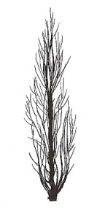 | 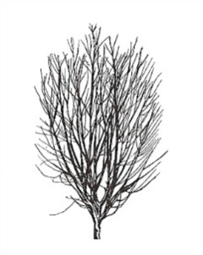 | 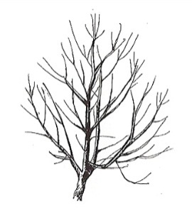 | 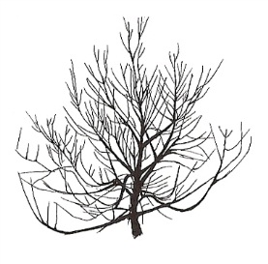 | 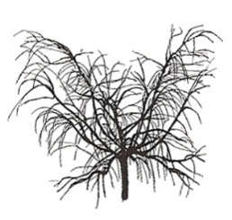
1 | 2 | 3 | 4 | 5
upright | upright to spreading | spreading | drooping | weeping
fastigiate | upright | upright to spreading | spreading | drooping

Characteristic 6 “Flowering shoot: presence of anthocyanin coloration”

Current wording:

6. |  | Flowering shoot: presence of anthocyanin coloration | Rameau mixte : présence de la pigmentation anthocyanique | Blütentrieb: Vorhandensein von Anthocyanfärbung | Rama floral: presencia de pigmentación antociánica
QL | (d) | absent | absente | fehlend | ausente | De flor doble blanca | 1
 |  | present | présente | vorhanden | presente | Robin | 9

Proposed new wording:

6.  (*) | VG | Flowering shoot: presence of anthocyanin coloration | Rameau mixte : présence de la pigmentation anthocyanique | Blütentrieb: Vorhandensein von Anthocyanfärbung | Rama floral: presencia de pigmentación antociánica
QL | (d) | absent | absente | fehlend | ausente | De flor doble blanca | 1
 |  | present | présente | vorhanden | presente | Robin | 9

Characteristic 7 “Flowering shoot: intensity of anthocyanin coloration”

Current wording:

7.  (+) |  | Flowering shoot: intensity of anthocyanin coloration | Rameau mixte : intensité de la pigmentation anthocyanique | Blütentrieb: Intensität der Anthocyanfärbung | Rama floral: intensidad de la pigmentación antociánica
QN | (d) | weak | faible | gering | débil | Springtime | 3
 |  | medium | moyenne | mittel | media | Fuzalode | 5
 |  | strong | forte | stark | fuerte | Robin, Sanguine Chanas | 7

Proposed new wording:

7.  (+) | VG | Flowering shoot: intensity of anthocyanin coloration | Rameau mixte : intensité de la pigmentation anthocyanique | Blütentrieb: Intensität der Anthocyanfärbung | Rama floral: intensidad de la pigmentación antociánica
QN | (d) | very weak | très faible | sehr gering | muy débil | Biancopendulo,  De flor doble blanca | 1
 |  | weak | faible | gering | débil | Springtime | 3
 |  | medium | moyenne | mittel | media | Fuzalode | 5
 |  | strong | forte | stark | fuerte | Robin, Sanguine Chanas | 7

Characteristic 15 “Stamen: position compared to petals”

Current wording:

15.  (+) |  | Stamen: position compared to petals | Étamines : position par rapport aux pétales | Staubgefäße: Stellung im Verhältnis zu den Blütenblättern | Estambre: posición relativa a los pétalos
QN | (d) | below | au-dessous | unterhalb | por debajo | Loring | 1
 | (e) | at same level | au même niveau | auf gleicher Höhe | en el mismo nivel | Robin, Springtime | 2
 |  | above | au-dessus | oberhalb | por encima | Redhaven | 3

Proposed new wording:

15.  (+) | VG | Stamen: position compared to petals | Étamines : position par rapport aux pétales | Staubgefäße: Stellung im Verhältnis zu den Blütenblättern | Estambre: posición relativa a los pétalos
QN | (d) | below | au-dessous | unterhalb | por debajo | Loring | 1
 | (e) | same level | même niveau | gleiche Höhe | mismo nivel | Robin, Springtime | 2
 |  | above | au-dessus | oberhalb | por encima | Redhaven | 3

Ad. 15: Stamen: position compared to petals

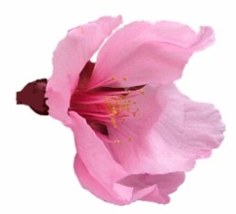 | 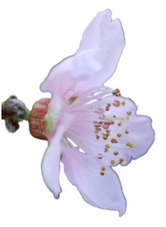 | 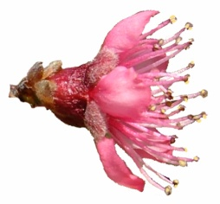
1 | 2 | 3
below | at same level | above
 | same level

Characteristic 28 “Leaf blade: red mid-vein on the lower side”

Current wording:

28. |  | Leaf blade: red mid-vein on the lower side | Nervure principale rouge face inférieure | Blattspreite: rote Hauptader auf der Unterseite | Limbo: nervio central rojo en el envés
QL | (b) | absent | absente | fehlend | ausente | Redhaven | 1
 |  | present | présente | vorhanden | presente | Sanguine Chanas | 9

Proposed new wording:

28.  (*)  (+) | VG | Leaf blade: red mid-vein on the lower side | Limbe : Nervure principale rouge face inférieure | Blattspreite: rote Hauptader auf der Unterseite | Limbo: nervio central rojo en el envés
QL | (b) | absent | absente | fehlend | ausente | Redhaven | 1
 |  | present | présente | vorhanden | presente | Sanguine Chanas | 9

Ad. 28: Leaf blade: red mid-vein on the lower side

To be observed during the period of new leaf growth.

Characteristic 35 “Fruit: shape of pistil end (excluding mucron tip)”

Current wording:

35.  (+) |  | Fruit: shape of pistil end (excluding mucron tip) | Fruit : forme de l’extrémité pistillaire (mucron non compris) | Frucht: Form des Kelchendes (ohne aufgesetzte Spitze) | Fruto: forma del extremo del pistilo (la punta del mucrón excluida)
 |  | prominently pointed | nettement pointue | deutlich zugespitzt | destacadamente puntiagudo | Jersey Land | 1
 |  | weakly pointed | faiblement pointue | schwach zugespitzt | débilmente puntiagudo | Springtime | 2
 |  | flat | plate | flach | plano | Redhaven | 3
 |  | weakly depressed | faiblement déprimée | schwach eingesenkt | débilmente hundido | Robin | 4
 |  | strongly depressed | fortement déprimée | stark eingesenkt | muy hundido | Bailou, UFO3 | 5

Proposed new wording:

35.  (+) | VG | Fruit: shape of pistil end (excluding mucron tip) | Fruit : forme de l’extrémité pistillaire (mucron exclu) | Frucht: Form des Kelchendes (außer aufgesetzte Spitze) | Fruto: forma del extremo del pistilo (la punta del mucrón excluida)
QN |  | prominently pointed | nettement pointue | deutlich zugespitzt | destacadamente puntiagudo | Jerseyland | 1
 |  | weakly pointed | faiblement pointue | schwach zugespitzt | débilmente puntiagudo | Springtime | 2
 |  | flat | plate | flach | plano | Redhaven | 3
 |  | weakly depressed | faiblement déprimée | schwach eingesenkt | débilmente hundido | Robin | 4
 |  | strongly depressed | fortement déprimée | stark eingesenkt | muy hundido | Bailou, UFO3 | 5
Characteristic 48 “Fruit: thickness of skin”

Current wording:

48.  (+) |  | Fruit: thickness of skin | Fruit : épaisseur de l’épiderme | Frucht: Dicke der Haut | Fruto: grosor de la piel
QN | (f) | thin | faible | dünn | fina | Fuzalode | 1
 |  | medium | moyenne | mittel | media | Mme Girerd | 2
 |  | thick | forte | dick | gruesa | Carman | 3

Proposed new wording:

48.  (+) | VG | Fruit: thickness of skin | Fruit : épaisseur de l’épiderme | Frucht: Dicke der Haut | Fruto: grosor de la piel
QN | (f) | thin | faible | dünn | fina | Fuzalode | 1
 |  | medium | moyenne | mittel | media | Mme Girerd | 2
 |  | thick | forte | dick | gruesa | Carman | 3

Ad. 48: Fruit: thickness of skin
excluding pubescence

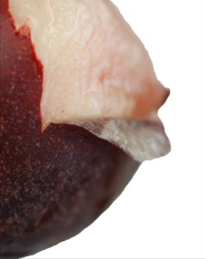

Characteristic 52 “Fruit: anthocyanin coloration of flesh next to skin”

Characteristic 52 to be split into two characteristics.

Current wording:

52.  (*)  (+) |  | Fruit: anthocyanin coloration of flesh next to skin | Fruit : pigmentation anthocyanique sous-épidermique | Frucht: Anthocyanfärbung direkt unter der Haut | Fruto: pigmentación antociánica de la pulpa pegada a la piel
QN | (f) | absent or very weak | absente ou très faible | fehlend oder sehr gering | ausente o muy débil | Redhaven | 1
 |  | weak | faible | gering | débil | Daisy, Dolores, Monco | 2
 |  | strong | forte | stark | fuerte | Monalu, Monof, Rich May, Sanguine Chanas, Sanguine Vineuse, Zairegem | 3

Proposed new wording:

52.  (*) | VG | Fruit: anthocyanin coloration of flesh next to skin | Fruit : pigmentation anthocyanique sous-épidermique | Frucht: Anthocyanfärbung direkt unter der Haut | Fruto: pigmentación antociánica de la pulpa pegada a la piel
QL | (f) | absent | absente | fehlend | ausente | Springfire | 1
 |  | present | présente | vorhanden | presente | Sanguine Vineuse | 9
NEW  (*)  (+) | VG | Fruit: degree of anthocyanin coloration of flesh next to skin | Fruit : degré de pigmentation anthocyanique sous-épidermique | Frucht: Anthocyanfärbung direkt unter der Haut | Fruto: intensidad de la pigmentación antociánica de la pulpa pegada a la piel
QN | (f) | weak | faible | schwach | débil | Daisy, Dolores, Monco | 1
 |  | medium | moyenne | mittel | media | Rich May, Zairegem, Merrill Franciscan | 2
 |  | strong | forte | stark | fuerte | Monalu, Monof,  Sanguine Chanas, Sanguine Vineuse | 3

Ad. 52 NEW: Fruit: degree of anthocyanin coloration of flesh next to skin

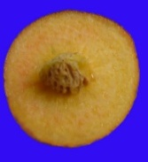 | 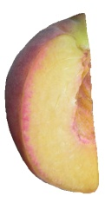 | 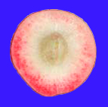
1 | 2 | 3
absent or very weak | weak | strong
weak | medium

Characteristic 53 “Fruit: anthocyanin coloration of flesh in central part of flesh”

Characteristic 53 to be split into two characteristics.

Current wording:

53.  (*)  (+) |  | Fruit: anthocyanin coloration of flesh in central part of flesh | Fruit : pigmentation anthocyanique de la partie centrale de la chair | Frucht: Anthocyanfärbung des Fleisches im mittleren Teil des Fruchtfleisches | Fruto: pigmentación antociánica de la parte central de la pulpa
QN | (f) | absent or very weak | absente ou très faible | fehlend oder sehr gering | ausente o muy débil | Robin | 1
 |  | weak | faible | gering | débil | Dolores, Monco | 2
 |  | strong | forte | stark | fuerte | Monof, Zairegem | 3

Proposed new wording:

53.  (*) | VG | Fruit: anthocyanin coloration of flesh in central part of flesh | Fruit : pigmentation anthocyanique de la partie centrale de la chair | Frucht: Anthocyanfärbung des Fleisches im mittleren Teil des Fruchtfleisches | Fruto: pigmentación antociánica de la parte central de la pulpa
QL | (f) | absent | absente | fehlend | ausente | Springfire | 1
 |  | present | présente | vorhanden | presente | Monof | 9
NEW  (*)  (+) | VG | Fruit: degree of anthocyanin coloration of flesh in central part of flesh | Fruit : degré de pigmentation anthocyanique de la partie centrale de la chair | Frucht: Anthocyanfärbung des Fleisches im mittleren Teil des Fruchtfleisches | Fruto: intensidad de la pigmentación antociánica de la parte central de la pulpa
QN | (f) | weak | faible | schwach | débil | Robin | 1
 |  | medium | moyenne | mittel | media | Dolores, Monco, Suncrest | 2
 |  | strong | forte | stark | fuerte | Monof, Zairegem | 3

Ad. 53 NEW: Fruit: degree of anthocyanin coloration of flesh in central part of flesh

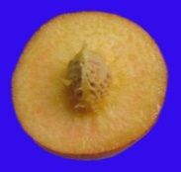 | 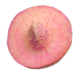 | 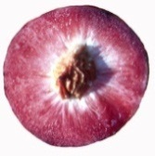
1 | 2 | 3
absent or very weak | weak | strong
weak | medium

Characteristic 54 “Fruit: anthocyanin coloration of flesh around stone”

Characteristic 54 to be split into two characteristics.

Current wording:

54.  (*)  (+) |  | Fruit: anthocyanin coloration of flesh around stone | Fruit : pigmentation anthocyanique de la chair autour du noyau | Frucht: Anthocyanfärbung im Bereich des Steines | Fruto: pigmentación antociánica de la pulpa alrededor del hueso
QN | (f) | absent or weak | absente ou faible | fehlend oder gering | ausente o débil | Springtime | 1
 |  | medium | moyenne | gering | media | Ryan Sun | 2
 |  | strong | forte | stark | fuerte | Summer Lady, Zaipeo | 3

Proposed new wording:
54.  (*) | VG | Fruit: anthocyanin coloration of flesh around stone | Fruit : pigmentation anthocyanique de la chair autour du noyau | Frucht: Anthocyanfärbung im Bereich des Steines | Fruto: pigmentación antociánica de la pulpa alrededor del hueso
QL | (f) | absent | absente | fehlend | ausente | Springfire | 1
 |  | present | présente | vorhanden | presente | Summer Lady | 9
NEW  (*)  (+) | VG | Fruit: degree of anthocyanin coloration of flesh around stone | Fruit : degré de pigmentation anthocyanique de la chair autour du noyau | Frucht: Anthocyanfärbung im Bereich des Steines | Fruto: intensidad de la pigmentación antociánica de la pulpa alrededor del hueso
QN | (f) | weak | faible | schwach | débil | Andross, Ghiaccio 1 | 1
 |  | medium | moyenne | mittel | media | Ryans Sun | 2
 |  | strong | forte | stark | fuerte | Summer Lady, Zaipeo | 3

Ad. 54 NEW: Fruit: degree of anthocyanin coloration of flesh around stone

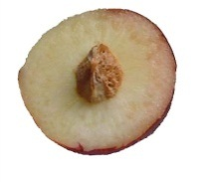 | 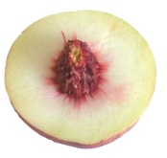 | 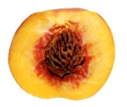
1 | 2 | 3
absent or very weak | medium | strong
weak

Characteristic 55 “Fruit: flesh fiber”

Current wording:

55. |  | Fruit: flesh fiber | Fruit : chair fibreuse | Frucht: Fleischfasern | Fruto: pulpa fibrosa
QN | (f) | absent or weak | absente ou faible | fehlend oder schwach | ausente o débil | Redhaven | 1
 |  | moderate | modérée | mäßig | moderada |  | 2
 |  | strong | forte | stark | fuerte | Sunhigh | 3

Proposed new wording:

55.  (+) | VG | Fruit: flesh fiber | Fruit : chair fibreuse | Frucht: Fleischfasern | Fruto: pulpa fibrosa
QN | (f) | absent or weak | absente ou faible | fehlend oder schwach | ausente o débil | Redhaven | 1
 |  | medium | moyenne | mittel | media |  | 2
 |  | strong | forte | stark | fuerte | Sunhigh | 3

Ad. 55: Fruit: flesh fiber

The flesh fiber is evaluated by biting into the flesh to determine the amount of fiber.

Characteristic 58 “Stone: size compared to fruit”

Current wording:

58.  (*)  (+) |  | Stone: size compared to fruit | Noyau : taille par rapport à celle du fruit | Stein: Größe im Verhältnis zur Frucht | Hueso: tamaño con respecto al fruto
QN | (g) | small | petit | klein | pequeño | Alex, Robin | 3
 |  | medium | moyen | mittel | mediano | Redhaven | 5
 |  | large | gros | groß | grande | Somervee | 7

Proposed new wording:
58.  (*)  (+) | MG | Stone: size in relation to fruit | Noyau : taille par rapport à celle du fruit | Stein: Größe im Verhältnis zur Frucht | Hueso: tamaño con respecto al fruto
QN | (g) | small | petit | klein | pequeño | Alex, Robin | 3
 |  | medium | moyen | mittel | mediano | Redhaven | 5
 |  | large | gros | groß | grande | Somervee | 7

Characterstics 63 “Stone: tendency to split” and 64 “Stone: adherence to flesh”

Current wording:

63.  (+) |  | Stone: tendency to split | Noyau : tendance à fendre | Stein: Tendenz zur Spaltung | Hueso: tendencia a fisurarse
QN | (g) | absent or very low | nul ou très faible | fehlend oder sehr gering | ninguna o muy débil | Fairhaven | 1
 |  | low | faible | gering | débil | Dixired | 3
 |  | medium | moyen | mittel | media | Springold | 5
 |  | high | élevé | groß | elevada | Cardinal | 7
 |  | very high | très élevé | sehr groß | muy elevada | Earlired | 9
64.  (*) |  | Stone: adherence to flesh | Noyau : adhérence à la chair | Stein: Anhaften am Fleisch | Hueso: adherencia a la pulpa
QL | (g) | absent | absente | fehlend | ausente | Fairhaven, Fuzalode | 1
 |  | present | présente | vorhanden | presente | Sweet Gold, Vivian | 9

Proposed new wording:

63.  (+) |  | Stone: tendency to split | Noyau : tendance à fendre | Stein: Tendenz zur Spaltung | Hueso: tendencia a fisurarse
QN | (g) | absent or very low | nul ou très faible | fehlend oder sehr gering | ninguna o muy débil | Fairhaven | 1
 |  | low | faible | gering | débil | Dixired | 3
 |  | medium | moyen | mittel | media | Springold | 5
 |  | high | élevé | groß | elevada | Cardinal | 7
 |  | very high | très élevé | sehr groß | muy elevada | Earlired | 9
64.  63.  (*) | VG | Stone: adherence to flesh | Noyau : adhérence à la chair | Stein: Anhaften am Fleisch | Hueso: adherencia a la pulpa
QL | (g) | absent | absente | fehlend | ausente | Fairhaven, Fuzalode | 1
 |  | present | présente | vorhanden | presente | Sweet Gold, Vivian | 9

Characteristic 66 “Time of beginning of leaf bud burst”

Current wording:

66.  (+) |  | Time of beginning of leaf bud burst | Époque de début de débourrement foliaire | Zeitpunkt des Aufbrechens der vegetativen Knospe | Época de comienzo de la brotación de la yema folear
QN |  | very early | très précoce | sehr früh | muy temprana | Sunred | 1
 |  | early | précoce | früh | temprana | Springtime | 3
 |  | medium | moyenne | mittel | media | Redhaven | 5
 |  | late | tardive | spät | tardía | Genadix 7 | 7
 |  | very late | très tardive | sehr spät | muy tardía | Philp | 9

Proposed new wording:

65.  (+) | MG | Time of beginning of leaf bud burst | Époque de début de débourrement foliaire | Zeitpunkt des Aufbrechens der vegetativen Knospe | Época de comienzo de la brotación de la yema foliar
QN |  | very early | très précoce | sehr früh | muy temprana | Sunred | 1
 |  | early | précoce | früh | temprana | Springtime | 3
 |  | medium | moyenne | mittel | media | Redhaven | 5
 |  | late | tardive | spät | tardía | Genadix 7 | 7
 |  | very late | très tardive | sehr spät | muy tardía | Reine des Vergers | 9

Characteristic 68 “Time of maturity for consumption”

Current wording:

68.  (*)  (+) |  | Time of maturity for consumption | Époque de maturité pour la consommation | Zeitpunkt der Genußreife | Época de madurez para el consumo
QN |  | very early | très précoce | sehr früh | muy temprana | Rich May,  Springtime, Zaibaro | 1
 |  | very early to early | très précoce à précoce | sehr früh bis früh | de muy temprana a temprana | Zainoar, Zaitani | 2
 |  | early | précoce | früh | temprana | Antonia, Redwing, Rich Lady, Robin | 3
 |  | early to medium | précoce à moyenne | früh bis mittel | de temprana a media | Craucail, Diamond Princess | 4
 |  | medium | moyenne | mittel | media | Fairhaven, Fantasia, Summer Bright, Zee Lady | 5
 |  | medium to late | moyenne à tardive | mittel bis spät | de media a tardía | Maillarbig,  Savana Red, Zaimor | 6
 |  | late | tardive | spät | tardía | Fairlane, Flacara, Veteran, Western red, Zailati, Zairova | 7
 |  | late to very late | tardive à très tardive | spät bis sehr spät | de tardía a muy tardía | Andgold, Tardibelle | 8
 |  | very late | très tardive | sehr spät | muy tardía | Firetime, Rubidoux | 9

Proposed new wording:

67.  (*)  (+) | MG | Time of maturity | Époque de maturité | Zeitpunkt der Reife | Época de madurez
QN |  | very early | très précoce | sehr früh | muy temprana | Rich May,  Springtime, Zaibaro | 1
 |  | very early to early | très précoce à précoce | sehr früh bis früh | de muy temprana a temprana | Zainoar, Zaitani | 2
 |  | early | précoce | früh | temprana | Antonia, Redwing,  Rich Lady, Robin | 3
 |  | early to medium | précoce à moyenne | früh bis mittel | de temprana a media | Craucail, Diamond Princess | 4
 |  | medium | moyenne | mittel | media | Fairhaven, Fantasia, Summer Bright, Zee Lady | 5
 |  | medium to late | moyenne à tardive | mittel bis spät | de media a tardía | Maillarbig,  Savana Red, Zaimor | 6
 |  | late | tardive | spät | tardía | Fairlane, Flacara,  Veteran, Western Red, Zailati, Zairova | 7
 |  | late to very late | tardive à très tardive | spät bis sehr spät | de tardía a muy tardía | Andgold, Tardibelle | 8
 |  | very late | très tardive | sehr spät | muy tardía | Rubidoux | 9
 |  | extremely late | extrêmement tardive | extrem spät | extremadamente tardía | Calante, Jesca | 10

Ad. 68 67: Time of maturity

Current wording:

The time of maturity for consumption is when the overall appearance, firmness and taste indicate that the fruit is ready for consumption.

Proposed new wording:

The time of maturity for consumption is when the overall appearance, firmness and taste indicate that the fruit is ready for consumption.
Chapter 8.2 “Explanations for individual characteristics”

Ad. 8: Flowering shoot: density of flower buds

Current wording:

To be observed along the shoot on one meter.

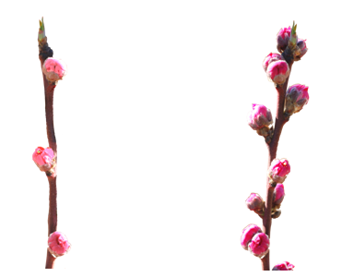
3 | 7
sparse | dense

Proposed new wording:

The density of flower buds is determined along the length of the current year’s shoot.

3 | 7
sparse | dense

Ad. 9: Flower: type

Current wording:

‘Campanulate’ (bell-shaped) is also referred to as ‘nonshowy’ : these types have small petals and stamens often higher than the petals.

‘Rosette’ (rose-shaped) is also referred to as ‘showy’ : these types have large petals.

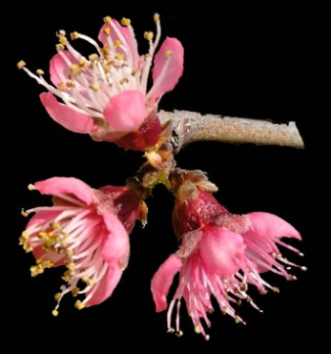 | 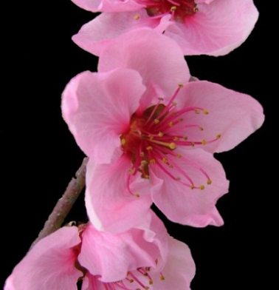
1 | 2
campanulate  (nonshowy) | rosette  (showy)

Proposed new wording:

‘Campanulate’ (bell-shaped) is also referred to as ‘non showy’ : these types have small petals and stamens often higher than the petals.

‘Rosette’ (rose-shaped) is also referred to as ‘showy’ : these types have large petals.

1 | 2
campanulate  (non showy) | rosette  (showy)

Ad. 41: Fruit: relative area of over color of skin

Current wording:

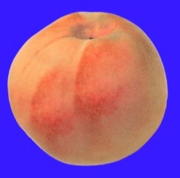 | 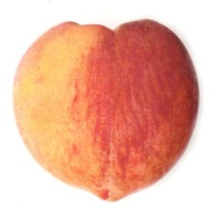 | 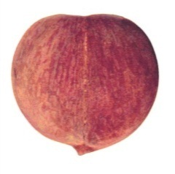
3 | 5 | 7
small | medium | large

Proposed new wording:

1 | 3 | 5 | 7
absent or very small | small | medium | large

Ad. 50: Fruit: firmness of flesh

To be deleted and to remove (+) from Characteristic 50.

To be observed at eating ripeness with a penetrometer.
Chapter 9 “Literature”

To add following literature references:

Chaparro J.X., Werner D.J., Whetten R.W. and D.M. O'Malley, 1995. Inheritance, genetic interaction and biochemical characterization of anthocyanin phenotypes in peach. J. Hered., 86: 32-38.

Hu D. and R. Scorza, 2009: Analysis of the ‘A72’ peach tree Growth Habit and its inheritance in progeny obtained from crosses of ‘A72’ with columnar peach trees. J. Amer. Sc. Hort. Sci. 134(2):236-243.

Layne D.R. and D. Bassi, 2008. The peach : Botany, production and uses. Ed. By Desmond R. Layne and Daniele Bassi. ISBN 978 1 84593 386 9. CABI, 30 nov. 2008 - 615 pages.

Monet R., Bastard Y. en Gibault B., 1988. Etude génétique du caractère « port pleureur » chez le pêcher. Agronomie, 8(2): 127-132.

Monet R. Guye A. and N. Dachary, 1996. Peach Mendelian genetics: a short review and new results. Agronomie, 16: 321-329.

Sajer O., Scorza R., Dardick C., Zhenbentyayeva T., 2012. Development of sequence-tagged site markers linked to the pillar growth type in peach (Prunus persica). Abbott A.G. and R. Horn, Plant Breeding, doi:10.1111/j.1439-0523.2011.01912.x

Scorza R., Lightner G.W. and A. Liverani, 1989. The pillar peach tree and growth habit analysis of compact x pillar progeny. J. Am. Soc. Hortic. Sci., 114: 991-995.

Takashi Haji, Hideaki Yaegaki, Masami Yamaguchi Department of Breeding, National Institute of Fruit Science: Changes in Ethylene Production and Flesh Firmness of Melting, Nonmelting and Stony hard in Peaches after Harvest: J. Japan. Soc. Hort. Sci 70(4): 458-459 2001.

Takashi Haji, Hideaki Yaegaki, Masami Yamaguchi Department of Breeding, National Institute of Fruit Science: Inheritance and expression of fruit texture melting, non-melting and stony hard in peach. Scientia Horticulture 105 (2005) 241-248.

Werner R.W. Creller M.A. and J.X. Chaparro, 2005. Inheritance of the blood-flesh trait in peach. Hortscience, 33(7): 1243-1246.

Werner R.W. and Chaparro J.X., 2005. Genetic interactions between pillar and weeping peach genotypes. Hortscience 40(1): 18-20.
Chapter 10 “Technical Questionnaire”

To modify Chapter 4.2 as follows:

Current wording:

4.2 Method of propagating the variety

4.2.1 Vegetative propagation

(a) cuttings [ ]

(b) in vitro propagation [ ]

(c) other (state method) [ ]

4.2.2 Other [ ]
(please provide details)

Proposed new wording:

4.2 Method of propagating the variety

4.2.1 Vegetative propagation

(a) budding or grafting [ ]

(b) in vitro propagation [ ]

(c) other (state method) [ ]

4.2.2 Other [ ]
(please provide details)

To delete the following characteristics from Chapter 5:

Fruit: flesh type (TQ characteristic), with the following groups:
- melting
- non-melting (pavies)
- stony hard
Stone: adherence to flesh (characteristic 64)

To add the following characteristics to Chapter 5²:

Tree: size (characteristic 1)
Flowering shoot: presence of anthocyanin coloration (characteristic 6)
Anthers: pollen (characteristic 17)
Leaf blade: red mid-vein on the lower side (characteristic 28)
Petiole: nectaries (characteristic 30)
Fruit: shape (in ventral view) (characteristic 33)

To modify Chapter 7.3 as follows:

Current wording:

7.3 Other information

7.3.1 A representative color photograph of the variety should accompany the Technical Questionnaire.

7.3.2 Pollinator

Good pollinators are the following varieties

..........................................................................

Proposed new wording:

7.3 Other information

7.3.1 A representative color photograph of the variety should accompany the Technical Questionnaire.

7.3.2 Pollinator

Good pollinators are the following varieties

..........................................................................

7.3.3 Explanations for the characteristic “Fruit: flesh type”

Fruits with melting flesh correspond to fruits used for fresh consumption.
Fruits with non-melting flesh correspond to fruits used for canning. The flesh is harder and elastic (clingstones/pavies).

The table below illustrates the principle in greater detail

type | activity |  |  | explanation | candiate variety  (please indicate)
 | ethylene | polygalacturonase
 |  | endo-type | exo-type
melting | present | present | present | Activity both ethylene and polygalacturonase exists in the flesh. Therefore flesh begins melting quickly after harvest. | [ ]
non-melting | present | present | absent | Activity of exo-type polygalacturonase is absent in the flesh. Therefore melting speed of flesh is very slow. | [ ]
stony hard | absent | absent | absent | Activity both ethylene and polygalacturonase are absent in the flesh. Therefore flesh does not begin to melt.  Ex. varieties: Odoroki, Yumyeong | [ ]

[End of document]

Adoption subject to agreement by the TWF at its forty-fifth session.
Adoption subject to agreement by the TWF at its forty-fifth session.

