 |  |  |  |  |  |  | E  TG/LOMAN(proj.5)  ORIGINAL: English  DATE: 2013-02-11
INTERNATIONAL UNION FOR THE PROTECTION OF NEW VARIETIES OF PLANTS
Geneva
 |  |  | DRAFT
 |  | LOMANDRA  UPOV Code: LOMAN  Lomandra Labill. |  |  | *

GUIDELINES

FOR THE CONDUCT OF TESTS

FOR DISTINCTNESS, UNIFORMITY AND STABILITY

prepared by an expert from Australia

to be considered by the
Technical Committee at its forty-ninth session,
to be held in Geneva from March 18 to 20, 2013

Alternative Names:*

Botanical name | English | French | German | Spanish
Lomandra Labill. | Lomandra, Mat Rush | Lomandra | Lomandra | Lomandra

The purpose of these guidelines (“Test Guidelines”) is to elaborate the principles contained in the General Introduction (document TG/1/3), and its associated TGP documents, into detailed practical guidance for the harmonized examination of distinctness, uniformity and stability (DUS) and, in particular, to identify appropriate characteristics for the examination of DUS and production of harmonized variety descriptions.

ASSOCIATED DOCUMENTS
These Test Guidelines should be read in conjunction with the General Introduction and its associated TGP documents.
TABLE OF CONTENTS PAGE

1. Subject of these Test Guidelines 3
2. Material Required 3
3. Method of Examination 3
3.1 Number of Growing Cycles 3
3.2 Testing Place 3
3.3 Conditions for Conducting the Examination 3
3.4 Test Design 3
3.5 Additional Tests 3
4. Assessment of Distinctness, Uniformity and Stability 4
4.1 Distinctness 4
4.2 Uniformity 5
4.3 Stability 5
5. Grouping of Varieties and Organization of the Growing Trial 5
6. Introduction to the Table of Characteristics 6
6.1 Categories of Characteristics 6
6.2 States of Expression and Corresponding Notes 6
6.3 Types of Expression 6
6.4 Example Varieties 6
6.5 Legend 7
7. Table of Characteristics/Tableau des caractères/Merkmalstabelle/Tabla de caracteres 8
8. Explanations on the Table of Characteristics 12
8.1 Explanations covering several characteristics 12
8.2 Explanations for individual characteristics 12
9. Literature 17
10. Technical Questionnaire 18

1. Subject of these Test Guidelines
These Test Guidelines apply to all varieties of Lomandra Labill..

2. Material Required
2.1 The competent authorities decide on the quantity and quality of the plant material required for testing the variety and when and where it is to be delivered. Applicants submitting material from a State other than that in which the testing takes place must ensure that all customs formalities and phytosanitary requirements are complied with.

2.2 The material is to be supplied in the form of plants expressing relevant characteristics of the variety in the first growing cycle.

2.3 The minimum quantity of plant material, to be supplied by the applicant, should be:

10 plants.

2.4 The plant material supplied should be visibly healthy, not lacking in vigor, nor affected by any important pest or disease.

2.5 The plant material should not have undergone any treatment which would affect the expression of the characteristics of the variety, unless the competent authorities allow or request such treatment. If it has been treated, full details of the treatment must be given.

3. Method of Examination

3.1 Number of Growing Cycles

The minimum duration of tests should normally be a single growing cycle.

3.2 Testing Place

Tests are normally conducted at one place. In the case of tests conducted at more than one place, guidance is provided in TGP/9 “Examining Distinctness”.

3.3 Conditions for Conducting the Examination

3.3.1 The tests should be carried out under conditions ensuring satisfactory growth for the expression of the relevant characteristics of the variety and for the conduct of the examination.

3.3.2 Because daylight varies, color determinations made against a color chart should be made either in a suitable cabinet providing artificial daylight or in the middle of the day in a room without direct sunlight. The spectral distribution of the illuminant for artificial daylight should conform with the CIE Standard of Preferred Daylight D 6500 and should fall within the tolerances set out in the British Standard 950, Part I. These determinations should be made with the plant part placed against a white background. The color chart and version used should be specified in the variety description.

3.4 Test Design

3.4.1 Each test should be designed to result in a total of at least 10 plants.

3.4.2 The design of the tests should be such that plants or parts of plants may be removed for measurement or counting without prejudice to the observations which must be made up to the end of the growing cycle.

3.5 Additional Tests

Additional tests, for examining relevant characteristics, may be established.

4. Assessment of Distinctness, Uniformity and Stability

4.1 Distinctness

4.1.1 General Recommendations

It is of particular importance for users of these Test Guidelines to consult the General Introduction prior to making decisions regarding distinctness. However, the following points are provided for elaboration or emphasis in these Test Guidelines.

4.1.2 Consistent Differences

The differences observed between varieties may be so clear that more than one growing cycle is not necessary. In addition, in some circumstances, the influence of the environment is not such that more than a single growing cycle is required to provide assurance that the differences observed between varieties are sufficiently consistent. One means of ensuring that a difference in a characteristic, observed in a growing trial, is sufficiently consistent is to examine the characteristic in at least two independent growing cycles.

4.1.3 Clear Differences

Determining whether a difference between two varieties is clear depends on many factors, and should consider, in particular, the type of expression of the characteristic being examined, i.e. whether it is expressed in a qualitative, quantitative, or pseudo-qualitative manner. Therefore, it is important that users of these Test Guidelines are familiar with the recommendations contained in the General Introduction prior to making decisions regarding distinctness.

4.1.4 Number of Plants / Parts of Plants to be Examined

Unless otherwise indicated, for the purposes of distinctness, all observations on single plants should be made on 9 plants or parts taken from each of 9 plants and any other observations made on all plants in the test, disregarding any off-type plants.

4.1.5 Method of Observation

The recommended method of observing the characteristic for the purposes of distinctness is indicated by the following key in the second column of the Table of Characteristics (see document TGP/9 “Examining Distinctness”, Section 4 “Observation of characteristics”):

MG: single measurement of a group of plants or parts of plants
MS: measurement of a number of individual plants or parts of plants
VG: visual assessment by a single observation of a group of plants or parts of plants
VS: visual assessment by observation of individual plants or parts of plants

Type of observation: visual (V) or measurement (M)

“Visual” observation (V) is an observation made on the basis of the expert’s judgment. For the purposes of this document, “visual” observation refers to the sensory observations of the experts and, therefore, also includes smell, taste and touch. Visual observation includes observations where the expert uses reference points (e.g. diagrams, example varieties, side-by-side comparison) or non-linear charts (e.g. color charts). Measurement (M) is an objective observation against a calibrated, linear scale e.g. using a ruler, weighing scales, colorimeter, dates, counts, etc.

Type of record: for a group of plants (G) or for single, individual plants (S)

For the purposes of distinctness, observations may be recorded as a single record for a group of plants or parts of plants (G), or may be recorded as records for a number of single, individual plants or parts of plants (S). In most cases, “G” provides a single record per variety and it is not possible or necessary to apply statistical methods in a plant-by-plant analysis for the assessment of distinctness.

In cases where more than one method of observing the characteristic is indicated in the Table of Characteristics (e.g. VG/MG), guidance on selecting an appropriate method is provided in document TGP/9, Section 4.2.

4.2 Uniformity

4.2.1 It is of particular importance for users of these Test Guidelines to consult the General Introduction prior to making decisions regarding uniformity. However, the following points are provided for elaboration or emphasis in these Test Guidelines:

4.2.2 For the assessment of uniformity of vegetatively propagated varieties, a population standard of 1% and an acceptance probability of at least 95 % should be applied. In the case of a sample size of 10 plants, 1 off-type is allowed.

4.3 Stability

4.3.1 In practice, it is not usual to perform tests of stability that produce results as certain as those of the testing of distinctness and uniformity. However, experience has demonstrated that, for many types of variety, when a variety has been shown to be uniform, it can also be considered to be stable.

4.3.2 Where appropriate, or in cases of doubt, stability may be further examined by testing a new plant stock to ensure that it exhibits the same characteristics as those shown by the initial material supplied.

5. Grouping of Varieties and Organization of the Growing Trial
5.1 The selection of varieties of common knowledge to be grown in the trial with the candidate varieties and the way in which these varieties are divided into groups to facilitate the assessment of distinctness are aided by the use of grouping characteristics.

5.2 Grouping characteristics are those in which the documented states of expression, even where produced at different locations, can be used, either individually or in combination with other such characteristics: (a) to select varieties of common knowledge that can be excluded from the growing trial used for examination of distinctness; and (b) to organize the growing trial so that similar varieties are grouped together.

5.3 The following have been agreed as useful grouping characteristics:

- Plant: habit (characteristic 1)
- Leaf blade: width (characteristic 6)
- Leaf: glaucosity of upper side (characteristic 11)
- Leaf: main color of upper side (characteristic 12) with the following groups:
Gr. 1: yellow
Gr. 2: yellow green
Gr. 3: light green
Gr. 4: medium green
Gr. 5: dark green
Gr. 6: blue green
Gr. 7: brown green

- Leaf: secondary color of upper side (characteristic 13) with the following groups:
Gr. 1: yellow
Gr. 2: yellow green
Gr. 3: light green
Gr. 4: medium green
Gr. 5: dark green
Gr. 6: blue green
Gr. 7: brown green

5.4 Guidance for the use of grouping characteristics, in the process of examining distinctness, is provided through the General Introduction and document TGP/9 “Examining Distinctness”.

6. Introduction to the Table of Characteristics

6.1 Categories of Characteristics

6.1.1 Standard Test Guidelines Characteristics

Standard Test Guidelines characteristics are those which are approved by UPOV for examination of DUS and from which members of the Union can select those suitable for their particular circumstances.

6.1.2 Asterisked Characteristics

Asterisked characteristics (denoted by *) are those included in the Test Guidelines which are important for the international harmonization of variety descriptions and should always be examined for DUS and included in the variety description by all members of the Union, except when the state of expression of a preceding characteristic or regional environmental conditions render this inappropriate.

6.2 States of Expression and Corresponding Notes

6.2.1 States of expression are given for each characteristic to define the characteristic and to harmonize descriptions. Each state of expression is allocated a corresponding numerical note for ease of recording of data and for the production and exchange of the description.

6.2.2 In the case of qualitative and pseudo-qualitative characteristics (see Chapter 6.3), all relevant states of expression are presented in the characteristic. However, in the case of quantitative characteristics with 5 or more states, an abbreviated scale may be used to minimize the size of the Table of Characteristics. For example, in the case of a quantitative characteristic with 9 states, the presentation of states of expression in the Test Guidelines may be abbreviated as follows:

State | Note
small | 3
medium | 5
large | 7

However, it should be noted that all of the following 9 states of expression exist to describe varieties and should be used as appropriate:

State | Note
very small | 1
very small to small | 2
small | 3
small to medium | 4
medium | 5
medium to large | 6
large | 7
large to very large | 8
very large | 9

6.2.3 Further explanation of the presentation of states of expression and notes is provided in document TGP/7 “Development of Test Guidelines”.

6.3 Types of Expression

An explanation of the types of expression of characteristics (qualitative, quantitative and pseudo-qualitative) is provided in the General Introduction.

6.4 Example Varieties

Where appropriate, example varieties are provided to clarify the states of expression of each characteristic.

6.5 Legend

(*) Asterisked characteristic – see Chapter 6.1.2

QL Qualitative characteristic – see Chapter 6.3
QN Quantitative characteristic – see Chapter 6.3
PQ Pseudo-qualitative characteristic – see Chapter 6.3

MG, MS, VG, VS – see Chapter 4.1.5

(a)-(d) See Explanations on the Table of Characteristics in Chapter 8.1

(+) See Explanations on the Table of Characteristics in Chapter 8.2.

7. Table of Characteristics/Tableau des caractères/Merkmalstabelle/Tabla de caracteres

 |  | English | français | deutsch | español | Example Varieties  Exemples  Beispielssorten  Variedades ejemplo | Note/  Nota
1  (*)  (+) | VG | Plant: habit | Plante : port | Pflanze: Wuchsform | Planta: hábito
PQ | (a) | upright | dressé | aufrecht | erguido | Merlom Ruby | 1
 |  | semi upright | demi-dressé | halbaufrecht | semierguido | Katrinus Deluxe | 2
 |  | spreading | étalé | breitwüchsig | abierto | Stormy Seas | 3
2  (*)  (+) | VG/  MG | Plant: height of foliage | Plante : hauteur du feuillage | Pflanze: Höhe des Laubes | Planta: altura del follaje
QN | (a) | short | bas | niedrig | corto | Merlom Ruby | 3
 |  | medium | moyen | mittel | medio | Stormy Seas | 5
 |  | tall | haut | hoch | alto | Katrinus Deluxe | 7
3  (*) | VG | Plant: density of foliage | Plante : densité du feuillage | Pflanze: Dichte des Laubes | Planta: densidad del follaje
QN | (a) | very sparse | très lâche | sehr locker | muy laxa |  | 1
 |  | sparse | lâche | locker | laxa | SIR5 | 3
 |  | medium | moyenne | mittel | media | Stormy Seas | 5
 |  | dense | dense | dicht | densa | Katrinus | 7
 |  | very dense | très dense | sehr dicht | muy densa | LM400 | 9
4  (*)  (+) | VG | Leaf: attitude of upper third | Feuille : port du tiers supérieur | Blatt: Haltung des oberen Drittels | Hoja: porte del tercio superior
PQ | (b) | erect | dressé | aufrecht | erecto |  | 1
 |  | semi-erect | demi-dressé | halbaufrecht | semierecto |  | 2
 |  | drooping | retombant | herabhängend | colgante |  | 3
5  (*) | VG/  MG | Leaf blade: length | Limbe : longueur | Blattspreite: Länge | Limbo: longitud
QN | (b) | very short | très court | sehr kurz | muy corto | Joey | 1
 |  | short | court | kurz | corto | LMF500 | 3
 |  | medium | moyen | mittel | medio | Katrinus Deluxe,  Merlom Ruby | 5
 |  | long | long | lang | largo | Katrinus | 7
 |  | very long | très long | sehr lang | muy largo |  | 9
6  (*) | VG/  MG | Leaf blade: width | Limbe : largeur | Blattspreite: Breite | Limbo: anchura
QN | (b) | very narrow | très étroit | sehr schmal | muy estrecho | LM300 | 1
 |  | narrow | étroit | schmal | estrecho | Merlom Ruby | 3
 |  | medium | moyen | mittel | medio | Stormy Seas | 5
 |  | broad | large | breit | ancho | Cassica | 7
 |  | very broad | très large | sehr breit | muy ancho |  | 9
7  (*)  (+) | VG | Leaf: profile in cross section | Feuille : profil en section transversale | Blatt: Profil im Querschnitt | Hoja: perfil en sección transversal
QN | (b) | flat to slightly concave | plate à légèrement concave | flach bis leicht konkav | plano a ligeramente cóncavo | Katrinus | 1
 | (c) | moderately concave | modérément concave | mäßig konkav | moderadamente cóncavo | Merlom Ruby | 2
 |  | strongly concave | fortement concave | stark konkav | fuertemente cóncavo |  | 3
 |  | inrolled | enroulée | eingerollt | enrollado |  | 4
8  (*)  (+) | VG | Leaf: type of apex | Feuille : type de sommet | Blatt: Typ der Spitze | Hoja: tipo de ápice
QL | (b) | entire | entier | ganzrandig | entero | Silver Falls | 1
 |  | toothed | denté | gezähnt | dentado |  | 2
9  (*)  (+) | VG | Leaf: length of middle tooth | Feuille : longueur de la dent médiane | Blatt: Länge des mittleren Zahns | Hoja: longitud del diente medio
QN | (b) | very short | très courte | sehr kurz | muy corto | LM300 | 1
 |  | short | courte | kurz | corto | Merlom Ruby | 3
 |  | medium | moyenne | mittel | medio | Katrinus | 5
 |  | long | longue | lang | largo | LM400 | 7
 |  | very long | très longue | sehr lang | muy largo |  | 9
10  (*) | VG | Leaf: texture | Feuille : texture | Blatt: Textur | Hoja: textura
QN | (b) | smooth | lisse | glatt | lisa | Stormy Seas | 1
 | (c) | medium | moyenne | mittel | media | Merlom Ruby | 2
 |  | rough | grossière | rauh | rugosa |  | 3
11  (*) | VG | Leaf: glaucosity of upper side | Feuille : glaucescence de la face supérieure | Blatt: Bereifung der Oberseite | Hoja: glauescencia en el haz
QN | (b) | very weak | très faible | sehr gering | muy débil | Lime Tuff | 1
 | (c) | weak | faible | gering | débil | Katrinus | 3
 |  | medium | moyenne | mittel | media | Merlom Ruby | 5
 |  | strong | forte | stark | fuerte | SIR5 | 7
 |  | very strong | très forte | sehr stark | muy fuerte | Stormy Seas | 9
12  (*)  (+) | VG | Leaf: main color of upper side | Feuille : couleur principale de la face supérieure | Blatt: Hauptfarbe der Oberseite | Hoja: color principal del haz
QN | (b) (c) | RHS Colour Chart  (indicate reference number) | Code RHS des couleurs (indiquer le numéro de référence) | RHS-Farbkarte (Nummer angeben) | Carta de colores RHS  (indíquese número de referencia)
13  (+) | VG | Leaf: secondary color of upper side | Feuille : couleur secondaire de la face supérieure | Blatt: Sekundärfarbe der Oberseite | Hoja: color secundario del haz
PQ | (b) (c) | RHS Colour Chart  (indicate reference number) | Code RHS des couleurs (indiquer le numéro de référence) | RHS-Farbkarte (Nummer angeben) | Carta de colores RHS  (indíquese número de referencia)
14 | VG | Leaf: glossiness of upper side | Feuille : brillance de la face supérieure | Blatt: Glanz der Oberfläche | Hoja: brillo del haz
QN | (b) | absent or weak | absente ou faible | fehlend oder gering | ausente o débil |  | 1
 | (c) | medium | moyenne | mittel | medio | Katrinus Deluxe | 2
 |  | strong | forte | stark | fuerte |  | 3
15  (+) | VG | Leaf: pliability | Feuille : flexibilité | Blatt: Biegsamkeit | Hoja: flexibilidad
QN | (b) | weak | faible | gering | débil | SIR5 | 1
 | (c) | medium | moyenne | mittel | media | Merlom Ruby | 2
 |  | strong | forte | stark | fuerte | Katrinus | 3
16  (*)  (+) | VG | Basal sheath: shredding of margin | Base de la gaine : broyage du bord | Basale Blattscheide: Faserung des Randes | Vaina basal: desflecado del margen
QN |  | absent or very weak | absent ou très faible | fehlend oder gering | ausente o muy débil | Lime Tuff | 1
 |  | weak | faible | gering | débil | Ll164 | 3
 |  | medium | moyen | mittel | medio | Ll264 | 5
 |  | strong | fort | stark | fuerte | LMF500 | 7
 |  | very strong | très fort | sehr stark | muy fuerte |  | 9
17  (*)  (+) | VG | Basal sheath: intensity of brown color | Base de la gaine: intensité de la couleur brune | Basale Blattscheide: Intensität der Braunfärbung | Vaina basal: intensidad del color marrón
QN |  | light | claire | hell | claro | Lime Tuff | 1
 |  | medium | moyenne | mittel | medio | Katrinus | 2
 |  | dark | foncée | dunkel | oscuro | Stormy Seas | 3
18 | VG | Inflorescence: position in relation to foliage | Inflorescence : position par rapport au feuillage | Blütenstand: Stellung im Verhältnis zum Laub | Inflorescencia: posición en relación con el follaje
QN | (d) | below | en dessous | unterhalb | por debajo | Merlom Ruby | 1
 |  | level | au même niveau | auf gleicher Höhe | al mismo nivel | Lime Tuff | 2
 |  | above | au-dessus | oberhalb | por encima | LHBYF | 3
19  (+) | VG | Inflorescence: number of branches | Inflorescence : nombre de ramifications | Blütenstand: Anzahl Verzweigungen | Inflorescencia: número de ramas
QN | (d) | absent or very few | nul ou très petit | fehlend oder sehr gering | ausente o muy bajo | Merlom Ruby | 1
 |  | few | petit | gering | bajo | LM300 | 3
 |  | medium | moyen | mittel | medio | Lime Tuff | 5
 |  | many | grand | groß | alto | LHCOM | 7
20  (+) | VG/  MG | Inflorescence: length of flowering part | Inflorescence : longueur de la partie en floraison | Blütenstand: Länge des blühenden Teils | Inflorescencia: longitud de la parte en floración
QN | (d) | very short | très courte | sehr kurz | muy corta | LM300 | 1
 |  | short | courte | kurz | corta | LHCOM | 3
 |  | medium | moyenne | mittel | media | Lime Tuff | 5
 |  | long | longue | lang | larga | LHBYF | 7
 |  | very long | très longue | sehr lang | muy larga |  | 9
21  (+) | VG/  MG | Peduncle: length | Pédoncule : longueur | Blütenstiel: Länge | Pedúnculo: longitud
QN | (d) | very short | très court | sehr kurz | muy corto | Merlom Ruby | 1
 |  | short | court | kurz | corto | Seascape | 3
 |  | medium | moyen | mittel | medio | LHCOM | 5
 |  | long | long | lang | largo | LM300, Lime Tuff | 7
 |  | very long | très long | sehr lang | muy largo |  | 9
22 | VG | Peduncle: color | Pédoncule : couleur | Blütenstiel: Farbe | Pedúnculo: color
PQ | (d) | yellow green | vert jaune | gelbgrün | verde amarillento | Little Pal | 1
 |  | green | vert | grün | verde |  | 2
 |  | orange brown | brun orangé | orangebraun | marrón anaranjado | LM300 | 3
 |  | red brown | brun rouge | rotbraun | marrón rojizo |  | 4
 |  | brown | brun | braun | marrón | Seascape | 5
23  (+) | VG/  MS | Bract: length | Bractée : longueur | Deckblatt: Länge | Bráctea: longitud
QN | (d) | very short | très courte | sehr kurz | muy corta | Seascape | 1
 |  | short | courte | kurz | corta | Silver Grace | 3
 |  | medium | moyenne | mittel | media | Merlom Ruby | 5
 |  | long | longue | lang | larga | Stormy Seas | 7
 |  | very long | très longue | sehr lang | muy larga | Katrinus Deluxe | 9
24  (+) | VG | Calyx: color | Calice : couleur | Kelch: Farbe | Cáliz: color
PQ | (d) | white | blanc | weiß | blanco | Bunyip | 1
 |  | yellow | jaune | gelb | amarillo | LM300 | 2
 |  | yellow green | vert jaune | gelbgrün | verde amarillento | LHCOM | 3
 |  | orange brown | brun orangé | orangebraun | marrón anaranjado | Lime Tuff | 4
 |  | grey purple | gris pourpre | graupurpurn | púrpura grisáceo | Stormy Seas | 5

8. Explanations on the Table of Characteristics

8.1 Explanations covering several characteristics

Characteristics containing the following key in the second column of the Table of Characteristics should be examined as indicated below:

(a) The assessment of plant characteristics should be carried out towards the end of active vegetative growth.
(b) Observations on the leaf should be made on a fully expanded leaf
(c) Observations should be made on the middle third of the leaf. Upper side is the leaf surface facing towards the axis, adaxial.
(d) Observations on the inflorescence and flower should be made on the main flower spike

8.2 Explanations for individual characteristics

Ad. 1: Plant: habit

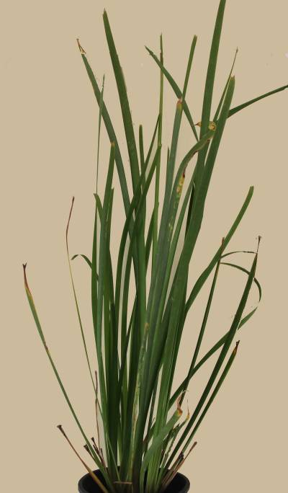 | 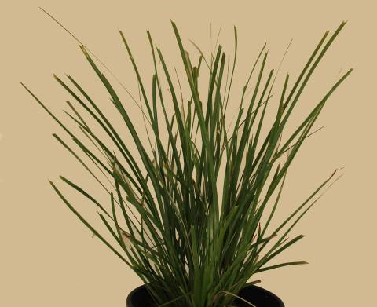 | 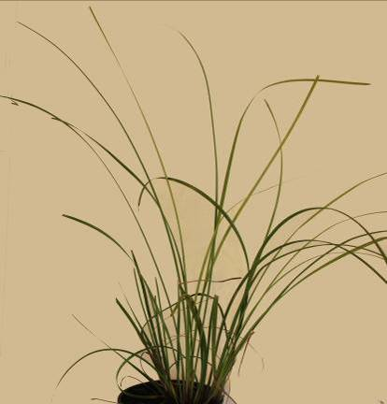
1 | 2 | 3
upright | semi upright | spreading

Ad. 2: Plant: height of foliage

Height of foliage is observed from base of plant to top of foliage, excluding inflorescence.

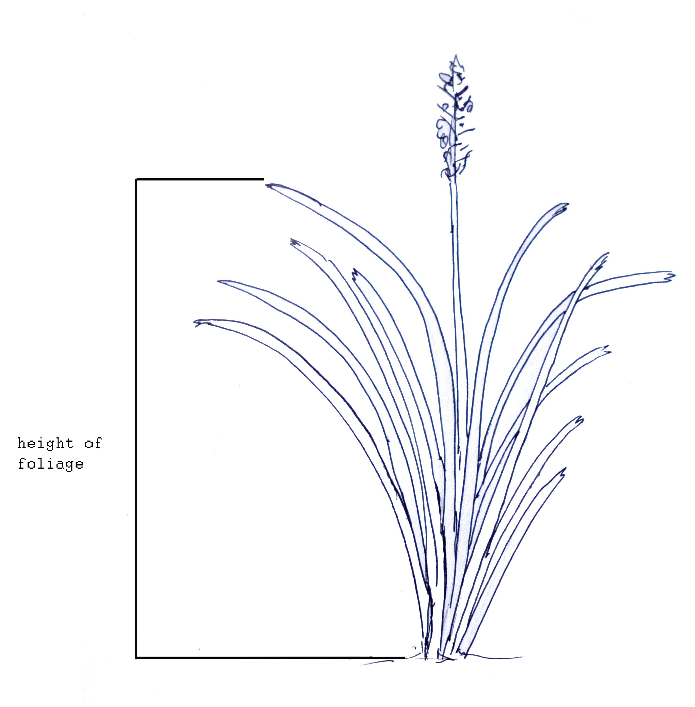
height of foliage

Ad. 4: Leaf: attitude of upper third

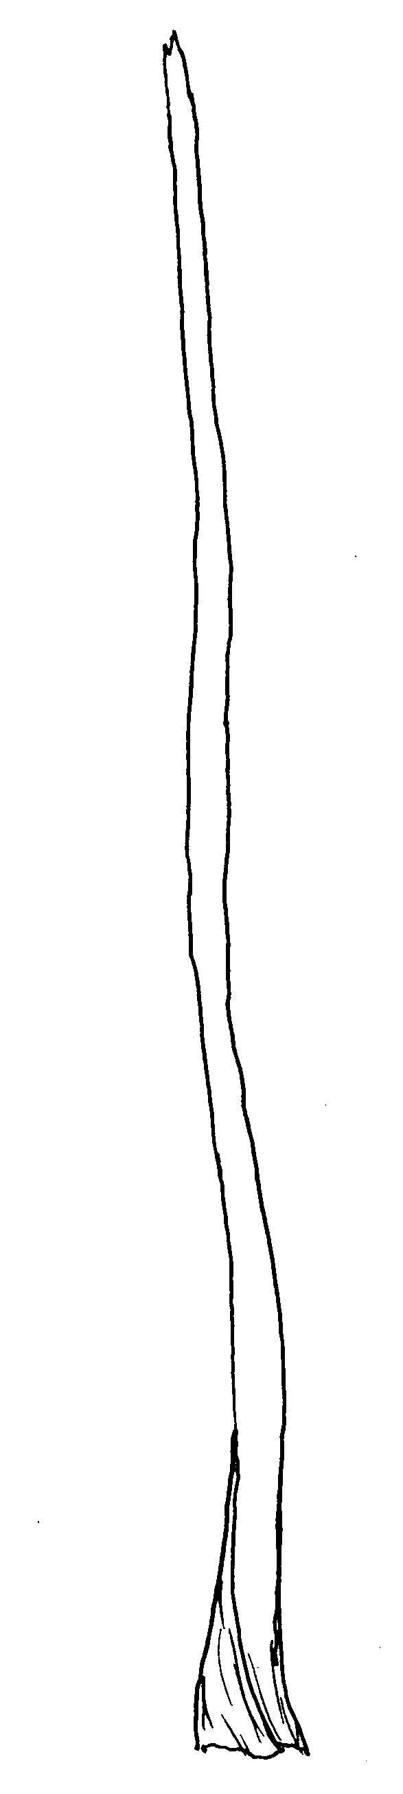 | 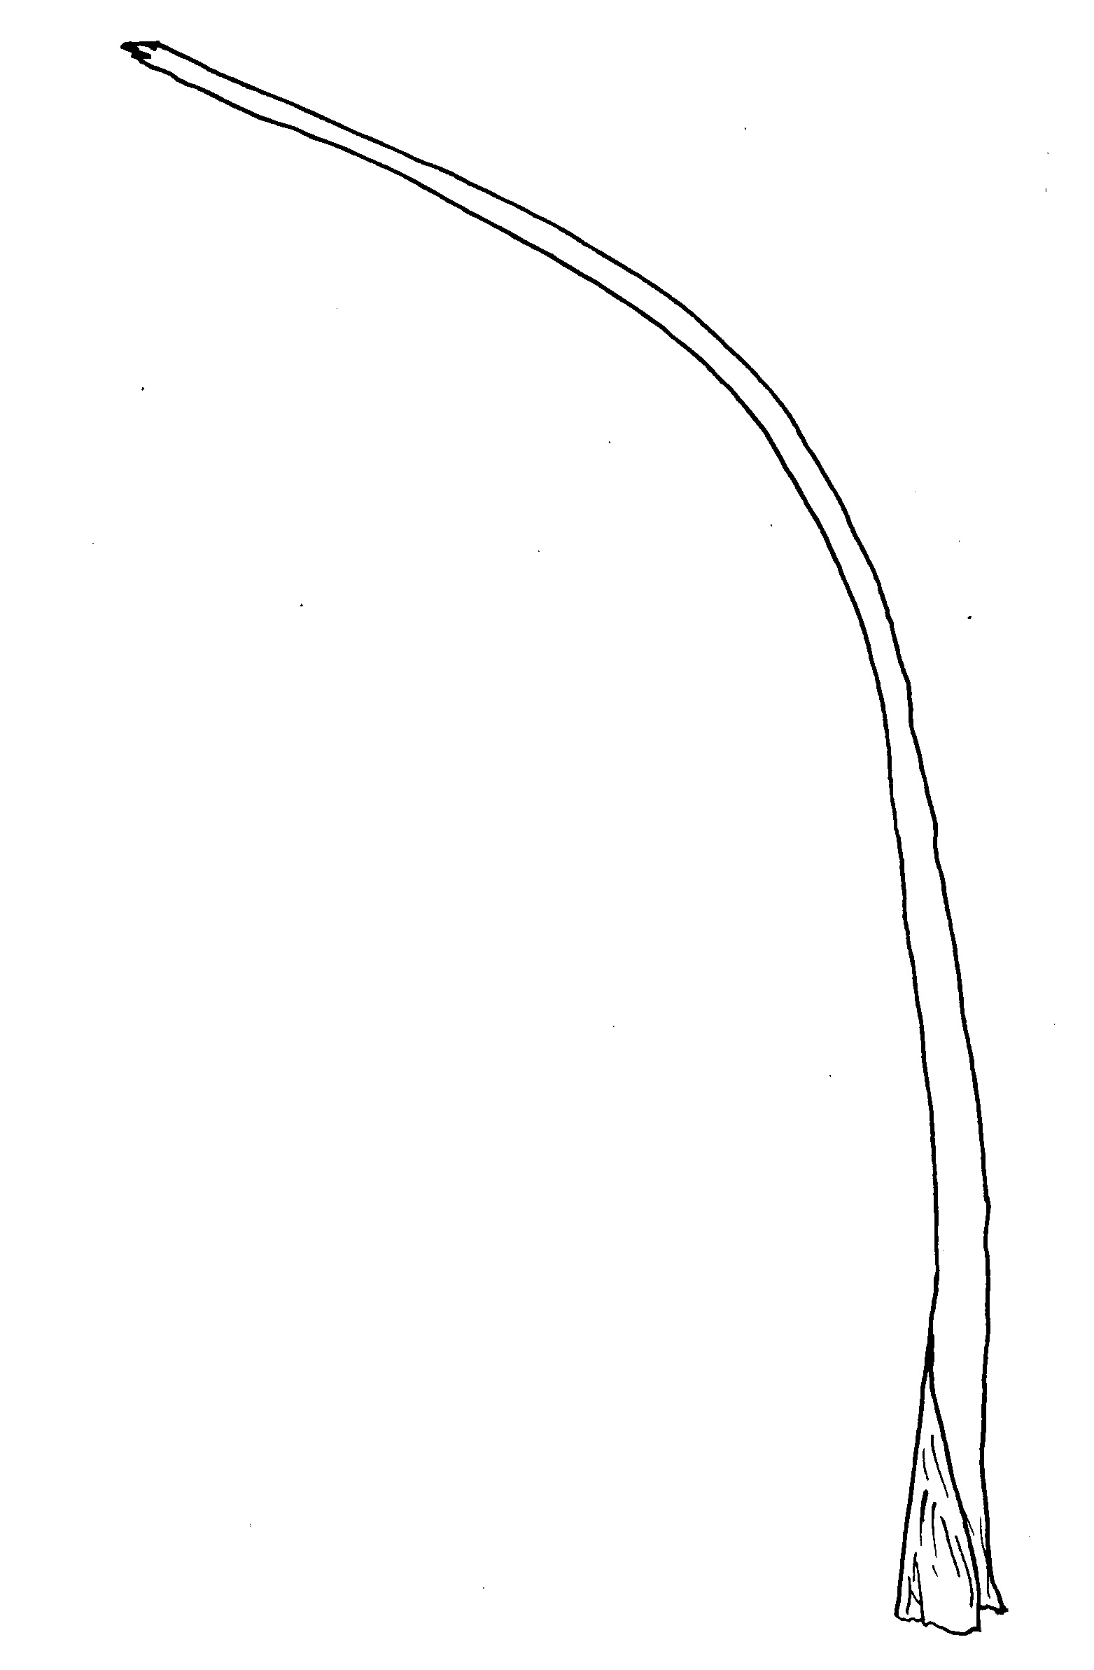 | 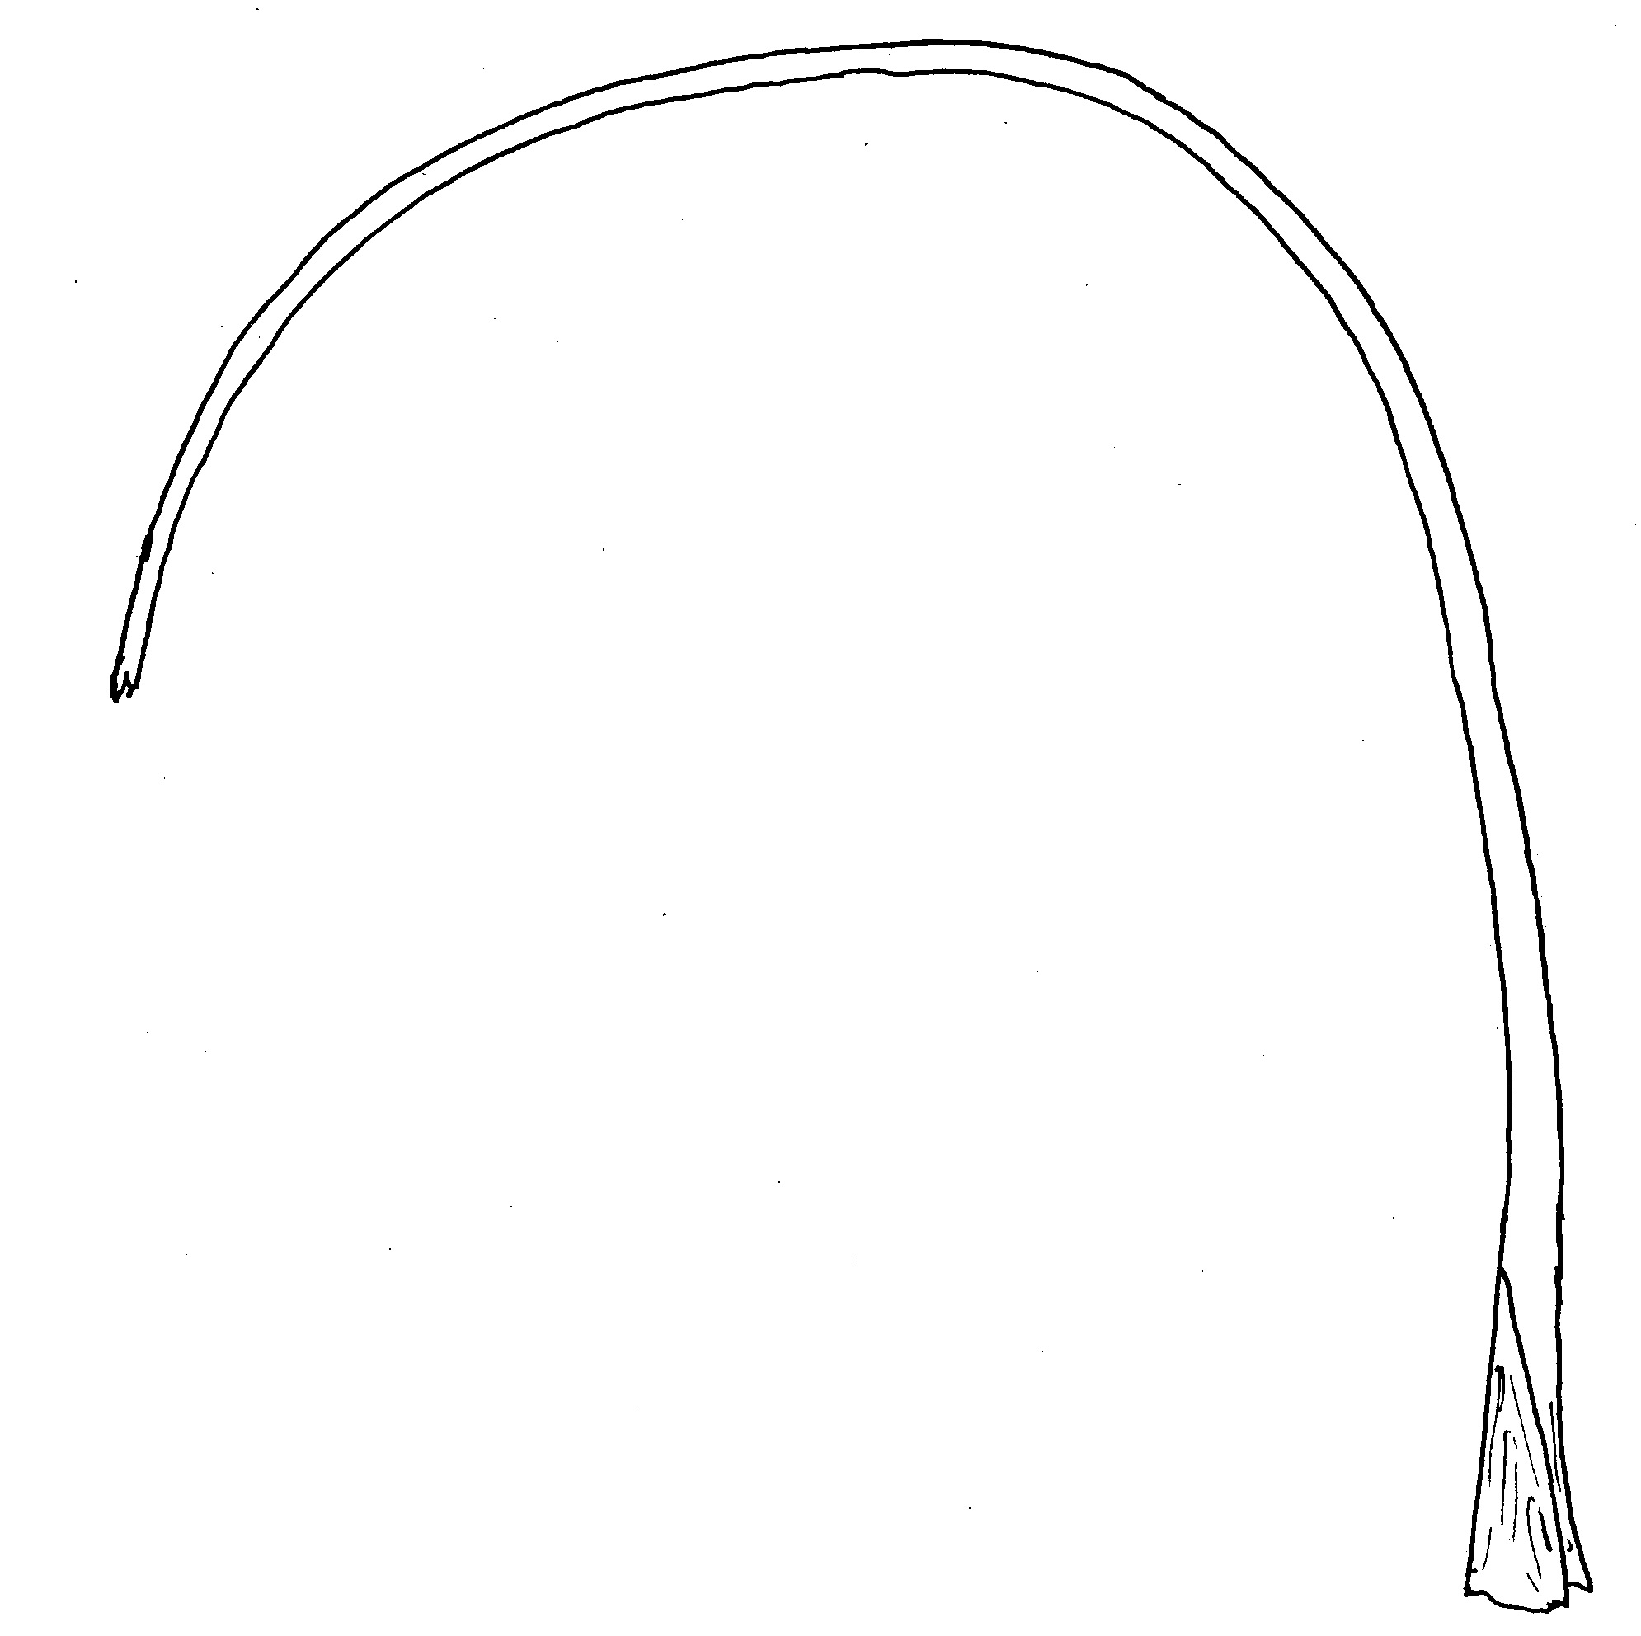
1 | 2 | 3
erect | semi-erect | drooping

Ad. 7: Leaf: profile in cross section

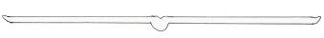 | 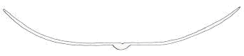 | 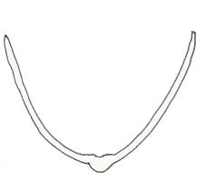 | 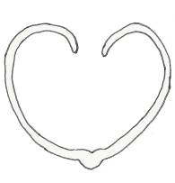
1 | 2 | 3 | 4
flat to slightly concave | moderately concave | strongly concave | inrolled

Ad. 8: Leaf: type of apex

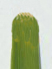 | 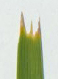
1 | 2
entire | toothed

Ad. 9: Leaf: length of middle tooth

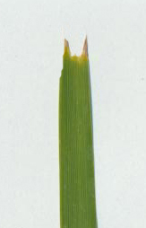 | 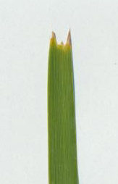 | 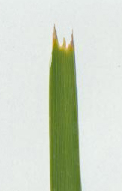 | 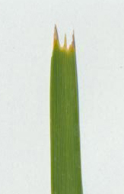
1 | 3 | 5 | 7
very short | short | medium | long

Ad. 12: Leaf: main color of upper side
Ad. 13: Leaf: secondary color of upper side

The main color is the color with the largest surface area. In cases where the areas of the main and secondary color are too similar to reliably decide which color has the largest area, the darkest color is considered to be the main color.

Sometimes there is a waxy layer covering the leaf surface which gives a bluish or whitish appearance. The layer should be removed by rubbing before observing leaf color.

Ad. 15: Leaf: pliability

Assessed by folding middle third of leaf over index finger and observing the extent of splitting. Strong pliability is indicated by little or no splitting.

Ad. 16: Basal sheath: shredding of margin

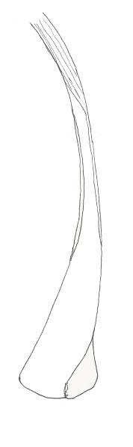 | 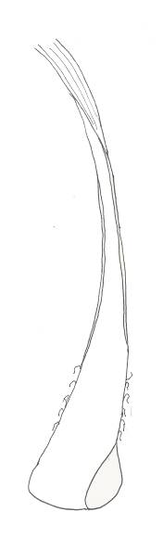 | 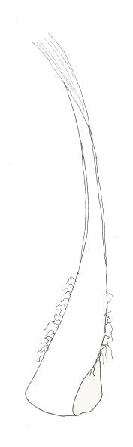 | 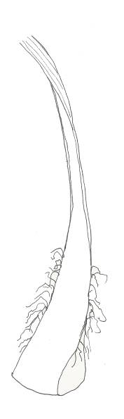
1 | 3 | 5 | 7
absent or very weak | weak | medium | strong

Ad. 17: Basal sheath: intensity of brown color

If present, the shredded margin of the basal leaf sheath should be excluded from the observation.

Ad. 19: Inflorescence: number of branches

The number of nodes with branches and the number of branches per node are observed.

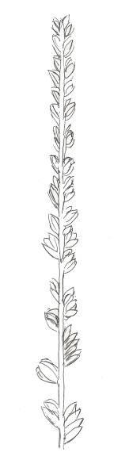 | 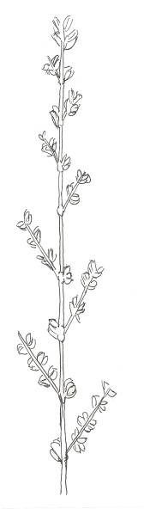 | 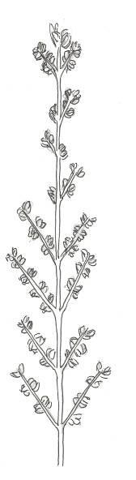 | 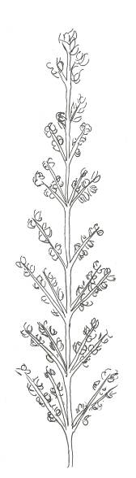
1 | 3 | 5 | 7
absent or very few | few | medium | many

Ad. 20: Inflorescence: length of flowering part
Ad. 21: Peduncle: length
Ad. 23: Bract: length

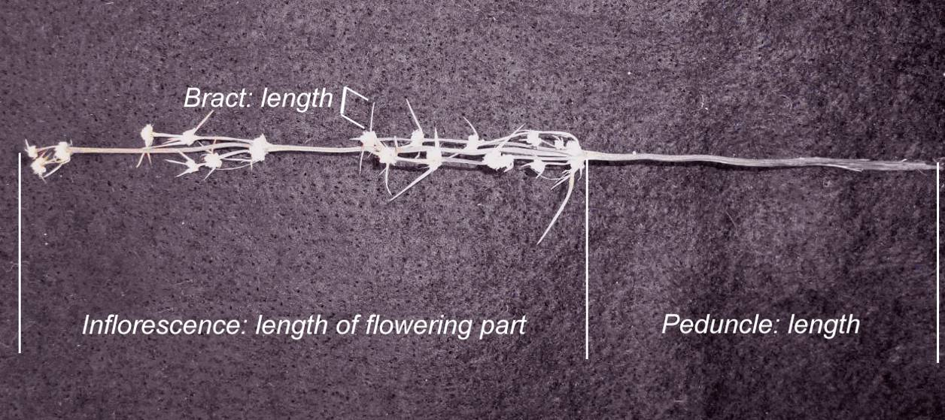

Ad. 24: Calyx: color

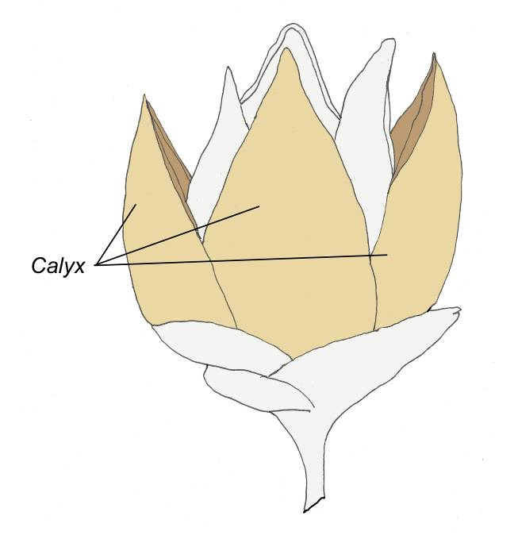

9. Literature

Lee, A.T., Macfarlane, T.D., 1986: Flora of Australia vol 46. Australian Government Publishing Service. Canberra, Australian Capital Territory, AU, pp. 100 to 141.

10. Technical Questionnaire

TECHNICAL QUESTIONNAIRE |  |  |  | Page {x} of {y} |  | Reference Number:
 |  |  |  |  |  | Application date:
 |  |  |  |  |  | (not to be filled in by the applicant)
TECHNICAL QUESTIONNAIRE
to be completed in connection with an application for plant breeders’ rights

1. Subject of the Technical Questionnaire
1.1.1 Botanical name |  |  | Lomandra Labill.
1.1.2 Common name |  |  | Lomandra, Mat Rush
1.2 Species
(please complete)
2. Applicant
Name
Address
Telephone No.
Fax No.
E-mail address
Breeder (if different from applicant)
3. Proposed denomination and breeder’s reference
Proposed denomination
(if available)

Breeder’s reference
#4. Information on the breeding scheme and propagation of the variety

4.1 Breeding scheme

Variety resulting from:

4.1.1 Crossing

(a) controlled cross [ ]
(please state parent varieties)

(…………………..……………..…) x (……………..…………………..…)
female parent male parent

(b) partially known cross [ ]
(please state known parent variety(ies))

(…………………..……………..…) x (……………..…………………..…)
female parent male parent

(c) unknown cross [ ]

4.1.2 Mutation [ ]
(please state parent variety)

4.1.3 Discovery and development [ ]
(please state where and when discovered and how developed)

4.1.4 Other [ ]
(please provide details)

4.2 Method of propagating the variety

4.2.1 Vegetative propagation

(a) cuttings [ ]

(b) in vitro propagation [ ]

(c) other (state method) [ ]

5. Characteristics of the variety to be indicated (the number in brackets refers to the corresponding characteristic in Test Guidelines; please mark the note which best corresponds).

 | Characteristics |  |  |  |  |  | Example Varieties |  |  | Note
5.1  (1) | Plant: habit
 | upright |  |  |  |  |  | Merlom Ruby |  |  | 1 [ ]
 | semi upright |  |  |  |  |  | Katrinus Deluxe |  |  | 2 [ ]
 | spreading |  |  |  |  |  | Stormy Seas |  |  | 3 [ ]
5.2  (6) | Leaf blade: width
 | very narrow |  |  |  |  |  | LM300 |  |  | 1 [ ]
 | very narrow to narrow |  |  |  |  |  |  |  |  | 2 [ ]
 | narrow |  |  |  |  |  | Merlom Ruby |  |  | 3 [ ]
 | narrow to medium |  |  |  |  |  |  |  |  | 4 [ ]
 | medium |  |  |  |  |  | Stormy Seas |  |  | 5 [ ]
 | medium to broad |  |  |  |  |  |  |  |  | 6 [ ]
 | broad |  |  |  |  |  | Cassica |  |  | 7 [ ]
 | broad to very broad |  |  |  |  |  |  |  |  | 8 [ ]
 | very broad |  |  |  |  |  |  |  |  | 9 [ ]
5.3  (11) | Leaf: glaucosity of upper side
 | very weak |  |  |  |  |  | Lime Tuff |  |  | 1 [ ]
 | very weak to weak |  |  |  |  |  |  |  |  | 2 [ ]
 | weak |  |  |  |  |  | Katrinus |  |  | 3 [ ]
 | weak to medium |  |  |  |  |  |  |  |  | 4 [ ]
 | medium |  |  |  |  |  | Merlom Ruby |  |  | 5 [ ]
 | medium to strong |  |  |  |  |  |  |  |  | 6 [ ]
 | strong |  |  |  |  |  | SIR5 |  |  | 7 [ ]
 | strong to very strong |  |  |  |  |  |  |  |  | 8 [ ]
 | very strong |  |  |  |  |  | Stormy Seas |  |  | 9 [ ]
 | Characteristics |  |  |  |  |  | Example Varieties |  |  | Note
5.4  (17) | Basal sheath: intensity of brown color
 | light |  |  |  |  |  | Lime Tuff |  |  | 1 [ ]
 | medium |  |  |  |  |  | Katrinus |  |  | 2 [ ]
 | dark |  |  |  |  |  | Stormy Seas |  |  | 3 [ ]
6. Similar varieties and differences from these varieties

Please use the following table and box for comments to provide information on how your candidate variety differs from the variety (or varieties) which, to the best of your knowledge, is (or are) most similar. This information may help the examination authority to conduct its examination of distinctness in a more efficient way.

Denomination(s) of variety(ies) similar to your candidate variety |  | Characteristic(s) in which your candidate variety differs from the similar variety(ies) |  |  | Describe the expression of the characteristic(s) for the similar variety(ies) |  |  | Describe the expression of the characteristic(s) for your candidate variety
Example |  | Plant: habit |  |  | semi upright |  |  | spreading
Comments:

#7. Additional information which may help in the examination of the variety

7.1 In addition to the information provided in sections 5 and 6, are there any additional characteristics which may help to distinguish the variety?

Yes [ ] No [ ]

(If yes, please provide details)

7.2 Are there any special conditions for growing the variety or conducting the examination?

Yes [ ] No [ ]

(If yes, please provide details)

7.3 Other information

7.3.1 Indicate the Plant: sex expression (if known).
Male [ ] Female […]

A representative color image of the variety should accompany the Technical Questionnaire.

8. Authorization for release

(a) Does the variety require prior authorization for release under legislation concerning the protection of the environment, human and animal health?

Yes [ ] No [ ]

(b) Has such authorization been obtained?

Yes [ ] No [ ]

If the answer to (b) is yes, please attach a copy of the authorization.

9. Information on plant material to be examined or submitted for examination.

9.1 The expression of a characteristic or several characteristics of a variety may be affected by factors, such as pests and disease, chemical treatment (e.g. growth retardants or pesticides), effects of tissue culture, different rootstocks, scions taken from different growth phases of a tree, etc.

9.2 The plant material should not have undergone any treatment which would affect the expression of the characteristics of the variety, unless the competent authorities allow or request such treatment. If the plant material has undergone such treatment, full details of the treatment must be given. In this respect, please indicate below, to the best of your knowledge, if the plant material to be examined has been subjected to:

(a) Microorganisms (e.g. virus, bacteria, phytoplasma) Yes [ ] No [ ]

(b) Chemical treatment (e.g. growth retardant, pesticide) Yes [ ] No [ ]

(c) Tissue culture Yes [ ] No [ ]

(d) Other factors Yes [ ] No [ ]

Please provide details for where you have indicated “yes”.

……………………………………………………………

10. I hereby declare that, to the best of my knowledge, the information provided in this form is correct:

Applicant’s name

Signature Date

[End of document]

* These names were correct at the time of the introduction of these Test Guidelines but may be revised or updated. [Readers are advised to consult the UPOV Code, which can be found on the UPOV Website (www.upov.int), for the latest information.]
# Authorities may allow certain of this information to be provided in a confidential section of the Technical Questionnaire.
# Authorities may allow certain of this information to be provided in a confidential section of the Technical Questionnaire.

