 |  |  |  |  |  |  | E  TG/EUCAL(proj.10)  ORIGINAL: English  DATE: 2013-02-26
INTERNATIONAL UNION FOR THE PROTECTION OF NEW VARIETIES OF PLANTS
Geneva
 |  |  | DRAFT
 |  | EUCALYPTUS  UPOV Code: EUCAL  Sub-genus Symphyomyrtus  Sections Transversaria, Maidenaria, Exsertaria |  |  | *

GUIDELINES

FOR THE CONDUCT OF TESTS

FOR DISTINCTNESS, UNIFORMITY AND STABILITY

prepared by experts from Brazil and China

to be considered by the
Technical Committee at its forty-ninth session,
to be held in Geneva from March 18 to 20, 2013

Alternative Names:*

Botanical name | English | French | German | Spanish
Eucalyptus L'Hér.  (Sub-genus Symphyomyrtus)  (Sections Transversaria, Maidenaria, Exsertaria) | Eucalyptus | Eucalyptus | Eukalyptus | Eucalipto

The purpose of these guidelines (“Test Guidelines”) is to elaborate the principles contained in the General Introduction (document TG/1/3), and its associated TGP documents, into detailed practical guidance for the harmonized examination of distinctness, uniformity and stability (DUS) and, in particular, to identify appropriate characteristics for the examination of DUS and production of harmonized variety descriptions.

ASSOCIATED DOCUMENTS
These Test Guidelines should be read in conjunction with the General Introduction and its associated TGP documents.
TABLE OF CONTENTS PAGE

1. Subject of these Test Guidelines 3
2. Material Required 3
3. Method of Examination 3
3.1 Number of Growing Cycles 3
3.2 Testing Place 3
3.3 Conditions for Conducting the Examination 3
3.4 Test Design 3
3.5 Additional Tests 3
4. Assessment of Distinctness, Uniformity and Stability 4
4.1 Distinctness 4
4.2 Uniformity 5
4.3 Stability 5
5. Grouping of Varieties and Organization of the Growing Trial 5
6. Introduction to the Table of Characteristics 5
6.1 Categories of Characteristics 5
6.2 States of Expression and Corresponding Notes 6
6.3 Types of Expression 6
6.4 Example Varieties 6
6.5 Legend 7
7. Table of Characteristics/Tableau des caractères/Merkmalstabelle/Tabla de caracteres 8
8. Explanations on the Table of Characteristics 17
8.1 Explanations covering several characteristics 17
8.2 Explanations for individual characteristics 18
9. Literature 27
10. Technical Questionnaire 28

Subject of these Test Guidelines
These Test Guidelines apply to all varieties of the species of the sections Transversaria, Maidenaria and Exsertaria of the sub-genus Symphyomyrtus of the genus Eucalyptus L'Hér.

Material Required
2.1 The competent authorities decide on the quantity and quality of the plant material required for testing the variety and when and where it is to be delivered. Applicants submitting material from a State other than that in which the testing takes place must ensure that all customs formalities and phytosanitary requirements are complied with.

2.2 The material is to be supplied in the form of young plants, 4 to 6 months old.

2.3 The minimum quantity of plant material, to be supplied by the applicant, should be:

7 plants.

2.4 The plant material supplied should be visibly healthy, not lacking in vigor, nor affected by any important pest or disease.

2.5 The plant material should not have undergone any treatment which would affect the expression of the characteristics of the variety, unless the competent authorities allow or request such treatment. If it has been treated, full details of the treatment must be given.

Method of Examination

3.1 Number of Growing Cycles

The minimum duration of tests should normally be a single growing cycle.

3.2 Testing Place

Tests are normally conducted at one place. In the case of tests conducted at more than one place, guidance is provided in TGP/9 “Examining Distinctness”.

3.3 Conditions for Conducting the Examination

3.3.1 The tests should be carried out under conditions ensuring satisfactory growth for the expression of the relevant characteristics of the variety and for the conduct of the examination.

3.4 Test Design

3.4.1 Each test should be designed to result in a total of at least 7 plants.

3.4.2 The design of the tests should be such that plants or parts of plants may be removed for measurement or counting without prejudice to the observations which must be made up to the end of the growing cycle.

Additional Tests

Additional tests, for examining relevant characteristics, may be established.

Assessment of Distinctness, Uniformity and Stability

4.1 Distinctness

4.1.1 General Recommendations

It is of particular importance for users of these Test Guidelines to consult the General Introduction prior to making decisions regarding distinctness. However, the following points are provided for elaboration or emphasis in these Test Guidelines.

4.1.2 Consistent Differences

The differences observed between varieties may be so clear that more than one growing cycle is not necessary. In addition, in some circumstances, the influence of the environment is not such that more than a single growing cycle is required to provide assurance that the differences observed between varieties are sufficiently consistent. One means of ensuring that a difference in a characteristic, observed in a growing trial, is sufficiently consistent is to examine the characteristic in at least two independent growing cycles.

4.1.3 Clear Differences

Determining whether a difference between two varieties is clear depends on many factors, and should consider, in particular, the type of expression of the characteristic being examined, i.e. whether it is expressed in a qualitative, quantitative, or pseudo-qualitative manner. Therefore, it is important that users of these Test Guidelines are familiar with the recommendations contained in the General Introduction prior to making decisions regarding distinctness.

4.1.4 Number of Plants / Parts of Plants to be Examined

Unless otherwise indicated, for the purposes of distinctness, all observations on single plants should be made on 5 plants or parts taken from each of 5 plants and any other observations made on all plants in the test, disregarding any off-type plants.

4.1.5 Method of Observation

The recommended method of observing the characteristic for the purposes of distinctness is indicated by the following key in the second column of the Table of Characteristics (see document TGP/9 “Examining Distinctness”, Section 4 “Observation of characteristics”):

MG: single measurement of a group of plants or parts of plants
MS: measurement of a number of individual plants or parts of plants
VG: visual assessment by a single observation of a group of plants or parts of plants
VS: visual assessment by observation of individual plants or parts of plants

Type of observation: visual (V) or measurement (M)

“Visual” observation (V) is an observation made on the basis of the expert’s judgment. For the purposes of this document, “visual” observation refers to the sensory observations of the experts and, therefore, also includes smell, taste and touch. Visual observation includes observations where the expert uses reference points (e.g. diagrams, example varieties, side-by-side comparison) or non-linear charts (e.g. color charts). Measurement (M) is an objective observation against a calibrated, linear scale e.g. using a ruler, weighing scales, colorimeter, dates, counts, etc.

Type of record: for a group of plants (G) or for single, individual plants (S)

For the purposes of distinctness, observations may be recorded as a single record for a group of plants or parts of plants (G), or may be recorded as records for a number of single, individual plants or parts of plants (S). In most cases, “G” provides a single record per variety and it is not possible or necessary to apply statistical methods in a plant-by-plant analysis for the assessment of distinctness.

In cases where more than one method of observing the characteristic is indicated in the Table of Characteristics (e.g. VG/MG), guidance on selecting an appropriate method is provided in document TGP/9, Section 4.2.

4.2 Uniformity

4.2.1 It is of particular importance for users of these Test Guidelines to consult the General Introduction prior to making decisions regarding uniformity. However, the following points are provided for elaboration or emphasis in these Test Guidelines:

4.2.2 For the assessment of uniformity, a population standard of 1% and an acceptance probability of at least 95% should be applied. In the case of a sample size of 7 plants, 1 off-type is allowed.

4.3 Stability

4.3.1 In practice, it is not usual to perform tests of stability that produce results as certain as those of the testing of distinctness and uniformity. However, experience has demonstrated that, for many types of variety, when a variety has been shown to be uniform, it can also be considered to be stable.

4.3.2 Where appropriate, or in cases of doubt, stability may be further examined by testing a new plant stock to ensure that it exhibits the same characteristics as those shown by the initial material supplied.

Grouping of Varieties and Organization of the Growing Trial
5.1 The selection of varieties of common knowledge to be grown in the trial with the candidate varieties and the way in which these varieties are divided into groups to facilitate the assessment of distinctness are aided by the use of grouping characteristics.

5.2 Grouping characteristics are those in which the documented states of expression, even where produced at different locations, can be used, either individually or in combination with other such characteristics: (a) to select varieties of common knowledge that can be excluded from the growing trial used for examination of distinctness; and (b) to organize the growing trial so that similar varieties are grouped together.

5.3 The following have been agreed as useful grouping characteristics:

- Leaf: waxiness of upper side (characteristic 2)
- Leaf: petiole (characteristic 4)
- Primary branch: type of insertion in main stem (characteristic 13)
- Flower: type (characteristic 45)
- Only varieties with flower type: umbel: Flower: number of buds (characteristic 46)
- Fruit: shape (characteristic 51)

5.4 Guidance for the use of grouping characteristics, in the process of examining distinctness, is provided through the General Introduction and document TGP/9 “Examining Distinctness”.

Introduction to the Table of Characteristics

6.1 Categories of Characteristics

6.1.1 Standard Test Guidelines Characteristics

Standard Test Guidelines characteristics are those which are approved by UPOV for examination of DUS and from which members of the Union can select those suitable for their particular circumstances.

6.1.2 Asterisked Characteristics

Asterisked characteristics (denoted by *) are those included in the Test Guidelines which are important for the international harmonization of variety descriptions and should always be examined for DUS and included in the variety description by all members of the Union, except when the state of expression of a preceding characteristic or regional environmental conditions render this inappropriate.

6.2 States of Expression and Corresponding Notes

6.2.1 States of expression are given for each characteristic to define the characteristic and to harmonize descriptions. Each state of expression is allocated a corresponding numerical note for ease of recording of data and for the production and exchange of the description.

6.2.2 In the case of qualitative and pseudo-qualitative characteristics (see Chapter 6.3), all relevant states of expression are presented in the characteristic. However, in the case of quantitative characteristics with 5 or more states, an abbreviated scale may be used to minimize the size of the Table of Characteristics. For example, in the case of a quantitative characteristic with 9 states, the presentation of states of expression in the Test Guidelines may be abbreviated as follows:

State | Note
small | 3
medium | 5
large | 7

However, it should be noted that all of the following 9 states of expression exist to describe varieties and should be used as appropriate:

State | Note
very small | 1
very small to small | 2
small | 3
small to medium | 4
medium | 5
medium to large | 6
large | 7
large to very large | 8
very large | 9

6.2.3 Further explanation of the presentation of states of expression and notes is provided in document TGP/7 “Development of Test Guidelines”.

Types of Expression

An explanation of the types of expression of characteristics (qualitative, quantitative and pseudo-qualitative) is provided in the General Introduction.

Example Varieties

Where appropriate, example varieties are provided to clarify the states of expression of each characteristic.

6.5 Legend

(*) Asterisked characteristic – see Chapter 6.1.2

QL: Qualitative characteristic – see Chapter 6.3
QN: Quantitative characteristic – see Chapter 6.3
PQ: Pseudo-qualitative characteristic – see Chapter 6.3

MG, MS, VG, VS – see Chapter 4.1.5

(a)-(d) See Explanations on the Table of Characteristics in Chapter 8.1
(+) See Explanations on the Table of Characteristics in Chapter 8.2

Table of Characteristics/Tableau des caractères/Merkmalstabelle/Tabla de caracteres

 |  | English | français | deutsch | español | Example Varieties  Exemples  Beispielssorten  Variedades ejemplo | Note/  Nota
1  (+) | VG | Branch: attitude | Rameau : port | Zweig: Haltung | Rama: porte
QN | (a) | erect | dressé | aufrecht | erecto |  | 1
 |  | semi-erect | demi-dressé | halbaufrecht | semierecto |  | 2
 |  | horizontal | horizontal | waagerecht | horizontal |  | 3
2  (*) | VG | Leaf: waxiness of upper side | Feuille : pruine de la face supérieure | Blatt: Wachsschicht auf der Oberseite | Hoja: pruína del haz
QN | (a) | absent or weak | absente ou faible | fehlend oder gering | ausente o débil | IPB3, IPB4, SUZSP0619 | 1
 |  | medium | moyenne | mittel | media | VM08 | 2
 |  | strong | forte | stark | fuerte | VT06 | 3
3 | VG | Leaf: anthocyanin coloration | Feuille : pigmentation anthocyanique | Blatt: Anthocyanfärbung | Hoja: pigmentación antociánica
QN | (a) | absent or very weak | absente ou très faible | fehlend oder sehr gering | ausente o muy débil | SEAGR46, SEAGR47, SUZBA9318 | 1
 |  | weak | faible | gering | débil | AEC 1528 | 3
 |  | medium | moyenne | mittel | media | IPB2, VT01 | 5
 |  | strong | forte | stark | fuerte |  | 7
 |  | very strong | très forte | sehr stark | muy fuerte |  | 9
4  (*)  (+) | VG | Leaf: petiole | Feuille : pétiole | Blatt: Blattstiel | Hoja: peciolo
QL | (a) | absent | absent | fehlend | ausente |  | 1
 |  | present | présent | vorhanden | presente |  | 9
5  (*)  (+) | VG | Only varieties without petiole: Leaf: attachment | Uniquement les variétés sans pétiole : Feuille : attache | Nur Sorten ohne Blattstiel: Blatt: Ansatzstelle | Sólo en variedades sin peciolo: Hoja: base
PQ | (a) | connate | connée | verwachsen | connada |  | 1
 |  | amplexicaul | amplexicaule | stengelumfassend | amplexical |  | 2
 |  | decurrent | décursive | herablaufend | decurrente |  | 3
6  (*)  (+) | VG/MS | Leaf blade: length | Limbe : longueur | Blattspreite: Länge | Limbo: longitud
QN | (a) | short | court | kurz | corto |  | 3
 |  | medium | moyen | mittel | medio | ARA 6075, SUZSP0530 | 5
 |  | long | long | lang | largo | ARA 6011, ARA 6061 | 7
7  (*) | VG/MS | Leaf blade: width | Limbe : largeur | Blattspreite: Breite | Limbo: anchura
QN | (a) | narrow | étroit | schmal | estrecho | SUZMA2015 | 3
 |  | medium | moyen | mittel | medio | SUZMA2040 | 5
 |  | broad | large | breit | ancho | ARA 6011, ARA 6061 | 7
8  (*)  (+) | VG/MS | Leaf blade: shape | Limbe : forme | Blattspreite: Form | Limbo: forma
QN | (a) | slightly elongated | légèrement allongé | leicht langgezogen | ligeramente alargada | SUZMA2015, VT09 | 3
 |  | moderately elongated | modérément allongé | mäßig langgezogen | moderadamente alargada | ARA1967, IPB2, VT01 | 5
 |  | very elongated | très allongé | stark langgezogen | muy alargada | SUZSP0530, VM08 | 7
9 | VG | Leaf blade: position of broadest part | Limbe : position de la partie la plus large | Blattspreite: Position der breitesten Stelle | Limbo: posición de la parte más ancha
QN | (a) | towards base | vers la base | zur Basis hin | hacia la base |  | 1
 |  | at middle | au milieu | in der Mitte | central |  | 2
 |  | towards top | vers le sommet | zur Spitze hin | hacia la parte superior |  | 3
10  (*)  (+) | VG | Leaf blade: shape of base | Limbe : forme de la base | Blattspreite: Form der Basis | Limbo: forma de la base
PQ | (a) | sagittate | sagittée | pfeilspitzenförmig | sagitada |  | 1
 |  | hastate | hastée | spießförmig | hastada |  | 2
 |  | auriculate | auriculée | geöhrt | auriculada |  | 3
 |  | cordate | cordiforme | herzförmig | cordada |  | 4
 |  | obtuse | obtuse | stumpf | obtusa |  | 5
 |  | cuneate | cunéiforme | keilförmig | cuneada |  | 6
 |  | attenuate | effilée | verjüngt | atenuada |  | 7
 |  | oblique | oblique | schräg abstehend | oblicua |  | 8
11  (*)  (+) | VG | Leaf blade: shape of apex | Limbe : forme du sommet | Blattspreite: Form des Scheitels | Limbo: forma del ápice
PQ | (a) | rounded | arrondi | abgerundet | redondeado |  | 1
 |  | obtuse | obtus | stumpf | obtuso |  | 2
 |  | acute | aigu | spitz | agudo |  | 3
 |  | subulate | subulé | pfriemförmig | subulado |  | 4
12  (*)  (+) | VG | Leaf blade: tip | Limbe : extrémité | Blattspreite: Spitze | Limbo: extremo
PQ | (a) | none | aucune | keine | ninguno |  | 1
 |  | apiculate | apiculée | fein zugespitzt | apiculado |  | 2
 |  | acuminate | acuminée | zugespitzt | acuminado |  | 3
 |  | cirrhous | cirrheuse | rankenförmig | cirriforme |  | 4
 |  | mucronate | mucronée | mit kurzer aufgesetzter Spitze | mucronado |  | 5
 |  | aristate | aristée | begrannt | aristado |  | 6
 |  | emarginate | émarginée | eingekerbt | emarginado |  | 7
 |  | obcordate | obcordiforme | verkehrt herzförmig | obcordado |  | 8
13  (*)  (+) | VG | Primary branch: type of insertion in main stem | Rameau primaire : type d’insertion sur la tige principale | Primärast: Typ des Ansatzes im Hauptstamm | Rama primaria: tipo de inserción en el tallo principal
QL | (b) | inverted “V” | inversée en “V” | verkehrtes „V“ | en “V” invertida |  | 1
 |  | circular | circulaire | rund | circular |  | 2
14  (+) | VG | Leaf: attitude | Feuille : port | Blatt: Haltung | Hoja: porte
QN | (b) | erect | dressé | aufrecht | erecto |  | 1
 |  | horizontal | horizontal | waagerecht | horizontal |  | 2
 |  | downwards | retombant | abwärts gerichtet | descendente |  | 3
15  (*) | VG | Leaf: waxiness of upper side | Feuille : pruine de la face supérieure | Blatt: Wachsschicht der Oberseite | Hoja: pruína del haz
QN | (b) | absent or weak | absente ou faible | fehlend oder gering | ausente o débil | IPB5, SEAGR47, SUZSP0628, SUZBA9318 | 1
 |  | medium | moyenne | mittel | media | ARA6011, ARA6061, ARA11097 | 2
 |  | strong | forte | stark | fuerte | ARA1967, VT01 | 3
16  (*)  (+) | VG | Leaf: petiole | Feuille : pétiole | Blatt: Blattstiel | Hoja: peciolo
QL | (b) | absent | absent | fehlend | ausente |  | 1
 |  | present | présent | vorhanden | presente |  | 9
17  (*)  (+) | VG/MS | Leaf blade: length | Limbe : longueur | Blattspreite: Länge | Limbo: longitud
QN | (b) | short | court | kurz | corto |  | 3
 |  | medium | moyen | mittel | medio | ARA 6075, SUZSP0530 | 5
 |  | long | long | lang | largo | ARA 6011, ARA 6061 | 7
18  (*) | VG/MS | Leaf blade: width | Limbe : largeur | Blattspreite: Breite | Limbo: anchura
QN | (b) | narrow | étroit | schmal | estrecho | SUZMA2015 | 3
 |  | medium | moyen | mittel | medio | SUZMA2040 | 5
 |  | broad | large | breit | ancho | ARA 6011, ARA 6061 | 7
19  (*)  (+) | VG/MS | Leaf blade: shape | Limbe : forme | Blattspreite: Form | Limbo: forma
QN | (b) | slightly elongated | légèrement allongé | leicht langgezogen | ligeramente alargada |  | 3
 |  | moderately elongated | modérément allongé | mäßig langgezogen | moderadamente alargada |  | 5
 |  | very elongated | très allongé | stark langgezogen | muy alargada |  | 7
20 | VG | Leaf blade: position of broadest part | Limbe : position de la partie la plus large | Blattspreite: Position der breitesten Stelle | Limbo: posición de la parte más ancha
QN | (b) | towards base | vers la base | zur Basis hin | hacia la base |  | 1
 |  | at middle | au milieu | in der Mitte | central |  | 2
 |  | towards top | vers le sommet | zur Spitze hin | hacia la parte superior |  | 3
21  (*)  (+) | VG | Leaf blade: shape of base | Limbe : forme de la base | Blattspreite: Form der Basis | Limbo: forma de la base
PQ | (b) | sagittate | sagittée | pfeilspitzenförmig | sagitada |  | 1
 |  | hastate | hastée | spießförmig | hastada |  | 2
 |  | auriculate | auriculée | geöhrt | auriculada |  | 3
 |  | cordate | cordiforme | herzförmig | cordada |  | 4
 |  | obtuse | obtuse | stumpf | obtusa |  | 5
 |  | cuneate | cunéiforme | keilförmig | cuneada |  | 6
 |  | attenuate | effilée | verjüngt | atenuada |  | 7
 |  | oblique | oblique | schräg abstehend | oblicua |  | 8
22  (*)  (+) | VG | Leaf blade: shape of apex | Limbe : forme du sommet | Blattspreite: Form des Scheitels | Limbo: forma del ápice
PQ | (b) | rounded | arrondi | abgerundet | redondeado |  | 1
 |  | obtuse | obtus | stumpf | obtuso |  | 2
 |  | acute | aigu | spitz | agudo |  | 3
 |  | subulate | subulé | pfriemförmig | subulado |  | 4
23  (*)  (+) | VG | Leaf blade: tip | Limbe : extrémité | Blattspreite: Spitze | Limbo: extremo
PQ | (b) | none | aucune | keine | ninguno |  | 1
 |  | apiculate | apiculée | fein zugespitzt | apiculado |  | 2
 |  | acuminate | acuminée | zugespitzt | acuminado |  | 3
 |  | cirrhous | cirrheuse | rankenförmig | cirriforme |  | 4
 |  | mucronate | mucronée | mit kurzer aufgesetzter Spitze | mucronado |  | 5
 |  | aristate | aristée | begrannt | aristado |  | 6
 |  | emarginate | émarginée | eingekerbt | emarginado |  | 7
 |  | obcordate | obcordiforme | verkehrt herzförmig | obcordado |  | 8
24 | VG | Trunk: waxiness (excluding rhytidome) | Tronc : pruine (rhytidome exclu) | Stamm: Wachsschicht (ohne Rhytidom) | Tronco: pruína (excluido el ritidoma)
QN | (c) | absent or weak | absente ou faible | fehlend oder gering | ausente o débil |  | 1
 |  | medium | moyenne | mittel | media |  | 2
 |  | strong | forte | stark | fuerte |  | 3
25  (+) | VG | Leaf: attitude | Feuille : port | Blatt: Haltung | Hoja: porte
QN | (c) | erect | dressé | aufrecht | erecto |  | 1
 |  | horizontal | horizontal | waagerecht | horizontal |  | 2
 |  | downwards | retombant | abwärts gerichtet | descendente |  | 3
26 | VG | Leaf: intensity of color of upper side in relation to lower side | Feuille : intensité de la couleur de la face supérieure par rapport à la face inférieure | Blatt: Intensität der Farbe der Oberseite im Vergleich zur Unterseite | Hoja: intensidad del color del haz en relación con el envés
QN | (c) | same or slightly darker | même couleur ou légèrement plus foncée | gleich oder leicht dunkler | del mismo color o ligeramente más oscuro |  | 1
 |  | moderately darker | modérément plus foncée | mäßig dunkler | moderadamente más oscuro |  | 2
 |  | much darker | beaucoup plus foncée | viel dunkler | más oscuro |  | 3
27 | VG | Leaf: waxiness of upper side | Feuille : pruine de la face supérieure | Blatt: Wachsschicht der Oberseite | Hoja: pruína del haz
QN | (c) | absent or weak | absente ou faible | fehlend oder gering | ausente o débil | IPB1, IPB2, IPB3 | 1
 |  | medium | moyenne | mittel | media | VT01, VT02, VT05 | 2
 |  | strong | forte | stark | fuerte |  | 3
28  (*)  (+) | VG | Leaf: petiole | Feuille : pétiole | Blatt: Blattstiel | Hoja: peciolo
QL | (c) | absent | absent | fehlend | ausente |  | 1
 |  | present | présent | vorhanden | presente |  | 9
29  (*)  (+) | VG/MS | Leaf blade: length | Limbe : longueur | Blattspreite: Länge | Limbo: longitud
QN | (c) | short | court | kurz | corto |  | 3
 |  | medium | moyen | mittel | medio | ARA 6075, SUZSP0530, VT 02 | 5
 |  | long | long | lang | largo | IPB1, IPB5, VT03 | 7
30  (*)  (+) | VG/MS | Leaf blade: width | Limbe : largeur | Blattspreite: Breite | Limbo: anchura
QN | (c) | narrow | étroit | schmal | estrecho |  | 3
 |  | medium | moyen | mittel | medio | IPB2, VT01, VT04 | 5
 |  | broad | large | breit | ancho | SUZSP1002, SUZSP0619 | 7
31  (+) | VG/MS | Leaf blade: shape | Limbe : forme | Blattspreite: Form | Limbo: forma
QN | (c) | slightly elongated | légèrement allongé | leicht langgezogen | ligeramente alargada |  | 3
 |  | moderately elongated | modérément allongé | mäßig langgezogen | moderadamente alargada |  | 5
 |  | very elongated | très allongé | stark langgezogen | muy alargada |  | 7
32 | VG | Leaf blade: position of broadest part | Limbe : position de la partie la plus large | Blattspreite: Position der breitesten Stelle | Limbo: posición de la parte más ancha
QN | (c) | towards base | vers la base | zur Basis hin | hacia la base |  | 1
 |  | at middle | au milieu | in der Mitte | central |  | 2
 |  | towards top | vers le sommet | zur Spitze hin | hacia la parte superior |  | 3
33  (+) | VG | Leaf blade: shape of base | Limbe : forme de la base | Blattspreite: Form der Basis | Limbo: forma de la base
PQ | (c) | sagittate | sagittée | pfeilspitzenförmig | sagitada |  | 1
 |  | hastate | hastée | spießförmig | hastada |  | 2
 |  | auriculate | auriculée | geöhrt | auriculada |  | 3
 |  | cordate | cordiforme | herzförmig | cordada |  | 4
 |  | obtuse | obtuse | stumpf | obtusa |  | 5
 |  | cuneate | cunéiforme | keilförmig | cuneada |  | 6
 |  | attenuate | effilée | verjüngt | atenuada |  | 7
 |  | oblique | oblique | schräg abstehend | oblicua |  | 8
34  (+) | VG | Leaf blade: shape of apex | Limbe : forme du sommet | Blattspreite: Form des Scheitels | Limbo: forma del ápice
PQ | (c) | rounded | arrondi | abgerundet | redondeado |  | 1
 |  | obtuse | obtus | stumpf | obtuso |  | 2
 |  | acute | aigu | spitz | agudo |  | 3
 |  | subulate | subulé | pfriemförmig | subulado |  | 4
35  (+) | VG | Leaf blade: tip | Limbe : extrémité | Blattspreite: Spitze | Limbo: extremo
PQ | (c) | none | aucune | keine | ninguno |  | 1
 |  | apiculate | apiculée | fein zugespitzt | apiculado |  | 2
 |  | acuminate | acuminée | zugespitzt | acuminado |  | 3
 |  | cirrhous | cirrheuse | rankenförmig | cirriforme |  | 4
 |  | mucronate | mucronée | mit kurzer aufgesetzter Spitze | mucronado |  | 5
 |  | aristate | aristée | begrannt | aristado |  | 6
 |  | emarginate | émarginée | eingekerbt | emarginado |  | 7
 |  | obcordate | obcordiforme | verkehrt herzförmig | obcordado |  | 8
36  (+) | VG | Trunk: texture of basal rhytidome | Tronc : texture du rhytidome basal | Stamm: Beschaffenheit des unteren Rhytidoms | Tronco: textura del ritidoma basal
QN | (d) | compact | compact | kompakt | compacto |  | 1
 |  | moderately fibrous | modérément fibreux | mäßig fibrös | moderadamente fibroso |  | 2
 |  | very fibrous | très fibreux | sehr fibrös | muy fibroso |  | 3
37  (+) | VG | Trunk: extension of rhytidome | Tronc : extension du rhytidome | Stamm: Ausdehnung des Rhytidoms | Tronco: extensión del ritidoma
QN | (d) | up to lower third | jusqu’au tiers inférieur | bis zum unteren Drittel | hasta el tercio inferior |  | 1
 |  | up to mid-third | jusqu’au tiers moyen | bis zum mittleren Drittel | hasta el tercio medio |  | 2
 |  | up to upper third | jusqu’au tiers supérieur | bis zum oberen Drittel | hasta el tercio superior |  | 3
38  (+) | MG | Trunk: density of wood | Tronc : densité du bois | Stamm: Dichte des Holzes | Tronco: densidad de la madera
QN | (d) | low | basse | gering | baja |  | 3
 |  | medium | moyenne | mittel | media |  | 5
 |  | high | élevée | hoch | alta |  | 7
39  (*)  (+) | VG | Trunk: rhytidome | Tronc : rhytidome | Stamm: Rhytidom | Tronco: ritidoma
QL | (d) | absent | absent | fehlend | ausente |  | 1
 |  | present | présent | vorhanden | presente |  | 9
40 | VG | Trunk: color of rhytidome | Tronc : couleur du rhytidome | Stamm: Farbe des Rhytidoms | Tronco: color del ritidoma
PQ | (d) | green | vert | grün | verde |  | 1
 |  | grey | gris | grau | gris | ARA11097 | 2
 |  | brown | brun | braun | marrón |  | 3
41  (*) | VG | Trunk: color (excluding rhytidome) | Tronc : couleur (rhytidome exclu) | Stamm: Farbe (ohne Rhytidom) | Tronco: color (excluido el ritidoma)
PQ | (d) | brownish white | blanc brunâtre | bräunlichweiß | blanco parduzco |  | 1
 |  | green | vert | grün | verde | VM 11 | 2
 |  | bluish green | vert bleuâtre | bläulichgrün | verde azulado | ARA 6075, IPB4 | 3
 |  | grey | gris | grau | gris | SUZMA 2001, VM08 | 4
 |  | brown | brun | braun | marrón | IPB7, VT01, VT02, | 5
42  (+) | VG | Primary branch: type of insertion in main stem | Rameau primaire : type d’insertion sur la tige principale | Primärast: Typ des Ansatzes im Hauptstamm | Rama primaria: tipo de inserción en el tallo principal
QL | (d) | inverted “V” | inversée en “V” | verkehrtes „V“ | en “V” invertida |  | 1
 |  | circular | circulaire | rund | circular |  | 9
43  (*)  (+) | VG | Leaf: petiole | Feuille : pétiole | Blatt: Blattstiel | Hoja: peciolo
QL | (d) | absent | absent | fehlend | ausente |  | 1
 |  | present | présent | vorhanden | presente |  | 9
44 | MG | Tree: time of first flowering | Arbre : époque de la première floraison | Baum: Zeitpunkt der ersten Blüte | Árbol: época de la primera floración
QN | (d) | early | précoce | früh | temprana | IPB1, IPB2, IPB5, SEAGR46, SUZSP0530, VT01 | 1
 |  | medium | moyenne | mittel | media | ARA6011, ARA6061 | 2
 |  | late | tardive | spät | tardía | VT04 | 3
45  (+) | VG | Flower: type | Fleur : type | Blüte: Typ | Flor: tipo
QL | (d) | solitary | isolée | einzeln | aislada |  | 1
 |  | umbel | ombelle | Dolde | umbela |  | 2
46 | MG | Only varieties with flower type: umbel: Flower: number of buds | Uniquement les variétés à type de fleurs : ombelle : Fleur : nombre de bourgeons | Nur Sorten mit Blütentyp: Dolde: Blüte: Anzahl der Knospen | Sólo las variedades con tipo de flor: umbela: Flor: número de yemas
QL | (d) | three | trois | drei | tres |  | 1
 |  | seven | sept | seven | siete |  | 2
 |  | nine | neuf | neun | nueve |  | 3
 |  | eleven | onze | elf | once |  | 4
 |  | more than eleven | plus de onze | mehr als elf | mas de once |  | 5
47  (+) | VG | Flower bud: shape of operculum | Bouton floral : forme de l’opercule | Blütenknospe: Form des Operculums | Botón floral: forma del opérculo
PQ | (d) | rostrate | rostré | hakenförmig | rostrado |  | 1
 |  | hemispherical | hémisphérique | halbkugelförmig | hemisférico |  | 2
 |  | hemispherical apiculate | hémisphérique apiculé | halbkugelförmig fein zugespitzt | apiculado hemisférico |  | 3
 |  | flattened with a prominent pointed tip | aplati avec une extrémité pointue proéminente | abgeflacht mit vorstehender spitzer Spitze | aplanado con extremo puntiagudo prominente |  | 4
 |  | horn-shaped | en corne | hornförmig | en forma de cuerno |  | 5
 |  | elongated | allongé | langgezogen | alargado |  | 6
 |  | conical | conique | konisch | cónico |  | 7
48 | VG/MS | Only varieties with flower type: umbel: Peduncle: length | Uniquement les variétés à type de fleurs : ombelle : Pédoncule : longueur | Nur Sorten mit Blütentyp: Dolde: Blütenstandstiel: Länge | Sólo las variedades con floración: umbela: Pedúnculo: longitud
QN | (d) | short | court | kurz | corto |  | 3
 |  | medium | moyen | mittel | medio | AEC 1528, ARA6061 | 5
 |  | long | long | lang | largo | IPB5, SEAGR47, SUZBA9318 | 7
49  (+) | VG | Peduncle: shape in cross section | Pédoncule : forme en section transversale | Blütenstandstiel: Form im Querschnitt | Pedúnculo: forma en sección transversal
QN | (d) | rounded | arrondi | abgerundet | redondeada |  | 1
 |  | rounded to flattened | arrondi à aplati | abgerundet bis abgeflacht | redondeada a aplanada |  | 2
 |  | flattened | aplati | abgeflacht | aplanada |  | 3
50 | VG/MS | Fruit: width | Fruit : largeur | Frucht: Breite | Fruto: anchura
QN | (d) | narrow | étroit | schmal | estrecho |  | 3
 |  | medium | moyen | mittel | medio |  | 5
 |  | broad | large | breit | ancho |  | 7
51  (+) | VG | Fruit: shape | Fruit : forme | Frucht: Form | Fruto: forma
PQ | (d) | conical | conique | konisch | cónico |  | 1
 |  | cylindrical | cylindrique | zylindrisch | cilíndrico |  | 2
 |  | ovoid | ovoïde | eiförmig | ovoide |  | 3
 |  | urceolate | urcéolé | urnenförmig | urceolado |  | 4
 |  | globose | globuleux | kugelförmig | globoso |  | 5
 |  | pyriform | pyriforme | birnenförmig | piriforme |  | 6
 |  | campanulate | campanulé | glockenförmig | acampanado |  | 7
 |  | hemispherical | hémisphérique | halbkugelförmig | hemisférico |  | 8
52  (+) | VG | Fruit: texture of surface | Fruit : texture de la surface | Frucht: Beschaffenheit der Oberfläche | Fruto: textura de la superficie
QL | (d) | smooth | lisse | glatt | lisa |  | 1
 |  | rough | rugueux | rauh | rugosa |  | 2
53  (+) | VG | Fruit: disc position | Fruit : position du disque | Frucht: Position der Scheibe | Fruto: posición del disco
QN | (d) | descending | retombant | herablaufend | descendente |  | 1
 |  | same level | même niveau | auf gleicher Höhe | al mismo nivel |  | 2
 |  | ascending | redressé | nach oben abstehend | orientado hacia arriba |  | 3
54  (+) | VG | Fruit: position of valve | Fruit : position de la valve | Frucht: Position des Ventils | Fruto: posición de la valva
QN | (d) | sunken | en creux | eingesunken | hundida |  | 1
 |  | rim level | au niveau du bord | auf Randhöhe | al nivel del borde |  | 2
 |  | above rim | au-dessus du bord | über den Rand hervorstehend | por encima del borde |  | 3
55  (+) | VG | Fruit: pedicel | Fruit : pédicelle | Frucht: Blattstiel | Fruto: pedicelo
QL | (d) | absent | absent | fehlend | ausente |  | 1
 |  | present | présent | vorhanden | presente |  | 9
56 | VG/MS | Fruit pedicel: length relative to calyx | Pédicelle du fruit : longueur par rapport au calice | Fruchtstiel: Länge im Vergleich zum Kelch | Pedicelo del fruto: longitud en relación con el cáliz
QN | (d) | shorter | plus court | kürzer | más corto |  | 1
 |  | equal | égal | gleich lang | igual |  | 2
 |  | longer | plus long | länger | más largo |  | 3

Explanations on the Table of Characteristics

8.1 Explanations covering several characteristics

Characteristics containing the following key in the second column of the Table of Characteristics should be examined as indicated below:

(a) Observations should be made on 10 to 12 month old trees.
- Observations should be made on 20 to 22 month old trees.
- Observations should be made on 42 to 44 month old trees.
- Observations should be made on 64 to 66 month old trees.

Observations on the leaf should be made on leaves located on terminal shoots in active growth.

8.2 Explanations for individual characteristics

Ad. 1: Branch: attitude

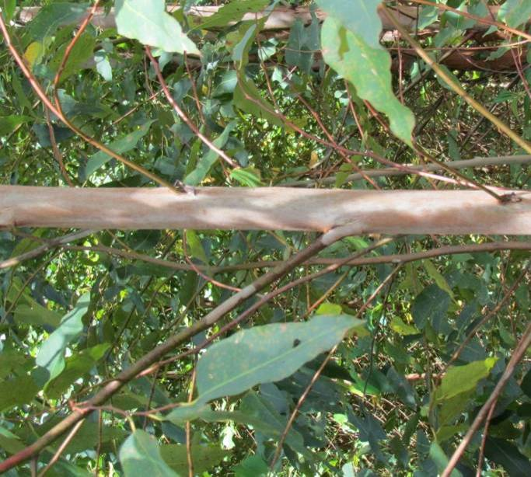 | 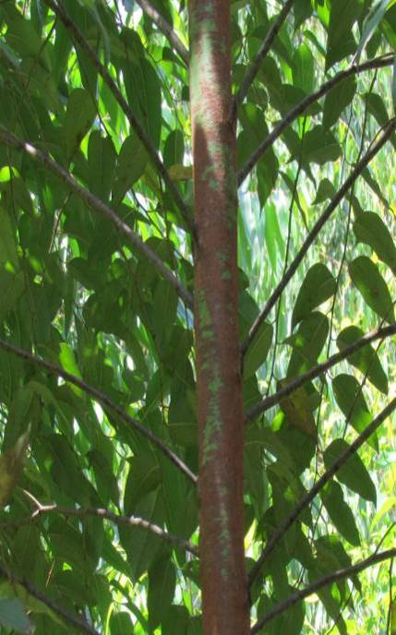
1 | 2
erect | semi-erect

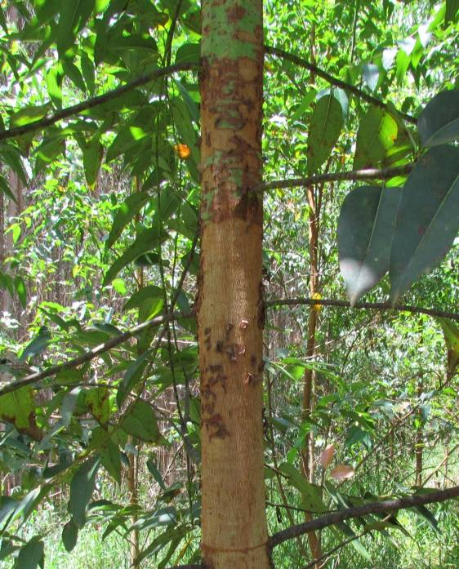
3
horizontal

Ad. 4, 16, 28: Leaf: petiole

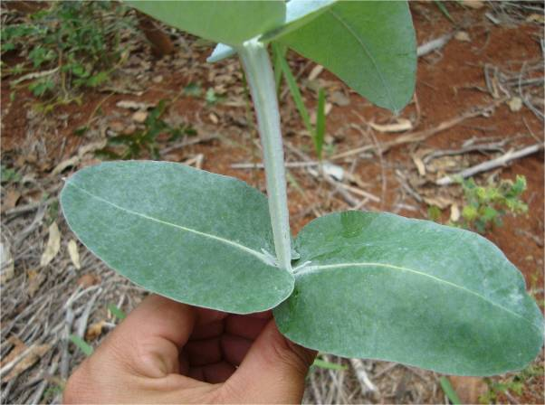 | 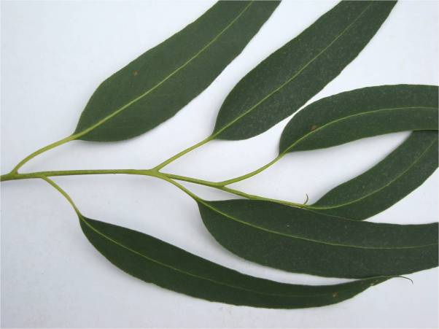
1 | 9
absent | present

Ad. 5: Only varieties without petiole: Leaf: attachment

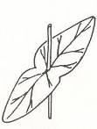 | 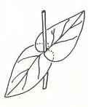 | 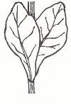
1 | 2 | 3
connate | amplexicaul | decurrent

Ad. 6, 17, 29: Leaf blade: length

The length should be evaluated on the biggest leaf of a branch located in the beginning of the upper third of the crown.

Ad. 8, 19, 31: Leaf blade: shape

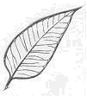 | 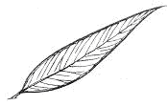 | 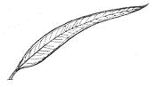
3 | 5 | 7
slightly elongated | moderately elongated | very elongated
Ad. 10, 21, 33: Leaf blade: shape of base

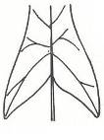 | 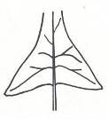 | 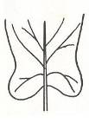 | 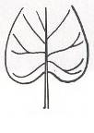
1 | 2 | 3 | 4
sagittate | hastate | auriculate | cordate

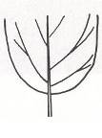 | 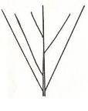 | 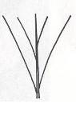 | 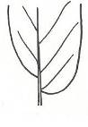
5 | 6 | 7 | 8
obtuse | cuneate | attenuate | oblique

Ad. 11, 22, 34: Leaf blade: shape of apex

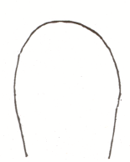 | 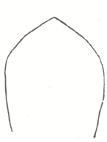 | 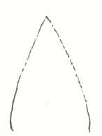 | 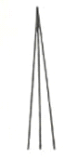
1 | 2 | 3 | 4
rounded | obtuse | acute | subulate

Ad. 12, 23, 35: Leaf blade: tip

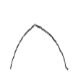 | 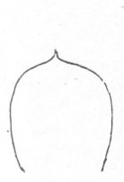 | 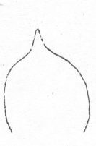
1 | 2 | 3
none | apiculate | acuminate

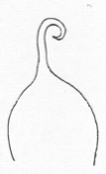 | 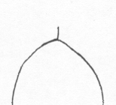 | 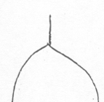
4 | 5 | 6
cirrhous | mucronate | aristate

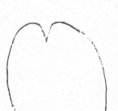 | 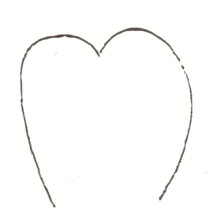
7 | 8
emarginate | obcordate

Ad. 13, 42: Primary branch: type of insertion in main stem

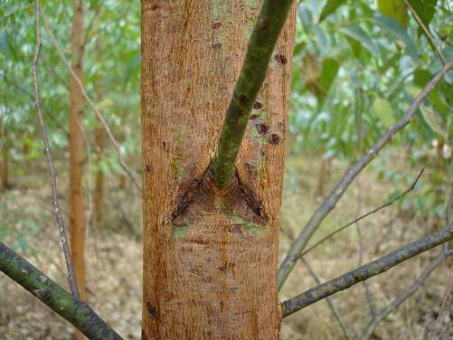 | 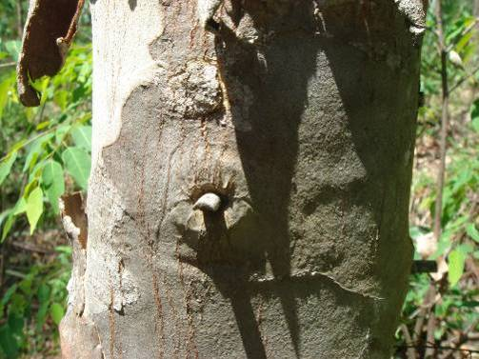
1 | 2
inverted “V” | circular

Ad. 14, 25: Leaf: attitude

This characteristic should be observed with the branch positioned vertically.

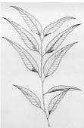 | 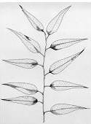 | 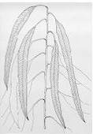
1 | 2 | 3
erect | horizontal | downwards

Ad. 30: Leaf blade: width

This evaluation should be performed on the same leaf selected for characteristic 28. The observation should be made in the widest part of the blade.

Ad. 36: Trunk: texture of basal rythidome

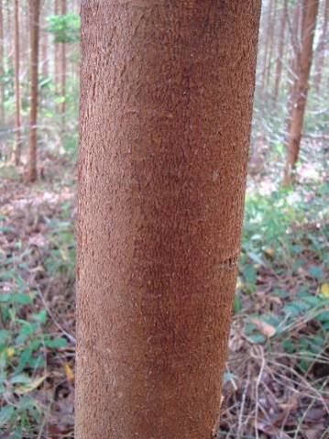 | 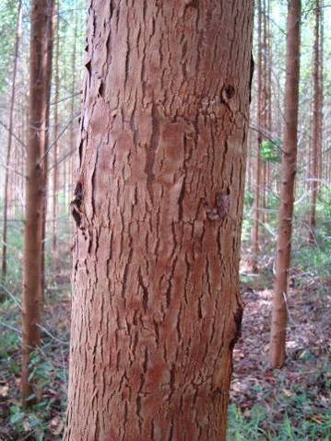
1 | 3
compact | very fibrous

Ad. 37: Trunk: extension of rhytidome

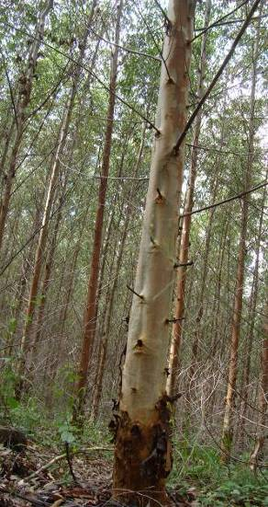 | 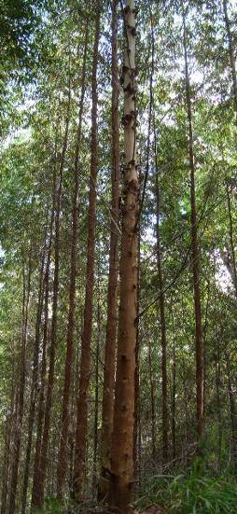 | 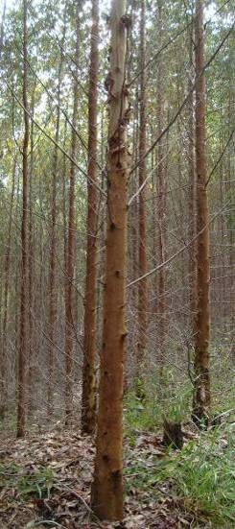
1 | 2 | 3
up to lower third | up to medium third | up to upper third

Ad. 38: Trunk: density of wood

The density should be evaluated on the basis of wood volume, through the hydrostatic balance methodology, according to TAPPI Norm #T258 om-94 (Technical Association of Pulp and Paper Industry).

Ad. 39: Trunk: rhytidome

For some varieties as a tree grows in diameter, the bark tissues are stretched and eventually crack. A new phellogen is then originated in the phloem, and the tissues outside this new layer die and dry out, thus forming part of the outer rough bark of the tree. This bark is known as the rhytidome.

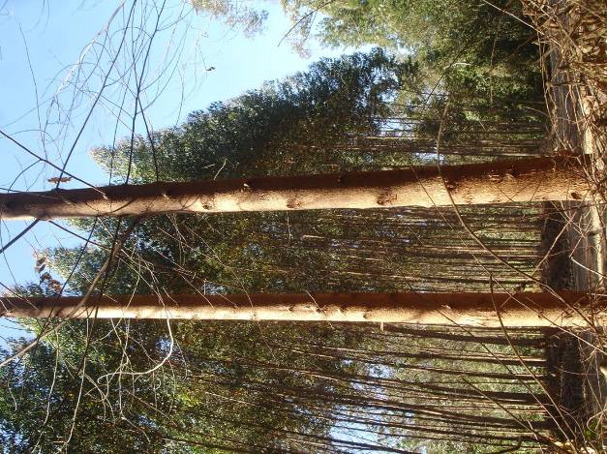 | 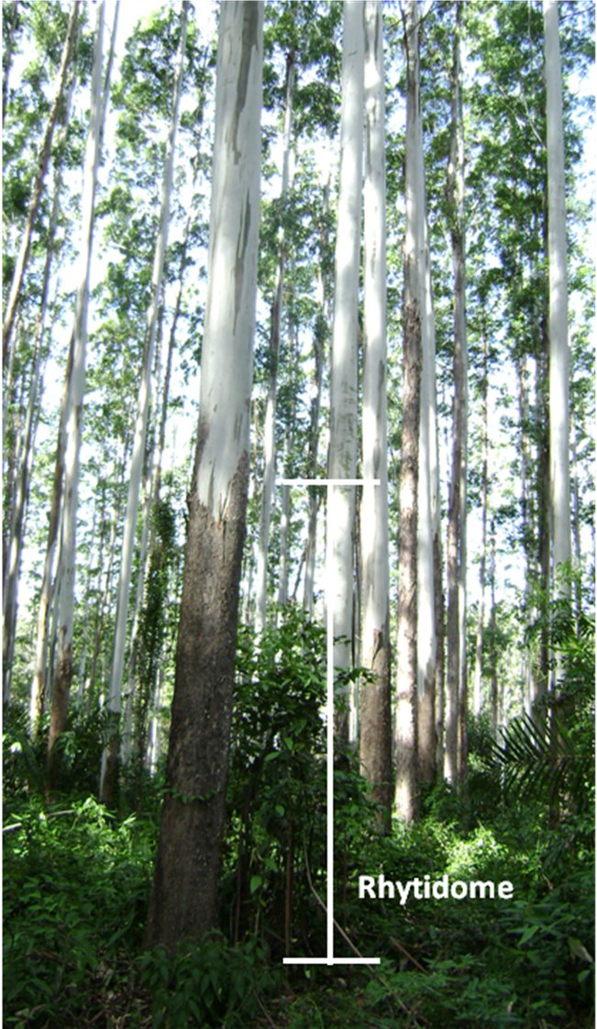
1 | 9
absent | present

Ad. 45: Flower: type

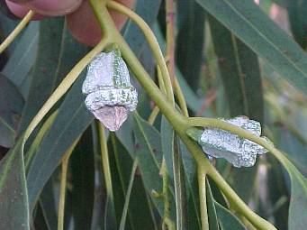 | 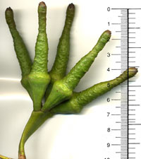
1 | 2
solitary | umbel

Ad. 47: Flower bud: shape of operculum

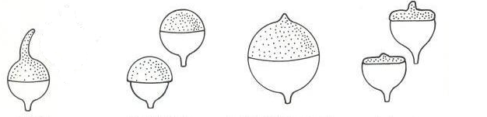
1 | 2 | 3 | 4
rostrate | hemispherical | hemispherical apiculate | flattened with a prominent pointed tip

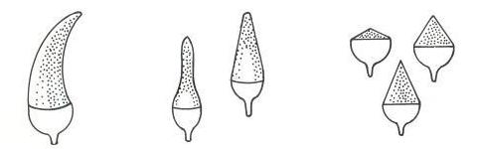
5 | 6 | 7
horn-shaped | elongated | conical

Ad. 49: Peduncle: shape in cross section

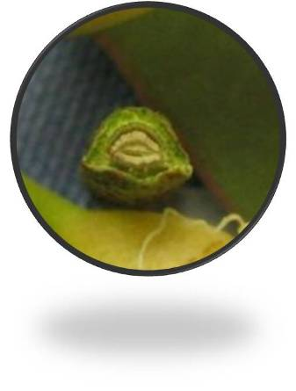 | 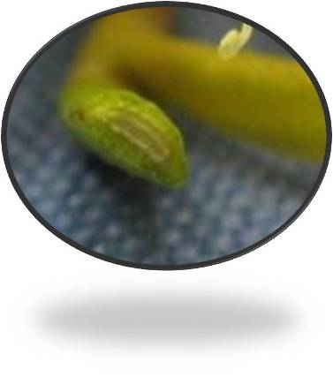
1 | 3
rounded | flattened

Ad. 51: Fruit: shape

 | 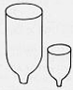 | 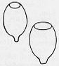 | 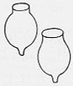
1 | 2 | 3 | 4
conical | cylindrical | ovoid | urceolate

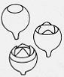 | 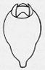 | 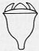 | 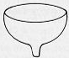
5 | 6 | 7 | 8
globose | pyriform | campanulate | hemispherical

Ad. 52: Fruit: texture of surface

The texture of the fruit should be observed on current season’s fruit.

Ad. 53: Fruit: disc position

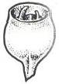 | 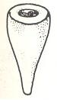 | 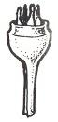
1 | 2 | 3
descending | same level | ascending

Ad. 54: Fruit: valve position

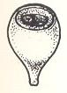 | 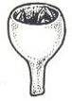
1 | 2 | 3
sunken | rim level | above rim

Ad. 55: Fruit: pedicel

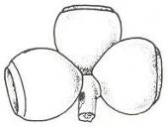 | 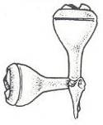
1 | 9
absent | present

Literature

Boland, D. J.; Brooker, M. I. H.; Chippendale, G. M.; Hall, N.; Hyland, B. P. M.; Johnston, R. D., Kleinig, D. A. & Turner, J. D., 1994: Forest trees of Autralia. 4ª ed. Melbourne, AU, Nelson: CSIRO, 703 p.

Brooker, M.I.H. & Kleinig, D.A., 1999: Field guide to eucalypts: south – eastern Australia Vol. 1. 2ª ed. Bloomings Books. 353 p.

Brooker, M.I.H. & Kleinig, D.A, 2002: Field guide to eucalypts: south – western and southern Australia Vol. 2. 2ª ed. Bloomings Books. 436 p.

Brooker, M.I.H. & Kleinig, D.A, 2004: Field guide to eucalypts: northern Australia Vol. 3. 2ª ed. Bloomings Books. 400 p.

Chippendale, G. M., 1968: Eucalyptus buds and fruits. Canberra: Forestry and Timber Bureau, AU, 96 p.

FAO, 1981: El eucalipto en la repoblación forestal. Roma, IT, 723 p.

Goes, E., 1985: Os Eucaliptos. Lisboa, PT, 372 p.

Penfold, A.R. & Willis, J.L., 1961: The Eucalypts. New York, US, 551p.

Drawings by: Anna Júlia Passold, Israel Gomes Vieira and Joel F. Penteado Jr. (Personal files of the researchers of the Instituto de Pesquisas e Estudos Florestais - IPEF, São Paulo, Brasil.)

Technical Questionnaire

TECHNICAL QUESTIONNAIRE |  |  |  | Page {x} of {y} |  | Reference Number:
 |  |  |  |  |  | Application date:
 |  |  |  |  |  | (not to be filled in by the applicant)
TECHNICAL QUESTIONNAIRE
to be completed in connection with an application for plant breeders’ rights

1. Subject of the Technical Questionnaire
1.1 Genus |  |  | Eucalyptus L'Hér.
1.2 Sub-genus |  |  | Symphyomyrtus
1.3 Section
 |  |  | Transversaria – Exsertaria - Maidenaria
1.4 Species
(please complete)
2. Applicant
Name
Address
Telephone No.
Fax No.
E-mail address
Breeder (if different from applicant)
3. Proposed denomination and breeder’s reference
Proposed denomination
(if available)

Breeder’s reference
#4. Information on the breeding scheme and propagation of the variety

4.1 Breeding scheme

Variety resulting from:

4.1.1 Crossing

(a) controlled cross [ ]
(please state parent varieties)

(…………………..……………..…) x (……………..…………………..…)
female parent male parent

(b) partially known cross [ ]
(please state known parent variety(ies))

(…………………..……………..…) x (……………..…………………..…)
female parent male parent

(c) unknown cross [ ]

4.1.2 Mutation [ ]
(please state parent variety)

4.1.3 Discovery and development [ ]
(please state where and when discovered and how developed)

4.1.4 Other [ ]
(please provide details)

4.2 Method of propagating the variety

4.2.1 Vegetative propagation

(a) cuttings [ ]

(b) in vitro propagation [ ]

(c) other (state method) [ ]

4.2.2 Other [ ]
(please provide details)

5. Characteristics of the variety to be indicated (the number in brackets refers to the corresponding characteristic in Test Guidelines; please mark the note which best corresponds).

 | Characteristics |  |  |  |  |  | Example Varieties |  |  | Note
5.1  (2) | Leaf: waxiness of upper side
 | absent or weak |  |  |  |  |  | IPB3, IPB4, SUZSP0619 |  |  | 1[ ]
 | medium |  |  |  |  |  | VM08 |  |  | 2[ ]
 | strong |  |  |  |  |  | VT06 |  |  | 3[ ]
5.2  (4) | Leaf: petiole
 | absent |  |  |  |  |  |  |  |  | 1[ ]
 | present |  |  |  |  |  |  |  |  | 9[ ]
5.3  (13) | Primary branch: type of insertion in main stem
 | inverted “V” |  |  |  |  |  |  |  |  | 1[ ]
 | circular |  |  |  |  |  |  |  |  | 2[ ]
5.4  (45) | Flower: type
 | solitary |  |  |  |  |  |  |  |  | 1[ ]
 | umbel |  |  |  |  |  |  |  |  | 2[ ]
5.5  (46) | Only varieties with flower type: umbel: Flower: number of buds
 | three |  |  |  |  |  |  |  |  | 1[ ]
 | seven |  |  |  |  |  |  |  |  | 2[ ]
 | nine |  |  |  |  |  |  |  |  | 3[ ]
 | eleven |  |  |  |  |  |  |  |  | 4[ ]
 | more than eleven |  |  |  |  |  |  |  |  | 5[ ]
 | Characteristics |  |  |  |  |  | Example Varieties |  |  | Note
5.6  (51) | Fruit: shape
 | conical |  |  |  |  |  |  |  |  | 1[ ]
 | cylindrical |  |  |  |  |  |  |  |  | 2[ ]
 | ovoid |  |  |  |  |  |  |  |  | 3[ ]
 | urceolate |  |  |  |  |  |  |  |  | 4[ ]
 | globose |  |  |  |  |  |  |  |  | 5[ ]
 | pyriform |  |  |  |  |  |  |  |  | 6[ ]
 | campanulate |  |  |  |  |  |  |  |  | 7[ ]
 | hemispherical |  |  |  |  |  |  |  |  | 8[ ]
6. Similar varieties and differences from these varieties

Please use the following table and box for comments to provide information on how your candidate variety differs from the variety (or varieties) which, to the best of your knowledge, is (or are) most similar. This information may help the examination authority to conduct its examination of distinctness in a more efficient way.

Denomination(s) of variety(ies) similar to your candidate variety |  | Characteristic(s) in which your candidate variety differs from the similar variety(ies) |  |  | Describe the expression of the characteristic(s) for the similar variety(ies) |  |  | Describe the expression of the characteristic(s) for your candidate variety
Example |  | Trunk: color (excluding rhytidome) |  |  | green |  |  | bluish green
Comments:

#7. Additional information which may help in the examination of the variety

7.1 In addition to the information provided in sections 5 and 6, are there any additional characteristics which may help to distinguish the variety?

Yes [ ] No [ ]

(If yes, please provide details)

7.2 Are there any special conditions for growing the variety or conducting the examination?

Yes [ ] No [ ]

(If yes, please provide details)

7.3 Other information

8. Authorization for release

(a) Does the variety require prior authorization for release under legislation concerning the protection of the environment, human and animal health?

Yes [ ] No [ ]

(b) Has such authorization been obtained?

Yes [ ] No [ ]

If the answer to (b) is yes, please attach a copy of the authorization.

9. Information on plant material to be examined or submitted for examination.

9.1 The expression of a characteristic or several characteristics of a variety may be affected by factors, such as pests and disease, chemical treatment (e.g. growth retardants or pesticides), effects of tissue culture, different rootstocks, scions taken from different growth phases of a tree, etc.

9.2 The plant material should not have undergone any treatment which would affect the expression of the characteristics of the variety, unless the competent authorities allow or request such treatment. If the plant material has undergone such treatment, full details of the treatment must be given. In this respect, please indicate below, to the best of your knowledge, if the plant material to be examined has been subjected to:

(a) Microorganisms (e.g. virus, bacteria, phytoplasma) Yes [ ] No [ ]

(b) Chemical treatment (e.g. growth retardant, pesticide) Yes [ ] No [ ]

(c) Tissue culture Yes [ ] No [ ]

(d) Other factors Yes [ ] No [ ]

Please provide details for where you have indicated “yes”.

……………………………………………………………

10. I hereby declare that, to the best of my knowledge, the information provided in this form is correct:

Applicant’s name

Signature Date

[End of document]

* These names were correct at the time of the introduction of these Test Guidelines but may be revised or updated. [Readers are advised to consult the UPOV Code, which can be found on the UPOV Website (www.upov.int), for the latest information.]
# Authorities may allow certain of this information to be provided in a confidential section of the Technical Questionnaire.
# Authorities may allow certain of this information to be provided in a confidential section of the Technical Questionnaire.

