 |  |  |  |  |  |  | E  TG/108/4(proj.8)  ORIGINAL: English  DATE: 2013-02-12
INTERNATIONAL UNION FOR THE PROTECTION OF NEW VARIETIES OF PLANTS
Geneva
 |  |  | DRAFT
 |  | GLADIOLUS  UPOV Code: GLADI  Gladiolus L. |  |  | *

GUIDELINES

FOR THE CONDUCT OF TESTS

FOR DISTINCTNESS, UNIFORMITY AND STABILITY

prepared by an expert from the Netherlands

to be considered by the

Technical Committee at its forty-ninth session,
to be held in Geneva from March 18 to 20, 2013

Alternative Names:*

Botanical name | English | French | German | Spanish
Gladiolus L. | Gladiolus | Glaïeul | Gladiole | Gladiolo

The purpose of these guidelines (“Test Guidelines”) is to elaborate the principles contained in the General Introduction (document TG/1/3), and its associated TGP documents, into detailed practical guidance for the harmonized examination of distinctness, uniformity and stability (DUS) and, in particular, to identify appropriate characteristics for the examination of DUS and production of harmonized variety descriptions.

ASSOCIATED DOCUMENTS
These Test Guidelines should be read in conjunction with the General Introduction and its associated TGP documents.
TABLE OF CONTENTS PAGE

1. Subject of these Test Guidelines 3
2. Material Required 3
3. Method of Examination 3
3.1 Number of Growing Cycles 3
3.2 Testing Place 3
3.3 Conditions for Conducting the Examination 3
3.4 Test Design 3
3.5 Additional Tests 3
4. Assessment of Distinctness, Uniformity and Stability 4
4.1 Distinctness 4
4.2 Uniformity 5
4.3 Stability 5
5. Grouping of Varieties and Organization of the Growing Trial 5
6. Introduction to the Table of Characteristics 5
6.1 Categories of Characteristics 5
6.2 States of Expression and Corresponding Notes 6
6.3 Types of Expression 6
6.4 Example Varieties 6
6.5 Legend 7
7. Table of Characteristics/Tableau des caractères/Merkmalstabelle/Tabla de caracteres 8
8. Explanations on the Table of Characteristics 18
8.1 Explanations covering several characteristics 18
8.2 Explanations for individual characteristics 18
9. Literature 27
10. Technical Questionnaire 28

Subject of these Test Guidelines

These Test Guidelines apply to all varieties of Gladiolus L..

Material Required

2.1 The competent authorities decide on the quantity and quality of the plant material required for testing the variety and when and where it is to be delivered. Applicants submitting material from a State other than that in which the testing takes place must ensure that all customs formalities and phytosanitary requirements are complied with.

2.2 The material is to be supplied in the form of corms, able to show all the characteristics in the first year.

2.3 The minimum quantity of plant material, to be supplied by the applicant, should be:

20 corms.

2.4 The plant material supplied should be visibly healthy, not lacking in vigor, nor affected by any important pest or disease.

2.5 The plant material should not have undergone any treatment which would affect the expression of the characteristics of the variety, unless the competent authorities allow or request such treatment. If it has been treated, full details of the treatment must be given.

Method of Examination

3.1 Number of Growing Cycles

The minimum duration of tests should normally be a single growing cycle.

3.2 Testing Place

Tests are normally conducted at one place. In the case of tests conducted at more than one place, guidance is provided in TGP/9 “Examining Distinctness”.

3.3 Conditions for Conducting the Examination

3.3.1 The tests should be carried out under conditions ensuring satisfactory growth for the expression of the relevant characteristics of the variety and for the conduct of the examination.

3.3.2 Because daylight varies, color determinations made against a color chart should be made either in a suitable cabinet providing artificial daylight or in the middle of the day in a room without direct sunlight. The spectral distribution of the illuminant for artificial daylight should conform with the CIE Standard of Preferred Daylight D 6500 and should fall within the tolerances set out in the British Standard 950, Part I. These determinations should be made with the plant part placed against a white background. The color chart and version used should be specified in the variety description.

3.4 Test Design

3.4.1 Each test should be designed to result in a total of at least 20 plants.

3.4.2 The design of the tests should be such that plants or parts of plants may be removed for measurement or counting without prejudice to the observations which must be made up to the end of the growing cycle.

3.5 Additional Tests

Additional tests, for examining relevant characteristics, may be established.

Assessment of Distinctness, Uniformity and Stability

4.1 Distinctness

4.1.1 General Recommendations

It is of particular importance for users of these Test Guidelines to consult the General Introduction prior to making decisions regarding distinctness. However, the following points are provided for elaboration or emphasis in these Test Guidelines.

4.1.2 Consistent Differences

The differences observed between varieties may be so clear that more than one growing cycle is not necessary. In addition, in some circumstances, the influence of the environment is not such that more than a single growing cycle is required to provide assurance that the differences observed between varieties are sufficiently consistent. One means of ensuring that a difference in a characteristic, observed in a growing trial, is sufficiently consistent is to examine the characteristic in at least two independent growing cycles.

4.1.3 Clear Differences

Determining whether a difference between two varieties is clear depends on many factors, and should consider, in particular, the type of expression of the characteristic being examined, i.e. whether it is expressed in a qualitative, quantitative, or pseudo-qualitative manner. Therefore, it is important that users of these Test Guidelines are familiar with the recommendations contained in the General Introduction prior to making decisions regarding distinctness.

4.1.4 Number of Plants / Parts of Plants to be Examined

Unless otherwise indicated, for the purposes of distinctness, all observations on single plants should be made on 10 plants or parts taken from each of 10 plants and any other observations made on all plants in the test, disregarding any off-type plants.

4.1.5 Method of Observation

The recommended method of observing the characteristic for the purposes of distinctness is indicated by the following key in the second column of the Table of Characteristics (see document TGP/9 “Examining Distinctness”, Section 4 “Observation of characteristics”):

MG: single measurement of a group of plants or parts of plants
MS: measurement of a number of individual plants or parts of plants
VG: visual assessment by a single observation of a group of plants or parts of plants
VS: visual assessment by observation of individual plants or parts of plants

Type of observation: visual (V) or measurement (M)

“Visual” observation (V) is an observation made on the basis of the expert’s judgment. For the purposes of this document, “visual” observation refers to the sensory observations of the experts and, therefore, also includes smell, taste and touch. Visual observation includes observations where the expert uses reference points (e.g. diagrams, example varieties, side-by-side comparison) or non-linear charts (e.g. color charts). Measurement (M) is an objective observation against a calibrated, linear scale e.g. using a ruler, weighing scales, colorimeter, dates, counts, etc.

Type of record: for a group of plants (G) or for single, individual plants (S)

For the purposes of distinctness, observations may be recorded as a single record for a group of plants or parts of plants (G), or may be recorded as records for a number of single, individual plants or parts of plants (S). In most cases, “G” provides a single record per variety and it is not possible or necessary to apply statistical methods in a plant-by-plant analysis for the assessment of distinctness.

In cases where more than one method of observing the characteristic is indicated in the Table of Characteristics (e.g. VG/MG), guidance on selecting an appropriate method is provided in document TGP/9, Section 4.2.

4.2 Uniformity

4.2.1 It is of particular importance for users of these Test Guidelines to consult the General Introduction prior to making decisions regarding uniformity. However, the following points are provided for elaboration or emphasis in these Test Guidelines:

4.2.2 For the assessment of uniformity of vegetatively propagated varieties, a population standard of 1 % and an acceptance probability of at least 95 % should be applied. In the case of a sample size of 20 plants, 1 off-type is allowed.

4.3 Stability

4.3.1 In practice, it is not usual to perform tests of stability that produce results as certain as those of the testing of distinctness and uniformity. However, experience has demonstrated that, for many types of variety, when a variety has been shown to be uniform, it can also be considered to be stable.

4.3.2 Where appropriate, or in cases of doubt, stability may be further examined by testing a new plant stock to ensure that it exhibits the same characteristics as those shown by the initial material supplied.

Grouping of Varieties and Organization of the Growing Trial

5.1 The selection of varieties of common knowledge to be grown in the trial with the candidate varieties and the way in which these varieties are divided into groups to facilitate the assessment of distinctness are aided by the use of grouping characteristics.

5.2 Grouping characteristics are those in which the documented states of expression, even where produced at different locations, can be used, either individually or in combination with other such characteristics: (a) to select varieties of common knowledge that can be excluded from the growing trial used for examination of distinctness; and (b) to organize the growing trial so that similar varieties are grouped together.

5.3 The following have been agreed as useful grouping characteristics:

(a) Flower: width (characteristic 15)
(b) Flower: main color (characteristic 16) with the following groups:
Gr. 1: white
Gr. 2: yellow
Gr. 3: orange
Gr. 4: pink orange
Gr. 5: pink
Gr. 6: purple
Gr. 7: red purple
Gr. 8: blue
Gr. 9: green

5.4 Guidance for the use of grouping characteristics, in the process of examining distinctness, is provided through the General Introduction and document TGP/9 “Examining Distinctness”.

Introduction to the Table of Characteristics

6.1 Categories of Characteristics

6.1.1 Standard Test Guidelines Characteristics

Standard Test Guidelines characteristics are those which are approved by UPOV for examination of DUS and from which members of the Union can select those suitable for their particular circumstances.

6.1.2 Asterisked Characteristics

Asterisked characteristics (denoted by *) are those included in the Test Guidelines which are important for the international harmonization of variety descriptions and should always be examined for DUS and included in the variety description by all members of the Union, except when the state of expression of a preceding characteristic or regional environmental conditions render this inappropriate.

6.2 States of Expression and Corresponding Notes

6.2.1 States of expression are given for each characteristic to define the characteristic and to harmonize descriptions. Each state of expression is allocated a corresponding numerical note for ease of recording of data and for the production and exchange of the description.

6.2.2 In the case of qualitative and pseudo-qualitative characteristics (see Chapter 6.3), all relevant states of expression are presented in the characteristic. However, in the case of quantitative characteristics with 5 or more states, an abbreviated scale may be used to minimize the size of the Table of Characteristics. For example, in the case of a quantitative characteristic with 9 states, the presentation of states of expression in the Test Guidelines may be abbreviated as follows:

State | Note
small | 3
medium | 5
large | 7

However, it should be noted that all of the following 9 states of expression exist to describe varieties and should be used as appropriate:

State | Note
very small | 1
very small to small | 2
small | 3
small to medium | 4
medium | 5
medium to large | 6
large | 7
large to very large | 8
very large | 9

6.2.3 Further explanation of the presentation of states of expression and notes is provided in document TGP/7 “Development of Test Guidelines”.

6.3 Types of Expression

An explanation of the types of expression of characteristics (qualitative, quantitative and pseudo-qualitative) is provided in the General Introduction.

6.4 Example Varieties

Where appropriate, example varieties are provided to clarify the states of expression of each characteristic.

6.5 Legend

(*) Asterisked characteristic – see Chapter 6.1.2

QL Qualitative characteristic – see Chapter 6.3
QN Quantitative characteristic – see Chapter 6.3
PQ Pseudo-qualitative characteristic – see Chapter 6.3

MG, MS, VG, VS – see Chapter 4.1.5

(a) See Explanations on the Table of Characteristics in Chapter 8.1
(+) See Explanations on the Table of Characteristics in Chapter 8.2.

Table of Characteristics/Tableau des caractères/Merkmalstabelle/Tabla de caracteres

 |  | English | français | deutsch | español | Example Varieties  Exemples  Beispielssorten  Variedades ejemplo | Note/  Nota
1.  (*) (+) | VG/  MS | Plant: height | Plante : hauteur | Pflanze: Höhe | Planta: altura
QN |  | short | basse | niedrig | baja | Albus, Nymph | 3
 |  | medium | moyenne | mittel | media | Dainty, Shocking, White Friendship | 5
 |  | tall | haute | hoch | alta | Traderhorn, Venetië, White Prosperity | 7
2.  (+) | VG/  MS | Foliage: height | Feuillage : hauteur | Laub: Höhe | Follaje: altura
QN |  | short | basse | niedrig | baja | Spic and Span | 3
 |  | medium | moyenne | mittel | media | Caprice, Eurovision, Princess Margaret Rose | 5
 |  | tall | haute | hoch | alta | Fidelio, Traderhorn | 7
3.  (*)  (+) | VG/  MS | Leaf: width | Feuille : largeur | Blatt: Breite | Hoja: anchura
QN |  | narrow | étroite | schmal | estrecha | Imperator, Flevo Primo | 3
 |  | medium | moyenne | mittel | media | Bono's Memory, Caprice, Traderhorn, White Friendship | 5
 |  | broad | large | breit | ancha | Sancerre | 7
4.  (*)  (+) | VG/  MS | Leaf: curvature of distal half | Feuille : courbure de la moitié distale | Blatt: Biegung der distalen Hälfte | Hoja: curvatura de la mitad distal
QN |  | absent or very weak | absente ou très faible | fehlend oder sehr gering | ausente o muy débil | Jessica | 1
 |  | weak | faible | gering | débil |  | 3
 |  | medium | moyenne | mittel | media | Advance | 5
 |  | strong | forte | stark | fuerte |  | 7
5.  (*) | VG | Inflorescence: lateral branches | Inflorescence : branches latérales | Blütenstand: Seitenzweige | Inflorescencia: ramas laterales
QL |  | absent | absentes | fehlend | ausentes | Pink Event Treasure, Spic and Span | 1
 |  | present | présentes | vorhanden | presentes | Charm, Elegance,  Rose Supreme,  White Prosperity | 9
6.  (*)  (+) | VG/  MS | Spike: length | Épi : longueur | Ähre: Länge | Espiga: longitud
QN |  | short | court | kurz | corta |  | 3
 |  | medium | moyen | mittel | media | Flevo Laguna, Millenium | 5
 |  | long | long | lang | larga |  | 7
7.  (*) (+) | VG/  MS | Spike: number of flowers | Épi : nombre de fleurs | Ähre: Anzahl Blüten | Espiga: número de flores
QN |  | few | petit | gering | bajo | Hawaii, Nymph | 3
 |  | medium | moyen | mittel | medio | Little Darling, Picture, White Friendship | 5
 |  | many | grand | groß | alto | Traderhorn | 7
8.  (*)  (+) | VG/  MS | Spike: number of open flowers | Épi : nombre de fleurs ouvertes | Ähre: Anzahl offener Blüten | Espiga: número de flores abiertas
QN |  | few | petit | gering | bajo |  | 3
 |  | medium | moyen | mittel | medio | Aurora, Pink Event | 5
 |  | many | élevé | groß | alto | Eva, Exselsa, Millenium | 7
9. | VG/  MS | Spike: length of internode | Epi : longueur de l’entre-nœud | Ähre: Internodienlänge | Espiga: longitud del entrenudo
QN |  | short | court | kurz | corto | Jazmina | 1
 |  | medium | moyen | mittel | medio | Cartago | 2
 |  | long | long | lang | largo | White Prosperity | 3
10. (*)  (+) | VG | Spike: arrangement of flowers | Épi : disposition des fleurs | Ähre: Anordnung der Blüten | Espiga: disposición de las flores
PQ |  | one row | un rang | in einer Reihe | en una hilera | Early Bird, Groene Specht | 1
 |  | zig-zag | en zigzag | im Zickzack | en zigzag | Charm, Flevo Laguna, Lady Godiva | 2
 |  | two rows | deux rangs | in zwei Reihen | en dos hileras | Carqueiranne, Jessica | 3
 |  | irregular | irrégulière | unregelmäßig | irregular | Albus, Harrogate | 4
11.  (+) | VG | Bract: shape of apex | Bractée : forme du sommet | Deckblatt: Form der Spitze | Bráctea: forma del ápice
QN |  | acute | aigu | spitz | agudo | Flevo Primo, Kalderon | 1
 |  | acute to obtuse | aigu à obtus | spitz bis stumpf | agudo a obtuso |  | 2
 |  | obtuse | obtus | stumpf | obtuso | Mexico, Sophie | 3
12. (*) | VG/  MG | Bract: anthocyanin coloration | Bractée: pigmentation anthocyanique | Hochblatt: Anthocyanfärbung | Bráctea: pigmentación antociánica
QN |  | absent or very weak | absente ou très faible | fehlend oder sehr gering | ausente o muy débil | Charm, Lady Godiva, Nova Lux, White Friendship | 1
 |  | weak | faible | gering | débil | Carqueiranne, Jessica, Spic and Span | 3
 |  | medium | moyenne | mittel | media | Eva, Helvetia, Treasure, Venetië | 5
 |  | strong | forte | stark | fuerte | Firebird, Harrogate, Oscar, Flevo Junior | 7
 |  | very strong | très forte | sehr stark | muy fuerte | Caprice | 9
13. (*)  (+) | VG | Flower: shape in front view | Fleur : forme en vue de face | Blüte: Form in Vorderansicht | Flor: forma en vista frontal
PQ |  | triangular | triangulaire | dreieckig | triangular | Beijing, Charm, Early Bird, Flevo Laguna,  Lady Godiva | 1
 |  | star-shaped | en forme d’étoile | sternförmig | en forma de estrella | Albus, Beauty of Holland | 2
 |  | round | arrondie | rund | redonda | Caprice, Orlando, Pegasus | 3
14. (*) (+) | VG/  MS | Flower: attitude | Fleur : port | Blüte: Haltung | Flor: porte
QN |  | upright | dressé | aufrecht | erguido | Princess Summer Yellow | 1
 |  | semi-upright | demi-dressé | halbaufrecht | semierguido | Flevo Laguna | 2
 |  | horizontal | horizontal | waagerecht | horizontal |  | 3
15. (*)  (+) | VG/  MS | Flower: width | Fleur : largeur | Blüte: Breite | Flor: anchura
QN |  | narrow | étroite | schmal | estrecha | Dainty, Flevo Laguna, Flevo Primo, Jackpot | 3
 |  | medium | moyenne | mittel | media | Groene Specht,  Joyeuse Entrée, Shocking | 5
 |  | broad | grande | breit | ancha | Traderhorn, White Friendship | 7
16. (*)  (+) | VG | Flower: main color | Fleur: couleur principale | Blüte: Hauptfarbe | Flor: color principal
PQ |  | RHS Colour Chart (indicate reference number) | Code RHS des couleurs (indiquer le numéro de référence) | RHS-Farbkarte (Nummer angeben) | Carta de colores RHS (indíquese el número de referencia)
17.  (+) | VG | Flower: shading of main color | Fleur : dégradé de la couleur principale | Blüte: Schattierung der Hauptfarbe | Flor: sombreado del color principal
PQ |  | none | aucun | keine | ninguno | Novalux | 1
 |  | lighter towards the base | plus clair vers la base | heller zur Basis hin | más claro hacia la base | Idola, Priscilla | 2
 |  | evenly shaded | uniformément dégradé | gleichmäßig schattiert | sombreado uniforme |  | 3
 |  | lighter towards the apex | plus clair vers le sommet | heller zur Spitze hin | más claro hacia el ápice | Charlotte | 4
18. | VG/  MS | Perianth tube: length | Tube du périanthe : longueur | Perianthröhre: Länge | Tubo del perianto: longitud
QN |  | short | court | kurz | corto | Eva, Picture | 1
 |  | medium | moyen | mittel | medio | Anitra, Flevo Laguna, Harrogate, Millenium | 2
 |  | long | long | lang | largo | Elegance, Zigeunerbaron | 3
19. (*) | VG/  MS | Perianth tube: number of spots on inner side | Tube du périanthe : nombre de taches sur la face interne | Perianthröhre: Anzahl Punkte auf der Innenseite | Tubo del perianto: número de manchas en la cara interna
QN |  | none or very few | aucun ou très petit | keine oder sehr gering | ninguno o muy bajo | Flevo Laguna,  Lady Godiva, Leonore | 1
 |  | few | petit | gering | bajo | Elegance, Fire Bird, Zigeunerbaron | 3
 |  | medium | moyen | mittel | medio | Bonaire, Eva, Nymph | 5
 |  | many | grand | groß | alto | Costa Mary Hously,  Little Darling | 7
 |  | very many | très grand | sehr groß | muy alto | Groene Specht, Jessica | 9
20. (*)  (+) | VG | Perianth tube: distribution of spots on inner side | Tube du périanthe : répartition des taches sur la face interne | Perianthröhre: Verteilung der Punkte auf der Innenseite | Tubo del perianto: distribución de las manchas en la cara interna
PQ |  | irregular | irrégulière | unregelmäßig | irregular | Elegance, Libelle, Princess Margaret Rose, Treasure | 1
 |  | interrupted band | bande interrompue | unterbrochener Streifen | banda interrumpida | Nymph, Picure, Sancerre | 2
 |  | continuous band | bande continue | ununterbrochener Streifen | banda continua | Groene Specht, Helvetia, Morning Kiss, Zigeunerbaron, | 3
21. (*) | VG | Perianth throat: number of spots on outer side | Gorge du périanthe : nombre de taches sur la face externe | Schlund der Perianthröhre: Anzahl Punkte auf der Außenseite | Garganta del perianto: número de manchas en la cara externa
QN |  | none | aucun | keine | ninguna |  | 1
 |  | few | petit | gering | bajo |  | 2
 |  | medium | moyen | mittel | medio |  | 3
 |  | many | grand | groß | alto | Millenium, Flevo Laguna | 4
22. (*) | VG | Perianth throat: color of spots on outer side | Gorge du périanthe : couleur des taches sur la face externe | Schlund der Perianthröhre: Farbe der Punkte auf der Außenseite | Garganta del perianto: color de las manchas de la cara externa
PQ |  | orange | orange | orange | naranja | Aurora | 1
 |  | pink | rose | rosa | rosa | White Prosperity | 2
 |  | medium red | rouge moyen | mittelrot | rojo medio | Bonaire, Helvetia, Nymph | 3
 |  | dark red | rouge foncé | dunkelrot | rojo oscuro | Elegance, Groene Specht, Jessica | 4
 |  | violet | violet | violett | violeta | Peter Pears, Zigeunerbaron | 5
23.  (+) | VG | Outer tepal: shape of blade | Tépale externe : forme du limbe | Äußeres Perigonblatt: Form der Spreite | Tépalo externo: forma del limbo
QN | (a) | ovate | ovale | eiförmig | ovado | Elegance, Millenium | 1
 |  | elliptic | elliptique | elliptisch | elíptico | Helvetia, Speranta | 2
 |  | obovate | obovale | verkehrt eiförmig | obovado | Candida Ali | 3
24. | VG/  MS | Outer tepal: undulation of margin | Tépale externe : ondulation du bord | Äußeres Perigonblatt: Randwellung | Tépalo externo: ondulación del borde
QN | (a) | absent or very weak | absente ou très faible | fehlend oder sehr gering | ausente o muy leve | Albus, Ben Trovato, Caprice, Lady Godiva, Lustige Witwe | 1
 |  | weak | faible | gering | leve | Jessica, Maestro, Spic and Span, Traderhorn | 3
 |  | medium | moyenne | mittel | media | Groene Specht, White Friendship, Zigeunerbaron | 5
 |  | strong | forte | stark | fuerte | Alice, Flevo Primo, June | 7
 |  | very strong | très forte | sehr stark | muy fuerte |  | 9
25. | VG/  MS | Inner tepal: undulation of margin | Tépale interne : ondulation du bord | Inneres Perigonblatt: Randwellung | Tépalo interno: ondulación del borde
QN | (a) | absent or very weak | absente ou très faible | fehlend oder sehr gering | ausente o muy leve | Flevo Beach | 1
 |  | weak | faible | gering | leve |  | 3
 |  | medium | moyenne | mittel | media | Casablanca | 5
 |  | strong | forte | stark | fuerte |  | 7
 |  | very strong | très forte | sehr stark | muy fuerte | Jester, White Pepper | 9
26. (*) | VG | Inner tepal: stripe | Tépale interne : raie | Inneres Perigonblatt: Streifen | Tépalo interno: estría
QL | (a) | absent | absente | fehlend | ausente | Elegance | 1
 |  | present | présente | vorhanden | presente | Advance, Alice Caprice | 9
27. | VG/  MS | Inner tepal: length of stripe | Tépale interne : longueur de la raie | Inneres Perigonblatt: Länge des Streifens | Tépalo interno: longitud de la estría
QN | (a) | short | courte | kurz | corta |  | 1
 |  | medium | moyenne | mittel | media | Fidelio, Pink Event, Venetië | 2
 |  | long | longue | lang | larga | Eva, Flevo Party, Millenium | 3
28. | VG/  MS | Inner tepal: width of stripe | Tépale interne : largeur de la raie | Inneres Perigonblatt: Breite des Streifens | Tépalo interno: anchura de la estría
QN | (a) | narrow | étroite | schmal | estrecha | Costa | 1
 |  | medium | moyenne | mittel | media | Flevo Party, Flevo Primo,  Spic and Span | 2
 |  | broad | grande | breit | ancha | Flevo Salsa | 3
29. (*) | VG | Inner tepal: color of stripe | Tépale interne : couleur de la raie | Inneres Perigonblatt: Farbe des Streifens | Tépalo interno: color de la estría
PQ | (a) | white | blanc | weiß | blanco | Bono's Memory, Millenium | 1
 |  | yellowish white | blanc jaunâtre | gelblich weiß | blanco amarillento | Fire Bird, Perseus | 2
 |  | yellow | jaune | gelb | amarillo | Bonaire, Charm | 3
 |  | orange | orange | orange | naranja |  | 4
 |  | pink | rose | rosa | rosa |  | 5
 |  | red | rouge | rot | rojo | Treasure | 6
 |  | purple red | rouge pourpre | purpurrot | rojo purpúra | Flevo Primo, Pegasus, Pink Event | 7
 |  | violet blue | bleu violet | violettblau | azul violáceo | Costa | 8
 |  | dark purple | pourpre foncé | dunkelpurpurn | púrpura oscuro |  | 9
30. (*) | VG | Inner tepal: macule | Tépale interne : macule | Inneres Perigonblatt: Fleck | Tépalo interno: mácula
QL | (a) | absent | absente | fehlend | ausente | Charm, Flevo Laguna | 1
 |  | present | présente | vorhanden | presente | Elegance, Hypnose, Millenium | 9
31. (*) (+) | VG | Inner tepal: position of macule | Tépale interne : position de la macule | Inneres Perigonblatt: Position des Flecks | Tépalo interno: posición de la mácula
QN | (a) | at base | à la base | an der Basis | en la base | Flevo Sunset, Home Coming | 1
 |  | between base and centre | entre la base et le centre | zwischen der Basis und dem Mittelteil | entre la base y el centro |  | 2
 |  | central | au centre | im Mittelteil | central | Traderhorn | 3
32. | VG/  MS | Inner tepal: size of macule in relation to size of inner tepal | Tépale interne : taille de la macule par rapport à la taille du tépale interne | Inneres Perigonblatt: Größe des Flecks im Verhältnis zur Größe des inneren Perigonblattes | Tépalo interno: tamaño de la mácula en relación con el tamaño del tépalo interno
QN | (a) | small | petite | klein | pequeña | Elegance, Victor Borge | 3
 |  | medium | moyenne | mittel | media |  | 5
 |  | large | grande | groß | grande | Jazmine, Velvet Eyes | 7
33. (*)  (+) | VG | Inner tepal: shape of macule | Tépale interne : forme de la macule | Inneres Perigonblatt: Form des Flecks | Tépalo interno: forma de la mácula
PQ | (a) | type 1 | type 1 | Typ 1 | tipo 1 |  | 1
 |  | type 2 | type 2 | Typ 2 | tipo 2 | Costa | 2
 |  | type 3 | type 3 | Typ 3 | tipo 3 | Helvetia, Millenium | 3
 |  | type 4 | type 4 | Typ 4 | tipo 4 | Elegance, Pink Event, Zigeunerbaron | 4
34. (*) (+) | VG | Inner tepal: main color of macule | Tépale interne : couleur principale de la macule | Inneres Perigonblatt: Hauptfarbe des Flecks | Tépalo interno: color principal de la mácula
PQ | (a) | RHS Colour Chart (indicate reference number) | Code RHS des couleurs (indiquer le numéro de référence) | RHS-Farbkarte (Nummer angeben) | Carta de colores RHS (indíquese el número de referencia)
35.  (+) | VG | Inner tepal: secondary color of macule | Tépale interne : couleur secondaire de la macule | Inneres Perigonblatt: Sekundärfarbe des Flecks | Tépalo interno: color secundario de la mácula
PQ | (a) | RHS Colour Chart (indicate reference number) | Code RHS des couleurs (indiquer le numéro de référence) | RHS-Farbkarte (Nummer angeben) | Tabla de colores RHS (indíquese el número de referencia)
36.  (+) | VG/  MS | Inner tepal: margin of macule | Tépale interne : bord de la macule | Inneres Perigonblatt: Rand des Flecks | Tépalo interno: borde de la mácula
QN | (a) | regular or slightly irregular | régulier ou légèrement irrégulier | regelmäßig oder leicht unregelmäßig | regular o ligeramente irregular | Hypnose, Jazmine | 1
 |  | moderately irregular | modérément irrégulier | etwas unregelmäßig | moderadamente irregular | Helvetia, Traderhorn | 2
 |  | very irregular | très irrégulier | sehr unregelmäßig | muy irregular |  | 3
37. (*) | VG | Inner tepal: different color of marginal zone | Tépale interne : couleur différente de la zone marginale | Inneres Perigonblatt: Unterschiedliche Farbe der Randzone | Tépalo interno: color diferente en la zona marginal
QL | (a) | absent | absente | fehlend | ausente |  | 1
 |  | present | présente | vorhanden | presente | Priscilla, Nymph | 9
38.  (+) | VG/  MS | Inner tepal: width of marginal zone | Tépale interne : largeur de la zone marginale | Inneres Perigonblatt: Breite der Randzone | Tépalo interno: anchura de la zona marginal
QN | (a) | narrow | étroite | schmal | estrecha | Flevo Junior, Millenium, Pink Event | 1
 |  | medium | moyenne | mittel | media |  | 2
 |  | broad | grande | breit | ancha | Priscilla | 3
39.  (+) | VG/  MS | Inner tepal: border of marginal zone | Tépale interne : limite de la zone marginale | Inneres Perigonblatt: Rand der Randzone | Tépalo interno: borde de la zona marginal
QN | (a) | slightly irregular | légèrement irrégulière | leicht unregelmäßig | ligeramente irregular |  | 1
 |  | moderately irregular | modérément irrégulière | etwas unregelmäßig | moderadamente irregular | Priscilla | 2
 |  | very irregular | très irrégulière | sehr unregelmäßig | muy irregular |  | 3
40. (*) | VG | Inner tepal: color of marginal zone | Tépale interne : couleur de la zone marginale | Inneres Perigonblatt: Farbe der Randzone | Tépalo interno: color de la zona marginal
PQ | (a) | RHS Colour Chart (indicate reference number) | Code RHS des couleurs (indiquer le numéro de référence) | RHS-Farbkarte (Nummer angeben) | Tabla de colores RHS (indíquese el número de referencia)
41.  (+) | VG/  MS | Median inner tepal: attitude | Tépale interne médian : port | Inneres mittleres Perigonblatt: Haltung | Tépalo interno medio: porte
QN | (a) | semi-erect | demi-dressé | halbaufrecht | semierecto | Charm, Jessica | 1
 |  | semi-erect to horizontal | demi-dressé à horizontal | halbaufrecht bis waagerecht | semierecto a horizontal |  | 2
 |  | horizontal | horizontal | waagerecht | horizontal | Bonaire, Lady Godiva, Nymph | 3
42.  (+) | VG | Median inner tepal: attitude of apex | Tépale interne médian : port du sommet | Inneres mittleres Perigonblatt: Haltung der Spitze | Tépalo interno medio: porte del ápice
QN | (a) | moderately recurved | légèrement incurvé | mäßig gebogen | moderadamente recurvado | Candy, Lady Godiva | 1
 |  | straight | droit | gerade | recto | Praha, White Prosperity | 2
 |  | moderately reflexed | légèrement réfléchi | mäßig zurückgebogen | moderadamente reflexo | Charm, Nymph, Zoe | 3
 |  | strongly reflexed | fortement réfléchi | stark zurückgebogen | muy reflexo | Little Darling | 4
43. (*)  (+) | VG | Filament: main color | Filament : couleur principale | Staubfaden: Hauptfarbe | Filamento: color principal
PQ |  | white | blanc | weiß | blanco | Bonaire, Nymph,  White Friendship | 1
 |  | light yellow | jaune clair | hellgelb | amarillo claro | Corona | 2
 |  | light pink | rose clair | hellrosa | rosa claro | Peter Pears, Spic and Span, Traderhorn | 3
 |  | medium pink | rose moyen | mittelrosa | rosa medio | Bono's Memory | 4
 |  | light red | rouge clair | hellrot | rojo claro | Jessica, Zigeunerbaron | 5
44. (*) | VG | Filament: small spots at base | Filet : petites taches sur la base | Staubfaden: kleine Punkte an der Basis | Filamento: manchas pequeñas en la base
QL |  | absent | absentes | fehlend | ausentes | Charm, Zigeunerbaron | 1
 |  | present | présentes | vorhanden | presentes | Jessica, Nymph, Traderhorn | 9
45. | VG/  MS | Filament: color of apex compared to main color | Filament : couleur du sommet par rapport à la couleur principale | Staubfaden: Farbe der Spitze im Vergleich zur Hauptfarbe | Filamento: color del ápice en comparación con el color principal
QN |  | same color | même couleur | gleiche Farbe | mismo color | Treasure, White Friendship, White Prosperity | 1
 |  | slightly different color | couleur légèrement différente | leicht unterschiedliche Farbe | color ligeramente diferente |  | 2
 |  | very different color | couleur très différente | sehr unterschiedliche Farbe | color muy diferente | Charm, Nymph, Traderhorn | 3
46.  (+) | VG | Anther: color of connective | Anthère : couleur du connectif | Staubblatt: Farbe des Konnektivs | Antera: color del conectivo
PQ |  | white | blanc | weiß | blanco | White Friendship,  White Prosperity, Zigeunerbaron | 1
 |  | yellow white | blanc jaune | gelbweiß | blanco amarillento | Charm, Lady Godiva | 2
 |  | light yellow | jaune clair | hellgelb | amarillo claro | Mykonos | 3
 |  | pink | rose | rosa | rosa | Fire Bird, Helvetia,  Peter Pears | 4
47. | VG | Anther: color of stomium | Anthère : couleur de la fente de déhiscence | Staubblatt: Farbe des Stomiums | Antera: color del estomio
PQ |  | white | blanche | weiß | blanco | Nymph, White Friendship | 1
 |  | yellow | jaune | gelb | amarillo | Costa | 2
 |  | orange | orange | orange | naranja |  | 3
 |  | red | rouge | rot | rojo | Denisa | 4
 |  | pink purple | pourpre rose | rosapurpur | púrpura rosado | Jessica,  Princess Margaret Rose,  White Friendship | 5
 |  | blue purple | pourpre bleu | blaupurpur | púrpura azul | Bonaire, Charm, Elegance | 6
 |  | violet | violette | violett | violeta |  | 7
48. (*) (+) | VG | Style: main color | Style : couleur principale | Griffel: Hauptfarbe | Estilo: color principal
PQ |  | white | blanc | weiß | blanco | Eva, Nymph, Treasure | 1
 |  | yellow | jaune | gelb | amarillo | Elegance, Flevo Laguna, Mykonos, Pegasus | 2
 |  | yellow pink | rose jaune | gelbrosa | rosa amarillento | Jessica, Peter Pears | 3
 |  | red | rouge | rot | rojo | Zigeunerbaron | 4
 |  | violet | violet | violett | violeta |  | 5
49.  (+) | VG | Style: color of base | Style : couleur de la base | Griffel: Farbe der Basis | Estilo: color de la base
PQ |  | white | blanc | weiß | blanco | Flevo Primo, Pegasus, Treasure, White Goddess | 1
 |  | yellow white | blanc jaune | gelbweiß | blanco amarillento | Bonaire, Traderhorn, White Friendship, Zigeunerbaron | 2
 |  | yellow green | vert jaune | gelbgrün | verde amarillento | Nymph, White Prosperity | 3
 |  | pink | rose | rosa | rosa | Excelsa | 4
50.  (+) | VG | Style: color of branches | Style : couleur des branches | Griffel: Farbe der Verzweigungen | Estilo: color de las ramas
PQ |  | white | blanc | weiß | blanco | Bonaire, Flevo Laguna, Lady Godiva, White Friendship | 1
 |  | light yellow | jaune clair | hellgelb | amarillo claro | Mykonos, Pegasus | 2
 |  | light pink | rose clair | hellrosa | rosa claro | Groene Specht, Treasure | 3
 |  | medium pink | rose moyen | mittelrosa | rosa medio | Charm, Elegance, Zigeunerbaron | 4
 |  | red | rouge | rot | rojo | Princess Margaret Rose, Venetië | 5
 |  | violet | violet | violett | violeta |  | 6
51. (*)  (+) | VG | Corm: color of flesh | Corme : couleur de la chair | Knolle: Farbe des Fleisches | Cormo: color de la pulpa
PQ |  | RHS Colour Chart (indicate reference number) | Code RHS des couleurs (indiquer le numéro de référence) | RHS-Farbkarte (Nummer angeben) | Carta de colores RHS (indíquese el número de referencia)
52.  (+) | VG/  MS | Time of beginning of flowering | Époque de début de la floraison | Zeitpunkt des Blühbeginns | Época de inicio de la floración
QN |  | very early | très précoce | sehr früh | muy temprana | Charm, Jackpot, Leonore | 1
 |  | early | précoce | früh | temprana | Fidelio, Groene Specht, Pegasus, Pink Event | 3
 |  | medium | moyenne | mittel | media | Jessica, Nymph, Peter Pears | 5
 |  | late | tardive | spät | tardía | Evening Sun,  Princess Margaret Rose, White Prosperity | 7
 |  | very late | très tardive | sehr spät | muy tardía | Carqueianne, Prelude | 9

Explanations on the Table of Characteristics

8.1 Explanations covering several characteristics

Characteristics containing the following key in the second column of the Table of Characteristics should be examined as indicated below:

(a) Illustration of inner and outer tepals:

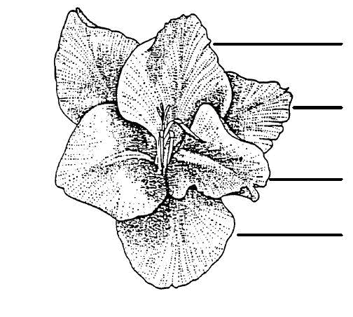
Median inner tepal
Lateral outer tepal
Lateral inner tepal
Median outer tepal

8.2 Explanations for individual characteristics

Ad. 1: Plant: height

Observations on plant height should be made including inflorescence.

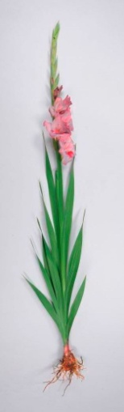
Spike
Height

Ad. 2: Foliage: height

The height of the foliage is to be observed excluding bracts.

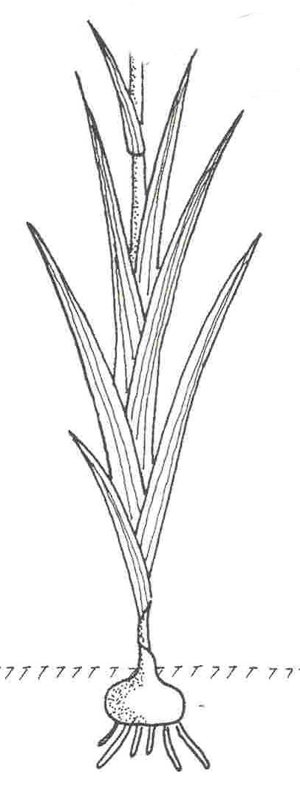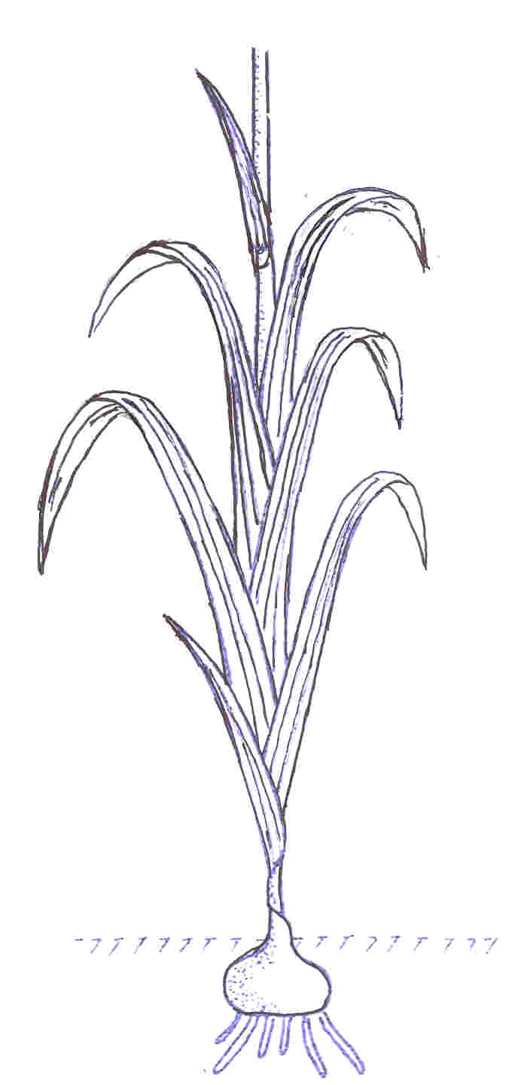

Ad. 3: Leaf: width

Observations on leaf width should be made on the second to last leaf.

Ad. 4: Leaf: curvature of distal half

1 | 7
absent or very weak | strong

Ad. 6: Spike: length

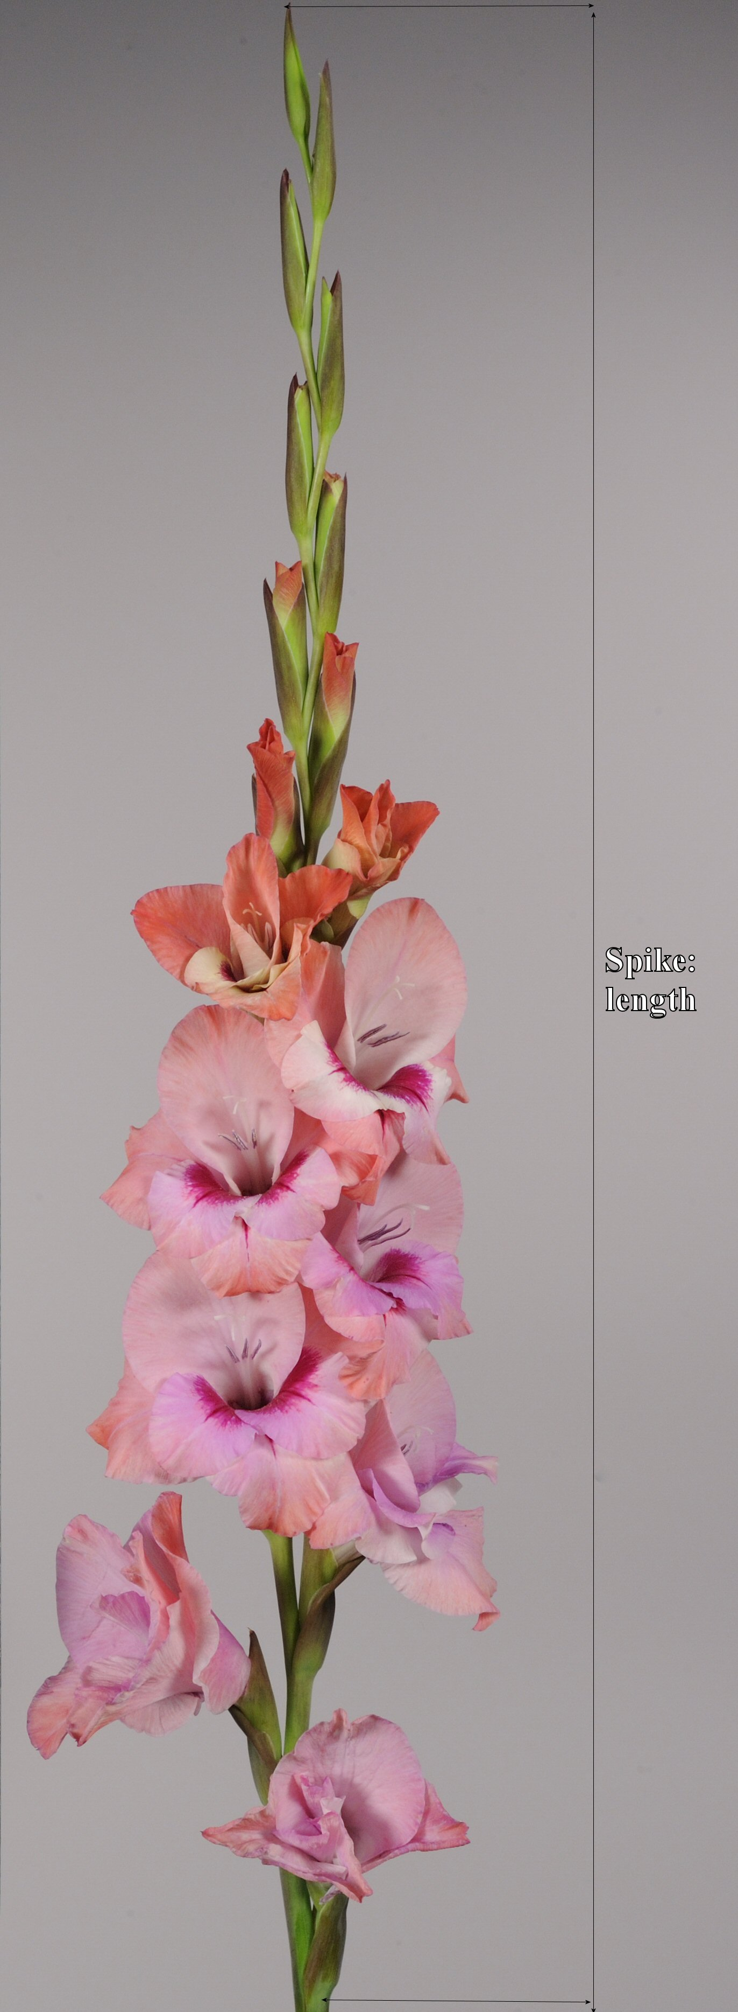
Length

Ad. 7: Spike: number of flowers

All flowers including the closed buds.

Ad. 8: Spike: number of open flowers

The observation should be made on all flowers which are fully open at the same time, including the first flower.

Ad. 10: Spike: arrangement of flowers

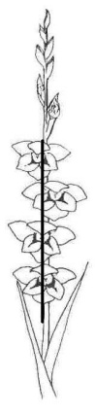 | 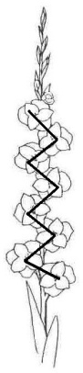 | 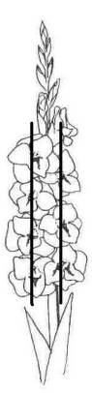
1 | 2 | 3 | 4
one row | zig-zag | two rows | irregular

Ad. 11: Bract: shape of apex

1 | 2 | 3
acute | acute to obtuse | obtuse

Ad. 13: Flower: shape in front view

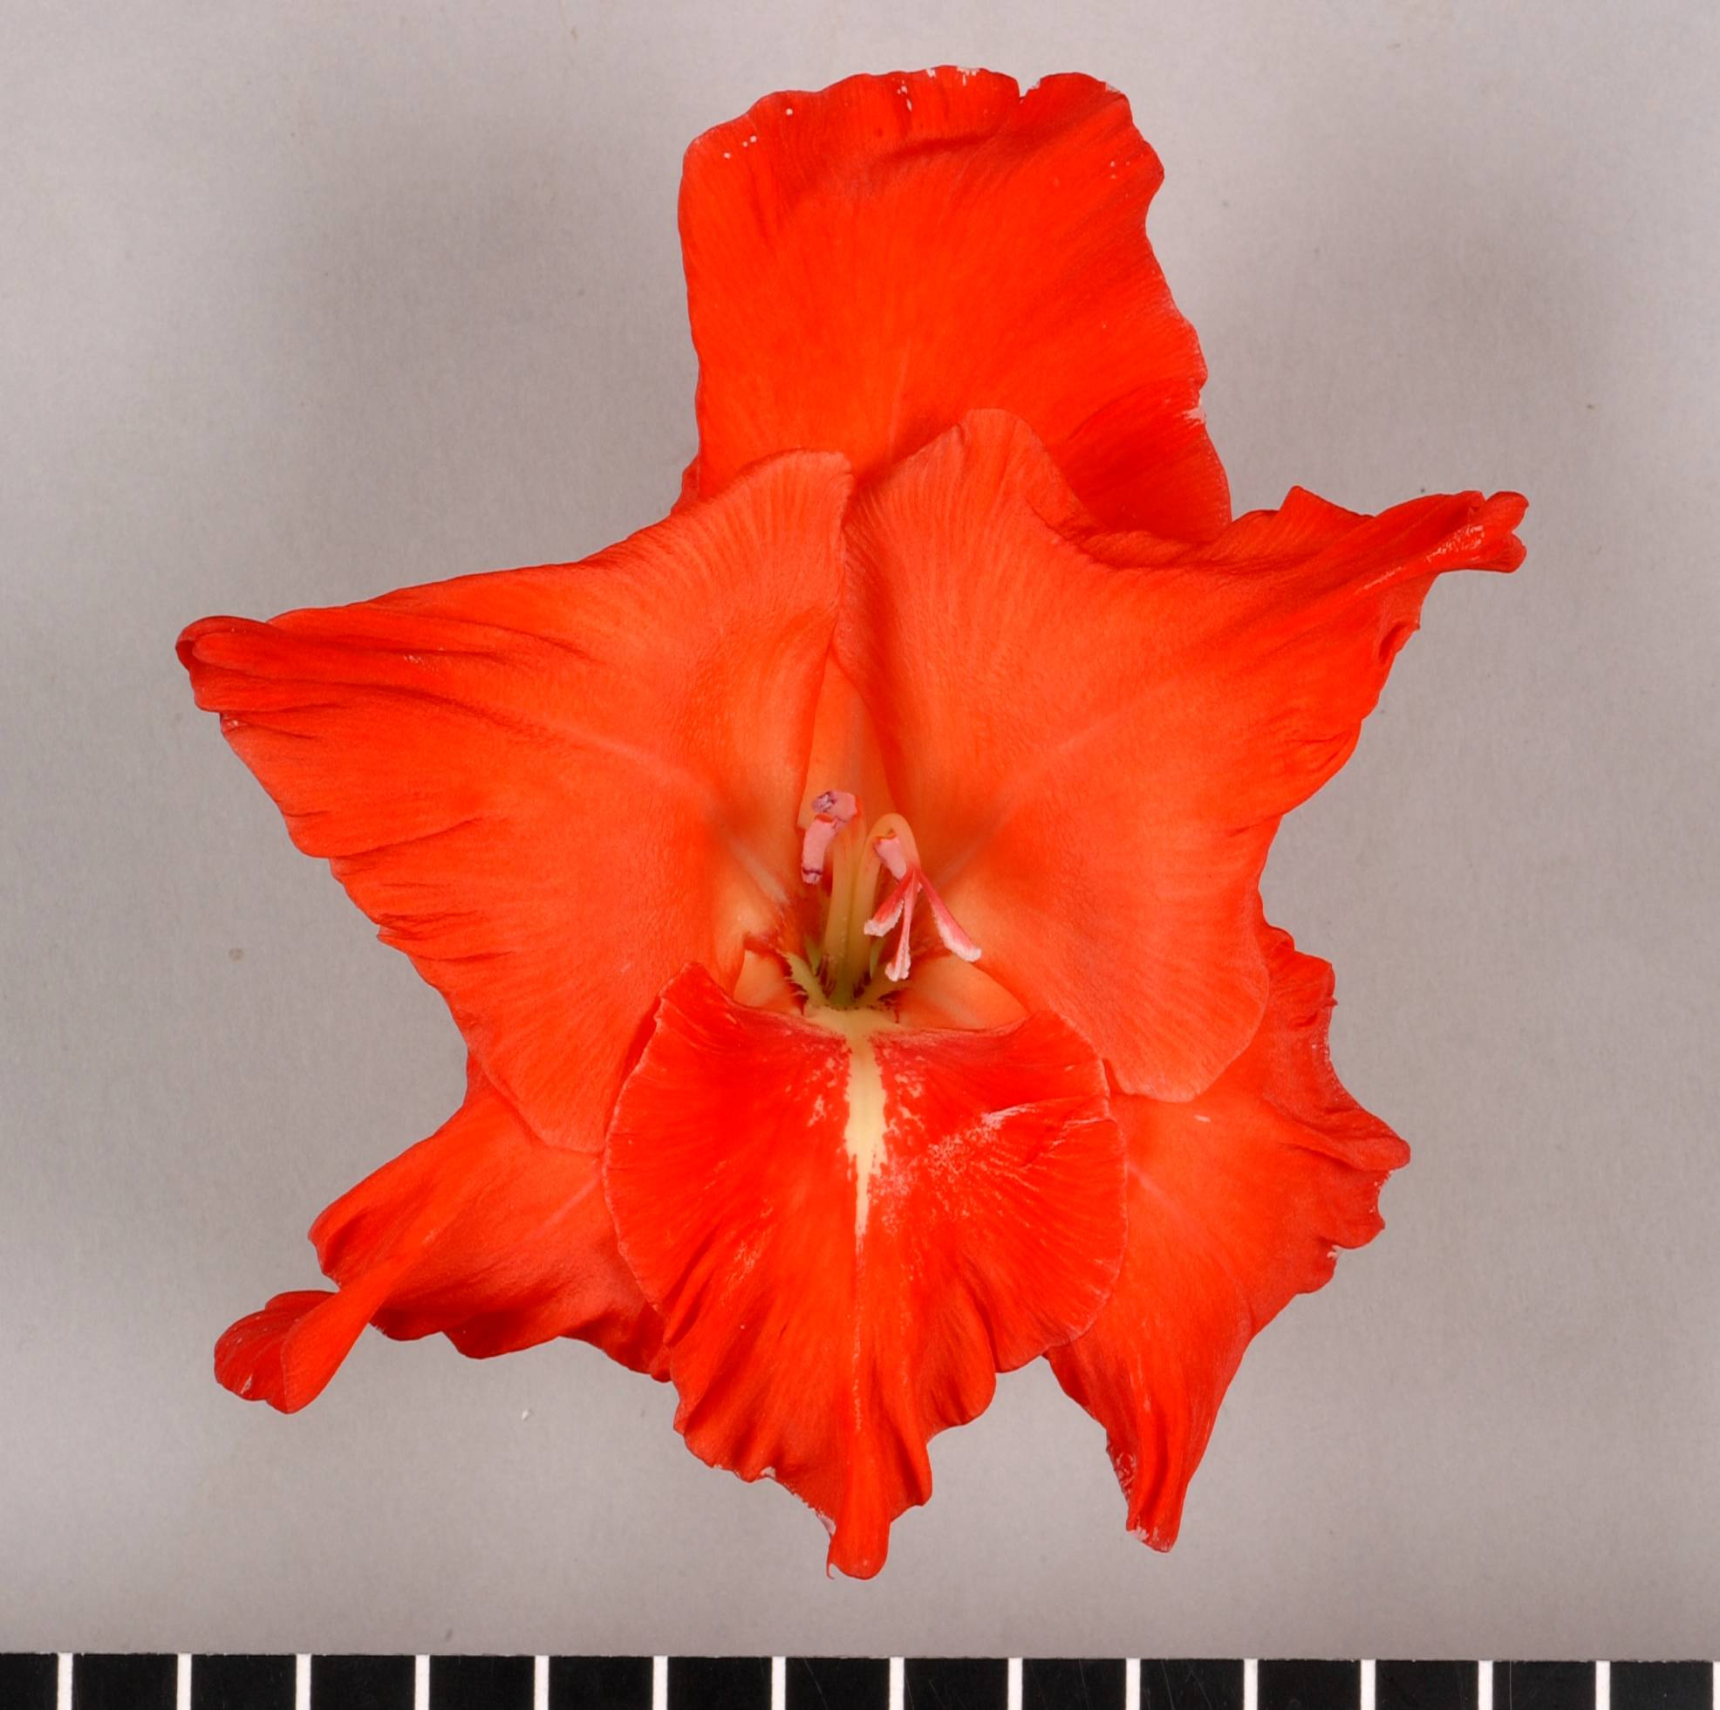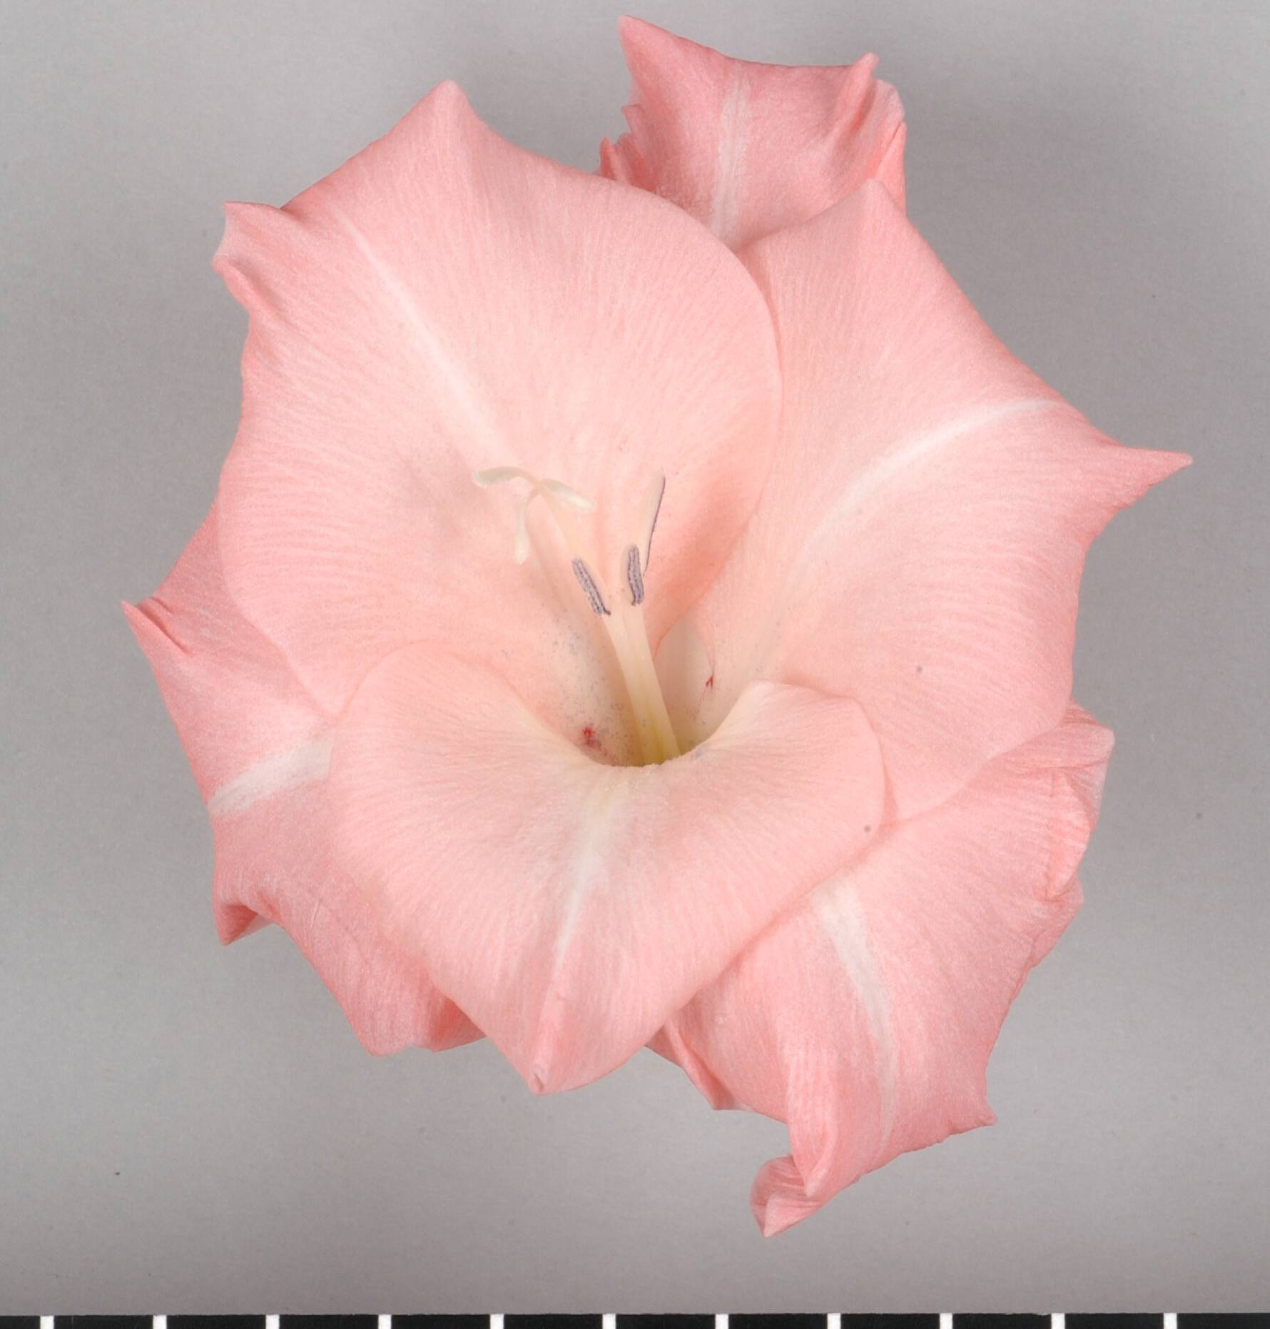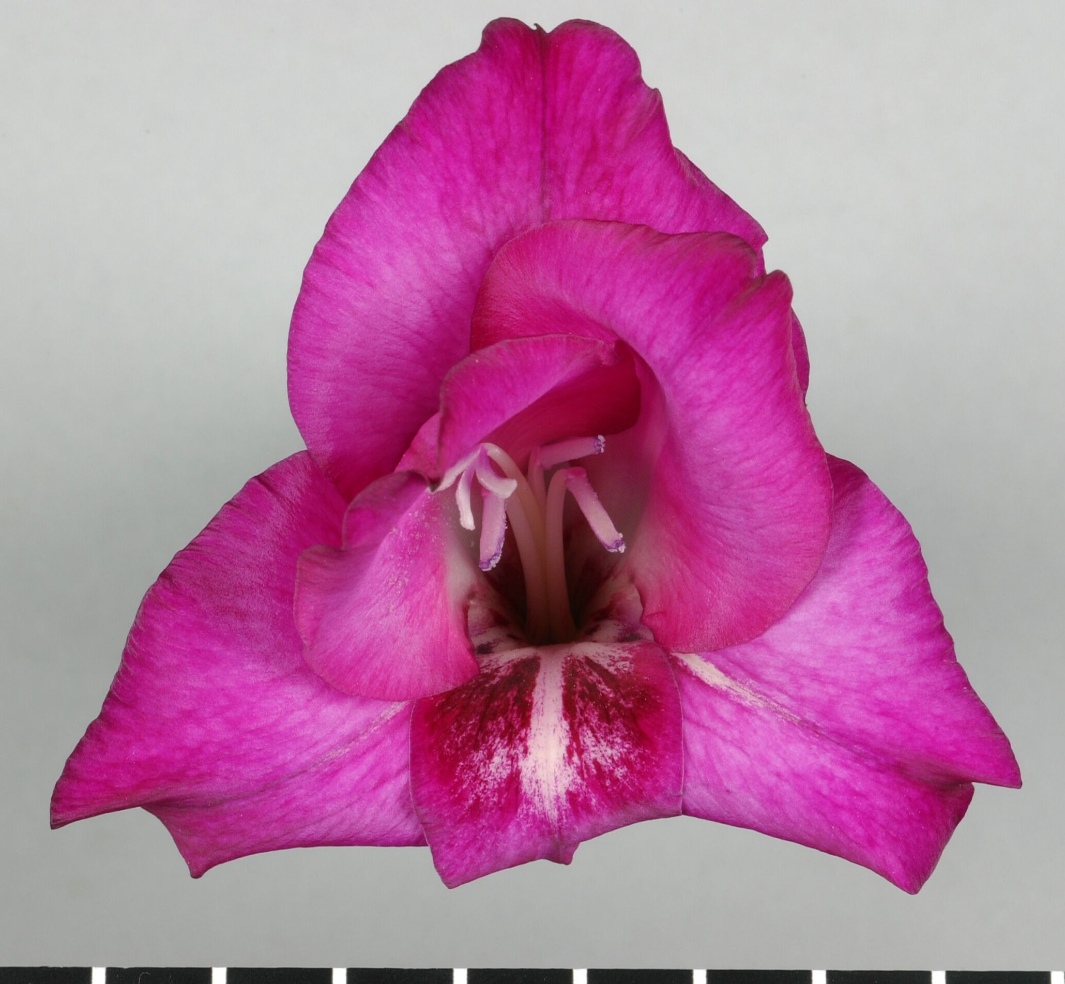
1 | 2 | 3
triangular | star-shaped | round

Ad. 14: Flower: attitude

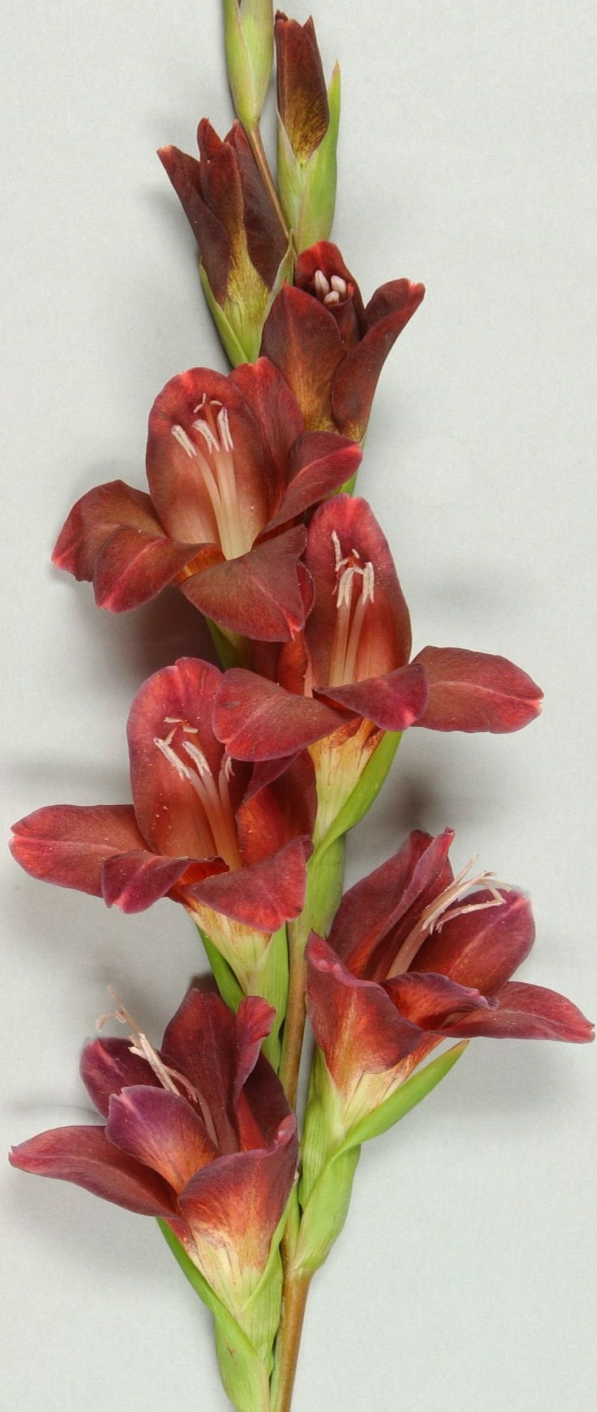 | 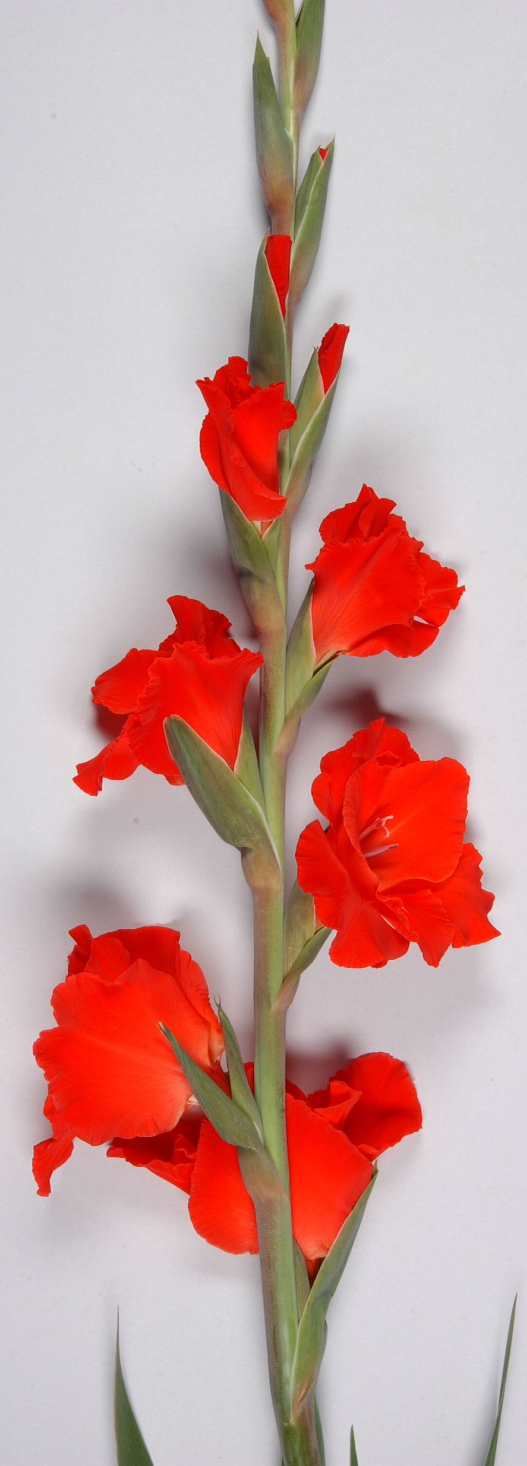 | 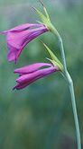
1 | 2 | 3
upright | semi-upright | horizontal

Ad. 15: Flower: width

The width of the broadest part should be observed at the longest part of the flower.

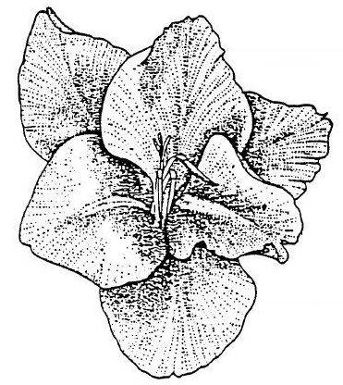
Width

Ad. 16: Flower: main color

The main color is the color with the largest surface area. In cases where the areas of the main and secondary color are too similar to reliably decide which color has the largest area, the lightest color is considered to be the main color.

Ad. 17: Flower: shading of main color

Only varieties with more than one color.

Ad. 20: Perianth tube: distribution of spots on inner side

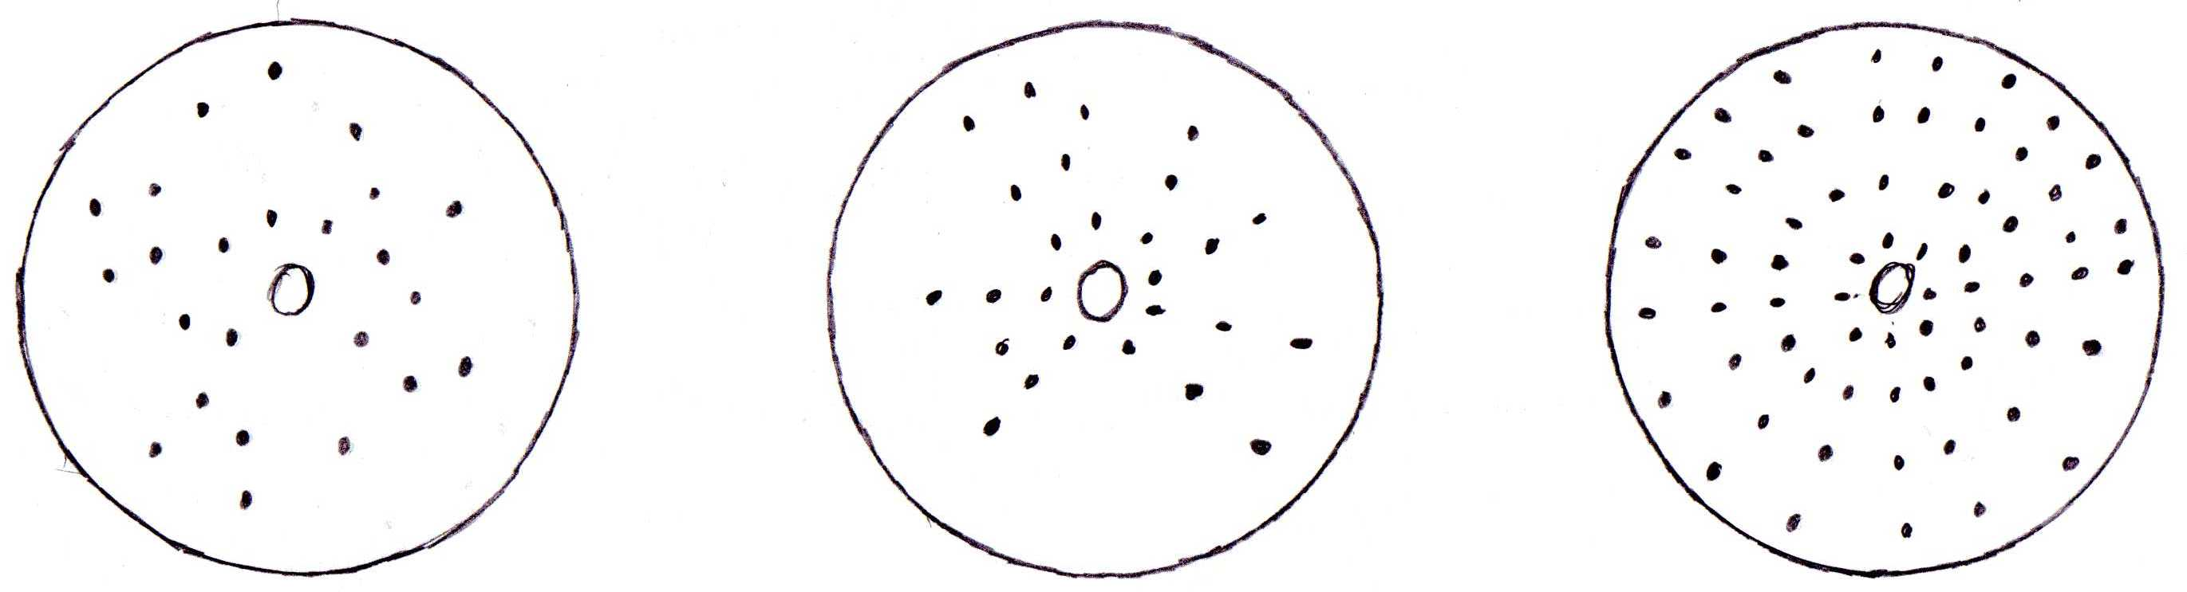
1 | 2 | 3
irregular | interrupted band | continuous band

Ad. 23: Outer tepal: shape of blade

broadest part towards base | 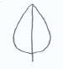 | 1  ovate
broadest part at the middle | 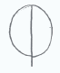 | 2  elliptic
broadest part towards apex |  | 3  obovate

Ad. 31: Inner tepal: position of macule

1 | 2 | 3
at base | between base and centre | central

Ad: 33: Inner tepal: shape of macule

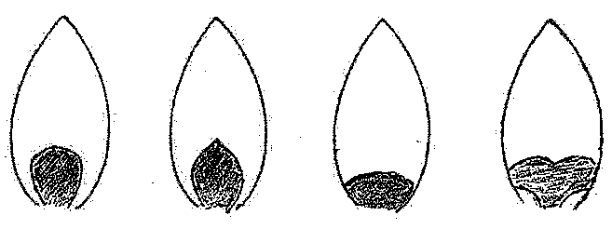
1 | 2 | 3 | 4
type 1 | type 2 | type 3 | type 4

Ad. 34: Inner tepal: main color of macule
Ad. 35: Inner tepal: secondary color of macule

The main color is the color with the largest surface area. In cases where the areas of the main and secondary color are too similar to reliably decide which color has the largest area, the lightest color is considered to be the main color.

Ad. 36: Inner tepal: margin of macule

1 | 2 | 3
regular or slightly irregular | moderately irregular | strongly irregular

Ad. 38: Inner tepal: width of marginal zone

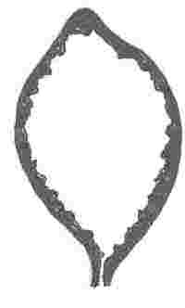

Ad. 39: Inner tepal: border of marginal zone

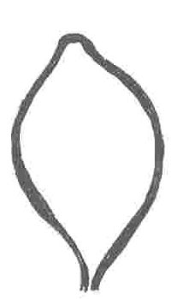 | 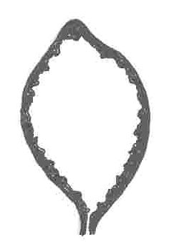
1 | 2 | 3
slightly irregular | moderately irregular | very irregular

Ad. 41: Median inner tepal: attitude

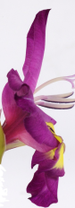 | 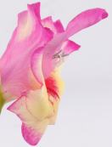 | 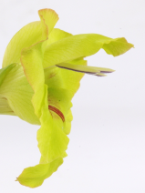
1 | 2 | 3
semi-erect | semi-erect to horizontal | horizontal

Ad. 42: Median inner tepal: attitude of apex

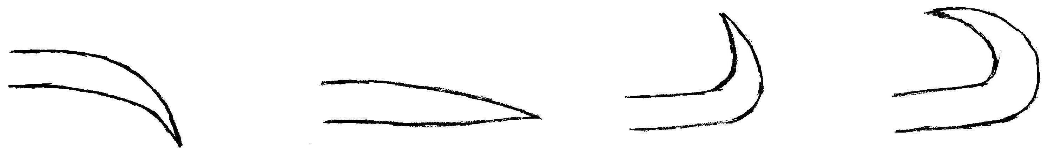
inner side | inner side | inner side | inner side
1 | 2 | 3 | 4
moderately recurved | straight | moderately reflexed | strongly reflexed

Ad. 43: Filament: main color

The main color is the color with the largest surface area. In cases where the areas of the main and secondary color are too similar to reliably decide which color has the largest area, the lightest color is considered to be the main color. In cases where the areas of the secondary and tertiary color are too similar to reliably decide which color has the largest area, the lightest color is considered to be the secondary color.

Ad. 46: Anther: color of connective

The connective is the tissue between the two parts of the anther.

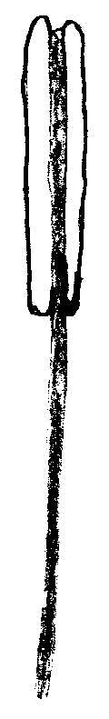

Ad. 48: Style: main color

The main color of the style should be observed without the basal part.

The main color is the color with the largest surface area. In cases where the areas of the main and secondary color are too similar to reliably decide which color has the largest area, the lightest color is considered to be the main color.

Ad. 49: Style: color of base
Ad. 50: Style: color of branches

branches

color of base

Ad. 51: Corm: color of flesh

For observation of the color of the flesh, the corm must be cut in cross section.

Ad. 52: Time of beginning of flowering

Time of beginning of flowering is the time when 50 % of the plants have the first flower fully open.

Literature

Baardse, A.A., 1972: "Bloembollenteelt IV; de gladiool," Tjeenk Willink, Zwolle, NL

Bloembollenkeuringsdienst, 1984: "Gladiolenstatistiek," Lisse, NL

Burge, A.A. et al., 1980: "A Selected List of Gladiolus Varieties," NL

Delpierre, G.R., du Plessis, N.M., 1974: "The wintergrowing Gladioli of South Africa," Tafelberg-Uitgewers Beperk, Capetown and Johannisburg and Nasionale Boekhandel (Publishers) Ltd., London, UK

Hamilton, A.P., 1976: "The European Gladioli," Quart. Bull. Alp. Gard. Soc. 44(2), Wallington, UK

Lewis, G.J., Obermeyer, A.A., 1972: "Gladiolus, a revision of the South African species," Purnell, Capetown, Johannisburg, London, New York

Nederlandse Gladiolus Vereniging, 1973: "Kleurbeschrijvingslijst," Hillegom, NL

North American Gladiolus Council, 1980-86: "A Selected List of Gladiolus Varieties", Sun City, AZ, USA

Raalte, D. van, 1965: "Handboek voor de bloemisterij 2," Born uitg., Assen, Amsterdam, NL

Technical Questionnaire

TECHNICAL QUESTIONNAIRE |  |  |  | Page {x} of {y} |  | Reference Number:
 |  |  |  |  |  | Application date:
 |  |  |  |  |  | (not to be filled in by the applicant)
TECHNICAL QUESTIONNAIRE
to be completed in connection with an application for plant breeders’ rights

1. Subject of the Technical Questionnaire
1.1 Botanical name |  |  | Gladiolus L.
1.2 Common name |  |  | Gladiolus
2. Applicant
Name
Address
Telephone No.
Fax No.
E-mail address
Breeder (if different from applicant)
3. Proposed denomination and breeder’s reference
Proposed denomination
(if available)

Breeder’s reference
#4. Information on the breeding scheme and propagation of the variety

4.1 Breeding scheme

Variety resulting from:

4.1.1 Crossing

(a) controlled cross [ ]
(please state parent varieties)

(…………………..……………..…) x (……………..…………………..…)
female parent male parent

(b) partially known cross [ ]
(please state known parent variety(ies))

(…………………..……………..…) x (……………..…………………..…)
female parent male parent

(c) unknown cross [ ]

4.1.2 Mutation [ ]
(please state parent variety)

4.1.3 Discovery and development [ ]
(please state where and when discovered and how developed)

4.1.4 Other [ ]
(please provide details)

4.2 Method of propagating the variety

4.2.1 Vegetative propagation

(a) cuttings [ ]

(b) in vitro propagation [ ]

(c) other (state method) [ ]

4.2.2 Other [ ]
(please provide details)

5. Characteristics of the variety to be indicated (the number in brackets refers to the corresponding characteristic in Test Guidelines; please mark the note which best corresponds).

 | Characteristics |  |  |  |  |  | Example Varieties |  |  | Note
5.1  (15) | Flower: width
 | very narrow |  |  |  |  |  |  |  |  | 1[ ]
 | very narrow to narrow |  |  |  |  |  |  |  |  | 2[ ]
 | narrow |  |  |  |  |  | Dainty, Flevo Laguna,  Flevo Primo, Jackpot |  |  | 3[ ]
 | narrow to medium |  |  |  |  |  |  |  |  | 4[ ]
 | medium |  |  |  |  |  | Groene Specht,  Joyeuse Entrée, Shocking |  |  | 5[ ]
 | medium to broad |  |  |  |  |  |  |  |  | 6[ ]
 | broad |  |  |  |  |  | Traderhorn, White Friendship |  |  | 7[ ]
 | broad to very broad |  |  |  |  |  |  |  |  | 8[ ]
 | very broad |  |  |  |  |  |  |  |  | 9[ ]
5.2i  (16) | Flower: main color
 | RHS Colour Chart (indicate reference number)
5.2ii  (16) | Flower: main color
 | white |  |  |  |  |  |  |  |  | 1[ ]
 | yellow |  |  |  |  |  |  |  |  | 2[ ]
 | orange |  |  |  |  |  |  |  |  | 3[ ]
 | pink orange |  |  |  |  |  |  |  |  | 4[ ]
 | pink |  |  |  |  |  |  |  |  | 5[ ]
 | purple |  |  |  |  |  |  |  |  | 6[ ]
 | red purple |  |  |  |  |  |  |  |  | 7[ ]
 | blue |  |  |  |  |  |  |  |  | 8[ ]
 | green |  |  |  |  |  |  |  |  | 9[ ]
6. Similar varieties and differences from these varieties

Please use the following table and box for comments to provide information on how your candidate variety differs from the variety (or varieties) which, to the best of your knowledge, is (or are) most similar. This information may help the examination authority to conduct its examination of distinctness in a more efficient way.

Denomination(s) of variety(ies) similar to your candidate variety |  | Characteristic(s) in which your candidate variety differs from the similar variety(ies) |  |  | Describe the expression of the characteristic(s) for the similar variety(ies) |  |  | Describe the expression of the characteristic(s) for your candidate variety
Example |  | Plant: height |  |  | short |  |  | medium
Comments:

#7. Additional information which may help in the examination of the variety

7.1 In addition to the information provided in sections 5 and 6, are there any additional characteristics which may help to distinguish the variety?

Yes [ ] No [ ]

(If yes, please provide details)

7.2 Are there any special conditions for growing the variety or conducting the examination?

Yes [ ] No [ ]

(If yes, please provide details)

7.3 Other information

7.3.1 Main use

(a) garden plant [ ]
(b) pot plant [ ]
(c) cut-flower [ ]
(d) other [ ]
(please provide details)

7.3.2 A representative color image of the variety should accompany the Technical Questionnaire.

8. Authorization for release

(a) Does the variety require prior authorization for release under legislation concerning the protection of the environment, human and animal health?

Yes [ ] No [ ]

(b) Has such authorization been obtained?

Yes [ ] No [ ]

If the answer to (b) is yes, please attach a copy of the authorization.

9. Information on plant material to be examined or submitted for examination.

9.1 The expression of a characteristic or several characteristics of a variety may be affected by factors, such as pests and disease, chemical treatment (e.g. growth retardants or pesticides), effects of tissue culture, different rootstocks, scions taken from different growth phases of a tree, etc.

9.2 The plant material should not have undergone any treatment which would affect the expression of the characteristics of the variety, unless the competent authorities allow or request such treatment. If the plant material has undergone such treatment, full details of the treatment must be given. In this respect, please indicate below, to the best of your knowledge, if the plant material to be examined has been subjected to:

(a) Microorganisms (e.g. virus, bacteria, phytoplasma) Yes [ ] No [ ]

(b) Chemical treatment (e.g. growth retardant, pesticide) Yes [ ] No [ ]

(c) Tissue culture Yes [ ] No [ ]

(d) Other factors Yes [ ] No [ ]

Please provide details for where you have indicated “yes”.

……………………………………………………………

10. I hereby declare that, to the best of my knowledge, the information provided in this form is correct:

Applicant’s name

Signature Date

[End of document]

* These names were correct at the time of the introduction of these Test Guidelines but may be revised or updated. [Readers are advised to consult the UPOV Code, which can be found on the UPOV Website (www.upov.int), for the latest information.]
# Authorities may allow certain of this information to be provided in a confidential section of the Technical Questionnaire.
# Authorities may allow certain of this information to be provided in a confidential section of the Technical Questionnaire.

