 |  | E  TC/49/9  ORIGINAL: English  DATE: February 18, 2013
INTERNATIONAL UNION FOR THE PROTECTION OF NEW VARIETIES OF PLANTS
Geneva
Technical Committee
Forty-Ninth Session
Geneva, March 18 to 20, 2013
Variety description databases
Document prepared by the Office of the Union
1 The purpose of this document is to report on developments concerning variety description databases.

Background

2 At its forty-fifth session, held in Geneva from March 30 to April 1, 2009, the Technical Committee (TC) noted from the developments reported in document TC/45/9 “Publication of Variety Descriptions” that members of the Union were developing databases containing morphological and/or molecular data and, where considered appropriate, were collaborating in the development of databases for the management of variety collections, particularly on a regional basis. The TC agreed that it could be beneficial to offer the possibility for members of the Union to report on that work in a coherent way to the TC, the Technical Working Parties (TWPs) and the Working Group on Biochemical and Molecular Techniques and DNA Profiling in Particular (BMT). On that basis, the TC agreed to replace the agenda item “Publication of variety descriptions” with an item for “Variety description databases” on the agendas of the forthcoming sessions of the TC, TWPs and the BMT. In that respect, it recalled the importance of the list of criteria for consideration for the use of descriptions obtained from different locations and sources as set out in document TC/45/9, paragraph 3. The TC also agreed that the information presented would not need to be related to the publication of descriptions (see document TC/45/16 “Report”, paragraph 173).

Developments in the Technical Working Parties at their sessions in 2011

3 The Technical Working Party for Agricultural Crops (TWA), at its fortieth session, held in Brasilia, Brazil, from May 16 to 20, 2011, considered the information provided in documents TWA/40/6 “Variety Descriptions Databases” and TWA/40/13 “Concept of a Database containing Pea Variety Descriptions”. The expert from France presented a concept of a database containing pea variety descriptions as the first step for the set up of the variety description database, attached as Annex to this document. The TWA agreed that the project for pea was a good example for the development of a variety description database and encouraged the French expert to continue its development. However, the TWA stressed that a good knowledge needed to be acquired with regard to the reliability of at least the grouping characteristics, before the presented concept could be applied for other species (see document TWA/40/23 “Report” paragraph 57).

4 The Technical Working Party on Automation and Computer Programs (TWC), at its twenty-ninth session, held in Geneva, Switzerland, from June 7 to 11, 2011, considered document TWC/29/13 “Concept of a Database Containing Pea Variety Descriptions”, presented by an expert from France. The TWC expressed its concern with regard to the relative low number of corresponding varieties found by the different countries. The grouping characteristics were the characteristics least influenced by the environment and an ICT solution would not be able to solve these harmonization problems. The TWC suggested that the Technical Working Party for Vegetables (TWV) should continue to discuss the concept and ways to achieve harmonization (see document TWC/29/31, “Report”, paragraph 48).

5 The TWC received a presentation entitled “GEMMA: A Technical Website to Share DUS Data” (document TWC/29/24) presented by an expert from France (see document TWC/29/31, “Report”, paragraph 49).

6 At its forty-fifth session, held in Monterey, United States of America, from July 25 to 29, 2011, the TWV considered documents TWV/45/6 “Variety Descriptions Databases”, TWV/45/13 “Concept of a Database containing Pea Variety Descriptions” and TWV/45/24 “Partial Revision of the Test Guidelines for Pea (Document TG/7/10)”, presented Mr. François Boulineau, in conjunction with its discussion on the partial revision of the Test Guidelines for Pea (see document TWV/45/26 “Report”, paragraphs 49 to 51).

7 The TWV considered document TWV/45/24, in conjunction with documents TWV/45/6 and TWV/45/13. It agreed that Mr. Boulineau should seek variety descriptions from members of the Union for the 2,400 (approximate) varieties of common knowledge that he had identified, to examine if the following characteristics were sufficiently reliable for use as grouping characteristics:

Current grouping characteristics:

Plant: anthocyanin coloration (characteristic 1)
Stem: number of nodes up to and including first fertile node (characteristic 5)
Stipule: flecking (characteristic 20)
Pod: parchment (characteristic 39)
Excluding varieties with pod parchment: entire: Pod: thickened wall (characteristic 40)
Pod: color (characteristic 43)
Immature seed: intensity of green color (characteristic 47)
Seed: type of starch grains (characteristic 49)
Seed: color of cotyledon (characteristic 52)
Only varieties with plant anthocyanin coloration present: Seed: marbling of testa (characteristic 53)
Only varieties with plant anthocyanin coloration present: Seed: violet or pink spots on testa (characteristic 54)
Seed: hilum color (characteristic 55)
Resistance to Fusarium oxysporum f. sp. pisi (characteristic 58.1)

Potential grouping characteristic:

Stem: fasciation (characteristic 3)
Stem: length (characteristic 4)
Foliage: color (characteristic 6)
Leaf: leaflets (characteristic 8)
Time of flowering (characteristic 24
Only varieties with stem fasciation absent: Plant: maximum number of flowers per node (characteristic 25)
Only varieties with plant anthocyanin coloration present: Flower: color of wing (characteristic 26)
Pod: length (characteristic 37)
Pod: width (characteristic 38)
Only varieties with Pod: thickened wall absent: Pod: shape of distal part (characteristic 41)
Pod: curvature (characteristic 42)
Only varieties with pod color green (Char. 43: state 2): intensity of green color (characteristic 44)
Excluding varieties with pod parchment: entire: Pod: suture strings (characteristic 45)
Seed: shape (characteristic 48)
Seed: weight (characteristic 57)
Resistance to Erysiphe pisi Syd. (characteristic 59)
Resistance to Ascochyta pisi, Race C (characteristic 60)

8 The TWV agreed that a circular should be prepared by Mr. Boulineau and issued by the Office of the Union to the Technical Committee representative for the following members of the Union, on the basis that they had indicated practical experience in the DUS examination of Pea:

Argentina; Austria; Bulgaria; Canada; China; Czech Republic; Denmark; Estonia; Europea Union (Community Plant Variety Office (CPVO)); France; Germany; Hungary; Japan; Kenya; Netherlands; New Zealand; Poland; Portugal; Republic of Korea; Republic of Moldova; Romania; Russian Federation; Slovakia; South Africa; Spain; Ukraine; United Kingdom; United States of America.

9 The TWV agreed that the contributors of variety descriptions should be invited to indicate the status of the variety descriptions provided and, in particular, if they constituted the “official” description of the variety concerned.

10 The TWV agreed that the first step in the possible development of a database on grouping characteristics for Pea would be to establish a suitable set of grouping characteristics, as agreed for the partial revision of the Test Guidelines for Pea (see document TWV/45/26 “Report”, paragraph 66).

11 The TWV was informed by Mr. Tom Christie (United Kingdom) about the European Cultivated Potato Database (ECPD) (http://www.europotato.org/menu.php), which was the result of collaboration between participants in eight European Union countries and five East European countries. The TWV noted that the database could be updated directly by each of the contributors (see document TWV/45/26 “Report”, paragraph 67).

12 At its thirteenth session held in Brasilia, Brazil, from November 22 to 24, 2011, the BMT noted the information provided in document BMT/13/4 “Variety Description Databases”
(see document BMT/13/36 “Report”, paragraph 58).

13 The BMT received a presentation by Mr. Joël Guiard (France) on “GEMMA: A Technical Web Site to Share DUS Data”, based on document BMT/13/17 [TWC/29/24], which is provided in document BMT/13/17 Add.

14 The BMT received a presentation by Mr. Ivan Schuster (Brazil) on “Construction of a Molecular Database for Soybean Variety Identification in Brazil”, based on document BMT/13/24, which is provided in document BMT/13/24 Add.

Developments in 2012

Technical Committee

15 The TC, at its forty-eighth session held in Geneva from March 26 to 28, 2012, considered document TC/48/9 “Variety Description Databases”. The TC noted the information provided on variety description databases at the sessions of the TWA, TWC, TWV, TWO, TWF and BMT, held in 2011 (see document TC/48/22 “Report on the Conclusions”, paragraphs 114 and 115).

16 The TC requested the experts from France to continue their work on grouping characteristics and on the development of a database containing Pea variety descriptions of members of the Union, as set out in paragraphs 7 to 10 of this document, and to report on their work to the TWPs at their sessions in 2012 and to the TC at its forty-ninth session (see document TC/48/22 “Report on the Conclusions”, paragraph 116).

Technical Working Party for Agricultural Crops

17 The TWA, at its forty-first session, held in Angers, France, from May 21 to 25, 2012, noted the information contained in document TWA/41/6 “Variety Description Databases” and in the presentation on a method to evaluate different grouping characteristics for Pea, provided by an expert from France, included in document TWA/41/6 Add. The TWA agreed that the work on the project for the Pea database should be continued and that it would be a good example for the development of similar databases for other crops. It also agreed that it would be a good basis for future revision of the Test Guidelines for Pea in respect of grouping characteristics (see document TWA/41/34 “Report” paragraph 52).

Technical Working Party for Vegetables

18 The TWV, at its forty-sixth session, held near the city of Venlo, Netherlands, from June 11 to 15, 2012, noted the information contained in document TWV/46/6 “Variety Description Databases” and in the presentation provided by an expert from France, which was included in document TWV/46/6 Add. The expert from France presented a method to evaluate different grouping characteristics for Pea. The TWV congratulated the expert from France for his work and the useful results contained in the presentation. The TWV agreed that the work on the project for the Pea database should be continued and that it would be a good example for the development of similar databases for other crops. It also agreed that it would be a good basis for future revision of the Test Guidelines for Pea in respect of grouping characteristics (see document TWV/46/41 “Report” paragraph 86).

Technical Working Party on Automation and Computer Programs

19 The TWC, at its thirtieth session, held in Chisinau, Republic of Moldova, from June 26 to 29, 2012, noted the information provided in document TWC/30/6 “Variety Description Databases” and in a presentation prepared by an expert from France, as contained in document TWC/30/6 Add. The TWC agreed that the work on the project for the Pea Database should be continued and requested to receive information on further developments at its thirty-first session (see document TWC/30/41 “Report” paragraphs 66 and 67 ).

Technical Working Party on Fruit Crops

20 The TWF, at its forty-third session, held in city of Beijing, China, from July 30 to August 3, 2012, noted the information contained in documents TWF/43/6 “Variety Description Databases” and TWF/43/6 Add. The TWF requested the Office of the Union to check whether any data that was used in a previous similar study for apple could be made available (see document TWF/43/38 “Report” paragraphs 77 and 78).

Technical Working Party for Ornamental Plants and Forest Trees

21 The TWO, at its forty-fifth session held in Jeju, Republic of Korea, from August 6 to 10, 2012, noted the information contained in documents TWO/45/6 “Variety Description Databases” and TWO/45/6 Add., including the presentation provided by an expert from France in the Annex to document TWO/45/6 Add. The TWO highlighted the importance of the study in the future harmonization of variety descriptions (see document TWO/45/37 “Report” paragraphs 49 and 50).

22 The Annex to this document contains a presentation on “Reference Collection and Grouping Characteristics; Example of the Pea Species”, prepared by experts from France, on the basis of replies from the Questionnaire on Variety Description for Pea (Partial Revision) circulated to UPOV members.

23 It is proposed that the results of the study be presented to the TWV at its forty-seventh session, to be held in Nagasaki, Japan, from May 20 to 24, 2013, and to:
(a) select characteristics to be used as grouping characteristics according to their qualities
(discriminating power, distortion, use);
(b) develop a procedure to improve the pea database; and
(c) consider making the pea database available to all examination offices.
It is also proposed that the results of the study be presented to other TWPs for their comments on the approach for managing variety collections.

24 The TC is invited to:

(a) note the developments on variety description databases, as set out in paragraphs 17 to 21 of this document;

(b) note that the results of the study on Pea will be presented to the TWV in order to:

(i) select characteristics to be used as grouping characteristics according to their qualities (discriminating power, distortion, use);

(ii) develop a procedure to improve the pea database; and

(iii) consider making the pea database available to all examination offices.

(c) agree that the results of the study be presented to other TWPs for their comments on the approach for managing variety collections; and

(d) invite the TWF to consider the results of the model study on Apple in document TC/41/9 “Publication of Variety Descriptions”.

[Annex follows]

Reference Collection and Grouping Characteristics

Example of the Pea species

Background

The Technical Working Party for Vegetables (TWV), at its forty-fifth session held in Monterey, United States of America, from July 25 to 29, 2011, considered document TWV/45/24 “Partial Revision of the Test Guidelines for Pea (document TG/7/10)”, presented by Mr. François Boulineau (France), in conjunction with documents TWV/45/6 “Variety Descriptions Databases” and TWV/45/13 “Concept of a Database Containing Pea Variety Descriptions”. It agreed that Mr. Boulineau should seek variety descriptions from members of the Union for the 2,400 (approximate) varieties of common knowledge that he had identified, to examine if the following characteristics were sufficiently reliable for use as grouping characteristics:

Current grouping characteristics:

Plant: anthocyanin coloration (characteristic 1)
Stem: number of nodes up to and including first fertile node (characteristic 5)
Stipule: flecking (characteristic 20)
Pod: parchment (characteristic 39)
Excluding varieties with pod parchment: entire: Pod: thickened wall (characteristic 40)
Pod: color (characteristic 43)
Immature seed: intensity of green color (characteristic 47)
Seed: type of starch grains (characteristic 49)
Seed: color of cotyledon (characteristic 52)
Only varieties with plant anthocyanin coloration present: Seed: marbling of testa (characteristic 53)
Only varieties with plant anthocyanin coloration present: Seed: violet or pink spots on testa (characteristic 54)
Seed: hilum color (characteristic 55)
Resistance to Fusarium oxysporum f. sp. pisi (characteristic 58.1)

Potential grouping characteristic:

Stem: fasciation (characteristic 3)
Stem: length (characteristic 4)
Foliage: color (characteristic 6)
Leaf: leaflets (characteristic 8)
Time of flowering (characteristic 24
Only varieties with stem fasciation absent: Plant: maximum number of flowers per node (characteristic 25)
Only varieties with plant anthocyanin coloration present: Flower: color of wing (characteristic 26)
Pod: length (characteristic 37)
Pod: width (characteristic 38)
Only varieties with Pod: thickened wall absent: Pod: shape of distal part (characteristic 41)
Pod: curvature (characteristic 42)
Only varieties with pod color green (Char. 43: state 2): intensity of green color (characteristic 44)
Excluding varieties with pod parchment: entire: Pod: suture strings (characteristic 45)
Seed: shape (characteristic 48)
Seed: weight (characteristic 57)
Resistance to Erysiphe pisi Syd. (characteristic 59)
Resistance to Ascochyta pisi, Race C (characteristic 60)

Circular E_12/079 - Questionnaire on Variety Descriptions for Pea (Partial Revision)

The TWV agreed that a circular should be prepared by Mr. Boulineau and issued by the Office of the Union to the Technical Committee representative for the following members of the Union, on the basis that they had indicated practical experience in the DUS examination of Pea:

Argentina; Austria; Bulgaria; Canada; China; Czech Republic; Denmark; Estonia; European Union (Community Plant Variety Office (CPVO)); France; Germany; Hungary; Japan; Kenya; Netherlands; New Zealand; Poland; Portugal; Republic of Korea; Republic of Moldova; Romania; Russian Federation; Slovakia; South Africa; Spain; Ukraine; United Kingdom; United States of America;

The TWV agreed that the contributors of variety descriptions should be invited to indicate the status of the variety descriptions provided and, in particular, if they constituted the “official” description of the variety concerned.

UPOV members contribution:
Following the propositions made during TWV/45, concerning the reference collection and the grouping characteristics of pea varieties, two Excel files have been sent.

- Excel File: Pea_Theoretical collection(V31jan2012) which is a compilation of varieties that are considered to be relevant for inclusion in the reference collection. According to the origin of each variety, some information is given on its administrative situation :
Yellow: varieties from the EU list (European Common Catalogue)
Green: varieties from the CPVO database
Blue: varieties from PLUTO, the UPOV Plant Variety Database
Orange: varieties from the OECD list
Pink: varieties under PMA (Provisional Market Authorization) in the EU system

On the right side of this file, three columns were proposed to be completed by UPOV members :
x Relevant variety for the reference collection: According to the administrative information or the knowledge of the variety, should this variety appear in the reference collection ?(Y: yes; N: no)
y Available description: Does the country have a description (at least for grouping characteristics) of this variety ? ?(Y: yes; N: no)
z Reference collection: Is this variety in the reference collection of the country, (seeds available)? (Y: yes; N: no)

- Excel File: Pea_Grouping characteristics which concerns the descriptions for grouping characteristics proposed to be included in the pea guideline. When an available description exists, the country is invited to complete this file.

If the UPOV member consider that any other varieties are relevant for the reference collection, it is pleased to add them at the end of the file.

Completed Excel files have been sent to Mr. François BOULINEAU at francois.boulineau@geves.fr and Ms. Stéphanie CHRISTIEN at stephanie.christien@geves.fr, with a copy to the Office of the Union (upov.mail@upov.int).

Results

Replies to the questionnaire
The Pea theoretical collection is composed of more than 3,100 well known varieties.
7,511 descriptions (complete or partial) were received, concerning 2,524 varieties, which represents more tan 80% of the varieties present in the theoretical collection.

14 UPOV members sent information:
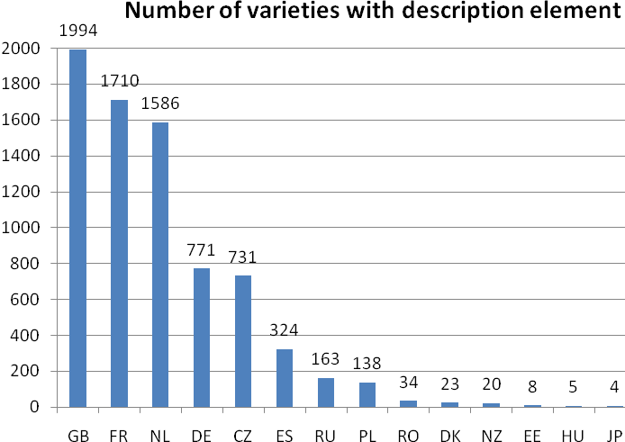

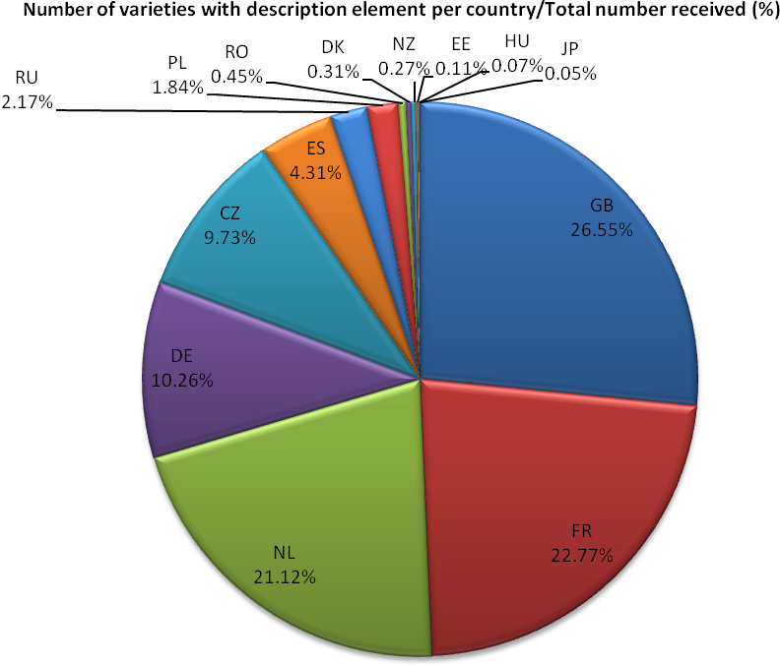
Properties of individual characteristics
Three indicators have been defined :
- Use of the characteristic
Number of times the characteristic is described for the described varieties

- .Discriminating power of the characteristic
Percentage of excluded varieties on the basis of the characteristic

- Distortion of the characteristic
Percentage of distortion for a characteristic corresponds to percentage of varieties for which different levels of expression of the observed characteristic have been recorded (depending on examination conditions, climate, stress, recorder, mistakes, etc.)
- For qualitative or pseudo-qualitative characteristics : number of varieties with different notes among the varieties described for this characteristic;
- For quantitative characteristics: number of descriptions with a note not included in the interval [note medium + or - 1.5] among the descriptions received for the characteristic.

Use of the characteristic

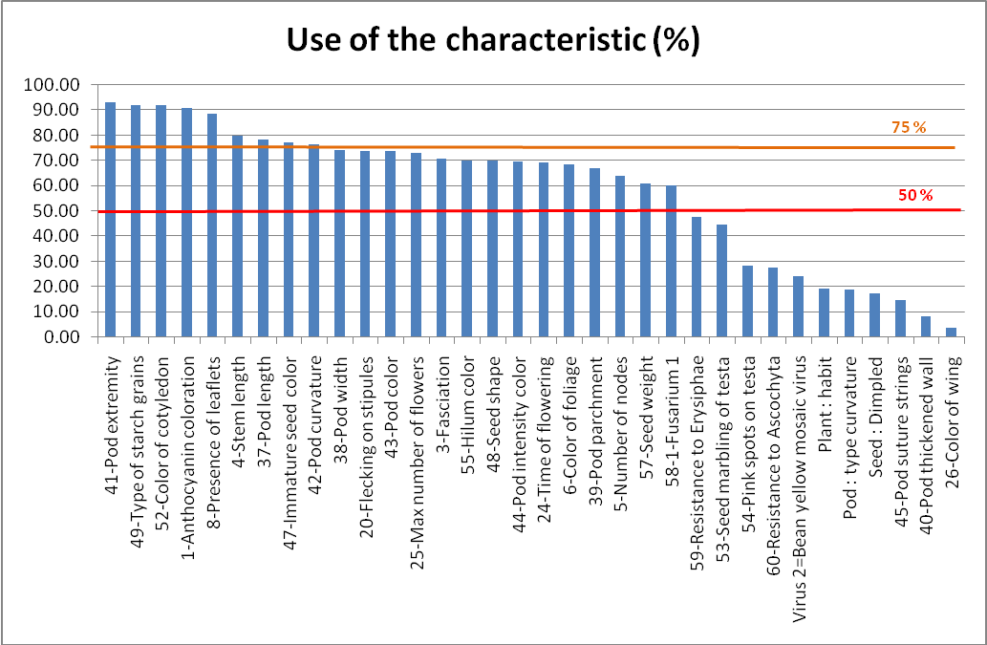

Discriminating power of the characteristic
Qualitative and Pseudo-qualitative characteristics

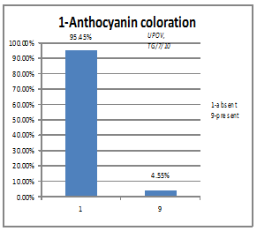 | 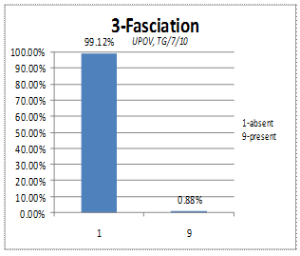
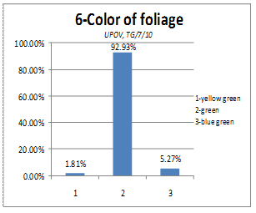 | 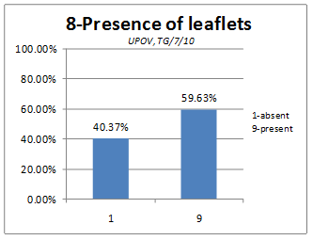
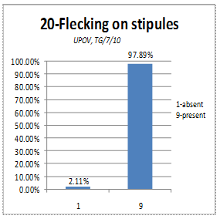 | 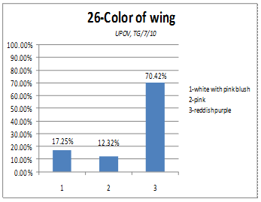
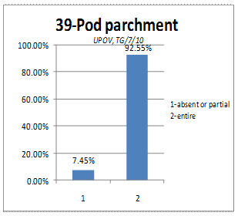 | 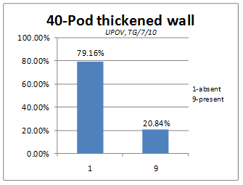
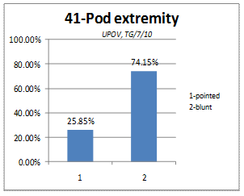 | 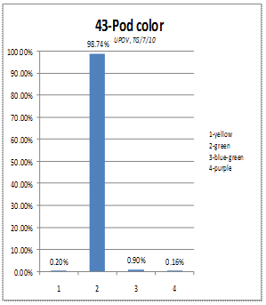
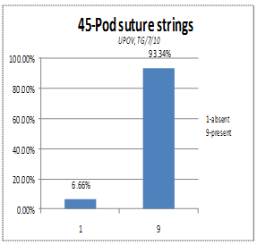 | 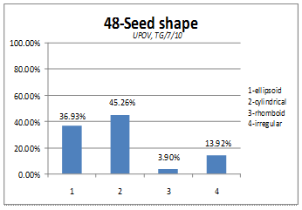
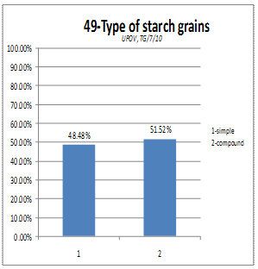 | 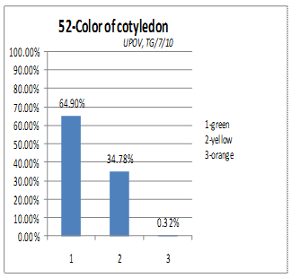
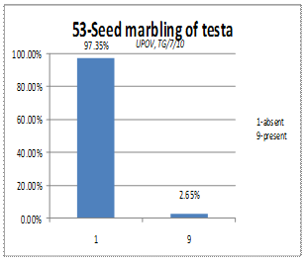 | 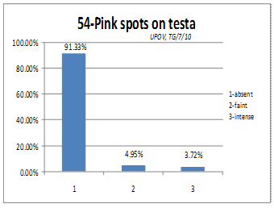
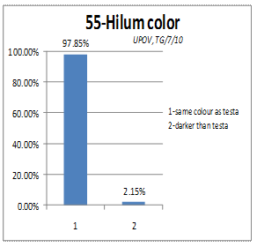 | 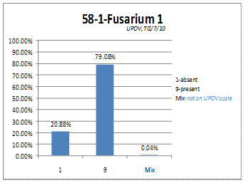
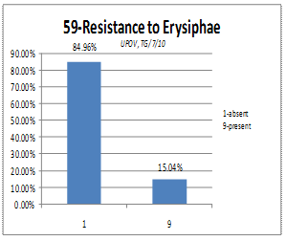 | 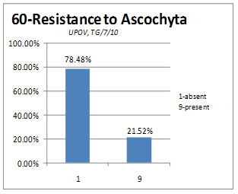
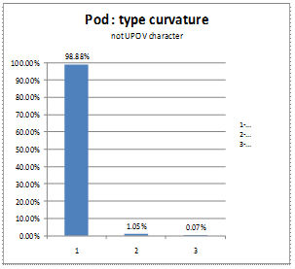 | 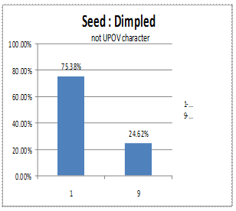
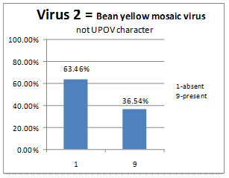

Quantitative characteristics
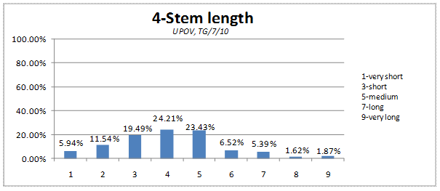
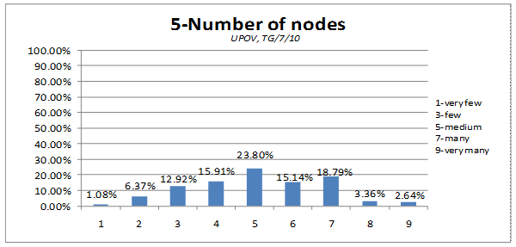
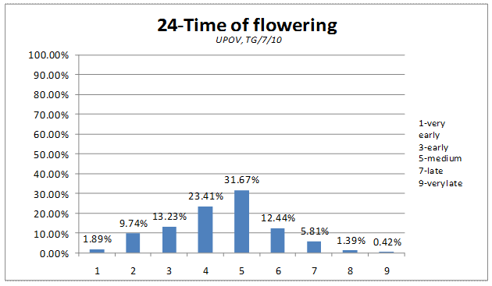
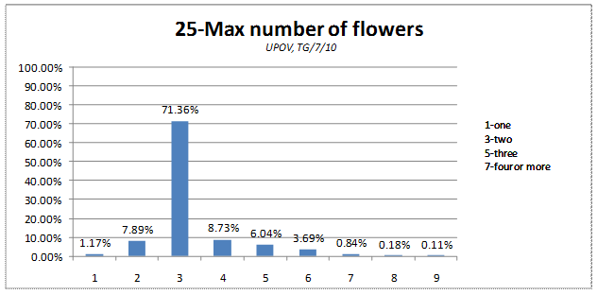
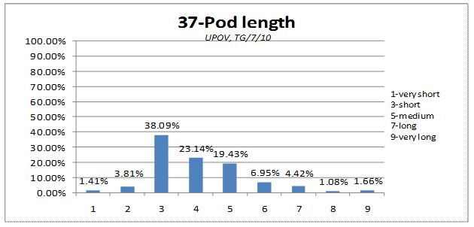
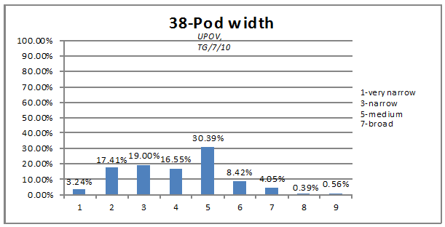
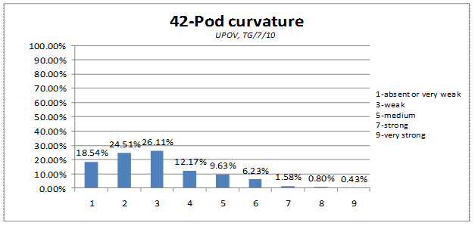
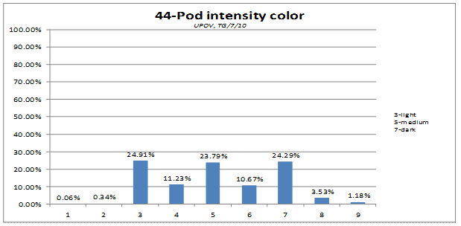
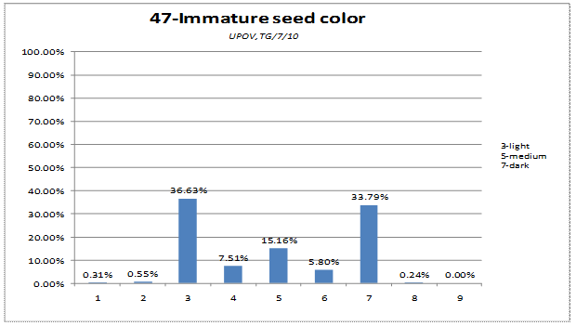
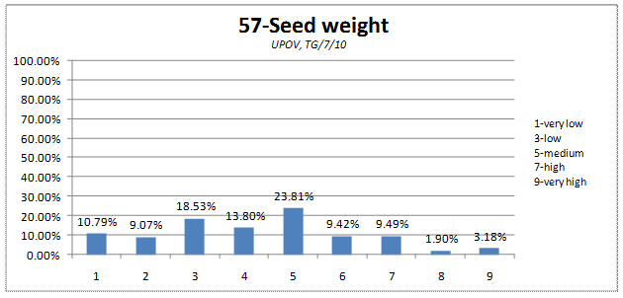
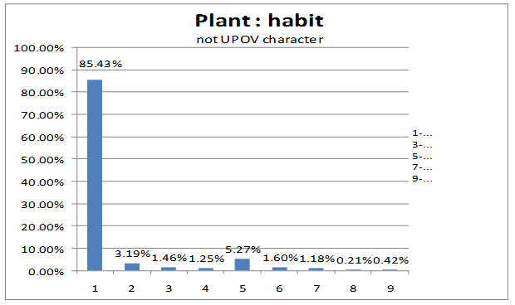

Distortion of the characteristic
Qualitative and Pseudo-qualitative characteristics
Characteristic | Distortion (%)
Pod : type curvature | 0.36%
3-Fasciation | 0.42%
60-Resistance to Ascochyta | 0.62%
53-Seed marbling of testa | 0.72%
1-Anthocyanin coloration | 0.81%
55-Hilum color | 1.03%
8-Presence of leaflets | 1.38%
43-Pod color | 1.86%
20-Flecking on stipules | 2.04%
45-Pod suture strings | 2.39%
54-Pink spots on testa | 2.39%
59-Resistance to Erysiphae | 2.42%
40-Pod thickened wall | 3.15%
49-Type of starch grains | 3.66%
Virus 2= Bean yellow mosaic virus | 4.22%
6-Color of foliage | 5.06%
41-Pod extremity | 5.13%
58-1-Fusarium 1 | 5.99%
39-Pod parchment | 6.17%
52-Color of cotyledon | 7.12%
26-Color of wing | 9.36%
Seed : Dimpled | 12.46%
48-Seed shape | 31.51%
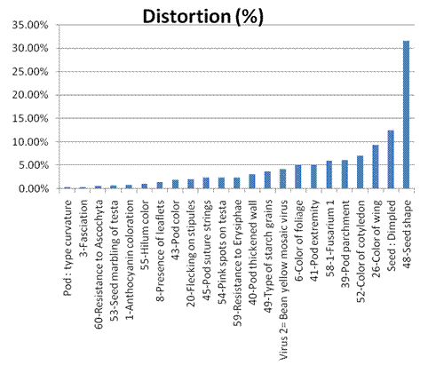
Quantitative characteristics

Characteristics | Distortion (%)
25-Max number of flowers | 2.83%
24-Time of flowering | 4.81%
Plant : habit | 5.00%
57-Seed weight | 5.32%
37-Pod length | 7.08%
44-Pod intensity color | 7.21%
42-Pod curvature | 7.88%
47-Immature seed color | 10.01%
5-Number of nodes | 12.98%
4-Stem length | 17.18%
38-Pod width | 19.23%

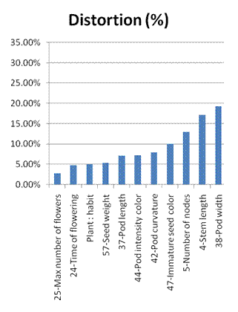
On the basis of the three indicators, each characteristic can be defined as follow

For official grouping characteristics (mentioned in the TG/7/10)
Characteristic | Use | Discriminating power | Distortion (%)
1-Anthocyanin coloration | 90.97 | 95/5 | 0.81%
5-Number of nodes | 64.12 | 55 (notes 4-5-6) | 12.98%
8-Presence of leaflets | 88.75 | 60/40 | 1.38%
20-Flecking on stipules | 73.81 | 98/2 | 2.04%
39-Pod parchment | 67.17 | 92.5/7.5 | 6.17%
40-Pod thickened wall | 8.24 | 80/20 | 3.15%
41-Pod extremity | 93.06 | 76/24 | 5.13%
43-Pod color | 73.72 | 98/2 | 1.86%
47-Immature seed color | 77.30 | 33 (notes 4-5-6) | 10.01%
49-Type of starch grains | 92.12 | 52/48 | 3.66%
52-Color of cotyledon | 91.88 | 65/35 | 7.12%
53-Seed marbling of testa | 44.76 | 97/3 | 0.72%
54-Pink spots on testa | 28.25 | 91/9 | 2.39%
55-Hilum color | 70.14 | 98/2 | 1.03%
58-1-Fusarium 1 | 60.19 | 80/20 | 5.99%

For candidate grouping characteristics
Characteristic | Use | Discriminating power | Distortion (%)
3-Fasciation | 70.71 | 99/1 | 0.42%
4-Stem length | 79.84 | 54 (notes 4-5-6) | 17.18%
6-Color of foliage | 68.51 | 93/7 | 5.06%
24-Time of flowering | 69.15 | 68 (notes 4-5-6) | 4.81%
25-Max number of flowers | 72.93 | 18 (notes 4-5-6) | 2.83%
26-Color of wing | 3.78 | 70/30 | 9.36%
37-Pod length | 78.58 | 49 (notes 4-5-6) | 7.08%
38-Pod width | 74.34 | 55 (notes 4-5-6) | 19.23%
42-Pod curvature | 76.70 | 28 (notes 4-5-6) | 7.88%
44-Pod intensity color | 69.84 | 46 (notes 4-5-6) | 7.21%
45-Pod suture strings | 14.79 | 93/7 | 2.39%
48-Seed shape | 70.02 | 37/45/4/14 | 31.51%
57-Seed weight | 61.06 | 47 (notes 4-5-6) | 5.32%
59-Resistance to Erysiphae | 47.61 | 85/15 | 2.42%
60-Resistance to Ascochyta | 27.47 | 78/22 | 0.62%
Plant : habit | 19.19 | 70 (notes 4-5-6) | 5.00%
Pod : type curvature | 19.05 | 99/1 | 0.36%
Seed : Dimpled | 17.36 | 75/25 | 12.46%
Virus 2= Bean yellow mosaic virus | 24.38 | 63/37 | 4.22%

[End of Annex and of document]

