 |  | E  TC/49/3  ORIGINAL: English  DATE: February 19, 2013
INTERNATIONAL UNION FOR THE PROTECTION OF NEW VARIETIES OF PLANTS
Geneva
Technical Committee
Forty-Ninth Session
Geneva, March 18 to 20, 2013
Matters arising from the Technical Working Parties
Document prepared by the Office of the Union
1 This document summarizes certain matters arising from the 2012 sessions of the Technical Working Parties (TWPs) which are not expressly covered by specific agenda items. The matters arising are presented in two sections. The first section, “Matters for information and for a possible decision to be taken by the Technical Committee (TC)”, identifies matters raised by the TWPs, which may require a decision to be taken by the TC. The Office of the Union (Office) has highlighted aspects where the TC may wish to take a decision by introducing a proposed decision paragraph. The second section, “Matters for information”, is provided for the information of the TC but does not require decisions at this stage.

2 The structure of this document is as follows:

I. MATTERS FOR INFORMATION AND FOR A POSSIBLE DECISION TO BE TAKEN BY THE TECHNICAL COMMITTEE 2
Guidance for drafters of Test Guidelines 2
Web Based TG Template 3
Experiences with new types and species 3
Levels of Uniformity According to the State of Expression of Obligatory Disease Resistance Characteristics and Varieties not bred for having such Disease Resistance 4
Data Loggers 4
Survey to seek views on the effectiveness of the Technical Working Parties 4

II. MATTERS FOR INFORMATION 5
Statistical analysis of categorical data 5
Database for researching TWC documents 6

ANNEX I: REVISED PRACTICAL GUIDE FOR DRAFTERS (LEADING EXPERTS)
OF UPOV TEST GUIDELINES

ANNEX II: SURVEY TO SEEK VIEWS ON THE EFFECTIVENESS OF THE TECHNICAL WORKING PARTIES, SUBMITTED TO THE TWO AND TWF AT THEIR SESSIONS IN 2012

ANNEX III: PROPOSAL FOR SURVEY FOR PARTICIPANTS TO ALL TWPS IN 2013

ANNEX IV: PROPOSAL FOR SURVEY FOR PARTICIPANTS TO THE TECHNICAL COMMITTEE IN 2013

3 The following abbreviations are used in this document:

CAJ: Administrative and Legal Committee
TC: Technical Committee
TC-EDC: Enlarged Editorial Committee
TWA: Technical Working Party for Agricultural Crops
TWC: Technical Working Party on Automation and Computer Programs
TWF: Technical Working Party for Fruit Crops
TWO: Technical Working Party for Ornamental Plants and Forest Trees
TWPs: Technical Working Parties
TWV: Technical Working Party for Vegetables

I. MATTERS FOR INFORMATION AND FOR A POSSIBLE DECISION TO BE TAKEN BY THE TECHNICAL COMMITTEE

Guidance for drafters of Test Guidelines

4 At their sessions in 2012, the TWA, TWV, TWF and TWO, noted the revision of the “Practical Guidance for Drafters (Leading Experts) of UPOV Test Guidelines”, Section “Test Guidelines for Discussion at the Technical Working Party”, as available on the TG Drafters webpage and as set out in the Annex I to this document, which concerned the information that “a ‘clean’ version of the draft should be provided: the draft should not contain any comments within the document. If necessary, any comments should be included in an annex or in a separate document” (see document TWA/41/34 “Report”, paragraph 79, document TWV/46/41 ”Report”, paragraph 78 , document TWF/43/38 “Report”, paragraph 85 and document TWO/45/37 “Report”, paragraph 87).

5 At its forty-fifth session of the TWO, held in Jeju, Republic of Korea, from August 6 to 10, 2012, the Chairman reminded drafters that the deadlines for drafts of Test Guidelines were indicated in Annex I to this document and on the Drafters’ webpage. He informed the TWO that the deadlines needed to be respected and encouraged subgroup members to confirm receipt of any e-mail correspondence (see document TWO/45/37 “Report”, paragraph 91).

6 At its forty-third session of the TWF, held in Beijing, China, from July 30 to August 3, 2012, the expert from the European Union questioned the length of time between the adoption of the Test Guidelines by the Technical Committee and the posting of the adopted Test Guidelines on the UPOV website. The Office of the Union informed the TWF that the Technical Working Parties, at their sessions, would be informed of which Test Guidelines had been adopted, but were not posted on the website due to missing information (see document TWF/43/38 “Report”, paragraphs 86 and 87).

7 The TWA, at its forty-first session, held in Angers, France, from May 21 to 25, 2012, concluded that to facilitate the work during the subgroup discussions it would be helpful to have relevant comments in the Test Guidelines (see document TWA/41/34 “Report”, paragraph 80).

8 At their sessions in 2012, the TWA, TWV and TWO noted that, if a Leading Expert of draft Test Guidelines could not attend a TWP session, the Test Guidelines could be withdrawn from the agenda of the concerned TWP session. If the Leading Expert and the interested experts wished, an informal subgroup discussion using electronic communications (e.g. WebEx) could be organized after the TWP, with the support of the Office of the Union (see document TWA/41/34 “Report”, paragraph 81, document TWV/46/41 ”Report”, paragraph 88, and document TWO/45/37 “Report”, paragraph 88).

9 At its forty-third session of the TWF, the expert from Israel proposed that acknowledgement be given to the drafters by an indication on the Test Guidelines (see document TWF/43/38 “Report”, paragraph 87).

10 The TC is invited to:

(a) note the comments of the TWPs, at their sessions in 2012, on revised “Practical Guidance for Drafters (Leading Experts) of UPOV Test Guidelines”, Section “Test Guidelines for Discussion at the Technical Working Party”, as set out in the Annex I to this document;

- consider whether to withdraw Test Guidelines from discussion in the Technical Working Parties if the Leading Expert is not present at the session, and to include this provision in a future revision of TGP/7, in section 2.2.5.3 “Requirements for Draft Test Guidelines to be considered by the Technical Working Parties”; and

- consider whether acknowledgement should be given to the drafters by an indication on the Test Guidelines.

Web-based TG Template

11 At their sessions in 2012, the TWA, TWV, TWC, TWF and TWO received a presentation on the project of a web-based TG Template in order to introduce the project to drafters of Test Guidelines and seek their feedback and input (see document TWA/41/34 “Report”, paragraph 82, document TWV/46/41 “Report”, paragraph 80 , document TWC/30/41 “Report”, paragraph 74, document TWF/43/38 “Report”, paragraph 84 and document TWO/45/37 “Report”, paragraph 89).

12 The TWA, at its forty-first session and the TWO, at its forty-fifth session, noted the features of the proposed TG Template and discussed possibilities on the use of such a template and related databases also for the development of national guidelines. The TWA supported the initiative and agreed to the continuation of work on the TG Template (see document TWA/41/34 “Report”, paragraph 83 and document TWO/45/37 “Report”, paragraph 90).

13 The TWV, at its forty-sixth session, held near the city of Venlo, Netherlands, from June 11 to 15, 2012, noted the features of the proposed TG Template and commented that it would be useful to be able to track changes. The TWV also proposed to include example varieties in the database in order to select appropriate example varieties from a drop down menu (see document TWV/46/41 “Report”, paragraph 81).

14 The TWV, at its forty-sixth session, noted the offer of assistance made by the Netherlands during the process of the creation of the web-based TG template (see document TWV/46/41 “Report”, paragraph 82).

15 The TWV, at its forty-sixth session, requested information on the timeline for the creation of the
web-based TG Template and proposed to schedule tests creating draft Test Guidelines for Technical Working Party sessions as soon as possible (see document TWV/46/41 “Report”, paragraph 83).

16 The TWC, at its thirtieth session, held in Chisinau, Republic of Moldova, from June 26 to 29, 2012, supported the initiative and the continuation of work on the TG Template (see document TWC/30/41, “Report”, paragraph 75).

17 A presentation on the project for the development of a web-based TG Template will be made by the Office of the Union, at the forty-ninth session of the TC.

18 The TC is invited to:

(a) note that a presentation on the project for the development of a web-based TG Template will be made by the Office of the Union, at the forty-ninth session of the TC; and

(b) note the comments of the TWPs on the project.

Experiences with new types and species

19 The TWV, at its forty-sixth session, considered document TWV/46/37 “Experiences with New Types and Species” and advised that it would be useful for members of the Union that receive applications for “new” types and species to contact relevant members of the Union for information on the number of applications they had received and their experience on those types and species (see documents TWV/46/37 and TWV/46/41 “Report”, paragraph 59).

20 The TWF, at its forty-third session, noted information from the representative from CIOPORA about new interspecific hybrids of cherry x plum, and of European and Asian pear (see document TWF/43/38 “Report”, paragraph 54).

21 The TWF, at its forty-third session, was informed by the expert from Israel about the new species Argania spinosa (L.) Skeels, which it was testing. The expert from Israel agreed to make a presentation about that species, at the TWF session in 2013 (see document TWF/43/38 “Report”, paragraph 55).

22 The TC is invited to:

(a) note the information concerning new types and species, as set out in paragraph 20 of this document; and

(b) request an expert from Israel to make a presentation on Argania spinosa (L.) Skeels, at the TWF session in 2013.

Levels of Uniformity According to the State of Expression of Obligatory Disease Resistance Characteristics and Varieties not bred for having such Disease Resistance

23 The TWV, at its forty-sixth session, noted the information provided in document TWV/46/34 “Levels of Uniformity According to the State of Expression of Obligatory Disease Resistance Characteristics and Varieties not bred for having such Disease Resistance”, presented by an expert from the European Union (see document TWV/46/41 “Report”, paragraph 57).

24 The TWV, at its forty-sixth session, noted the proposal of the European Union to collect data on the subject from members of the European Union to be presented at the forty-seventh session of the TWV, (document TWV/46/41 “Report”, paragraph 58).

25 The TC is invited to note that an expert of the European Union will collect data on “Levels of Uniformity According to the State of Expression of Obligatory Disease Resistance Characteristics and Varieties not bred for having such Disease Resistance”, from members of the European Union, which will be presented at the forty-seventh session of the TWV.

Data Loggers

26 The TWC, at its thirtieth session, noted the information provided in document TWC/30/34 “Updated Survey on Hand Held Data Capture Devices”. It recommended that the information should be revised on the basis of a new circular to be issued by the Office of the Union inviting further entries in advance of the thirty-first session of the TWC (see document TWC/30/41, “Report”, paragraph 81).

27 The TC is invited to request the Office of Union to issue a new circular concerning hand held data capture devices, inviting further entries in advance of the thirty-first session of the TWC.

Survey to seek views on the effectiveness of the Technical Working Parties

28 Participants at the forty-third session of the TWF and at the forty-fifth session of the TWO were invited to participate in a survey to provide feedback on the effectiveness of the TWPs. At a meeting held in Geneva, on January 11, 2013, the Chairpersons of the TC and the TWPs reviewed the results of the survey, a summary of which is provided in Annex II to this document.

29 Based on discussions arising from the results of the survey, the TC and TWP Chairpersons agreed to invite the TC to consider:

- the possible benefits of regional distribution of the TWP venues within a year, in order to maximize opportunities for participation;
- inviting the TWPs to consider modifying the length (shorten or lengthen) of the TWP sessions according to the agenda and number of Test Guidelines to be discussed;
- providing a summary of the main changes to, and key features of, relevant TGP documents
(e.g. TGP/7, TGP/8 and TGP/14), under agenda item 3(b) “Reports on developments within UPOV”;
- preparing a “quick reference” guide document for TWP participants with extracts from, for example, documents TGP/7 and TGP/14, covering frequently arising matters in the Test Guidelines (e.g. ratio/shape, color, notes, types of expression, method of observation);
- adding a decision paragraph in the TWP documents, to help to reach a clear conclusion on important points; and
- inviting the TWPs to review the results of the survey of the TWO and TWF participants, at their sessions in 2013.

30 The TC and TWP Chairpersons agreed on the usefulness of a survey and proposed that the TC consider whether to:

- organize a survey for participants at the TWP sessions in 2013, as proposed in Annex III of this document;
- organize a survey for the participants at the preparatory workshops in 2013, as explained in
document TC/49/10; and
- organize a survey for participants at the forty-ninth session of the Technical Committee in order to seek their views on the effectiveness of the TC, with a view to seeking improvements. Annex IV to this document proposes the questions that might be included in a survey.

31 The TC is invited to:

(a) consider the proposals concerning possible means of improving the effectiveness of the TWPs, as set out in paragraph 29 of this document; and

- consider the proposals for a survey of the participants at the TC and TWP sessions in 2013, as set out in paragraph 30, of this document.

II. MATTERS FOR INFORMATION

Statistical analysis of categorical data

32 The TWC, at its thirtieth session, received a presentation of document TWC/30/38 “F-Ratio Test for Plant Varietal Distinctness with Categorical Characteristics” made by an expert from China and noted that the F-test was not used in this context by other TWC experts (see document TWC/30/41 “Report”, paragraph 87).

33 The TWC, at its thirtieth session, noted that China has developed a program for DUS analysis named DUSA (see document TWC/30/41 “Report”, paragraph 88).

34 The TWC, at its thirtieth session, agreed to discuss “Statistical analysis of categorical data”, at its thirty-first session, on the basis of documents to be prepared by China and the United Kingdom (see document TWC/30/41 “Report”, paragraph 92).

Database for researching TWC documents

35 The TWC, at its thirtieth session, received a CD, prepared by the experts from Germany, containing a database to search for TWC working documents (see document TWC/30/41 “Report”, paragraph 89).

[Annexes follow]
REVISED PRACTICAL GUIDE FOR DRAFTERS (LEADING EXPERTS)
OF UPOV TEST GUIDELINES

TEST GUIDELINES FOR DISCUSSION AT THE TECHNICAL WORKING PARTY
(a) Test Guidelines to be re-discussed by the TWP
• Please use the Word version of the draft Test Guidelines prepared by the Office for the TWP session as the starting point for the subsequent year’s draft (it will be correctly formatted) and incorporate all agreed changes as recorded in the TWP report; then repeat the process in (b) and (c) below
• The necessary information is provided in the UPOV website at http://www.upov.int/restricted_temporary/tg/index.html

Unless otherwise agreed at the TWP session, or thereafter by the TWP Chairperson, the timetable for the consideration of draft Test Guidelines by the Technical Working Parties is as follows:

- Draft for circulation to the subgroup of interested experts
Timing: | The deadline for circulation by the Leading Expert to the Interested Experts (Subgroup) is provided in an Annex to the TWP report
Circulation of Subgroup draft by Leading Expert |  | 14 weeks before TWP session
Format: | Draft Test Guidelines should be prepared using the Electronic TG Template (http://www.upov.int/restricted_temporary/tg/index.html)
Sources of information: | Drafter’s webpage (http://www.upov.int/restricted_temporary/tg/index.html):  – adopted TGs in Word format & Word versions of TWP drafts  – TGP/7 Annex 4 “Collection of Approved Characteristics”  – Subgroup of Interested Experts
Circulation and comments: | The Leading Expert (not the Office) circulates the draft to the Interested Experts.  The list of Interested Experts is provided in an Annex to the TWP report and on the Drafter’s webpage. A deadline for comments to be made by the subgroup of Interested Experts is provided in the same Annex to the TWP report.
Comments to be received from Subgroup: |  |  | 10 weeks before TWP session

- Draft for the TWP session
Timing: | The deadline for the draft to be submitted to the Office of the Union (Office) is provided in the Annex to the TWP report
Sending of draft to the Office by the Leading Expert |  |  | 6 weeks
Format: |  | Draft Test Guidelines should be prepared with the Electronic TG Template (http://www.upov.int/restricted_temporary/tg/index.html)  A “clean” version of the draft should be provided: the draft should not contain any comments within the document. If necessary, any comments should be included in an annex or in a separate document  All characteristics in the Table of Characteristics should be numbered in sequence without letters (i.e. 1, 2, 3, not 1, 2, 2(a), 3) (previous numbering can be shown in brackets, e.g. “5. (old 4.)”  Revisions (track change) mode should not be used:  Additions can be indicated (manually) by highlighting & underlining  Deletions can be indicated (manually) by highlighting & strikethrough  Different colored text should not be used to indicate comments / changes  Illustrations should be inserted as shown on the following page
Posting of draft on the website by the Office |  |  | 4 weeks
“Final” drafts: | Drafts at the “final” stage should have no missing information from any chapter of the Test Guidelines and should include, for example, explanations of characteristics contained in the Table of Characteristics and an appropriate set of example varieties.

In cases where either of the deadlines for circulation of the Subgroup draft or for the sending of the draft to the Office by the Leading Expert is not met, the Test Guidelines would be withdrawn from the TWP agenda and the Office would inform the TWP accordingly at the earliest opportunity (i.e. not later than 4 weeks before the TWP session). In those cases where draft Test Guidelines are withdrawn from the TWP agenda because of failure by the Leading Expert to meet the relevant dates, it would be possible for specific matters concerning those Test Guidelines to be discussed at the TWP session. However, to consider specific matters it would be necessary for a document to be provided to the Office at least 6 weeks before the TWP session.

TEST GUIDELINES TO BE SUBMITTED TO THE TECHNICAL COMMITTEE (TC)
• The Office will prepare the draft Test Guidelines for the Enlarged Editorial Committee
(TC-EDC) and the TC.
• Please provide all missing information requested in the TWP report by the date specified in the Annex to the TWP report, but please do not provide that information in the form of revised Test Guidelines containing that information.

INSERTING IMAGES INTO THE TEST GUIDELINES

In order to avoid distortions of the illustrations and to minimize the size of the files, please:

(a) – Use: JPG, JPEG or PNG format to reduce the size of the images.
Please do not use: TIF, TIFF, BMP, TGA, PCX or JP2.

(b) – Insert the illustration for each individual state into an individual cell of a table (e.g. by using the command edit; copy and then “paste” or “paste special”). Please see Annex for further guidance.

Example

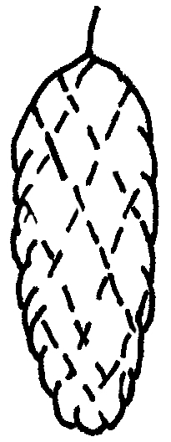 | 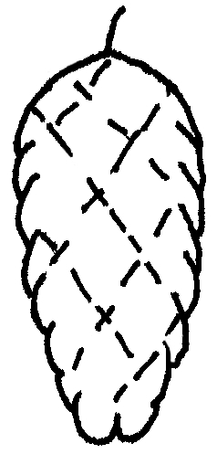 | 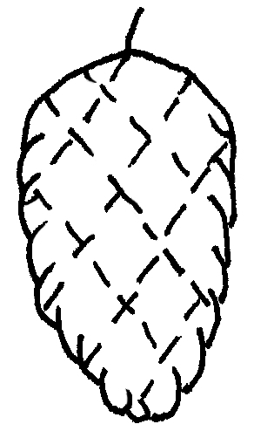 | 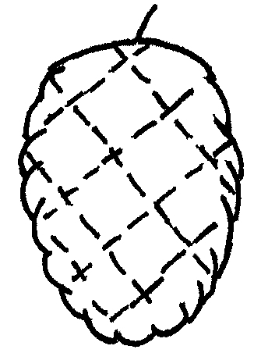 | 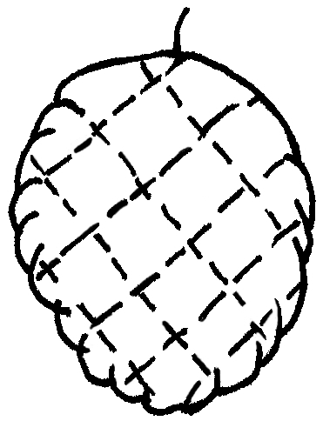
1 | 2 | 3 | 4 | 5
cylindrical | narrow ovate | medium ovate | broad ovate | circular

(c) – When an illustration contains several elements (e.g. drawings, arrows, figures, text, etc.) please, fix them in place, by “grouping” or by incorporating them into an image (e.g. by using the command edit; copy and inserting it using “paste special” and PNG format).

Ad. 21: Corolla: reflexing of lateral lobes
Ad. 22: Corolla: length in relation to width

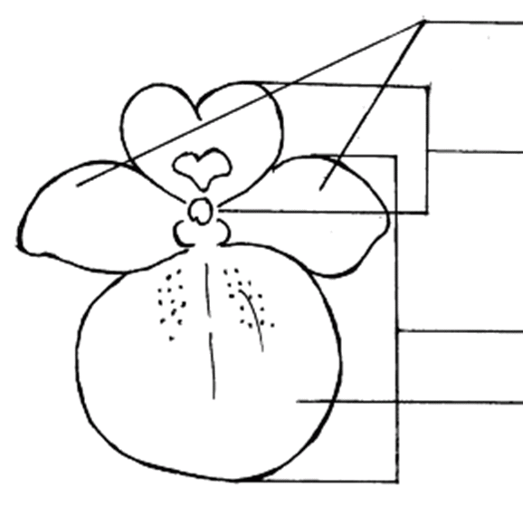 | lateral lobes of corolla  upper lip of corolla  lower lip of corolla  lower lobe of corolla

IN WORD 2003 (AND ALIKE), CHECK THAT THE FOLLOWING SETTINGS ARE ACTIVATED:

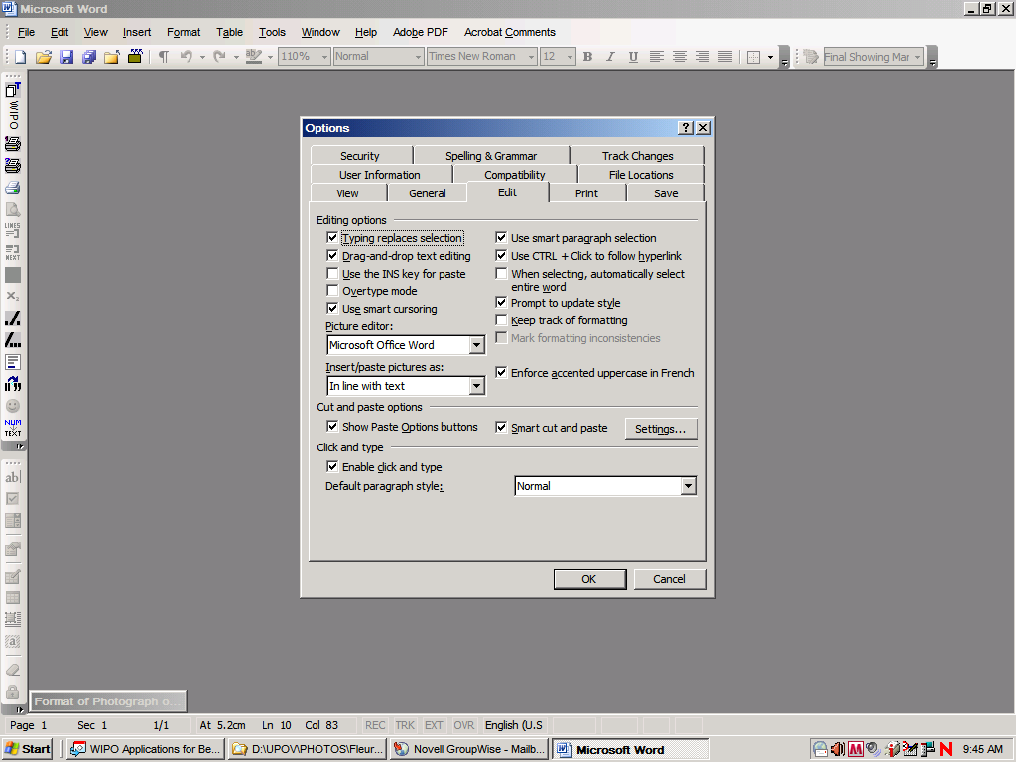
Menu > Tools > Options > Edit

and

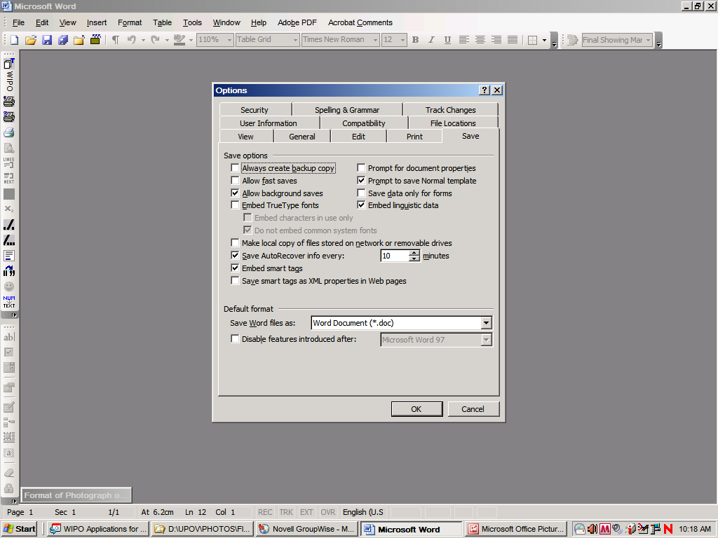

Once the cursor is inside the table, insert the picture (Menu > insert > picture > from file >…).

If the picture is already in a Word document, cut and paste it in the table.

In previous versions of Word (Word 6.0 1995, or Word 97), use “Paste special” and uncheck the option “floating over text” on the right hand in order to paste the picture inside the table.

[Annex II follows]

SURVEY TO SEEK VIEWS ON THE EFFECTIVENESS OF THE TECHNICAL WORKING PARTIES, SUBMITTED TO THE TWO AND TWF AT THEIR SESSIONS IN 2012

[Annex III follows]

PROPOSAL FOR SURVEY FOR PARTICIPANTS TO ALL TWPS IN 2013

- Are you representing: a Member of the Union, an observer State, an observer Intergovernmental Organization (IGO), an observer Non-Governmental Organization (NGO)?
- How many TWP meetings have you attended? [none, 1, 2, less than 5, 5-10, more than 10]
- Have you attended other Technical Working Parties or other UPOV bodies? [none, TWA, TWO etc…, TC, CAJ, CC, Council]
- Regarding the draft TGPs documents, was the introduction effective, and the decision paragraph useful? [scale from very poor to very good] (Note: comments box will be provided)
- Was the organization of the discussion effective in order to reach a conclusion? [scale from very poor to very good] (Note: comments box will be provided)
- Did you feel encouraged to contribute to the discussion? [scale from very poor to very good] (Note: comments box will be provided)
- How satisfied are you with the way in which the Test Guidelines were presented/discussed at the TWP session? [scale from very poor to very good] (Note: comments box will be provided)
- Are you satisfied with the work program of the week? [scale from very poor to very good] (Note: comments box will be provided)
- Are you satisfied with the Technical Visit? [scale from very poor to very good] (Note: comments box will be provided)

[Annex IV follows]

PROPOSAL FOR SURVEY FOR PARTICIPANTS TO THE TECHNICAL COMMITTEE IN 2013

- Are you representing: a Member of the Union, an Observer State, an observer Intergovernmental Organization (IGO), observer Non-Governmental Organization (NGO)?
- How many TC meetings have you attended? [none, 1, 2, less than 5, 5-10, more than 10]
- How many TWP meetings have you attended? [none, 1, 2, less than 5, 5-10, more than 10]
- The report on developments in UPOV (agenda item 4) was useful and of an appropriate length
[scale from: do not agree to strongly agree] (Note: comments box will be provided)
- The progress report from the TWP chairpersons (agenda item 5) was useful and of an appropriate length [scale from: do not agree to strongly agree] (Note: comments box will be provided)
- Was the discussion on application of molecular technique models by members of the Union (item 3(a)(i)) useful? [scale from not useful to very useful] (Note: comments box will be provided)
- Was the discussion on the situation with regard to molecular techniques in other international organizations (item 3(a)(ii)) useful? [scale from not useful to very useful] (Note: comments box will be provided)
- Was the discussion on the use of DUS test reports by members of the Union (item 3(b)) useful? [scale from not useful to very useful] (Note: comments box will be provided)
- Did you feel encouraged to participate in the discussions under agenda item 3? [scale from not at all encouraged to very encouraged] (Note: comments box will be provided)
- I attend the TC sessions to (more than one answer possible):
(a) hear about developments
(b) learn more about the UPOV system
(c) meet experts from other UPOV members
(d) participate in discussions on important matters
(e) other (please provide details)

[End of Annex IV and of document]

