 |  | E  TC/49/29  ORIGINAL: English  DATE: February 8, 2013
INTERNATIONAL UNION FOR THE PROTECTION OF NEW VARIETIES OF PLANTS
Geneva
Technical Committee
Forty-Ninth Session
Geneva, March 18 to 20, 2013
Revision of document TGP/8: Part II: Techniques Used in DUS Examination,
New Section: Data Processing for the Assessment of Distinctness and for Producing Variety Descriptions
Document prepared by the Office of the Union
1 The purpose of this document is to present the developments concerning a possible new section for document TGP/8: “Data Processing for the Assessment of Distinctness and for Producing Variety Descriptions”.

2 The following abbreviations are used in this document:

CAJ: Administrative and Legal Committee
TC: Technical Committee
TC-EDC: Enlarged Editorial Committee
TWA: Technical Working Party for Agricultural Crops
TWC: Technical Working Party on Automation and Computer Programs
TWF: Technical Working Party for Fruit Crops
TWO: Technical Working Party for Ornamental Plants and Forest Trees
TWV: Technical Working Party for Vegetables
TWPs: Technical Working Parties

3 The structure of this document is as follows:

background 2
Comments of the Technical Working Parties (TWPs) in 2012 2
Comments of the Enlarged Editorial Committee (TC-EDC) in 2013 3

ANNEX: TRANSFORMATION OF MEASUREMENT INTO NOTES FOR VARIETY DESCRIPTIONS- SUMMARY OF DIFFERENT APPROACHES PRESENTED AT THE TECHNICAL WORKING PARTIES IN 2012 (IN ENGLISH ONLY)

background

4 The Technical Committee (TC), at its forty-eighth session, held in Geneva from March 26 to 28, 2012, considered Annex III: “TGP/8 PART I: DUS Trial Design and data analysis, New Section 6 – Data processing for the assessment of distinctness and for producing variety Descriptions” in conjunction with Annex VIII: “TGP/8 PART II: Techniques used in DUS Examination, New Section 13 - Methods for data processing for the assessment of distinctness and for producing variety descriptions” of
document TC/48/19 Rev. It agreed that the information provided in Annex VIII of document TC/48/19 Rev. and at the UPOV DUS Seminar, held in Geneva in March 2010, together with the method provided by Japan and the method used in France for producing variety descriptions for herbage crops, as presented at the TWC at its twenty-sixth session (see document TWC/26/15, TWC/26/15 Add. and TWC/26/24), provided a very important first step in developing common guidance on data processing for the assessment of distinctness and for producing variety descriptions, but concluded that the information as presented in
Annex VIII of document TC/48/19 Rev. would not be appropriate for inclusion in document TGP/8. It agreed that the Office of the Union should summarize the different approaches set out in
Annex VIII of document TC/48/19 Rev. with regard to aspects in common and aspects where there was divergence. As a next step, on the basis of that summary, consideration could be given to developing general guidance. The TC agreed that the section should include examples to cover the range of variation of characteristics. It further agreed that the detailed information on the methods should be made available via the UPOV website, with references in document TGP/8 (see document TC/48/22 “Report on Conclusions” paragraph 52).

Comments of the Technical Working Parties (TWPs) in 2012

5 At their sessions in 2012, the TWA, TWV, TWC, TWF and the TWO, considered documents TWA/41/30, TWV/46/30, TWC/30/30, TWF/43/30 and TWO/45/30 respectively, as set out in Annex to this document (in English only∗).

6 The TWPs, at their sessions in 2012, made the following comments:

General | The TWA noted the information that a summary of different approaches used for data processing for the assessment of distinctness and for producing variety descriptions would be developed by the Office of the Union (see document TWA/41/34 “Report”, paragraph 44). | TWA
 | The TWV considered document TWV/46/30 and received a presentation made by the Office containing a summary of different approaches for transforming means into notes for variety descriptions. The TWV was informed that the summary would be presented to the TWC at its thirtieth session and that it would be further developed (see document TWV/46/41 “Report”, paragraphs 43 and 44). | TWV
 | The TWC noted information provided in documents TWC/30/30 and TWC/30/30 Add. and agreed that the experts from Finland, Italy and the United Kingdom would support the Office of the Union to summarize the different approaches for further developing common guidance on data processing for the assessment of distinctness and for producing variety descriptions (see document TWC/30/41 “Report”, paragraph 42).  The TWC agreed that experts from the United Kingdom in cooperation with experts from France and Germany should conduct a practical exercise. The exercise would be to process a common data set to produce variety descriptions in order to determine the aspects in common and where there was divergence among the methods (see document TWC/30/41 “Report”, paragraph 43). | TWC
 | The TWF considered documents TWF/43/30 and TWF/43/30 Add. and received a presentation made by the Office containing a summary of different approaches for transforming means into notes for variety descriptions.  The TWF expressed concern that a specific country may have difficulty in describing the full range of states of expression of a characteristic because some varieties might not be available. A universal set of example varieties, the use of historical data and experience of the experts could be a way to address this issue.  The TWF recommended that consideration be given to the construction of a meaningful range of expression in the case of a limited range of available varieties.  (see document TWF/43/38 “Report”, paragraphs 29 to 31) | TWF
 | The TWO agreed with the recommendations of the TWF that consideration be given to the construction of a meaningful scale of expression in the case of a limited range of available example varieties (see document TWO/45/37 “Report”, paragraph 32). | TWO

7 In accordance with the proposal of the TWC, the Office of the Union has invited experts from the United Kingdom, France and Germany to make a proposal for a practical exercise.

Comments of the Enlarged Editorial Committee (TC-EDC) in 2013

8 The TC-EDC, at its meeting held in Geneva on January 9 and 10, 2013, considered
document TC-EDC/Jan 13/16: “Revision of document TGP/8: Part II: Techniques Used in DUS Examination,
New Section: Data Processing for the Assessment of Distinctness and for Producing Variety Descriptions”.

9 The TC-EDC, agreed that it would be necessary for the experts from the United Kingdom, France and Germany to provide a common test data set of self-pollinated and/or vegetatively propagated varieties for performing a practical exercise, because the COY method was already well established for cross-pollinated varieties.

10 The Chairperson of the TWC offered to provide variety descriptions from Finland.

11 The TC is invited to:

- consider the comments made by the TWPs at their sessions in 2012; and

- request the experts from the United Kingdom, France and Germany to provide a common data set of self-pollinated and/or vegetatively propagated varieties for performing a practical exercise.

[Annex follows]

(IN ENGLISH ONLY)

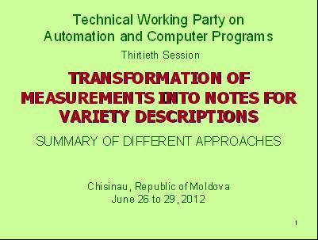

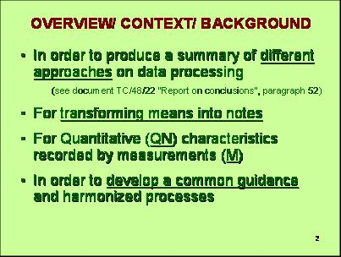

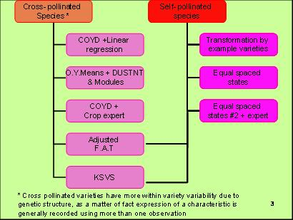

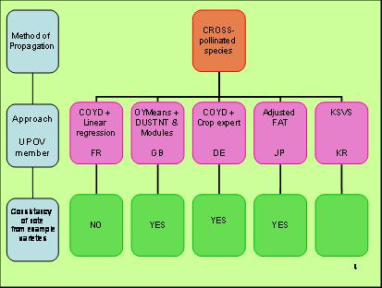

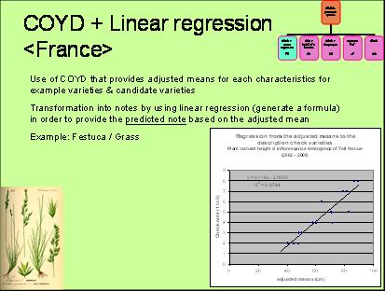

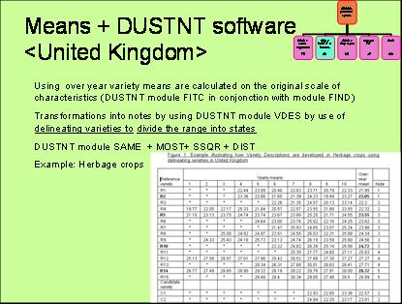

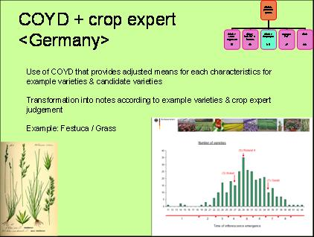

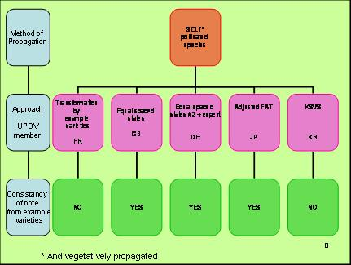

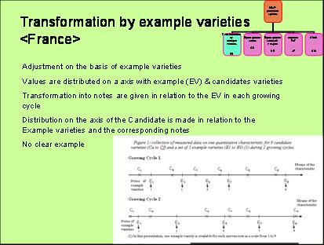

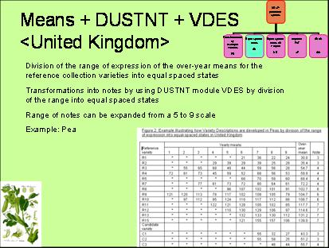

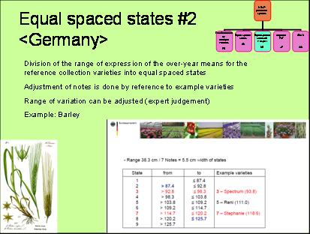

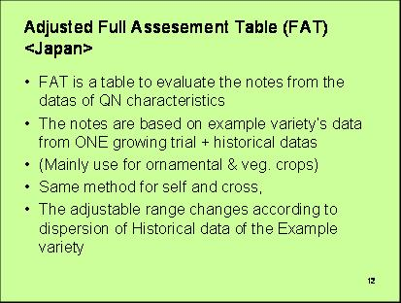

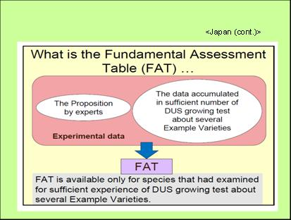

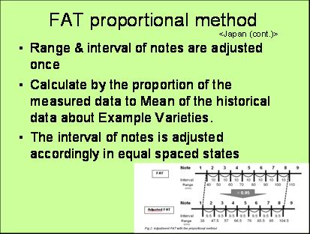

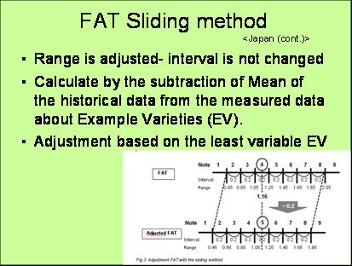

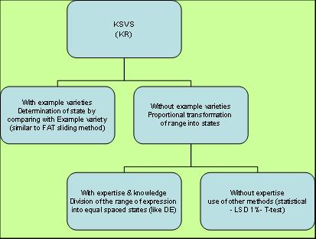

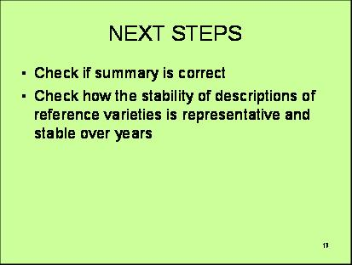

[End of Annex and of document]

 The TC-EDC, at its meeting on January 9 and 10, 2013, agreed that it would not be appropriate to translate the text for the forty-ninth session of the TC.

