 |  | E  TC/49/26  ORIGINAL: English  DATE: January 28, 2013
INTERNATIONAL UNION FOR THE PROTECTION OF NEW VARIETIES OF PLANTS
Geneva
Technical Committee
Forty-Ninth Session
Geneva, March 18 to 20, 2013
Revision of document TGP/8: Part II: Techniques Used in DUS Examination,
Section 4: 2x1% Method- Minimum Number of Degrees of Freedom
for the 2x1% Method
Document prepared by the Office of the Union

1 The purpose of this document is to present a proposal for a revision of document TGP/8, Part II, Section 4: “2x1 % Method”.

BACKGROUND

2 The Technical Committee (TC), at its forty-eighth session, held in Geneva from March 26 to 28, 2012, considered the proposal for a revision of Section 4: “2x1 % Method” on the basis of document TC/48/19 Rev. “Revision of document TGP/8 Trial Design and Techniques Used in the Examination of Distinctness, Uniformity and Stability”, Annex XII, as prepared by an expert from the United Kingdom.
The TC noted that at least 10 degrees of freedom were required for the residual mean square used to estimate the standard error in the t-test in each year. It agreed that further clarification was needed with regard to the significance of the wording “preferably at least 20 degrees of freedom” (see document TC/48/22 “Report on Conclusions” paragraph 63).

3 The TC agreed with the workplan for the development of document TGP/8 presented in Annex XV to document TC/48/19 Rev., which indicated that document for a revision of Section 4: “2x1 % Method” would be considered by the Technical Working Parties (TWPs) in 2012. The TC noted that new drafts of relevant sections would need to be prepared by April 26, 2012, in order that the sections could be included in the draft to be considered by the TWPs at their sessions in 2012 (see document TC/48/22 “Report on Conclusions” paragraphs 49 and 78).

4 The following abbreviations are used in this document:

TC: Technical Committee
TC-EDC: Enlarged Editorial Committee
TWA: Technical Working Party for Agricultural Crops
TWC: Technical Working Party on Automation and Computer Programs
TWF: Technical Working Party for Fruit Crops
TWO: Technical Working Party for Ornamental Plants and Forest Trees
TWPs: Technical Working Parties
TWV: Technical Working Party for Vegetables

COMMENTS BY THE TECHNICAL WORKING PARTIES IN 2012

5 At their sessions in 2012, the TWA, TWV, TWC, TWF and TWO considered documents TWA/41/22, TWV/46/22, TWC/30/22, TWF/43/22, TWO/45/22, respectively, presenting a proposal for revision of Section 4: “2x1 % Method” of document TGP/8, and commented as follows:

General | The TWA noted the proposal for the revision of Section 4 of document TGP/8 on the minimum number of degrees of freedom for the 2x1% method.  The TWA agreed to invite the TWC to clarify whether COYD was the preferred method, or to explain the circumstances in which the 2x1% method would be preferred (see document TWA/41/34 “Report”, paragraphs 31 and 32). | TWA
 | The TWV agreed with the proposal made by the TWA, to invite the TWC to clarify whether COYD was the preferred method, or to explain the circumstances in which the 2x1% method would be preferred (see document TWV/46/41 “Report”, paragraph 32). | TWV
 | The TWC clarified that the COYD method was preferable over the 2x1% method for assurance that results were consistent and repeatable, as stated under Section 3.2.3 of TGP/8, and in particular bullet point 2 (page 59) (see document TWC/30/41 “Report”, paragraph 33).  “3.2.3 The main advantages of the COYD method are:  (…)  it ensures that judgments about distinctness will be reproducible in other seasons; in other words, the same genetic material should give similar results, within reasonable limits, from season-to-season;” | TWC

6 The TC-EDC, at its meeting on January 9 and 10, 2013, considered document TC-EDC/Jan13/13 “Revision of document TGP/8: Part II: Techniques Used in DUS Examination, Section 4: “2x1% - Minimum Number of Degrees of Freedom for 2x1% Method”. The TC-EDC made no proposals concerning amendments to the text provided in the Annex to this document.

7 The Annex to this document presents the proposed additional text for inclusion in document TGP/8, Part II, Section 4: “2x1% Method”. The text that is proposed to be added is shown by highlight in the Annex. The amendments to the proposed text presented in document TC/48/19 Rev., Annex XII, considered by the TC, at its forty-eighth session, are indicated by strikethrough for deletions and underlining for additions.
No amendments have been made to the text considered by the TWPs at their sessions in 2012.

8 The TC is invited to consider the Annex to this document, as a basis for a future revision of document TGP/8: Part II: Techniques Used in DUS Examination, Section 4.

[Annex follows]
EXTRACT FROM DOCUMENT TGP/8/1

TGP/8/1: Part II: Section 4: 2x1% METHOD – MINIMUM NUMBER OF DEGREES OF FREEDOM
FOR THE 2x1% METHOD

4. 2X1% METHOD

4.1 Requirements for application of method

4.1.1 The 2x1% Criterion is an appropriate method for assessing the distinctness of varieties where:

- the characteristic is quantitative;

- there are some differences between plants (or plots) of a variety;

- observations are made on a plant (or plot) basis over two or more years;

- there are at least 10, and preferably at least 20, degrees of freedom for the residual mean square used to estimate the standard error in the t-test in each year;

- To have replicated plots

4.2 The 2x1% Criterion (Method)

4.2.1 For two varieties to be distinct using the 2x1% criterion, the varieties need to be significantly different in the same direction at the 1% level in at least two out of three years in one or more measured characteristics. The tests in each year are based on Student’s two-tailed t--test of the differences between variety means with standard errors estimated using the residual mean square from the analysis of the variety x replicate plot means.

4.2.2 With respect to the 2x1% criterion, compared to COYD, it is important to note that:

- Information is lost because the criterion is based on the accumulated decisions arising from the results of t-tests made in each of the test years. Thus, a difference which is not quite significant at the 1% level contributes no more to the separation of a variety pair than a zero difference or a difference in the opposite direction. For example, three differences in the same direction, one of which is significant at the 1% level and the others at the 5% level would not be regarded as distinct.
- Some characteristics are more consistent over years than others in their expression of differences between varieties. However, beyond requiring differences to be in the same direction in order to count towards distinctness, the 2x1% criterion takes no account of consistency in the size of the differences from year to year.
- It is recommended that there should be at least 10, and preferably at least 20, degrees of freedom for the residual mean square used to estimate the standard error in the t-test in each year. This is to ensure that the residual mean square is based on sufficient data to be a reliable estimate of the varieties-by-replicates variation used in the standard error in the t-test. The fewer the data, the fewer the degrees of freedom for the residual mean square, and the less reliable the estimate of the standard error in the t-test. Assuming replicates are arranged in blocks, 20 degrees of freedom corresponds to 11 varieties in three replicates, or 5 varieties in six replicates, whereas, ten degrees of freedom corresponds to 6 varieties in three replicates, or 3 varieties in six replicates. This is compensated for by use of a larger critical t-value in the t-test. The result is a less powerful test, which means that there is a reduced chance of declaring varieties as being distinct. From the graph below, it can be seen that the power of the test is good with 20 or more degrees of freedom for the residual mean square, that it is still reasonably powerful if the degrees of freedom drop to 10, though more is preferable.
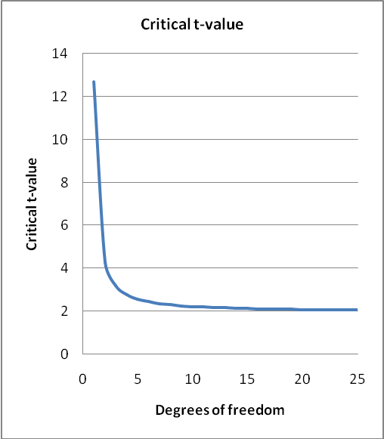

Assuming replicates are arranged in blocks, 20 degrees of freedom corresponds to 11 varieties in three replicates, or 5 varieties in six replicates, whereas, ten degrees of freedom corresponds to 6 varieties in three replicates, or 3 varieties in six replicates.
The fewer the degrees of freedom for the residual mean square below 20, the greater the loss in precision in the estimate of the standard error in the t-test. This is compensated for by the critical t-value used in the t-test being larger, which results in a reduction in the power of the test: meaning that there is a reduced chance of declaring varieties as being distinct.

[End of Annex and of document]

