 |  | E  TG/ONCID(proj.6)  ORIGINAL: English  DATE: 2012-01-16
INTERNATIONAL UNION FOR THE PROTECTION OF NEW VARIETIES OF PLANTS
GENEVA
DRAFT
 | ONCIDIUM  x ONCIDESA  x IONOCIDIUM  x ZELENKOCIDIUM  UPOV Code:  ONCID; ONCIE; IONOC; ZELEN  (Oncidium Sw. x Oncidesa Hort.,  x Ionocidium Hort., x Zelenkocidium J.M.H.Shaw.) | *

GUIDELINES

FOR THE CONDUCT OF TESTS

FOR DISTINCTNESS, UNIFORMITY AND STABILITY

prepared by experts from Japan

to be considered by the
Technical Committee at its forty-eighth session,
to be held in Geneva from March 26 to 28, 2012

Alternative Names:*

Botanical name | English | French | German | Spanish
Oncidium Sw. | Oncidium | Orchidee danseuse,  Oncidium | Oncidium | Oncidium,  Dama Danzante
x Oncidesa Hort. (Oncidium Sw x Gomesa R.B.)
x Ionocidium Hort. (Oncidium Sw. x Ionopsis Kunth.)
x Zelencocidium J.M.H. Shaw (Oncidium Sw. x Zelenkoa M.W.Chase & N.H.Williams.

The purpose of these guidelines (“Test Guidelines”) is to elaborate the principles contained in the General Introduction (document TG/1/3), and its associated TGP documents, into detailed practical guidance for the harmonized examination of distinctness, uniformity and stability (DUS) and, in particular, to identify appropriate characteristics for the examination of DUS and production of harmonized variety descriptions.

ASSOCIATED DOCUMENTS

These Test Guidelines should be read in conjunction with the General Introduction and its associated TGP documents.
TABLE OF CONTENTS PAGE

1. Subject of these Test Guidelines 4
2. Material Required 4
3. Method of Examination 4
3.1 Number of Growing Cycles 4
3.2 Testing Place 4
3.3 Conditions for Conducting the Examination 4
3.4 Test Design 5
3.5 Additional Tests 5
4. Assessment of Distinctness, Uniformity and Stability 5
4.1 Distinctness 5
4.2 Uniformity 6
4.3 Stability 6
5. Grouping of Varieties and Organization of the Growing Trial 7
6. Introduction to the Table of Characteristics 8
6.1 Categories of Characteristics 8
6.2 States of Expression and Corresponding Notes 8
6.3 Types of Expression 9
6.4 Example Varieties 9
6.5 Legend 9
7. Table of Characteristics/Tableau des caractères/Merkmalstabelle/Tabla de caracteres 10
8. Explanations on the Table of Characteristics 33
8.1 Explanations covering several characteristics 33
8.2 Explanations for individual characteristics 33
8.3 Explanation of the origin of example varieties 46
9. Literature 47
10. Technical Questionnaire 48

Subject of these Test Guidelines
These Test Guidelines apply to all varieties of Oncidium Sw. and their intergeneric hybrids with Cochlioda Lindl., Cyrtochilum, Gomesa R.B., Ionopsis Kunth. and Zelenkoa M.W.Chase & N.H. Williams.

Material Required
2.1 The competent authorities decide on the quantity and quality of the plant material required for testing the variety and when and where it is to be delivered. Applicants submitting material from a State other than that in which the testing takes place must ensure that all customs formalities and phytosanitary requirements are complied with.

2.2 The material is to be supplied in the form of plants that have not previously flowered, ready to show all the characteristics with growing inflorescence.

2.3 The minimum quantity of plant material, to be supplied by the applicant, should be:

9 plants.

2.4 The plant material supplied should be visibly healthy, not lacking in vigor, nor affected by any important pest or disease.

2.5 The plant material should not have undergone any treatment which would affect the expression of the characteristics of the variety, unless the competent authorities allow or request such treatment. If it has been treated, full details of the treatment must be given.

Method of Examination

3.1 Number of Growing Cycles
The minimum duration of tests should normally be a single growing cycle.

3.2 Testing Place
Tests are normally conducted at one place. In the case of tests conducted at more than one place, guidance is provided in TGP/9 “Examining Distinctness”.

3.3 Conditions for Conducting the Examination
3.3.1 The tests should be carried out under conditions ensuring satisfactory growth for the expression of the relevant characteristics of the variety and for the conduct of the examination.

3.3.2 Because daylight varies, color determinations made against a color chart should be made either in a suitable cabinet providing artificial daylight or in the middle of the day in a room without direct sunlight. The spectral distribution of the illuminant for artificial daylight should conform with the CIE Standard of Preferred Daylight D 6500 and should fall within the tolerances set out in the British Standard 950, Part I. These determinations should be made with the plant part placed against a white background. The color chart and version used should be specified in the variety description.

3.4 Test Design
3.4.1 Each test should be designed to result in a total of at least 9 plants.

3.4.2 The design of the tests should be such that plants or parts of plants may be removed for measurement or counting without prejudice to the observations which must be made up to the end of the growing cycle.

3.5 Additional Tests
Additional tests, for examining relevant characteristics, may be established.

Assessment of Distinctness, Uniformity and Stability

4.1 Distinctness
4.1.1 General Recommendations
It is of particular importance for users of these Test Guidelines to consult the General Introduction prior to making decisions regarding distinctness. However, the following points are provided for elaboration or emphasis in these Test Guidelines.

4.1.2 Consistent Differences
The differences observed between varieties may be so clear that more than one growing cycle is not necessary. In addition, in some circumstances, the influence of the environment is not such that more than a single growing cycle is required to provide assurance that the differences observed between varieties are sufficiently consistent. One means of ensuring that a difference in a characteristic, observed in a growing trial, is sufficiently consistent is to examine the characteristic in at least two independent growing cycles.

4.1.3 Clear Differences
Determining whether a difference between two varieties is clear depends on many factors, and should consider, in particular, the type of expression of the characteristic being examined, i.e. whether it is expressed in a qualitative, quantitative, or pseudo-qualitative manner. Therefore, it is important that users of these Test Guidelines are familiar with the recommendations contained in the General Introduction prior to making decisions regarding distinctness.

4.1.4 Number of Plants / Parts of Plants to be Examined
Unless otherwise indicated, for the purposes of distinctness, all observations on single plants should be made on 8 plants or parts taken from each of 8 plants and any other observations made on all plants in the test, disregarding any off-type plants.

4.1.5 Method of Observation
The recommended method of observing the characteristic for the purposes of distinctness is indicated by the following key in the second column of the Table of Characteristics (see document TGP/9 “Examining Distinctness”, Section 4 “Observation of characteristics”):

MG: single measurement of a group of plants or parts of plants
MS: measurement of a number of individual plants or parts of plants
VG: visual assessment by a single observation of a group of plants or parts of plants
VS: visual assessment by observation of individual plants or parts of plants

Type of observation: visual (V) or measurement (M)

“Visual” observation (V) is an observation made on the basis of the expert’s judgment. For the purposes of this document, “visual” observation refers to the sensory observations of the experts and, therefore, also includes smell, taste and touch. Visual observation includes observations where the expert uses reference points (e.g. diagrams, example varieties, side-by-side comparison) or non-linear charts (e.g. color charts). Measurement (M) is an objective observation against a calibrated, linear scale e.g. using a ruler, weighing scales, colorimeter, dates, counts, etc.

Type of record: for a group of plants (G) or for single, individual plants (S)

For the purposes of distinctness, observations may be recorded as a single record for a group of plants or parts of plants (G), or may be recorded as records for a number of single, individual plants or parts of plants (S). In most cases, “G” provides a single record per variety and it is not possible or necessary to apply statistical methods in a plant-by-plant analysis for the assessment of distinctness.

In cases where more than one method of observing the characteristic is indicated in the Table of Characteristics (e.g. VG/MG), guidance on selecting an appropriate method is provided in document TGP/9, Section 4.2.

4.2 Uniformity
4.2.1 It is of particular importance for users of these Test Guidelines to consult the General Introduction prior to making decisions regarding uniformity. However, the following points are provided for elaboration or emphasis in these Test Guidelines:

4.2.1 For the assessment of uniformity, a population standard of 95% and an acceptance probability of at least 1% should be applied. In the case of a sample size of 9 plants, 1 off-type is allowed.

4.3 Stability
4.3.1 In practice, it is not usual to perform tests of stability that produce results as certain as those of the testing of distinctness and uniformity. However, experience has demonstrated that, for many types of variety, when a variety has been shown to be uniform, it can also be considered to be stable.

4.3.2 Where appropriate, or in cases of doubt, stability may be further examined by testing a new plant stock to ensure that it exhibits the same characteristics as those shown by the initial material supplied.

Grouping of Varieties and Organization of the Growing Trial
5.1 The selection of varieties of common knowledge to be grown in the trial with the candidate varieties and the way in which these varieties are divided into groups to facilitate the assessment of distinctness are aided by the use of grouping characteristics.

5.2 Grouping characteristics are those in which the documented states of expression, even where produced at different locations, can be used, either individually or in combination with other such characteristics: (a) to select varieties of common knowledge that can be excluded from the growing trial used for examination of distinctness; and (b) to organize the growing trial so that similar varieties are grouped together.

5.3 The following have been agreed as useful grouping characteristics:

Guidance for the use of grouping characteristics, in the process of examining distinctness, is provided through the General Introduction and document TGP/9 “Examining Distinctness”.

(a) Plant: size (characteristic 1)
(b) Flower: width in front view (characteristic 23)
(c) Petal: ground color (characteristic 71) with the following groups:
(d) Petal: diffused over color (if present) (characteristic 72) with the following groups:
(e) Petal: color of spots (if present) (characteristic 75) with the following groups:
(f) Petal: color of bands (if present) (characteristic 78) with the following groups:
(g) Petal: color of stripes (if present) (characteristic 79) with the following groups:
(h) Petal: color of margin (if present) (characteristic 81) with the following groups:
(i) Petal: color of macule (if present) (characteristic 83) with the following groups:
(j) Lip: apical lobe: ground color (characteristic 92) with the following groups:

Grouping characteristics from (c) to (j) should be applicable with following color groups
Gr.1: white
Gr.2: yellow
Gr.3: orange
Gr.4: pink
Gr.5: red
Gr.6: violet
Gr.7: brown

Introduction to the Table of Characteristics

6.1 Categories of Characteristics
6.1.1 Standard Test Guidelines Characteristics

Standard Test Guidelines characteristics are those which are approved by UPOV for examination of DUS and from which members of the Union can select those suitable for their particular circumstances.

6.1.2 Asterisked Characteristics

Asterisked characteristics (denoted by *) are those included in the Test Guidelines which are important for the international harmonization of variety descriptions and should always be examined for DUS and included in the variety description by all members of the Union, except when the state of expression of a preceding characteristic or regional environmental conditions render this inappropriate.

6.2 States of Expression and Corresponding Notes
6.2.1 States of expression are given for each characteristic to define the characteristic and to harmonize descriptions. Each state of expression is allocated a corresponding numerical note for ease of recording of data and for the production and exchange of the description.

6.2.2 In the case of qualitative and pseudo-qualitative characteristics (see Chapter 6.3), all relevant states of expression are presented in the characteristic. However, in the case of quantitative characteristics with 5 or more states, an abbreviated scale may be used to minimize the size of the Table of Characteristics. For example, in the case of a quantitative characteristic with 9 states, the presentation of states of expression in the Test Guidelines may be abbreviated as follows:

State | Note
small | 3
medium | 5
large | 7

However, it should be noted that all of the following 9 states of expression exist to describe varieties and should be used as appropriate:

State | Note
very small | 1
very small to small | 2
small | 3
small to medium | 4
medium | 5
medium to large | 6
large | 7
large to very large | 8
very large | 9

6.2.3 Further explanation of the presentation of states of expression and notes is provided in document TGP/7 “Development of Test Guidelines”.

6.3 Types of Expression
An explanation of the types of expression of characteristics (qualitative, quantitative and pseudo-qualitative) is provided in the General Introduction.

6.4 Example Varieties
Where appropriate, example varieties are provided to clarify the states of expression of each characteristic.

6.5 Legend
(*) Asterisked characteristic – see Chapter 6.1.2

QL Qualitative characteristic – see Chapter 6.3
QN Quantitative characteristic – see Chapter 6.3
PQ Pseudo-qualitative characteristic – see Chapter 6.3

MG, MS, VG, VS – see Chapter 4.1.5

(a)-(c) See Explanations on the Table of Characteristics in Chapter 8.1.

(+) See Explanations on the Table of Characteristics in Chapter 8.2.

Table of Characteristics/Tableau des caractères/Merkmalstabelle/Tabla de caracteres
 |  | English | français | deutsch | español | Example Varieties  Exemples  Beispielssorten  Variedades ejemplo | Note/  Nota
1  (*)  (+) | VG | Plant: size | Plante : taille | Pflanze: Größe | Planta: tamaño
QN |  | small | petite | klein | pequeño | Fragrance Fantasy | 3
 |  | medium | moyenne | mittel | medio | Yellow Angel | 5
 |  | large | grande | groß | grande | Kurisu | 7
2  (*)  (+) | VG | Plant: attitude of leaves | Plante : port des feuilles | Pflanze: Stellung der Blätter | Planta: porte de las hojas
QN | (b) | erect | dressé | aufrecht | erecto | Haruka | 1
 |  | semi-erect | demi-dressé | halbaufrecht | semierecto | Only You | 2
 |  | horizontal | horizontal | waagrecht | horizontal |  | 3
 |  | pendulous | retombant | halbhängend | péndulo |  | 4
3  (*) | VG | Pseudobulb: size | Pseudobulbe : taille | Pseudobulbe: Größe | Pseudobulbo: tamaño
QN | (a) | small | petit | klein | pequeño | Haru Ichiban | 3
 |  | medium | moyen | mittel | medio |  | 5
 |  | large | grand | groß | grande | Nihao, Papurikon,  Shimizu Parasol | 7
4  (*)  (+) | VG | Pseudobulb: shape in longitudinal section | Pseudobulbe : forme en section longitudinale | Pseudobulbe: Form im Längsschnitt | Pseudobulbo: forma en sección longitudinal
PQ | (a) | ovate | ovale | eiförmig | oval | Yellow Days, YMC-2 | 1
 |  | elliptic | elliptique | elliptisch | elíptica | Haruka, Ruru | 2
 |  | circular | circulaire | kreisförmig | circular | Ami | 3
 |  | oblate | aplati | breitrund | achatada |  | 4
5  (+) | VG | Pseudobulb: shape in cross section | Pseudobulbe : forme en section transversale | Pseudobulbe: Form im Querschnitt | Pseudobulbo: forma en sección transversal
PQ | (a) | broad oblate | aplatie large | breit breitrund | achatada ancha | Suzy | 1
 |  | medium oblate | aplatie moyenne | mittel breitrund | achatada media |  | 2
 |  | narrow oblate | aplatie étroite | schmal breitrund | achatada estrecha | Yellow Angel | 3
 |  | circular | circulaire | kreisförmig | circular |  | 4
6  (+) | MG/MS | Pseudobulb: number of cataphylls | Pseudobulbe : nombre de cataphylles | Pseudobulbe: Anzahl der Kataphylle | Pseudobulbo: número de catáfilos
QN | (a) | few | rares | gering | bajo | Fight Yuko | 1
 |  | medium | moyen | mittel | medio | Ruru | 2
 |  | many | nombreux | hoch | alto |  | 3
7  (+) | MG/MS | Pseudobulb: number of leaves | Pseudobulbe : nombre de feuilles | Pseudobulbe: Anzahl der Blätter | Pseudobulbo: número de hojas
QN | (a) | one | une | eines | una | Ami | 1
 |  | two | deux | zwei | dos | Monshirotyo no Cafe | 2
 |  | three | trois | drei | tres | Shimizu Parasol Papurikon | 3
 |  | more than three | plus de trois | mehr als drei | más de tres |  | 4
8 | VG/MG | Leaf: length | Feuille : longueur | Blatt: Länge | Hoja: longitud
QN | (b) | short | courte | kurz | corta | Fragrance Fantasy | 3
 |  | medium | moyenne | mittel | media | Suzy | 5
 |  | long | longue | lang | larga | Shimizu Parasol Papurikon | 7
9  (*) | VG/MG | Leaf: width | Feuille : largeur | Blatt: Breite | Hoja: anchura
QN | (b) | narrow | étroite | schmal | estrecha | Sakura no Sato,  Yellow Days | 3
 |  | medium | moyenne | mittel | media | Suzy | 5
 |  | broad | large | breit | ancha |  | 7
10  (*)  (+) | VG | Leaf: shape | Feuille : forme | Blatt: Form | Hoja: forma
PQ | (b) | narrow lanceolate | lancéolée étroite | schmal lanzettlich | lanceolada estrecha | Sakurako | 1
 |  | linear | linéaire | linear | lineal | Haruka,  Kaori no Izumi | 2
 |  | narrow elliptic | elliptique étroite | schmal elliptisch | elíptica estrecha |  | 3
 |  | medium elliptic | elliptique moyenne | mittel elliptisch | elíptica media |  | 4
11 | VG | Leaf: shape in cross section | Feuille : forme en section transversale | Blatt: Form im Querschnitt | Hoja: forma en sección transversal
QN | (b) | concave | concave | konkav | cóncava | Yellow Days | 1
 |  | flat | plate | flach | plana | Flambeau | 2
 |  | convex | convexe | konvex | convexa |  | 3
12 | VG | Leaf: intensity of green color on upper side | Feuille : intensité de la couleur verte sur la face supérieure | Blatt: Intensität der Grünfärbung der Oberseite | Hoja: intensidad del color verde en el haz
QN | (b) | light | claire | hell | claro |  | 1
 |  | medium | moyenne | mittel | medio | Ruru | 2
 |  | dark | foncée | dunkel | oscuro | Nancy | 3
13  (*)  (+) | VG | Inflorescence: type | Inflorescence : type | Blütenstand: Typ | Inflorescencia: tipo
QL |  | raceme | grappe | Blütentraube | racimo | Poco-A-Poco, Yellow | 1
 |  | simple panicle | panicule | einfache Rispe | panícula simple | Yurara | 2
 |  | compound panicle | panicule composée | zusammengesetzte Rispe | panícula compuesta | Ami | 3
14  (+) | VG/MG | Inflorescence: length of flowering part | Inflorescence : longueur de la partie florale | Blütenstand: Länge des blühenden Teils | Inflorescencia: longitud de la parte en floración
QN |  | short | courte | kurz | corta |  | 3
 |  | medium | moyenne | mittel | media | Monshirotyo no Cafe | 5
 |  | long | longue | lang | larga | Kurisu | 7
15  (+) | VG/MG | Inflorescence: width | Inflorescence : largeur | Blütenstand: Breite | Inflorescencia: anchura
QN |  | narrow | étroite | schmal | estrecha | Fragrance Fantasy | 3
 |  | medium | moyenne | mittel | media | Ruru | 5
 |  | broad | large | breit | ancha | Kurisu | 7
16  (*) | MS/MG | Inflorescence: number of flowers | Inflorescence : nombre de fleurs | Blütenstand: Anzahl der Blüten | Inflorescencia: número de flores
QN |  | few | rares | gering | bajo |  | 3
 |  | medium | moyen | mittel | medio | Yasukaspa Akane | 5
 |  | many | nombreuses | hoch | alto | Ruru | 7
17  (*)  (+) | VG/MG | Peduncle: length | Pédoncule : longueur | Blütenstandstiel: Länge | Pedúnculo: longitud
QN |  | short | court | kurz | corto | Kaoli no Izumi, Sakura no Sato | 3
 |  | medium | moyen | mittel | medio | Ruru | 5
 |  | long | long | lang | largo | Flambeau | 7
18  (*) | VG/MG | Peduncle: thickness | Pédoncule : épaisseur | Blütenstandstiel: Dicke | Pedúnculo: grosor
QN |  | thin | mince | dünn | delgado | Fragrance Fantasy | 1
 |  | medium | moyenne | mittel | medio | Kurisu | 2
 |  | thick | épaisse | dick | grueso |  | 3
19  (*)  (+) | VG | Peduncle: anthocyanin coloration | Pédoncule : pigmentation anthocyanique | Blütenstandstiel: Anthocyanfärbung | Pedúnculo: pigmentación antociánica
QN |  | absent or weak | absente ou faible | fehlend oder schwach | ausente o débil | Monshirotyo no Cafe | 1
 |  | moderate | modérée | mittel | moderada | Kurisu | 2
 |  | strong | forte | stark | fuerte | Nancy | 3
20  (*)  (+) | VG | Flower: curvature of sepals | Fleur : courbure des sépales | Blume: Biegung der Kelchblätter | Flor: curvatura de los sépalos
QN | (c) | incurving | incurvée | aufgebogen | curvados hacia adentro | Yellow Angel | 1
 |  | straight | droite | gerade | rectos | Shimizu Parasol Papurikon | 2
 |  | recurving | recurvée | zurückgebogen | curvados hacia afuera | Ami | 3
21  (*)  (+) | VG | Flower: curvature of petals | Fleur : courbure des pétales | Blüte: Biegung der Blütenblätter | Flor: curvatura de los pétalos
QN | (c) | incurving | incurvée | aufgebogen | curvados hacia adentro | Yellow Angel | 1
 |  | straight | droite | gerade | rectos | Shimizu Parasol Papurikon | 2
 |  | recurving | recurvée | zurückgebogen | curvados hacia afuera | Ami | 3
22  (*)  (+) | VG/MG | Flower: length in front view | Fleur : longueur vue de face | Blüte: Länge in Vorderansicht | Flor: longitud en perspectiva frontal
QN |  | short | courte | kurz | corta | Kurisu | 3
 |  | medium | moyenne | mittel | media | Ami | 5
 |  | long | longue | lang | larga | Gotoh | 7
23  (*)  (+) | VG/MS | Flower: width in front view | Fleur : largeur vue de face | Blüte: Breite in Vorderansicht | Flor: anchura en perspectiva frontal
QN |  | narrow | étroite | schmal | estrecha | Kurisu | 3
 |  | medium | moyenne | mittel | media | Sakurako | 5
 |  | broad | large | breit | ancha | Trinity | 7
24 | VG | Flower: fragrance | Fleur : parfum | Blüte: Duft | Flor: fragancia
QN |  | absent or weak | absent ou faible | fehlend oder gering | ausente o débil | Pink Sugar, Rur | 1
 |  | moderate | modéré | mittel | moderada | Only One | 2
 |  | strong | fort | stark | fuerte |  | 3
25  (*) | VG/MG | Dorsal sepal: length | Sépale dorsal : longueur | Dorsales Kelchblatt: Länge | Sépalo dorsal: longitud
QN | (c) | short | court | kurz | corto | Yellow Days, YMC-2 | 1
 |  | medium | moyen | mittel | medio |  | 2
 |  | long | long | lang | largo | Gotoh | 3
26  (*) | VG/MG | Dorsal sepal: width | Sépale dorsal : largeur | Dorsales Kelchblatt: Breite | Sépalo dorsal: anchura
QN | (c) | narrow | étroit | schmal | estrecho | Kurisu | 1
 |  | medium | moyen | mittel | medio | YMC-2 | 2
 |  | broad | large | breit | ancho | Sakurako | 3
27  (*)  (+) | VG | Dorsal sepal: shape | Sépale dorsal : forme | Dorsales Kelchblatt: Form | Sépalo dorsal: forma
PQ | (c) | lanceolate | lancéolé | lanzettlich | lanceolada | Shell White | 1
 |  | ovate | ovale | eiförmig | oval | Flambeau | 2
 |  | linear | linéaire | linear | lineal | Ota | 3
 |  | narrow elliptic | elliptique étroit | schmal elliptisch | elíptica estrecha | Haruka, Nancy | 4
 |  | elliptic | elliptique | elliptisch | elíptica | Yellow Days, Yurara | 5
 |  | obovate | obovale | verkehrt eiförmig | oboval | Kaori no Izumi | 6
28  (*)  (+) | VG | Dorsal sepal: curvature of longitudinal axis | Sépale dorsal : courbure de l’axe longitudinal | Dorsales Kelchblatt: Biegung der Längsachse | Sépalo dorsal: curvatura del eje longitudinal
QN | (c) | strongly incurving | fortement incurvé | stark aufgebogen | fuertemente curvado hacia adentro |  | 1
 |  | moderately incurving | modérément incurvé | mäßig aufgebogen | moderadamente curvado hacia adentro | Nihao, Yellow Days | 3
 |  | straight | droit | gerade | recto | Gotoh | 5
 |  | moderately recurving | modérément retombant | mäßig zurückgebogen | moderadamente curvado hacia afuera | Flambeau | 7
 |  | strongly recurving | fortement retombant | stark zurückgebogen | fuertemente curvado hacia afuera |  | 9
29  (+) | VG | Dorsal sepal: cross section | Sépale dorsal : section transversale | Dorsales Kelchblatt: Querschnitt | Sépalo dorsal: sección transversal
QN | (c) | strongly concave | fortement concave | stark konkav | fuertemente cóncavo |  | 1
 |  | moderately concave | moyennement concave | mäßig konkav | moderadamente cóncavo |  | 3
 |  | flat | plate | flach | plano | Only You, YMC-2 | 5
 |  | moderately convex | moyennement convexe | mäßig konvex | moderadamente convexo | Shell White,  Yellow Days | 7
 |  | strongly convex | fortement convexe | stark konvex | fuertemente convexo |  | 9
30  (+) | VG | Dorsal sepal: undulation of margin | Sépale dorsal : ondulation du bord | Dorsales Kelchblatt: Wellung des Randes | Sépalo dorsal: ondulación del borde
QN | (c) | absent or weak | absente ou faible | fehlend oder gering | ausente o débil | Only You | 1
 |  | moderate | modérée | mittel | moderada | Yellow Days | 2
 |  | strong | forte | stark | fuerte |  | 3
31  (*) | VG | Dorsal sepal: ground color | Sépale dorsal : couleur de fond | Dorsales Kelchblatt: Grundfarbe | Sépalo dorsal: color de fondo
PQ | (c) | RHS Colour Chart (indicate reference number) | Code RHS des couleurs (indiquer le numéro de référence) | RHS-Farbkarte (Nummer angeben) | Carta de colores RHS (indicar el número de referencia)
32  (+) | VG | Dorsal sepal: diffused over color (if present) | Sépale dorsal : répartition de la couleur du lavis (si présent) | Dorsales Kelchblatt: diffuse Deckfarbe (falls vorhanden) | Sépalo dorsal: color difuso por encima (de haberlo)
PQ | (c) | RHS Colour Chart (indicate reference number) | Code RHS des couleurs (indiquer le numéro de référence) | RHS-Farbkarte (Nummer angeben) | Carta de colores RHS (indicar el número de referencia)
33 | VG | Dorsal sepal: number of spots | Sépale dorsal : nombre de taches | Dorsales Kelchblatt: Anzahl der Flecken | Sépalo dorsal: número de lunares
QN | (c) | absent or very few | absent ou très rares | fehlend oder sehr gering | bajo o muy pocos | Fight Yuko | 1
 |  | few | rares | gering | bajo |  | 2
 |  | medium | moyen | mittel | medio | Makali Gotoh | 3
 |  | many | nombreuses | hoch | alto |  | 4
34 | VG | Dorsal sepal: size of spots (if present) | Sépale dorsal :  taille des taches (si présentes) | Dorsales Kelchblatt: Größe der Flecken (falls vorhanden) | Sépalo dorsal: tamaño de los lunares (de haberlos)
QN | (c) | very small | très petit | sehr klein | muy pequeño |  | 1
 |  | small | petite | klein | pequeño | Pink Sugar | 2
 |  | medium | moyenne | mittel | medio | Makali Gotoh | 3
 |  | large | large | groß | grande | Kurisu | 4
35  (+) | VG | Dorsal sepal: color of spots (if present) | Sépale dorsal : couleur des taches (si présentes) | Dorsales Kelchblatt: Farbe der Flecken (falls vorhanden) | Sépalo dorsal: color de los lunares (de haberlos)
PQ | (c) | RHS Colour Chart (indicate reference number) | Code RHS des couleurs (indiquer le numéro de référence) | RHS-Farbkarte (Nummer angeben) | Carta de colores RHS (indicar el número de referencia)
36 | VG | Dorsal sepal: number of bands | Sépale dorsal : nombre de bandes | Dorsales Kelchblatt: Anzahl der Bänder | Sépalo dorsal: número de bandas
QN | (c) | absent or very few | absent ou très rares | fehlend oder sehr wenige | ausentes o muy bajo | Fight Yuko | 1
 |  | few | rares | wenige | bajo |  | 2
 |  | medium | moyen | mittel | medio | Monshirotyo no Cafe | 3
 |  | many | nombreuses | viele | alto |  | 4
37 | VG | Dorsal sepal: distribution of bands (if present) | Sépale dorsal : répartition des bandes (si présentes) | Dorsales Kelchblatt: Verteilung der Bänder (falls vorhanden) | Sépalo dorsal: distribución de las bandas (de haberlas)
PQ | (c) | basal area | zone basale | basaler Bereich | zona basal |  | 1
 |  | middle area | zone médiane | mittlerer Bereich | zona media |  | 2
 |  | distal area | zone distale | distaler Bereich | zona distal |  | 3
 |  | basal and middle area | zone basale et médiane | basaler und mittlerer Bereich | zonas basal y media |  | 4
 |  | distal and middle area | zone distale et médiane | distaler und mittlerer Bereich | zonas distal y media |  | 5
 |  | whole area | zone entière | gesamter Bereich | en toda la superficie |  | 6
38  (+) | VG | Dorsal sepal: color of bands  (if present) | Sépale dorsal : couleur des bandes  (si présentes) | Dorsales Kelchblatt: Farbe der Bänder (falls vorhanden) | Sépalo dorsal: color de las bandas (de haberlas)
PQ | (c) | RHS Colour Chart (indicate reference number) | Code RHS des couleurs (indiquer le numéro de référence) | RHS-Farbkarte (Nummer angeben) | Carta de colores RHS (indicar el número de referencia)
39  (+) | VG | Dorsal sepal: color of stripes  (if present) | Sépale dorsal : couleur des stries  (si présentes) | Dorsales Kelchblatt: Farbe der Streifen (falls vorhanden) | Sépalo dorsal: color de las franjas (de haberlas)
PQ | (c) | RHS Colour Chart (indicate reference number) | Code RHS des couleurs (indiquer le numéro de référence) | RHS-Farbkarte (Nummer angeben) | Carta de colores RHS (indicar el número de referencia)
40 | VG | Dorsal sepal: width of marginal color | Sépale dorsal : largeur de la couleur marginale | Dorsales Kelchblatt: Breite der Farbe des Randes | Sépalo dorsal: anchura del color del borde
QN | (c) | absent or very narrow | absente ou très étroite | fehlend oder sehr schmal | ausente o muy estrecha |  | 1
 |  | narrow | étroite | schmal | estrecha |  | 2
 |  | medium | moyenne | mittel | media |  | 3
 |  | broad | large | breit | ancha |  | 4
41  (+) | VG | Dorsal sepal: color of margin (if present) | Sépale dorsal : couleur du bord (si présent) | Dorsales Kelchblatt: Farbe des Randes (falls vorhanden) | Sépalo dorsal: color del borde (de haberlo)
PQ | (c) | RHS Colour Chart (indicate reference number) | Code RHS des couleurs (indiquer le numéro de référence) | RHS-Farbkarte (Nummer angeben) | Carta de colores RHS (indicar el número de referencia)
42 | VG | Dorsal sepal: size of macule (if present) | Sépale dorsal :  taille de la macule (si présente) | Dorsales Kelchblatt: Größe des Flecks (falls vorhanden) | Sépalo dorsal: tamaño de la mácula (de haberla)
QN | (c) | very small | très petite | sehr klein | muy pequeño |  | 1
 |  | small | petite | klein | pequeño |  | 2
 |  | medium | moyenne | mittel | medio |  | 3
 |  | large | large | groß | grande |  | 4
43  (+) | VG | Dorsal sepal: color of macule  (if present) | Sépale dorsal : couleur de la macule  (si présente) | Dorsales Kelchblatt: Farbe des Flecks (falls vorhanden) | Sépalo dorsal: color de la mácula (de haberla)
PQ | (c) | RHS Colour Chart (indicate reference number) | Code RHS des couleurs (indiquer le numéro de référence) | RHS-Farbkarte (Nummer angeben) | Carta de colores RHS (indicar el número de referencia)
44  (*) | VG/MG | Lateral sepal: length | Sépale latéral : longueur | Seitliches Kelchblatt: Länge | Sépalo lateral: longitud
QN | (c) | short | court | kurz | corto | Yellow Days, YMC-2 | 1
 |  | medium | moyen | mittel | medio |  | 2
 |  | long | long | lang | largo | Gotoh | 3
45  (*) | VG/MG | Lateral sepal: width | Sépale latéral : largeur | Seitliches Kelchblatt: Breite | Sépalo lateral: anchura
QN | (c) | narrow | étroit | schmal | estrecho | Ami | 1
 |  | medium | moyen | mittel | medio | Flambeau | 2
 |  | broad | large | breit | ancho | Gotoh | 3
46  (*)  (+) | VG | Lateral sepal: shape | Sépale latéral : forme | Seitliches Kelchblatt: Form | Sépalo lateral: forma
PQ | (c) | lanceolate | lancéolé | lanzettlich | lanceolada | Suzy | 1
 |  | ovate | ovale | eiförmig | oval | Gotoh | 2
 |  | elliptic | elliptique | elliptisch | elíptica |  | 3
 |  | obovate | obovale | verkehrt eiförmig | oboval | Yasukasupa Koharu | 4
 |  | broad obovate | obovale large | breit verkehrt eiförmig | oboval ancha | YMC-2 | 5
 |  | curving obovate | obovale courbé | gebogen verkehrt eiförmig | oboval curva | Only You | 6
47  (*)  (+) | VG | Lateral sepal: curvature of longitudinal axis | Sépale latéral : courbure de l’axe longitudinal | Seitliches Kelchblatt: Biegung der Längsachse | Sépalo lateral: curvatura del eje longitudinal
QN | (c) | strongly incurving | fortement incurvé | stark aufgebogen | fuertemente curvado hacia adentro |  | 1
 |  | moderately incurving | modérément incurvé | mäßig aufgebogen | moderadamente curvado hacia adentro | Haruka, Yellow Days | 3
 |  | straight | droit | gerade | recto | Only You | 5
 |  | moderately recurving | modérément retombant | mäßig zurückgebogen | moderadamente curvado hacia afuera | Gotoh | 7
 |  | strongly recurving | fortement retombant | stark zurückgebogen | fuertemente curvado hacia afuera | Nancy, Pink Sugar | 9
48  (+) | VG | Lateral sepal: cross section | Sépale latéral : section transversale | Seitliches Kelchblatt: Querschnitt | Sépalo lateral: sección transversal
QN | (c) | strongly concave | fortement concave | stark konkav | fuertemente cóncavo |  | 1
 |  | moderately concave | moyennement concave | mäßig konkav | moderadamente cóncavo |  | 3
 |  | flat | plate | flach | plano | Flambeau | 5
 |  | moderately convex | moyennement convexe | mäßig konvex | moderadamente convexo |  | 7
 |  | strongly convex | fortement convexe | stark konvex | fuertemente convexo |  | 9
49 | VG | Lateral sepal: twisting | Sépale latéral : torsion | Seitliches Kelchblatt: Verdrehung | Sépalo lateral: torsión
QN | (c) | absent or weak | absente ou faible | fehlend oder gering | ausente o débil | Ami | 1
 |  | moderate | modérée | mittel | moderada |  | 2
 |  | strong | forte | stark | fuerte | Shimizu Parasol Papurikon | 3
50  (+)  (*) | VG | Lateral sepal: undulation of margin | Sépale latéral : ondulation du bord | Seitliches Kelchblatt: Wellung des Rands | Sépalo lateral: ondulación del borde
QN | (c) | absent or weak | absente ou faible | fehlend oder gering | ausente o débil | Haruka,  Kaori no Izumi | 1
 |  | moderate | modérée | mittel | moderada | Monshirotyo no Cafe | 2
 |  | strong | forte | stark | fuerte |  | 3
51  (*) | VG | Lateral sepal: ground color | Sépale latéral : couleur de fond | Seitliches Kelchblatt: Grundfarbe | Sépalo lateral: color de fondo
PQ | (c) | RHS Colour Chart (indicate reference number) | Code RHS des couleurs (indiquer le numéro de référence) | RHS-Farbkarte (Nummer angeben) | Carta de colores RHS (indicar el número de referencia)
52  (+) | VG | Lateral sepal: diffused over color (if present) | Sépale latéral : répartition de la couleur du lavis (si présent) | Seitliches Kelchblatt: diffuse Deckfarbe (falls vorhanden) | Sépalo lateral: color difuso por encima (de haberlo)
PQ | (c) | RHS Colour Chart (indicate reference number) | Code RHS des couleurs (indiquer le numéro de référence) | RHS-Farbkarte (Nummer angeben) | Carta de colores RHS (indicar el número de referencia)
53 | VG | Lateral sepal: number of spots | Sépale latéral : nombre de taches | Seitliches Kelchblatt: Anzahl der Flecken | Sépalo lateral: número de lunares
QN | (c) | absent or very few | absentes ou très rares | fehlend oder sehr gering | ausentes o muy bajo | Fight Yuko | 1
 |  | few | rares | gering | bajo |  | 2
 |  | medium | moyen | mittel | medio | Makali Gotoh | 3
 |  | many | nombreuses | groß | alto |  | 4
54 | VG | Lateral sepal: size of spots (if present) | Sépale latéral :  taille des taches (si présentes) | Seitliches Kelchblatt: Größe der Flecken (falls vorhanden) | Sépalo lateral: tamaño de los lunares (de haberlos)
QN | (c) | very small | très petite | sehr klein | muy pequeño |  | 1
 |  | small | petite | klein | pequeño |  | 2
 |  | medium | moyenne | mittel | medio | Makali Gotoh | 3
 |  | large | large | groß | grande | Kurisu | 4
55  (+) | VG | Lateral sepal: color of spots (if present) | Sépale latéral : couleur des taches (si présentes) | Seitliches Kelchblatt: Farbe der Flecken (falls vorhanden) | Sépalo lateral: color de los lunares (de haberlos)
PQ | (c) | RHS Colour Chart (indicate reference number) | Code RHS des couleurs (indiquer le numéro de référence) | RHS-Farbkarte (Nummer angeben) | Carta de colores RHS (indicar el número de referencia)
56 | VG | Lateral sepal: number of bands | Sépale latéral : nombre de bandes | Seitliches Kelchblatt: Anzahl der Bänder | Sépalo lateral: número de bandas
QN | (c) | absent or very few | absent ou très petit | fehlend oder sehr wenige | ausentes o muy bajo | Fight Yuko | 1
 |  | few | petit | wenige | bajo |  | 2
 |  | medium | moyen | mittel | medio | Monshirotyo no Cafe | 3
 |  | many | grand | viele | alto |  | 4
57 | VG | Lateral sepal: distribution of bands (if present) | Sépale latéral : répartition des bandes (si présentes) | Seitliches Kelchblatt: Verteilung der Bänder (falls vorhanden) | Sépalo lateral: distribución de las bandas (de haberlas)
PQ | (c) | basal area | zone basale | basaler Bereich | zona basal |  | 1
 |  | middle area | zone médiane | mittlerer Bereich | zona media |  | 2
 |  | distal area | zone distale | distaler Bereich | zona distal |  | 3
 |  | basal and middle area | zone basale et médiane | basaler und mittlerer Bereich | zonas basal y media |  | 4
 |  | distal and middle area | zone distale et médiane | distaler und mittlerer Bereich | zonas distal y media |  | 5
 |  | whole area | zone entière | gesamter Bereich | en toda la superficie |  | 6
58  (+) | VG | Lateral sepal: color of bands  (if present) | Sépale latéral : couleur des bandes  (si présentes) | Seitliches Kelchblatt: Farbe der Bänder (falls vorhanden) | Sépalo lateral: color de las bandas (de haberlas)
PQ | (c) | RHS Colour Chart (indicate reference number) | Code RHS des couleurs (indiquer le numéro de référence) | RHS-Farbkarte (Nummer angeben) | Carta de colores RHS (indicar el número de referencia)
59  (+) | VG | Lateral sepal: color of stripes  (if present) | Sépale latéral : couleur des stries  (si présentes) | Seitliches Kelchblatt: Farbe der Streifen (falls vorhanden) | Sépalo lateral: color de las franjas (de haberlas)
PQ | (c) | RHS Colour Chart (indicate reference number) | Code RHS des couleurs (indiquer le numéro de référence) | RHS-Farbkarte (Nummer angeben) | Carta de colores RHS (indicar el número de referencia)
60 | VG | Lateral sepal: width of marginal color | Sépale latéral : largeur de la couleur marginale | Seitliches Kelchblatt: Breite der Farbe des Randes | Sépalo lateral: anchura del color del borde
QN | (c) | absent or very narrow | absente ou très étroite | fehlend oder sehr schmal | ausente o muy estrecha |  | 1
 |  | narrow | étroite | schmal | estrecha |  | 2
 |  | medium | moyenne | mittel | media |  | 3
 |  | broad | large | breit | ancha |  | 4
61  (+) | VG | Lateral sepal: color of margin (if present) | Sépale latéral : couleur du bord (si présent) | Seitliches Kelchblatt: Farbe des Randes (falls vorhanden) | Sépalo lateral: color del borde (de haberlo)
PQ | (c) | RHS Colour Chart (indicate reference number) | Code RHS des couleurs (indiquer le numéro de référence) | RHS-Farbkarte (Nummer angeben) | Carta de colores RHS (indicar el número de referencia)
62 | VG | Lateral sepal: size of macule (if present) | Sépale latéral : taille de la macule (si présente) | Seitliches Kelchblatt: Größe des Flecks (falls vorhanden) | Sépalo lateral: tamaño de la mácula (de haberla)
QN | (c) | very small | très petite | sehr klein | muy pequeño |  | 1
 |  | small | petite | klein | pequeño |  | 2
 |  | medium | moyenne | mittel | medio |  | 3
 |  | large | grande | groß | grande |  | 4
63  (+) | VG | Lateral sepal: color of macule  (if present) | Sépale latéral : couleur de la macule  (si présente) | Seitliches Kelchblatt: Farbe des Flecks (falls vorhanden) | Sépalo lateral: color de la mácula (de haberla)
PQ | (c) | RHS Colour Chart (indicate reference number) | Code RHS des couleurs (indiquer le numéro de référence) | RHS-Farbkarte (Nummer angeben) | Carta de colores RHS (indicar el número de referencia)
64  (*) | VG/MG | Petal: length | Pétale : longueur | Blütenblatt: Länge | Pétalo: longitud
QN | (c) | short | court | kurz | corto | Fight Yuko, Haruka | 1
 |  | medium | moyen | mittel | medio | Flambeau | 2
 |  | long | long | lang | largo | Gotoh | 3
65  (*) | VG/MG | Petal: width | Pétale : largeur | Blütenblatt: Breite | Pétalo: anchura
QN | (c) | narrow | étroit | schmal | estrecho | Only You | 1
 |  | medium | moyen | mittel | medio | Fight Yuko | 2
 |  | broad | large | breit | ancho |  | 3
66  (*)  (+) | VG | Petal: shape | Pétale : forme | Blütenblatt: Form | Pétalo: forma
PQ | (c) | ovate | ovale | eiförmig | oval |  | 1
 |  | linear | linéaire | linear | lineal | Ota | 2
 |  | elliptic | elliptique | elliptisch | elíptica |  | 3
 |  | oblanceolate | oblancéolé | verkehrt lanzettlich | oblanceolada | Ami | 4
 |  | broad obovate | obovale large | breit verkehrt eiförmig | oboval ancha | Yasukasupa Komachi | 5
67  (*)  (+) | VG | Petal: curvature of longitudinal axis | Pétale : courbure de l’axe longitudinal | Blütenblatt: Biegung der Längsachse | Pétalo: curvatura del eje longitudinal
QN | (c) | strongly incurving | fortement incurvé | stark aufgebogen | fuertemente curvado hacia adentro |  | 1
 |  | moderately incurving | modérément incurvé | mäßig aufgebogen | moderadamente curvado hacia adentro | Yellow Days, YMC-2 | 3
 |  | straight | droit | gerade | recto | Kaori no Izumi | 5
 |  | moderately recurving | modérément retombant | mäßig zurückgebogen | moderadamente curvado hacia afuera | Ami | 7
 |  | strongly recurving | fortement retombant | stark zurückgebogen | fuertemente curvado hacia afuera |  | 9
68  (+) | VG | Petal: cross section | Pétale : section transversale | Blütenblatt: Querschnitt | Pétalo: sección transversal
QN | (c) | strongly concave | fortement concave | stark konkav | fuertemente cóncavo |  | 1
 |  | moderately concave | moyennement concave | mäßig konkav | moderadamente cóncavo |  | 3
 |  | flat | plate | flach | plano | Yellow Days, YMC-2 | 5
 |  | moderately convex | moyennement convexe | mäßig konvex | moderadamente convexo | Shell White, Monshirotyo no Cafe | 7
 |  | strongly convex | fortement convexe | stark konvex | fuertemente convexo |  | 9
69 | VG | Petal: twisting | Pétale : torsion | Blütenblatt: Verdrehung | Pétalo: torsión
QN | (c) | absent or weak | absente ou faible | fehlend oder gering | ausente o débil | Ami | 1
 |  | moderate | modérée | mittel | moderada |  | 2
 |  | strong | forte | stark | fuerte | Shimizu Parasol Papurikon | 3
70  (+) | VG | Petal: undulation of margin | Pétale : ondulation du bord | Blütenblatt: Wellung des Randes | Pétalo: ondulación del borde
QN | (c) | absent or weak | absente ou faible | fehlend oder gering | ausente o débil | Haruka, Ruru | 1
 |  | moderate | modérée | mittel | moderada | Yellow Days | 2
 |  | strong | forte | stark | fuerte |  | 3
71  (*) | VG | Petal: ground color | Pétale : couleur de fond | Blütenblatt: Grundfarbe | Pétalo: color de fondo
PQ | (c) | RHS Colour Chart (indicate reference number) | Code RHS des couleurs (indiquer le numéro de référence) | RHS-Farbkarte (Nummer angeben) | Carta de colores RHS (indicar el número de referencia)
72  (*)  (+) | VG | Petal: diffused over color  (if present) | Pétale : répartition de la couleur du lavis (si présent) | Blütenblatt: diffuse Deckfarbe (falls vorhanden) | Pétalo: color difuso por encima (de haberlo)
PQ | (c) | RHS Colour Chart (indicate reference number) | Code RHS des couleurs (indiquer le numéro de référence) | RHS-Farbkarte (Nummer angeben) | Carta de colores RHS (indicar el número de referencia)
73 | VG | Petal: number of spots | Pétale : nombre de taches | Blütenblatt: Anzahl der Flecken | Pétalo: número de lunares
QN | (c) | absent or very few | absent ou très rares | fehlend oder sehr gering | ausentes o muy bajo | Fight Yuko | 1
 |  | few | rares | gering | bajo |  | 2
 |  | medium | moyen | mittel | medio | Makali Gotoh | 3
 |  | many | nombreuses | groß | alto |  | 4
74 | VG | Petal: size of spots  (if present) | Pétale : taille des taches  (si présentes) | Blütenblatt: Größe der Flecken (falls vorhanden) | Pétalo: tamaño de los lunares (de haberlos)
QN | (c) | very small | très petite | sehr klein | muy pequeño |  | 1
 |  | small | petite | klein | pequeño | Makali Gotoh | 2
 |  | medium | moyenne | mittel | medio | Kurisu | 3
 |  | large | grande | groß | grande |  | 4
75  (*)  (+) | VG | Petal: color of spots  (if present) | Pétale : couleur des taches  (si présentes) | Blütenblatt: Farbe der Flecken (falls vorhanden) | Pétalo: color de los lunares (de haberlos)
PQ | (c) | RHS Colour Chart (indicate reference number) | Code RHS des couleurs (indiquer le numéro de référence) | RHS-Farbkarte (Nummer angeben) | Carta de colores RHS (indicar el número de referencia)
76 | VG | Petal: number of bands | Pétale : nombre de bandes | Blütenblatt: Anzahl der Bänder | Pétalo: número de bandas
QN | (c) | absent or very few | absent ou très rares | fehlend oder sehr gering | ausentes o muy bajo |  | 1
 |  | few | rares | gering | bajo | Monshirotyo no Cafe | 2
 |  | medium | moyen | mittel | medio | Volcano Queen | 3
 |  | many | nombreuses | groß | alto |  | 4
77 | VG | Petal: distribution of bands (if present) | Pétale : répartition des taches (si présentes) | Blütenblatt: Verteilung der Bänder (falls vorhanden) | Pétalo: distribución de las bandas (de haberlas)
PQ | (c) | basal area | zone basale | basaler Bereich | zona basal |  | 1
 |  | middle area | zone médiane | mittlerer Bereich | zona media |  | 2
 |  | distal area | zone distale | distaler Bereich | zona distal |  | 3
 |  | basal and middle area | zone basale et médiane | basaler und mittlerer Bereich | zonas basal y media |  | 4
 |  | distal and middle area | zone distale et médiane | distaler und mittlerer Bereich | zonas distal y media |  | 5
 |  | whole area | zone entière | gesamter Bereich | en toda la superficie |  | 6
78  (*)  (+) | VG | Petal: color of bands  (if present) | Pétale : couleur des bandes  (si présentes) | Blütenblatt: Farbe der Bänder (falls vorhanden) | Pétalo: color de las bandas (de haberlas)
PQ | (c) | RHS Colour Chart (indicate reference number) | Code RHS des couleurs (indiquer le numéro de référence) | RHS-Farbkarte (Nummer angeben) | Carta de colores RHS (indicar el número de referencia)
79  (+) | VG | Petal: color of stripes  (if present) | Pétale : couleur des stries  (si présentes) | Blütenblatt: Farbe der Streifen (falls vorhanden) | Pétalo: color de las franjas (de haberlas)
PQ | (c) | RHS Colour Chart (indicate reference number) | Code RHS des couleurs (indiquer le numéro de référence) | RHS-Farbkarte (Nummer angeben) | Carta de colores RHS (indicar el número de referencia)
80 | VG | Petal: width of marginal color | Pétale : largeur de la couleur marginale | Blütenblatt: Breite der Farbe des Randes | Pétalo: anchura del color del borde
QN | (c) | absent or very narrow | absente ou très étroite | fehlend oder sehr schmal | ausente o muy estrecha |  | 1
 |  | narrow | étroite | schmal | estrecha |  | 2
 |  | medium | moyenne | mittel | media |  | 3
 |  | broad | large | breit | ancha |  | 4
81  (*)  (+) | VG | Petal: color of margin (if present) | Pétale : couleur du bord (si présent) | Blütenblatt: Farbe des Randes (falls vorhanden) | Pétalo: color del borde (de haberlo)
PQ | (c) | RHS Colour Chart (indicate reference number) | Code RHS des couleurs (indiquer le numéro de référence) | RHS-Farbkarte (Nummer angeben) | Carta de colores RHS (indicar el número de referencia)
82 | VG | Petal: size of macule (if present) | Pétale : taille de la macule (si présente) | Blütenblatt: Größe des Flecks (falls vorhanden) | Pétalo: tamaño de la mácula (de haberla)
QN | (c) | very small | très petite | sehr klein | muy pequeño |  | 1
 |  | small | petite | klein | pequeño |  | 2
 |  | medium | moyenne | mittel | medio |  | 3
 |  | large | large | groß | grande |  | 4
83  (*)  (+) | VG | Petal: color of macule  (if present) | Pétale : couleur de la macule  (si présente) | Blütenblatt: Farbe des Flecks (falls vorhanden) | Pétalo: color de la mácula (de haberla)
PQ | (c) | RHS Colour Chart (indicate reference number) | Code RHS des couleurs (indiquer le numéro de référence) | RHS-Farbkarte (Nummer angeben) | Carta de colores RHS (indicar el número de referencia)
84  (*)  (+) | VG/MS | Lip: length | Labelle : longueur | Lippe: Länge | Labio: longitud
QN | (c) | short | court | kurz | largo | Ami | 1
 |  | medium | moyen | mittel | medio | Gotoh | 2
 |  | long | long | lang | corto | Flambeau | 3
85  (*)  (+) | VG/MS | Lip: width | Labelle : largeur | Lippe: Breite | Labio: anchura
QN | (c) | narrow | étroit | schmal | estrecho | Gotoh,  Kaoli no Izumi | 1
 |  | medium | moyen | mittel | medio | Monshirotyo no Cafe | 2
 |  | broad | large | breit | ancho | Flambeau | 3
86  (*)  (+) | VG | Lip: size of lateral lobe in relation to apical lobe | Labelle : taille du lobe latéral par rapport au lobe apical | Lippe: Größe des Seitenlappens im Verhältnis zum apikalen Lappen | Labio: tamaño del lóbulo lateral en relación con el lóbulo apical
QN | (c) | smaller | plus petite | kleiner | más pequeño | Shimizu Prasol Papurikon, Yurara | 1
 |  | same size | même taille | gleiche Größe | mismo tamaño | Ami | 2
 |  | larger | plus grande | größer | más grande | Haruka, Only One | 3
87  (+) | VG | Lip: undulation of margin | Labelle : ondulation du bord | Lippe: Wellung des Randes | Labio: ondulación del borde
QN | (c) | absent or weak | absente ou faible | fehlend oder gering | ausente o débil | Ami | 1
 |  | moderate | modérée | mittel | moderada |  | 2
 |  | strong | forte | stark | fuerte |  | 3
88  (*)  (+) | VG | Lip: apical lobe: shape | Labelle : lobe apical : forme | Lippe: apikaler Lappen: Form | Labio: lóbulo apical: forma
PQ | (c) | rhombic | losangique | rautenförmig | rómbica | Only You | 1
 |  | circular | circulaire | kreisförmig | circular |  | 2
 |  | oblate | aplati | breitrund | achatada |  | 3
 |  | flabellate | flabelliforme | fächerförmig | flabeliforme | Monshirotyo no Café, Pink Sugar | 4
 |  | obdeltate | obdeltoïde | verkehrt deltaförmig | obdeltada |  | 5
89  (*)  (+) | VG | Lip: apical lobe: indentation of apex | Labelle : lobe apical : découpure du sommet | Lippe: apikaler Lappen: Einschnitt der Spitze | Labio: lóbulo apical: indentación del ápice
QN | (c) | absent or very weak | absente ou très faible | fehlend oder sehr gering | ausente o muy débil | Yasukasupa Akane | 1
 |  | weak | faible | gering | débil | Ami | 2
 |  | medium | moyenne | mittel | media | Pink Sugar,  Shimizu Prasol Papurikon | 3
 |  | strong | forte | stark | fuerte | Haruka, Yellow Days | 4
90  (*)  (+) | VG | Lip: apical lobe: curvature of longitudinal axis | Labelle : lobe apical : courbure de l’axe longitudinal | Lippe: apikaler Lappen: Biegung der Längsachse | Labio: lóbulo apical: curvatura del eje longitudinal
QN | (c) | incurving | incurvé | aufgebogen | curvado hacia adentro | Yellow Angel,  Yellow Days | 1
 |  | straight | droit | gerade | recto | Pink Sugar,  Shimizu Prasol Papurikon | 2
 |  | recurving | retombant | zurückgebogen | curvado hacia afuera | Only You | 3
91  (+) | VG | Lip: apical lobe: cross section | Labelle : lobe apical : section transversale | Lippe: apikaler Lappen: Querschnitt | Labio: lóbulo apical: sección transversal
QN |  | concave | concave | konkav | cóncavo | Kaori no Izumi | 1
 |  | flat | plat | flach | plano |  | 2
 |  | convex | convexe | konvex | convexo | Only You | 3
92  (*)  (+) | VG | Lip: apical lobe: ground color | Labelle : lobe apical : couleur de fond | Lippe: apikaler Lappen: Grundfarbe | Labio: lóbulo apical: color de fondo
PQ | (c) | RHS Colour Chart (indicate reference number) | Code RHS des couleurs (indiquer le numéro de référence) | RHS-Farbkarte (Nummer angeben) | Carta de colores RHS (indicar el número de referencia)
93  (+) | VG | Lip: apical lobe: diffused over color (if present) | Labelle : lobe apical : répartition de la couleur du lavis (si présent) | Lippe: apikaler Lappen: diffuse Deckfarbe (falls vorhanden) | Labio: lóbulo apical: color difuso por encima (de haberlo)
PQ | (c) | RHS Colour Chart (indicate reference number) | Code RHS des couleurs (indiquer le numéro de référence) | RHS-Farbkarte (Nummer angeben) | Carta de colores RHS (indicar el número de referencia)
94  (+) | VG | Lip: apical lobe: color of spots (if present) | Labelle : lobe apical : couleur des taches (si présentes) | Lippe: apikaler Lappen: Farbe der Flecken (falls vorhanden) | Labio: lóbulo apical: color de los lunares (de haberlos)
PQ | (c) | RHS Colour Chart (indicate reference number) | Code RHS des couleurs (indiquer le numéro de référence) | RHS-Farbkarte (Nummer angeben) | Carta de colores RHS (indicar el número de referencia)
95  (+) | VG | Lip: apical lobe: color of bands  (if present) | Labelle : lobe apical : couleur des bandes (si présentes) | Lippe: apikaler Lappen: Farbe der Bänder (falls vorhanden) | Labio: lóbulo apical: color de las bandas (de haberlas)
PQ | (c) | RHS Colour Chart (indicate reference number) | Code RHS des couleurs (indiquer le numéro de référence) | RHS-Farbkarte (Nummer angeben) | Carta de colores RHS (indicar el número de referencia)
96  (+) | VG | Lip: apical lobe: color of margin  (if present) | Labelle : lobe apical : couleur du bord (si présent) | Lippe: apikaler Lappen: Farbe des Randes (falls vorhanden) | Labio: lóbulo apical: color del borde (de haberlo)
PQ | (c) | RHS Colour Chart (indicate reference number) | Code RHS des couleurs (indiquer le numéro de référence) | RHS-Farbkarte (Nummer angeben) | Carta de colores RHS (indicar el número de referencia)
97  (+) | VG | Lip: lateral lobe: ground color | Labelle : lobe latéral : couleur de fond | Lippe: Seitenlappen: Grundfarbe | Labio: lóbulo lateral: color de fondo
PQ | (c) | RHS Colour Chart (indicate reference number) | Code RHS des couleurs (indiquer le numéro de référence) | RHS-Farbkarte (Nummer angeben) | Carta de colores RHS (indicar el número de referencia)
98 | VG | Lip: callus: color | Labelle : callus :  couleur | Lippe: Kallus: Farbe | Labio: callo: color
PQ |  | white | blanc | weiß | blanco | Fight Yuko | 1
 |  | yellow | jaune | gelb | amarillo | Fragrance Fantasy | 2
 |  | orange | orange | orange | anaranjado | Yasukasupa Akane | 3
 |  | red | rouge | rot | rojo |  | 5
 |  | red purple | rouge pourpre | rotpurpurn | púrpura rojizo |  | 4
 |  | yellow brown | brun jaune | gelbbraun | marrón amarillento | Shimizu Parasol Papurikon | 6
 |  | brown | brun | braun | marrón |  | 7
99 | VG | Lip: color of blotches surrounding callus | Labelle : couleur des taches entourant le callus | Lippe: Farbe der den Kallus umgebenden Flecken | Labio: color de las manchas que rodean al callo
PQ |  | white | blanc | weiß | blanco | Fragrance Fantasy | 1
 |  | yellow | jaune | gelb | amarillo | Yellow Days | 2
 |  | orange | orange | orange | anaranjado |  | 3
 |  | red | rouge | rot | rojo | Yasukasupa Akane | 5
 |  | red purple | rouge pourpre | rotpurpurn | púrpura rojizo |  | 4
 |  | yellow brown | brun jaune | gelbbraun | marrón amarillento |  | 6
 |  | brown | brun | braun | marrón | Monshirotyo no Café | 7

Explanations on the Table of Characteristics

8.1 Explanations covering several characteristics
Unless otherwise noted, all characteristics should be observed when 80% of flowers have opened on the first inflorescence.

Characteristics containing the following key in the second column of the Table of Characteristics should be examined as indicated below:

(a) Observations on pseudobulb should be made on the flowering pseudobulb.
(b) Observations on leaf should be made on the longest leaf of a flowering pseudobulb.
(c) Observations on the sepal, petal and lip should be made on the front of flower.
(d) Observations on the inflorescence should be made on the longest inflorescence.

8.2 Explanations for individual characteristics
Ad. 1: Plant: size

The size of plant is evaluated by observation of whole plant size including pseudobulb and leaf.

Ad.2: Plant: attitude of leaves

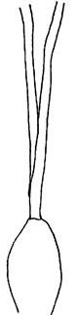 | 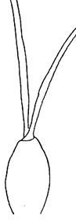 | 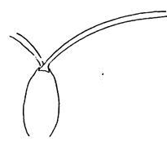 | 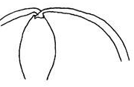
1 | 2 | 3 | 4
erect | semi-erect | horizontal | pendulous

Ad. 4: Pseudobulb: shape in longitudinal section

The shape in longitudinal section should be observed shape in longitudinal section of the most broad part of pseudobulb.

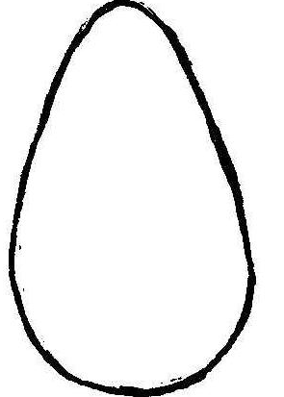 |  | 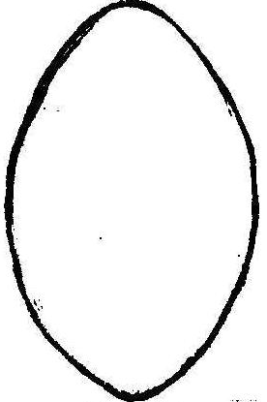 |  | 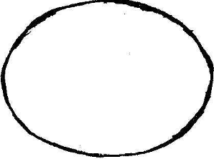
1 | 2 |  | 3 | 4
ovate | elliptic |  | circular | oblate

Ad. 5: Pseudobulb: shape in cross section

 | 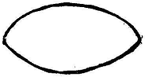 | 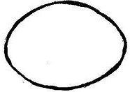 | 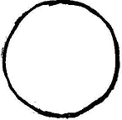
1 | 2 | 3 | 4
broad oblate | medium oblate | narrow oblate | circular

Ad. 6: Pseudobulb: number of cataphylls
Ad. 7: Pseudobulb: number of leaves
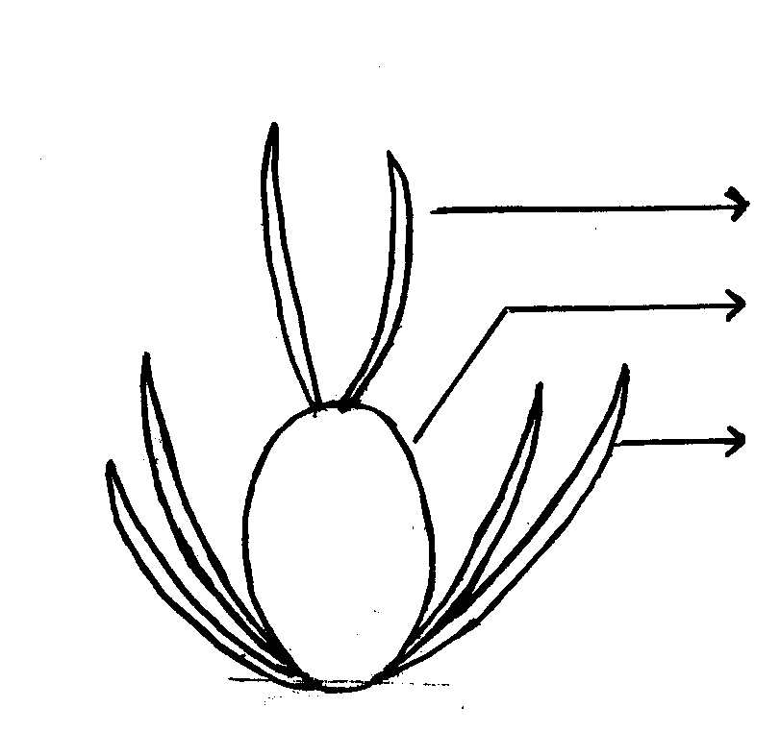
leaves
pseudobulb
cataphylls

Ad. 10: Leaf: shape

1 | 2 | 3 | 4
narrow lanceolate | linear | narrow elliptic | medium elliptic

Ad. 13: Inflorescence: type
Ad. 14: Inflorescence: length of flowering part
Ad. 15: :Inflorescence: width
Ad. 17: Peduncle: length

Inflorescence: width

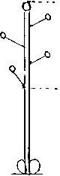 | 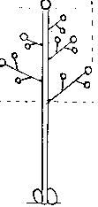 | 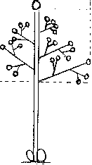 | Inflorescence: length  of flowering part  Peduncle: length
1 | 2 | 3
raceme | simple panicle | compound panicle

Ad.19: Peduncle: anthocyanin coloration

Anthocyanin coloration should be observed on the area of strongest coloration along whole length of peduncle.

Ad. 20: Flower: curvature of sepals

front view for sepals | view to see from side for sepals
dorsal sepal  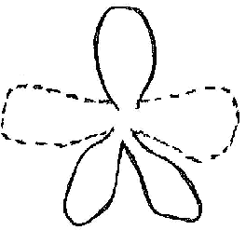  lateral sepal  front of flower | 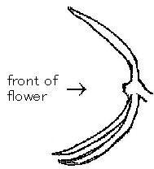 |  | 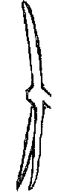 | 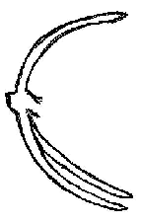
 |  | 1 | 2 | 3
 |  | incurving | straight | recurving

Ad. 21: Flower: curvature of petals

front view for petals | view to see from side for petals
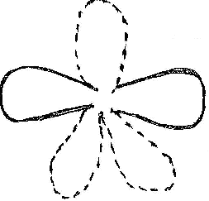  petal  front of flower | 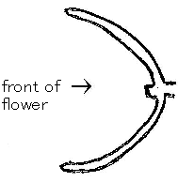 | 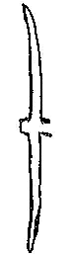 | 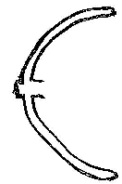
 | 1 | 2 | 3
 | incurving | straight | recurving

Ad. 22: Flower: length in front view
Ad. 23: Flower: width in front view

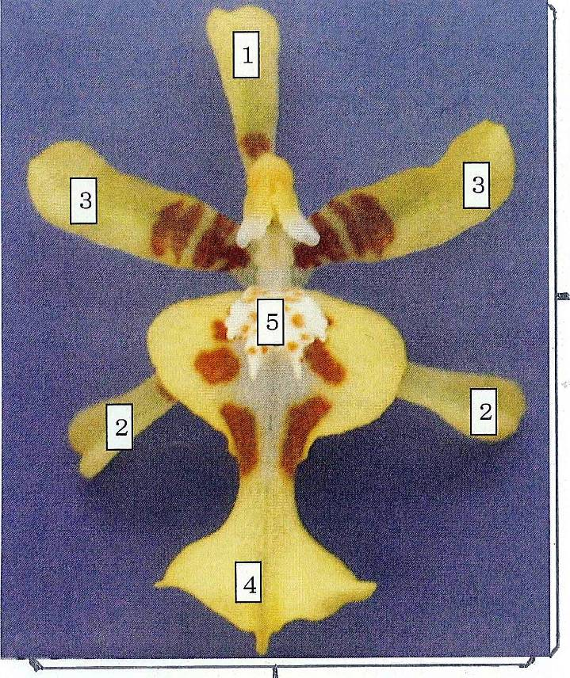
Flower: length in front view

Flower: width in front view

1 Dorsal sepal 2 Lateral sepal
3 Petal 4 Lip
5 Callus
Ad. 27: Dorsal sepal: shape

 | 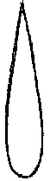 | 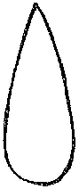
 | 1 | 2
 | lanceolate | ovate
 | 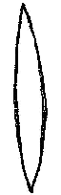 | 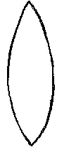 | 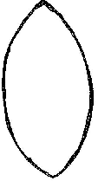
 | 3 | 4 | 5
 | linear | narrow elliptic | elliptic
 |  |  | 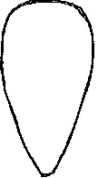
 |  |  | 6
 |  |  | obovate

Ad. 28: Dorsal sepal: curvature of longitudinal axis
Ad. 47: Lateral sepal: curvature of longitudinal axis
Ad. 67: Petal: curvature of longitudinal axis

inner  side | 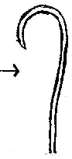 |  | 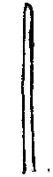 | 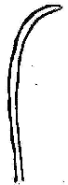 | 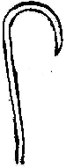
 | 1 | 3 | 5 | 7 | 9
 | strongly incurving | moderately incurving | straight | moderately recurving | strongly recurving
Ad. 29: Dorsal sepal: cross section
Ad. 48: Lateral sepal: cross section
Ad. 68: Petal: cross section

front of flower | 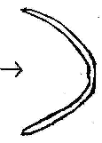 | 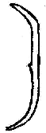 | 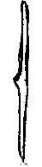 | 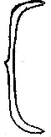 | 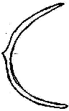
 | 1 | 3 | 5 | 7 | 9
 | strongly concave | moderately concave | flat | moderately convex | strongly convex

Ad.30: Dorsal sepal: undulation of margin
Ad.50: Lateral sepal: undulation of margin
Ad.70: Petal: undulation of margin
Ad.87: Lip: undulation of margin

1 | 2 | 3
absent or weak | medium | strong

Ad. 31: Dorsal sepal: ground color
Ad. 51: Lateral sepal: ground color
Ad. 71: Petal: lauchat2
Ad. 92: Lip: apical lobe: ground color
Ad. 97: Lip: lateral lobe: ground color

Ground color: The first color to appear chronologically during the development of the plant part. Other colors may develop in time in the form of spots, blotches, or a color flush or blush. The ground color is not always the color occupying the largest surface area of the plant part concerned. The ground color can be the main color of the lower side of an organ.

Ad. 32: Dorsal sepal: diffused over color (if present)
Ad. 35: Dorsal sepal: color of spots (if present)
Ad. 38: Dorsal sepal: color of bands (if present)
Ad. 39: Dorsal sepal: color of stripes (if present)
Ad. 41: Dorsal sepal: color of margin (if present)
Ad. 43: Dorsal sepal: color of macule (if present)
Ad. 52: Lateral sepal: diffused over color (if present)
Ad. 55: Lateral sepal: color of spots (if present)
Ad. 58: Lateral sepal: color of bands (if present)
Ad. 59: Lateral sepal: color of stripes (if present)
Ad. 61: Lateral sepal: color of margin (if present)
Ad. 63: Lateral sepal: color of macule (if present)
Ad. 72: Petal: diffused over color (if present)
Ad. 75: Petal: color of spots (if present)
Ad. 78: Petal: color of bands (if present)
Ad. 79: Petal: color of stripes (if present)
Ad. 81: Petal: color of margin (if present)
Ad. 83: Petal: color of macule (if present)

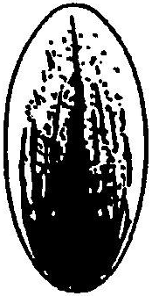 | 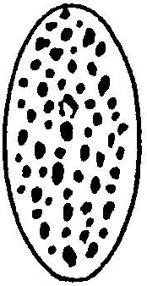 | 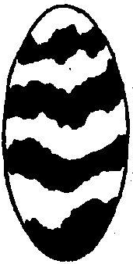 | 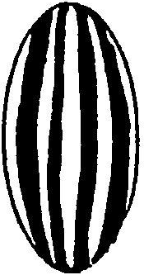 | 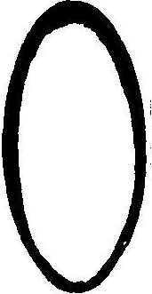 | 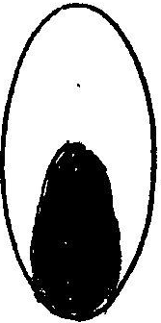
diffused over color | color of spots | color of bands | color of stripes | color of margin | color of macule

Ad. 32: Dorsal sepal: diffused over color (if present)
Ad. 52: Lateral sepal: diffused over color (if present)
Ad. 72: Petal: diffused over color (if present)
Ad. 93: Lip: apical lobe: diffused over color (if present)

Over color: In the case of a plant part which has a ground color upon which a second color such as a flush develops over time, the flush is considered the over color. The over color is not always the color occupying the smallest surface area of the plant part concerned.

Ad. 37: Dorsal sepal: distribution of bands (if present)
Ad. 57: Lateral sepal: distribution of bands (if present)
Ad. 77: Petal: distribution of bands (if present)

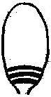 | 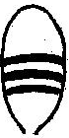 | 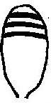 | 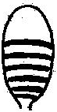 | 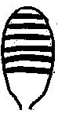 | 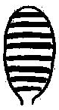
1 | 2 | 3 | 4 | 5 | 6
basal area | middle area | distal area | basal and middle area | distal and middle area | whole area

Ad. 40: Dorsal sepal: width of marginal color
Ad. 60: Lateral sepal: width of marginal color
Ad. 80: Petal: width of marginal color

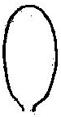 | 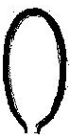 | 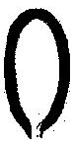 | 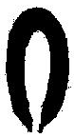
1 | 2 | 3 | 4
absent or very narrow | narrow | medium | broad

Ad. 42: Dorsal sepal: size of macule (if present)
Ad. 62: Lateral sepal: size of macule (if present)
Ad. 82: Petal: size of macule (if present)

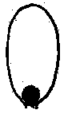 | 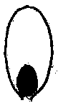 | 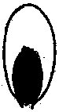 | 
1 | 2 | 3 | 4
very small | small | medium | large

Ad. 46: Lateral sepal: shape

 | 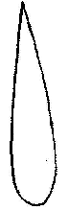 | 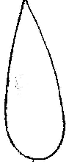
 | 1 | 2
 | lanceolate | ovate
 |  | 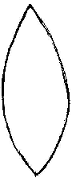
 |  | 3
 |  | elliptic
 |  | 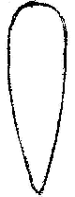 | 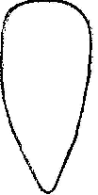 | 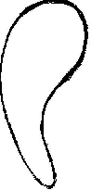
 |  | 4 | 5 | 6
 |  | obovate | broad obovate | curving  obovate

Ad. 49: Lateral sepal: twisting
Ad. 69: Petal: twisting

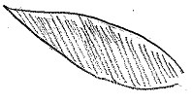 | 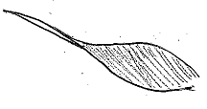 | 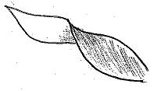
1 | 2 | 3
absent or weak | moderate | strong

Ad. 66: Petal: shape

 |  | 1
 |  | ovate
 | 2 | 3
 | linear | elliptic
 |  | 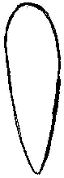
 |  | 4 | 5
 |  | oblanceolate | broad obovate

Ad. 84: Lip: length
Ad. 85: Lip: width

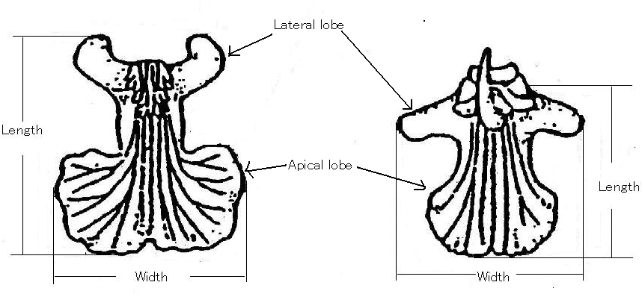

Ad. 86: Lip: size of lateral lobe in relation to apical lobe

The size of both lateral lobes compared to the size of the single apical lobe.

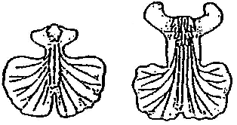 | 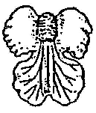 | 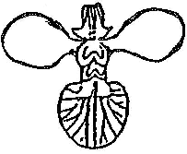
1 | 2 | 3
smaller | same size | larger

Ad. 88: Lip: apical lobe: shape

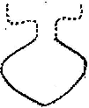 |  | 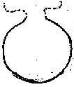 | 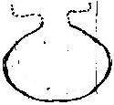 | 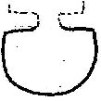 | 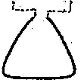
1 | 2 |  | 3 | 4 | 5
rhombic | circular |  | oblate | flabellate | obdeltate

Ad. 89: Lip: apical lobe: indentation of apex

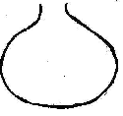 | 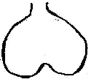 |  | 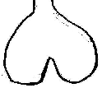 | 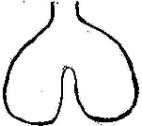
1 | 2 | 3 |  | 4
absent or very weak | weak | medium |  | strong

Ad. 90: Lip: apical lobe: curvature of longitudinal axis

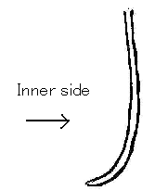 | 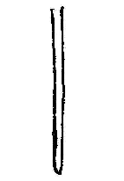 | 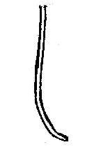
1 | 2 | 3
incurving | straight | recurving

Ad. 91: Lip: apical lobe: cross section

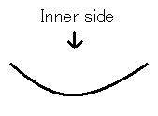 | 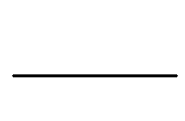 | 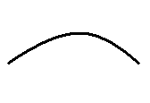
1 | 2 | 3
concave | flat | convex

Ad. 93: Lip: apical lobe: diffused over color (if present)
Ad. 94: Lip: apical lobe: color of spots (if present)
Ad. 95: Lip: apical lobe: color of bands (if present)
Ad. 96: Lip: apical lobe: color of margin (if present)

diffused over color | color of spots | color of bands | color of margin

Explanation of the origin of example varieties
The variety denominations are placed between single quotation marks
(e.g. Ella ‘Flambeau’).

No. | Denomination | Seed parent | Pollen parent
1 | Dancing Sunlight ‘Suzy’ | Cochlioda | Oncidium
2 | Dancing Sunlight ‘Ami’ | Cochlioda | Oncidium
3 | Dancing Sunlight ‘Nancy’ | Cochlioda | Oncidium
4 | Ella ‘Flambeau’ | Gomesa | Oncidium
5 | Fight Yuko | Oncidium | Oncidium
6 | Haru Ichiban | Mutant of Oncidium
7 | Haruka | Ionopsis | Oncidium
8 | Kaori no Izumi | Oncidium | Oncidium
9 | Kinsei ‘Abe No.4’ | Oncidium | Oncidium
10 | Kukoo ‘YMC-2’ | Zelenkoa | Oncidium
11 | Kurisu | Cochlioda | Oncidium
12 | Makalii ‘Gotoh’ | Oncidium | Oncidium
13 | Mayfair ‘Yellow Angel’ | Oncidium | Cyrtocidium
14 | Misaki Wave ‘Yurara’ | Cyrtocidium | Oncidium
15 | Monshirotyo no Café | Oncidium | Oncidium
16 | Morning Medley ‘Sakurako’ | Cochlioda | Oncidium
17 | Only One | Oncidium | Oncidium
18 | Only You | Oncidium | Oncidium
19 | Pink Sugar | Ionopsis | Oncidium
20 | Poco-A-Poco Yellow | Oncidium | Ionopsis
21 | Sakura no Sato | Ionopsis | Oncidium
22 | Sang-Chan ‘Nihao’ | Cyrtocidium | Cyrtochilum
23 | Shell white | Cyrtocidium | Oncidium
24 | Shimizu Parasol Papurikon | Oncidium | Oncidium
25 | Sunlight Siesta ‘Ota’ | Cochlioda | Oncidium
26 | Sunlight Siesta ‘Ruru’ | Cochlioda | Oncidium
27 | Twinkle ‘Fragrance Fantasy’ | Oncidium | Oncidium
28 | Yasukasupa Akane | Oncidium | Oncidium
29 | Yasukasupa Koharu | Oncidium | Oncidium
30 | Yasukasupa Komachi | Oncidium | Oncidium
31 | Yellow Days | Mutant of Oncidium

Literature
Higuchi, H., 1983: Japanese Test Guideline for Oncidium. Ministry of Agriculture, Forestry and Fisheries. Japan, Tokyo, JP.

Karasawa, K., 1989: Orchid Atlas Volume7. Orchid Atlas Publishing Society. Tokyo, JP, pp. 40 to 110.

Karasawa, K., 1996: Color Dictionary of Orchid. The Yamatokeikoku Ltd. Tokyo, JP, pp. 407 to 432.

Karasawa, K., 2003: Species Orchidacearum- 1 Text. Japan Broadcasting Publishing Co. Ltd. Tokyo, JP, pp.296 to 308.

Karasawa, K., 2003: Species Orchidacearum- 2 Plates. Japan Broadcasting Publishing Co. Ltd. Tokyo, JP, pp.295 to 307.

Oda, Z., 1984: Orchid-Varieties, Breeding, Cultivation and Propagation. The Hokuryu Ltd. Tokyo, JP, pp.315 to 319.

Yoneda, K., 2003: The Grand Dictionary of Flower Horticulture Volume15 Orchid. The Rural Culture Association. Tokyo, JP, pp.371 to 391.

Technical Questionnaire
TECHNICAL QUESTIONNAIRE |  | Page {x} of {y} | Reference Number:
 |  |  | Application date:
 |  |  | (not to be filled in by the applicant)
TECHNICAL QUESTIONNAIRE
to be completed in connection with an application for plant breeders’ rights

1. Subject of the Technical Questionnaire(please indicate the relevant genus or hybrid)
1.1.1 Genus name | [Oncidium SW.]
1.1.2 Botanical name | [ ] |  |  | [ ]
1.1.3 Common name | [Oncidium]
1.2.1 Genus name | [x Oncidesa Hort.]
1.2.2 Botanical name | [ ] |  |  | [ ]
1.2.3 Common name | [ ]
1.3.1 Genus name | [x Ionocidium Hort.]
1.3.2 Botanical name | [ ] |  |  | [ ]
1.3.3 Common name | [ ]
1.4.1 Genus name | [x Zelenkocidium J.M.H.Shaw.]
1.4.2 Botanical name | [ ] |  |  | [ ]
1.4.3 Common name | [ ]
2. Applicant
Name
Address
Telephone No.
Fax No.
E-mail address
Breeder (if different from applicant)
3. Proposed denomination and breeder’s reference
Proposed denomination
(if available)

Breeder’s reference
#4. Information on the breeding scheme and propagation of the variety

4.1 Breeding scheme

4.1.1 Crossing

(a) controlled cross [ ]
(please state parent varieties)

(…………………..……………..…) x (……………..…………………..…)
female parent male parent

(b) partially known cross [ ]
(please state known parent variety(ies))

(…………………..……………..…) x (……………..…………………..…)
female parent male parent

(c) unknown cross [ ]

4.1.2 Mutation [ ]
(please state parent variety)

4.1.3 Discovery and development [ ]
(please state where and when discovered and how developed)

4.1.4 Other [ ]
(please provide details)

4.2 Method of propagating the variety
4.2.1 Vegetative propagation

(a) cuttings [ ]

(b) in vitro propagation [ ]

(c) other (state method) [ ]

4.2.2 Seed [ ]

4.2.3 Other [ ]
(please provide details)

TECHNICAL QUESTIONNAIRE |  |  | Page {x} of {y} |  | Reference Number:
5. Characteristics of the variety to be indicated (the number in brackets refers to the corresponding characteristic in Test Guidelines; please mark the note which best corresponds).

 | Characteristics |  |  |  |  | Example Varieties |  | Note
5.1  (1) | Plant: size
 | very small |  |  |  |  |  |  | 1[ ]
 | very small to small |  |  |  |  |  |  | 2[ ]
 | small |  |  |  |  | Fragrancy Fantasy |  | 3[ ]
 | small to medium |  |  |  |  |  |  | 4[ ]
 | medium |  |  |  |  | Yellow Angel |  | 5[ ]
 | medium to large |  |  |  |  |  |  | 6[ ]
 | large |  |  |  |  | Kurisu |  | 7[ ]
 | large to very large |  |  |  |  |  |  | 8[ ]
 | very large |  |  |  |  |  |  | 9[ ]
5.2  (23) | Flower: width in front view
 | very narrow |  |  |  |  |  |  | 1[ ]
 | very narrow to narrow |  |  |  |  |  |  | 2[ ]
 | narrow |  |  |  |  | Kurisu |  | 3[ ]
 | narrow to medium |  |  |  |  |  |  | 4[ ]
 | medium |  |  |  |  | Sakuroku |  | 5[ ]
 | medium to broad |  |  |  |  |  |  | 6[ ]
 | broad |  |  |  |  | Trinity |  | 7[ ]
 | broad to very broad |  |  |  |  |  |  | 8[ ]
 | very broad |  |  |  |  |  |  | 9[ ]
 | Characteristics |  |  |  |  | Example Varieties |  | Note
5.3  (71) | Petal: ground color
 | white |  |  |  |  |  |  | 1[ ]
 | yellow |  |  |  |  |  |  | 2[ ]
 | orange |  |  |  |  |  |  | 3[ ]
 | pink |  |  |  |  |  |  | 4[ ]
 | red |  |  |  |  |  |  | 5[ ]
 | violet |  |  |  |  |  |  | 6[ ]
 | brown |  |  |  |  |  |  | 7[ ]
5.4  (72) | Petal: diffused over color (if present)
 | white |  |  |  |  |  |  | 1[ ]
 | yellow |  |  |  |  |  |  | 2[ ]
 | orange |  |  |  |  |  |  | 3[ ]
 | pink |  |  |  |  |  |  | 4[ ]
 | red |  |  |  |  |  |  | 5[ ]
 | violet |  |  |  |  |  |  | 6[ ]
 | brown |  |  |  |  |  |  | 7[ ]
5.5  (75) | Petal: color of spots (if present)
 | white |  |  |  |  |  |  | 1[ ]
 | yellow |  |  |  |  |  |  | 2[ ]
 | orange |  |  |  |  |  |  | 3[ ]
 | pink |  |  |  |  |  |  | 4[ ]
 | red |  |  |  |  |  |  | 5[ ]
 | violet |  |  |  |  |  |  | 6[ ]
 | brown |  |  |  |  |  |  | 7[ ]
 | Characteristics |  |  |  |  | Example Varieties |  | Note
5.6  (78) | Petal: color of bands (if present)
 | white |  |  |  |  |  |  | 1[ ]
 | yellow |  |  |  |  |  |  | 2[ ]
 | orange |  |  |  |  |  |  | 3[ ]
 | pink |  |  |  |  |  |  | 4[ ]
 | red |  |  |  |  |  |  | 5[ ]
 | violet |  |  |  |  |  |  | 6[ ]
 | brown |  |  |  |  |  |  | 7[ ]
5.7  (79) | Petal: color of stripes (if present)
 | white |  |  |  |  |  |  | 1[ ]
 | yellow |  |  |  |  |  |  | 2[ ]
 | orange |  |  |  |  |  |  | 3[ ]
 | pink |  |  |  |  |  |  | 4[ ]
 | red |  |  |  |  |  |  | 5[ ]
 | violet |  |  |  |  |  |  | 6[ ]
 | brown |  |  |  |  |  |  | 7[ ]
5.8  (81) | Petal: color of margin (if present)
 | white |  |  |  |  |  |  | 1[ ]
 | yellow |  |  |  |  |  |  | 2[ ]
 | orange |  |  |  |  |  |  | 3[ ]
 | pink |  |  |  |  |  |  | 4[ ]
 | red |  |  |  |  |  |  | 5[ ]
 | violet |  |  |  |  |  |  | 6[ ]
 | brown |  |  |  |  |  |  | 7[ ]
 | Characteristics |  |  |  |  | Example Varieties |  | Note
5.9  (83) | Petal: color of macule (if present)
 | white |  |  |  |  |  |  | 1[ ]
 | yellow |  |  |  |  |  |  | 2[ ]
 | orange |  |  |  |  |  |  | 3[ ]
 | pink |  |  |  |  |  |  | 4[ ]
 | red |  |  |  |  |  |  | 5[ ]
 | violet |  |  |  |  |  |  | 6[ ]
 | brown |  |  |  |  |  |  | 7[ ]
5.10  (92) | Lip: apical lobe: ground color (if present)
 | white |  |  |  |  |  |  | 1[ ]
 | yellow |  |  |  |  |  |  | 2[ ]
 | orange |  |  |  |  |  |  | 3[ ]
 | pink |  |  |  |  |  |  | 4[ ]
 | red |  |  |  |  |  |  | 5[ ]
 | violet |  |  |  |  |  |  | 6[ ]
 | brown |  |  |  |  |  |  | 7[ ]
6. Similar varieties and differences from these varieties

Please use the following table and box for comments to provide information on how your candidate variety differs from the variety (or varieties) which, to the best of your knowledge, is (or are) most similar. This information may help the examination authority to conduct its examination of distinctness in a more efficient way.

Denomination(s) of variety(ies) similar to your candidate variety |  | Characteristic(s) in which your candidate variety differs from the similar variety(ies) |  | Describe the expression of the characteristic(s) for the similar variety(ies) |  |  | Describe the expression of the characteristic(s) for your candidate variety
Example |  | Petal: ground color |  | yellow |  |  | white
Comments:

#7. Additional information which may help in the examination of the variety

7.1 In addition to the information provided in sections 5 and 6, are there any additional characteristics which may help to distinguish the variety?

Yes [ ] No [ ]

(If yes, please provide details)

7.2 Are there any special conditions for growing the variety or conducting the examination?

Yes [ ] No [ ]

(If yes, please provide details)

7.3 Other information

A representative color image of the variety should accompany the Technical Questionnaire.

8. Authorization for release

(a) Does the variety require prior authorization for release under legislation concerning the protection of the environment, human and animal health?

Yes [ ] No [ ]

(b) Has such authorization been obtained?

Yes [ ] No [ ]

If the answer to (b) is yes, please attach a copy of the authorization.

9. Information on plant material to be examined or submitted for examination.

9.1 The expression of a characteristic or several characteristics of a variety may be affected by factors, such as pests and disease, chemical treatment (e.g. growth retardants or pesticides), effects of tissue culture, different rootstocks, scions taken from different growth phases of a tree, etc.

9.2 The plant material should not have undergone any treatment which would affect the expression of the characteristics of the variety, unless the competent authorities allow or request such treatment. If the plant material has undergone such treatment, full details of the treatment must be given. In this respect, please indicate below, to the best of your knowledge, if the plant material to be examined has been subjected to:

(a) Microorganisms (e.g. virus, bacteria, phytoplasma) Yes [ ] No [ ]

(b) Chemical treatment (e.g. growth retardant, pesticide) Yes [ ] No [ ]

(c) Tissue culture Yes [ ] No [ ]

(d) Other factors Yes [ ] No [ ]

Please provide details for where you have indicated “yes”.

……………………………………………………………

10. I hereby declare that, to the best of my knowledge, the information provided in this form is correct:

Applicant’s name

Signature Date

[End of document]

* These names were correct at the time of the introduction of these Test Guidelines but may be revised or updated. [Readers are advised to consult the UPOV Code, which can be found on the UPOV Website (www.upov.int), for the latest information.]
# Authorities may allow certain of this information to be provided in a confidential section of the Technical Questionnaire.
# Authorities may allow certain of this information to be provided in a confidential section of the Technical Questionnaire.

