 |  | E  TG/LONIC(proj.4)  ORIGINAL: English  DATE: 2012-01-16
INTERNATIONAL UNION FOR THE PROTECTION OF NEW VARIETIES OF PLANTS
GENEVA
DRAFT

 | BLUE HONEYSUCKLE, HONEYBERRY  UPOV Code: LONIC_CAE  Lonicera caerulea L. | *

GUIDELINES

FOR THE CONDUCT OF TESTS

FOR DISTINCTNESS, UNIFORMITY AND STABILITY

prepared by an expert from Germany

to be considered by the

Technical Committee at its forty-eighth session,
to be held in Geneva from March 26 to 28, 2012

Alternative Names:*

Botanical name | English | French | German | Spanish
Lonicera caerulea L. | Blue Honeysuckle, Honeyberry, Haskap | Camérisier bleu | Blaue Honigbeere | Madreselva Azul

The purpose of these guidelines (“Test Guidelines”) is to elaborate the principles contained in the General Introduction (document TG/1/3), and its associated TGP documents, into detailed practical guidance for the harmonized examination of distinctness, uniformity and stability (DUS) and, in particular, to identify appropriate characteristics for the examination of DUS and production of harmonized variety descriptions.

ASSOCIATED DOCUMENTS

These Test Guidelines should be read in conjunction with the General Introduction and its associated TGP documents.

TABLE OF CONTENTS PAGE

1. Subject of these Test Guidelines 3
2. Material Required 3
3. Method of Examination 3
3.1 Number of Growing Cycles 3
3.2 Testing Place 3
3.3 Conditions for Conducting the Examination 3
3.4 Test Design 4
3.5 Additional Tests 4
4. Assessment of Distinctness, Uniformity and Stability 4
4.1 Distinctness 4
4.2 Uniformity 5
4.3 Stability 5
5. Grouping of Varieties and Organization of the Growing Trial 6
6. Introduction to the Table of Characteristics 6
6.1 Categories of Characteristics 6
6.2 States of Expression and Corresponding Notes 6
6.3 Types of Expression 7
6.4 Example Varieties 7
6.5 Legend 7
7. Table of Characteristics/Tableau des caractères/Merkmalstabelle/Tabla de caracteres 8
8. Explanations on the Table of Characteristics 11
8.1 Explanations covering several characteristics 11
8.2 Explanations for individual characteristics 11
9. Literature 11
10. Technical Questionnaire 11

Subject of these Test Guidelines
These Test Guidelines apply to all fruit varieties of Lonicera caerulea L.

Material Required
2.1 The competent authorities decide on the quantity and quality of the plant material required for testing the variety and when and where it is to be delivered. Applicants submitting material from a State other than that in which the testing takes place must ensure that all customs formalities and phytosanitary requirements are complied with.

2.2 The material is to be supplied in the form of plants on their own roots.

2.3 The minimum quantity of plant material, to be supplied by the applicant, should be:

5 plants.

2.4 The plant material supplied should be visibly healthy, not lacking in vigor, nor affected by any important pest or disease.

2.5 The plant material should not have undergone any treatment which would affect the expression of the characteristics of the variety, unless the competent authorities allow or request such treatment. If it has been treated, full details of the treatment must be given.

Method of Examination

3.1 Number of Growing Cycles
3.1.1 The minimum duration of tests should normally be two independent growing cycles.

3.1.2 The growing cycle is considered to be the duration of a single growing season, beginning with bud burst (flowering and/or vegetative), flowering and fruit harvest and concluding when the following dormant period ends with the swelling of new season buds.

3.2 Testing Place
Tests are normally conducted at one place. In the case of tests conducted at more than one place, guidance is provided in TGP/9 “Examining Distinctness”.

3.3 Conditions for Conducting the Examination
3.3.1 The tests should be carried out under conditions ensuring satisfactory growth for the expression of the relevant characteristics of the variety and for the conduct of the examination.

3.3.2 In order to enable the assessment of growth habit characteristics, the plants should be grown as bushes.

3.4 Test Design
Each test should be designed to result in a total of at least 5 plants.

3.5 Additional Tests
Additional tests, for examining relevant characteristics, may be established.

Assessment of Distinctness, Uniformity and Stability

4.1 Distinctness

4.1.1 General Recommendations

It is of particular importance for users of these Test Guidelines to consult the General Introduction prior to making decisions regarding distinctness. However, the following points are provided for elaboration or emphasis in these Test Guidelines.

4.1.2 Consistent Differences

The differences observed between varieties may be so clear that more than one growing cycle is not necessary. In addition, in some circumstances, the influence of the environment is not such that more than a single growing cycle is required to provide assurance that the differences observed between varieties are sufficiently consistent. One means of ensuring that a difference in a characteristic, observed in a growing trial, is sufficiently consistent is to examine the characteristic in at least two independent growing cycles.

4.1.3 Clear Differences

Determining whether a difference between two varieties is clear depends on many factors, and should consider, in particular, the type of expression of the characteristic being examined, i.e. whether it is expressed in a qualitative, quantitative, or pseudo-qualitative manner. Therefore, it is important that users of these Test Guidelines are familiar with the recommendations contained in the General Introduction prior to making decisions regarding distinctness.

4.1.4 Number of Plants / Parts of Plants to be Examined

Unless otherwise indicated, for the purposes of distinctness, all observations on single plants should be made on 3 plants or parts taken from each of 3 plants and any other observations made on all plants in the test, disregarding any off-type plants.

4.1.5 Method of Observation

The recommended method of observing the characteristic for the purposes of distinctness is indicated by the following key in the second column of the Table of Characteristics (see document TGP/9 “Examining Distinctness”, Section 4 “Observation of characteristics”):

MG: single measurement of a group of plants or parts of plants
MS: measurement of a number of individual plants or parts of plants
VG: visual assessment by a single observation of a group of plants or parts of plants
VS: visual assessment by observation of individual plants or parts of plants

Type of observation: visual (V) or measurement (M)

“Visual” observation (V) is an observation made on the basis of the expert’s judgment. For the purposes of this document, “visual” observation refers to the sensory observations of the experts and, therefore, also includes smell, taste and touch. Visual observation includes observations where the expert uses reference points (e.g. diagrams, example varieties, side-by-side comparison) or non-linear charts (e.g. color charts). Measurement (M) is an objective observation against a calibrated, linear scale e.g. using a ruler, weighing scales, colorimeter, dates, counts, etc.

Type of record: for a group of plants (G) or for single, individual plants (S)

For the purposes of distinctness, observations may be recorded as a single record for a group of plants or parts of plants (G), or may be recorded as records for a number of single, individual plants or parts of plants (S). In most cases, “G” provides a single record per variety and it is not possible or necessary to apply statistical methods in a plant-by-plant analysis for the assessment of distinctness.

In cases where more than one method of observing the characteristic is indicated in the Table of Characteristics (e.g. VG/MG), guidance on selecting an appropriate method is provided in document TGP/9, Section 4.2.

4.2 Uniformity
4.2.1 It is of particular importance for users of these Test Guidelines to consult the General Introduction prior to making decisions regarding uniformity. However, the following points are provided for elaboration or emphasis in these Test Guidelines:

4.2.2 For the assessment of uniformity, a population standard of 1% and an acceptance probability of at least 95% should be applied. In the case of a sample size of 5 plants, no off-types are allowed.

4.3 Stability
4.3.1 In practice, it is not usual to perform tests of stability that produce results as certain as those of the testing of distinctness and uniformity. However, experience has demonstrated that, for many types of variety, when a variety has been shown to be uniform, it can also be considered to be stable.

4.3.2 Where appropriate, or in cases of doubt, stability may be further examined by testing a new plant stock to ensure that it exhibits the same characteristics as those shown by the initial material supplied.

Grouping of Varieties and Organization of the Growing Trial
5.1 The selection of varieties of common knowledge to be grown in the trial with the candidate varieties and the way in which these varieties are divided into groups to facilitate the assessment of distinctness are aided by the use of grouping characteristics.

5.2 Grouping characteristics are those in which the documented states of expression, even where produced at different locations, can be used, either individually or in combination with other such characteristics: (a) to select varieties of common knowledge that can be excluded from the growing trial used for examination of distinctness; and (b) to organize the growing trial so that similar varieties are grouped together.

The following have been agreed as useful grouping characteristics:

(a) Plant: vigor (characteristic 1)
(b) Plant: habit (characteristic 2)
(c) Leaf blade: shape of apex (characteristic 14)
(d) Time of beginning of fruit ripening (characteristic 36)

5.3 Guidance for the use of grouping characteristics, in the process of examining distinctness, is provided through the General Introduction and document TGP/9 “Examining Distinctness”.

Introduction to the Table of Characteristics

6.1 Categories of Characteristics
6.1.1 Standard Test Guidelines Characteristics

Standard Test Guidelines characteristics are those which are approved by UPOV for examination of DUS and from which members of the Union can select those suitable for their particular circumstances.

6.1.2 Asterisked Characteristics

Asterisked characteristics (denoted by *) are those included in the Test Guidelines which are important for the international harmonization of variety descriptions and should always be examined for DUS and included in the variety description by all members of the Union, except when the state of expression of a preceding characteristic or regional environmental conditions render this inappropriate.

6.2 States of Expression and Corresponding Notes
6.2.1 States of expression are given for each characteristic to define the characteristic and to harmonize descriptions. Each state of expression is allocated a corresponding numerical note for ease of recording of data and for the production and exchange of the description.

6.2.2 In the case of qualitative and pseudo-qualitative characteristics (see Chapter 6.3), all relevant states of expression are presented in the characteristic. However, in the case of quantitative characteristics with 5 or more states, an abbreviated scale may be used to minimize the size of the Table of Characteristics. For example, in the case of a quantitative characteristic with 9 states, the presentation of states of expression in the Test Guidelines may be abbreviated as follows:

State | Note
small | 3
medium | 5
large | 7

However, it should be noted that all of the following 9 states of expression exist to describe varieties and should be used as appropriate:

State | Note
very small | 1
very small to small | 2
small | 3
small to medium | 4
medium | 5
medium to large | 6
large | 7
large to very large | 8
very large | 9

6.2.3 Further explanation of the presentation of states of expression and notes is provided in document TGP/7 “Development of Test Guidelines”.

6.3 Types of Expression
An explanation of the types of expression of characteristics (qualitative, quantitative and pseudo-qualitative) is provided in the General Introduction.

6.4 Example Varieties
Where appropriate, example varieties are provided to clarify the states of expression of each characteristic.

6.5 Legend
(*) Asterisked characteristic – see Chapter 6.1.2

QL: Qualitative characteristic – see Chapter 6.3
QN: Quantitative characteristic – see Chapter 6.3
PQ: Pseudo-qualitative characteristic – see Chapter 6.3

MG, MS, VG, VS: see Chapter 4.1.5

(a)-(g) See Explanations on the Table of Characteristics in Chapter 8.1
(+) See Explanations on the Table of Characteristics in Chapter 8.2

Table of Characteristics/Tableau des caractères/Merkmalstabelle/Tabla de caracteres
 |  | English | français | deutsch | español | Example Varieties/  Exemples/  Beispielssorten/  Variedades ejemplo | Note/  Nota
1  (*)  (+) | VG | Plant: vigor | Plante : vigueur | Wuchsstärke | Planta: vigor
QN | (a) | weak | faible | schwach | débil | 88/6 | 3
 |  | medium | moyenne | mittel | medio | Amur | 5
 |  | strong | forte | stark | fuerte | Altai | 7
2  (*) | VG | Plant: habit | Plante : port | Wuchsform | Planta: hábito
QN | (a) | upright | dressé | aufrecht | erecto | Amur, L-Kola 1 | 1
 |  | semi-upright | demi-dressé | halbaufrecht | semierecto | Altai, L-Kola 28 | 2
 |  | spreading | étalé | breitwüchsig | rastrero | 88/7 | 3
3  (+) | VG | Plant: branching | Plante : ramification | Pflanze: Verzweigung | Planta: ramificación
QN | (a) | weak | faible | gering | débil | L-Kola 1 | 3
 |  | medium | moyenne | mittel | medio | L-Kola 28 | 5
 |  | strong | forte | stark | fuerte | 88/6 | 7
4  (*) | VG | One-year-old shoot: lenticels | Rameau d’un an : lenticelles | Einjähriger Trieb: Lentizellen | Rama de un año: lenticelas
QL | (a) | absent | absentes | fehlend | ausentes |  | 1
 |  | present | présentes | vorhanden | presentes |  | 9
5  (*) | VG | One-year-old shoot: pubescence | Rameau d’un an : pilosité | Einjähriger Trieb: Behaarung | Rama de un año: pubescencia
QN | (a) | absent or very weak | nulle ou très faible | fehlend oder sehr gering | ausente o muy débil | Amur | 1
 |  | weak | faible | gering | débil | Altai | 3
 |  | medium | moyenne | mittel | media |  | 5
 |  | strong | forte | stark | fuerte | 88/6 | 7
6  (*) | VG | One-year-old shoot: color of bark | Rameau d’un an : couleur de l’écorce | Einjähriger Trieb: Farbe der Rinde | Rama de un año: color de la corteza
PQ | (a) | yellow brown | jaune brun | gelbbraun | marrón amarillento |  | 1
 |  | light brown | brun clair | hellbraun | marrón claro |  | 2
 |  | dark brown | brun foncé | dunkelbraun | marrón oscuro |  | 3
 |  | red brown | rouge, brun | rotbraun | marrón rojizo |  | 4
7  (*)  (+) | VG | One-year-old shoot: development of adventitious buds | Rameau d’un an : développement de bourgeons adventifs | Einjähriger Trieb: Ausbildung von Adventivknospen | Rama de un año: desarrollo de yemas adventicias
QN | (a) | weak | faible | schwach | débil |  | 1
 |  | medium | moyen | mittel | medio | L-Kola 28 | 3
 |  | strong | fort | stark | fuerte | L-Kola 1 | 5
8  (+) | VG | Shoot: pubescence of tip | Rameau : pilosité du sommet | Trieb: Behaarung der Spitze | Tallo: pubescencia del extremo
QN |  | absent or weak | absente ou faible | fehlend oder gering | ausente o débil | L-Kola 28 | 1
 |  | medium | moyenne | mittel | media |  | 3
 |  | strong | forte | stark | fuerte | 88/6, 88/7 | 5
9  (+) | VG | Shoot: glossiness of bark of tip | Rameau : brillance de l’écorce du sommet | Trieb: Glanz der Rinde der Spitze | Tallo: brillo de la corteza del extremo
QN |  | absent or weak | absente ou faible | fehlend oder gering | ausente o débil | 88/6, 88/7 | 1
 |  | medium | moyenne | mittel | medio |  | 3
 |  | strong | forte | stark | fuerte | L-Kola 1, L-Kola 28 | 5
10  (+) | VG | Shoot: anthocyanin coloration of tip | Rameau : pigmentation anthocyanique du sommet | Trieb: Anthocyanfärbung der Spitze | Tallo: pigmentación antociánica del extremo
QN |  | absent or very weak | absente ou très faible | fehlend oder sehr gering | ausente o muy débil | 88/7 | 1
 |  | weak | faible | gering | débil | Altai, L-Kola 28 | 2
 |  | medium | moyenne | mittel | media |  | 3
 |  | strong | forte | stark | fuerte | Amur | 4
 |  | very strong | très forte | sehr stark | muy fuerte |  | 5
11  (*) | VG/MS | Leaf blade: length | Limbe : longueur | Blattspreite: Länge | Limbo: longitud
QN | (d) | short | court | kurz | corto |  | 3
 |  | medium | moyen | mittel | medio |  | 5
 |  | long | long | lang | largo |  | 7
12  (*) | VG/MS | Leaf blade: width | Limbe : largeur | Blattspreite: Breite | Limbo: anchura
QN | (d) | narrow | étroit | schmal | estrecho |  | 3
 |  | medium | moyen | mittel | medio |  | 5
 |  | broad | large | breit | ancho |  | 7
13  (*) | VG/MS | Leaf blade: length/width ratio | Limbe : rapport longueur/largeur | Blattspreite: Verhältnis Länge/Breite | Limbo: relación longitud/anchura
QN | (d) | moderately elongated | modérément allongé | mäßig langgezogen | moderadamente alargada |  | 1
 |  | medium | moyen | mittel | media |  | 2
 |  | moderately compressed | modérément resserré | mäßig zusammengedrückt | moderadamente comprimido |  | 3
14  (*)  (+) | VG | Leaf blade: shape of apex | Limbe : forme du sommet | Blattspreite: Form der Spitze | Limbo: forma del ápice
PQ | (b) | acute | aigu | spitz | aguda | Altai, L-Kola 28 | 1
 |  | obtuse | obtus | stumpf | obtusa |  | 2
 |  | rounded | arrondi | abgerundet | redondeada | Amur, 88/7 | 3
15 | VG | Leaf blade: pubescence of lower side | Limbe : pilosité de la face inférieure | Blattspreite: Behaarung der Unterseite | Limbo: pubescencia en el envés
QN | (b) | absent or very weak | nulle ou très faible | fehlend oder sehr gering | ausente o muy débil | Amur, L-Kola 1,  L-Kola 28 | 1
 |  | very weak | très faible | sehr gering | muy débil |  | 3
 |  | medium | moyenne | mittel | media | Altai, 88/6 | 5
 |  | strong | forte | stark | fuerte | 88/7 | 7
 |  | very strong | très forte | sehr stark | muy fuerte |  | 9
16 | VG | Leaf blade: intensity of green color on upper side | Limbe : intensité de la couleur verte de la face supérieure | Blattspreite: Intensität der Grünfärbung der Oberseite | Limbo: intensidad del color verde en el haz
QN | (b) | light | légère | hell | claro |  | 1
 |  | medium | moyenne | mittel | medio | 88/7 | 3
 |  | dark | foncée | dunkel | oscuro | 88/6 | 5
17  (+) | VG | Stem-clasping leaf: size | Feuille embrassant la tige : taille | Stengelumfassendes Blatt: Größe | Hoja amplexical: tamaño
QN | (b) | small | petite | klein | pequeño | Altai | 1
 |  | medium | moyenne | mittel | medio | L-Kola 28 | 3
 |  | large | grande | groß | grande | Amur | 5
18  (+) | VG | Stem-clasping leaf: pubescence | Feuille embrassant la tige : pilosité | Stengelumfassendes Blatt: Behaarung | Hoja amplexical: pubescencia
QL | (b) | absent | absente | fehlend | ausente |  | 1
 |  | present | présente | vorhanden | presente | L-Kola 1 | 9
19  (+) | VG | Flower: pubescence of corolla tube | Fleur : pilosité du tube de la corolle | Blüte: Behaarung der Kronröhre | Flor: pubescencia del tubo de la corola
QN | (c) | weak | faible | gering | débil | L-Kola 1 | 1
 |  | medium | moyenne | mittel | media | L-Kola 28 | 3
 |  | strong | forte | stark | fuerte | Amur | 5
20  (+) | VG | Flower: attitude | Fleur : port | Blüte: Stellung | Flor: porte
QN | (c) | upwards | dressé | aufwärts | ascendente |  | 1
 |  | horizontal | horizontal | horizontal | horizontal |  | 3
 |  | downwards | retombant | abwärts | descendente |  | 5
21  (+) | VG | Flower: style length relative to anther length | Fleur : longueur du style par rapport à la longueur de l’anthère | Blüte: Länge des Griffels im Verhältnis zur Länge der Anthere | Flor: longitud del estilo respecto de la longitud de la antera
QN | (c) | shorter | plus court | kürzer | más corta |  | 1
 |  | equal | égal | gleich | igual |  | 2
 |  | longer | plus long | länger | más larga |  | 3
22  (*) | VG | Sepal: length | Sépale : longueur | Kelchblatt: Länge | Sépalo: longitud
QN | (c) | short | court | kurz | corto |  | 1
 |  | medium | moyen | mittel | medio | Amur | 3
 |  | long | long | lang | largo | Altai | 5
23  (*)  (+) | VG/MS | Fruit: length | Fruit : longueur | Frucht: Länge | Fruto: longitud
QN | (d) | short | court | kurz | corto |  | 1
 |  | medium | moyen | mittel | medio | Amur | 3
 |  | long | long | lang | largo | Altai | 5
24  (*)  (+) | VG/MS | Fruit: width | Fruit : largeur | Frucht: Breite | Fruto: anchura
QN | (d) | narrow | étroit | schmal | estrecho | Jaltská, Maistar, Nimfa, Sinaja ptica, Sinoglaska | 1
 |  | medium | moyen | mittel | medio | Amur, Lipnická, Mailon, Morena, Tomička, Viola, Zoluska | 3
 |  | broad | large | breit | ancho | Amfora, Fialka | 5
25  (*)  (+) | VG | Fruit: shape in cross section | Fruit : forme en section transversale | Frucht: Form im Querschnitt | Fruto: forma en la sección transversal
QN | (d) | narrow elliptic | elliptique étroite | schmal elliptisch | elíptica estrecha |  | 1
 |  | broad elliptic | elliptique large | breit elliptisch | elíptica ancha |  | 2
 |  | circular | ronde | kreisförmig | circular |  | 3
26  (*)  (+) | VG | Fruit: shape (in lateral view) | Fruit : forme (vue latérale) | Frucht: Form (in Seitenansicht) | Fruto: forma (vista lateral)
PQ | (d) | ovate | ovale | eiförmig | oval |  | 1
 |  | narrow oblong | oblongue étroite | schmal rechteckig | oblonga estrecha |  | 2
 |  | broad oblong | oblongue large | breit rechteckig | oblonga ancha |  | 3
 |  | obovate | obovale | verkehrt eiförmig | oboval |  | 4
 |  | campanulate | campanulée | glockenförmig | acampanada |  | 5
27  (+) | VG | Fruit: shape at calyx end | Fruit : forme au sommet | Frucht. Form am Kelchende | Fruto: forma del extremo del cáliz
PQ | (d) | acute | pointue | spitz | aguda |  | 1
 |  | rounded | arrondie | abgerundet | redondeada |  | 2
 |  | truncate | tronquée | gerade | truncada |  | 3
28 | VG | Fruit: tip | Fruit : sommet | Frucht: Spitze | Fruto: extremo
QL | (d) | absent | absent | fehlend | ausente |  | 1
 |  | present | présent | vorhanden | presente |  | 9
29  (+) | VG | Fruit: size of eye opening | Fruit : taille de l’ouverture de l’œil | Frucht: Größe der Augenöffnung | Fruto: tamaño de la apertura del ojo
QN | (d) | small | petite | klein | pequeño |  | 1
 |  | medium | moyenne | mittel | medio |  | 3
 |  | large | grande | groß | grande |  | 5
30  (+) | VG | Fruit: surface | Fruit : surface | Frucht: Oberfläche | Fruto: superficie
QN | (d) | smooth | lisse | glatt | lisa | Amur, L-Kola 1 | 1
 |  | medium | moyenne | mittel | media | Altai | 2
 |  | rough | rugueuse | rauh | rugosa | L-Kola 28 | 3
31  (+) | VG | Fruit: bloom of skin | Fruit : pruine de l’épiderme | Frucht: Bereifung der Schale | Fruto: pruina de la epidermis
QN | (d) | weak | faible | gering | débil |  | 1
 |  | medium | moyenne | mittel | media |  | 3
 |  | strong | forte | stark | fuerte | Altai, Amur | 5
32  (+) | VG | Fruit: intensity of blue color of skin | Fruit : intensité de la couleur bleue de l’épiderme | Frucht: Intensität der Blaufärbung der Schale | Fruto: intensidad del color azul de la piel
QN | (d) | light | légère | hell | clara | Amfora, Bakcarskaja, Fialka, Gerda, Morena, Nimfa | 1
 |  | medium | moyenne | mittel | media | Roksana, Zoluška | 3
 |  | dark | foncée | dunkel | oscura | Altaj, Amur, Tomička, Viola | 5
33 | VG | Fruit: tufts of hairs at apex | Fruits : touffes de poils au sommet | Frucht: Haarbüschel an der Spitze | Fruto: mechones de pelos en el ápice
QL | (d) | absent | absentes | fehlend | ausentes | Amur, L-Kola 1 | 1
 |  | present | présentes | vorhanden | presentes | Altai, 88/7 | 9
34  (*)  (+) | VG/MG | Time of bud burst | Époque de débourrement | Zeitpunkt des Knospenaufbruchs | Época de brotación de las yemas
QN |  | early | précoce | früh | temprana | L-Kola 28 | 3
 |  | medium | moyenne | mittel | media | L-Kola 1 | 5
 |  | late | tardive | spät | tardía | 88/6, 88/7 | 7
35  (*)  (+) | VG/MG | Time of beginning of flowering | Époque du début de la floraison | Zeitpunkt des Blühbeginns | Época del inicio de la floración
QN |  | early | précoce | früh | temprana | Altai, L-Kola 28 | 3
 |  | medium | moyenne | mittel | media | Amur, L-Kola 1 | 5
 |  | late | tardive | spät | tardía |  | 7
36  (*)  (+) | VG/MG | Time of beginning of fruit ripening | Époque du début de maturité des fruits | Zeitpunkt des Beginns der Fruchtreife | Época de inicio de maduración del fruto
QN |  | early | précoce | früh | temprana | Altai, L-Kola 1,  L-Kola 28 | 3
 |  | medium | moyenne | mittel | media | Amur, 88/6, 88/7 | 5
 |  | late | tardive | spät | tardía |  | 7

Explanations on the Table of Characteristics

8.1 Explanations covering several characteristics
Characteristics containing the following key in the second column of the Table of Characteristics should be examined as indicated below:

(a) All observations on the plant should be made on unpruned bushes in the dormant season.
(b) All observations on the flower should be made at the time of full flowering.
(c) All observations on the fruit should be made at the time when the fruit is ready to be picked.

8.2 Explanations for individual characteristics
Ad. 1: Plant: vigor

The vigor of the plant should be considered as the overall abundance of vegetative growth.

Ad. 3: Plant: branching

The branching of the plant is considered to be the number of branches and the amount of lateral shoots.

Ad. 7: One-year-old shoot: development of adventitious buds

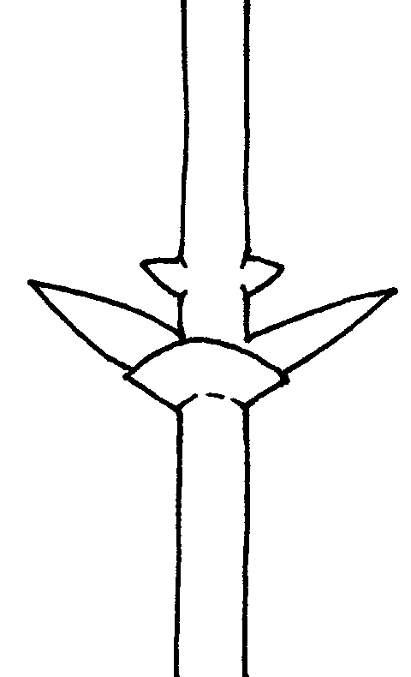 | 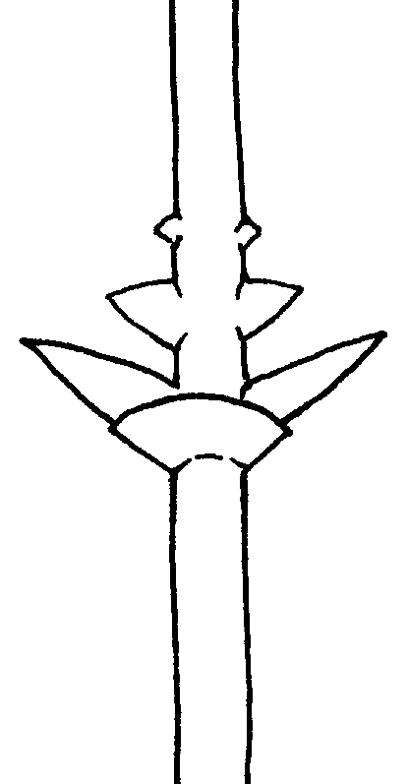 | 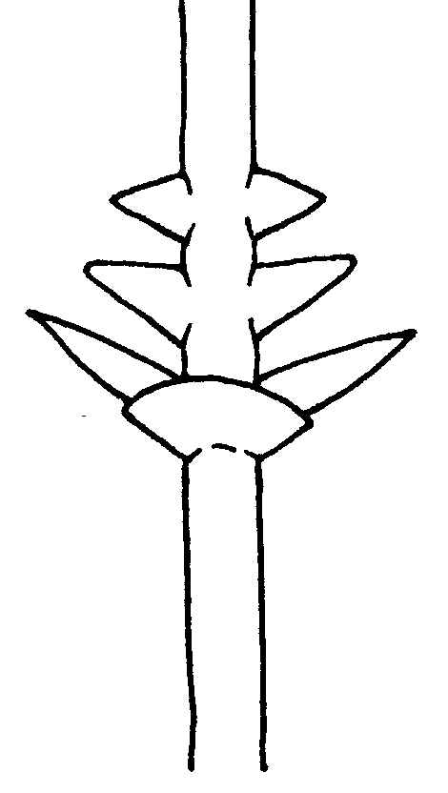
1 | 3 | 5
weak | medium | strong

Ad. 8: Shoot: pubescence of tip
Ad. 9: Shoot: glossiness of bark of tip
Ad. 10: Shoot: anthocyanin coloration of tip

To be observed during rapid growth.

Ad. 14: Leaf blade: shape of apex

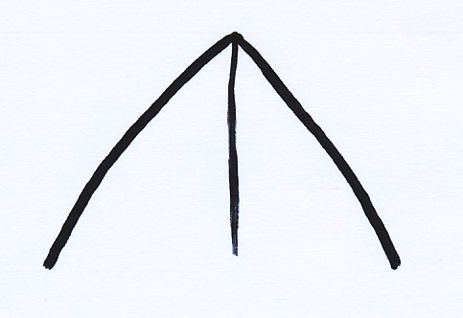 | 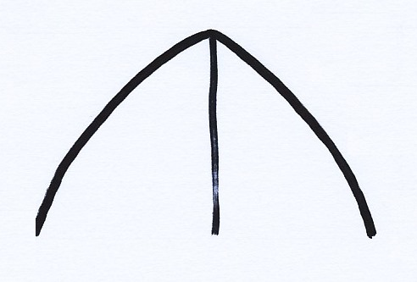 | 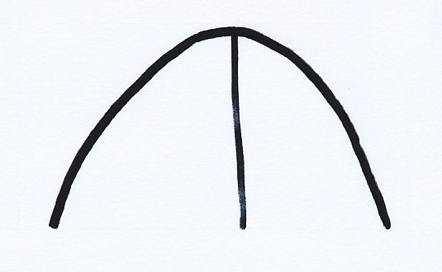
1 | 2 | 3
acute | obtuse | rounded

Ad. 17: Stem-clasping leaf: size
Ad. 18: Stem-clasping leaf: pubescence

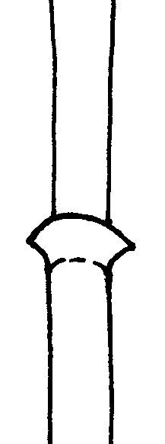 | 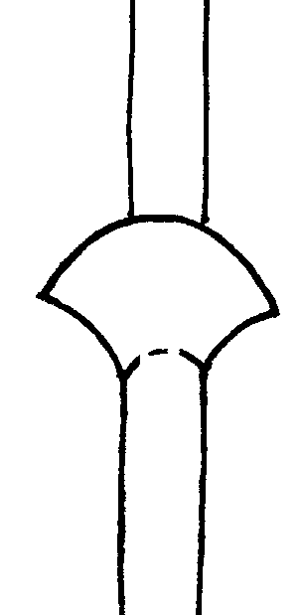 | 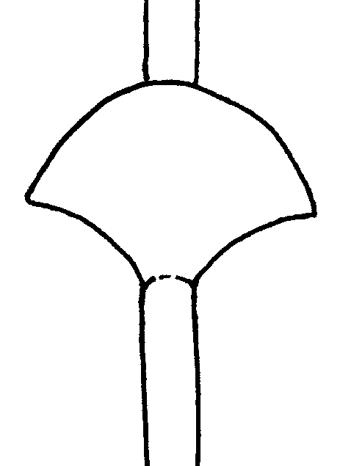
1 | 3 | 5
small | medium | large

Ad. 19: Flower: pubescence of corolla tube

The pubescence is to be observed at the base of the corolla of a single flower.

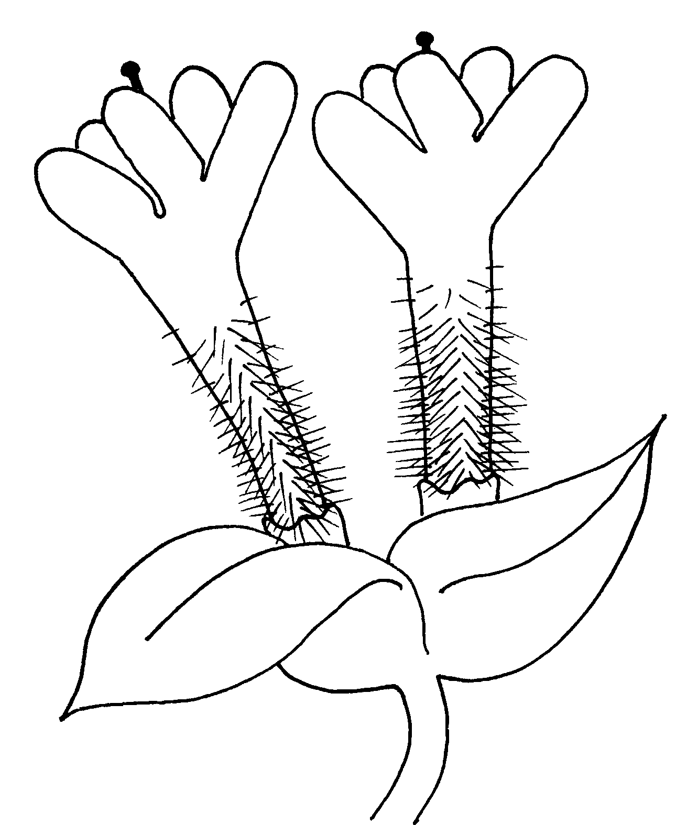

Ad. 20: Flower: attitude
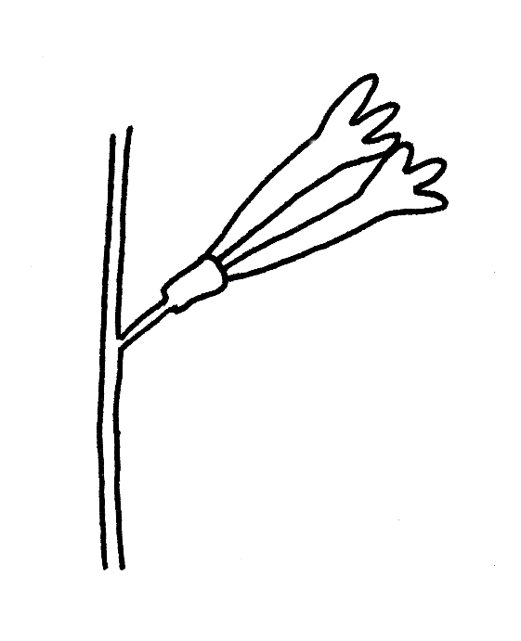 | 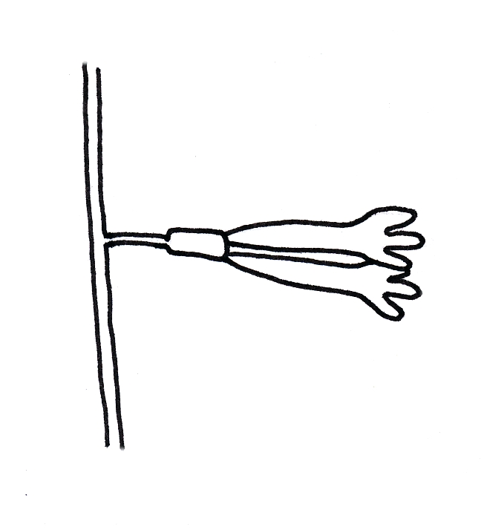 | 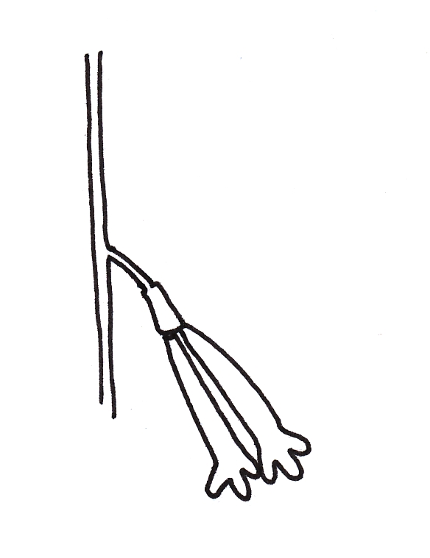
1 | 3 | 5
upwards | horizontal | downwards

Ad. 21: Flower: style length relative to anther length

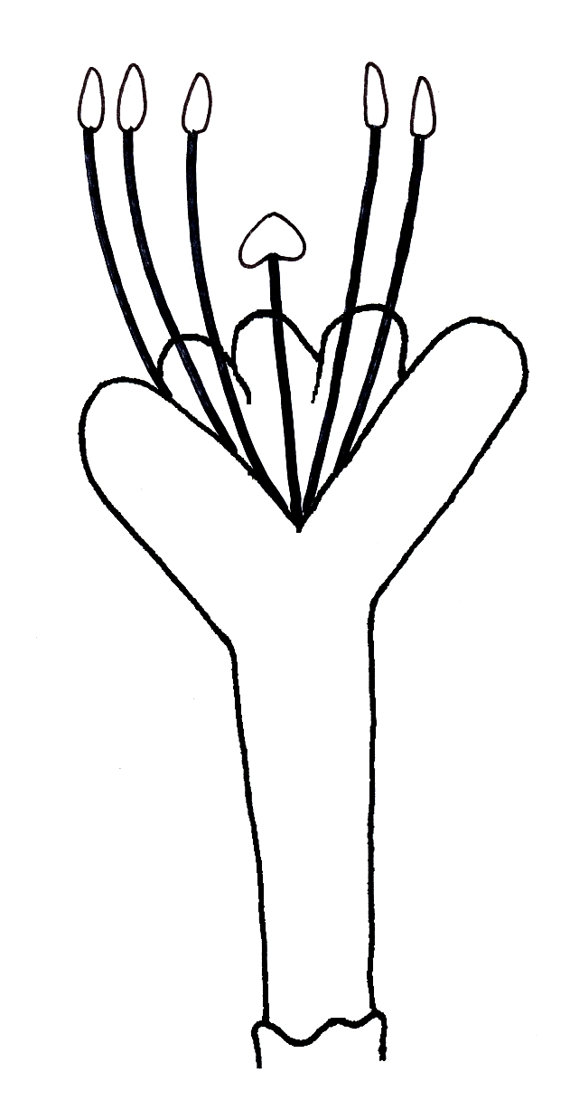 | 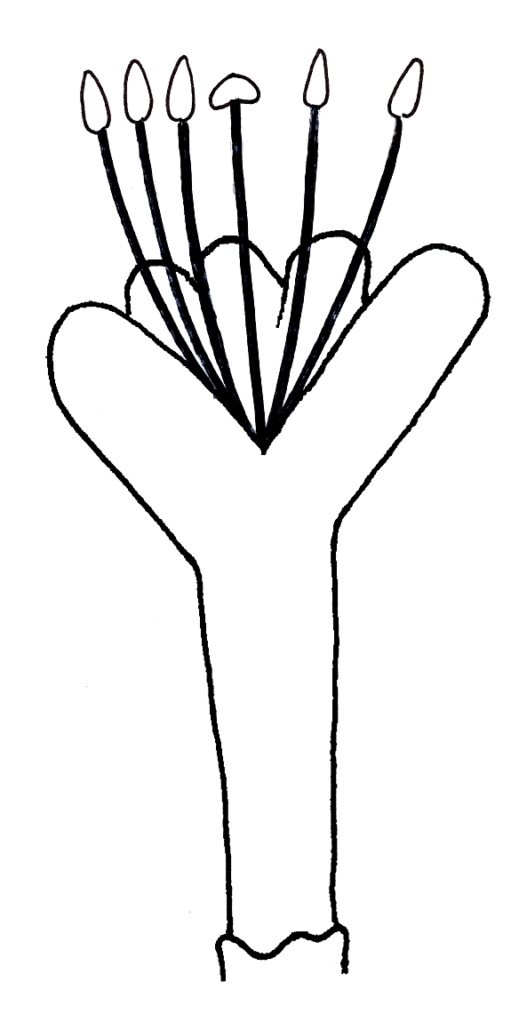 | 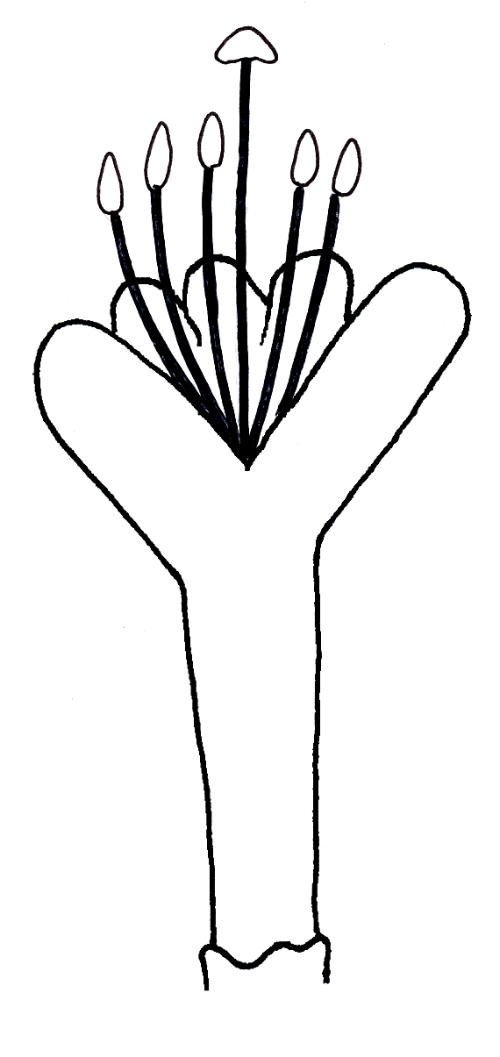
1 | 2 | 3
shorter | equal | longer
Ad. 23: Fruit: length
Ad. 24: Fruit: width
Ad. 26: Fruit: shape (in lateral view )

 |  | ← broadest part →
 |  | below middle | at middle | above middle
compressed ← ratio length/width → elongated |  |  | 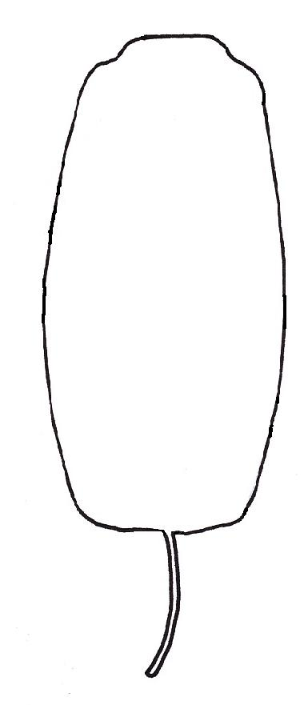
compressed ← ratio length/width → elongated |  | 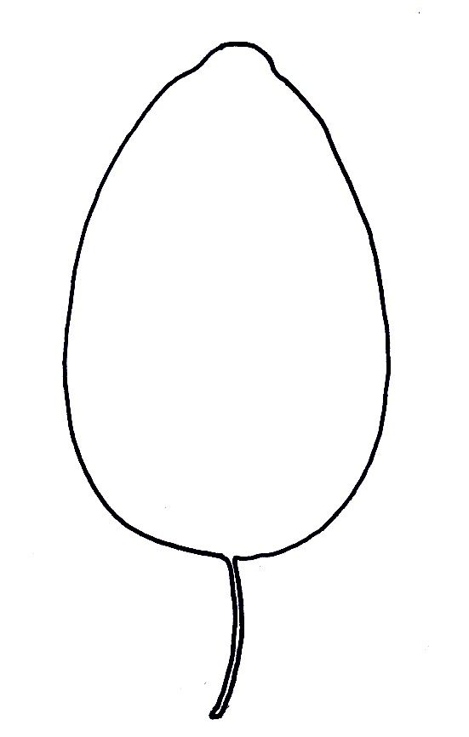 |  | 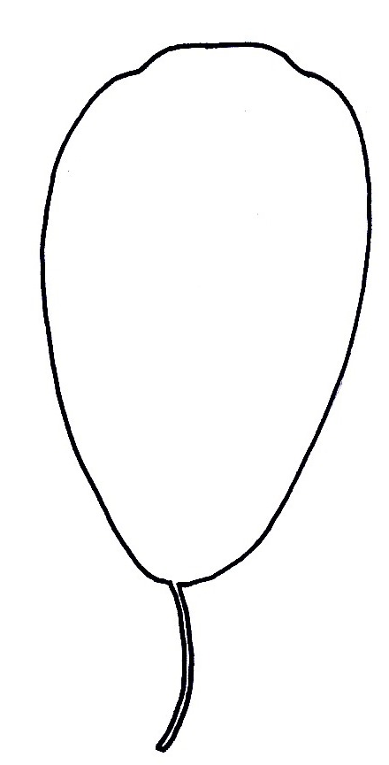 | 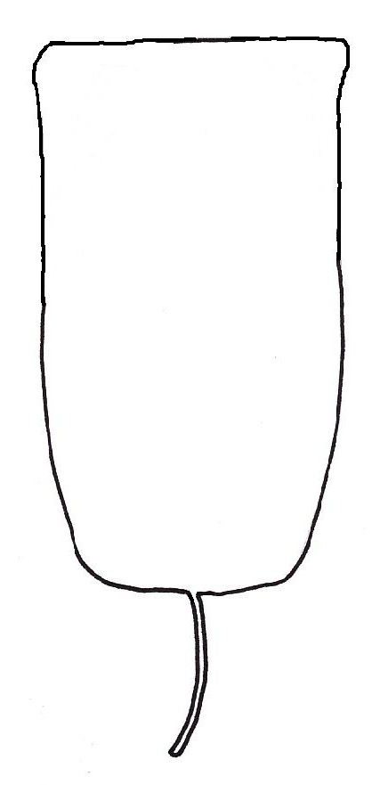
compressed ← ratio length/width → elongated |  |  | 2  narrow oblong
compressed ← ratio length/width → elongated |  |  | 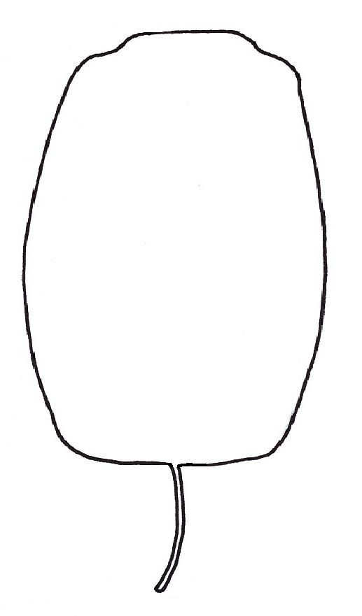
compressed ← ratio length/width → elongated |  | 1  ovate | 3  broad oblong | 4  obovate | 5  campanulate

Ad. 25: Fruit: shape in cross section

 |  | broadest part
 |  | below middle | at middle | above middle
elongated |  |  | 
elongated |  |  | 1  narrow elliptic
← ratio leng th/width → |  |  | 
← ratio leng th/width → |  |  | 2  broad elliptic
compressed |  |  | 
compressed |  |  | 3  circular

Ad. 27: Fruit: shape at calyx end

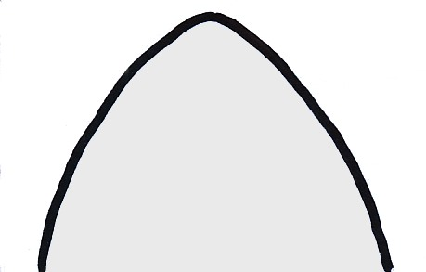 |  | 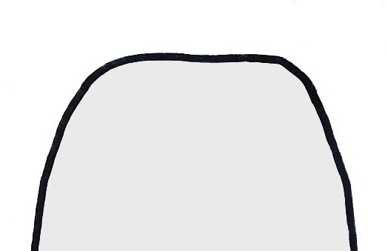
1 | 2 | 3
acute | rounded | truncate

Ad. 29: Fruit: size of eye opening

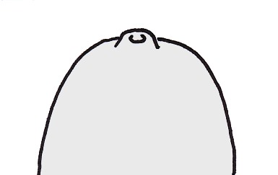 |  | 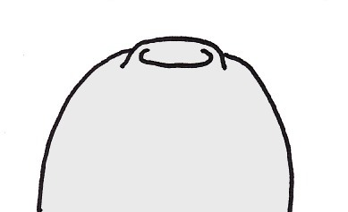
1 | 3 | 5
small | medium | large

Ad. 30: Fruit: surface

 | 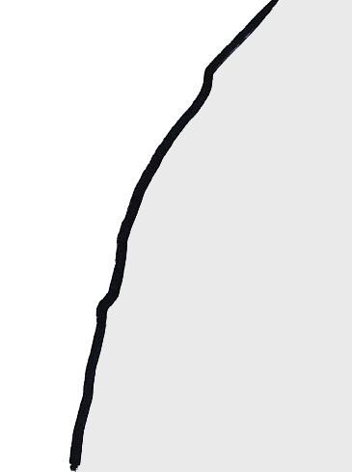 | 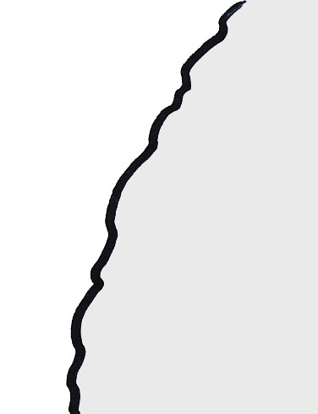
1 | 2 | 3
smooth | medium | rough

Ad. 31: Fruit: bloom of skin

The bloom of the fruit is considered as the waxy layer on the fruit skin, which forms part of the cuticule. It is also known as “glaucosity” and can be removed by rubbing.

Ad. 32: Fruit: intensity of blue color of skin

The blue color of skin should be assessed after the removal of bloom.

Ad. 34: Time of bud burst

The time of bud burst is when 10% of the buds show opening of the bud scales.

Ad. 35: Time of beginning of flowering

The time of beginning of flowering is when 10% of the flowers start opening.

Ad. 36: Time of beginning of fruit ripening

The time of beginning of fruit ripening is when the fruit starts to be most easily removed from the plant.

Literature
Hummer, K.E., 2006: Blue Honeysuckle: A New Berry Crop for North America. Journal of the American Pomological Society 60(1). 3-8

Plekhanova, M.N. 2000. BLUE HONEYSUCKLE (Lonicera Caerulea L.) - A New Commercial Berry Crop For Temperate Climate: Genetic Resources And Breeding. Acta Hort. (ISHS) 538:159-164

Smolik M., Ochmian I., Grajkowski J., 2010: Genetic variability of Polish and Russian accessions of cultivated blue honeysuckle (Lonicera caerulea). Genetika 46(8):1079-85

Technical Questionnaire
TECHNICAL QUESTIONNAIRE |  |  |  | Page {x} of {y} |  | Reference Number:
 |  |  |  |  |  | Application date:
 |  |  |  |  |  | (not to be filled in by the applicant)
TECHNICAL QUESTIONNAIRE
to be completed in connection with an application for plant breeders’ rights

1. Subject of the Technical Questionnaire
1.1 Botanical name |  |  | Lonicera caerulea L.
1.2 Common name |  |  | Blue Honeysuckle, Honeyberry
2. Applicant
Name
Address
Telephone No.
Fax No.
E-mail address
Breeder (if different from applicant)
3. Proposed denomination and breeder’s reference
Proposed denomination
(if available)

Breeder’s reference
#4. Information on the breeding scheme and propagation of the variety

4.1 Breeding scheme

Variety resulting from:

4.1.1 Crossing

(a) controlled cross [ ]
(please state parent varieties)

(…………………..……………..…) x (……………..…………………..…)
female parent male parent

(b) partially known cross [ ]
(please state known parent variety(ies))

(…………………..……………..…) x (……………..…………………..…)
female parent male parent

(c) unknown cross [ ]

4.1.2 Mutation [ ]
(please state parent variety)

4.1.3 Discovery and development [ ]
(please state where and when discovered and how developed)

4.1.4 Other [ ]
(please provide details)

4.2 Method of propagating the variety

4.2.1 Vegetative propagation

(a) cuttings [ ]

(b) in vitro propagation [ ]

(c) other (state method) [ ]

4.2.2 Seed [ ]

4.2.3 Other [ ]
(please provide details)

5. Characteristics of the variety to be indicated (the number in brackets refers to the corresponding characteristic in Test Guidelines; please mark the note which best corresponds).
 | Characteristics |  |  |  |  |  | Example Varieties |  |  | Note
5.1  (1) | Plant: vigor
 | very weak |  |  |  |  |  |  |  |  | 1[ ]
 | very weak to weak |  |  |  |  |  |  |  |  | 2[ ]
 | weak |  |  |  |  |  | 88/6 |  |  | 3[ ]
 | weak to medium |  |  |  |  |  |  |  |  | 4[ ]
 | medium |  |  |  |  |  | Amur |  |  | 5[ ]
 | medium to strong |  |  |  |  |  |  |  |  | 6[ ]
 | strong |  |  |  |  |  | Altai |  |  | 7[ ]
 | strong to very strong |  |  |  |  |  |  |  |  | 8[ ]
 | very strong |  |  |  |  |  |  |  |  | 9[ ]
5.2  (2) | Plant: habit
 | upright |  |  |  |  |  | Amur, L-Kola 1 |  |  | 1[ ]
 | semi-upright |  |  |  |  |  | Altai, L-Kola 28 |  |  | 2[ ]
 | spreading |  |  |  |  |  | 88/7 |  |  | 3[ ]
5.3  (14) | Leaf blade: shape of apex
 | acute |  |  |  |  |  | Altai, L-Kola 28 |  |  | 1[ ]
 | obtuse |  |  |  |  |  |  |  |  | 2[ ]
 | rounded |  |  |  |  |  | Amur, 88/7 |  |  | 3[ ]
 | Characteristics |  |  |  |  |  | Example Varieties |  |  | Note
5.5  (36) | Time of beginning of fruit ripening
 | very early |  |  |  |  |  |  |  |  | 1[ ]
 | very early to early |  |  |  |  |  |  |  |  | 2[ ]
 | early |  |  |  |  |  | Altai, L-Kola 1, L-Kola 28 |  |  | 3[ ]
 | early to medium |  |  |  |  |  |  |  |  | 4[ ]
 | medium |  |  |  |  |  | Amur, 88/6, 88/7 |  |  | 5[ ]
 | medium to late |  |  |  |  |  |  |  |  | 6[ ]
 | late |  |  |  |  |  |  |  |  | 7[ ]
 | late to very late |  |  |  |  |  |  |  |  | 8[ ]
 | very late |  |  |  |  |  |  |  |  | 9[ ]
6. Similar varieties and differences from these varieties
Please use the following table and box for comments to provide information on how your candidate variety differs from the variety (or varieties) which, to the best of your knowledge, is (or are) most similar. This information may help the examination authority to conduct its examination of distinctness in a more efficient way.

Denomination(s) of variety(ies) similar to your candidate variety |  | Characteristic(s) in which your candidate variety differs from the similar variety(ies) |  |  | Describe the expression of the characteristic(s) for the similar variety(ies) |  |  | Describe the expression of the characteristic(s) for your candidate variety
Example |  | Fruit: shape (in lateral view) |  |  | ovate |  |  | narrow oblong
Comments:

#7. Additional information which may help in the examination of the variety

7.1 In addition to the information provided in sections 5 and 6, are there any additional characteristics which may help to distinguish the variety?

Yes [ ] No [ ]

(If yes, please provide details)

7.2 Are there any special conditions for growing the variety or conducting the examination?

Yes [ ] No [ ]

(If yes, please provide details)

7.3 Other information

A representative color image of the variety should accompany the Technical Questionnaire.

8. Authorization for release

(a) Does the variety require prior authorization for release under legislation concerning the protection of the environment, human and animal health?

Yes [ ] No [ ]

(b) Has such authorization been obtained?

Yes [ ] No [ ]

If the answer to (b) is yes, please attach a copy of the authorization.

9. Information on plant material to be examined or submitted for examination.

9.1 The expression of a characteristic or several characteristics of a variety may be affected by factors, such as pests and disease, chemical treatment (e.g. growth retardants or pesticides), effects of tissue culture, different rootstocks, scions taken from different growth phases of a tree, etc.

9.2 The plant material should not have undergone any treatment which would affect the expression of the characteristics of the variety, unless the competent authorities allow or request such treatment. If the plant material has undergone such treatment, full details of the treatment must be given. In this respect, please indicate below, to the best of your knowledge, if the plant material to be examined has been subjected to:

(a) Microorganisms (e.g. virus, bacteria, phytoplasma) Yes [ ] No [ ]

(b) Chemical treatment (e.g. growth retardant, pesticide) Yes [ ] No [ ]

(c) Tissue culture Yes [ ] No [ ]

(d) Other factors Yes [ ] No [ ]

Please provide details for where you have indicated “yes”.

……………………………………………………………

10. I hereby declare that, to the best of my knowledge, the information provided in this form is correct:

Applicant’s name

Signature Date

[End of document]

* These names were correct at the time of the introduction of these Test Guidelines but may be revised or updated. [Readers are advised to consult the UPOV Code, which can be found on the UPOV Website (www.upov.int), for the latest information.]
# Authorities may allow certain of this information to be provided in a confidential section of the Technical Questionnaire.
# Authorities may allow certain of this information to be provided in a confidential section of the Technical Questionnaire.

