 |  | E  TG/ECNCE(proj.6)  ORIGINAL: English  DATE: 2012-01-16
INTERNATIONAL UNION FOR THE PROTECTION OF NEW VARIETIES OF PLANTS
GENEVA
DRAFT
 | ECHINACEA  UPOV Code: ECNCE  Echinacea Moench. | *

GUIDELINES

FOR THE CONDUCT OF TESTS

FOR DISTINCTNESS, UNIFORMITY AND STABILITY

prepared by experts from the United Kingdom and Poland

to be considered by the
Technical Committee at its forty-eighth session,
to be held in Geneva from March 26 to 28, 2012

Alternative Names:*

Botanical name | English | French | German | Spanish
Echinacea Moench. | Echinacea,  Cone Flower | Echinacée | Igelkopf | Equinácea

The purpose of these guidelines (“Test Guidelines”) is to elaborate the principles contained in the General Introduction (document TG/1/3), and its associated TGP documents, into detailed practical guidance for the harmonized examination of distinctness, uniformity and stability (DUS) and, in particular, to identify appropriate characteristics for the examination of DUS and production of harmonized variety descriptions.

ASSOCIATED DOCUMENTS

These Test Guidelines should be read in conjunction with the General Introduction and its associated TGP documents.

TABLE OF CONTENTS PAGE

1. Subject of these Test Guidelines 3
2. Material Required 3
3. Method of Examination 3
3.1 Number of Growing Cycles 3
3.2 Testing Place 3
3.3 Conditions for Conducting the Examination 3
3.4 Test Design 4
3.5 Additional Tests 4
4. Assessment of Distinctness, Uniformity and Stability 4
4.1 Distinctness 4
4.2 Uniformity 6
4.3 Stability 6
5. Grouping of Varieties and Organization of the Growing Trial 6
6. Introduction to the Table of Characteristics 7
6.1 Categories of Characteristics 7
6.2 States of Expression and Corresponding Notes 8
6.3 Types of Expression 8
6.4 Example Varieties 8
6.5 Legend 9
7. Table of Characteristics/Tableau des caractères/Merkmalstabelle/Tabla de caracteres 10
8. Explanations on the Table of Characteristics 25
8.1 Explanations covering several characteristics 25
8.2 Explanations for individual characteristics 25
9. Literature 36
10. Technical Questionnaire 37

Subject of these Test Guidelines
These Test Guidelines apply to all varieties of Echinacea Moench.

Material Required
2.1 The competent authorities decide on the quantity and quality of the plant material required for testing the variety and when and where it is to be delivered. Applicants submitting material from a State other than that in which the testing takes place must ensure that all customs formalities and phytosanitary requirements are complied with.

2.2 The material is to be supplied in the form of young plants, or seed.

2.3 The minimum quantity of plant material, to be supplied by the applicant, should be:

vegetatively propagated varieties: 10 young plants
seed propagated varieties: a sufficient quantity of seed to produce 40 plants

In the case of seed, the seed should meet the minimum requirements for germination, species and analytical purity, health and moisture content, specified by the competent authority.

2.4 The plant material supplied should be visibly healthy, not lacking in vigor, nor affected by any important pest or disease.

2.5 The plant material should not have undergone any treatment which would affect the expression of the characteristics of the variety, unless the competent authorities allow or request such treatment. If it has been treated, full details of the treatment must be given.

Method of Examination

3.1 Number of Growing Cycles
The minimum duration of tests should normally be a single growing cycle.

3.2 Testing Place
Tests are normally conducted at one place. In the case of tests conducted at more than one place, guidance is provided in TGP/9 “Examining Distinctness”.

3.3 Conditions for Conducting the Examination
3.3.1 The tests should be carried out under conditions ensuring satisfactory growth for the expression of the relevant characteristics of the variety and for the conduct of the examination.

3.3.2 Observation of color by eye

Because daylight varies, color determinations made against a color chart should be made either in a suitable cabinet providing artificial daylight or in the middle of the day in a room without direct sunlight. The spectral distribution of the illuminant for artificial daylight should conform with the CIE Standard of Preferred Daylight D 6500 and should fall within the tolerances set out in the British Standard 950, Part I. These determinations should be made with the plant part placed against a white background. The color chart and version used should be specified in the variety description.

3.4 Test Design
3.4.1 Vegetatively propagated varieties: each test should be designed to result in a total of at least 10 plants.

3.4.2 Seed propagated varieties: each test should be designed to result in a total of at least 40 plants, which should be divided between at least two replicates.

3.4.3 The design of the tests should be such that plants or parts of plants may be removed for measurement or counting without prejudice to the observations which must be made up to the end of the growing cycle.

3.5 Additional Tests
Additional tests, for examining relevant characteristics, may be established.

Assessment of Distinctness, Uniformity and Stability

4.1 Distinctness
4.1.1 General Recommendations
It is of particular importance for users of these Test Guidelines to consult the General Introduction prior to making decisions regarding distinctness. However, the following points are provided for elaboration or emphasis in these Test Guidelines.

4.1.2 Consistent Differences
The differences observed between varieties may be so clear that more than one growing cycle is not necessary. In addition, in some circumstances, the influence of the environment is not such that more than a single growing cycle is required to provide assurance that the differences observed between varieties are sufficiently consistent. One means of ensuring that a difference in a characteristic, observed in a growing trial, is sufficiently consistent is to examine the characteristic in at least two independent growing cycles.

4.1.3 Clear Differences
Determining whether a difference between two varieties is clear depends on many factors, and should consider, in particular, the type of expression of the characteristic being examined, i.e. whether it is expressed in a qualitative, quantitative, or pseudo-qualitative manner. Therefore, it is important that users of these Test Guidelines are familiar with the recommendations contained in the General Introduction prior to making decisions regarding distinctness.

4.1.4 Number of Plants / Parts of Plants to be Examined
4.1.4.1 Unless otherwise indicated, for vegetatively propagated varieties, for the purposes of distinctness, all observations on single plants should be made on 9 plants or parts taken from each of 9 plants and any other observations made on all plants in the test, disregarding any off-type plants.

4.1.4.2 Unless otherwise indicated, for seed-propagated varieties, for the purposes of distinctness, all observations on single plants should be made on 30 plants or parts taken from each of 30 plants and any other observations made on all plants in the test, disregarding any off-type plants.

4.1.5 Method of Observation
The recommended method of observing the characteristic for the purposes of distinctness is indicated by the following key in the second column of the Table of Characteristics (see document TGP/9 “Examining Distinctness”, Section 4 “Observation of characteristics”):

MG: single measurement of a group of plants or parts of plants
MS: measurement of a number of individual plants or parts of plants
VG: visual assessment by a single observation of a group of plants or parts of plants
VS: visual assessment by observation of individual plants or parts of plants

Type of observation: visual (V) or measurement (M)

“Visual” observation (V) is an observation made on the basis of the expert’s judgment. For the purposes of this document, “visual” observation refers to the sensory observations of the experts and, therefore, also includes smell, taste and touch. Visual observation includes observations where the expert uses reference points (e.g. diagrams, example varieties, side-by-side comparison) or non-linear charts (e.g. color charts). Measurement (M) is an objective observation against a calibrated, linear scale e.g. using a ruler, weighing scales, colorimeter, dates, counts, etc.

Type of record: for a group of plants (G) or for single, individual plants (S)

For the purposes of distinctness, observations may be recorded as a single record for a group of plants or parts of plants (G), or may be recorded as records for a number of single, individual plants or parts of plants (S). In most cases, “G” provides a single record per variety and it is not possible or necessary to apply statistical methods in a plant-by-plant analysis for the assessment of distinctness.

In cases where more than one method of observing the characteristic is indicated in the Table of Characteristics (e.g. VG/MG), guidance on selecting an appropriate method is provided in document TGP/9, Section 4.2.

4.2 Uniformity
4.2.1 It is of particular importance for users of these Test Guidelines to consult the General Introduction prior to making decisions regarding uniformity. However, the following points are provided for elaboration or emphasis in these Test Guidelines:

4.2.2 For the assessment of uniformity of vegetatively propagated varieties, a population standard of 1% and an acceptance probability of at least 95% should be applied. In the case of a sample size of 10 plants, 1 off-type is allowed.

4.2.3 The assessment of uniformity of seed-propagated varieties should be according to the recommendations for cross-pollinated varieties in the General Introduction.

4.3 Stability
4.3.1 In practice, it is not usual to perform tests of stability that produce results as certain as those of the testing of distinctness and uniformity. However, experience has demonstrated that, for many types of variety, when a variety has been shown to be uniform, it can also be considered to be stable.

4.3.2 Where appropriate, or in cases of doubt, stability may be further examined by testing a new seed or plant stock to ensure that it exhibits the same characteristics as those shown by the initial material supplied.

Grouping of Varieties and Organization of the Growing Trial
5.1 The selection of varieties of common knowledge to be grown in the trial with the candidate varieties and the way in which these varieties are divided into groups to facilitate the assessment of distinctness are aided by the use of grouping characteristics.

5.2 Grouping characteristics are those in which the documented states of expression, even where produced at different locations, can be used, either individually or in combination with other such characteristics: (a) to select varieties of common knowledge that can be excluded from the growing trial used for examination of distinctness; and (b) to organize the growing trial so that similar varieties are grouped together.

5.3 The following have been agreed as useful grouping characteristics:

- Leaf: variegation (Characteristic 12)
(b) Ray floret: main color of inner side (Characteristic 31) with the following groups:
Gr. 1: green
Gr. 2: white
Gr. 3: yellow
Gr. 4: orange
Gr. 5: red
Gr. 6: pink
Gr. 7: purple

(c) Disc: type (Characteristic 39)
(d) Only varieties with disc type: daisy: Disc: color of paleae (spikes) (Characteristic 47)
(e) Only varieties with disc type: anemone: Disc: color after disc florets open (Characteristic 50) with the following groups:
Gr. 1: green
Gr. 2: white
Gr. 3: yellow
Gr. 4: orange
Gr. 5: red
Gr. 6: pink
Gr. 7: purple

(f) Only varieties with disc type: daisy: Disc: presence of ray florets within the disc (Characteristic 51)

Guidance for the use of grouping characteristics, in the process of examining distinctness, is provided through the General Introduction and document TGP/9 “Examining Distinctness”.

Introduction to the Table of Characteristics

6.1 Categories of Characteristics
6.1.1 Standard Test Guidelines Characteristics

Standard Test Guidelines characteristics are those which are approved by UPOV for examination of DUS and from which members of the Union can select those suitable for their particular circumstances.

6.1.2 Asterisked Characteristics

Asterisked characteristics (denoted by *) are those included in the Test Guidelines which are important for the international harmonization of variety descriptions and should always be examined for DUS and included in the variety description by all members of the Union, except when the state of expression of a preceding characteristic or regional environmental conditions render this inappropriate.

6.2 States of Expression and Corresponding Notes
6.2.1 States of expression are given for each characteristic to define the characteristic and to harmonize descriptions. Each state of expression is allocated a corresponding numerical note for ease of recording of data and for the production and exchange of the description.

6.2.2 In the case of qualitative and pseudo-qualitative characteristics (see Chapter 6.3), all relevant states of expression are presented in the characteristic. However, in the case of quantitative characteristics with 5 or more states, an abbreviated scale may be used to minimize the size of the Table of Characteristics. For example, in the case of a quantitative characteristic with 9 states, the presentation of states of expression in the Test Guidelines may be abbreviated as follows:

State | Note
small | 3
medium | 5
large | 7

However, it should be noted that all of the following 9 states of expression exist to describe varieties and should be used as appropriate:

State | Note
very small | 1
very small to small | 2
small | 3
small to medium | 4
medium | 5
medium to large | 6
large | 7
large to very large | 8
very large | 9

6.2.3 Further explanation of the presentation of states of expression and notes is provided in document TGP/7 “Development of Test Guidelines”.

6.3 Types of Expression
An explanation of the types of expression of characteristics (qualitative, quantitative and pseudo-qualitative) is provided in the General Introduction.

6.4 Example Varieties
Where appropriate, example varieties are provided to clarify the states of expression of each characteristic.

6.5 Legend
(*) Asterisked characteristic – see Chapter 6.1.2

QL Qualitative characteristic – see Chapter 6.3
QN Quantitative characteristic – see Chapter 6.3
PQ Pseudo-qualitative characteristic – see Chapter 6.3

MG, MS, VG, VS – see Chapter 4.1.5

(a)-(d) See Explanations on the Table of Characteristics in Chapter 8.1

(+) See Explanations on the Table of Characteristics in Chapter 8.2

Table of Characteristics/Tableau des caractères/Merkmalstabelle/Tabla de caracteres
 |  | English | français | deutsch | español | Example Varieties/  Exemples/  Beispielssorten/  Variedades ejemplo | Note/  Nota
1 | VG | Plant: growth habit | Plante : port | Pflanze: Wuchsform | Planta: porte
QN |  | upright | dressé | aufrecht | erecto | Mount Hood | 1
 |  | semi upright | demi-dressé | halbaufrecht | semierecto | Green Jewel, Ida | 2
 |  | semi spreading | demi-étalé | halbbreitwüchsig | semirastrero | Mistral | 3
 |  | spreading | étalé | breitwüchsig | rastrero |  | 4
2  (*)  (+) | VG/MG | Plant: height | Plante : hauteur | Pflanze: Höhe | Planta: altura
QN |  | short | courte | niedrig | baja | Mistral | 3
 |  | medium | moyenne | mittel | media | Green Jewel | 5
 |  | tall | haute | hoch | alta | Mount Hood | 7
3  (+) | VG | Plant: floriferousness | Plante : floribondité | Pflanze: Blütenreichhaltig-keit | Planta: capacidad florífera
QN |  | weak | faible | gering | baja | Tiki Torch | 3
 |  | medium | moyenne | mittel | media | Green Jewel | 5
 |  | strong | élevée | groß | alta | Mistral | 7
4  (+) | VG | Plant: density | Plante : densité | Pflanze: Dichte | Planta: densidad
QN |  | sparse | faible | locker | laxa | Hot Summer | 3
 |  | medium | moyenne | mittel | media | Mount Hood | 5
 |  | dense | dense | dicht | densa | Mistral | 7
5 | VG | Stem: color | Tige : couleur | Trieb: Farbe | Tallo: color
PQ | (a) | green | vert | grün | verde | Green Jewel | 1
 |  | green tinged slightly purple | vert légèrement teinté de pourpre | grün leicht meliert mit purpurn | verde levemente teñido de púrpura | Catharina | 2
 |  | green tinged heavily purple | vert fortement teinté de pourpre | grün stark meliert mit purpurn | verde fuertemente teñido de púrpura | Merlot | 3
 |  | purple | pourpre | purpurn | púrpura | Fatal Attraction | 4
6 | VG | Stem: number of leaves | Tige : nombre de feuilles | Trieb: Anzahl der Blätter | Tallo: número de hojas
QN |  | few | petit | gering | bajo |  | 3
 |  | medium | moyen | mittel | medio | Green Jewel | 5
 |  | many | grand | groß | alto | Ida, Mistral | 7
7  (*) | VG/ MS | Leaf: length (including petiole) | Feuille : longueur (y compris le pétiole) | Blatt: Länge (einschl. Blattstiel) | Hoja: longitud (incluido el pecíolo)
QN | (b) | short | courte | kurz | corta | Mistral | 3
 |  | medium | moyenne | mittel | media | Merlot | 5
 |  | long | longue | lang | larga | Green Jewel | 7
8  (*) | VG/MS | Leaf: width | Feuille : largeur | Blatt: Breite | Hoja: anchura
QN | (b) | narrow | étroite | schmal | estrecha | Purity | 3
 |  | medium | moyenne | mittel | media | Green Jewel | 5
 |  | broad | large | breit | ancha | Catharina | 7
9  (*) | VG/ MS | Leaf : length/width ratio | Feuille : rapport longueur/largeur | Blatt: Verhältnis Länge/Breite | Hoja: relación entre la longitud y la altura
QN | (b) | slightly elongated | légèrement allongée | leicht langgezogen | ligeramente elongada | Merlot | 3
 |  | moderately elongated | modérément allongée | mäßig langgezogen | moderadamente elongada | Polar Breeze | 5
 |  | strongly elongated | fortement allongée | stark langgezogen | muy elongada |  | 7
10 | VG | Leaf: position of broadest part | Feuille : position de la partie la plus large | Blatt: Position der breitesten Stelle | Hoja: posición del diámetro máximo
QN | (b) | at middle or slightly towards base | au milieu ou légèrement vers la base | in der Mitte oder leicht zur Basis hin | en el medio o ligeramente hacia la base |  | 1
 |  | moderately towards base | plus ou moins vers la base | leicht zur Basis hin | moderadamente hacia la base | Tomato Soup | 2
 |  | strongly towards base | fortement vers la base | stark zur Basis hin | marcadamente hacia la base | Milkshake | 3
11 | VG | Leaf: intensity of green color | Feuille : intensité de la couleur verte | Blatt: Intensität der Grünfärbung | Hoja: intesidad del color verde
QN | (b) | light | claire | hell | claro | Tomato Soup | 1
 |  | medium | moyenne | mittel | medio | Purity | 2
 |  | dark | foncée | dunkel | oscuro | Fatal Attraction | 3
12  (*) | VG | Leaf: variegation | Feuille : panachure | Blatt: Panaschierung | Hoja: variegación
QL | (b) | absent | absente | fehlend | ausente | Tomato Soup | 1
 |  | present | présente | vorhanden | presente | Prairie Frost | 9
13  (*) | VG | Leaf: color of variegation | Feuille : couleur de la panachure | Blatt: Farbe der Panaschierung | Hoja: color de la variegación
PQ | (b) | white | blanc | weiß | blanco |  | 1
 |  | yellowish white | blanc jaunâtre | gelblich weiß | blanco amarillento | Prairie Frost | 2
 |  | yellow | jaune | gelb | amarillo |  | 3
 |  | yellow green | vert jaune | gelbgrün | verde amarillento |  | 4
14  (*) | VG | Leaf: distribution of variegation | Feuille : répartition de la panachure | Blatt: Verteilung der Panaschierung | Hoja: distribución de la variegación
PQ | (b) | marginal | marginale | am Rand | marginal | Prairie Frost | 1
 |  | central zone | zone centrale | in der Mitte | zona central |  | 2
 |  | irregular | irrégulière | unregelmäßig | irregular | Sparkler | 3
15  (*) | VG | Leaf: rugosity | Feuille : rugosité | Blatt: Rauheit | Hoja: rugosidad
QN | (b) | absent or very weak | absente ou très faible | fehlend oder sehr gering | ausente o muy débil | Hot Papaya | 1
 |  | weak | faible | gering | débil | Summer Cocktail | 3
 |  | medium | moyenne | mittel | media | Green Jewel | 5
 |  | strong | forte | stark | fuerte | Catharina | 7
16 | VG | Leaf: glossiness | Feuille : brillance | Blatt: Glanz | Hoja: brillo
QN | (b) | absent or very weak | absente ou très faible | fehlend oder sehr gering | ausente o muy débil | Mistral, Lilliput | 1
 |  | weak | faible | gering | débil | After Midnight | 2
 |  | medium | moyenne | mittel | medio |  | 3
 |  | strong | forte | stark | fuerte | Pineapple Sundae | 4
17  (*)  (+) | VG | Leaf: indentations of margin | Feuille : denticulations du bord | Blatt: Randeinschnitte | Hoja: indentaciones del borde
QN | (b) | absent or very few | absentes ou très rares | fehlend oder sehr wenige | ausente o muy pocos | Hot Papaya | 1
 |  | few | rares | wenige | pocos | Catharina | 2
 |  | medium | assez nombreuses | mittel | medio | Green Jewel | 3
 |  | many | nombreuses | viele | muchos | Avalanche | 4
18  (*) | VG | Peduncle: color | Pédoncule : couleur | Stiel: Farbe | Pedúnculo: color
PQ |  | green | vert | grün | verde | Green Jewel | 1
 |  | green tinged slightly purple | vert légèrement teinté de pourpre | grün leicht meliert mit purpurn | verde levemente teñido de púrpura | Tomato Soup | 2
 |  | green tinged heavily purple | vert fortement teinté de pourpre | grün stark meliert mit purpurn | verde fuertemente teñido de púrpura |  | 3
 |  | purple | pourpre | purpurn | púrpura | After Midnight | 4
19  (*) | VG | Peduncle: pubesence | Pédoncule : pubescence | Stiel: Behaarung | Pedúnculo: pubescencia
QN |  | absent or very sparse | absente ou très faible | fehlend oder sehr gering | ausente o muy laxa |  | 1
 |  | sparse | faible | gering | laxa | Hot Papaya | 2
 |  | medium | moyenne | mittel | media | Tomato Soup | 3
 |  | dense | dense | stark | densa | Green Jewel | 4
 |  | very dense | très dense | sehr stark | muy densa | Mistral | 5
20  (*)  (+) | VG/ MS | Flower head: diameter | Capitule : diamètre | Blütenkopf: Durchmesser | Capítulo: diámetro
QN | (c) | small | petit | klein | pequeño | Kim’s Mop Head | 3
 |  | medium | moyen | mittel | medio | Green Jewel | 5
 |  | large | grand | groß | ancho | Merlot | 7
21  (*)  (+) | VG/ MS | Flower head: height | Capitule : hauteur | Blütenkopf: Höhe | Capítulo: altura
QN | (c) | low | bas | niedrig | pequeño |  | 3
 |  | medium | moyen | mittel | medio | Mistral | 5
 |  | high | haut | hoch | alto | Hot Papaya | 7
22  (*)  (+) | VG/ MS | Flower head: number of ray florets | Capitule : nombre de fleurs ligulées | Blütenkopf: Anzahl der Zungenblüten | Capítulo: número de flores liguladas
QN | (c) | few | petit | gering | escaso | Tiki Torch | 3
 |  | medium | moyen | mittel | medio | Mistral | 5
 |  | many | élevé | groß | elevado | Fatal Attraction | 7
23  (*)  (+) | VG | Flower head: attitude of ray florets at origin | Capitule : port des fleurs ligulées à l’origine | Blütenkopf: ursprüngliche Stellung der Zungenblüten | Capítulo: porte de flores liguladas en la base
QN | (c) | semi-erect | demi-dressé | halbaufrecht | semierecto | Lilliput | 1
 |  | horizontal | horizontal | horizontal | horizontal | Merlot | 2
 |  | semi-drooping | demi-retombant | halbhängend | semicolgante | Mount Hood | 3
 |  | drooping | retombant | hängend | colgante | Hot Papaya | 4
24  (*)  (+) | VG | Flower head: relative number of ligulate ray florets | Capitule : nombre relatif de fleurs ligulées | Blütenkopf: relative Anzahl zungenförmiger Randblüten | Capítulo: número relativo de flores liguladas
QN | (c) | none | aucun | keine | ninguno | All that Jazz | 1
 |  | few | petit | gering | escaso |  | 2
 |  | medium | moyen | mittel | medio |  | 3
 |  | many | grand | groß | elevado | Sundown | 4
 |  | all or almost all | toutes ou presque toutes | alle oder fast alle | todas o casi todas | Merlot | 5
25 (*)  (+) | VG | Flower head: relative number of spatulate ray florets | Capitule : nombre relatif de fleurs spatulées | Blütenkopf: relative Anzahl spatelförmiger Randblüten | Capítulo: número relativo de flores liguladas espatuladas
QN | (c) | none | aucun | keine | ninguno |  | 1
 |  | few | petit | gering | escaso | All that Jazz | 2
 |  | medium | moyen | mittel | medio | Sundown | 3
 |  | many | grand | groß | elevado |  | 4
 |  | all or almost all | toutes ou presque toutes | alle oder fast alle | todas o casi todas |  | 5
26  (*)  (+) | VG | Flower head: relative number of quilled ray florets | Capitule : nombre relatif de fleurs tubulées | Blütenkopf: relative Anzahl röhrenförmiger Randblüten | Capítulo: número relativo de flores liguladas enrolladas
QN | (c) | none | aucun | keine | ninguno |  | 1
 |  | few | petit | gering | escaso | Sundown | 2
 |  | medium | moyen | mittel | medio |  | 3
 |  | many | grand | große | elevado | All that Jazz | 4
 |  | all or almost all | toutes ou presque toutes | alle oder fast alle | todas o casi todas |  | 5
27  (*) | VG/ MS | Ray floret: length | Fleur ligulée : longueur | Zungenblüte: Länge | Flor ligulada: longitud
QN | (c) | short | courte | kurz | corta | Fatal Attraction | 3
 | (d) | medium | moyenne | mittel | media | Merlot | 5
 |  | long | longue | lang | larga | Tomato Soup | 7
28  (*) | VG/ MS | Ray floret: width | Fleur ligulée : largeur | Zungenblüte: Breite | Flor ligulada: anchura
QN | (c) | narrow | étroite | schmal | estrecha | Fatal Attraction | 3
 | (d) | medium | moyenne | mittel | media | Summer Cocktail | 5
 |  | broad | large | breit | ancha | Milkshake | 7
29  (*) | VG/ MS | Ray floret: length/width ratio | Fleur ligulée : rapport longueur/largeur | Zungenblüte: Verhältnis Länge/Breite | Flor ligulada: relación entre la longitud y la altura
QN | (c) | low | faible | klein | baja | Meditation | 3
 | (d) | medium | moyen | mittel | media | Razzmatazz | 5
 |  | high | élevé | groß | elevada | Mount Hood | 7
30  (*)  (+) | VG | Only varieties with spatulate or quilled ray florets: Ray floret: color of outer side | Variétés avec fleurs ligulées spatulées ou tubulées seulement : Fleur ligulée : couleur de la face externe | Nur Sorten mit spatel- oder röhrenförmigen Zungenblüten: Zungenblüte: Farbe der Außenseite | Sólo variedades con flores liguladas espatuladas o enrolladas: Flor ligulada: color de la cara externa
PQ | (c)  (d) | RHS Colour Chart (indicate reference number) | Code RHS des couleurs (indiquer le numéro de référence) | RHS-Farbkarte (Nummer angeben) | Carta de colores RHS (indicar número de referencia)
31  (*) | VG | Ray floret: main color of inner side | Fleur ligulée : couleur principale de la face interne | Zungenblüte: Hauptfarbe der Innenseite | Flor ligulada: color principal de la cara interna
PQ | (c)  (d) | RHS Colour Chart (indicate reference number) | Code RHS des couleurs (indiquer le numéro de référence) | RHS-Farbkarte (Nummer angeben) | Carta de colores RHS (indicar número de referencia)
32  (*) | VG | Ray floret: secondary color of inner side | Fleur ligulée : couleur secondaire de la face interne | Zungenblüte: Sekundärfarbe der Innenseite | Flor ligulada: color secundario de la cara interna
PQ | (c)  (d) | RHS Colour Chart (indicate reference number) | Code RHS des couleurs (indiquer le numéro de référence) | RHS-Farbkarte (Nummer angeben) | Carta de colores RHS (indicar número de referencia)
33  (*)  (+) | VG | Ray floret: distribution of secondary color of inner side | Fleur ligulée : distribution de la couleur secondaire de la face interne | Zungenblüte: Verteilung der Sekundärfarbe der Innenseite | Flor ligulada: distribución del color secundario de la cara interna
PQ | (c) | at the base | à la base | an der Basis | en la base |  | 1
 | (d) | in the basal quarter | dans le quart basal | im basalen Viertel | en el cuarto basal | Green Envy | 2
 |  | in the basal half | dans la moitié basale | in der basalen Hälfte | en la mitad basal | Summer Cocktail | 3
34  (+) | VG | Ray floret: curvature | Fleur ligulée : courbure | Zungenblüte: Biegung | Flor ligulada: curvatura
QN | (c) | strongly incurving | fortement incurvée | stark aufgebogen | muy incurvada |  | 1
 | (d) | weakly incurving | faiblement incurvée | schwach aufgebogen | levemente incurvada | Green Jewel | 2
 |  | straight | droite | gerade | recta | Mount Hood | 3
 |  | weakly reflexing | faiblement récurvée | schwach nach unten gebogen | levemente recurvada | Lilliput | 4
 |  | strongly reflexing | fortement récurvée | stark nach unten gebogen | muy recurvada | Hot Papaya | 5
35  (*) | VG | Ray floret: twisting | Fleur ligulée : torsion | Zungenblüte: Drehung | Flor ligulada: torsión
QN | (c) | absent or very weak | absente ou très faible | fehlend oder sehr schwach | ausente o muy débil | Merlot | 1
 | (d) | weak | faible | schwach | débil | Hot Papaya | 2
 |  | moderate | modérée | mittel | moderada |  | 3
 |  | strong | forte | stark | fuerte |  | 4
36  (+) | VG | Ray floret: profile in cross section | Fleur ligulée : profil en section transversale | Zungenblüte: Profil im Querschnitt | Flor ligulada: perfil en sección transversal
QN | (c) | strongly concave | fortement concave | stark konkav | fuertemente cóncava | Vintage Wine | 1
 | (d) | moderately concave | moyennement concave | mäßig konkav | moderadamente cóncava | Green Jewel | 2
 |  | weakly concave | faiblement concave | schwach konkav | levemente cóncava | Merlot | 3
 |  | flat | plate | flach | plana | Tomato Soup | 4
 |  | weakly convex | faiblement convexe | schwach konvex | levemente convexa |  | 5
 |  | moderately convex | moyennement convexe | mäßig konvex | moderadamente convexa |  | 6
 |  | strongly convex | fortement convexe | stark konvex | fuertemente convexa |  | 7
37  (*)  (+) | VG | Ray floret: shape of apex | Fleur ligulée : forme du sommet | Zungenblüte: Form der Spitze | Flor ligulada: forma del ápice
PQ | (c) | pointed | pointu | spitz | agudo | Purity | 1
 | (d) | rounded | arrondi | abgerundet | redondeado | Tiki Torch | 2
 |  | truncate | tronqué | gerade | truncado | Green Jewel | 3
38  (*)  (+) | VG | Ray floret: indentations of tip | Fleur ligulée : denticulations du sommet | Zungenblüte: Einschnitte der Spitze | Flor ligulada: indentaciones de la punta
QN | (c) | absent or very shallow | absentes ou très peu profondes | fehlend oder sehr flach | ausentes o muy superficiales |  | 1
 | (d) | shallow | peu profondes | flach | superficiales | Hot Summer | 2
 |  | medium | moyennes | mittel | medias | Green Jewel | 3
 |  | deep | profondes | tief | profundas |  | 4
39  (*)  (+) | VG | Disc: type | Disque : type | Scheibe: Typ | Disco: tipo
QL | (c) | daisy | marguerite | margeritenförmig | margarita | Merlot | 1
 |  | anemone | anémone | anemonenförmig | anémona | Hot Papaya | 2
40  (*)  (+) | VG/ MS | Only varieties with disc type: daisy: Disc: diameter | Variétés avec type de disque seulement : marguerite : Disque : diamètre | Nur Sorten mit Scheiben vom Typ: margeritenförmig: Scheibe: Durchmesser | Sólo variedades con tipo de disco: margarita: Disco: diámetro
QN | (c) | small | petit | klein | pequeño | Tomato Soup | 3
 |  | medium | moyen | mittel | medio | Summer Cocktail | 5
 |  | large | grand | groß | ancho | Merlot | 7
41  (*) | VG/MS | Only varieties with disc type: anemone: Disc: diameter | Variétés avec type de disque seulement : anémone : Disque : diamètre | Nur Sorten mit Scheiben vom Typ: anemonenförmig: Scheibe: Durchmesser | Sólo variedades con tipo de disco: anémona: Disco: diámetro
QN | (c) | small | petit | klein | pequeño | Pink Double Delight | 3
 |  | medium | moyen | mittel | medio | Razzmatazz | 5
 |  | large | grand | groß | ancho | Hot Papaya | 7
42  (*)  (+) | VG/ MS | Only varieties with disc type: daisy: Disc: height | Variétés avec type de disque seulement : marguerite : Disque : hauteur | Nur Sorten mit Scheiben vom Typ: margeritenförmig: Scheibe: Höhe | Sólo variedades con tipo de disco: margarita: Disco: altura
QN | (c) | low | basse | niedrig | bajo | Fatal Attraction | 3
 |  | medium | moyenne | mittel | medio | Purity | 5
 |  | high | élevée | hoch | alto | After Midnight | 7
43  (*) | VG/ MS | Only varieties with disc type: anemone: Disc: height | Variétés avec type de disque seulement : anémone : Disque : hauteur | Nur Sorten mit Scheiben vom Typ: anemonenförmig: Scheibe: Höhe | Sólo variedades con tipo de disco: anémona: Disco: altura
QN | (c) | low | basse | niedrig | bajo | Meringue | 3
 |  | medium | moyenne | mittel | medio |  | 5
 |  | high | élevée | hoch | alto | Catharina | 7
44  (*)  (+) | VG/MS | Only varieties with disc type: daisy: Disc: ratio height/diameter | Variétés avec type de disque seulement : marguerite : Disque : rapport hauteur/diamètre | Nur Sorten mit Scheiben vom Typ: margeritenförmig: Scheibe: Verhältnis Höhe/Durch-messer | Sólo variedades con tipo de disco: margarita: Disco: relación entre altura y diámetro
QN | (c) | low | petit | klein | baja | Green Jewel | 3
 |  | medium | moyen | mittel | media | Purity | 5
 |  | high | élevé | groß | elevada | Tiki Torch | 7
45  (*) | VG/MS | Only varieties with disc type: anemone Disc: ratio height/diameter | Variétés avec type de disque seulement : anémone : Disque : rapport hauteur/diamètre | Nur Sorten mit Scheiben vom Typ: anemonenförmig: Scheibe: Verhältnis Höhe/Durch-messer | Sólo variedades con tipo de disco: anémona: Disco: relación entre altura y diámetro
QN | (c) | low | petit | klein | baja | Meringue | 3
 |  | medium | moyen | mittel | media |  | 5
 |  | high | élevé | groß | elevada | Hot Papaya | 7
46  (*)  (+) | VG | Disc: diameter in relation to flower head | Disque : diamètre par rapport au capitule | Scheibe: Durchmesser im Verhältnis zum Blütenkopf | Disco: diámetro en relación con el capítulo
QN | (c) | small | petit | klein | pequeño | Tomato Soup | 3
 |  | medium | moyen | mittel | medio | Green Jewel | 5
 |  | large | grand | groß | grande | Milkshake | 7
47  (*)  (+) | VG | Only varieties with disc type: daisy: Disc: color of paleae (spikes) | Variétés avec type de disque seulement : marguerite : Disque : couleur des épis | Nur Sorten mit Scheiben vom Typ: margeritenförmig: Scheibe: Farbe der Paleae (Stacheln) | Sólo variedades con tipo de disco: margarita: Disco: color de las espigas
PQ | (c) | green | vert | grün | verde |  | 1
 |  | yellowish green | vert jaunâtre | gelblich grün | verde amarillento | Green Jewel | 2
 |  | yellow | jaune | gelb | amarillo |  | 3
 |  | orange | orange | orange | naranja | Purity, Mount Hood | 4
 |  | red orange | orange rouge | rotorange | naranja rojizo |  | 5
 |  | red brown | rouge brun | rotbraun | marrón rojizo | Merlot, Hot Summer | 6
 |  | purple brown | brun pourpre | purpurbraun | marrón púrpura | Fatal Attraction | 7
48  (*)  (+) | VG | Only varieties with disc type: daisy: Disc: second color of paleae (spikes) | Variétés avec type de disque seulement : marguerite : Disque : deuxième couleur des épis | Nur Sorten mit Scheiben vom Typ: margeritenförmig: Scheibe: Sekundärfarbe der Paleae (Stacheln) | Sólo variedades con tipo de disco: margarita: Disco: color secundario de las espigas
PQ | (c) | green | vert | grün | verde | Purity, Green Jewel | 1
 |  | yellow | jaune | gelb | amarillo | Hot Summer | 2
 |  | orange | orange | orange | naranja | Mount Hood | 3
 |  | red orange | orange rouge | rotorange | naranja rojizo | Merlot, Fatal Attraction | 4
 |  | red brown | rouge brun | rotbraun | marrón rojizo |  | 5
49  (*) | VG | Only varieties with disc type: anemone: Disc: color before disc florets open | Variétés avec type de disque seulement : anémone : Disque : couleur avant l’ouverture des fleurons discaux | Nur Sorten mit Scheiben vom Typ: anemonenförmig: Scheibe: Farbe vor dem Öffnen der Scheibenblüten | Sólo variedades con tipo de disco: anémona: Disco: color antes de la apertura de los flósculos del disco
PQ |  | RHS Colour Chart (indicate reference number) | Code RHS des couleurs (indiquer le numéro de référence) | RHS-Farbkarte (Nummer angeben) | Carta de colores RHS (indicar número de referencia)
50  (*) | VG | Only varieties with disc type: anemone: Disc: color after disc florets open | Variétés avec type de disque seulement : anémone : Disque : couleur après l’ouverture des fleurons discaux | Nur Sorten mit Scheiben vom Typ: anemonenförmig: Scheibe: Farbe nach dem Öffnen der Scheibenblüten | Sólo variedades con tipo de disco: anémona: Disco: color después de la apertura de los flósculos del disco
PQ |  | RHS Colour Chart (indicate reference number) | Code RHS des couleurs (indiquer le numéro de référence) | RHS-Farbkarte (Nummer angeben) | Carta de colores RHS (indicar número de referencia)
51  (*)  (+) | VG | Only varieties with disc type: daisy: Disc: presence of ray florets within the disc | Variétés avec type de disque seulement : marguerite : Disque :présence de fleurs ligulées à l’intérieur du disque | Nur Sorten mit Scheiben vom Typ: margeritenförmig: Scheibe: Vorhandensein von Zungenblüten in der Scheibe | Sólo variedades con tipo de disco: margarita: Disco: presencia de flores liguladas en el disco
QL | (c) | absent | absente | fehlend | ausentes | Merlot | 1
 |  | present | présente | vorhanden | presentes | Mount Hood | 9
52  (*)  (+) | VG | Only varieties with disc type: daisy: with ray florets within the disc: Disc: number of ray florets within the disc | Variétés avec type de disque seulement : marguerite : avec des fleurs ligulées à l’intérieur du disque : Disque : nombre de fleurs ligulées à l’intérieur du disque | Nur Sorten mit Scheiben vom Typ: margeritenförmig: mit Zungenblüten in der Scheibe: Scheibe: Anzahl Zungenblüten in der Scheibe | Sólo variedades con tipo de disco: margarita: con flores liguladas en el disco: Disco: número de flores liguladas en el disco
QN | (c) | few | petit | gering | escaso | Mount Hood | 3
 |  | medium | moyen | mittel | medio | Double Decker | 5
 |  | many | grand | groß | elevado | Pink Poodle | 7
53  (*) | VG/ MS | Only varieties with disc type: anemone: Disc floret: length | Variétés avec type de disque seulement : anémone : Fleuron discal : longueur | Nur Sorten mit Scheiben vom Typ: anemonenförmig: Scheibenblüte: Länge | Sólo variedades con tipo de disco: anémona: Flósculo del disco: longitud
QN | (c) | short | court | kurz | corto | Milkshake | 3
 |  | medium | moyen | mittel | medio |  | 5
 |  | long | long | lang | largo | Hot Papaya | 7
54 | VG/MS | Only varieties with disc type: anemone: Disc floret: width | Variétés avec type de disque seulement : anémone : Fleuron discal : largueur | Nur Sorten mit Scheiben vom Typ: anemonenförmig: Scheibenblüte: Breite | Sólo variedades con tipo de disco: anémona: Flósculo del disco: anchura
QN | (c) | very narrow | très étroit | sehr schmal | muy estrecho | Milkshake | 1
 |  | narrow | étroit | schmal | estrecho |  | 2
 |  | medium | moyen | mittel | medio | Pink Sorbet | 3
 |  | broad | large | breit | ancho | Hot Papaya | 4
 |  | very broad | très large | sehr breit | muy ancho |  | 5
55  (+) | VG | Only varieties with disc type: anemone: Disc floret: curvature | Variétés avec type de disque seulement : anémone : Fleuron discal : courbure | Nur Sorten mit Scheiben vom Typ: anemonenförmig: Scheibenblüte: Biegung | Sólo variedades con tipo de disco: anémona: Flósculo del disco: curvatura
QN | (c) | straight | droit | gerade | recto | Milkshake | 1
 |  | weakly reflexed | légèrement réfléchi | schwach gebogen | levemente reflexo | Pink Sorbet | 2
 |  | strongly reflexed | fortement réfléchi | stark gebogen | muy reflexo | Hot Papaya | 3
56  (*)  (+) | VG | Only varieties with disc type: anemone: Disc floret: length of tube | Variétés avec type de disque seulement : anémone : Fleuron discal : longueur du tube | Nur Sorten mit Scheiben vom Typ: anemonenförmig: Scheibenblüte: Länge der Röhre | Sólo variedades con tipo de disco: anémona: Flósculo del disco: longitud del tubo
QN | (c) | short | court | kurz | corto | Hot Papaya | 3
 |  | medium | moyen | mittel | medio |  | 5
 |  | long | long | lang | largo | Milkshake | 7
57  (*) | VG | Only varieties with disc type: anemone: Disc floret: depth of indentations of tip | Variétés avec type de disque seulement : anémone : Fleuron discal : profondeur des denticulations du sommet | Nur Sorten mit Scheiben vom Typ: anemonenförmig: Scheibenblüte: Tiefe der Einschnitte der Spitze: | Sólo variedades con tipo de disco: anémona: Flósculo del disco: profundidad de las indentaciones de la punta
QN | (c) | absent or very shallow | absente ou très peu profonde | fehlend oder sehr flach | ausentes o muy superficiales |  | 1
 |  | shallow | peu profonde | flach | superficiales |  | 2
 |  | medium | moyenne | mittel | medias | Pink Sorbet | 3
 |  | deep | profonde | tief | profundas | Hot Papaya | 4

Explanations on the Table of Characteristics

8.1 Explanations covering several characteristics
Unless otherwise indicated, all characteristics should be examined at the time of full flowering.

Characteristics containing the following key in the second column of the Table of Characteristics should be examined as indicated below:

(a) Stem characteristics are recorded on the middle third of the stem, excluding the peduncle
(b) Leaf characteristics are recorded on typical stem leaves taken from the middle third of the flowering stem, and are recorded looking at the upper surface unless otherwise indicated.
(c) Unless otherwise indicated, all flower head, ray floret and disc characters to be recorded when half the disc florets in the head have dehisced/opened.
(d) All ray floret characteristics should be observed on the most typical ray florets of the predominant type.

8.2 Explanations for individual characteristics
Ad. 2: Plant: height
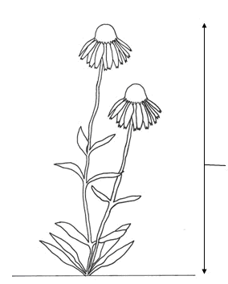
Plant height

Ad. 3: Plant: floriferousness

The number of flowers should be observed as the number of flowers open at the same time on the plant, at the time of full flowering

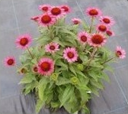 | 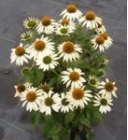 | 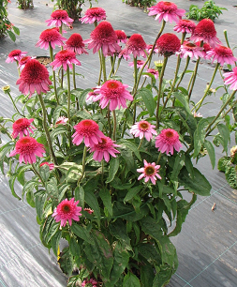
3 | 5 | 7
weak | medium | strong

Ad. 4: Plant: density

The plant density is observed as the overall impression, based on stems, leaves and flowers

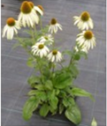 | 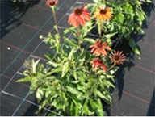 | 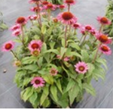
3 | 5 | 7
sparse | medium | dense

Ad. 17: Leaf: indentations of margin

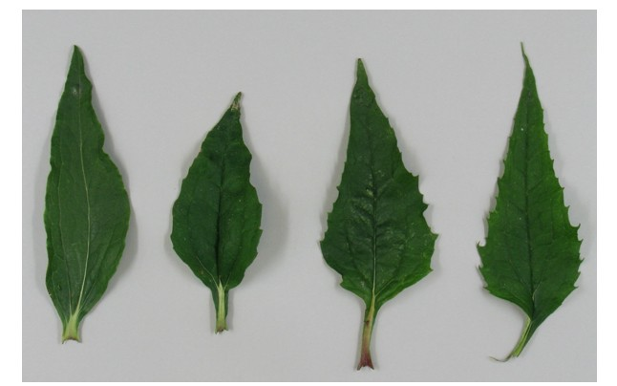
1 | 2 | 3 | 4
absent or very few | few | medium | many

Ad. 20: Flower head: diameter
Ad. 21: Flower head: height

It is the natural flower head diameter and height which is recorded.

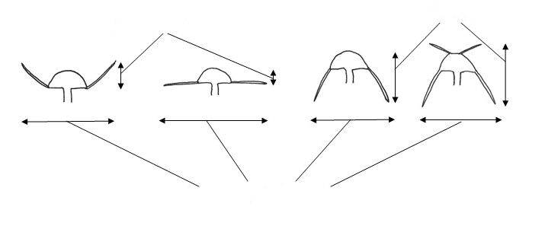
Flower head: diameter
Flower head: height
Flower head: height

Ad. 22: Flower head: number of ray florets

This excludes any ray florets within the disc (see characteristic 51)

Ad. 23: Flower head: attitude of ray florets at origin

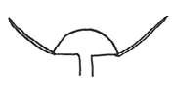 | 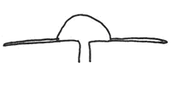 | 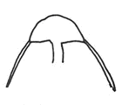
1 | 2 | 3
semi-erect | horizontal | semi-drooping

Ad. 24: Flower head: relative number of ligulate ray florets

“Relative” means the number of ligulate ray florets relative to the overall number of ray florets. It is this which is assessed, not the absolute number of ligulate ray florets.

Ligulate florets are flat.

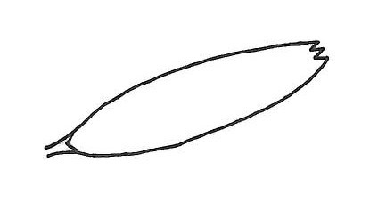

Ad. 25: Flower head: relative number of spatulate ray florets

“Relative” means the number of spatulate ray florets relative to the overall number of ray florets. It is this which is assessed, not the absolute number of spatulate ray florets.

Spatulate ray florets are where part of the floret is tubular and part is flat.

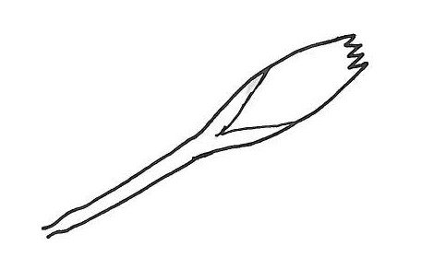

Ad. 26: Flower head: relative number of quilled ray florets

“Relative” means the number of quilled ray florets relative to the overall number of ray florets. It is this which is assessed, not the absolute number of quilled ray florets.

Quilled florets are where the whole length of the floret is tubular.

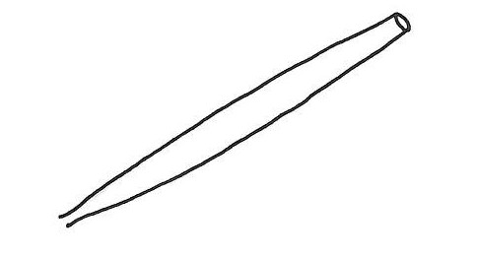

Ad.30: Only varieties with spatulate or quilled ray florets: Ray floret: color of outer side

To be record on the quilled part of the floret, on the area facing upwards

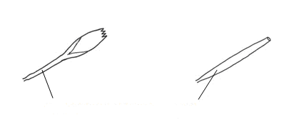
Color to be recorded on this part.

Ad. 33: Ray floret: distribution of secondary color of inner side

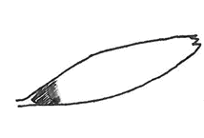 | 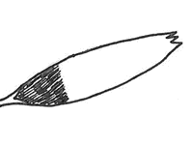 | 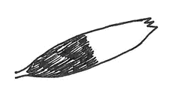
1 | 2 | 3
at the base | in the basal quarter | in the basal half

Ad. 34: Ray floret: curvature

 |  | inner side
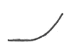 | 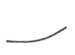 | 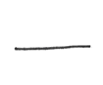 | 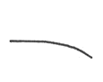 | 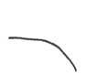
1 | 2 | 3 | 4 | 5
strongly incurving | weakly incurving | straight | weakly reflexing | strongly reflexing

Ad. 36: Ray floret: profile in cross section

To be observed at the midpoint of the floret

 |  |  | inner side
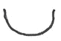 |  | 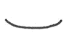 | 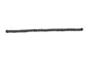 | 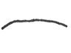 | 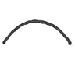 | 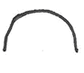
1 | 2 | 3 | 4 | 5 | 6 | 7
strongly concave | moderately concave | weakly concave | flat | weakly convex | moderately convex | strongly convex

Ad. 37: Ray floret: shape of apex

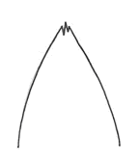 | 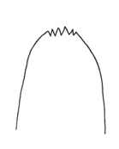 | 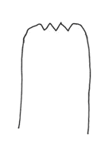
1 | 2 | 3
pointed | rounded | truncate

Ad. 38: Ray floret: indentations of tip

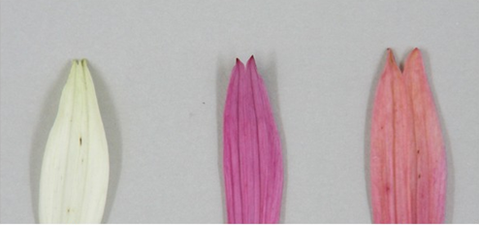
2 | 3 | 4
shallow | medium | deep

Ad. 39: Disc: type

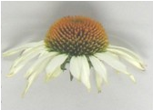 | 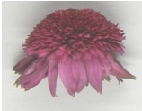
1 | 2
daisy | anemone

Ad. 40: Only varieties with disc type: daisy: Disc: diameter
Ad. 42: Only varieties with disc type: daisy: Disc: height

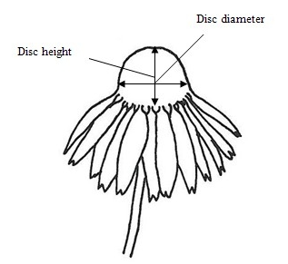
Ad. 44: Only varieties with disc type: daisy: Disc: ratio height/diameter

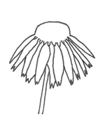 | 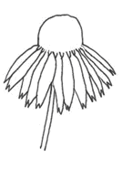 | 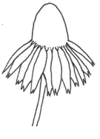
3 | 5 | 7
low | medium | high

Ad. 46: Disc: diameter in relation to flower head

The disc diameter is assessed relative to the natural flower head diameter.

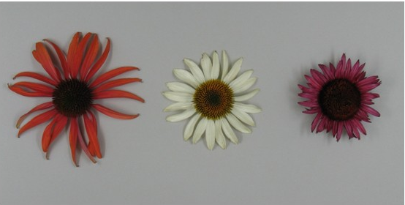
3 | 5 | 7
small | medium | large

Ad. 47: Only varieties with disc type: daisy: Disc: color of paleae (spikes)
Ad. 48: Only varieties with disc type: daisy: Disc: second color of paleae (spikes)

To be recorded on paleae half way between the base and the top of the disc, just before the disc florets associated with the paleae have dehisced/opened – (see diagram below)

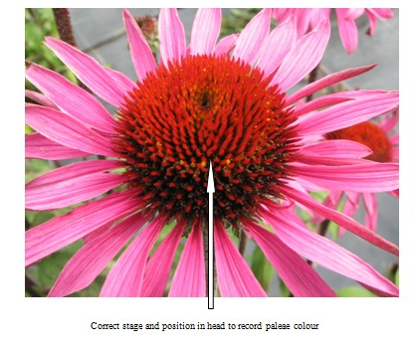

The color of the paleae (spikes) (characteristic 47) is always observed as the color at the tip, irrespective of area covered.

The second color (characteristic 48) is observed as the color directly below the tip (if different from the tip color).

Any further colors should be ignored.
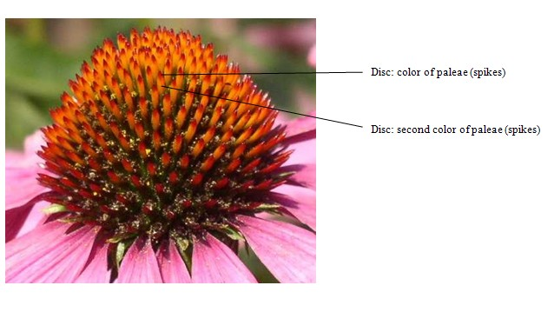
Ad. 51: Only varieties with disc type: daisy: Disc: presence of ray florets within the disc
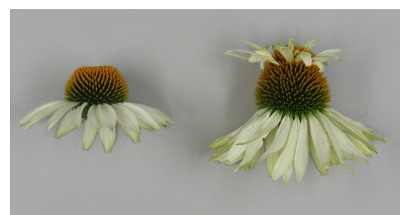
1 | 9
absent | present

Ad. 52: Only varieties with disc type: daisy: with ray florets within the disc: Disc: number of ray florets within the disc

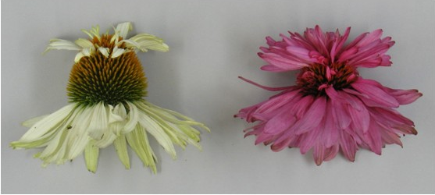
3 | 7
few | many

Ad. 55: Only varieties with disc type: anemone: Disc floret: curvature

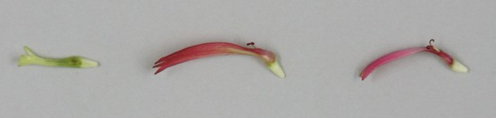
1 | 2 | 3
straight | weakly reflexed | strongly reflexed

Ad. 56: Only varieties with disc type: anemone: Disc floret: length of tube

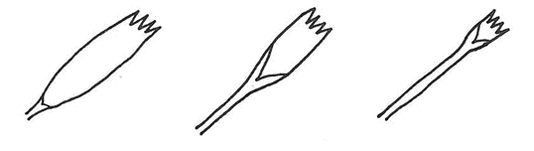
3 | 5 | 7
short | medium | long

Literature

Bauer, R., Wagner, H. 1990: Echinacea. Handbuch für Ärzte, Apotheker und andere Naturwissenschaftler. Wissenschaftliche Verlagsgesellschaft GmbH Stuttgart, DE

Beschreibende Sortenliste Arznei und Gewürzpflanzen. 2002: Bundessortenamt: 161-163

Foster, S. 1991: Echinacea. Nature’s immune enhancer. Healing Arts Press. Rochester, VT

Köck, O. 2001: Medicinal plant varieties of Hungary: 23

Kozłowski, J. 1996: Jeżówka purpurowa w uprawie. Wiadomości Zielarskie 5: 3-4

McGregor, R. 1968: The taxonomy of the genus Echinacea (Composite). The University of Kansas Science Bulletin. 48 (4): 113-142

Rice, G. (ed)., 2006: Royal Horticultural Society Encyclopedia of Perennials.
Dorling Kinsdersley Ltd.. London, GB.

Seidler-Łożykowska, K., Dąbrowska, J. 1996: Evaluation of Echinacea purpurea collection. Herba Polonica 3: 155-161

Seidler-Łożykowska, K., Dąbrowska, J. 2003: Yield and polyphenolic acids content in purple coneflower (Echinacea purpurea Moench) at different growth stages. Journal of Herbs, Spices & Medicinal Plants 10 (3): 7-12

Seidler-Łożykowska, K., Kaźmierczak, K. 2004: Breeding program on purple coneflower (Echinacea purpurea Moench) III. Comparative experiment, Herba Polonica 50 (2): 17-20

Technical Questionnaire
TECHNICAL QUESTIONNAIRE |  | Page {x} of {y} | Reference Number:
 |  |  | Application date:
 |  |  | (not to be filled in by the applicant)
TECHNICAL QUESTIONNAIRE
to be completed in connection with an application for plant breeders’ rights

1. Subject of the Technical Questionnaire
1.1 Genus
1.1.1 Botanical name | Echinacea Moench.
1.1.2 Common name | Echinacea, Cone Flower
1.2 Species
(please indicate)
2. Applicant
Name
Address
Telephone No.
Fax No.
E-mail address
Breeder (if different from applicant)
3. Proposed denomination and breeder’s reference
Proposed denomination
(if available)

Breeder’s reference
#4. Information on the breeding scheme and propagation of the variety

4.1 Breeding scheme

Variety resulting from:

4.1.1 Crossing

(a) controlled cross [ ]
(please state parent varieties)

(…………………..……………..…) x (……………..…………………..…)
female parent male parent

(b) partially known cross [ ]
(please state known parent variety(ies))

(…………………..……………..…) x (……………..…………………..…)
female parent male parent

(c) unknown cross [ ]

4.1.2 Mutation [ ]
(please state parent variety)

4.1.3 Discovery and development [ ]
(please state where and when discovered and how developed)

4.1.4 Other [ ]
(please provide details)

4.2 Method of propagating the variety

4.2.1 Seed-propagated varieties

(a) Self-pollination [ ]
(b) Cross-pollination
(i) population [ ]
(ii) synthetic variety [ ]
(c) Hybrid [ ]
(please provide details)

(d) Other [ ]
(please provide details)

4.2.2 Vegetatively propagated varieties

(a) cuttings [ ]

(b) in vitro propagation [ ]

(c) other (state method) [ ]

TECHNICAL QUESTIONNAIRE |  |  | Page {x} of {y} |  | Reference Number:
5. Characteristics of the variety to be indicated (the number in brackets refers to the corresponding characteristic in Test Guidelines; please mark the note which best corresponds).

 | Characteristics |  |  |  |  | Example Varieties |  | Note
5.1  (12) | Leaf: variegation
 | absent |  |  |  |  | Tomato Soup |  | 1 [ ]
 | present |  |  |  |  | Prairie Frost |  | 9 [ ]
5.2  (31) | Ray floret: main color of inner side
 | green |  |  |  |  | Green Jewel |  | 1 [ ]
 | white |  |  |  |  | Purity |  | 2 [ ]
 | yellow |  |  |  |  | Harvest Moon |  | 3 [ ]
 | orange |  |  |  |  | Tiki Torch |  | 4 [ ]
 | red |  |  |  |  | Tomato Soup |  | 5 [ ]
 | pink |  |  |  |  | Meditation |  | 6 [ ]
 | purple |  |  |  |  | Magnus, Catharina |  | 7 [ ]
5.3  (32) | Ray floret: secondary color of inner side
 | green |  |  |  |  |  |  | 1 [ ]
 | white |  |  |  |  |  |  | 2 [ ]
 | yellow |  |  |  |  |  |  | 3 [ ]
 | orange |  |  |  |  |  |  | 4 [ ]
 | red |  |  |  |  |  |  | 5 [ ]
 | pink |  |  |  |  | Green Envy |  | 6 [ ]
 | purple |  |  |  |  |  |  | 7 [ ]
5.4  (39) | Disc: type
 | daisy |  |  |  |  | Merlot |  | 1 [ ]
 | anemone |  |  |  |  | Hot Papaya |  | 2 [ ]
 | Characteristics |  |  |  |  | Example Varieties |  | Note
5.5  (47) | Only varieties with disc type: daisy: Disc: color of paleae (spikes)
 | green |  |  |  |  |  |  | 1 [ ]
 | yellowish green |  |  |  |  | Green Jewel |  | 2 [ ]
 | yellow |  |  |  |  |  |  | 3 [ ]
 | orange |  |  |  |  | Purity, Mount Hood |  | 4 [ ]
 | red orange |  |  |  |  |  |  | 5 [ ]
 | red brown |  |  |  |  | Merlot, Hot Summer |  | 6 [ ]
 | purple brown |  |  |  |  | Fatal Attraction |  | 7 [ ]
5.6  (51) | Only varieties with disc type: daisy: Disc: presence of ray florets within the disc
 | absent |  |  |  |  | Merlot |  | 1 [ ]
 | present |  |  |  |  | Mount Hood |  | 9 [ ]
6. Similar varieties and differences from these varieties

Please use the following table and box for comments to provide information on how your candidate variety differs from the variety (or varieties) which, to the best of your knowledge, is (or are) most similar. This information may help the examination authority to conduct its examination of distinctness in a more efficient way.

Denomination(s) of variety(ies) similar to your candidate variety |  | Characteristic(s) in which your candidate variety differs from the similar variety(ies) |  | Describe the expression of the characteristic(s) for the similar variety(ies) |  |  | Describe the expression of the characteristic(s) for your candidate variety
Example |  | Ray floret color |  | pink |  |  | purple
Comments:

#7. Additional information which may help in the examination of the variety

7.1 In addition to the information provided in sections 5 and 6, are there any additional characteristics which may help to distinguish the variety?

Yes [ ] No [ ]

(If yes, please provide details)

7.2 Are there any special conditions for growing the variety or conducting the examination?

Yes [ ] No [ ]

(If yes, please provide details)

7.3.1 Other information

Main use of the variety

(a) garden plant [ ]
(b) cut flower [ ]
(c) herbal/pharmaceutical [ ]
(d) other [ ]
(please provide details)

..............................................................

7.3.2 A representative color image of the variety should accompany the Technical Questionnaire.

8. Authorization for release

(a) Does the variety require prior authorization for release under legislation concerning the protection of the environment, human and animal health?

Yes [ ] No [ ]

(b) Has such authorization been obtained?

Yes [ ] No [ ]

If the answer to (b) is yes, please attach a copy of the authorization.

9. Information on plant material to be examined or submitted for examination.

9.1 The expression of a characteristic or several characteristics of a variety may be affected by factors, such as pests and disease, chemical treatment (e.g. growth retardants or pesticides), effects of tissue culture, different rootstocks, scions taken from different growth phases of a tree, etc.

9.2 The plant material should not have undergone any treatment which would affect the expression of the characteristics of the variety, unless the competent authorities allow or request such treatment. If the plant material has undergone such treatment, full details of the treatment must be given. In this respect, please indicate below, to the best of your knowledge, if the plant material to be examined has been subjected to:

(a) Microorganisms (e.g. virus, bacteria, phytoplasma) Yes [ ] No [ ]

(b) Chemical treatment (e.g. growth retardant, pesticide) Yes [ ] No [ ]

(c) Tissue culture Yes [ ] No [ ]

(d) Other factors Yes [ ] No [ ]

Please provide details for where you have indicated “yes”.

……………………………………………………………

10. I hereby declare that, to the best of my knowledge, the information provided in this form is correct:

Applicant’s name

Signature Date

[End of document]

* These names were correct at the time of the introduction of these Test Guidelines but may be revised or updated. [Readers are advised to consult the UPOV Code, which can be found on the UPOV Website (www.upov.int), for the latest information.]
# Authorities may allow certain of this information to be provided in a confidential section of the Technical Questionnaire.
# Authorities may allow certain of this information to be provided in a confidential section of the Technical Questionnaire.

