 |  | E  TG/CANNA(proj.10)  ORIGINAL: English  DATE: 2012-01-26
INTERNATIONAL UNION FOR THE PROTECTION OF NEW VARIETIES OF PLANTS
GENEVA
DRAFT

CANNA

UPOV Code: CANNA

Canna L.

GUIDELINES

FOR THE CONDUCT OF TESTS

FOR DISTINCTNESS, UNIFORMITY AND STABILITY
prepared by experts from France
to be considered by the
Technical Committee at its forty-eighth session,
to be held in Geneva from March 26 to 28, 2012

Alternative Names:*

Botanical name | English | French | German | Spanish
Canna L. | Canna | Balisier, Canna | Blumenrohr | Platanillo

The purpose of these guidelines (“Test Guidelines”) is to elaborate the principles contained in the General Introduction (document TG/1/3), and its associated TGP documents, into detailed practical guidance for the harmonized examination of distinctness, uniformity and stability (DUS) and, in particular, to identify appropriate characteristics for the examination of DUS and production of harmonized variety descriptions.

ASSOCIATED DOCUMENTS

These Test Guidelines should be read in conjunction with the General Introduction and its associated TGP documents.

TABLE OF CONTENTS PAGE

1. Subject of these Test Guidelines 3
2. Material Required 3
3. Method of Examination 3
3.1 Number of Growing Cycles 3
3.2 Testing Place 3
3.3 Conditions for Conducting the Examination 3
3.4 Test Design 4
3.5 Additional Tests 4
4. Assessment of Distinctness, Uniformity and Stability 4
4.1 Distinctness 4
4.2 Uniformity 5
4.3 Stability 5
5. Grouping of Varieties and Organization of the Growing Trial 6
6. Introduction to the Table of Characteristics 7
6.1 Categories of Characteristics 7
6.2 States of Expression and Corresponding Notes 7
6.3 Types of Expression 8
6.4 Example Varieties 8
6.5 Legend 8
7. Table of Characteristics/Tableau des caractères/Merkmalstabelle/Tabla de caracteres 9
8. Explanations on the Table of Characteristics 14
8.1 Explanations covering several characteristics 14
8.2 Explanations for individual characteristics 14
9. Literature 18
10. Technical Questionnaire 19

Subject of these Test Guidelines
These Test Guidelines apply to all varieties of Canna L.

Material Required
2.1 The competent authorities decide on the quantity and quality of the plant material required for testing the variety and when and where it is to be delivered. Applicants submitting material from a State other than that in which the testing takes place must ensure that all customs formalities and phytosanitary requirements are complied with.

2.2 The material is to be supplied in the form of rhizomes or young plants which will flower within one year and display all characteristics of the variety.

2.3 The minimum quantity of plant material, to be provided by the applicant, should be:

8 young plants or 8 rhizomes.

2.4 The plant material supplied should be visibly healthy, not lacking in vigor, nor affected by any important pest or disease.

2.5 The plant material should not have undergone any treatment which would affect the expression of the characteristics of the variety, unless the competent authorities allow or request such treatment. If it has been treated, full details of the treatment must be given.

Method of Examination

3.1 Number of Growing Cycles
The minimum duration of tests should normally be a single growing cycle.

3.2 Testing Place
Tests are normally conducted at one place. In the case of tests conducted at more than one place, guidance is provided in TGP/9 “Examining Distinctness”.

3.3 Conditions for Conducting the Examination
3.3.1 The tests should be carried out under conditions ensuring satisfactory growth for the expression of the relevant characteristics of the variety and for the conduct of the examination.

3.3.2 Because daylight varies, color determinations made against a color chart should be made either in a suitable cabinet providing artificial daylight or in the middle of the day in a room without direct sunlight. The spectral distribution of the illuminant for artificial daylight should conform with the CIE Standard of Preferred Daylight D 6500 and should fall within the tolerances set out in the British Standard 950, Part I. These determinations should be made with the plant part placed against a white background. The color chart and version used should be specified in the variety description.

3.4 Test Design
3.4.1 Each test should be designed to result in a total of at least 8 plants.

3.4.2 The design of the tests should be such that plants or parts of plants may be removed for measurement or counting without prejudice to the observations which must be made up to the end of the growing cycle.

3.5 Additional Tests
Additional tests, for examining relevant characteristics, may be established.

Assessment of Distinctness, Uniformity and Stability

4.1 Distinctness

4.1.1 General Recommendations

It is of particular importance for users of these Test Guidelines to consult the General Introduction prior to making decisions regarding distinctness. However, the following points are provided for elaboration or emphasis in these Test Guidelines.

4.1.2 Consistent Differences

The differences observed between varieties may be so clear that more than one growing cycle is not necessary. In addition, in some circumstances, the influence of the environment is not such that more than a single growing cycle is required to provide assurance that the differences observed between varieties are sufficiently consistent. One means of ensuring that a difference in a characteristic, observed in a growing trial, is sufficiently consistent is to examine the characteristic in at least two independent growing cycles.

    - Clear Differences

Determining whether a difference between two varieties is clear depends on many factors, and should consider, in particular, the type of expression of the characteristic being examined, i.e. whether it is expressed in a qualitative, quantitative, or pseudo-qualitative manner. Therefore, it is important that users of these Test Guidelines are familiar with the recommendations contained in the General Introduction prior to making decisions regarding distinctness.

    - Number of plants / Parts of Plants to be examined

Unless otherwise indicated, for the purposes of distinctness, all observations on single plants should be made on 7 plants or parts taken from each of 7 plants and any other observations made on all plants in the test, disregarding any off-type plants.

4.1.5 Method of Observation
The recommended method of observing the characteristic for the purposes of distinctness is indicated by the following key in the second column of the Table of Characteristics (see document TGP/9 “Examining Distinctness”, Section 4 “Observation of characteristics”):

MG: single measurement of a group of plants or parts of plants
MS: measurement of a number of individual plants or parts of plants
VG: visual assessment by a single observation of a group of plants or parts of plants
VS: visual assessment by observation of individual plants or parts of plants

Type of observation: visual (V) or measurement (M)

“Visual” observation (V) is an observation made on the basis of the expert’s judgment. For the purposes of this document, “visual” observation refers to the sensory observations of the experts and, therefore, also includes smell, taste and touch. Visual observation includes observations where the expert uses reference points (e.g. diagrams, example varieties, side-by-side comparison) or non-linear charts (e.g. color charts). Measurement (M) is an objective observation against a calibrated, linear scale e.g. using a ruler, weighing scales, colorimeter, dates, counts, etc.

Type of record: for a group of plants (G) or for single, individual plants (S)

For the purposes of distinctness, observations may be recorded as a single record for a group of plants or parts of plants (G), or may be recorded as records for a number of single, individual plants or parts of plants (S). In most cases, “G” provides a single record per variety and it is not possible or necessary to apply statistical methods in a plant-by-plant analysis for the assessment of distinctness.

In cases where more than one method of observing the characteristic is indicated in the Table of Characteristics (e.g. VG/MG), guidance on selecting an appropriate method is provided in document TGP/9, Section 4.2.

4.2 Uniformity
4.2.1 It is of particular importance for users of these Test Guidelines to consult the General Introduction prior to making decisions regarding uniformity. However, the following points are provided for elaboration or emphasis in these Test Guidelines:

4.2.2 For the assessment of uniformity, a population standard of 1% and an acceptance probability of at least 95% should be applied. In the case of a sample size of 8 plants, 1 off-type is allowed.

4.3 Stability
4.3.1 In practice, it is not usual to perform tests of stability that produce results as certain as those of the testing of distinctness and uniformity. However, experience has demonstrated that, for many types of variety, when a variety has been shown to be uniform, it can also be considered to be stable.
4.3.2 Where appropriate, or in cases of doubt, stability may be tested, either by growing a further generation, or by testing a new plant stock to ensure that it exhibits the same characteristics as those shown by the previous material supplied.

Grouping of Varieties and Organization of the Growing Trial
5.1 The selection of varieties of common knowledge to be grown in the trial with the candidate varieties and the way in which these varieties are divided into groups to facilitate the assessment of distinctness are aided by the use of grouping characteristics.

5.2 Grouping characteristics are those in which the documented states of expression, even where produced at different locations, can be used, either individually or in combination with other such characteristics: (a) to select varieties of common knowledge that can be excluded from the growing trial used for examination of distinctness; and (b) to organize the growing trial so that similar varieties are grouped together.

5.3 The following have been agreed as useful grouping characteristics:

- Plant: height at beginning of flowering (characteristic 1)

(b) Leaf blade: main color (characteristic 7) with the following groups:
Gr. 1: yellowish white
Gr. 2: yellow
Gr. 3: yellow green
Gr. 4: green
Gr. 5: orange
Gr. 6: orange brown
Gr. 7: brown
Gr. 8: purple

(c) Leaf blade: secondary color (excluding veins) (characteristic 8) with the following groups:
Gr. 1: none
Gr. 2: white
Gr. 3: purple

(d) Staminode: ground color (characteristic 16) with the following groups:
Gr. 1: yellowish white
Gr. 2: yellow
Gr. 3: orange
Gr. 4: pink
Gr. 5: red

5.4 Guidance for the use of grouping characteristics, in the process of examining distinctness, is provided through the General Introduction and document TGP/9 “Examining Distinctness”.

Introduction to the Table of Characteristics

6.1 Categories of Characteristics
6.1.1 Standard Test Guidelines Characteristics

Standard Test Guidelines characteristics are those which are approved by UPOV for examination of DUS and from which members of the Union can select those suitable for their particular circumstances.

6.1.2 Asterisked Characteristics

Asterisked characteristics (denoted by *) are those included in the Test Guidelines which are important for the international harmonization of variety descriptions and should always be examined for DUS and included in the variety description by all members of the Union, except when the state of expression of a preceding characteristic or regional environmental conditions render this inappropriate.

6.2 States of Expression and Corresponding Notes
6.2.1 States of expression are given for each characteristic to define the characteristic and to harmonize descriptions. Each state of expression is allocated a corresponding numerical note for ease of recording of data and for the production and exchange of the description.

6.2.2 In the case of qualitative and pseudo-qualitative characteristics (see Chapter 6.3), all relevant states of expression are presented in the characteristic. However, in the case of quantitative characteristics with 5 or more states, an abbreviated scale may be used to minimize the size of the Table of Characteristics. For example, in the case of a quantitative characteristic with 9 states, the presentation of states of expression in the Test Guidelines may be abbreviated as follows:

State | Note
small | 3
medium | 5
large | 7

However, it should be noted that all of the following 9 states of expression exist to describe varieties and should be used as appropriate:

State | Note
very small | 1
very small to small | 2
small | 3
small to medium | 4
medium | 5
medium to large | 6
large | 7
large to very large | 8
very large | 9

6.2.3 Further explanation of the presentation of states of expression and notes is provided in document TGP/7 “Development of Test Guidelines”.

6.3 Types of Expression
An explanation of the types of expression of characteristics (qualitative, quantitative and pseudo-qualitative) is provided in the General Introduction.

6.4 Example Varieties
Where appropriate, example varieties are provided to clarify the states of expression of each characteristic.

6.5 Legend
(*) Asterisked characteristic – see Chapter 6.1.2

QL Qualitative characteristic – see Chapter 6.3
QN Quantitative characteristic – see Chapter 6.3
PQ Pseudo-qualitative characteristic – see Chapter 6.3

MG, MS, VG, VS – see Chapter 4.1.5

(a) See Explanations on the Table of Characteristics in Chapter 8.1

(+) See Explanations on the Table of Characteristics in Chapter 8.2.

Table of Characteristics/Tableau des caractères/Merkmalstabelle/Tabla de caracteres
 |  | English | français | deutsch | español | Example Varieties/  Exemples/  Beispielssorten/  Variedades ejemplo | Note/  Nota
1  (*)  (+) | MG | Plant: height at beginning of flowering | Plante : hauteur au début de la floraison | Pflanze: Höhe bei Blühbeginn | Planta: altura al comienzo de la floración
QN |  | short | basse | niedrig | corta | Tafraout | 3
 |  | medium | moyenne | mittel | media | Oiseau de feu | 5
 |  | tall | haute | hoch | alta | Liberté | 7
2 | VG | Plant: growth habit | Plante : port | Pflanze: Wuchsform | Planta: porte
QN |  | upright | dressé | aufrecht | erguido | Liberté | 1
 |  | upright to semi upright | dressé à demi-dressé | aufrecht bis halbaufrecht | erguido a semi-erguido |  | 2
 |  | semi upright | demi-dressé | halbaufrecht | semi-erguido | Pretoria, Prince Charmant | 3
3  (*) | MG | Leaf blade: length | Limbe foliaire : longueur | Blattspreite: Länge | Limbo: longitud
QN |  | short | courte | kurz | corta | Lolita, Turcano | 3
 |  | medium | moyenne | mittel | media | Oiseau d’or | 5
 |  | long | longue | lang | larga | Liberté | 7
4  (*) | MG | Leaf blade: width | Limbe foliaire : largeur | Blattspreite: Breite | Limbo: anchura
QN |  | narrow | étroite | schmal | estrecha | Caballero | 3
 |  | medium | moyenne | mittel | media | Oiseau de feu | 5
 |  | broad | large | breit | ancha | Liberté | 7
5 | VG | Leaf blade: glossiness | Limbe foliaire : brillance | Blattspreite: Glanz | Limbo: brillo
QN |  | weak | faible | gering | débil | Strasbourg | 1
 |  | medium | moyenne | mittel | medio | Oiseau D’Or | 2
 |  | strong | forte | stark | fuerte | Russian Red | 3
6  (*) | VG | Leaf: color of veins | Feuille : couleur des nervures | Frucht: Farbe der Adern | Hoja: color de las venas
PQ |  | light green | vert clair | hellgrün | verde claro | Oiseau D’or | 1
 |  | yellow | jaune | gelb | amarillo | Panach | 2
 |  | orange | orange | orange | anaranjado | Andalucia | 3
 |  | red | rouge | rot | rojo | Phasion | 4
 |  | purple | pourpre | purpurn | púrpura | Liberté | 5
7  (*)  (+)  PQ | VG | Leaf blade: main color | Limbe foliaire : couleur principale | Blattspreite: Hauptfarbe | Limbo: color principal
 |  | RHS Colour Chart (indicate reference number) | Code RHS des couleurs (indiquer le numéro de référence) | RHS-Farbkarte (Nummer angeben) | Carta de colores RHS (indíquese el número de referencia)
8  (*)  (+) | VG | Leaf blade: secondary color  (excluding veins) | Limbe foliaire : couleur secondaire (sans les nervures) | Blattspreite: Sekundärfarbe (ohne Adern) | Limbo: color secundario (excluidas las venas)
PQ |  | none | aucune | keine | ninguno | Oiseau d’or | 1
 |  | white | blanche | weiß | blanco | Stuttgart | 2
 |  | purple | pourpre | purpurn | púrpura | Cleopatra | 3
9  (*)  (+) | VG | Leaf blade: pattern of secondary color (excluding veins) | Limbe foliaire : distribution de la couleur secondaire (sans les nervures) | Blattspreite: Muster der Sekundärfarbe (ohne Adern) | Limbo: distribución del color secundario (excluidas las venas)
PQ |  | diffused | diffuse | diffus | difuso |  | 1
 |  | in sectors | en taches | flächig | en sectores | Cleopatra | 2
 |  | marbled | marbrée | mamoriert | jaspeado | Stuttgart | 3
10 | VG | Inflorescence: position in relation to foliage | Inflorescence : position par rapport au feuillage | Blütenstand: Stellung im Vergleich zum Laub | Inflorescencia: posición en relación con el follaje
QN |  | at same level | au même niveau | auf gleicher Höhe | al mismo nivel | Flamèche | 1
 |  | moderately above | légèrement au-dessus | etwas oberhalb | moderadamente por encima | Félix Ragot | 2
 |  | strongly above | nettement au-dessus | stark oberhalb | muy por encima | Liberté | 3
11 | VG | Inflorescence: length (excluding peduncle) | Inflorescence : longueur (en excluant le pédoncule) | Blütenstand: Länge (ohne Blütenstiel) | Inflorescencia: longitud (excluido el pedúnculo)
QN |  | short | courte | kurz | corta | Flamèche | 3
 |  | medium | moyenne | mittel | media | Roi Soleil | 5
 |  | long | longue | lang | larga | Marabout | 7
12  (*)  (+) | VG | Inflorescence: arrangement of staminodes | Inflorescence : position des staminodes | Blütenstand: Anordnung der Staminodien | Inflorescencia: disposición de los estaminodios
QN | (a) | free | libres | freistehend | separados | Perkéo | 1
 |  | moderately overlapping | modérément recouvrants | mäßig überlappend | moderadamente solapados | Mactro | 2
 |  | strongly overlapping | fortement recouvrants | stark überlappend | fuertemente solapados | Peau Rouge | 3
13  (*) | VG | Staminode: width (excluding first flower) | Staminode : largeur (en excluant la première fleur) | Staminodie: Breite (ohne erste Blüte) | Estaminodio: anchura (excluida la primera flor)
QN | (a) | narrow | étroit | schmal | estrecha | Fiesta | 3
 |  | medium | moyen | mittel | media | Angèle Martin | 5
 |  | broad | large | breit | ancha | Prince Charmant | 7
14  (*)  (+) | VG | Staminode: reflexing | Staminode : courbure | Staminodie: Biegung | Estaminodio: curvatura
QN | (a) | weak | faible | gering | débil | Angèle Martin | 1
 |  | medium | moyenne | mittel | media | Peau rouge | 2
 |  | strong | forte | stark | fuerte | Roma | 3
15  (*) | VG | Staminode: undulation | Staminode : ondulation | Staminodie: Wellung | Estaminodio: ondulación
QN | (a) | absent or weak | absente ou faible | fehlend oder gering | ausente o débil |  | 1
 |  | medium | moyenne | mittel | media | Mactro | 2
 |  | strong | forte | stark | fuerte | Alberich | 3
16  (*)  (+) | VG | Staminode: ground color | Staminode : couleur de fond | Staminodie: Grundfarbe | Estaminodio: color de fondo
PQ | (a) | yellowish white | blanc jaunâtre | gelblichweiß | blanco amarillento | Niagara | 1
 |  | yellow | jaune | gelb | amarillo | Félix Ragot | 2
 |  | orange | orange | orange | anaranjado | Liberté | 3
 |  | pink | rose | rosa | rosa | Carmen | 4
 |  | red | rouge | rot | rojo | Roi Soleil | 5
17  (*)  (+) | VG | Staminode: color of flush | Staminode : couleur de la zone irisée | Staminodie: Farbe der Flammung | Estaminodio: color de los tintes
PQ | (a) | none | aucune | keine | ninguno | Roi Soleil | 1
 |  | yellowish white | blanc jaunâtre | gelblichweiß | blanco amarillento |  | 2
 |  | yellow | jaune | gelb | amarillo |  | 3
 |  | yellow orange | jaune orange | gelborange | naranja amarillento |  | 4
 |  | red | rouge | rot | rojo | Talisman | 5
18  (*)  (+) | VG | Staminode: color of flames | Staminode : couleur des flammes | Staminodie: Farbe der Flammen | Estaminodio: color de las llamaradas
PQ | (a) | none | aucune | keine | ninguno | Roi Soleil | 1
 |  | yellowish white | blanc jaunâtre | gelblichweiß | blanco amarillento |  | 2
 |  | yellow | jaune | gelb | amarillo |  | 3
 |  | yellow orange | jaune orange | gelborange | anaranjado amarillo |  | 4
 |  | red | rouge | rot | rojo |  | 5
19  (*)  (+) | VG | Staminode: ground color of blotches | Staminode : couleur de fond des taches | Staminodie: Grundfarbe der Flecken | Estaminodio: color de fondo de las manchas
PQ | (a) | none | aucune | keine | ninguno | Roi Soleil | 1
 |  | yellowish white | blanc jaunâtre | gelblichweiß | blanco amarillento |  | 2
 |  | yellow | jaune | gelb | amarillo |  | 3
 |  | yellow orange | jaune orange | gelborange | anaranjado amarillo |  | 4
 |  | red | rouge | rot | rojo | Dollar | 5
20  (*)  (+) | VG | Staminode: color of marginal zone | Staminode : couleur de la bordure | Staminodie: Farbe der Randzone | Estaminodio: color de la zona del borde
PQ | (a) | same as base color | aucune | wie die Grundfarbe | igual al color base | Roi Soleil | 1
 |  | yellowish white | blanc jaunâtre | gelblichweiß | blanco amarillento |  | 2
 |  | yellow | jaune | gelb | amarillo | Lolita, Lucifer, Reine Charlotte | 3
 |  | yellow orange | jaune orange | gelborange | anaranjado amarillo | Mactro | 4
 |  | orange | orange | orange | anaranjado |  | 5
 |  | pink | rose | rosa | rosa |  | 6
 |  | orange red | rouge orangé | orangerot | rojo anaranjado |  | 7
 |  | red | rouge | rot | rojo |  | 8
21  (+) | MG | Time of beginning of flowering | Époque de début de floraison | Zeitpunkt des Blühbeginns | Época del inicio de la floración
QN |  | early | précoce | früh | temprana | Corial | 3
 |  | medium | moyenne | mittel | media | Roi Soleil | 5
 |  | late | tardive | spät | tardía | Liberté | 7

Explanations on the Table of Characteristics

8.1 Explanations covering several characteristics
Characteristics containing the following key in the second column of the Table of Characteristics should be examined as indicated below:

(a): all observations on the staminode should be made on an open flower.

General terminology

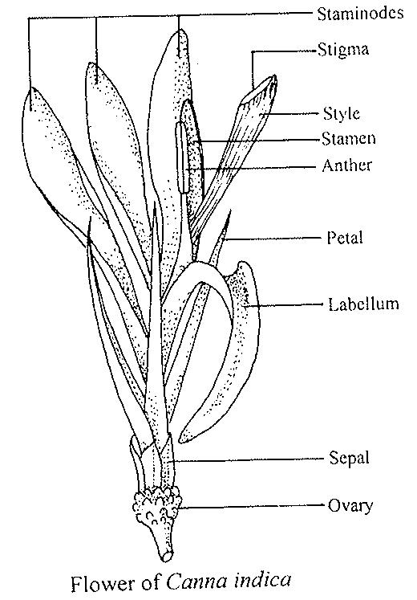

8.2 Explanations for individual characteristics
Ad. 1: Plant: height at beginning of flowering

Plant height includes the inflorescence (the flower spike) and is determined at the beginning of flowering.

Ad. 7: Leaf blade: main color

Main color is the color with largest surface area.

Ad. 8: Leaf blade: secondary color (excluding veins)

Secondary color is the color with the second largest surface area excluding the color of the veins.

Ad. 9: Leaf blade: pattern of secondary color (excluding veins)

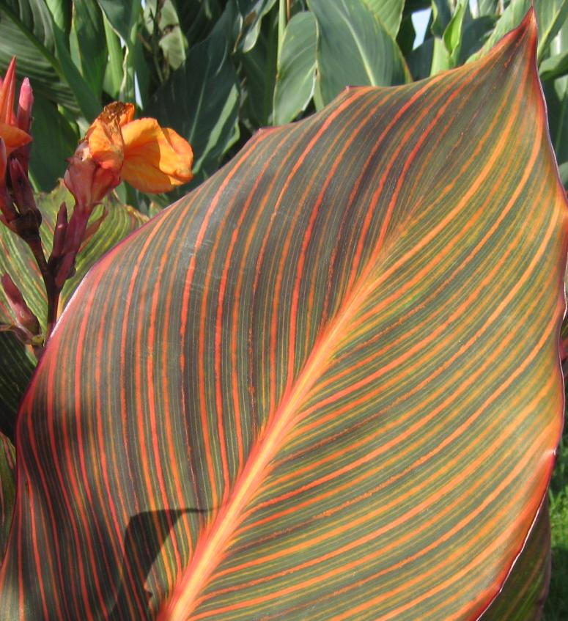 | 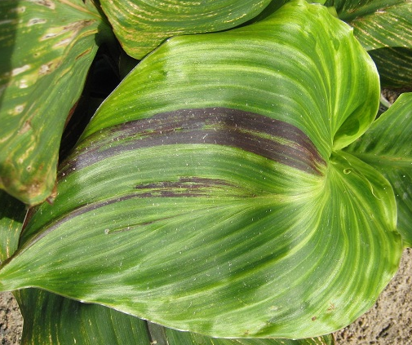 | 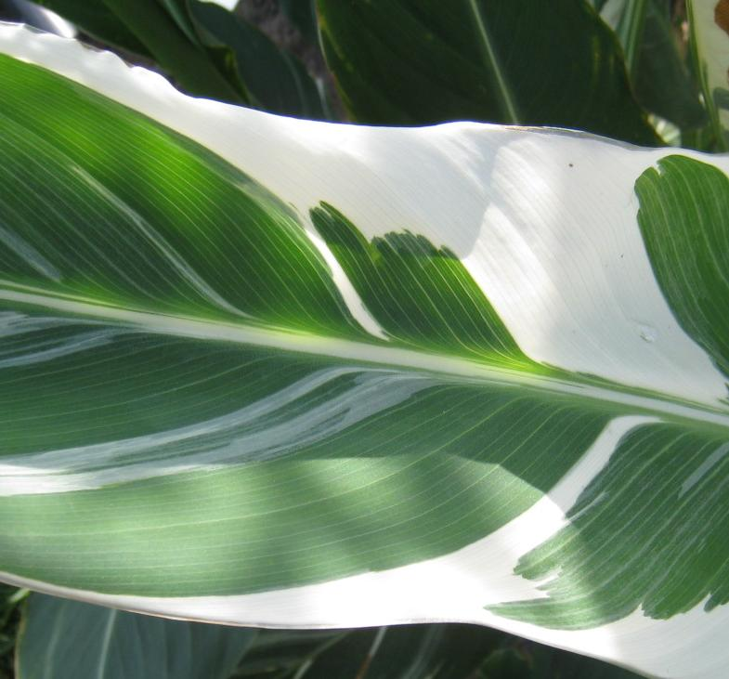
1 | 2 | 3
diffused | in sectors | marbled

Ad. 12: Inflorescence: arrangement of staminodes

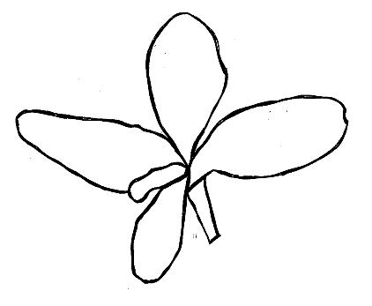 | 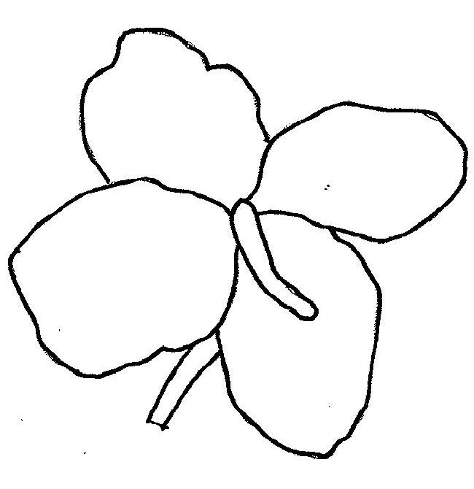 | 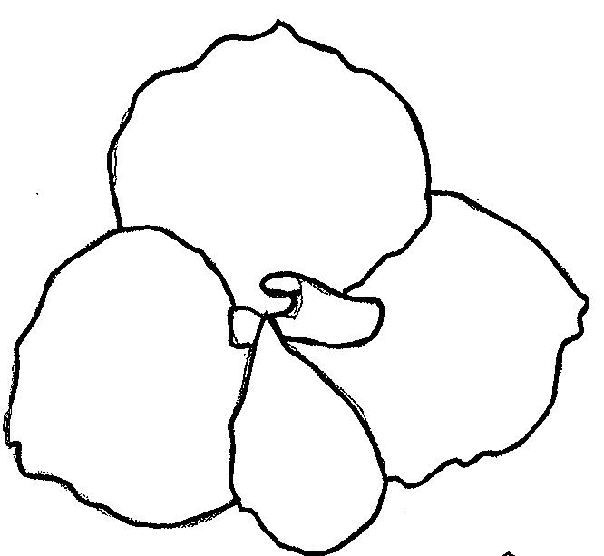
1 | 2 | 3
free | moderately overlapping | strongly overlapping

Ad. 14: Staminode: reflexing

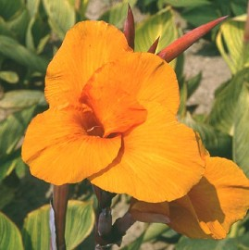 | 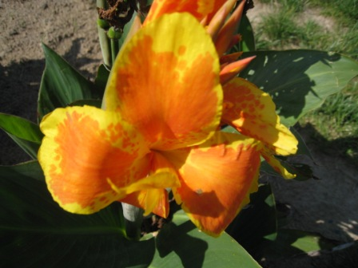 | 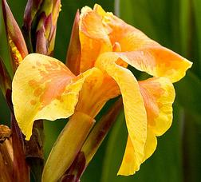
1 | 2 | 3
weak | medium | strong

Ad. 16: Staminode: ground color

The ground color is the first color to appear chronologically during the development of the plant part. Other colors may develop in time in the form of spots, blotches, or a color flush or blush. The ground color is not always the color occupying the largest surface area of the plant part concerned. The ground color can be the main color of the lower side of an organ.

Ad. 17: Staminode: color of flush

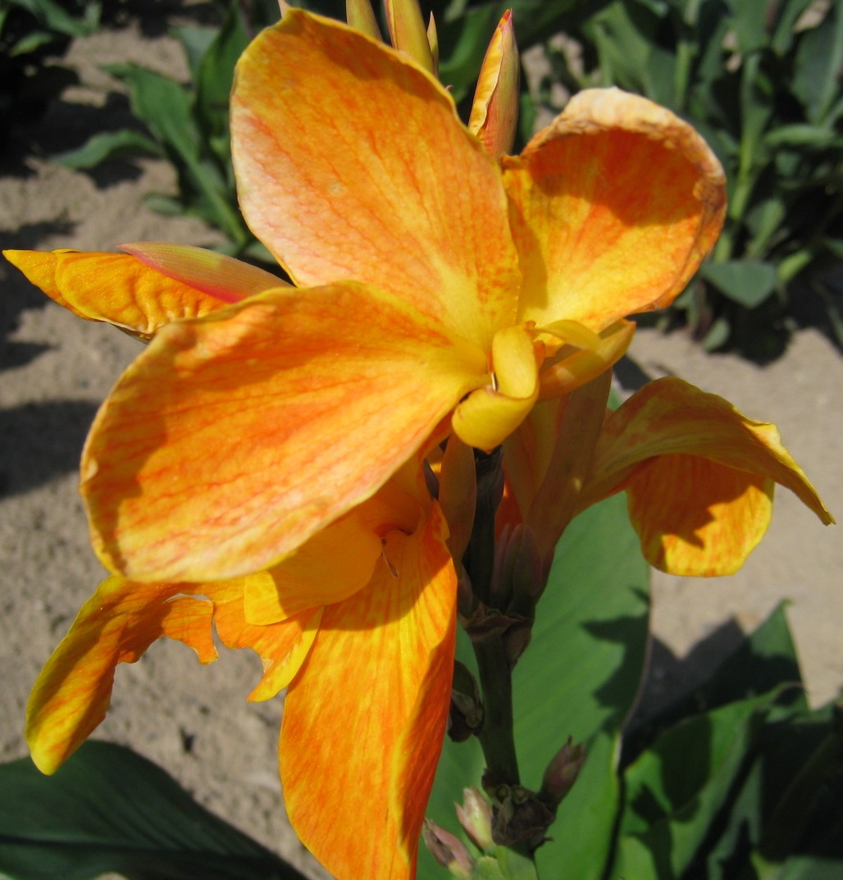
yellow orange

Ad. 18: Staminode: color of flames

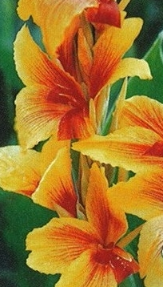
red

Ad. 19: Staminode: ground color of blotches

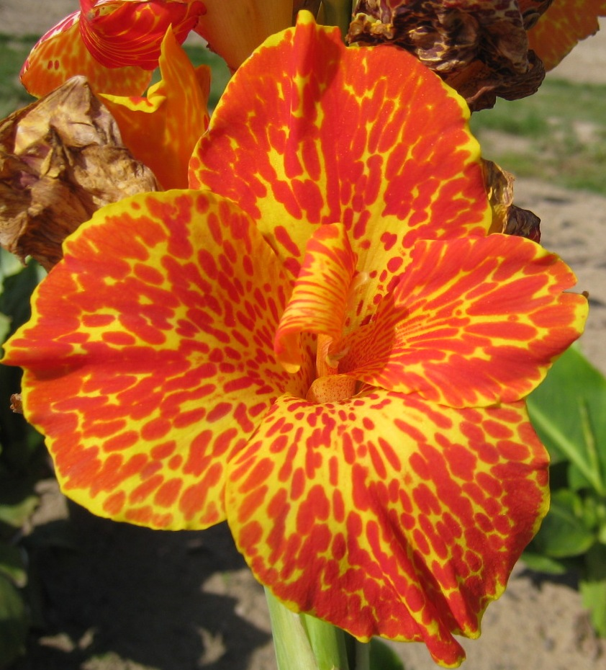
red

Ad. 20: Staminode: color of marginal zone

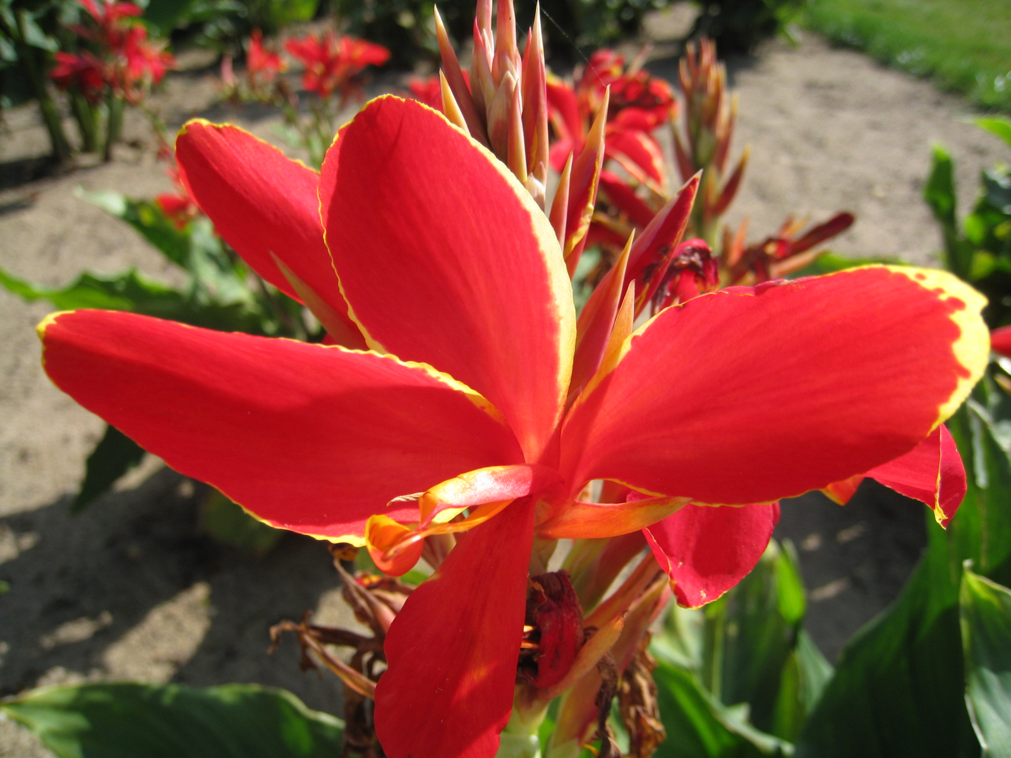
yellow

Ad. 21: Time of beginning of flowering

The time of beginning of flowering is when the first flower has fully opened on 50% of the plants.

Literature
Cooke, I., 2001: Gardeners Guide to Growing Cannas. Timber Press. 160 pp.

Technical Questionnaire
TECHNICAL QUESTIONNAIRE |  |  |  | Page {x} of {y} |  | Reference Number:
 |  |  |  |  |  | Application date:
 |  |  |  |  |  | (not to be filled in by the applicant)
TECHNICAL QUESTIONNAIRE
to be completed in connection with an application for plant breeders’ rights

1. Subject of the Technical Questionnaire
1.1 Genus
1.1.1 Botanical name |  |  | Canna L.
1.1.2 Common name |  |  | Canna
1.2 Species
(please complete)
2. Applicant
Name
Address
Telephone No.
Fax No.
E-mail address
Breeder (if different from applicant)
3. Proposed denomination and breeder’s reference
Proposed denomination
(if available)

Breeder’s reference
#4. Information on the breeding scheme and propagation of the variety

4.1 Breeding scheme

Variety resulting from:

4.1.1 Crossing

(a) controlled cross [ ]
(please state parent varieties)

(…………………..……………..…) x (……………..…………………..…)
female parent male parent

(b) partially known cross [ ]
(please state known parent variety(ies))

(…………………..……………..…) x (……………..…………………..…)
female parent male parent

(c) unknown cross [ ]

4.1.2 Mutation [ ]
(please state parent variety)

4.1.3 Discovery and development [ ]
(please state where and when discovered and how developed)

4.1.4 Other [ ]
(please provide details)

4.2 Method of propagating the variety

4.2.1 Vegetative propagation

(a) cuttings [ ]

(b) in vitro propagation [ ]

(c) other (state method) [ ]

4.2.2 Seed [ ]

4.2.3 Other [ ]
(please provide details)

5. Characteristics of the variety to be indicated (the number in brackets refers to the corresponding characteristic in Test Guidelines; please mark the note which best corresponds).

 | Characteristics |  |  |  |  |  | Example Varieties |  |  | Note
5.1  (1) | Plant: height at beginning of flowering
 | very short |  |  |  |  |  |  |  |  | 1[ ]
 | very short to short |  |  |  |  |  |  |  |  | 2[ ]
 | short |  |  |  |  |  | Tarfraout |  |  | 3[ ]
 | short to medium |  |  |  |  |  |  |  |  | 4[ ]
 | medium |  |  |  |  |  | Oiseau de feu |  |  | 5[ ]
 | medium to tall |  |  |  |  |  |  |  |  | 6[ ]
 | tall |  |  |  |  |  | Liberté |  |  | 7[ ]
 | tall to very tall |  |  |  |  |  |  |  |  | 8[ ]
 | very tall |  |  |  |  |  |  |  |  | 9[ ]
5.2 i  (7) | Leaf blade: main color
 | RHS Colour Chart (indicate reference number)
5.2 ii  (7) | Leaf blade: main color
 | yellowish white |  |  |  |  |  |  |  |  | 1[ ]
 | yellow |  |  |  |  |  |  |  |  | 2[ ]
 | yellow green |  |  |  |  |  | Pretoria |  |  | 3[ ]
 | green |  |  |  |  |  | Oiseau d’or |  |  | 4[ ]
 | orange |  |  |  |  |  |  |  |  | 5[ ]
 | orange brown |  |  |  |  |  |  |  |  | 6[ ]
 | brown |  |  |  |  |  |  |  |  | 7[ ]
 | purple |  |  |  |  |  | Liberté |  |  | 8[ ]
 | Characteristics |  |  |  |  |  | Example Varieties |  |  | Note
5.3  (8) | Leaf blade: secondary color (excluding veins)
 | none |  |  |  |  |  | Oiseau d’or |  |  | 1[ ]
 | white |  |  |  |  |  | Stuttgart |  |  | 2[ ]
 | purple |  |  |  |  |  | Cleopatra |  |  | 3[ ]
5.4  (16) | Staminode: ground color
 | yellowish white |  |  |  |  |  | Niagara |  |  | 1[ ]
 | yellow |  |  |  |  |  | Félix Ragot |  |  | 2[ ]
 | orange |  |  |  |  |  | Liberté |  |  | 3[ ]
 | pink |  |  |  |  |  | Carmen |  |  | 4[ ]
 | red |  |  |  |  |  | Roi Soleil |  |  | 5[ ]
6. Similar varieties and differences from these varieties

Please use the following table and box for comments to provide information on how your candidate variety differs from the variety (or varieties) which, to the best of your knowledge, is (or are) most similar. This information may help the examination authority to conduct its examination of distinctness in a more efficient way.

Denomination(s) of variety(ies) similar to your candidate variety |  | Characteristic(s) in which your candidate variety differs from the similar variety(ies) |  |  | Describe the expression of the characteristic(s) for the similar variety(ies) |  |  | Describe the expression of the characteristic(s) for your candidate variety
Example |  | Staminode : main color |  |  | yellowish white |  |  | yellow
Comments:

#7. Additional information which may help in the examination of the variety

7.1 In addition to the information provided in sections 5 and 6, are there any additional characteristics which may help to distinguish the variety?

Yes [ ] No [ ]

(If yes, please provide details)

7.2 Are there any special conditions for growing the variety or conducting the examination?

Yes [ ] No [ ]

(If yes, please provide details)

7.3 Other information

7.3.1 Main use

(a) garden plant [ ]
(b) pot plant [ ]
(c) cut-flower [ ]
(d) other [ ]
(please provide details)

7.3.2 A representative color image of the variety should accompany the Technical Questionnaire.

8. Authorization for release

(a) Does the variety require prior authorization for release under legislation concerning the protection of the environment, human and animal health?

Yes [ ] No [ ]

(b) Has such authorization been obtained?

Yes [ ] No [ ]

If the answer to (b) is yes, please attach a copy of the authorization.

9. Information on plant material to be examined or submitted for examination.

9.1 The expression of a characteristic or several characteristics of a variety may be affected by factors, such as pests and disease, chemical treatment (e.g. growth retardants or pesticides), effects of tissue culture, different rootstocks, scions taken from different growth phases of a tree, etc.

9.2 The plant material should not have undergone any treatment which would affect the expression of the characteristics of the variety, unless the competent authorities allow or request such treatment. If the plant material has undergone such treatment, full details of the treatment must be given. In this respect, please indicate below, to the best of your knowledge, if the plant material to be examined has been subjected to:

(a) Microorganisms (e.g. virus, bacteria, phytoplasma) Yes [ ] No [ ]

(b) Chemical treatment (e.g. growth retardant, pesticide) Yes [ ] No [ ]

(c) Tissue culture Yes [ ] No [ ]

(d) Other factors Yes [ ] No [ ]

Please provide details for where you have indicated “yes”.

……………………………………………………………

10. I hereby declare that, to the best of my knowledge, the information provided in this form is correct:

Applicant’s name

Signature Date

[End of document]

These names were correct at the time of the introduction of these Test Guidelines but may be revised or updated. [Readers are advised to consult the UPOV Code, which can be found on the UPOV Website (www.upov.int), for the latest information.]
# Authorities may allow certain of this information to be provided in a confidential section of the Technical Questionnaire.
# Authorities may allow certain of this information to be provided in a confidential section of the Technical Questionnaire.

