E
UPOV/EXN/HRV/2 Draft 1
ORIGINAL: English
DATE: May 12, 2014
INTERNATIONAL UNION FOR THE PROTECTION OF NEW VARIETIES OF PLANTS
Geneva

DRAFT

EXPLANATORY NOTES ON
Acts in respect of harvested material
under the 1991 Act of the upov convention
Document prepared by the Office of the Union
to be considered by the Administrative and Legal Committee Advisory Group
by correspondence
Disclaimer: this document does not represent UPOV policies or guidance
Note for Draft version

Except where stated otherwise:

Strikethrough (highlighted) indicates deletion from the text of document UPOV/EXN/HRV/1.

Underlining (highlighted) indicates insertion to the text of document UPOV/EXN/HRV/1.

Text for which different views have been expressed with regard to deletion is highlighted without strikethrough or underlining.

Alternative text is highlighted without strikethrough or underlining.

Footnotes will be retained in published document.

Endnotes are background information when considering this draft and will not appear in the final, published document

CONTENTS

PREAMBLE 3
ACTS IN RESPECT OF HARVESTED MATERIAL 4
(a) Relevant article 4
(b) Harvested material 4
(c) Unauthorized use of propagating material 4
Acts in respect of propagating material 4
Conditions and limitations 6
Compulsory exceptions to the breeder’s right 6
Optional exception to the breeder’s right 6
(d) Reasonable opportunity to exercise his right 6
(e) Illustrative examples 7
Example 1 [see Examples 1 to 4 in document CAJ­AG/13/8/3] 8
Example 2 [see Example 9 in document CAJ­AG/13/8/3] 9
Example 3 [see Examples 5 and 6 in document CAJ­AG/13/8/3] 10
Example 4 [see Example 7 in document CAJ­AG/13/8/3] 12
Example 5 [see Example 8 in document CAJ­AG/13/8/3] 14
Example 6 [see Example 11 in document CAJ­AG/13/8/3] 15
Example 7 [see Example 10 in document CAJ­AG/13/8/3] 15

EXPLANATORY NOTES ON ACTS IN RESPECT OF HARVESTED MATERIAL
UNDER THE 1991 ACT OF THE UPOV CONVENTION

PREAMBLE

The purpose of these Explanatory Notes is to provide guidance on the scope of the breeder’s right concerning acts in respect of harvested material (Article 14(2) of the 1991 Act) under the International Convention for the Protection of New Varieties of Plants (UPOV Convention). The only binding obligations on members of the Union are those contained in the text of the UPOV Convention itself, and these Explanatory Notes must not be interpreted in a way that is inconsistent with the relevant Act for the member of the Union concerned.

ACTS IN RESPECT OF HARVESTED MATERIAL

(a) Relevant article

Article 14 of the 1991 Act of the UPOV Convention

(1) [Acts in respect of the propagating material] (a) Subject to Articles 15 and 16, the following acts in respect of the propagating material of the protected variety shall require the authorization of the breeder:

(i) production or reproduction (multiplication),
(ii) conditioning for the purpose of propagation,
(iii) offering for sale,
(iv) selling or other marketing,
(v) exporting,
(vi) importing,
(vii) stocking for any of the purposes mentioned in (i) to (vi), above.

(b) The breeder may make his authorization subject to conditions and limitations.

(2) [Acts in respect of the harvested material] Subject to Articles 15 and 16, the acts referred to in items (i) to (vii) of paragraph (1)(a) in respect of harvested material, including entire plants and parts of plants, obtained through the unauthorized use of propagating material of the protected variety shall require the authorization of the breeder, unless the breeder has had reasonable opportunity to exercise his right in relation to the said propagating material.

[…]

1. Article 14(2) of the 1991 Act requires that, in order for the breeder’s right to extend to acts in respect of harvested material, the harvested material must have been obtained through the unauthorized use of propagating material and that the breeder must not have had reasonable opportunity to exercise his the right in relation to the said propagating material. The following paragraphs provide guidance in relation to “unauthorized use” and “reasonable opportunity”.

(b) Harvested material

2. The UPOV Convention does not provide a definition of harvested material. However, Article 14(2) of the 1991 Act refers to “[…] harvested material, including entire plants and parts of plants, obtained through the unauthorized use of propagating material of the protected variety […]”, thereby indicating that harvested material includes entire plants and parts of plants obtained through the use of propagating material.

3. The explanation that harvested material includes entire plants and parts of plants, which is material that can potentially be used for propagating purposes, means that at least some forms of harvested material have the potential to be used as propagating material.

(c) Unauthorized use of propagating material

Acts in respect of propagating material

4. ^{and} “Unauthorized use” refers to the acts in respect of the propagating material that require the authorization of the holder of the breeder’s right breeder1 in the territory concerned (Article 14(1) of the 1991 Act), but where such authorization was not obtained. Thus, unauthorized acts can only occur in the territory of the member of the Union where a breeder’s right has been granted and is in force and in other territories if, without the breeder’s consent, there is:

(i) further propagation of the variety in question (see Article 16(1)(i) of the 1991 Act), or
(ii) export of material of the variety, which enables the propagation of the variety, into a country which does not protect varieties of the plant genus or species to which the variety belongs, except where the exported material is for final consumption purposes (see Article 16(1)(ii) of the 1991 Act)

The breeder can enforce their right in the territory of the member of the Union where a breeder's right has been granted and is in force, against unauthorized acts which occurred elsewhere, in accordance with Article 16 of the 1991 Act.

5. Article 16(1) of the 1991 Act of the UPOV Convention [Exhaustion of right] states that:

“The breeder’s right shall not extend to acts concerning any material of the protected variety, or of a variety covered by the provisions of Article 14(5), which has been sold or otherwise marketed by the breeder or with his consent in the territory of the Contracting Party concerned, or any material derived from the said material, unless such acts

(i) involve further propagation of the variety in question or

(ii) involve an export of material of the variety, which enables the propagation of the variety, into a country which does not protect varieties of the plant genus or species to which the variety belongs, except where the exported material is for final consumption purposes.”

5. 6. With regard to “unauthorized use”, Article 14(1)(a) of the 1991 Act of the UPOV Convention states that “Subject to Articles 15 [Exceptions to the Breeder’s Right] and 16 [Exhaustion of the Breeder’s Right], the following acts in respect of the propagating material of the protected variety shall require the authorization of the breeder:

“(i) production or reproduction (multiplication),
“(ii) conditioning for the purpose of propagation,
“(iii) offering for sale,
“(iv) selling or other marketing,
“(v) exporting,
“(vi) importing,
“(vii) stocking for any of the purposes mentioned in (i) to (vi), above.”

Thus, subject to Articles 15 and 16, “unauthorized use” refers to the acts listed in (i) to (vii) above in respect of propagating material in the territory concerned, where such authorization was not obtained.

6. 7. For example, in the territory of a member of the Union where a breeder’s right has been granted and is in force, unauthorized export of propagating material would be an unauthorized act.

[Alternative text 1:
6. 7. For example, unauthorized export of propagating material from the territory of a member of the Union where a breeder’s right has been granted and is in force, into a country which does not protect varieties of the plant genus or species to which the variety belongs, except where the exported material is for final consumption purposes, would be an unauthorized act.]

[Alternative text 2:
6. 7. For example, in the territory of a member of the Union where a breeder’s right has been granted and is in force, unauthorized export of material (propagating material of any kind; harvested material, including entire plants and parts of plants; or any product made directly from the harvested material) that enables the propagation of the variety would be an unauthorized act.] iii

Conditions and limitations

7. 8. Article 14(1)(b) of the 1991 Act of the UPOV Convention further states that “[t]he breeder may make his authorization subject to conditions and limitations”. Thus, subject to Articles 15 and 16, “unauthorized use” also refers to the acts listed in Article 14(1)(a) (i) to (vii) that are not undertaken in accordance with the conditions and limitations established by the breeder.

8. 9. Document UPOV/EXN/CAL “Explanatory Notes on Conditions and Limitations Concerning the Breeder’s Authorization in Respect of Propagating Material under the UPOV Convention”, provides guidance concerning the conditions and limitations to which the breeder’s authorization may be subject, for acts in respect of propagating material under the UPOV Convention. The infringement of a breeder's right shall also be linked to non-contractual responsibility. The act of an individual who purchases and produces propagating material from the licensee, in breach of the conditions and limitations made by the breeder, is considered as an offence to the plant breeder's right. iii

Compulsory exceptions to the breeder’s right

9. 10. Document UPOV/EXN/EXC “Explanatory Notes on Exceptions to the Breeder’s Right under the 1991 Act of the UPOV Convention”, Section I “Compulsory Exceptions to the Breeder’s Right”, provides guidance on the provisions for the compulsory exceptions to the breeder’s right provided in Article 15 (1) of the 1991 Act of the UPOV Convention. “Unauthorized use” would not refer to acts covered by Article 15 (1) of the 1991 Act of the UPOV Convention.

Optional exception to the breeder’s right

10. 11. Article 15(2) of the 1991 Act of the UPOV Convention [Optional exception] states that “Notwithstanding Article 14, each Contracting Party may, within reasonable limits and subject to the safeguarding of the legitimate interests of the breeder, restrict the breeder’s right in relation to any variety in order to permit farmers to use for propagating purposes, on their own holdings, the product of the harvest which they have obtained by planting, on their own holdings, the protected variety or a variety covered by
Article 14(5)(a)(i) or (ii)”. Document UPOV/EXN/EXC “Explanatory Notes on Exceptions to the Breeder’s Right under the 1991 Act of the UPOV Convention”, Section II “The Optional Exception to the Breeder’s Right”, provides guidance on the optional exception provided in Article 15 (2) of the 1991 Act of the UPOV Convention.

11. 12. Where a member of the Union decides to incorporate this optional exception into its legislation, “unauthorized use” would not refer to acts that were covered by the optional exception. However, subject to Articles 15(1) and 16, “unauthorized use” would refer to acts that were included in the scope of the breeder’s right and were not covered by the optional exception in the legislation of the member of the Union concerned. In particular, “unauthorized use” would refer to acts that did not comply with the reasonable limits and the safeguarding of the legitimate interests of the breeder provided in the optional exception.

(d) Reasonable opportunity to exercise his right

12. 13. The provisions under Article 14(2) of the 1991 Act mean that breeders can only exercise their rights in relation to the harvested material if they have not had a “reasonable opportunity” to exercise their rights in relation to the propagating material.

13 14. The term “his right”, in Article 14(2) of the 1991 Act, relates to the breeder’s right in the territory concerned (see paragraph 4 above): a breeder can only exercise his right in that territory. Thus, “exercise his right” in relation to the propagating material means to exercise his right in relation to the propagating material in the territory concerned. ii ^{and}

[Alternative text
14. A variety can be exploited in the country in which it is protected by a breeder’s right without this taking the form, in that country, of production of propagating material or of a trade act related to such material, in other words, without the owner of the breeder’s right being able to exercise his right under Article 14(1). This is the case, for example, when the harvested material is imported. The aim of paragraph Article 14(2) is to give the holder the possibility of exercising his right in relation to the harvested material under the circumstances defined in this particular paragraph. The text of Article 14(2) implies that, in any action for infringement, the defendant will have to prove that the plaintiff (the holder of the right) could reasonably have exercised the right at an earlier stage.]

(e) Illustrative examples

15. The following examples have been provided to illustrate some situations where a breeder may be considered to be able to exercise their right in relation to harvested material because the harvested material has been obtained through the unauthorized use of propagating material and the breeder has not had reasonable opportunity to exercise the right in relation to the said propagating material.

--------------------------------------------------------------------------------------------

[Note:

Document UPOV/EXN/HRV/1 does not contain any examples. The following examples are based on the examples presented in document CAJ-AG/13/8/3, amended in accordance with the changes agreed by the CAJ-AG at its eighth session, held in Geneva on October 25, 2013, and comments received, copies of which are posted on the CAJ-AG website. Changes to the examples in document CAJ-AG/13/8/3 could not be indicated in this document in an appropriate way, due to their extensive nature, e.g. merging of examples. However, the examples in this document make reference to the corresponding examples in document CAJ­AG/13/8/3 (see document CAJ-AG/13/8/10 “Report”, paragraph 57)]

Example 1 [see Examples 1 to 4 in document CAJ­AG/13/8/3]

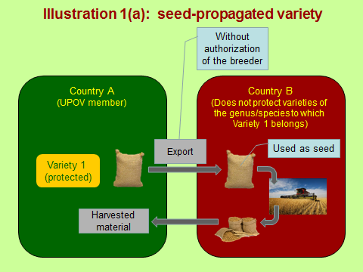
The breeder of Variety 1 can exercise the right on the imported harvested material if there was unauthorized export of propagating material and the breeder did not have a reasonable opportunity in Country A to exercise the right in relation to the export of propagating material (see Article 14(2)).

The breeder’s right is not exhausted in Country A, because of the following acts:

- export of material of the variety, which enables the propagation of the variety, into a country which does not protect varieties of the plant genus or species to which the variety belongs, except where the exported material is for final consumption purposes (see Article 16(1)(ii)), and
- further propagation of the variety in question (see Article 16(1)(i))

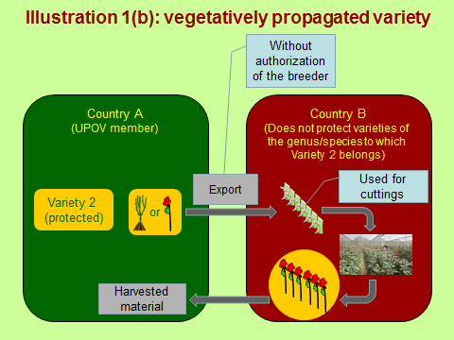
The same explanation applies for Variety 2 as for Variety 1.

Example 2 [see Example 9 in document CAJ­AG/13/8/3]

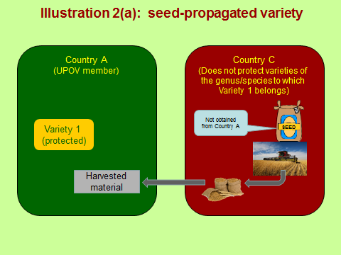
Variety 1 is protected in Country A. However, propagating material of Variety 1 is not produced in Country A and the breeder has no opportunity to exercise the right in relation to the propagating material.

The breeder of Variety 1 can exercise the right on the imported harvested material in Country A because the import of harvested material from Country C is the first opportunity for the breeder to exercise the right.

The right is not exhausted because material of the variety has not been sold or otherwise marketed with the breeder’s consent in Country A.
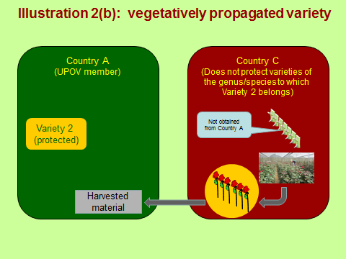
The same explanation applies for Variety 2 as for Variety 1.

Example 3 [see Examples 5 and 6 in document CAJ­AG/13/8/3]

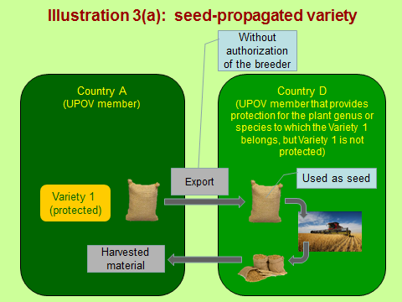
Alternative (a)

The breeder of Variety 1 could seek protection of the variety in Country D. Nevertheless, the breeder of Variety 1 can exercise the right in Country A on the imported harvested material if there was unauthorized export of propagating material and the breeder did not have a reasonable opportunity in Country A to exercise the right in relation to the export of propagating material (see Article 14(2)).

The breeder’s right is not exhausted in Country A, because of further propagation of the variety in question (see Article 16(1)(i)).

Alternative (b)

The breeder of Variety 1 cannot exercise the right on the imported harvested material because the right is exhausted (see Article 16(1)(ii)). ^{and}

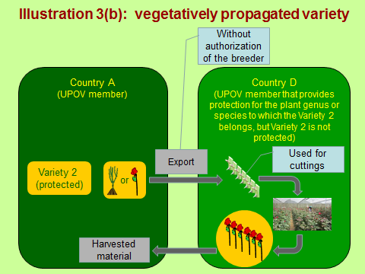
The same explanation applies for Variety 2 as for Variety 1.

Example 4 [see Example 7 in document CAJ­AG/13/8/3]

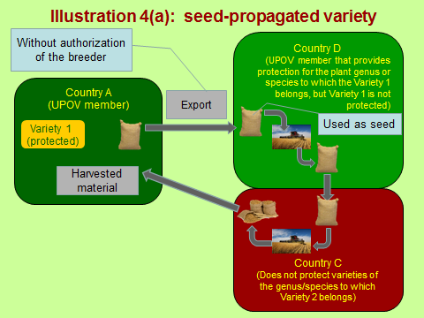
Alternative (a)

The breeder of Variety 1 can exercise the right in Country A on the imported harvested material if there was unauthorized export of propagating material and the breeder did not have a reasonable opportunity in Country A to exercise the right in relation to the export of propagating material (see Article 14(2)).

The breeder’s right is not exhausted in Country A, because of the following acts:

- further propagation of the variety in question (see Article 16(1)(i)), and
- export of material of the variety, which enables the propagation of the variety, into a country which does not protect varieties of the plant genus or species to which the variety belongs, except where the exported material is for final consumption purposes (see Article 16(1)(ii)) xi

Alternative (b)

The breeder of Variety 1 cannot exercise the right on the imported harvested material because the right is exhausted (see Article 16(1)(i)).

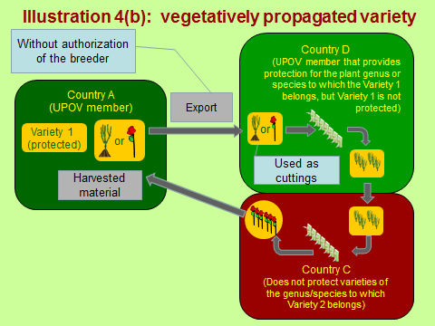
The same explanation applies for Variety 2 as for Variety 1.

Example 5 [see Example 8 in document CAJ­AG/13/8/3]

The breeder of Variety 2 authorizes a propagator in Country A to produce 50,000 plants for sale for cut-flower production. The propagator produces 50,000 plants, which are sold to a grower in Country A. The grower in Country A plants 25,000 plants, but sells 25,000 plants to a grower in Country D (for cut-flower production), where Variety 2 is not protected. The grower in Country D uses the 25,000 plants to propagate further plants of Variety 2.
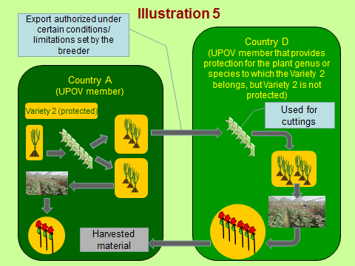
The breeder of Variety 2 did not authorize export of plants for further propagation.

The breeder of Variety 2 can exercise the right on the imported harvested material if there was unauthorized export of propagating material and the breeder did not have a reasonable opportunity in Country A to exercise the right in relation to the export of propagating material.

The breeder’s right is not exhausted in Country A, because of further propagation of the variety in question (see Article 16(1)(i)). ^{and}

Example 6 [see Example 11 in document CAJ­AG/13/8/3]

Variety 1 is protected in Country A. In Country A, an exception under Article 15(2) of the 1991 Act is applicable for variety A, with a limit on the amount of the harvested material which the farmer is allowed to use for propagating purposes. The farmer uses more than the permitted amount for propagating purposes on his own holding without the authorization of the breeder.

Explanation

The breeder of Variety 1 can exercise the right on the harvested material if the breeder did not have a reasonable opportunity to exercise the right in relation to the propagating material (see Article 14(2)).

The breeder’s right is not exhausted because there is “further propagation of the variety in question” (see Article 16(1)(i)).

Example 7 [see Example 10 in document CAJ­AG/13/8/3]

Variety 3 is protected in Country A. In Country A, there is an exception under Article 15(2) of the 1991 Act, but that exception is not applicable for the species to which variety 3 belongs. A farmer uses some of the harvested material of variety 3 for propagating purposes on the farmer’s own holding without the authorization of the breeder.

Explanation

The breeder of Variety 3 can exercise the right on the harvested material if the breeder did not have a reasonable opportunity to exercise the right in relation to the propagating material (see Article 14(2)).

The breeder’s right is not exhausted because there is “further propagation of the variety in question” (see Article 16(1)(i)).

“breeder” means - the person who bred, or discovered and developed, a variety, - the person who is the employer of the aforementioned person or who has commissioned the latter’s work, where the laws of the relevant Contracting Party so provide, or - the successor in title of the first or second aforementioned person, as the case may be; (see Article 1 of the 1991 Act of the UPOV Convention)
Article 16(2) of the 1991 Act of the UPOV Convention states that: “For the purposes of [Article 16] paragraph (1), ‘material’ means, in relation to a variety, “(i) propagating material of any kind, “(ii) harvested material, including entire plants and parts of plants, and “(iii) any product made directly from the harvested material.”
Provided that the breeder has not given consent for the acts concerned.
Provided that the breeder has not given consent for the acts concerned.
Provided that the breeder has not given consent for the acts concerned.
Provided that the breeder has not given consent for the acts concerned.
Provided that the breeder has not given consent for the acts concerned.
Gender neutral term
Comment of the European Seed Association (ESA) (see http://www.upov.int/edocs/mdocs/upov/en/caj_ag_13_8/caj_ag_13_8_www_253728.pdf). “The draft explanatory note (document UPOV/EXN/HRV Draft 10) which was presented to the CAJ and which the CAJ decided to propose for adoption to the UPOV Council [adopted by the Council on October 24, 2013, as document UPOV/EXN/HRV/1] contains the following sentence in paragraph 4: “Thus, unauthorized acts can only occur in the territory of the member of the Union where a breeder’s right has been granted and is in force.” At the same time work in the CAJ-AG has started on the development of illustrative examples regarding the situations in which the breeder could exercise his right on the harvested material. The document CAJ-AG/13/8/3 presenting the illustrative examples recalls the discussions which took place prior to the Diplomatic Conference in 1991 on the extension of the scope to harvested material and proposes to seek explanations to the examples taking into account also the considerations raised in those discussions. Therefore, some of the examples (in particular example 9) presented in document CAJ-AG/13/8/3 concern situations where products are imported into the country where the protection is granted from countries without protection. Such examples would however not fit into the restrictive interpretation included in paragraph 4 (as cited above) of the explanatory note as proposed for adoption to the UPOV Council. “As expressed during the Sixty-Eighth Session of the CAJ, ESA is concerned regarding the room which remains for discussion of illustrative examples after the adoption of the abovementioned interpretation of the notion of „unauthorized use“. Nevertheless, we understand and can follow the explanations given at the Sixty-Eighth Session of the CAJ according to which a revision of the explanatory note on acts in respect of harvested material, and in particular of the interpretation addressed above, remains possible should the discussion on the illustrative examples lead to the conclusion that such revision would be necessary. ESA is therefore confident that the range of examples that can still be discussed in relation to this subject is not going to be limited by the aforementioned paragraph 4.”
Comments of the European Union (see http://www.upov.int/edocs/mdocs/upov/en/caj_ag_13_8/caj_ag_13_8_www_268177.pdf)
Proposal of the Russian Federation (see http://www.upov.int/edocs/mdocs/upov/en/caj_ag_13_8/caj_ag_13_8_www_253207.pdf) “1. Paragraph 5 should be added by the following: ‘Article 16(1)(ii) of the 1991 Act states: ‘The breeder's right shall not extend to acts concerning any material of the protected variety, or of a variety covered by the provisions of Article 14(5), which has been sold or otherwise marketed by the breeder or with his consent in the territory of the Contracting Party concerned, or any material derived from the said material, unless such acts … ‘(ii) involve an export of material of the variety, which enables the propagation of the variety, into a country which does not protect varieties of the plant genus or species to which the variety belongs, except where the exported material is for final consumption purposes.”
Proposal of the Russian Federation (see http://www.upov.int/edocs/mdocs/upov/en/caj_ag_13_8/caj_ag_13_8_www_253207.pdf) “2. It would be applicable paragraph 6 to write down in the following edition: ‘E.g., unauthorized export of propagating material from the territory of a UPOV member, where the breeder's right has been granted and it is in force, into a country which does not protect varieties of the plants genus or species to which the variety belongs, except where the exported material is for final consumption purposes, would be unauthorized act.”
Proposal of the Russian Federation to delete paragraphs 7 and 8 (see http://www.upov.int/edocs/mdocs/upov/en/caj_ag_13_8/caj_ag_13_8_www_253207.pdf) “3. Paragraphs 7 and 8 should be excluded because: “The person who has been authorized (under Article 14(1)((i-vii)) to acts in respect of propagating material, but not kept to the conditions and limitations made by the breeder (under Article 14(1)(b)), was the very infringer. The breeder has reasonable opportunity to exerci se his right on the given batch of the propagating material, having sued to the licensee. The law-abiding farmer having purchased the propagating material from the licensee (violated conditions and limitations of the breeder), has the right to produce harvested material of the variety without any liabilities to the breeder (Article 16 (1)).” (see http://www.upov.int/edocs/mdocs/upov/en/caj_ag_13_8/caj_ag_13_8_www_274004.pdf) “1) When preparing any Explanatory Notes it should be guided by the UPOV Convention provisions but not be tempted to extend breeder’s right on a harvested material produced beyond the territory protected. “It should not be considered in the Explanatory Notes any private treaties including new forms of direct contracts with farmers pretending to profit earning over and above those provided by scope of the breeder’s right in the UPOV Convention.”
Comment of the European Seed Association (see http://www.upov.int/edocs/mdocs/upov/en/caj_ag_13_8/caj_ag_13_8_www_253728.pdf) At the Sixty-Eighth Session of the CAJ comments from the Russian Federation have been distributed and it was concluded that those comments would be addressed by the CAJ-AG. Given that the explanatory note as presented to the CAJ was proposed to the Council for adoption we understand that the comments of the Russian Federation might be considered by the CAJ-AG in the framework of a possible future revision. In this respect, with regard to comment number 3 of the Russian Federation ESA wishes to note that paragraphs 7 and 8 of the explanatory note should not be deleted since it is crucial to clarify in the explanatory note that acts carried out without respecting the conditions of an authorization also constitute „unauthorized use“ for the purpose of Article 14(2) and (3) of the UPOV 1991 Convention. Furthermore, in respect of that comment number 3 of the Russian Federation we would like to draw the attention of the CAJ-AG to the decision of the Court of Justice of the European Union in case C-140/10 (Greenstar-Kanzi Europe) which may provide useful elements for the discussion of this matter.
Comment of the Russian Federation (see http://www.upov.int/edocs/mdocs/upov/en/caj_ag_12_7/comments_russian_federation.pdf) “We consider it is inadmissible in any Explanatory notes to provide with every the Union member to determine ‘reasonable opportunity’ for breeder to exercise ‘his right’. The UPOV Convention provision concerning enforcement of PBR only in the territory where it has been granted should not be revised in Explanatory notes. According to the UPOV Convention it is a norm - if the breeder did not apply and had not protection for his variety, he has no ‘his right’ on acts in respect of propagating material and consequently has no right on acts in respect of harvested material grown in the territory in question and on acts in respect of material exported from the territory to a protection country.”
Comment of the Russian Federation (see http://www.upov.int/edocs/mdocs/upov/en/caj_ag_13_8/caj_ag_13_8_www_253826.pdf) “It is observed in the document [document CAJ-AG/13/8/10] unreasonable PBR expansion on an imported harvested material into PVP country. The reference is made to absence of ‘reasonable opportunity’ of the breeder to control acts in respect of seeds (propagating material) in the territory without PVP. “Extractions from documents CAJ/XXIII/8 and C[A]J/XXIV/6 are only protocol materials of preparatory discussions in the period before 1991 Diplomatic Conference for the UPOV Convention revision and cannot be the basis for development any Explanatory notes, on harvested material in particular. “It is necessary to be guided only by the text of the 1991 Act of the UPOV Convention. (It would be also useful to address to the UPOV Model PVP Law of 1993 2. and to comments to it).” Note: The Model Law on the Protection of New Varieties of Plants (1996) states as follows: “13.9 A variety can be exploited in the country in which it is protected by a breeder’s right without this taking the form, in that country, of production of propagating material or of a trade act related to such material, in other words, without the owner of the breeder’s right being able to exercise his right under paragraph (1) [Article 14(1) of the 1991 Act of the UPOV Convention]. This is the case, for example, when the harvested material is imported. The aim of paragraph (2) [Article 14(2) of the 1991 Act of the UPOV Convention] is to give the holder the possibility of exercising his right in relation to the harvested material under the circumstances defined in this particular paragraph. “13.10 Special attention should be paid to the wording of this provision if it is decided not to use the text of the Convention: the text proposed in the Model Law implies that, in any action for infringement, the defendant will have to prove that the plaintiff (the holder of the right) could reasonably have exercised his right at an earlier stage.” (see http://www.upov.int/edocs/mdocs/upov/en/caj_ag_13_8/caj_ag_13_8_www_274004.pdf) “2) The term ‘reasonable opportunity’ must not be considered in Explanatory Notes on Acts in Respect of Harvested Material. “Act 14 (2) of the UPOV Convention provides the breeder wide opportunities (within provisions of 14(1)) to suppress illegal activities in respect of propagating material which sometime has the place in the territory protected. In case of production of harvested material from the illegal propagating material the breeder according to Act 14(2) has opportunity to claim in court his right on that harvested material. The court only establishes on the base of parties evidence if the breeder had a reasonable opportunity to exercise his right in respect of the propagating material used. The proof of absence of the reasonable opportunity is a matter of the very breeder.”
Comment of the Russian Federation (see http://www.upov.int/edocs/mdocs/upov/en/caj_ag_13_8/caj_ag_13_8_www_253826.pdf) “Example 9. “It would be appropriate to write: ‘Breeder of Variety 1 has PBR in Country A. However propagating material of Variety 1 is not grown up in Country A and, the breeder has no opportunity to exercise his right on acts in respect of propagating material.’ “In this case the breeder has PBR in the country on all batches of imported harvested material of the variety.”
Comments of European Union (see http://www.upov.int/edocs/mdocs/upov/en/caj_ag_13_8/caj_ag_13_8_www_268177.pdf)
Extract from document CAJ-AG/13/8/3: (Note: this alternative assumes that there is exhaustion of the right because there is no “export of material of the variety, which enables the propagation of the variety, into a country which does not protect varieties of the plant genus or species to which the variety belongs, except where the exported material is for final consumption purposes” and assumes that that “further propagation” means propagation that requires the authorization of the breeder, because authorization is not required in Country D. In previous discussions in the CAJ­AG, it was noted that such an explanation implied that there would be less protection for breeders in Country A if harvested material originated from a non-UPOV member with no PVP law compared to a UPOV member, for the same situation, and concluded that such a situation would not have been the intention of the Convention.)
Comment of the Russian Federation (see http://www.upov.int/edocs/mdocs/upov/en/caj_ag_13_8/caj_ag_13_8_www_253826.pdf) “Examples 5 and 6 [Example 3]. “There is protection of genus and species to which Variety 1 belonds in country D. Absence of protection of Variety 1 in country D changes nothing. There is PBR exhaustion under Article 16(1)(ii).”
Comment of the Russian Federation (see http://www.upov.int/edocs/mdocs/upov/en/caj_ag_13_8/caj_ag_13_8_www_253826.pdf) “Example 7 [Example 4]. “The situation in Country F [country D] is similar as ones in Examples 5 and 6 [Example 3]. There is PBR exhaustion on exported batch of seeds.”
Comments of the European Union (see http://www.upov.int/edocs/mdocs/upov/en/caj_ag_13_8/caj_ag_13_8_www_268177.pdf) “Note: In the EU, to prevent exhaustion of a plant breeder's right, the breach of contract (no respect of the conditions and limitations set out in the licensing contract with the breeder) must relate to an essential aspect of the plant breeder's right (e.g. CJEU court case C-140/10). Further propagation is considered to be an essential element of the plant breeder's right. Therefore further propagation (to propagate more than the terms of the contract) will not result in the exhaustion of the plant breeder's right.”
Comment of the Russian Federation (see http://www.upov.int/edocs/mdocs/upov/en/caj_ag_13_8/caj_ag_13_8_www_253826.pdf) “Example 8 [Example 5]. “There were no infringements when exporting of saplings from country H [country A]. Country I [country D] provides protection for genus and species to which Variety 3 belongs. Protection absence for the variety does not change anything. “If cut flowers in Country H [country A] are used as propagating material the breeder can exercise his right on the import of cutting into Country H [country A].” [End of document]

