 |  | E  CAJ-AG/12/7/6  ORIGINAL: English  DATE: October 30, 2012
INTERNATIONAL UNION FOR THE PROTECTION OF NEW VARIETIES OF PLANTS
Geneva
Administrative and Legal Committee Advisory Group
Seventh Session
Geneva, October 29 and 30, 2012
report on the conclusions
adopted by the Administrative and Legal Committee Advisory Group
Opening of the session

1 The Administrative and Legal Committee Advisory Group (CAJ-AG) held its seventh session in Geneva on October 29, 2012, starting at 2.30 p.m. and October 30, 2012, under the Chairmanship of the Vice Secretary-General of UPOV.

2 The list of participants is reproduced in the Annex to this document. In addition to the ad hoc invitations for the International Community of Breeders of Asexually Reproduced Ornamental and Fruit Varieties (CIOPORA), European Coordination Via Campesina (ECVC), and International Seed Federation (ISF), agreed by the CAJ-AG at its sixth session which was held in Geneva on October 18, 2011, (see paragraph 14 of document CAJ/66/2), the CAJ-AG had agreed by correspondence to invite the Association for Plant Breeding for the Benefit of Society (APBREBES) to attend the relevant part of the CAJ-AG to present its views on the participation of observers in the CAJ-AG.

Adoption of the agenda and of the draft schedule

3 The CAJ-AG approved the draft schedule for the seventh session of the CAJ-AG as set out in document CAJ-AG/12/7/ INF. On the afternoon of October 29, 2012, at 3.00 p.m., the CAJ-AG discussed the agenda items in the presence of the above mentioned observers. The CAJ-AG continued discussions at 4.30 p.m. and on October 30, 2012, without the presence of the observers.

4 The CAJ-AG adopted the draft agenda, after moving agenda item 6 “Explanatory Notes on Propagation and Propagating Material” (document CAJ-AG/12/7/4) after agenda item 3(b).

5 The CAJ-AG noted that the comments on relevant explanatory notes from: the Russian Federation (comments of October 29), CIOPORA (comments of October 4 and of October 15, 2012), European Seed Association (ESA) (comments of October 8, 2012) and ISF (comments of October 15, 2012) had been notified to the CAJ and CAJ-AG and posted in the CAJ-AG website.

Discussions in the presence of observers

6 The CAJ-AG agreed that the report on discussions in the presence of observers would be presented in the draft full report and noted that the observers would be invited to comment on the draft of the relevant section of the report.

Discussions without the presence of observers

Explanatory Notes

Explanatory Notes on the Definition of Breeder under the 1991 Act of the UPOV Convention

7 The CAJ-AG considered documents UPOV/EXN/BRD Draft 5 and CAJ-AG/12/7/2, the comments as set out in paragraph 5 and the views expressed by ECVC.

8 The CAJ-AG agreed the following concerning document UPOV/EXN/BRD Draft 5:

Paragraph 4 | to read as follows: “The term ‘person’ in Article 1(iv) of the 1991 Act of the UPOV Convention should be understood to embrace both physical and legal persons. The term person refers to one or more persons. For the purpose of this document, legal person refers to an entity with rights and obligations in accordance with the legislation of the member of the Union concerned. ”
Paragraph 9 | to read as follows: “With regard to ‘discovered and developed’, a discovery might be the initial step in the process of breeding a new variety. However, the term ‘discovered and developed’ means that a mere discovery, or find, would not entitle the person to obtain a breeder’s right. Development of plant material into a variety is necessary for a breeder to be entitled to obtain a breeder’s right. A person would not be entitled to protection of an existing variety that was discovered and propagated unchanged by that person.”

9 The CAJ-AG agreed that, on the basis of the above amendments, the Office of the Union should prepare a revised version of document UPOV/EXN/BRD Draft 5, to be considered by the CAJ at its sixty-seventh session, to be held in Geneva on March 21, 2013.

10 In relation to the views expressed by ECVC, the CAJ-AG agreed that it would not be appropriate to include reference to “prior informed consent” and “access to genetic-resources and benefit-sharing” in Explanatory Notes under the UPOV Convention.

Explanatory Notes on Acts in Respect of Harvested Material under the 1991 Act of the UPOV Convention

11 The CAJ-AG considered documents UPOV/EXN/HRV Draft 8 and CAJ-AG/12/7/2, the comments as set out in paragraph 5 and the views expressed by CIOPORA, ECVC and ISF.

12 The CAJ-AG agreed the following concerning document UPOV/EXN/HRV Draft 8:

Paragraph 11 | to read as follows: “Where a member of the Union decides to incorporate this optional exception into its legislation, ‘unauthorized use’ would not refer to acts that were covered by the optional exception. Subject to Articles 15 (1) and 16, ‘unauthorized use’ would refer to acts that were not covered by the optional exception in the legislation of the member of the Union concerned. In particular, ‘unauthorized use’ would refer to acts that did not comply with the terms and conditions of the optional exception.”
Paragraph 12 | to read as follows: “The provisions under Article 14(2) of the 1991 Act mean that breeders can only exercise their rights in relation to the harvested material if they have not been able had a ‘reasonable opportunity’ to exercise their rights in relation to the propagating material.”
Paragraph 13 | to read as follows: “The term ‘his right’, in Article 14(2) of the 1991 Act, relates to the breeder’s right in the territory concerned (see paragraph 6 above): a breeder can only exercise his right in that territory. Thus, ‘exercise his right’ in relation to the propagating material means to exercise his right in relation to the propagating material in the territory concerned. It is a matter for each member of the Union to determine what constitutes “reasonable opportunity” to exercise his right.”

13 The CAJ-AG agreed that the comments made by ECVC would not be relevant for inclusion in the Explanatory Notes on Acts in Respect of Harvested Material.

14 The CAJ-AG agreed that on the basis of the above amendments, the Office of the Union should prepare a revised version of document UPOV/EXN/HRV Draft 8, to be considered by the CAJ at its sixty-seventh session, to be held in Geneva on March 21, 2013. The CAJ-AG further agreed to propose to the CAJ that the CAJ-AG be invited to immediately start work on illustrative examples for a future possible revision. The CAJ-AG also agreed to propose to the CAJ that the CAJ-AG be invited to consider the development of guidance on “reasonable opportunity”.

Explanatory Notes on Propagation and Propagating Material

15 The CAJ-AG considered document CAJ-AG/12/7/4, the comments as set out in paragraph 5 and the presentations and views expressed by CIOPORA and ISF.

16 The CAJ-AG agreed that the Office of the Union should prepare a draft “Explanatory Note on Propagation and Propagating Material Under the 1991 Act of the UPOV Convention” for consideration at its eighth session. The basis of the Explanatory Note would be:

(a) to explain forms of material that could be propagating material, including an explanation on the basis of document UPOV/EXN/HRV Draft 8 that “some forms of harvested material have the potential to be used as propagating material”, in a similar way to that explained in the “Model Law on the Protection of New Varieties of Plants” (“Model Law” - UPOV Publication No. 842), Section 1.19;

(b) to provide a non-exhaustive list of factors that might be considered in deciding whether material is propagating material, such as:

(i) whether the material has been used to propagate the variety;
(ii) whether the material is capable of producing entire plants of the variety;
(iii) whether there has been a custom/practice of using the material for that purpose;
(iv) the intention on the part of those concerned (producer, seller, buyer, user); and
(v) whether the plant material is suitable for reproducing the variety unchanged.

17 It was noted that the list above was a tentative, initial list that would require further consideration. It was also agreed that, in the preparation of the draft Explanatory Note by the Office of the Union, CIOPORA and ISF should be invited to provide additional factors.

Explanatory Notes on Essentially Derived Varieties under the 1991 Act of the UPOV Convention (revision)

18 The CAJ-AG considered documents CAJ-AG/12/7/3 and UPOV/EXN/EDV/2 Draft 2, the comments as set out in paragraph 5 and the views expressed by CIOPORA, ECVC and ISF.

Revision of the “Explanatory Notes on Essentially Derived Varieties Under the 1991 Act of the UPOV Convention” (document UPOV/EXN/EDV/2 Draft 2)

19 The CAJ-AG agreed the following concerning document UPOV/EXN/EDV/2 Draft 2:

Figure 4 | First box to read as follows:  Initial Variety “A”  (NOT PROTECTED)  bred and protected by Breeder 1

20 The CAJ-AG agreed that, on the basis of the text provided by ISF (document CAJ-AG/12/7/3, paragraph 8, reproduced below) with suitable amendments, the Office of the Union should prepare a text on the possibility to use molecular marker data information of an initial variety to obtain essentially derived varieties to be considered for by the CAJ-AG at its eighth session, to be held in October 2013.

“The collection of molecular data from the initial variety and the subsequent application of the obtained DNA profiles with the explicit intention to select for similar genotypes in a particular population, which is mostly related to the initial variety, may also be regarded as predominant derivation from the initial variety. Therefore, for the purpose of EDV assessment, “predominant derivation” may result from: i) The use of –mainly- the plant material of an initial variety for selection or (back) crossing followed by selection in the breeding process, or ii) The use of molecular marker data, collected from an initial variety, for the purpose of selection of genotypes close or similar to the genotype of the initial variety, or in the case of hybrids, close or similar to the genotype of its parent lines.”

21 The CAJ-AG agreed that on the basis of the above amendments, the Office of the Union should prepare a revised version of document UPOV/EXN/EDV/2 Draft 2, to be considered by the CAJ at its sixty-seventh session, to be held in Geneva on March 21, 2013.

The relationship between Article 14(5)(b)(i) and (iii) of the 1991 Act of the UPOV Convention

22 CAJ-AG agreed that, on the basis of the explanatory note 6(ii) on Article 5 “Effects of the Right Granted to the Breeder” presented in document IOM/IV/2 (document CAJ-AG/12/7/3, paragraph 11, reproduced below), the Office of the Union should prepare draft guidance on the relationship between Article 14(5)(b)(i) and (iii) of the 1991 Act of the UPOV Convention for consideration by the CAJ-AG at its eighth session, to be held in October 2013.

[Extract of the explanatory notes on Article 5 “Effects of the Right Granted
to the Breeder” presented in document IOM/IV/2,
“Revision of the Convention”]

“5. Paragraph 3. – This paragraph introduces a new concept into the law of plant variety protection: the exploitation – but not the breeding – of a variety that is essentially derived from a protected variety would be subject to the right granted to the breeder of the latter variety (‘dependence’).

“6. The Committee has not yet taken a final position on the question whether the word ‘single’ would be inserted or omitted; at the present stage of the discussions, there seems to be general agreement on the fact that the following conditions should be met for there to be dependence:

“[…]

“(ii) the derived variety must retain almost the totality of the genotype of the mother variety and be distinguishable from that variety by a very limited number of characteristics (typically by one)

“[…]”

Matters concerning essentially derived varieties arising after the grant of a breeder’s right

23 The CAJ-AG noted the presentation by the Delegation of the European Union made to the CAJ-AG at its seventh session.

24 The CAJ-AG agreed that, at an appropriate future meeting of the CAJ-AG, the Delegations of Australia, Brazil and the European Union and other members of the Union would be invited to make presentations on their systems concerning essentially derived varieties.

Matters arising after the grant of a breeder’s right

25 The CAJ-AG considered document CAJ-AG/11/6/4.

26 The CAJ-AG considered that it would be appropriate to develop further guidance in separate documents for the following matters, on the basis of the relevant sections in document CAJ-AG/11/6/4:

(a) Cancellation of the breeder’s right;
(b) Nullity of the breeder’s right;
(c) Variety denominations; and
(d) Variety descriptions.

27 The CAJ-AG agreed that the Office of the Union should seek clarification on the issues that the European Union and the Russian Federation intended to be covered in relation to possible further guidance on provisional protection.

28 The CAJ-AG agreed that the Office of the Union should seek clarification on the issues that the Russian Federation intended to be covered in relation to possible further guidance on filing of applications and enforcement of breeders’ rights.

29 It the light of other developments and matters considered by relevant guidance under consideration the CAJ-AG agreed not to continue discussions on:

(e) Material covered by the breeder’s right;
(f) Essentially derived varieties;
(g) Exhaustion of the breeder’s right;
(k) Providing information on varieties covered by the breeder’s right.

Matters referred by the CAJ to the CAJ-AG for consideration since the sixth session of the CAJ-AG

30 The CAJ-AG considered document CAJ-AG/12/7/5.

31 With regard to the request of the CAJ to consider the suggestion to include a limited number of permanent places for observers representing various stakeholder groups such as farmers, breeders and certain other observer non-governmental organizations (NGOs) in the CAJ-AG and to allow the stakeholder groups to coordinate on the persons to occupy those places at each session of the CAJAG, according to the matters under consideration, the CAJ-AG noted that document UPOV/INF/7 “Rules of Procedure of the Council”, Rules 36 and 20, states as follows:

“Rule 36: Establishment of Committees

“(1) The Council may set up permanent or temporary committees to prepare its work or to examine technical, legal or any other questions of interest to UPOV.

“(2) When setting up any committees, the Council shall establish the terms of reference of that committee and shall determine whether and to what extent observers will be invited to the meetings of the committee; the Council may, at any time, decide changes in the initials terms of reference and in the decision concerning observers.”

“Rule 20: Observers and Experts

“(1) Observers and experts may take part in debates at the invitation of the chairman.

“(2) They may not submit proposals, amendments or motions, and have no right to vote.”

32 The CAJ-AG agreed that it, in that context, the CAJ-AG should seek further guidance from the CAJ before making a proposal.

Date and program for the eighth session

33 Subject to approval by the Administrative and Legal Committee (CAJ) at its sixty-seventh session, to be held on March 21, 2013, the CAJ-AG agreed the following program for its eighth session, to be held in October 2013:

1. Opening of the session

2. Adoption of the agenda

3. Explanatory Notes on Essentially Derived Varieties under the 1991 Act of the UPOV Convention (revision)

4. Explanatory Notes on Propagation and Propagating Material

5. Possible revision on cancellation of the breeder’s right

6. Possible revision on Nullity of the breeder’s right

7. Possible revision on Variety denominations

8. Possible revision on Variety descriptions

9. Matters arising after the grant of a breeder’s right on: provisional protection, filing of applications and enforcement of breeders’ rights.

10. Matters referred by the CAJ to the CAJ-AG for consideration since the seventh session of the CAJ-AG
11. Date and program for the ninth session

34 The CAJ-AG noted that subject to any changes that the CAJ might agree at its sixty-seventh session, to be held on March 21, 2013, the sixty-eighth session of the CAJ would be held on October 21 and 22, 2013, and that the eighth session of the CAJ-AG would be held on October 25, 2013.

[Annex follows]

CAJ-AG/12/7/6

ANNEXE / ANNEX / ANLAGE / ANEXO

LISTE DES PARTICIPANTS / LIST OF PARTICIPANTS /
TEILNEHMERLISTE / LISTA DE PARTICIPANTES

(dans l’ordre alphabétique des noms français des membres/
in the alphabetical order of the names in French of the members/
in alphabetischer Reihenfolge der französischen Namen der Mitglieder/
por orden alfabético de los nombres en francés de los miembros)
i. MEMBRES / MEMBERS / VERBANDSMITGLIEDER / MIEMBROS
ALLEMAGNE / GERMANY / DEUTSCHLAND / ALEMANIA
 |  |  |  | Michael KÖLLER, Referent, Ministerium für Ernährung, Landwirtschaft und Verbraucherschutz, Wilhelmstrasse 54, 10117 Berlin  (tel.: +49 30 18529 4044 e-mail: Michael.Koeller@bmelv.bund.de)
 |  |  |  | Barbara SOHNEMANN (Frau), Justiziarin, Leiterin, Rechtsangelegenheiten, Sortenverwaltung, Gebühren, Bundessortenamt, Postfach 610440, 30604 Hannover  (tel.: +49 511 95665624 fax: +49 511 95669600 e-mail: barbara.sohnemann@bundessortenamt.de)
AUSTRALIE / AUSTRALIA / AUSTRALIEN / AUSTRALIA
 |  |  |  | Doug WATERHOUSE, Chief, Plant Breeder's Rights Office, IP Australia, 47 Bowes Street, Phillip ACT 2606  (tel.: +61 2 6283 7981 fax: +61 2 6283 7999 e-mail: doug.waterhouse@ipaustralia.gov.au)
BELGIQUE / BELGIUM / BELGIEN / BÉLGICA
 |  |  |  | Françoise DE SCHUTTER (Mme), Attachée, Office belge de la Propriété intellectuelle (OPRI), 16, bvd Roi Albert II, B-1000 Bruxelles  (tel.: 32 2 277 9555 e-mail: francoise.deschutter@economie.fgov.be)
BOLIVIE (ÉTAT PLURINATIONAL DE) / BOLIVIA (PLURINATIONAL STATE OF) /
BOLIVIEN (PLURINATIONALER STAAT) / BOLIVIA (ESTADO PLURINACIONAL DE)
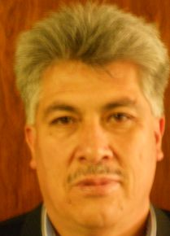 |  |  |  | Sergio Rider ANDRADE CÁCERES, Director Nacional de Semillas del INIAF, Instituto Nacional de Innovación Agropecuaria y Forestal (INIAF), Avenida 6 de agosto, Nro. 2170, Edificio Hoy, Mezanine, 4793 La Paz  (tel.: +591 2 2441153 fax: +591 2 2441153 e-mail: rideran@yahoo.es)
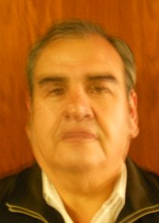 |  |  |  | Freddy CABALLERO LEDEZMA, Responable: Unidad de Fiscalización y Registros, Fiscalización y Registros de Semillas, Instituto Nacional de Innovación Agropecuaria y Forestal (INIAF), Capitán Ravelo No. 2329, Belisario Salinas, No. 490, 4793 La Paz  (tel.: +591 2 2441153 fax: +591 2 2441153 e-mail: calefred@yahoo.es)
Luis Fernando ROSALES LOZADA, Primer Secretario, Misión Permanente, 139, rue de Lausanne, 1202 Ginebra
(tel.: +41 22 908 0717 fax: +41 22 908 0722 e-mail: fernando.rosales@bluewin.ch)
BRÉSIL / BRAZIL / BRASILIEN / BRASIL
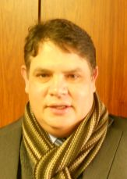 |  |  |  | Helcio CAMPOS BOTELHO, Director, Department of Intellectual Property and Agricultural Technology, Secretariat of Agricultural Development and Cooperativism, Ministério da Agricultura, Livestock and Food Supply, Esplanada dos Ministérios, Bloco 'D', Anexo A, Sala 233, Brasilia, D.F.70043-900  (tel.: +55 61 3218 5202 fax: +55 61 3321 4524 e-mail: helcio.botelho@agricultura.gov.br)
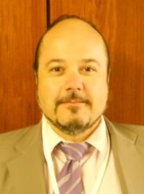 |  |  |  | Luís Gustavo ASP PACHECO, Federal Agricultural Inspector, National Plant Variety Protection Office (SNPC), Ministry of Agriculture, Livestock and Food Supply, Esplanada dos Ministerios, Bloco 'D', Anexo A, sala 250, CEP 70043-900 Brasilia , D.F.  (tel.: +55 61 3218 2461 fax: +55 61 3224 2842 e-mail: luis.pacheco@agricultura.gov.br)
CANADA / CANADA / KANADA / CANADÁ
 |  |  |  | Sandy MARSHALL (Ms.), Senior Policy Specialist, Plant Breeders' Rights Office, Canadian Food Inspection Agency (CFIA), 59 Camelot Drive, Ottawa Ontario K1A 0Y9  (tel.: +1 613 773 7134 fax: +1 613 773 7261 e-mail: sandy.marshall@inspection.gc.ca)
CHILI / CHILE / CHILE / CHILE
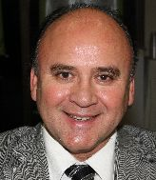 |  |  | Jaime IBIETA S., Director, División Semillas, Servicio Agrícola y Ganadero (SAG), Ministerio de Agricultura, Avda. Presidente Bulnes 140, piso 2, Santiago de Chile  (tel.: +56 2 345 1561 fax: +56 2 697 2179 e-mail: jaime.ibieta@sag.gob.cl)
CHINE / CHINA / CHINA / CHINA
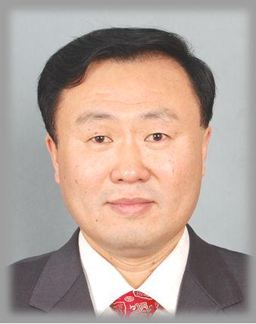 |  |  |  | LV Bo, Director, Division of Variety Management, Bureau of Seed Management, Ministry of Agriculture, No. 11 Nongzhanguannanli, Beijing  (tel.: +86 10 59193150 fax: +86 10 59193142 e-mail: lvbo@agri.gov.cn)
 |  |  |  | Xiaohong YAO (Mrs.), Deputy Division Director, State Intellectual Property Office of P.R. China, International Cooperation Department SIPO, 6 Xitucheng Road Haiden District, 100088 Beijing  (tel.: +86 10 59193150 fax: +86 10 59193142 e-mail: yaoxiaohong@sipo.gov.cn)
COLOMBIE / COLOMBIA / KOLUMBIEN / COLOMBIA
 |  |  |  | Ana Luisa DÍAZ JIMÉNEZ (Sra.), Directora Técnica de Semillas, Dirección Técnica de Semillas, Instituto Colombiano Agropecuario (ICA), Carrera 41 No. 17-81, Piso 4°, Bogotá D.C.  (tel.: +57 1 3323700 fax: +57 1 3323700 e-mail: ana.diaz@ica.gov.co)
DANEMARK / DENMARK / DÄNEMARK / DINAMARCA
 |  |  |  | Gerhard DENEKEN, Head, Department of Variety Testing, The Danish AgriFish Agency (NaturErhvervestyrelsen), Ministry of Food, Agriculture and Fisheries, Teglvaerksvej 10, Tystofte, DK-4230 Skaelskoer  (tel.: +45 5816 0601 fax: +45 58 160606 e-mail: gde@naturerhverv.dk)
ESPAGNE / SPAIN / SPANIEN / ESPAÑA
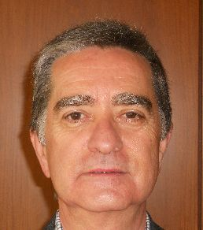 |  |  |  | Luis SALAICES, Jefe de Área del Registro de Variedades, Oficina Española de Variedades Vegetales (OEVV), Ministerio de Agricultura, Alimentación y Medio Ambiente, Calle Alfonso XII, No. 62, 2a Planta, E-28014 Madrid  (tel.: +34 91 3476712 fax: +34 91 3476703 e-mail: luis.salaices@magrama.es)
ESTONIE / ESTONIA / ESTLAND / ESTONIA
 |  |  |  | Renata TSATURJAN (Ms.), Chief Specialist, Plant Production Bureau, Ministry of Agriculture, 39/41 Lai Street, EE-15056 Tallinn  (tel.: +372 625 6507 fax: +372 625 6200 e-mail: renata.tsaturjan@agri.ee)
ÉTATS-UNIS D'AMÉRIQUE / UNITED STATES OF AMERICA /
VEREINIGTE STAATEN VON AMERIKA / ESTADOS UNIDOS DE AMÉRICA
 |  |  |  | Kitisri SUKHAPINDA (Ms.), Patent Attorney, Office of Policy and External Affairs, United States Patent and Trademark Office (USPTO), Madison Building, West Wing, 600 Dulany Street, MDW 10A30, Alexandria VA 22313  (tel.: +1 571 272 9300 fax: + 1 571 273 0085 e-mail: kitisri.sukhapinda@uspto.gov)
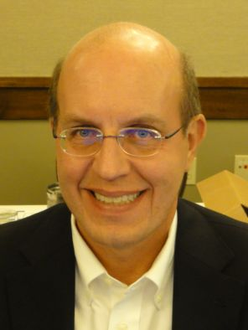 |  |  |  | Paul M. ZANKOWSKI, Commissioner, Plant Variety Protection Office, United States Department of Agriculture (USDA), National Agricultural Library (NAL), 10301, Baltimore Ave., Beltsville MD 20705  (tel.: +1 301 504 5518 fax: +1 301 504 5291 e-mail: paul.zankowski@ams.usda.gov)
 |  |  |  | Minna MOEZIE (Ms.), Patent Attorney, Office of External Affairs, U.S. Patent and Trademark Office (USPTO), U.S. Department of Commerce, United States Patent and Trademark Office (USPTO), Department of Commerce, P.O. Box 1450, Alexandria VA 22313-1450  (tel.: +1 571 272 9300 fax: +1 571 273 0085 e-mail: minna.moezie@uspto.gov)
 |  |  |  | Ruihong GUO (Ms.), Associate Administrator, Agricultural Marketing Service, 1400 Independence Avenue, SW, Room 3071, Washington D.C. D.C.  (tel.: 202 720 5115 fax: 202 720 8477 e-mail: ruihong.guo@ams.usda.gov)
 |  |  |  | Karin L. FERRITER (Ms.), Intellectual Property Attaché, United States Mission to the WTO, 11, route de Pregny, 1292 Chambesy  (tel.: +41 22 749 5281 e-mail: karin_ferriter@ustr.eop.gov)
FRANCE / FRANCE / FRANKREICH / FRANCIA
 |  |  |  | Mlle Virginie BERTOUX, Ingénieur GEVES, Instance nationale des obtentions végétales (INOV), Groupe d'étude et de contrôle des variétés et des semences (GEVES), 25 Rue Georges Morel, CS 90024  (tel.: +33 2 41 22 86 49 fax: +33 2 41 22 86 01 e-mail: virginie.bertoux@geves.fr)
HONGRIE / HUNGARY / UNGARN / HUNGRÍA
 |  | Ágnes Gyözöné SZENCI (Mrs.), Senior Chief Advisor, Agricultural Department, Ministry of Agriculture and Rural Development, Kossuth Tér. 11, H-1055 Budapest, Pf. 1  (tel.: +36 1 7953826 fax: +36 1 7950498 e-mail: gyozone.szenci@vm.gov.hu)
 |  | Szabolcs FARKAS, Head, Patent Department, Hungarian Intellectual Property Office (HIPO), 2, Garibaldi utea, H-1054 Budapest  (tel.: +36 1 4745902 fax: +36 1 474 5596 e-mail: szabolcs.farkas@hipo.gov.hu)
 |  | Katalin MIKLO (Ms.), Head, Agriculture and Plant Variety Protection Section, Hungarian Intellectual Property Office, Garibaldi U. 2., H-1054 Budapest  (tel.: 36 1 474 5898 fax: 36 1 474 5850 e-mail: katalin.miklo@hipo.gov.hu)
IRLANDE / IRELAND / IRLAND / IRLANDA
 |  |  |  | Donal COLEMAN, Controller of Plant Breeders' Rights, Department of Agriculture, National Crops Centre, Backweston Farm, Leixlip , Co. Kildare  (tel.: +353 1 630 2902 fax: +353 1 628 0634 e-mail: donal.coleman@agriculture.gov.ie)
ISRAËL / ISRAEL / ISRAEL / ISRAEL
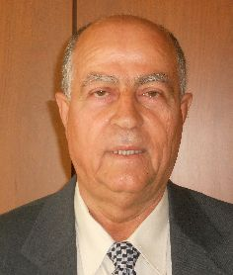 |  |  |  | Omar ZEIDAN, Chairman of PBR Council, Deputy Diretor Extension Services, Ministry of Agriculture, P.O. Box 28, Beit-Dagan 50250  (tel.: +972 3 9485948 fax: +972 3 9485668 e-mail: ozaidan@shaham.moag.gov.il)
Michal GOLDMAN (Mrs.), Registrar, Plant Breeder's Rights Council, Ministry of Agriculture, P.O. Box 30, Beit-Dagan 50250
(tel.: +972 3 9485902 fax: +972 3 9485903 e-mail: michalg@moag.gov.il)
JAPON / JAPAN / JAPAN / JAPÓN
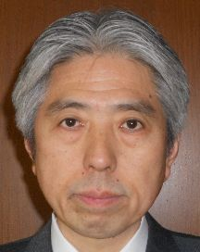 |  |  |  | Takashi UEKI, Director, Plant Variety Protection Office, New Business and Intellectual Property Division, Food Industry Affairs Bureau, Ministry of Agriculture, Forestry and Fisheries, 1-2-1 Kasumigaseki, Chiyoda-ku, 100-8950 Tokyo  (tel.: +81 3 6738 6444 fax: +81 3 3502 5301 e-mail: takashi_ueki@nm.maff.go.jp)
 |  |  |  | Akiko NAGANO (Ms.), Associate Director, New Business and Intellectual Property Division Food Industry Affairs Bureau Ministry of Agriculture, Forestry and Fisheries (MAFF),  (tel.: +81-3-6738-6444 fax: +81-3-3502-5301 e-mail: akiko_nagano@nm.maff.go.jp)
kenya / kenya / kenia / kenya
Simon Mucheru MAINA, Senior Inspector, Kenya Plant Health Inspectorate Service (KEPHIS), P.O. Box 8145, 30100 Eldoret
(tel.: +254 722 427 718 e-mail: smaina@kephis.org)
LETTONIE / LATVIA / LETTLAND / LETONIA
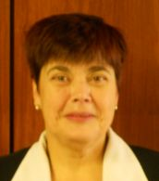 |  |  |  | Sofija KALININA (Mrs.), Senior Officer, Seed Control Department, Division of Seed Certification and Plant Variety Protection, State Plant Protection Service, Lielvardes iela 36/38, LV-1006 Riga  (tel.: +371 673 65568 fax: +371 673 65571 e-mail: sofija.kalinina@vaad.gov.lv)
LITUANIE / LITHUANIA / LITAUEN / LITUANIA
 |  |  |  | Arvydas BASIULIS, Deputy Director, State Plant Service under the Ministry of Agriculture of the Republic of Lithuania, Ozo 4A, LT-08200 Vilnius  (tel.: +370 5 237 5611 fax: +370 5 273 0233 e-mail: arvydas.basiulis@vatzum.lt)
 |  |  |  | Sigita JUCIUVIENE (Mrs.), Head, Division of Plant Variety, Registration and Legal Protection, State Plant Service under the Ministry of Agriculture of the Republic of Lithuania, Ozo St. 4a, LT-08200 Vilnius  (tel.: +370 5 234 3647 fax: +370 5 237 0233 e-mail: sigita.juciuviene@vatzum.lt)
MAROC / MOROCCO / MAROKKO / MARRUECOS
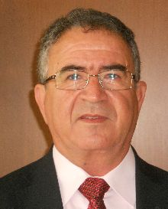 |  |  |  | Amar TAHIRI, Chef de la Division du contrôle des semences et plants, Office National de Sécurité sanitaire des Produits alimentaires (ONSSA), Ministère de l'Agriculture et de la Pêche Maritime, Rue Hafiane Cherkaoui, B.P. 1308, Rabat-Instituts  (tel.: +212 537 771085fax: +212 537 779852 e-mail: amar.tahiri@gmail.com)
MEXIQUE / MEXICO / MEXIKO / MÉXICO
 |  |  |  | Enriqueta MOLINA MACÍAS (Srta.), Directora General, Servicio Nacional de Inspección y Certificación de Semillas (SNICS), Secretaría de Agricultura, Ganadería, Desarrollo Rural, Pesca y Alimentación (SAGARPA), Av. Presidente Juárez, 13, Col. El Cortijo, Tlalnepantla, Estado de México54000  (tel.: +52 55 3622 0667 fax: +52 55 3622 0670 e-mail: nriqueta.molina@sagarpa.gob.mx)
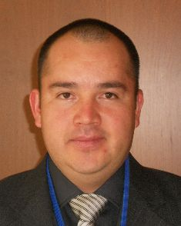 |  |  |  | Eduardo PADILLA VACA, Subdirector, Registro y Control de Variedades Vegetales, Servicio Nacional de Inspección y Certificación de Semillas (SNICS), Av. Presidente Juárez 13, Col. El Cortijo, 54000 Tlalnepantla , Estado de México  (tel.: +52 55 3622 0667 fax: +52 55 3622 0670 e-mail: eduardo.padilla@snics.gob.mx)
NORVÈGE / NORWAY / NORWEGEN / NORUEGA
Marianne SMITH (Ms.), Senior Executive Officer, Royal Ministry of Agriculture, P.O. Box 8007 Dep., N-0030 Oslo
(tel.: +47 22 24 9264 fax: +47 22 24 9559 e-mail: marianne.smith@lmd.dep.no)
 |  |  |  | Tor Erik JØRGENSEN, Head of Section, Norwegian Food Safety Authority, Felles postmottak, P.O. Box 383, N-2381 Brumunddal  (tel.: +47 6494 4393 fax: +47 6494 4411 e-mail: tor.erik.jorgensen@mattilsynet.no)
 |  |  |  | Bell Batta TORHEIM (Mrs.), Programme Coordinator, The Development Fund, Grensen 9b, Miljohuset, N-0159 Oslo  (tel.: +47 23 109600 fax: +47 23 109601 e-mail: bell@utviklingsfondet.no)
NOUVELLE-ZÉLANDE / NEW ZEALAND / NEUSEELAND / NUEVA ZELANDIA
 |  |  |  | Christopher J. BARNABY, Assistant Commissioner / Principal Examiner, Plant Variety Rights Office, Intellectual Property Office of New Zealand, Private Bag 4714, Christchurch 8140  (tel.: +64 3 9626206 fax: +64 3 9626202 e-mail: Chris.Barnaby@pvr.govt.nz)
PARAGUAY / PARAGUAY / PARAGUAY
 |  | Dolía Melania GARCETE GONZALEZ (Sra.), Directora, Dirección de Semillas (DISE), Servicio Nacional de Calidad y Sanidad Vegetal y de Semillas (SENAVE), Gaspar Rodriguez de Francia No. 685, e/ Julia Miranda Cueto y R. Mariscal Estigarribia, Asunción (tel.: +595 21 577243 / 584645 fax: +595 21 582201  e-mail: dolia.garcete@senave.gov.py)
 |  | Roberto ROJAS GONZALEZ, Director, Asesoría Jurídica del Servicio Nacional de Calidad Sanidad Vegetal y de Semillas (SENAVE), Humaita No. 145 entre Nstra, Señora de Asunción e Independencia, Asunción  (tel.: 595 21 496072 fax: 595 21 496072 e-mail: roberto.rojas@senave.gov.py)
PAYS-BAS / NETHERLANDS / NIEDERLANDE / PAÍSES BAJOS
 |  |  |  | Marien VALSTAR, Sector Manager Seeds and Plant Propagation Material, Ministerie van Economische Zaken, Landbouw en Innovatie, P.O. Box 20401, NL-2500 EK Den Haag  (tel.: +31 70 379 8911 fax: +31 70 378 6153 e-mail: m.valstar@minlnv.nl)
 |  |  |  | Krieno Adriaan FIKKERT, Secretary, Plant Variety Board (Raad voor Plantenrassen), Postbus 40, NL-2370 AA Roelofarendsveen  (tel.: +31 71 3326310 fax: +31 71 3326363 e-mail: k.fikkert@naktuinbouw.nl)
 |  |  |  | Groenewoud KEES JAN, Secretary to the Plant Variety Board, Postbus 40, NL-2370 AA Roelofarendsveen  (tel.: +31713326310 fax: +31713326363)
 |  |  |  | Vera OSTENDORF (Ms.), Jurist, Ministry of Agriculture, Nature and Food Quality, P.O. Box 20401, NL-2500 EK Den Haag  (tel.: +31 70 378 4180 fax: +31 70 378 6127 e-mail: v.i.ostendorf@minlnv.nl)
POLOGNE / POLAND / POLEN / POLONIA
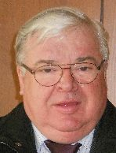 |  |  |  | Edward S. GACEK, Director, Research Centre for Cultivar Testing (COBORU), PL-63-022 Slupia Wielka  (tel.: +48 61 285 2341 fax: +48 61 285 3558 e-mail: e.gacek@coboru.pl)
 |  |  |  | Marcin BEHNKE, Vice Director General, Research Centre for Cultivar Testing (COBORU), PL-63-022 Slupia Wielka  (tel.: +48 61 285 2341 fax: +48 61 285 3558 e-mail: m.behnke@coboru.pl)
RÉPUBLIQUE DE CORÉE / REPUBLIC OF KOREA / REPUBLIK KOREA / REPÚBLICA DE COREA
 |  |  |  | CHOI Keun-Jin, Director of Variety Testing Division, Korea Seed & Variety Service (KSVS), Ministry for Food, Agriculture, Forestry and Fisheries (MIFAFF), 39 Taejang-ro, Yeongtong-gu, Gyeonggi-do, Suwon-si 443-400  (tel.: +82 31 8008 0200 fax: 82 31 203 7431 e-mail: kjchoi1001@korea.kr)
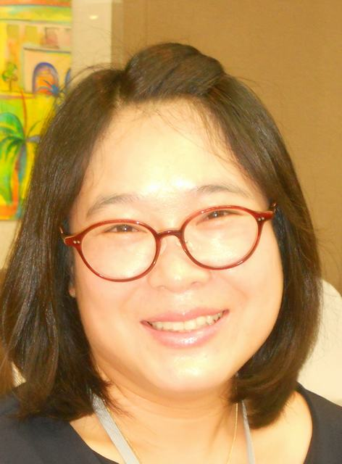 |  |  |  | Oksun KIM (Ms.), Plant Variety Protection Division, Korea Seed & Variety Service (KSVS) / MIFAFF, 328, Jungang-ro, Manan-gu, Anyang, 430-016 Gyeonggi-do  (tel.: +82 31 467 0191 fax: +82 31 467 0160 e-mail: oksunkim@korea.kr)
 |  |  |  | Min Jung KIM (Ms.), Patent Examiner, Korean Intellectual Property Office (KIPO), Government Complex Daejeon, Building 4, 189, Cheongsa-ro, Seo-gu, Daejeon Metropolitan City 302-701  (tel. +82 42 4815550 fax: +82 42 4723514 e-mail: koremily99@kipo.go.kr)
RÉPUBLIQUE DE MOLDOVA / REPUBLIC OF MOLDOVA / REPUBLIK MOLDAU /
REPÚBLICA DE MOLDOVA
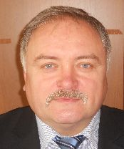 |  |  |  | Mihail MACHIDON, President, State Commission for Crops Variety Testing and Registration (SCCVTR), Bd. Stefan cel Mare, 162, C.P. 1873, MD-2004 Chisinau  (tel.: +373 22 220300 fax: +373 2 211537 e-mail: mihail.machidon@yahoo.com)
 |  |  |  | Ala GUŞAN (Mrs.), Head, Inventions and Plant Varieties Department, State Agency on Intellectual Property (AGEPI), 24/1 Andrei Doga str., MD-2024 Chisinau  (tel.: +373 22 400582 fax: +373 22 440119 e-mail: office@agepi.md)
RÉPUBLIQUE DOMINICAINE / DOMINICAN REPUBLIC / DOMINIKANISCHE REPUBLIK /
REPÚBLICA DOMINICANA
Agnes CISHEK HERRERA (Sra.), Viceministra de Planificación Sectorial Agropecuaria, Ministerio de Agricultura, Km. 6 1/2 de la Autopista Duarte, Urbanización Jardines del Norte, Santo Domingo D.N.
(tel.: +1 809 547 388 e-mail: agnes.cishek@agricultura.gob.do)
Dora Luisa SÁNCHEZ BOROMINO (Sra.), Directora, Oficina de Tratados Comerciales Agrícolas (OTCA), Ministerio de Agricultura, Km. 6 1/2 de la Autopista Duarte, Urbanización Jardines del Norte, Santo Domingo D.N.
(tel.: +1 809 547 3888 fax: +1 809 227 3164 e-mail: dsanchez@otcasea.gob.do)
 |  |  |  | Ysset ROMAN (Sra.), Ministro Consejero, Misión Permanente, 63 Rue de Lausanne, Ginebra, Suiza  (tel.: +41 22 715 3910 e-mail: mission.repdom@rep-dominicana.ch)
RÉPUBLIQUE TCHÈQUE / CZECH REPUBLIC / TSCHECHISCHE REPUBLIK /
REPÚBLICA CHECA
 |  |  |  | Daniel JUREÇKA, Director, Plant Production Section, Central Institute for Supervising and Testing in Agriculture (ÚKZÚZ), Hroznová 2, 656 06 Brno  (tel.: +420 543 548 210 fax: +420 543 217 649 e-mail: daniel.jurecka@ukzuz.cz)
ROUMANIE / ROMANIA / RUMÄNIEN / RUMANIA
 |  |  |  | Mihaela-Rodica CIORA (Mrs.), Head of Technical Department, State Institute for Variety Testing and Registration (ISTIS), 61, Marasti, Sector 1, P.O. Box 32-35, 011464 Bucarest  (tel.: +40 213 184380 fax: +40 213 184408 e-mail: mihaela_ciora@yahoo.com)
 |  |  |  | Mirela Dana CINDEA (Mrs.), Expert, State Institute for Variety Testing and Registration Romania, 61, Marasti, Sector 1, Bucarest  (tel.: 021 318 43 80 fax: 021 318 44 08 e-mail: istis@easynet.ro)
 |  |  |  | Teodor Dan ENESCU, Expert Soya, Potato and other Agronimical species, State Institute for Variety Testing and Registration (ISTIS), 61, Marasti, sector 1, P.O. Box 32-35, 011464 Bucarest  (tel.: +40 21 318 43 80 fax: +40 21 318 44 08 e-mail: teonscu@yahoo.com)
ROYAUME-UNI / UNITED KINGDOM / VEREINIGTES KÖNIGREICH / REINO UNIDO
 |  |  |  | Andrew MITCHELL, Controller of Plant Variety Rights, The Food and Environment Research Agency (FERA), Whitehouse Lane, Huntingdon Road, Cambridge CB3 0LF  (tel.: +44 1223 342 384 fax: +44 1223 342 386 e-mail: andrew.mitchell@fera.gsi.gov.uk)
SUISSE / SWITZERLAND / SCHWEIZ / SUIZA
 |  |  |  | Eva TSCHARLAND (Frau), Juristin, Direktionsbereich Landwirtschaftliche Produktionsmittel, Bundesamt für Landwirtschaft, Mattenhofstrasse 5, CH-3003 Bern  (tel.: +41 31 322 2594 fax: +41 31 323 2634 e-mail: eva.tscharland@blw.admin.ch)
TURQUIE / TURKEY / TÜRKEI / TURQUÍA
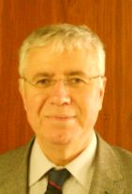 |  |  |  | Kamil YILMAZ, Director, Variety Registration and Seed Certification Centre, Ministry of Agriculture and Rural Affairs, P.O. Box 30, 06172 Yenimahalle - Ankara  (tel.: +90 312 315 4605 fax: +90 312 315 0901 e-mail: kyilmaz60@hotmail.com)
UNION EUROPÉENNE / EUROPEAN UNION / EUROPÄISCHE UNION / UNIÓN EUROPEA
 |  |  |  | Päivi MANNERKORPI (Ms.), Chef de secteur - Seed and Plant Propagating Material, Direction Générale Santé et Protection des Consommateurs, Commission européene (DG SANCO), Rue Froissart 101, 2/180, 1040 Bruxelles, Belgium  (tel.: +32 2 299 3724 fax: +32 2 296 9399 e-mail: paivi.mannerkorpi@ec.europa.eu)
 |  |  |  | Martin EKVAD, President, Community Plant Variety Office (CPVO), 3, boulevard Maréchal Foch, CS 10121, 49101 Angers Cedex 02  (tel.: +33 2 4125 6415 fax: +33 2 4125 6410 e-mail: ekvad@cpvo.europa.eu)
 |  |  |  | Muriel LIGHTBOURNE (Mme), Head of Legal Affairs, Community Plant Variety Office (CPVO), 3, Bd. Maréchal Foch, CS 10121, 49101 Angers Cedex  (tel.: +33 2 41 256414 fax: +33 2 41 256410 e-mail: lightbourne@cpvo.europa.eu)
 |  |  |  | Isabelle CLEMENT-NISSOU (Mrs.), Policy Officer, Direction Générale Santé et Protection des Consommateurs, Commission européenne (DG SANCO), rue Froissart 101, 1040 Bruxelles  (tel.: +32 229 87834 fax: +33 229 60951 e-mail: isabelle.clement-nissou@ec.europa.eu)
VIET NAM / VIET NAM / VIETNAM / VIET NAM
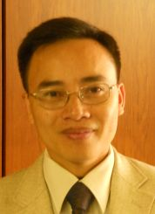 |  |  |  | Nguyen Quoc MANH, Deputy Chief of PVP office, Plant Variety Protection Office of Viet Nam, No 2 Ngoc Ha Street, Ba Dinh Dist, (84) 48 Hanoi  (tel.: +84 4 38435182 fax: +84 4 37344967 e-mail: quocmanh.pvp.vn@gmail.com)
II. ORGANISATIONS / ORGANIZATIONS / ORGANISATIONEN / ORGANIZACIONES
ASSOCIATION FOR PLANT BREEDING FOR THE BENEFIT OF SOCIETY
 |  |  |  | Susan H. BRAGDON (Ms.), Executive Director of APBREBES, Association for Plant Breeding for the Benefit of Society, 3130 SE Lambert Street, Portland , OR97202, États-Unis d'Amérique  (tel.: +1 503 772 9595 e-mail: bragdonsh@gmail.com)
COMMUNAUTÉ INTERNATIONALE DES OBTENTEURS DE PLANTES ORNEMENTALES ET
FRUITIÈRES À REPRODUCTION ASEXUÉE (CIOPORA) / INTERNATIONAL COMMUNITY
OF BREEDERS OF ASEXUALLY REPRODUCED ORNAMENTAL AND FRUIT PLANTS
(CIOPORA) / Internationale Gemeinschaft der Züchter vegetativ vermehrbarer Zier- und Obstpflanzen (CIOPORA) / Comunidad Internacional de Obtentores de Variedades Ornamentales y Frutales de Reproducción Asexuada (CIOPORA)
 | Edgar KRIEGER, Secretary General, CIOPORA - International Community of Breeders of Asexually Reproduced Ornamental and Fruit Plants (CIOPORA), Postfach 13 05 06, 20105 Hamburg , Germany  (tel.: +49 40 555 63702 fax: +49 40 555 63703 e-mail: edgar.krieger@ciopora.org)
 | Mr. Alain MEILLAND, Vice-President de CIOPORA & Président d' AOHE, Meilland International, Domaine Saint André, F-83340 LE CANET DES MAURES, France  (tel.: +33 494 500320 fax: +33 494 479829 e-mail: meilland.a@wanadoo.fr)
EUROPEAN COORDINATION VIA CAMPESINA (ECVC)
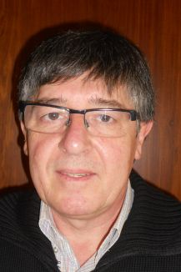 | Carlos MATEOS, Technical Advisor, Rue de la Sablonnière 18, Bruxelles 1000, Belgique (tel.: +32 2 217 3112 e-mail: cmateos@coag.org)
INTERNATIONAL SEED FEDERATION (ISF)
 |  |  |  | Marcel BRUINS, Secretary General, International Seed Federation (ISF), 7, chemin du Reposoir, 1260 Nyon, Switzerland  (tel.: +41 22 365 4420 fax: +41 22 365 4421 e-mail: isf@worldseed.org)
Jean DONNENWIRTH, International Intellectual Property Manager, Pioneer Hi-Bred S.A.R.L., Chemin de l'Enseigure, 31840 Aussonne , France
(tel.: +33 5 6106 2084 fax: +33 5 6106 2091 e-mail: jean.donnenwirth@pioneer.com)
 |  |  |  | Michael ROTH, Intellectual Property Consultant, 4393 Westminster Place, E2NA, 63108 St. Louis, MO, United States of America  (tel.: +1 314 210 1832 e-mail: seed.law@gmail.com)
III. BUREAU / OFFICER / VORSITZ / OFICINA
 |  |  |  | Peter BUTTON, Chair

IV. BUREAU DE L’UPOV / OFFICE OF UPOV / BÜRO DER UPOV / OFICINA DE LA UPOV
 | Peter BUTTON, Vice Secretary-General
 | Yolanda HUERTA (Mrs.), Legal Counsel
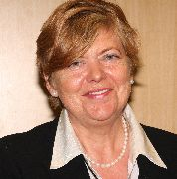 | Julia BORYS (Mrs.), Senior Technical Counsellor
 | Fuminori AIHARA, Counsellor
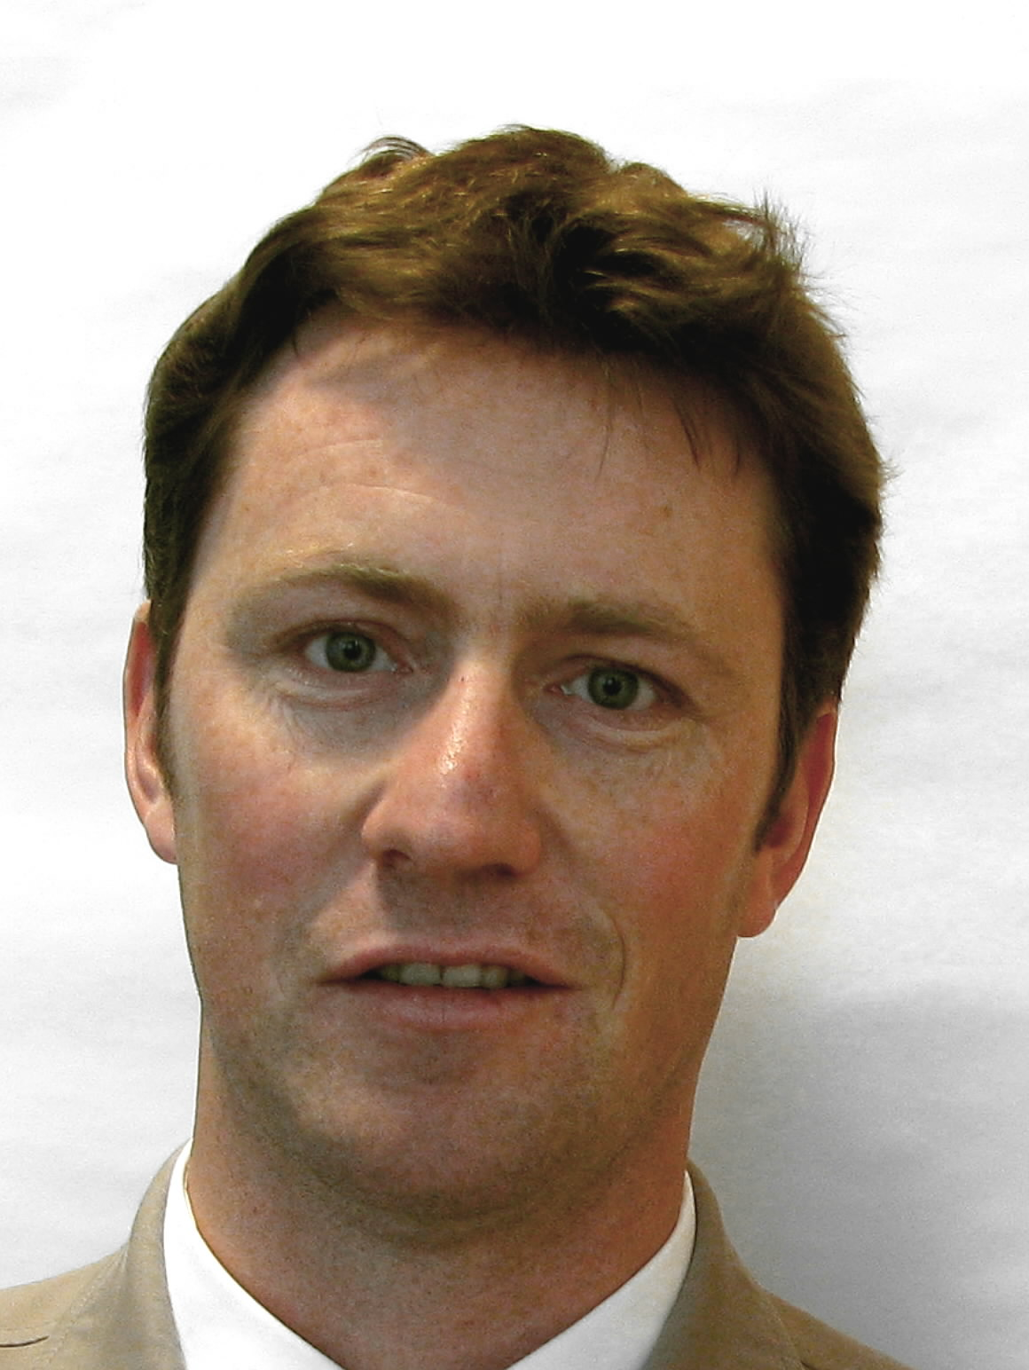 | Ben RIVOIRE, Consultant
 | Leontino TAVEIRA, Consultant

[Fin du document /
End of document /
Ende des Dokuments /
Fin del documento]

