E
International Union for the Protection of New Varieties of Plants

Administrative and Legal Committee  Seventy-Sixth Session  Geneva, October 30, 2019 | CAJ/76/INF/2  Original: English  Date: August 8, 2019
UPOV PRISMA – matters for information
Document prepared by the Office of the Union
Disclaimer: this document does not represent UPOV policies or guidance

EXECUTIVE SUMMARY

The purpose of this document is to report on developments concerning UPOV PRISMA, since the seventy-fifth session of the Administrative and Legal Committee (CAJ), held in Geneva on October 31, 2018.

The CAJ is invited to note:

(a) the developments concerning UPOV PRISMA, as set out in this document;

(b) that further developments concerning UPOV PRISMA will be reported at the seventy-sixth session of the CAJ; and

(c) that proposals concerning financial aspects of UPOV PRISMA will be considered by the Consultative Committee at its ninety-sixth session and, if appropriate, by the Council at its fifty-third ordinary session.

The following abbreviations are used in this document:

CAJ: Administrative and Legal Committee
EAF: Electronic Application Form
PRISMA: Plant variety data Routing Information System using Multilingual Application forms
TG: Test Guidelines
TQ: Technical Questionnaire
ISF: International Seed Federation
CIOPORA: International Community of Breeders of Asexually Reproduced Ornamental and Fruit Varieties

The structure of this document is as follows:

EXECUTIVE SUMMARY 1
Background 2
DEVELOPMENTs SINCE THE seventy-FIFTH session of the Administrative and Legal Committee 2
Developments in the Administrative and Legal Committee (CAJ) in October 2018 2
Developments in the Consultative Committee and the Council in October 2018 2
Developments in 2019 3
Meeting on the development of the electronic application form (EAF/13) 3
Version 2.2 3
Participating UPOV members and crops/species covered 3
Languages 4
New Functionalities 4
Use of UPOV PRISMA 5
UPOV PRISMA surveyS 7
ADquation Survey of Registered Users 7
Objective and target of the surveys 7
Recommendations from the surveys 7
UPOV Survey of Stakeholders 8
Follow-up and action plan after the surveys 8
Financing of UPOV PRISMA 8
FURTHER DEVELOPMENTS 8

Background

The background and previous developments concerning UPOV PRISMA (formerly the Electronic Application Form project) are reported in document CAJ/75/8 “Electronic Application Form”.

DEVELOPMENTs SINCE THE seventy-FIFTH session of the Administrative and Legal Committee

Developments in the Administrative and Legal Committee (CAJ) in October 2018

The CAJ at its seventy-fifth session on October 31, 2018, considered documents CAJ/75/8 and CAJ/75/13 and the presentation made by the Office of the Union on recent developments in UPOV PRISMA, provided as document CAJ/75/8 Add.

The CAJ noted that the TC, at its fifty-fourth session, had agreed that it would be helpful for the Office of the Union, upon request, to generate a report for participating authorities to UPOV PRISMA on the extent to which their application forms were harmonized with the application forms of other members of the Union and the UPOV model application form. The CAJ noted that TC had noted that that was a matter that should be reported to the CAJ (see document CAJ/75/13, paragraph 17).

The CAJ noted that proposals concerning financial aspects of UPOV PRISMA would be considered by the Consultative Committee at its ninety-fifth session and, if appropriate, by the Council at its fifty-second ordinary session (see document CAJ/75/14 “Report”, paragraphs 46 to 49).

Developments in the Consultative Committee and the Council in October 2018

The Council at its fifty-second ordinary session in Geneva on November 2, 2018, noted the work of the Consultative Committee at its ninety-fifth session, as reported in document C/52/17 “Report by the
President on the work of the ninety-fifth session of the Consultative Committee”, which included the following information concerning UPOV PRISMA (see document C/52/20 “Report”, paragraph 12):

- The Consultative Committee noted the developments concerning UPOV PRISMA and the financial contributions made to UPOV PRISMA from ISF, CIOPORA, CropLife International and the Ministry of Agriculture, Nature and Food Quality of the Netherlands.
- The Consultative Committee noted that more time was needed to increase the number of UPOV PRISMA users in order to achieve a reliable survey of the suitability of financing options and also to ensure reliability for users. With regard to a survey of financing options, the Vice Secretary-General confirmed the intention to survey users that had submitted applications via UPOV PRISMA, registered entities, newsfeed subscribers and possibly other potential users. The survey would be structured to enable the results of the different categories to be analyzed separately.
- The Consultative Committee recommended to the Council to approve the use UPOV PRISMA free of charge in 2019.
- On the above basis, the Consultative Committee requested the Office of the Union to present options to the Consultative Committee, at its ninety sixth session, for the financing of UPOV PRISMA, including: fee per submission; fee per variety; subscription model(s) for applicants; subscription model(s) for members of the Union and package(s) of UPOV services (see document C/52/17 “Report by the President on the work of the ninety-fifth session of the Consultative Committee”, paragraphs 44 to 47).

The Council at its fifty-first ordinary session agreed to extend the introductory phase for UPOV PRISMA until December 2019, during which UPOV PRISMA will be free of charge (see document C/52/20 “Report”, paragraph 12 (a)).

Developments in 2019

Meeting on the development of the electronic application form (EAF/13)

The Thirteenth Meeting on the Development of an Electronic Application Form (“EAF/13 meeting”) was, held in Geneva on March 28, 2019. The report of the meeting is provided in document EAF/13/3 “Report”.

Version 2.2

Version 2.2 of UPOV PRISMA was released on June 13, 2019.

Participating UPOV members and crops/species covered

The table below summarizes the participating PVP Offices and the crops supported in UPOV PRISMA Version 2.2 (changes from Version 2.1 are highlighted):

Authority |  | Crop coverage in Version 2.2
African Intellectual Property Organization (OAPI) | OA | All genera and species
Argentina | AR | Apple Fruit Varieties, Barley, Black Radish, Oriental Radish, Brussels Sprouts, Cauliflower, Chinese Cabbage, Grapevine, Maize, Melon, Potato, Rose, Shallot, Grey Shallot, Soya Bean, Spinach, Sweet Pepper, Hot Pepper, Paprika, Chili, Tomato Rootstocks, Watermelon, Welsh Onion, Japanese Bunching Onion, Wheat, Egg Plant, Witloof Chicory, Broad Bean, Fig, Papaya, Salvia, Green onion, Indian mustard, Sugarcane, Cotton
Australia | AU | All genera and species
Bolivia (Plurinational State of) | BO | All genera and species
Canada | CA | All genera & species excluding algae, bacteria and fungi
Chile | CL | All genera and species
China | CN | Lettuce
Colombia | CO | All genera and species
Costa Rica | CR | All genera and species
Dominican Republic | DO | All genera and species
Ecuador | EC | All genera and species
European Union | QZ | All genera & species excluding agricultural crops
France | FR | All genera & species
Georgia | GE | Maize, Wheat, Field Bean, French Bean, Apple (fruit varieties), Pear, Barley, Oats, Potato, Cherry (Sweet Cherry), Raspberry, Tomato, Peach, Hazelnut, Blackberry, Soya Bean, Sunflower, Walnut, Blueberry, Chick-Pea, Lentil
Kenya | KE | All genera and species
Mexico | MX | All genera and species
Netherlands | NL | All genera and species
New Zealand | NZ | All genera and species
Norway | NO | All genera and species
Paraguay | PY | Soya bean
Republic of Moldova | MD | Maize, Wheat, Pea, Barley, European Plum, Tomato, Grapevine, Sweet Pepper, Hot Pepper, Paprika, Chili, Sunflower, Walnut, Apple Fruit Varieties, Lettuce, Potato, Rose, Soya bean, Oats, Rye, Strawberry, Blackberry
Republic of Korea | KR | Apple Fruit Varieties, Lettuce, Potato, Soya bean, Rose
Serbia | RS | Apple Fruit Varieties, Rose, Raspberry and Blueberry
South Africa | ZA | All genera and species
Sweden | SE | All genera and species
Switzerland | CH | All genera and species
Trinidad and Tobago | TT | Anthuriums , Bromeliaceae, Heliconiaceae, Orchidaceae, Sterculiaceae, Cajanus cajans, Vigna sp., Theobroma cacao L.
Tunisia | TN | All genera and species
Turkey | TR | All genera and species
United Kingdom | GB | All genera and species
United States of America | US | 192 crops including Lettuce, Potato, Soya bean and Wheat
Uruguay | UY | All genera & species
Viet Nam | VN | 15 selected crops
Total | 33

Languages

The languages supported in Version 2.2 are as follows (changes from Version 2.1 are highlighted in grey):
Navigation languages | Output form languages
- Chinese  - English  - French  - German  - Japanese  - Korean  - Russian  - Spanish  - Turkish  - Vietnamese | - Chinese  - English  - French  - German  - Georgian  - Korean  - Norwegian  - Romanian  - Spanish  - Serbian  - Swedish  - Turkish  - Vietnamese

New Functionalities

Additional functionalities were introduced, as follows:

- Application data for national listing for Netherlands;
- Enhancement of agent role (“handshake” functionality);
- Improved copy functionality;
- Full scale for states of expression / notes in variety characteristics and variety comparisons.

Use of UPOV PRISMA

Information on the use of UPOV PRISMA to June 30, 2019, is provided below:

Number of submissions via UPOV PRISMA:

 | 2017 | 2018 | 2019
January | 1 |  | 7
February |  | 3 | 9
March | 2 | 3 | 6
April |  | 3 | 23
May | 1 | 1 | 33
June |  | 7 | 10
July |  | 7
August |  | 1
September | 3 | 8
October | 1 | 19
November | 3 | 16
December | 3 | 9
Total | 14 | 77 | 88

Number of new user registrations in UPOV PRISMA:

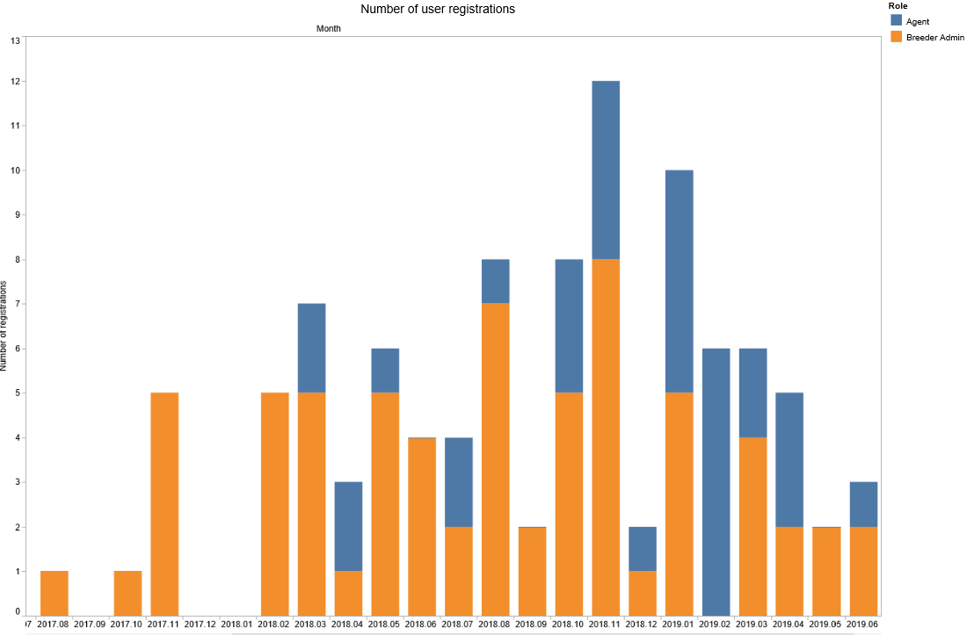

Number of submissions per participating Authority in UPOV PRISMA:

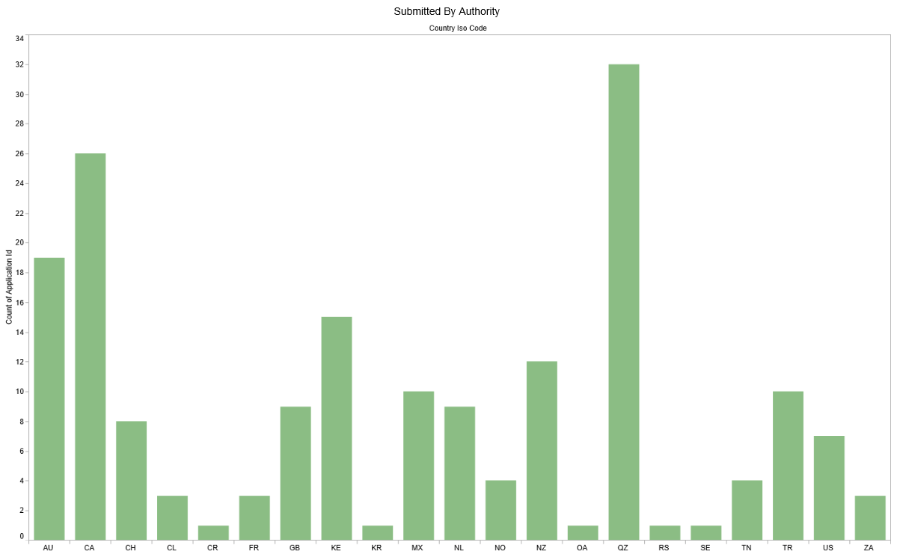

Number of submissions by crop type in UPOV PRISMA:

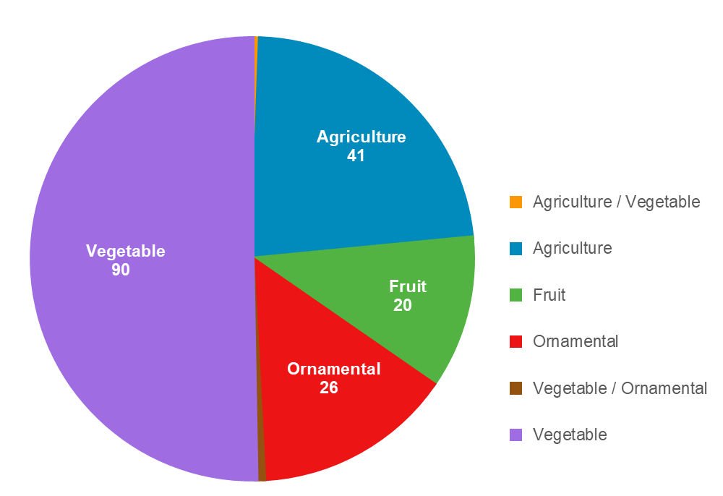

UPOV PRISMA surveyS

ADquation Survey of Registered Users

Objective and target of the surveys

In order to assess the value of the service provided and to determine a suitable fee for UPOV PRISMA, the Office of the Union conducted an independent survey of registered users of UPOV PRISMA. On the basis of a Request for Proposals from market study providers, ADquation was selected to conduct the survey.

At the time of the survey (April 2019), 103 entities had registered in UPOV PRISMA . Some entities had submitted applications via UPOV PRISMA, some had drafted applications but not submitted data, while some others had registered but had not been active.

Two sets of surveys were established.

- Qualitative survey (“One-to-one interviews”) with 20 registered users selected by ADquation; and
- Quantitative survey (Online questionnaire) sent to all 103 registered users.
The Qualitative survey involved in-depth conversations with interviewees to explain their views and experiences of UPOV PRISMA. ADquation chose 20 registered users for telephone interviews conducted by ADquation interviewers in English, French or Spanish. Ten users had already submitted applications (7 breeders and 3 agents) and 10 had registered but had not submitted applications (9 breeders and 1 agent). The main goals of the survey for “active users” were to receive information on user experience, identify the benefits of UPOV PRISMA and to determine a suitable fee. The main goals of the survey for “inactive” registered entities were to identify difficulties encountered and to assess a suitable fee at which it would be acceptable to use UPOV PRISMA. Respondents were from 9 countries: Australia, Canada, France, Mexico, Netherlands, New Zealand, Norway, Spain and United Kingdom.

The quantitative survey took the form of an online questionnaire with 32 questions on: respondents profile and PVP application submission process; UPOV PRISMA usage; UPOV PRISMA perception; proposed improvements; and UPOV PRISMA pricing. 103 entities (222 persons) were invited to complete the survey. 37 responses were received (36% response rate based on the number of entities) with 31 breeders and 6 agents. 9 entities participated in both the qualitative and the quantitative survey. The answers received were from 14 countries: Australia, Belgium, Chile, Denmark, France, Germany, Italy, Latvia, Mexico, Netherlands, New Zealand, Norway, United Kingdom and United States of America.

Recommendations from the surveys

On the basis of the replies to the surveys, the recommendations made by ADquation were as follows:

- Very risky to make users pay for UPOV PRISMA at that time because of technical problems.
- However thanks to their trust in the concept, in UPOV and in its team, all remain confident in the tool and will be willing to pay a fee when it is fully operational.
- Defects to solve and missing features to develop (priority ranking):
  - Solve IT bugs / technical problems
  - Make sure that all countries and crops are regularly checked (updated form, translations…)
  - Ongoing inclusion of new countries / new crops
- In parallel, advise to work with UPOV members with the following objectives:
  - Ongoing harmonization of application forms between countries
  - Improve the communication between members and applicants during the process (mainly acknowledgement of receipt)
- While introducing UPOV PRISMA, avoid too strong promises (in particular time-saving) and focus on smooth process and serenity (peace of mind).
- Individual support is crucial to make sure users are able:
  - to complete a whole application, in all situations
  - to connect all third-parties in an appropriate way and with the appropriate rights.
- Video training is not sufficient despite the feeling of easiness it provides. Direct contact is recommended.
- Once all the evolutions are set up, we advise a price between 100 € (110 CHF) and 150 € (170 CHF).”

UPOV Survey of Stakeholders

Following the completion of the ADquation survey, an online survey was conducted by the Office of the Union using a set of questions selected from the ADquation online survey. This survey, conducted in June 2019, was offered to UPOV members, PVP Office contacts, users of UPOV services and breeders. The survey was completed by 14 respondents, of which 3 were breeders or agents.

Follow-up and action plan after the surveys

On the basis of the information obtained from the ADquation survey, the Office of the Union plans the following approach:

- take the following actions to address technical issues and improve the user experience:
  - deploy automatic test tool to identify and eliminate IT bugs;
  - provide direct communication tool to UPOV PRISMA helpdesk;
  - redesign user interface for a better user experience;
  - work with PVP Offices to ensure that receipt of application data is acknowledged and that data are duly and promptly processed;
  - introduce new functionalities to improve the value of the tool as far as resources allow (e.g. DUS Arrangement Tool);
- endeavor to ensure that information and forms in UPOV PRISMA are complete and up-to-date and arrange for verification of translations by relevant persons;
- expand geographical and crop coverage of UPOV PRISMA and inclusion of coverage of national listing, as far as resources allow, with priority being given to items (a) and (b);
- explore opportunities to facilitate harmonization of forms where appropriate;
- amend UPOV PRISMA promotion strategy to focus on the benefits of a smooth and reliable process, rather than time-saving; and
- explore possibilities to assist members of the Union to receive, process and manage application data.

Financing of UPOV PRISMA

Proposals concerning financial aspects of UPOV PRISMA will be considered by the Consultative Committee at its ninety-sixth session, to be held in Geneva, on October 31, 2019 and, if appropriate, by the Council at its fifty-third ordinary session, to be held in Geneva on November 1, 2019.

FURTHER DEVELOPMENTS

The fourteenth meeting of the EAF (EAF/14 meeting) will be held in Geneva on October 28, 2019.

An oral report on latest developments, including latest figures on the use of UPOV PRISMA, will be made at the seventy-sixth session of the CAJ.

[End of document]

