E
International Union for the Protection of New Varieties of Plants

Administrative and Legal Committee  Seventy-Sixth Session  Geneva, October 30, 2019 | CAJ/76/2  Original: English  Date: October 29, 2019
Report on developments in the Technical Committee
Document prepared by the Office of the Union
Disclaimer: this document does not represent UPOV policies or guidance
The purpose of this document is to report on developments in the Technical Committee (TC) at its fifty-fifth session, held in Geneva on October 28 and 29, 2019, of relevance for matters to be considered by the Administrative and Legal Committee (CAJ) at its seventy-sixth session, to be held in Geneva on October 30, 2019. Those developments are reported in the Annex to this document. The report of the TC is available in document TC/55/25 “Report”.

[Annex follows]

CAJ/76/2

ANNEX

CONCLUSIONS OF THE TECHNICAL COMMITTEE IN RELATION TO MATTERS
TO BE CONSIDERED BY THE ADMINISTRATIVE AND LEGAL COMMITTEE

Agenda item 7: TGP documents

TGP documents (document CAJ/76/5)

Matters for adoption by the Council in 2019

The TC noted the revision of the following TGP documents, to be put forward for adoption by the Council at its fifty-third ordinary session, subject to the approval of the CAJ at its seventy-sixth session:

- Document TGP/7 “Development of Test Guidelines” (document TGP/7/7), on the basis of document TGP/7/7 Draft 1 Rev.

- Document TGP/8 “Trial Design and Techniques Used in the Examination of Distinctness, Uniformity and Stability” (document TGP/8/3), on the basis of document TGP/8/4 Draft 1.

- Document TGP/10 “Examining Uniformity” (document TGP/10/1), on the basis of document TGP/10/2 Draft 1.

- Document TGP/14 “Glossary of Terms Used in UPOV Documents” (document TGP/14/3), on the basis of document TGP/14/4 Draft 1.

- Document TGP/15 “Guidance on the use of Biochemical and Molecular Markers in the examination of Distinctness, Uniformity and Stability (DUS)” (document TGP/15/1), on the basis of document TGP/15/2 Draft 2.

The TC noted note that, in conjunction with the adoption of the revised TGP documents, the Council would be invited to adopt a revision of document TGP/0 “List of TGP documents and latest issue dates” (document TGP/0/10), on the basis of document TGP/0/11 Draft 1.

Program for the development of TGP documents

The TC agreed the program for the development of TGP documents, as set out in the Appendix to this document.

AGENDA ITEM 8: Variety denominations

Variety denominations (documents CAJ/76/6 and UPOV/EXN/DEN/1 Draft 2)

The TC considered documents TC/55/8 and TC/55/8 Add.

The TC noted the comments by the TWPs and agreed with the proposals to revise the list of classes in document UPOV/INF/12/5, as follows:

- Proposal to split the current class 205 (Cichorium and Lactuca) into two new classes:
• Class: Lactuca – Cichorium endivia (Endive), Cichorium intybus var. foliosum (Salad Chicory)
• Class: Cichorium intybus var. sativum (Industrial Chicory)

(b) Proposal for genus Epichloe (formerly Neotyphodium) to be added to Class 203 (Agrostis, Dactylis, Festuca, Festulolium, Lolium, Phalaris, Phleum and Poa)

AGENDA ITEM 9: UPOV information databases

UPOV information databases (document CAJ/76/7 and CAJ/76/7 Add.)

The TC considered documents TC/55/5 and TC/55/5 Add.

Amendments to the “Guide to the UPOV Code System”

The TC considered the proposed amendments to the “Guide to the UPOV Code System” to reflect the creation of exceptions for the UPOV Codes for popcorn, sweet corn and Brassica oleracea, as set out in document TC/55/5, Annex I.

The TC recalled that the main purpose of the UPOV Code System was to overcome the problem of synonyms for plant taxa and should be based on taxonomic criteria, also bearing in mind that the UPOV Code System was used by other international organizations, such as ISTA.

The TC agreed that the exceptions proposed to the “Guide to the UPOV Code System” diverged from the Germplasm Resources Information Network (GRIN). The TC agreed that UPOV Codes should continue following GRIN taxonomy as far as possible.

The TC agreed to postpone the amendment to the “Guide to the UPOV Code System” and to explore alternative solutions to enable UPOV Codes to provide useful information on variety groups or types for DUS testing purposes. The TC agreed to invite the Office of the Union to prepare a document with proposals, for consideration at its fifty-sixth session.

UPOV code amendments

Proposals for UPOV code amendments

The TC agreed to amend the following UPOV Codes, as set out in documents TC/55/5, paragraphs 18 to 62 and TC/55/5 Add., paragraphs 4, 8 and 12:

- ASCOC, ASNEO, NEOFI and NEOFI_FAL
- BERBE_REP
- CITRU_LIT
- CRTNT and CRTNT_CAL
- ECSED and ECSED_EMO
- ECHIN_CHA
- EPICH_FES
- EUTRE
- EUTRE_JAP
- ISOPL, DGISO, ISOPL_CAN and DGISO_PCA
- HAWOR_FAS, HAWOR_LIM, HAWOR_LFA and HAWOR_MAR
- HAWOT_FAS
- HAWOT_LIM
- HAWOT_LFA
- HELLE_FNI
- HOMLC and HOMLC_PLA
- LAVN_XAL
- LOBIV and LOBIV_SIL
- MAHON, MAHON_ACA, MAHON_AQU, MAHON_BEA, MAHON_JAP, MAHON_LOM, MAHON_PUM and MAHON_REP
- MUEHL_PLA
- NEOTY_LOL
- SENEC_BIC, SENEC_CIN, SENEC_CHE, SENEC_CON, SENEC_CRU, SENEC_FIC, SENEC_HER, SENEC_JAC, SENEC_LAX and SENEC_TAL
- VANDA_FAL
- WASAB and WASAB_JAP

Implementation of UPOV code amendments

The TC noted that members of the Union and contributors of data to the PLUTO database would be informed of the changes and the date of the changes to UPOV Codes by means of a circular in advance of the amendments, as set out in document TC/55/5, paragraph 64.

The TC noted that contributors to the PLUTO database would be requested to use the amended UPOV codes when submitting their plant variety data to the Office of the Union, as set out in document TC/55/5, paragraph 64.

Pluto database

Program for improvements to the PLUTO database

The TC agreed with the proposal to revise Section 3.1.3 of the “Program for improvements to the PLUTO database” to reflect the change of the acceptable character set to ISO/IEC Standard 8859 1: 1998, as follows:

“3.1.3 Subject to Section 3.1.4, the character set for data shall be the Extended ASCII [American Standard Code for Information Interchange] representation, as defined in ISO [International Standards Organization]/IEC [International Electrotechnical Commission] Standard 8859 1: 1998.”

The TC noted that the CAJ, at its seventy-sixth session, would consider the proposed revision of the Section 3.1.3 of the “Program for improvements to the PLUTO database”, in conjunction with the comments by the TC, at its fifty-fifth session.

Request from the ISTA Nomenclature Committee

The TC noted that the Office of the Union had received a request from the International Seed Testing Association (ISTA) Nomenclature Committee to provide UPOV Codes for all botanical names listed in the ISTA stabilized list of botanical names of crops, as set out in document TC/55/5 Add., paragraph 2. On October 3, 2019, the Office of the Union provided the ISTA Nomenclature Committee with a list of UPOV Codes covering all botanical names in the ISTA stabilized list.

AGENDA ITEM 10: Exchange and use of software and equipment

Exchange and use of software and equipment (document CAJ/76/8)

Document UPOV/INF/22 “Software and equipment used by members of the Union”

The TC considered document UPOV/INF/22/6 Draft 1 and agreed to propose the revision of document UPOV/INF/22 on that basis.

The TC noted that the proposals of the TC, at its fifty-fifth session, concerning the revision of document UPOV/INF/22 would be reported to the CAJ at its seventy-sixth session, to be held in Geneva on October 30, 2019, and if agreed by the CAJ, a draft of document UPOV/INF/22/6 would be presented for adoption by the Council at its fifty-third ordinary session, to be held on November 1, 2019.

Availability of documents UPOV/INF/16 “Exchangeable Software” and UPOV/INF/22 “Software and Equipment Used by Members of the Union” in a searchable form

The TC noted that the information in documents UPOV/INF/16 and UPOV/INF/22 would be made available in a searchable format on the UPOV website following the introduction of the new website design.

AGENDA ITEM 11: Matters for information

Molecular techniques (document CAJ/76/INF/3)

Review of document UPOV/INF/17 “Guidelines for DNA-Profiling: Molecular Marker Selection and Database Construction (‘BMT Guidelines’)”

The TC noted that the BMT, at its eighteenth session, had considered document UPOV/INF/17/2 Draft 2 “Guidelines for DNA-Profiling: Molecular marker selection and database construction (‘BMT Guidelines’).

The TC noted that the proposal by the TWV to develop guidance on elements, to be included in a protocol of DNA marker assay for a specific characteristic in document UPOV/INF/17, had been reported to the BMT, at its eighteenth session.

The TC agreed with the proposal by the BMT, at its eighteenth session, for the European Union, France and the Netherlands to prepare a new draft of document UPOV/INF/17 “Guidelines for DNA-Profiling: Molecular marker selection and database construction (‘BMT Guidelines’)” (document UPOV/INF/17/2 Draft 3) for consideration at the nineteenth session of the BMT.

Cooperation between international organizations

Joint document explaining the principal features of the systems of OECD, UPOV and ISTA

The TC agreed with the BMT, at its eighteenth session, that relevant elements from the World Seed Partnership and the FAQ on the use of molecular techniques in the examination of DUS, would be a suitable basis for the Office of the Union to develop a draft of a joint document explaining the principal features of the systems of OECD, UPOV and ISTA, in consultation with OECD.

Inventory on the use of molecular marker techniques, by crop

The TC considered the possible development of an inventory on the use of molecular marker techniques, by crop, with a view to developing a joint OECD/UPOV/ISTA document containing that information, in a similar format to document UPOV/INF/16 “Exchangeable Software”.

The TC agreed the following elements for the inventory:

- Country or Intergovernmental Organization using molecular marker technique
- Whether the Authority uses molecular marker techniques
- Source [name of the Authority] and Contact details [email address]
- Type of molecular marker technique [AFLP, Capillary electrophoresis fragment analysis, MNP, RAPD-STS, SSR, SNPs, Taqman, Whole genome sequencing, other technique (please specify)] [more than one answer allowed]
- Source of the molecular marker and contact details [email address]
- Availability of the marker [publicly available or a proprietary marker]
- Status (i.e. in current use or under development)
- Crop(s) for which the molecular marker technique is used and characteristic concerned [botanical name(s) and UPOV code(s) to be provided]
- Purpose of the use of the molecular technique [UPOV model “Characteristic-Specific Molecular Markers”, UPOV model “Combining Phenotypic and Molecular Distances in the Management of Variety Collections”, Purity, Identity, Verification of conformity of plant material to a protected variety for the exercise of breeders’ rights, Verification of hybridity]
- Whether the molecular marker technique was used as part of Seed Certification in the last two years [National certification, OECD certification] [relevant for OECD seed schemes]
- Number of times the Authority used the molecular marker technique in the last 2 years [routine, occasional] [e.g. 1 to 5, 6 to 20, 21 to 100, more than 100]
- Whether the molecular marker technique is covered by [UPOV Test Guideline(s), UPOV TGP document(s), other UPOV document(s)] (please specify)
- Whether the molecular technique is validated/recognized/authorized [yes to specify a particular organization or authority]
- [relevant for OECD seed schemes]
- Whether the Authority created databases with information obtained from use of the molecular marker technique

The TC agreed that the question “whether the molecular technique is validated” should be amended to read “Whether the molecular technique is validated/recognized/authorized”.

The TC agreed that a circular should be issued to request members of the Union to complete a survey as a basis to develop an inventory on the use of molecular marker techniques, by crop, in coordination with the OECD.

The TC agreed with the BMT that the survey should have structured answers to allow the comparison of results, as much as possible.

The TC agreed that the Office of the Union should conduct a test survey with experts from the United Kingdom.

Lists of possible joint initiatives with OECD and ISTA in relation to molecular techniques

The TC considered possible joint initiatives with OECD and ISTA in relation to molecular techniques and agreed with the proposal made by the BMT, at its eighteenth session, for joint workshops to be repeated in future.

The TC agreed with the BMT to propose a joint initiative that each organization inform the others about use of molecular markers in their work.

The TC noted there were no definitions on biochemical and molecular techniques in UPOV. The TC agreed that information from the survey on the techniques could help to clarify techniques that were considered to be biochemical or molecular.

Session to facilitate cooperation in relation to the use of molecular techniques

The TC noted that, at their sessions in 2019, the TWPs and the BMT had formed discussion groups to allow participants to exchange information on their work on biochemical and molecular techniques and explore areas for cooperation. The TC noted the outcomes of discussions at the TWPs, which had been reported to the BMT, at its eighteenth session.

Developments at Technical Working Parties and the Working Group on Biochemical and Molecular Techniques, and DNA-Profiling in Particular in 2019

The TC noted that the BMT, at its eighteenth session, had been be invited to develop proposals on next steps to explore areas for cooperation in the use of molecular techniques.

The TC noted the following outcomes from discussions at the BMT on issues concerning cooperation between partners and service providers, including confidentiality, access to data and material:

- DNA-fingerprint data should be treated as confidential;
- Variety identification data using a small number of SNP markers could be made publicly available;
- Consent by the breeder should be required before sharing of DNA-based information;
- Breeders should be informed about the publication of variety identification by SNPs;
- Parental line information should be treated as confidential;
- Invitation for breeders, observer organizations and other participants to make presentations on ownership matters during the breeders’ day at the nineteenth session of the BMT;
- Proposal to develop an agreement template with breeders for the use of molecular data. The template should include a requirement for a description of the intended use of the data;
- Noted that New Zealand had published a position on access and use of plant material including molecular data. For example, molecular data would only be provided with permission of breeder.

The TC agreed with the BMT that breeders, observer organizations and other participants be invited to make presentations on ownership matters during the breeders’ day at the nineteenth session of the BMT.

The TC recalled that document TGP/5 Section 1 “Model administrative agreement for international cooperation in the testing of varieties” provided guidance on confidentiality of molecular information.

[Appendix follows]

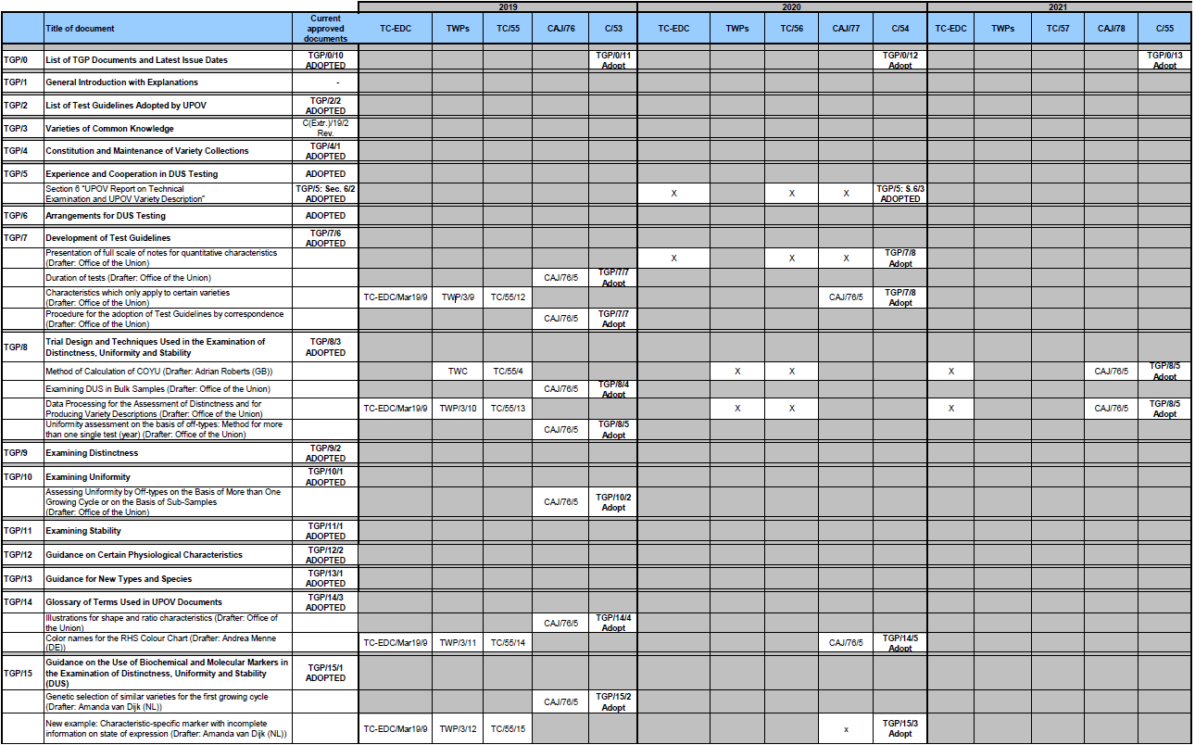
[End of Annex and of document]

