E
International Union for the Protection of New Varieties of Plants

Administrative and Legal Committee  Seventy-Fifth Session  Geneva, October 31, 2018 | CAJ/75/11  Original: English  Date: October 19, 2018
Molecular techniques
Document prepared by the Office of the Union
Disclaimer: this document does not represent UPOV policies or guidance

Executive summary

The purpose of this document is to report developments concerning molecular techniques since the seventy-fourth session of the CAJ.

The CAJ is invited to note that:

(a) the TC, at its fifty-fourth session, will be invited to agree that the Model “Combining Phenotypic and Molecular Distances in the Management of Variety Collections” of document TGP/15 “Guidance on the Use of Biochemical and Molecular Markers in the Examination of Distinctness, Uniformity and Stability (DUS)”, Section 2.2, be revised at a later stage once an additional threshold level has been implemented in France, as set out in paragraph 18 of this document;

(b) the TC, at its fifty-fourth session, will be invited to consider the inclusion of a new model “Genetic selection of similar varieties for the first growing cycle” and the example French Bean” in document TGP/15 on the basis of document TGP/15/2 Draft 1, subject to any revisions proposed by the TC-EDC in order to reflect the comments of the BMT and TWV, as set out in paragraph 28 of this document;

(c) the TC, at its fifty-fourth session, will be invited to request the European Union, France and the Netherlands to prepare a new draft of document UPOV/INF/17 “Guidelines for DNA-profiling: Molecular Marker Selection and Database Construction (‘BMT Guidelines’)” for consideration at the eighteenth session of the BMT;

(d) the TC, at its fifty-fourth session, will be invited to request the European Union, France and the Netherlands to prepare a new draft of document UPOV/INF/17 “Guidelines for DNA-profiling: Molecular Marker Selection and Database Construction (‘BMT Guidelines’)” for consideration at the eighteenth session of the BMT;

(e) it is anticipated that the CAJ, at its seventy-sixth session, to be held on October 30, 2019, will be invited to consider the inclusion of the new model “Genetic selection of similar varieties for the first growing cycle” and the example of French Bean in document TGP/15, subject to approval by the TC at its fifty-fourth session, as set out in paragraph 29 of this document;

(f) at the sixteenth and seventeenth sessions of the BMT, discussion groups were formed for BMT participants to exchange information on their work and explore areas for cooperation, as set out in paragraphs 46 and 48 of this document;

(g) the BMT plans to discuss, at its eighteenth session, issues concerning cooperation between partners and service providers, including confidentiality, access to data and material, authorization for work to be performed and availability of results and information to partners, as set out in paragraph 49 of this document; and

(h) the TC, at its fifty-fourth session, will be invited to consider whether the results of the coordination session in the BMT be reported to the other TWPs and that the TWPs be invited to undertake a similar session to build on the BMT outcomes and feed into the future work of the BMT, as set out in paragraph 50 of this document.

The following abbreviations are used in this document:

BMT: Working Group on Biochemical and Molecular Techniques, and DNA-Profiling in Particular
CAJ: Administrative and Legal Committee
TC: Technical Committee
TC-EDC: Enlarged Editorial Committee
TWA: Technical Working Party for Agricultural Crops
TWV: Technical Working Party for Vegetables
TWPs: Technical Working Parties
OECD: Organization for Economic Co-operation and Development
ISTA: International Seed Testing Association

The structure of this document is as follows:

Executive summary 1
Background 2
revision of document TGP/15 “Guidance on the Use of Biochemical and Molecular Markers in the Examination of Distinctness, Uniformity and Stability (DUS)” 2
Revision of the Model “Combining Phenotypic and Molecular Distances in the Management of Variety Collections” 2
Proposal for inclusion of a new model “Genetic Selection of Similar Varieties for the First Growing Cycle” 5
Review of document UPOV/INF/17 “Guidelines for DNA-Profiling: Molecular Marker Selection and Database Construction (‘BMT Guidelines’)” 6
Background 6
Developments in the BMT in 2018 6
Cooperation between international organizations 7
Background 7
Developments in the BMT in 2018 7
Session to facilitate cooperation at the BMT 8

ANNEX ROLE OF THE WORKING GROUP ON BIOCHEMICAL AND MOLECULAR TECHNIQUES, AND DNA-PROFILING IN PARTICULAR (BMT)

Background

The role of the BMT is reproduced in the Annex to this document.

revision of document TGP/15 “Guidance on the Use of Biochemical and Molecular Markers in the Examination of Distinctness, Uniformity and Stability (DUS)”

Revision of the Model “Combining Phenotypic and Molecular Distances in the Management of Variety Collections”

Background

The BMT, at its sixteenth session, considered documents BMT/16/8 “The use of molecular markers (SNP) for maize DUS testing in France (2013 to 2016)” and BMT/16/8 Add. and received a presentation by an expert from France (see document BMT/16/29 “Report”, paragraphs 8 to 10).

The BMT agreed that France should propose a revision to document TGP/15 “Guidance on the Use of Biochemical and Molecular Markers in the Examination of Distinctness, Uniformity and Stability (DUS)”, Annex II, “Example: Parent Lines in Maize”, to reflect the refinements that had been made in France on the basis of its experience in the application of the Model “Combining Phenotypic and Molecular Distances in the Management of Variety Collections”, for consideration by the TC at its fifty-fourth session.

The BMT agreed that it would be advantageous if the draft revision of document TGP/15, to be considered by the TC at its fifty-fourth session, could be published sufficiently before the forty-seventh session of the TWA, and before the seventeenth session of the BMT, in order that any comments of the TWA and BMT on the draft revision could be reported to the TC at its fifty-fourth session.

Document TGP/15/2 Draft 1 was prepared for consideration by the TWA, BMT, TWV and TC at their sessions in 2018.

Comments by the TWA in 2018

The TWA, at its forty-seventh session, considered document TWP/2/7 “Molecular Techniques” and document TGP/15/2 Draft 1.

The TWA received a presentation by an expert from France on the refinements that had been made on the basis of experience in the application of the Model “Combining Phenotypic and Molecular Distances in the Management of Variety Collections”. A copy of the presentation is provided in document BMT/16/8 Add. “Addendum to the use of molecular markers (SNP) for maize DUS testing in France (2013 to 2016)” .

The TWA noted that the studies for the refinement of the model used in France were still ongoing and that a final conclusion on the threshold level to be used had not yet been reached (e.g. Rogers distance = 0.2). The TWA noted that this would mean that a new proposal would need to be presented to the BMT and TWA at future sessions as a basis to propose a revision of TGP/15 for this model.

The TWA noted that the new slide introduced in document TGP/15/2 Draft 1, to illustrate the refinement in the approach used by France did not reflect a final decision on the genetic distance threshold to be used in parent lines of maize (below).

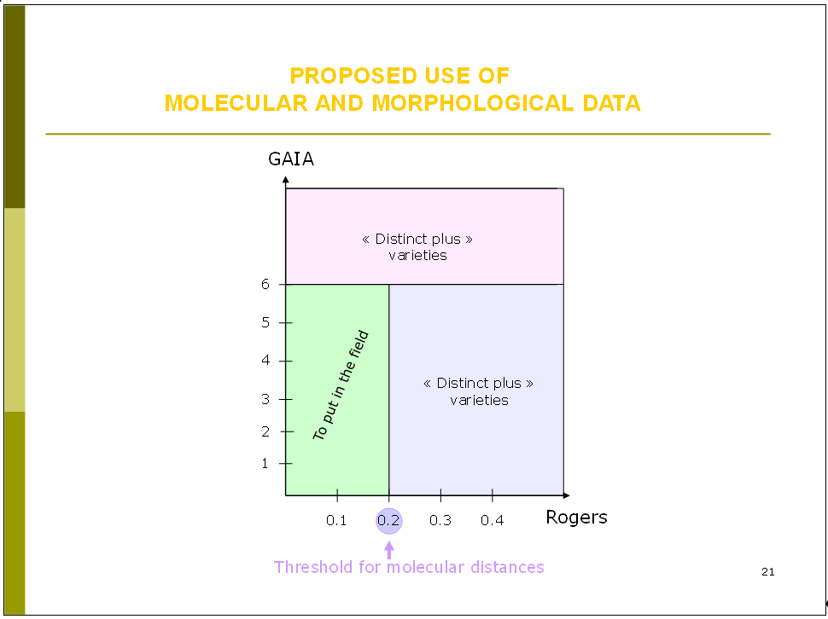

The TWA agreed that the following extract from document BMT/16/8 Add. slide 16, should be included in the proposed revision of document TGP/15:

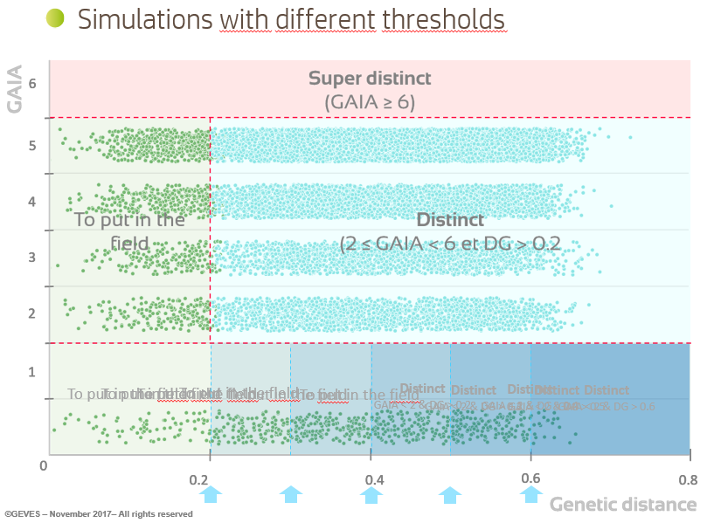

The TWA noted the refinements being made to the model used in France on the following basis:

- a “parameter setting step” analyzing several growing cycles was being used to established the threshold value;

- any threshold value would be crop-specific and should be determined by crop experts.

The TWA noted that the method used in France only rejected a candidate variety after the third growing cycle.

Comments by the BMT in 2018

The BMT, at its seventeenth session considered documents BMT/17/7 “Revision of document TGP/15 ‘Guidance on the Use of Biochemical and Molecular Markers in the Examination of Distinctness, Uniformity and Stability (DUS)’” and TGP/15/2 Draft 1. Document BMT/17/7 contained a revised proposal from France for the revision of document TGP/15, Section 2.2, in response to the comments made by the TWA at its forty-seventh session.

The BMT considered the revision of the example of parent lines in maize prepared by the experts from France. The BMT noted that the establishment of an additional threshold for genetic distance below GAIA distance 2 had not been implemented in France at that time. The BMT noted that the nature of document TGP/15 was to present examples of the use of molecular markers in DUS examination among UPOV members. The BMT agreed to recommend that the example in document TGP/15, Section 2.2, be revised at a later stage once the additional threshold level had been implemented in France.

The CAJ is invited to note that the TC, at its fifty-fourth session, will be invited to agree that the Model “Combining Phenotypic and Molecular Distances in the Management of Variety Collections” of document TGP/15 “Guidance on the Use of Biochemical and Molecular Markers in the Examination of Distinctness, Uniformity and Stability (DUS)”, Section 2.2, be revised at a later stage once an additional threshold level has been implemented in France, as set out in paragraph 18 of this document.

Proposal for inclusion of a new model “Genetic Selection of Similar Varieties for the First Growing Cycle”

Background

The BMT, at its sixteenth session, considered documents BMT/16/19 “Genetic selection of similar varieties for the first growing cycle: example French Bean” and BMT/16/19 Add., and received a presentation by an expert from the Netherlands.

The BMT agreed that the approach presented in document BMT/16/19 “Genetic selection of similar varieties for the first growing cycle: example French bean” and BMT/16/19 Add. “Addendum to Genetic selection of similar varieties for the first growing cycle: example French bean” was a suitable use of molecular techniques in the examination of DUS and should be proposed for inclusion in document TGP/15. Therefore, it was agreed that the Netherlands should prepare an explanation of the method as a basis for a revision of document TGP/15 to be considered by the TC at its fifty-fourth session.

The BMT agreed that it would be advantageous if the draft revision of document TGP/15, to be considered by the TC at its fifty-fourth session, could be published sufficiently before the fifty-second session of the TWV, to be held in Beijing, China, from September 17 to 21,2018, and before the seventeenth session of the BMT, in order that any comments of the TWV and BMT on the draft revision could be reported to the TC at its fifty-fourth session.

Comments by the BMT in 2018

The BMT, at its seventeenth session, considered documents BMT/17/7 “Revision of document TGP/15 ‘Guidance on the Use of Biochemical and Molecular Markers in the Examination of Distinctness, Uniformity and Stability (DUS)’” and TGP/15/2 Draft 1.

The BMT considered the new application model “Genetic Selection of Similar Varieties for the First Growing Cycle” and agreed that it should be proposed for inclusion in document TGP/15 on the basis of a simplified version of draft text presented in document TGP/15/2 draft 1. The BMT agreed that the proposal to be put forward for approval by the TC should contain the description of the method without comparison to other approaches. The BMT also agreed to invite the Netherlands to review whether the schematic explaining the process was necessary and/or might be simplified.

Comments by the TWV in 2018

The TWV, at its fifty-second session considered documents TWP/2/7 Rev. “Molecular Techniques” and TGP/15/2 Draft 1 and noted the report on developments in the Technical Working Parties (TWPs) and BMT, as set out in paragraphs 6 to 37 of document TWP/2/7 Rev. and in document TWV/52/18.

The TWV agreed with the proposal of the BMT, at its seventeenth session, that the new application model “Genetic Selection of Similar Varieties for the First Growing Cycle” should be proposed for inclusion in document TGP/15 on the basis of a simplified version of draft text presented in document TGP/15/2 Draft 1. The TWV agreed to propose that the Netherlands review the schematic explaining the process and to simplify it, and recommended to clarify in the guidance the basis on which the comparing varieties are selected on the basis of genetic selection. The TWV agreed with the BMT that the new application model to be put forward for approval by the TC should contain the description of the method without comparison to other approaches.

The Netherlands offered to provide a revised draft text of the new model “Genetic selection of similar varieties for the first growing cycle” and the example of French Bean in document TGP/15 for consideration by the TC-EDC prior to presentation to the Technical Committee at its fifty-fourth session.

The TC, at its fifty-fourth session, will be invited to consider the inclusion of the new model “Genetic selection of similar varieties for the first growing cycle” and the example of French Bean in document TGP/15 on the basis of document TGP/15/2 Draft 1, subject to any revisions proposed by the TC-EDC in order to reflect the comments of the BMT and TWV.

On the above basis, it is anticipated that the CAJ, at its seventy-sixth session, to be held on October 30, 2019, will be invited to consider the inclusion of the new model “Genetic selection of similar varieties for the first growing cycle” and the example of French Bean (see paragraphs 20 to 22, above) in document TGP/15, subject to approval by the TC at its fifty-fourth session. The program for the development of TGP documents is presented in Annex III to document CAJ/75/2 “TGP documents”.

The CAJ is invited to note that:

(a) the TC, at its fifty-fourth session, will be invited to consider the inclusion of a new model “Genetic selection of similar varieties for the first growing cycle” and the example French Bean”
in document TGP/15 on the basis of document TGP/15/2 Draft 1, subject to any revisions proposed by the TC-EDC in order to reflect the comments of the BMT and TWV, as set out in paragraph 28 of this document; and

(b) it is anticipated that the CAJ, at its seventy-sixth session, to be held on October 30, 2019, would be invited to consider the inclusion of the new model “Genetic selection of similar varieties for the first growing cycle” and the example of French Bean in document TGP/15, subject to approval by the TC at its fifty-fourth session, as set out in paragraph 29 of this document.

Review of document UPOV/INF/17 “Guidelines for DNA-Profiling: Molecular Marker Selection and Database Construction (‘BMT Guidelines’)”

Background

The BMT, at its sixteenth session, considered documents BMT/16/4 “Review of document UPOV/INF/17 “Guidelines for DNA-profiling: Molecular Marker Selection and Database Construction (‘BMT Guidelines’)”” and BMT/16/5 “Standards for Databases containing Molecular Information” and received a presentation by the Office of the Union, a copy of which is reproduced BMT/16/5 Add.

The BMT agreed to invite members and observers to provide comments on document UPOV/INF/17 “Guidelines for DNA-profiling: Molecular Marker Selection and Database Construction (‘BMT Guidelines’)”. The comments would be compiled by the Office of the Union in a document that would form the basis of a review of document UPOV/INF/17 by the BMT at its seventeenth session. The BMT further agreed to propose to introduce a new chapter concerning cooperation in the exchange of data and construction of databases in document UPOV/INF/17 on the basis of document BMT/16/5.

Developments in the BMT in 2018

The BMT, at its seventeenth session, considered documents BMT/17/10 and BMT/17/10 Add. “Review of document UPOV/INF/17 ‘Guidelines for DNA-profiling: Molecular Marker Selection and Database Construction (“BMT Guidelines”)’” and UPOV/INF/17/2 Draft 1 “Guidelines for DNA-Profiling: Molecular marker selection and database construction (‘BMT Guidelines’)”.

The BMT agreed to propose to the TC that the European Union, France, Netherlands prepare a new draft of document UPOV/INF/17 for consideration of at the eighteenth session of the BMT.

The CAJ is invited to note that the TC, at its fifty-fourth session, will be invited to request the European Union, France and the Netherlands to prepare a new draft of document UPOV/INF/17 “Guidelines for DNA-profiling: Molecular Marker Selection and Database Construction (‘BMT Guidelines’)” for consideration at the eighteenth session of the BMT.

Cooperation between international organizations

Background

The BMT, at its sixteenth session, considered document BMT/16/3.

The BMT noted that the TC, at its fifty-third session, had agreed that possible future collaboration between UPOV, OECD and ISTA might include the harmonization of terms and methodologies used for different crops and the possible development of standards, after agreement by those organizations.

The BMT noted that practical workshops on “DNA Techniques and Variety Identification” had been held in Roelofarendsveen, Netherlands, from May 8 to 10, 2017 and from September 20 to 22, 2017.

The BMT noted that the TC had agreed that UPOV and OECD should consider making progress in the matters reported in this document if ISTA was unable to participate in the near future.

The BMT recalled that the TC, at its fifty-first session, had agreed:

(a) to develop a joint document explaining the principal features of the systems of the OECD, UPOV and ISTA;
(b) to develop an inventory on the use of molecular marker techniques, by crop, with a view to developing a joint OECD/UPOV/ISTA document containing that information, in a similar format to UPOV document UPOV/INF/16 “Exchangeable Software”, subject to the approval of the Council and in coordination with OECD and ISTA; and
(c) the proposal for the BMT, at its fifteenth session, to develop lists of possible joint initiatives with OECD and ISTA in relation to molecular techniques for consideration by the TC to be presented at the TC, at its fifty-third session.

The BMT agreed that the initiatives above, and consideration of possible harmonization of terms and methodologies used for different crops and the possible development of standards, might be advanced through a further international practical workshop, to be jointly coordinated by OECD, UPOV and ISTA and supported by Naktuinbouw and/or another partner with the relevant facilities.

Developments in the BMT in 2018

The BMT, at its seventeenth session, considered document BMT/17/3 “Cooperation between International Organizations”.

The BMT noted that ISTA was not in a position to agree to the proposed joint activities with UPOV and OECD at that time and agreed to propose to the TC that UPOV and OECD should make progress on the matters previously agreed by the TC, namely:

(a) to develop a joint document explaining the principal features of the systems of the OECD, UPOV and ISTA;

(b) to develop an inventory on the use of molecular marker techniques, by crop, with a view to developing a joint OECD/UPOV/ISTA document containing that information, in a similar format to UPOV document UPOV/INF/16 “Exchangeable Software”, subject to the approval of the Council and in coordination with OECD and ISTA; and

(c) the proposal for the BMT, at its fifteenth session, to develop lists of possible joint initiatives with OECD and ISTA in relation to molecular techniques for consideration by the TC to be presented at the TC, at its fifty-third session.

The BMT agreed that ISTA should be welcomed to join the above initiatives as and when it was in a position to do so.

The CAJ is invited to note that the TC, at its fifty-fourth session, will be invited to consider whether UPOV and OECD should make progress on the matters previously agreed by the TC, as set out in paragraph 43 of this document.

Session to facilitate cooperation at the BMT

At the sixteenth session of the BMT, discussion groups were formed for: agricultural crops; fruit crops; ornamental plants and forest trees; and vegetables, for BMT participants to exchange information on their work and explore areas for cooperation.

The BMT, at its seventeenth session, considered document BMT/17/5 “Session to facilitate cooperation in relation to the use of molecular techniques”.

Discussion groups were formed for: maize and soybeans; other agricultural crops; fruit crops and forest trees; ornamental plants; and vegetables, for BMT participants to exchange information on their work and explore areas for cooperation.

Taking into account the reports of the cooperation sessions, the BMT noted the common interest to address issues concerning cooperation between partners and service providers, including confidentiality, access to data and material, authorization for work to be performed and availability of results and information to partners and agreed to add this as an agenda item for it eighteenth session in order for experts, including breeders, to present information on their experiences (see proposed agenda item 8 “Management of databases and exchange of data and material” for the eighteenth session of the BMT).

The BMT agreed to propose to the TC that the results of the coordination session in the BMT be reported to the other TWPs and that the TWPs be invited to undertake a similar session to build on the BMT outcomes and feed into the future work of the BMT. The BMT agreed that the information on crop interest by participants at the sixteenth session of the BMT should be added to the above in the document to be prepared for the TWPs and the eighteenth session of the BMT.

The CAJ is invited to note that:

(a) at the sixteenth and seventeenth sessions of the BMT, discussion groups were formed for BMT participants to exchange information on their work and explore areas for cooperation, as set out in paragraphs 46 and 48 of this document;

(b) the BMT plans to discuss, at its eighteenth session, issues concerning cooperation between partners and service providers, including confidentiality, access to data and material, authorization for work to be performed and availability of results and information to partners, as set out in paragraph 49 of this document; and

(c) the TC, at its fifty-fourth session, will be invited to consider whether the results of the coordination session in the BMT be reported to the other TWPs and that the TWPs be invited to undertake a similar session to build on the BMT outcomes and feed into the future work of the BMT, as set out in paragraph 50 of this document.

[Annex follows]

ROLE OF THE WORKING GROUP ON BIOCHEMICAL AND MOLECULAR TECHNIQUES,
AND DNA-PROFILING IN PARTICULAR (BMT)
(as agreed by the Technical Committee at its thirty-eighth session, held in Geneva,
from April 15 to 17, 2002 (see document TC/38/16, paragraph 204))

The BMT is a group open to DUS experts, biochemical and molecular specialists and plant breeders, whose role is to:

- Review general developments in biochemical and molecular techniques;

- Maintain an awareness of relevant applications of biochemical and molecular techniques in plant breeding;

- Consider the possible application of biochemical and molecular techniques in DUS testing and report its considerations to the TC;

- If appropriate, establish guidelines for biochemical and molecular methodologies and their harmonization and, in particular, contribute to the preparation of document TGP/15, “New Types of Characteristics.” These guidelines to be developed in conjunction with the Technical Working Parties;

- Consider initiatives from TWPs, for the establishment of crop specific subgroups, taking into account available information and the need for biochemical and molecular methods;

- Develop guidelines regarding the management and harmonization of databases of biochemical and molecular information, in conjunction with the TWC;

- Receive reports from Crop Subgroups and the BMT Review Group;

- Provide a forum for discussion on the use of biochemical and molecular techniques in the consideration of essential derivation and variety identification.

[End of Annex and of document]

Held in La Rochelle, France, from November 7 to 10, 2017.
To be held in Geneva, from October 29 to 30, 2018.
To be held in Naivasha, Kenya, from May 21 to 25, 2018.
Held in Naivasha, Kenya, from May 21 to 25, 2018.
See document TWA/47/7 “Report”, paragraphs 44 to 49.
Held in Montevideo, Uruguay, from September 10 to 13, 2018.
See document BMT/17/25 “Report”, paragraph 58.
See document BMT/16/29 “Report”, paragraphs 18 to 20.
See document BMT/17/25 “Report”, paragraph 59.
Held in Beijing, China, from September 17 to 21, 2018.
See document BMT/16/29 “Report”, paragraphs 44 and 45.
See document BMT/17/25 “Report”, paragraphs 15 and 50.
See document BMT/16/29 “Report”, paragraphs 24 and 30.
See document TC/52/29 Rev. “Revised Report”, paragraph 129.
See document BMT/17/25 “Report”, paragraphs 54 and 55.
See document BMT/16/29 “Report”, paragraphs 48.
See document BMT/17/25 “Report”, paragraphs 68 and 69.
See document BMT/17/25 “Report”, paragraphs 77 and 78.

