E
CAJ/72/3 Add.
ORIGINAL: English
DATE: October 27, 2015
INTERNATIONAL UNION FOR THE PROTECTION OF NEW VARIETIES OF PLANTS
Geneva
ADministrative and legal committee
Seventy-Second Session
Geneva, October 26 and 27, 2015
Addendum to document CAJ/72/3
Variety denominations
Document prepared by the Office of the Union
Disclaimer: this document does not represent UPOV policies or guidance
The Annex to this document contains a presentation made by Argentina on variety denominations, at the seventy-second session of the Administrative and Legal Committee (CAJ).

[Annex follows]

CAJ/72/3 Add.

ANNEX

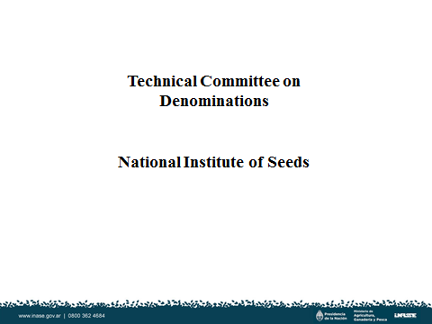

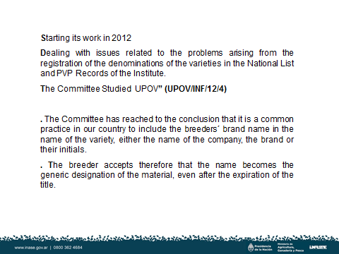

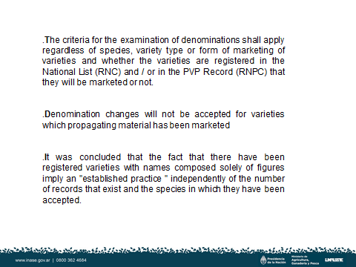

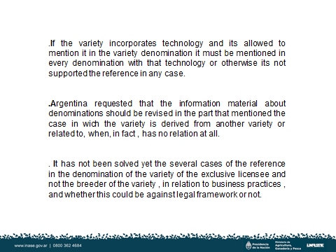

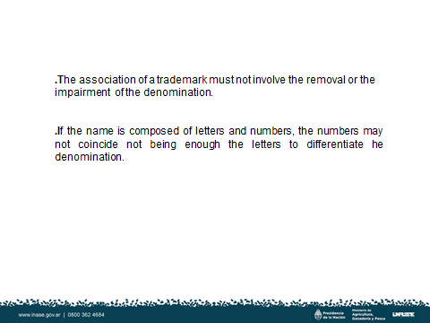

[End of Annex and of document]

