 |  | E  CAJ/66/8  ORIGINAL: English  DATE: October 29, 2012
INTERNATIONAL UNION FOR THE PROTECTION OF NEW VARIETIES OF PLANTS
Geneva
ADministrative and legal committee
Sixty-Sixth Session
Geneva, October 29, 2012
Report on the Conclusions
adopted by the Administrative and Legal Committee
Opening of the session

1 The Administrative and Legal Committee (CAJ) held its sixty-sixth session in Geneva on October 29, 2012, under the Chairmanship of Mr. Lü Bo (China).

2 The session was opened by the Chair, who welcomed the participants. The list of participants is reproduced in the Annex to this report.

3 The Chair informed the CAJ that France had deposited its instrument of ratification of the 1991 Act of the UPOV Convention on April 27 2012, and had become bound by the 1991 Act on May 27, 2012, and that Panama had deposited its instrument of accession to the 1991 Act of the UPOV Convention on October 22, 2012, and would become bound by the 1991 Act on November 22, 2012.

4 The Vice Secretary-General introduced Mr. Ben Rivoire, a national of France and Mr. Leontino Taveira, a national of Brazil, who had joined the Office of the Union as Consultants in May 2012.

5 The Chair confirmed that the report of the sixty-fifth session of the CAJ held in Geneva on March 29, 2012 (document CAJ/65/13), had been adopted by correspondence and was available on the UPOV website.

Adoption of the agenda

6 The CAJ adopted the agenda, as presented in document CAJ/66/1, with the addition of document CAJ/66/5 Add., under agenda item 5 (b).

Development of Information Materials Concerning the UPOV Convention

7 The CAJ considered documents CAJ/66/2 and UPOV/INF/15/2 Draft 1.

UPOV/INF/15 “Guidance for Members of UPOV on Ongoing Obligations and Related Notifications and on the Provision of Information to Facilitate Cooperation” (Revision) (document UPOV/INF/15/2 Draft 1)

8 The CAJ agreed the following amendments to document UPOV/INF/15/2 Draft 1:

Paragraph 9(a) | to delete the word “both” in the second sentence
Paragraph 12 | the second and third sentences to read as follows: “[…] Any changes to that legislation governing breeders’ rights shall be notified promptly to the Secretary-General in one of the UPOV languages (English, French, German or Spanish) and published accordingly. The English version of those changes in the legislation and/or the relevant consolidated text will also then be published in the UPOV Gazette and Newsletter and in the UPOV Lex (http://www.upov.int/upovlex/en/) at the earliest opportunity”.

9 The CAJ agreed that, on the basis of the above amendments, the Office of the Union should prepare a revised version of document UPOV/INF/15/2 Draft 1, to be considered for adoption by the Council at its thirtieth extraordinary session of the Council, to be held in Geneva on March 22, 2013.

10 The CAJ noted that a document providing background information on the proposed changes and a first draft of the revision of document UPOV/INF/5 “UPOV Model Plant Breeders’ Rights Gazette” was planned to be presented to the CAJ at its sixty-seventh session, to be held in March 2013.

11 The CAJ noted the information concerning the seventh session of the Advisory Group to the CAJ (CAJ-AG), to be held in Geneva on October 29 (p.m.) and 30, 2012, as set out in paragraphs 11 to 15 of document CAJ/66/2.

12 The CAJ noted the following developments concerning the seventh session of the CAJ-AG:

(a) comments on relevant explanatory notes from: the International Community of Breeders of Asexually Reproduced Ornamental and Fruit Varieties (CIOPORA) (comments of October 4 and of October 15, 2012), European Seed Association (ESA) (comments of October 8, 2012) and International Seed Federation (ISF) (comments of October 15, 2012) had been notified to the CAJ and CAJ-AG and posted in the CAJ-AG website;

(b) in addition to the ad hoc invitations for CIOPORA, European Coordination Via Campesina (ECVC), and ISF, agreed by the CAJ-AG at its sixth session, which was held in Geneva on October 18, 2011, (see paragraph 14 of document CAJ/66/2), the CAJ-AG had agreed by correspondence to invite the Association for Plant Breeding for the Benefit of Society (APBREBES) to attend the relevant part of the CAJ-AG to present its views on the participation of observers in the CAJ-AG; and

(c) a draft schedule for the seventh session of the CAJ-AG (document CAJ-AG/12/7/INF) had been notified to the CAJ and CAJ-AG and posted in the CAJ-AG website.

Variety Denominations

13 The CAJ considered document CAJ/66/3.

14 The CAJ approved the following steps in relation to potential areas for cooperation between UPOV and the International Commission for the Nomenclature of Cultivated Plants of the International Union for Biological Sciences (IUBS Commission) and the International Society for Horticultural Science Commission for Nomenclature and Cultivar Registration (ISHS Commission):

(a) Members of the IUBS Commission and the Office of the Union to draft a brief, joint notice for publication in Hanburyana in order to inform the Sixth International Symposium on the Nomenclature of Cultivated Plants, scheduled to take place from July 15 to 18, 2013, in Beijing, China, of the areas where greater cooperation and harmonization between UPOV and the IUBS Commission could be beneficial, on the basis set out in document CAJ/66/3;

(b) Members of the IUBS Commission to approach Ms. Janet Cubey, Chairperson of the ISHS Commission with a view to UPOV organizing a meeting with ISHS and other relevant partners to discuss denomination classes and the concept of a common search platform for variety denomination searching purposes;

(c) Members of the IUBS Commission to inform UPOV of appropriate contact details for the IUBS Commission;

(d) Members of the IUBS Commission to consider how to initiate the process for UPOV to have observer status in the IUBS Commission; and

(e) further meetings, preferably using web conferencing, between members of the IUBS Commission, ISHS Commission and the Office of the Union, as necessary, in order to advance the points in (a) to (d).

UPOV information databases

15 The CAJ considered document CAJ/66/4.

16 The CAJ noted that the publication of the amended UPOV Code System would be arranged in conjunction with the consequential changes of a number of UPOV codes, which would be coordinated with the notification to all members of the Union and other contributors to the Plant Variety Database.

17 The CAJ noted the new features of the PLUTO Plant Variety Database as presented by Mr. Glenn Mac Stravic, Head of the Brand Database Section at the World Intellectual Property Organization (WIPO) at its sixty-sixth session. In particular, the CAJ noted the following developments concerning the Plant Variety Database, as reported in document CAJ/66/4:

(a) Information on the latest date of submission by the contributors has been provided for the PLUTO database in the form of a pdf document. However, in the longer term, it is planned that the date of submission will be provided for individual data retrieved from the database;

(b) The addition of a page for searching variety denominations;

(c) An explanation of the search rules for the PLUTO database to be provided, as demonstrated at the sixty-sixth session of the CAJ;

(d) Options to save search settings for the PLUTO database, as demonstrated at the sixty-sixth session of the CAJ.

(e) Requirement for users of the PLUTO Database to register to use the database, with a view to using that information for future improvements. It was noted that this would mean that the PLUTO database would still be freely accessible; and

(f) The necessary arrangements for the inclusion of data in the original alphabet, in addition to the data being provided in Roman alphabet, have been made.

18 The CAJ noted the information on the contribution of data and the provision of assistance to contributors to the Plant Variety Database, as reported in document CAJ/66/4, Annex II, and noted that contributors could now provide information on dates on which a variety was commercialized for the first time in the territory of application and other territories.

19 The CAJ noted that the production of the UPOV-ROM by Jouve would terminate at the end of 2012, after which time the WIPO Brand Database Unit would produce a CD-ROM version of the PLUTO database (PLUTO CD-ROM). The CAJ invited members of the Union wishing to receive the PLUTO CD-ROM version of the Plant Variety Database from 2013 to inform the Office of the Union in order to ensure that the PLUTO CD-ROM would be compatible with their IT systems.

20 The CAJ welcomed the proposal by the Delegation of the European Union to make a presentation at the sixty-seventh session of the CAJ, to be held on March 21, 2013, on the Community Plant Variety Office (CPVO) experience in the use of its denomination similarity search tool in the examination of proposed denominations.

21 The CAJ requested the Office of the Union to conduct a survey of members of the Union on their use of databases for plant variety protection purposes and also on their use of electronic application systems.

Electronic Application Systems

Electronic Version of the UPOV Model Application Form

22 The CAJ considered documents CAJ/66/5.

23 The CAJ endorsed the development of a prototype electronic form for interested members of the Union and agreed that the key aspects of the prototype from the perspective of members of the Union would be as follows:

Form Content: The UPOV electronic form would contain all items required by the participating members of the Union, i.e. it would contain all items in the UPOV Model Application Form and, in addition, items required for an application in the participating member of the Union concerned. Applicants would select the members of the Union in which they wish to make an application and all relevant items for the selected members of the Union would be presented for completion.

Status: Participating members of the Union would decide the status of any data provided via the UPOV electronic form for their own situation.

Data format: The UPOV electronic form would enable data to be transferred to participating members of the Union in Word, Excel, PDF or XML format. The participating members of the Union would decide in which format(s) to accept data. In the case of XML format, a standard format would be developed, based on WIPO standard ST.96.

Languages: The UPOV electronic form would present all items (questions) in English, French, German and Spanish. Translations for all items (questions) in other languages would be provided by the participating members of the Union, with a suitable disclaimer.

Crops/species: Crops/species for the prototype would be one or more of:

Wheat (Triticum aestivum L.); Maize (Zea mays L.);
Potato (Solanum tuberosum L.); Lettuce (Lactuca sativa L.);
Tomato (Solanum lycopersicum L.); Pea (Pisum sativum L.); and Ryegrass (Lolium L.);

and one or more of:

Rose (Rosa L.); Chrysanthemum (Chrysanthemum L.);
Carnation (Dianthus L.); Pelargonium (Pelargonium L'Hér. ex Ait.); Petunia (Petunia Juss.); Peach (Prunus persica (L.) Batsch); and Apple (Malus domestica Borkh.).

Participating members of the Union would be able to select the crops/species in which to participate, i.e. the UPOV electronic form for each crop/species could have different participating members of the Union. The selection of the crops/species for the prototype would be made by the Office of the Union in consultation with the participating members of the Union, ISF and CIOPORA.

Partners: The partners in the development of the prototype would be the participating members of the Union (including the continued participation of the Community Plant Variety Office of the European Union (CPVO)), Office of the Union, WIPO Internet Services Section, WIPO Standards Section, WIPO Global Database Service, ISF and CIOPORA.

Meetings: Meetings for the development of the prototype would, in general, be held in Geneva with an option to participate by web conference.

24 The CAJ noted that, whilst the prototype would be based on selected crops / species the electronic application system project was intended to be relevant for all crops / species. The CAJ also noted that participation in the prototype did not require members of the Union to have electronic application systems in place.

25 The following members of the Union, including the continued participation of the European Union, indicated their interest to be participating members of the Union in the prototype: Australia, Brazil, Canada, Colombia, Dominican Republic, Mexico, New Zealand, Paraguay, Republic of Korea, United States of America and Viet Nam.

26 The CAJ noted that the next meeting of experts on the prototype of the electronic version of the UPOV model application form, including interested members of the Union, would take place in Geneva on March 20, 2013, starting at 6.00 p.m.

Standard References to the UPOV Model Application Form

27 The CAJ considered document CAJ/66/5 Add.

28 The CAJ noted the replies to the survey on the use of standard references of the UPOV Model Application Form and noted that a submission had also been received from Latvia after the publication of the addendum.

Use of electronic communication for meetings

29 The CAJ considered document CAJ/66/6.

30 The CAJ noted the information provided on the use of electronic communication of meetings within UPOV and noted that a report on the conclusions of the Consultative Committee concerning policy on access to electronic communication for meetings would be made to the CAJ at its sixty-seventh session in March 2013. The CAJ recalled the importance of physical participation in UPOV meetings.

Issues concerning a unique variety identifier

31 The CAJ considered document CAJ/66/7.

32 The CAJ noted the discussions in the ad hoc Working Group on Variety Denominations and in the CAJ on issues concerning a unique variety identifier.

33 The CAJ agreed that no further action would be appropriate, for the time being, in relation to the possible development of a regional or international synonym register, or of a unique variety identifier. However, it agreed that the matter should be kept under review.

Program for the sixty-seventh session

34 The CAJ noted that during the forty-ninth session of the Technical Committee to be held in Geneva in March 2013, item 3 on the draft agenda to be considered on March 20, 2013, would be dedicated to a discussion on:

(a) molecular techniques:
(i) application of models by members of the Union; and
(ii) presentation of the situation with regard to molecular techniques in other international organizations; and
- use of DUS test reports by members of the Union (see document TC/48/22 “Report on the conclusions”, paragraph 161).

35 The CAJ agreed the following program for its sixty-seventh session, to be held in Geneva on March 21, 2013, and anticipated that a full day would be necessary to cover the program:

1. Opening of the session

2. Adoption of the agenda

3. Report on developments in the Technical Committee

4. Development of information materials concerning the UPOV Convention

5. TGP documents

6. Molecular techniques

7. Variety denominations

8. Information and databases

(a) UPOV information databases

(b) Exchangeable software

(c) Electronic application systems

9. Use of electronic communication for meetings

10. Program for the sixty-eighth session

11. Adoption of the report on the conclusions (if time permits)

12. Closing of the session

36 This report was adopted by the Administrative and Legal Committee at the close of its session on October 29, 2012.

[Annex follows]
CAJ/66/8

ANNEXE / ANNEX / ANLAGE / ANEXO

LISTE DES PARTICIPANTS / LIST OF PARTICIPANTS /
TEILNEHMERLISTE / LISTA DE PARTICIPANTES

(dans l’ordre alphabétique des noms français des membres/
in the alphabetical order of the names in French of the members/
in alphabetischer Reihenfolge der französischen Namen der Mitglieder/
por orden alfabético de los nombres en francés de los miembros)
i. MEMBRES / MEMBERS / VERBANDSMITGLIEDER / MIEMBROS
ALLEMAGNE / GERMANY / DEUTSCHLAND / ALEMANIA
 |  | Michael KÖLLER, Referent, Ministerium für Ernährung, Landwirtschaft und Verbraucherschutz, Wilhelmstrasse 54, 10117 Berlin  (tel.: +49 30 18529 4044 e-mail: Michael.Koeller@bmelv.bund.de)
 |  | Barbara SOHNEMANN (Frau), Justiziarin, Leiterin, Rechtsangelegenheiten, Sortenverwaltung, Gebühren, Bundessortenamt, Postfach 610440, 30604 Hannover  (tel.: +49 511 95665624 fax: +49 511 95669600 e-mail: barbara.sohnemann@bundessortenamt.de)
AUSTRALIE / AUSTRALIA / AUSTRALIEN / AUSTRALIA
 |  | Doug WATERHOUSE, Chief, Plant Breeder's Rights Office, IP Australia, 47 Bowes Street, Phillip ACT 2606  (tel.: +61 2 6283 7981 fax: +61 2 6283 7999 e-mail: doug.waterhouse@ipaustralia.gov.au)
BELGIQUE / BELGIUM / BELGIEN / BÉLGICA
 |  | Françoise DE SCHUTTER (Mme), Attachée, Office belge de la Propriété intellectuelle (OPRI), Bruxelles  (tel.: 32 2 277 9555 e-mail: francoise.deschutter@economie.fgov.be)
BOLIVIE (ÉTAT PLURINATIONAL DE) / BOLIVIA (PLURINATIONAL STATE OF) /
BOLIVIEN (PLURINATIONALER STAAT) / BOLIVIA (ESTADO PLURINACIONAL DE)
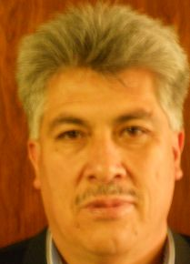 |  | Sergio Rider ANDRADE CÁCERES, Director Nacional de Semillas del INIAF, Instituto Nacional de Innovación Agropecuaria y Forestal (INIAF), Avenida 6 de agosto, Nro. 2170, Edificio Hoy, Mezanine, 4793 La Paz  (tel.: +591 2 2441153 fax: +591 2 2441153 e-mail: rideran@yahoo.es)
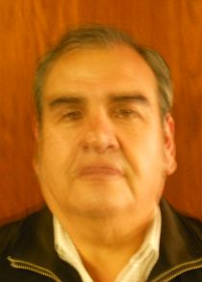 |  | Freddy CABALLERO LEDEZMA, Responable: Unidad de Fiscalización y Registros, Fiscalización y Registros de Semillas, Instituto Nacional de Innovación Agropecuaria y Forestal (INIAF), Capitán Ravelo No. 2329, Belisario Salinas, No. 490, 4793 La Paz  (tel.: +591 2 2441153 fax: +591 2 2441153 e-mail: calefred@yahoo.es)
Luis Fernando ROSALES LOZADA, Primer Secretario, Misión Permanente, 139, rue de Lausanne, 1202 Ginebra
(tel.: +41 22 908 0717 fax: +41 22 908 0722 e-mail: fernando.rosales@bluewin.ch)
BRÉSIL / BRAZIL / BRASILIEN / BRASIL
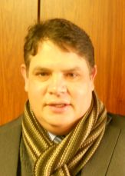 |  | Helcio CAMPOS BOTELHO, Director, Department of Intellectual Property and Agricultural Technology, Secretariat of Agricultural Development and Cooperativism, Ministério da Agricultura, Livestock and Food Supply, Esplanada dos Ministérios, Bloco 'D', Anexo A, Sala 233, Brasilia, D.F.70043-900  (tel.: +55 61 3218 5202 fax: +55 61 3321 4524 e-mail: helcio.botelho@agricultura.gov.br)
 |  | Luís Gustavo ASP PACHECO, Federal Agricultural Inspector, National Plant Variety Protection Office (SNPC), Ministry of Agriculture, Livestock and Food Supply, Esplanada dos Ministerios, Bloco 'D', Anexo A, sala 250, CEP 70043-900 Brasilia , D.F.  (tel.: +55 61 3218 2461 fax: +55 61 3224 2842 e-mail: luis.pacheco@agricultura.gov.br)
CANADA / CANADA / KANADA / CANADÁ
 |  | Sandy MARSHALL (Ms.), Senior Policy Specialist, Plant Breeders' Rights Office, Canadian Food Inspection Agency (CFIA), 59 Camelot Drive, Ottawa Ontario K1A 0Y9  (tel.: +1 613 773 7134 fax: +1 613 773 7261 e-mail: sandy.marshall@inspection.gc.ca)
CHILI / CHILE / CHILE / CHILE
 |  | Jaime IBIETA S., Director, División Semillas, Servicio Agrícola y Ganadero (SAG), Santiago de Chile  (tel.: +56 2 345 1561 fax: +56 2 697 2179 e-mail: jaime.ibieta@sag.gob.cl)
CHINE / CHINA / CHINA / CHINA
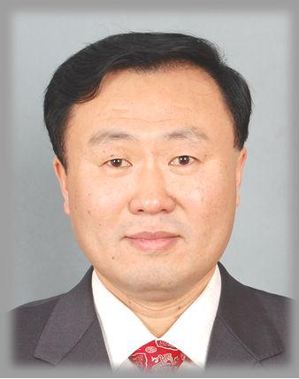 |  | LV Bo, Director, Division of Variety Management, Bureau of Seed Management, Ministry of Agriculture, No. 11 Nongzhanguannanli, Beijing  (tel.: +86 10 59193150 fax: +86 10 59193142 e-mail: lvbo@agri.gov.cn)
COLOMBIE / COLOMBIA / KOLUMBIEN / COLOMBIA
 |  | Ana Luisa DÍAZ JIMÉNEZ (Sra.), Directora Técnica de Semillas, Dirección Técnica de Semillas, Instituto Colombiano Agropecuario (ICA), Carrera 41 No. 17-81 Zona Industrial de Puente Aranda Bogotá  (tel.: +57 1 3323700 fax: +57 1 3323700 e-mail: ana.diaz@ica.gov.co)
Juan Camilo SARETZKI-FORERO, Primer Secretario, Misión Permanente de Colombia, Chemin Champ d’Anier 17-19, 1209 Ginebra
(tel.: 41 22 789 4718 fax: 41 22 791 0787 e-mail: juan.saretzki@cancilleria.gov.co)
DANEMARK / DENMARK / DÄNEMARK / DINAMARCA
 |  | Gerhard DENEKEN, Head, Department of Variety Testing, The Danish AgriFish Agency (NaturErhvervestyrelsen), Ministry of Food, Agriculture and Fisheries, Teglvaerksvej 10, Tystofte, DK-4230 Skaelskoer  (tel.: +45 5816 0601 fax: +45 58 160606 e-mail: gde@naturerhverv.dk)
ESPAGNE / SPAIN / SPANIEN / ESPAÑA
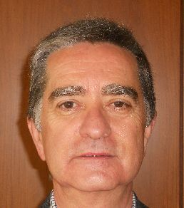 |  | Luis SALAICES, Jefe de Área del Registro de Variedades, Oficina Española de Variedades Vegetales (OEVV), Ministerio de Agricultura, Alimentación y Medio Ambiente, Calle Alfonso XII, No. 62, 2a Planta, E-28014 Madrid  (tel.: +34 91 3476712 fax: +34 91 3476703 e-mail: luis.salaices@magrama.es)
ESTONIE / ESTONIA / ESTLAND / ESTONIA
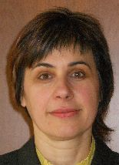 |  | Renata TSATURJAN (Ms.), Chief Specialist, Plant Production Bureau, Ministry of Agriculture, 39/41 Lai Street, EE-15056 Tallinn  (tel.: +372 625 6507 fax: +372 625 6200 e-mail: renata.tsaturjan@agri.ee)
ÉTATS-UNIS D'AMÉRIQUE / UNITED STATES OF AMERICA /
VEREINIGTE STAATEN VON AMERIKA / ESTADOS UNIDOS DE AMÉRICA
 |  | Kitisri SUKHAPINDA (Ms.), Patent Attorney, Office of Policy and External Affairs, United States Patent and Trademark Office (USPTO), Madison Building, West Wing, 600 Dulany Street, MDW 10A30, Alexandria VA 22313  (tel.: +1 571 272 9300 fax: + 1 571 273 0085 e-mail: kitisri.sukhapinda@uspto.gov)
 |  | Paul M. ZANKOWSKI, Commissioner, Plant Variety Protection Office, United States Department of Agriculture (USDA), National Agricultural Library (NAL), 10301, Baltimore Ave., Beltsville MD 20705  (tel.: +1 301 504 5518 fax: +1 301 504 5291 e-mail: paul.zankowski@ams.usda.gov)
 |  | Minna MOEZIE (Ms.), Office of External Affairs, U.S. Patent and Trademark Office (USPTO), U.S. Department of Commerce, United States Patent and Trademark Office (USPTO), Department of Commerce, Alexandria  (tel.: +1 571 272 9300 fax: +1 571 273 0085 e-mail: minna.moezie@uspto.gov)
 |  | Ruihong GUO, Associate Administrator, Agricultural Marketing Service, 1400 Independence Avenue, SW, Room 3071, Washington D.C. D.C.  (tel.: 202 720 5115 fax: 202 720 8477 e-mail: ruihong.guo@ams.usda.gov)
FRANCE / FRANCE / FRANKREICH / FRANCIA
 |  | Mlle Virginie BERTOUX, Ingénieur GEVES, Instance nationale des obtentions végétales (INOV), Groupe d'étude et de contrôle des variétés et des semences (GEVES), 25 Rue Georges Morel,  CS 90024  (tel.: +33 2 41 22 86 49 fax: +33 2 41 22 86 01 e-mail: virginie.bertoux@geves.fr)
HONGRIE / HUNGARY / UNGARN / HUNGRÍA
 |  | Ágnes Gyözöné SZENCI (Mrs.), Senior Chief Advisor, Agricultural Department, Ministry of Agriculture and Rural Development, Budapest  (tel.: +36 1 7953826 fax: +36 1 7950498 e-mail: gyozone.szenci@vm.gov.hu)
 |  | Szabolcs FARKAS, Head, Patent Department, Hungarian Intellectual Property Office (HIPO), Budapest  (tel.: +36 1 4745902 fax: +36 1 474 5596 e-mail: szabolcs.farkas@hipo.gov.hu)
 |  | Katalin MIKLÓ (Ms.), Head, Agriculture and Plant Variety Protection Section, Hungarian Intellectual Property Office, Budapest  (tel.: 36 1 474 5898 fax: 36 1 474 5850 e-mail: katalin.miklo@hipo.gov.hu)
ISRAËL / ISRAEL / ISRAEL / ISRAEL
Michal GOLDMAN (Mrs.), Registrar, Plant Breeder's Rights Council, Ministry of Agriculture, P.O. Box 30, Beit-Dagan 50250
(tel.: +972 3 9485902 fax: +972 3 9485903 e-mail: michalg@moag.gov.il)
JAPON / JAPAN / JAPAN / JAPÓN
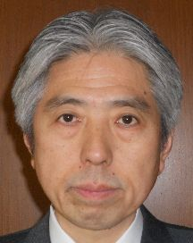 |  | Takashi UEKI, Director, Plant Variety Protection Office, New Business and Intellectual Property Division, Food Industry Affairs Bureau, Ministry of Agriculture, Forestry and Fisheries, Tokyo  (tel.: +81 3 6738 6444 fax: +81 3 3502 5301 e-mail: takashi_ueki@nm.maff.go.jp)
 |  | Akiko NAGANO (Ms.), Associate Director, New Business and Intellectual Property Division Food Industry Affairs Bureau Ministry of Agriculture, Forestry and Fisheries (MAFF),  (tel.: +81-3-6738-6444 fax: +81-3-3502-5301 e-mail: akiko_nagano@nm.maff.go.jp)
kenya / kenya / kenia / kenya
Simon Mucheru MAINA, Senior Inspector, Kenya Plant Health Inspectorate Service (KEPHIS), P.O. Box 8145, 30100 Eldoret
(tel.: +254 722 427 718 e-mail: smaina@kephis.org)
LETTONIE / LATVIA / LETTLAND / LETONIA
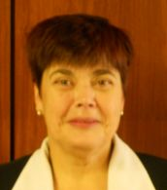 |  | Sofija KALININA (Mrs.), Senior Officer, Seed Control Department, Division of Seed Certification and Plant Variety Protection, State Plant Protection Service, Lielvardes iela 36/38, LV-1006 Riga  (tel.: +371 673 65568 fax: +371 673 65571 e-mail: sofija.kalinina@vaad.gov.lv)
LITUANIE / LITHUANIA / LITAUEN / LITUANIA
 |  | Arvydas BASIULIS, Deputy Director, State Plant Service under the Ministry of Agriculture of the Republic of Lithuania, Ozo 4A, LT-08200 Vilnius  (tel.: +370 5 237 5611 fax: +370 5 273 0233 e-mail: arvydas.basiulis@vatzum.lt)
 |  | Sigita JUCIUVIENE (Mrs.), Head, Division of Plant Variety, Registration and Legal Protection, State Plant Service under the Ministry of Agriculture of the Republic of Lithuania, Ozo St. 4a, LT-08200 Vilnius  (tel.: +370 5 234 3647 fax: +370 5 237 0233 e-mail: sigita.juciuviene@vatzum.lt)
MAROC / MOROCCO / MAROKKO / MARRUECOS
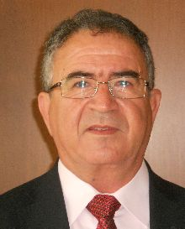 |  | Amar TAHIRI, Chef de la Division du contrôle des semences et plants, Office National de Sécurité sanitaire des Produits alimentaires (ONSSA), Ministère de l'Agriculture et de la Pêche Maritime, Rue Hafiane Cherkaoui, B.P. 1308, Rabat-Instituts (fax: +212 537 771085 fax : + 212 537 779852 e-mail: amar.tahiri@gmail.com)
MEXIQUE / MEXICO / MEXIKO / MÉXICO
 |  | Enriqueta MOLINA MACÍAS (Srta.), Directora General, Servicio Nacional de Inspección y Certificación de Semillas (SNICS), Secretaría de Agricultura, Ganadería, Desarrollo Rural, Pesca y Alimentación (SAGARPA), Tlalnepantla  (tel.: +52 55 3622 0667 fax: +52 55 3622 0670 e-mail: enriqueta.molina@sagarpa.gob.mx)
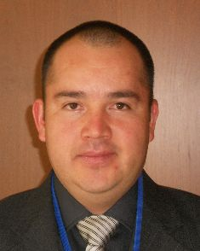 |  | Eduardo PADILLA VACA, Director de Variedades Vegetales, Registro y Control de Variedades Vegetales, Servicio Nacional de Inspección y Certificación de Semillas (SNICS), Av. Presidente Juárez 13, Col. El Cortijo, 54000 Tlalnepantla , Estado de México  (tel.: +52 55 3622 0667 fax: +52 55 3622 0670 e-mail: eduardo.padilla@snics.gob.mx)
NOUVELLE-ZÉLANDE / NEW ZEALAND / NEUSEELAND / NUEVA ZELANDIA
 |  | Christopher J. BARNABY, Assistant Commissioner / Principal Examiner, Plant Variety Rights Office, Intellectual Property Office of New Zealand, Private Bag 4714, Christchurch 8140  (tel.: +64 3 9626206 fax: +64 3 9626202 e-mail: Chris.Barnaby@pvr.govt.nz)
PARAGUAY / PARAGUAY / PARAGUAY
Dolía Melania GARCETE GONZALEZ (Sra.), Directora, Dirección de Semillas (DISE), Servicio Nacional de Calidad y Sanidad Vegetal y de Semillas (SENAVE), Asunción
(tel.: +595 21 577243 / 584645 fax: +595 21 582201 e-mail: dolia.garcete@senave.gov.py)
Roberto ROJAS GONZALEZ, Director, Asesoría Jurídica del Servicio Nacional de Calidad Sanidad Vegetal y de Semillas (SENAVE), Asunción
(tel.: 595 21 496072 fax: 595 21 496072 e-mail: roberto.rojas@senave.gov.py)
PAYS-BAS / NETHERLANDS / NIEDERLANDE / PAÍSES BAJOS
 |  | Marien VALSTAR, Sector Manager Seeds and Plant Propagation Material, Ministerie van Economische Zaken, Landbouw en Innovatie, P.O. Box 20401, NL-2500 EK Den Haag  (tel.: +31 70 379 8911 fax: +31 70 378 6153 e-mail: m.valstar@minlnv.nl)
 |  | Krieno Adriaan FIKKERT, Secretary, Plant Variety Board (Raad voor Plantenrassen), Postbus 40, NL-2370 AA Roelofarendsveen  (tel.: +31 71 3326310 fax: +31 71 3326363 e-mail: k.fikkert@naktuinbouw.nl)
 |  | Kees Jan GROENEWOUD, Secretary to the Plant Variety Board (Raad voor Plantenrassen), Postbus 40, NL-2370 AA Roelofarendsveen  (tel.: +31713326310 fax: +31713326363)
 |  | Vera OSTENDORF (Ms.), Jurist, Ministry of Agriculture, Nature and Food Quality, P.O. Box 20401, NL-2500 EK Den Haag  (tel.: +31 70 378 4180 fax: +31 70 378 6127 e-mail: v.i.ostendorf@minlnv.nl)
POLOGNE / POLAND / POLEN / POLONIA
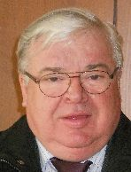 |  | Edward S. GACEK, Director, Research Centre for Cultivar Testing (COBORU), PL-63-022 Slupia Wielka  (tel.: +48 61 285 2341 fax: +48 61 285 3558 e-mail: e.gacek@coboru.pl)
 |  | Marcin BEHNKE, Vice Director General, Research Centre for Cultivar Testing (COBORU), PL-63-022 Slupia Wielka  (tel.: +48 61 285 2341 fax: +48 61 285 3558 e-mail: m.behnke@coboru.pl)
RÉPUBLIQUE DE CORÉE / REPUBLIC OF KOREA / REPUBLIK KOREA / REPÚBLICA DE COREA
 |  | CHOI Keun-Jin, Director of Variety Testing Division, Korea Seed & Variety Service (KSVS), Ministry for Food, Agriculture, Forestry and Fisheries (MIFAFF), 39 Taejang-ro, Yeongtong-gu, Gyeonggi-do, Suwon-si 443-400  (tel.: +82 31 8008 0200 fax: 82 31 203 7431 e-mail: kjchoi1001@korea.kr)
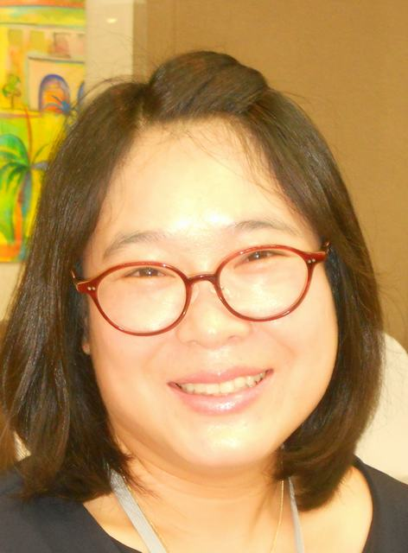 |  | Oksun KIM (Ms.), Plant Variety Protection Division, Korea Seed & Variety Service (KSVS) / MIFAFF, 328, Jungang-ro, Manan-gu, Anyang, 430-016 Gyeonggi-do  (tel.: +82 31 467 0191 fax: +82 31 467 0160 e-mail: oksunkim@korea.kr)
 |  | Min Jung KIM (Ms.), Patent Examiner, Korean Intellectual Property Office (KIPO), Government Complex Daejeon, Building 4, 189, Cheongsa-ro, Seo-gu, Daejeon Metropolitan City 302-701  (tel. +82 42 4815550 fax: +82 42 4723514 e-mail: koremily99@kipo.go.kr)
RÉPUBLIQUE DE MOLDOVA / REPUBLIC OF MOLDOVA / REPUBLIK MOLDAU /
REPÚBLICA DE MOLDOVA
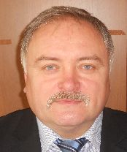 |  | Mihail MACHIDON, President, State Commission for Crops Variety Testing and Registration (SCCVTR), Bd. Stefan cel Mare, 162, C.P. 1873, MD-2004 Chisinau  (tel.: +373 22 220300 fax: +373 2 211537 e-mail: mihail.machidon@yahoo.com)
 |  | Ala GUŞAN (Mrs.), Head, Inventions and Plant Varieties Department, State Agency on Intellectual Property (AGEPI), 24/1 Andrei Doga str., MD-2024 Chisinau  (tel.: +373 22 400582 fax: +373 22 440119 e-mail: office@agepi.md)
RÉPUBLIQUE DOMINICAINE / DOMINICAN REPUBLIC / DOMINIKANISCHE REPUBLIK /
REPÚBLICA DOMINICANA
Agnes CISHEK HERRERA (Sra.), Viceministra de Planificación Sectorial Agropecuaria, Ministerio de Agricultura, Km. 6 1/2 de la Autopista Duarte, Urbanización Jardines del Norte,
Santo Domingo D.N.
(tel.: +1 809 547 388 e-mail: agnes.cishek@agricultura.gob.do)
Dora Luisa SÁNCHEZ BOROMINO (Sra.), Directora, Oficina de Tratados Comerciales Agrícolas (OTCA), Ministerio de Agricultura, Km. 6 1/2 de la Autopista Duarte, Urbanización Jardines del Norte,
Santo Domingo D.N.
(tel.: +1 809 547 3888 fax: +1 809 227 3164 e-mail: dsanchez@otcasea.gob.do)
 |  | Ysset ROMAN (Sra.), Ministro Consejero, Misión Permanente, 63 Rue de Lausanne, Ginebra, Suiza  (tel.: +41 22 715 3910 e-mail: mission.repdom@rep-dominicana.ch)
RÉPUBLIQUE TCHÈQUE / CZECH REPUBLIC / TSCHECHISCHE REPUBLIK /
REPÚBLICA CHECA
 |  | Daniel JUREÇKA, Director, Plant Production Section, Central Institute for Supervising and Testing in Agriculture (ÚKZÚZ), Hroznová 2, 656 06 Brno  (tel.: +420 543 548 210 fax: +420 543 217 649 e-mail: daniel.jurecka@ukzuz.cz)
ROYAUME-UNI / UNITED KINGDOM / VEREINIGTES KÖNIGREICH / REINO UNIDO
 |  | Andrew MITCHELL, Controller of Plant Variety Rights, The Food and Environment Research Agency (FERA), Whitehouse Lane, Huntingdon Road, Cambridge CB3 0LF  (tel.: +44 1223 342 384 fax: +44 1223 342 386 e-mail: andrew.mitchell@fera.gsi.gov.uk)
SLOVAQUIE / SLOVAKIA / SLOWAKEI / ESLOVAQUIA
 |  | Bronislava BÁTOROVÁ (Mrs.), National Coordinator, Senior Officer, Department of Variety Testing, Central Controlling and Testing Institute in Agriculture (ÚKSÚP), Akademická 4, SK-949 01 Nitra  (tel.: +421 37 655 1080 fax: +421 37 652 3086 e-mail: bronislava.batorova@uksup.sk)
SUISSE / SWITZERLAND / SCHWEIZ / SUIZA
 |  | Eva TSCHARLAND (Frau), Juristin, Direktionsbereich Landwirtschaftliche Produktionsmittel, Bundesamt für Landwirtschaft, Mattenhofstrasse 5, CH-3003 Bern  (tel.: +41 31 322 2594 fax: +41 31 323 2634 e-mail: eva.tscharland@blw.admin.ch)
TURQUIE / TURKEY / TÜRKEI / TURQUÍA
 |  | Kamil YILMAZ, Director, Variety Registration and Seed Certification Centre, Ministry of Agriculture and Rural Affairs, P.O. Box 30, 06172 Yenimahalle - Ankara  (tel.: +90 312 315 4605 fax: +90 312 315 0901 e-mail: kyilmaz60@hotmail.com)
UNION EUROPÉENNE / EUROPEAN UNION / EUROPÄISCHE UNION / UNIÓN EUROPEA
 |  | Päivi MANNERKORPI (Ms.), Chef de secteur - Seed and Plant Propagating Material, Direction Générale Santé et Protection des Consommateurs, Commission européene (DG SANCO), Rue Froissart 101, 2/180, 1040 Bruxelles, Belgium  (tel.: +32 2 299 3724 fax: +32 2 296 9399 e-mail: paivi.mannerkorpi@ec.europa.eu)
 |  | Martin EKVAD, President, Community Plant Variety Office (CPVO), 3, boulevard Maréchal Foch, CS 10121, 49101 Angers Cedex 02  (tel.: +33 2 4125 6415 fax: +33 2 4125 6410 e-mail: ekvad@cpvo.europa.eu)
 |  | Muriel LIGHTBOURNE (Mme), Head of Legal Affairs, Community Plant Variety Office (CPVO), 3, Bd. Maréchal Foch, CS 10121, 49101 Angers Cedex  (tel.: +33 2 41 256414 fax: +33 2 41 256410 e-mail: lightbourne@cpvo.europa.eu)
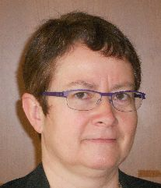 |  | Isabelle CLEMENT-NISSOU (Mrs.), Policy Officer, Direction Générale Santé et Protection des Consommateurs, Commission européenne (DG SANCO), rue Froissart 101, 1040 Bruxelles  (tel.: +32 229 87834 fax: +33 229 60951 e-mail: isabelle.clement-nissou@ec.europa.eu)
VIET NAM / VIET NAM / VIETNAM / VIET NAM
 |  | Nguyen Quoc MANH, Deputy Chief of PVP Office, Plant Variety Protection Office of Viet Nam, No 2 Ngoc Ha Street, Ba Dinh Dist, (84) 48 Hanoi  (tel.: +84 4 38435182 fax: +84 4 37344967 e-mail: quocmanh.pvp.vn@gmail.com)
II. OBSERVATEURS / OBSERVERS / BEOBACHTER / OBSERVADORES
GHANA / GHANA / GHANA / GHANA
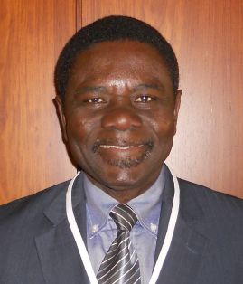 | Hans ADU DAPAAH, Director, CSIR-Crops Research Institute, P.O. Box 3785, Kumasi, Ghana  (tel.: +233 03220 60396 fax: +233 03220 60396 e-mail: hadapaah@cropsresearch.org)
 | Grace Ama ISSAHAQUE (Mrs.), Principal State Attorney, Registrar-General’s Department, Ministry of Justice, P.O. Box 118, Accra  (tel.: +233 21 666 469 fax: +233 21 666 081 e-mail: graceissahaque@hotmail.com)
RÉPUBLIQUE-UNIE DE TANZANIE / UNITED REPUBLIC OF TANZANIA /
VEREINIGTE REPUBLIK TANSANIA / REPÚBLICA UNIDA DE TANZANÍA
 |  | Juma Ali JUMA, Deputy Principal Secretary, Ministry of Agriculture and Natural Resources, P.O. Box 159, Zanzibar  (tel.: +255242230986 fax : +255242234650 e-mail: i_alsaady@yahoo.com)
 |  | Audax Peter RUTABANZIBWA, Chairman, PBR Advisory Committee and Head of Legal Unit, Ministry of Agriculture, Food Security and Cooperatives (MAFC), P.O. Box 9192, Dar es Salaam  (tel.: +255 22 2865392 fax: +255 22 862077 e-mail: udax.rutabanzibwa@kilimo.go.tz)
 |  | Patrick NGWEDIAGI, Registrar, Plant Breeders' Rights Office, Ministry of Agriculture, Food Security and Cooperatives, P.O. Box 9192, Dar es Salaam  (tel.: +255 22 2861404 fax: +255 22 286 1403 e-mail: ngwedi@yahoo.com)
 |  | Sidra Juma AMRAN (Ms.), Head of Legal Unit, Ministry of Agriculture and Natural Resources, P.O. Box 159, Zanzibar  (tel.: +255242230986 fax: +255242234650)
Arabie saoudite / Saudi Arabia / Saudi-Arabien / Arabia Saudita
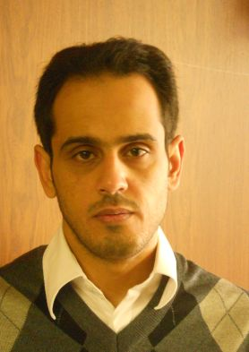 |  | Marzouq AL AFTAN, Patent Examiner, General Directorate of Industrial Property, King Abdulaziz City for Science and Technology (KACST), P.O. Box 6086. Riyadh 11442  (tel.: +966 1 4883555 e-mail: maftan@kacst.edu.sa)
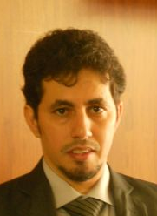 |  | Abdusalam ALZAHRANI, Legal Researcher, General Directorate of Industrial Property, King Abdulaziz City for Science and Technology (KACST), P.O. Box 6086. Riyadh 11442  (tel.: +966 1 4883555 e-mail: amzhrani@kacst.edu.sa)
III. ORGANISATIONS / ORGANIZATIONS / ORGANISATIONEN / ORGANIZACIONES
ORGANISATION MONDIALE DE LA PROPRIÉTÉ INTELLECTUELLE (OMPI) /
WORLD INTELLECTUAL PROPERTY ORGANIZATION (WIPO) /
WELTORGANISATION FÜR GEISTIGES EIGENTUM (WIPO) /
ORGANIZACIÓN MUNDIAL DE LA PROPIEDAD INTELECTUAL (OMPI)
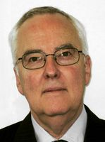 |  | Rolf JÖRDENS, Special Advisor, Global Issues Sector, World Intellectual Property Organization (WIPO), 34, chemin des Colombettes, 1211 Genève 20, Suisse  (tel.: +41 22 338 9155 fax: +41 22 338 7500 e-mail: rolf.joerdens@wipo.int)
ASSOCIATION FOR PLANT BREEDING FOR THE BENEFIT OF SOCIETY
 |  | Susan H. BRAGDON (Ms.), Executive Director of APBREBES, Association for Plant Breeding for the Benefit of Society, 3130 SE Lambert Street, Portland , OR97202, États-Unis d'Amérique  (tel.: +1 503 772 9595 e-mail: bragdonsh@gmail.com)
 |  | François MEIENBERG, Board Member, Berne Declaration, P.O. Box 8026, Zürich , Suisse  (tel.: +41 44 277 7004 fax: +41 44 277 7001 e-mail: food@evb.ch)
ASSOCIATION INTERNATIONALE DES PRODUCTEURS HORTICOLES (AIPH) /
INTERNATIONAL ASSOCIATION OF HORTICULTURAL PRODUCERS (AIPH) /
INTERNATIONALER VERBAND DES ERWERBSGARTENBAUES (AIPH) /
ASOCIACIÓN INTERNACIONAL DE PRODUCTORES HORTÍCOLAS (AIPH)
 |  | Mia HOPPERUS BUMA (Mrs), Secretary, Committee for Novelty Protection, International Association of Horticultural Producers (AIPH), Oude Herenweg 10, 2215 RZ Voorhout  (tel.: +31 651547355 e-mail: buma@aiph.org)
COMMUNAUTÉ INTERNATIONALE DES OBTENTEURS DE PLANTES ORNEMENTALES ET
FRUITIÈRES À REPRODUCTION ASEXUÉE (CIOPORA) / INTERNATIONAL COMMUNITY
OF BREEDERS OF ASEXUALLY REPRODUCED ORNAMENTAL AND FRUIT PLANTS
(CIOPORA) / Internationale Gemeinschaft der Züchter vegetativ vermehrbarer Zier- und Obstpflanzen (CIOPORA) / Comunidad Internacional de Obtentores de Variedades Ornamentales y Frutales de Reproducción Asexuada (CIOPORA)
 |  | Edgar KRIEGER, Secretary General, CIOPORA - International Community of Breeders of Asexually Reproduced Ornamental and Fruit Plants (CIOPORA), Hamburg, Germany  (tel.: +49 40 555 63702 fax: +49 40 555 63703 e-mail: edgar.krieger@ciopora.org)
INTERNATIONAL SEED FEDERATION (ISF)
 |  | Marcel BRUINS, Secretary General, International Seed Federation (ISF), 7, chemin du Reposoir, 1260 Nyon, Switzerland  (tel.: +41 22 365 4420 fax: +41 22 365 4421 e-mail: isf@worldseed.org)
 |  | Michael ROTH, Intellectual Property Consultant, 4393 Westminster Place, E2NA, 63108 St. Louis, MO, United States of America  (tel.: +1 314 210 1832 e-mail: seed.law@gmail.com)
ASIA AND PACIFIC SEED ASSOCIATION (APSA)
 |  | Uday SINGH, Chairman, APSA Intellectual Property Working Group, Asia and Pacific Seed Association (APSA), P.O. Box 1030, Kasetsart Post Office, 10903 Bangkok, Thaïlande  (tel.: +66 2 940 5465 fax: +66 2 940 5467 e-mail: tom.burns@apsaseed.org)
EUROPEAN SEED ASSOCIATION (ESA)
 |  | Szonja CSÖRGÖ (Mrs), Manager, Intellectual Property & Legal Affairs, European Seed Association (ESA), Bruxelles, Belgique  (tel.: +32 2 7432860 fax: +32 2 7432869 e-mail: szonjacsorgo@euroseeds.org)
IV. BUREAU / OFFICER / VORSITZ / OFICINA
 |  | Lü BO, Chair
 |  | Martin EKVAD, Vice-Chair
V. BUREAU DE L’UPOV / OFFICE OF UPOV / BÜRO DER UPOV / OFICINA DE LA UPOV
 |  | Peter BUTTON, Vice Secretary-General
 |  | Yolanda HUERTA (Mrs.), Legal Counsel
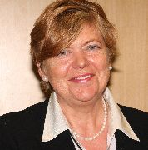 |  | Julia BORYS (Mrs.), Senior Technical Counsellor
 |  | Fuminori AIHARA, Counsellor
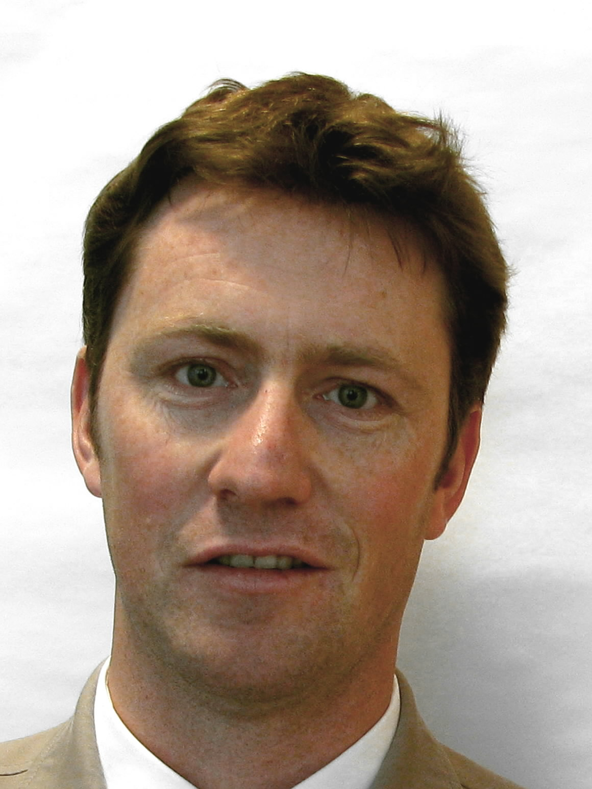 |  | Ben RIVOIRE, Consultant
 |  | Leontino TAVEIRA, Consultant

[Fin du document /
End of document /
Ende des Dokuments /
Fin del documento]

