E
International Union for the Protection of New Varieties of Plants

Council  Thirty-Fifth Extraordinary Session  Geneva, March 23, 2023 | C(Extr.)/35/3  Original: English  Date: March 23, 2023
Draft Press Release
Document prepared by the Office of the Union
Disclaimer: this document does not represent UPOV policies or guidance
The Annex to this document contains a draft press release on the thirty-fifth extraordinary session of the Council.

The Council is invited to consider the draft press release, contained in the Annex to this document, subject to developments in the Council.

[Annex follows]

UPOV Press Release 137

Geneva, March 23, 2023

UPOV Council Appoints New Vice Secretary-General

The Council of the International Union for the Protection of New Varieties of Plants (UPOV) appointed Ms. Yolanda Huerta Casado, a national of Spain, to the post of Vice Secretary-General on March 23, 2023. The Council took the decision by consensus. Ms. Huerta will take up the position as the seventh Vice Secretary-General of UPOV on October 23, 2023.

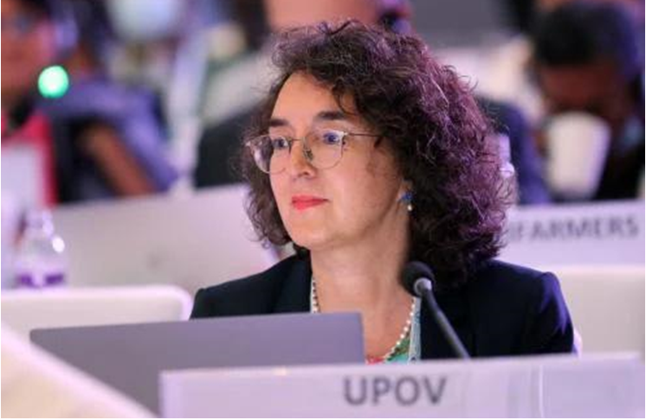

Ms. Huerta holds a Licencia en Derecho (LL.B.) from the University of Barcelona, and holds a LL.M., International Law, from the University of Montreal. Ms. Huerta has experience as an intellectual property lawyer and has worked as a Legal Officer at the World Intellectual Property Organization (WIPO). Since 2001, she has worked at UPOV, where she became Legal Counsel and Director of Training and Assistance in 2017.

Ms. Huerta succeeds Mr. Peter Button, a national of United Kingdom, who will vacate the position on October 22, 2023, after more than 12 years as Vice Secretary-General and more than 23 years of service in UPOV.

NOTES TO EDITORS

UPOV is an intergovernmental organization based in Geneva.

The purpose of UPOV is to provide and promote an effective system of plant variety protection, with the aim of encouraging the development of new varieties of plants, for the benefit of society.

UPOV has 78 members covering 97 States. The members of UPOV are:

African Intellectual Property Organization, Albania, Argentina, Australia, Austria, Azerbaijan, Belarus, Belgium, Bolivia (Plurinational State of), Bosnia and Herzegovina, Brazil, Bulgaria, Canada, Chile, China, Colombia, Costa Rica, Croatia, Czech Republic, Denmark, Dominican Republic, Ecuador, Egypt, Estonia, European Union, Finland, France, Georgia, Germany, Ghana, Hungary, Iceland, Ireland, Israel, Italy, Japan, Jordan, Kenya, Kyrgyzstan, Latvia, Lithuania, Mexico, Montenegro, Morocco, Netherlands, New Zealand, Nicaragua, North Macedonia, Norway, Oman, Panama, Paraguay, Peru, Poland, Portugal, Republic of Korea, Republic of Moldova, Romania, Russian Federation, Saint Vincent and the Grenadines, Serbia, Singapore, Slovakia, Slovenia, South Africa, Spain, Sweden, Switzerland, Trinidad and Tobago, Tunisia, Türkiye, Ukraine, United Kingdom, United Republic of Tanzania, United States of America, Uruguay, Uzbekistan and Viet Nam.

For further information about UPOV, please contact the UPOV Secretariat:

Tel: (+41-22) 338 9111 E-mail: upov.mail@upov.int Website: https://www.upov.int

Social media
Twitter account: @UPOVint
LinkedIn account: https://www.linkedin.com/company/upov-official

[End of Annex and of document]

