E
International Union for the Protection of New Varieties of Plants

TGP/15/4 Draft 1 Rev.
Original: English
Date: October 16, 2026

DRAFT
(REVISION)

Associated Document to the
General Introduction to the Examination of Distinctness, Uniformity and Stability
and the Development of Harmonized Descriptions of New Varieties of Plants (document TG/1/3)
DOCUMENT TGP/15
GUIDANCE ON THE USE OF BIOCHEMICAL AND MOLECULAR MARKERS
IN THE EXAMINATION OF DISTINCTNESS, UNIFORMITY AND STABILITY (DUS)

Document prepared by the Office of the Union
to be considered by
the Technical Committee, the Administrative and Legal Committee, and the Council in 2026

Disclaimer: this document does not represent UPOV policies or guidance

Note for Draft version

Underlining (highlighted in grey) indicates insertion and strikethrough (highlighted in grey) indicates deletion of text to the previous version (document TGP/15/3).

Text in blue indicates the new position of existing text. Strikethrough in blue indicates the former position of existing text.

The new “Guidelines for the validation of a new characteristic-specific molecular marker protocol as an alternative method for observation” is presented as “Section 3” to this document.

TABLE OF CONTENTS
1. INTRODUCTION 3
2. APPLICATION MODELS 3
2.1 Characteristic-Specific Molecular Markers (see Annex I) 3
Example 1: Gene Specific Marker for Herbicide Tolerance 4
Example 2: Gene Specific Marker with Incomplete Information on State of Expression for Disease Resistance in Tomato 5
2.2 Combining Phenotypic and Molecular Distances in the Management of Variety Collections (see Annex II) 5
Example 1: Parent lines in Maize (see Annex II, example 1) 5
Example 2: Genetic Selection of Similar Varieties for the First Growing Cycle (see Annex II, example 2) 9
3. GUIDELINES FOR THE VALIDATION OF A NEW CHARACTERISTIC-SPECIFIC MOLECULAR MARKER PROTOCOL AS AN ALTERNATIVE METHOD FOR OBSERVATION 11
3.1 Objectives of these guidelines 11
3.2 Scope of these guidelines 11
3.3 Performance criteria for a new molecular marker based protocol 11
Specificity 11
Sensitivity and limit of detection 11
Repeatability 12
Reproducibility 12
Robustness 13
3.4 Validation report 13
Content of the validation report 13
Publicity 13
3.5 Standard Protocol for characteristic-specific molecular marker 14
3.6 Follow-up survey after acceptance of the marker protocol 16
3.7 Literature 16

ANNEX I MODEL: CHARACTERISTIC-SPECIFIC MOLECULAR MARKERS
EXAMPLE 1: GENE SPECIFIC MARKER FOR HERBICIDE TOLERANCE
EXAMPLE 2: GENE SPECIFIC MARKER WITH INCOMPLETE INFORMATION ON STATE OF EXPRESSION FOR DISEASE RESISTANCE IN TOMATO

ANNEX II MODEL: COMBINING PHENOTYPIC AND MOLECULAR DISTANCES IN THE MANAGEMENT OF VARIETY COLLECTIONS
EXAMPLE 1: PARENT LINES IN MAIZE
EXAMPLE 2: GENETIC SELECTION OF SIMILAR VARIETIES FOR THE FIRST GROWING CYCLE: FRENCH BEAN

1. INTRODUCTION
1.1 Document UPOV/INF/18 “Possible Use of Molecular Markers in the Examination of Distinctness, Uniformity and Stability (DUS)” considers possible application models for the use of biochemical and molecular markers in the examination of DUS that were proposed to the Ad hoc Subgroup of Technical and Legal Experts of Biochemical and Molecular Techniques (BMT Review Group) by the Technical Committee (TC), on the basis of the work of the Working Group on Biochemical and Molecular Techniques, and DNA-Profiling in Particular (BMT) and Ad Hoc Crop Subgroups on Molecular Techniques (Crop Subgroups) (see http://www.upov.int/about/en/organigram.html). The assessment of the BMT Review Group and the views of the Technical Committee, the Administrative and Legal Committee (CAJ) on those models are presented in document UPOV/INF/18.

1.2 The purpose of this document is to provide guidance on the use of biochemical and molecular markers in the examination of Distinctness, Uniformity and Stability (DUS) on the basis of the models that have received a positive assessment and for which accepted examples have been provided.

1.3 The only binding obligations on members of the Union are those contained in the text of the UPOV Convention itself, and this document must not be interpreted in a way that is inconsistent with the relevant Act for the member of the Union concerned.

1.4 The following abbreviations are used in this document:

CAJ: Administrative and Legal Committee
TC: Technical Committee
TWP(s): Technical Working Party(ies)
BMT: Working Group on Biochemical and Molecular Techniques, and DNA-Profiling in Particular
BMT Review Group: Ad Hoc Subgroup of Technical and Legal Experts on Biochemical and Molecular Techniques
Crop Subgroup: Ad Hoc Crop Subgroup on Molecular Techniques

2. APPLICATION MODELS

2.1 Characteristic-Specific Molecular Markers (see Annex I)
2.1.1 Molecular markers can be used as a method of examining DUS characteristics that satisfy the criteria for characteristics set out in the General Introduction, Chapter 4, section 4.2, on the following basis:

(a) the test for the marker is conducted on the same number of individual plants, with the same criteria for distinctness, uniformity and stability as for the examination of the characteristic by a bioassay;

(b) there is verification of the reliability of the link between the marker and the characteristic;

(c) different markers for the same characteristic are different methods for examining the same characteristic;

(d) markers linked to different genes conferring expression of the same characteristic are different methods for examining the same characteristic; and

(e) markers linked to different regulatory elements for the same gene conferring expression of the same characteristic are different methods for examining the same characteristic.

2.1.2 Annex I to this document Paragraphs 2.1.5 to 2.1.18 provides examples of the use of characteristic-specific molecular markers.

2.1.3 It is a matter for the relevant authority to consider if the assumptions are met when applying the model and examples, as presented in Annex I of this document paragraphs 2.1.5 to 2.1.18.

2.1.4 In order to include a method based on the model in Annex I of this document in Test Guidelines the relevant Technical Working Party and the TC would need to agree that the requirement for reliability of the link between the gene and the expression of the characteristic was satisfied.

Example 1: Gene Specific Marker for Herbicide Tolerance
Prepared by experts from France

2.1.5 A variety is genetically modified by the insertion of a gene for tolerance to herbicide “Formula X.” Varieties containing this gene are not harmed when sprayed with Formula X; however, varieties without this gene are always killed if sprayed with this particular herbicide. Tolerance of Formula X, examined in field trials by spraying of plots, is an accepted DUS characteristic, and it can be used to establish distinctness between varieties.

2.1.6 It is proposed that, rather than spraying varieties in the field (this is difficult to organize in the standard DUS trial), the characteristic “tolerance of Formula X” is examined by conducting a test for the presence of a molecular marker linked to the gene. This marker is located on a part of the gene “construct.” The gene “construct” comprises all the elements which are inserted into the plant during the genetic modification and, in addition to the gene itself, contains additional elements for regulating the gene when in the plant. The marker may be located within the gene, partly on the gene or outside the gene itself.

Assumptions to be made in the example

2.1.7 The following assumptions are made:

(a) The DUS Examination

2.1.8 It is assumed that the test for the marker would be conducted to the same extent as for the field test, i.e. the same number of individual plants, over the same number of years and with the same criteria for distinctness, uniformity and stability.

(b) Reliability of the Linkage

2.1.9 It is assumed that the link between the marker and the gene would be checked to ensure that the marker is a reliable predictor of tolerance to Formula X. This check would be necessary to ensure, for example, that the marker does not become separated from the gene and that the presence of the gene is still resulting in tolerance to Formula X.

(c) Development of Different Molecular Markers for the Same Gene

2.1.10 It would be possible to develop different gene constructs containing Formula X tolerance and to identify separate molecular markers for these individual gene constructs, all of which would be linked to exactly the same gene for Formula X tolerance. If all the different markers for the same gene were accepted as different methods for examining the same existing phenotypic characteristic, the consideration of the approach would be the same. For the use of “Molecular […] [markers] as a predictor of traditional characteristics,” it is necessary to work on the basis that the markers correspond to a traditional, i.e. existing, approved characteristic. Therefore, it is assumed that different markers for the same gene would be treated as different methods for examining the same characteristic, i.e. tolerance to Formula X.

(d) Different Genes Producing Tolerance to the Same Herbicide

2.1.11 It might be possible to develop different genes which confer tolerance to Formula X. In the simplest case, this could be considered in the same way as different markers for the same gene, i.e. the different genes, with their respective markers, would be considered as different methods for examining the same characteristic, i.e. tolerance to Formula X. However, the different genes are likely to have a different chemical mechanism to produce the tolerance to Formula X. Thus, the chemicals produced from the different genes will be different and, these different chemicals might be a basis for establishing distinctness in some circumstances. Nevertheless, under this model, it would first be necessary to approve the chemical components as UPOV characteristics, before accepting molecular markers linked to these potential characteristics. This in turn would be a separate example. Therefore, it is assumed that different genes would be treated as different methods for examining the same characteristic, i.e. tolerance to Formula X.

(e) Different Gene Constructs Producing the Same Herbicide Tolerance but With Different Control of the Expression

2.1.12 It is also possible that different gene constructs could be developed which contain the same gene for tolerance to Formula X, but which had different regulatory control. For example, the regulatory elements may result in the Formula X tolerance only being switched on at certain stages of development. For simplicity, in considering this example, it is assumed that the different markers linked to different regulatory elements for the same gene would all be treated as different methods for examining the same characteristic of tolerance to Formula X. However, it is also assumed that further consideration would be given to this matter at a later stage.

Example 2: Gene Specific Marker with Incomplete Information on State of Expression for Disease Resistance in Tomato
Prepared by experts from the Kingdom of the Netherlands

2.1.13 Resistance to Tomato mosaic virus (ToMV) Strain 0 in Tomato is conferred by the presence of allele Tm1 from gene Tm1 or alleles Tm2 or Tm2² from gene Tm2.

2.1.14 A single marker identifies the presence of resistance alleles Tm2 and Tm2² and the susceptible allele tm2. Marker Tm2/2² is positioned in the protein coding sequence.

2.1.15 A variety will be resistant to ToMV Strain 0 if resistance allele Tm2 or resistance allele Tm2² is present.

2.1.16 A variety with homozygous allele tm2 will be susceptible to ToMV Strain 0 unless resistance is coded by resistance allele Tm1. In this case, resistance to ToMV Strain 0 cannot be assessed by a DNA marker test because there is no reliable marker for gene Tm1.

Table 1: Schematic overview of resistance to Tomato mosaic virus and resistance alleles:

Genetic background | tm2/tm2  and  tm1/tm1 | Tm2/Tm2 or Tm2²/Tm2² or Tm2²/Tm2 or  Tm2/tm2 or Tm2²/tm2  and  Tm1/Tm1 or Tm1/tm1 or tm1/tm1 | tm2/tm2  and  Tm1/Tm1 or Tm1/tm1
Marker Tm2/2² | susceptible allele | resistant allele | susceptible allele
Resistance to ToMV - Strain 0 | absent | present | present

2.1.17 If a variety is claimed to be resistant to ToMV Strain 0, the DNA marker test may be performed. In cases where the resistance is based on the presence of the allele Tm2 or Tm2², the DNA marker test could replace the traditional bioassay.

2.1.18 If the DNA marker test does not confirm the resistance claim or if the variety is claimed to be susceptible, a bioassay must be performed.

2.2 Combining Phenotypic and Molecular Distances in the Management of Variety Collections (see Annex II)

Example 1: Parent lines in Maize (see Annex II, example 1)
2.2.1 A key feature of the process of eliminating varieties of common knowledge prior to the DUS growing trial is that the threshold is set with a suitable margin of safety. This threshold is termed the “Distinctness plus” threshold, which means that the distances between a candidate variety and “Distinct plus” varieties are robust enough to take a decision without direct comparison in the growing trial.

2.2.2 A combination of phenotypic differences and molecular distances can be used to identify within the variety collection, those varieties which need to be compared with candidate varieties in order to improve the selection of “Distinct plus” varieties, on the following basis:

(a) there is reliable information that the molecular distances are sufficiently related to phenotypic differences, such that

(b) the method selects varieties in the variety collection which are similar to the candidate varieties; and

- the method does not create an increased risk of not selecting a variety in the variety collection which needs to be compared to the candidate varieties in the field.

2.2.3 Annex II to this document “Combining Phenotypic and Molecular Distances in the Management of Variety Collections” Paragraphs 2.2.4 to 2.2.16 provides an example, prepared by experts from France, of the use of combining phenotypic differences and molecular distances in the management of variety collections.

Description

2.2.4 A key feature of the process of eliminating varieties of common knowledge prior to the DUS growing trial is that the threshold for deciding which varieties can be safely excluded (i.e. are distinct on the basis of descriptions), can be set with a suitable margin of safety, because those varieties which are eliminated, will not be included in the growing trial. This threshold, with a safety margin, is termed the “Distinctness plus” threshold which means that the distances between a candidate variety and “distinct plus” varieties are robust enough to take a decision without direct comparison in the growing trial.

2.2.5 The objective of this example is to develop an efficient tool, based on a combination of phenotypic and molecular distances, to identify within the variety collection, those varieties which need to be compared with candidate varieties (see Figure 1) in order to improve the selection of “distinct plus” varieties and so to limit the workload without decreasing the quality of the test. The challenge is to develop a secure system that:

(a) only selects varieties which are similar to the candidate varieties; and

(b) limits the risk of not selecting a variety in the variety collection which needs to be compared in the field, especially when there is a large or expensive variety collection.

Figure 1
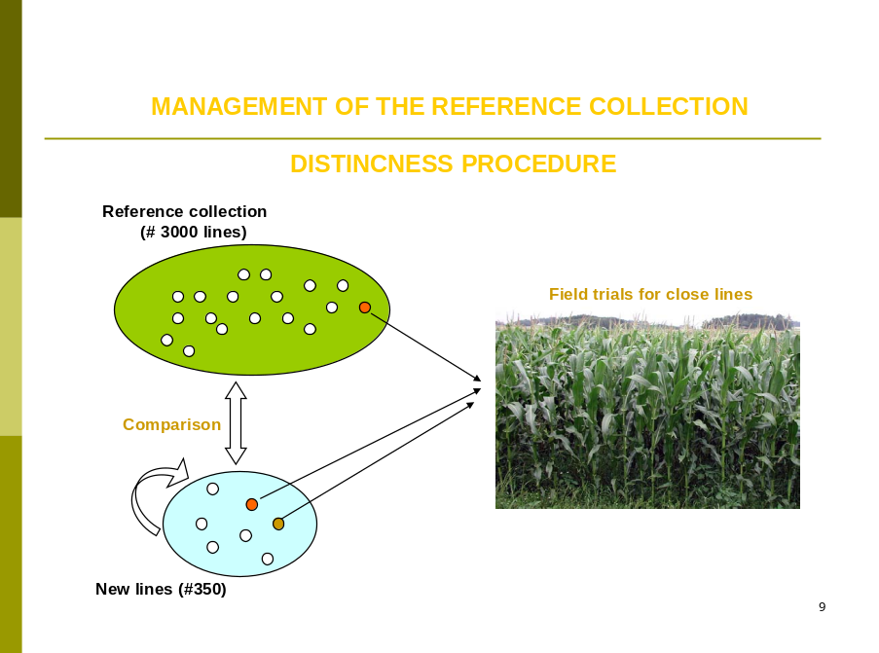

2.2.6 The new system has been elaborated on the following background:

(a) Studies done on molecular distances in maize for DUS testing and essential derivation, which showed the link with the parentage between varieties (see documents BMT/3/6 “The Estimation of Molecular Genetic Distances in Maize or DUS and ED Protocols: Optimization of the Information and new Approaches of Kinship” and document BMT/3/6 Add.)

(b) An experiment done by GEVES on a set of maize parental lines, which showed that there is a link between the evaluation of distinctness by experts (global assessment) and a molecular distance computed on Simple Sequence Repeat (SSR) molecular data (see Figure 2).

Components of the system

GAIA distance

2.2.7 The GAIA distance component is computed with the GAIA software developed by GEVES. The GAIA distance is a combination of differences observed on phenotypic characteristics, where each difference contributes to the distance according to the reliability of the characteristics, especially regarding its variability and its susceptibility to environment. The larger the size of the difference and the greater the reliability of the characteristic, the more the difference contributes to the GAIA distance. Only differences that are equal or larger than the minimum distance required for each individual characteristic are included.

Molecular distance

2.2.8 The molecular distance component is computed on the differences observed on a set of markers. Different types of molecular markers and distances can be used. In the case of the study done in France on maize, 60 SSR markers and Roger’s distance have been used. It is important that sufficient markers, with a good distribution on the chromosomes, are used. The type of markers, the effect of the number of markers and the distribution of the markers need to be considered according to the species concerned.

2.2.9 Before combining these two components, an evaluation of the link between molecular distance and a global assessment of distinctness by a panel of experts needs to be done on a set of pairs of varieties. In the case of maize, that evaluation was made on the following basis:

Material: 504 pairs of varieties tested in parallel with molecular markers

Field design: pairs of varieties grown side by side
(1 plot = 2 rows of 15 plants)

Visual assessment by maize crop experts:

Scale of similarity:

1. the two varieties are similar or very close
3. the two varieties are distinct but close
5. the comparison was useful, but the varieties are clearly distinct
7. the comparison should have been avoided because the varieties are very different
9. the comparison should have been avoided because the varieties are totally different
(“even” notes are not used in the scale)

2.2.10 In the case of maize, this evaluation showed that no parental lines with a molecular distance greater than 0.15 were considered as similar or very close by a DUS expert evaluation (see Figure 2).

Figure 2
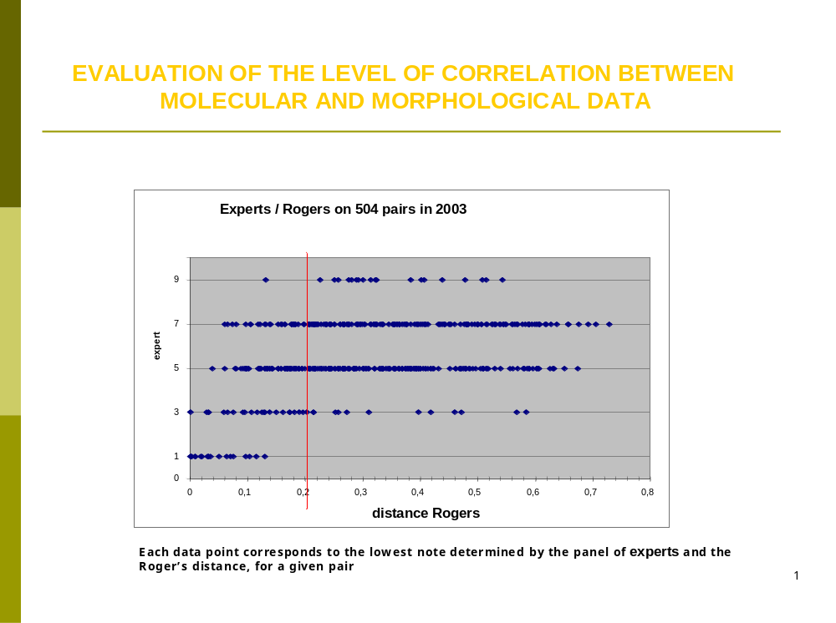

2.2.11 On the basis of that result, the combination of morphological and molecular distances offers the possibility to establish a decision scheme as follows (see Figure 3):

Figure 3
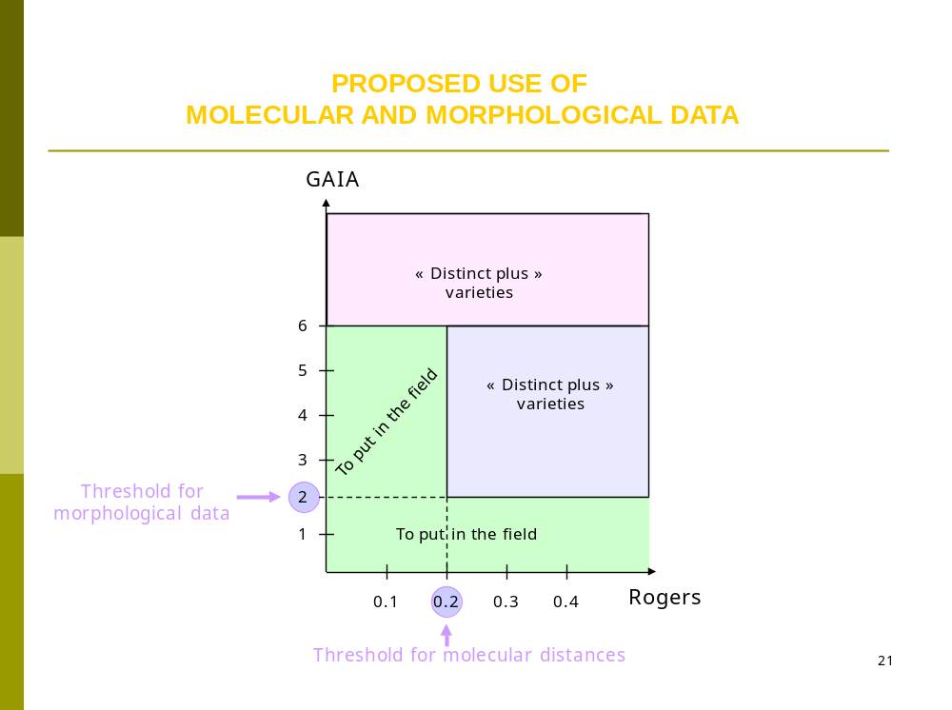

2.2.12 All pairs of varieties with a GAIA distance equal to, or larger than, 6 and all varieties with a GAIA distance between 2 and 6, plus a molecular distance equal to, or larger than, 0.2 are declared “Distinct plus”.

2.2.13 This scheme shows that less parental lines need to be observed in the field compared to the situation where only a GAIA distance of 6 is used on its own.

2.2.14 The robustness of this system has been studied with different GAIA and molecular distances.

Advantages and constraints

2.2.15 Advantages

(a) Improvement of the management of variety collections with less varieties needing to be compared in the field;
(b) Use of morphological and molecular distances with thresholds defined by DUS experts. GAIA was also calibrated against DUS experts’ evaluations when developed by GEVES;
(c) Use of molecular data that are not susceptible to the environment; the set of markers and the laboratory protocol are well defined;
(d) Use of only phenotypic characteristics with a good robustness and possibility to use descriptions coming from different origins under close cooperation (The maize database that has been developed in cooperation between France, Germany, Spain and the Community Plant Variety Office of the European Union (CPVO) is a good example to illustrate the value of this approach with a variety collection shared between different offices);
(e) Electrophoresis characteristics can also be replaced; and
(f) There is no influence of lack of uniformity in molecular profiles provided enough markers are used and the number of variants is low. In the case of maize parental lines, the level of molecular uniformity is high but could be a problem in some other crops.

2.2.16 Constraints

(a) Not efficient, or less efficient, for species with synthetic varieties or populations;
(b) Necessity to have enough good DNA markers and enough phenotypic characteristics with low susceptibility to environment; and
(c) Preliminary work with calibration in comparison with DUS expert evaluation of distinctness.

Example 2: Genetic Selection of Similar Varieties for the First Growing Cycle (see Annex II, example 2)
2.2.17 This approach involves a step to check for genetic similarity before the first growing cycle.

2.2.18 In cases where the minimum duration of tests is normally two growing cycles, a selection of similar varieties in the variety collection for comparison with candidate varieties in the first growing cycle is made according to genetic similarity. As a next step, the information provided by the applicant in the Technical Questionnaire (TQ) is used to see if some of the genetically similar varieties do not have to be compared in a growing trial because of differences in DUS characteristics.

2.2.19 On the basis of the variety description of DUS characteristics produced in the first growing cycle, a further search is made of varieties in the variety collection to identify any similar varieties that were not compared in the first growing cycle and which should be compared with the candidate variety in the second growing cycle.

2.2.20 Example 2 in Annex II to this document “Genetic Selection of Similar Varieties for the First Growing Cycle” Paragraphs 2.2.21 to 2.2.31 provides an example, prepared by experts from the Kingdom of the Netherlands, of the genetic selection of similar varieties for the first growing cycle in the case of French Bean.

Introduction

2.2.21 This approach involves a step to check for genetic similarity before the first growing cycle.

2.2.22 In cases where the minimum duration of tests is normally two growing cycles, a selection of similar varieties in the variety collection for comparison with candidate varieties in the first growing cycle is made according to genetic similarity. As a next step, the information provided by the applicant in the Technical Questionnaire (TQ) is used to see if some of the genetically similar varieties do not have to be compared in a growing trial because of differences in DUS characteristics.

2.2.23 On the basis of the variety description of DUS characteristics produced in the first growing cycle, a further search is made of varieties in the variety collection to identify any similar varieties that were not compared in the first growing cycle and which should be compared with the candidate variety in the second growing cycle.

Procedure

Determine genetic similarity

2.2.24 The DNA-profile of the candidate variety is produced as soon as plant material is received.

2.2.25 The DNA-profile is compared with the profiles of all varieties in the variety collection and genetically similar varieties are identified.

Technical Questionnaire information

2.2.26 The information provided by the applicant in the Technical Questionnaire (TQ) is then used to see if there are clear differences in DUS characteristics from some of the genetically similar varieties so that they do not need to be compared with candidate varieties in a growing trial.

Field trial

First growing cycle:

2.2.27 The candidate and the genetically similar varieties selected by the procedure above are grown in the same field trial. A complete description of the DUS characteristics of the candidate variety is produced and is compared to the descriptions of all varieties in the variety collection using a database containing descriptions produced at the same location in previous years.

Possible outcomes:

2.2.28 If the candidate variety is not distinct from the genetically similar varieties on the basis of DUS characteristics, the test will be continued for another growing cycle.

2.2.29 In any case, the description of the candidate variety produced in the first growing cycle is compared to the descriptions of the varieties in the variety collection using a database containing descriptions produced at the same location:

(a) If the candidate variety is found to be distinct from all varieties grown in the first growing cycle and to all other varieties in the variety collection at the end of the first growing cycle and it fulfills the uniformity and stability requirements the DUS test may be concluded after the first growing cycle.

(b) In all other cases a second growing cycle is performed.

Second growing cycle

2.2.30 In the second growing cycle, the candidate variety is grown with all varieties in the variety collection from which it was not found to be distinct at the end of the first growing cycle.

2.2.31 At the end of the second growing cycle, an assessment of DUS is made. If it is not possible to reach a decision on DUS at the end of the second growing cycle, a further growing cycle may be conducted.

3. GUIDELINES FOR THE VALIDATION OF A NEW CHARACTERISTIC-SPECIFIC MOLECULAR MARKER PROTOCOL AS AN ALTERNATIVE METHOD FOR OBSERVATION

3.1 Objectives of these guidelines
3.1.1 The purpose of these guidelines is to provide practical guidance for the harmonized validation of a new method based on application model “characteristic-specific molecular marker” before its use as an alternative test (see section 2.1 of this document). Performance criteria required for the validation are described and guidance on their assessment is given. These guidelines also describe a standard protocol and a follow-up survey.

3.1.2 If a different technique is used, the laboratory should validate its method in comparison to the reference method to show that the alternative technique gives the same results.

3.2 Scope of these guidelines
- All species
- Characteristic-Specific Molecular Markers
- For the examination of Distinctness, Uniformity, and Stability (DUS).

3.3 Performance criteria for a new molecular marker based protocol

Specificity

Definition
3.3.1 Specificity is defined as the correlation between the genotype and the phenotype, i.e. the reliability of the link between the marker and the characteristic.

Requirement
3.3.2 The correlation between the genotype and the phenotype should be 100%. If the correlation is less than 100% a follow-up test(s) should be performed to ensure the reliability of the results. A decision rule can be used in that case. Less than 100% correlation can be caused by other genetics.

How to evaluate it?
3.3.3 Number of varieties: To start the marker selection process an appropriate number of varieties (development set) is needed to reflect at the most the diversity observed within the group/species/type for which the markers are intended to be discriminative.

3.3.4 Varieties should represent the different states of expression (if known varieties with heterozygous and homozygous state), coming from different breeders, with different genetic background of the characteristic and different types. Well phenotypically characterized varieties for the trait of interest should be used when available.

3.3.5 Number of plants per variety: At least one plant per variety should be evaluated if the available varieties are phenotypically well characterized. If not, the number of plants should be the same as for the morphological observation described in the UPOV Test Guidelines.

3.3.6 The specificity can be assessed within one laboratory.

Sensitivity and limit of detection

Definition
3.3.7 The limit of detection is defined as the minimal quantity of the target that can be reliably detected.

3.3.8 In case of analyses performed on bulk samples (e.g. pool of different plants of the same variety) the sensitivity is critical and should be assessed. For the use on individual plants, the quantity of the target is not critical and this performance criterium is optional.

Requirement
3.3.9 In the case of the pool, the requirement would be to detect any off-type in the pool.

How to evaluate it?
3.3.10 Sensitivity of the detection should be checked with artificial samples generated by mixing one off-type to a pool.

Repeatability

Definition (based on ISO 16 577:2016; reference to document UPOV/INF/17)
3.3.11 Repeatability means that identical test results are obtained with the same method, on identical test items, in the same laboratory, by the same operator, using the same equipment within short intervals of time.

3.3.12 For qualitative methods, accordance is equivalent to the repeatability of quantitative methods (Langton et al., 2002).

Requirement
3.3.13 Ideally, 100% repeatability should be reached but a performance ≥90% is generally accepted. If the repeatability of the reference method is published the repeatability of the alternative method should be at least equivalent.

How to evaluate it?
3.3.14 The repeatability can be evaluated within one laboratory.

3.3.15 At least three technical replicates drawn from a same plant (three independent DNA extractions) should be analyzed. At least all expected types of genotype should be included.

Reproducibility

Definition (based on ISO 16 577:2016; reference to UPOV/INF/17)
3.3.16 Reproducibility means that identical test results are obtained with the same method, on identical test items, within the same laboratory or between different laboratories, with different operators, using different equipment at different times.

3.3.17 For qualitative methods, concordance is equivalent to the reproducibility of quantitative methods (Langton et al., 2002).

Requirement
3.3.18 Ideally, 100% reproducibility should be reached but a performance ≥90% is generally accepted. If the reproducibility of the reference method is published the reproducibility of the alternative method should be at least equivalent.

How to evaluate it?
3.3.19 Reproducibility should be assessed between different laboratories by an interlaboratory validation study (Ring-test) with coded samples of known genotypes. All expected types of genotype should be included.

3.3.20 The ring-test should involve at least, three different laboratories including at least two different examination offices. If possible, experienced laboratories familiar with the species and the technique should be involved. If not, a training can be organized ahead of the ring-test with un-coded samples. Laboratories can participate in a ring-test on voluntary basis. In case there are not enough participating laboratories, an intra-laboratory reproducibility assessment will be possible with different operators.

3.3.21 All laboratories should follow the protocol to be validated. In the protocol standard and optional parts can be defined by the validation team. Laboratories can participate in a ring‑test on voluntary basis. In case there are not enough participating laboratories, the reproducibility can be determined within one laboratory.

3.3.22 Number of varieties: At least all expected types of genotype should be included.

3.3.23 Guidelines/Norms on interlaboratory studies can be followed, e.g. ISO 13495 Foodstuffs - Principles of selection and criteria of validation for varietal identification methods u sing specific nucleic acid, ISO 17043 Conformity assessment - General requirements for proficiency testing, EPPO pm7-122-2 Guidelines for the organization of interlaboratory comparisons by plant pest diagnostic laboratories, ISTA TCOM-P-10-Validation of seed health methods and organization and analysis of interlaboratory comparative tests (CT). The validation team should cite the guidelines followed in its report.

Robustness

Definition (based on ISO 16 577:2016; reference to UPOV/INF/17)
3.3.24 Robustness is a measure of the capacity to remain unaffected by small, but deliberate deviations from the experimental conditions described in the procedure parameters and provides an indication of its reliability during normal usage (e.g. change of DNA extraction method or change of real time machine).

Requirement
3.3.25 Ideally, robustness should be 100%. Less than 100% means that the method is not robust to a change of one parameter and this should be indicated in the protocol as a mandatory step (e.g. a change of a mastermix that would be critical).

How to evaluate it?
3.3.26 Specific assessment of robustness is optional. Robustness is evaluated partially during the ring test (reproducibility), (different laboratories, equipment, machinery, etc.).

3.4 Validation report
3.4.1 The validation report and results should be peer-reviewed by two (preferably 3 if the reproducibility was done within one laboratory) of the responsible bodies. Reviewing is on voluntary basis but preferably performed by a laboratory familiar with the species and the method.

3.4.2 During the reviewing process, the reviewers can require extra validation data in concertation with the validation team.

Content of the validation report
- Raw data generated during the different steps of the validation process
- Detail protocol with standard and optional steps defined
- Performance criteria assessment
- Conclusion

Publicity
3.4.3 The validation report should be available upon request. In the new protocol the validation process should be mentioned with the contact examination office.

3.5 Standard Protocol for characteristic-specific molecular marker
3.5.1 Standard elements are indicated in the column “essential information”, the other elements may be used depending on the characteristic related to the test protocol. If a laboratory wants to modify a standard chapter it should validate its method in comparison to the reference method.

Table 1: Standard protocol for characteristic-specific molecular marker as alternative method for observation

Chapter | Elements in a Standard characteristic-specific molecular marker protocol | Essential information for harmoni-zation | Remark
1 | Characteristic | YES | Name of the characteristic.
2 | Genes and alleles | YES | Need to avoid dominant marker or presence/absence marker otherwise the robustness should be assessed.
2.1 | Targeted gene(s) | YES | a) file(s) containing the DNA sequence information (order of nucleotides).  b) reference to DNA information in public databases (like gene bank).  c) reference to publications in which the DNA sequence information of the states of expression of the characteristic is revealed.  d) reference to a particular position on the published reference genome version.
2.2 | Allele corresponding to expression state 1 | YES | a) file(s) containing the DNA sequence information (order of nucleotides).  b) reference to DNA information in public databases (like gene bank).  c) reference to publications in which the DNA sequence information of the states of expression of the characteristic is revealed.  d) reference to a particular position on the published reference genome version in combination with the SNP or INDEL that is responsible for the state of expression.
2.3 | Allele corresponding to expression state n | YES | a) file(s) containing the DNA sequence information (order of nucleotides).  b) reference to DNA information in public databases (like gene bank).  c) reference to publications in which the DNA sequence information of the states of expression of the characteristic is revealed.  d) reference to a particular position on the published reference genome version in combination with the SNP or INDEL that is responsible for the state of expression.
3 | Primers (and probes) | YES | Primer and probe sequences, reference to accessions and sequences in public databases (gene bank numbers), literature.
3.1 | Primers (and probes) to detect allele ‘9’ | YES | Primer Sequences corresponding to allele(s) for expression ‘9’ (resistance).
3.2 | Primers (and probes) to detect allele ‘1’ | YES | Primer Sequences corresponding to allele(s) for expression ‘1’ (susceptibility).
3.3 | Primers (and probes) to detect allele ‘x’ | YES | Primer Sequences corresponding to allele(s) for expression ‘x’.
4 | Format of the test
4.1 | Number of plants per genotype | YES | A minimal number of individual plants required: the test for the marker is conducted on the same number of individual plants, with the same criteria for distinctness, uniformity and stability as for the examination of the characteristic by direct observation of the characteristic (documents TGP/9 and TGP/10).
4.2 | Control varieties | YES | Control varieties (same as in direct observation of the characteristic) as standards representing all relevant combination of alleles. For example homozygous for allele corresponding to expression state 9 (present), homozygous for allele corresponding to expression state 1 (absent) and heterozygous (both alleles are present) corresponding, e.g. to either resistance, susceptibility or intermediate resistance of the variety (depending on gene function; dominant - recessive). DNA controls can be directly used.
4.3 | Process controls | YES | - Negative process control(s).  - Positive DNA control(s) that can be the control varieties.  - Internal amplification control in case of a presence/absence marker (a marker targeting the cytochrome oxidase gene as an internal amplification marker).  - Buffer used for extraction.
5 | Preparations | NO | Depending on the method used. Not in the Test Guidelines. Detailed protocol(s) can be provided as an example in annex or available on request from the organization that developed the marker.  Mostly sampling of seedlings followed by DNA extraction using CTAB method.
6 | Technique of the method | YES | Conventional PCR, TETRA-ARMS, qPCR, KASP, amplicon sequencing.
6.1 | Particular conditions | NO | Depending on the method used. Not in the Test Guidelines. Detailed protocol(s) can be provided as an example in annex or available on request from the institute that developed the marker.  PCR protocol describing primer, enzyme, dNTP concentrations, PCR cycle scheme.
6.2 | Particular hardware or infrastructure | NO | Depending on the method used. Not in the Test Guidelines. Detailed protocol(s) can be provided as an example in annex or available on request from the institute that developed the marker.  Machines, commercial kits, manufactures of components, lot numbers of chemicals.
7 | Observations | NO | Depending on the method used. Not in the Test Guidelines. Detailed protocol(s) can be provided as an example in annex or available on request from the institute that developed the marker.  Bands on agarose gel (conventional PCR), Ct values (qPCR) Variant call based on sequencing reads.
7.1 | Validity of the results | YES | Depending on the method used.  For qPCR, check for typical exponential amplification curves.  Check if the controls are as expected (negative controls = no signal; positive controls = shows expected signals for all fluorophores).
8 | Interpretation of the results | YES | Relation between alleles and expressions (with its notes).  In case the DNA marker test result does not confirm the declaration in the Technical Questionnaire, a field trial or bio-assay should be performed.
9 | Validation of the protocol | YES | To provide information on the validation of the protocol or to refer to contact the examination office for further information.
9.1 | Contact Examination Office | YES | Contact of the institution that developed the protocol, name of the service.

3.5.2 An example of “characteristic-specific molecular marker as alternative method for observation” is provided in the Test Guidelines for Tomato (TG/44/12), under characteristic ‘Resistance to Tomato Mosaic Virus’ (ToMV) (see Ad. 59(ii), ‘DNA marker test’). Although compliant with the present guidance, it was adopted prior to the standard presentation format outlined in Table 1 and is therefore presented in a different format. The report of the comparative test conducted by three laboratories is available upon request to info@naktuinbouw.nl.

3.6 Follow-up survey after acceptance of the marker protocol
3.6.1 Validation of the marker is not fixed as new genetics can arise from the market. This is a continuous evaluation process. Specificity should be re-assessed after validation acceptance using parallel testing with direct observation of the characteristic (marker test and bioassay) at least during the first year.

3.6.2 After the first year of acceptance of the protocol, morphological checks on about 10% of the new varieties should be performed.

3.7 Literature
Arens P., Mansilla C., Deinum D., Cavellini L., Moretti A., Rolland S., van der Schoot H., Calvache D., Ponz F., Collonnier C., Mathis R., Smilde D., Caranta C.; Vosman B., 2010: Development and evaluation of robust molecular markers linked to disease resistance in tomato for distinctness, uniformity and stability testing.
Theoretical and applied genetics 120(3). pp. 655-64

Langton, S.D., Chevennement, R., Nagelkerke, N. and Lombard, B. (2002). Analysing collaborative trials for qualitative microbiological methods: accordance and concordance. International Journal of Food Microbiology, 79, 175-181

[Annexes follow]

[End of document]

ANNEX I

MODEL: CHARACTERISTIC-SPECIFIC MOLECULAR MARKERS

EXAMPLE 1: GENE SPECIFIC MARKER FOR HERBICIDE TOLERANCE

prepared by experts from France

Example

1. A variety is genetically modified by the insertion of a gene for tolerance to herbicide “Formula X.” Varieties containing this gene are not harmed when sprayed with Formula X; however, varieties without this gene are always killed if sprayed with this particular herbicide. Tolerance of Formula X, examined in field trials by spraying of plots, is an accepted DUS characteristic, and it can be used to establish distinctness between varieties.

2. It is proposed that, rather than spraying varieties in the field (this is difficult to organize in the standard DUS trial), the characteristic “tolerance of Formula X” is examined by conducting a test for the presence of a molecular marker linked to the gene. This marker is located on a part of the gene “construct.” The gene “construct” comprises all the elements which are inserted into the plant during the genetic modification and, in addition to the gene itself, contains additional elements for regulating the gene when in the plant. The marker may be located within the gene, partly on the gene or outside the gene itself.

Assumptions to be made in the example

3. The following assumptions are made:

(a) The DUS Examination

It is assumed that the test for the marker would be conducted to the same extent as for the field test, i.e. the same number of individual plants, over the same number of years and with the same criteria for distinctness, uniformity and stability.

(b) Reliability of the Linkage

It is assumed that the link between the marker and the gene would be checked to ensure that the marker is a reliable predictor of tolerance to Formula X. This check would be necessary to ensure, for example, that the marker does not become separated from the gene and that the presence of the gene is still resulting in tolerance to Formula X.

(c) Development of Different Molecular Markers for the Same Gene

It would be possible to develop different gene constructs containing Formula X tolerance and to identify separate molecular markers for these individual gene constructs, all of which would be linked to exactly the same gene for Formula X tolerance. If all the different markers for the same gene were accepted as different methods for examining the same existing phenotypic characteristic, the consideration of the approach would be the same. For the use of “Molecular […] [markers] as a predictor of traditional characteristics,” it is necessary to work on the basis that the markers correspond to a traditional, i.e. existing, approved characteristic. Therefore, it is assumed that different markers for the same gene would be treated as different methods for examining the same characteristic, i.e. tolerance to Formula X.

(d) Different Genes Producing Tolerance to the Same Herbicide

It might be possible to develop different genes which confer tolerance to Formula X. In the simplest case, this could be considered in the same way as different markers for the same gene, i.e. the different genes, with their respective markers, would be considered as different methods for examining the same characteristic, i.e. tolerance to Formula X. However, the different genes are likely to have a different chemical mechanism to produce the tolerance to Formula X. Thus, the chemicals produced from the different genes will be different and, these different chemicals might be a basis for establishing distinctness in some circumstances. Nevertheless, under this model, it would first be necessary to approve the chemical components as UPOV characteristics, before accepting molecular markers linked to these potential characteristics. This in turn would be a separate example. Therefore, it is assumed that different genes would be treated as different methods for examining the same characteristic, i.e. tolerance to Formula X.

(e) Different Gene Constructs Producing the Same Herbicide Tolerance but With Different Control of the Expression

It is also possible that different gene constructs could be developed which contain the same gene for tolerance to Formula X, but which had different regulatory control. For example, the regulatory elements may result in the Formula X tolerance only being switched on at certain stages of development. For simplicity, in considering this example, it is assumed that the different markers linked to different regulatory elements for the same gene would all be treated as different methods for examining the same characteristic of tolerance to Formula X. However, it is also assumed that further consideration would be given to this matter at a later stage.

MODEL: CHARACTERISTIC-SPECIFIC MOLECULAR MARKERS

EXAMPLE 2: GENE SPECIFIC MARKER WITH INCOMPLETE INFORMATION ON STATE OF EXPRESSION FOR DISEASE RESISTANCE IN TOMATO
prepared by experts from The Netherlands

Example

1. Resistance to Tomato mosaic virus (ToMV) Strain 0 in Tomato is conferred by the presence of allele Tm1 from gene Tm1 or alleles Tm2 or Tm2² from gene Tm2.

2. A single marker identifies the presence of resistance alleles Tm2 and Tm2² and the susceptible allele tm2. Marker Tm2/2² is positioned in the protein coding sequence.

3. A variety will be resistant to ToMV Strain 0 if resistance allele Tm2 or resistance allele Tm2² is present.

4. A variety with homozygous allele tm2 will be susceptible to ToMV Strain 0 unless resistance is coded by resistance allele Tm1. In this case, resistance to ToMV Strain 0 cannot be assessed by a DNA marker test because there is no reliable marker for gene Tm1.

Table 1: Schematic overview of resistance to Tomato mosaic virus and resistance alleles:

Genetic background | tm2/tm2  and  tm1/tm1 | Tm2/Tm2 or Tm2²/Tm2² or Tm2²/Tm2 or  Tm2/tm2 or Tm2²/tm2  and  Tm1/Tm1 or Tm1/tm1 or tm1/tm1 | tm2/tm2  and  Tm1/Tm1 or Tm1/tm1
Marker Tm2/2² | susceptible allele | resistant allele | susceptible allele
Resistance to ToMV - Strain 0 | absent | present | present

5. If a variety is claimed to be resistant to ToMV Strain 0, the DNA marker test may be performed. In cases where the resistance is based on the presence of the allele Tm2 or Tm2², the DNA marker test could replace the traditional bioassay.

6. If the DNA marker test does not confirm the resistance claim or if the variety is claimed to be susceptible, a bioassay must be performed.

[Annex II follows]

ANNEX II

MODEL: COMBINING PHENOTYPIC AND MOLECULAR DISTANCES IN
THE MANAGEMENT OF VARIETY COLLECTIONS

EXAMPLE 1: PARENT LINES IN MAIZE

prepared by experts from France

1. Description

1.1 A key feature of the process of eliminating varieties of common knowledge prior to the DUS growing trial is that the threshold for deciding which varieties can be safely excluded (i.e. are distinct on the basis of descriptions), can be set with a suitable margin of safety, because those varieties which are eliminated, will not be included in the growing trial. This threshold, with a safety margin, is termed the “Distinctness plus” threshold which means that the distances between a candidate variety and “distinct plus” varieties are robust enough to take a decision without direct comparison in the growing trial.

1.2 The objective of this example is to develop an efficient tool, based on a combination of phenotypic and molecular distances, to identify within the variety collection, those varieties which need to be compared with candidate varieties (see Figure 1) in order to improve the selection of “distinct plus” varieties and so to limit the workload without decreasing the quality of the test. The challenge is to develop a secure system that:

(a) only selects varieties which are similar to the candidate varieties; and

(b) limits the risk of not selecting a variety in the variety collection which needs to be compared in the field, especially when there is a large or expensive variety collection.

Figure 1

1.3 The new system has been elaborated on the following background:

(a) Studies done on molecular distances in maize for DUS testing and essential derivation, which showed the link with the parentage between varieties (see documents BMT/3/6 “The Estimation of Molecular Genetic Distances in Maize or DUS and ED Protocols: Optimization of the Information and new Approaches of Kinship” and document BMT/3/6 Add.)

(b) An experiment done by GEVES on a set of maize parental lines, which showed that there is a link between the evaluation of distinctness by experts (global assessment) and a molecular distance computed on Simple Sequence Repeat (SSR) molecular data (see Figure 2).

1.4 Components of the system

1.4.1 GAIA distance

The GAIA distance component is computed with the GAIA software developed by GEVES. The GAIA distance is a combination of differences observed on phenotypic characteristics, where each difference contributes to the distance according to the reliability of the characteristics, especially regarding its variability and its susceptibility to environment. The larger the size of the difference and the greater the reliability of the characteristic, the more the difference contributes to the GAIA distance. Only differences that are equal or larger than the minimum distance required for each individual characteristic are included.

1.4.2 Molecular distance

The molecular distance component is computed on the differences observed on a set of markers. Different types of molecular markers and distances can be used. In the case of the study done in France on maize, 60 SSR markers and Roger’s distance have been used. It is important that sufficient markers, with a good distribution on the chromosomes, are used. The type of markers, the effect of the number of markers and the distribution of the markers need to be considered according to the species concerned.

1.4.3 Before combining these two components, an evaluation of the link between molecular distance and a global assessment of distinctness by a panel of experts needs to be done on a set of pairs of varieties. In the case of maize, that evaluation was made on the following basis:

Material: 504 pairs of varieties tested in parallel with molecular markers

Field design: pairs of varieties grown side by side
(1 plot = 2 rows of 15 plants)

Visual assessment by maize crop experts:

Scale of similarity:

1. the two varieties are similar or very close
3. the two varieties are distinct but close
5. the comparison was useful, but the varieties are clearly distinct
7. the comparison should have been avoided because the varieties are very different
9. the comparison should have been avoided because the varieties are totally different
(“even” notes are not used in the scale)

In the case of maize, this evaluation showed that no parental lines with a molecular distance greater than 0.15 were considered as similar or very close by a DUS expert evaluation (see Figure 2).

Figure 2

1.4.4 On the basis of that result, the combination of morphological and molecular distances offers the possibility to establish a decision scheme as follows (see Figure 3):

Figure 3

1.4.5 All pairs of varieties with a GAIA distance equal to, or larger than, 6 and all varieties with a GAIA distance between 2 and 6, plus a molecular distance equal to, or larger than, 0.2 are declared “Distinct plus”.

1.4.6 This scheme shows that less parental lines need to be observed in the field compared to the situation where only a GAIA distance of 6 is used on its own.

1.4.7 The robustness of this system has been studied with different GAIA and molecular distances.

2. Advantages and constraints

2.1 Advantages

(a) Improvement of the management of variety collections with less varieties needing to be compared in the field;
(b) Use of morphological and molecular distances with thresholds defined by DUS experts. GAIA was also calibrated against DUS experts’ evaluations when developed by GEVES;
(c) Use of molecular data that are not susceptible to the environment; the set of markers and the laboratory protocol are well defined;
(d) Use of only phenotypic characteristics with a good robustness and possibility to use descriptions coming from different origins under close cooperation (The maize database that has been developed in cooperation between France, Germany, Spain and the Community Plant Variety Office of the European Union (CPVO) is a good example to illustrate the value of this approach with a variety collection shared between different offices);
(e) Electrophoresis characteristics can also be replaced; and
(f) There is no influence of lack of uniformity in molecular profiles provided enough markers are used and the number of variants is low. In the case of maize parental lines, the level of molecular uniformity is high but could be a problem in some other crops.

2.2 Constraints

(a) Not efficient, or less efficient, for species with synthetic varieties or populations;
(b) Necessity to have enough good DNA markers and enough phenotypic characteristics with low susceptibility to environment; and
(c) Preliminary work with calibration in comparison with DUS expert evaluation of distinctness.

MODEL: COMBINING PHENOTYPIC AND MOLECULAR DISTANCES IN
THE MANAGEMENT OF VARIETY COLLECTIONS

EXAMPLE 2: Genetic Selection of Similar Varieties for the First Growing Cycle: FRENCH BEAN

prepared by experts from the Netherlands

1. Introduction

1.1 This approach involves a step to check for genetic similarity before the first growing cycle.

1.2 In cases where the minimum duration of tests is normally two growing cycles, a selection of similar varieties in the variety collection for comparison with candidate varieties in the first growing cycle is made according to genetic similarity. As a next step, the information provided by the applicant in the Technical Questionnaire (TQ) is used to see if some of the genetically similar varieties do not have to be compared in a growing trial because of differences in DUS characteristics.

1.3 On the basis of the variety description of DUS characteristics produced in the first growing cycle, a further search is made of varieties in the variety collection to identify any similar varieties that were not compared in the first growing cycle and which should be compared with the candidate variety in the second growing cycle.

2. Procedure

Determine genetic similarity

2.1 The DNA-profile of the candidate variety is produced as soon as plant material is received.

2.2 The DNA-profile is compared with the profiles of all varieties in the variety collection and genetically similar varieties are identified.

Technical Questionnaire information

2.3 The information provided by the applicant in the Technical Questionnaire (TQ) is then used to see if there are clear differences in DUS characteristics from some of the genetically similar varieties so that they do not need to be compared with candidate varieties in a growing trial.

Field trial

First growing cycle:

2.4 The candidate and the genetically similar varieties selected by the procedure above are grown in the same field trial. A complete description of the DUS characteristics of the candidate variety is produced and is compared to the descriptions of all varieties in the variety collection using a database containing descriptions produced at the same location in previous years.

Possible outcomes:

2.5 If the candidate variety is not distinct from the genetically similar varieties on the basis of DUS characteristics, the test will be continued for another growing cycle.

2.6 In any case, the description of the candidate variety produced in the first growing cycle is compared to the descriptions of the varieties in the variety collection using a database containing descriptions produced at the same location:

(a) If the candidate variety is found to be distinct from all varieties grown in the first growing cycle and to all other varieties in the variety collection at the end of the first growing cycle and it fulfills the uniformity and stability requirements the DUS test may be concluded after the first growing cycle.

(b) In all other cases a second growing cycle is performed.

Second growing cycle

2.7 In the second growing cycle, the candidate variety is grown with all varieties in the variety collection from which it was not found to be distinct at the end of the first growing cycle.

2.8 At the end of the second growing cycle, an assessment of DUS is made. If it is not possible to reach a decision on DUS at the end of the second growing cycle, a further growing cycle may be conducted.

[End of Annex II and of document]

