E
International Union for the Protection of New Varieties of Plants

Council  Sixtieth Ordinary Session  Geneva, October 23, 2026 | C/60/4  Original: English  Date: July 1, 2026
Appointment of the Secretary-General
Document prepared by the Office of the Union
Disclaimer: this document does not represent UPOV policies or guidance
Introduction

The UPOV Convention (Article 26(5)(iii) of the 1991 Act and Article 21(b) of the 1978 Act) states that the Council of UPOV shall appoint the Secretary-General of UPOV and determine the terms of appointment.

The Agreement between the World Intellectual Property Organization and the International Union for the Protection of New Varieties of Plants (WIPO/UPOV Agreement, document UPOV/INF/8), signed on November 26, 1982, Article 4 provides as follows:

“(1) The Council of UPOV shall appoint as Secretary-General of UPOV the Director General of WIPO.
“(2) When the post of Director General of WIPO is vacant, and as long as it is vacant, the person acting as Director General of WIPO shall be Acting Secretary-General of UPOV.
“(3) During the period between the effective date of appointment of the
Director General of WIPO and his appointment as Secretary-General of UPOV, he shall be Acting Secretary-General of UPOV.
“(4) The appointment of the Secretary-General of UPOV shall last as long as he is Director General of WIPO and shall cease on the day his appointment as Director General of WIPO ceases.
“(5) The indemnity of the Secretary-General of UPOV, payable by UPOV, shall be determined by the Council of UPOV.”

On October 25, 2020, in the procedure by correspondence, the Council appointed Mr. Daren Tang as the Secretary General of UPOV for the period from October 30, 2020, to September 30, 2026 (see document C/54/17 “Outcome of the consideration of documents by correspondence”, paragraphs 12 and 13, and document C/54/21 “Report”, paragraphs 8 and 9).

Appointment of the Director General of WIPO

The General Assembly of WIPO, at the Sixty-Seventh Series of Meetings of the Assemblies of WIPO Member States, held in Geneva on April 21, 2026, appointed Mr. Daren Tang as Director General of WIPO for a term from October 1, 2026, to September 30, 2032.

In accordance with Article 4(3) of the WIPO/UPOV Agreement, Mr. Tang will be Acting Secretary-General of UPOV as from October 1, 2026.

Appointment of the Secretary-General of UPOV

In accordance with the relevant provisions of the UPOV Convention (Article 26(5)(iii) of the 1991 Act and Article 21(b) of the 1978 Act) and of the WIPO/UPOV Agreement (see paragraphs 1 and 2, above), the Council is invited to appoint Mr. Tang as the Secretary-General of UPOV for the period from October 23, 2026, to September 30, 2032. The Annex to this document contains the curriculum vitae of Mr. Tang.

Furthermore, Article 4(5) of the WIPO/UPOV Agreement provides that “[t]he indemnity of the Secretary-General of UPOV, payable by UPOV, shall be determined by the Council of UPOV.”

In accordance with decisions of the Council of UPOV, the indemnity of the Secretary-General of UPOV corresponds to twenty percent of the salary, including post adjustment, which the Secretary-General would receive in his capacity as Director General of WIPO.

Mr. Tang has expressed his wish not to receive indemnity as Secretary-General of UPOV and to use this indemnity in the UPOV program and budget for financing activities of particular interest to developing countries.

The Council is invited to appoint Mr. Daren Tang as the Secretary-General of UPOV for the period from October 23, 2026, to September 30, 2032.

[Annex follows]

Curriculum Vitae of Mr. Daren Tang

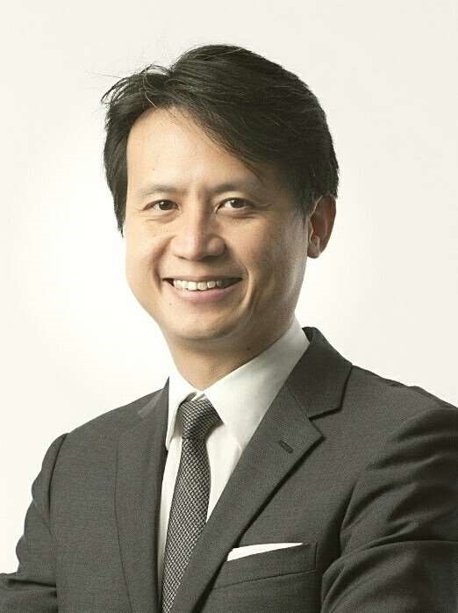
Year of Birth: 1972
Nationality: Singaporean
ACADEMIC QUALIFICATIONS
2013 Advanced Management Program
Harvard Business School, USA
2006 Master of Laws (LL.M) with Distinction
Georgetown University Law Centre, USA
Fellow, Institute of International Economic Law
1997 Bachelor of Laws (LL.B) with Honours
National University of Singapore
PROFESSIONAL EXPERIENCE

2020 – Director General
present World Intellectual Property Organization (WIPO)

Secretary-General
International Union for the Protection of New Varieties of Plants (UPOV)

Board Member
UN System Chief Executives Board for Coordination
2015 – 2020 Chief Executive
Intellectual Property Office of Singapore (IPOS)
Ministry of Law, Singapore

2012 – 2015 Deputy Chief Executive and Chief Legal Counsel
Intellectual Property Office of Singapore
Ministry of Law, Singapore

2003 – 2012 Senior State Counsel
International Affairs Division
Attorney-General’s Chambers, Singapore

2001 – 2003 Legal Consultant
Ministry of Trade and Industry, Singapore

1997 – 2001 State Counsel/Deputy Public Prosecutor

PAST APPOINTMENTS
Chairperson, Standing Committee on Copyright and Related Rights (SCCR), WIPO, 2017 – 2020
Member, Singapore-Guangdong Collaboration Council (SGCC)
Member, Manufacturing Sub-Committee of the Future Economy Council, Singapore
Member, Modern Services Sub-Committee of the Future Economy Council, Singapore
Member, Research, Innovation and Enterprise Strategy Committee (RIE SC), Prime Minister’s Office, Singapore
Member, Research, Innovation and Enterprise Executive Committee (RIE Exco), Prime Minister’s Office, Singapore
Co-Chair, National IP Working Group, Prime Minister’s Office, Singapore
Advisory Board Member, Saudi Authority for Intellectual Property (SAIP)
Member, Group of Experts on IP Office of the Future Project, International Trademark Association (INTA)
Board Chairman, IPOS International
Board Member, EW Barker Centre for Law & Business, National University of Singapore
Board Director, Fraunhofer Singapore
Coordinator and Principal Examiner, Intellectual Property Law Course for the Singapore Bar Exam run by the Singapore Institute of Legal Education
HONOURS
2016 Public Administration Medal (Silver)
Prime Minister’s Office, Singapore
2006 Fellow
Institute of International Economic Law, Georgetown University, USA
LANGUAGES
English, Mandarin Chinese, understanding of French, Cantonese
PUBLICATIONS
The Tea Bone Zen Mind Manual of Tea
[End of Annex and of document]

Appointment of the Director General, A/67/2, Summary Report, A/67/3

