E
International Union for the Protection of New Varieties of Plants

Council  Sixtieth Ordinary Session  Geneva, October 23, 2026 | C/60/2  Original: English  Date: August 24, 2026
UPOV Performance Report 2024-2025
Document prepared by the Office of the Union
Disclaimer: this document does not represent UPOV policies or guidance
The UPOV Performance Report (UPR) 2024-2025 has been prepared in accordance with Regulations 2.14 and 2.14bis of the Financial Regulations and Rules and reports performance against criteria established in the Program and Budget for the 2024-2025 Biennium (document C/57/4 Rev.).
The Council is invited to note the UPOV Performance Report 2024-2025.

[UPOV Performance Report (UPR) 2024-2025 follows]



UPOV Performance Report 2024-2025

Contents
executive summary 3
I. FINANCIAL AND RESULTS OVERVIEW 5
II. program performance 11
Pillar 1: Bring together stakeholders to help shape the UPOV system 11
Pillar 2: Provide guidance and assistance and facilitate cooperation for implementing the UPOV system 16
Pillar 3: Provide high quality services for UPOV members and users of the UPOV system 25
Foundation: Empower our people to work effectively, collaboratively and innovatively by providing them with the right resources, training and environment 30
iii. annexes 32
ANNEX I Extrabudgetary Funds (Funds-in-Trust) 32
ANNEX II Working Capital Fund and Contributions 35
ANNEX III Status in relation to UPOV 39
ANNEX IV Members of the Union 41
ANNEX V List of Activities in 2024-2025 42
iv. appendix 43
ACRONYMS AND ABBREVIATIONS 43

executive summary
The UPOV Performance Report 2024-2025 presents UPOV’s financial results, program achievements and strategic initiatives for the biennium. It shows continued demand for plant variety protection, progress in legislative development and membership expansion, enhanced capacity-building and technical cooperation, and further development of digital tools supporting plant breeders and authorities. At the same time, the biennium was marked by significant resource constraints. Projected income from several sources did not materialize as anticipated or was received only shortly before the close of the second year of the biennium, requiring prioritization of activities and limiting the full implementation of some initiatives foreseen in the Program and Budget.

For 2024-2025, UPOV recorded a Budgetary Result of 308,018 Swiss francs and an Overall Result, after IPSAS adjustments, of 128,451 Swiss francs. Total income (before IPSAS adjustments) reached 7.5 million Swiss francs, i.e. 396,780 Swiss francs or 5 per cent below the biennial estimate. Contributions represented 95.4 per cent of the total income, supported by the accessions of Armenia in 2024 and Nigeria in 2025; Nigeria’s contribution will be paid in 2026. In 2025, the late receipt of annual contributions from some UPOV members created uncertainty as to whether those contributions would be received before year-end, making planning difficult, delaying implementation and spending decisions and, in certain cases, resulting in the cancellation of activities. Lower-than-projected income from UPOV PRISMA, PLUTO and distance learning courses reflected overestimated projections. Equally, program support costs from Funds-in-Trust and miscellaneous income were below expectations, primarily due to a voluntary contribution which did not materialize in 2025, and foreign exchange losses linked to the strengthening of the Swiss franc against the United States dollar.

Total expenditure amounted to 7.2 million Swiss francs, i.e. 704,798 Swiss francs or 9 per cent below the biennial budget. This reflected personnel savings from vacant positions, partly offset by increased expenditure on the development of UPOV e-PVP components and administrative support for UPOV e-PVP services to UPOV members.

Plant variety protection activity continued to grow. Approximately 29,250 applications were filed in UPOV members in 2024 and 33,850 in 2025. Following modest growth of 0.6 per cent in 2024, applications increased by 15.7 per cent in 2025, representing the strongest year-on-year expansion since 2017. China remained the leading destination for applications, followed by the Community Plant Variety Office of the European Union and the United States of America. The five largest jurisdictions accounted for 79.4 per cent of all applications in 2025.

UPOV membership expanded during the biennium. Armenia became the seventy-ninth member of UPOV on March 2, 2024, and Nigeria became the eightieth member on March 27, 2025, bringing the coverage of the UPOV PVP system to 99 States. The Council provided positive advice on legislation of the United Arab Emirates and the Lao People’s Democratic Republic in 2024, and Malaysia in 2025, enabling their potential membership and accession to the 1991 Act of the UPOV Convention.

In 2025, assistance was provided to 13 States on legislative matters and membership procedures (same as in 2024); however, limited resources constrained the Office’s ability to maintain closer engagement with new members and with members transitioning to the 1991 Act, and to provide more tailored support for PVP implementation, capacity-building and cooperation.

Communication and outreach were strengthened through the launch of a new UPOV website in English on October 10, 2025. The project, initiated in July 2024, rebuilt the website’s information architecture, content, visual identity and templates, with more than 40 new pages designed to improve usability and search performance. The new website has improved access to information and services for UPOV members and stakeholders and better explains the benefits of plant variety protection to broader audiences. Continued efforts to raise global visibility through coherent branding, diversified communication formats, and social media outreach will require sustained resources and engagement from the UPOV community to support awareness-raising and outreach activities.

Training and assistance activities continued to support implementation of the UPOV system. In 2024, the Executive Program on Plant Variety Protection, organized with the USPTO in Geneva, brought together 27 high-level participants from 20 countries and five organizations. A regional workshop in Accra, Ghana, organized with the USPTO and ARIPO, supported sustainable agriculture and food security in the African region. The Executive Program could not be held in 2025 because the voluntary contribution supporting it did not materialize. Distance learning activities and courses under the UPOV International Certificate on Plant Variety Protection continued to provide structured learning opportunities. During the Biennium, a total of 2,350 participants registered for UPOV distance learning courses (including DL-205 course in Chinese) and UPOV received 211 application requests for the PVP Certificate accreditation program of which 78 achieved the 50 credits required for the award of the Certificate.

UPOV also advanced its digital services. In 2025, UPOV PRISMA surpassed 10,000 applications since its launch, demonstrating the value of simplified cross-border filing for breeders. The United Kingdom joined UPOV e-PVP in April 2025, and the new version of the UPOV e-PVP DUS Exchange Module was launched, based on a successful pilot between Viet Nam and the Kingdom of the Netherlands, to strengthen cooperation in the examination of plant variety protection applications. PLUTO usage, member contributions to PLUTO, and 93 per cent coverage of applications by UPOV Test Guidelines continued to reflect sustained interest in harmonized technical information. Further digitalization was constrained by limited resources for the development and maintenance of databases and other tools, including the web-based Test Guideline template.

Technical and legal cooperation remained central to UPOV’s work. In 2024, the Technical Committee addressed disease resistance characteristics in DUS examination. In 2025, the Technical Committee considered policy matters related to a range of new technologies and approaches aimed at increasing efficiency in DUS examination, including machine learning, genomic prediction, shared molecular databases, phenotyping and image analysis. To further enhance international cooperation in examination of new varieties, the Administrative and Legal Committee held a seminar in 2025 on cooperation with breeders in DUS examination. In 2025, 82 Test Guidelines were discussed and 45 were adopted. Cooperation with ISTA and the OECD was strengthened, including through work on harmonized terminology and common molecular marker sets, while UPOV continued to explore emerging tools such as genomic methods, machine learning and advanced phenotyping.

Looking ahead, the 2025 UPOV horizon scanning exercise, based on interviews with visionaries and experts from across the plant breeding ecosystem, underscored that the UPOV system is at a strategic crossroad. Its continued impact will depend on its ability to adapt to rapid innovation in plant breeding, support climate-resilient and sustainable agriculture, respond to globalization and new business models, improve public understanding of the value of plant variety protection, and foster inclusivity across regions and stakeholders.

In this context, the establishment by the Consultative Committee of the Consultative Group on UPOV Resources Strategy (CG-URS) in October 2025 is a significant step. Its mandate to identify options for achieving UPOV’s financial sustainability responds directly to the central lesson of the biennium: UPOV delivered important results despite financial and staffing constraints, but sustained future performance, expansion of UPOV membership, tailored assistance to UPOV members, enhanced harmonization and cooperation, strategic communication, and digital transformation will require a more predictable and sustainable resource base.

I. FINANCIAL AND RESULTS OVERVIEW
Key Financials

The overall budgetary result for UPOV as well as the Reserve and Working Capital Funds (RWCF) for the biennium 2024/25 is shown in Table 1 below. Total income (before IPSAS adjustments) amounted to 7.5 million Swiss francs, and total expenditure amounted to 7.2 million Swiss francs, resulting in a budgetary surplus of 0.3 million Swiss francs for the biennium 2024/25.

At the end of 2025, the total RWCF amounted to -0.6 million Swiss francs, comprising 1 million Swiss francs in the Reserve Fund, 0.6 million Swiss francs in the Working Capital Fund and Actuarial losses through Net Assets of -2.2 million Swiss francs.

Table 1. Key Financials 2024/25
(in thousands of Swiss francs)

Key Financials | 2024/25 Program & Budget | 2024/25  Actuals | 2024/25 Actuals compared to  Program & Budget
Income | 7,901 | 7,505 | 95%
Expenditure | 7,901 | 7,197 | 91%
Budgetary Result | - | 308 | n/a
IPSAS adj. to Reg. Budget Income |  | -
IPSAS adj. to Reg. Budget Expenditure |  | (180)
Surplus / (Deficit) |  | 128
Reserve and Working Capital Funds (RWCF)
Reserve Fund |  | 996
Working Capital Fund |  | 580
Actuarial gains/(losses) through Net Assets |  | (2,156)
Total RWCF at end of period |  | (580)

Chart 1. Income, Expenditure and Budgetary Result in 2024/25
(in thousands of Swiss francs)
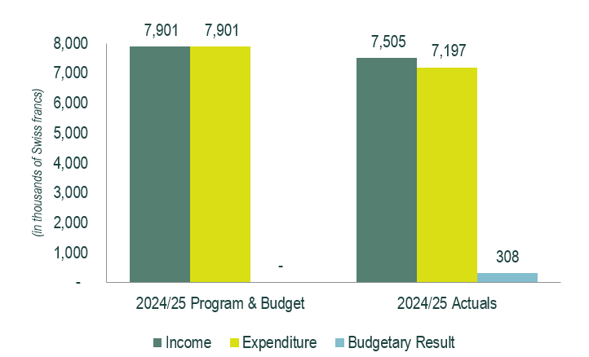

Actual income amounted to 7.5 million Swiss francs in 2024/25, i.e. 0.4 million Swiss francs lower than the biennial estimate. See Table 2 below.

Income from contributions continued to be the single largest source of income, representing 95.4 per cent of total income, with Armenia and Nigeria becoming members in 2024 and 2025, respectively. The income shortfalls from UPOV PRISMA, PLUTO, and Distance Learning Courses were due to overestimated projections. Income from Funds-in-Trust-related program support costs was lower than anticipated, as a voluntary contribution did not materialize as expected. Miscellaneous income was also lower due to foreign exchange losses resulting from the strengthening of the Swiss franc vis-à-vis the United States dollar.

Table 2. Income in 2024/25
(in thousands of Swiss francs)

Income | 2024/25  Estimates | 2024/25  Actual | 2024/25 Actuals compared to Estimates
Contributions (unitary) | 7,193 | 7,150 | 99%
UPOV PRISMA Fees | 396 | 258 | 65%
PLUTO Fees | 113 | 23 | 21%
FITs Program support costs | 120 | 97 | 81%
Distance Learning course fees | 80 | 27 | 34%
Miscellaneous¹ | - | (52) | n/a
Total | 7,901 | 7,505 | 95%
¹Miscellaneous income mainly reflects unrealized forex gains/(losses) due to the revaluation process of the cash and other assets and liabilities accounts (currencies other than Swiss francs).

Chart 2. Income Share by Source in 2024/25

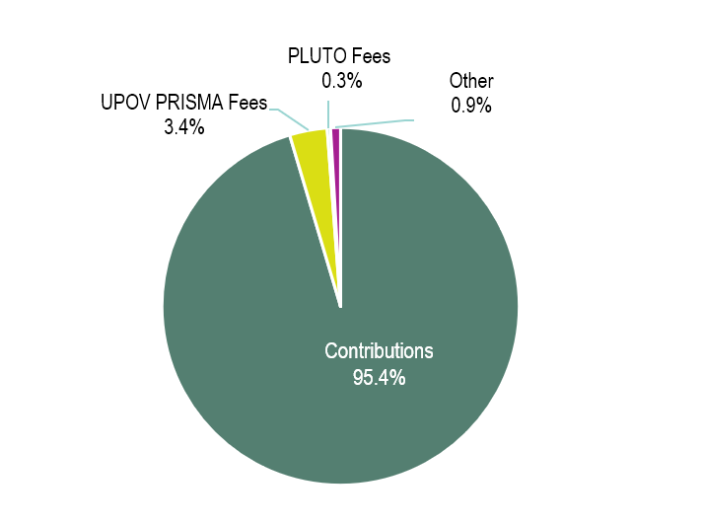

Expenditure

Actual expenditure amounted to 7.2 million Swiss francs for 2024/25, i.e. 0.7 million Swiss francs below the budget. This is shown in Table 3 and by expected results in Table 4.

Table 3. Budget vs. Expenditure by Cost Category in 2024/25
(in thousands of Swiss francs)

 | Cost Category | 2024/25  Program & Budget | 2024/25  Actuals | 2024/25 Actuals compared to P&B
Personnel Resources
 | Posts | 5,186 | 4,440 | 86%
 | Temporary staff | 569 | 175 | 31%
 | Other Staff costs | - | - | -
 | Total, Personnel Resources | 5,755 | 4,616 | 80%
Non-Personnel Resources
Internships and Fellowships
 | Internships | 15 | 3 | 22%
 | Fellowships | 15 | - | -
 | Sub-total, Internships and Fellowships | 30 | 3 | 11%
Travel, Training and Grants
 | Staff Missions | 145 | 101 | 70%
 | Third Party Travel | 5 | 2 | 41%
 | Sub-total, Travel | 150 | 103 | 69%
Contractual Services
 | Conferences | 200 | 226 | 113%
 | Publishing | - | - | -
 | Individual Contractual Services | 100 | 145 | 145%
 | Other Contractual Services | 415 | 843 | 203%
 | Sub-total, Contractual Services | 715 | 1,214 | 170%
Operating Expenses
 | Sub-total, Operating Expenses | 1,250 | 1,260 | 101%
Equipment and Supplies
 | Furniture and Equipment | 1 | - | -
 | Supplies and Materials | 1 | 0 | 23%
 | Sub-total, Equipment and Supplies | 2 | 0 | 12%
 | Total, Non-Personnel Resources | 2,147 | 2,581 | 120%
 | TOTAL | 7,901 | 7,197 | 91%

Personnel Resources

Actual personnel expenditure in 2024/25 amounted to 4.6 million Swiss francs, i.e. 1.1 million Swiss francs lower than the budget. This was mainly due to personnel savings resulting from vacant positions, comprising four posts and one temporary position, as well as lower-than-budgeted expenditure on education grants, dependency allowances, and repatriation grants, as a former staff member did not claim the repatriation grant. Contributions to the United Nations Joint Staff Pension Fund (UNJSPF) were also lower than budgeted owing to the strengthening of the Swiss franc vis-à-vis the United States dollar. A portion of these savings was retained to offset the shortfall in income, while another portion was redirected to support the development of UPOV e-PVP components and administrative support for UPOV e-PVP services to UPOV members.

Non-Personnel Resources

Actual non-personnel expenditure amounted to 2.6 million Swiss francs in 2024/25, i.e. 0.4 million Swiss francs higher than the budget.

There were no fellows during the biennium. However, one intern was hired in 2025 to support the migration of content to the new UPOV website.

Expenditure on travel, training, and grants in 2024/25 amounted to 0.1 million Swiss francs, representing 69 per cent of the biennial budget. This reflects a concerted effort to reprioritize activities, focusing resources on those of a strategic nature and an increased use of virtual and hybrid modalities.

Contractual services:

Conferences: Expenditure on conferences exceeded the biennial budget, mainly due to unforeseen expenditure on interpretation for the Consultative Group on the UPOV Resource Strategy.

Publishing: There was no expenditure on publishing in 2024/25.

Individual Contractual Services (ICS): Experts provided guidance and support on the UPOV system, particularly on legal matters, and prepared the study on the ‘Scope of the Breeder's Right’ and its relationship with the ‘Exhaustion of the Breeder's Right’, commissioned by the Working Group on Harvested Material and Unauthorized Use of Propagating Material (WG-HRV).

Other Contractual Services (OCS): Expenditure on OCS was substantially higher than the biennial budget. This was primarily due to higher-than-budgeted expenditure on: (i) the development and maintenance of UPOV e-PVP (UPOV PRISMA, DUS Exchange Module, and Administrative Module), as well as the PLUTO database, the TG Template, and the GENIE database; and (ii) administrative support related to the organization of meetings, events, UPOV sessions and TWPs.

Operating expenses in 2024/25 were in line with budgeted costs.

Expenditure on equipment and supplies amounted to 234 Swiss francs in 2024/25.

Table 4. Budget vs. Expenditure by Expected Results in 2024/25
(in thousands of Swiss francs)

 |  | 2024/25 Program & Budget | 2024/25 Actuals | 2024/25 Actuals compared to Program & Budget
1.1 | Governance by the UPOV Council and work of UPOV Committees and other bodies | 1,326 | 710 | 54%
1.2 | Development of legislation on plant variety protection in accordance with the 1991 Act of the UPOV Convention | 309 | 212 | 69%
2.1 | Enhanced awareness of the role of the UPOV system | 344 | 471 | 137%
2.2 | Guidance and assistance on the UPOV Convention and its implementation | 2,856 | 2,245 | 79%
2.3 | Enhanced harmonization and cooperation in examination | 700 | 887 | 127%
3.1 | Development of e‐PVP services | 873 | 1,187 | 136%
4.1 | Diversification of revenue | 241 | 162 | 67%
4.2 | A Secretariat that is empowered and is provided with the right resources and training to work effectively, collaboratively and innovatively | 1,252 | 1,323 | 106%
Total |  | 7,901 | 7,197 | 91%

Resources

The number of posts by category is shown in Table 5 below. There were 11 occupied and four vacant positions at the end of 2025. The post of the Secretary-General is included within the post count, but at no cost, as the current Director General of WIPO has declined any salary or allowance for his functions as Secretary-General of UPOV.

Table 5. Budgeted and Actuals Posts in 2024/25

Post Category | 2024/25 Budgeted  Posts | 2024/25  Actual  Posts | Difference
Directors | 4 | 4 | 0
Professionals | 7 | 4 | (3)
General Service | 4 | 3 | (1)
TOTAL | 15 | 11 | (4)

Evolution of Income and Expenditure

The overall evolution of actual income and expenditure (before IPSAS adjustments) for the period from 2016 to 2025 is shown below in Table 6.

Table 6. Evolution of Actual Income and Expenditure during 2016-2025
(in thousands of Swiss francs)

 | Actuals
 | 2016 | 2017 | 2018 | 2019 | 2020 | 2021 | 2022 | 2023 | 2024 | 2025
Income | 3,431 | 3,420 | 3,422 | 3,509 | 3,598 | 3,806 | 3,804 | 3,768 | 3,795 | 3,709
Expenditure | 3,239 | 3,586 | 3,355 | 3,500 | 3,267 | 3,804 | 3,575 | 3,807 | 3,437 | 3,759
Budgetary Result | 192 | (166) | 67 | 9 | 332 | 2 | 230 | (39) | 358 | (50)

Chart 3. Evolution of Income and Expenditure 2016-2025

Funds-in-Trust (extrabudgetary funds)

The overall evolution of Funds-in-Trust contributions for the period from 2016 to 2025 is shown below in Chart 4.

Chart 4. Evolution of Funds-in-Trust from 2016 to 2025

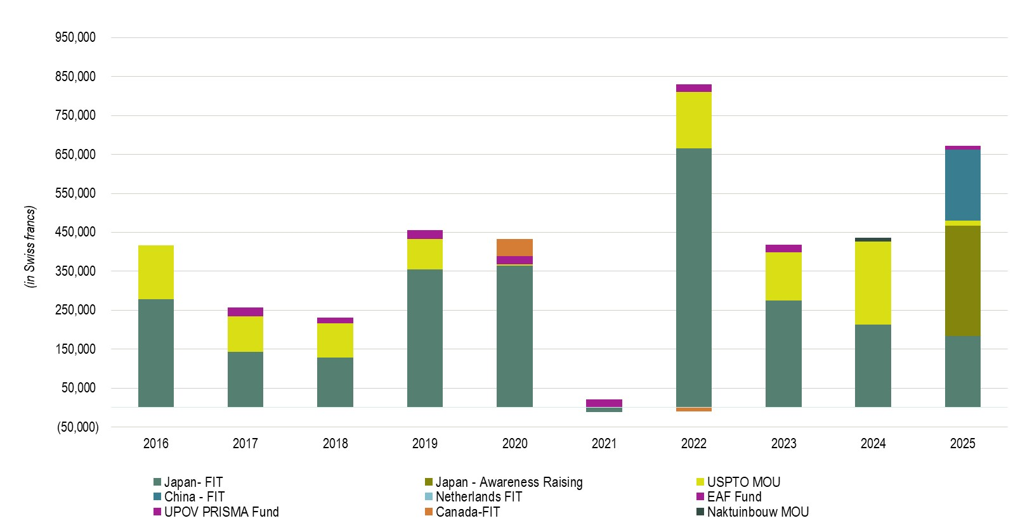

II. program performance

Pillar 1: Bring together stakeholders to help shape the UPOV system

Performance Data:
Expected Results | Performance Indicators | Baselines | Targets | Performance Data  (2024-2025)
1.1 Governance by the UPOV Council and work of UPOV Committees and other bodies | Growth in the number of varieties developed under the UPOV system  [Statistics for 2025 will not be available from WIPO before June 2026]
 | Number of applications in UPOV members | 27,260 (2022)  29,070 (2023) | 27,500 (2024) | 29,250 (2024)  33,850 (2025)
 | Number of titles granted in UPOV members | 14,920 (2022)  21,150 (2023) | 16,500 (2024) | 17,270 (2024)  17,430 (2025)
 | Number of titles in force in UPOV members | 161,210 (2022)  195,610 (2023) | 170,000 (2024) | 203,760(2024)  209,840 (2025)
1.2 Development of legislation on plant variety protection in accordance with the 1991 Act of the UPOV Convention | Number of States/organizations that become UPOV members
 | States and organizations that become members of the Union | None (2022)  None (2023) | 1 per year | 1 (2024)  1 (2025)
Note: 2022/2023 baseline values have been updated to reflect data from the UPOV Statistics Database.

Key Accomplishments:

1.1 Governance by the UPOV Council and work of UPOV Committees and other bodies
Growth in the number of varieties developed under the UPOV system
In 2025, approximately 33,850 plant variety applications were filed globally, representing a robust +15.7 per cent increase compared with 2024, continuing a ten-year growth trend (see Figure 1). This represents the most significant year-on-year expansion since 2017, an acceleration from the near-flat 0.6 per cent growth rate observed in 2024 (about 29,250 applications) as compared to 2023 (29,082 applications).

Figure 1: Trend in plant variety applications worldwide, 2011–2025
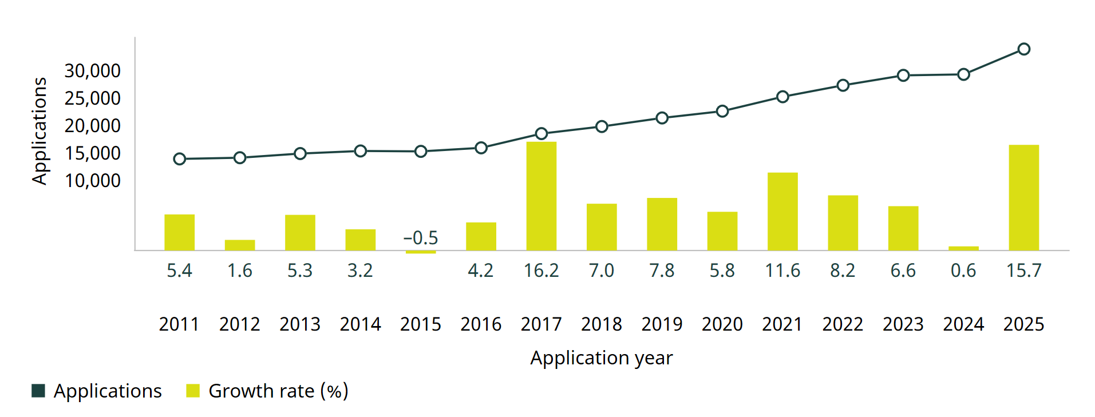
Source: UPOV/WIPO

In 2025, China solidified its position as the world's leading destination for plant variety applications, receiving 20,967 filings and accounting for 61.9 per cent of the global total. The Community Plant Variety Office (CPVO) of the European Union (EU) ranked second with 2,897 applications (8.6 percent of the global total), followed by the United States of America (1,298), Ukraine (895) and the United Kingdom (UK) (825) (Figure 2). Among the remaining top 10 offices, Ukraine (+21.9 per cent) and Argentina (+26.1 per cent ) also recorded double-digit growth in 2025, with both offices rebounding after declines in 2024. The United Kingdom (+3.6 per cent), the United States of America (+2.4 per cent ) and the Republic of Korea (+1.6 per cent) recorded modest gains.

Four of the top 10 offices experienced a decline in applications in 2025. The sharpest decline was recorded by the office of the Russian Federation (–42.9 per cent), primarily due to a drop in resident filings. The CPVO and Japan each saw applications fall by –11.4 per cent, also largely driven by fewer resident filings. The Kingdom of the Netherlands recorded a slight decline of –0.8 per cent, although unlike the other offices, this was attributable to a fall in non-resident filings.

In 2025, the United Kingdom stood apart among the top 10, with non-residents responsible for 79.5 per cent of applications received – a stark contrast with 2024, when resident filings accounted for 94 per cent.

Figure 2. Plant variety applications for the top 10 offices, 2025
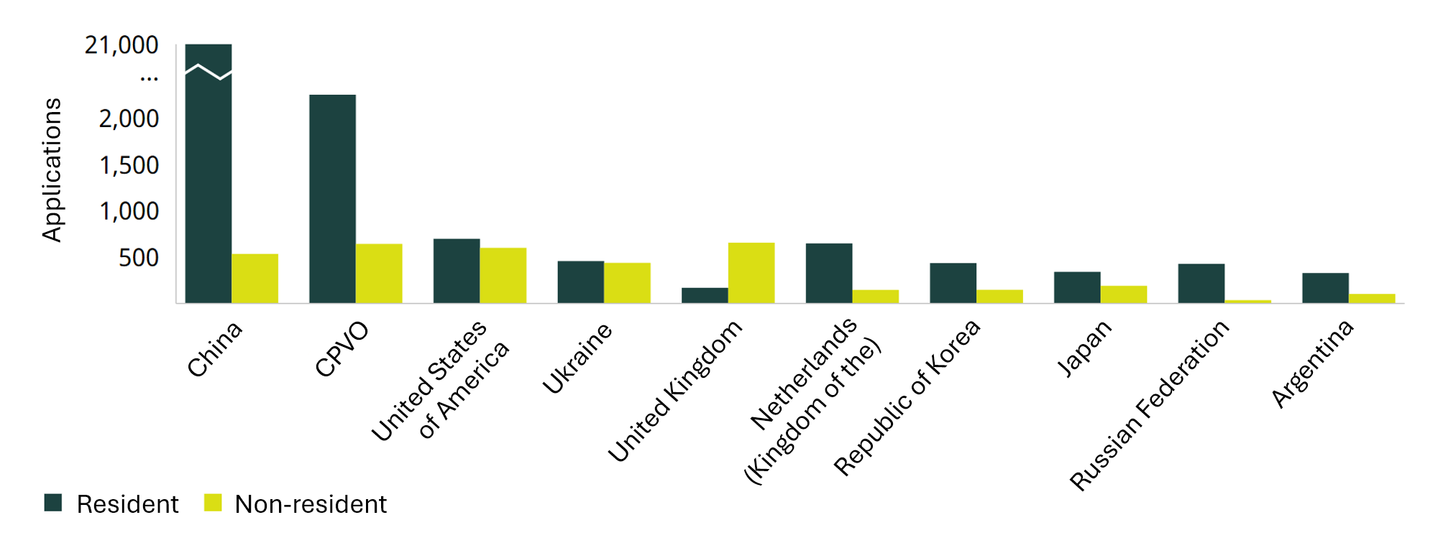
Source: UPOV/WIPO

Asia extended its dominance as the top region for plant variety filings in 2025, accounting for 67.3 per cent of all applications worldwide, up from 61.7 per cent in 2024. Driven by an average annual growth rate of 17.5 percent over the past decade, Asia's global share has more than doubled from 29.6 per cent in 2015 (Figure 3). Europe remained the second-largest region, though its share continued to erode, falling from 42.8 per cent in 2015 to 20.0 per cent in 2025. Beyond Asia, Latin America and the Caribbean (+2.4 per cent), Africa (+1.3 per cent) and Europe (+0.3 percent) also recorded positive average annual growth over the decade. Northern America (–1.3 per cent) and Oceania (–2.2 per cent), however, both saw their filing volumes decline over the same period.

Figure 3. Plant variety applications by region, 2015 and 2025
Region | Number of applications |  | Share of world total (%) |  | Average growth (%)
Region | 2015 | 2025 | 2015 | 2025 | 2015–2025
Africa | 506 | 575 | 3.30 | 1.70 | 1.3
Asia | 4,527 | 22,787 | 29.60 | 67.32 | 17.5
Europe | 6,550 | 6,764 | 42.80 | 19.98 | 0.3
Latin America and the Caribbean | 1,318 | 1,670 | 8.60 | 4.93 | 2.4
Northern America | 1,907 | 1,669 | 12.50 | 4.93 | –1.3
Oceania | 482 | 385 | 3.20 | 1.14 | –2.2
World | 15,290 | 33,850 | 100 | 100 | 21.5
Source: UPOV/WIPO

Applications received by offices from resident and non-resident applicants are referred to as office data, whereas applications filed by applicants at a national or regional office (resident applications) or at a foreign office (applications abroad) are referred to as origin data. Here, plant variety statistics based on the origin of residence are reported in order to complement the global picture. Note that for applicants domiciled within EU member states, filing at the CPVO regional office is regarded as a resident filing, when discussing office data, and such filings are regarded as regional filings, when discussing origin data.

China-based applicants were the most active in 2025, submitting 20,472 plant variety applications. This represents a 29.5 per cent increase from the 15,806 applications submitted in 2024. Applicants from the Kingdom of the Netherlands ranked second in 2025, with 3,082 filings, an 11.3 per cent increase compared to 2024 (2,770 filings). The next largest origins were the United States of América (1,854 in 2025 and 1,779 in 2024), France (1,053 in 2025 and 1,027 in 2024) and Germany (815 in 2025).

Collectively, the top five origins accounted for 80.6 per cent of all plant variety filings worldwide in 2025, with China (60.5 per cent of the total) and the Kingdom of the Netherlands (9.1 per cent) contributing the largest shares (Figure 4). This represents an increase over 2024, when the top five origins accounted for 76.4 per cent of total filings.

Seven of the top 10 origins recorded growth in 2025. Ukraine led with a 41.4 per cent increase, driven entirely by an increase in resident filings. China (+29.5 per cent), the Kingdom of the Netherlands (+11.3 per cent) and Germany (+7.4 per cent) also posted strong gains. Conversely, the Russian Federation (–35.6 per cent) and Switzerland (–26.2 per cent) experienced double-digit declines.

Applicants from five of the top 10 origins primarily filed applications abroad or at a regional office, while those from China, Ukraine, the Republic of Korea and the Russian Federation filed almost exclusively domestically.

Figure 4. Plant variety applications for the top 10 origins of the applicants, 2025
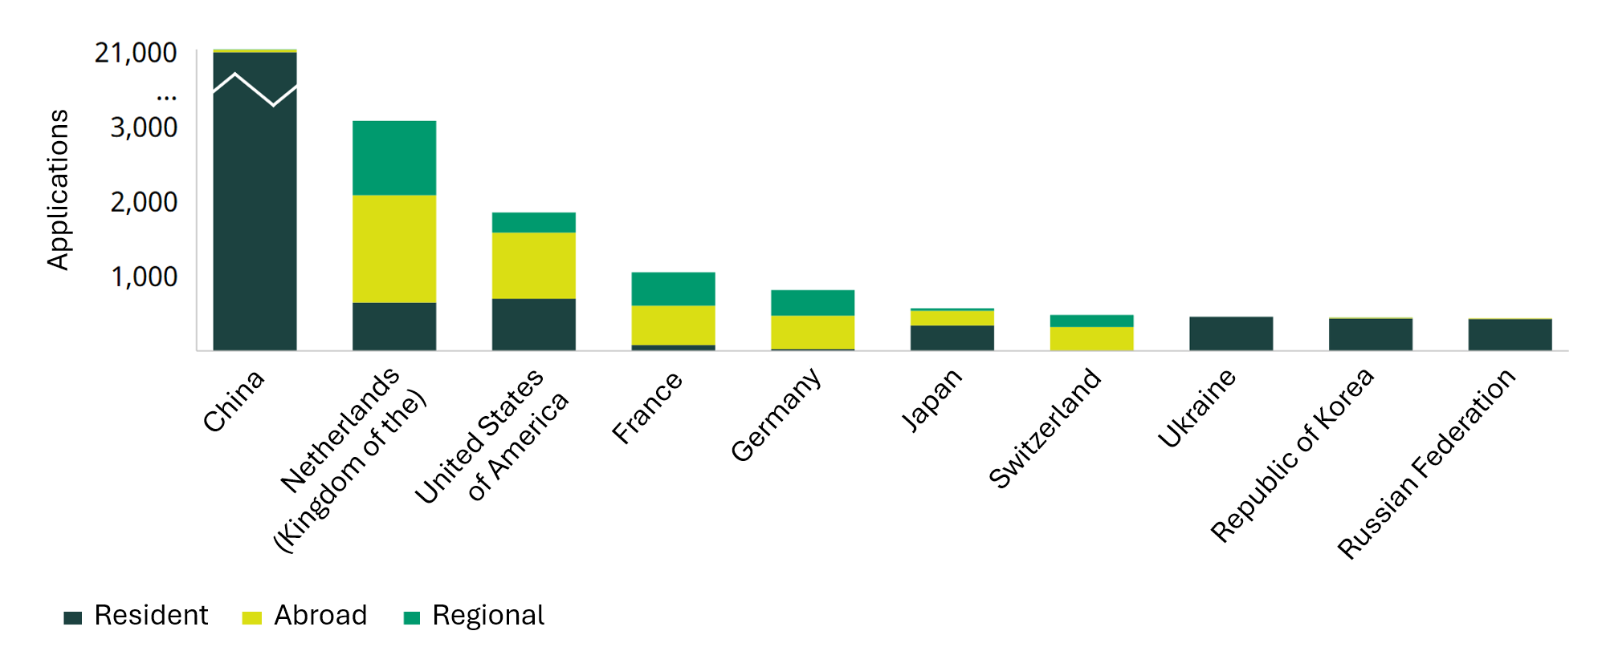
Source: UPOV/WIPO

The total number of plant variety titles issued increased by a modest 0.9 per cent in 2025, following a considerable decline in 2024 (Figure 5). The modest growth recorded in 2025 is in line with the long-term upward trend.

China led in 2025, issuing 6,986 titles, a 4.7 per cent increase compared with the previous year. The next largest issuers were the CPVO (2,762 titles), the United States of America (1,323), Japan (769) and Ukraine (657). The CPVO (+6.0 per cent), the United States of America (+6.5 per cent) and Japan (+9.4 per cent) all registered upward trajectory. Ukraine, however, experienced a sharp 25.2 per cent decline in titles issued in 2025 compared to 2024.

Beyond the top five offices, several other countries registered notable growth. Australia (+36.3 per cent), Mexico (+30.6 per cent) and Brazil (+10.9 per cent) all posted double-digit increases, while Poland, starting from a smaller base, recorded an exceptional 57.7 per cent increase.

Note that the grant process takes time, therefore fluctuations in the volume of plant variety titles granted may be a consequence of changes in processing capacity or procedural delay.

Figure 5. Trend in plant variety titles issued worldwide, 2011–2025
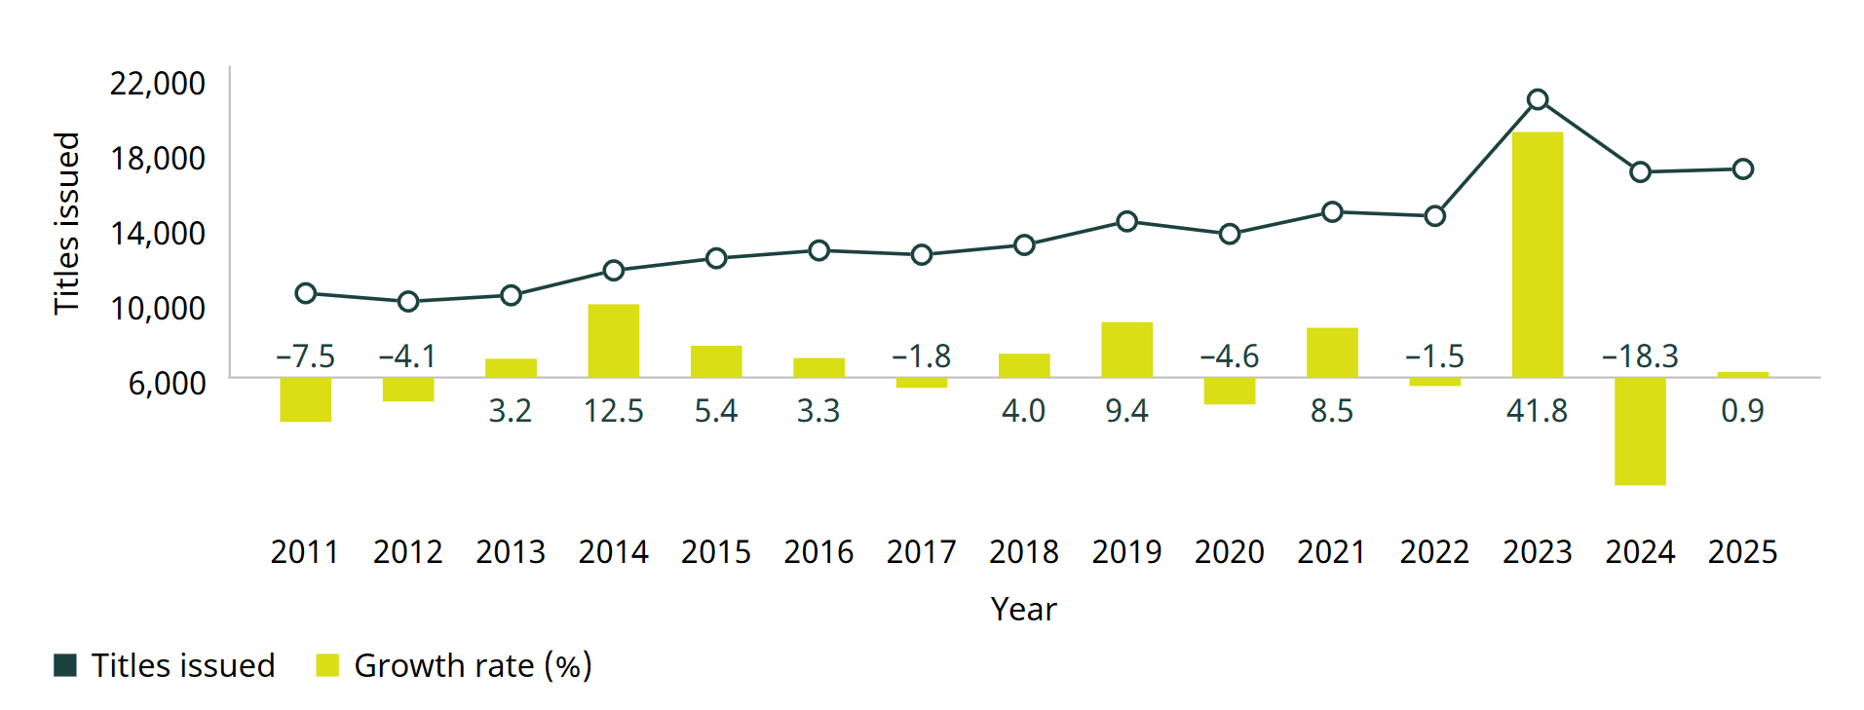
Source: UPOV/WIPO

Around 209,840 plant variety titles were in force at the end of 2025, up +3.0 per cent compared with 2024, when around 203,760 titles were in force, up 4.2 per cent compared with 2023.

At the end of 2025, China (45,519), the CPVO (31,798), the United States of America (27,947), the United Kingdom (20,211) and Ukraine (14,460) had the highest number of active titles. Other offices maintaining at least 5,000 active titles included the Kingdom of the Netherlands (10,144), the Russian Federation (7,980), Japan (7,623) and the Republic of Korea (6,862).

1.2 Development of legislation on plant variety protection in accordance with the 1991 Act of the UPOV Convention
UPOV membership expanded during the biennium. Armenia became the seventy-ninth member of UPOV on March 2, 2024, and Nigeria became the eightieth member on March 27, 2025, bringing the coverage of the UPOV PVP system to 99 States.

Figure 6. Accession to/ratification of the 1991 Act  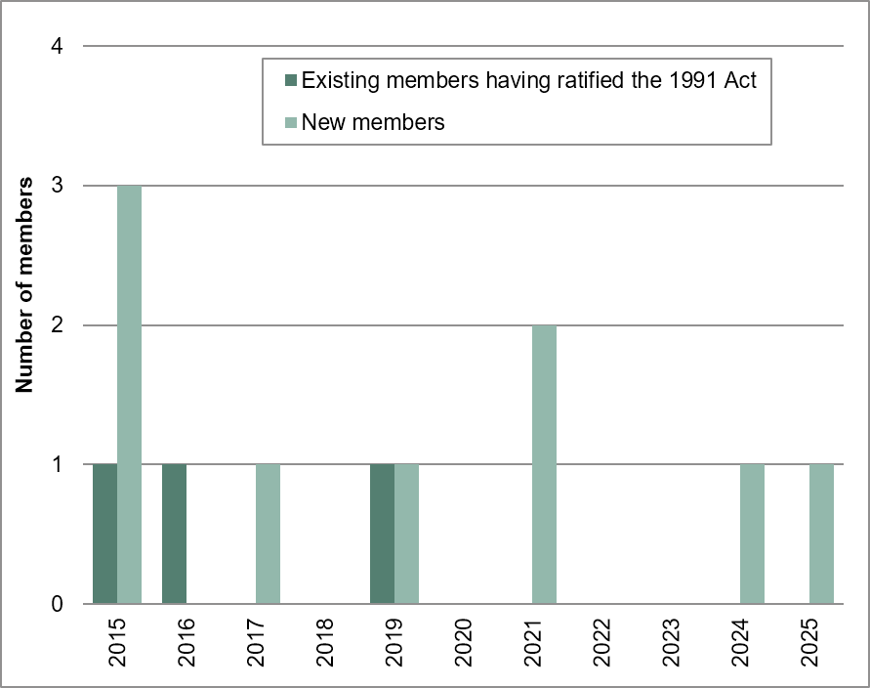 | Figure 7. New members of the Union  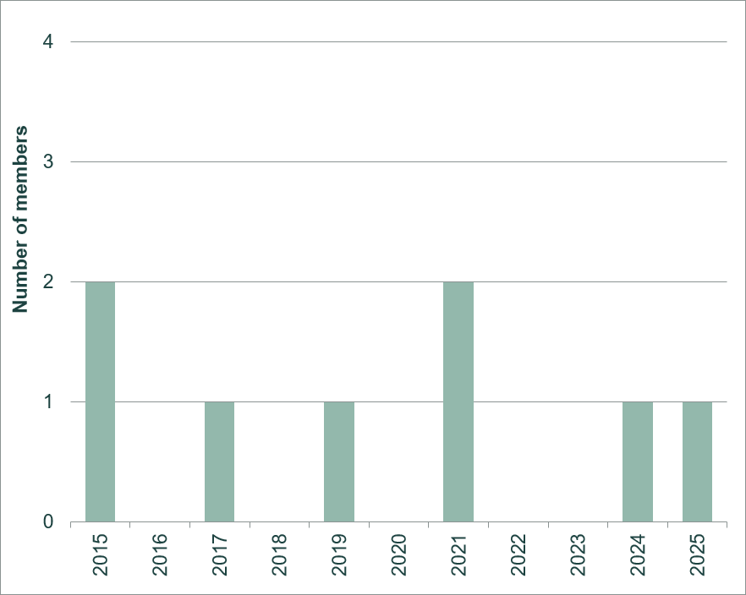

In 2025, comments on laws were provided to 13 States (same as in 2024), including two UPOV members (Georgia and Uruguay) and 11 non-members: Bahrain, Cambodia, Gambia (the), Guatemala, Jamaica, Kazakhstan, Malaysia, Seychelles, Suriname, Thailand, United Arab Emirates.

The Council also provided positive advice on legislation of the United Arab Emirates and the Lao People’s Democratic Republic in 2024, and Malaysia in 2025, enabling their potential membership and accession to the 1991 Act of the UPOV Convention.

Figure 8. States/Organizations provided with  comments on laws  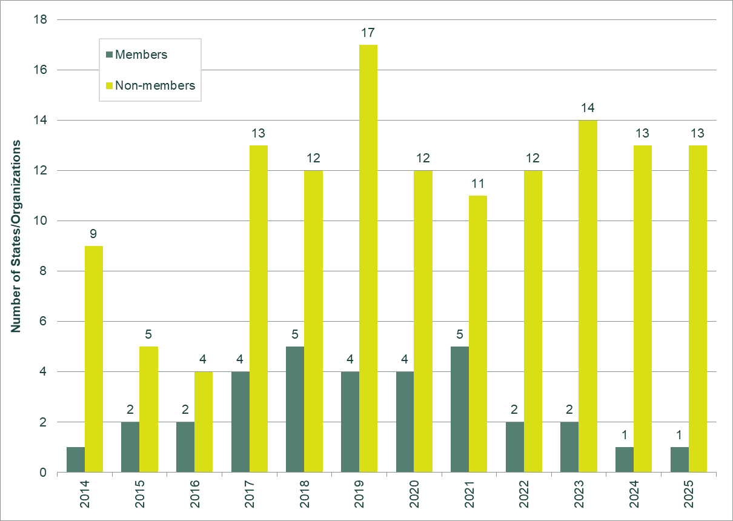 | Figure 9. States/Organizations which received  positive advice from the Council  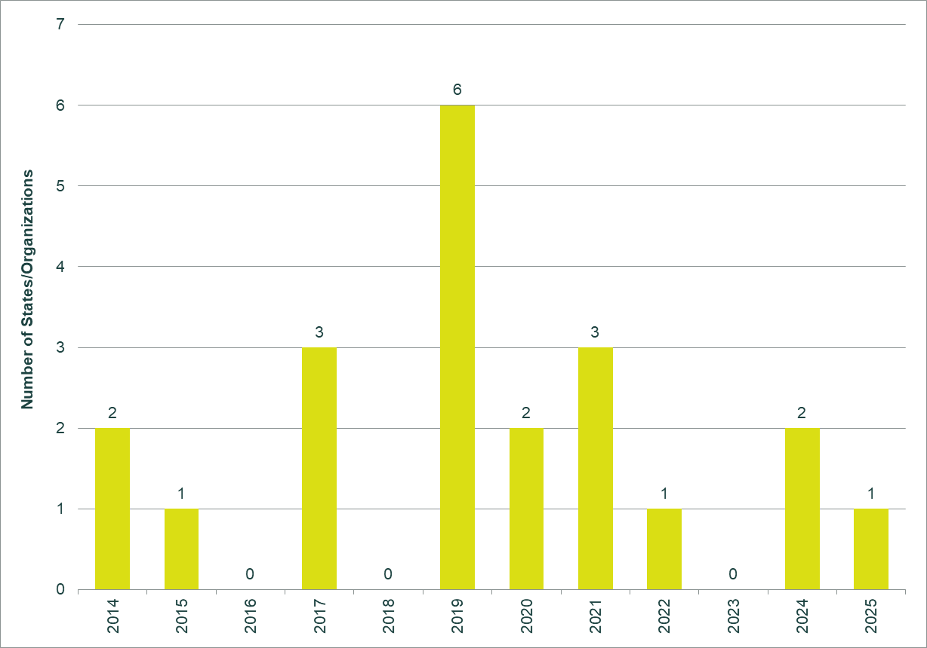

In 2025, the Office of the Union held meetings (virtual or in person) with government officials from the following States to discuss assistance for the development of legislation on plant variety protection: Cambodia, Gambia (the), Georgia, Guatemala, Jamaica, Malawi, Malaysia, Mauritius, Rwanda, Saudi Arabia, Seychelles, Suriname, Thailand, Zambia and Zimbabwe.

The engagement aiming at creating an enabling legal environment for plant variety protection and becoming a UPOV member is driven by national or regional development goals. Limited resources constrained the Office’s ability to conduct baseline assessments, fact-finding missions, diagnostics of institutional capacity, stakeholder mapping, or the identification of strategic crops and drivers demonstrating the role of new varieties and plant variety protection in economic and agricultural development. This deficiency in information limited the Office’s capacity to provide tailor-made assistance and engage in policy discussions with relevant officials and stakeholders.

Pillar 2: Provide guidance and assistance and facilitate cooperation for implementing the UPOV system

Performance Data:
Expected Results | Performance Indicators | Baselines | Targets | Performance Data  (2024-2025)
2.1 Enhanced awareness of the role of the UPOV system | Views of UPOV information
2.1 Enhanced awareness of the role of the UPOV system | Visits to UPOV website | 876,805 visits  (2022 - Google analytics)  494,227 pageviews  (2023 - Matomo analytics) | 1,250,000 (2025) | 1,130,631 (2024 – Matomo analytics)  1,048,574 (2025 - Matomo analytics)
2.1 Enhanced awareness of the role of the UPOV system | Visitors to UPOV website | 118,316 unique users (2022 - Google analytics)  106,656 unique visitors (2023 - Matomo analytics) | 175,000 (2025) | 147,244 (2024 – Matomo analytics)  208,828 (2025 – Matomo analytics)
2.1 Enhanced awareness of the role of the UPOV system | Number of followers on social media | X: 2,255 (end 2022)  X: 2,544 (end 2023)  LinkedIn: 3,912 (end 2022)  LinkedIn: 5,467 (end 2023) | X: 4,000  (end 2025);  LinkedIn: 7,500  (end 2025) | X:  2,668 (2024)  2,702 (2025);  LinkedIn:  6,831 (2024)  8,403 (2025)
2.1 Enhanced awareness of the role of the UPOV system | Number of views of videos on benefits page of UPOV website | 4,412 visits  (2022 - Google analytics)  2,454 pageviews  (2023 - Matomo analytics) | 7,500 (2025) | 3,921 (2024)  3,762 (2025)
2.2 Guidance and assistance on the UPOV Convention and its implementation | Number of States and organizations participating in UPOV training/assistance activities | 118 States and 28 organizations (2022)  155 States and 31 organizations (2023) | 70 States and  12 organizations (2025) | 128 States and  31 organizations (2024)  83 States and  35 organizations (2025)
 | Number of participants successfully completing UPOV distance learning courses | 595 (2022)  740 (2023, including  DL-205 course in Chinese) | 750 (2025) | 1027 (2024)  841 (2025)  (including DL-205 course in Chinese)
 | Number of academic institutions that include information on the UPOV system in their courses | Africa: 1;  Americas: 0,  Asia/Pacific: 2;  Europe: 6  (2023) | Africa: 3;  Americas: 2,  Asia/Pacific: 4;  Europe: 7  (2025) | Africa: 1;  Americas: 0;  Asia/Pacific: 2;  Europe: 6  (2024)  Africa: 2;  Americas: 0;  Asia/Pacific: 2;  Europe: 6  (2025)
 | Number of persons with UPOV International Certificate on Plant Variety Protection | Not applicable (2023) | Cumulative 100 (2025) | Cumulative 50 (2024)  Cumulative 78 (2025)
 | Number of graduates of  UPOV Train-the-Trainer course  (currently international and regional Executive Programs) | 21 (2022)  22 (2023) | 45 (2025) | 75 (2024 & 2025)
2.3 Enhanced harmonization and cooperation in examination | Use of UPOV Test Guidelines and Technical Questionnaires
2.3 Enhanced harmonization and cooperation in examination | Number of UPOV members using UPOV Technical Questionnaires unchanged in UPOV PRISMA | 24 (2023) | 30 (2025) | 25 (2024)  27 (2025)
2.3 Enhanced harmonization and cooperation in examination | Number of UPOV members using UPOV Technical Questionnaire characteristics unchanged in UPOV PRISMA | 6 (2023) | 8 (2025) | 8 (2024)  8 (2025)
2.3 Enhanced harmonization and cooperation in examination | % of all PVP applications in UPOV members covered by UPOV TGs | 94% (2023) | 94% | 95% (2024)  93% (2025)
2.3 Enhanced harmonization and cooperation in examination | Number of DUS reports downloaded from UPOV ePVP DUS Exchange module | Not applicable (2022)  None (2023) | 400 | 7 (2024)  116 (2025)

Key Accomplishments:

2.1 Enhanced awareness of the role of the UPOV system
In the 2024/2025 biennium, UPOV developed a cohesive visual identity and tone of voice for communication materials across all communication channels. The communication approach was enhanced with a mix of formats, including documents, videos, and real-time news items shared via the UPOV website, circular emails, and social media platforms. New communication materials about local stories and successfully protected varieties were developed with UPOV members, starting in 2024 with the feature on Dr. Mary Mgonja: a Tanzanian plant breeder and farmer, developed in collaboration with the United Republic of Tanzania. Content development in 2025 included 14 original news articles and three beneficiary stories from Africa and Latin America, illustrating the real-world impact of plant variety protection for the new case studies page.

A new newsletter channel was established on LinkedIn, reaching over 3,000 new subscribers through two editions delivered in June and October 2025. The initiative created a direct channel for UPOV members and stakeholder communication, contributing to organizational visibility beyond UPOV's existing digital footprint.

Communications delivered measurable growth in UPOV's digital presence and stakeholder engagement. LinkedIn following grew by over 53.7 per cent — from 5,467 followers in December 2023 to 8,403 by year-end 2025 — generating 227,542 annual post views and significantly expanding the organization's reach among global professional audiences. This growth was underpinned by a consistent output of original content, including 30+ social media assets — infographics, cards, and images — developed to drive platform engagement throughout the year.

Among the year's best performing content, the World IP Day carousel cards — depicting new plant varieties through the lens of the 2025 theme of music — ranked as the top post, while cards developed to introduce the new UPOV Committee Chairs claimed second place with over 10,000 impressions.

X (formerly Twitter) saw a 6.2 per cent follower growth in the biennium, rising from 2,544 in 2023 to 2,702 followers by year end 2025. This trend is consistent with the platform's declining traction among intergovernmental and professional organizations globally. Continued presence nonetheless positions UPOV within ongoing sector conversations and ensures discoverability for audiences who remain active there.

Communications outreach and promotional support was provided for all UPOV events throughout the biennium, as well as at the request of UPOV members and stakeholders for promotion of PVP, ensuring consistent representation of UPOV’s work across every public-facing moment.

In the 2024/2025 biennium, the UPOV website received an increased number of individual visitors (from 106,656 in 2023 to 208,828 in 2025), representing a 95.8 per cent expansion of outreach. The most visited pages include “Meetings” and “Test Guidelines”, in addition to the home page.

A new UPOV website was launched on October 10, 2025, with improved information architecture and topic-based clusters for intuitive navigation and optimized searches. The new website is responsive for use in mobile devices and tablets and introduces an AI translation widget for the pages with structured content (e.g. case studies). These features should increase outreach for the 2026/2027 biennium.

In the 2024/2025 biennium, due to resources constraints, no new videos were made available on the benefits page of the UPOV website. The reduced offer of new content could partially explain the reduced number of views of videos on the UPOV website (3,762) in relation to the target (7,500).

Figure 10. Number of visitors to the UPOV website

Figure 11. Website Overview for 2024 (inner ring) and 2025 (outer ring): Where are the users going?

Figure 12. @UPOVint and UPOV LinkedIn followers  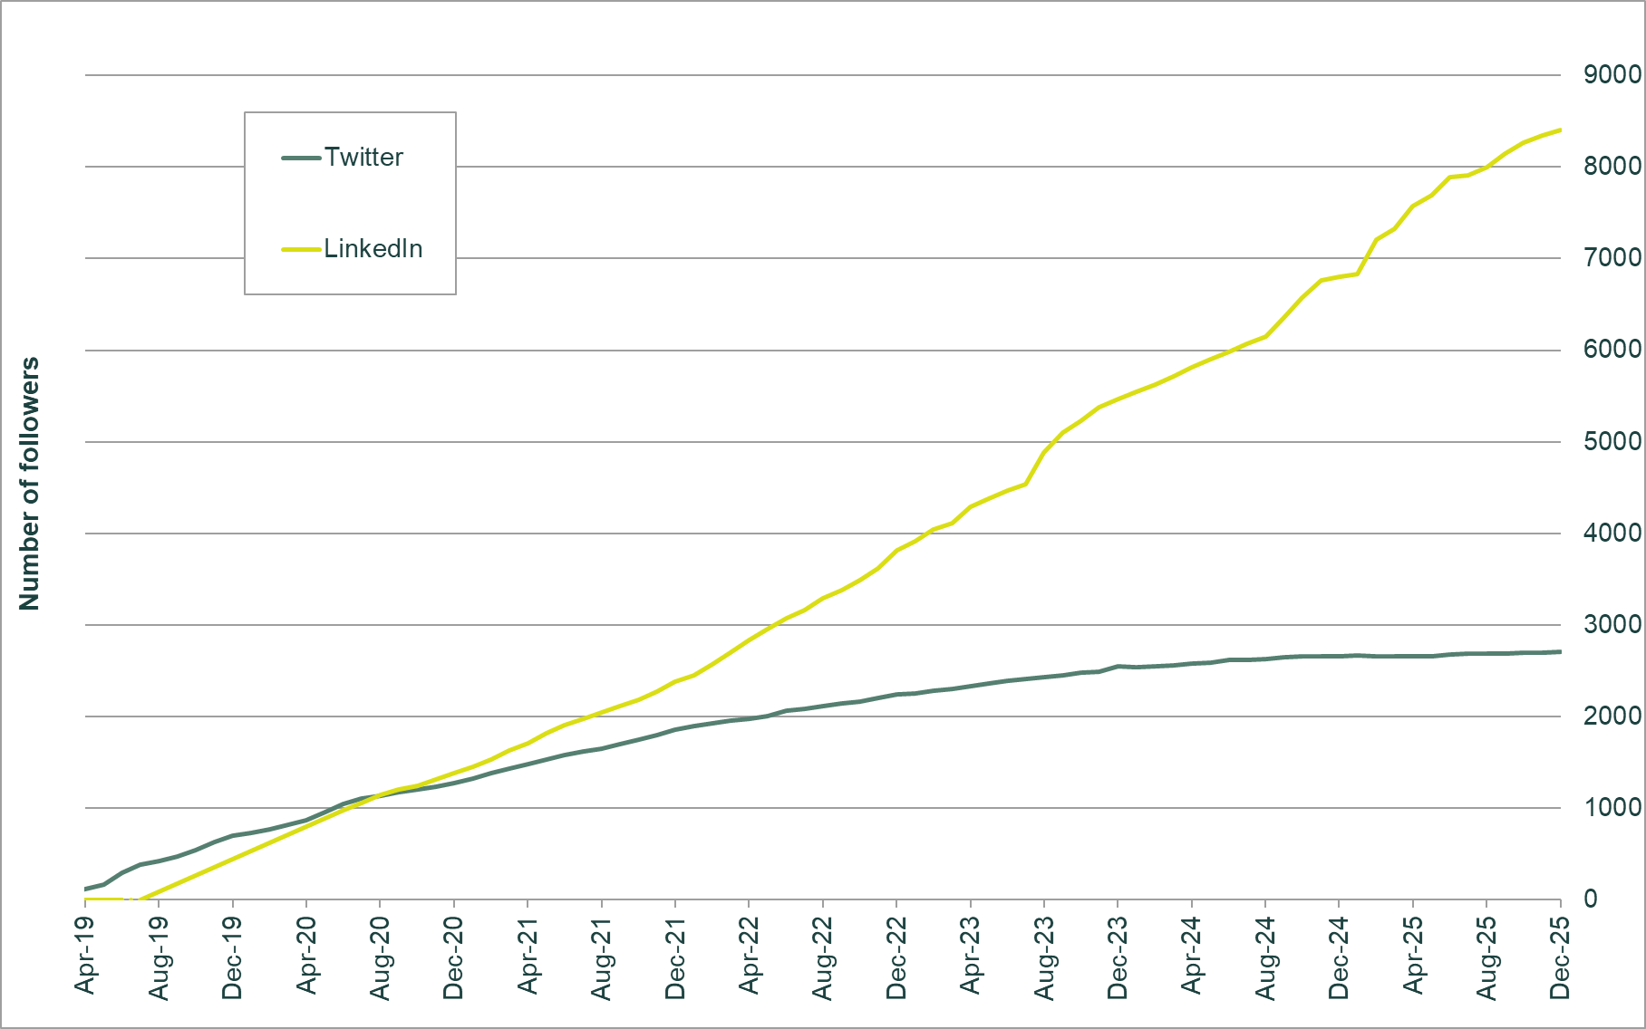 | Figure 13. UPOV LinkedIn followers (by country)

Figure 14. UPOV LinkedIn Infographic  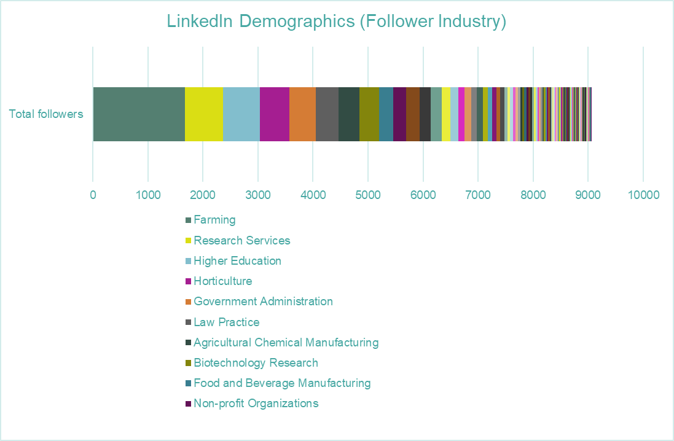 | Figure 15. One of the best performing social media posts  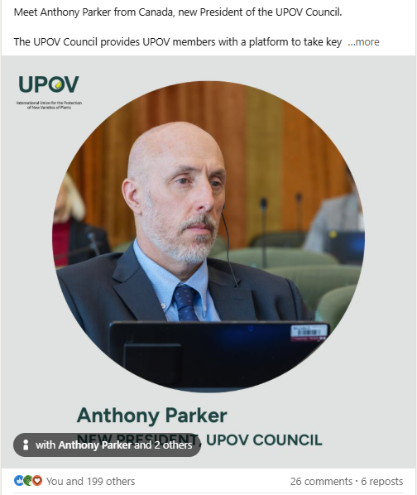

2.2 Guidance and assistance on the UPOV Convention and its implementation
In the 2024/2025 biennium, UPOV training and assistance activities were delivered to participants from 83 States and 35 organizations. The Office of the Union participated primarily through virtual means, and in other cases only when there was support from UPOV members. However, limited resources constrained the Office’s ability to maintain closer engagement with UPOV members and stakeholders and provide more tailored support for PVP implementation, capacity-building and cooperation.
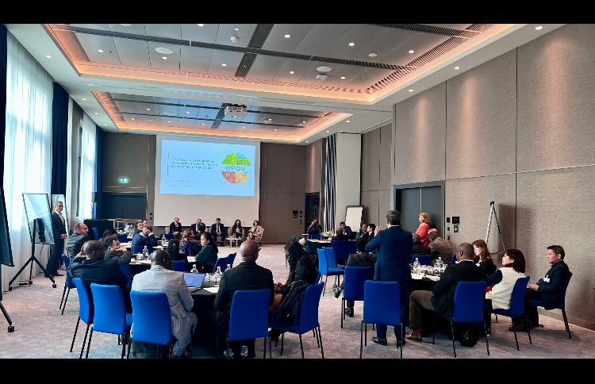
The Executive Program on Plant Variety Protection for the Development of Agriculture was organized by UPOV in cooperation with USPTO and with the assistance of the Ministry of Agriculture, Forestry and Fisheries of Japan, and was held in Geneva from December 3 to 6, 2024. Twenty-seven high-level participants from twenty countries and five international organizations attended the Executive Program. The methodology utilized co-creation sessions and panel discussions for direct interaction between participants and farmers, growers, plant breeders and policy makers from different continents. Together, they assessed possibilities in local contexts through different perspectives and developed their own approaches for sustainable agricultural development using the UPOV system. The Executive Program could not be held in 2025 because the voluntary contribution supporting it did not materialize.

In June 2024, UPOV organized with the United States Patent and Trademark Office (USPTO) and the African Regional Intellectual Property Organization (ARIPO) a regional workshop on plant variety protection for ARIPO Member States. The same methodology and content approach as in UPOV’s Executive Program was applied for this event. The Workshop entitled “Plant variety protection for sustainable agricultural development and food security in the context of climate change”, was held in Accra, Ghana, and organized with the assistance of the Registrar General’s Department, Ministry of Justice, Ghana. The Workshop provided a wealth of useful information on the impact of PVP in addressing food security, climatic impacts and providing trade opportunities, demonstrating the benefits that ARIPO member States can gain by acceding to the Arusha Protocol and becoming UPOV members.

The East Asia Plant Variety Protection Forum 18th Annual Meeting was held in Singapore, on August 4, 2025. The aim of the Forum 10th Year Strategic Plan is to “Establish effective PVP systems consistent with the UPOV Convention among Forum members towards achieving all Forum members’ membership of UPOV, as a basis for further PVP harmonization and cooperation in the region in order to contribute to developing sustainable agriculture and achieving food security.” In connection with the Forum, an International Seminar was held on August 5, 2025, to create awareness on the role of plant variety protection in development of agriculture. Forty-four participants from fifteen countries and two international organizations attended the events.

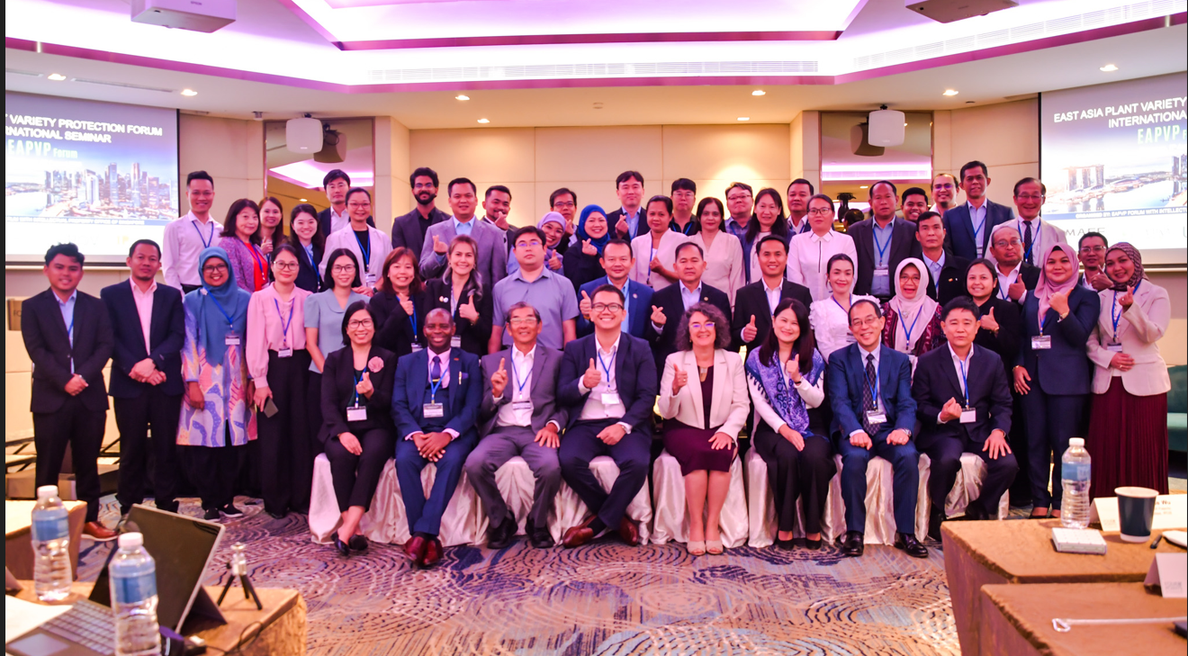

Information on meetings, training and assistance activities organized with or by other States and Organizations with the support or contribution of the UPOV Office can be consulted in the list of activities in Annex V. Since a results-based approach for UPOV planning and reporting has been adopted, UPOV Performance Reports now present streamlined and outcome-based information on training and assistance activities.

In the 2024/2025 biennium, the UPOV distance learning (DL) courses helped address the increasing demand for assistance in the introduction and implementation of the UPOV system.

The following graphic provides a summary of the total number of participants in distance learning courses, per language. In 2025, a total of 1,053 participants registered for distance learning courses. From these, 841 completed the courses obtaining 70 per cent or more in the final exam (“successful completion”).

Figure 16. Registrations in UPOV distance learning courses by language

There were 10 fee-paying students in 2024 and 17 in 2025, in comparison to 12 in 2023. The plans to update the UPOV DL courses to include content on recent developments, benefits of PVP and improved design have been postponed due to limited resources.

Number of participants in UPOV distance learning courses in 2024 by category (English, French, German and Spanish)
Category | Number of participants in 2024
Category | DL-205 | DL-305 | DL-305A | DL-305B | Total
Category 1: Government officials of members of the Union | 345 | 135 | 59 | 66 | 605
Category 2: Officials of observer States / intergovernmental organizations | 57 | 11 | 5 | 7 | 80
Category 3: Others (Fee: CHF1,000) | 8 | - | - | 2 | 10
Category 4: Discretionary waiving of fee for selected students | 132 | 4 | 1 | 1 | 138
Total number of participants | 542 | 150 | 65 | 76 | 833
Successful completion, total | 399 | 126 | 55 | 65 | 645

Number of participants in UPOV distance learning courses in 2025 by category (English, French, German and Spanish)
Category | Number of participants in 2025
Category | DL-205 | DL-305 | DL-305A | DL-305B | Total
Category 1: Government officials of members of the Union | 329 | 159 | 54 | 69 | 611
Category 2: Officials of observer States / intergovernmental organizations | 51 | 7 | 3 | 1 | 62
Category 3: Others (Fee: CHF1,000) | 15 | - | 2 | - | 17
Category 4: Discretionary waiving of fee for selected students | 123 | 2 | - | - | 125
Total number of participants | 518 | 168 | 59 | 70 | 815
Successful¹⁰ completion, total | 394 | 143 | 53 | 65 | 655

In the 2024/2025 biennium, the UPOV distance learning course DL-205 was offered in the Chinese language, in accordance with the “Program for the use of Chinese Language in UPOV” approved by the Council.

Number of participants in the DL-205 course in Chinese language:
Course | Language | Number of participants in 2024 | Number of participants in 2025
DL205-S1 | Chinese | 265 | 166
DL205-S2 | Chinese | 199 | 72
Total participants: |  | 464 | 238
Successful completion, total: |  | 382 | 186

Figure 17. UPOV DL-205, DL-305, DL-305A and DL-305B Courses: 2024-2025 participation
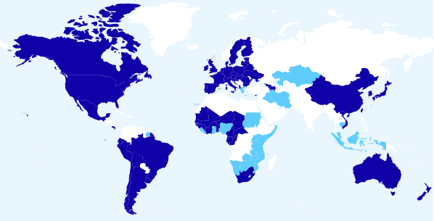
The boundaries shown on this map do not imply the expression of any opinion whatsoever on the part of UPOV concerning the legal status of any country or territory.
- Members of the Union (54): African Intellectual Property Organization (OAPI), Albania, Argentina, Armenia, Australia, Austria, Azerbaijan, Belarus, Belgium, Bolivia (Plurinational State of), Brazil, Bulgaria, Canada, Chile, China, Costa Rica, Croatia, Czech Republic, Denmark, Ecuador, Estonia, European Union, Finland, France, Georgia, Germany, Ghana, Hungary, Ireland, Italy, Japan, Kenya, Lithuania, Mexico, Netherlands (Kingdom of the), New Zealand, Nigeria, Peru, Poland, Portugal,
Republic of Korea, Romania, Singapore, Slovakia, Slovenia, South Africa, Spain, Sweden, Switzerland, Ukraine, United Kingdom, United Republic of Tanzania, United States of America, Uruguay, Viet Nam
- Non-members of the Union (11): African Regional Intellectual Property Organization (ARIPO), Cambodia, Greece, Indonesia,
Iran (Islamic Republic of), Iraq, Kazakhstan, Malaysia, Pakistan, Rwanda, Suriname.

To harness the various training initiatives provided by UPOV and its members, UPOV introduced in April 2024 the “UPOV International Certificate on Plant Variety Protection” (UPOV PVP Certificate).

The UPOV PVP Certificate is awarded to individuals who have acquired the necessary number of credits from UPOV endorsed courses and activities. The UPOV PVP Certificate was awarded to 50 individuals in 2024 and 28 in 2025. The total number of requests for the UPOV PVP Certificate reached 211 by the end of 2025, although most requestors did not meet the minimum number of credits required.

Authorities, organizations, and academic entities in UPOV members are invited to propose the inclusion of their training activities and academic programs on plant variety protection in the UPOV PVP Certificate. Five additional activities providing credits for the UPOV PVP Certificate were included in the program in 2024 and one in 2025.

Another objective of the UPOV PVP Certificate program is to increase the number of academic institutions that include information on the UPOV system in their courses. In the 2024/2025 biennium, one additional academic institution offering a program on PVP joined the UPOV PVP Certificate program (Europe); and one academic institution developed a partnership with UPOV to provide access to the UPOV DL-205 course for their students.

Figure 18. UPOV PVP Certificate (since launch in April 2024 to December 2025)
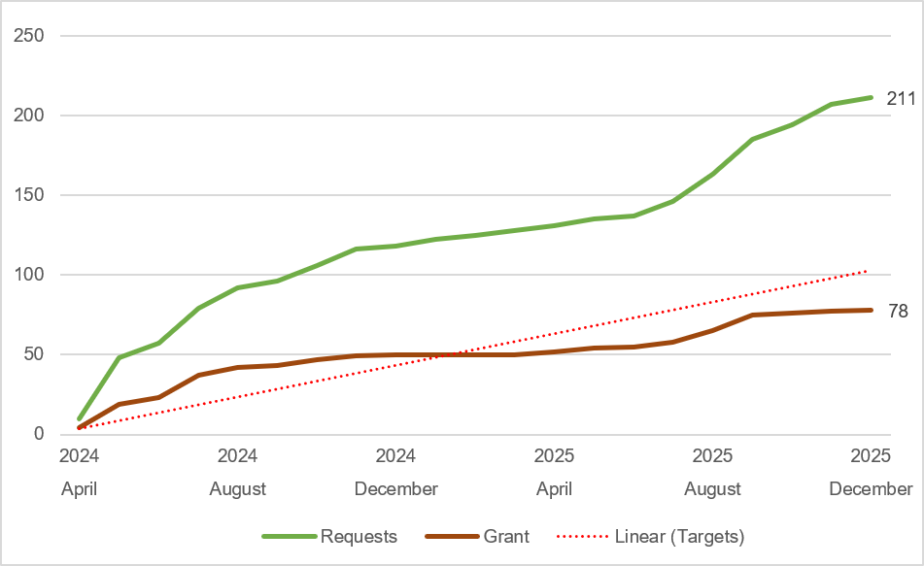

2.3 Enhanced harmonization and cooperation in examination
In the 2024/2025 biennium, the percentage of PVP applications in UPOV members reported in the PLUTO database which are covered by UPOV Test Guidelines (TGs) slightly decreased to 93 per cent from 94 per cent in 2023. This decrease was due to data clean-up in the PLUTO database, with the removal of duplicated variety entries. During the biennium, the harmonization of DUS examination through common Test Guidelines focused on revising 55 existing Test Guidelines and the adoption of five new Test Guidelines for Goji, Leucanthemum, Mulberry, Oxypetalum and Zoysia Grasses.

The number of authorities using UPOV Technical Questionnaires in UPOV PRISMA expanded from 25 (2024) to 27 (2025) with Nigeria and ARIPO joining in October 2025. The number of UPOV members using UPOV Technical Questionnaire characteristics in UPOV PRISMA increased to 8 in the biennium, from 6 in 2023.

Using the UPOV Technical Questionnaire, whether the full Technical Questionnaire or just the characteristics, streamlines the addition of new authorities or expanding crop coverage in UPOV PRISMA. This also simplifies filing applications in multiple authorities participating in UPOV PRISMA and highlights the advantages of harmonization.

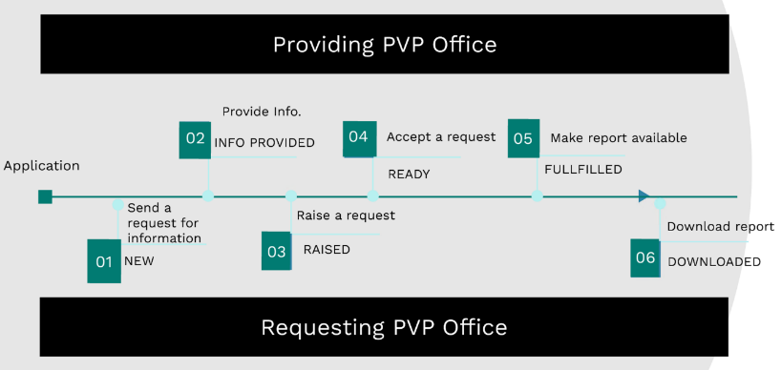
The “UPOV e-PVP DUS Exchange Module,” launched in 2024, has shown notable growth in usage. This is reflected by the participation of 16 authorities, the downloading of 116 DUS reports, and a total of 681 requests processed.

This increase in adoption signals enhanced efficiency and collaboration among participating authorities. By streamlining data exchange and facilitating access to DUS reports, the module contributes to improved decision-making and faster processing times, ultimately supporting innovation and transparency in plant variety protection.
In the 2024/2025 biennium, the work of the Technical Committee and its Technical Working Parties focused on options to improve the support provided for variety examination. The initiatives included the introduction of an agenda item for discussion of characteristics, approaches, and challenges for DUS examination relevant to drafting national test guidelines of UPOV members; a new procedure for the live editing of draft Test Guidelines during the Technical Working Parties; and the recording of discussion outcomes using the online tool for drafting Test Guidelines (“web-based TG template”).

Disease resistance characteristics in DUS examination received particular attention during the biennium, with a discussion session held at the Technical Committee in 2024 and further advanced at the Technical Working Party for Vegetables in 2025. This initiative recognizes the importance of developing new varieties that withstand diseases and the challenges and opportunities for UPOV members examining these characteristics in DUS tests.

To further enhance international cooperation in DUS examination, the Administrative and Legal Committee held a Seminar on cooperation with breeders in DUS examination on October 22, 2025. Different aspects were considered for increased understanding on the challenges and opportunities of these arrangements, including roles and responsibilities of authorities and breeders, independence, selection of similar varieties, on-site visits and associated costs. The Seminar was preceded by a series of webinars. All video recordings and presentation materials are available on the UPOV website.

Figure 19. Plant Breeders’ Rights Entries in Plant Variety Database covered by Test Guidelines

Pillar 3: Provide high quality services for UPOV members and users of the UPOV system

Performance Data:
Expected Results | Performance Indicators | Baselines | Targets | Performance Data  (2024-2025)
3.1 Development of UPOV e‐PVP services | Percentage of PVP applications of UPOV members included in PLUTO database within 1 year | 42% (2022)  33% (2023) | 60% (2024) | 40% (2024)  47% (2025)
 | Number of PLUTO users | 3,054 (2022)  4,514 (2023) | 4,000 (2025) | 5,500 (2024)  7,608 (2025)
 | Number of applications made via UPOV PRISMA | 1,907 (2022)  1,873 (2023) | 3,150 (2025) | 1,964 (2024)  1,864 (2025)
 | Number of UPOV members using the UPOV e-PVP Administration Module to manage and publish PVP applications | Not applicable (2022)  1 (2023) | 10 | 1 (2024)  2 (2025)

Key Accomplishments:
The development of UPOV e-PVP services progressed in 2025. During the 2024-2025 biennium, UPOV PRISMA application volumes exceeded the target by 21.5 per cent, reaching 3,828 applications. The United Kingdom accounted for 81 per cent of filings, with 1,614 applications in 2024 and 1,489 applications in 2025, highlighting the continued reliance on the United Kingdom as the main source of UPOV PRISMA revenue. At the same time, exploratory submissions to new territories increased, including applications to Morocco (11) Uruguay (2) and ARIPO (5). In parallel, the UPOV PRISMA user base expanded with the registration of
66 new administrator accounts (35 agents and 31 breeders).

Authority | Number of UPOV PRISMA applications
Authority | 2023 | 2024 | 2025
African Intellectual Property Organization (OAPI)
African Regional Intellectual Property Organization (ARIPO) |  |  | 5
Argentina*
Australia | 17 | 21 | 17
Bolivia (Plurinational State of)*
Canada | 56 | 46 | 27
Chile |  |  | 9
China |  |  | 6
Colombia |  | 4 | 3
Costa Rica |  |  | 2
Dominican Republic |  |  | 1
Ecuador | 1 |  | 1
European Union | 78 | 69 | 119
France | 2 | 12 | 4
Georgia | 3 | 2 | 2
Japan
Kenya | 23 | 25 | 8
Morocco |  |  | 11
Mexico | 17 | 12 | 24
Netherlands (Kingdom of the) |  | 3 | 1
New Zealand | 7 | 8 | 8
Nigeria
Norway | 1 | 1 | 7
Paraguay*
Peru |  | 1
Republic of Moldova |  | 1
Republic of Korea
Saint Vincent and the Grenadines
Serbia |  | 28 | 2
South Africa | 24 | 20 | 19
Sweden
Switzerland | 6 | 3 | 7
Trinidad and Tobago
Tunisia |  |  | 2
Türkiye | 57 | 52 | 65
United Kingdom | 1,562 | 1,614 | 1,489
United Republic of Tanzania
United States of America | 18 | 39 | 23
Uruguay |  |  | 2
Viet Nam | 1 | 3
40 | 1,873 | 1,964 | 1,864
* Until required information is provided, applicants will not be able to submit application data

Viet Nam joined the UPOV e-PVP Administration Module in 2024. The United Kingdom established UPOV PRISMA as its online filing tool for all PVP applications and onboarded UPOV e-PVP Administration Module in April 2025.

An increasing number of UPOV members are interested in using the UPOV e-PVP DUS Report Exchange Module. The actual use of the tool has increased since a new version was deployed in April 2025, bringing the number of requests to 681 and the number of reports submitted to a receiving PVP Office to 16. This development demonstrates the potential of the DUS Report Exchange Module to facilitate cooperation between members in DUS testing.

The number of PLUTO database users (7,608) continues to grow, reflecting sustained community interest in conducting ad hoc searches; this trend extends to the premium service, which saw an increased usage in 2025 (24 subscriptions).

A key driver increasing use of the PLUTO database was the inclusion of a link to the Plant Varieties and Seeds Gazette of the United Kingdom (https://gazette.upovepvp.upov.int/).

In 2025, 67 per cent of UPOV members, representing 54 authorities, contributed data to the PLUTO database. Although participation increased to 57 out of 80 members, the share of annual PVP applications included in PLUTO grew modestly, from 40 per cent in 2024 to 47 per cent in 2025. This was mainly because contributors had not uploaded all relevant data: records uploaded by UPOV members represented only 52 per cent of the applications reported in the statistics. Planned enhancements to the PLUTO database are intended to help contributors keep their data complete and up to date.

Figure 20. Number of applications made via UPOV PRISMA
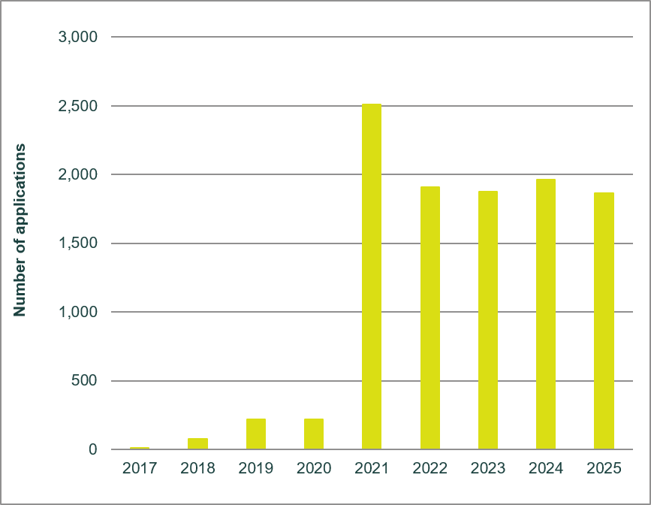

Figure 21. Protection of plant genera and species in 2024-2025
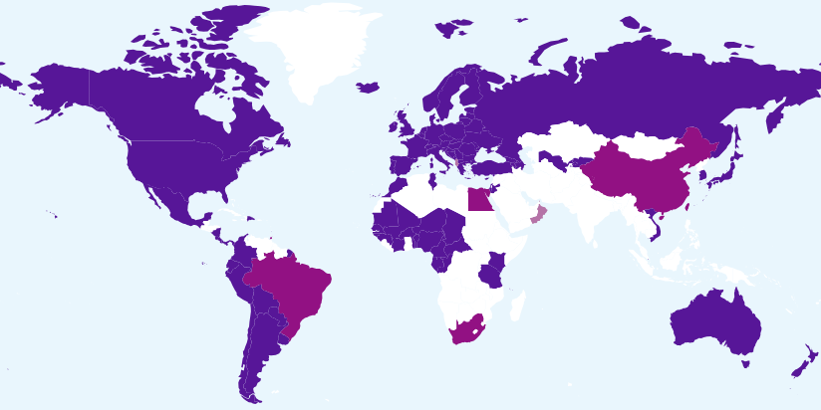
The boundaries shown on this map do not imply the expression of any opinion whatsoever on the part of UPOV concerning the legal status of any country or territory.
Members of the Union offering protection for all plant genera and species
Members of the Union offering protection for a limited number of plant genera and species
Members of the Union who had not notified the extension of protection to all genera and species

Figure 22. Evolution of protection to plant genera and species

Figure 23. Data from PLUTO database
Applications filed by crop type: | Titles issued by crop type:
   | Crop type
  Year | Agriculture | Forest trees | Fruit | Ornamental | Vegetables
  2014 | 30% | 0.8% | 11% | 47% | 10%
  2015 | 33% | 0.5% | 14% | 36% | 16%
  2016 | 37% | 0.6% | 11% | 34% | 18%
  2017 | 33% | 0.5% | 11% | 38% | 17%
  2018 | 35% | 0.5% | 12% | 33% | 20%
  2019 | 34% | 0.6% | 10% | 37% | 19%
  2020 | 35% | 0.6% | 8% | 36% | 21%
  2021 | 42% | 0.6% | 8% | 32% | 17%
  2022 | 39% | 0.7% | 15% | 28% | 17%
  2023 | 37% | 0.7% | 10% | 34% | 19%
  2024 | 37% | 0.8% | 10% | 35% | 19%
  2025 | 47% | 0.1% | 15% | 23% | 23%
   | Crop type
  Year | Agriculture | Forest trees | Fruit | Ornamental | Vegetables
  2014 | 35% | 0.6% | 10% | 43% | 12%
  2015 | 32% | 0.9% | 10% | 44% | 13%
  2016 | 32% | 1.1% | 9% | 40% | 18%
  2017 | 27% | 0.4% | 12% | 45% | 16%
  2018 | 27% | 0.5% | 11% | 43% | 18%
  2019 | 34% | 0.4% | 9% | 38% | 18%
  2020 | 38% | 0.5% | 7% | 34% | 21%
  2021 | 46% | 0.5% | 7% | 27% | 18%
  2022 | 42% | 0.5% | 12% | 30% | 15%
  2023 | 39% | 0.5% | 8% | 35% | 17%
  2024 | 39% | 0.5% | 8% | 35% | 18%
  2025 | 21% | 0.1 | 17% | 54% | 14%

Figure 24. Plant Genera/Species with Cooperation Agreements, Practical Experience and
Plant Breeders’ Rights Entries in Plant Variety Database

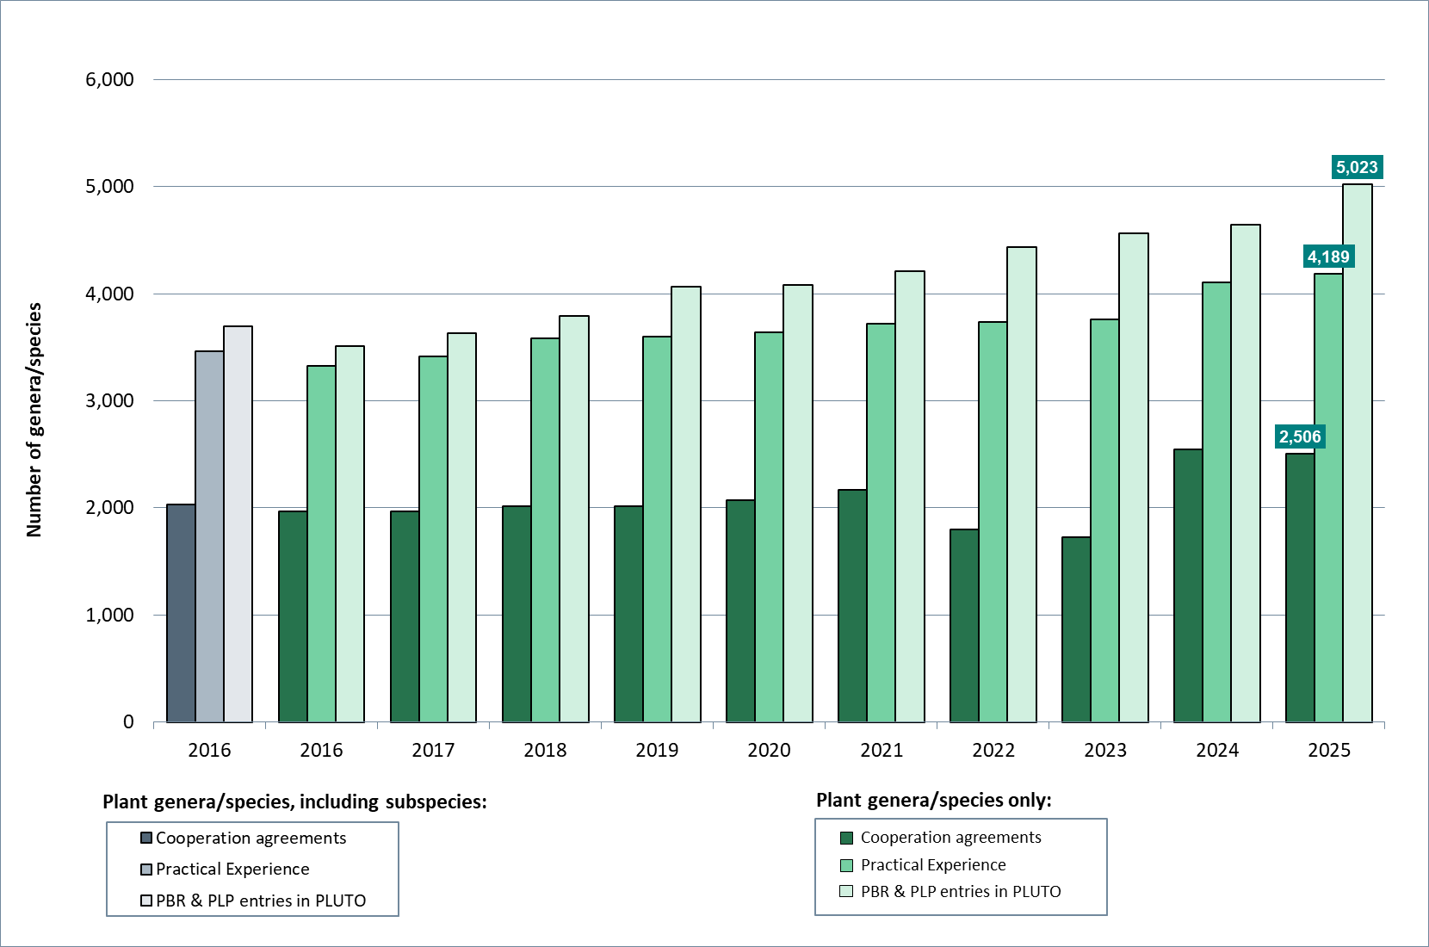

Foundation: Empower our people to work effectively, collaboratively and innovatively by providing them with the right resources, training and environment

Performance Data:
Expected Results | Performance Indicators | Baselines | Targets | Performance Data  (2024-2025)
4.1 Diversification of revenue | Income from sources other than UPOV member contributions | 6.2% (2022)  5.7% (2023) | 9% |  | 5.9% (2024)  4.6% (2024 & 2025)
4.2 A Secretariat that is empowered and is provided with the right resources and training to work effectively, collaboratively and innovatively | Staff satisfaction level | 79% (2022)  72% (2023) | 88% |  | 84% (2024)  68% (2025)

Key Accomplishments:
Diversification of revenue

In 2025, members’ contributions constituted UPOV’s primary source of income, representing 95.4 per cent of total income. The value of the contribution unit has remained unchanged at 53,641 Swiss francs since 1995.

The income projections in the 2024-2025 Program and Budget anticipated a 20 per cent increase in revenue from paid submissions made through UPOV PRISMA. However, these projections proved to be overly optimistic, and the income projections for 2026-2027 have therefore been revised to reflect a more moderate increase of 5 per cent. Promotion of UPOV services that contribute to revenue diversification will continue in accordance with the priorities agreed by the Council.

On October 23, 2025, the Consultative Committee agreed to establish a Consultative Group of the Consultative Committee on UPOV Resources Strategy (CG-URS). The mandate of the CG-URS is to identify options for achieving UPOV’s financial sustainability (see Annex to document CC/103/12, “Report”). The advisory recommendations of the CG-URS will be considered by the Consultative Committee on October 22, 2026.

At its fifty-ninth ordinary session, on October 24, 2025, the Council adopted documents C/59/14 “Strategic Business Plan 2026-2029”, C/59/15 “UPOV Risk Appetite Statement” and C/59/16 “UPOV Resources Strategy”.

A Secretariat that is empowered and is provided with the right resources and training to work effectively, collaboratively and innovatively

The UPOV Resources Strategy (URS) (document C/59/16), adopted by the Council on October 24, 2025, refers to human resource related initiatives to implement the UPOV Resource Strategy as follows:

- (a) Resource Optimization: Leverage member-funded talent programs (fellows, JPOs, FIT) to expand capacity. Review contractual model to focus core positions on critical roles.

- (b) Skills transformation: Systematically upgrade capabilities in digital technologies, communication, data analysis, project management, and stakeholder engagement.

- (c) Workforce planning: Map critical skill gaps and optimize staffing models for current and future service delivery.

In relation to (a) above, in 2025, a new Funds-in-Trust in the form of extrabudgetary funds from the Government of China was established. A JPO was recruited under the FIT with China to analyze and present information on plant variety protection and support the development of UPOV services.

In relation to (b) and (c) above, until UPOV’s financial situation improves, the resources to develop and retain staff and ensure business continuity are limited and not fully aligned to strategic needs.

UPOV reinforces managing-for-results (RBM) and upholds fiscal discipline and prudent financial management in its operations.

iii. annexes

ANNEX I Extrabudgetary Funds (Funds-in-Trust)
The extrabudgetary funds (including funds in trust) allocated by donors are presented below as independent accounts.

Trust funds as at December 31, 2025
(expressed in Swiss francs)

Note: Funds-in-Trust in the form of an extrabudgetary fund from the Government of China intended for the recruitment of a Junior Professional Officer (JPO) to analyze and present information on plant variety protection (PVP) and support the development of UPOV services.

Note: Funds in trust in the form of an extrabudgetary fund from the Government of Japan for training and assistance activities on the protection of new plant varieties and cooperation in the Asian region.

Note: Funds-in-Trust in the form of an extrabudgetary fund from the Government of Japan intended for UPOV Communication and Raising Awareness Activities.

Note: UPOV PRISMA is an on-line tool to assist in making plant variety protection (PVP) applications to PVP Offices of participating members of the Union. The UPOV PRISMA Fund is a contribution made by Naktuinbouw (Kingdom of the Netherlands) to support the development of UPOV PRISMA.

Note: Extrabudgetary fund from the Government of the United States of America, intended for education in intellectual property protection in the area of plant variety protection.

Note: Extrabudgetary fund from Naktuinbouw (Kingdom of the Netherlands), intended for improvement and maintenance of UPOV e-PVP.

[Annex II follows]

ANNEX II Working Capital Fund and Contributions

Working Capital Fund as at December 31, 2025
Under Regulation 4.2 of the Financial Regulations and Rules of UPOV (see document UPOV/INF/4/7), UPOV has a Working Capital Fund. According to the Statement of Financial Position as at December 31, 2025, the Working Capital Fund stands at 580,012 Swiss francs. The share of each member of the Union, calculated in accordance with the decision taken by the Council at its twenty-third extraordinary session, held in Geneva on April 7, 2006 (see document C(Extr.)/23/5 “Report”, paragraph 12, Annex II and document UPOV/INF/13/2, Annex), is as follows:

Contributions of Members of the Union

Contribution Payments Received in Advance

Amounts of the contributions due and unpaid Working Capital as at December 31, 2025
* Nigeria became a member of the Union on March 27, 2025. Nigeria’s contribution will be paid in 2026.

[Annex III follows]

ANNEX III Status in relation to UPOV

The following table provides detailed information on the status in relation to UPOV.

UPOV members
African Intellectual Property Organization^{2, 4}
Albania²
Argentina1
Armenia²
Australia²
Austria2
Azerbaijan²
Belarus²
Belgium2
Bolivia (Plurinational State of)¹
Bosnia and Herzegovina²
Brazil¹
Bulgaria²
Canada2
Chile¹
China¹
Colombia¹
Costa Rica²
Croatia²
Czech Republic²
Denmark2
Dominican Republic²
Ecuador¹
Egypt²
Estonia²
European Union^{2, 3}
Finland2
France2
Georgia²
Germany2
Ghana²
Hungary2
Iceland2
Ireland2
Israel²
Italy1
Japan²
Jordan²
Kenya²
Kyrgyzstan²
Latvia²
Lithuania²
Mexico¹
Montenegro²
Morocco2
Netherlands (Kingdom of the)²
New Zealand1
Nicaragua¹
Nigeria²
North Macedonia²
Norway1
Oman²
Panama²
Paraguay¹
Peru²
Poland2
Portugal¹
Republic of Korea²
Republic of Moldova²
Romania²
Russian Federation²
Saint Vincent and the Grenadines²
Serbia²
Singapore²
Slovakia²
Slovenia²
South Africa1
Spain2
Sweden²
Switzerland²
Trinidad and Tobago¹
Tunisia²
Türkiye²
Ukraine²
United Kingdom²
United Republic of Tanzania²
United States of America²
Uruguay¹
Uzbekistan²
Viet Nam²

(Total 80)

¹ 1978 Act is the latest Act by which 17 States are bound.
² 1991 Act is the latest Act by which 61 States and 2 organizations are bound.
³ Operates a plant breeders’ rights system which covers the territory of its 27 member States (Austria, Belgium, Bulgaria, Croatia, Cyprus, Czech Republic, Denmark, Estonia, Finland, France, Germany, Greece, Hungary, Ireland, Italy, Kingdom of the Netherlands, Latvia, Lithuania, Luxembourg, Malta, Poland, Portugal, Romania, Slovakia, Slovenia, Spain, Sweden).
⁴ Operates a plant breeders’ rights system which covers the territory of its 17 member States (Benin, Burkina Faso, Cameroon, Central African Republic, Chad, Comoros, Congo, Côte d’Ivoire, Equatorial Guinea, Gabon, Guinea, Guinea Bissau, Mali, Mauritania, Niger, Senegal, Togo).

States and intergovernmental organizations which had initiated the procedure
for acceding to the UPOV Convention

Afghanistan, Brunei Darussalam, Guatemala, Honduras, India, Iran (Islamic Republic of), Jamaica, Kazakhstan, Lao People’s Democratic Republic, Malaysia, Mauritius, Mongolia, Myanmar, Philippines, Tajikistan, United Arab Emirates, Venezuela (Bolivarian Republic of) and Zimbabwe, as well as the African Regional Intellectual Property Organization (ARIPO).

States and intergovernmental organizations which had been in contact with the Office of the Union
for assistance in the development of laws based on the UPOV Convention

Algeria, Antigua and Barbuda, Bahrain, Barbados, Cabo Verde, Cambodia, Cuba, Cyprus, El Salvador, Gambia (the), Indonesia, Iraq, Libya, Liechtenstein, Malawi, Mozambique, Namibia, Pakistan, Rwanda, Saudi Arabia, Seychelles, Sudan, Suriname, Thailand, Timor-Leste, Tonga, Turkmenistan and Zambia, as well as the Southern African Development Community (SADC).

The following map provides a graphic overview of the status in relation to UPOV at the end of 2025.

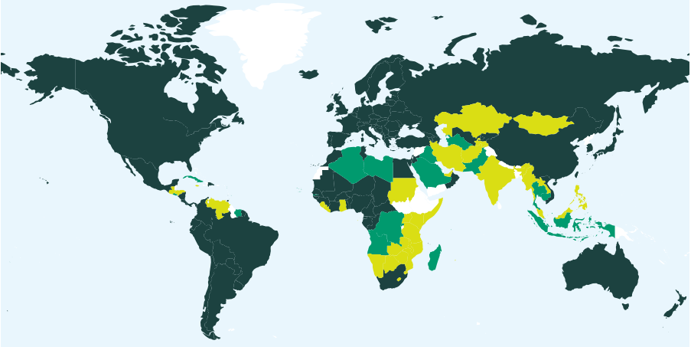
The boundaries shown on this map do not imply the expression of any opinion whatsoever on the part of UPOV concerning the legal status of any country or territory
80 members of UPOV covering 99 States at the end of 2025

18 States and 1 intergovernmental organization had initiated the procedure for acceding to the UPOV Convention at the end of 2025

29 States and 1 intergovernmental organization which had been in contact with the Office of the Union for assistance in the development of laws based on the UPOV Convention at the end of 2025

[Annex IV follows]

ANNEX IV Members of the Union
This Annex provides the status of the members of the Union in relation to the Convention and its various Acts, as of December 31, 2025 (see Article 32(1) of the 1978 Act and Article 34(2) of the 1991 Act).



https://www.upov.int/edocs/mdocs/upov/en/c_60/c_60_2_annex_iv.pdf

[Annex V follows]

ANNEX V List of Activities in 2024-2025



https://www.upov.int/edocs/mdocs/upov/en/c_60/c_60_2_annex_v.pdf

[Appendix follows]

iv. appendix

ACRONYMS AND ABBREVIATIONS
UPOV terms

CAJ | Administrative and Legal Committee
DL-205 | UPOV distance learning course “Introduction to the UPOV System of Plant Variety Protection under the UPOV Convention”
DL-305 | UPOV distance learning course “Examination of Applications for Plant Breeders’ Rights”
DL-305A | UPOV distance learning course “Administration of Plant Breeders’ Rights” (part A of DL-305)
DL-305B | UPOV distance learning course “DUS Examination”  (part B of DL-305)
DUS | Distinctness, Uniformity and Stability
EAM | Meeting on Electronic Applications
Office | Office of the Union
PBR | Plant Breeder’s Right
PLUTO | UPOV Plant Variety Database
TC | Technical Committee
TC-EDC | Enlarged Editorial Committee
TWA | Technical Working Party for Agricultural Crops
TWF | Technical Working Party for Fruit Crops
TWM | Technical Working Party on Testing Methods and Techniques
TWO | Technical Working Party for Ornamental Plants and Forest Trees
TWP(s) | Technical Working Party(ies)
TWV | Technical Working Party for Vegetables
UPOV e-PVP | UPOV e-PVP comprises a package of electronic tools for implementation of the UPOV system of plant variety protection by UPOV members. UPOV e-PVP includes UPOV PRISMA, UPOV e-PVP Administration Module, UPOV e-PVP DUS Report Exchange Module, and the PLUTO database.
UPOV PRISMA | UPOV PRISMA PBR Application Tool
WG-HRV | Working Group on harvested Material and Unauthorized use of Propagating Material
WSP | World Seed Partnership

Acronyms (also included in Annex V)

AFBI | Agri-Food and Biosciences Institute
AfrIPI | Project financed by the European Union and implemented by EUIPO
AFSTA | African Seed Trade Association
AIPPI | International Association for the Protection of Intellectual Property
ALA (Argentina) | Asociación de Laboratorios Agropecuarios Privados (Private Agricultural Laboratories Association)
ALLEA | European Federation of Academies of Sciences and Humanities
AMPPI (Mexico) | Asociación Mexicana para la Protección de la Propiedad Intelectual (Mexican Association for the Protection of Intellectual Property)
AOHE | Association of European Horticultural Breeders
APSA | Asia and Pacific Seed Association
ARIPO | African Regional Intellectual Property Organization
ASEAN | Association of Southeast Asian Nations
ASIPI | Asociación Interamericana de la Propiedad Intelectual (Inter-American Association of Intellectual Property)
AWGIPC | ASEAN Working Group on Intellectual Property Cooperation
CIOPORA | International Community of Breeders of Asexually Reproduced Ornamental and Fruit Varieties
CPVO | Community Plant Variety Office of the European Union
EAPVP Forum | East Asia Plant Variety Protection Forum
EUIPO | European Union Intellectual Property Office
FAO | Food and Agriculture Organization of the United Nations
FORUM | FORUM Institut für Management
IICA | Inter-American Institute for Cooperation on Agriculture
INDECOPI (Peru) | Instituto Nacional de Defensa de la Competencia y de la Protección de la Propiedad Intelectual (National Institute for the Defense of Competition and the Protection of Intellectual Property of Peru)
InnoVar | EU-funded project "Next-generation variety testing for improved cropping on European farmland"
INVITE | EU-funded project "INnovations in plant VarIety Testing in Europe"
IPC (Islamic Republic of Iran) | Intellectual Property Center
IPKey LA | IPKey Latin America
IPKey SEA | IPKey South-East Asia
ISF | International Seed Federation
ISTA | International Seed Testing Association
ITPGRFA (FAO) | International Treaty on Plant Genetic Resources for Food and Agriculture
JATAFF | Japan Association for Techno-innovation in Agriculture, Forestry and Fisheries
JICA | Japan International Cooperation Agency
KEPHIS | Kenya Plant Health Inspectorate Service
NSAR (Rwanda) | National Seed Association of Rwanda
OAPI | Organisation Africaine de la Propriété Intellectuelle (African Intellectual Property Organization)
OECD | Organisation for Economic Co-operation and Development
PARPOV (Paraguay) | Asociación Paraguaya de Obtentores Vegetales (Paraguayan Association of Plant Breeders)
SAA | Seed Association of the Americas
SEMAE (France) | L'interprofession des semences et plants (French Interprofessional Organisation for Seeds and Plants)
SENAVE (Paraguay) | Servicio Nacional de Calidad y Sanidad Vegetal y de Semillas (National Service for Plant and Seed Quality and Health of Paraguay)
SNICS (Mexico) | Servicio Nacional de Inspección y Certificación de Semillas (National Seed Inspection and Certification Service of Mexico)
UFS | Union française des semenciers (French Seed Association)
USPTO | United States Patent and Trademark Office
WFO | World Farmers' Organisation
WIPO | World Intellectual Property Organization
WNO | WIPO Nigeria Office
WSP | World Seed Partnership
WTO | World Trade Organization

[End of document]

Note: Figures in tables throughout the document may not add up due to rounding.
2024/25 Actuals for Supplies and Materials amount to 234 Swiss francs.
The United Kingdom also issued another 21,805 plant variety titles in 2023 related to plant variety rights transferred from the European Union, as part of the withdrawal agreement.
The number of titles in force in the United Kingdom is an estimate.
The Figure includes the number of titles in force in the United Kingdom as an estimate.
Includes the States and organizations listed in Annex V and in UPOV distance learning courses (Figure 17).
The total number of participants successfully completing DL courses includes participants in the courses administered by China under “Program for the use of Chinese Language in UPOV” approved by the UPOV Council.
Africa: OAPI IP Masters (OA), Limpopo University (ZA); Asia/Pacific: JICA (JP), KOIKA (KR); Europe: Alicante University Magister Lucentinus (ES), Naktuinbouw PBR for Food Security (NL), La Salle University Master in Plant Breeding (FR), Maastricht University IP Master (NL), Turin University LL.M. in IP (IT), Zaragoza University IP Master (ES).
The methodology for the 2024 UPOV’s Executive Program (27 participants) was applied for the 2024 ARIPO Regional Workshop on Plant Variety Protection for ARIPO Member States (48 participants). The Executive Program could not be held in 2025 because the voluntary contribution supporting it did not materialize.
Successful completion of UPOV DL Courses means obtaining 70% or more in the final exam.

