|  |  |
| --- | --- |
|  | E |
| International Union for the Protection of New Varieties of Plants |  |

|  |  |
| --- | --- |
| Council  Fifty-Ninth Ordinary Session  Geneva, October 24, 2025 | C/59/16  Original: English  Date: September 19, 2025 |

upov Resources Strategy

Document prepared by the Office of the Union

Disclaimer: this document does not represent UPOV policies or guidance

In 2024, the Consultative Committee endorsed the development of a UPOV Resources Strategy (URS) to improve long term financial sustainability of UPOV and increase UPOV’s outreach and impact in accordance with the Strategic Business Plan 2026-2029 (document C/59/14).

The URS has been developed to ensure financial sustainability to empower UPOV’s mission. The purpose of the strategy is to provide UPOV with sufficient and stable financial and human resources to operate effectively, foster collaboration, and support innovation in plant variety protection worldwide.

In accordance with the proposal in the Draft Program and Budget for the 2026-2027 Biennium to undertake consultations with UPOV members to assess the value of the contribution unit (see document C/59/4, Annex, paragraph 21), the URS anticipates a member Dialogue on Contribution Unit Reform, including the need to: (i) adjust the value of the contribution unit; and (ii) develop a mechanism for regular reviews of the contribution unit.

The URS also takes into account the results of the 2025 review of the WIPO/UPOV Service Level Arrangement (SLA) which resulted in a substantial increase in the cost of services provided by WIPO to UPOV.

In 2003, a discussion was initiated on UPOV’s financial situation with the assistance of a Consultative Group. The Consultative Committee may wish to set up a Consultative Group to prepare recommendations on matters identified in the URS, for consideration by the Consultative Committee and the Council in 2026.

The Council is invited to consider the UPOV Resources Strategy (URS) presented in the Annex to this document in conjunction with the recommendations of the Consultative Committee at its hundred and third session, to be held in Geneva on October 23, 2025.

[Annex follows]

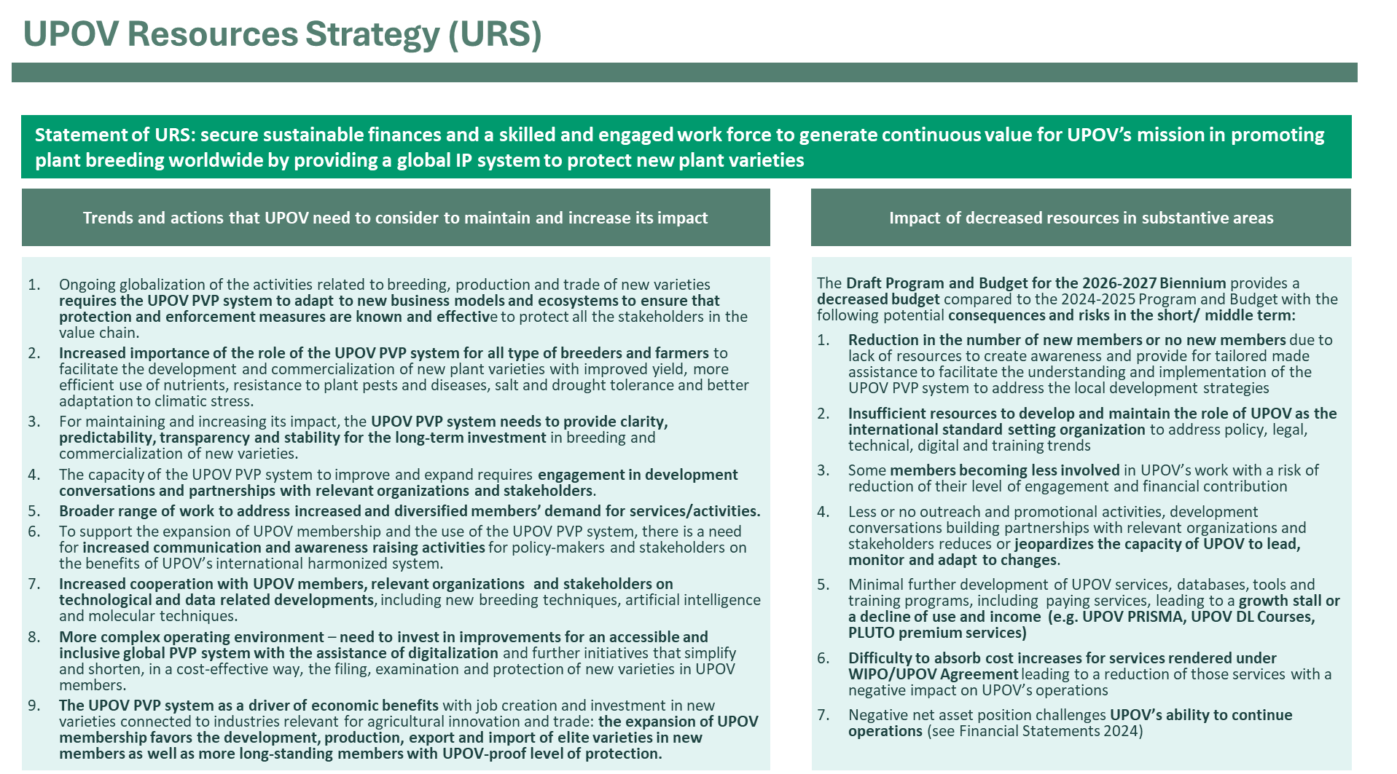

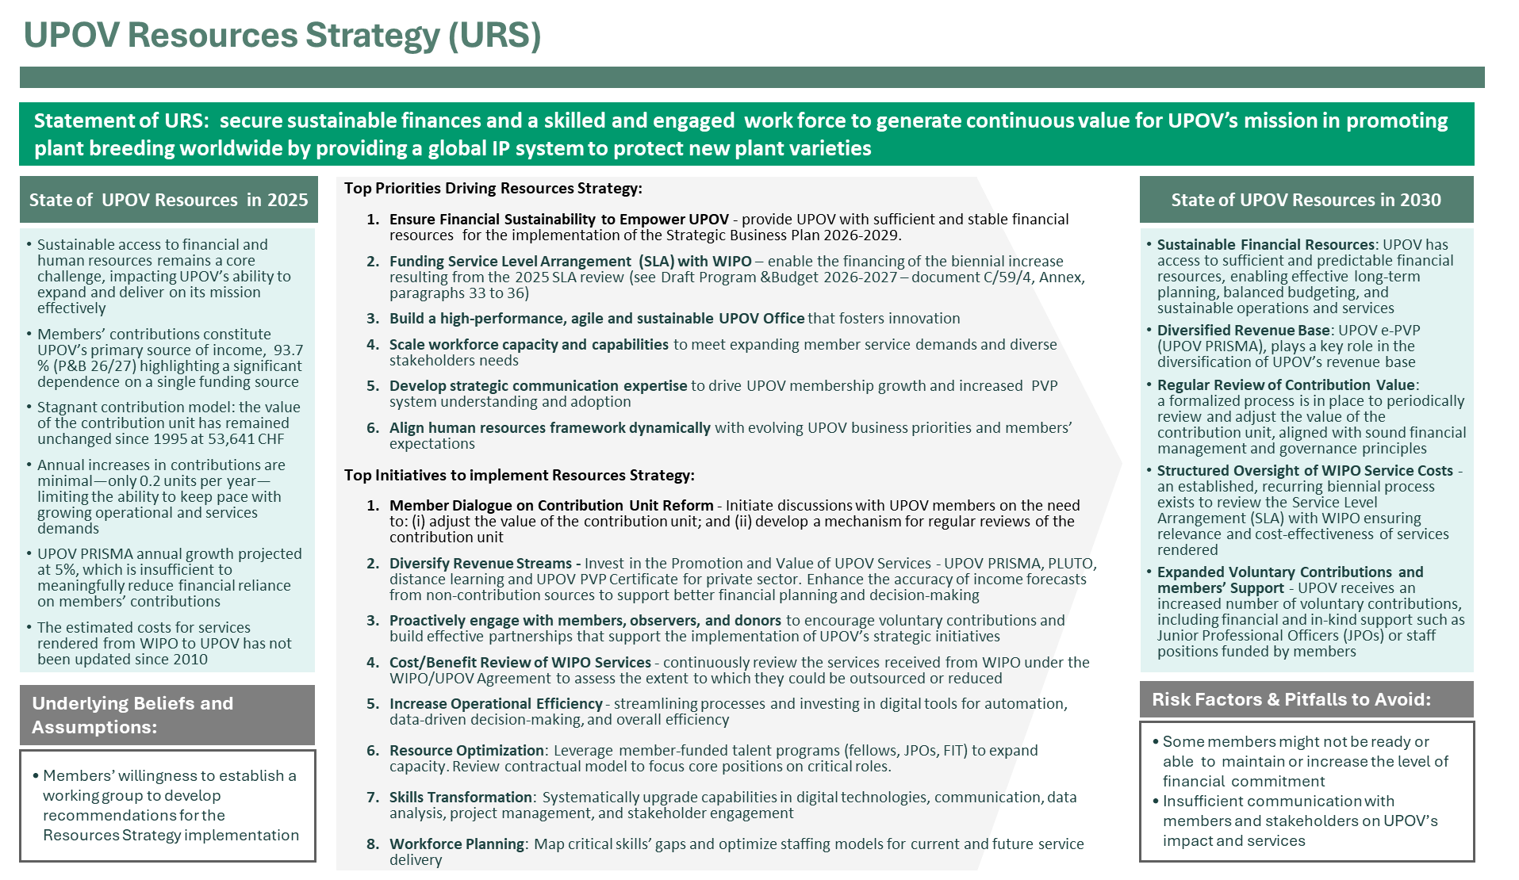

[End of Annex and of document]