|  |  |
| --- | --- |
|  | E |
| International Union for the Protection of New Varieties of Plants |  |

|  |  |
| --- | --- |
| Council  Fifty-Ninth Ordinary Session  Geneva, October 24, 2025 | C/59/15  Original: English  Date: September 19, 2025 |

UPOV RISK APPETITE STATEMENT

prepared by the Office of the Union

Disclaimer: this document does not represent UPOV policies or guidance

UPOV undertakes a structured approach to risk management, based upon WIPO’s risk management framework and practices. This Risk Appetite Statement sets out how UPOV will manage risks while implementing the Strategic Business Plan 2026-2029 (SBP).

Aligning an organization’s Risk Appetite Statement to its strategy is a best practice according to the United Nations High Level Committee on Management Risk Management Forum Guidelines on Risk Appetite Statements[1] and the Committee of Sponsoring Organizations of the Treadway Commission (COSO)[2].

This Risk Appetite Statement is therefore structured by the UPOV Strategy House’s three strategic pillars and foundation. It defines the risk appetite in pursuit of each Expected Result within the Strategy House.

The Council is invited to take note of the present document.

[Annex follows]

**INTERNATIONAL UNION FOR THE PROTECTION OF NEW VARIETIES OF PLANTS**

**Risk Appetite Statement**

# INTRODUCTION

1. WIPO’s risk management framework, which includes the Policy on Risk Management and the Risk Handbook, help guide risk management at UPOV in achieving the Expected Results in the Strategic Business Plan 2026-2029 (SBP).
2. This Risk Appetite Statement defines UPOV’s risk appetite in pursuing its mission to provide and promote an effective system of plant variety protection, with the aim of encouraging the development of new varieties of plants, for the benefit of society.

# GUIDING PRINCIPLES

1. UPOV’s approach to risk management is guided by:

* a structured risk-aware culture
* shared ownership of risks among Council, UPOV members, and the Office of the Union
* strategic alignment with Expected Results
* transparent risk informed decision-making and continuous learning

# DEFINITIONS

1. **Risk**: an uncertainty that if occurring would affect the achievement of UPOV’s strategic, financial or project objectives.
2. **Risk management**: a coordinated approach to assessing and responding to all risks.
3. **Risk appetite**: the amount of residual risk, on a broad level, that UPOV is willing to take in pursuit of its Expected Results, and accordingly, its Strategic Pillars.
4. **Risk capacity**: the amount of *residual* *risk*[3], that an organization can cope with, and still meet performance expectations over time.
5. **Risk universe:** the reasonable outside limits of possible performance outcomes, if risks arise. The risk universe is represented by the outside boundaries of possible outcomes, as shown in figure 1.

Figure 1 - Risk universe, capacity and appetite

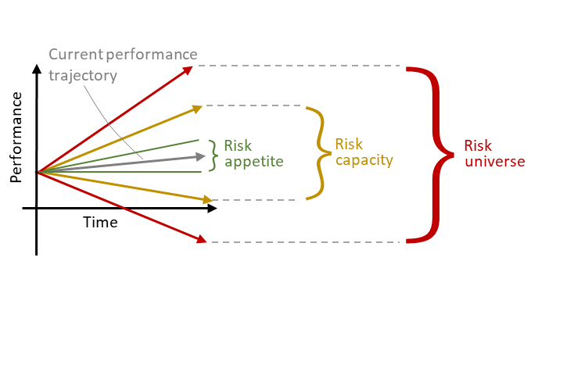

1. The following three appetite levels used are:

* **low** – Expected Result areas where UPOV avoids risk, or acts to minimize or eliminate the likelihood of occurrence due to potential downside costs and impacts.
* **medium** – Expected Result areas requiring constant balance between potential upside benefits and potential downside costs or negative impact.
* **high** – Expected Result areas where UPOV has a preference for calculated risk-taking because the potential upside benefits outweigh the potential costs or downside impacts.

# STRATEGIC IMPLEMENTATION OF RISK APPETITE IN THE CONTEXT OF THE SBP

1. The Strategy House defines UPOV’s mission, strategic pillars, and Expected Results, with specific risk appetites assigned to each Expected Result (Figure 2).
2. UPOV’s overall appetite is **medium**. When UPOV undertakes work in pursuit of certain Expected Results, a lower or higher appetite may be sought. In some cases, the work may contribute to more than one Expected Result; should the appetites be different, the lower appetite would prevail.



Figure 2 – UPOV Strategy House with risk appetites

1. The following examples provide how the risk appetite is implemented in practice:
2. **Low** risk appetite activities (e.g., Expected Result 1.1 – Governance by the UPOV Council and work of UPOV Committees) ensure systematic review of the UPOV Office of the Union’s support to the UPOV governance and UPOV Committees, such as assessing meeting frequency and format changes, to maintain effectiveness of the essential role of those committees in guiding UPOV’s strategic direction.
3. **Medium** risk appetite activities (e.g., Expected Result 3.1 – Development of UPOV e-PVP services) balance innovative approaches with stability in digital development. This means new UPOV e-PVP modules and cooperation platforms can be introduced while ensuring seamless integration with existing systems. For example, when implementing platforms for cooperation in the examination of distinctness, uniformity and stability (DUS), and extending UPOV PRISMA coverage, changes are coordinated to ensure system reliability.
4. **High** risk appetite activities (e.g. Expected Result 2.1 – Enhanced awareness of the role of the UPOV system), test innovative communication approaches, such as developing engaging videos and social media content, exploring virtual activities for broader outreach, and using machine translation to increase language accessibility, while ensuring accuracy of information.
5. As UPOV implements its activities and projects, it will be guided by the risk appetite level that corresponds to the Expected Result and will ensure UPOV takes decisions and actions to align with the risk appetite boundaries.

# REVIEW

1. This Statement will be reviewed and updated in alignment with the SBP cycle, with provision for earlier revision if significant changes in context occur.

[End of Annex and of document]

1. Available at https://unsceb.org/rmtf.
2. COSO: Enterprise Risk Management Integrating with Strategy and Performance
3. Residual risk is the risk recorded that remains after relevant response actions and controls currently implemented are taken into consideration.