|  |  |
| --- | --- |
|  | E |
| International Union for the Protection of New Varieties of Plants |  |

|  |  |
| --- | --- |
| Council  Fifty-Eighth Ordinary Session  Geneva, October 25, 2024 | C/58/18  Original: English  Date: September 27, 2024 |

EXAMINATION OF THE CONFORMITY OF THE law on intellectual property of the Lao PEOple’s democratic republic WITH THE 1991 ACT OF THE UPOV CONVENTION

Document prepared by the Office of the Union

Disclaimer: this document does not represent UPOV policies or guidance

# Executive summary

By letter, dated and received on September 23, 2024, addressed to the Secretary‑General of UPOV, Mr. Saybandith Sayavongkhamdy, Deputy Director General, Department of Intellectual Property, Ministry of Industry and Commerce, requested the examination of the Law on Intellectual Property of the Lao People’s Democratic Republic (hereinafter referred to as the “Law”), for conformity with the 1991 Act of the UPOV Convention (hereinafter referred to as the “1991 Act”). The letter is reproduced in Annex I to this document. Annex II contains a copy of the Law in English.

The Council is invited to:

(a) note the analysis in this document;

(b) take a positive decision on the conformity of the Law with the provisions of the 1991 Act, which allows the Lao People’s Democratic Republic to deposit its instrument of accession to the 1991 Act; and

(c) authorize the Secretary-General to inform the Government of the Lao People’s Democratic Republic of the above decision.

# BACKGROUND

Article 34(3) of the 1991 Act provides that “[a]ny State which is not a member of the Union and any intergovernmental organization shall, before depositing its instrument of accession, ask the Council to advise it in respect of the conformity of its Draft Laws with the provisions of this Convention. If the decision embodying the advice is positive, the instrument of accession may be deposited.”

Since 2008, the Office of the Union has provided assistance to the Government of the Lao People’s Democratic Republic in the development of legislation in accordance with the 1991 Act. Delegations of Lao People’s Democratic Republic participated at the Workshops on drafting legislation in accordance with the 1991 Act of the UPOV Convention” (Workshops for Laws) in 2011, 2017, and 2022 and also participated at the “National Workshop on Plant Variety Protection under the UPOV Convention” held in Vientiane in 2008 and 2018.

From 2016 to 2024, the Office of the Union provided comments on different versions of the Draft Law.

On November 20, 2023, the National Assembly of the Lao People’s Democratic Republic adopted the revised version of the Law on Intellectual Property.

By letter, dated September 23, 2024, addressed to the Secretary‑General of UPOV, Mr. Saybandith Sayavongkhamdy, Deputy Director General, Department of Intellectual Property, Ministry of Industry and Commerce, requested the examination of the Law, for conformity with the 1991 Act. The letter is reproduced in Annex I to this document. Annex II contains a copy of the translation of the Law in English.

# BASIS FOR THE protection of new plant varieties IN Lao people’s democratic republic

The Law governs intellectual property rights in general. Part IV of the law implements the substantive provisions of the 1991 Act, whilst some general provisions, such as definitions and enforcement, are found in other Parts of the Law. An analysis of the Law follows in the order of the substantive provisions of the 1991 Act. Provisions in the Law that implement optional provisions of the 1991 Act are cited.

## Article 1 of the 1991 Act: Definitions

Article 3 of the Law contains definitions of breeder and variety corresponding to the definitions in Article 1(iv) and (vi) of the 1991 Act, respectively.

## Article 2 of the 1991 Act: Basic Obligation of the Contracting Parties

Chapters 2, 3 and 4 of Part IV of the Law provide provisions on the Registration of New Plant Varieties and their protection. Accordingly, the Law contains provisions corresponding to the basic obligation provided by Article 2 of the 1991 Act.

## Article 3 of the 1991 Act: Genera and Species to be Protected

Article 68 of the Law provides as follows:

“68. All genera and species of plant may be granted for new plant variety registration.

Plant variety to be protected is the plant that has been registered for new plant variety as compliance to the requirement of this law.”

Article 68 of the Law contains provisions on the genera and species that correspond to the provisions under Article 3(2) of the 1991 Act.

## Article 4 of the 1991 Act: National Treatment

Articles 6 and 75.3 of the Law contain provisions on national treatment corresponding to the provisions of Article 4 of the 1991 Act.

## Articles 5 to 9 of the 1991 Act: Conditions of Protection, Novelty, Distinctness, Uniformity and Stability

Articles 69 to 73 of the Law contain provisions on the conditions of protection corresponding to the provisions of Articles 5 to 9 of the 1991 Act.

Article 70 of the Law contains provisions concerning the optional provision of Article 6(2) “Varieties of recent creation” of the 1991 Act, as follows:

“[…]

Where a plant genus or species was not previously allowed to register prior to the enforcement of this Law, varieties belonging to such plant genus or species shall be considered to satisfy the condition of novelty defined in this Article even where the sale or disposal of to others took place in the in Lao PDR within four years before the filing date or, in the case of trees or of vines, within six years before the said date, in compliance with the requirements of paragraph one of this article. This shall only apply to applications for a breeder’s right filed within two years in Lao PDR, at the latest, after the enforcement of this Law.”

Article 10 of the 1991 Act: Filing of Applications

Article 77 of the Law contains provisions on the filing of applications. The Law does not seem to contain provisions which conflict with Article 10 of the 1991 Act.

Article 11 of the 1991 Act: Right of Priority

Article 76 of the Law contains provisions on the right of priority corresponding to the provisions of Article 11 of the 1991 Act.

Article 12 of the 1991 Act: Examination of the Application

Articles 78 and 80 of the Law contain provisions concerning the examination of the application corresponding to the provisions of Article 12 of the 1991 Act.

Article 13 of the 1991 Act: Provisional Protection

Article 84 of the Law contains provisions on provisional protection corresponding to the provisions of Article 13 of the 1991 Act.

Article 14 of the 1991 Act: Scope of the Breeder’s Right

Article 82 of the Law contains provisions on the scope of the breeder’s right corresponding to the provisions of Article 14 of the 1991 Act.

Article 82, paragraph 4, of the Law contains the optional provision of Article 14(3) “Acts in respect of certain products ” of the 1991 Act, as follows:

“4. Subject to Articles 85 and 86, the acts as defined in items 1.1 to 1.7 of this Article in respect of products made directly from harvested material of the protected variety falling within the provisions of paragraph 2 of this Article through the unauthorized use of the said harvested material shall require the authorization of the breeder, unless the breeder has had reasonable opportunity to exercise his or her right in relation to the said harvested material.”

Article 15 of the 1991 Act: Exceptions to the Breeder’s Right

Article 85 of the Law contains provisions concerning the compulsory exceptions to the breeder’s right corresponding to the provisions of Article 15(1) of the 1991 Act.

Article 85.5 of the Law contains provisions concerning the optional exception under Article 15(2) of the 1991 Act, as follows:

“[…]

5. The breeder’s right shall not extend to farmers who, within reasonable limits and subject to the safeguarding of the legitimate interests of the breeder, use for propagating purposes, on their own holdings, the product of the harvest which the farmers have obtained by planting on their own holdings, the protected variety or a variety covered by number 1 or 2 in paragraph 5 of Article 82. The reasonable limits and the means of safeguarding the legitimate interests of the breeder shall be specified in the Regulations.”

Article 16 of the 1991 Act: Exhaustion of the Breeder’s Right

Article 86 of the Law contains provisions concerning the exhaustion of the breeder’s right which correspond to the provisions of Article 16 of the 1991 Act.

Article 17 of the 1991 Act: Restrictions on the Exercise of the Breeder’s Right

Article 90 of the Law contains provisions concerning the restrictions on the exercise of the breeder’s right which correspond to the provisions of Article 17 of the 1991 Act.

Article 18 of the 1991 Act: Measures Regulating Commerce

Article 87 of the Law contains provisions concerning measures regulating commerce which correspond to the provisions of Article 18 of the 1991 Act. The Law does not seem to contain provisions which conflict with Article 18 of the 1991 Act.

Article 19 of the 1991 Act: Duration of the Breeder’s Right

Article 83 of the Law contains provisions concerning the duration of the breeder’s right which correspond to the provisions of Article 19 of the 1991 Act.

Article 20 of the 1991 Act: Variety Denomination

Articles 74 and 81 of the Law contain provisions on variety denominations corresponding to the provisions of Article 20 of the 1991 Act.

Article 21 of the 1991 Act: Nullity of the Breeder’s Right

Article 88 of the Law contains provisions on the nullity of the breeder’s right corresponding to the provisions of Article 21 of the 1991 Act.

Article 22 of the 1991 Act: Cancellation of the Breeder’s Right

Article 89 of the Law contains provisions on the cancellation of the breeder’s right corresponding to the provisions of Article 22 of the 1991 Act.

Article 30 of the 1991 Act: Implementation of the Convention

In relation to the obligation to “provide for appropriate legal remedies for the effective enforcement of breeders’ rights” (Article 30(1)(i) of the 1991 Act), Articles 118 to 140, and in particular Article 119 and Articles 138 to 140, of the Law contain provisions on the available measures for the enforcement of breeders’ rights.

Articles 77 and 81 of the Law correspond to the obligation to grant breeders’ rights by the Ministry of Industry and Commerce as required by Article 30(1)(ii) of the 1991 Act.

Article 79 of the Law corresponds to the obligation to publish information concerning applications for and grant of breeders’ rights, and proposed and approved denominations as required in Article 30(1)(iii) of the 1991 Act.

General Conclusion

In the opinion of the Office of the Union, the Law incorporates the substantive provisions of the 1991 Act. On that basis, the Lao People’s Democratic Republic is in a position “to give effect” to the provisions of the 1991 Act, as required by its Article 30(2).

The Council is invited to:

(a) note the analysis in this document;

(b) take a positive decision on the conformity of the Law with the provisions of the 1991 Act, which allows the Lao People’s Democratic Republic to deposit its instrument of accession to the 1991 Act; and

(c) authorize the Secretary-General to inform the Government of the Lao People’s Democratic Republic of the above decision.

[Annexes follow]

[Annex II follows]

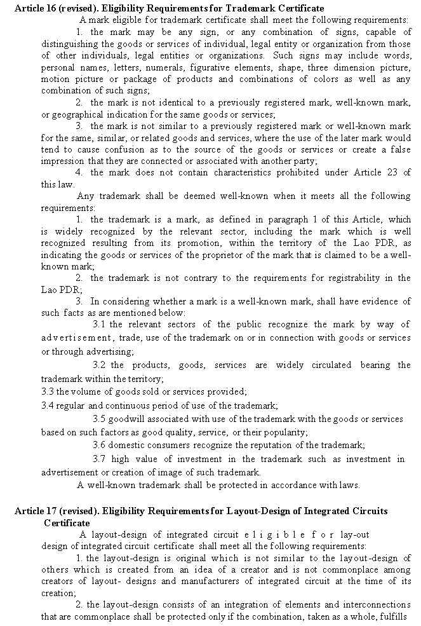

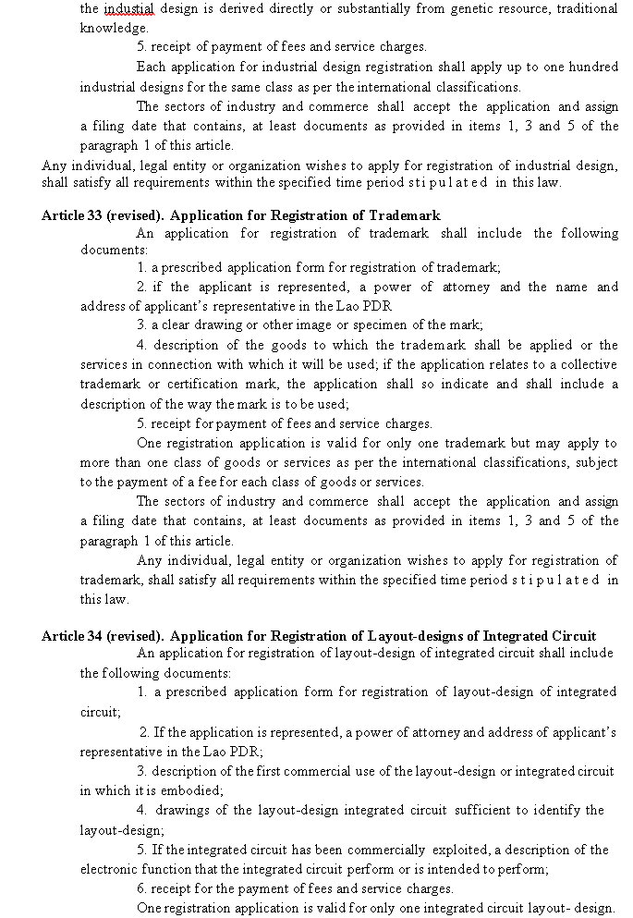

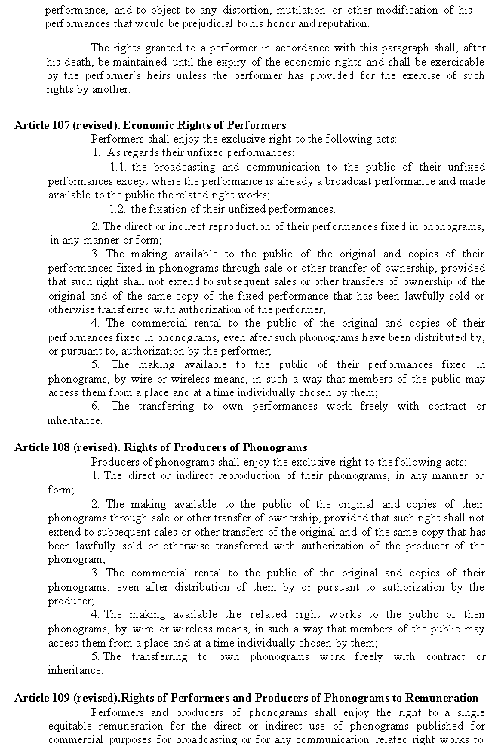

[End of Annex II and of document /

Fin de l’Annexe II et du document /

Ende der Anlage II und des Dokuments /

Fin del Anexo II y del documento]