|  |  |
| --- | --- |
|  | E |
| International Union for the Protection of New Varieties of Plants |  |

|  |  |
| --- | --- |
| Council  Fifty-Seventh Ordinary Session  Geneva, October 27, 2023 | C/57/2  Original: English  Date: August 14, 2023 |

UPOV Performance Report 2022

Document prepared by the Office of the Union

Disclaimer: this document does not represent UPOV policies or guidance

The UPOV Performance Report (UPR) 2022 has been prepared in accordance with Regulations 2.14 and 2.14*bis* of the Financial Regulations and Rules and reports performance against criteria established in the Program and Budget for the 2022-2023 Biennium (document C/55/4 Rev.).

The Council is invited to note the UPOV Performance Report 2022.

[UPOV Performance Report (UPR) 2022 follows]



UPOV Performance Report 2022

Contents

executive summary 3

Financial overview 3

Overall Policy on Plant Variety Protection (Sub-program UV.1) 4

Services to the Union for enhancing the Effectiveness of the UPOV System (Sub-program UV.2) 6

Assistance in the Introduction and Implementation of the UPOV System (Sub-program UV.3) 8

External Relations (Sub-program UV.4) 9

I. FINANCIAL AND RESULTS OVERVIEW 10

II. program performance 17

SUB-PROGRAM UV.1:    Overall Policy on Plant Variety Protection 17

SUB-PROGRAM UV.2:    Services to the Union for Enhancing the Effectiveness of the UPOV System 21

SUB-PROGRAM UV.3:    Assistance in the Introduction and Implementation of the UPOV System 24

SUB-PROGRAM UV.4:    External Relations 29

iii. annexes 32

ANNEX I Extrabudgetary Funds (Funds-in-Trust) 32

ANNEX II Working Capital Fund and Contributions 35

ANNEX III Status in relation to UPOV 39

ANNEX IV Members of the Union 41

ANNEX V List of Activities in 2022 42

iv. appendix 43

ACRONYMS AND ABBREVIATIONS 43

# executive summary

## Financial overview

The overall budgetary result for UPOV in 2022 amounted to a surplus of 0.2 million Swiss francs.

Overall income for 2022 was in line with the budget. Higher than budgeted income from new contributions from Ghana and Saint Vincent and the Grenadines (0.2 units each, respectively), UPOV PRISMA fees and distance learning courses was offset by lower than budgeted income from PLUTO fees and Funds-in-Trust related program support costs. As a result of an issue with the mechanism for raising invoices, the income from PLUTO did not reflect the number of fee-paying users in 2022. This issue will be rectified in 2023.

Income other than from contribution units of 6.2 per cent in 2022 is consistent with the target in the Strategic Business Plan (SBP) for the period 2023-2027 of reaching 10 per cent by 2027.

Figure 1. Income other than Contribution Units



To ensure a prudent implementation of the biennial program and budget, expenditure is contained in the first year of the biennium. In 2022, overall expenditure reached 47 per cent of the biennial budget 2022/23. Personnel costs represented 43 per cent of the biennial budget, which reflected one position being vacant for most of the year and a delay in the recruitment of a temporary staff until the second year of the biennium. These developments were offset by additional expenditure on contractual services. There was no expenditure on internships and fellowships because of the COVID-19 pandemic still restricting the mobility of potential fellows. Travel, training and grants related expenditure in 2022 represented only 10 per cent of the biennial budget following the adoption of the “new normal”, notably an increased use of virtual/hybrid meeting tools, resulting in reduced travel costs.

## Overall Policy on Plant Variety Protection (Sub-program UV.1)

### Growth of the UPOV system

The reports in 2022 revealed that 2021 was a record year for plant variety protection, with the following milestones surpassed for the first time:

* 25,000 applications (12 percent increase)
* 15,000 titles granted (9 percent increase)
* 150,000 titles in force (9 percent increase)

More than 56 per cent (187,190) of all titles granted under the UPOV system (331,078) are no longer in force which means that the varieties concerned are now available without any restrictions in the territories concerned.

Figure 2. Total applications filed, titles issued and titles in force



Figure 3 demonstrates that the recent increase in number of applications and titles granted resulted from strong growth in the Asian region, notably in China, which accounted for 42 per cent of all applications in UPOV members in 2021. Figures 4 and 5 also demonstrate that the growth in number of applications and titles granted has mainly resulted from increased numbers of applications by residents.

|  |  |
| --- | --- |
| Figure 3. Applications for Plant Breeders’ Rights – by region | |
| Figure 4. Applications for Plant Breeders’ Rights by Resident/Non‑Resident | Figure 5. Plant Breeders’ Rights Titles Granted by Resident/Non‑Resident |

Analysis by crop type[1] indicates that the proportion of applications and title grants for agricultural crops has increased substantially over the last 10 years, while that of ornamentals has experienced a significant decline. In 2012, almost half of all applications and titles granted were for ornamentals, whereas ornaments represented less than one-third in 2022:

|  |  |  |  |  |  |  |  |  |  |  |  |  |  |  |  |  |  |  |  |  |  |  |  |  |  |  |  |  |  |  |  |  |  |  |  |  |  |  |  |  |  |  |  |  |  |  |  |  |  |
| --- | --- | --- | --- | --- | --- | --- | --- | --- | --- | --- | --- | --- | --- | --- | --- | --- | --- | --- | --- | --- | --- | --- | --- | --- | --- | --- | --- | --- | --- | --- | --- | --- | --- | --- | --- | --- | --- | --- | --- | --- | --- | --- | --- | --- | --- | --- | --- | --- | --- |
| *Applications filed by crop type*   |  |  |  |  |  |  | | --- | --- | --- | --- | --- | --- | |  | Crop type | | | | | | Year | Agriculture | Forest trees | Fruit | Ornamental | Vegetables | | 2012 | 27% | 0.9% | 12% | 48% | 12% | | 2022 | 39% | 0.7% | 15% | 28% | 17% | | *Titles issued by crop type*   |  |  |  |  |  |  | | --- | --- | --- | --- | --- | --- | |  | Crop type | | | | | | Year | Agriculture | Forest trees | Fruit | Ornamental | Vegetables | | 2012 | 26% | 0.7% | 9% | 48% | 15% | | 2022 | 42% | 0.5% | 12% | 30% | 15% | |

### Strategic Business Plan

The growth in the UPOV system was an important consideration in the Strategic Business Plan (SBP) for the period 2023-2027, which was adopted by the Council in 2022.

The SBP Strategy House outlines UPOV’s Mission, Strategic Pillars and Foundation, providing a framework to respond to the need for an effective system of plant variety protection that will encourage the development of new varieties of plants, for the benefit of society.

The Strategy House is rooted in continuous improvement by building on UPOV’s strengths while charting a future course with a new focus on providing services to UPOV members and users of the UPOV system.

|  |
| --- |
|  |

### Work of UPOV Committees

A review was initiated in the Technical Committee to assess opportunities for the work of the Technical Committee and its Technical Working Parties (TWPs) to become more effective, particularly with a view to increasing cooperation as a fundamental benefit of UPOV membership. In particular, the Technical Committee further agreed that the TWPs should alternate one year of physical meeting with one year of virtual meeting; there would be at least two virtual TWP meetings in a calendar year, thereby ensuring that experts would be able to participate electronically in all discussions on Test Guidelines, TGP and TWP documents.

## Services to the Union for enhancing the Effectiveness of the UPOV System (Sub-program UV.2)

### UPOV e-PVP

##### The SBP explains that developments in IT, combined with the establishment of the post of UPOV IT Officer, have enabled UPOV to develop the UPOV e-PVP initiative, which presents an opportunity to provide services to members of the Union in a way which will improve the efficiency of the global UPOV system and achieve a “leveling-up” across UPOV. UPOV e-PVP will provide coherent and comprehensive assistance in the implementation of the UPOV system of plant variety protection, some or all of the components of which could be used by members of the Union, as considered appropriate. UPOV e-PVP comprises the following package of compatible tools:

1. Applying for PVP
   1. Extending coverage of UPOV PRISMA to more members of the Union and more crops/species
   2. Tool to provide information to PVP applicants on cooperation in DUS examination between members of the Union in a user-friendly form (DART – DUS Arrangement Tool)
2. PVP Office Administration
   1. Electronic PVP administration module for members of the Union to manage and publish PVP applications, including transmission of data to the PLUTO database
   2. UPOV similarity search tool for variety denomination purposes based on UPOV agreed algorithm running on data in the PLUTO database
3. Facilitating cooperation
   1. UPOV member cooperation platforms (e.g. e-PVP Asia) to cooperate in the administration and examination of applications
   2. Platform for exchange of existing DUS reports
   3. Platform for members of the Union to make their documented DUS procedures and information on their quality management systems available to other members of the Union
   4. Module for members of the Union to use the web-based TG Template and database of characteristics to develop individual authorities’ test guidelines (IATG) in their language
   5. Platform/portal for UPOV member databases containing variety description information (e.g. PLUTO database)

The Administrative and Legal Committee (CAJ) approved the proposal to expand the scope of the EAF meetings to cover the reporting of UPOV e-PVP developments and to change the name of the meetings to “Meeting on Electronic Applications”.

#### UPOV PRISMA

The number of applications made via UPOV PRISMA in 2022 was 1,907, compared to the 2021 figure of 2,508. This indicates underlying growth, once the 2021 figure is reduced by the one off peak of around 800 applications in June 2021, which was a result of a transition period in accordance with the withdrawal agreement of the United Kingdom from the European Union. Under this transition period, for a Community Plant Variety Rights application made by 31 December 2020, but not yet decided by the Community Plant Variety Office of the European Union (CPVO), applications for plant breeders' rights made in the United Kingdom within six months of 31 December, 2020, were given the same priority date as the Community Plant Variety Rights application.

Figure 6. Number of applications made via UPOV PRISMA



#### PLUTO database

The number of registered PLUTO users increased by 132 per cent from 1,314 in 2021 to 3,054 in 2022.

### Guidance and information materials

The UPOV Collection provides a set of guidance and information materials concerning plant variety protection under the UPOV Convention.

The set of Explanatory notes (EXN) and Information documents (INF) is now largely complete. In 2022, work was focused on three topics: the Consultative Committee established a working group on essentially derived varieties (CC/WG-EDV) to advance the revision of the Explanatory Notes on Essentially Derived Varieties; a working group on harvested material and unauthorized use of propagating material (WG-HRV) was established to consider possible revisions to relevant Explanatory Notes; and a working group was established to consider guidance concerning smallholder farmers in relation to private and non-commercial use (WG-SHF).

The review to assess opportunities for the work of the Technical Committee and its Technical Working Parties (TWPs) (see above) is intended to assess the needs of members of the Union and observers in relation to the technical guidance provided by UPOV and to consider whether those needs are being met by the TWPs in their current format. The survey is being undertaken in the context of how the work of the TWPs has evolved. For example, figures 7 and 8 demonstrate the progressive reduction in the number of new Test Guidelines and new TGP documents being developed. In particular, this review will take into account that the adoption of new Test Guidelines is unlikely to significantly increase the number of PVP applications covered by Test Guidelines and the increased focus on the revision of Test Guidelines will continue. Work on Test Guidelines is also now taking into account the benefits for UPOV PRISMA and applicants of the Test Guidelines being updated to reflect the needs of all UPOV members.

|  |  |
| --- | --- |
| Figure 7. Number of Test Guidelines discussed at TWPs | Figure 8. Number of TGP documents discussed at TWPs |
|  |  |

## Assistance in the Introduction and Implementation of the UPOV System (Sub-program UV.3)

### Enhanced awareness

UPOV achieved greater impact in the assistance provided in the legislative/UPOV membership processes by connecting with policy-makers with the agricultural development perspective. When Ghana, the most recent UPOV member, addressed the Council for the first time in 2022, it stated: “Ghana’s membership to UPOV is critical to its food and nutrition security as well as meeting its national development goals”.

There has been an increased engagement in activities with UPOV members and other training partners to explain the role of UPOV and plant variety protection in ensuring global food security and supply and protecting the environment. For instance, a new focus of the Train the Trainer program was implemented in 2022 to provide a forum for senior officials and prominent experts to exchange information and experiences in communicating the impact of plant variety protection under the UPOV Convention and its relationship to important policy areas (e.g. relationship of PVP and innovation in the agricultural sector, the synergies between plant breeding and conservation of genetic resources).

### Development of legislation

UPOV achieved greater impact in the assistance provided in the legislative/UPOV membership processes by increasing additional knowledge and resources through partnerships (e.g. Workshop for drafting legislation in accordance with the UPOV Convention and cooperation with UPOV members and WIPO).

In October 2022, the Council took a positive decision on the conformity of the “Draft Law on the Protection of Varieties of Plants of Armenia”.

## External Relations (Sub-program UV.4)

### Seminar

In October 2022, UPOV organized a seminar on the role of plant breeding and plant variety protection in enabling agriculture to mitigate and adapt to climate change[2]. Mr. Marien Valstar, President of the Council, concluded the following:

* Climate change is increasingly affecting everyone around the world: farmers, breeders and consumers. Effects are biotic (new pests and diseases) and abiotic (heat, drought, rain, seasonal changes).
* A range of strategies is needed to respond to the challenges. Plant breeding has a vital role to play in these strategies; farmers need new plant varieties to adapt to climate change but also to sustainably increase productivity in order to minimize climate change.
* Plant breeding is a long-term process that requires long-term investment from public institutions and from private companies. Plant breeders need a regulatory environment that promotes innovation and supports the conservation and utilization of genetic resources.
* The UPOV system enables plant breeders to provide farmers with the varieties they will need to feed the world in the face of climate change.

### Videos

UPOV also published the following videos to raise awareness of the role of plant variety protection[3]:

* How UPOV helps a family plant breeding business in the Netherlands to operate globally
* Netherlands Triple Helix - government, business and academia working together. Learn how this complements plant variety protection
* New varieties of common beans (Phaseolus Vulgaris) Impact achieved by EMBRAPA through Plant Variety Protection of New Varieties in Brazil
* New Varieties of trees and herbs with high quality developed in China (National Forestry and Grassland Administration (NFGA))
* Improved options for raspberry growers in Chile

### Social media

UPOV continued to post content on social media on a regular basis. There continued to be strong growth in the number of LinkedIn followers, while there was only very modest growth in the number of UPOV followers on Twitter. The number of visits to the UPOV website grew modestly (4 per cent), while the number of new visitors decreased by 6 per cent. A review of UPOV’s engagement on social media is being conducted to ensure that resources are deployed in a more effective way.

# I. FINANCIAL AND RESULTS OVERVIEW

**Key Financials**

The overall budgetary result for UPOV as well as the Reserve and Working Capital Funds (RWCF) as at the end of 2022 is shown in Table 1 below. Total income (before IPSAS adjustments) amounted to 3.8 million Swiss francs, and total expenditure amounted to 3.6 million Swiss francs, resulting in a budgetary surplus of 0.2 million Swiss francs for 2022.

At the end of 2022, the total RWCF amounted to 0.3 million Swiss francs, comprising 0.9 million Swiss francs in the Reserve Fund, 0.6 million Swiss francs in the Working Capital Fund and Actuarial losses through Net Assets of 1.1 million Swiss francs.

**Table 1. Key Financials 2022**

*(in thousands of Swiss francs)*

|  |  |  |  |
| --- | --- | --- | --- |
| **Key Financials** | **2022/23 Program & Budget** | **2022 Actuals** | **2022 Actuals compared to Program & Budget** |
|
|  |  |  |  |
| Income | 7,635 | 3,804 | 50% |
| Expenditure | 7,635 | 3,575 | 47% |
| **Budgetary Result** | **-** | **230** | **n/a** |
|  |  |  |  |
| IPSAS adj. to Reg. Budget Income |  | - |  |
| IPSAS adj. to Reg. Budget Expenditure |  | (132) |  |
|  |  |  |  |
| **Surplus / (Deficit)** |  | **97** |  |
|  |  |  |  |
|  |  |  |  |
| **Reserve and Working Capital Funds (RWCF)** |  |  |  |
| Reserve Fund |  | 890 |  |
| Working Capital Fund |  | 578 |  |
| Actuarial gains/(losses) through Net Assets |  | (1,137) |  |
| **Total RWCF at end of period** |  | **332** |  |

**Chart 1. Income, Expenditure and Budgetary Result in 2022**

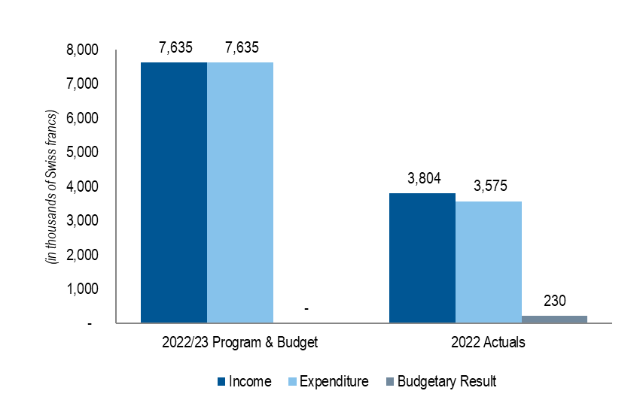

Note: Figures in tables throughout the document may not add up due to rounding.

**Income**

Actual income amounted to 3.8 million Swiss francs in 2022, in line with the budgeted figure (50 per cent of the biennial budget). See Table 2 below.

Higher than budgeted income from new contributions from Ghana and Saint Vincent and the Grenadines (0.2 units each, respectively), UPOV PRISMA fees and distance learning courses was offset by lower than budgeted income from PLUTO fees and Funds-in-Trust related program support costs. As a result of an issue with the mechanism for raising invoices, the income from PLUTO did not reflect the number of fee paying users in 2022. This issue will be rectified in 2023.

**Table 2. Income in 2022**

*(in thousands of Swiss francs)*

|  |  |  |  |
| --- | --- | --- | --- |
| **Income** | **2022/23**  **Estimates** | **2022**  **Actual** | **2022 Actuals compared to Estimates** |
| Contributions (unitary) | 7,129 | 3,570 | 50% |
| UPOV PRISMA Fees | 219 | 131 | 60% |
| PLUTO Fees | 113 | 12 | 11% |
| FITs Program support costs | 125 | 64 | 51% |
| Distance Learning course fees | 49 | 38 | 78% |
| Miscellaneous1 | - | (11) | n/a |
| **Total** | **7,635** | **3,804** | **50%** |
| *1Miscellaneous income mainly reflects unrealized forex gains/(losses) due to the revaluation process of the cash and other assets and liabilities accounts (currencies other than Swiss francs).* | | | |

**Chart 2. Income Share by Source in 2022**

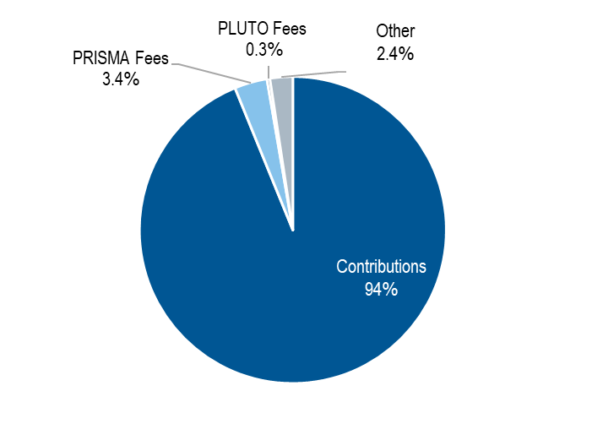

**Expenditure**

Actual expenditure amounted to 3.6 million Swiss francs in 2022 (47 per cent of the biennial budget). This is shown in Table 3 and by sub-programs in Table 4 and Table 5.

**Table 3. Budget vs. Expenditure by Cost Category in 2022**

*(in thousands of Swiss francs)*

|  |  |  |  |  |
| --- | --- | --- | --- | --- |
|  | **Cost Category** | **2022/23 Program & Budget** | **2022 Actuals** | **2022 Actuals compared to P&B** |
|  |
| **Personnel Resources** | |  |  |  |
|  | Posts | 4,792 | 2,131 | 44% |
|  | Temporary staff | 526 | 168 | 32% |
|  | Other Staff costs | - | - | - |
|  | **Total, Personnel Resources** | **5,319** | **2,300** | **43%** |
|  |  |  |  |  |
| **Non-Personnel Resources** | |  |  |  |
|  |  |  |  |  |
| ***Internships and Fellowships*** | |  |  |  |
|  | Internships | 5 | - | - |
|  | Fellowships | 65 | - | - |
|  | *Sub-total, Internships and Fellowships* | **70** | **-** | **-** |
| ***Travel, Training and Grants*** | |  |  |  |
|  | Staff Missions | 349 | 38 | 11% |
|  | Third Party Travel | 12 | - | - |
|  | *Sub-total, Travel* | **361** | **38** | **10%** |
| ***Contractual Services*** | |  |  |  |
|  | Conferences | 180 | 133 | 74% |
|  | Publishing | - | - | - |
|  | Individual Contractual Services | 5 | 33 | +100% |
|  | Other Contractual Services | 405 | 433 | +100% |
|  | *Sub-total, Contractual Services* | **590** | **599** | **+100%** |
| ***Operating Expenses*** | |  |  |  |
|  | *Sub-total, Operating Expenses* | **1,285** | **638** | **50%** |
| ***Equipment and Supplies*** | |  |  |  |
|  | Furniture and Equipment | 5 | - | - |
|  | Supplies and Materials | 5 | 0 | 5% |
|  | *Sub-total, Equipment and Supplies* | **10** | **0** | **3%** |
|  |  |  |  |  |
|  | **Total, Non-Personnel Resources** | **2,316** | **1,275** | **55%** |
|  |  |  |  |  |
|  | **TOTAL** | **7,635** | **3,575** | **47%** |
|  |  |  |  |  |
| *Note: 2022 Actuals for Supplies and Materials amount to 267 Swiss francs.* | | |  |  |

**Personnel Resources**

Personnel resources are budgeted using an actual-based costing methodology. Actual expenditure in 2022 was slightly lower than budgeted (43 per cent of the biennial budget). The expenditure on posts (44 per cent of the biennial budget) was lower than budgeted as a result of a position being vacant for most of the year.

The expenditure on temporary staff reached 32 per cent of the budget for the biennium resulting from a delay in the recruitment of a temporary staff until the second year of the biennium.

**Non-Personnel Resources**

There was no expenditure on internships and fellowships because of the COVID-19 pandemic still restricting mobility of potential fellows.

Travel, Training and Grants related expenditure in 2022 represented only 10 per cent of the biennial budget following the adoption of the “new normal”, notably an increased use of virtual/hybrid meeting tools.

Contractual services:

*Conferences:* Expenditure on conferences was higher than budgeted (74 per cent of the biennial budget) as a result of a higher than anticipated number of meetings with interpretation and higher expenditure on seminars.

*Publishing*: There was no expenditure related to publishing in 2022.

*Individual Contractual Services (ICS)*: An ICS provided guidance and support on the UPOV system, in particular on technical matters and UPOV services (partial replacement of a staff member on a professional post).

*Other Contractual Services (OCS)*: Expenditure on OCS was substantially higher than anticipated for the first year of the biennium (107 per cent per cent of the biennial budget) as a result of: (i) an agency worker providing administrative support (replacement of a staff member on a temporary position); (ii) an agency worker managing the UPOV PRISMA helpdesk (replacement of a staff member on a fixed term post); and (iii) the cost of servicing the virtual meeting platform for UPOV meetings.

Operating expenses in 2022 were in line with budgeted costs.

Equipment and supplies: Equipment and supplies related expenditure amounted to 267 Swiss francs in 2022.

**Table 4. Budget vs. Expenditure by Sub-Program in 2022**

*(in thousands of Swiss francs)*

|  |  |  |  |  |
| --- | --- | --- | --- | --- |
|  |  | **2022/23 Program & Budget** | **2022 Actuals** | **2022 Actuals compared to Program & Budget** |
|  |  |
|  |  |  |  |  |
|  |  |  |  |  |
|  | UV.1 Overall Policy on Plant Variety Protection | 816 | 394 | 48% |
|  | UV.2 Services to the Union for Enhancing the Effectiveness of the UPOV System | 4,486 | 2,126 | 47% |
|  | UV.3 Assistance in the Introduction and Implementation of the UPOV System | 1,672 | 685 | 41% |
|  | UV.4 External Relations | 660 | 369 | 56% |
|  |  |  |  |  |
|  | **TOTAL** | **7,635** | **3,575** | **47%** |

**Table 5. Expenditure Details by Sub-Program in 2022**

*(in thousands of Swiss francs)*

|  |  |  |  |  |  |  |
| --- | --- | --- | --- | --- | --- | --- |
|  | **Cost Category** | **Sub-programs** | | | |  |
|  | **UV.1** | **UV.2** | **UV.3** | **UV.4** | **Total** |
| **Personnel Resources** | |  |  |  |  |  |
|  | Posts | 352 | 956 | 586 | 238 | 2,131 |
|  | Temporary staff | - | 168 | - | - | 168 |
|  | Other Staff costs | - | - | - | - | - |
|  | **Total, Personnel Resources** | **352** | **1,124** | **586** | **238** | **2,300** |
|  |  |  |  |  |  |  |
| **Non-Personnel Resources** | |  |  |  |  |  |
|  |  |  |  |  |  |  |
| ***Internships and Fellowships*** | |  |  |  |  |  |
|  | Interns | **-** | - | - | - | - |
|  | Fellowships | **-** | - | - | - | - |
|  | *Sub-total, Internships and Fellowships* | **-** | **-** | **-** | **-** | **-** |
| ***Travel, Training and Grants*** | |  |  |  |  |  |
|  | Staff Missions | - | 4 | 6 | 28 | 38 |
|  | Third Party Travel | - | - | - | - | - |
|  | *Sub-total, Travel* | **-** | **4** | **6** | **28** | **38** |
| ***Contractual Services*** | |  |  |  |  |  |
|  | Conferences | 39 | 69 | - | 24 | 133 |
|  | Publishing | - | - | - | - | - |
|  | Individual Contractual Services | - | 30 | 3 | - | 33 |
|  | Other Contractual Services | 3 | 262 | 90 | 78 | 433 |
|  | *Sub-total, Contractual Services* | **43** | **360** | **93** | **103** | **599** |
| ***Operating Expenses*** | |  |  |  |  |  |
|  | *Sub-total, Operating Expenses* | **-** | **637** | **1** | **0** | **638** |
| ***Equipment and Supplies*** | |  |  |  |  |  |
|  | Furniture and Equipment | - | - | - | - | - |
|  | Supplies and Materials | 0 | - | 0 | - | 0 |
|  | *Sub-total, Equipment and Supplies* | **0** | **-** | **0** | **-** | **0** |
|  |  |  |  |  |  |  |
|  | **Total, Non-Personnel Resources** | **43** | **1,001** | **99** | **131** | **1,275** |
|  |  |  |  |  |  |  |
|  | **TOTAL** | **394** | **2,126** | **685** | **369** | **3,575** |
|  |  |  |  |  |  |  |
| *Note: Non-personnel expenditure on: (i) Operating Expenses under UV.4 amounted to 496 Swiss francs, and (ii) Supplies and Materials under UV.1 and UV.3 amounted to 161 Swiss francs, and 106 Swiss francs, respectively.* | | | | | | |

**Resources**

The number of posts by category is shown in Table 6 below. There were 12 occupied posts in 2022, and one professional post being vacant for most of the year. The post of the Secretary-General is included within the post count, but at no cost, because the current Director General of WIPO has declined any salary or allowance from his functions as Secretary-General of UPOV.

**Table 6. Budgeted and Actuals Posts in 2022**

|  |  |  |  |  |
| --- | --- | --- | --- | --- |
|  |  | **2022/23** | **2022** | **Difference** |
|  | **Post Category** | **Budgeted** | **Occupied** |
|  |  | **Posts** | **Posts** |
|  |  |  |  |  |
|  | Directors | 3 | 3 | - |
|  | Professionals | 6 | 5 | -1 |
|  | General Service | 4 | 4 | - |
|  |  |  |  |  |
|  | **TOTAL** | **13** | **12** | **-1** |

**Evolution of Income and Expenditure**

The overall evolution of actual income and expenditure (before IPSAS adjustments) for the period from 2012 to 2022 is shown below in Table 7.

**Table 7. Evolution of Actual Income and Expenditure during 2012-2022**

*(in thousands of Swiss francs)*

|  |  |  |  |  |  |  |  |  |  |  |  |  |
| --- | --- | --- | --- | --- | --- | --- | --- | --- | --- | --- | --- | --- |
|  | **Actuals** | | | | | | | | | | | |
|  | **2012** | **2013** | **2014** | **2015** | **2016** | **2017** | **2018** | **2019** | **2020** | **2021** | **2022** |
|  |  |  |  |  |  |  |  |  |  |  |  |
| Income | 3,388 | 3,403 | 3,384 | 3,409 | 3,431 | 3,420 | 3,422 | 3,509 | 3,598 | 3,806 | 3,804 |
| Expenditure | 2,954 | 3,331 | 3,275 | 3,517 | 3,239 | 3,586 | 3,355 | 3,500 | 3,267 | 3,804 | 3,575 |
| **Budgetary Result** | **434** | **72** | **109** | **(109)** | **192** | **(166)** | **67** | **9** | **332** | **2** | **230** |

**Chart 3. Evolution of Income and Expenditure 2012-2022**

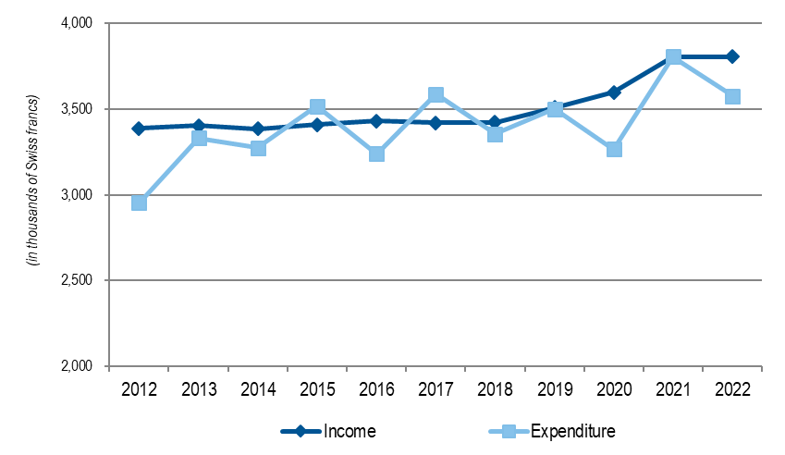

**Funds-in-Trust (extrabudgetary funds)**

The overall evolution of the actual income of the Funds-in-Trust for the period from 2012 to 2022 is shown below in Chart 4. It should be noted that the contribution for FIT Japan relating to 2021 was received in 2022.

**Chart 4. Evolution of Funds-in-Trust from 2012 to 2022**

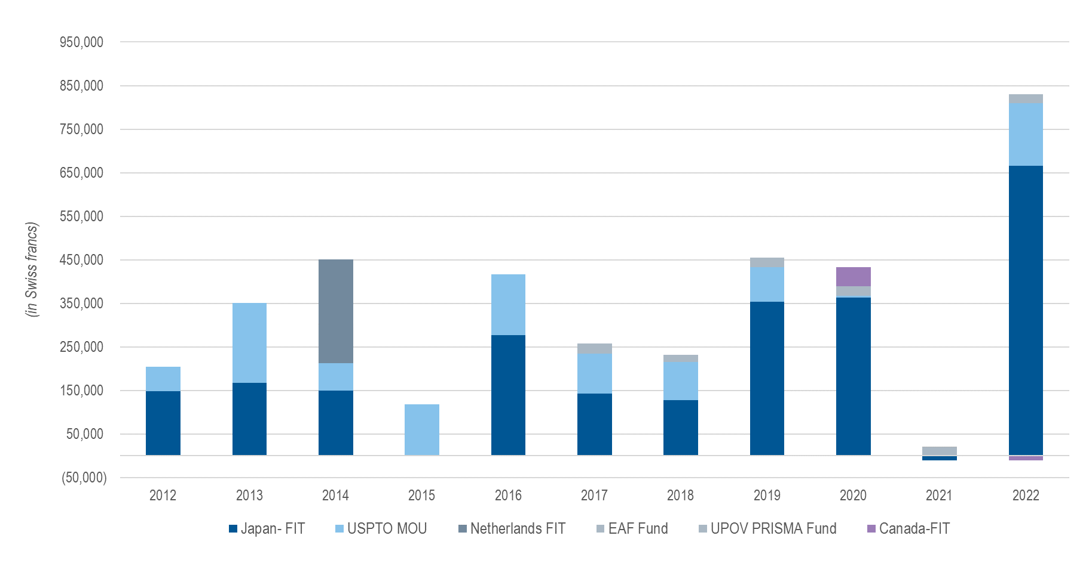

# II. program performance

## SUB-PROGRAM UV.1:    Overall Policy on Plant Variety Protection

### Objectives:

(a) Policy direction and executive management.

(b) Planning, implementation and evaluation of program and budget.

### Performance Data:

| **Expected Results** | **Performance Indicators** | **Performance Data**[4] |
| --- | --- | --- |
| 1. Governance by the UPOV Council and Consultative Committee, including monitoring of the work of UPOV Committees | (a) Approval and monitoring of the work programs of the CAJ, TC, TWPs and ad hoc working groups | Achieved – see document C/55/18 “Report”, paragraphs 45 to 50.  The Council noted that the Consultative Committee had decided to establish:  - a Working Group on guidance concerning smallholder farmers in relation to private and non-commercial use (WG-SHF) – see document C/55/18 “Report”, paragraph 19;  - a Consultative Committee Working Group on Essentially Derived Varieties (CC/WG-EDV) – see document C/56/15 “Report”, paragraph 33  - an Ad hoc Sub-Committee concerning the appointment of a new Vice Secretary-General – see document C/56/12 “Outcome of the consideration of documents by correspondence”, paragraph 15(c)(v)  The Council noted that the Administrative and Legal Committee had decided to establish:  - a Working Group on harvested material and unauthorized use of propagating material (WG-HRV) – see document CAJ/78/13 “Report”, paragraph 24.  The Council noted that the Technical Committee had decided to establish:  - a “Working Group on DUS support (WG-DUS)” – see document TC/58/31 “Report”, paragraph 64.  In accordance with the recommendation of the Consultative Committee, the Council agreed to organize a “Seminar to explore the role of plant breeding and plant variety protection in enabling agriculture to adapt to, and mitigate, climate change”, which was held on October 11, 12 and 26, 2022. |
| (b) Approval of Program and Budget | Draft Program and Budget for the 2024-2025 Biennium to be considered at the Council in October 2023 (see document C/57/4) |
| (c) Approval of the financial statements | Achieved – see document C/56/4 “Financial statements for 2021” |
| (d) Approval of the UPOV Performance Report (UPR) | Document C/56/2 “UPOV Performance Report 2020-2021” |
| 2. Examination of the conformity of laws, or draft laws, with the 1991 Act of the UPOV Convention | (a) Recommendations by the Consultative Committee | see (b) below |
| (b) Decisions by the Council | Based on the recommendation by the Consultative Committee, the Council took a positive decision on the conformity of the “Draft Law on the Protection of Varieties of Plants of Armenia”. |
| 3. Review of developments concerning applications and grants of plant breeders’ rights | (a) Number of applications | Number of applications for PBR:  Total: 25,135 (2021)   * Filed by residents: 18,910 (2021) * Filed by non-residents: 6,225 (2021) * Asia Pacific: 13,562 (2021) * European Union: 4,904 (2021) * Europe (excluding EU): 2,274 (2021) * North America: 2,268 (2021) * Latin America: 1,509 (2021) * Africa: 538 (2021) * Near/Middle East: 80 (2021)   see figures 3, 4 and 9 |
| (b) Number of titles granted | 2021: 15,081 titles granted  see figures 5 and 9 |
| (c) Number of titles in force | 2021: 141,888 titles in force  see figure 10 |
| (d) Number of genera/species protected by members of the Union | see figures 11 and 12 concerning the number of members protecting all genera and species and number of limited genera and species |
| (e) Number of genera/species for which varieties have been protected | 2021: 4,214  see figure 16 |
| (f) Analysis by crop type | see figure 13 |
| 4. Policies to diversify UPOV’s revenue portfolio | (a) Income from sources other than UPOV member contributions | The Strategic Business Plan (SBP) 2023-2027 was adopted in October 2022. The SBP specifies that sources of income other than contributions of members of the Union should be targeted to reach 10 per cent of UPOV’s income by 2027. A key basis for diversifying income is to generate income from services provided to users of the UPOV system while making services available to PVP offices without charge. Extrabudgetary funds, UPOV PRISMA and the PLUTO database are planned to be the principal sources of income other than from contributions of members of the Union. |

|  |  |
| --- | --- |
| Figure 9. Applications for Plant Breeders’ Rights and Titles Issued | Figure 10. Plant Breeders’ Rights Titles in Force |

Figure 11. Protection of plant genera and species in 2022

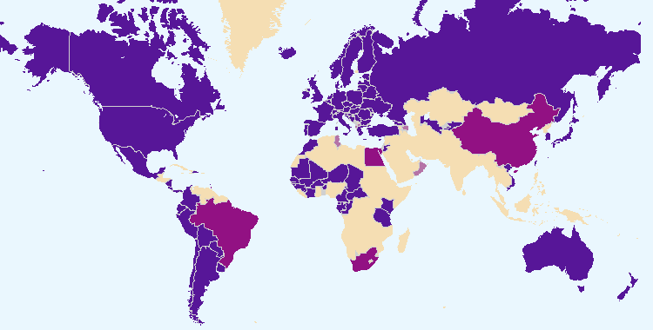

The boundaries shown on this map do not imply the expression of any opinion whatsoever on the part of UPOV concerning the legal status of any country or territory.

|  |  |  |
| --- | --- | --- |
|  |  | Members of the Union offering protection for all plant genera and species |
|  |  |  |
|  |  | Members of the Union offering protection for a limited number of plant genera and species |
|  |  |  |
|  |  | Members of the Union who had not notified the extension of protection to all genera and species |

Figure 12. Evolution of protection to plant genera and species



Figure 13. Data from PLUTO database

|  |  |  |  |  |  |  |  |  |  |  |  |  |  |  |  |  |  |  |  |  |  |  |  |  |  |  |  |  |  |  |  |  |  |  |  |  |  |  |  |  |  |  |  |  |  |  |  |  |  |  |  |  |  |  |  |  |  |  |  |  |  |  |  |  |  |  |  |  |  |  |  |  |  |  |  |  |  |  |  |  |  |  |  |  |  |  |  |  |  |  |  |  |  |  |  |  |  |  |  |  |  |  |  |  |  |  |  |  |  |  |  |  |  |  |  |  |  |  |  |  |  |  |  |  |  |  |  |  |  |  |  |  |  |  |  |  |  |  |  |  |  |  |  |  |  |  |  |  |  |  |  |  |  |  |  |  |  |
| --- | --- | --- | --- | --- | --- | --- | --- | --- | --- | --- | --- | --- | --- | --- | --- | --- | --- | --- | --- | --- | --- | --- | --- | --- | --- | --- | --- | --- | --- | --- | --- | --- | --- | --- | --- | --- | --- | --- | --- | --- | --- | --- | --- | --- | --- | --- | --- | --- | --- | --- | --- | --- | --- | --- | --- | --- | --- | --- | --- | --- | --- | --- | --- | --- | --- | --- | --- | --- | --- | --- | --- | --- | --- | --- | --- | --- | --- | --- | --- | --- | --- | --- | --- | --- | --- | --- | --- | --- | --- | --- | --- | --- | --- | --- | --- | --- | --- | --- | --- | --- | --- | --- | --- | --- | --- | --- | --- | --- | --- | --- | --- | --- | --- | --- | --- | --- | --- | --- | --- | --- | --- | --- | --- | --- | --- | --- | --- | --- | --- | --- | --- | --- | --- | --- | --- | --- | --- | --- | --- | --- | --- | --- | --- | --- | --- | --- | --- | --- | --- | --- | --- | --- | --- | --- | --- | --- | --- |
| *Applications filed by crop type:*   |  |  |  |  |  |  | | --- | --- | --- | --- | --- | --- | |  | Crop type | | | | | | Year | Agriculture | Forest trees | Fruit | Ornamental | Vegetables | | 2012 | 27% | 0.9% | 12% | 48% | 12% | | 2013 | 25% | 1.0% | 12% | 49% | 11% | | 2014 | 30% | 0.8% | 11% | 47% | 10% | | 2015 | 33% | 0.5% | 14% | 36% | 16% | | 2016 | 37% | 0.6% | 11% | 34% | 18% | | 2017 | 33% | 0.5% | 11% | 38% | 17% | | 2018 | 35% | 0.5% | 12% | 33% | 20% | | 2019 | 34% | 0.6% | 10% | 37% | 19% | | 2020 | 35% | 0.6% | 8% | 36% | 21% | | 2021 | 42% | 0.6% | 8% | 32% | 17% | | 2022 | 39% | 0.7% | 15% | 28% | 17% | | *Titles issued by crop type:*   |  |  |  |  |  |  | | --- | --- | --- | --- | --- | --- | |  | Crop type | | | | | | Year | Agriculture | Forest trees | Fruit | Ornamental | Vegetables | | 2012 | 26% | 0.7% | 9% | 48% | 15% | | 2013 | 34% | 0.7% | 10% | 42% | 13% | | 2014 | 35% | 0.6% | 10% | 43% | 12% | | 2015 | 32% | 0.9% | 10% | 44% | 13% | | 2016 | 32% | 1.1% | 9% | 40% | 18% | | 2017 | 27% | 0.4% | 12% | 45% | 16% | | 2018 | 27% | 0.5% | 11% | 43% | 18% | | 2019 | 34% | 0.4% | 9% | 38% | 18% | | 2020 | 38% | 0.5% | 7% | 34% | 21% | | 2021 | 46% | 0.5% | 7% | 27% | 18% | | 2022 | 42% | 0.5% | 12% | 30% | 15% | |

## SUB-PROGRAM UV.2:    Services to the Union for Enhancing the Effectiveness of the UPOV System

### Objectives:

(a) To maintain and improve the effectiveness of the UPOV system.

(b) To provide and develop the legal, administrative and technical basis for international cooperation in plant variety protection according to the UPOV Convention.

### Performance Data:

| **Expected Results** | | **Performance Indicators** | **Performance Data** |
| --- | --- | --- | --- |
| 5. Guidance on the UPOV Convention and its implementation and information on its application | | (a) Adoption of new or revised guidance and information materials concerning the UPOV Convention | | The Council adopted:   * Revisions to 2 adopted information documents:   UPOV/INF/16/10 Exchangeable Software (inclusion of the PATHOSTAT application)  UPOV/INF/22/8 Software and Equipment Used by Members of the Union   * Revision of 1 adopted Explanatory Notes document:   UPOV/EXN/DEN/2: Explanatory Notes on Variety Denominations under the UPOV Convention   * Revisions to 3 previously adopted TGP documents adopted and published on the UPOV website:   TGP/5: Section 6 Experience and Cooperation in DUS Testing, Section 6: UPOV Report on Technical Examination and UPOV Variety Description  TGP/8/4: Trial Design and Techniques Used in the Examination of Distinctness, Uniformity and Stability  TGP/12/2 Guidance on certain physiological characteristics |
| (b) Adoption of new or revised Test Guidelines | | Adoption of 1 new Test Guidelines; 7 full revisions of Test Guidelines; and 13 partial revisions of Test Guidelines |
| (c) Proportion of PBR applications covered by adopted Test Guidelines | | 94% based on entries in PLUTO Plant Variety Database  (368,148 out of 391,604) |
| (d) Number of Test Guidelines under development in the TWPs | | 5 new Test Guidelines; 30 full revisions of Test Guidelines; and 13 partial revisions of Test Guidelines |
| 6. Enhanced cooperation in DUS examination | | (a) Plant genera and species for which members of the Union have practical experience included in GENIE database | | 2022: 3,733 plant genera/species  see figure 16 |
| (b) Plant genera and species for which members of the Union cooperate in DUS examination included in GENIE database | | 2022: 1,799 plant genera/species  see figure 16 |
| (c) New initiatives to facilitate or enhance voluntary cooperation between members of the Union | | TC: interviews of members and observers on improving the technical support provided by UPOV for DUS examination and development of proposals to address issues raised regarding the organization of Technical Working Party meetings, development of Test Guidelines, training and exchange of DUS test reports  UPOV e-PVP: No initiatives in 2022 |
| 7. Enhanced cooperation in examination of variety denominations and novelty | | (a) Quantity and quality of data in PLUTO database: | |  |
| (i) number of contributors | | 2022: 45 contributors |
| (ii) number of new submissions | | 2022: 244 new submissions |
| (iii) number of records | | 2022: 1,016,419 records |
| (iv) number of mandatory items provided | | N/A |
| (v) number of non-mandatory items provided | | N/A |
| (b) Number of PLUTO users and frequency of use | | 2022: 3,054 users |
| (c) New initiatives to facilitate or enhance voluntary cooperation between members of the Union | | UPOV e-PVP included in Strategic Business Plan (SBP) for the period 2023-2027 |
| 8. Improved administration of PVP applications | | (a) Number of members of the Union participating in UPOV PRISMA | | 2022: 36 members, covering 75 States |
| (b) Number of crops/species covered by UPOV PRISMA | | UPOV members covering all genera and species in 2022 = 23  UPOV members covering selected crops/species in 2022 = 21 |
| (c) Number of applications made via UPOV PRISMA | | 2022: 1,170 applications for PBR, 737 applications for National Listing |
| (d) Number of registered UPOV PRISMA users | | 2022: 106 new registered users (58 agents and 48 breeder admins) |
| (e) Number of members of the Union receiving applications via UPOV PRISMA | | 2022: 22 members |
| (f) Use of electronic PVP administration module (e-PVP) by members of the Union to manage and publish PVP applications | | None in 2022 |

|  |  |
| --- | --- |
| Figure 14. Adoption of Test Guidelines | Figure 15. Plant Breeders’ Rights Entries in Plant Variety Database covered by Test Guidelines |

Figure 16. Plant Genera/Species with Cooperation Agreements, Practical Experience and   
Plant Breeders’ Rights Entries in Plant Variety Database



## SUB-PROGRAM UV.3:    Assistance in the Introduction and Implementation of the UPOV System

### Objectives:

(a) To raise awareness of the role of plant variety protection according to the UPOV Convention.

(b) To assist States and organizations, particularly governments of developing countries and countries in transition to a market economy, in the development of legislation in accordance with the 1991 Act of the UPOV Convention.

(c) To assist States and organizations in their accession to the 1991 Act of the UPOV Convention.

(d) To assist States and organizations in implementing an effective plant variety protection system in accordance with the UPOV Convention.

### Performance Data:

| **Expected Results** | **Performance Indicators** | **Performance Data** |
| --- | --- | --- |
| 9. Enhanced awareness of the role of plant variety protection in accordance with the UPOV Convention | (a) States and organizations that become members of the Union | None |
| (b) States that accede to or ratify the 1991 Act of the UPOV Convention | None |
| (c) States and organizations that initiate with the Council of UPOV the procedure for becoming members of the Union | Armenia  See figure 17 |
| (d) States and organizations that contact the Office of the Union for assistance in the development of legislation on plant variety protection | Members of the Union (2): Georgia, Mexico  Non-members of the Union (16): Antigua and Barbuda, Armenia, Barbados, Cambodia, Guatemala, Jamaica, Kazakhstan, Lao People’s Democratic Republic, Malawi, Malaysia, Mongolia, Namibia, Nigeria, Timor-Leste, Zambia and Zimbabwe  see figure 17 |
| (e) States and organizations provided with information at UPOV activities | see Annex V to this document |
| (f) Participation in distance learning courses | Members of the Union (54): African Intellectual Property Organization (OAPI), Argentina, Australia, Austria, Belarus, Belgium, Bolivia (Plurinational State of), Brazil, Bulgaria, Canada, Chile, China, Colombia, Croatia, Dominican Republic, Ecuador, Estonia, European Union, Finland, France, Georgia, Germany, Ghana, Greece, Hungary, Ireland, Italy, Japan, Kenya, Mexico, Morocco, Netherlands, New Zealand, Nicaragua, Oman, Peru, Poland, Portugal, Republic of Korea, Romania, Russian Federation, Singapore, Slovakia, South Africa, Spain, Sweden, Switzerland, Tunisia, Türkiye, Ukraine, United Kingdom, United Republic of Tanzania, United States of America, United Kingdom, Uruguay;  Non-members of the Union: (9): Indonesia, Iran (Islamic Republic of), Jamaica, Malaysia, Myanmar, Nigeria, Pakistan, Philippines, Senegal  There were also students from EPO and FAO.  See figures 23 and 24 |
| (g) Participation in UPOV training/assistance activities | see Annex V to this document |
| (h) Participation in training/assistance activities involving UPOV staff or UPOV trainers on behalf of UPOV staff | see Annex V to this document |
| (i) Academic institutions that include information on the UPOV system and which invite UPOV to contribute | see Annex V to this document |
| 10. Development of legislation on plant variety protection in accordance with the 1991 Act of the UPOV Convention | (a) States and organizations receiving a positive advice from the Council | Armenia  See figures 18 and 20 |
| (b) States and organizations provided with comments on laws | Members of the Union (2): Georgia and Mexico  Non-members of the Union (12): Antigua and Barbuda, Armenia, Barbados, Cambodia, Guatemala, Kazakhstan, Malawi, Malaysia, Mongolia, Nigeria (regulations), Timor-Leste and Zambia  see figures 18 and 19 |
| (c) Meetings with government officials to discuss legislative matters | Members of the Union (5): China, Georgia, Israel, Mexico and New Zealand  Non-members of the Union (14): Antigua and Barbuda, Armenia, Barbados, Brunei Darussalam, Cambodia, Guatemala, Jamaica, Kazakhstan, Lao People’s Democratic Republic, Malaysia, Nigeria, Timor-Leste, Zambia and Zimbabwe  see figure 18 and Annex V |
| 11. Implementation of plant variety protection system in accordance with the UPOV Convention | (a) Number of applications | Number of applications for PBR:  Total: 25,135 (2021)  • Filed by residents: 18,910 (2021)  • Filed by non-residents: 6,225 (2021)  - Asia Pacific: 13,562 (2021)  - European Union: 4,904 (2021)  - Europe (excluding EU): 2,274 (2021)  - North America: 2,268 (2021)  - Latin America: 1,509 (2021)  - Africa: 538 (2021)  - Near/Middle East: 80 (2021)  See 3 (a) |
| (b) Number of titles granted | 15,081 (2021)  See 3 (b) |
| (c) Number of titles in force | 141,888 (2021)  See 3 (c) |
| (d) Number of genera/species protected by members of the Union | See 3 (d) |
| (e) Number of genera/species for which varieties have been protected | 4,214 (2021)  See 3 (e) |
| (f) Development of an international curriculum leading to UPOV-recognized qualifications | Discussions in 2022 with training partners to implement the project agreed by the Consultative Committee for an “International Certificate on Plant Variety Protection recognized by UPOV” |

Figure 17. States and organizations that contacted the Office of the Union in 2022 for assistance in the development of legislation on plant variety protection and States and organizations that initiated with the Council of UPOV the procedure for becoming members of the Union

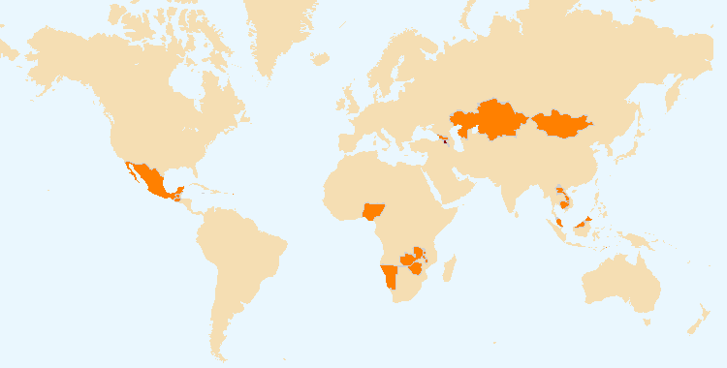

The boundaries shown on this map do not imply the expression of any opinion whatsoever on the part of UPOV concerning the legal status of any country or territory.

 States and organizations that initiated with the Council of UPOV the procedure for becoming members of the Union

 States and organizations that contacted the Office of the Union for assistance in the development of legislation on plant variety protection

Figure 18. Assistance provided in drafting legislation on plant variety protection in 2022

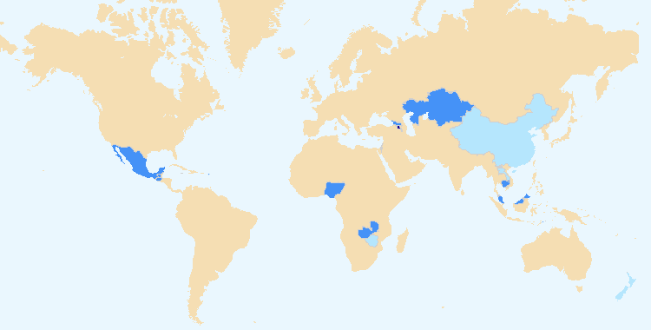

The boundaries shown on this map do not imply the expression of any opinion whatsoever on the part of UPOV concerning the legal status of any country or territory.

 States and organizations which received a positive advice from the Council of UPOV

 States and organizations provided with comments on laws

 Meetings with government officials to discuss legislative matters

|  |  |
| --- | --- |
| Figure 19. States/Organizations provided with  comments on laws | Figure 20. States/Organizations which received positive advice from the Council |

|  |  |
| --- | --- |
| Figure 21. Accession to/ratification of the 1991 Act | Figure 22. New members of the Union |

*Number of participants in main sessions* of UPOV distance learning courses in 2022 by category*

|  |  |  |  |  |  |
| --- | --- | --- | --- | --- | --- |
| **Category** | **Number of participants in 2022** | | | | |
| **DL-205** | **DL-305** | **DL-305A** | **DL-305B** | **Total** |
| Category 1: Government officials of members of the Union | 324 | 130 | 69 | 88 | 611 |
| Category 2: Officials of observer States / intergovernmental organizations | 18 | 4 | 5 | 3 | 30 |
| Category 3: Others (Fee: CHF1,000) | 25 | 5 | 0 | 1 | 31 |
| Category 4: Discretionary waiving of fee for selected students | 9 | 2 | 0 | 1 | 12 |
| Total: | 376 | 141 | 74 | 93 | 684 |

Figure 23. UPOV DL-205, DL-305, DL-305A and DL-305B Courses: 2022 participation

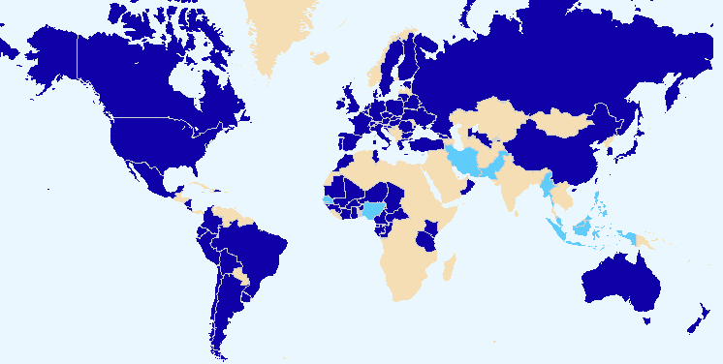

The boundaries shown on this map do not imply the expression of any opinion whatsoever on the part of UPOV concerning the legal status of any country or territory.

  Members of the Union   Non-members of the Union

Figure 24. Participants in all distance learning courses  
by language[5]



## SUB-PROGRAM UV.4:    External Relations

### Objectives

(a) To broaden and enhance the understanding of the UPOV system of plant variety protection.

(b) To provide information on the UPOV Convention to other intergovernmental organizations, with the aim of achieving mutual supportiveness with other international treaties.

### Performance Data:

| **Expected Results** | **Performance Indicators** | **Performance Data** |
| --- | --- | --- |
| 12. Broaden understanding of UPOV’s role and activities | (a) Number of new visitors to UPOV website | 2022: 118,316 unique users (-6.52%)  see figure 25 |
| (b) Number of visits to general public features on UPOV website | 2022: 876,805 visits (+3.75%)  see figure 26 |
| (c) Number of social media posts | 2022: UPOV Twitter 574 posts  UPOV LinkedIn 560 posts  VSG UPOV Twitter 28 posts[6] |
| (d) Number of followers on social media | @UPOVint on 31/12/2022: 2,255 followers  @vsgupov on 31/12/2022 722 followers  UPOV LinkedIn account: on 31/12/2022: 3,912 followers  Vice-Secretary General (Peter Button) LinkedIn account: on 05/12/2022: 1,059 followers[7]  See figures 28 and 29 |
|  | (e) Number of studies published on UPOV website | Two published studies:   * CPVO-EUIPO report: Impact of the Community Plant Variety Rights System and on the EU Economy and the Environment; * IP Australia Report: The economic impact of plant breeders' right in Australia |
|  | (f) Number of videos published on UPOV website | New videos published in 2022:   * NETHERLANDS: How UPOV helps a family plant breeding business in the Netherlands to operate globally * NETHERLANDS: Netherlands Triple Helix - government, business and academia working together. Learn how this complements plant variety protection * BRAZIL: New varieties of common BEANS (Phaseolus Vulgaris) Impact achieved by EMBRAPA through Plant Variety Protection of New Varieties in Brazil * CHINA: New Varieties of trees and herbs with high quality developed in China (National Forestry and Grassland Administration (NFGA)) * CHILE: Improved options for raspberry growers in Chile   Combined total views: 38,499 |
|  | (g) Number of visits to benefits page on UPOV website | 2022: 4,412 visits |
|  | (h) Number of relevant languages in which studies and videos are available | Videos on the Benefits page of the UPOV website:   * Diversity in tomato (*English, French, Spanish*) * (Netherlands) Triple Helix (*English*) * (China) New Varieties of trees and herbs with high quality developed in China (*English, Chinese*) * (Brazil) New varieties of Common Bean: Impact achieved by EMBRAPA through PVP of new varieties (*English, French, Spanish)* * (Netherlands) How UPOV helps a family plant breeding business in the Netherlands to operate globally (*English*) * (Chile) Improved options for raspberry growers in Chile (*English, Spanish)* * (Peru) The plant variety protection system: the benefits for the development of the rice sector in Peru *(English, Spanish)* * (Uruguay) How PVP enabled a public breeder to ensure a supply of high quality onion seed to farmers (*English, Spanish)* * (Ecuador) The role of PVP in the development of a new blackberry variety that improves farmers’ working conditions *(English, Spanish)* * (Argentina) Using the UPOV system to benefit custodians of native wild germplasm in Argentina (*English, Spanish)* * UPOV system bringing benefits for agriculture in Colombia (*English, French, Spanish)* * (China) Celebration of the twentieth anniversary of the accession of China to UPOV Convention *(English)* * (Japan) Ashiro Rindo (*English*) * Canadian cherry growers benefit from government policy (*English, French, Spanish)* * Rose industry blooming in Kenya (*English, French, Spanish)* * (Japan) Tsuyahime Rice *(English, French, Spanish, Chinese, Thai)*   Studies:   * UPOV Report on the Impact of Plant Variety Protection  (*English, French, German, Spanish*) * Socio-economic benefits of UPOV membership in Viet Nam: An ex-post assessment on plant breeding and agricultural productivity after 10 years (Corresponding author: Steffen Noleppa) by HFFA Research GmbH (*English and Vietnamese*) |
|  | (i) Participation at meetings of, and with, relevant stakeholders | see Annex V to this document |
|  | (j) Participation by stakeholders in events, seminars and symposia | see Annex V to this document |
|  | (k) Initiatives of the World Seed Partnership | Not applicable |

|  |  |
| --- | --- |
| Figure 25. Visits to the UPOV website*[8]* – Number of visitors | Figure 26. Website Overview for 2022: Where are the users going?[9] |

|  |  |
| --- | --- |
| Figure 27. @UPOVint and UPOV LinkedIn followers    Note: UPOV LinkedIn analytics tracked from May 17 2020, onwards. @UPOVint analytics tracked from March 4, 2019, onwards. | Figure 28. @vsgupov and Peter Button’s followers |

# iii. annexes

ANNEX I Extrabudgetary Funds (Funds-in-Trust)

The extrabudgetary funds (including Funds-in-Trust) received from donors are presented below.



**Income and expenditure by Fund for the year 2022**



*Note: Fund-in-Trust from the Government of Canada intended for implementing a technical assistance project in Senegal to improve the capacity of the Ministry of Agriculture and Rural Infrastructure in certain aspects of agriculture, including training and capacity building in order to implement UPOV and Plant Breeders’ Rights Intellectual Property regime.*



*Note: Fund-in-Trust from the Government of Japan intended for regional seminars and workshops on the protection of new plant varieties in the Asian region as well as the development of the EAPVP Pilot Project.*



*Note: Extrabudgetary fund from the Netherlands intended to provide and promote the UPOV system of plant variety protection.*



*Note: UPOV PRISMA is an on-line tool to assist in making plant variety protection (PVP) applications to PVP Offices of participating members of the Union.  The UPOV PRISMA Fund is a contribution made by Naktuinbouw (Netherlands) to support the development of UPOV PRISMA.*



*Note: Extrabudgetary fund from the Government of the United States of America, intended for education in intellectual property protection in the area of plant variety protection.*

[Annex II follows]

ANNEX II Working Capital Fund and Contributions

Working Capital Fund as at December 31, 2022

Under Regulation 4.2 of the Financial Regulations and Rules of UPOV (see document UPOV/INF/4/6), UPOV has a Working Capital Fund. According to the Statement of Financial Position as at December 31, 2022, the Working Capital Fund stands at 578,345 Swiss francs. The share of each member of the Union, calculated in accordance with the decision taken by the Council at its twenty-third extraordinary session, held in Geneva on April 7, 2006 (see document C(Extr.)/23/5 “Report”, paragraph 12, Annex II and document UPOV/INF/13/2, Annex), is as follows:



Contributions of Members of the Union



Contribution Payments Received in Advance



**Amounts of the Contributions Due and Unpaid Working Capital as at December 31, 2022**



[Annex III follows]

ANNEX III Status in relation to UPOV

The following table provides detailed information on the status in relation to UPOV.

**UPOV members**

African Intellectual Property Organization2, 4

Albania2

Argentina1

Australia2

Austria2

Azerbaijan2

Belarus2

Belgium2

Bolivia (Plurinational State of)1

Bosnia and Herzegovina2

Brazil1

Bulgaria2

Canada2

Chile1

China1

Colombia1

Costa Rica2

Croatia2

Czech Republic2

Denmark2

Dominican Republic2

Ecuador1

Egypt2

Estonia2

European Union2, 3

Finland2

France2

Georgia2

Germany2

Ghana2

Hungary2

Iceland2 Ireland2

Israel2

Italy1

Japan2

Jordan2

Kenya2

Kyrgyzstan2

Latvia2

Lithuania2

Mexico1

Montenegro2

Morocco2

Netherlands2

New Zealand1

Nicaragua1

North Macedonia2Norway1

Oman2

Panama2

Paraguay1

Peru2

Poland2

Portugal1

Republic of Korea2

Republic of Moldova2

Romania2

Russian Federation2

Saint Vincent and the Grenadines2

Serbia2

Singapore2

Slovakia2

Slovenia2

South Africa1Spain2

Sweden2

Switzerland2

Trinidad and Tobago1

Tunisia2

Türkiye2

Ukraine2

United Kingdom2

United Republic of Tanzania2

United States of America2

Uruguay1

Uzbekistan2

Viet Nam2

(Total 78)

1 1978 Act is the latest Act by which 17 States are bound.

2 1991 Act is the latest Act by which 59 States and 2 organizations are bound.

3 Operates a plant breeders’ rights system which covers the territory of its 27 member States *(Austria, Belgium, Bulgaria, Croatia, Cyprus, Czech Republic, Denmark, Estonia, Finland, France, Germany, Greece, Hungary, Ireland, Italy, Latvia, Lithuania, Luxembourg, Malta, Netherlands, Poland, Portugal, Romania, Slovakia, Slovenia, Spain, Sweden).*

4 Operates a plant breeders’ rights system which covers the territory of its 17 member States *(Benin, Burkina Faso, Cameroon, Central African Republic, Chad, Comoros, Congo, Côte d’Ivoire, Equatorial Guinea, Gabon, Guinea, Guinea Bissau, Mali, Mauritania, Niger, Senegal, Togo).*

**States and intergovernmental organizations which had initiated the procedure  
for acceding to the UPOV Convention**

Afghanistan, Armenia, Brunei Darussalam, Guatemala, Honduras, India, Iran (Islamic Republic of), Jamaica, Kazakhstan, Malaysia, Mauritius, Mongolia, Myanmar, Nigeria, Philippines, Tajikistan, United Arab Emirates, Venezuela (Bolivarian Republic of) and Zimbabwe, as well as the African Regional Intellectual Property Organization (ARIPO).

**States and intergovernmental organizations which had been in contact with the Office of the Union   
for assistance in the development of laws based on the UPOV Convention**

Algeria, Antigua and Barbuda, Bahrain, Barbados, Cambodia, Cuba, Cyprus, El Salvador, Indonesia, Iraq, Lao People’s Democratic Republic, Libya, Liechtenstein, Malawi, Mozambique, Namibia, Pakistan, Saudi Arabia, Sudan, Thailand, Tonga, Turkmenistan and Zambia, as well as the Southern African Development Community (SADC).

The following map provides a graphic overview of the status in relation to UPOV at the end of 2022.

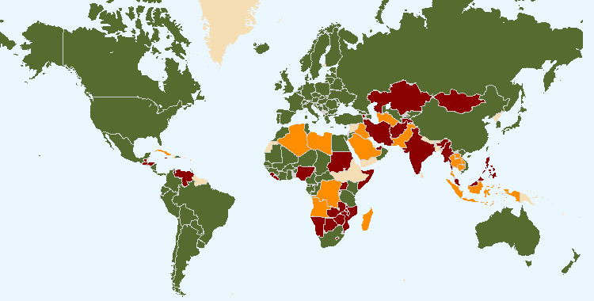

The boundaries shown on this map do not imply the expression of any opinion whatsoever on the part of UPOV concerning the legal status of any country or territory

 78 members of UPOV covering 97 States at the end of 2022

 19 States and 1 intergovernmental organization had initiated the procedure for acceding the UPOV Convention at the end of 2022

 23 States and 1 intergovernmental organization which had been in contact with the Office of the Union for assistance in the development of laws based on the UPOV Convention at the end of 2022

[Annex IV follows]

ANNEX IV Members of the Union

This Annex provides the status of the members of the Union in relation to the Convention and its various Acts, as of December 31, 2022 (see Articles 31 and 32 of the 1961 Convention, Article 32(1) of the 1978 Act and Article 34(2) of the 1991 Act).



<https://www.upov.int/edocs/mdocs/upov/en/c_57/c_57_2_annex_iv.pdf>

[Annex V follows]

ANNEX V List of Activities in 2022



<https://www.upov.int/edocs/mdocs/upov/en/c_57/c_57_2_annex_v.pdf>

[Appendix follows]

# iv. appendix

## ACRONYMS AND ABBREVIATIONS

**UPOV terms**

|  |  |
| --- | --- |
| BMT | Working Group on Biochemical and Molecular Techniques, and DNA-Profiling in Particular |
| CAJ | Administrative and Legal Committee |
| DL-205 | UPOV distance learning course “Introduction to the UPOV System of Plant Variety Protection under the UPOV Convention” |
| DL-305 | UPOV distance learning course “Examination of Applications for Plant Breeders’ Rights” |
| DL-305A | UPOV distance learning course “Administration of Plant Breeders’ Rights” (part A of DL‑305) |
| DL-305B | UPOV distance learning course “DUS Examination” (part B of DL-305) |
| DUS | Distinctness, Uniformity and Stability |
| EAF (see also UPOV PRISMA) | UPOV Electronic Application Form |
| EAM | Meeting on Electronic Applications |
| EDV | essentially derived variety |
| Office | Office of the Union |
| PBR | Plant Breeder’s Right |
| PLUTO | UPOV Plant Variety Database |
| TC | Technical Committee |
| TC‑EDC | Enlarged Editorial Committee |
| TWA | Technical Working Party for Agricultural Crops |
| TWC | Technical Working Party on Automation and Computer Programs |
| TWF | Technical Working Party for Fruit Crops |
| TWM | Technical Working Party on Testing Methods and Techniques |
| TWO | Technical Working Party for Ornamental Plants and Forest Trees |
| TWP(s) | Technical Working Party(ies) |
| TWV | Technical Working Party for Vegetables |
| UPOV e-PVP | UPOV e-PVP comprises a package of electronic tools for implementation of the UPOV system of plant variety protection by UPOV members. UPOV e-PVP includes UPOV PRISMA, UPOV e-PVP Administration Module, UPOV e-PVP DUS Report Exchange Module, and the PLUTO database. |
| UPOV PRISMA | UPOV PRISMA PBR Application Tool |
| WSP | World Seed Partnership |

**Acronyms (also included in Annex V)**

|  |  |
| --- | --- |
| 2050Today | A climate action initiative bringing together a community of international Geneva institutions |
| AFSTA | African Seed Trade Association |
| AIPH | International Association of Horticultural Producers |
| AIPPI | International Association for the Protection of Intellectual Property |
| AOHE | Association of European Horticultural Breeders |
| APBREBES | Association for Plant Breeding for the Benefit of Society |
| APSA | Asia and Pacific Seed Association |
| ARIPO | African Regional Intellectual Property Organization |
| ASEAN | Association of Southeast Asian Nations |
| BruIPO | Intellectual Property Office of Brunei Darussalam |
| CARDI | Cambodian Agricultural Research and Development Institute |
| CARICOM | Caribbean Community |
| CarIPI | CARIFORUM Intellectual Property Rights and Innovation |
| CATIE | Centro Agronómico Tropical de Investigación y Enseñanza (Tropical Agricultural Research and Teaching Center) |
| CBD | Convention on Biological Diversity |
| CFIA | Canadian Food Inspection Agency |
| CGIAR | Consultative Group on International Agricultural Research |
| CIOPORA | International Community of Breeders of Asexually Reproduced Ornamental and Fruit Varieties |
| CIPO (Saint Vincent and the Grenadines) | Commerce and Intellectual Property Office |
| CLI | CropLife International |
| CNIPA | China National Intellectual Property Administration |
| COPA/COGECA | Comité des organisations professionnelles agricoles/Confédération générale des coopératives agricoles (Committee of Professional Agricultural Organisations/General Confederation of Agricultural) |
| CORAF | Conseil Ouest et Centre Africain pour la Recherche et le Développement Agricoles |
| CPVO | Community Plant Variety Office of the European Union |
| EAPVP Forum | East Asia Plant Variety Protection Forum |
| EAPVP Pilot Project | East Asia Plant Variety Protection Pilot Project |
| EEAS | European External Action Service |
| EMBO | European Molecular Biology Organization |
| EPSO | European Plant Science Organisation |
| EUIPO | European Intellectual Property Office |
| FAO | Food and Agriculture Organization of the United Nations |
| GES | Geneva English School |
| GEVES (France) | Groupe d'Étude et de contrôle des Variétés Et des Semences |
| INASE (Argentina) | Instituto Nacional de Semillas (National Seed Institute of Argentina) |
| INDECOPI (Peru) | Instituto Nacional de Defensa de la Competencia y de la Protección de la Propiedad Intelectual (National Institute for the Defense of Competition and Protection of Intellectual Property of Peru) |
| INIA (Peru) | Instituto Nacional de Innovación Agraria (National Institute of Agrarian Innovation) |
| INIFAP (Mexico) | Instituto Nacional de Investigaciones Forestales, Agrícolas y Pecuarias (National Institute of Forestry, Agricultural and Livestock Research) |
| InnoVar | EU-funded project ‘Next generation variety testing for improved cropping on European farmland’ |
| INPA | Institut National de Recherche Agricole |
| INTA | Instituto Nicaragüense de Tecnología Agropecuaria (Nicaraguan Institute of Agricultural Technology) |
| IP Key LA | IP Key Latin America |
| IP Key SEA | IP Key South-East Asia |
| ISF | International Seed Federation |
| ISRA | Institut Sénégalais de Recherches Agricoles |
| ISTA | International Seed Testing Association |
| ITPGRFA | International Treaty on Plant Genetic Resources for Food and Agriculture |
| ITU | International Telecommunication Union |
| JIPO | Jamaica Intellectual Property Office |
| LESI-YMC | Licensing Executives Society International-Young Members Congress |
| MAPA (Spain) | Ministry of Agriculture, Fisheries and Food of Spain |
| Naktuinbouw | The Netherlands Inspection Service for Horticulture |
| NASC (Nigeria) | National Agricultural Seed Council of Nigeria |
| OAPI | African Intellectual Property Organization |
| OECD | Organisation for Economic Co-Operation and Development |
| OFINASE (Costa Rica) | Oficina Nacional de Semillas (National Seed Office) |
| OREVADO (Dominican Republic) | Office of Plant Variety Registration and Protection of Breeders' Rights of the Dominican Republic |
| PAIRED | Partnership for Agricultural Research, Education and Development |
| SAA | Seed Association of the Americas |
| SEMAE (France) | L'interprofession des semences et plants (French Interprofessional Organisation for Seeds and Plants) |
| SENADI (Ecuador) | Servicio Nacional de Derechos Intelectuales (National Service for Intellectual Rights of Ecuador) |
| SNICS (Mexico) | Servicio Nacional de Inspección y Certificación de Semillas (National Seed Inspection and Certification Service of Mexico) |
| SNL | Structure Nationale de Liaison |
| THASTA | Thai Seed Trade Association |
| UN | United Nations |
| UNIGE | University of Geneva |
| USDA | United States Department of Agriculture |
| USPTO | United States Patent and Trademark Office |
| WFO | World Farmers’ Organization |
| WIPO | World Intellectual Property Organization |
| WTO | World Trade Organization |

1. See Figure 13.
2. See <https://www.upov.int/meetings/en/details.jsp?meeting_id=71391>
3. See <https://www.upov.int/about/en/benefits_upov_system.html>.
4. Where data is provided over years, this is provided for the period 2012-2022 unless data is unavailable for all years.
5. Figures for 2021 revised.
6. Data for Peter Button’s account not available (similar to @vsgupov account)
7. Data for December 31. 2022 not available
8. Definitions used in Website statistics in this report:

   - “Users” are individuals who have had at least one session within the selected date range.

   - A “session” is a group of user interactions with your website that take place within a given time frame. For example a single session can contain multiple page views, events, social interactions, and ecommerce transactions. A single user can open multiple sessions. Those sessions can occur on the same day, or over several days, weeks, or months. As soon as one session ends, there is then an opportunity to start a new session. There are two methods by which a session ends:

   • Time-based expiration:

   * After 30 minutes of inactivity
   * At midnight

   • Campaign change:

   * If a user arrives via one campaign, leaves, and then comes back via a different campaign.

   - “Unique Pageviews” are the number of visits during which the specified page was viewed at least once.

   - “Pageviews” are the total number of times that a page was viewed. Repeated views of a single page by the same user during the same session are counted.

   - “Number of visits” is the number of devices used to visit the website in a month (a person may use more than one device).

   [End of appendix and of document]
9. PLUTO, UPOV PRISMA: The data corresponds to access to these databases via the website (and does not include access to the databases using direct links).