E
International Union for the Protection of New Varieties of Plants

Council  Fifty-Seventh Ordinary Session  Geneva, October 27, 2023 | C/57/16  Original: English  Date: October 27, 2023
Draft Press Release
Document prepared by the Office of the Union
Disclaimer: this document does not represent UPOV policies or guidance
The Annex to this document contains a draft press release on the fifty-seventh ordinary session of the Council.

The Council is invited to consider the draft press release, contained in the Annex to this document, subject to developments in the Council.

[Annex follows]

ANNEX

UPOV Press Release 140

Geneva, October 27, 2023

UPOV Council Holds its Annual Session

The Council of the International Union for the Protection of New Varieties of Plants (UPOV) held its fifty-seventh ordinary session on October 27, 2023, chaired by Mr. Yehan Cui (China). The report of the session is provided in document C/57/17 (see link).

It was the first Council with the new UPOV leadership team: Ms. Yolanda Huerta, from Spain, as the seventh Vice Secretary-General of UPOV, Mr. Martin Ekvad, from Sweden, who joins as Director of Legal Affairs and Mr. Leontino Taveira from Brazil who assumes the position of Director of Global Development and Technical Affairs.

Mr. Daren Tang, Secretary-General, provided opening remarks, a copy of which are reproduced in Appendix I.

Round-up of key developments:

Developments in UPOV

A presentation by the Vice Secretary-General on “Report on developments in UPOV”, made for the fifty-seventh ordinary session of the Council, is available at the C/57 webpage, in English.

UPOV PRISMA online application tool

UPOV PRISMA (see https://www.upov.int/upovprisma/en/index.html) is an on-line tool to assist in making plant variety protection (PVP) applications to PVP Offices of participating UPOV members, thereby helping to increase the introduction of new plant varieties to farmers in UPOV members. By the end of 2022, 36 members of the Union, covering 75 States, were participating in UPOV PRISMA and there has been strong growth in the use of UPOV PRISMA since its launch in 2017 (see figure below).

Number of applications using UPOV PRISMA (annual)
2022

UPOV e-PVP

UPOV e-PVP was launched on September 28, 2023. Viet Nam was the first UPOV member joining UPOV e--PVP by using the full package of components.

UPOV e-PVP provides the following components to assist UPOV members in implementing the UPOV system of plant variety protection:
    - UPOV PRISMA: online application tool for making applications to PVP Offices
    - UPOV e-PVP Administration Module: digitalized system for PVP offices to manage applications and grants, communicate with applicants and holders, publish information and transmit data to the PLUTO Database
    - UPOV e-PVP DUS Report Exchange Module: platform for PVP offices to exchange DUS reports
    - PLUTO database: information on plant varieties
UPOV e-PVP also provides the basis for platforms for UPOV member cooperation in the administration and examination of applications.
The Council welcomed the expressions of commitment from Ghana to join UPOV e-PVP and from Canada, Community Plant Variety Office (CPVO) of the European Union and Netherlands (Kingdom of the) to join the UPOV e-PVP DUS Report Exchange Module.

UPOV International PVP Certificate

The Council endorsed the implementation plan for the “UPOV International certificate on plant variety protection” (“UPOV PVP Certificate”).

The UPOV PVP Certificate would be awarded to learners that acquired the necessary number of credits from completing UPOV-endorsed training and/or activities on the UPOV Convention and guidance, operation of a PVP Office and the examination of applications, including DUS examination.

New videos published on UPOV website

The following videos were published on the UPOV website in 2023:

Netherlands (Kingdom of):  - Diversity in Tomato | Viet Nam:  - Farmer-Breeders in Viet Nam  - Development of the flower industry in Viet Nam  - Transformation of the seed sector in Viet Nam  - Role of PVP in supporting national agricultural policy in Viet Nam

Seminar proceedings

The English version of the proceedings of the Seminar on the role of plant breeding and plant variety protection in enabling agriculture to mitigate and adapt to climate change, held in 2022, is now available on the Seminar webpage. The French, German and Spanish versions will follow.

Observers in UPOV bodies

Observer status was granted to:

- Rwanda in the Council, Administrative and Legal Committee (CAJ), Technical Committee (TC) and Technical Working Parties (TWPs)
- Nigeria in the Technical Working Parties (TWPs)
- International Association for the Protection of Intellectual Property (AIPPI) in the Administrative and Legal Committee (CAJ)

FAQ on CBD, ITPGRFA and UPOV

The Council approved the following FAQ: “Complementarity between the UPOV Convention, the Convention on Biological Diversity (CBD) and the International Treaty on Plant Genetic Resources for Food and Agriculture (ITPGRFA)”, a copy of which is reproduced in Appendix II.

Adoption of documents

The Council adopted revised versions of the following documents:

UPOV/EXN/DEN Explanatory Notes on Variety Denominations under the UPOV Convention
UPOV/EXN/EDV Explanatory Notes on Essentially Derived Varieties under the 1991 Act of the UPOV Convention

TGP/7 Development of Test Guidelines
TGP/12 Guidance on Certain Physiological Characteristics
TGP/14 Glossary of Terms Used in UPOV Documents

UPOV/INF/16 Exchangeable Software
UPOV/INF/22 Software and Equipment Used by Members of the Union
UPOV/INF/23 UPOV Code System

All adopted documents will be published in the UPOV Collection (see http://www.upov.int/upov_collection/en/).

Award of medal

Mr. Peter Button was awarded a UPOV Gold Medal in recognition of his outstanding contribution as Vice Secretary-General of UPOV from December 1, 2010, to October 22, 2023.

Plant Variety Protection Statistics

The number of applications for plant variety protection increased from 25,133 in 2021 to 27,187 in 2022 (8.2 percent increase).

The number of titles issued decreased from 15,082 in 2021 to 14,860 in 2022 (1.5 percent decrease), resulting from a 1.0 percent decrease in the number of titles issued to residents (10,257 in 2022; 10,365 in 2021) and a 2.4 percent decrease in the number of titles issued to non-residents (4,603 in 2022; 4,717 in 2021).

The total of 161,232 titles in force at the end of 2022 represented a 4.6 percent increase on figures for 2021 (154,105).

The following graphs indicate trends in applications filed and titles issued since 1986. Information is also provided on the top 10 members of the Union receiving the largest number of applications in 2012, 2021 and 2022 and an analysis of applications by residence of breeders for the same years.

Total applications filed, titles issued and titles in force

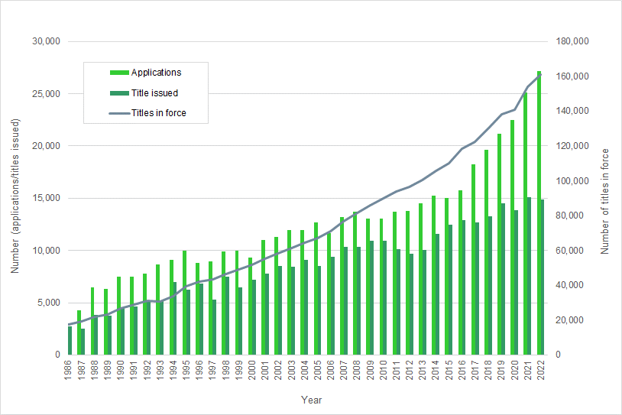

Applications filed by residents/non-residents

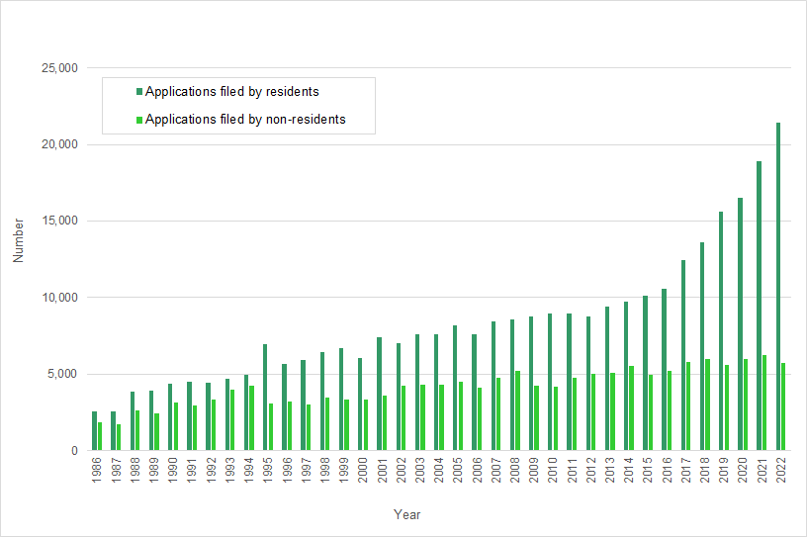

Titles issued to residents/non-residents

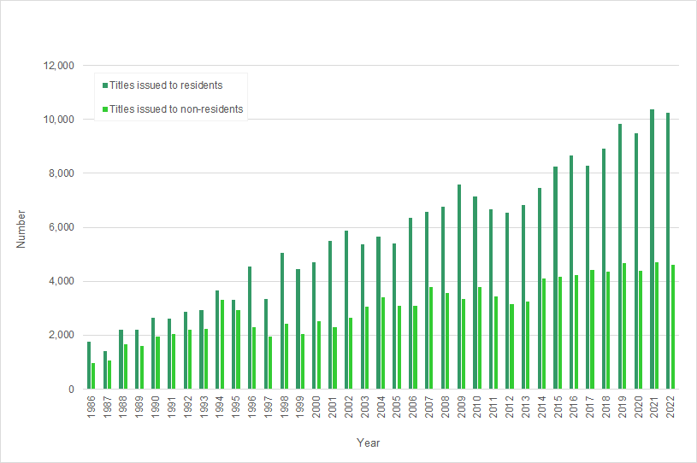

Titles in force / Number of UPOV members

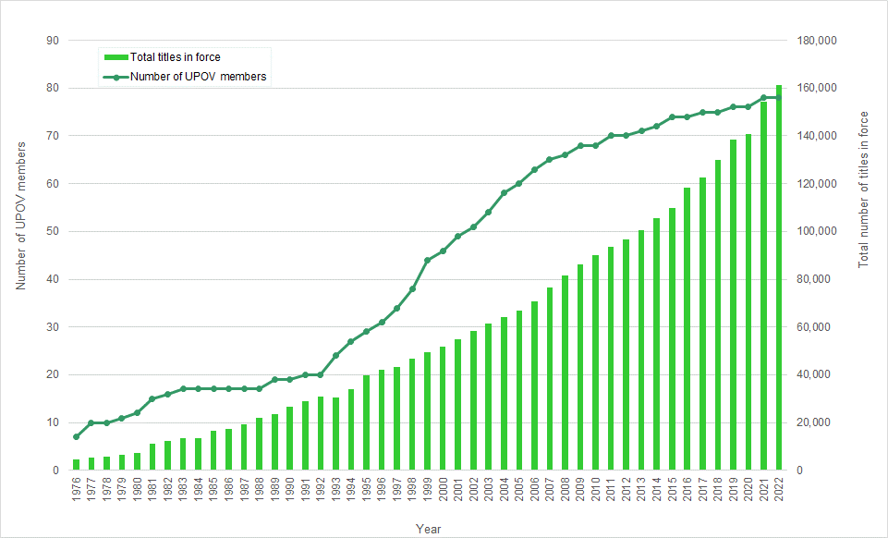

Applications received by region

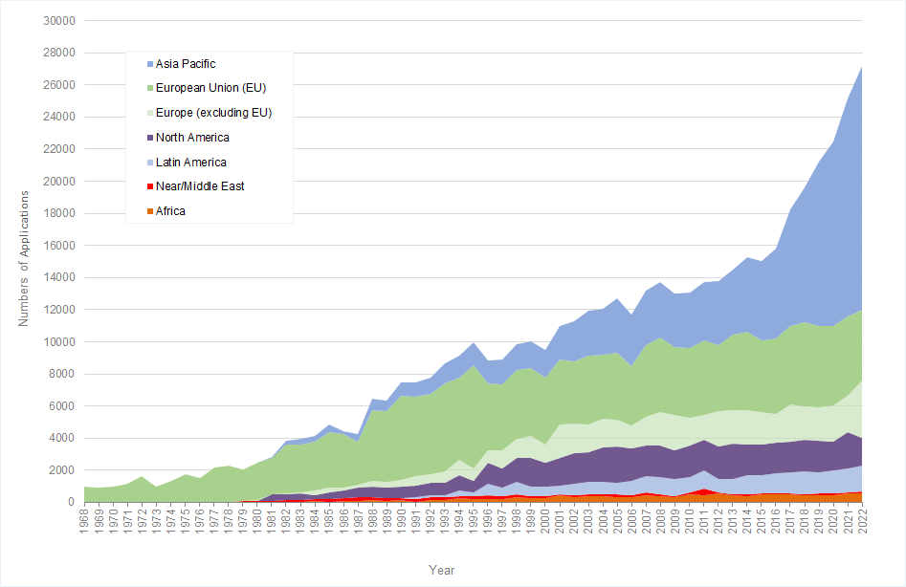

Top 10: UPOV members by number of plant variety protection applications received

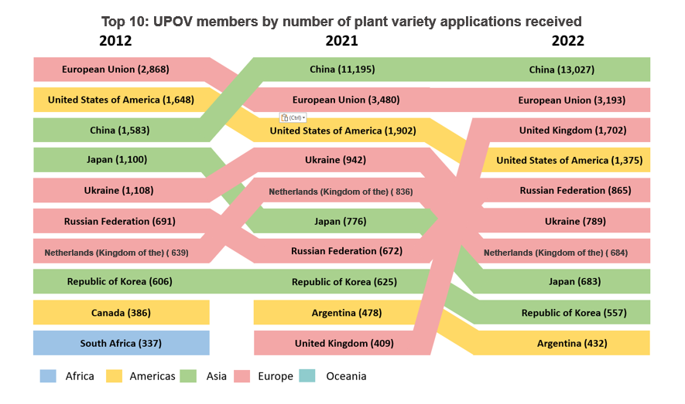

Top 10: UPOV members by number of plant variety protection titles issued

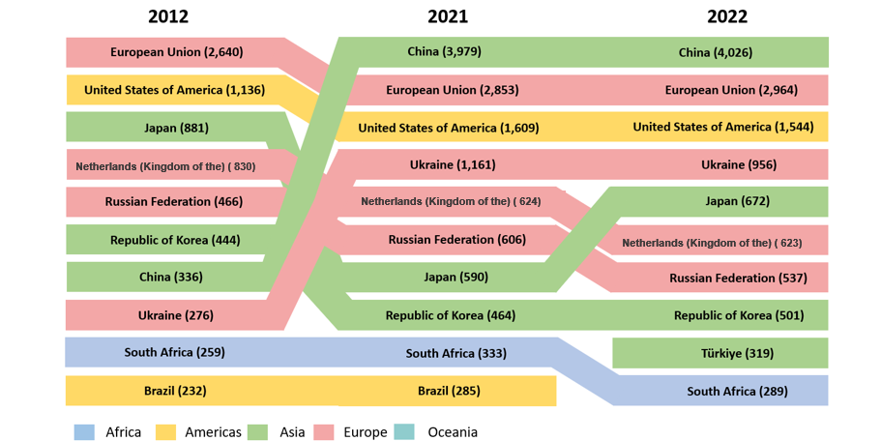

Top 10: Country of residence of applicants

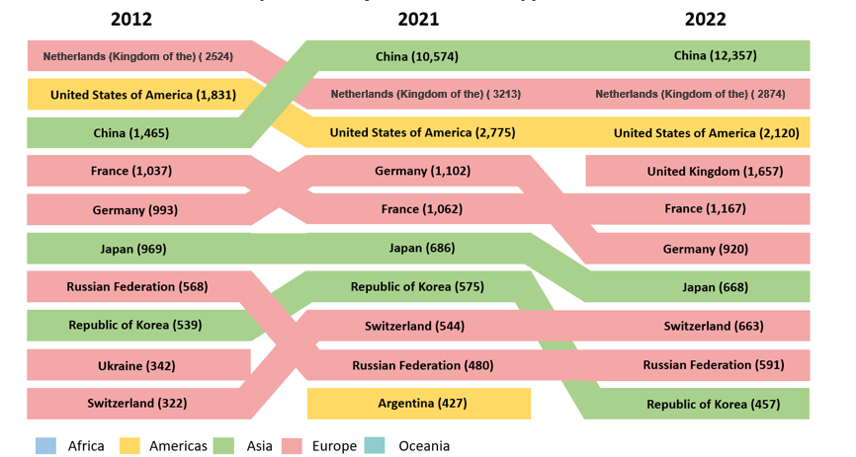

NOTES TO EDITORS

UPOV is an intergovernmental organization based in Geneva.

The purpose of UPOV is to provide and promote an effective system of plant variety protection, with the aim of encouraging the development of new varieties of plants, for the benefit of society.

UPOV has 78 members covering 97 States. The members of UPOV are:

African Intellectual Property Organization, Albania, Argentina, Australia, Austria, Azerbaijan, Belarus, Belgium, Bolivia (Plurinational State of), Bosnia and Herzegovina, Brazil, Bulgaria, Canada, Chile, China, Colombia, Costa Rica, Croatia, Czech Republic, Denmark, Dominican Republic, Ecuador, Egypt, Estonia, European Union, Finland, France, Georgia, Germany, Ghana, Hungary, Iceland, Ireland, Israel, Italy, Japan, Jordan, Kenya, Kyrgyzstan, Latvia, Lithuania, Mexico, Montenegro, Morocco, Netherlands (Kingdom of the), New Zealand, Nicaragua, North Macedonia, Norway, Oman, Panama, Paraguay, Peru, Poland, Portugal, Republic of Korea, Republic of Moldova, Romania, Russian Federation, Saint Vincent and the Grenadines, Serbia, Singapore, Slovakia, Slovenia, South Africa, Spain, Sweden, Switzerland, Trinidad and Tobago, Tunisia, Türkiye, Ukraine, United Kingdom, United Republic of Tanzania, United States of America, Uruguay, Uzbekistan and Viet Nam.

For further information about UPOV, please contact the UPOV Secretariat:

Tel: (+41-22) 338 9111 E-mail: upov.mail@upov.int

Website: https:www.upov.int

Social media

Twitter account: @UPOVint
LinkedIn account: https://www.linkedin.com/company/upov-official

[Appendices follow]

APPENDIX I

[TO BE INSERTED]

OPENING REMARKS OF MR. DAREN TANG, SECRETARY-GENERAL,
AT THE FIFTY-SEVENTH ORDINARY SESSION OF THE COUNCIL

[Appendix II follows]

APPENDIX II

FAQ on CBD, ITPGRFA and UPOV

Complementarity between the UPOV Convention, the Convention on Biological Diversity (CBD) and the International Treaty on Plant Genetic Resources for Food and Agriculture (ITPGRFA)

Aims and objectives

Biological diversity or ‘biodiversity’ is the term used to describe the variety of all living organisms and includes diversity within species, between species and of ecosystems. Biodiversity underpins all human activity, notably including agriculture and, therefore, food security.

The Convention on Biological Diversity (CBD) has three objectives: the conservation of biodiversity, the sustainable use of the components of biodiversity and the fair and equitable sharing of the benefits arising out of the utilization of genetic resources. A supplementary agreement to the CBD, the Nagoya Protocol on Access to Genetic Resources and the Fair and Equitable Sharing of Benefits Arising from the Utilization elaborates on the Convention’s provisions on access to genetic resources, traditional knowledge and benefit-sharing in order to contribute to the conservation and sustainable use of biodiversity.

The objectives of the International Treaty on Plant Genetic Resources for Food and Agriculture are the conservation and sustainable use of plant genetic resources for food and agriculture and the fair and equitable sharing of the benefits arising out of their use, in harmony with the Convention on Biological Diversity, for sustainable agriculture and food security. The International Treaty relates to plant genetic resources for food and agriculture.

The Treaty aims at: recognizing the enormous contributions of farmers to diversity of crops that feed the world; establishing a global system to provide farmers, plant breeders and scientists with access to plant genetic materials; ensuring that recipients share benefits they derive from the use of these genetic materials.

UPOV's mission is to provide and promote an effective system of plant variety protection, with the aim of encouraging the development of new varieties of plants, for the benefit of society.

Synergies between biodiversity, sustainable agriculture and plant breeding

Conservation of biodiversity depends on sustainable agriculture and a halt or reversal to the expansion of agricultural land, while there are parallel demands on agricultural land for food and energy production. This means that there is a need to produce more from existing agricultural land, in a sustainable way. Conversely, sustainable agriculture is dependent on the conservation and sustainable use of biodiversity, in particular by ensuring healthy soils and thriving populations of pollinators to achieve fertile crops, among other things.

By encouraging the development of new varieties of plants, the UPOV system encourages the sustainable use of biodiversity while creating new genetic diversity. New plant varieties with improved yield, more efficient use of nutrients, resistance to plant pests and diseases, salt and drought tolerance and better adaptation to climatic stress, according to the needs and preferences of farmers and consumers, can sustainably increase productivity and product quality in agriculture, horticulture and forestry. These attributes can reduce the pressure on the natural environment and biodiversity by reducing the need for inputs while reducing the area of land needed for agriculture. Plant breeding sustainably uses biological diversity and relies on the conservation of biodiversity to develop new varieties that deliver substantial benefits for farmers and society as a whole. The critical importance of biodiversity to agriculture is recognized in the CBD and the Nagoya Protocol acknowledges the importance of genetic resources for food and agriculture and their special role for food security. The recognition of the importance of crop and genetic diversity for sustainable agriculture and food security is central to the objectives of the ITPGRFA.

Benefits arising from the utilization of genetic resources

By encouraging plant breeding, the UPOV system incentivizes the generation of benefits arising out of the utilization of genetic resources. In addition, the “breeder’s exemption” in the UPOV Convention enables plant diversity in the form of protected plant varieties to be available for further breeding activities because acts done using such varieties for the purpose of breeding other varieties are not subject to any restriction by the breeder. This reflects the fact that access to protected varieties contributes to sustaining greatest progress in plant breeding and, thereby, to maximize the use of genetic resources for the benefit of society.

The CBD, Nagoya Protocol and ITPGRFA establish the requirements and mechanisms for the sharing of benefits arising out of the utilization of genetic resources. In relation to the breeder’s exemption, a recipient of material from the Multilateral System of the ITPGRFA who commercializes a product that is available without restriction to others for further research and breeding is not obliged but it is encouraged to contribute to the benefit sharing fund of the ITPGRFA.

Legislation in Contracting Parties

International cooperation, as well as coherence in the relevant legislative, administrative and policy measures concerning the CBD, ITPGRFA and the UPOV Convention, in the Contracting Parties concerned, is beneficial for achieving the desired outcomes of those treaties, notably in relation to sustainable agriculture and food security in the context of climate change and land degradation as well as the conservation of biodiversity, access to genetic resources and the sharing of benefits from their utilization.

[End of Appendix II and of document]

