|  |  |
| --- | --- |
|  | E |
| International Union for the Protection of New Varieties of Plants |  |

|  |  |
| --- | --- |
| Council  Fifty-Sixth Ordinary Session  Geneva, October 28, 2022 | C/56/15  Original: English  Date: October 28, 2022 |

Report

adopted by the Council

Disclaimer: this document does not represent UPOV policies or guidance

Opening of the session

The Council of the International Union for the Protection of New Varieties of Plants (UPOV) held its fifty‑sixth ordinary session in Geneva on October 28, 2022, chaired by Mr. Marien Valstar (the Netherlands), President of the Council.

The list of participants is reproduced in Annex I to this report.

The session was opened by the President who welcomed the participants.

The President reported that Ghana had deposited its instrument of accession to the 1991 Act of the UPOV Convention on November 3, 2021, and had become bound by the 1991 Act on December 3, 2021. Ghana became the 78th member of the Union on December 3, 2021.

The Council noted the intervention made by Ghana, a copy of which is reproduced in Annex III, Appendix III to this report.

Mr. Daren Tang, Secretary-General, welcomed the participants. A copy of the Secretary‑General’s remarks is reproduced in Annex III, Appendix I to this report.

On behalf of the Council, the President of the Council expressed his deepest condolences for the sad loss of Mr. René Royon, who passed away on June 26, 2022. He recalled the remarkable lifetime dedication of René to protect the rights of breeders, notably through the co-founding and leadership of the International Community of Breeders of Asexually Reproduced Horticultural Plants (CIOPORA). The President noted that René played an important role in the development of the UPOV Convention through his contributions to the 1961, 1972, 1978 and 1991 Diplomatic Conferences and made outstanding contributions to UPOV’s work in his different capacities, as CIOPORA’s Secretary-General, later as CIOPORA’s Board member, and indeed, well beyond his retirement in 2004, he continued to be engaged in UPOV’s activities and events.

The Delegation of the European Union, speaking on behalf of the European Union and its Member States, expressed solidarity with Ukraine and condemned the Russian aggression.

The Delegation of the Russian Federation observed that UPOV was not an appropriate place for political discussions and emphasized the need to respect the mandate of the Council.

The Delegation of Belarus expressed its view that UPOV was not an appropriate place for political discussions.

The Delegation of the United States of America expressed its solidarity with the people of Ukraine.

The Delegation of Japan expressed also its solidarity with the people of Ukraine.

Adoption of the agenda

The Council adopted the revised draft agenda, as presented in document C/56/1 Rev.

Report by the Vice Secretary-General on developments in UPOV

The Council noted that a video presentation in English, with subtitles in English, French, German and Spanish, had been made available on the C/56 webpage in advance of the Council session. A copy of the presentation was provided in document C/56/INF/2.

The Vice Secretary-General reported that Mr. Kees van Ettekoven, a national of the Netherlands, had started working for UPOV as Technical Expert in October 2022 and that Ms. Laurianne Nicolo had started working at UPOV under an agency contract in February 2022.

Examination of the conformity of the Draft Law on the Protection of Varieties of Plants of Armenia with the 1991 Act of the UPOV Convention

The Council considered document C/56/14.

The Council decided to:

(a) take note of the analysis in document C/56/14;

(b) take a positive decision on the conformity of the Draft Law of Armenia on the Protection of Varieties of Plants with the provisions of the 1991 Act of the International Convention for the Protection of New Varieties of Plants, which allows Armenia once the Draft Law is adopted with no changes and the Law is in force, to deposit its instrument of accession to the 1991 Act; and

(c) authorize the Secretary-General to inform the Government of Armenia of the above decision.

The Delegation of Armenia expressed its appreciation for the positive decision of the Council in respect of the examination of the Draft Law of Armenia on the Protection of Varieties of Plants for conformity with the 1991 Act of the UPOV Convention. It looked forward to working closely with UPOV for accession to the UPOV Convention and to cooperating with members of the Union.

Report by the President on the work of the ninety-seventh session of the Consultative Committee; adoption of recommendations, if any, prepared by that Committee

The Council considered document C/56/13.

The representative of the Association for Plant Breeding for the Benefit of Society (APBREBES) supported the continuation of the Working Group on Guidance concerning Smallholder Farmers in relation to private and non-commercial use (WG-SHF).  He considered that a revision of the FAQ on exceptions to the breeder’s right would not be sufficient to address the needs of smallholder farmers and that a revision of document UPOV/EXN/EXC was also necessary.

The representative of the International Seed Federation (ISF), speaking on behalf of CropLife International, Seed Association of the Americas (SAA), Asia and Pacific Seed Association (APSA), African Seed Trade Association (AFSTA) and Euroseeds, expressed its support for the work of the WG-SHF and expressed the commitment of the seed sector to meeting the needs of all farmers around the world.

The Delegation of Japan recalled that there were many ways for countries to support smallholder farmers beyond exceptions to the plant breeder’s right.

Based on the recommendation of the Consultative Committee, reported in document C/56/13, the Council agreed that provision be made for an exclusively physical meeting of the thirty-fifth extraordinary session of the UPOV Council, to be held on March 23, 2023.

The Council noted the work of the Consultative Committee at its ninety-ninth session, as reported in document C/56/13.

Adoption of documents

The Council considered document C/56/3, UPOV/INF/16/11 Draft 1, UPOV/INF/22/9 Draft 1, UPOV/INF‑EXN/16 Draft 1, C/56/9, UPOV/EXN/EDV/3 Draft 3, TGP/5 Section 6/4 Draft 1 and TGP/0/14 Draft 1.

*Information Materials*

*UPOV/INF/16: Exchangeable Software (Revision) (document UPOV/INF/16/11 Draft 1)*

The Council noted that the TC and the CAJ had approved the inclusion of the PATHOSTAT application in document UPOV/INF/16.

(d) DUS trial design and data analysis

|  |  |  |  |  |  |  |  |
| --- | --- | --- | --- | --- | --- | --- | --- |
| Date added | Program name | Programming language | Function (brief summary) | Source & contact details | Condition for supply | UPOV member(s) using the software | Application by user(s) |
|  | PATHOSTAT | Excel | Decision support tool to integrate statistics for the analysis of pest resistance test results for vegetable species | France: Ms. Sophie Perrot  e-mail: [sophie.perrot@geves.fr](mailto:sophie.perrot@geves.fr)  and [PATHOSTAT | (geves.fr)](https://www.geves.fr/tools/pathostat/) | Available as a web service / not for download | FR | Vegetable species |

The Council adopted a revision of document UPOV/INF/16/10 “Exchangeable Software”, on the basis of document UPOV/INF/16/11 Draft 1, with the inclusion of the PATHOSTAT application.

*UPOV/INF/22: Software and Equipment Used by Members of the Union (Revision) (document UPOV/INF/22/9 Draft 1)*

The Council adopted a revision of document UPOV/INF/22/8 “Software and equipment used by members of the Union”, on the basis of document UPOV/INF/22/9 Draft 1.

*UPOV/INF-EXN: List of UPOV/INF-EXN Documents and Latest Issue Dates (Revision) (document UPOV/INF-EXN/16 Draft 1)*

The Council adopted a revision of document UPOV/INF‑EXN/16 “List of INF-EXN Documents and Latest Issue Dates”, on the basis of document UPOV/INF-EXN/16 Draft 1.

*Explanatory Notes*

*UPOV/EXN/DEN: Explanatory Notes on Variety Denominations under the UPOV Convention (document C/56/3, Annex I)*

The Council adopted a revision of document UPOV/EXN/DEN/1 “Explanatory Notes on Variety Denominations under the UPOV Convention”, on the basis of the proposed amendments presented in Annex I to document C/56/3.

*UPOV/EXN/EDV: Explanatory Notes on Essentially Derived Varieties under the 1991 Act of the UPOV Convention (Revision) (documents C/56/9 and UPOV/EXN/EDV/3 Draft 3)*

The Council noted that document C/56/9 provides information to assist the Council in its consideration of the revision of document UPOV/EXN/EDV2 (UPOV/EXN/EDV/3 Draft 3).

*Explanatory Notes on Essentially Derived Varieties under the 1991 Act of the UPOV Convention (document C/56/9)*

The Council noted the developments concerning the consideration of document UPOV/EXN/EDV/3 Draft 3 by correspondence, reported in document C/56/9.

The Council noted that the Consultative Committee had agreed to establish the Consultative Committee Working Group on Essentially Derived Varieties (CC/WG-EDV) with the following terms of reference (ToR):

PURPOSE:

The purpose of the CC/WG-EDV is to draft a revision of the “Explanatory Notes on Essentially Derived Varieties under the 1991 Act of the UPOV Convention” for consideration by the Consultative Committee and the Council in October 2023.

COMPOSITION:

1. members of the Union that express an interest to be part of the CC/WG-EDV in reply to a Circular to be issued after the ninety-ninth session of the Consultative Committee;

(b) other members of the Union would be free to participate at any meeting of the CC/WG-EDV; and

(c) meetings to be chaired by the Vice Secretary-General.

MODUS OPERANDI:

1. The CC/WG-EDV to:
2. use document UPOV/EXN/EDV/3 Draft 3 as the basis for preparing an agreed draft revision of the “Explanatory Notes on Essentially Derived Varieties under the 1991  Act of the UPOV Convention”;
3. consider the concerns that have been raised (policy, legal or technical) with regard to document UPOV/EXN/EDV/3 Draft 3 (see document C/56/9) and, as appropriate, invite members, relevant stakeholders and/or experts to elaborate their perspectives on the matters raised; and
4. prepare an agreed draft revision of the “Explanatory Notes on Essentially Derived Varieties under the 1991 Act of the UPOV Convention”   
   (document UPOV/EXN/EDV/3 Draft 4) by July 31, 2023.

(b) the CC/WG-EDV to meet at a time and frequency to address its mandate, by physical and/or virtual means, as agreed by the CC/WG-EDV; and

(c) the documents of the CC/WG-EDV to be made available to members of the Union.

The Council noted that the Consultative Committee had agreed to consider at its one hundred and first session the outcome of the CC/WG-EDV and a recommendation to the Council, at its fifty-seventh ordinary session, on replacing or repealing the 2017 version of the “Explanatory Notes on Essentially Derived Varieties under the 1991 Act of the UPOV Convention”.

The Council noted that the Consultative Committee was committed to work expeditiously on a new explanatory note to be recommended to the Council.

The representative of CIOPORA, on behalf all the breeders’ organizations, expressed its disappointment concerning the decision not to adopt document UPOV/EXN/EDV/3 Draft 3 and considered that the decision would harm breeders. He requested that breeders’ organizations be part of the composition of the new working Group (CC/WG-EDV).

The President of the Council recalled that the terms of reference of the Working Group on Essentially Derived Varieties under section “MODUS OPERANDI”, paragraph (2)(ii) provided as follows:

“(ii) consider the concerns that have been raised (policy, legal or technical) with regard to document UPOV/EXN/EDV/3 Draft 3 (see document C/56/9) and, as appropriate, invite members, relevant stakeholders and/or experts to elaborate their perspectives on the matters raised; and”

The representative of the APBREBES expressed its support for the decision of the Consultative Committee regarding document UPOV/EXN/EDV/3 Draft 3. He suggested an expert examination on the compatibility between the wording of UPOV/EXN/EDV/3 Draft 3 and the text of the UPOV Convention and on the impact of innovation in plant breeding.

The President explained that the ToR of the CC/WG-EDV provided for the possibility to consult experts, if appropriate, and that the proposal for the “Seminar on the interaction between plant variety protection and the use of plant breeding technologies” was aimed at providing information on impact of plant variety protection matters.

In accordance with the recommendation of the Consultative Committee, the Council agreed to organize a “Seminar on the interaction between plant variety protection and the use of plant breeding technologies” in hybrid format, to be held on March 22, 2023.

*TGP Documents*

*Document TGP/5: Experience and Cooperation in DUS Testing, Section 6: UPOV Report on Technical Examination and UPOV Variety Description (Revision) (document TGP/5  Section 6/4 Draft 1)*

The Council adopted a revision of document TGP/5 “Experience and Cooperation in DUS Testing”, Section 6/3 “UPOV Report on Technical Examination and UPOV Variety Description”, on the basis of document TGP/5:  Section 6/4 Draft 1.

*Document TGP/8: Trial Design and Techniques Used in the Examination of Distinctness, Uniformity and Stability (Revision) (document C/56/3, Annex II)*

The Council adopted a revision of document TGP/8/4 “Trial Design and Techniques Used in the Examination of Distinctness, Uniformity and Stability”, as presented in Annex II to document C/56/3.

*Document TGP/12: Guidance on Certain Physiological Characteristics (Revision)   
(document C/56/3, Annex III)*

The Council adopted a revision of document TGP/12/2 “Guidance on certain physiological characteristics”, as presented in Annex III to document C/56/3.

*Document TGP/0: List of TGP documents and latest issue dates (Revision) (document TGP/0/14 Draft 1)*

The Council adopted a revision of document TGP/0 “List of TGP documents and latest issue dates”, on the basis of document TGP/0/14 Draft 1.

Financial statements for 2021

The Council approved the Financial Statements for 2021, as presented in document C/56/4.

Performance Report for 2020

The Council considered document C/56/2.

The Council noted the UPOV Performance Report 2020-2021.

Report of the External Auditor

The Council noted the information contained in the Report of the External Auditor, as presented in document C/56/5, in conjunction with an oral report made by Mr. Simon Irwin, National Audit Office, United Kingdom.

The Council expressed its gratitude to the National Audit Office of the United Kingdom for acting as External Auditor of the UPOV accounts.

Procedure for the appointment of the External Auditor (document C/56/12)

The Council considered document C/56/12.

The Council noted the developments with regard to the procedure for the appointment of the External Auditor of WIPO reported in document C/56/12.

In accordance with the recommendation of the Consultative Committee, the Council approved the following the procedure for the appointment of the External Auditor of UPOV for a term of office of six years starting from January 2024, to December 2029, as set out in paragraph 8 of document C/56/12:

Considering that from the five nominations received from WIPO member States, two of them are not from UPOV members, the following steps are approved:

* 1. the Office of the Union to start consultations with UPOV members that have, in the past, audited the UPOV accounts or are members of the UN Board of Auditors;
  2. if the General Assembly of WIPO, in 2023, appoints the Comptroller and Auditor General of a WIPO member State that
     1. is also a UPOV member, then the Council shall designate as External Auditor, with its agreement, the WIPO External Auditor;
     2. is not a UPOV member, then the Office of the Union would make a proposal to the Council, to appoint with its agreement, a UPOV member that has, in the past, audited the UPOV accounts or is a member of the UN Board of Auditors.

Arrears in contributions as of September 30, 2022

The Council considered document C/56/6.

The Council noted the status of payment of contributions as of September 30, 2022, and noted that due to a recent payment, Belgium had no arrears.

Strategic Business Plan 2023-2027 (document C/56/10)

The Council considered document C/56/10.

The Council adopted the Strategic Business Plan 2023-2027, as presented in the Annex to document C/56/10.

Program of meetings

## *Approval of work programs for the Administrative and Legal Committee, the Technical Committee and the Technical Working Parties*

The Council considered document C/56/7 and received an oral presentation by the Chair of the CAJ, on the work of the seventy-ninth session of the CAJ, based on document CAJ/79/11 “Report”.

The Council approved the work program for the eightieth session of the CAJ, as presented in the report of the seventy-ninth session of the CAJ (see document CAJ/79/11 “Report”, paragraph 57).

The Council noted the work of the Technical Committee (TC) and of the Technical Working Parties (TWPs), and the oral presentation made by the Chair of the TC on the work of the fifty‑eighth session of the TC, based on document TC/58/31 “Report”.

The Council approved the work of the TC and the work programs of the TWPs and BMT reported to the Council, as provided in document TC/58/31 “Report”.

## *Calendar of meetings in 2023*

The Council considered document C/56/8 and the recommendation by the Consultative Committee at its ninety-ninth session, as reported in document C/56/13.

The Council approved the calendar of meetings in 2023, and the tentative dates for meetings in 2024 and 2025, as set out in document C/56/8, with the following changes:

MARCH 2023

Wednesday, 15 EAF/21 (virtual meeting)

~~Wednesday, 15~~ Tuesday, 21 WG-HRV/3 (~~virtual~~ hybrid meeting)

Tuesday, 21 and Wednesday, 22 TC-EDC (virtual meeting)

Wednesday, 22 Seminar on the interaction between plant variety protection and the use of plant breeding technologies (hybrid meeting)

Thursday, 23 (morning) CC/100

Thursday, 23 (afternoon) C(Extr.)/35 (extraordinary session) (physical participation only)

~~Thursday, 16~~ Friday, 24 WG-SHF/3 (~~virtual~~ hybrid meeting)

The Council noted that the composition of the CC/WG-EDV, and the dates for its meetings would be addressed in a procedure by correspondence in accordance with the ToRs of the CC/WG-EDV.

The Council noted that the Geneva time of virtual and hybrid meetings would be included in the calendar of meetings.

The Council noted that, in view of the agreed changes, new dates for the TC-EDC in March would be announced by correspondence to the TC-EDC.

Election of new Chairpersons

The Council elected, in each case for a term of three years ending with the fifty-ninth ordinary session of the Council, in 2025:

(a) Mr. Yehan Cui (China), President of the Council;

(b) Mr. Anthony Parker (Canada), Vice-President of the Council;

(c) Ms. María Laura Villamayor (Argentina), Chair of the Administrative and Legal Committee;

(d) Ms. Minori Hagiwara (Japan), Vice-Chair of the Administrative and Legal Committee;

(e) Ms. Beate Rücker (Germany), Chair of the Technical Committee; and

(f) Ms. Nuria Urquía Fernández (Spain), Vice-Chair of the Technical Committee.

The Council expressed its appreciation to the outgoing President of the Council, Mr. Marien Valstar (Netherlands), to Mr. Patrick Ngwediagi (United Republic of Tanzania), outgoing Chair of the Administrative and Legal Committee, and to Mr. Nik Hulse (Australia), outgoing Chair of the Technical Committee, for the work carried out during their terms.

Matters for information:

The Council noted the following documents under item 15 “Matters for information”, which had been posted for information on the C/56 webpage:

1. Report on activities during the first nine months of 2022 (document C/56/INF/3)
2. Situation in the legislative, administrative and technical fields:
3. Reports by representatives of members and observers (document C/56/INF/4)
4. Cooperation in examination (document C/56/INF/5); List of the taxa protected by the members of the Union (document C/56/INF/6); Plant variety protection statistics for the period 2016-2020 (document C/56/INF/7)

The Council noted the oral presentation made by the Office of the Union concerning information contained in documents C/56/INF/5 “Cooperation in examination” and C/56/INF/6 “List of Taxa protected and PVP statistics” (see Annex II).

Press release

The Council considered the draft press release, as contained in document C/56/11.

The Council approved the draft press release, as reproduced in Annex III to this report.

UPOV Medal

In recognition of his contribution as Chair of the Consultative Committee and President of the Council of UPOV, the Secretary-General awarded a UPOV Gold Medal to Mr. Marien Valstar (Netherlands).

This report was adopted by the Council at the close of its session, on October 28, 2022.

[Annexes follow]

LISTE DES PARTICIPANTS / LIST OF PARTICIPANTS /   
TEILNEHMERLISTE / LISTA DE PARTICIPANTES

(dans l’ordre alphabétique des noms français des membres /  
in the alphabetical order of the French names of the Members /  
in alphabetischer Reihenfolge der französischen Namen der Mitglieder /  
por orden alfabético de los nombres en francés de los miembros)

I. MEMBRES / MEMBERS / VERBANDSMITGLIEDER / MIEMBROS

AFRIQUE DU SUD / SOUTH AFRICA / SÜDAFRIKA / SUDÁFRICA

Noluthando NETNOU-NKOANA (Ms.), Director, Genetic Resources, Department of Agriculture, Rural development and Land Reform, Pretoria   
(e-mail: noluthandon@daff.gov.za)

ALLEMAGNE / GERMANY / DEUTSCHLAND / ALEMANIA

Elmar PFÜLB (Mr.), President, Federal Plant Variety Office, Bundessortenamt, Hannover   
(e-mail: postfach.praesident@bundessortenamt.de)

ARGENTINE / ARGENTINA / ARGENTINIEN / ARGENTINA

María Laura VILLAMAYOR (Sra.), Coordinadora de Relaciones Institucionales, Instituto Nacional de Semillas (INASE), Secretaría de Agricultura, Ganadería, Pesca y Alimentación, Buenos Aires   
(e-mail: mlvillamayor@inase.gob.ar)

Betina FABBIETTI (Sra.), Segunda Secretaria, Misión Permanente de la República Argentina ante la Oficina de las Naciones Unidas en Ginebra, Ginebra  
(e-mail: betina.fabbietti@missionarg.ch)

AUSTRALIE / AUSTRALIA / AUSTRALIEN / AUSTRALIA

Edwina VANDINE (Ms.), Chief of Plant Breeders' Rights, Plant Breeder's Rights Office, IP Australia, Woden   
(e-mail: edwina.vandine@ipaustralia.gov.au)

Nik HULSE (Mr.), Director, Policy and International Affairs, Policy and Stakeholders Group, IP Australia, Woden   
(e-mail: nik.hulse@ipaustralia.gov.au)

Isabel Louise WARD (Ms.), Assistant Director, Plant Breeder's Rights, IP Australia, Woden  
(e-mail: Isabel.Ward@ipaustralia.gov.au)

AUTRICHE / AUSTRIA / ÖSTERREICH / AUSTRIA

Maximilian POCK (Mr.), Policy Officer - Plant Health, Seed and Varieties, Abteilung II/5, Pflanzliche Produkte, Bundesministerium für Landwirtschaft, Regionen und Tourismus, Vienna   
(e-mail: maximilian.pock@bmlrt.gv.at)

Birgit GULZ-KUSCHER (Ms.), Legal Advisor for Seed Law and Plant Variety Protection Law, Federal, Federal Ministry for Agriculture, Forestry, Regions and Water Management, Vienna   
(e-mail: birgit.gulz-kuscher@bml.gv.at)

BÉLARUS / BELARUS / BELARUS / BELARÚS

Tatsiana SIAMASHKA (Ms.), Deputy Director, State Inspection for Testing and Protection of Plant Varieties, Minsk   
(e-mail: belsort@mail.ru)

Maryna SALADUKHA (Ms.), Deputy Head, International Cooperation Department, State Inspection for Testing and Protection of Plant Varieties, Minsk   
(e-mail: belsort@mail.ru)

BELGIQUE / BELGIUM / BELGIEN / BÉLGICA

Shannah BOENS (Ms.), Attaché, FOD Economie, KMO, Middenstand en Energie, Algemene Directie Economische Reglementering, Dienst voor de Intellectuele Eigendom, Bruxelles   
(e-mail: shannah.boens@economie.fgov.be)

BOLIVIE (ÉTAT PLURINATIONAL DE) / BOLIVIA (PLURINATIONAL STATE OF) /   
BOLIVIEN (PLURINATIONALER STAAT) / BOLIVIA (ESTADO PLURINACIONAL DE)

Wilber LEZANO POVEDA (Sr.), Director Nacional de Semillas, Instituto Nacional de Innovación Agropecuaria y Forestal (INIAF), La Paz   
(e-mail: wilberlezano@yahoo.com)

Carlos ROMÁN ESCOBAR (Sr.), Responsable Nacional de Certificación de Semillas, Instituto Nacional de Innovación Agropecuaria y Forestal (INIAF), La Paz   
(e-mail: romancarlitos@gmail.com)

Mariana NARVAEZ VARGAS (Sra.), Primer Secretario, Misión Permanente de Bolivia ante la Oficina de las Naciones Unidas en Ginebra, Ginebra  
(e-mail: yarmila.nv@gmail.com)

José Luis VACAFLOR DOMÍNGUEZ (Sr.), Responsable Nacional de Fiscalización y Registros de Semillas, Instituto Nacional de Innovación Agropecuaria y Forestal (INIAF), La Paz   
(e-mail: joseluisvacaflor@hotmail.com)

BOSNIE-HERZÉGOVINE / BOSNIA AND HERZEGOVINA / BOSNIEN UND HERZEGOWINA /   
BOSNIA Y HERZEGOVINA

Mirjana BRZICA (Ms.), Head, Department of seeds, seedling and protection of new varieties of plants, Administration of Bosnia and Herzegovina for Plant Health Protection, Ministry of Foreign Trade and Economic Relations, Sarajevo   
(e-mail: mirjana.brzica@uzzb.gov.ba)

BRÉSIL / BRAZIL / BRASILIEN / BRASIL

Stefânia PALMA ARAUJO (Ms.), Coordinator, Plant Variety Protection Office, National Plant Variety Protection Service, Serviço Nacional de Proteção de Cultivares (SNPC), Brasilia  
(e-mail: stefania.araujo@agro.gov.br)

Vitor VAZ (Mr.), IP delegate, Permanent Mission of Brazil to the World Trade Organization and Other Economic Organizations in Geneva, Geneva   
(e-mail: vitor.vaz@itamaraty.gov.br)

CANADA / CANADA / KANADA / CANADÁ

Anthony PARKER (Mr.), Commissioner, Plant Breeders' Rights Office, Canadian Food Inspection Agency (CFIA), Ottawa  
(e-mail: anthony.parker@inspection.gc.ca)

CHILI / CHILE / CHILE / CHILE

Manuel Antonio TORO UGALDE (Sr.), Jefe Sección, Registro de Variedades Protegidas, Departamento de Semillas y Plantas, Servicio Agrícola y Ganadero (SAG), Santiago de Chile   
(e-mail: manuel.toro@sag.gob.cl)

Martín CORREA F. (Sr.), Consejero, Misión Permanente de Chile ante la Organización Mundial del Comercio, Ginebra  
(e-mail: macorrea@subrei.gon.cl)

CHINE / CHINA / CHINA / CHINA

Yehan CUI (Mr.), Chief Agronomist, Division of Plant Variety Protection, Development Center of Science and Technology (DCST), Ministry of Agriculture and Rural Affairs (MARA), Beijing   
(e-mail: cuiyehan@agri.gov.cn)

Guang CHEN (Mr.), Division Director, Division of Plant Variety Protection, Office for Protection of New Varieties of Plant, National Forestry and Grassland Administration of China (NFGA), Beijing   
(e-mail: chenguang@cnpvp.net)

Ruixi HAN (Mr.), Deputy Director, Division of DUS Tests, Development Center of Science and Technology (DCST), Ministry of Agriculture and Rural Affairs (MARA), Beijing   
(e-mail: wudifeixue007@163.com)

Yumei GONG (Ms.), Vice Director, PVP Office, National Forestry and Grassland Administration (NFGA), Beijing   
(e-mail: 2457677530@qq.com)

Yingjie XU (Ms.), Third Secretary, Permanent Mission of China to the United Nations Office and Other International Organizations, Geneva

Boxuan WU (Mr.), Program Administrator, Division I, International Cooperation Department, China National Intellectual Property Administration (CNIPA), Beijing   
(e-mail: wuboxuan@cnipa.gov.cn)

Yang YANG (Ms.), Senior Examiner, Division of Plant Variety Protection, Development Center of Science & Technology (DCST), Ministry of Agriculture and Rural Affairs (MARA), Beijing   
(e-mail: yangyang@agri.gov.cn)

Yuxia LIU (Ms.), Principal Staff Member, Division of Plant Variety Protection, Office for Protection of New Varieties of Plant, National Forestry and Grassland Administration of China (NFGA), Beijing   
(e-mail: liuyuxia@cnpvp.net)

COLOMBIE / COLOMBIA / KOLUMBIEN / COLOMBIA

Álvaro Alejandro GÓMEZ OCAMPO (Sr.), Ministro Plenipotenciario, Misión Permanente de Colombia ante las Naciones Unidas y otros Organismos Internacionales en Ginebra, Genève   
(e-mail: alvaro.gomez@cancilleria.gov.co)

COSTA RICA / COSTA RICA / COSTA RICA / COSTA RICA

Tania LÓPEZ LEE (Sra.), Directora Ejecutiva, Oficina de Semillas, Oficina Nacional de Semillas (OFINASE), San José   
(e-mail: tlopez@ofinase.go.cr)

DANEMARK / DENMARK / DÄNEMARK / DINAMARCA

Kristine Bech KLINDT (Ms.), Chief Consultant, Ministry of Environment and Food of Denmark, The Danish AgriFish Agency, Copenhagen   
(e-mail: krba@naturerhverv.dk)

ÉGYPTE / EGYPT / ÄGYPTEN / EGIPTO

Shymaa ABOSHOSHA (Ms.), Agronomist, Plant Variety Protection Office (PVPO), Central Administration for Seed Testing and Certification (CASC), Giza   
(e-mail: sh_z9@hotmail.com)

ESPAGNE / SPAIN / SPANIEN / ESPAÑA

José Antonio SOBRINO MATÉ (Sr.), Subdirector General de Medios de Producción Agrícolas, Oficina Española de Variedades Vegetales (MPA y OEVV), DG Producciones y Mercados Agrarios, Ministerio de Agricultura y Pesca, Alimentación (MAPA), Madrid   
(e-mail: jasobrino@mapa.es)

Nuria URQUÍA FERNÁNDEZ (Sra.), Jefe de Área de Registro de Variedades, Oficina Española de Variedades Vegetales (MPA y OEVV), Ministerio de Agricultura, Pesca y Alimentación (MAPA), Madrid   
(e-mail: nurquia@mapa.es)

ESTONIE / ESTONIA / ESTLAND / ESTONIA

Merjan SAVILA (Mr.), Head, Plant Reproductive Material, Plant Health Department, Ministry of Rural Affairs, Tallinn   
(e-mail: Merjan.Savila@agri.ee)

ÉTATS-UNIS D'AMÉRIQUE / UNITED STATES OF AMERICA / VEREINIGTE STAATEN VON AMERIKA /   
ESTADOS UNIDOS DE AMÉRICA

Kitisri SUKHAPINDA (Ms.), Patent Attorney, Office of Policy and International Affairs (OPIA), United States Patent and Trademark Office (USPTO), Department of Commerce, Alexandria   
(e-mail: kitisri.sukhapinda@uspto.gov)

Ruihong GUO (Ms.), Deputy Administrator, AMS, Science & Technology Program, United States Department of Agriculture (USDA), Washington D.C.   
(e-mail: ruihong.guo@usda.gov)

Jeffery HAYNES (Mr.), Commissioner, Plant Variety Protection Office, USDA, AMS, S&T, Washington D.C.   
(e-mail: Jeffery.Haynes@usda.gov)

Christian HANNON (Mr.), Patent Attorney, Office of Policy and International Affairs (OPIA), U.S. Patent and Trademark Office (USPTO), Alexandria  
(e-mail: christian.hannon@uspto.gov)

Yasmine Nicole FULENA (Ms.), Intellectual Property Adviser, Permanent Mission of the United States of America to the United Nations Office and other international organizations in Geneva, Chambésy   
(e-mail: fulenayn@state.gov)

FÉDÉRATION DE RUSSIE / RUSSIAN FEDERATION / RUSSISCHE FÖDERATION /   
FEDERACIÓN DE RUSIA

Anton GAYTER (Mr.), Deputy Chairman, State Commission of the Russian Federation for Selection Achievements Test and Protection, Moscow   
(e-mail: gsk@gossortrf.ru)

Svetlana SOLNYSHKINA (Ms.), Deputy Chairrman, Accounts Chamber of the Russian Federation, Moscow   
(e-mail: Solnyshkina1@yandex.ru)

Liliia IASKOVA (Ms.), Head, Department for Vegetables, Fruit and Berry Crops and Ornamental Plants, State Commission of the Russian Federation for Selection Achievements Test and Protection, Moscow   
(e-mail: gsk@gossortrf.ru)

Valentina VORCHIK (Ms.), Deputy Head of Department, Federal State Budgetary Institution Russian Agricultural Center (FSBI ROSSELHOSCENTER), Moscow   
(e-mail: rscsertifikat@mail.ru)

Olga PANTELEEVA (Ms.), Agricultural Attache, Russian Agricultural Ministry, Bern   
(e-mail: o.panteleeva@mcx.gov.ru)

FINLANDE / FINLAND / FINNLAND / FINLANDIA

Tarja Päivikki HIETARANTA (Ms.), Senior Officer, Plant Variety Registration, Finnish Food Authority, Loimaa  
(e-mail: tarja.hietaranta@ruokavirasto.fi)

FRANCE / France / FRANKREICH / FRANCIA

Mariem OMRANI (Mme), Chargée d'études semences et ressources phytogénétiques, Bureau des semences et de la protection intégrée des cultures, Sous-direction de la qualité, de la santé et de la protection des végétaux, Ministère de l’Agriculture et de l'Alimentation, Paris   
(e-mail: mariem.omrani@agriculture.gouv.fr)

Yvane MERESSE (Mme), Responsable INOV, Groupe d'Étude et de Contrôle des Variétés et des Semences (GEVES), Beaucouzé cedex   
(e-mail: yvane.meresse@geves.fr)

GHANA / GHANA / GHANA / GHANA

Diana Asonaba DAPAAH (Ms.), Deputy Attorney General and Deputy Minister of Justice, Office of the Attorney General and Ministry of Justice, Accra   
(e-mail: diana.dapaah@mojagd.gov.gh)

Godsentina Atswei GOGO-TAWIAH (Ms.), State Attorney, Registrar-General Department, Ministry of Justice, Accra   
(e-mail: atweigogo@gmail.com)

Grace Ama ISSAHAQUE (Ms.), Chief State Attorney, Industrial Property Office, Accra   
(e-mail: graceissahaque@hotmail.com)

Jemima M. OWARE (Ms.), Registrar General, Registrar-General's Department, Ministry of Justice, Accra   
(e-mail: jemimaoware@yahoo.co.uk)

Hans ADU-DAPAAH Mr.), Vice-President, CSIR- College of Science and Technology (CCST), Crops Research Institute, Kumasi   
(e-mail: hadapaah@yahoo.com)

HONGRIE / HUNGARY / UNGARN / HUNGRÍA

Dóra GYETVAINÉ VIRÁG (Ms.), Vice-President for Industrial Property Administration, Hungarian Intellectual Property Office (HIPO), Budapest   
(e-mail: dora.virag@hipo.gov.hu)

Katalin MIKLÓ (Ms.), Head, Patent Department, Hungarian Intellectual Property Office, Budapest   
(e-mail: katalin.miklo@hipo.gov.hu)

IRLANDE / IRELAND / IRLAND / IRLANDA

Elizabeth HYLAND (Ms.), Deputy Controller, Office of the Controller of Plant Breeders Rights, Department of Agriculture, Food and the Marine, Leixlip   
(e-mail: Elizabeth.Hyland@agriculture.gov.ie)

ISRAËL / ISRAEL / ISRAEL / ISRAEL

Dikla DABBY-NAOR (Ms.), Chairperson, Plant Breeders' Rights Council, Ministry of Agriculture and Rural Development, Beit-Dagan   
(e-mail: diklad@moag.gov.il)

JAPON / JAPAN / JAPAN / JAPÓN

Minori HAGIWARA (Ms.), Director, Intellectual Property Division, Export and International Affairs Bureau, Ministry of Agriculture, Forestry and Fisheries (MAFF), Tokyo   
(e-mail: minori_hagiwara110@maff.go.jp)

Hiroshi AKAI (Mr.), First Secretary, Permanent Mission of Japan to the United Nations Office and other international organizations in Geneva, Geneva  
(e-mail: hiroshi.akai@mofa.go.jp)

Koji AKAMATSU (Mr.), Deputy Director, Plant Variety Protection Office, Intellectual Property Division, Export and International Affairs Bureau, Ministry of Agriculture, Forestry and Fisheries (MAFF), Tokyo   
(e-mail: koji_akamatsu510@maff.go.jp)

Daisuke FUJITSUKA (Mr.), Technical Official, Plant Variety Protection Office, Intellectual Property Division, Food Industry Affairs Bureau, Ministry of Agriculture, Forestry and Fisheries (MAFF), Tokyo  
(e-mail: daisuke_fujitsuka080@maff.go.jp)

Misato TSUJI (Ms.), Technical Official, Plant Variety Protection Office, Intellectual Property Division, Export and International Affairs Bureau, Ministry of Agriculture, Forestry and Fisheries (MAFF), Tokyo   
(e-mail: misato_tsuji720@maff.go.jp)

KENYA / Kenya / KENIA / KENYA

Theophilus M. MUTUI (Mr.), Managing Director, Kenya Plant Health Inspectorate Service (KEPHIS), Nairobi   
(e-mail: tmutui@kephis.org)

Simon Mucheru MAINA (Mr.), Head, Seed Certification and Plant Variety Protection, Kenya Plant Health Inspectorate Service (KEPHIS), Nairobi   
(e-mail: smaina@kephis.org)

Grace Muthoni MUGO (Ms.), Assistant Director, Research, Extension and Liaison Unit, State Department for Crop Development and Agricultural Research, Ministry of Agriculture, Livestock and Fisheries, Nairobi   
(e-mail: mugomgrace@gmail.com)

LITUANIE / LITHUANIA / LITAUEN / LITUANIA

Inga JAKIMAVIČIŪTĖ (Ms.), Chief Specialist, Plant Variety Division, The State Plant Service under the Ministry of Agriculture, Vilnius   
(e-mail: inga.jakimaviciute@vatzum.lt)

MAROC / MOROCCO / MAROKKO / MARRUECOS

Zoubida TAOUSSI (Mme), Responsable de la protection des obtentions végétales, Office National de Sécurité Sanitaire de Produits Alimentaires (ONSSA), Rabat   
(e-mail: ztaoussi67@gmail.com)

MEXIQUE / MEXICO / MEXIKO / MÉXICO

Víctor Manuel VÁSQUEZ NAVARRETE (Sr.), Director de área, Servicio Nacional de Inspección y Certificación de Semillas (SNICS), Secretaria de Agricultura y Desarrollo Rural (Agricultura), Ciudad de México   
(e-mail: victor.vasquez@agricultura.gob.mx)

NORVÈGE / NORWAY / NORWEGEN / NORUEGA

Pia BORG (Ms.), Senior Advisor, Norwegian Food Safety Authority, Brumunddal   
(e-mail: pia.borg@mattilsynet.no)

Elin Cecilie RANUM (Ms.), Advisor, Utviklingsfondet, Oslo   
(e-mail: elin@utviklingsfondet.no)

NOUVELLE-ZÉLANDE / NEW ZEALAND / NEUSEELAND / NUEVA ZELANDIA

Christopher James BARNABY (Mr.), PVR Manager / Assistant Commissioner, Plant Variety Rights Office, Intellectual Property Office of New Zealand, Ministry of Business, Innovation and Employment, Christchurch   
(e-mail: Chris.Barnaby@pvr.govt.nz)

PARAGUAY / PARAGUAY / PARAGUAY / PARAGUAY

Fernando RÍOS ALVARENGA (Sr.), Director, Dirección de Semillas, Servicio Nacional de Calidad y Sanidad Vegetal y de Semillas (SENAVE), San Lorenzo   
(e-mail: fernando.rios@senave.gov.py)

PAYS-BAS / NETHERLANDS / NIEDERLANDE / PAÍSES BAJOS

Marien VALSTAR (Mr.), Senior Policy Officer, Seeds and Plant Propagation Material, DG Agro, Ministry of Agriculture, Nature and Food Quality, The Hague   
(e-mail: m.valstar@minlnv.nl)

Kees Jan GROENEWOUD (Mr.), Secretary, Dutch Board for Plant Varieties (Raad voor Plantenrassen), Ministry of Agriculture, Nature Management and Fisheries, Roelofarendsveen   
(e-mail: c.j.a.groenewoud@raadvoorplantenrassen.nl)

POLOGNE / POLAND / POLEN / POLONIA

Marcin BEHNKE (Mr.), Deputy Director General for Experimental Affairs, Research Centre for Cultivar Testing (COBORU), Slupia Wielka   
(e-mail: m.behnke@coboru.gov.pl)

Michał RĘBARZ (Mr.), Head of Foreign Cooperation Office, Research Centre for Cultivar Testing (COBORU), Slupia Wielka   
(e-mail: m.rebarz@coboru.gov.pl)

Małgorzata JANISZEWSKA-MICHALSKA (Ms.), Head, Legal and Human Resources Office, Research Centre for Cultivar Testing (COBORU), Slupia Wielka   
(e-mail: m.janiszewska@coboru.pl)

Alicja RUTKOWSKA-LOS (Ms.), Head, National Listing and Plant Breeders' Rights Protection Office, The Research Centre for Cultivar Testing (COBORU), Slupia Wielka   
(e-mail: a.rutkowska-los@coboru.gov.pl)

Marcin KRÓL (Mr.), Head, DUS Testing Department, Research Centre for Cultivar Testing (COBORU), Slupia Wielka   
(e-mail: M.Krol@coboru.gov.pl)

PORTUGAL / PORTUGAL / PORTUGAL / PORTUGAL

Carlos GODINHO (Mr.), Senior Officer, Directorate General for Food and Veterinary (DGAV), Lisboa   
(e-mail: carlos.godinho@dgav.pt)

RÉPUBLIQUE DE CORÉE / REPUBLIC OF KOREA / REPUBLIK KOREA / REPÚBLICA DE COREA

Tae Hoon KIM (Mr.), Senior Forest Researcher, Examiner, National Forest Seed Variety Center (NFSV), Chungcheongbuk-do   
(e-mail: algae23@korea.kr)

Keum-Soon PARK (Ms.), DUS Examiner, Korea Seed and Variety Service (KSVS), Gyeongsangbuk-do   
(e-mail: ks1012@korea.kr)

Yong-Hyun CHO (Mr.), DUS Examiner, Plant Vareity Protection Division, Korean Seed and Variety Service (KSVS)   
(e-mail: flammulina@korea.kr)

RÉPUBLIQUE DE MOLDOVA / REPUBLIC OF MOLDOVA / REPUBLIK MOLDAU /   
REPÚBLICA DE MOLDOVA

Mihail MACHIDON (Mr.), Director, State Commission for Crops Variety Testing (SCCVT), Chisinau   
(e-mail: info@cstsp.md)

Ala GUSAN (Ms.), Chief expert, Patents Division, Inventions and Plant Varieties Department, State Agency on Intellectual Property of the Republic of Moldova (AGEPI), Chisinau   
(e-mail: ala.gusan@agepi.gov.md)

RÉPUBLIQUE Dominicaine / dominican REPUBLIC / dominikanische REPUBLIK /   
REPÚBLICA Dominicana

María Ayalivis GARCÍA MEDRANO (Sra.), Directora, Oficina para el Registro de Variedades y Obtenciones Vegetales (OREVADO), Santo Domingo   
(e-mail: mgarcia@orevado.gob.do)

Octavio Augusto BERAS-GOICO JUSTINIANO (Sr.), Encargado del Departamento Legal, Oficina de Registro de Variedades y Obtenciones Vegetales (OREVADO), Santo Domingo   
(e-mail: ota470@gmail.com)

RÉPUBLIQUE TCHÈQUE / CZECH REPUBLIC / TSCHECHISCHE REPUBLIK / REPÚBLICA CHECA

Andrea POVOLNÁ (Ms.), Head of DUS Department, National Plant Variety Office, Central Institute for Supervising and Testing in Agriculture (ÚKZÚZ), Brno   
(e-mail: andrea.povolna@ukzuz.cz)

Lenka CLOWEZOVÁ (Ms.), Agricultural Commodities Departement, Ministry of Agriculture, Praha   
(e-mail: lenka.clowezova@mze.cz)

Lydie CECHOVÁ (Ms.), Crop Expert, Central Institute for Supervising and Testing in Agriculture (UKZUZ), Hradec Nad Svitavou   
(e-mail: lydie.cechova@ukzuz.cz)

Volker WACHTLER (Mr.), Political Administrator, General Secretariat, Council of the European Union, Bruxelles   
(e-mail: volker.wachtler@consilium.europa.eu)

RÉPUBLIQUE-UNIE DE TANZANIE / UNITED REPUBLIC OF TANZANIA /   
VEREINIGTE REPUBLIK TANSANIA / REPÚBLICA UNIDA DE TANZANÍA

Patrick NGWEDIAGI (Mr.), Director General, Tanzania Official Seed Certification Institute (TOSCI), Morogoro   
(e-mail: dg@tosci.go.tz)

Twalib Mustafa NJOHOLE (Mr.), Registrar of Plant Breeders' Rights, Plant Breeders Rights' Office, Ministry of Agriculture (MoA), Dodoma   
(e-mail: twalib.njohole@kilimo.go.tz)

ROUMANIE / ROMANIA / RUMÄNIEN / RUMANIA

Teodor Dan ENESCU (Mr.), Counsellor, State Institute for Variety Testing and Registration (ISTIS), Bucarest  
(e-mail: enescu_teodor@istis.ro)

ROYAUME-UNI / UNITED KINGDOM / VEREINIGTES KÖNIGREICH / REINO UNIDO

Fiona HOPKINS (Ms.), Joint Head of Plant Varieties and Seeds, Animal and Plant Health and Welfare Directorate, Department for Environment, Food and Rural Affairs (DEFRA), Cambridge   
(e-mail: fiona.hopkins@defra.gov.uk)

SERBIE / SERBIA / SERBIEN / SERBIA

Jovan VUJOVIC (Mr.), Head, Plant Protection Directorate, Group for Plant Variety Protection and Biosafety, Ministry of Agriculture, Forestry and Water Management, Belgrade   
(e-mail: jovan.vujovic@minpolj.gov.rs)

Gordana LONCAR (Ms.), Senior Adviser for Plant Variety protection, Plant Protection Directorate, Group for Plant Variety Protection and Biosafety, Ministry of Agriculture, Forestry and Water Management, Belgrade   
(e-mail: gordana.loncar@minpolj.gov.rs)

singapour / singapour / singapur / singapur

Benjamin TAN (Mr.), IP Counsellor, Permanent Mission of the Republic of Singapore to WTO and WIPO, Geneva   
(e-mail: Benjamin_tan@ipos.gov.sg)

Qiu Li LOH (Ms.), Manager, Intellectual Property Office of Singapore (IPOS), Singapour  
(e-mail: LOH_Qiu_Li@ipos.gov.sg)

SLOVAQUIE / SLOVAKIA / SLOWAKEI / ESLOVAQUIA

Ľubomir BASTA (Mr.), Head of DUS testing, Department of Variety Testing, Central Control and Testing Institute in Agriculture (ÚKSÚP), Spisské Vlachy  
(e-mail: lubomir.basta@uksup.sk)

SUÈDE / SWEDEN / SCHWEDEN / SUECIA

Magnus FRANZÉN (Mr.), Deputy Head, Plant and Control Department, Swedish Board of Agriculture, Jönköping   
(e-mail: magnus.franzen@jordbruksverket.se)

SUISSE / SWITZERLAND / SCHWEIZ / SUIZA

Olivier FÉLIX (M.), Responsable de secteur, Protection durable des végétaux et variétés, Office fédéral de l'agriculture (OFAG), Bern   
(e-mail: olivier.felix@blw.admin.ch)

Alwin KOPSE (M.), Sous-directeur général adjoint, Chef des Affaires internationales, Affaires internationales et sécurité alimentaire, Office fédéral de l'agriculture (OFAG), Berne   
(e-mail: alwin.kopse@blw.admin.ch)

Manuela BRAND (Ms.), Plant Variety Rights Office, Office fédéral de l'agriculture (OFAG), Bern   
(e-mail: manuela.brand@blw.admin.ch)

TUNISIE / TUNISIA / TUNESIEN / TÚNEZ

Omar BRAHMI (M.), Chef, Service d'évaluation, d'homologation et de protection des obtentions végétales, Direction Général de la Santé Végétale et de Contrôle des Intrants Agricoles, Ministère de l'Agriculture, des Ressources Hydrauliques et de la Pêche, Tunis   
(e-mail: brahmi_omar@yahoo.fr)

TÜRKIYE / TÜRKEI / TÜRKIYE / TÜRKIYE

Cengiz BUDAN (Mr.), Deputy General Director of Plant Production, Ministry of Agriculture and Forestry, Ankara   
(e-mail: Cengiz.budan@tarimorman.gov.tr)

Sezgin KARADENIZ (Mr.), Head, Seed Policies Department and PBR Office, General Directorate of Plant Production, Ministry of Agriculture and Forestry, Ankara   
(e-mail: sezgin.karadeniz@tarimorman.gov.tr)

Levent DOGRUYOL (Mr.), Section Coordinator, Plant Production, Ministry of Agriculture and Forestry, Ankara   
(e-mail: ldogruyol@hotmail.com)

Mehmet CAKMAK (Mr.), PBR Expert, Senior Agricultural Engineer, Msc., Seed Department, General Directorate of Plant Production, Ministry of Agriculture and Forestry, Ankara   
(e-mail: mehmet.cakmak@tarimorman.gov.tr)

UNION EUROPÉENNE / EUROPEAN UNION / EUROPÄISCHE UNION / UNIÓN EUROPEA

Andrea POVOLNÁ (Ms.), Head of DUS Department, National Plant Variety Office, Central Institute for Supervising and Testing in Agriculture (ÚKZÚZ), Brno   
(e-mail: andrea.povolna@ukzuz.cz)

Päivi MANNERKORPI (Ms.), Team Leader - Plant Reproductive Material, Unit G1 Plant Health, Directorate General for Health and Food Safety (DG SANTE), European Commission, Brussels   
(e-mail: paivi.mannerkorpi@ec.europa.eu)

Francesco MATTINA (Mr.), President, Community Plant Variety Office (CPVO), Angers   
(e-mail: mattina@cpvo.europa.eu)

Dirk THEOBALD (Mr.), Senior Adviser, Community Plant Variety Office (CPVO), Angers   
(e-mail: theobald@cpvo.europa.eu)

Volker WACHTLER (Mr.), Political Administrator, General Secretariat, Council of the European Union, Bruxelles   
(e-mail: volker.wachtler@consilium.europa.eu)

VIET NAM / VIET NAM / VIETNAM / VIET NAM

Thi Hang CAM (Ms.), Officer/Examiner, Department of Crop Production (DCP), Plant Variety Protection Office (PVPO), Ministry of Agriculture and Rural Development (MARD), Hanoi   
(e-mail: pvpvietnam@mard.gov.vn)

Thi Thuy Hang TRAN (Ms.), Officer/Examiner, Plant Variety Protection Office (PVPO), Ministry of Agriculture and Rural Development (MARD), Hanoi   
(e-mail: tranhang.mard.vn@gmail.com)

II. OBSERVATEURS / OBSERVERS / BEOBACHTER / OBSERVADORES

ARABIE SAOUDITE / SAUDI ARABIA / SAUDI-ARABIEN / ARABIA SAUDITA

Ali NAMAZI (Mr.), Head of Plant Varieties, General Directorate of Patents, Saudi Authority for Intellectual Property (SAIP), Riyadh   
(e-mail: anamazi@saip.gov.sa)

Naser ALMARRI (Mr.), Director General, Seed Center and Plant Genetic Resources Bank, Ministry of Environment, Water and Agriculture, Riyadh   
(e-mail: almarri@mewa.gov.sa)

Fahd ALAIJAN (Mr.), Patent Expert, Saudi Authority for Intellectual Property )(SAIP), Riyadh   
(e-mail: fajlan@saip.gov.sa)

ARMÉNIE / ARMENIA / ARMENIEN / ARMENIA

Arman KHOJOYANS (Mr.), Deputy Minister for Economy, Ministry of Agriculture, Yerevan   
(e-mail: akhojoyan@mineconomy.am)

Varsik MARTIROSYAN (Ms.), Acting head of the department of Plant production, Ministry of Agriculture, Yerevan   
(e-mail: vmartirosyan@mineconomy.am)

GUYANA / GUYANA / GUYANA / GUYANA

David Bartholomew FREDERICKS (Mr.), Chief Scientist, National Agricultural Research and Extension Institute (NAREI), East Coast Demerara   
(e-mail: dfredericsdks@narei.gov.gy)

IRAQ / Iraq / Irak / Iraq

Afaf NASSEER (Ms.), Responsible of morphological calcification crops lab, State Board of Seed Testing and Certification, State Board of Seed Testing and Certification, Baghdad   
(e-mail: Afaf.mahdee16@gmail.com)

KAZAKHSTAN / KAZAKHSTAN / KASACHSTAN / KAZAJSTÁN

Abilkhaiyr TAMABEK (Mr.), Vice Minister, Ministry of Agriculture, Nur-Sultan   
(e-mail: tamabek.a@minagri.gov.kz)

Azat SULTANOV (Mr.), Director, Department of Agriculture, Ministry of Agriculture, Nur-Sultan   
(e-mail: sultanov.a@minagri.gov.kz)

Talgat AZHGALIYEV (Mr.), Chairman, State Commission for Variety Testing of Agricultural Crops (RSI), Ministry of Agriculture, Nur-Sultan   
(e-mail: office@sortcom.kz)

Ademi GABDOLA (Ms.), Head of department, State Commission for variety testing of agricultural crops, Nur‑Sultan   
(e-mail: for_work_15@mail.ru)

THAÏLANDE / THAILAND / THAILAND / TAILANDIA

Pimchanok PITFIELD (Ms.), Ambassador, Permanent Representative of Thailand to the WTO and WIPO in Geneva

Pornpimol SUGANDHAVANIJA (Ms.), Deputy Permanent Representative, Permanent Mission of Thailand to the WTO, Geneva   
(e-mail: pornpimol@thaiwto.com)

Jaruwan SUKKHAROM (Ms.), Minister Counsellor, Permanent Mission of Thailand to the WTO, Geneva   
(e-mail: jaruwan@thaiwto.com)

Rungthiwa THANUMTHAT (Ms.), Senior Agricultural Research Officer, Plant Variety Protection Office, Ministry of Agriculture and Cooperatives, Bangkok   
(e-mail: rungthiwa_pvp@yahoo.com)

Orporn PHUEAKKHLAI (Ms.), Agricultural Research Officer, Practitioner Level, Plant Variety Protection Office, Ministry of Agriculture and Cooperatives, Bangkok   
(e-mail: orpornpk@gmail.com)

ZIMBABWE / ZIMBABWE / SIMBABWE / ZIMBABWE

Tanyaradzwa Milne MANHOMBO (Mr.), Counsellor, Permanent Mission of Zimbabwe to the United Nations Office and other international organizations in Geneva, Chambésy   
(e-mail: tanyamilne2000@yahoo.co.uk)

Edmore MTETWA (Mr.), Acting Head, Research and Specialist Services Department, Seed Services Institute, Agricultural Research, Innovation and Development Directorate, Harare   
(e-mail: mtetwae@gmail.com)

III. ORGANISATIONS / ORGANIZATIONS / ORGANISATIONEN / ORGANIZACIONES

AFRICAN SEED TRADE ASSOCIATION (afsta)

Justin J. RAKOTOARISAONA (Mr.), Secretary General, African Seed Trade Association (AFSTA), Nairobi, Kenya   
(e-mail: justin@afsta.org)

Catherine LANGAT (Ms.), Technical Manager, African Seed Trade Association (AFSTA), Nairobi, Kenya   
(e-mail: catherine@afsta.org)

ASSOCIATION INTERNATIONALE DES PRODUCTEURS HORTICOLES (AIPH) /   
INTERNATIONAL ASSOCIATION OF HORTICULTURAL PRODUCERS (AIPH) /   
INTERNATIONALER VERBAND DES ERWERBSGARTENBAUES (AIPH) /   
ASOCIACIÓN INTERNACIONAL DE PRODUCTORES HORTÍCOLAS (AIPH)

Mia HOPPERUS BUMA (Ms.), Advisor, Committee for Novelty Protection, International Association of Horticultural Producers (AIPH), Oxfordshire, United Kingdom   
(e-mail: info@miabuma.nl)

ASSOCIATION FOR PLANT BREEDING FOR THE BENEFIT OF SOCIETY (APBREBES)

François MEIENBERG (Mr.), Coordinator, Association for Plant Breeding for the Benefit of Society (APBREBES), Zürich, Switzerland  
(e-mail: contact@apbrebes.org)

COMMUNAUTÉ INTERNATIONALE DES OBTENTEURS DE PLANTES HORTICOLES À REPRODUCTION ASEXUÉE (CIOPORA) / INTERNATIONAL COMMUNITY OF BREEDERS OF ASEXUALLY REPRODUCED HORTICULTURAL PLANTS (CIOPORA) / Internationale Gemeinschaft der Züchter vegetativ vermehrbarer gartenbaulicher Pflanzen (CIOPORA) / Comunidad Internacional de Obtentores de Plantas Hortícolas de Reproducción Asexuada (CIOPORA)

Edgar KRIEGER (Mr.), Secretary General, International Community of Breeders of Asexually Reproduced Horticultural Plants (CIOPORA), Hamburg, Germany   
(e-mail: edgar.krieger@ciopora.org)

CROPLIFE INTERNATIONAL

Marcel BRUINS (Mr.), Consultant, CropLife International, Bruxelles, Belgium  
(e-mail: marcel@bruinsseedconsultancy.com)

INTERNATIONAL SEED FEDERATION (ISF)

Hélène KHAN NIAZI (Ms.), International Agriculture Manager, International Seed Federation (ISF), Nyon, Switzerland   
(e-mail: h.khanniazi@worldseed.org)

ORGANISATION RÉGIONALE AFRICAINE DE LA PROPRIÉTÉ INTELLECTUELLE (ARIPO) /   
AFRICAN REGIONAL INTELLECTUAL PROPERTY ORGANIZATION (ARIPO) /   
Afrikanische Regionalorganisation für gewerbliches Eigentum (ARIPO)  
ORGANIZACIÓN REGIONAL AFRICANA DE LA PROPIEDAD INTELECTUAL (ARIPO)

Flora Kokwihyukya MPANJU (Ms.), Head, Search and Substantive Examination, Harare, Zimbabwe   
(e-mail: fmpanju@aripo.org)

SEED ASSOCIATION OF THE AMERICAS (SAA)

Diego A. RISSO (Sr.), Director Ejecutivo, Seed Association of the Americas (SAA), Montevideo, Uruguay  
(e-mail: drisso@saaseed.org)

Iv. BUREAU DE L’OMPI / OFFICE OF WIPO / BÜRO DER WIPO / OFICINA DE LA OMPI

Chitra NARAYANASWANY (Ms.), Director, Program Planning and Finance (Controller), Department of Program Planning and Finance

Janice COOK ROBBINS (Ms.), Director, Finance Division, Department of Program Planning and Finance

V. VÉRIFICATEUR EXTERNE DE L’UPOV / EXTERNAL AUDITOR OF UPOV /  
EXTERNER REVISOR DER UPOV / AUDITOR EXTERNO DE LA UPOV

Simon IRWIN (Mr.), National Audit Office, United Kingdom

VI. BUREAU / OFFICER / VORSITZ / OFICINA

Marien VALSTAR (Mr.), President

Yehan CUI (Mr.), Vice-President

VII. BUREAU DE L’UPOV / OFFICE OF UPOV / BÜRO DER UPOV / OFICINA DE LA UPOV

Daren TANG (Mr.), Secretary-General

Peter BUTTON (Mr.), Vice Secretary-General

Yolanda HUERTA (Ms.), Legal Counsel and Director of Training and Assistance

Leontino TAVEIRA (Mr.), Head of Technical Affairs and Regional Development (Latin America, Caribbean)

Hend MADHOUR (Ms.), IT Officer

Manabu SUZUKI (Mr.), Technical/Regional Officer (Asia)

Kees VAN ETTEKOVEN (Mr.), Technical Expert

[L’annexe II suit /  
Annex II follows /  
Anlage II folgt /  
Sigue el Anexo II]

PRESENTATION MADE BY THE OFFICE OF THE UNION CONCERNING INFORMATION   
CONTAINED IN DOCUMENTS C/56/INF/5 “COOPERATION IN EXAMINATION”   
AND C/56/INF/6 “LIST OF TAXA PROTECTED AND PVP STATISTICS”

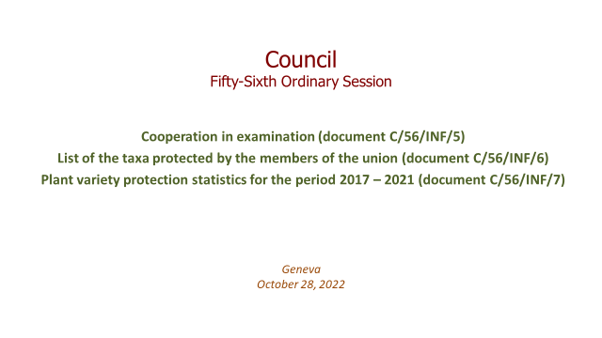

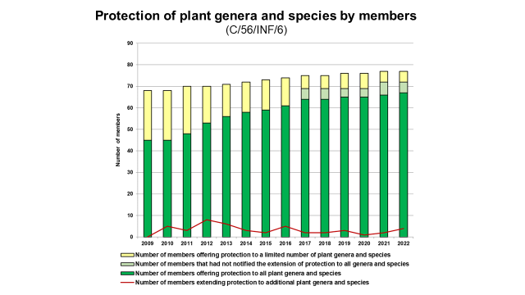

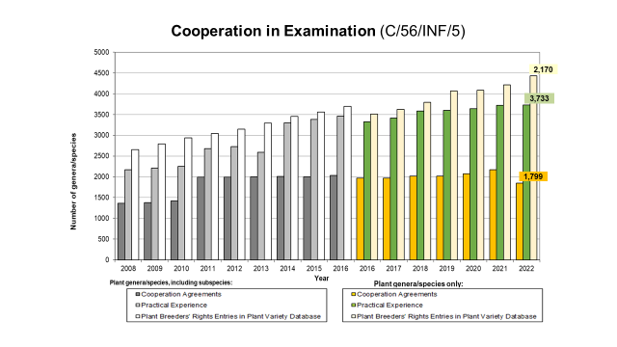

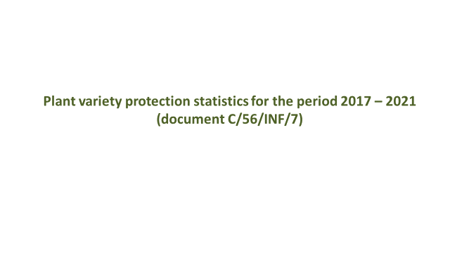

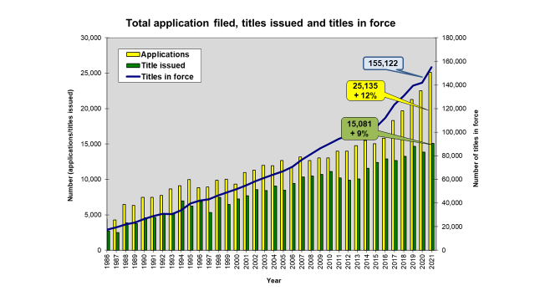

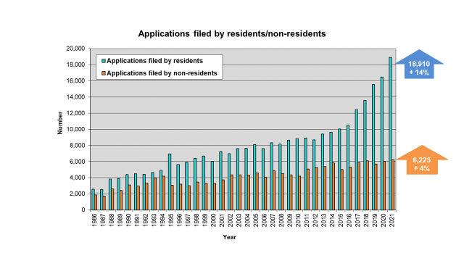

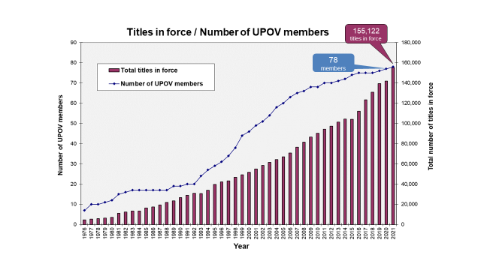

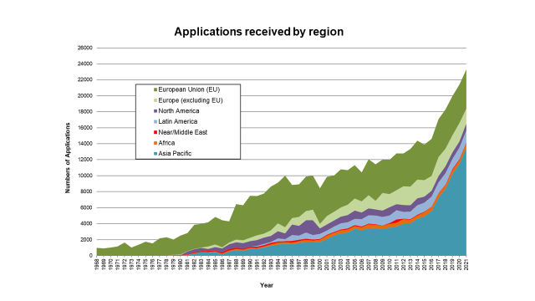

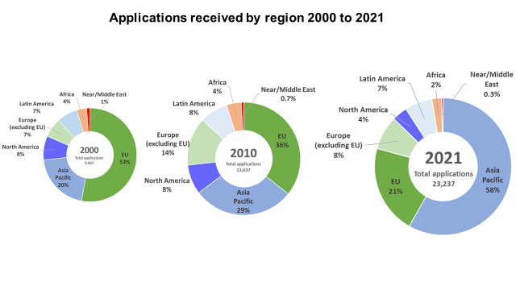

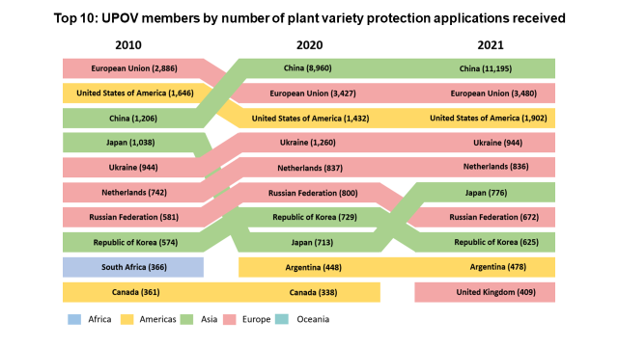

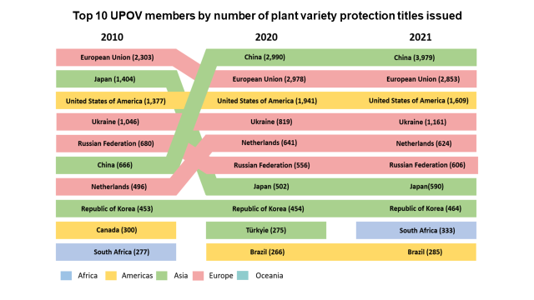

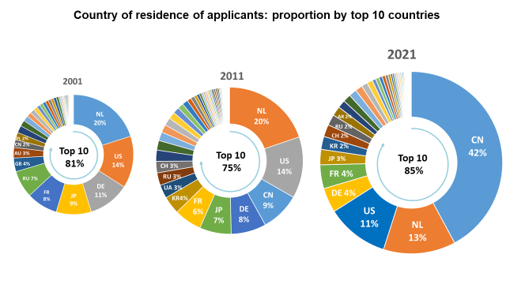

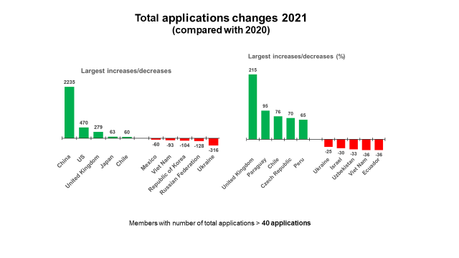

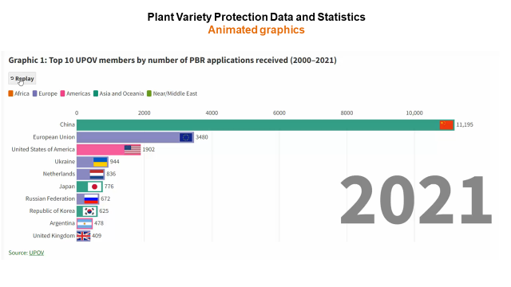

[Annex III follows]

DRAFT PRESS RELEASE

UPOV Press Release 136

Geneva, October 28, 2022

**UPOV Council Holds its Annual Session**

The Council of the International Union for the Protection of New Varieties of Plants (UPOV) held   
its fifty‑sixth ordinary session on October 28, 2022, under the chairmanship of   
Mr. Marien Valstar (Netherlands). The report of the session is provided in document C/56/15 (see <https://www.upov.int/meetings/en/details.jsp?meeting_id=67788>).

Mr. Daren Tang, Secretary-General, provided opening remarks, a copy of which are reproduced in Appendix I.

**Round-up of key developments:**

Ghana

Ghana deposited its instrument of accession to the 1991 Act of the UPOV Convention on November 3, 2021, and became bound by the 1991 Act on December 3, 2021. On the occasion of the participation for the first time in the UPOV Council as a member, Ms. Diana Asonaba Dapaah, Deputy Attorney General and Deputy Minister of Justice of Ghana made a statement, a copy of which is attached in Appendix II.

Draft Law of Armenia

The Council took a positive decision on the conformity of the Draft Law on the Protection of Varieties of Plants of Armenia with the provisions of the 1991 Act of the UPOV Convention, which allows Armenia, once the Draft Law is adopted with no changes and the Law is in force, to deposit its instrument of accession to the 1991 Act.

Procedure for selection of new Vice Secretary-General

The members of the Union selected the following candidates to be interviewed for the post of Vice Secretary‑General:

Mr. Martin Ake EKVAD (Sweden)

Ms. Yolanda HUERTA CASADO (Spain)

Mr. Leontino REZENDE TAVEIRA (Brazil)

An extraordinary session of the Council will be held on March 23, 2023, to appoint the new   
Vice Secretary-General.

Developments in UPOV

A video presentation by the Vice Secretary-General on “Report on developments in UPOV”, made for the fifty‑sixth ordinary session of the Council, is available at the [C/56](https://www.upov.int/meetings/en/details.jsp?meeting_id=67788) webpage, in English, with subtitles in English, French, German and Spanish.

Events

*Seminar on the role of plant breeding and plant variety protection in enabling agriculture to mitigate and adapt to climate change*

On October 11, 12 and 26, 2022, UPOV organized a seminar on the role of plant breeding and plant variety protection in enabling agriculture to mitigate and adapt to climate change (“Seminar”), by a combination of virtual and hybrid means. Over 450 participants registered for the Seminar. A video of the seminar will be made available on October 31, 2002, on the [Seminar](https://www.upov.int/meetings/en/details.jsp?meeting_id=71391) webpage, with interpretation channels in English, French, German, Spanish (on October 11 and 12) and Chinese and Russian in addition (on October 26). All presentations are available on the Seminar webpage.

The proceedings of the Seminar will be published on the UPOV Website in English, French, German and Spanish.

Mr. Daren Tang, Secretary-General, provided the welcome and opening remarks, a copy of which are reproduced in Appendix III.

Mr. Marien Valstar, President of the Council, provided the following concluding remarks:

* Climate change is increasingly affecting everyone around the world: farmers, breeders and consumers. Effects are biotic (new pests and diseases) and abiotic (heat, drought, rain, seasonal changes).
* A range of strategies is needed to respond to the challenges. Plant breeding has a vital role to play in these strategies; farmers need new plant varieties to adapt to climate change but also to sustainably increase productivity in order to minimize climate change.
* Plant breeding is a long-term process that requires long-term investment from public institutions and from private companies. Plant breeders need a regulatory environment that promotes innovation and supports the conservation and utilization of genetic resources.
* The UPOV system enables plant breeders to provide farmers with the varieties they will need to feed the world in the face of climate change.

UPOV Performance Report 2020-2021

The impact of the COVID-19 pandemic in 2020 and 2021 presented an unprecedented challenge in relation to the implementation of UPOV’s program within the framework of the approved Program and Budget for the 2020-2021 Biennium. In response, the Office of the Union received strong support from members of the Union and observers to adapt its work processes to ensure continued delivery of its services and program of work.

The main impact of the COVID-19 pandemic was in relation to meetings of UPOV bodies, UPOV’s training and assistance activities and external relations, because of the need to discontinue travel. In the case of meetings of UPOV bodies, members of the Union readily embraced the proposal to move to virtual meetings and to put in place procedures to enable consideration of documents by correspondence. These procedures enabled the work of UPOV bodies to continue as planned with no negative consequences for progress on substantial matters. Indeed, the move to virtual modalities resulted in significantly greater participation in Technical Working Party meetings (see figure 1). Another positive impact of the measures taken in response to the COVID-19 pandemic was a substantial reduction in UPOV’s carbon footprint, which was halved from 2019 to 2020 (see figure 2). The wide availability of virtual meeting options also created new opportunities for meeting with colleagues and resulted in an overall increase in the frequency of contacts (see figure 3).

|  |  |
| --- | --- |
| Figure 1. Number of TWP participants | Figure 2. UPOV’s carbon footprint |

|  |
| --- |
| Figure 3. Number of missions, activities and meetings involving UPOV |

In the light of the COVID-19 pandemic and increasing concerns about food security and climate change, the adoption of the FAQ “[How does the UPOV system support sustainable development?](https://www.upov.int/about/en/faq.html#QS11)” proved to be timely. The FAQ recalls that the tremendous progress in agricultural productivity in various parts of the world is largely based on improved varieties.

A recent survey by the World Farmers’ Organisation (WFO) demonstrated the importance that farmers attach to new, improved plant varieties. The survey revealed that more than 7 in 10 farmers that responded to the survey used new, improved plant varieties, with more than 90% of those farmers considering such varieties to be important for the success of their farm. More than 9 out of 10 of the farmers considered that new, improved plant varieties were important to respond to climate change and for the sustainability of food systems.

UPOV PRISMA online application tool

UPOV PRISMA (see <https://www.upov.int/upovprisma/en/index.html>) is an on-line tool to assist in making plant variety protection (PVP) applications to PVP Offices of participating UPOV members, thereby helping to increase the introduction of new plant varieties to farmers in UPOV members. By the end of 2021, 36 members of the Union, covering 75 States, were participating in UPOV PRISMA and there has been strong growth in the use of UPOV PRISMA since its launch in 2017 (see figure 4).

Figure 4. Number of applications using UPOV PRISMA (annual)



Adoption of documents

The Council adopted revised versions of the following documents:

UPOV/EXN/DEN Explanatory Notes on Variety Denominations under the UPOV Convention

TGP/5 Experience and Cooperation in DUS Testing Section 6: UPOV Report on Technical Examination and UPOV Variety Description

TGP/8 Trial Design and Techniques Used in the Examination of Distinctness, Uniformity and Stability

TGP/12 Guidance on Certain Physiological Characteristics

UPOV/INF/16 Exchangeable Software

UPOV/INF/22 Software and Equipment Used by Members of the Union

All adopted documents will be published in the UPOV Collection (see <http://www.upov.int/upov_collection/en/>).

Award of medals

Mr. Marien Valstar (Netherlands) was awarded a UPOV Gold Medal on completing his term as President of the Council, from November 2, 2019 to October 28, 2022.

Mr. Patrick Ngwediagi (United Republic of Tanzania) was awarded a UPOV Silver Medal on completing his term as Chair of the Administrative and Legal Committee, from 2020 to 2022.

Mr. Nik Hulse (Australia) was awarded a UPOV Silver Medal on completing his term as Chair of the Technical Committee, from 2020 to 2022.

Election of the new Chairpersons

TheCouncil elected, in each case for a term of three years ending with the fifty-ninth ordinary session of the Council, in 2025:

(a) Mr. Yehan Cui (China)

President of the Council

(b) Mr. Anthony Parker (Canada)

Vice-President of the Council

(c) Ms. María Laura Villamayor (Argentina),

Chair of the Administrative and Legal Committee

(d) Ms. Minori Hagiwara (Japan)

Vice-Chair of the Administrative and Legal Committee

(e) Ms. Beate Rücker (Germany)

Chair of the Technical Committee

(f) Ms. Nuria Urquía Fernández (Spain)

Vice-Chair of the Technical Committee

Plant Variety Protection Statistics

The number of applications for plant variety protection increased from 22,512 in 2020 to 25,135 in 2021 (12 percent increase).

The number of titles issued increased from 13,873 in 2020 to 15,081 in 2021 (8.7 percent increase).

The total of 155,122 titles in force at the end of 2021 represented a 9.3 percent increase on figures for 2020 (141,888).

The following graphs indicate trends in applications filed and titles issued since 1986. Information is also provided on the top 10 members of the Union receiving the largest number of applications in 2010, 2020 and 2021 and an analysis of applications by residence of breeders for the same years.

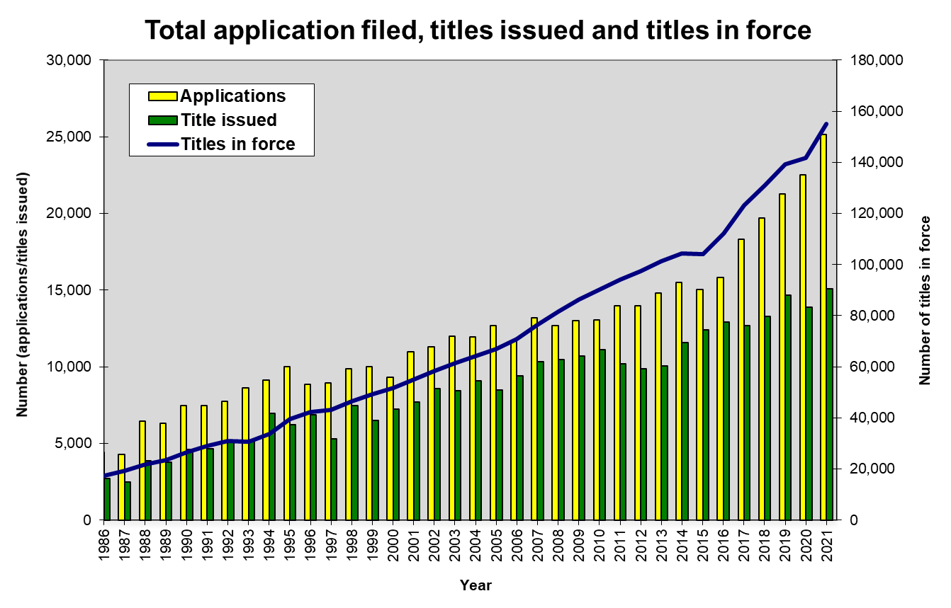

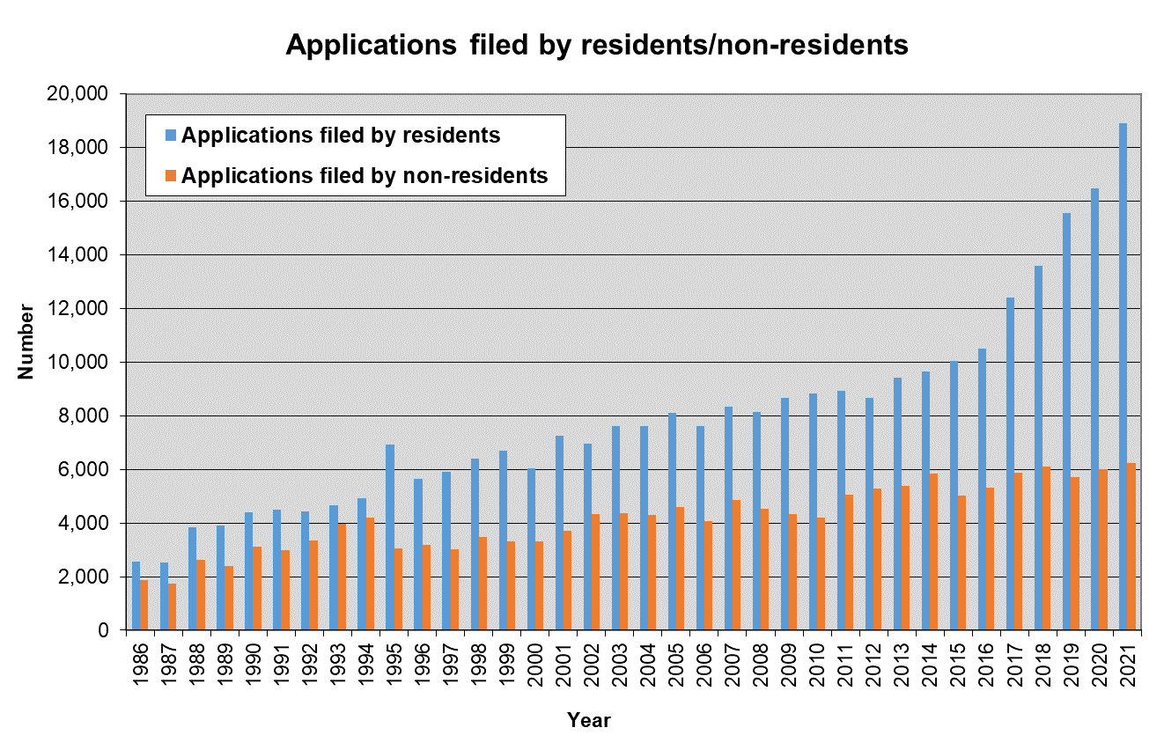

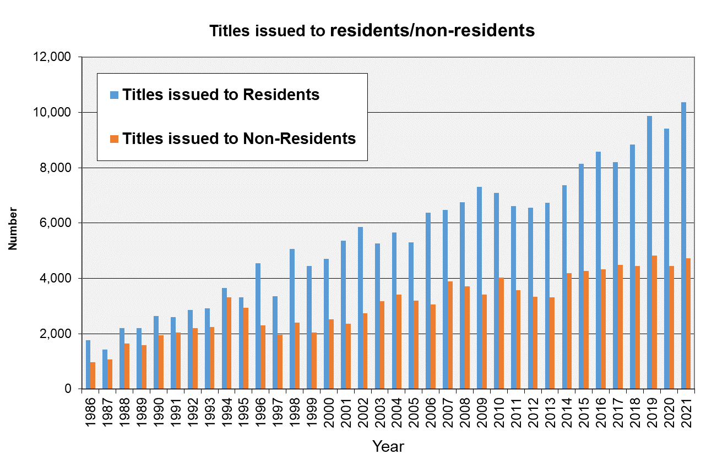

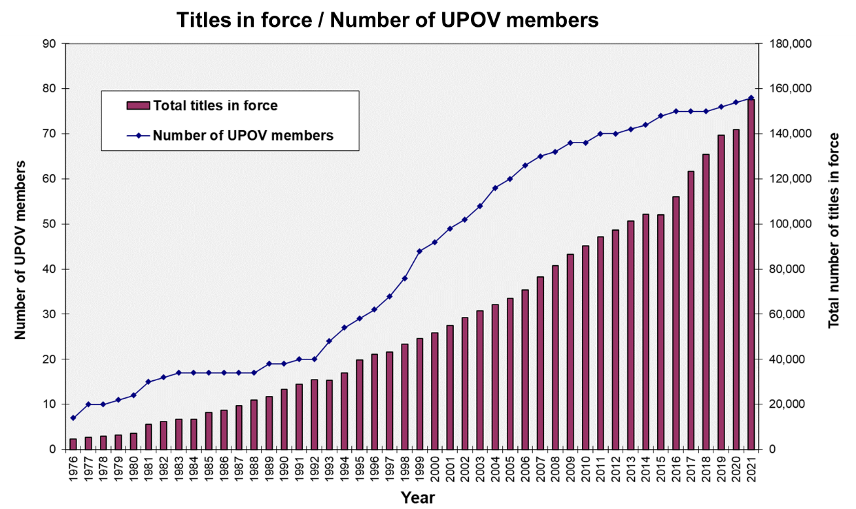

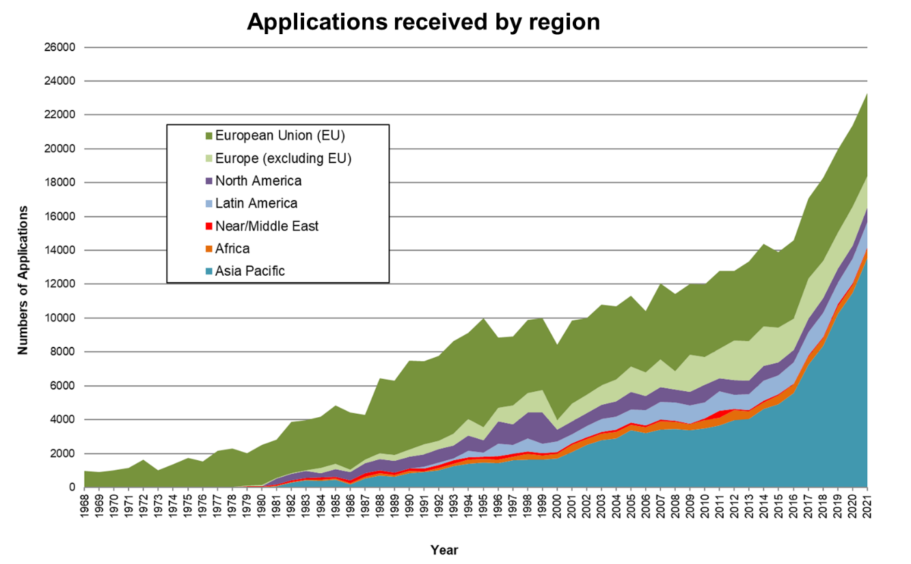





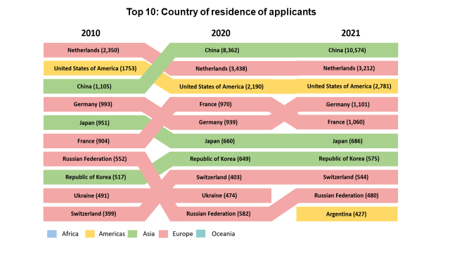

**NOTES TO EDITORS**

UPOV is an intergovernmental organization based in Geneva.

The purpose of UPOV is to provide and promote an effective system of plant variety protection, with the aim of encouraging the development of new varieties of plants, for the benefit of society.

UPOV has 78 members covering 97 States. The members of UPOV are:

African Intellectual Property Organization, Albania, Argentina, Australia, Austria, Azerbaijan, Belarus, Belgium, Bolivia (Plurinational State of), Bosnia and Herzegovina, Brazil, Bulgaria, Canada, Chile, China, Colombia, Costa Rica, Croatia, Czech Republic, Denmark, Dominican Republic, Ecuador, Egypt, Estonia, European Union, Finland, France, Georgia, Germany, Ghana, Hungary, Iceland, Ireland, Israel, Italy, Japan, Jordan, Kenya, Kyrgyzstan, Latvia, Lithuania, Mexico, Montenegro, Morocco, Netherlands, New Zealand, Nicaragua, North Macedonia, Norway, Oman, Panama, Paraguay, Peru, Poland, Portugal, Republic of Korea, Republic of Moldova, Romania, Russian Federation, Saint Vincent and the Grenadines, Serbia, Singapore, Slovakia, Slovenia, South Africa, Spain, Sweden, Switzerland, Trinidad and Tobago, Tunisia, Turkey, Ukraine, United Kingdom, United Republic of Tanzania, United States of America, Uruguay, Uzbekistan and Viet Nam.

For further information about UPOV, please contact the UPOV Secretariat:

Tel: (+41-22) 338 9111 E-mail: upov.mail@upov.int

Website: https:www.upov.int

Social media

UPOV Twitter Twitter account: @UPOVint

UPOV LinkedIn LinkedIn account: <https://www.linkedin.com/company/upov-official>

[Appendices follow]

OPENING REMARKS OF MR. DAREN TANG, SECRETARY-GENERAL,   
AT THE FIFTY-SIXTH ORDINARY SESSION OF THE COUNCIL

Mr. Marien Valstar, President of the UPOV Council,

Excellencies,

Distinguished Delegates,

Dear Colleagues and Friends,

Welcome to the fifty-sixth session of the UPOV Council, and a warm welcome back to Geneva and in-person meetings for many of you attending in person. A warm welcome as well to those of you joining us virtually from around the world.

I would like to begin by acknowledging the invaluable contribution to UPOV of our President, Marien Valstar. As many of you are aware, these are Marien's final sessions as President of the UPOV Council and I would like to take the opportunity to express my gratitude for the guidance and support you have provided to me and the Office of Union during your tenure. Navigating the challenges brought about by the pandemic has not been easy, but this task would have been even tougher without your wise counsel.

I would also like to pay tribute to Mr. Peter Button, who has served as Vice Secretary-General since 2010, since this will be his last appearance before us at an ordinary session of the Council. Over these 12 years, Peter has been instrumental to the growth and development of UPOV and he has worked tirelessly to move the Organization forward.

During his time in office, Peter witnessed a substantial increase in the reach and use of UPOV. UPOV members grew from 68 to 78, and we just welcomed Ghana as our latest member of the UPOV family. Applications grew from about 13,000 in 2010 to 22,000 in 2020. And titles in force have surged from 90,000 to over 140,000 now.

The response under his stewardship, and with your support as UPOV members, has been to create new tools to better serve users of the UPOV system, PRISMA and e-PVP being two such examples that have been transformational. The Office of the Union has facilitated Members in producing numerous guides and other materials that help the UPOV system continue being up to date. With the increase in interest in the PVP system, Peter has also had to reach out to forge new partnerships with stakeholders, as well as revamped the way UPOV engages and communicates.

Having worked with him for the past 2 years, I have had the chance to witness Peter’s singular qualities – a deep professionalism, openness, transparency, and above all, elegance, humility and self-effacement. The team he leads may be small but it is tight-knit and highly effective, and it is these qualities he demonstrates that allows them to shine collectively. So Peter, let me put on record our gratitude and thanks to you, and while it is not time to say farewell yet, it is never too early to wish you all the best.

***

**Global Context**

Dear Colleagues,

When we gathered last year, the international community was still beset by the COVID-19 crisis. While the threat from the pandemic has begun to recede, it seems that there has been no break in the storm clouds overhead.

The range of socio-economic challenges that we face today are as complex and profound as any that have emerged in recent decades. Whether it is inflationary, supply-chain or energy pressures, the urgent threat of a warming planet, or geopolitical stresses, we seem to have entered a new and more volatile era.

In such a world where food security and sustainability are increasingly important, it is even more critical that we support innovation in the agricultural and agrifood sectors.

But this does not happen by itself. Rather, the creation of a vibrant innovation ecosystem requires attention, care and support, so that great ideas that can help feed our people, address climate change and bring color and taste into our lives, will have a chance to become reality. Plant variety protection is a critical component in such an ecosystem. PVP supports long-term investment in plant breeding and provides a framework for the development of seeds and new varieties that advance farmers' needs and those of society as a whole.

Indeed, the benefits provided by the UPOV system have long played a role in building momentum behind the UN Sustainable Development Goals. New varieties of plants with features such as improved yield or an ability to better adapt to climate stress, not only support agricultural productivity but also benefit communities worldwide.

That is why it is vital that in the face of global headwinds we come together to reaffirm and reinforce the importance of UPOV’s work.

With this in mind, allow me to highlight three areas of strategic significance, and where our efforts can create tangible impact on the ground.

**Creating Impact**

First, ensuring global food security and supply.

Due to rising prices and disruption to patterns of international trade and production, the threat of food shortages is increasing in many parts of the world. The number of people experiencing acute food insecurity is projected to rise to over 220 million by the end of the year.

Investment in plant breeding and improvements in new kinds of crops and varieties are critical to reversing this trend and making food systems more resilient. Bolstering food security featured prominently in last year's seminar on strategies that address policies involving PVP and plant breeding. Let us be ready to explore what more we can do together to support agricultural productivity and sustainable food production, particularly among developing nations, which often have the most vulnerable food systems.

Second, spurring economic development in rural areas through plant breeding and PVP.

Agriculture is the backbone of many of your economies and a significant source of employment for rural populations. Take the case of Kenya, where agriculture contributes a third of GDP and 7 in 10 rural jobs.

Stimulating breeding activities among farmers is an important driver of agricultural growth. Since Viet Nam joined UPOV in 2006, the annual income of farmers has increased by around 25 percent, with plant breeding activities now supporting more than 2.5 percent of Viet Nam's GDP.

These economic benefits open up new opportunities and transform lives. One of the strengths of the UPOV system is that it is equally relevant for individual breeders, small and medium enterprises and larger breeding institutes and firms. We will continue to uphold and raise awareness of the system so that it benefits more farmers' and communities around the world.

And third, harnessing UPOV’s global reach to generate further action on climate change.

As the most recent IPCC report states with high confidence, rising temperatures are a serious threat to human life, biodiversity and infrastructure. With this in mind, UPOV recently held a productive session on the role of plant breeding and PVP in supporting climate change mitigation and adaptation.

We heard how more than 8 in 10 farmers surveyed by the World Farmers' Organization have identified improved plant varieties as an important tool in responding to climate change. And how PVP systems - such as the EU's Community Plant Variety Rights (CPVR) system – are reducing greenhouse gas emissions, in this case by over 60 million tons a year.

Together, we look forward to building momentum behind this conversation and to using UPOV’s expertise, and position as a global, neutral convener, to drive climate action forward.

***

Excellencies, Distinguished Delegates,

UPOV's mission is to provide and promote an effective system of plant variety protection, with the aim of encouraging the development of new varieties of plants for the benefit of society.

These last three words are absolutely critical. Supporting your people and economies to navigate a challenging global environment will continue to be at the very heart of our strategic approach in the years ahead.

With these words, I wish the Council every success in its deliberations today and pledge the Office’s continued support, commitment and dedication, under the direction of UPOV’s members, so what we do here will truly benefit all peoples and regions of the world.

Thank you.

[Appendix II of Annex III follows]

INTERVENTION BY THE DELEGATION OF GHANA   
AT THE FIFTY-SIXTH ORDINARY SESSION OF THE COUNCIL

President, Secretary-General,

Distinguished Ladies and Gentlemen,

On behalf of the Government of the Ghana, the Office of the Attorney General and Ministry of Justice and the Ministry of Food and Agriculture, Ghana appreciates the warm welcome into the UPOV family. We are very honoured to be a member of UPOV.

On November 3, 2021, Ghana, deposited its instrument of accession to the UPOV Convention (1991 Act). On December 3, 2021, Ghana became the Seventy – Eight (78) member of UPOV.

The Plant Variety Protection Act, (Act 1050) 2020 of Ghana entered into force on 29th December 2020. On September 4, 2021, the Council of UPOV took a positive decision on the conformity of the Plant Variety Protection Act, Act 1050 of 2020 with the 1991 Act of the UPOV Convention.

Plant breeders’ rights in Ghana fall under the responsibility of the Registrar- General’s Department, Ministry of Justice. The Office has the appropriate legal and institutional framework for the grant of protection of plant breeders’ rights. Experts received excellent training in Wageningen in the Netherlands, USPTO and UPOV in the field of plant breeders’ rights.

As of today, in Ghana applications can be filed for all plant genera and species.

I would like also to share the reasons why it is important for Ghana to be a UPOV member. Agriculture is one of the important sources of livelihood in Africa and particularly so in Ghana. Ghana recognizes the progress made in breeding activities at the national level, which is key to meeting society needs in the agricultural sector. Also, Ghana recognizes the UPOV System as offering an effective protection of new varieties of plants.

The government of Ghana is committed to improve breeding activities and develop the seed sector, provide protection to breeders and use agriculture to provide for food and jobs in the rural sector and farming communities. Ghana’s accession to the UPOV Convention to become a UPOV Member is not only opportune but critical to its food and nutrition security as well as meeting its national development goals.

I would like to emphasize our gratitude for the assistance received by Ghana from many well-wishers in the accession procedure to the UPOV Convention. The Delegation also wishes to thank all who had given their support and technical assistance over the last couple of years to the country’s effort to have in place an effective system for the protection of new varieties of plants in accordance with the UPOV Convention. In this regard we in particular want to thank the UPOV Secretariat, Switzerland, Netherlands, France, European Union and the United States of America.

The Delegation of Ghana wishes to express its sincere appreciation to the Council of UPOV and to all the delegates for the warm welcome extended to Ghana as the 78th UPOV member.

Thank you.

[Appendix III of Annex III follows]

UPOV SEMINAR ON THE ROLE OF PLANT BREEDING AND PLANT VARIETY PROTECTION IN ENABLING AGRICULTURE TO MITIGATE AND ADAPT TO CLIMATE CHANGE

Geneva, October 11, 12 (by virtual means) and 26 (in hybrid format), 2022

Opening Remarks of Mr. Daren Tang, Secretary-General, UPOV

Mr. Marien Valstar, President of the UPOV Council,

Dear Participants, Dear Colleagues, Dear Friends,

Warm greetings from Geneva. It is a great pleasure to speak to you today.

The challenges presented by climate change are clear and considerable.

As the most recent Intergovernmental Panel on Climate Change (IPCC) report states with high confidence, rising temperatures are a serious threat to human life, biodiversity and infrastructure.

Extreme weather is exposing millions of people to food and water scarcity, especially in the global south.

Plants and animal species are experiencing changes in their ranges, seasonal patterns and habitats.

Economies are being hit by the increasing frequency of heatwaves, floods, droughts, wildfires and other climate hazards.

And shifts in temperature and rainfall patterns threaten key crop yields.

In response, we must sow the seeds of climate action across all sectors of the economy.

The role agriculture can play in mitigating and adapting to the climate threat was a theme that emerged strongly from last year's UPOV seminar on the policy impact of plant breeding and plant variety protection.

We heard how PVP is enhancing food security and improving farmers’ livelihoods in China, Kenya and Mexico.

We heard how PVP is supporting the development of the European Union's flagship Green Deal and Farm to Fork strategy.

And we heard how agritech is progressing innovative solutions, including through the authorization of a new agricultural R&D authority in the United States.

This led the UPOV council to agree to bring the global community together for a session dedicated to the role of plant breeding and PVP in combatting climate change.

In so doing, we are building momentum behind one of the key recommendations from the IPCC's special report on climate change and land.

The report surveyed various policy options and concluded that, in this context, boosting soil carbon and increasing food productivity are amongst the most effective climate responses at our disposal.

New and improved plant varieties have an important role to play on both fronts.

On soil carbon, improved rotation and the development of deeper rooting varieties are two concrete ways in which plants can regenerate soil fertility and protect natural ecosystems.

While on food productivity, we know that plant breeding and PVP help increase yields in a sustainable way.

A study of Viet Nam's experience after a decade of UPOV membership, found that the use of inputs per hectare in arable farming had decreased, at the same time as crop yields grew.

Meanwhile, a recent EU paper revealed that the CPVR (Community Plant Variety Rights) system is helping to lower annual greenhouse gas emissions by over 60 million tons each year.

These are just two examples of how plant breeding and plant variety protection are increasing food productivity in a sustainable way.

Our work now must be to build on this momentum and to use innovation, technology and improved practices to further accelerate climate action for the benefit of all.

Ladies and Gentlemen,

Over the next the few days, we will hear from expert speakers from every region of the world.

I urge you to use this opportunity to continue to share best practices and to learn from one another.

It is your engagement, in the work of UPOV and beyond, that will help to shape effective policy responses and put the planet on a more sustainable footing.

Thank you very much and best wishes for a productive seminar.

[End of Annex III and of document]