|  |  |
| --- | --- |
|  | E |
| International Union for the Protection of New Varieties of Plants |  |

|  |  |
| --- | --- |
| Council  Fifty-Sixth Ordinary Session  Geneva, October 28, 2022 | C/56/11  Original: English  Date: October 28, 2022 |

Draft Press Release

Document prepared by the Office of the Union

Disclaimer: this document does not represent UPOV policies or guidance

The Annex to this document contains a draft press release on the fifty-sixth ordinary session of the Council.

The Council is invited to consider the draft press release, contained in the Annex to this document, subject to developments in the Council.

[Annex follows]

ANNEX

UPOV Press Release 136

Geneva, October 28, 2022

**UPOV Council Holds its Annual Session**

The Council of the International Union for the Protection of New Varieties of Plants (UPOV) held   
its fifty‑sixth ordinary session on October 28, 2022, under the chairmanship of   
Mr. Marien Valstar (Netherlands). The report of the session is provided in document C/56/15 (see <https://www.upov.int/meetings/en/details.jsp?meeting_id=67788>).

Mr. Daren Tang, Secretary General, provided opening remarks, a copy of which are reproduced in Appendix I.

**Round-up of key developments:**

Ghana

Ghana deposited its instrument of accession to the 1991 Act of the UPOV Convention on November 3, 2021, and became bound by the 1991 Act on December 3, 2021. On the occasion of the participation for the first time in the UPOV Council as a member, Ms. Diana Asonoba Dapaah, Deputy Attorney General and Deputy Minister of Justice of Ghana made a statement, a copy of which is attached in Appendix II.

Draft Law of Armenia

The Council took a positive decision on the conformity of the Draft Law on the Protection of Varieties of Plants of Armenia with the provisions of the 1991 Act of the UPOV Convention, which allows Armenia, once the Draft Law is adopted with no changes and the Law is in force, to deposit its instrument of accession to the 1991 Act.

Procedure for selection of new Vice Secretary-General

The members of the Union selected the following candidates to be interviewed for the post of Vice Secretary‑General:

Mr. Martin Ake EKVAD (Sweden)

Ms. Yolanda HUERTA CASADO (Spain)

Mr. Leontino REZENDE TAVEIRA (Brazil)

An extraordinary session of the Council will be held on March 23, 2023, to appoint the new   
Vice Secretary-General.

Developments in UPOV

A video presentation by the Vice Secretary-General on “Report on developments in UPOV”, made for the fifty‑sixth ordinary session of the Council, is available at the [C/56](https://www.upov.int/meetings/en/details.jsp?meeting_id=67788) webpage, in English, with subtitles in English, French, German and Spanish.

Events

*Seminar on the role of plant breeding and plant variety protection in enabling agriculture to mitigate and adapt to climate change*

On October 11, 12 and 26, 2022, UPOV organized a seminar on the role of plant breeding and plant variety protection in enabling agriculture to mitigate and adapt to climate change (“Seminar”), by a combination of virtual and hybrid means. Over 450 participants registered for the Seminar. A video of the seminar will be made available on October 31, 2002, on the [Seminar](https://www.upov.int/meetings/en/details.jsp?meeting_id=71391) webpage, with interpretation channels in English, French, German, Spanish (on October 11 and 12) and Chinese and Russian in addition (on October 26). All presentations are available on the Seminar webpage.

The proceedings of the Seminar will be published on the UPOV Website in English, French, German and Spanish.

Mr. Daren Tang, Secretary General, provided the welcome and opening remarks, a copy of which are reproduced in Appendix III.

Mr. Marien Valstar, President of the Council, provided the following concluding remarks:

* Climate change is increasingly affecting everyone around the world: farmers, breeders and consumers. Effects are biotic (new pests and diseases) and abiotic (heat, drought, rain, seasonal changes).
* A range of strategies is needed to respond to the challenges. Plant breeding has a vital role to play in these strategies; farmers need new plant varieties to adapt to climate change but also to sustainably increase productivity in order to minimize climate change.
* Plant breeding is a long-term process that requires long-term investment from public institutions and from private companies. Plant breeders need a regulatory environment that promotes innovation and supports the conservation and utilization of genetic resources.
* The UPOV system enables plant breeders to provide farmers with the varieties they will need to feed the world in the face of climate change.

UPOV Performance Report 2020-2021

The impact of the COVID-19 pandemic in 2020 and 2021 presented an unprecedented challenge in relation to the implementation of UPOV’s program within the framework of the approved Program and Budget for the 2020-2021 Biennium. In response, the Office of the Union received strong support from members of the Union and observers to adapt its work processes to ensure continued delivery of its services and program of work.

The main impact of the COVID-19 pandemic was in relation to meetings of UPOV bodies, UPOV’s training and assistance activities and external relations, because of the need to discontinue travel. In the case of meetings of UPOV bodies, members of the Union readily embraced the proposal to move to virtual meetings and to put in place procedures to enable consideration of documents by correspondence. These procedures enabled the work of UPOV bodies to continue as planned with no negative consequences for progress on substantial matters. Indeed, the move to virtual modalities resulted in significantly greater participation in Technical Working Party meetings (see figure 1). Another positive impact of the measures taken in response to the COVID-19 pandemic was a substantial reduction in UPOV’s carbon footprint, which was halved from 2019 to 2020 (see figure 2). The wide availability of virtual meeting options also created new opportunities for meeting with colleagues and resulted in an overall increase in the frequency of contacts (see figure 3).

|  |  |
| --- | --- |
| Figure 1. Number of TWP participants | Figure 2. UPOV’s carbon footprint |

|  |
| --- |
| Figure 3. Number of missions, activities and meetings involving UPOV |

In the light of the COVID-19 pandemic and increasing concerns about food security and climate change, the adoption of the FAQ “[How does the UPOV system support sustainable development?](https://www.upov.int/about/en/faq.html#QS11)” proved to be timely. The FAQ recalls that the tremendous progress in agricultural productivity in various parts of the world is largely based on improved varieties.

A recent survey by the World Farmers’ Organisation (WFO) demonstrated the importance that farmers attach to new, improved plant varieties. The survey revealed that more than 7 in 10 farmers that responded to the survey used new, improved plant varieties, with more than 90% of those farmers considering such varieties to be important for the success of their farm. More than 9 out of 10 of the farmers considered that new, improved plant varieties were important to respond to climate change and for the sustainability of food systems.

UPOV PRISMA online application tool

UPOV PRISMA (see <https://www.upov.int/upovprisma/en/index.html>) is an on-line tool to assist in making plant variety protection (PVP) applications to PVP Offices of participating UPOV members, thereby helping to increase the introduction of new plant varieties to farmers in UPOV members. By the end of 2021, 36 members of the Union, covering 75 States, were participating in UPOV PRISMA and there has been strong growth in the use of UPOV PRISMA since its launch in 2017 (see figure 4).

Figure 4. Number of applications using UPOV PRISMA (annual)



Adoption of documents

The Council adopted revised versions of the following documents:

UPOV/EXN/DEN Explanatory Notes on Variety Denominations under the UPOV Convention

TGP/5 Experience and Cooperation in DUS Testing Section 6: UPOV Report on Technical Examination and UPOV Variety Description

TGP/8 Trial Design and Techniques Used in the Examination of Distinctness, Uniformity and Stability

TGP/12 Guidance on Certain Physiological Characteristics

UPOV/INF/16 Exchangeable Software

UPOV/INF/22 Software and Equipment Used by Members of the Union

All adopted documents will be published in the UPOV Collection (see <http://www.upov.int/upov_collection/en/>).

Award of medals

Mr. Marien Valstar (Netherlands) was awarded a UPOV Gold Medal on completing his term as President of the Council, from November 2, 2019 to October 28, 2022.

Mr. Patrick Ngwediagi (United Republic of Tanzania) was awarded a UPOV Silver Medal on completing his term as Chair of the Administrative and Legal Committee, from 2020 to 2022.

Mr. Nik Hulse (Australia) was awarded a UPOV Silver Medal on completing his term as Chair of the Technical Committee, from 2020 to 2022.

Election of the new Chairpersons

TheCouncil elected, in each case for a term of three years ending with the fifty-ninth ordinary session of the Council, in 2025:

(a)

President of the Council

(b)

Vice-President of the Council

(c)

Chair of the Administrative and Legal Committee

(d)

Vice-Chair of the Administrative and Legal Committee

(e) Ms. Beate Rücker (Germany)

Chair of the Technical Committee

(f) Ms. Nuria Urquía Fernández (Spain)

Vice-Chair of the Technical Committee

Plant Variety Protection Statistics

The number of applications for plant variety protection increased from 22,512 in 2020 to 25,135 in 2021 (12 percent increase).

The number of titles issued increased from 13,873 in 2020 to 15,081 in 2021 (8.7 percent increase).

The total of 155,122 titles in force at the end of 2021 represented a 9.3 percent increase on figures for 2020 (141,888).

The following graphs indicate trends in applications filed and titles issued since 1986. Information is also provided on the top 10 members of the Union receiving the largest number of applications in 2010, 2020 and 2021 and an analysis of applications by residence of breeders for the same years.

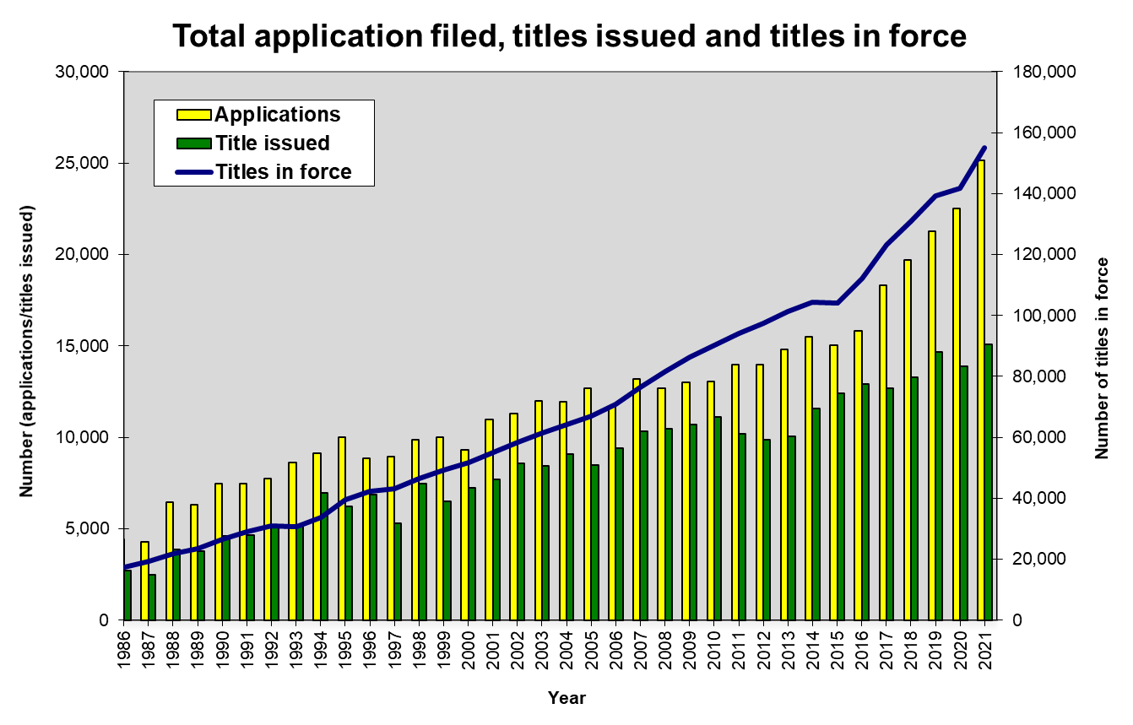

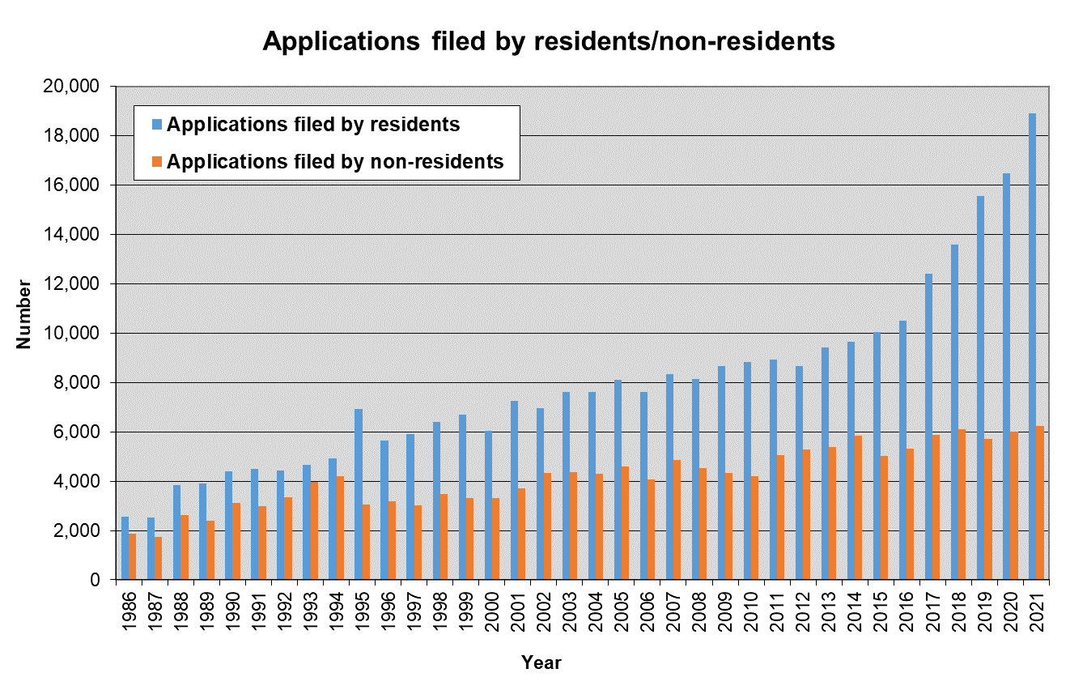

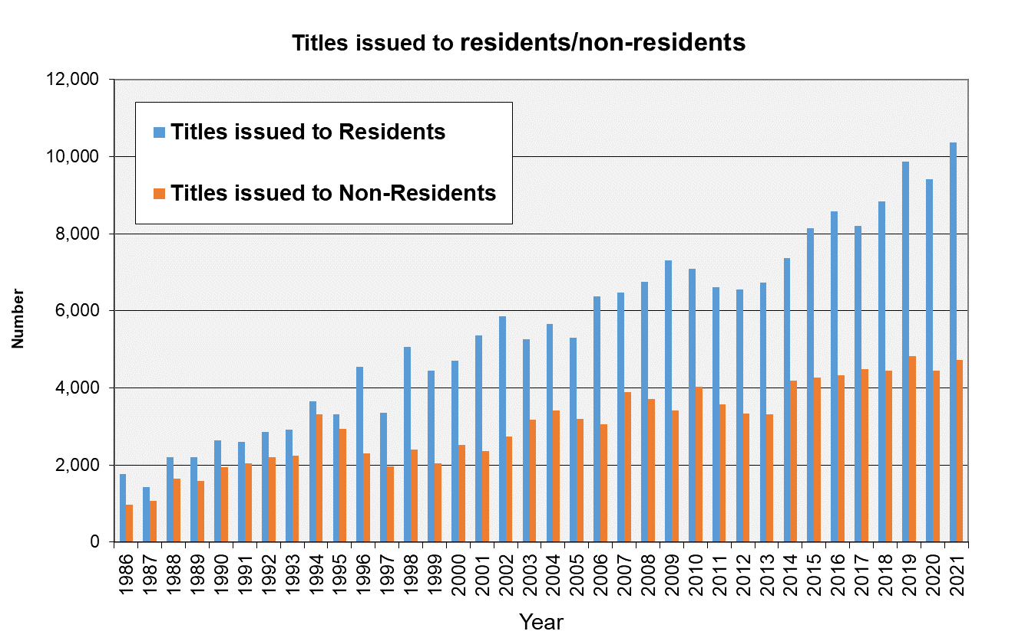

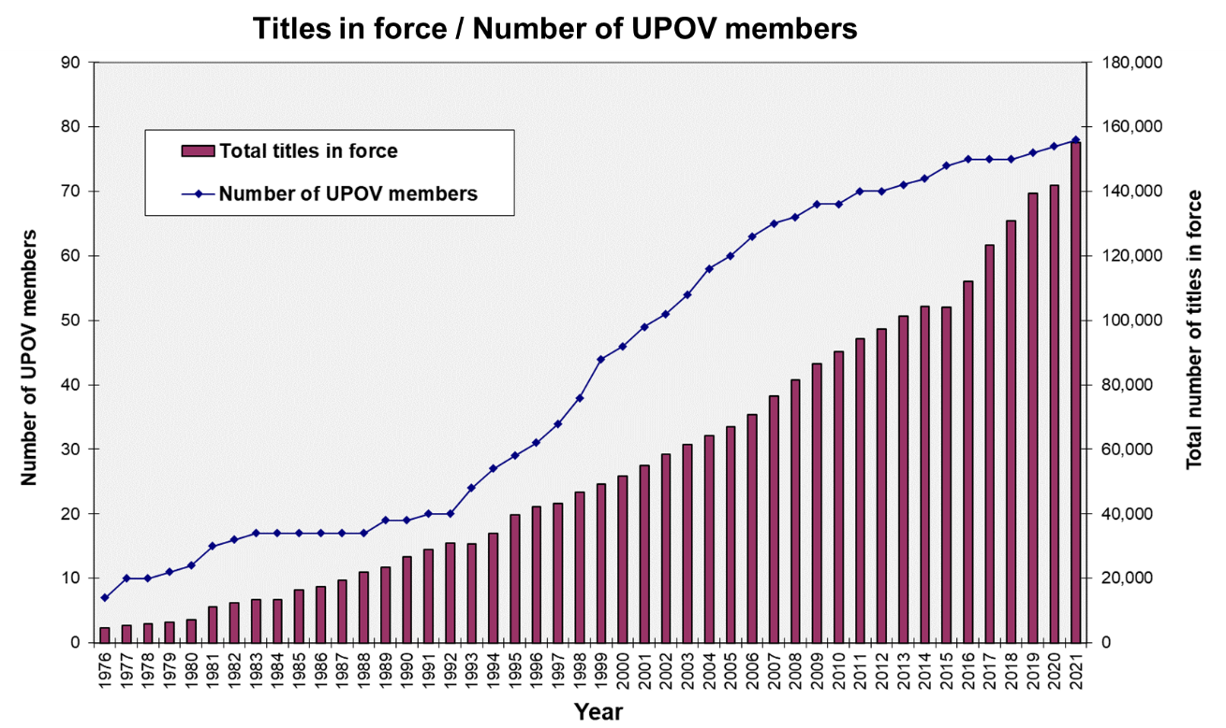

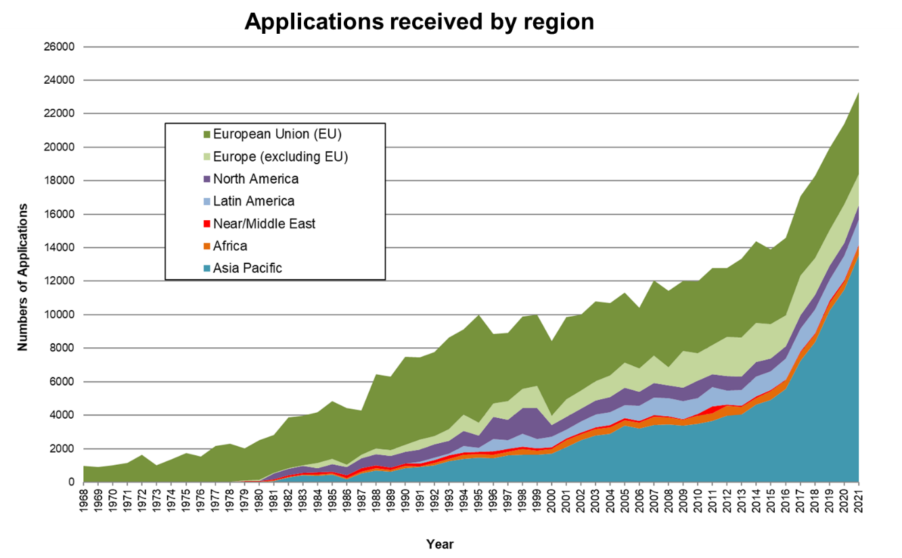

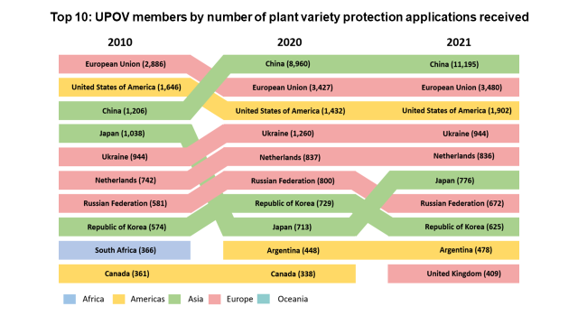

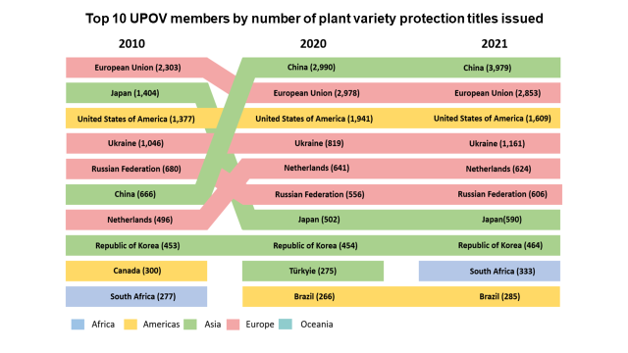

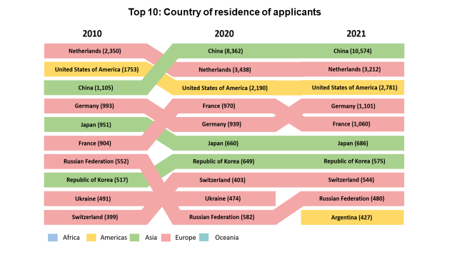

**NOTES TO EDITORS**

UPOV is an intergovernmental organization based in Geneva.

The purpose of UPOV is to provide and promote an effective system of plant variety protection, with the aim of encouraging the development of new varieties of plants, for the benefit of society.

UPOV has 78 members covering 97 States. The members of UPOV are:

African Intellectual Property Organization, Albania, Argentina, Australia, Austria, Azerbaijan, Belarus, Belgium, Bolivia (Plurinational State of), Bosnia and Herzegovina, Brazil, Bulgaria, Canada, Chile, China, Colombia, Costa Rica, Croatia, Czech Republic, Denmark, Dominican Republic, Ecuador, Egypt, Estonia, European Union, Finland, France, Georgia, Germany, Ghana, Hungary, Iceland, Ireland, Israel, Italy, Japan, Jordan, Kenya, Kyrgyzstan, Latvia, Lithuania, Mexico, Montenegro, Morocco, Netherlands, New Zealand, Nicaragua, North Macedonia, Norway, Oman, Panama, Paraguay, Peru, Poland, Portugal, Republic of Korea, Republic of Moldova, Romania, Russian Federation, Saint Vincent and the Grenadines, Serbia, Singapore, Slovakia, Slovenia, South Africa, Spain, Sweden, Switzerland, Trinidad and Tobago, Tunisia, Turkey, Ukraine, United Kingdom, United Republic of Tanzania, United States of America, Uruguay, Uzbekistan and Viet Nam.

For further information about UPOV, please contact the UPOV Secretariat:

Tel: (+41-22) 338 9111 E-mail: upov.mail@upov.int

Website: https:www.upov.int

Social media

UPOV Twitter Twitter account: @UPOVint

UPOV LinkedIn LinkedIn account: <https://www.linkedin.com/company/upov-official>

[Appendices follow]

APPENDIX I

OPENING REMARKS OF MR. DAREN TANG, SECRETARY GENERAL,   
AT THE FIFTY-SIXTH ORDINARY SESSION OF THE COUNCIL

[to be inserted]

[Appendix II follows]

APPENDIX II

INTERVENTION BY THE DELEGATION OF GHANA   
AT THE FIFTY-SIXTH ORDINARY SESSION OF THE COUNCIL

[to be inserted]

[Appendix III follows]

APPENDIX III

UPOV SEMINAR ON THE ROLE OF PLANT BREEDING AND PLANT VARIETY PROTECTION IN ENABLING AGRICULTURE TO MITIGATE AND ADAPT TO CLIMATE CHANGE

Geneva, October 11, 12 (by virtual means) and 26 (in hybrid format), 2022

Opening Remarks of Mr. Daren Tang, Secretary General, UPOV

[to be inserted]

[End of document]