E
International Union for the Protection of New Varieties of Plants

Council  Document on Developments | C/Developments/2021/2  Original: English  Date: June 3, 2021
Developments on the Plant Variety Protection Act, 2021 of Nigeria
Document prepared by the Office of the Union
Disclaimer: this document does not represent UPOV policies or guidance
The purpose of this document is to invite the Council to consider the “Plant Variety Protection Act, 2021” of Nigeria (Act) and to reaffirm its positive decision of August 21, 2019, concerning conformity with the provisions of the 1991 Act of the International Convention for the Protection of New Varieties of Plants.

procedure to reaffirm a decision of conformity of the Council by correspondence

Article 34(3) of the 1991 Act provides that “any State which is not a member of the Union and any intergovernmental organization shall, before depositing its instrument of accession, ask the Council to advise it in respect of the conformity of its laws with the provisions of this Convention. If the decision embodying the advice is positive, the instrument of accession may be deposited.”

In the context of the organization of a single set of sessions from 2018, and in order to facilitate the examination of laws of future members, the Council, at its fifty-first ordinary session, held in Geneva on October 26, 2017, approved the proposals to amend document UPOV/INF/13/1 “Guidance on how to become a member of UPOV”, in order to introduce a procedure for examination of laws by correspondence and adopted a revision of document UPOV/INF/13/1 (document UPOV/INF/13/2) (see document C/51/22 “Report”, paragraph 20(g)).

Document UPOV/INF/13/2 “Guidance on how to become a member of UPOV” provides the procedure to reaffirm a decision of conformity of the Council by correspondence as follows:

Applicability of the procedure to reaffirm a decision of conformity of the Council by correspondence

“(e) Decision embodying the advice of the Council

“19. […]

“(iii) The decision of the Council embodying the advice concerning a draft law is positive; however, changes are introduced during the procedure of adopting the law: if in the opinion of the Office of the Union those changes do not affect the substantive provisions of the 1991 Act of the UPOV Convention, the Office of the Union will prepare a document presenting those changes and its opinion and the Council will be invited to reaffirm its decision of conformity. If the Council reaffirms its decision of conformity, the State or intergovernmental organization may deposit its instrument of accession to the UPOV Convention (see section C “Implementation of the Convention”). The procedure for examination of a law by correspondence will apply mutatis mutandis to the procedure to reaffirm a decision of conformity of the Council if the conditions in paragraph 11 apply;”

In accordance with paragraph 19(iii) of document UPOV/INF/13/2, the procedure for examination of a law by correspondence will apply mutatis mutandis to the procedure to reaffirm a decision of conformity of the Council if the conditions in paragraph 11 of document UPOV/INF/13/2 apply.

“11. The procedure of examination of laws by correspondence will be applicable if:

“(i) the request is received less than four weeks prior to the week of the earliest ordinary session of the Council and more than six months before the date of the subsequent ordinary session of the Council; and

“(ii) the analysis of the Office of the Union anticipates a positive decision and does not identify any significant issues concerning the conformity of the legislation with the UPOV Convention.”

In accordance with paragraph 11 of document UPOV/INF/13/2, the letter with the request of to reaffirm the decision of conformity of the Council of 2019 was received on April 22, 2021, being more than six months before the date of the fifty-fifth ordinary session of the Council. The Office of the Union anticipates a reaffirmation of the positive decision and has not identified any significant issues in relation to the changes introduced during the procedure of adopting the Act, concerning the conformity of the Act with the UPOV Convention.

Posting of the document on developments and the Plant Variety Protection Act on the UPOV website

“14. […]

“(i) the analysis document and the law will be posted on the UPOV website within six weeks of receipt of the request and members and observers to the Council will be informed accordingly; and

“(ii) members or observers will have the opportunity to provide comments within 30 days from the date the analysis document is posted on the UPOV website.”

In accordance with paragraph 14 of document UPOV/INF/13/2, the Office of the Union has posted this document concerning developments on the Act of Nigeria (document C/Developments/2021/2) on the UPOV website in order to provide an opportunity for comments from Council members and observers (see UPOV Circular E-21/080 of June 3, 2021).

BACKGROUND

The Government of Nigeria initiated the procedure to become a member of UPOV by letter dated April 19, 2019, addressed to the Secretary-General of UPOV, in which His Excellency Mr. Audu Ogbeh, Minister for Agriculture and Rural Development of Nigeria, requested the examination of the Plant Variety Protection (PVP) Bill of Nigeria (Draft Law) for conformity with the 1991 Act of the UPOV Convention. In accordance with UPOV Circular E-19/129 of August 21, 2019, the Council examined the Draft Law and decided, by correspondence, to:

“(a) note the analysis of document C/Analysis/2019/1;

“(b) take a positive decision on the conformity of the ‘Plant Variety Protection Bill of Nigeria’ with the 1991 Act of the International Convention for the Protection of New Varieties of Plants, which allows Nigeria once the Draft Law is adopted with no changes and the Law is in force, to deposit its instrument of accession to the 1991 Act; and

“(c) authorize the Secretary-General to inform the Government of Nigeria of the above decision.”

By letter dated April 22, 2021, His Excellency, Mr. Alhaji Muhammad Sabo Nanono, Minister for Agriculture and Rural Development, Federal Ministry of Agriculture and Rural Development of Nigeria, addressed to the Secretary-General of UPOV, reported that the National Assembly of Nigeria had adopted the “Plant Variety Protection Act, 2021” of Nigeria. The Minister for Agriculture and Rural Development, Mr. Nanono, also informed the Secretary-General that, during the parliamentary procedure, certain changes were introduced in the Plant Variety Protection (PVP) Bill of Nigeria, which were not part of the decision of the UPOV Council of August 21, 2019, and requested the confirmation of the positive decision of 2019 by the Council of UPOV.
The letter is reproduced in Annex I to this document. The full text of the Plant Variety Protection Act 2021 of Nigeria attached to the letter is available at https://www.upov.int/meetings/en/details.jsp?meeting_id=60600.

Changes INTRODUCED IN the Plant Variety Protection Act, 2021 of NIGERIA in relation to the text presented to the Council in 2019

The changes introduced in the text of the Act as a result of the parliamentary procedure, in relation to the text of the Draft Law submitted to the Council in 2019, are presented in revision mode in Annex II to this document (in English only).

General Conclusion

In the opinion of the Office of the Union the changes introduced in the Act during the parliamentary procedure, do not affect the substantive provisions of the 1991 Act of the UPOV Convention.

[Annexes follow]

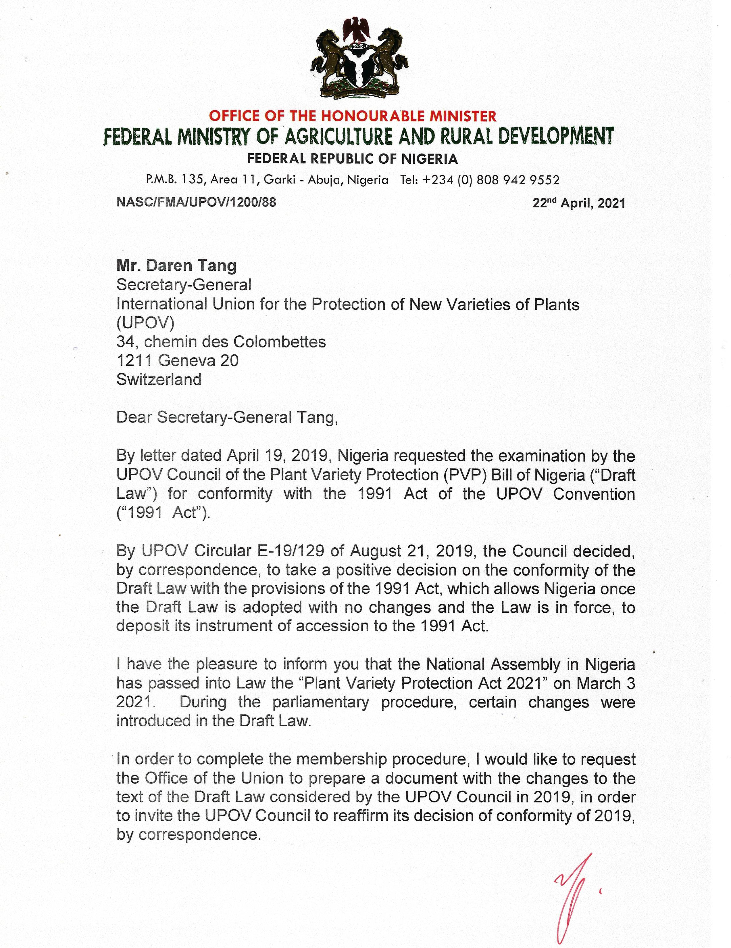

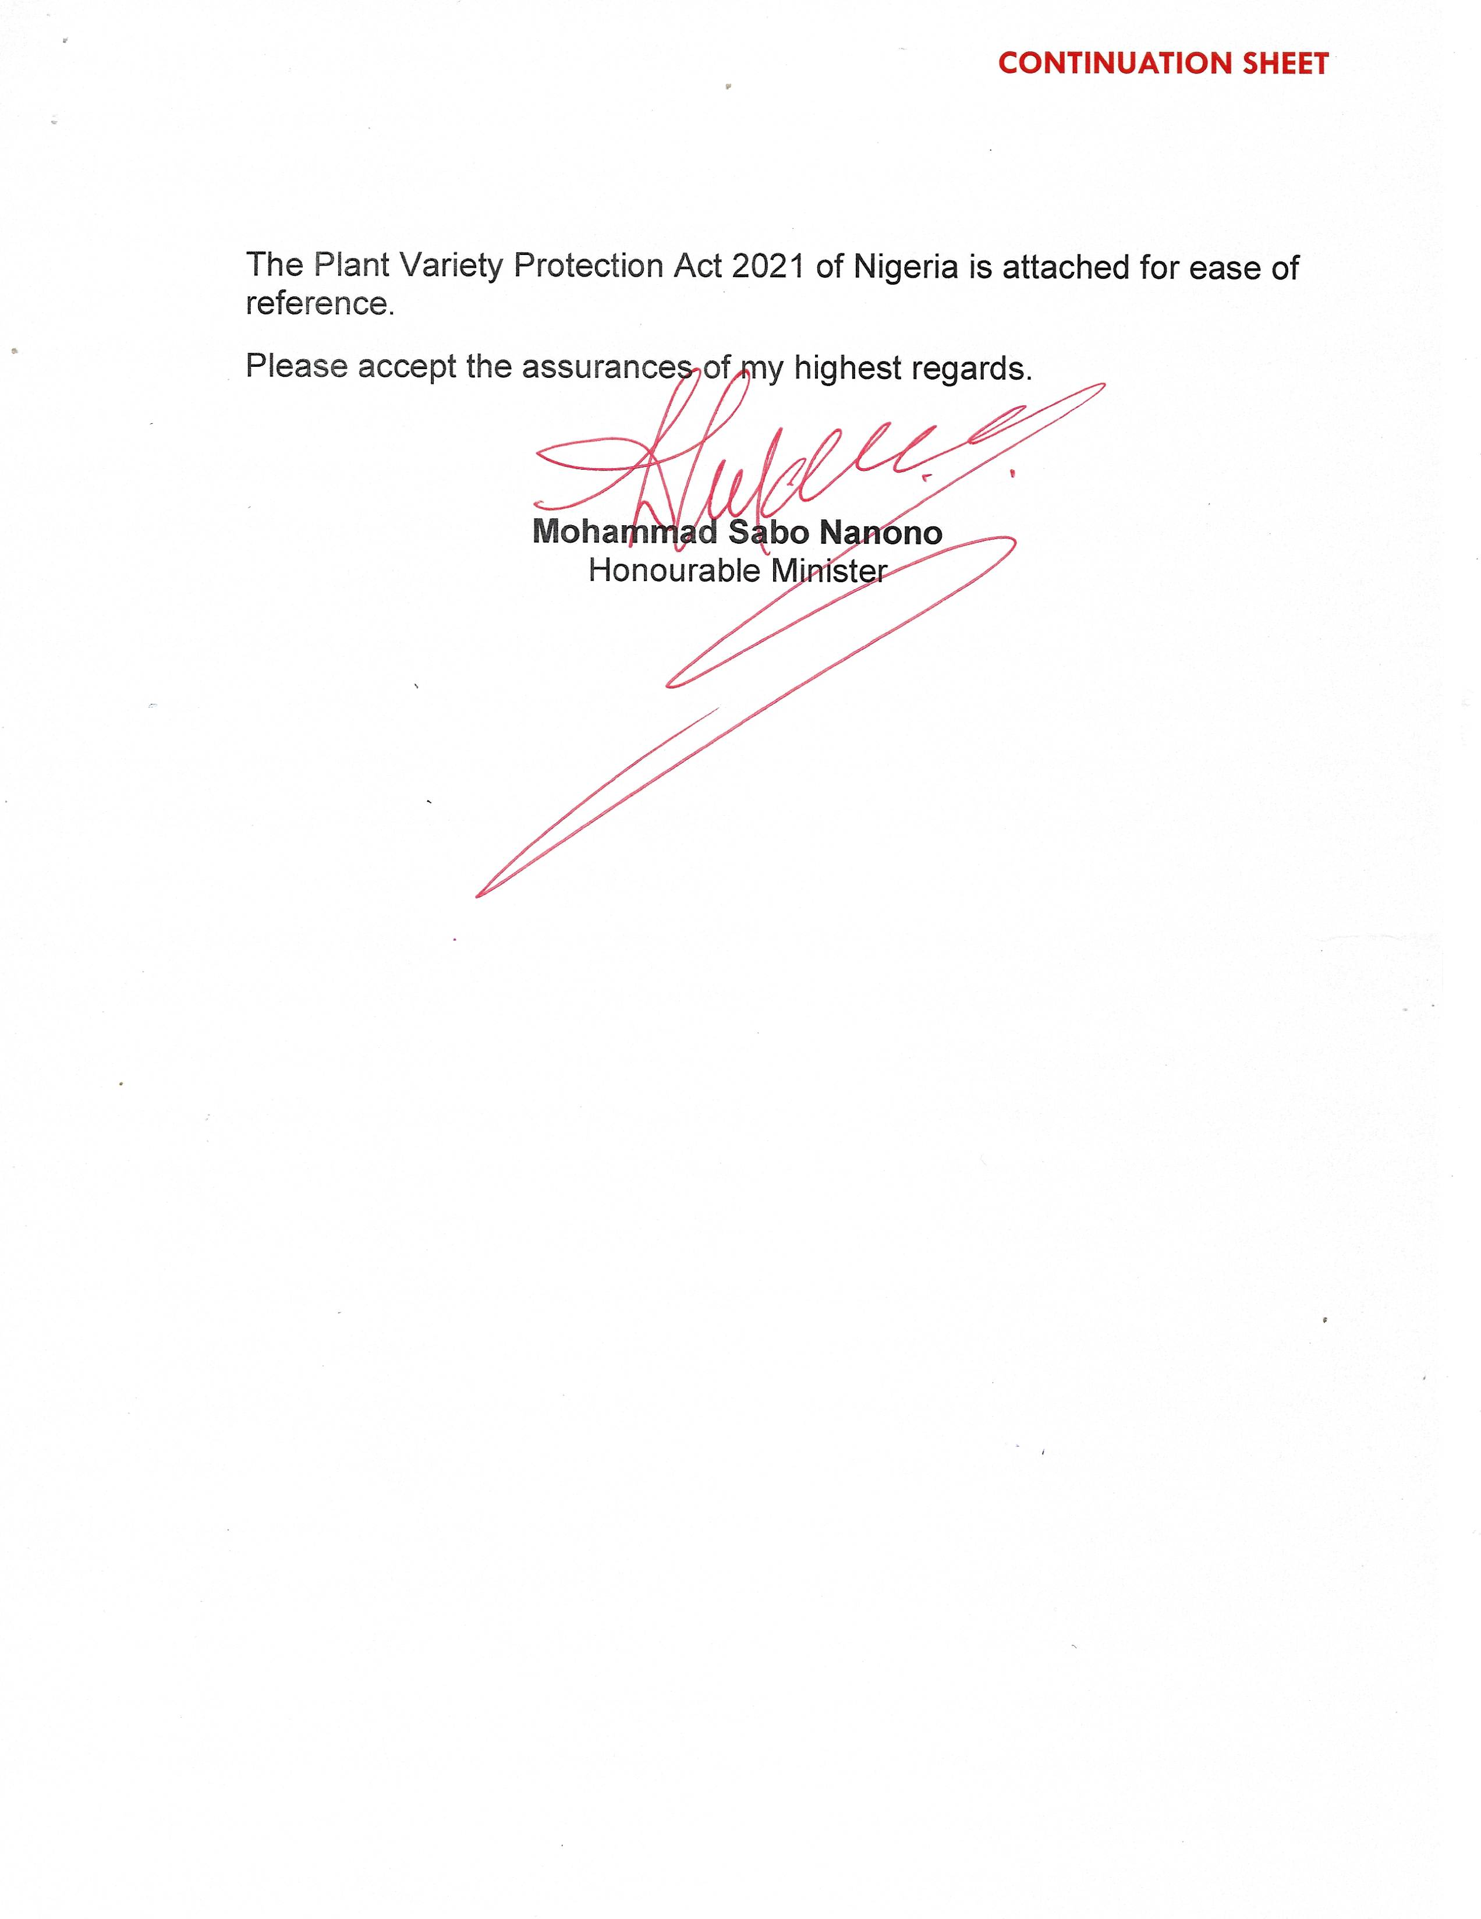

[Annex II follows]

CHANGES INTRODUCED IN THE PLANT VARIETY PROTECTION ACT, 2021 OF NIGERIA IN RELATION TO THE TEXT PRESENTED TO THE COUNCIL IN 2019

The changes introduced in the text of the Act, as a result of the parliamentary procedure, in relation to the text of the Draft Law submitted to the Council in 2019 are presented in revision mode in this Annex.

Strikethrough indicates deletion from the text presented to the Council in 2019.

Underlining indicates insertion to the text presented to the Council in 2019.

PLANT VARIETY PROTECTION ACT, 2021

EXPLANATORY MEMORANDUM
This Act protects plant varieties, encourages investment in plant breeding and crop variety development and establishes a Plant Variety Protection Office for the promotion of increased staple crop productivity for smallholder farmers in Nigeria.
Arrangement of Sections
Sections:
PART I - PRELIMINARY PROVISIONS
1. Objectives
2. Application
PART II - PLANT VARIETY PROTECTION OFFICE
3. Establishment of Plant Variety Protection Office
4. Appointment of Registrar
5. Functions of the Office
6. Register of plant variety protections' rights
7. Register to be evidence
8. Inspection of register
9. Plant Variety Protection Advisory Committee
10. Functions of the Committee
11. Powers of the Committee
PART III - VARIETIES TO BE PROTECTED
12. Genera and species to be protected
13. Conditions of protection
14. Novelty
15. Distinctness
16. Uniformity and stability
PART IV-APPLICATION FOR PLANT VARIETY PROTECTION RIGHTS
17. Application for plant variety protection's right
18. The contents of an application
19. Variety denomination
PART V- CONSIDERATION AND DISPOSITION OF APPLICATION
20. The filing date of an application
21. Right of priority
22. Amendment of application
23. Publication of notice of application
24. Objection to the proposed grant of breeder's right
25. Grounds for objection
26. Notice to the applicant and reply to an objection
27. Disposition of applications
PART VI - PROVISIONAL AND FINAL PROTECTION
28. Provisional protection
29. Scope of the breeder's right, essentially derived and certain other varieties
30. Exceptions to the breeder's right
31. Exhaustion of the breeder's right
32. Duration of a plant breeder's right
33. Protection and damages for infringement of a breeder's right
34. Fees
PART VII - NULLITY, CANCELLATION AND SURRENDER OF BREEDER'S RIGHT
35. Nullity of the breeder's right
36. Cancellation of the breeder's right
37. Notification of nullification and cancellation
38. Surrender of breeder's right
39. Authorisation or assignment of breeder's right
40. Restrictions on the exercise of breeder's right
41. Information on authorisation or assignment of breeder's right
PART VIII- APPEALS
42. Appeals from decisions of Registrar
43. Decisions of the Minister on appeals
PART IX - PLANT BREEDERS' RIGHTS DEVELOPMENT FUND, ACCOUNTS, AUDIT AND ANNUAL REPORT
44. Plant Breeders' Rights Development Fund
45. Accounts and audit
46. Annual report to be submitted to the Minister
PART X-OFFENCES AND PENALTIES
47. Offences and penalties
PART XI - GENERAL PROVISIONS
48. Collection of fees
49. Confidentiality and disclosure
50. Action against the State
51. Breeders right in respect of existing varieties of recent creation
52. Agreement with foreign governments
53. Agents
54. Registrar to make guidelines
55. Regulations
56. Interpretation
57. Citation
PLANT VARIETY PROTECTION ACT, 2021

An Act for the protection of plant varieties, to encourage investment in plant breeding and crop variety development, to establish a plant variety protection office for the promotion of increase staple crop productivity for smallholder farmers in Nigeria; and for related matters.

Commencement

Enacted by the National Assembly of the Federal Republic of Nigeria:

PART I - PRELIMINARY PROVISIONS

Objectives
1. The objectives of this Act are to:

(a) promote increased staple crop productivity for smallholder farmers in Nigeria and encourage investment in plant breeding and crop variety development;

(b) promote increased mutual accountability in the seed sector; and

(c) protect new varieties of plants.

Application
2. This Act applies to:
(a) a breeder; and

(b) any plant genera and species.

PART II - PLANT VARIETY PROTECTION OFFICE

Establishment of Plant Variety Protection Office
3. There is established the Plant Variety Protection Office ( in this Act referred to as “the Office”) which is domiciled in the National Agricultural Seeds Council.

Appointment of Registrar.

4. (1) The Board shall appoint a fit and proper person as the Registrar on the recommendation of the Director-General.

(2) The Registrar shall have at least a master’s degree in plant breeding, seed science, agronomy or in related fields with a minimum of seven years cognate experience and shall perform the functions assigned to him by the Director-General.

(3) The Registrar shall be responsible for the day-to-day management and administration of the Office and answerable to the Director-General.

Functions of the Office.
5. The Office shall :

(a) grant breeders' rights;

(b) maintain a register and provide information on plant breeders' rights issued in Nigeria;

(c) facilitate transfer and licensing of plant breeders' rights;

(d) collaborate with local and international bodies whose functions relate to plant breeders' rights matters; and

(e) perform other functions as are necessary for the furtherance of the objects of this Act.

Register of plant variety protections' rights.
6. (1) The Registrar shall maintain a breeder' rights register in which the information required to be registered under this Act shall be entered.

(2) The information to be listed in the register for each registered variety shall include:

(a) the species and denomination of a variety;

(b) the full name and address of the:

(i) applicant or holder of the breeder's right, and

(ii) person who bred or discovered and developed the variety, in case the person is different from the applicant or holder of the breeder's right;

(c) the date and time of inception of the breeder's right;

(d) any other matter which:

(i) is required by this Act or any other written law to be entered in the register, and

(ii) may affect the validity or ownership of plant breeders' rights; and

(e) any other information which may be required by Regulations made under this Act.

(3) The register shall be the first evidence of any matter entered in it.

Register to be evidence.
7. (1)The register shall be evidence of all matters directed or authorised by the Act to be noted in it.

(2) A certificate by the Registrar to the effect that an entry has or has not been made in the register or that any other thing authorised by this Act to be done, has or has not been done, shall be first evidence of the matters specified in that certificate.

(3) A copy of an entry in the register or an extract from the register, certified by the Registrar, shall be admitted in evidence in any court without further proof or production of the register.

Inspection of register
8. (1) The register shall be open for inspection by any member of the public during business hours.

(2) A certified copy of any entry in the register shall be given upon request and payment of the fees prescribed in the Regulations made under this Act.

Plant Variety Protection Advisory Committee.
9. (1) An Ad-hoc Committee to be known as the Plant Variety Protection’ Advisory Committee ( in this Act referred to as "the Committee") may be established to perform the functions specified in section 10 of this Act.

(2) The Director-General shall, subject to gender consideration, appoint members of the Committee and it shall be composed of one representative each from:

(a) the Council, who shall be the Chairman of the Committee;

(b) the Ministry;

(c) a registered plant breeder association;

(d) a registered seed traders association;

(e) the registered farmers’ association;

(f) a university offering a course on plant breeding;

(g) the Attorney-General of the Federation’s office;

(h) the National Office for Technology Acquisition and Promotion;

(i) the National Quarantine Services;

(j) the National Biotechnology Development Agency;

(k) the National Biosafety Management Agency;

(l) the National Crop Variety Release Committee;

(m) Registrar of Trademarks;

(n) Registrar of Patents and Design; and

(o) the Registrar.

(3) The Secretary of the Council shall be the Secretary of the Committee.

Functions of the Committee.
10. The Committee shall:

(a) through the Director-General of National Agricultural Seed Council (NASC) advise the Minister on enforcement of this Act;

(b) receive reports of plant breeders' rights applications from the Registrar;

(c) receive information on the plant breeders' rights reports and on the Registrar's tests results; and

(d) manage the operations of the Fund.

Powers of the Committee.
11. The Committee shall:

(a) make its own rules of procedure;

(b) give the Registrar directives of a specific and general nature; and

(c) call on breeders and any other interested person for hearing on plant variety protection matters.

PART III — VARIETIES TO BE PROTECTED

Genera and species to be protected
12. The protection of varieties under this Act shall apply to all plant genera and species.

Conditions of protection.
13. (1) The breeder's right shall be granted with respect to a variety which is new distinct, uniform and stable.

(2) The grant of the breeder's right shall not be subject to any further or different conditions, provided that the:

(a) variety is designated by a denomination in accordance with the provisions of section 19 of this Act; and

(b) applicant complies with the provisions of this Act and that he pays the fees prescribed in the Regulations made under this Act.

Novelty
14. (1) The variety is deemed to be new if, at the date of filing of the application for a breeder's right, propagating or harvested material of the variety has not been sold or otherwise disposed of to any person with the consent of the breeder, for purposes of exploitation of the variety in:

(a) Nigeria, earlier than one year before the date of filing the application; and

(b) a territory other than Nigeria earlier than:
(i) four years, or

(ii) six years before the said date in the case of a tree or vine.

(2) Subject to subsection (1), the following acts shall not be considered to result in the loss of novelty:
(a) a trial of the variety not involving sale or disposal of, to others for purposes of exploitation of the variety; and

(b) sale or disposal of to:

(i) others without the consent of the breeder,

(ii) any person that forms part of an agreement for the transfer of rights to the successor in title,

(iii) any person that forms part of an agreement under which a person multiplies propagating material of the variety concerned on behalf of the breeder, provided that the property in the multiplied material reverts to the breeder and the multiplied material is not used for the production of another variety,

(iv) any person that forms part of an agreement under which a person undertakes field tests or laboratory trials, or small-scale processing trials with a view of evaluating the variety,

(v) any person that forms part of the fulfillment of a statutory or administrative obligation concerning biological security or the entry of varieties in an official catalogue of varieties admitted to trade,

(vi) any person of harvested material which is a by-product or a surplus product of the creation of the variety or of the activities referred to in subparagraphs (iii) - (v) provided that the said material is sold or disposed of without variety identification for the purposes of consumption, and

(vii) any person due to or in consequence of the fact that the breeder had displayed the variety at an official or officially recognised exhibition.

Distinctness
15. (1) A variety is deemed to be distinct where it is clearly distinguishable from any other variety whose existence is a matter of common knowledge at the time of the filing of the application.

(2) For purposes of subsection (1), the filing of an application for the granting of breeder's right or for the entering of another variety in the official register of varieties in any country, is deemed to render that other variety a matter of common knowledge from the date of the application, provided that the application leads to the granting of breeder's right or to the entering of the said other variety in the official register of varieties.

Uniformity and stability.
16. A variety is deemed to be:

(a) uniform if, subject to the variation that may be expected from the particular features of its propagation, it is sufficiently uniform in its relevant characteristics; and

(b) stable, where its relevant characteristics remain unchanged after repeated propagation or, in the case of a particular cycle of propagation, at the end of each such cycle.

PART IV — APPLICATION FOR PLANT VARIETY PROTECTION RIGHTS

17. A breeder of a new variety may apply for the grant of a breeder's right for that variety.

The contents of an application.
18. The application for breeder’s right relating to a variety shall contain:

(a) the name and address of the applicant;

(b) where the applicant is the successor-in-title of the person who bred, or discovered and developed the variety:

(i) proof of title or authority in the form and content satisfactory to the Registrar or as may be specified by Regulations establishing the existence and validity of the assignment or succession, and

(ii) the name and address of the person who bred, or discovered and developed the variety;

(c) the proposed denomination and the description of the characteristics of the variety as the Registrar may require;

(d) samples of the propagating material in the quantities as the Registrar may require; and

(e) any additional information, documents and material that may be required in connection with the application as may be prescribed in the Regulations.

Variety denomination.
19. (1) The variety shall be designated by a denomination which shall be its generic designation.

(2) Subject to subsection (6), the rights in the designation registered as the denomination of the variety shall not hamper the free use of the denomination in connection with the variety even after the expiration of the breeder’s right.

(3) The denomination:

(a) shall enable the variety to be identified;

(b) shall not mislead or cause confusion concerning the characteristics, value or identity of the variety or the identity of the breeder;

(c) shall be different from every denomination which designates, in the territory of any member of an international organisation dealing with plant breeders’ rights matters to which Nigeria is a party, an existing variety of the same plant species or of a closely related species; and

(d) may not consist solely of figures except where this is an established practice for designating varieties.

(4) The denomination of the variety shall be submitted by the applicant to the Registrar and where the Registrar finds that the denomination does not satisfy the requirements of this section, he shall:

(a) refuse to register it; and

(b) direct the applicant to propose another denomination within the period to be prescribed in the Regulations made under this Act.

(5) The Registrar shall register the denomination at the time the breeder’s right is granted.

(6) Prior rights of third persons shall not be affected and where, by reason of a prior right, the use of the denomination of a variety is forbidden to a person who, in accordance with the provisions of subsection (10), is obliged to use it, the Registrar shall direct the applicant to submit another denomination for the variety.

(7) Where the variety is already protected by a member of an international organisation dealing with the plant breeders’ rights matters to which Nigeria is a party, or an application for the protection of the same variety is filed in a member of such organisation, the variety denomination which has been proposed or registered in that other member of the organisation shall be submitted by the applicant to the Registrar.

(8) The Registrar shall:

(a) register the denomination submitted, unless he considers the denomination unsuitable within Nigeria; and

(b) direct the applicant to submit another denomination where the denomination is unsuitable.

(9) The Registrar shall in writing, inform the authorities of the members of UPOV on matters concerning variety denominations, in particular the submission, registration and cancellation of the denominations.

(10) Any person who, within Nigeria, offers for sale or markets propagating material of a variety protected within the said territory shall be obliged to use the denomination of that variety, even after the expiration of the breeder’s right of that variety, except where prior rights prevent the use.

(11) When a variety is offered for sale or marketed, it shall be permitted to associate a trademark, trade name or other similar indication with a registered variety denomination and where such an indication is so associated, the denomination shall nevertheless be easily recognisable.

PART V — CONSIDERATION AND DISPOSITION OF APPLICATION

The filing date of an application.
20. (1) The file date of an application shall be the date which the application was filed at the registry by the applicant.

(2) For the purposes of this section, an application is deemed to have been submitted in the form prescribed under this Act.

Right of priority.
21. (1) Any breeder who has duly filed an application for the protection of a variety in one of the members of an international organisation dealing with plant breeder’s right matters which Nigeria is a party shall enjoy a right of priority for a maximum period of 12 months.

(2) The period referred to in subsection (1) shall be computed from the date of filing the first application and the day of filing shall not be included in the latter period.

(3) The applicant shall, in order to benefit from the right of priority in the subsequent application in Nigeria, claim within 12 months the priority of the first application.

(4) The Registrar may direct the applicant to furnish, within a period of at least three months from the filing date, a certified true copy of the documents which constitute the first application that was filed and samples or other evidence indicating that the variety which is the subject matter of both applications is the same.

(5) The applicant may submit to the Registrar any necessary information, document or material required in this Act for the purpose of the examination within a period of two years after the expiration of the period of priority or a period of six months where the first application is rejected or withdrawn.

Amendment of application.
22. (1) An applicant may amend his application for the grant of a breeder's right for a variety at any time without affecting its filing date, provided that the amendment does not affect the variety which is the subject of the application.

(2) Where any amendment of an application occurs after publication of a notice under section 23 of this Act, the applicant shall be liable to pay the cost of re-publication.

Publication of notice of application.
23. The Registrar shall publish in the Federal Government Gazette or in two national daily newspapers of wide circulation, a notice of every filed application for plant breeder's right that satisfies the requirements of this Act specifying:

(a) the name and address of the applicant;

(b) the filing date of the application;

(c) the proposed denomination; and

(d) such other information as may be specified in the Regulations.

Objection to the proposed grant of breeder's right.
24. (1) A person may submit to the Registrar a written objection to the matter specified in the notice under section 23 of this Act within one month of its publication.

(2) A notice of objection made under subsection (1) shall:

(a) specify the grounds on which the objection is based;

(b) include a statement of the facts alleged in support of the grounds stated under paragraph (a); and

(c) be supported by an affidavit or other proof, where required by the Registrar.

Grounds for objection.
25. An objection submitted under section 24 shall be based on the allegation that the:

(a) applicant is not entitled to file the application;

(b) application contains a material misrepresentation; and

(c) contents of the application do not comply with this Act or the Regulations.

Notice to the applicant and reply to an objection.
26. (1) The Registrar shall, within two weeks from the date on which an objection has been filed:

(a) notify the applicant that an objection has been made under section 24 of this Act; and

(b) provide the applicant with a copy of the notice of objection and all the supporting documents that have been submitted with the objection.

(2) The applicant may submit a written response to the objection to the Registrar within two weeks or such further period as the Registrar may allow from the date of the notification made under subsection (1).

(3) Where the applicant submits a response under subsection (2), he shall send a copy to the person making the objection.

(4) The Minister may reply to any objection made against the Federal Government.

Disposition of applications.
27. (1) The Registrar shall examine an application and reply upon:

(a) completion of the notice requirements under section 23; and

(b) the expiration of time limits for objections and replies.

(2) Where any decision to grant a breeder's right require an examination for compliance with the conditions specified under this Act, the Registrar may, in the course of the examination, grow or cause to be grown the variety or carry out other necessary tests, or take into account the results of growing tests or other trials which have already been carried out.

(3) The Registrar may, for the purpose of an examination, direct the breeder to provide the necessary information, document or material.

(4) The Registrar shall grant the breeder’s right where he concludes that:

(a) the applicant is entitled to file the application;

(b) the application conforms to the requirements of this Act;

(c) no objection has been filed; and

(d) where an objection has been filed, there are no grounds for objection.

(5) For each variety for which breeder's right is granted, the Registrar shall:

(a) issue a certificate of registration to the holder;

(b) enter the variety in the register as provided for under section 6 of this Act; and

(c) publish a notice of the grant of breeder's right and the approved denomination in the Gazette.

PART VI — PROVISIONAL AND FINAL PROTECTION
.
Provisional protection
28. The holder of a breeder's right shall be entitled to equitable remuneration from any person who, during the period between the publication of the application under section 23 of this Act for the grant of a breeder's right and the date of the grant of that right, has carried out acts which, once the right is granted, require the breeder's authorisation as provided for under section 29 of this Act.

Scope of the breeder's right, essentially derived and certain other varieties.
29. (1) Subject to sections 30 and 31 of this Act, the following acts in respect of the propagating material of the protected variety shall require the authorisation of the holder of the breeder's right:

(a) production or reproduction(multiplication);

(b) conditioning for the purpose of propagation;

(c) offering for sale;

(d) selling or marketing;

(e) exporting;

(f) importing; and

(g) stocking for any purposes mentioned in paragraphs (a) - (f).

(2) The holder of the breeder’s right may give his authorisation subject to conditions and limitations.

(3) Subject to the provisions of sections 30 and 31 of this Act, the acts referred to in subsection (1) (a) - (g) in respect of:

(a) harvested material, including entire plants and parts of plants, obtained through the unauthorised use of propagating material of the protected variety, shall require the authorisation of the holder of the breeder’s right, unless the holder of the breeder’s right has had reasonable opportunity to exercise his right in relation to the said propagating material; and

(b) products made directly from harvested material of the protected variety falling within the provision of paragraph (a) through the unauthorised use of the said harvested material, shall require the authorisation of the breeder, unless the breeder has had reasonable opportunity to exercise his right in relation to the said harvested material.

(4) The provisions of subsections (1) - (3) shall apply to a variety:

(a) that is essentially derived from the protected variety, where the protected variety is not itself an essentially derived variety;

(b) which is not clearly distinguishable in accordance with section 15 of this Act from the protected variety; and

(c) whose production requires the repeated use of the protected variety.

(5) For the purposes of subsection (4) (a), a variety shall be deemed to be essentially derived from another variety when:

(a) it is predominantly derived from the initial variety, or from a variety that is itself predominantly derived from the initial variety, while retaining the expression of the essential characteristics that result from the genotype or combination of genotype of the initial variety;

(b) it is clearly distinguishable from the initial variety; and

(c) except for the differences which result from the act of derivation, it conforms to the initial variety in the expression of the essential characteristics that result from the genotype or combination of genotypes of the initial variety.

(6) For the purpose of this section, an essentially derived variety may be obtained through:

(a) the selection of a natural, induced mutant or of somaclonial variant;

(b) the selection of a variant individual from plants of the initial variety; and

(c) backcrossing, or transformation by genetic engineering.

Exceptions to the breeder's right.
30. (1) The breeder's right shall not extend to any act carried out:

(a) privately and for non-commercial purposes;

(b) for experimental purposes; and

(c) for the purpose of breeding any other variety, and, except where the provisions of section 29 (4) - (6) of this Act apply, any act referred to in section 29 (1) - (3) in respect of such other varieties.

(2) For the list of agricultural crops specified by the Minister, the breeder's right shall not extend to a farmer who, within reasonable limits and subject to the safeguarding of the legitimate interests of the holder of the breeder's right, uses for propagating purposes on his own holding, the product of the harvest which he has obtained by planting on his own holding, the protected variety or a variety referred to in section 29 (4) (a) or (b) of this Act.

(3) The reasonable limits and the means of safeguarding the legitimate interest of the holder of the breeder's right shall be specified in the regulations made under this Act.

Exhaustion of the breeder’s right.
31. (1) The breeder’s right shall not extend to an act concerning any material of the protected variety or of a variety covered by the provisions of section 29 (4) - (6) of this Act, which has been sold or otherwise marketed by the breeder or with his consent in Nigeria, or any material derived from the said material, unless the act involves:

(a) further propagation of the variety in question; or

(b) an export of material of the variety, which enables the propagation of the variety, into a country which does not protect varieties of the plant genius or species to which the variety belongs, except where the exported material is for final consumption purposes.

(2) In this section "material" means, in relation to a variety:

(a) propagating material of any kind;

(b) harvested material, including entire plants and parts of plants; and

(c) any product made directly from the harvested material.

Duration of a plant breeders' right.
32. (1) Except as specified in Part VII of this Act, the breeders' rights granted under this Act shall expire after 20 years from the date of the grant except for trees and vines whose breeders' rights shall expire after 25 years from the date of grant.

(2) The Registrar may extend the duration referred to in subsection (1) for an additional five years where he receives a six month written notice from the holder of the breeder's right before the expiration of the original term.

Protection and damages for infringement of a breeder's right.
33. (1) A breeder's right is protected by both civil and criminal measures stipulated in any written law.

(2) A suit by the holder of breeder's right against any person who infringes the breeder's right may be brought to the court.

Fees
34. The holder of a breeder's right shall pay fees at times and rates specified in the Regulations made under this Act.

PART VII — NULLITY, CANCELLATION AND SURRENDER OF BREEDER'S RIGHT

Nullity of the breeder's right.
35. The Registrar shall declare a breeder's right granted by him null where it is established that:

(a) the variety did not comply with the conditions specified in sections 14 or 15 at the time the breeder's right was granted;

(b) where the grant of the breeder's right has been essentially based upon information and documents furnished by the applicant, the conditions laid down in section16 were not complied with at the time of the grant of the breeder's right; or

(c) the breeder's right has been granted to a person who is not entitled to it, unless it is transferred to the person who is so entitled.

Cancellation of the breeder's right.
36. (1) The Registrar may cancel a breeder's right granted by him where he has established that the conditions specified in section 16 of this Act are no longer fulfilled.

(2) Without prejudice to subsection (1), the Registrar may cancel a breeder's right granted by him, within the prescribed period provided in the Regulations made under this Act, where the holder of the breeder's right:

(a) does not provide the Registrar with the information, documents or materials deemed necessary for verifying the maintenance of the variety;

(b) fails to pay the fees which may be payable to keep his right in force; or

(c) does not propose another suitable denomination where the denomination of the variety is cancelled after the grant of the right.

Notification of nullification and cancellation.
37. (1) The Registrar shall notify the holder of the breeder's right of any decision made under sections 35 and 36 of this Act and the grounds for such decision.

(2) A person who receives the notice referred to in subsection (1) may send a written objection to the Registrar within 30 days from the date of receipt of the notification.

(3) The Registrar may hold, within a reasonable time after receipt of an objection, a hearing or may decide the matter based on the written submission of the interested parties.

(4) Where the Registrar nullifies and cancels any breeder's right under this section, he shall publish the nullification or cancellation by a notice in the Federal Government Gazette or two national daily newspapers of wide circulation, after the expiration of 30 days from the date of the decision or following a decision made under subsection (3).

(5) The holder of the breeder's right shall return to the Registrar any certificate of the grant of a breeder's right that has been nullified or cancelled under this section.

Surrender of breeder's right.
38. (1) A holder of a breeder's right may, by written notice to the Registrar, surrender the right.

(2) The Registrar shall, within one month from the date of receiving the notice referred to subsection (1), terminate the breeder's right and publish a notice in the Federal Government Gazette or two national daily newspapers of the termination.

Authorisation or assignment of breeder's right.
39. The holder of breeder's right may assign or authorise any person, to undertake any activity described or referred to in section 29 of this Act.

Restrictions on the exercise of breeder's right.
40. (1) The free exercise of a breeder's right shall, unless where expressly provided in this Act, not be restricted for reasons other than of public interest.

(2) When any such restriction has the effect of the Registrar authorising a third party to perform any act for which the breeder's authorisation is required, the breeder shall receive equitable remuneration.

Information on authorisation or assignment of breeder's right.
41. (1) A person authorised under section 39 of this Act may, in not more than 60 days from the effective date of the authorisation :

(a) notify the Registrar of the transaction; and

(b) submit a copy of the authorisation agreement to the Registrar.

(2) The Registrar may prescribe the form and manner of the notification to be made under subsection (1).

(3) Where an assignment or other transmission of all of a breeder's right is made, the assignee or recipient shall notify the Registrar for the purposes of making changes in the Register.

PART VIII — APPEALS

Appeals from decision of Registrar.
42. (1) An appeal from the decisions of the Registrar made under this Act shall lie to the Minister.

(2) A person who is aggrieved by any of the decisions of the Registrar may appeal to the Minister by submitting a notice of the appeal within 60 days following the publication, or of the receipt, of the individual notice of such decision by the person whose interest is the source or subject of the appeal.

Decisions of the Minister on appeals.
43. (1) The Minister:

(a) may conduct an investigation, if he deems necessary to do so, and may hold a hearing of the appeal or make a decision based on written submissions;

(b) may confirm, set aside or vary any decision or action of the Registrar and may order the Registrar to carry out his decision; and

(c) shall give the reasons for his decision in writing, and copies of the decision shall be given to the appellant, the Registrar and any other interested party.

(2) Subject to the provisions of this section, a decision of the Minister shall be final.

PART IX — PLANT BREEDERS' RIGHTS DEVELOPMENT FUND, ACCOUNTS, AUDIT AND
ANNUAL REPORT

Plant Breeders Rights Development Fund.
44. (1) The Minister shall, after consultation with the Minister responsible for finance, establish the Plant Breeders' Rights Development Fund (in this Act referred to as "the Fund') into which money realised under this Act shall be kept.

(2) The sources of money for the Fund shall include:

(a) fees payable under this Act; and

(b) any donation or grant from the Government or any other person.

(3) The Fund shall be applied for:

(a) development and promotion of the plant breeders' rights;

(b) training of plant breeders on matters concerning plant breeders' rights;

(c) establishment and maintenance of variety collection and data base; and

(d) any other activity relating to administration of this Act.

(4) In addition to the functions entrusted to it under section 10 of this Act, the Committee shall operate as the Fund Committee, whereby:

(a) the Registrar shall be a member of the Fund Committee and shall serve as the Secretary of the Fund;

(b) the Fund Committee shall make rules and procedures for the operations and management of the Fund;

(c) separate books of accounts and other records in respect of the Fund shall be kept properly and maintained and be subject to audit.

Accounts and audit.
45. (1) The Office shall cause to be kept and maintain proper books of accounts with respect to:

(a) all sums of money received and expended by the Office and matters in respect of which the receipt and expenditure take place;

(b) all the assets and liabilities of the Office and the Fund; and

(c) the income and expenditure statement of the Office.

(2) The financial year of the Office and the Fund shall end on 31 December of each year.

(3) The books of accounts of the Plant Breeders’ Rights Office and the Fund shall be audited at the end of each financial year by the Accountant-General of the Federation and Auditor-General for the Federation.

Annual report to be submitted to the Minister.
46. (1) The Registrar shall, submit to the Minister a copy of the audited accounts and annual report on the activities of the Office in respect of that particular year not later than six months after the end of each financial year.

(2) The Registrar shall, within a period of six months or such longer period as the National Assembly may by resolution prescribe after the accounts have been audited, lay the audited accounts and audit report before the National Assembly.

PART X — OFFENCES AND PENALTIES
Offences and penalties
47. (1) Any person who knowingly:

(a) makes a false entry in the register,

(b) makes a writing which falsely purports to be a copy of an entry in the register or of a document lodged with the Registrar,

(c) produces or tenders a false entry of copy as evidence,

(d) submits a false document or makes a false statement or representation to the Registrar in regard to any action described under this Act,

(e) obstructs or hinders the Registrar or any officer in the exercise of his powers or the carrying out of his functions under this Act,

(f) having been duly summoned to appear at any proceedings under this Act, fails without lawful excuse to appear,

(g) having appeared as a witness at any proceedings under this Act, refuses without lawful excuse to be sworn or to produce any document or answer any question which he may be lawfully required to produce or answer,

(h) contravenes the obligation to use the denomination as required by section 19 (10) of this Act,

(i) gives false information in any application or makes any false statement in evidence;

(j) violates breeders right;

(k) any person whoviolates the provisions of section 29, and

(l) contravenes any other provisions of this Act
commits an offence.

(2) Any person who commits an offence under this Act is liable on conviction:

(a) as a first offender, to a fine of at least N1,000,000 or imprisonment for a term of at least one year; and

(b) in the event of such person having been previously convicted under this section, he is liable to fine of at least N2,000,000 or imprisonment for a term of at least two years or both.

PART XI — GENERAL PROVISIONS

Collection of fees.
48. Notwithstanding any other provision of this Act, the Registrar shall collect fees from the applicant or any other person filling a document or requesting access of administrative action under this Act, for each application, extension, filing, inquiry or other administrative process or service.

Confidentiality and disclosure.
49. (1) The contents of any license or assignment shall be confidential unless both parties agreed to permit access to a third party and only to the extent of the permission so granted.

(2) The applicant may declare some portion of the application to be confidential, where declared so, the Registrar shall determine whether the application can be processed without the publication or other violation of that confidentiality, and give the applicant the option of altering his statement of confidentiality or withdraw the application.

(3) Except as otherwise provided for in this Act, any person who discloses any information made available under this Act, except to:

(a) the Minister, the Registrar or any other person for the purposes of carrying out his duties or the performance of his function under this Act,

(b) a police officer for the purposes of an investigation or inquiry relating to the enforcement of the provision of this Act, or

(c) any other person when required to do so by any court or under any written law,

commits an offence and is liable on conviction to a fine of at least N5,000,000.00 or to imprisonment for a term of at least two years or to both.

Action against the State.
50. (1) Subject to the existing law on institution of action against the State, this Act shall be binding on the Government with regard to its applications for breeder's right and other interests acquired or given in breeder's right to the same extent and with the same effect as its applies to any other person.

(2) No claim shall lie against the State, the Minister, the Registrar or any other officer for anything done in good faith in the discharge of duties under the powers conferred by this Act.

Breeders right in respect of existing varieties of recent creation.
51. (1) Where, according to section 12, this Act applies to a plant genus or species to which it did not previously apply, varieties belonging to such plant genus or species shall be considered to satisfy the condition of novelty defined in section 14 (1) even where the sale or disposal of, to others described in that paragraph took place in Nigeria within four years before the filing date or, in the case of trees or of vines, within six years before the said date.

(2) Within 12 months from the date of commencement of this Act, the breeder of an existing variety of recent creation may apply to the Registrar in respect of that variety to benefit from the provisions under subsection (1).

Agreement with foreign governments.
52. The Minister may enter into bilateral or multilateral agreements with states and intergovernmental or non-governmental organisations in order to facilitate cooperation in testing.

Agents.
53. (1) When the breeder is a non-resident or in the case of a corporation, does not have its registered office in Nigeria, he shall have an agent who is resident in Nigeria.

(2) The Registrar may, for any gross misconduct or prescribed cause or any other reasonable cause considered by the Registrar to be sufficient, refuse to recognise or to continue to recognise any person as authorised by the breeder to act in the capacity of an agent.

Registrar to make guidelines.
54. The Registrar shall make guidelines for the proper implementation of this Act and Regulations made under this Act.

Regulations.
55. (1) The Registrar shall, with the approval of the Minister make Regulations under this Act.

(2) Without prejudice to subsection (1), Regulations made shall prescribe:

(a) various forms to be used under this Act;

(b) the procedure to be followed in any proceedings before the Registrar;

(c) specific information and facilities to be provided, and of the propagating and other materials to be submitted with respect to a variety;

(d) the test, trials, examinations and other steps to be taken with respect to a variety, by applicants or by the Registrar and the time within which the steps are to be taken; and

(e) the fees to be paid in respect of:

(i) application for the grants of breeder's right, for extension of its terms,

(ii) maintenance of breeder's right,

(iii) request for administrative review, including objections to nullity and cancelation of breeder's right, appeals from administrative decisions and other administrative actions,

(iv) technical examination,

(v) the inspection of obtained record in the register or other transaction involving a breeder's right,

(vi) provision of certified copy of any entry in it, and

(vii) any other fees to be paid under this Act.

Interpretation
56. In this Act :

" agent", in relation to an applicant or a holder of plant breeder's right, means a person who is duly authorised by the applicant or holder to act, on behalf of the applicant or holder;

"applicant" means the breeder entitled to file an application for the grant of a breeder's right in accordance with the definition of breeder provided for in this Act;

"breeder" means a:

(a) person who bred or discovered and developed a variety;

(b) person who is the employer of the person who bred or discovered and developed, a variety or who has commissioned the latter's work; or

(c) a successor-in-title of a person mentioned in paragraph (a) or (b);

"breeder's right" means the right of the breeder provided for in this Act;

"business hours" means 9 am-3 pm Mondays-Fridays, excluding public holidays;

"Council" means the National Agricultural Seed Council (NASC);

"Director-General" means the Director-General of National Agricultural Seed Council;

"Fund" means the Fund established under section 44 of this Act;

"Gazette" means the Federal Government Gazette;

"Minister" means the Minister responsible for agriculture;

"Ministry" means the Ministry responsible for agriculture;

"register" means the register of plant breeders' rights kept under section 6 of this Act;

"Registrar" means the Registrar of plant breeders' rights appointed in accordance with section 4 of this Act;

"propagating material" means a plant or part of the plant used to multiply the plant;

"sell" means to offer, advertise, keep, expose, transmit, convey, deliver or:

(a) prepare for sale, exchange, dispose of for any consideration; or

(b) transmit, convey or deliver in pursuance of the sale;

"UPOV" means Union Internationale Pour la Protection des Obtentions Végétales;

"variety" means a plant grouping within a single botanical taxon of the lowest known rank, which grouping, irrespective of whether the conditions for the grant of a breeder's right are fully met, can be:

(a) defined by the expression of the characteristics resulting from a given genotype or combination of genotypes;

(b) distinguished from any other plant grouping by the expression of at least one of the said characteristics; and

(c) considered as a unit with regard to its suitability for being propagated unchanged.

Citation
57 This Act may be cited as the Plant Variety Protection Act, 2021

[End of Annex II and of document /
Fin de l’Annexe II et du document /
Ende der Anlage II und des Dokuments /
Fin del Anexo II y del documento]

