E
International Union for the Protection of New Varieties of Plants

Council  Document on Developments | C/Developments/2021/1  Original: English  Date: May 28, 2021
Developments on the Plant Variety Protection Act (Act 1050 of 2020) of Ghana
Document prepared by the Office of the Union
Disclaimer: this document does not represent UPOV policies or guidance
The purpose of this document is to invite the Council to consider the “Plant Variety Protection Act” (Act 1050 of 2020) of Ghana (Act) and to reaffirm its positive decision of October 24, 2013, concerning conformity with the provisions of the 1991 Act of the International Convention for the Protection of New Varieties of Plants.

procedure to reaffirm a decision of conformity of the Council by correspondence

Article 34(3) of the 1991 Act provides that “any State which is not a member of the Union and any intergovernmental organization shall, before depositing its instrument of accession, ask the Council to advise it in respect of the conformity of its laws with the provisions of this Convention. If the decision embodying the advice is positive, the instrument of accession may be deposited.”

In the context of the organization of a single set of sessions from 2018, and in order to facilitate the examination of laws of future members, the Council, at its fifty-first ordinary session, held in Geneva on October 26, 2017, approved the proposals to amend document UPOV/INF/13/1 “Guidance on how to become a member of UPOV”, in order to introduce a procedure for examination of laws by correspondence and adopted a revision of document UPOV/INF/13/1 (document UPOV/INF/13/2) (see document C/51/22 “Report”, paragraph 20(g)).

Document UPOV/INF/13/2 “Guidance on how to become a member of UPOV” provides the procedure to reaffirm a decision of conformity of the Council by correspondence as follows:

Applicability of the procedure to reaffirm a decision of conformity of the Council by correspondence

“(e) Decision embodying the advice of the Council

“19. […]

“(iii) The decision of the Council embodying the advice concerning a draft law is positive; however, changes are introduced during the procedure of adopting the law: if in the opinion of the Office of the Union those changes do not affect the substantive provisions of the 1991 Act of the UPOV Convention, the Office of the Union will prepare a document presenting those changes and its opinion and the Council will be invited to reaffirm its decision of conformity. If the Council reaffirms its decision of conformity, the State or intergovernmental organization may deposit its instrument of accession to the UPOV Convention (see section C “Implementation of the Convention”). The procedure for examination of a law by correspondence will apply mutatis mutandis to the procedure to reaffirm a decision of conformity of the Council if the conditions in paragraph 11 apply;”

In accordance with paragraph 19(iii) of document UPOV/INF/13/2, the procedure for examination of a law by correspondence will apply mutatis mutandis to the procedure to reaffirm a decision of conformity of the Council if the conditions in paragraph 11 of document UPOV/INF/13/2 apply.

“11. The procedure of examination of laws by correspondence will be applicable if:

“(i) the request is received less than four weeks prior to the week of the earliest ordinary session of the Council and more than six months before the date of the subsequent ordinary session of the Council; and

“(ii) the analysis of the Office of the Union anticipates a positive decision and does not identify any significant issues concerning the conformity of the legislation with the UPOV Convention.”

In accordance with paragraph 11 of document UPOV/INF/13/2, the letter with the request of to reaffirm the decision of conformity of the Council of 2013 was received on April 21, 2021, being more than six months before the date of the fifty-fifth ordinary session of the Council. The Office of the Union anticipates a reaffirmation of the positive decision and has not identified any significant issues in relation to the changes introduced during the procedure of adopting the Act, concerning the conformity of the Act with the UPOV Convention.

Posting of the document on developments and the Plant Variety Protection Act on the UPOV website

“14. […]

“(i) the analysis document and the law will be posted on the UPOV website within six weeks of receipt of the request and members and observers to the Council will be informed accordingly; and

“(ii) members or observers will have the opportunity to provide comments within 30 days from the date the analysis document is posted on the UPOV website.”

In accordance with paragraph 14 of document UPOV/INF/13/2, the Office of the Union has posted this document concerning developments on the Act of Ghana (document C/Developments/2021/1) on the UPOV website in order to provide an opportunity for comments from Council members and observers (see UPOV Circular E-21/077 of May 28, 2021).

BACKGROUND

The Government of Ghana initiated the procedure to become a member of UPOV by letter dated September 25, 2012, addressed to the Secretary-General of UPOV, in which His Excellency Dr. Benjamin Kunbuor, Attorney General and Minister of Justice of the Republic of Ghana, requested the examination of the Plant Breeders’ Bill (Draft Law) for conformity with the 1991 Act of the UPOV Convention. The Council, at its forty-sixth ordinary session, held in Geneva on November 1, 2012, examined the Draft Law and decided to (see document C/46/19 “Report”, paragraph 12):

“(a) note the analysis in document C/46/14 and the following changes proposed by the Delegation of Ghana in the Plant Breeders’ Bill of Ghana (Draft Law):

“(i) the deletion of the word “conclusively” in Section 15(2);
“(ii) the replacement of the words “Plant Breeders Advisory Committee” by “Plant Breeders Technical Committee” in Section 30; and
“(iii) the deletion of the word “seed’ in Section 43(g);

“(b) take a positive decision on the conformity of Draft Law with the provisions of the 1991 Act of the International Convention for the Protection of New Varieties of Plants, which allows Ghana, once the Draft Law is modified as recommended in paragraphs 10, 18 and 24 of document C/46/14, and in subparagraph (a) above, with no additional changes, and the Draft Law is adopted and the Law is in force, to deposit its instrument of accession to the 1991 Act; and

“(c) authorize the Secretary-General to inform the Government of Ghana of that decision.”

By letter dated September 4, 2013, Her Excellency, Mrs. Marietta Brew Appiah-Opong, Attorney-General and Minister of Justice of Ghana addressed to the Secretary-General of UPOV, reported that, during the first reading of the Draft Law by the Parliament of Ghana in June 2013, additional changes, which were not part of the decision of the Council of November 1, 2012, had been introduced, and requested the confirmation of the decision of November 1, 2012, by the Council of UPOV. The Council, at its forty-seventh ordinary session, held in Geneva on October 24, 2013, decided to (see document C/47/20 “Report”, paragraph 14):

“(a) note the information provided by the Delegation of Ghana that the text of Section 10 of the Bill provided in document C/47/18, Annex II, had been modified as follows: “Where the application is by an applicant who is a successor-in-title, the applicant shall support the applicant application with the proof of the successor’s title”;

“(b) note that the Plant Breeders’ Bill of Ghana, which was presented to the Parliament incorporated the changes in the decision of the Council of November 1, 2012 (see document C/46/19 “Report”, paragraph 12, and paragraph 2 of document C/47/18);

“(c) agree that the additional changes presented in the Annex II to document C/47/18, including the change in the above paragraph (a), do not affect the substantive provisions of the 1991 Act of the UPOV Convention, and

“(d) confirm the decision on conformity of November 1, 2012.”

By letter dated April 21, 2021, The Honorable, Mr. Godfred Yeboah Dame, Attorney-General and Minister for Justice, Office of the Attorney-General and Ministry of Justice of Ghana, addressed to the Secretary-General of UPOV, reported that the Parliament of Ghana had adopted the “Plant Variety Protection Act” (Act 1050 of 2020) of Ghana and that the Act had been enacted by the President on December 29, 2020.
The Attorney-General and Minister for Justice, Mr. Yeboah Dame, also informed the Secretary-General that, during the parliamentary procedure, certain changes were introduced in the Plant Breeder’s Bill of Ghana, which were not part of the decision of the UPOV Council of October 24, 2013, and requested the confirmation of the positive decision of 2013 by the Council of UPOV. The letter is reproduced in Annex I to this document. The full text of the Plant Variety Protection Act (Act 1050 of 2020) of Ghana attached to the letter is available at https://www.upov.int/meetings/en/details.jsp?meeting_id=60600.

Changes INTRODUCED IN the Plant Variety Protection Act (Act 1050 of 2020) of GHANA in relation to the text presented to the Council in 2013

The Act incorporates the changes provided in the decisions of the Council of November 1, 2012, and October 24, 2013 (see paragraphs 8(a) and 9(a), above). Those changes, and additional changes introduced in the text of the Act as a result of the parliamentary procedure, in relation to the text of the Draft Law submitted to the Council in 2013, are presented in revision mode in Annex II to this document (in English only).

The text of Section 19(6) of the Act contains provisions concerning essentially derived varieties under Article 14(5) of the 1991 Act, that are different to the text of the corresponding provisions of the Draft Law of 2013, as follows:

“Scope and duration Duration of plant breeder right Plant Breeder Right
“Requirement of authorisation of holder of a plant breeder right for specific acts
“[Section] 19.20. (1) […]

“(6) An essentially derived variety may be obtained by the selection of a mutant or variant including
“(a) a natural mutant or induced mutant,;
“(b) a somaclonal variant, or;
“(c) a variant individual from a plant of the initial variety, back crossing or transformation by genetic engineering.; or
“(d) any other mutant or variant from a plant of the initial variety.”

The text of Section 22 of the Act contains provisions concerning measures regulating commerce under Article 18 of the 1991 Act, that are different to the text of the corresponding provisions of the Draft Law of 2013, as follows:

“Measures regulating commerce

“22. 23. A plant breeder right shall be independent of is subject to any measure taken by the Republic to regulate, within Ghana, the production, certification and marketing of material of a variety or the importation or exportation of the material.”

In the letter of April 21, 2021, addressed to the Secretary-General of UPOV (see Annex I), the Attorney-General and Minister for Justice, Mr. Yeboah Dame, clarified that reference to “a plant breeder right” in Section 22 “Measures regulating commerce” of the Act 1050 of 2020 should be understood to refer to “the material of the variety covered by a plant breeder right.”

General Conclusion

On the above basis, in the opinion of the Office of the Union the changes introduced in the Act during the parliamentary procedure, do not affect the substantive provisions of the 1991 Act of the UPOV Convention.

[Annexes follow]

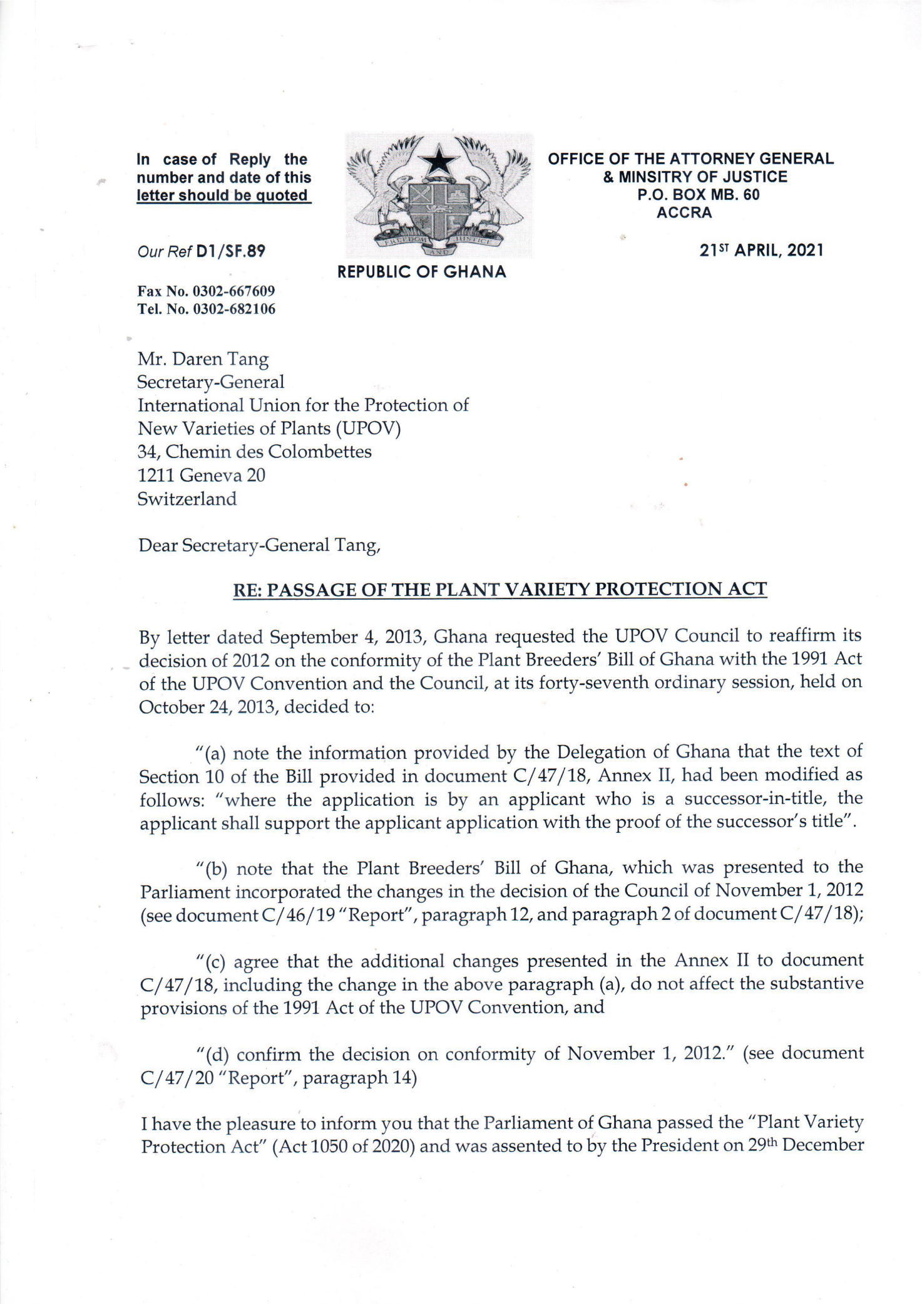
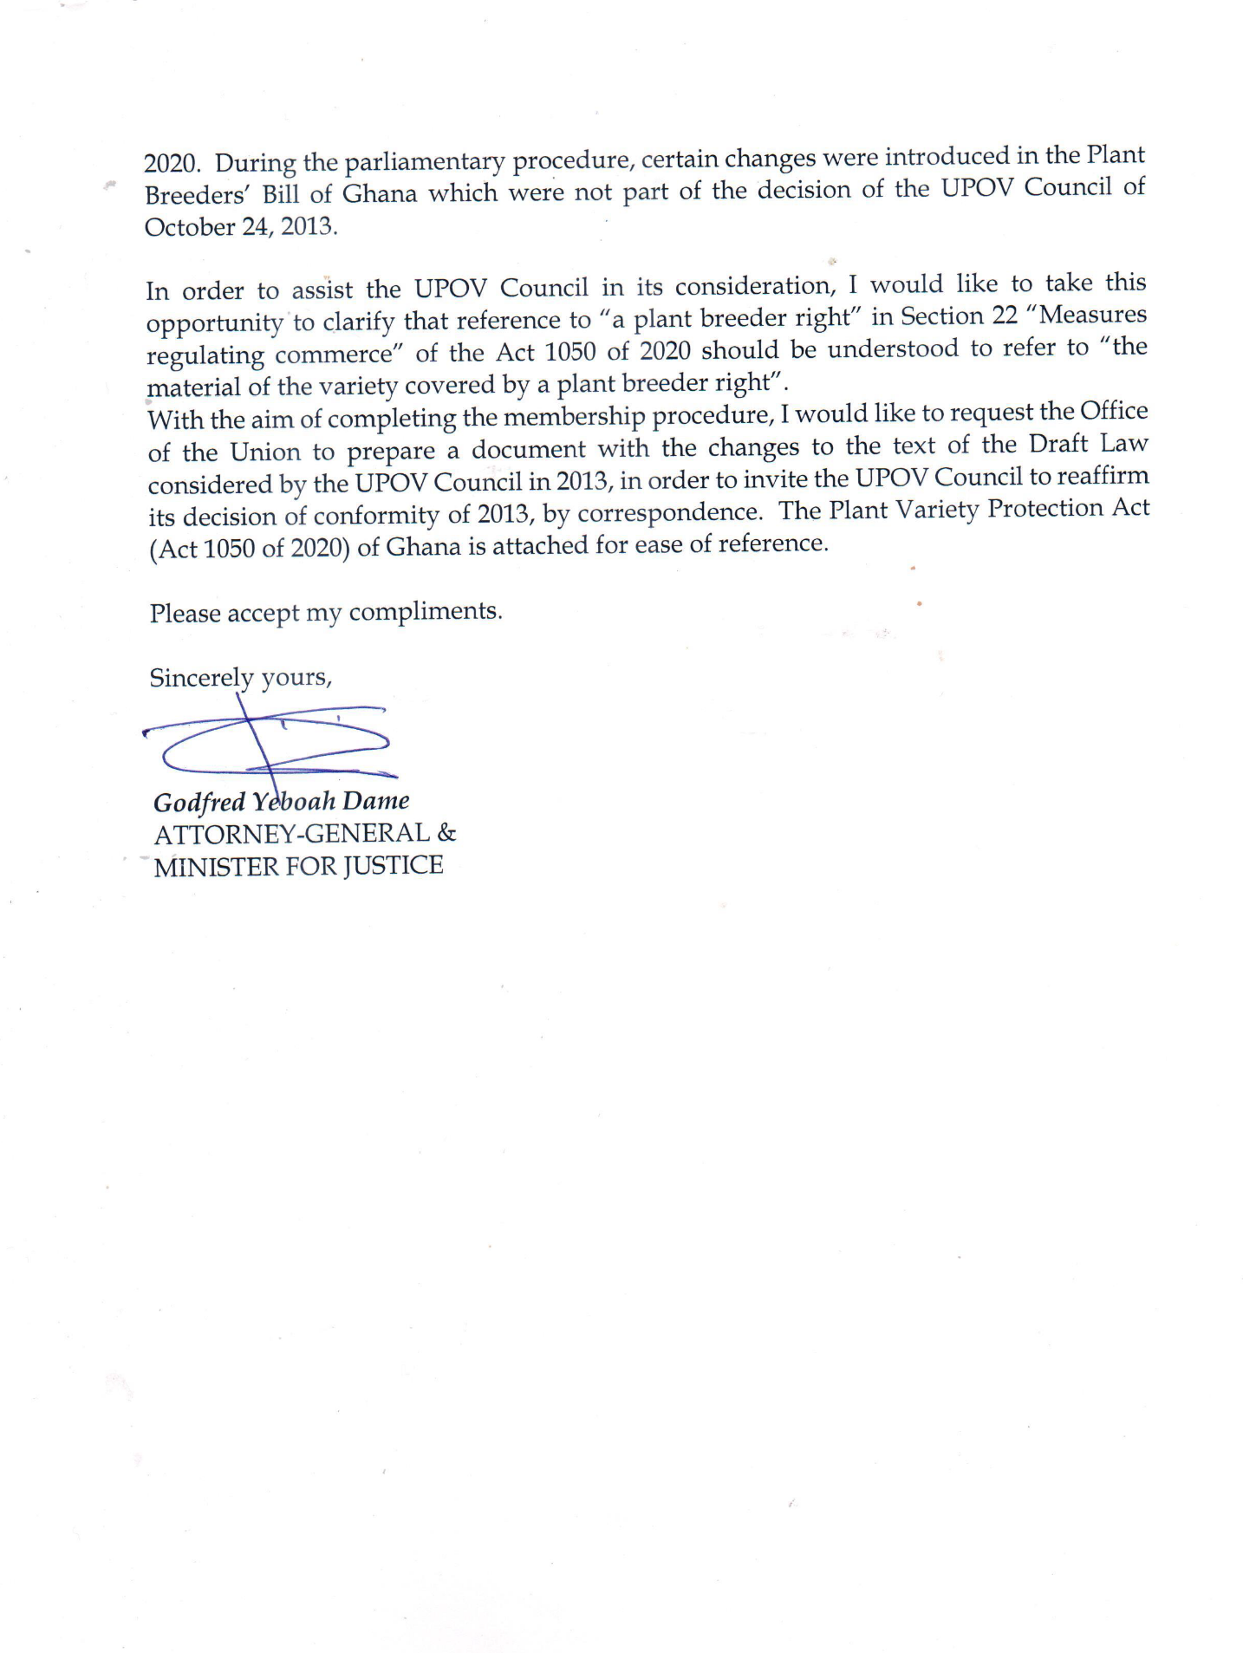

[Annex II follows]

CHANGES INTRODUCED IN THE PLANT VARIETY PROTECTION ACT (ACT 1050 OF 2020) OF GHANA IN RELATION TO THE TEXT PRESENTED TO THE COUNCIL IN 2013

The changes introduced in the text of the Act, as a result of the parliamentary procedure, in relation to the text of the Draft Law submitted to the Council in 2013 are presented in revision mode in this Annex.

Strikethrough indicates deletion from the text presented to the Council in 2013.

Underlining indicates insertion to the text presented to the Council in 2013.

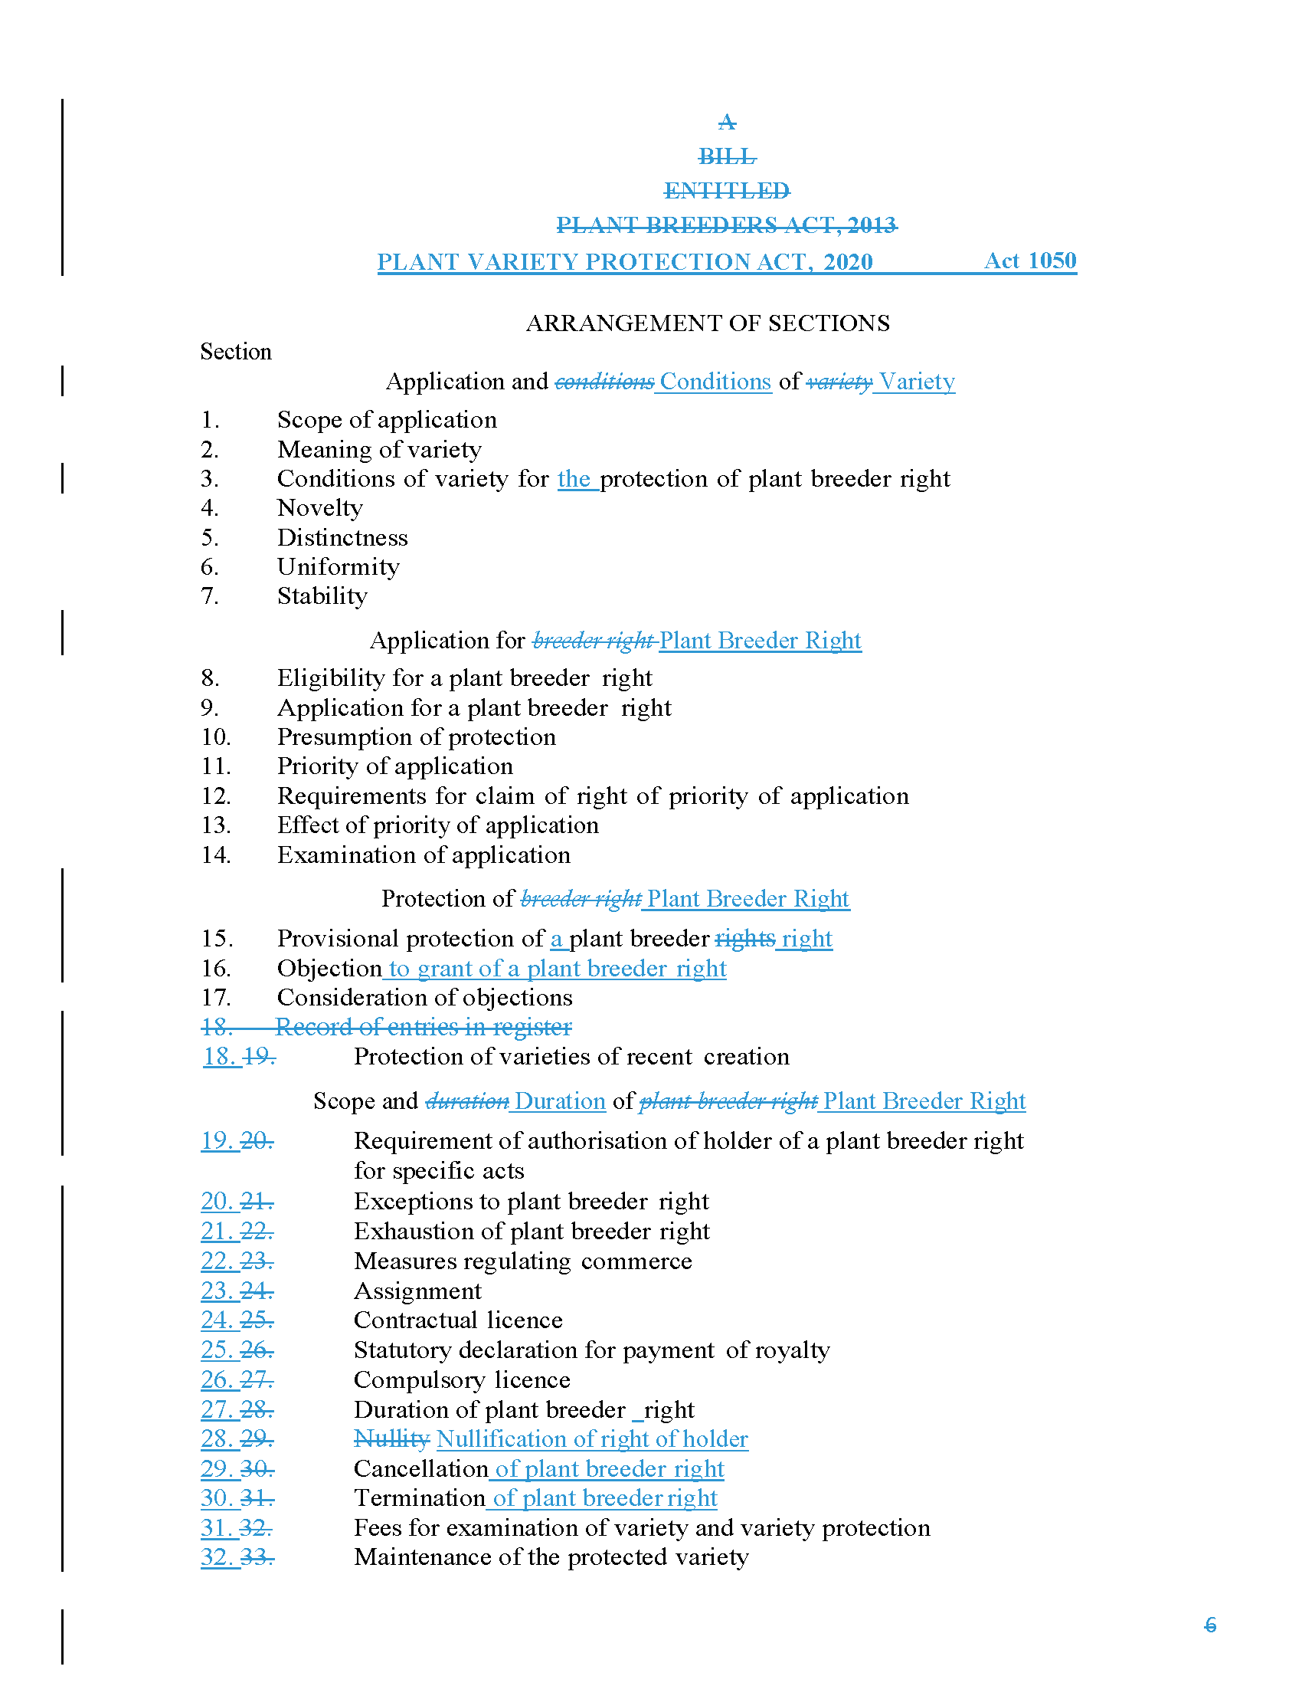

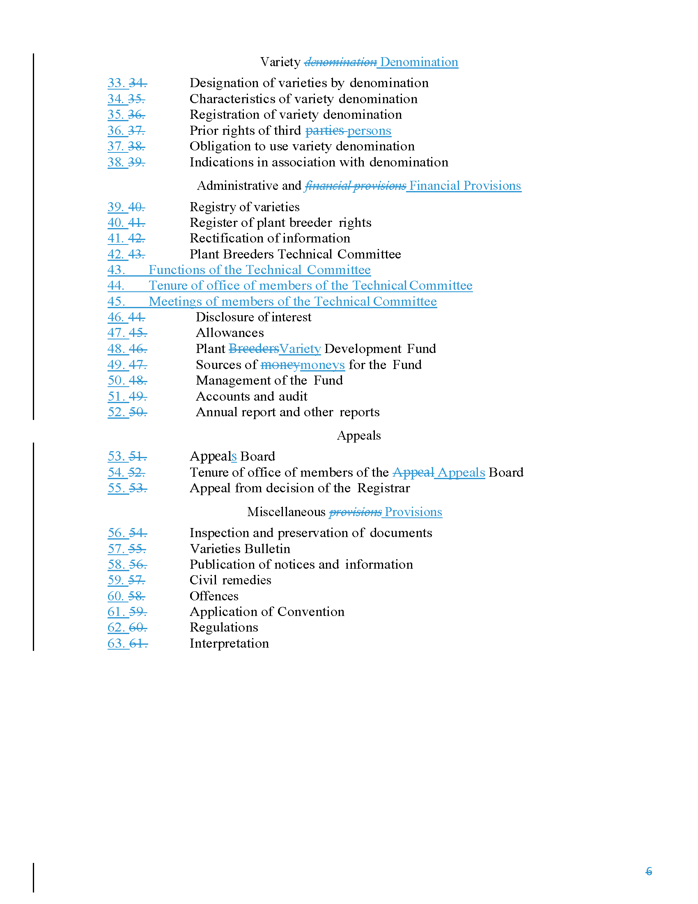

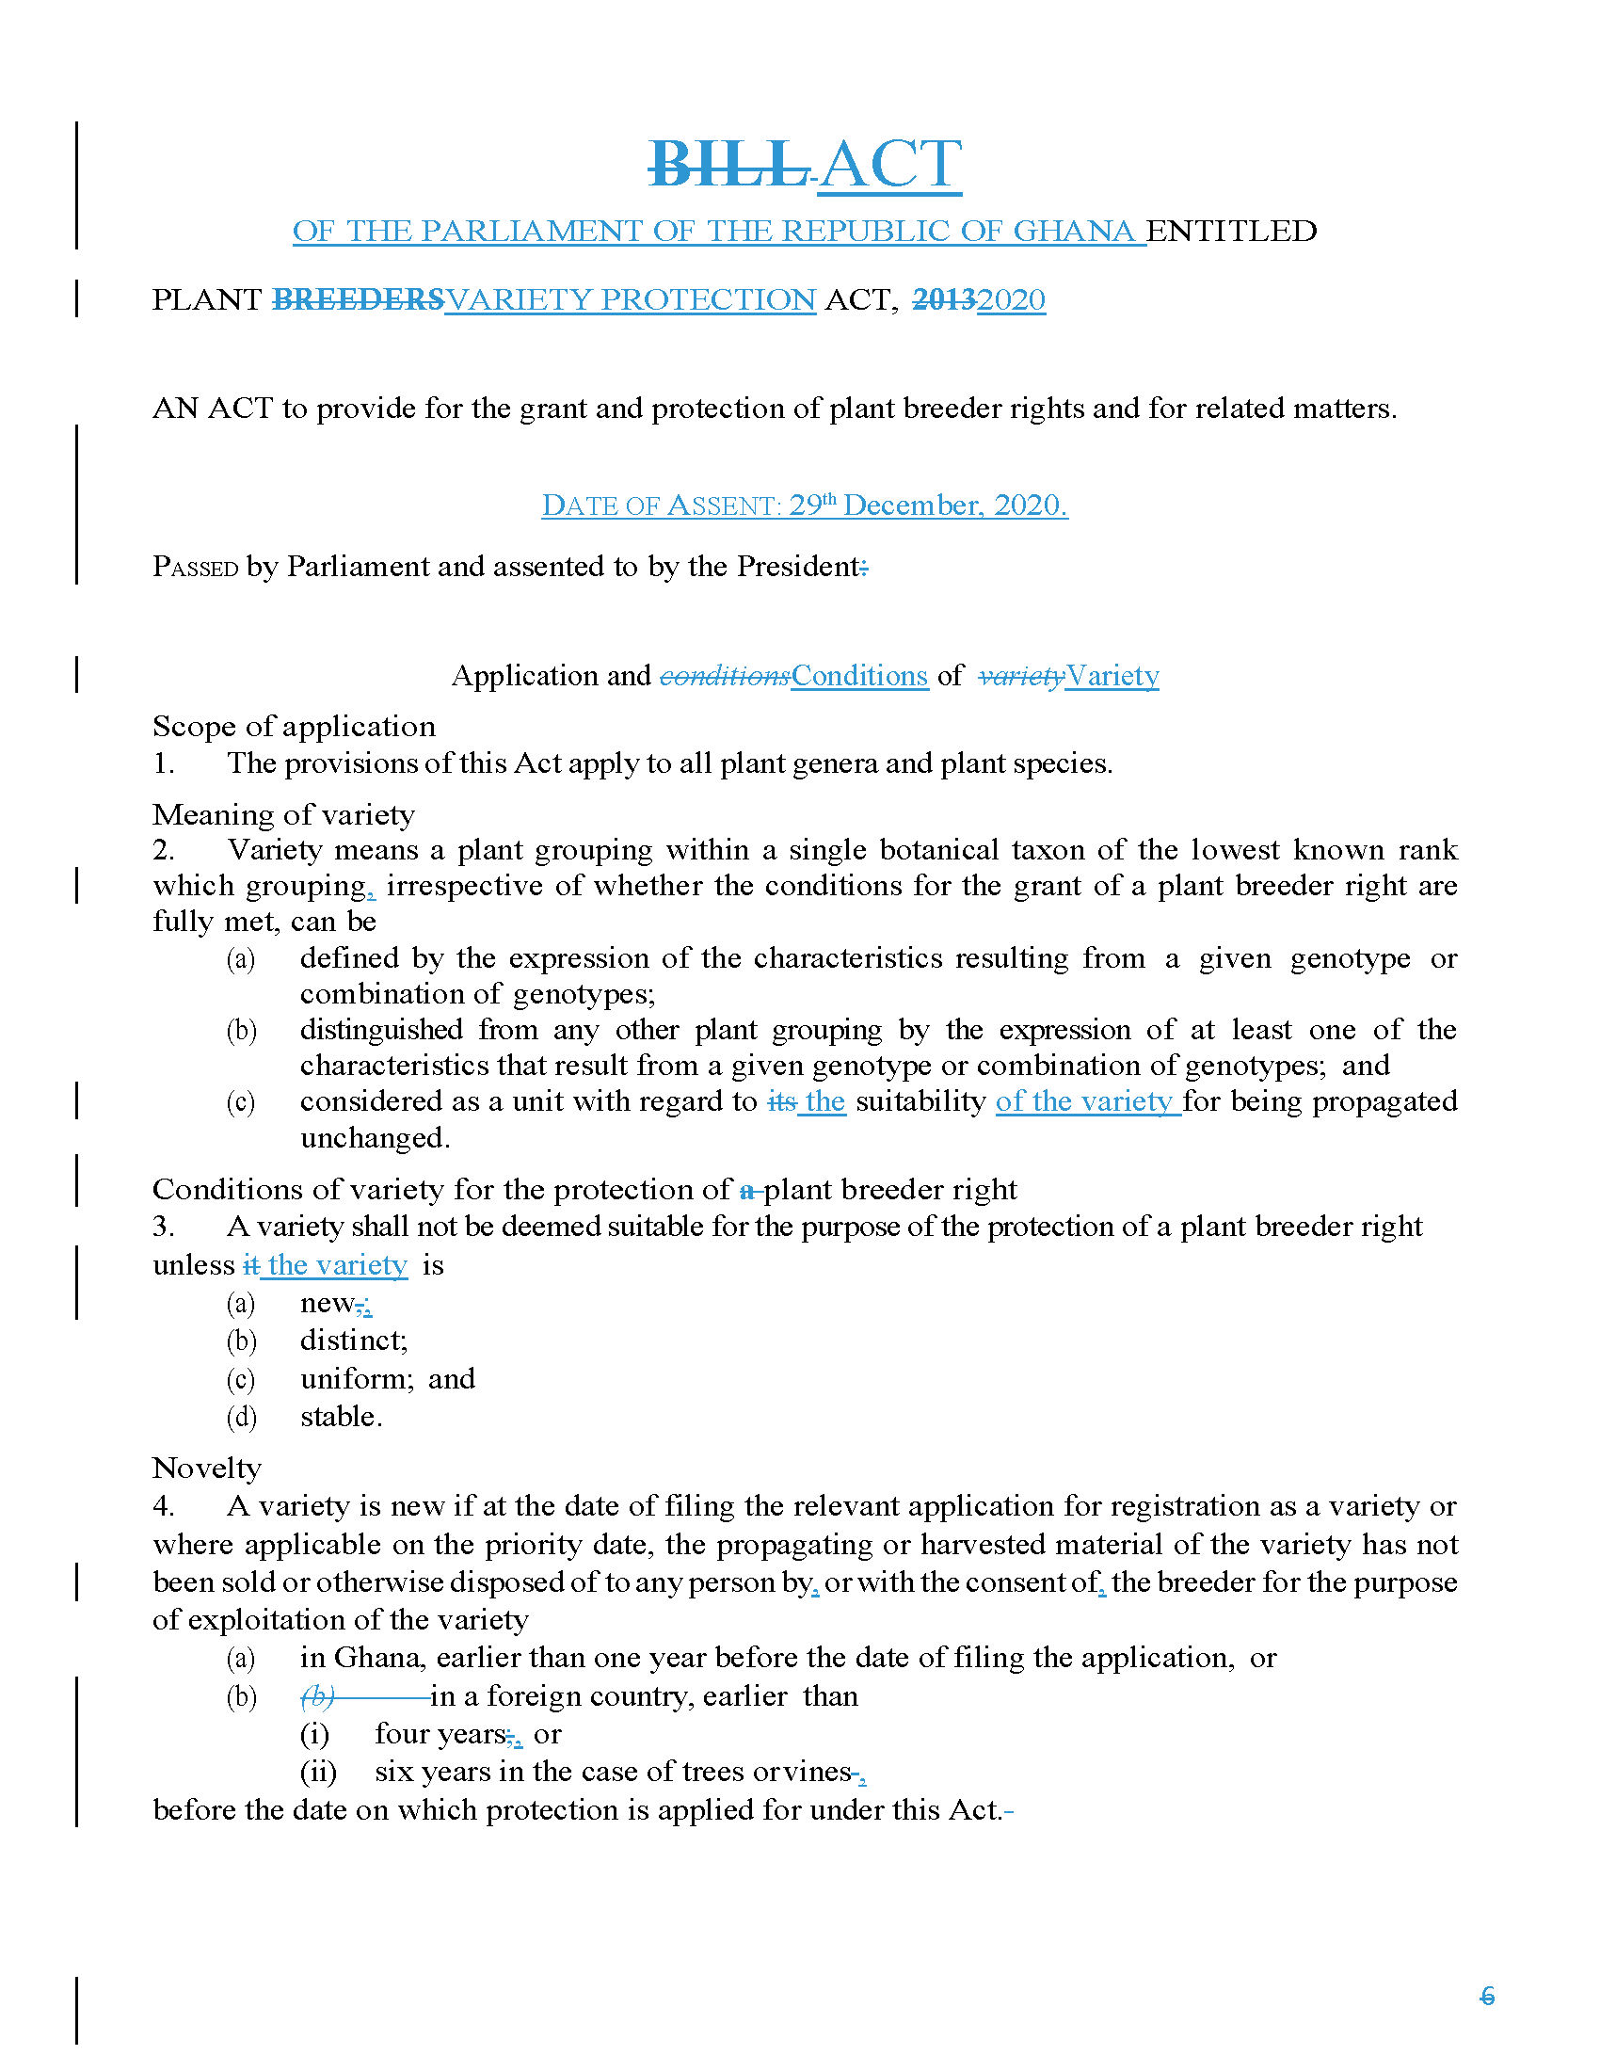

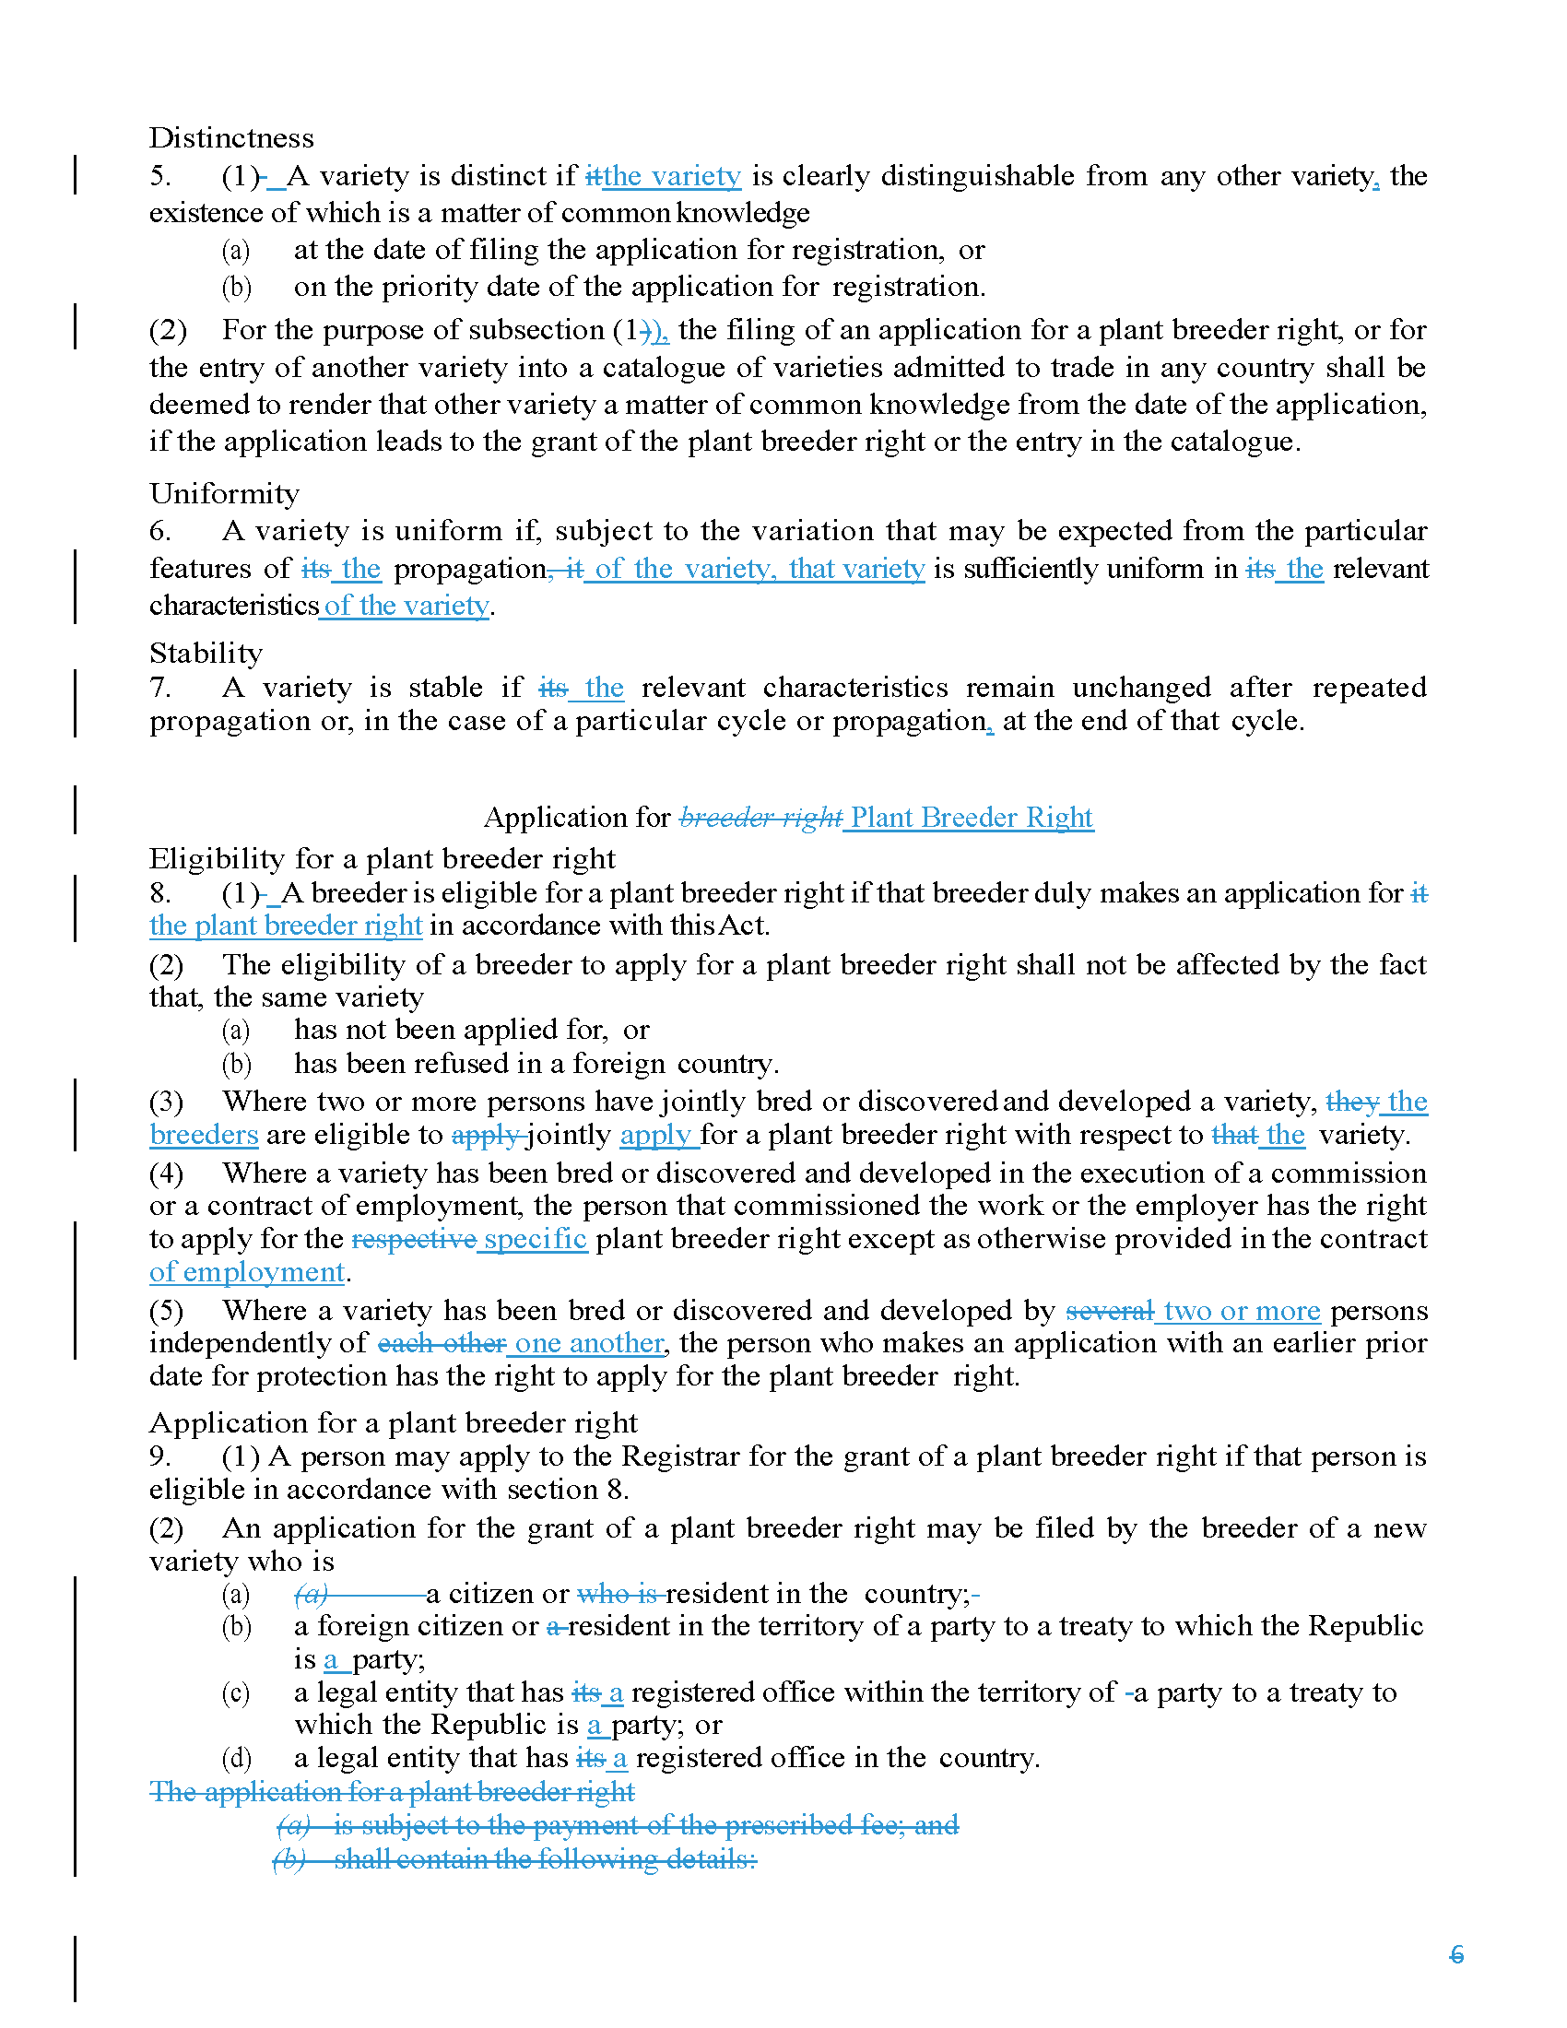

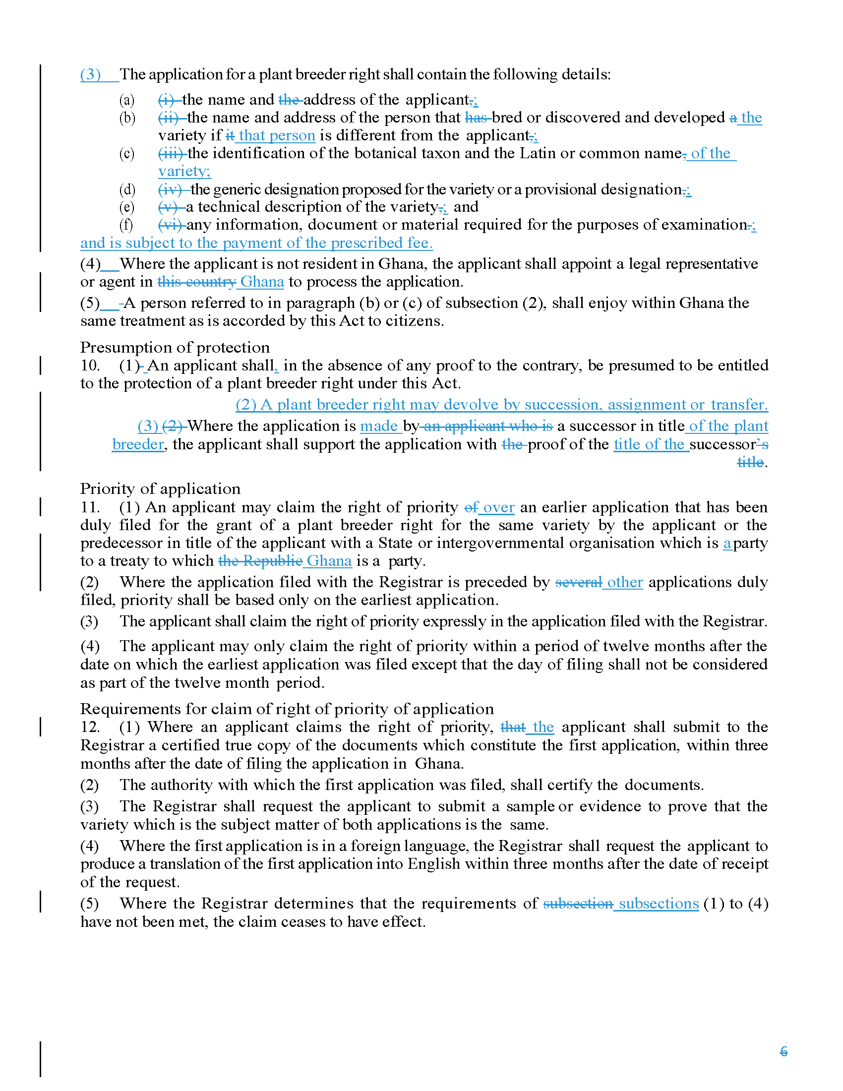

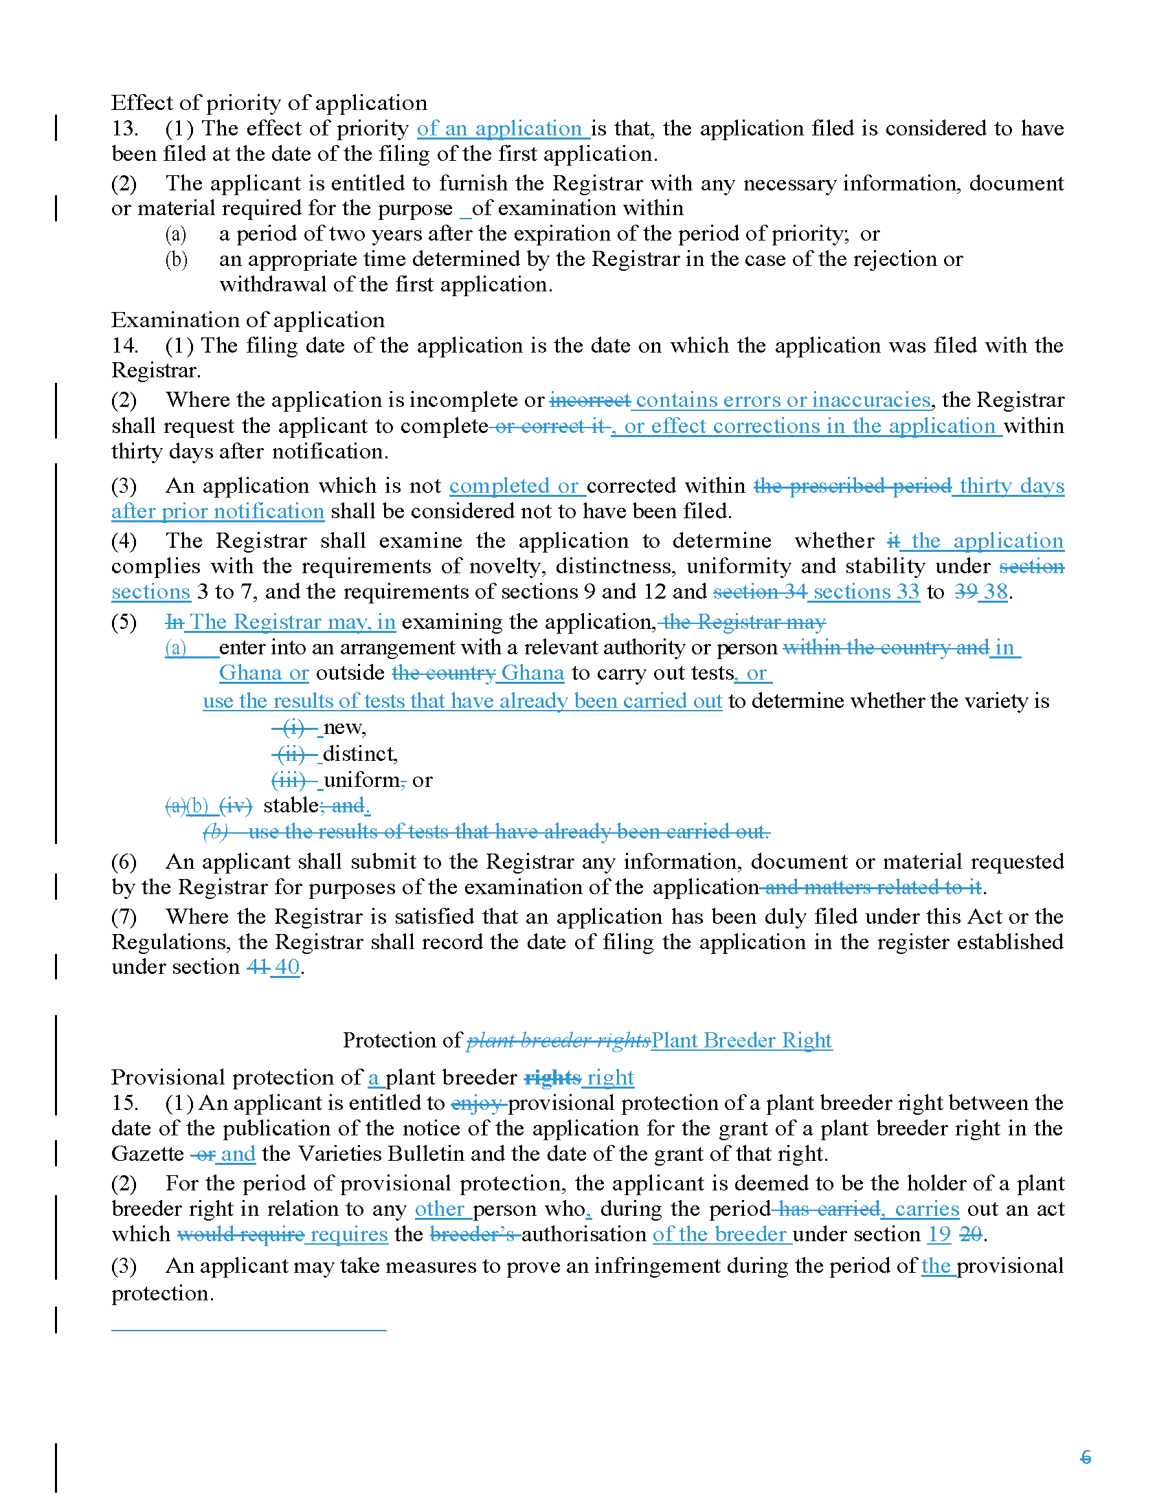

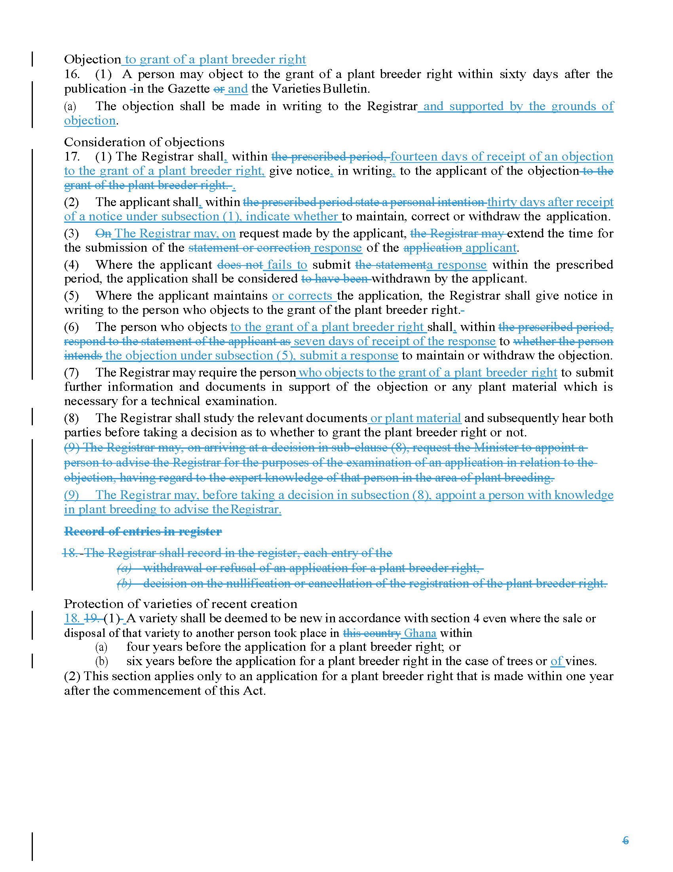

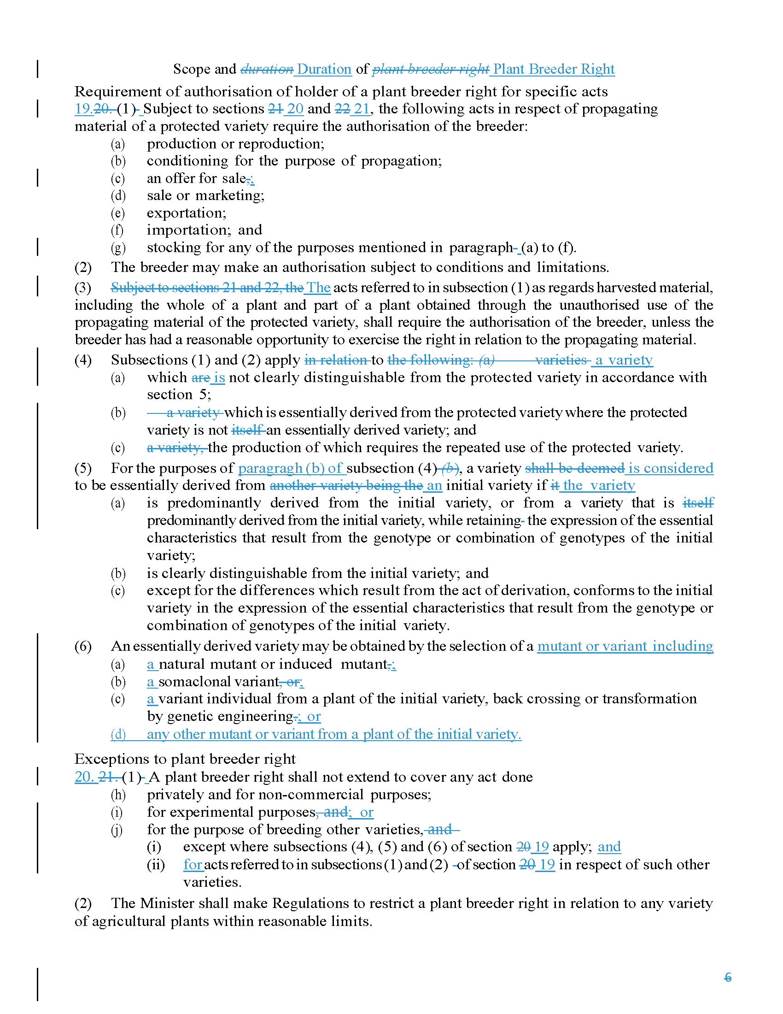

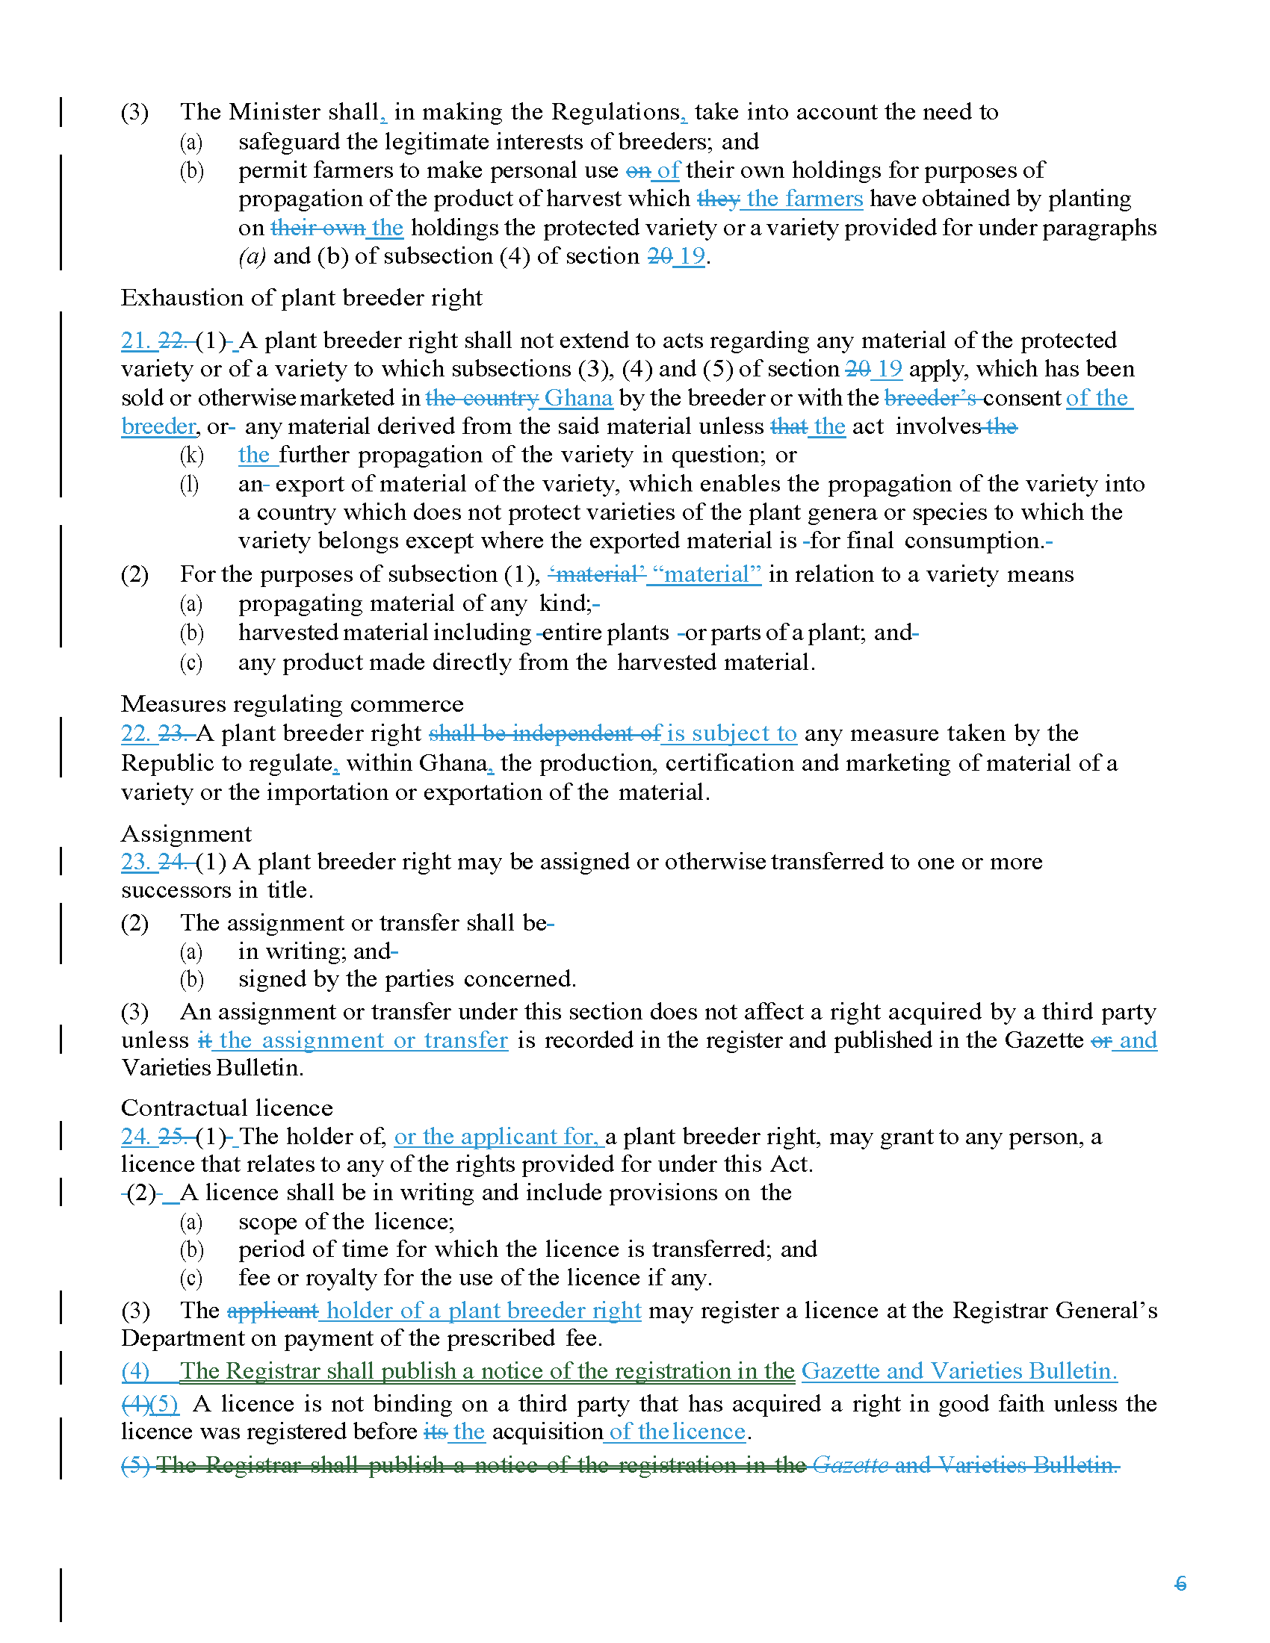

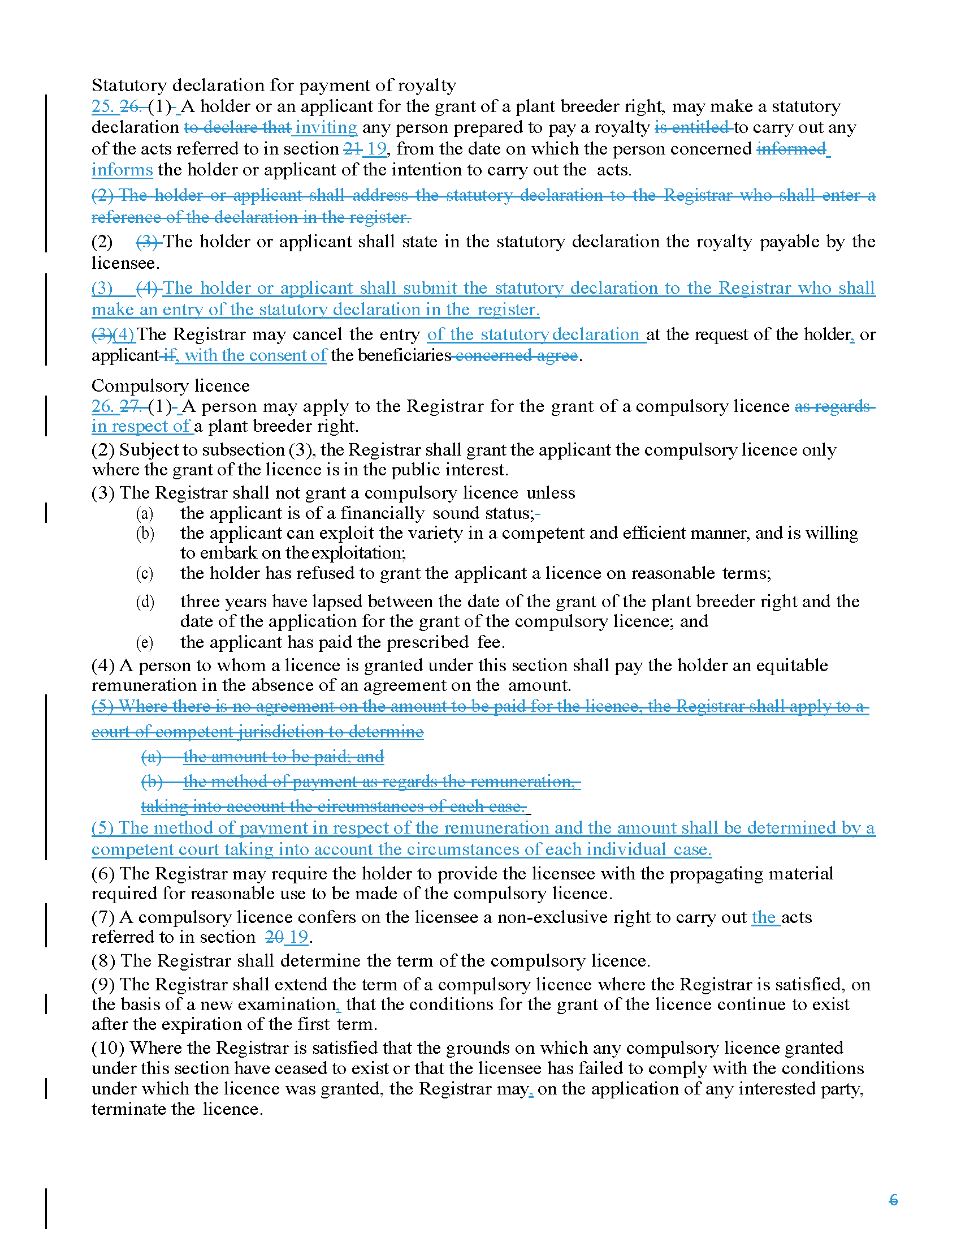

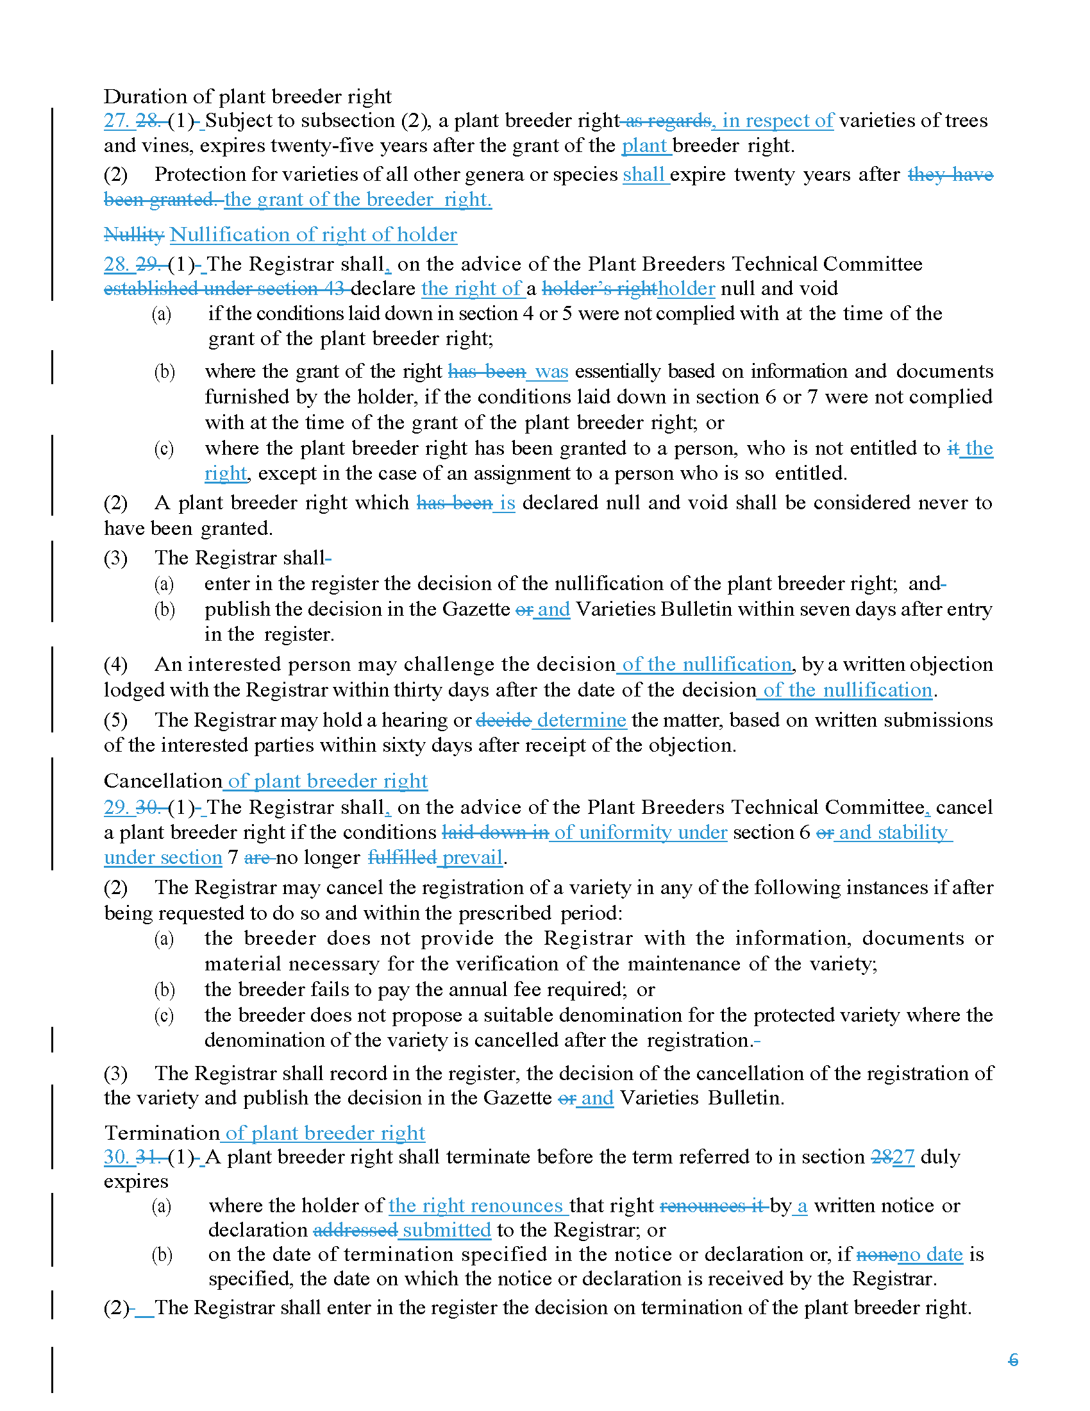

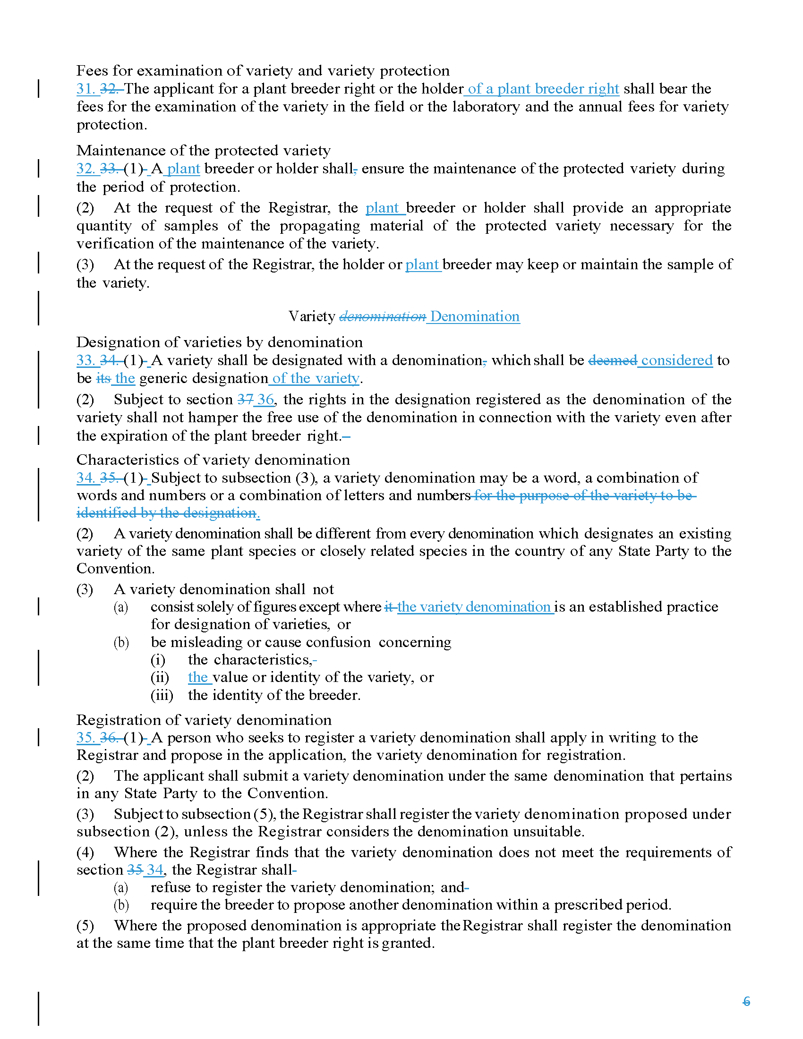

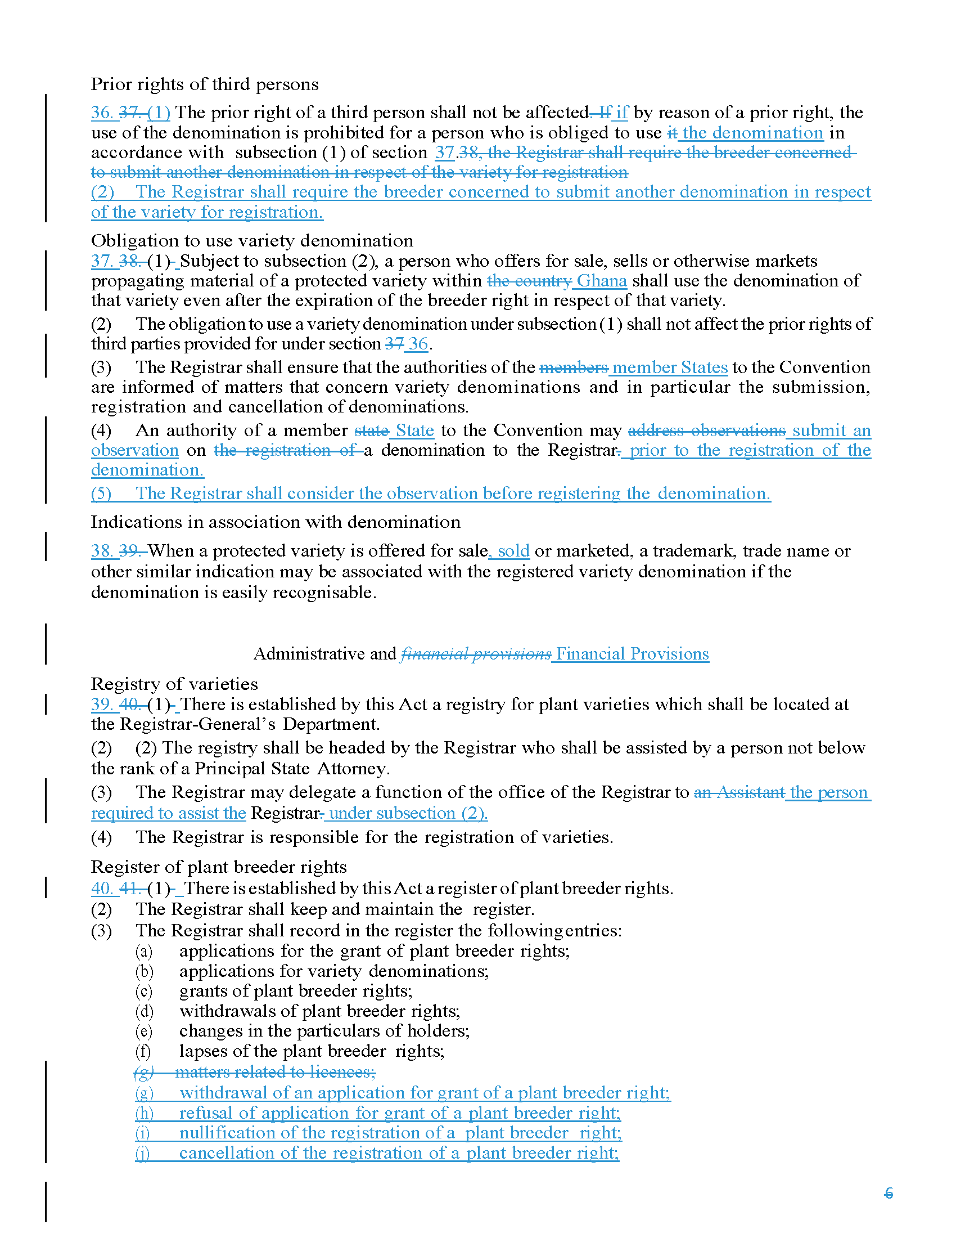

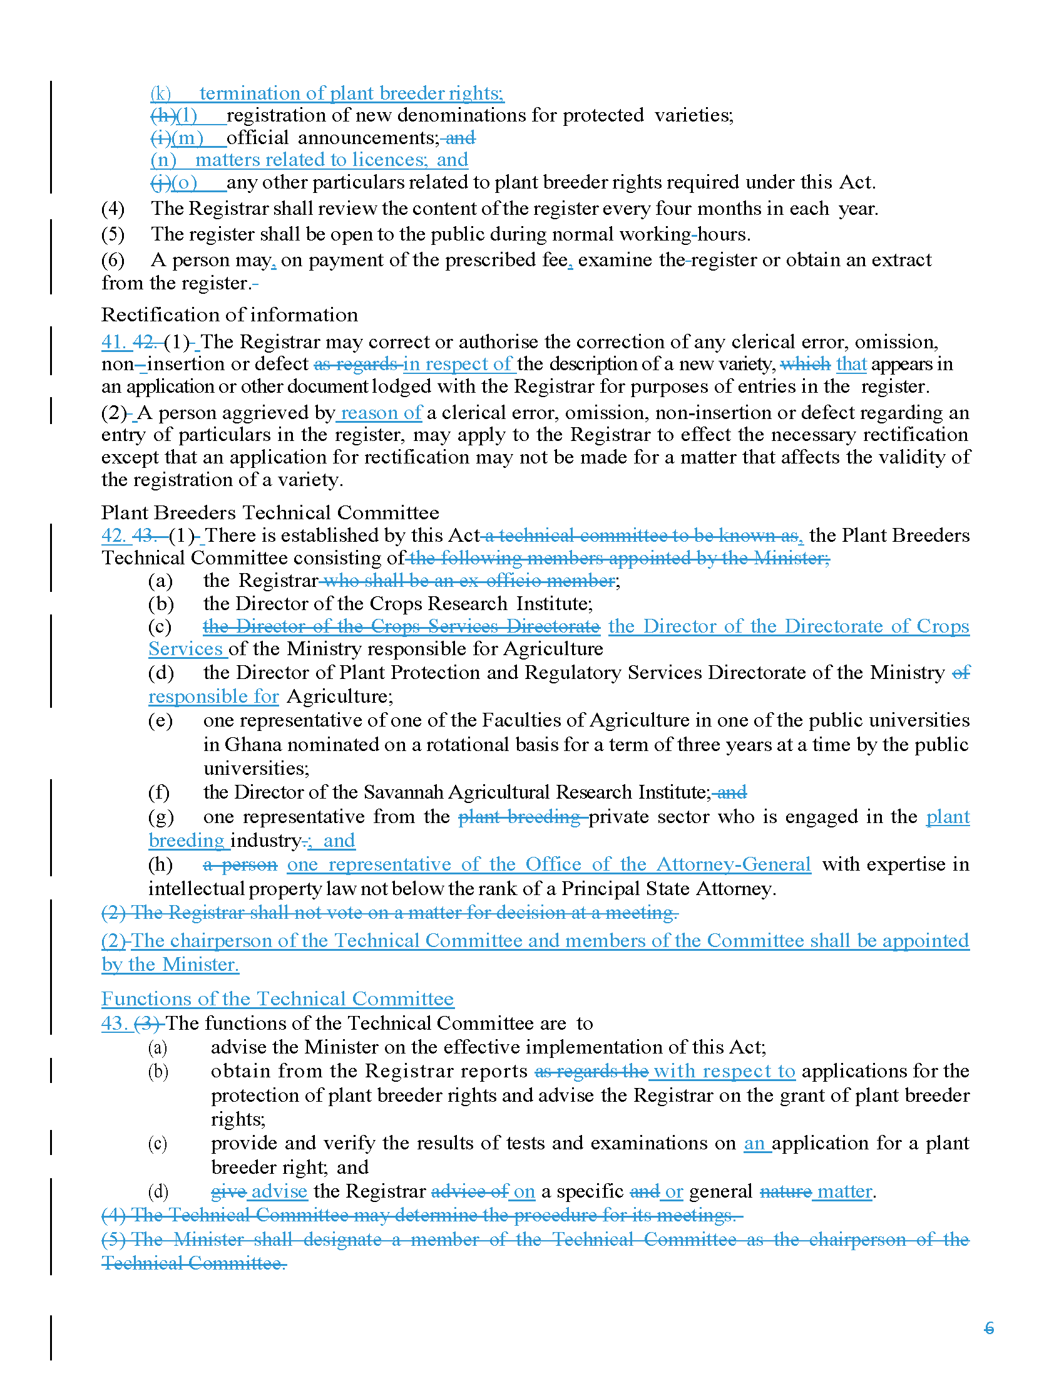

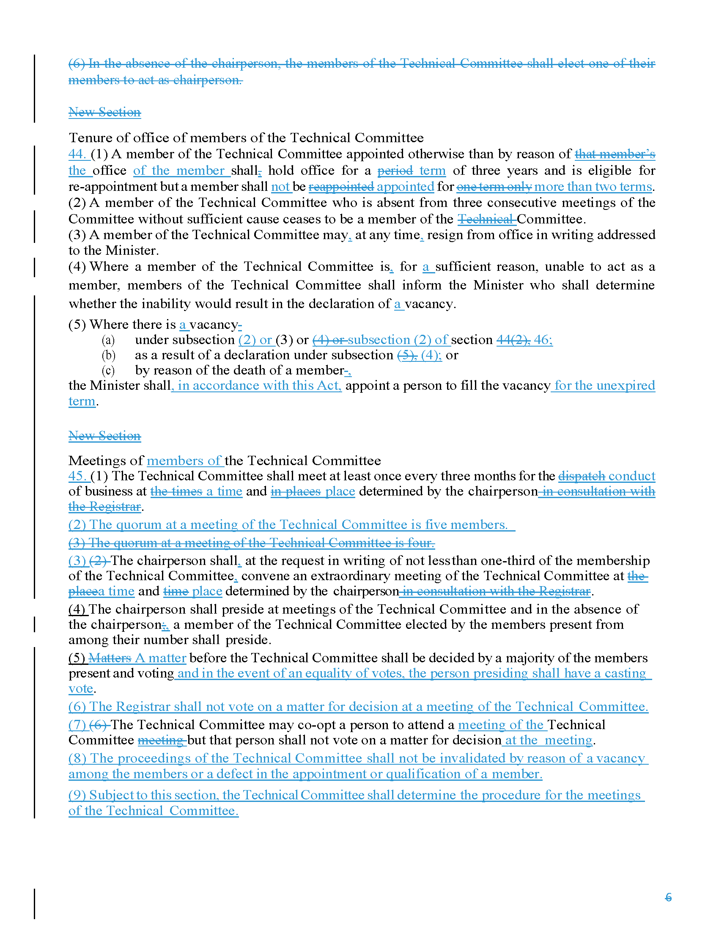

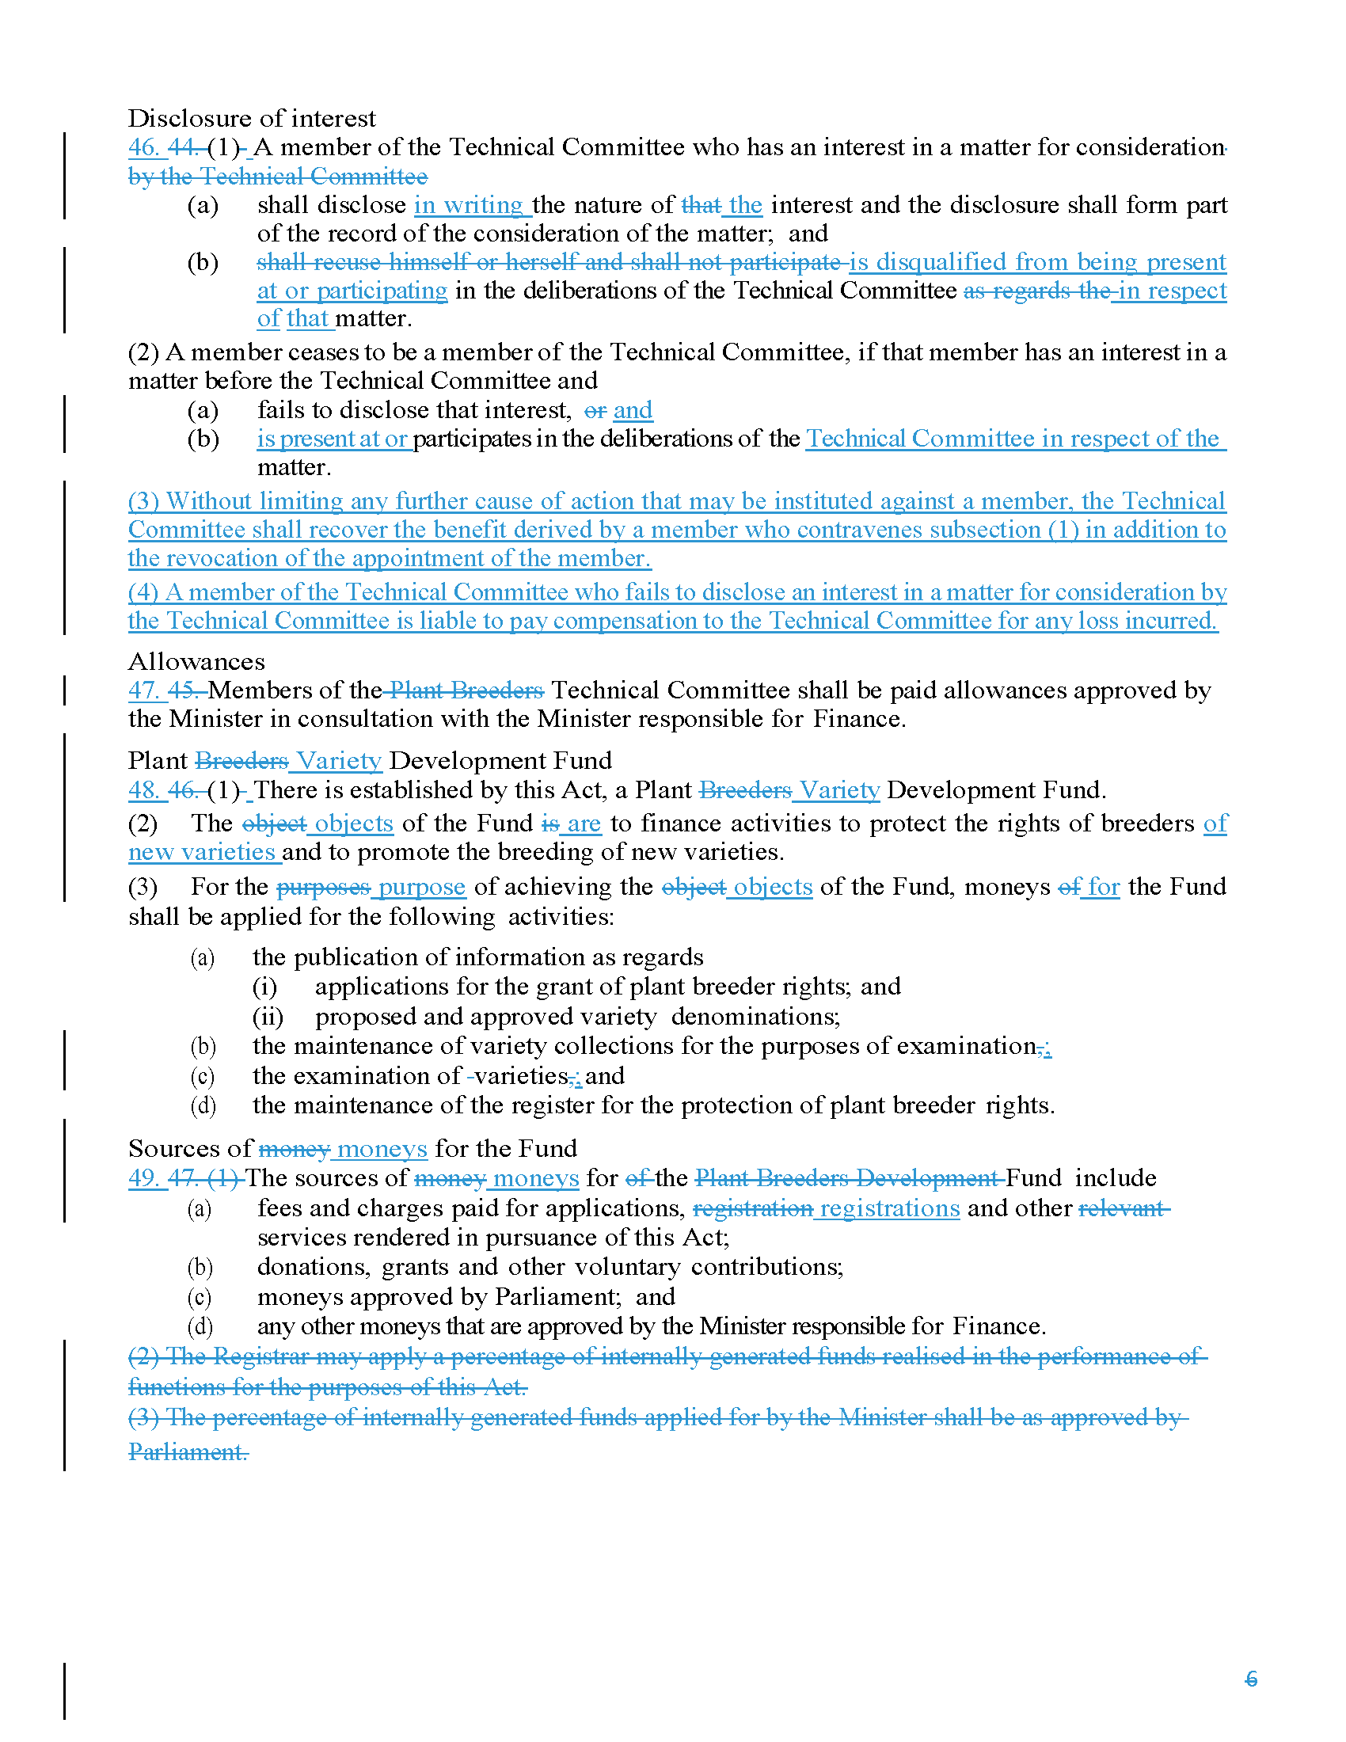

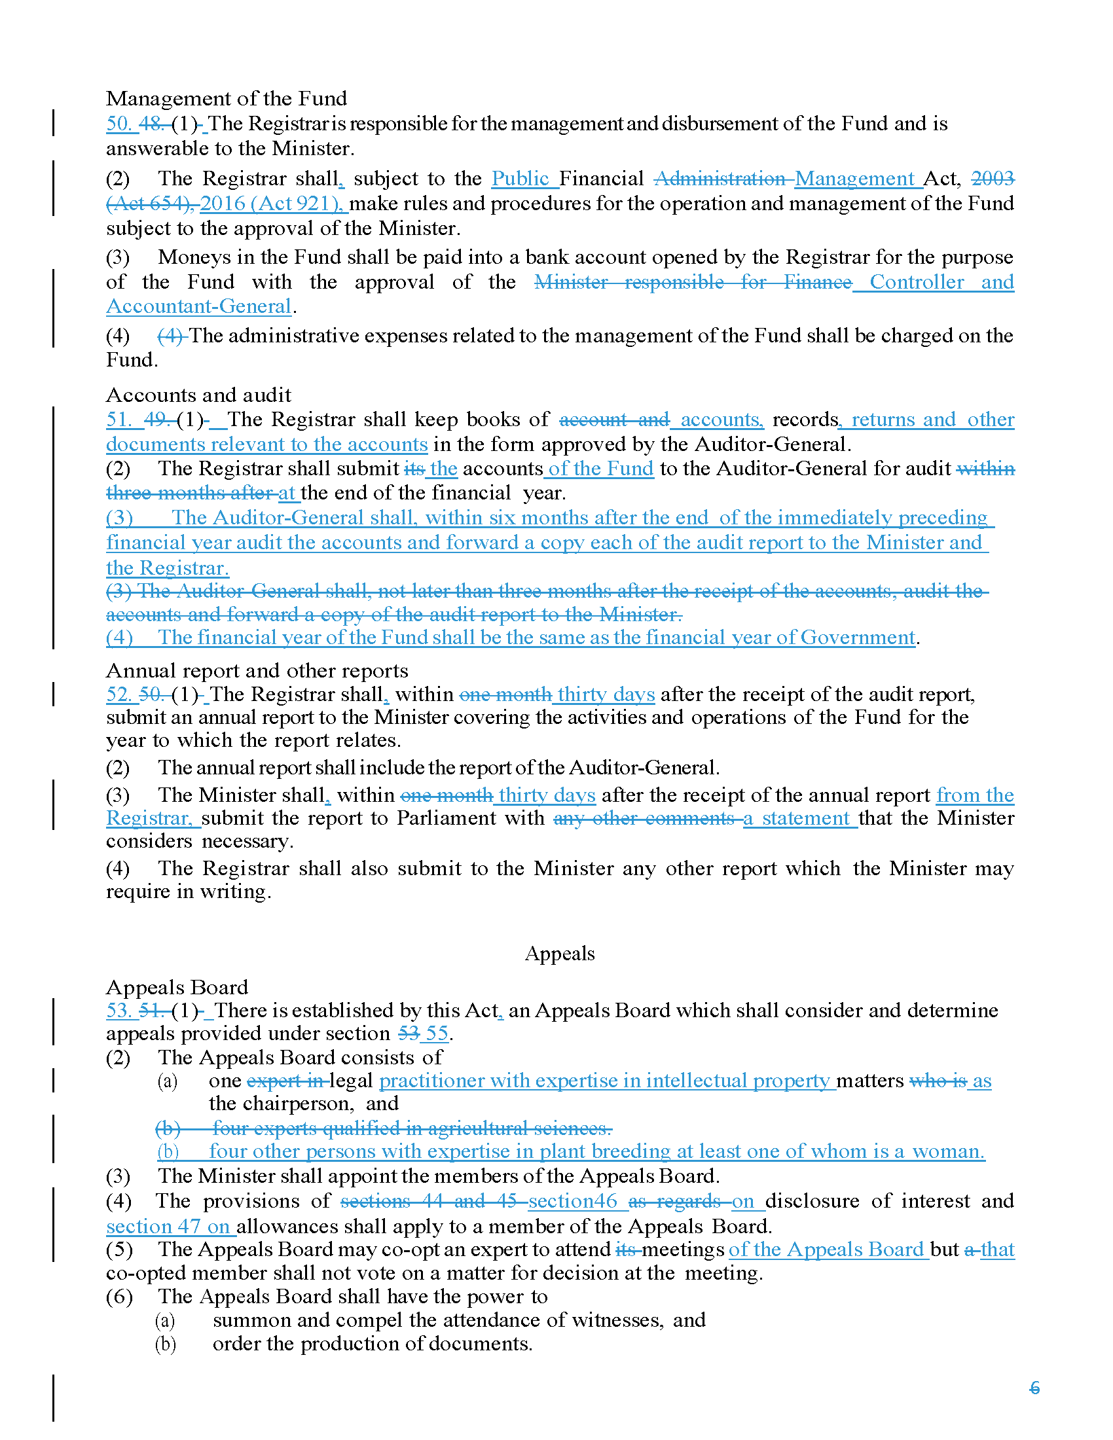

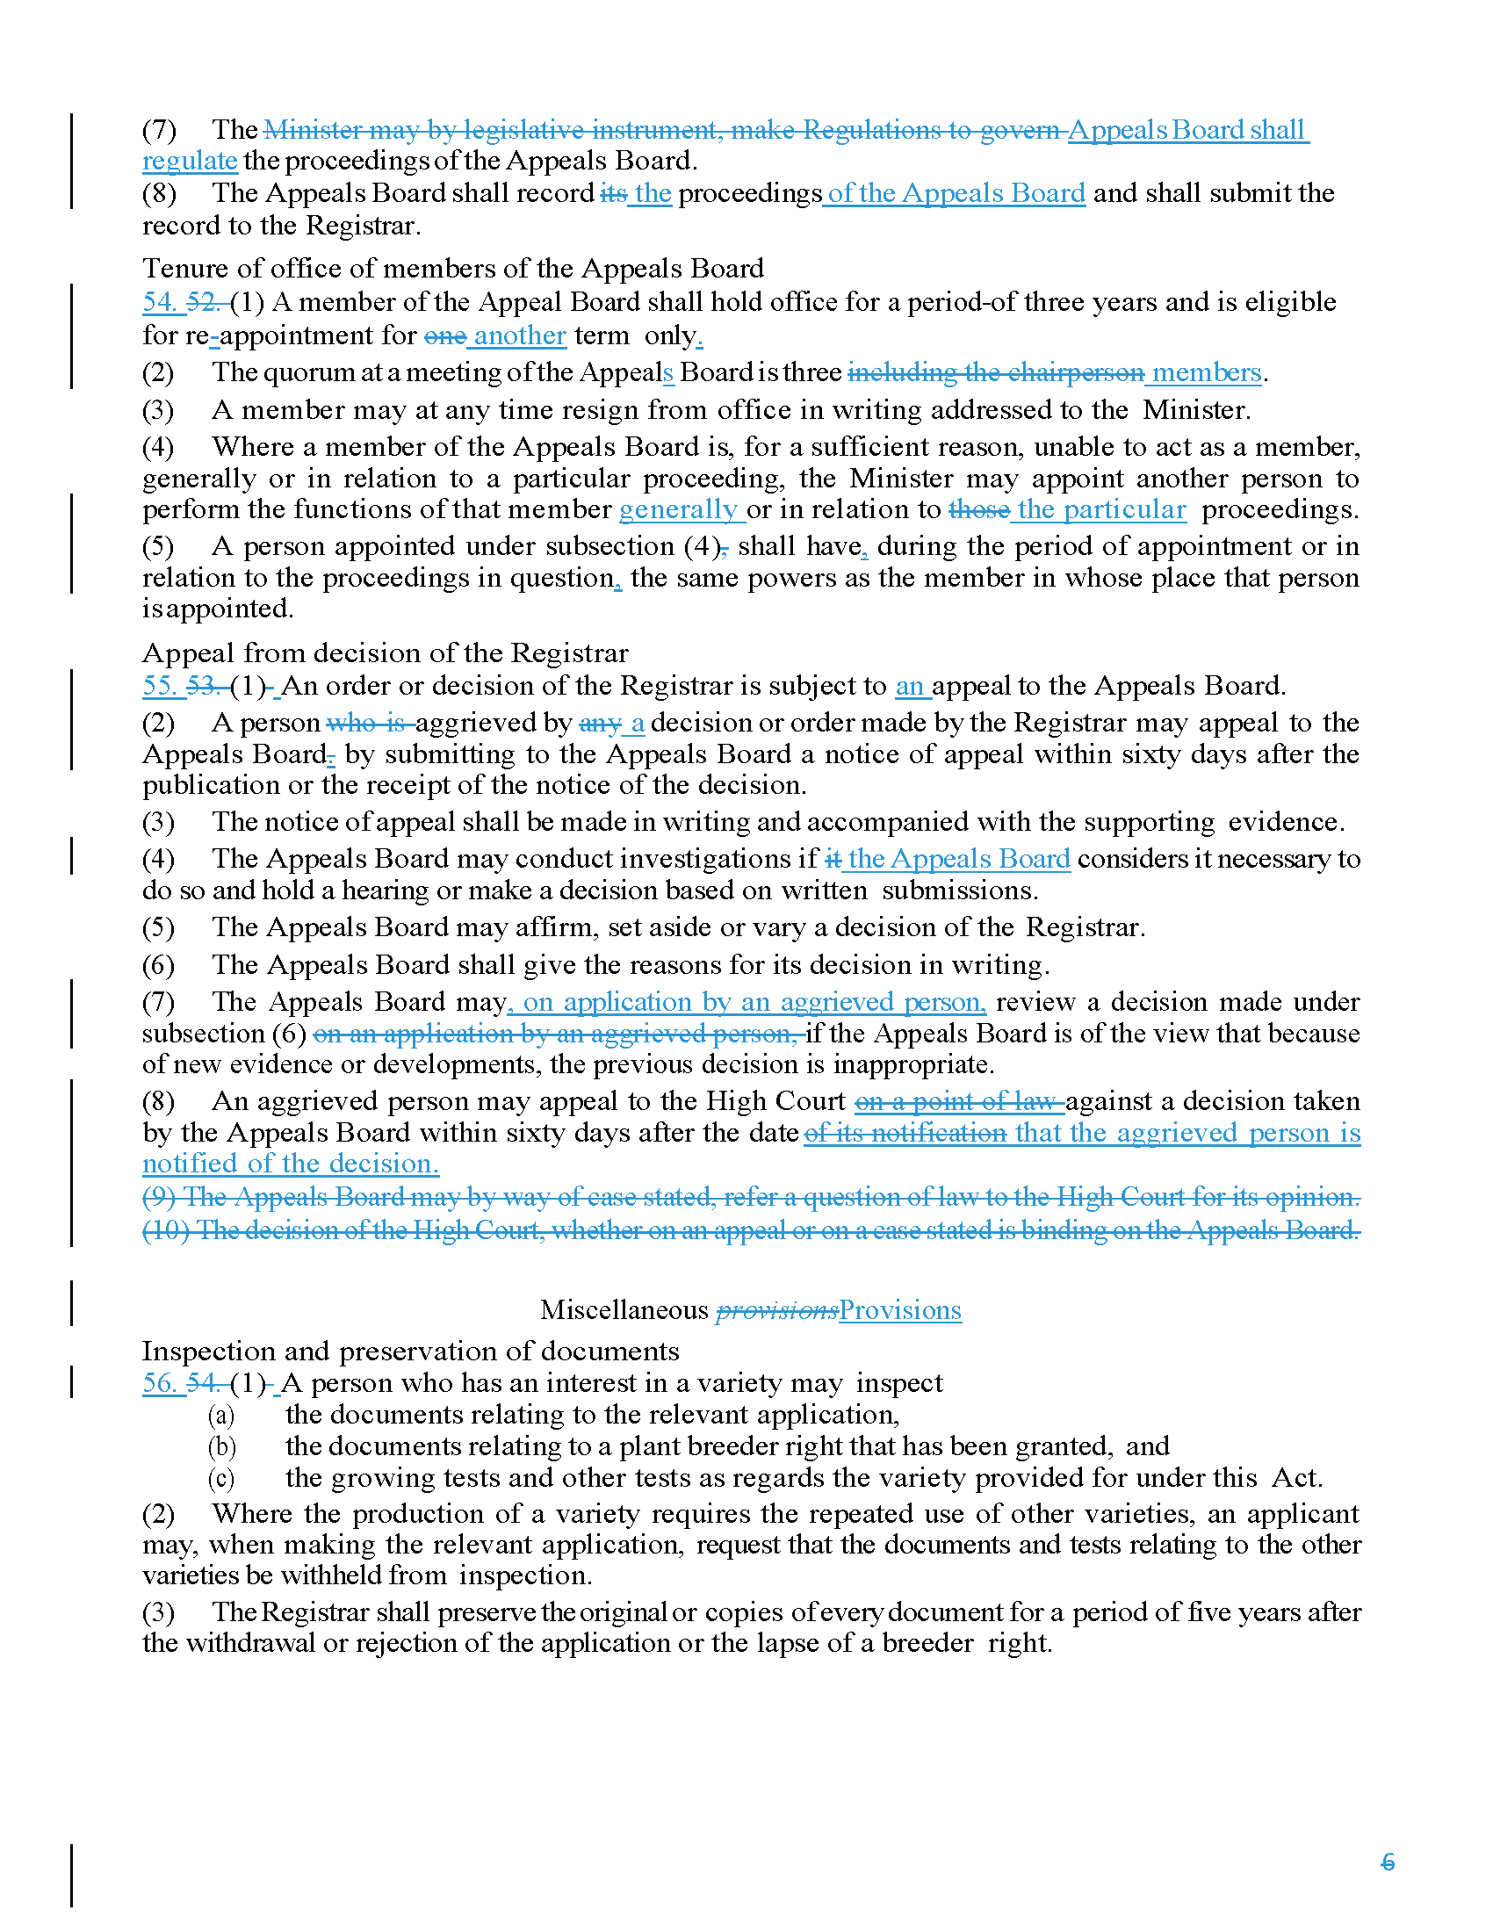

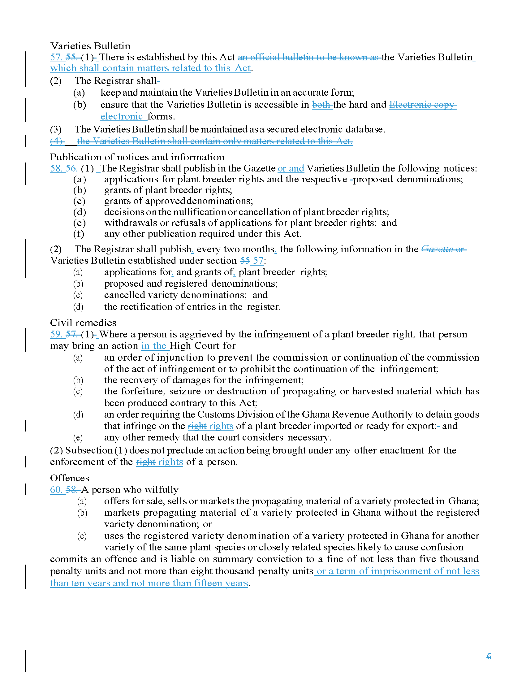

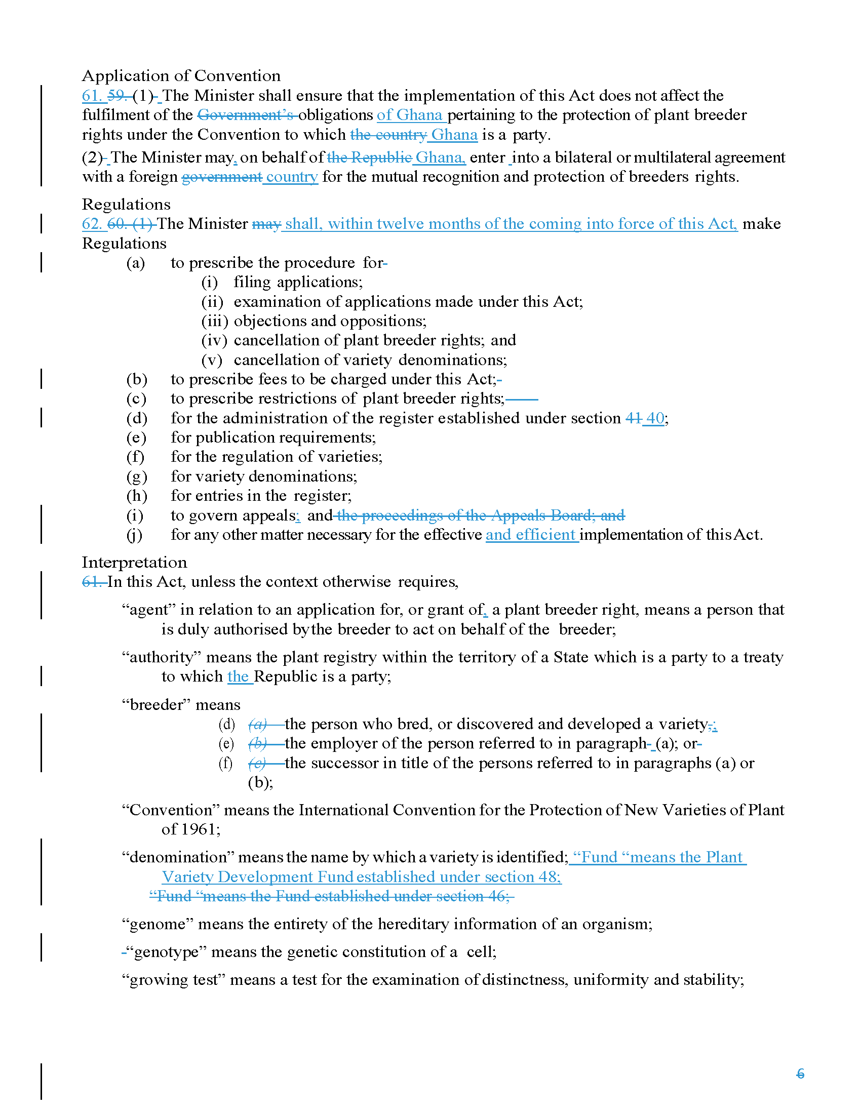

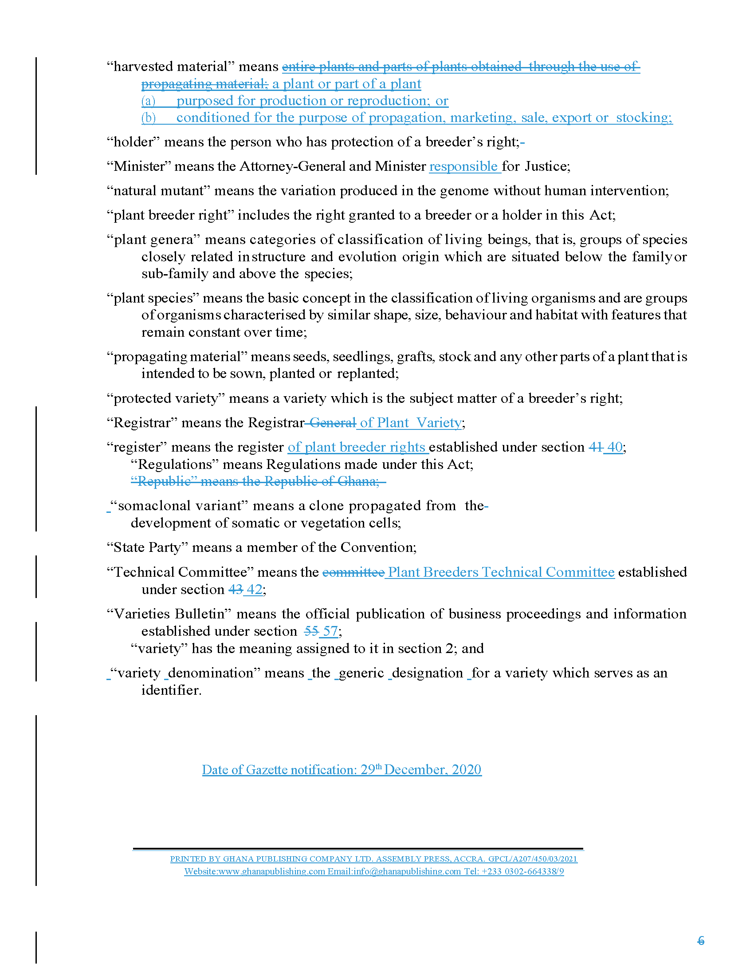
[End of Annex II and of document /
Fin de l’Annexe II et du document /
Ende der Anlage II und des Dokuments /
Fin del Anexo II y del documento]

