|  |  |
| --- | --- |
|  | E |
| International Union for the Protection of New Varieties of Plants |  |

|  |  |
| --- | --- |
| Council  Fifty-Fifth Ordinary Session Geneva, October 29, 2021 | C/55/INF/3  Original: English  Date: October 26, 2021 |

Report on activities during the first nine months of 2021

Document prepared by the Office of the Union

Disclaimer: this document does not represent UPOV policies or guidance

EXECUTIVE SUMMARY

Saint Vincent and the Grenadines became the seventy-seventh member of UPOV on March 22, 2021.

In response to the ongoing COVID-19 pandemic, a number of measures continued to be taken in 2021 in recognition of UPOV’s commitment to the health and safety of its personnel, as well as the communities where they live and work, while delivering the program of work approved by the Council. As the epidemiological situation improved, a phased return to work for UPOV staff began in September and is due to be complete by mid-November, except for staff in a “vulnerable” category. Returning personnel will work on premises at least two days per week.

All meetings of UPOV bodies in the first nine months of 2021 were conducted by virtual means.

No official travel was undertaken in the first nine months of 2021.

The lack of travel has been compensated by virtual activities, resulting in an increased number of meetings or activities compared to 2019 (see Figure 1).

Figure 1. Number of missions, activities and meetings involving UPOV

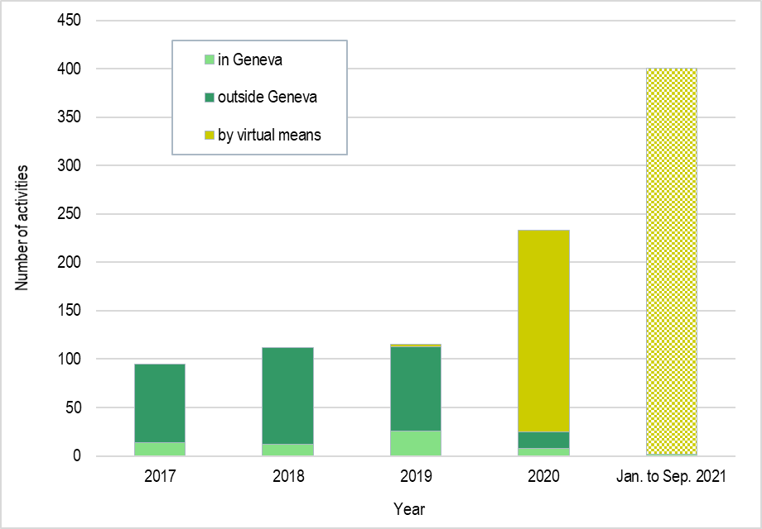

The move to virtual meetings of UPOV bodies, combined with consideration of documents by correspondence, resulted in significantly more time being allocated to meeting preparation and administration. This was possible because of the reduction in travel time of UPOV staff and time required for organizing travel to physical activities. In terms of financial resources, the reduction in travel costs was somewhat offset by the additional cost of hosting virtual meetings of UPOV bodies that meet in Geneva. The reduction in travel costs also enabled investment in IT development work on UPOV PRISMA, PLUTO and e-PVP to be advanced.

There was considerable growth in the number of applications made via UPOV PRISMA in 2021 compared to previous years, with 1,864 applications being made from January 1 to September 30, 2021, compared to 221 in 2020 (see Figure 2).

Figure 2. Applications in UPOV PRISMA (annual)



16. The new version of the PLUTO database was launched on October 11, 2021, at the new URL <https://pluto.upov.int>.

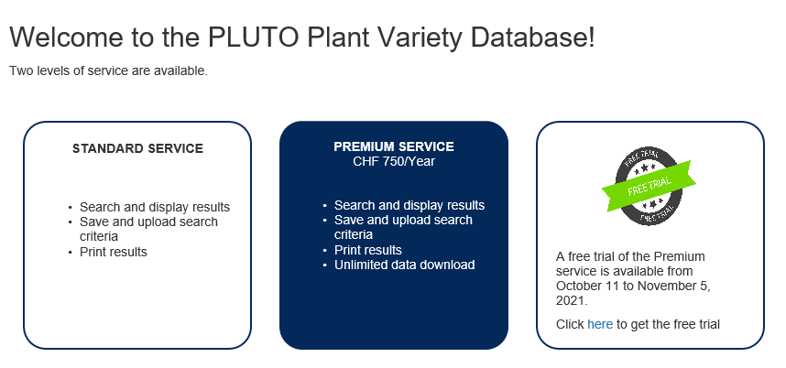

Table of contents

UPOV status 5

Members 5

Situation in Relation to the Various Acts of the Convention 5

States/organizations that have initiated the procedure to become a member of the Union 5

Activities in 2021 6

Sessions of UPOV Bodies 6

Other meetings and events 6

Distance learning courses 7

UPOV PRISMA 7

PLUTO database 7

Publications 7

ANNEX I: Members of the Union

ANNEX II: Participation in the UPOV distance learning courses

ANNEX III: List of activities during the first nine months of 2021

APPENDIX: Acronyms and abbreviations

# UPOV status

## Members

Saint Vincent and the Grenadines deposited its instrument of accession to the UPOV Convention on February 22, 2021, and became the seventy-seventh member of UPOV on March 22, 2021.

As of September 30, 2021, the Union comprised 77 members (75 States and 2 organizations), covering 96 States (see figure 3). The “List of UPOV members” is reproduced in Annex I.

Figure 3. Members of the Union as at September 30, 2021

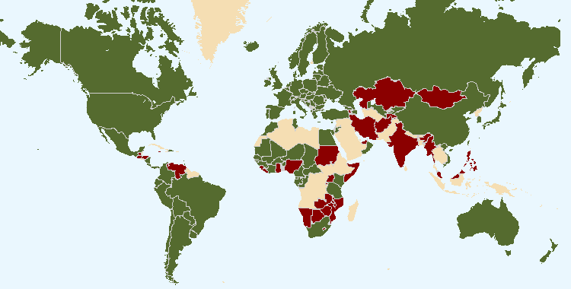

The boundaries shown on this map do not imply the expression of any opinion whatsoever on the part of UPOV concerning the legal status of any country or territory

## Situation in Relation to the Various Acts of the Convention

On September 30, 2021, the situation of the members of the Union in relation to the Convention and its various Acts was as follows:

(a) 60 members (covering 81[1] States) were bound by the 1991 Act; and

(b) 17 members were bound by the 1978 Act.

## States/organizations that have initiated the procedure to become a member of the Union

In 2021, the Council reaffirmed its decision on conformity with the 1991 Act of the UPOV Convention in respect of the following laws:

1. the “Plant Variety Protection Act” (Act 1050 of 2020) of Ghana, which was adopted by the Parliament of Ghana and enacted by the President on December 29, 2020;
2. the “Plant Variety Protection Act, 2021” of Nigeria, which was adopted by the National Assembly on March 3, 2021.

At the request of Jamaica dated September 27, 2021, the New Plant Varieties (Rights of Breeders) Bill, 2021, of Jamaica will be examined by the Council, at its fifty-fifth ordinary session, to be held via electronic means on October 30, 2021, for conformity with the 1991 Act of the UPOV Convention.

The following map provides a graphic overview of developments concerning the status in relation to UPOV during the first nine months of 2021:

Figure 4 - Changes of status in relation to UPOV during the first nine months of 2021

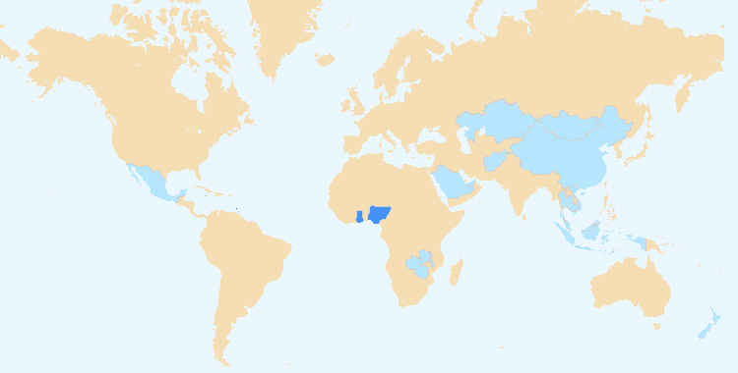

The boundaries shown on this map do not imply the expression of any opinion whatsoever on the part of UPOV concerning the legal status of any country or territory.

 State that became member of the Union during the first nine months of 2021: Saint Vincent and the Grenadines (1)

 States and organizations that requested advice from the Council of UPOV during the first nine months of 2021: Ghana, Jamaica and Nigeria (3)

 States and organizations that were in contact with the Office of the Union for assistance in the development of legislation on plant variety protection during the first nine months of 2021

Members of the Union (5): China, Mexico, New Zealand, Trinidad and Tobago and Viet Nam

Non-members of the Union (16): Afghanistan, Barbados, Cambodia, Ghana, Indonesia, Jamaica, Kazakhstan, Malaysia, Malawi, Mongolia, Nigeria, Saudi Arabia, Thailand, United Arab Emirates, Zambia and Zimbabwe

# Activities in 2021

## Sessions of UPOV Bodies

The following meetings were held via electronic means during the first nine months of 2021:

* WG-EDV/2: February 4
* TC-EDC: March 23 and 24
* EAF/17: March 25
* WG-EDV/3: April 27
* TWV/55: May 3 to 7, hosted by Turkey
* TWO/53: June 7 to 11, hosted by the Netherlands
* TWA/50: June 21 to 25, hosted by the United Republic of Tanzania
* TWF/52: July 12 to 16, hosted by China
* TWC/39: September 20 to 22, hosted by the United States of America
* BMT/20: September 22 to 24, hosted by the United States of America

## Other meetings and events

During the first nine months of 2021, the Office undertook a total of 2 missions (in Geneva) and participated in a total of 399 virtual events. A summary of those activities is provided in Annex III to this document.

## Distance learning courses

One session of each of the UPOV Distance Learning Courses DL-205 “Introduction to the UPOV System of Plant Variety Protection under the UPOV Convention”, DL-305 “Examination of applications for plant breeders’ rights” (DL-305A and DL305B in one course), DL-305A “Administration of Plant Breeders’ Rights” and DL-305B “DUS Examination” was organized in English, French German and Spanish. A breakdown of the students participating in the UPOV distance learning courses DL-205 and DL-305 is included in Annex II.

## UPOV PRISMA

There was considerable growth in the number of applications made via UPOV PRISMA in 2021 compared to previous years, with 1,864 applications being made from January 1 to September 30, 2021, compared to 221 in 2020 (see Figure 4).

For varieties for which an application was made for Plant Variety Rights at the CPVO by December 31, 2020, but not yet decided by the CPVO, an application for Plant Breeders’ Rights in the United Kingdom made within six months of December 20, 2020, (June 30, 2021) was given the same priority date as the one in the CPVO application. Therefore, there was an exceptionally large number of applications for Plant Breeders’ Rights in the United Kingdom, and consequently UPOV PRISMA, in June 2021.

Figure 4 – Number of applications using UPOV PRISMA (monthly)



## PLUTO database

The new version of the PLUTO database was launched on October 11, 2021, at the new URL <https://pluto.upov.int>. The Office published 180 updates of the Plant Variety Database (PLUTO).

## Publications

### Test Guidelines

Three new Test Guidelines and nine revised or partially revised adopted Test Guidelines, adopted in December 2020 by correspondence by the TC, have been published on the UPOV website:

| **Document No.  No. du document  Dokument-Nr.  No del documento** | **English** | **Français** | **Deutsch** | **Español** | **Botanical name** |
| --- | --- | --- | --- | --- | --- |
| NEW TEST GUIDELINES / NOUVEAUX PRINCIPES DIRECTEURS D’EXAMEN /  NEUE PRÜFUNGSRICHTILINIEN / NUEVAS DIRECTRICES DE EXAMEN | | | | | |
| TG/334/1 | Ranunculus | Renoncule | Hahnenfuß | Ranúnculo | *Ranunculus asiaticus* L.*; Ranunculus cortusifolius* Willd. |
| TG/335/1 | Coreopsis | Coréopsis | Mädchenauge | Coreopsis | *Coreopsis* L. |
| TG/336/1 | Brown Mustard | Moutarde Brune | Sareptasenf | Mostaza de Sarepta, Mostaza india | *Brassica juncea* (L.) Czern. |
| REVISIONS OF ADOPTED TEST GUIDELINES / RÉVISIONS DE PRINCIPES DIRECTEURS D’EXAMEN ADOPTÉS /  REVISIONEN ANGENOMMENER PRÜFUNGSRICHTLINIEN / REVISIONES DE DIRECTRICES DE EXAMEN ADOPTADAS | | | | | |
| TG/5/8 | Red Clover | Trèfle violet | Rotklee | Trébol rojo | *Trifolium pratense* L. |
| TG/16/9 | Rice | Riz | Reis | Arroz | *Oryza sativa* L. |
| TG/34/7 | Timothy | Fléole | Lieschgras | Fleo | *Phleum nodosum* L.;  *Phleum pratense* L. |
| TG/58/7 | Rye | Seigle | Roggen | Centeno | *Secale cereale* L. |
| TG/133/5 | Hydrangea | Hortensia | Hortensie | Hortensia | *Hydrangea* L. |
| TG/143/5 | Chick-Pea | Pois chiche | Kichererbse | Garbanzo | *Cicer arietinum* L. |
| PARTIAL REVISIONS OF TEST GUIDELINES / RÉVISIONS PARTIELLES DE PRINCIPES DIRECTEURS D’EXAMEN ADOPTÉS / TEILREVISIONEN ANGENOMMENER PRÜFUNGSRICHTLINIEN / REVISIONES PARCIALES DE DIRECTRICES DE EXAMEN ADOPTADAS | | | | | |
| TG/26/5 Corr.2 Rev. | Chrysanthemum | Chrysanthème | Chrysantheme | Crisantemo | *Chrysanthemum* L. |
| TG/207/2 Rev. | Calibrachoa | Calibrachoa | Calibrachoa | Calibrachoa | *Calibrachoa* Cerv. |
| TG/240/1 Rev. | Common Sea Buckthorn | Argousier | Sanddorn | Espino amarillo | *Hippophae rhamnoides* L. |

### Press Releases

The Office published four press releases.

*The Council is invited to note this report.*

[Annexes follow]

C/55/INF/3

ANNEX I MEMBERS OF THE INTERNATIONAL UNION FOR THE PROTECTION OF NEW VARIETIES OF PLANTS

**International Convention for the Protection of New Varieties of Plants\***

UPOV Convention (1961), as revised at Geneva (1972, 1978 and 1991)

**Status on September 30, 2021**

| State/Organization | Date on which State/Organization became member of  UPOV | Number of contribution units | Latest Act[2] of the Convention to which State/Organization is party and date on which State/Organization became party to that Act | |
| --- | --- | --- | --- | --- |
|  |  |  |  |  |
| African Intellectual Property  Organization[3] | July 10, 2014 | 0.2 | 1991 Act | July 10, 2014 |
| Albania | October 15, 2005 | 0.2 | 1991 Act | October 15, 2005 |
| Argentina | December 25, 1994 | 0.5 | 1978 Act | December 25, 1994 |
| Australia | March 1, 1989 | 1.0 | 1991 Act | January 20, 2000 |
| Austria | July 14, 1994 | 0.75 | 1991 Act | July 1, 2004 |
| Azerbaijan | December 9, 2004 | 0.2 | 1991 Act | December 9, 2004 |
| Belarus | January 5, 2003 | 0.2 | 1991 Act | January 5, 2003 |
| Belgium[4] | December 5, 1976 | 1.5 | 1991 Act | June 2, 2019 |
| Bolivia (Plurinational State of) | May 21, 1999 | 0.2 | 1978 Act | May 21, 1999 |
| Bosnia and Herzegovina | November 10, 2017 | 0.2 | 1991 Act | November 10, 2017 |
| Brazil | May 23, 1999 | 0.25 | 1978 Act | May 23, 1999 |
| Bulgaria | April 24, 1998 | 0.2 | 1991 Act | April 24, 1998 |
| Canada | March 4, 1991 | 1.0 | 1991 Act | July 19, 2015 |
| Chile | January 5, 1996 | 0.2 | 1978 Act | January 5, 1996 |
| China | April 23, 1999 | 2.0 | 1978 Act[5] | April 23, 1999 |
| Colombia | September 13, 1996 | 0.2 | 1978 Act | September 13, 1996 |
| Costa Rica | January 12, 2009 | 0.2 | 1991 Act | January 12, 2009 |
| Croatia | September 1, 2001 | 0.2 | 1991 Act | September 1, 2001 |
| Czech Republic | January 1, 1993 | 0.5 | 1991 Act | November 24, 2002 |
| Denmark[6] | October 6, 1968 | 0.5 | 1991 Act | April 24, 1998 |
| Dominican Republic | June 16, 2007 | 0.2 | 1991 Act | June 16, 2007 |
| Ecuador | August 8, 1997 | 0.2 | 1978 Act | August 8, 1997 |
| Egypt | December 1, 2019 | 0.2 | 1991 Act | December 1, 2019 |
| Estonia | September 24, 2000 | 0.2 | 1991 Act | September 24, 2000 |
| European Union[7] | July 29, 2005 | 5.0 | 1991 Act | July 29, 2005 |
| Finland | April 16, 1993 | 1.0 | 1991 Act | July 20, 2001 |
| France | October 3, 1971 | 5.0 | 1991 Act | May 27, 2012 |
| Georgia | November 29, 2008 | 0.2 | 1991 Act | November 29, 2008 |
| Germany | August 10, 1968 | 5.0 | 1991 Act | July 25, 1998 |
| Hungary | April 16, 1983 | 0.5 | 1991 Act | January 1, 2003 |
| Iceland | May 3, 2006 | 0.2 | 1991 Act | May 3, 2006 |
| Ireland | November 8, 1981 | 1.0 | 1991Act | January 8, 2012 |
| Israel | December 12, 1979 | 0.5 | 1991 Act | April 24, 1998 |
| Italy | July 1, 1977 | 2.0 | 1978 Act | May 28, 1986 |
| Japan | September 3, 1982 | 5.0 | 1991 Act | December 24, 1998 |
| Jordan | October 24, 2004 | 0.2 | 1991 Act | October 24, 2004 |
| Kenya | May 13, 1999 | 0.2 | 1991 Act | May 11, 2016 |
| Kyrgyzstan | June 26, 2000 | 0.2 | 1991 Act | June 26, 2000 |
| Latvia | August 30, 2002 | 0.2 | 1991 Act | August 30, 2002 |
| Lithuania | December 10, 2003 | 0.2 | 1991 Act | December 10, 2003 |
| Mexico | August 9, 1997 | 0.75 | 1978 Act | August 9, 1997 |
| Montenegro | September 24, 2015 | 0.2 | 1991 Act | September 24, 2015 |
| Morocco | October 8, 2006 | 0.2 | 1991 Act | October 8, 2006 |
| Netherlands | August 10, 1968 | 3.0 | 1991 Act[8] | April 24, 1998 |
| New Zealand | November 8, 1981 | 1.0 | 1978 Act | November 8, 1981 |
| Nicaragua | September 6, 2001 | 0.2 | 1978 Act | September 6, 2001 |
| North Macedonia | May 4, 2011 | 0.2 | 1991 Act | May 4, 2011 |
| Norway | September 13, 1993 | 1.0 | 1978 Act | September 13, 1993 |
| Oman | November 22, 2009 | 1.0 | 1991 Act | November 22, 2009 |
| Panama | May 23, 1999 | 0.2 | 1991 Act | November 22, 2012 |
| Paraguay | February 8, 1997 | 0.2 | 1978 Act | February 8, 1997 |
| Peru | August 8, 2011 | 0.2 | 1991 Act | August 8, 2011 |
| Poland | November 11, 1989 | 0.5 | 1991 Act | August 15, 2003 |
| Portugal | October 14, 1995 | 0.2 | 1978 Act | October 14, 1995 |
| Republic of Korea | January 7, 2002 | 1.5 | 1991 Act | January 7, 2002 |
| Republic of Moldova | October 28, 1998 | 0.2 | 1991 Act | October 28, 1998 |
| Romania | March 16, 2001 | 0.2 | 1991 Act | March 16, 2001 |
| Russian Federation | April 24, 1998 | 2.0 | 1991 Act | April 24, 1998 |
| Saint Vincent and the Grenadines | March 22, 2021 | 0.2 | 1991 Act | March 22, 2021 |
| Serbia | January 5, 2013 | 0.2 | 1991 Act | January 5, 2013 |
| Singapore | July 30, 2004 | 0.2 | 1991 Act | July 30, 2004 |
| Slovakia | January 1, 1993 | 0.5 | 1991 Act | June 12, 2009 |
| Slovenia | July 29, 1999 | 0.2 | 1991 Act | July 29, 1999 |
| South Africa | November 6, 1977 | 1.0 | 1978 Act | November 8, 1981 |
| Spain | May 18, 1980 | 2.0 | 1991 Act | July 18, 2007 |
| Sweden | December 17, 1971 | 1.5 | 1991 Act | April 24, 1998 |
| Switzerland | July 10, 1977 | 1.5 | 1991 Act | September 1, 2008 |
| Trinidad and Tobago | January 30, 1998 | 0.2 | 1978 Act | January 30, 1998 |
| Tunisia | August 31, 2003 | 0.2 | 1991 Act | August 31, 2003 |
| Turkey | November 18, 2007 | 0.5 | 1991 Act | November 18, 2007 |
| Ukraine | November 3, 1995 | 0.2 | 1991 Act | January 19, 2007 |
| United Kingdom | August 10, 1968 | 2.0 | 1991 Act | January 3, 1999 |
| United Republic of Tanzania | November 22, 2015 | 0.2 | 1991 Act | November 22, 2015 |
| United States of America | November 8, 1981 | 5.0 | 1991 Act[9] | February 22, 1999 |
| Uruguay | November 13, 1994 | 0.2 | 1978 Act | November 13, 1994 |
| Uzbekistan | November 14, 2004 | 0.2 | 1991 Act | November 14, 2004 |
| Viet Nam | December 24, 2006 | 0.2 | 1991 Act | December 24, 2006 |

(Total: 77)

C/55/INF/3

ANNEX II PARTICIPATION IN THE UPOV DISTANCE LEARNING COURSES

|  |  |  |  |  |  |
| --- | --- | --- | --- | --- | --- |
| DL-205 “Introduction to the UPOV System of Plant Variety Protection under the UPOV Convention” | | | | | |
|  | English | French | German | Spanish | Total |
| Session I, 2021: Total by language | 127 | 70 | 2 | 57 | 256 |

|  |  |  |  |  |  |
| --- | --- | --- | --- | --- | --- |
| Pre- training support sessions of DL-205 “Introduction to the UPOV System of Plant Variety Protection under the UPOV Convention” | | | | | |
|  | English | French | German | Spanish | Total |
| DL-205 special sessions, 2021: Total by language | 65 | 4 | 0 | 7 | 76 |

|  |  |  |  |  |  |
| --- | --- | --- | --- | --- | --- |
| DL-305 “Examination of applications for plant breeders’ rights” | | | | | |
|  | English | French | German | Spanish | Total |
| DL-305, Session I, 2021: Total by language | 24 | 14 | 1 | 11 | 50 |

|  |  |  |  |  |  |
| --- | --- | --- | --- | --- | --- |
| DL-305A “Administration of Plant Breeders’ Rights” | | | | | |
|  | English | French | German | Spanish | Total |
| DL-305A, Session 1, 2021: Total by language | 26 | 2 | 0 | 14 | 42 |

|  |  |  |  |  |  |
| --- | --- | --- | --- | --- | --- |
| DL-305B “DUS Examination” | | | | | |
|  | English | French | German | Spanish | Total |
| DL-305B, Session I, 2021: Total by language | 28 | 3 | 1 | 8 | 40 |

[Annex III follows]

ANNEX III LIST OF ACTIVITIES DURING THE FIRST NINE MONTHS OF 2021



<https://www.upov.int/edocs/mdocs/upov/en/c_55/c_55_inf_3_annex_iii.pdf>

[Appendix follows]

C/55/INF/3

APPENDIX ACRONYMS AND ABBREVIATIONS

**UPOV terms**

|  |  |
| --- | --- |
| BMT | Working Group on Biochemical and Molecular Techniques, and DNA-Profiling in Particular |
| CAJ | Administrative and Legal Committee |
| DL-205 | UPOV distance learning course “Introduction to the UPOV System of Plant Variety Protection under the UPOV Convention” |
| DL-305 | UPOV distance learning course “Examination of Applications for Plant Breeders’ Rights” |
| DL-305A | UPOV distance learning course “Administration of Plant Breeders’ Rights” (part A of DL‑305) |
| DL-305B | UPOV distance learning course “DUS Examination” (part B of DL-305) |
| DUS | Distinctness, Uniformity and Stability |
| EAF (see also UPOV PRISMA) | UPOV Electronic Application Form |
| EDV | essentially derived variety |
| Office | Office of the Union |
| PBR | Plant Breeder’s Right |
| PLUTO | UPOV Plant Variety Database |
| TC | Technical Committee |
| TC‑EDC | Enlarged Editorial Committee |
| TWA | Technical Working Party for Agricultural Crops |
| TWC | Technical Working Party on Automation and Computer Programs |
| TWF | Technical Working Party for Fruit Crops |
| TWM | Technical Working Party on Testing Methods and Techniques |
| TWO | Technical Working Party for Ornamental Plants and Forest Trees |
| TWP(s) | Technical Working Party(ies) |
| TWV | Technical Working Party for Vegetables |
| WG-EDV | Working Group on Essentially Derived Varieties |
| UPOV PRISMA | UPOV PRISMA PBR Application Tool |
| WSP | World Seed Partnership |

**Acronyms (included in Annex III)**

|  |  |
| --- | --- |
| 2050Today | A climate action initiative bringing together a community of international Geneva institutions |
| 4SD | Skills, Systems & Synergies for Sustainable Development |
| AAFC | Agriculture and Agri-Food Canada |
| AATF | African Agricultural Technology Foundation |
| ABAPI (Brazil) | *Associação Brasileira de Agentes da Propriedade Industrial* (Brazilian Association of Industrial Property Agents) |
| ABPI (Brazil) | *Associação Brasileira da propriedade intelectual* (Brazilian Association of Intellectual Property) |
| AFSTA | African Seed Trade Association |
| AGRA | Alliance for a Green Revolution in Africa |
| AIPH | International Association of Horticultural Producers |
| APBA | African Plant Breeders Association |
| APBREBES | Association for Plant Breeding for the Benefit of Society |
| APSA | Asia and Pacific Seed Association |
| ARIPO | African Regional Intellectual Property Organization |
| ASA (Argentina) | *Asociación Semilleros Argentinos* (Argentine Seed Growers Association) |
| ASEAN | Association of Southeast Asian Nations |
| ASIWA | Alliance for Seed Industry in West Africa |
| ASTA | American Seed Trade Association |
| BruIPO | Intellectual Property Office of Brunei Darussalam |
| Bundessortenamt (Germany) | Federal Plant Variety Office of Germany |
| CARICOM | Caribbean Community |
| CARIFORUM | Caribbean Forum of the African, Caribbean and Pacific Group of States |
| CarIPI | CARIFORUM Intellectual Property Rights and Innovation |
| CBD | Convention on Biological Diversity |
| CBD SBI | Subsidiary Body on Implementation of the CBD |
| CBD SBSTTA | Subsidiary Body on Scientific, Technical and Technological Advice of the CBD |
| CFIA | Canadian Food Inspection Agency |
| CGIAR | Consultative Group on International Agricultural Research |
| CGRFA | Commission on Genetic Resources for Food and Agriculture |
| CIOPORA | International Community of Breeders of Asexually Reproduced Ornamental and Fruit Varieties |
| CIPO (Saint Vincent and the Grenadines) | Commerce and Intellectual Property Office of Saint Vincent and the Grenadines |
| CLI | CropLife International |
| CNI (Brazil) | *Confederação Nacional da Indústria* (National Confederation of Industry of Brazil) |
| COPA-COGECA (European Union) | Committee of Professional Agricultural Organisations - General Confederation of Agricultural Cooperatives |
| CORAF (see also WECARD) | *Conseil Ouest et Centre Africain pour la Recherche et le Développement Agricoles* |
| CPVO | Community Plant Variety Office of the European Union |
| CROCEVIA | International Centre Crossroad |
| CSA (China) | China Seed Association |
| DCST | Development Center of Science and Technology of China |
| DOA (Malaysia) | Department of Agriculture of Malaysia |
| DOA (Thailand) | Department of Agriculture of Thailand |
| EAPVP Forum | East Asia Plant Variety Protection Forum |
| ECUASEM | Ecuadorian Seed Association |
| ECVC | European Coordination Via Campesina |
| EMBRAPA (Brazil) | Brazilian Agricultural Research Corporation |
| EU40 | Platform of young Pro-European Members of the European Parliament and of the 28 EU national parliaments |
| EUIPO | European Intellectual Property Office |
| FAO | Food and Agriculture Organization of the United Nations |
| FIAN | Foodfirst Information and Action Network |
| GESLIVE (Spain) | Affiliate company of the National Association of Plant Breeders (ANOVE) of Spain |
| GEVES (France) | *Groupe d'Étude et de contrôle des Variétés Et des Semences* |
| GNIS (France) | *Groupement national interprofessionnel des semences et plants*, renamed SEMAE on January 27, 2021 (see further down) |
| GRUR (Germany) | German Association for the Protection of Intellectual Property |
| HEPIA (Switzerland) | *Haute école du paysage, d'ingénierie et d'architecture de Genève*  (Geneva School of Landscape, Engineering and Architecture of Switzerland) |
| ICA (Colombia) | I*nstituto Colombiano Agropecuario* (Colombian Agricultural Institute) |
| IDIAP (Panama) | *Instituto de Innovación Agropecuaria de Panamá* |
| INASE (Argentina) | *Instituto Nacional de Semillas* (National Seed Institute of Argentina) |
| INASE (Uruguay) | *Instituto Nacional de Semillas* (National Seed Institute of Uruguay) |
| INDECOPI (Peru) | *Instituto Nacional de Defensa de la Competencia y de la Protección de la Propiedad Intelectual* (National Institute for the Defense of Competition and Protection of Intellectual Property of Peru) |
| INPI (Brazil) | *Instituto Nacional da Propriedade Industrial* (National Institute of Industrial Property of Brazil) |
| IPC | International Planning Committee for Food Sovereignty (IPC) |
| IP Key SEA | IP Key South-East Asia |
| IPOS | Intellectual Property Office of Singapore |
| ISF | International Seed Federation |
| ISTA | International Seed Testing Association |
| ITPGRFA | International Treaty on Plant Genetic Resources for Food and Agriculture |
| JATAFF | Japan Association for Techno-innovation in Agriculture, Forestry and Fisheries |
| JICA | Japan International Cooperation Agency |
| JICE | Japan International Cooperation Center |
| JIPO | Jamaica Intellectual Property Office |
| KEPHIS | Kenya Plant Health Inspectorate Service |
| MAFF (Cambodia) | Ministry of Agriculture, Forestry and Fisheries of Cambodia |
| MAFF (Japan) | Ministry of Agriculture, Forestry and Fisheries of Japan |
| MAFI (Indonesia) | Ministry of Agriculture and Food Industries of Indonesia |
| MAIL (Afghanistan) | Ministry of Agriculture Irrigation and Livestock of Afghanistan |
| MAPA (Spain) | Ministry of Agriculture, Fisheries and Food of Spain |
| MARA (China) | Ministry of Agriculture and Rural Affairs of China |
| MARD (Montenegro) | Ministry of Agriculture and Rural Development of Montenegro |
| MARD (Viet Nam) | Ministry of Agriculture and Rural Development of Viet Nam |
| MFARD (Mongolia) | Mongolian Farmers Association for Rural Development |
| MISTI (Cambodia) | Ministry of Industry, Science, Technology and Innovation of Cambodia |
| MOCCAE (United Arab Emirates) | Ministry of Climate Change and Environment of the United Arab Emirates |
| MOFA (Japan) | Ministry of Foreign Affairs of Japan |
| Naktuinbouw | The Netherlands Inspection Service for Horticulture |
| NASC (Nigeria) | National Agricultural Seed Council of Nigeria |
| NCSS (Japan) | National Center for Seeds and Seedlings of Japan |
| NESG (Nigeria) | Nigerian Economic Summit Group |
| NFGA (China) | National Forestry and Grassland Administration of China |
| OAPI | African Intellectual Property Organization |
| OECD | Organisation for Economic Co-Operation and Development |
| OREVADO (Dominican Republic) | Office of Plant Variety Registration and Protection of Breeders' Rights of the Dominican Republic |
| PRONACOM (Guatemala) | *Programa Nacional de Competitividad* (National Competitiveness Program of Guatemala) |
| PRV (Sweden) | Swedish Patent and Registration Office |
| PSIA (Philippines) | Philippine Seed Industry Association |
| ROM Global | Results-Oriented Monitoring of Asia and the Pacific, Latin America and the Caribbean, and Centrally Managed Thematic Interventions (European Commission contractor) |
| SAA | Seed Association of the Americas |
| SADER (Mexico) | *Secretaría de Agricultura y Desarrollo Rural* (Ministry of Agriculture and Rural Development of Mexico) |
| SAG | *Servicio Agrícola y Ganadero* (Agricultural and Livestock Service of Chile) |
| SAIP (Saudi Arabia) | Saudi Authority for Intellectual Property |
| SCCI (Zambia) | Seed Control and Certification Institute of Zambia |
| SeCan | Canada's Seed Partner |
| SEMAE (France) | *L'interprofession des semences et plants* (French Interprofessional Organisation for Seeds and Plants) |
| SENADI (Ecuador) | *Servicio Nacional de Derechos Intelectuales* (National Service for Intellectual Rights of Ecuador) |
| SENAVE (Paraguay) | *Servicio Nacional de Calidad y Sanidad Vegetal y de Semillas* National Service of Quality and Plant and Seed Health of Paraguay |
| Sida (Sweden) | Swedish International Development Cooperation Agency |
| SIL | Soybean Innovation Lab |
| SNICS (Mexico) | *Servicio Nacional de Inspección y Certificación de Semillas* (National Seed Inspection and Certification Service of Mexico) |
| SNPC (Brazil) | *Serviço Nacional de Proteção de Cultivares* (National Cultivar Protection Service of Brazil) |
| TTIPO | Trinidad and Tobago Intellectual Property Office |
| UIPVE | Ukrainian Institute for Plant Variety Examination |
| UN EMG | United Nations Environment Management Group |
| UNFSS | United Nations Forum on Sustainability Standards |
| UNIGE | University of Geneva |
| USAID | United States Agency for International Development |
| USDA | United States Department of Agriculture |
| USPTO | United States Patent and Trademark Office |
| WBCSD | World Business Council for Sustainable Development |
| WFO | World Farmers’ Organization |
| WJO | WIPO Japan Office |
| WIPO | World Intellectual Property Organization |
| WTO | World Trade Organization |

[End of appendix and of document]

1. 81 States comprises those States bound by the 1991 Act and States covered by the plant breeders’ rights regional systems due to their membership to the European Union and OAPI.
2. * The International Union for the Protection of New Varieties of Plants (UPOV), established by the International Convention for the Protection of New Varieties of Plants, is an independent intergovernmental organization having legal personality. Pursuant to an agreement concluded between the World Intellectual Property Organization (WIPO) and UPOV, the Director General of WIPO is the Secretary-General of UPOV and WIPO provides administrative services to UPOV.

   “1978 Act” means the Act of October 23, 1978, of the International Convention for the Protection of New Varieties of Plants; “1991 Act” means the Act of March 19, 1991, of the Convention.
3. Operates a plant breeders’ rights system which covers the territory of its 17 member States (member States of OAPI: Benin, Burkina Faso, Cameroon, Central African Republic, Chad, Comoros, Congo, Côte d’Ivoire, Equatorial Guinea, Gabon, Guinea, Guinea‑Bissau, Mali, Mauritania, Niger, Senegal, Togo).
4. With a notification under Article 34(2) of the 1978 Act.
5. With a declaration that the 1978 Act is not applicable to Hong Kong, China.
6. With a declaration that the Convention of 1961, the Additional Act of 1972, the 1978 Act and the 1991 Act are not applicable to Greenland and the Faroe Islands.
7. Operates a plant breeders’ rights system which covers the territory of its 27 member States (member States of the European Union: Austria, Belgium, Bulgaria, Croatia, Cyprus, Czech Republic, Denmark, Estonia, Finland, France, Germany, Greece, Hungary, Ireland, Italy, Latvia, Lithuania, Luxembourg, Malta, Netherlands, Poland, Portugal, Romania, Slovakia, Slovenia, Spain, Sweden).
8. Ratification for the Kingdom in Europe.
9. With a reservation pursuant to Article 35(2) of the 1991 Act.

   [Annex II follows]