|  |  |
| --- | --- |
|  | E |
| International Union for the Protection of New Varieties of Plants |  |

|  |  |
| --- | --- |
| Council  Fifty-Fifth Ordinary Session Geneva, October 29, 2021 | C/55/2  Original: English  Date: September 30, 2021 |

UPOV Performance Report 2020

Document prepared by the Office of the Union

Disclaimer: this document does not represent UPOV policies or guidance

At its fifty-fourth ordinary session, held via electronic means on October 30, 2020, the Council approved the consolidation of existing financial and performance reports into a “UPOV Performance Report” (UPR), to be presented alongside the Financial Statements, on an annual basis, starting with the reports for 2020 (see document C/54/17 “Outcome of the consideration of documents by correspondence”, paragraph 31).

The UPR 2020 has been prepared in accordance with Regulations 2.14 and 2.14*bis* of the Financial Regulations and Rules and reports performance against criteria established in the draft Program and Budget for the 2020-2021 Biennium (document C/53/4 Rev.).

The Council is invited to note the UPOV Performance Report 2020.

[UPOV Performance Report (UPR) 2020 follows]



UPOV Performance Report 2020

Contents

INTRODUCTION 3

executive summary 4

I. FINANCIAL AND RESULTS OVERVIEW 10

II. program performance 17

SUB-PROGRAM UV.1: Overall Policy on Plant Variety Protection 17

SUB-PROGRAM UV.2: Services to the Union for Enhancing the Effectiveness of the UPOV System 23

SUB-PROGRAM UV.3: Assistance in the Introduction and Implementation of the UPOV System 29

SUB-PROGRAM UV.4: External Relations 35

iii. annexes 37

ANNEX I Extrabudgetary Funds (Funds in Trust) 37

ANNEX II Working Capital Fund and Contributions 40

ANNEX III Status in relation to UPOV 44

ANNEX IV Members of the Union 46

ANNEX V List of Activities in 2020 47

iv. appendix 48

ACRONYMS AND ABBREVIATIONS 48

# INTRODUCTION

The UPOV Performance Report (UPR) for 2020 is a new streamlined report, consolidating the former Annual Report of the Secretary-General (AR), Financial Management Report (FMR) and the Performance Report for the Biennium (PRB), which provides a comprehensive and transparent assessment of financial and programmatic performance in 2020. The report eliminates the duplication of information produced in the AR, FMR, PRB, and the Annual Financial Statements, while ensuring no loss of information, thus resulting in improved clarity for members of the Union and productivity benefits within the Office of the Union.

# executive summary

**General overview**

The impact of the COVID-19 pandemic in 2020 presented an unprecedented challenge in relation to the implementation of UPOV’s program within the framework of the approved Program and Budget for the 2020‑2021 Biennium. In response, the Office of the Union received strong support from members of the Union and observers to adapt its work processes to ensure continued delivery of its services and program of work. UPOV benefits from the administrative support provided by WIPO under the WIPO/UPOV Agreement (document UPOV/INF/8) and measures taken by WIPO also enabled the Office of the Union to move to fully-remote working in a matter of days, allowing it to continue its functions without major disruption.

The main impact of the COVID-19 pandemic was in relation to meetings of UPOV bodies, UPOV’s training and assistance activities and external relations, because of the need to discontinue travel. In the case of meetings of UPOV bodies, members of the Union readily embraced the proposal to move to virtual meetings and to put in place procedures to enable consideration of documents by correspondence. These procedures enabled the work of UPOV bodies to continue as planned with no negative consequences for progress on substantial matters. Indeed, the move to virtual modalities resulted in significantly greater participation in Technical Working Party meetings (see summary of Sub-program UV.2 below) and, in general, more opportunities for consultation. Where possible, training and assistance activities were implemented by virtual modalities, also benefitting from higher levels of participation while needing to seek innovative ways of ensuring effective engagement. The lack of travel negatively impacted on physical meetings of other organizations, which impacted on UPOV’s work on external relations. However, the wide availability of virtual meeting options created new opportunities for meeting with colleagues and resulted in an overall increase in the frequency of contacts (see figure 1).

Figure 1. Number of missions, activities and meetings involving UPOV



In order to implement the COVID-19 mitigation measures above, a significant reallocation of resources was required compared to the expected plan. The move to virtual meetings, combined with consideration of documents by correspondence, resulted in significantly more time being allocated to meeting preparation and administration. This was possible because of the reduction in travel time of UPOV staff and time required for organizing travel to physical activities. In terms of financial resources, the substantial reduction in travel costs was somewhat offset by the additional cost of hosting virtual meetings of UPOV bodies that meet in Geneva. Given the unpredictability of the COVID-19 situation and the biennial term of UPOV’s program and budget, the majority of funds allocated for travel in 2020 were rolled-over to 2021.

The following sections report on selected developments by sub-program.

***Overall Policy on Plant Variety Protection (Sub-program UV.1)***

The intensified focus on climate change and the development of more sustainable food systems mean that the adoption of the FAQ “How does the UPOV system support sustainable development?”[1] has been very useful for explaining the relevance of UPOV’s work. This FAQ builds on the relevance of the UPOV system in achieving a number of the United Nations Sustainable Development Goals (SDGs):

Figure 2. UN SDGs for which the UPOV system has particular relevance

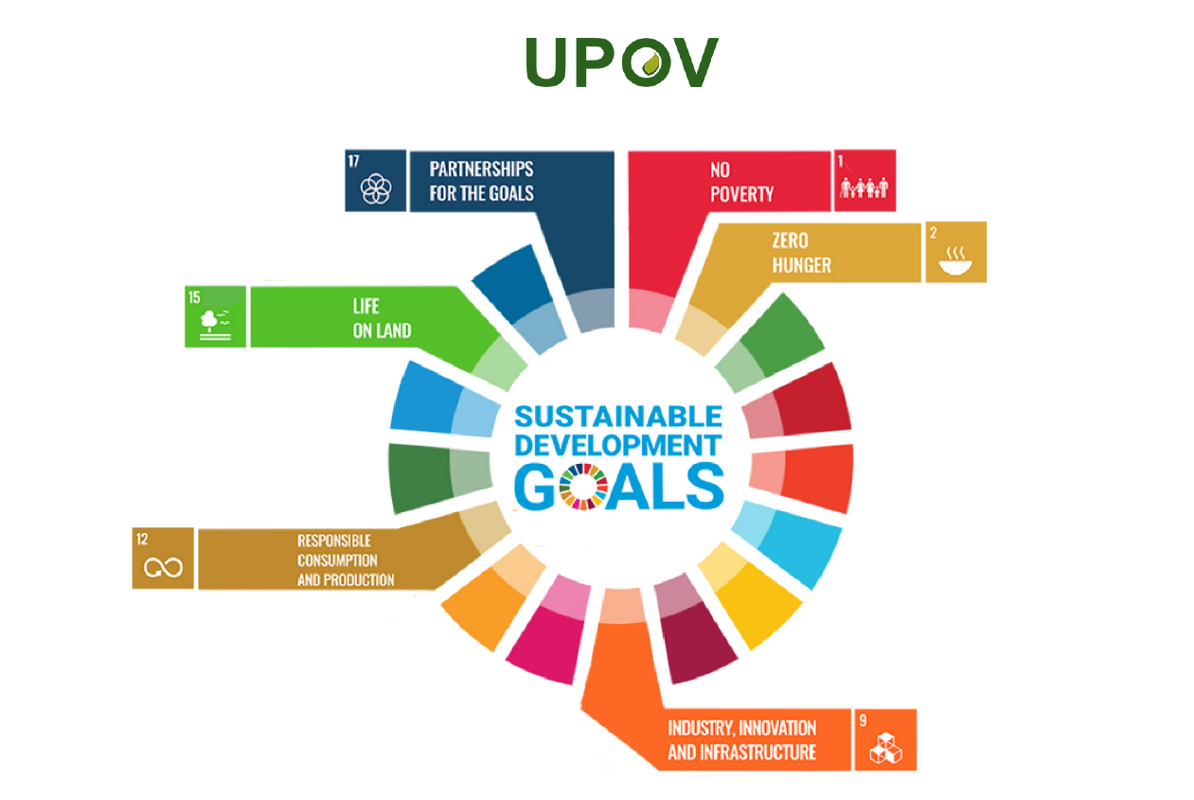

A key development for improving UPOV’s future performance was the approval of the Strategic Business Plan 2021-2025 (SBP) by the Consultative Committee. The SBP identified the following targets:

Target 1: Tools for implementation of the UPOV system (e-PVP)

a) Applying for PVP

b) Administration of PVP applications

c) Facilitating cooperation in DUS examination

Target 2: Training and education programs

a) Virtual training and education

b) UPOV qualification

Target 3: Communications

a) Effective cooperation with stakeholders

b) Effective cooperation with relevant international intergovernmental organizations

c) Increase outreach via social media

d) Use of machine translation technology to make UPOV material available in a wider range of languages

A core component in the SBP is the use of digitalization to enhance UPOV’s ability to provide and promote an effective system of plant variety protection. This strategy has proven to be very timely in the advent of the COVID-19 pandemic, which may also enable the plan to be advanced more rapidly than anticipated because of the reduction in travel costs.

In a move to improve the efficiency of UPOV’s work, the Council approved the establishment and the terms of reference for the Technical Working Party on Testing Methods and Techniques (TWM), to encompass the work of the TWC and BMT, to take effect from 2022. At a time of rapid technological advances and digitalization, the creation of a single Technical Working Party to consider these developments in the context of UPOV’s technical work will increase awareness of developments and provide a clear focal point.

***Services to the Union for enhancing the Effectiveness of the UPOV System (Sub-program UV.2)***

In response to the COVID-19 pandemic, all meetings of UPOV bodies were held by virtual means. In the case of the UPOV bodies that meet in Geneva, a procedure was also put in place to enable consideration of documents by correspondence. In the case of the Technical Working Parties (TWPs), comments on documents were invited in advance of the meetings and the discussions at the meetings were based on those comments. These procedures enabled the work of UPOV bodies to continue as planned with no negative consequences for progress on substantial matters.

In the case of the (TWPs), the move to virtual meetings in 2020 resulted in significantly greater participation than in previous years (see figures 3 and 4). The increase in number of participants ranged from 34% in the TWO to 120% in the TWF, compared to the average of the preceding five years. The increase in number of members of the Union that attended the TWPs ranged from 33% in the TWA to 90% in the TWC, compared to the average of the preceding five years. A survey of TWP participants (see figure 5) revealed a high level of satisfaction with the meetings overall, with more than 90% of participants being satisfied or very satisfied with the meetings.

|  |  |
| --- | --- |
| Figure 3. Total number of participants in TWPs  (2015-2020) | Figure 4. Number of UPOV members participating in at least one TWP per year (2015‑2020) |
|  |  |
| Figure 5. General satisfaction of TWP participants in virtual meetings (2020) (in %) | |

Discussions at the TWPs (see document TWP/5/12) recognized that engagement in virtual meetings was more challenging than at physical meetings, sometimes being compounded by technical issues, and that there were less opportunities for informal interactions at the periphery of the meeting. Conversely, virtual platforms created new opportunities for discussions and consultations outside the meeting week, enabling issues to be advanced before the meeting. Technical visits are an important means of exchanging information and knowledge at the TWPs and these were not possible in 2020. However, it was recognized that virtual technical visits would be an option to be pursued in 2021.

In contrast to the TWP meetings, the number of members of the Union participating in virtual meetings of UPOV bodies that meet in Geneva (Council, Consultative Committee, CAJ and TC) was similar to previous years (see figures 10 and 11 under Sub‑Program UV.1, and figures 20 and 21 under Sub-Program UV.2). It is possible that the arrangements for approving documents by correspondence in advance of the UPOV sessions reduced the interest for participation in the meetings. Furthermore, the procedure for approving documents by correspondence required several rounds of consultation, which created new demands on members of the Union and observers and substantially increased the amount of administration work in the organization of the sessions.

As part of the measures to facilitate or enhance voluntary cooperation between members of the Union, the TC agreed to propose the development of a package of compatible IT tools with the following elements:

* 1. Platform for:
     1. exchange of existing DUS reports for:
        1. members of the Union to post and receive existing DUS reports and arrange payment, as appropriate
        2. PVP applicants to request use of existing DUS reports and make payments, as appropriate
     2. members of the Union to make their documented DUS procedures and information on their quality management systems available to other members of the Union
  2. Tool to provide information on cooperation in DUS examination between members of the Union to PVP applicants in a user-friendly form, using information contained in the GENIE database
  3. Module for members of the Union to use the web-based TG Template and database of characteristics to develop individual authorities’ test guidelines (IATG) in their language
  4. Platform for UPOV member databases containing variety description information

A number of these elements will form a component of the “e-PVP” initiative (Target 1: Tools for implementation of the UPOV system (e-PVP)), under the Strategic Business Plan 2021-2025 (SBP) (see Overall Policy on Plant Variety Protection (Sub-program UV.1) above).

The TC also requested the Office of the Union to identify Test Guidelines where a partial revision of the Test Guidelines, including the Technical Questionnaires, could be anticipated to produce significant benefits for harmonization between members and to present proposals for partial revisions to the TWPs, at their sessions in 2021. The Test Guidelines identified have a large number of PBR applications in several members of the Union, and a number of members of the Union have indicated that their technical questionnaires have differences from the UPOV Technical Questionnaire. The crops are also relevant for UPOV PRISMA.

In 2019, the Council approved the launch of a new version of the PLUTO database with free and premium options, from November 2020. Issues with an IT provider, which were exacerbated by the COVID-19 pandemic, combined with the need to undergo a more extensive analysis of data in the existing PLUTO database than planned, led to a decision to delay the launch of the new version of PLUTO until 2021. This decision also took into account that the launch of a new version during the evolving COVID-19 pandemic might not be convenient timing for users.

The introduction of UPOV PRISMA in 2017 was a major development in facilitating applications for plant breeders’ rights. By the end of 2020, 35 members of the Union, covering 74 States, were participating in UPOV PRISMA. Use of UPOV PRISMA grew only very slightly in 2020, with 221 applications made via UPOV PRISMA, compared to 217 applications in 2019. The COVID-19 pandemic may have affected the interest in using a new system.

***Assistance in the Introduction and Implementation of the UPOV System (Sub-Program UV.3)***

The COVID-19 pandemic had a major impact on UPOV’s training and assistance activities. Where possible, training and assistance activities were implemented by virtual modalities, also benefitting from higher levels of participation while needing to seek innovative ways of ensuring effective engagement. As reported in the General Overview, the reduction in missions and activities was also compensated by a large number of virtual meetings in which issues could be discussed at relatively short notice because of the increased availability of people that would otherwise have been traveling. There was a significant increase in the number of participants in UPOV’s DL-205 distance learning course, particularly by officials from members of the Union (see figure 6).

Figure 6. Participants in the main sessions of the DL-205 Course  
by registration category



***External Relations (Sub-Program UV.4)***

The COVID-19 pandemic had a significant impact on external relations, because of the need to discontinue travel. However, the wide availability of virtual meeting options created new opportunities for meeting with officials and other stakeholders and resulted in an increase in the frequency of contacts (see figure 1).

A significant development in 2019 was the introduction of the @UPOVint and @vsgupov Twitter accounts, combined with the use of the UPOV LinkedIn account. In 2020, the number of followers continued to grow. In addition to the additional direct outreach from social media postings, there was further evidence that the number of UPOV website visitors (“visits”) and sessions has also increased as a result (see figures 7 to 9).

|  |  |
| --- | --- |
| Figure 7: @UPOVint followers | Figure 8: @vsgupov followers |
|  |  |

|  |
| --- |
| Figure 9. Visits to the UPOV website*[2]*i in 2020: Global coverage |
|  |

# I. FINANCIAL AND RESULTS OVERVIEW

**Key Financials**

The overall budgetary result for UPOV as well as the Reserve and Working Capital Funds (RWCF) as at the end of 2020 is shown in Table 1 below. The total income (before IPSAS adjustments) amounted to 3.6 million Swiss francs, and the total expenditure amounted to 3.3 million Swiss francs, resulting in a budgetary surplus of 0.3 million Swiss francs for 2020.

At the end of 2020, the total RWCF amounted to 0.4 million Swiss francs, comprising 1.1 million Swiss francs in the Reserve Fund, 0.6 million Swiss francs in the Working Capital Fund and Actuarial losses through Net Assets of 1.3 million Swiss francs.

**Table 1. Key Financials 2020**

*(in thousands of Swiss francs)*

|  |  |  |  |
| --- | --- | --- | --- |
| **Key Financials** | **2020/21 Program & Budget** | **2020  Actuals** | **2020 Actuals compared to P&B** |
|
| Income | 7,347 | 3,598 | 49% |
| Expenditure | 7,347 | 3,267 | 44% |
| **Budgetary Result** | **-** | **332** | **n/a** |
|  |  |  |  |
| IPSAS adj. to Reg. Budget Income |  | 64 |  |
| IPSAS adj. to Reg. Budget Expenditure |  | (147) |  |
| **Surplus / (Deficit)** |  | **249** |  |
|  |  |  |  |
|  |  |  |  |
| **Reserve and Working Capital Funds (RWCF)** |  |  |  |
| Reserve Fund |  | 1,059 |  |
| Working Capital Fund |  | 575 |  |
| Actuarial gains/(losses) through Net Assets |  | (1,266) |  |
| **Total RWCF at end of period** |  | **368** |  |

**Chart 1. Income, Expenditure and Budgetary Result in 2020**



Note: Figures in tables throughout the document may not add up due to rounding.

**Income**

Actual income amounted to 3.6 million Swiss francs in 2020, in line with the budgeted figure (49 per cent of the biennial budget). See Table 2 below.

Income from contributions continued to be the single largest source of income representing 98.6 per cent of total income. The increase in income from contributions, resulting from China increasing its number of contribution units from 0.5 unit in 2019 to 2 units in 2020, and higher income from distance learning courses was offset by lower than budgeted income from UPOV PRISMA fees and lower income generated from Funds-in-Trust related program support costs. The latter was due to a reduction in activities incurring travel costs, as a result of the COVID-19 pandemic.

**Table 2. Income in 2020**

*(in thousands of Swiss francs)*

|  |  |  |  |
| --- | --- | --- | --- |
| **Income** | **2020/21 Estimates** | **2020 Actual** | **2020 Actuals compared to Estimates** |
|
| Contributions (unitary) | 6,946 | 3,548 | 51% |
| PRISMA Fees | 250 | 17 | 7% |
| FITs Programme support costs | 121 | 30 | 25% |
| Distance Learning course fees | 30 | 21 | 70% |
| Miscellaneous1 | - | (18) | n/a |
| **Total** | **7,347** | **3,598** | **49%** |
| *1 Miscellaneous income mainly reflects unrealized forex gains/(losses) due to the revaluation process of the cash and other assets and liabilities accounts (currencies other than Swiss francs).* | | | |

**Chart 2. Income Share by Source in 2020**

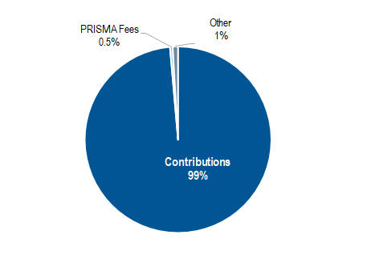

**Expenditure**

Actual expenditure amounted to 3.3 million Swiss francs in 2020 (44 per cent of the biennial budget). This is shown in Table 3 and by sub-programs in Table 4 and Table 5.

**Table 3. Budget vs. Expenditure by Cost Category in 2020**

*(in thousands of Swiss francs)*

|  |  |  |  |  |
| --- | --- | --- | --- | --- |
|  | **Cost Category** | **2020/21 Program & Budget** | **2020 Actuals** | **2020 Actuals compared to P&B** |
|  |
| **A. Personnel Resources** | |  |  |  |
|  | Posts | 4,688 | 2,158 | 46% |
|  | Temporary staff | 251 | 27 | 11% |
|  | Other Staff costs | - | 1 | n/a |
|  | **Total, A** | **4,939** | **2,186** | **44%** |
|  |  |  |  |  |
| **B. Non-Personnel Resources** | |  |  |  |
| ***Internships and Fellowships*** | |  |  |  |
|  | Internships | 5 | - | - |
|  | Fellowships | 65 | 24 | 38% |
|  | *Sub-total, Internships and Fellowships* | **69** | **24** | **35%** |
| ***Travel*** | |  |  |  |
|  | Staff Missions | 500 | 27 | 5% |
|  | Third Party Travel | 25 | 1 | 6% |
|  | *Sub-total, Travel* | **525** | **28** | **5%** |
| ***Contractual Services*** | |  |  |  |
|  | Conferences | 160 | 56 | 35% |
|  | Publishing | - | - | n/a |
|  | Individual Contractual Services1 | 20 | 0 | 1% |
|  | Other Contractual Services | 385 | 347 | 90% |
|  | *Sub-total, Contractual Services* | **565** | **403** | **71%** |
| ***Operating Expenses*** | |  |  |  |
|  | *Sub-total, Operating Expenses* | **1,239** | **621** | **50%** |
| ***Equipment and Supplies*** | |  |  |  |
|  | Furniture and Equipment | 5 | - | - |
|  | Supplies and Materials | 5 | 4 | 83% |
|  | *Sub-total, Equipment and Supplies* | **10** | **4** | **42%** |
|  |  |  |  |  |
|  | **Total, B** | **2,408** | **1,080** | **45%** |
|  | **TOTAL** | **7,347** | **3,267** | **44%** |
|  |  |  |  |  |
| *1 2020 Actuals for Individual Contractual Services amount to 200 Swiss francs.* | | | |  |

**Personnel Resources**

Personnel resources are budgeted using an actuals based costing methodology. The estimated expenditure for 2020 was lower than budgeted (44 per cent of the biennial budget). The expenditure on posts (46 per cent of the biennial budget) was lower than budgeted as a result of two posts in the general service staff category being occupied at 80 per cent and a position being vacant for a part of the year.

The expenditure on temporary staff reached 11 per cent of the budget for the biennium resulting from a delay in the recruitment of temporary staff.

**Non-Personnel Resources**

Internships and fellowships expenditure were lower than budgeted (35 per cent of the biennial budget) because the COVID-19 pandemic prevented travel by the fellow and the recruitment of a replacement fellow.

Travel, training and grants expenditure in 2020 represented only 5 per cent of the biennial budget due to the COVID‑19 pandemic.

Contractual services:

*Conferences:* Expenditure on conferences was lower than budgeted (35 per cent of the biennial budget). However, while costs for hosting events for participants were avoided because meetings were held virtually, additional costs (25,535 Swiss francs) were incurred for the virtual meeting platform, reflected under “Other Contractual Services”.

*Publishing*: There was no expenditure on publishing in 2020.

*Individual Contractual Services (ICS)*: There was minimal expenditure (200 Swiss francs) on ICS in 2020.

*Other Contractual Services (OCS)*: Estimated expenditure on OCS was substantially higher than anticipated for the first year of the biennium (90 per cent of the biennial budget) mainly as a result of higher expenditure on agency workers to compensate for: (i) administrative staff working part-time; (ii) non recruitment of a temporary administrative staff member; and (iii) cost of the servicing of the virtual meeting platform for UPOV meetings.

Operating expenses in 2020 were in line with budgeted costs.

Expenditure on equipment and supplies was broadly in line with budgeted costs.

**Table 4. Budget vs. Expenditure by Sub-Program in 2020**

*(in thousands of Swiss francs)*

|  |  |  |  |
| --- | --- | --- | --- |
|  | **2020/21 Program & Budget** | **2020  Actuals** | **2020 Actuals compared to P&B** |
|  |
|  |  |  |  |
| UV.1 Overall Policy on Plant Variety Protection | 798 | 404 | 51% |
| UV.2 Services to the Union for Enhancing the Effectiveness of the UPOV System | 4,268 | 2,033 | 48% |
| UV.3 Assistance in the Introduction and Implementation of the UPOV System | 1,633 | 608 | 37% |
| UV.4 External Relations | 648 | 221 | 34% |
|  |  |  |  |
| **TOTAL** | **7,347** | **3,267** | **44%** |

**Table 5. Expenditure Details by Sub-Program in 2020**

*(in thousands of Swiss francs)*

|  |  |  |  |  |  |  |
| --- | --- | --- | --- | --- | --- | --- |
|  | **Cost Category** | **Sub-programs** | | | | **Total** |
|  | **UV.1** | **UV.2** | **UV.3** | **UV.4** |
| **A. Personnel Resources** | |  |  |  |  |  |
|  | Posts | 371 | 1,005 | 578 | 205 | 2,158 |
|  | Temporary staff | 5 | 3 | 15 | 4 | 27 |
|  | Other Staff costs1 | 0 | 1 | 0 | 0 | 1 |
|  | **Total, A** | **377** | **1,008** | **593** | **209** | **2,186** |
|  |  |  |  |  |  |  |
| **B. Non-Personnel Resources** | |  |  |  |  |  |
| ***Internships and Fellowships*** | |  |  |  |  |  |
|  | Interns | **-** | - | - | - | - |
|  | Fellowships | **-** | 24 | - | - | 24 |
|  | *Sub-total, Internships and Fellowships* | **-** | **24** | **-** | **-** | **24** |
| ***Travel*** | |  |  |  |  |  |
|  | Staff Missions2 | - | 0 | 14 | 12 | 27 |
|  | Third Party Travel | - | - | 1 | - | 1 |
|  | *Sub-total, Travel* | **-** | **0** | **15** | **12** | **28** |
| ***Contractual Services*** | |  |  |  |  |  |
|  | Conferences | 16 | 40 | - | - | 56 |
|  | Publishing | - | - | - | - | - |
|  | Individual Contractual Services3 | - | - | 0 | - | 0 |
|  | Other Contractual Services | 7 | 340 | - | - | 347 |
|  | *Sub-total, Contractual Services* | **23** | **380** | **0** | **-** | **403** |
| ***Operating Expenses*** | |  |  |  |  |  |
|  | *Sub-total, Operating Expenses4* | **0** | **621** | **-** | **-** | **621** |
| ***Equipment and Supplies*** | |  |  |  |  |  |
|  | Furniture and Equipment | - | - | - | - | - |
|  | Supplies and Materials | 4 | - | - | - | 4 |
|  | *Sub-total, Equipment and Supplies* | **4** | **-** | **-** | **-** | **4** |
|  |  |  |  |  |  |  |
|  | **Total, B** | **27** | **1,025** | **16** | **12** | **1,080** |
|  | **TOTAL** | **404** | **2,033** | **608** | **221** | **3,267** |
|  |  |  |  |  |  |  |
| *1 Expenditure under Other Staff costs UV.1, UV.3, and UV.4 amounts to 193 Swiss francs, 304 Swiss francs, and 107 Swiss francs, respectively.* | | | | | | |
| *2 Expenditure under Staff Missions UV.2 amounts to 251 Swiss francs.* | | | |  |  |  |
| *3 Expenditure under Individual Contractual Services UV.3 amounts to 200 Swiss francs.* | | | | |  |  |
| *4 Expenditure under Operating Expenses UV.1 amounts to 276 Swiss francs.* | | | | |  |  |

**Resources**

The number of posts by category is shown in Table 6 below. There was no change in 2020 in the total number of posts. The post of the Secretary-General is included within the post count, but at no cost, because the current Director General of WIPO has declined any salary or allowance from his functions as Secretary-General of UPOV.

**Table 6. Budgeted and Actuals Posts in 2020**

|  |  |  |  |
| --- | --- | --- | --- |
| **Post Category** | **2020/21 Budgeted Posts** | **2020 Actual Posts** | **Difference** |
|
|  |  |  |  |
| Directors | 3 | 3 | - |
| Professionals | 5 | 5 | - |
| General Service | 4 | 4 | - |
|  |  |  |  |
| **TOTAL** | **12** | **12** | **-** |

**Evolution of Income and Expenditure**

The overall evolution of actual income and expenditure (before IPSAS adjustments) for the period from 2010 to 2020 is shown below in Table 7.

**Table 7. Evolution of Actual Income and Expenditure during 2010-2020**

*(in thousands of Swiss francs)*

|  |  |  |  |  |  |  |  |  |  |  |  |
| --- | --- | --- | --- | --- | --- | --- | --- | --- | --- | --- | --- |
|  | **Actuals** | | | | | | | | | | |
|  | **2010** | **2011** | **2012** | **2013** | **2014** | **2015** | **2016** | **2017** | **2018** | **2019** | **2020** |
| Income | 3,412 | 3,489 | 3,388 | 3,403 | 3,384 | 3,409 | 3,431 | 3,420 | 3,422 | 3,509 | 3,598 |
| Expenditure | 3,501 | 2,978 | 2,954 | 3,331 | 3,275 | 3,517 | 3,239 | 3,586 | 3,355 | 3,500 | 3,267 |
| **Budgetary Result** | **(89)** | **511** | **434** | **72** | **109** | **(109)** | **192** | **(166)** | **67** | **9** | **332** |

**Chart 3. Evolution of Income and Expenditure 2010-2020**

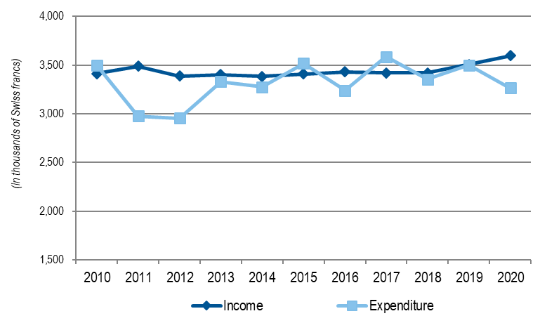

### **Funds-in-Trust (extra-budgetary funds)**

The overall evolution of the actual income of the Funds-in-Trust for the period from 2010 to 2020 is shown below in Table 8.

**Table 8. Evolution of Funds-in-Trust from 2010 to 2020**

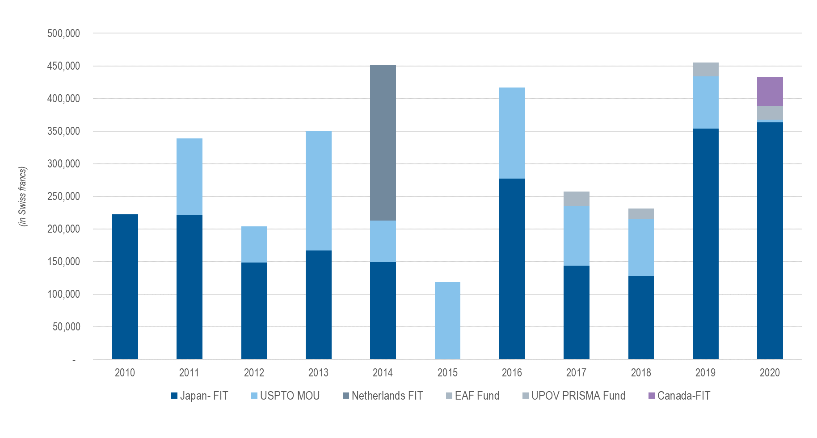

# II. program performance

## SUB-PROGRAM UV.1: Overall Policy on Plant Variety Protection

### Objectives:

(a) To maintain and improve the effectiveness of the UPOV system.

(b) To provide and develop the legal, administrative and technical basis for international cooperation in plant variety protection according to the UPOV Convention.

### Performance Data:

|  |  |  |
| --- | --- | --- |
| **Expected Results** | **Performance Indicators** | **Performance Data**[3] |
| 1. Identify and implement the strategic goals and objectives of UPOV | (a) Strategic Business Plan that identifies the financial and human resources needed to achieve the strategic goals and objectives of the Union and defines long‑term steps and key milestones of outreach activities with a view to improving organizational visibility and enhancing revenue generation efforts. | The Consultative Committee:   * noted the information on the latest situation concerning the 10 specific targets that were identified for improvement in the Strategic Business Plan 2018‑2023; * approved the draft Strategic Business Plan 2021-2025; and * requested that the Strategic Business Plan be updated on a biennial basis in order to set the direction for the subsequent two biennia and to coincide with the preparation of the draft program and budget for the subsequent biennium.   see document CC/97/3 “Strategic Business Plan” |
| 2. Reviewing the training and assistance strategy | (a) Evaluation of annual reports of the Secretary-General, performance reports for the biennia and other information; and | see document CC/97/14 “Training and assistance strategy” |
| (b) Measures to provide training and assistance in the introduction and implementation of the UPOV system. | see document CC/97/14 “Training and assistance strategy” |
| 3. Reviewing the communication strategy | (a) Evaluation of annual reports of the Secretary-General, performance reports for the biennia and other information; and | see document CC/97/6 Rev. “Communication strategy” |
| (b) Recommendations by the Consultative Committee on the communication strategy. | Based on the recommendation by the Consultative Committee, the Council adopted the text of the FAQ “How does the UPOV system support sustainable development?” |
| 4. Policy direction on inter-relations with other organizations | (a) Recommendations by the Consultative Committee; and | The Consultative Committee agreed to the participation of the Office of the Union in the reference group for the research project “Pathways to food security, poverty alleviation and livelihoods through the implementation of farmers’ rights to crop genetic diversity (DIVERSIFARM)”. |
| (b) Decisions by the Council | None |
| 5. Policies to diversify UPOV’s revenue portfolio | (a) Income from sources other than UPOV member contributions | The Strategic Business Plan 2021-2025 specifies that sources of income other than contributions of members of the Union should be targeted to reach 7.5% of UPOV’s income by 2025. Extrabudgetary funds, UPOV PRISMA and the PLUTO database are identified as the principal sources of alternative income. |
| 6. Organization of Council and Consultative Committee sessions | (a) Participation in the sessions of the Council and the Consultative Committee. | The Council decided that the UPOV Sessions in October 2020 would be held in the form of virtual meetings, in combination with prior consideration of documents by correspondence.  see figures 10 and 11 |

|  |  |
| --- | --- |
| Figure 10. Participation[4]* in Ordinary Sessions of the Council (October sessions) | Figure 11. Participation* in Consultative Committee Sessions |

| **Expected Results** | **Performance Indicators** | **Performance Data** |
| --- | --- | --- |
| 7. Organize and monitor the work of UPOV committees | (a) Approval and monitoring of the work programs of the CAJ, TC, TWPs and ad hoc working groups; | Achieved - see document C/54/21 “Report”, paragraphs 53 to 57   * The Council approved the establishment and the terms of reference for the Technical Working Party on Testing Methods and Techniques (TWM), to encompass the work of the TWC and BMT, to take effect from 2022. The Council elected the Chairperson of the BMT to act as Chairperson of the TWM, ending with the fifty seventh ordinary session of the Council, in 2023. * Based on the recommendation by the CAJ, the Council decided to organize a seminar in the first half of 2021, to exchange information on matters concerning harvested material and unauthorized use of propagating material. |
| (b) Election of Chairs of the CAJ, TC, TWPs and ad hoc working groups and Vice Chairs of the CAJ and TC; and | The Council elected the following Chairpersons, in each case for a term of three years ending with the fifty-seventh ordinary session of the Council, in 2023, as follows: (a) Ms. Renée Cloutier (Canada), TWA; (b) Mr. Christopher Barnaby (New Zealand), TWF; (c) Ms. Ashley Balchin (Canada), TWO; (d) Ms. Marian van Leeuwen (Netherlands), TWV; and (e) Ms. Beate Rücker (Germany), BMT. |
| (c) Approval of the annual calendars of meetings. | Achieved - see document C/54/8 Rev. |
| 8. Coordination, monitoring and performance assessment of Program and Budget for the 2020‑2021 Biennium | (a) Delivery of program within budget for the 2020‑2021 Biennium; | Results not available until 2021 |
| (b) Approval of the financial statements; and | see document C/55/5 “Financial statements for 2020” |
| (c) Approval of the financial management report. | see this document C/55/2 “UPOV Performance Report 2020”  The Council approved the consolidation of existing financial and performance reports into a “UPOV Performance Report” (UPR). The UPR would be presented alongside the Financial Statements, on an annual basis, starting with the reports for 2020. |
| 9. Preparation and adoption of the Program and Budget for the 2022‑2023 Biennium | (a) Preparation and adoption of the Program and Budget for the 2022‑2023 Biennium. | see document C/55/4 “Draft Program and Budget for the 2022-2023 Biennium” |
| 10. Examination of the conformity of laws, or draft laws, with the 1991 Act of the UPOV Convention | (a) Recommendations by the Consultative Committee; and | See (b) below |
| (b) Decisions by the Council. | On the basis of the recommendation by the Consultative Committee, the Council:   * took a positive decision on the conformity of the “Draft Law on Plant Variety Protection of the United Arab Emirates” (by correspondence) * took a positive decision on the conformity of the “Draft Plant Breeders Rights Act of Zimbabwe” |
| 11. Review of developments concerning applications and grants of plant breeders’ rights | (a) Number of applications; | see figures 12, 13 and 14 |
| (b) Number of titles granted; | see figures 15 and 16 |
| (c) Number of titles in force; | see figure 15 |
| (d) Number of genera/species protected by members of the Union; | see figures 17 and 18 |
| (e) Number of genera/species for which varieties have been protected; and | see figure 27 under Sub-Program UV.2 |
| (f) Analysis by crop type. | see figure 19 “Data from PLUTO database” |

|  |  |
| --- | --- |
| Figure 12. Applications for Plant Breeders’ Rights | |
| Figure 13. Applications for Plant Breeders’ Rights and Titles Issued | Figure 14. Applications for Plant Breeders’ Rights by Resident/Non‑Resident |
| Figure 15. Plant Breeders’ Rights Titles in Force | Figure 16. Plant Breeders’ Rights Titles Granted by Resident/Non‑Resident |

Figure 17. Protection to plant genera and species in 2020

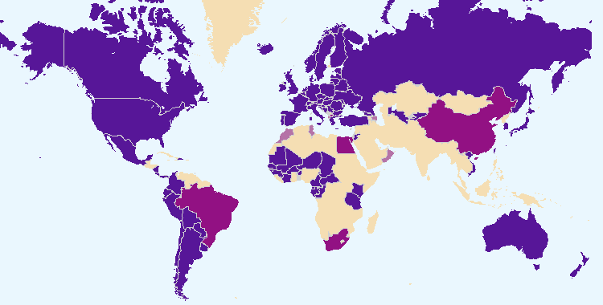

The boundaries shown on this map do not imply the expression of any opinion whatsoever on the part of UPOV concerning the legal status of any country or territory.

|  |  |  |
| --- | --- | --- |
|  |  | Members of the Union offering protection for all plant genera and species |
|  |  |  |
|  |  | Members of the Union offering protection for a limited number of plant genera and species |
|  |  |  |
|  |  | Members of the Union who had not notified the extension of protection to all genera and species |

Figure 18. Evolution of protection to plant genera and species



Figure 19: Data from PLUTO database

|  |  |  |  |  |  |  |  |  |  |  |  |  |  |  |  |  |  |  |  |  |  |  |  |  |  |  |  |  |  |  |  |  |  |  |  |  |  |  |  |  |  |  |  |  |  |  |  |  |  |  |  |  |  |  |  |  |  |  |  |  |  |  |  |  |  |  |  |  |  |  |  |  |  |  |  |  |  |  |  |  |  |  |  |  |  |  |  |  |  |  |  |  |  |  |  |  |  |  |  |  |  |  |  |  |  |  |  |  |  |  |  |  |  |  |  |  |  |  |  |  |  |  |  |  |  |  |  |  |  |  |  |  |  |
| --- | --- | --- | --- | --- | --- | --- | --- | --- | --- | --- | --- | --- | --- | --- | --- | --- | --- | --- | --- | --- | --- | --- | --- | --- | --- | --- | --- | --- | --- | --- | --- | --- | --- | --- | --- | --- | --- | --- | --- | --- | --- | --- | --- | --- | --- | --- | --- | --- | --- | --- | --- | --- | --- | --- | --- | --- | --- | --- | --- | --- | --- | --- | --- | --- | --- | --- | --- | --- | --- | --- | --- | --- | --- | --- | --- | --- | --- | --- | --- | --- | --- | --- | --- | --- | --- | --- | --- | --- | --- | --- | --- | --- | --- | --- | --- | --- | --- | --- | --- | --- | --- | --- | --- | --- | --- | --- | --- | --- | --- | --- | --- | --- | --- | --- | --- | --- | --- | --- | --- | --- | --- | --- | --- | --- | --- | --- | --- | --- | --- | --- | --- | --- | --- |
| *Applications filed by crop type:*   |  |  |  |  |  |  | | --- | --- | --- | --- | --- | --- | |  | Crop type | | | | | | Year | Agriculture | Forest trees | Fruit | Ornamental | Vegetables | | 2012 | 27% | 0.9% | 12% | 48% | 12% | | 2013 | 25% | 1.0% | 12% | 49% | 11% | | 2014 | 30% | 0.8% | 11% | 47% | 10% | | 2015 | 33% | 0.5% | 14% | 36% | 16% | | 2016 | 37% | 0.6% | 11% | 34% | 18% | | 2017 | 33% | 0.5% | 11% | 38% | 17% | | 2018 | 35% | 0.5% | 12% | 33% | 20% | | 2019 | 34% | 0.6% | 10% | 37% | 19% | | 2020 | 35% | 0.6% | 8% | 36% | 21% | | *Titles issued by crop type:*   |  |  |  |  |  |  | | --- | --- | --- | --- | --- | --- | |  | Crop type | | | | | | Year | Agriculture | Forest trees | Fruit | Ornamental | Vegetables | | 2012 | 26% | 0.7% | 9% | 48% | 15% | | 2013 | 34% | 0.7% | 10% | 42% | 13% | | 2014 | 35% | 0.6% | 10% | 43% | 12% | | 2015 | 32% | 0.9% | 10% | 44% | 13% | | 2016 | 32% | 1.1% | 9% | 40% | 18% | | 2017 | 27% | 0.4% | 12% | 45% | 16% | | 2018 | 27% | 0.5% | 11% | 43% | 18% | | 2019 | 34% | 0.4% | 9% | 38% | 18% | | 2020 | 38% | 0.5% | 7% | 34% | 21% | |

| **Expected Results** | **Performance Indicators** | **Performance Data** |
| --- | --- | --- |
| 12. Facilitating applications through UPOV PRISMA | (a) Recommendations by the Consultative Committee; and | At the ninety-seventh session of the Consultative Committee, it was agreed that the Office of the Union should present proposals on the reporting of the financing of UPOV PRISMA for consideration by the Consultative Committee at its ninety-eighth session. |
| (b) Decisions by the Council; | None |
| 13. Facilitating voluntary cooperation between members of the Union in the implementation of the UPOV Convention | (a) Recommendations by the Consultative Committee; and | At its ninety-seventh session, the Consultative Committee agreed to broaden the agenda item “Providing support for new members of the Union” to “New developments in members of the Union”, to identify and consider possibilities to address relevant developments in members of the Union. |
| (b) Decisions by the Council. | Based on the recommendations of the Consultative Committee, the Council agreed the organization of a seminar, which would be open to members and observers, in the week of the UPOV sessions in 2021, to exchange information and experiences on strategies involving plant breeding and plant variety protection that addressed broad policy issues. |
| 14. Policy on other matters | (a) Recommendations by the Consultative Committee; | The Consultative Committee considered a report on an initiative concerning smallholder farmers and a presentation made by Oxfam, Plantum and Euroseeds, and agreed on actions to be taken in relation to providing guidance regarding the implementation of the exception of acts done privately and for non-commercial purposes in relation to smallholder farmers, taking into account the concerns raised at the ninety-seventh session. |
| (b) Decisions by the Council; and | None |
| (c) Adoption of documents presenting UPOV policy by the Council. | None |

## SUB-PROGRAM UV.2: Services to the Union for Enhancing the Effectiveness of the UPOV System

### Objectives:

(a) To raise awareness of the role of plant variety protection according to the UPOV Convention.

(b) To assist States and organizations, particularly governments of developing countries and countries in transition to a market economy, in the development of legislation in accordance with the 1991 Act of the UPOV Convention.

(c) To assist States and organizations in their accession to the 1991 Act of the UPOV Convention.

(d) To assist States and organizations in implementing an effective plant variety protection system in accordance with the UPOV Convention.

### Performance Data:

| **Expected Results** | | **Performance Indicators** | | **Performance Data** |
| --- | --- | --- | --- | --- |
| 1. Participation by members of the Union and observers in the work of the UPOV bodies | | (a) Participation in the Administrative and Legal Committee, Technical Committee and Technical Working Parties and associated preparatory workshops. | | see figures 20 and 21, and figures 3 and 4  The TWPs did not hold a preparatory workshop at their sessions in 2020. The elements to be discussed during the preparatory workshops were presented as an introduction to the respective agenda items during the normal program for the sessions. | |

|  |  |
| --- | --- |
| Figure 20. Number of Participating Members and Observer States/Organizations in the CAJ | Figure 21. Number of Participating Members and Observer States/Organizations in the TC |

| **Expected Results** | **Performance Indicators** | **Performance Data** |
| --- | --- | --- |
| 2. Guidance on the UPOV Convention and its implementation and information on its application | (a) Adoption of new or revised information materials concerning the UPOV Convention; | The Council adopted:  - 3 revisions to previously adopted information documents  UPOV/INF/4/6 Financial Regulations and Rules of UPOV (Revision of Regulation 4.6)  UPOV/INF/16/9 Exchangeable Software (Revision)  UPOV/INF/22/7 Software and equipment used by members of the Union (Revision) |
| (b) Publication of the UPOV Gazette and Newsletter; | Matters published in the past in the UPOV Gazette and Newsletter are now published in UPOV Lex (see below) |
| (c) Inclusion of laws and relevant notifications of members of the Union in UPOV Lex; | 3 laws concerning the following 3 members of the Union were included in the UPOV Lex database: Egypt, Estonia and Paraguay |
| (d) Availability of UPOV documents and materials in languages other than the UPOV languages (English, French, German and Spanish). | Translation into Chinese of the DL-205 “Introduction to the UPOV System of Plant Variety Protection under the UPOV Convention” (not yet published) |
| 3. Guidance on the examination of varieties | (a) Adoption of new or revised TGP documents and information materials; | Revisions to 4 previously adopted TGP documents adopted and published on the UPOV website:  TGP/5: Section 6/3 Experience and Cooperation in DUS Testing: UPOV Report on Technical Examination and UPOV Variety Description (Revision)  TGP/7/8 Development of Test Guidelines (Revision)  TGP/14/5 Glossary of Terms Used in UPOV Documents (Revision)  TGP/15/3 Guidance on the Use of Biochemical and Molecular Markers in the Examination of Distinctness, Uniformity and Stability (DUS) (Revision) |
| (b) Adoption of new or revised Test Guidelines; | see figures22 and 23 |
| (c) Proportion of PBR applications covered by adopted Test Guidelines; | At the end of 2020, the adopted Test Guidelines covered 94% of all PBR-related entries in the PLUTO Plant Variety Database (321,732 of 343,064)  (94% at the end of 2019 (307,853 of 328,525))  see figure 24 |
| (d) Number of Test Guidelines under development in the TWPs; | see figures 25 and 26 |
| (e) Participation in the development of Test Guidelines; | 14 members of the Union acting as Leading Experts of Test Guidelines in 2020 (15 in 2019) |
| (f) Development of a web-based Test Guidelines Template (TG Template) with facility for:  (i) translation in UPOV languages;  (ii) use by members of the Union in the preparation of individual authorities’ test guidelines. | No new developments. |

|  |  |
| --- | --- |
| Figure 22. Adoption of Test Guidelines | Figure 23. Draft Test Guidelines discussed in TWPs |

Figure 24. Plant Breeders’ Rights Entries in Plant Variety Database covered by Test Guidelines



|  |  |
| --- | --- |
| Figure 25. Total number of Test Guidelines adopted  (by Technical Working Party) | Figure 26. Total number of Test Guidelines adopted (by region of the leading expert) |

| **Expected Results** | | **Performance Indicators** | | **Performance Data** |
| --- | --- | --- | --- | --- |
| 4. Cooperation in DUS examination | | (a) Plant genera and species for which members of the Union have practical experience included in GENIE database; | | see figure 27 | |
| (b) Plant genera and species for which members of the Union cooperate in DUS examination included in GENIE database; | | see figure 27 | |
| (c) New initiatives to facilitate or enhance voluntary cooperation between members of the Union. | | The TC agreed to propose the development of a package of compatible IT tools with the following elements:   1. Platform for:    * 1. exchange of existing DUS reports for:         1. UPOV members to post and receive existing DUS reports and arrange payment, as appropriate         2. PVP applicants to request use of existing DUS reports and make payments, as appropriate      2. UPOV members to make their documented DUS procedures and information on their quality management systems available to other members of the Union 2. Tool to provide information on cooperation in DUS examination between UPOV members to PVP applicants in a user-friendly form, using information contained in the GENIE database 3. Module for UPOV members to use the web‑based TG Template and database of characteristics to develop individual authorities’ test guidelines (IATG) in their language 4. Platform for UPOV member databases containing variety description information   The TC requested the Office of the Union to identify Test Guidelines where a partial revision of the Test Guidelines, including the Technical Questionnaires, could be anticipated to produce significant benefits for harmonization between members and to present proposals for partial revisions to the Technical Working Parties, at their sessions in 2021. The Test Guidelines identified have a large number of PBR applications in several members of the Union, and a number of members of the Union have indicated that their technical questionnaires have differences from the UPOV Technical Questionnaire. The crops are also relevant for UPOV PRISMA. | |

Figure 27. Plant Genera/Species with Cooperation Agreements, Practical Experience and   
Plant Breeders’ Rights Entries in Plant Variety Database



| **Expected Results** | | **Performance Indicators** | | **Performance Data** |
| --- | --- | --- | --- | --- |
| 5. Cooperation in examination of variety denominations and novelty | (a) Quantity and quality of data in PLUTO database: | |  | |
| (i) number of contributors; | | - Number of contributors included in the PLUTO database:  65 in 2020 (64 in 2019; 63 in 2018; 62 in 2017)  - Number of members of the Union that contributed data:  47 in 2020 (49 in 2019; 48 in 2018; 48 in 2017) | |
| (ii) number of new submissions; | | - Number of submissions of new data:  300 in 2020 (294 in 2019; 248 in 2018; 222 in 2017)  - Number of members of the Union that contributed data for the first time:  0 in 2020 (1 in 2019; 1 in 2018; 2 in 2017) | |
| (iii) number of records; | | Total number of records included in the PLUTO database at the end of 2020: 825,769  (873,549 at the end of 2019; 828,808 at the end of 2018; 797,669 at the end of 2017) | |
| (iv) number of mandatory items provided; | | n/a | |
| (v) number of non-mandatory items provided; | | n/a | |
| (b) Number of PLUTO users and frequency of use; | | 1,958 PLUTO users in 2020 | |
| (c) Development and approval by the Council of a UPOV similarity search tool for variety denominations for inclusion in PLUTO database; | | The CAJ noted the conclusion of the CPVO and the Office of the Union that the CPVO similarity algorithm is performing well and that, for the time being, it would not be a suitable use of resources to seek improvements to the algorithm for the purposes of checking the similarity of variety denominations.  The CAJ agreed that the Office of the Union explore with the CPVO possibilities for the variety denomination search tool to consider checking denominations for characteristics | |
| (d) New initiatives to facilitate or enhance voluntary cooperation between members of the Union. | | UPOV Office provided training activities for support UPOV tools including PLUTO | |

| **Expected Results** | | **Performance Indicators** | | **Performance Data** |
| --- | --- | --- | --- | --- |
| 6. Development of UPOV PRISMA | (a) Number of UPOV members participating in UPOV PRISMA; | | At the end of 2020, 35 members of the Union, covering 74 States | |
| (b) Number of crops/species covered by UPOV PRISMA; | | At the end of 2020, UPOV PRISMA was available for all genera and species in 23 members of the Union, and for a limited list of genera & species in 12 UPOV members | |
| (c) Number of applications made via UPOV PRISMA; | | In 2020, 222 applications were made for PBR via UPOV PRISMA (219 in 2019; 77 in 2018; 14 in 2017).  In 2020, 2 applications were made for National Listing via UPOV PRISMA (5 in 2019) | |
| (d) Number of registered UPOV PRISMA users; | | At the end of 2020, 219 Users were registered in UPOV PRISMA (115 Breeders, 104 Agents) (140 in 2019: 88 breeders/ 52 agents) | |
| (e) Number of UPOV members receiving applications via UPOV PRISMA; | | In 2020, 23 participating UPOV members received applications via UPOV PRISMA (26 in 2019) | |
| (f) Number of crops/species for which applications made using UPOV PRISMA; | | At the end of 2020, there were 41 crops/species (including subspecies) for which applications were made using UPOV PRISMA. In 2019, there were 45 crops/species (including subspecies) for which applications were made using UPOV PRISMA. | |
| (g) Number of UPOV members using UPOV PRISMA as their exclusive online tool for PBR applications; | | n/a | |
| (h) Development of Technical Questionnaires agreed between interested members of the Union for crops/species not covered by Test Guidelines. | | At the end of 2020, no technical questionnaire agreed between interested members of the Union for crops/species not covered by Test Guidelines were developed | |

## SUB-PROGRAM UV.3: Assistance in the Introduction and Implementation of the UPOV System

### Objectives:

(a) To raise awareness of the role of plant variety protection according to the UPOV Convention.

(b) To assist States and organizations, particularly governments of developing countries and countries in transition to a market economy, in the development of legislation in accordance with the 1991 Act of the UPOV Convention.

(c) To assist States and organizations in their accession to the 1991 Act of the UPOV Convention.

(d) To assist States and organizations in implementing an effective plant variety protection system in accordance with the UPOV Convention.

### Performance Data:

| **Expected Results** | **Performance Indicators** | | **Performance Data** |
| --- | --- | --- | --- |
| 1. Raising awareness of the role of plant variety protection in accordance with the UPOV Convention | (a) States and organizations that initiate with the Council of UPOV the procedure for becoming members of the Union; | see figure 28 | |
| (b) States and organizations that contact the Office of the Union for assistance in the development of legislation on plant variety protection; | see figure 28 | |

Figure 28. States and organizations that contacted the Office of the Union in 2020 for assistance in the development of legislation on plant variety protection and States and organizations that initiated with the Council of UPOV the procedure for becoming members of the Union

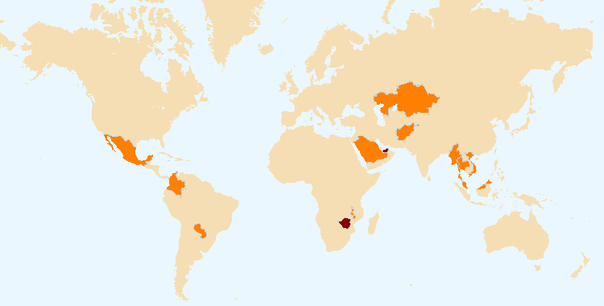

The boundaries shown on this map do not imply the expression of any opinion whatsoever on the part of UPOV concerning the legal status of any country or territory.

 States and organizations that initiated with the Council of UPOV the procedure for becoming members of the Union

United Arab Emirates and Zimbabwe (2)

 States and organizations that contacted the Office of the Union for assistance in the development of legislation on plant variety protection

Members of the Union (4): Colombia, Mexico, Paraguay and Viet Nam

Non-members of the Union (12): Afghanistan, Jamaica, Kazakhstan, Liechtenstein, Malaysia, Malawi, Myanmar, Saint Vincent and the Grenadines, Saudi Arabia, Thailand, United Arab Emirates and Zimbabwe

| **Expected Results** | **Performance Indicators** | | **Performance Data** | |
| --- | --- | --- | --- | --- |
| 1. Raising awareness of the role of plant variety protection in accordance with the UPOV Convention | (c) States and organizations provided with information at UPOV activities; | see Annex V to this document | | |
| (d) States and organizations participating in study tours; | see Annex V to this document | | |
| (e) Participation in UPOV awareness-raising activities, or activities involving UPOV; | see Annex V to this document | | |
| (f) Number of studies published on UPOV website; | No new studies published | |
| (g) Number of visits to benefits page on UPOV website; | 4,125 pageviews in 2020 (4,670 in 2019) | |
| (h) Number of videos published on UPOV website; | No new videos published | |
| (i) Number of views of videos published on UPOV website; | Combined total views : 35,247  see figure 29 | |
| (j) Number of followers on UPOV Twitter accounts; | @UPOVint: 1,316 on 31/12/2020 (726 on 31/12/2019)  @vsgupov: 606 on 31/12/2020 (451 on 31/12/2019) | |
| (k) Number of relevant languages in which studies and videos are available. | All videos on the Benefits page of the UPOV website are available in English, French and Spanish. In addition, the following languages are available as indicated below:   * (Japan) Tsuyahime Rice *(Chinese and Thai)*   Studies:   * UPOV Report on the Impact of Plant Variety Protection  (*English, French, German, Spanish*) * Socio-economic benefits of UPOV membership in Viet Nam:  An ex-post assessment on plant breeding and agricultural productivity after 10 years (Corresponding author:  Steffen Noleppa) by HFFA Research GmbH (*English and Vietnamese*) | |

Figure 29: Visits to the UPOV websitei – Videos on Benefits page



*All language versions and long and short versions, where applicable.

Note: Analytics are only provided for videos viewed on Youtube (<https://www.upov.int/about/en/benefits_upov_system.html>).

| **Expected Results** | **Performance Indicators** | | **Performance Data** |
| --- | --- | --- | --- |
| 2. Assistance in drafting legislation on plant variety protection in accordance with the 1991 Act of the UPOV Convention | (a) Meetings with government officials to discuss legislative matters; | see Annex V to this document and figure 30 | |
| (b) States and organizations provided with comments on laws; | see figures 30 and 31 | |
| (c) States and organizations receiving a positive advice from the Council; | see figures 30 and 32 | |
| (d) Participation in workshops on laws. | see Annex V to this document | |

Figure 30. Assistance provided in drafting legislation on plant variety protection

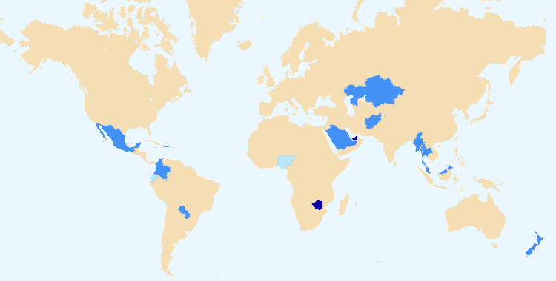

The boundaries shown on this map do not imply the expression of any opinion whatsoever on the part of UPOV concerning the legal status of any country or territory.

 States and organizations which received a positive advice from the Council of UPOV

United Arab Emirates and Zimbabwe (2)  
(see also figure 32)

 States and organizations provided with comments on laws

Members of the Union (4): Colombia, Mexico, New Zealand and Paraguay

Non-members of the Union (12): Afghanistan, Jamaica, Kazakhstan, Liechtenstein, Malaysia, Mauritius, Myanmar, Saint Vincent and the Grenadines, Saudi Arabia, Thailand, United Arab Emirates, and Zimbabwe  
(see also figure 31)

 Meetings with government officials to discuss legislative matters;

Members of the Union (3): Colombia, Ecuador and Mexico

Non-members of the Union (9): Afghanistan, Brunei Darussalam, Jamaica, Malaysia, Mauritius, Nigeria, Saint Vincent and the Grenadines, Thailand and United Arab Emirates

|  |  |
| --- | --- |
| Figure 31. States/Organizations provided with  comments on laws | Figure 32. States/Organizations which received positive advice from the Council |

| **Expected Results** | **Performance Indicators** | | **Performance Data** |
| --- | --- | --- | --- |
| 3. Assistance to States and organizations in the accession to the 1991 Act of the UPOV Convention | (a) States that accede to or ratify the 1991 Act of the UPOV Convention; | None - see figure 33 | |
| (b) States and organizations that become members of the Union; | None - see figure 34 | |
| (c) Meetings with government officials to discuss legislative matters; | see Annex V to this document and figure 30 | |
| (d) States and organizations provided with comments on laws. | see figures 30 and 31 | |

|  |  |
| --- | --- |
| Figure 33. Accession to/ratification of the 1991 Act | Figure 34 New members of the Union |

| **Expected Results** | **Performance Indicators** | | **Performance Data** |
| --- | --- | --- | --- |
| 4. Assistance in implementing an effective plant variety protection system in accordance with the UPOV Convention | (a) Participation in distance learning courses; | see figures 35 and 36, and figure 6 | |

*Number of participants in main sessions* of UPOV distance learning courses in 2020 by category*

|  |  |  |  |  |  |
| --- | --- | --- | --- | --- | --- |
| **Category** | **Number of participants** | | | | |
| **DL-205** | **DL-305** | **DL-305A** | **DL-305B** | **Total** |
| Category 1: Government officials of members of the Union | 386 | 86 | 60 | 59 | 591 |
| Category 2: Officials of observer States / intergovernmental organizations | 43 | 9 | 12 | 4 | 68 |
| Category 3: Others (Fee: CHF1,000) | 22 | 1 | 1 | - | 24 |
| Category 4: Discretionary waiving of fee for selected students | 8 | 2 | - | - | 10 |
| Total: | 459  (353 in 2019) | 98  (93 in 2019) | 73  (51 in 2019) | 63  (38 in 2019) | 693  (535 in 2019) |

*Including additional special session in English for students aimed at Category 3 during COVID-19 confinement period.

Figure 35. UPOV DL-205, DL-305, DL-305A and DL-305B Courses: 2020 participation

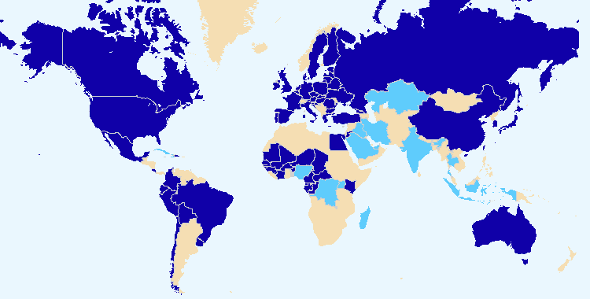

The boundaries shown on this map do not imply the expression of any opinion whatsoever on the part of UPOV concerning the legal status of any country or territory.

 Members of the Union

47 members: African Intellectual Property Organization (OAPI, including participants from Benin, Burkina Faso, Cameroon, Central African Republic, Chad, Congo, Côte d’Ivoire, Guinea, Mali, Niger and Senegal), Australia, Austria, Belarus, Belgium, Bolivia (Plurinational State of), Brazil, Canada, Chile, China, Colombia, Costa Rica, Croatia, Czech Republic, Denmark, Dominican Republic, Ecuador, Egypt, Estonia, European Union (EU, including participants from Greece), France, Georgia, Germany, Ireland, Italy, Japan, Jordan, Kenya, Latvia, Lithuania, Mexico, Netherlands, Peru, Poland, Portugal, Republic of Korea, Russian Federation, Slovakia, Slovenia, Spain, Sweden, Trinidad and Tobago, Turkey, Ukraine, United Kingdom, United States of America, Uruguay

 Non-members of the Union

17 States: Barbados, Brunei Darussalam, Cuba, Democratic Republic of the Congo, Haiti, India, Indonesia, Iran (Islamic Republic of), Iraq, Jamaica, Kazakhstan, Madagascar, Nigeria, Saudi Arabia, Thailand, Uganda, United Arab Emirates

There were also participants from CIOPORA, EPO, FAO and WIPO.

|  |
| --- |
| Figure 36. Participants in all distance learning courses by language |

| **Expected Results** | **Performance Indicators** | **Performance Data** | |
| --- | --- | --- | --- |
| 4. Assistance in implementing an effective plant variety protection system in accordance with the UPOV Convention *(continued)* | (b) Participation in UPOV training/assistance activities; | see Annex V to this document | |
| (c) Participation in training/assistance activities developed in conjunction with UPOV; | see Annex V to this document | |
| (d) Participation in activities involving UPOV staff or UPOV trainers on behalf of UPOV staff; | see Annex V to this document | |
| (e) Participation by observer States and organizations in the CAJ, TC, TWPs and the associated preparatory workshops; | see Sub-Program UV.2, Section 1 “Participation by members of the Union and observers in the work of the UPOV bodies”, sub‑section (a) |
| (f) Participation in training/assistance activities operated by third parties to which UPOV substantially contributed; | see Annex V to this document |
| (g) Academic institutions that include information on the UPOV system and which invite UPOV to contribute; | see Annex V to this document |
| (h) Number of students studying academic courses from academic institutions that include information on the UPOV system and which invite UPOV to contribute; | see Annex V to this document |
| (i) Number of academic institutions that include participation of students in UPOV distance learning courses; | 5 (in 2020):   * La Salle Beauvais University - IP Plant Breeding Master Programme * OAPI Masters IP Training Course * Máster Lvcentinvs in Plant Variety Protection, Alicante University * Advanced Masters Intellectual Property Law and Knowledge Management, University of Maastricht * IP Master of WIPO, ILO, Turin University |
| (j) Availability of materials in relevant languages. | No developments in 2020 |

## SUB-PROGRAM UV.4: External Relations

### Objectives

(a) To broaden and enhance the understanding of the UPOV system of plant variety protection.

(b) To provide information on the UPOV Convention to other intergovernmental organizations, with the aim of achieving mutual supportiveness with other international treaties.

### Performance Data:

| **Expected Results** | **Performance Indicators** | | **Performance Data** |
| --- | --- | --- | --- |
| 1. Broaden public understanding of UPOV’s role and activities | (a) Availability of suitable information and materials for the general public on UPOV website; | * Adoption of FAQ on the How does the UPOV system support sustainable development? * Updated editions of the information leaflet “What it is, What it does” on UPOV and plant variety protection in English, French, German and Spanish (Publication No. 437) * 3 press releases | |
| (b) Number of new visitors to UPOV website; | 14% increase in the number of visitors in 2020:  106,164 unique users in 2020 (92.966 in 2019)  see figure 37 | |
| (c) Number of visits to general public feature on UPOV website; | see figure 9 (above) and figure 38 | |
| (d) Improved design of UPOV website, including responsive layout; | The Consultative Committee, at its ninety-sixth session, approved the proposed redesign of the UPOV website as demonstrated at the session and noted the plans for the implementation of the redesigned UPOV website and a new content management system (CMS).  To ensure compatibility between the UPOV and WIPO websites that would allow UPOV to benefit from WIPO resources, work on the redesign of the UPOV website was postponed until the World Intellectual Property Organization (WIPO) had selected a new content management system (CMS). | |

|  |  |
| --- | --- |
| Figure 37. Visits to the UPOV websitei – Number of visitors | Figure 38. Website Overview for 2020: Where are the users going?    *On June 17, 2020, UPOV LEX migrated to the cloud. The change in technology resulted in a reduction of the number of pageviews by up to 4 to reach the same information, which is reflected in the 2020 analytics. |

| **Expected Results** | **Performance Indicators** | | **Performance Data** |
| --- | --- | --- | --- |
| 1. Broaden public understanding of UPOV’s role and activities | (e) Information provided via UPOV Twitter and UPOV Vice Secretary‑General’s Twitter accounts | see figures 7 and 8 (above), and figures 39 and 40 | |

Evolution of use of social media: Followers

|  |  |
| --- | --- |
|  |  |
| Figure 39: UPOV LinkedIn followers | Figure 40: Peter Button LinkedIn followers |
|  |  |

Note: The UPOV LinkedIn account was not used prior to July 2019. Analytics tracked from May 17 2020, onwards.

| **Expected Results** | **Performance Indicators** | | **Performance Data** |
| --- | --- | --- | --- |
| 2. Enhance understanding of UPOV’s role and activities for stakeholders | (a) Availability on UPOV website and through other media of suitable information and materials for stakeholders, particularly for breeders and farmers; | see Sub-Program UV.4, performance indicator “1. Broaden public understanding of UPOV’s role and activities”, | |
| (b) Number of visits to stakeholder features on the UPOV website; | After analysis of the level of use of the stakeholder features on the UPOV website and the launch of Twitter and LinkedIn accounts, it had been concluded that stakeholder features were not an essential feature of the main UPOV webpage and would not be included in the redesigned UPOV website. | |
| (c) Participation by stakeholders in seminars and symposia; | see Annex V to this document | |
| (d) Participation at meetings of, and with, relevant stakeholders; | see Annex V to this document | |
| (e) Articles in relevant publications to which UPOV has contributed. | No new articles | |
| 3. Enhance understanding of UPOV’s role and activities with other organizations | (a) Participation at meetings of, and with, relevant organizations; | see Annex V to this document | |
| (b) Initiatives of the World Seed Partnership; | Finalization of WSP infographic (See worldseedpartnership.org)  see Annex V to this document | |
| (c) Contributions to relevant organizations. | see Annex V to this document | |

# iii. annexes

ANNEX I Extrabudgetary Funds (Funds in Trust)

The extrabudgetary funds (including funds in trust) allocated by donors are presented below as independent accounts.



**Income and expenditure by Fund for the year 2020**



*Note: Funds in trust in the form of an extrabudgetary fund from the Government of Canada intended for implementing a technical assistance project in Senegal to improve the capacity of the Ministry of Agriculture and Rural Infrastructure in certain aspects of agriculture, including training and capacity building in order to implement UPOV and Plant Breeders’ Rights Intellectual Property regime.*



*Note: Funds in trust in the form of an extrabudgetary fund from the Government of Japan intended for regional seminars, workshops on the protection of new plant varieties in the Asian region and the development of the EAPVP Pilot Project.*



*Note: Extrabudgetary fund from the Government of the United States of America, intended for education in intellectual property protection in the area of plant variety protection.*



*Note: Extrabudgetary fund from the Netherlands intended to provide and promote the UPOV system of plant variety protection.*



*Note: Extrabudgetary fund from various organizations, communities and federations to promote the UPOV PRISMA PBR application tool. UPOV PRISMA is an on-line tool to assist in making plant variety protection (PVP) applications to PVP Offices of participating members of the Union. This extrabudgetary fund is now closed.*



*Note: UPOV PRISMA is an on-line tool to assist in making plant variety protection (PVP) applications to PVP Offices of participating members of the Union.  The UPOV PRISMA Fund is a contribution made by Naktuinbouw (Netherlands) to support the development of UPOV PRISMA.*

[Annex II follows]

ANNEX II Working Capital Fund and Contributions

Working Capital Fund as at December 31, 2020

Under Regulation 4.2 of the Financial Regulations and Rules of UPOV (see document UPOV/INF/4/6), UPOV has a Working Capital Fund. According to the Statement of Financial Position as at December 31, 2020, the Working Capital Fund stands at 575,011 Swiss francs.  The share of each member of the Union, calculated in accordance with the decision taken by the Council at its twenty-third extraordinary session, held in Geneva on April 7, 2006 (see document C(Extr.)/23/5 “Report”, paragraph 12, Annex II and document UPOV/INF/13/2, Annex), is as follows:



Contributions of Members of the Union



Amounts of the Contributions Due as at December 31, 2020



Contribution Payments Received in Advance



[Annex III follows]

ANNEX III Status in relation to UPOV

The following table provides detailed information on the status in relation to UPOV.

**UPOV members**

African Intellectual Property Organization2, 4

Albania2

Argentina1

Australia2

Austria2

Azerbaijan2

Belarus2

Belgium2

Bolivia (Plurinational State of)1

Bosnia and Herzegovina2

Brazil1

Bulgaria2

Canada2

Chile1

China1

Colombia1

Costa Rica2

Croatia2

Czech Republic2

Denmark2

Dominican Republic2

Ecuador1

Egypt2

Estonia2

European Union2, 3

Finland2

France2

Georgia2

Germany2

Hungary2

Iceland2 Ireland2

Israel2

Italy1

Japan2

Jordan2

Kenya2

Kyrgyzstan2

Latvia2

Lithuania2

Mexico1

Montenegro2

Morocco2

Netherlands2

New Zealand1

Nicaragua1

North Macedonia2Norway1

Oman2

Panama2

Paraguay1

Peru2

Poland2

Portugal1

Republic of Korea2

Republic of Moldova2

Romania2

Russian Federation2

Serbia2

Singapore2

Slovakia2

Slovenia2

South Africa1Spain2

Sweden2

Switzerland2

Trinidad and Tobago1

Tunisia2

Turkey2

Ukraine2

United Kingdom2

United Republic of Tanzania2

United States of America2

Uruguay1

Uzbekistan2

Viet Nam2

(Total 76)

1 1978 Act is the latest Act by which 17 States are bound.

2 1991 Act is the latest Act by which 57 States and 2 organizations are bound.

3 Operates a plant breeders’ rights system which covers the territory of its 27 member States (Austria, Belgium, Bulgaria, Croatia, Cyprus, Czech Republic, Denmark, Estonia, Finland, France, Germany, Greece, Hungary, Ireland, Italy, Latvia, Lithuania, Luxembourg, Malta, Netherlands, Poland, Portugal, Romania, Slovakia, Slovenia, Spain, Sweden) and until December 31, 2020, the United Kingdom..

4 Operates a plant breeders’ rights system which covers the territory of its 17 member States *(Benin, Burkina Faso, Cameroon, Central African Republic, Chad, Comoros, Congo, Côte d’Ivoire, Equatorial Guinea, Gabon, Guinea, Guinea Bissau, Mali, Mauritania, Niger, Senegal, Togo).*

**States and intergovernmental organizations which had initiated the procedure  
for acceding to the UPOV Convention**

Afghanistan, Armenia, Brunei Darussalam, Ghana, Guatemala, Honduras, India, Iran (Islamic Republic of), Kazakhstan, Malaysia, Mauritius, Mongolia, Myanmar, Nigeria, Philippines, Saint Vincent and the Grenadines, Tajikistan, Venezuela (Bolivarian Republic of), Zimbabwe, as well as the African Regional Intellectual Property Organization (ARIPO).

**States and intergovernmental organizations which had been in contact with the Office of the Union   
for assistance in the development of laws based on the UPOV Convention**

Algeria, Bahrain, Barbados, Cambodia, Cuba, Cyprus, El Salvador, Indonesia, Iraq, Jamaica, Lao People’s Democratic Republic, Libya, Liechtenstein, Mozambique, Namibia, Pakistan, Saudi Arabia, Sudan, Thailand, Tonga, Turkmenistan, United Arab Emirates, Zambia, as well as the Southern African Development Community (SADC).

The following map provides a graphic overview of the status in relation to UPOV at the end of 2020.

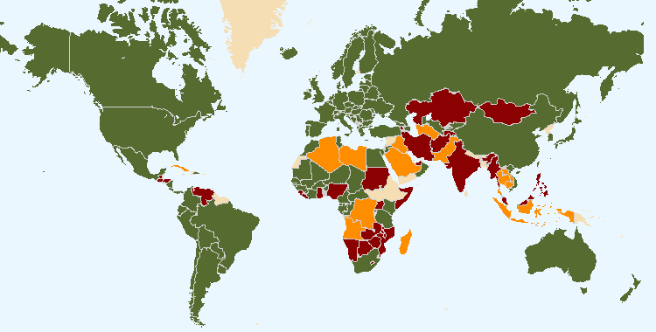

The boundaries shown on this map do not imply the expression of any opinion whatsoever on the part of UPOV concerning the legal status of any country or territory

 76 members of UPOV covering 95 States at the end of 2020

 20 States and 1 intergovernmental organization had initiated the procedure for acceding the UPOV Convention at the end of 2020

 23 States and 1 intergovernmental organization which had been in contact with the Office of the Union for assistance in the development of laws based on the UPOV Convention at the end of 2020

[Annex IV follows]

ANNEX IV Members of the Union

This Annex provides the status of the members of the Union in relation to the Convention and its various Acts, as of December 31, 2020 (see Articles 31 and 32 of the 1961 Convention, Article 32(1) of the 1978 Act and Article 34(2) of the 1991 Act).



<https://www.upov.int/edocs/mdocs/upov/en/c_55/c_55_2_annex_iv.pdf>

[Annex V follows]

ANNEX V List of Activities in 2020



<https://www.upov.int/edocs/mdocs/upov/en/c_55/c_55_2_annex_v.pdf>

[Appendix follows]

# iv. appendix

## ACRONYMS AND ABBREVIATIONS

**UPOV terms**

|  |  |
| --- | --- |
| BMT | Working Group on Biochemical and Molecular Techniques, and DNA-Profiling in Particular |
| CAJ | Administrative and Legal Committee |
| DL-205 | UPOV distance learning course “Introduction to the UPOV System of Plant Variety Protection under the UPOV Convention” |
| DL-305 | UPOV distance learning course “Examination of Applications for Plant Breeders’ Rights” |
| DL-305A | UPOV distance learning course “Administration of Plant Breeders’ Rights” (part A of DL‑305) |
| DL-305B | UPOV distance learning course “DUS Examination” (part B of DL-305) |
| DUS | Distinctness, Uniformity and Stability |
| EAF (see also UPOV PRISMA) | UPOV Electronic Application Form |
| EDV | essentially derived variety |
| Office | Office of the Union |
| PBR | Plant Breeder’s Right |
| PLUTO | UPOV Plant Variety Database |
| TC | Technical Committee |
| TC‑EDC | Enlarged Editorial Committee |
| TWA | Technical Working Party for Agricultural Crops |
| TWC | Technical Working Party on Automation and Computer Programs |
| TWF | Technical Working Party for Fruit Crops |
| TWM | Technical Working Party on Testing Methods and Techniques |
| TWO | Technical Working Party for Ornamental Plants and Forest Trees |
| TWP(s) | Technical Working Party(ies) |
| TWV | Technical Working Party for Vegetables |
| WG-EDV | Working Group on Essentially Derived Varieties |
| UPOV PRISMA | UPOV PRISMA PBR Application Tool |
| WSP | World Seed Partnership |

**Acronyms (also included in Annex V)**

|  |  |
| --- | --- |
| 2050Today | A climate action initiative bringing together a community of international Geneva institutions |
| AATF | African Agricultural Technology Foundation |
| AFSTA | African Seed Trade Association |
| AIPH | International Association of Horticultural Producers |
| AOHE | Association of European Horticultural Breeders |
| APBREBES | Association for Plant Breeding for the Benefit of Society |
| APSA | Asia and Pacific Seed Association |
| ARIPO | African Regional Intellectual Property Organization |
| AUDA-NEPAD | African Union Development Agency-New Partnership for Africa's Development |
| BruIPO | Intellectual Property Office of Brunei Darussalam |
| CARICOM | Caribbean Community |
| CARIFORUM | Caribbean Forum of the African, Caribbean and Pacific Group of States |
| CarIPI | CARIFORUM Intellectual Property Rights and Innovation |
| CBD | Convention on Biological Diversity |
| CBD SBI | Subsidiary Body on Implementation of the CBD |
| CBD SBSTTA | Subsidiary Body on Scientific, Technical and Technological Advice of the CBD |
| CFIA | Canadian Food Inspection Agency |
| CIOPORA | International Community of Breeders of Asexually Reproduced Ornamental and Fruit Varieties |
| CLI | CropLife International |
| COBORU (Poland) | Research Centre for Cultivar Testing |
| COMESA | Common Market for Eastern and Southern Africa |
| COPA-COGECA (European Union) | Committee of Professional Agricultural Organisations - General Confederation of Agricultural Cooperatives |
| CPVO | Community Plant Variety Office of the European Union |
| DAR (MOALI) | Department of Agricultural Research, MOALI (Myanmar) (see below) |
| DCST (China) | Development Center of Science and Technology of China |
| EAPVP Forum | East Asia Plant Variety Protection Forum |
| EDF | European Development Fund |
| EUIPO | European Intellectual Property Office |
| FAO | Food and Agriculture Organization of the United Nations |
| GEVES (France) | *Groupe d'Étude et de contrôle des Variétés Et des Semences* |
| GNIS (France) | *Groupement national interprofessionnel des semences et plants* |
| IFOAM-Organics International | International Federation of Organic Agriculture Movements |
| INDECOPI (Peru) | National Institute for the Defense of Free Competition and the Protection of Intellectual Property |
| InnoVar project | "Next-generation variety testing for improved cropping on European farmland" (project funded under the EU Horizon 2020 Research and Innovation Programme) |
| IP Key | IP Key is co-financed by the European Union and the European Intellectual Property Office (EUIPO). It is implemented by EUIPO in cooperation with EPO. |
| IP Key LA | IP Key Latin America |
| IP Key SEA | IP Key South-East Asia |
| ISF | International Seed Federation |
| ISO | International Organization for Standardization |
| ISTA | International Seed Testing Association |
| ITPGRFA | International Treaty on Plant Genetic Resources for Food and Agriculture |
| JATAFF | Japan Association for Techno-innovation in Agriculture, Forestry and Fisheries |
| JICA | Japan International Cooperation Agency |
| JICE | Japan International Cooperation Center |
| MAFF (Japan) | Ministry of Agriculture, Forestry and Fisheries of Japan |
| MARA (China) | Ministry of Agriculture and Rural Affairs of China |
| MOALI (Myanmar) | Ministry of Agriculture, Livestock and Irrigation of Myanmar |
| NAHEP ICAR (India) | National Agricultural Higher Education Project, Indian Council of Agricultural Research |
| Naktuinbouw | The Netherlands Inspection Service for Horticulture |
| NAPB (United States of America) | National Association of Plant Breeders |
| NASC (Nigeria) | National Agricultural Seeds Council |
| NCSS (Japan) | National Center for Seeds and Seedlings (National Agriculture and Food Research Organization - NARO) of Japan |
| NFGA (China) | National Forestry and Grassland Administration of China |
| OAPI | African Intellectual Property Organization |
| OECD | Organisation for Economic Co-Operation and Development |
| OEVV (Spain) | *Oficina Española de Variedades Vegetales* (Spanish Plant Variety Office) |
| PRV (Sweden) | Swedish Patent and Registration Office |
| PVPO | Plant Variety Protection Office |
| SAA | Seed Association of the Americas |
| SAG (Chile) | *Servicio Agrícola y Ganadero* (Agricultural and Livestock Service) |
| SENADI (Ecuador) | *Servicio Nacional de Derechos Intelectuales* (National Service of Intellectual Rights) |
| SENAVE (Paraguay) | *Servicio Nacional de Calidad y Sanidad Vegetal y de Semillas* (National Service for Plant and Seed Quality and Health) |
| SFSA | Syngenta Foundation for Sustainable Agriculture |
| Sida | Swedish International Development Cooperation Agency |
| SIL | Soyabean Innovation Lab |
| SNICS (Mexico) | *Servicio Nacional de Inspección y Certificación de Semillas* (National Seed Inspection and Certification Service) |
| TTIPO | Trinidad and Tobago Intellectual Property Office |
| TRIPS | Trade Related Aspects of Intellectual Property Rights |
| UNFCCC | United Nations Framework Convention on Climate Change (UN Climate Change) |
| UNIGE | University of Geneva |
| USPTO | United States Patent and Trademark Office |
| WFO | World Farmers’ Organization |
| WFRS Breeders' Club | World Federation of Rose Societies Breeders’ Club |
| WIPO | World Intellectual Property Organization |
| WTO | World Trade Organization |
| WWF | World Wildlife Fund |

1. <https://www.upov.int/about/en/faq.html#QS10>
2. Definitions used in Website statistics in this report:

   - “Users” are individuals who have had at least one session within the selected date range.

   - A “session” is a group of user interactions with your website that take place within a given time frame. For example a single session can contain multiple page views, events, social interactions, and ecommerce transactions. A single user can open multiple sessions. Those sessions can occur on the same day, or over several days, weeks, or months. As soon as one session ends, there is then an opportunity to start a new session. There are two methods by which a session ends:

   • Time-based expiration:

   * After 30 minutes of inactivity
   * At midnight

   • Campaign change:

   * If a user arrives via one campaign, leaves, and then comes back via a different campaign.

   - “Unique Pageviews” are the number of visits during which the specified page was viewed at least once.

   - “Pageviews” are the total number of times that a page was viewed. Repeated views of a single page by the same user during the same session are counted.

   - “Number of visits” is the number of devices used to visit the website in a month (a person may use more than one device).

   [End of appendix and of document]
3. Where data is provided over years, this is provided for the period 2010-2020 unless data is unavailable for all years.
4. * Participation is assessed on the basis of the number of participating members and observer States/organization, rather than the number of individual participants.