|  |  |
| --- | --- |
|  | E |
| International Union for the Protection of New Varieties of Plants |  |

|  |  |
| --- | --- |
| Council  Fifty-Fifth Ordinary Session Geneva, October 29, 2021 | C/55/14  Original: English  Date: October 29, 2021 |

Draft Press release

Document prepared by the Office of the Union

Disclaimer: this document does not represent UPOV policies or guidance

The Annex to this document contains a draft press release on the fifty-fifth ordinary session of the Council and decisions taken by the Council by correspondence in advance of the session.

The Council is invited to consider the draft press release, contained in the Annex to this document, subject to developments in the Council.

[Annex follows]

ANNEX

UPOV Press Release 133

Geneva, October 29, 2021

**UPOV Council Holds its Annual Session**

The Council of the International Union for the Protection of New Varieties of Plants (UPOV) held its fifty-fifth ordinary session by virtual means on October 29, 2021. The Council took decisions on the following   
matters at the session or by correspondence in advance of the session. The report of the session,   
with information on decisions taken by correspondence, is provided in documents C/55/18 and C/55/12 (see <https://www.upov.int/meetings/en/details.jsp?meeting_id=60600>)

**Round-up of key developments:**

Draft Law of Jamaica

The Council took a positive decision on the conformity of the New Plant Varieties (Rights of Breeders) Bill, 2021, of Jamaica (“Draft Law”) with the provisions of the 1991 Act of the UPOV Convention, which allows Jamaica once the Draft Law is adopted with no changes and the Law is in force, to deposit its instrument of accession to the 1991 Act.

Vice Secretary-General

The Council extended the appointment of Mr. Peter Button as Vice Secretary-General from December 1, 2022, until his retirement in October 2023. The Council further approved the procedure and timetable for the appointment of a new Vice Secretary-General.

Developments in UPOV

A video presentation by the Vice Secretary-General on “Report on developments in UPOV”, made for the fifty‑fifth ordinary session of the Council, is available at the [C/55](https://www.upov.int/meetings/en/details.jsp?meeting_id=60600) webpage, in English, with subtitles in English, French, German and Spanish.

Events

*Seminar on strategies that address policies involving plant breeding and plant variety protection*

On October 20, 2021, UPOV organized a seminar on strategies that address policies involving plant breeding and plant variety protection (Seminar), held by electronic means. The Seminar was attended by 132 participants from 45 members of the Union and 13 observers. A video of the seminar is available at <https://www.upov.int/meetings/en/details.jsp?meeting_id=64550>. A video recording of the Seminar is available on the UPOV website in English and will also be made available in the other languages available during the Seminar: French, German, Spanish and Russian.

The proceedings of the Seminar will be published on the UPOV Website in all UPOV languages.

Mr. Daren Tang, Secretary‑General, provided the welcome and opening remarks, a copy of which are reproduced in Appendix I.

Mr. Marien Valstar, President of the Council, provided concluding remarks as reproduced in Appendix II. In his concluding remarks, the President observed a need for a further opportunity to explore the role of plant breeding and plant variety protection in relation to the need for agriculture to adapt to, and mitigate, climate change and proposed that consideration be given to organizing a seminar in 2022, dedicated to this theme.

The Council agreed to the organization of a seminar in 2022 to explore the role of plant breeding and plant variety protection in enabling agriculture to adapt to, and mitigate, climate change.

Program and Budget for the 2022-2023 Biennium

The Council approved the Program and Budget of the Union for the 2022‑2023 Biennium, including:

(i) the amount of contributions from members of the Union;

(ii) the proposed maximum ceiling of expenditure in the regular budget being 7,634,500 Swiss francs or the income received in the biennium, whichever is the lower; and

(iii) the total number of posts.

*Digitalization*

The Program and Budget looks to build on the opportunities for digitalization to transform the level of support that UPOV can provide in the implementation of the UPOV system of plant variety protection.

It is planned that the following package of compatible tools (e-PVP) will be further developed in the 2022-2023 biennium. These tools will provide coherent and comprehensive assistance in the implementation of the UPOV system of plant variety protection, some or all of which can be used by members of the Union, as considered appropriate:

1) Applying for PVP

(a) Extending coverage of UPOV PRISMA to more members of the Union and more crops/species

(b) UPOV member cooperation platforms (e.g. regional) to cooperate in the administration and examination of applications

2) Administration of PVP applications

(a) Electronic PVP administration module for members of the Union to manage and publish PVP applications

(b) UPOV similarity search tool for variety denomination purposes based on UPOV agreed algorithm running on data in the PLUTO database

(c) Enhancement of PLUTO database by increasing quantity and quality of data included

3) Facilitating cooperation in DUS examination

(a) Platform for exchange of existing DUS reports

(b) Tool to provide information on cooperation in DUS examination between members of the Union to PVP applicants in a user-friendly form

(c) Platform for members of the Union to make their documented DUS procedures and information on their quality management systems available to other members of the Union

(d) Module for members of the Union to use the web-based TG Template and database of characteristics to develop individual authorities’ test guidelines (IATG) in their language

(e) Platform/portal for UPOV member databases containing variety description information

The following figure provides a graphic overview of how the e-PVP components could be integrated in relation to the “Functions and structure of a PBR Office” as identified in document UPOV/INF/15 “Guidance for Members of UPOV”.

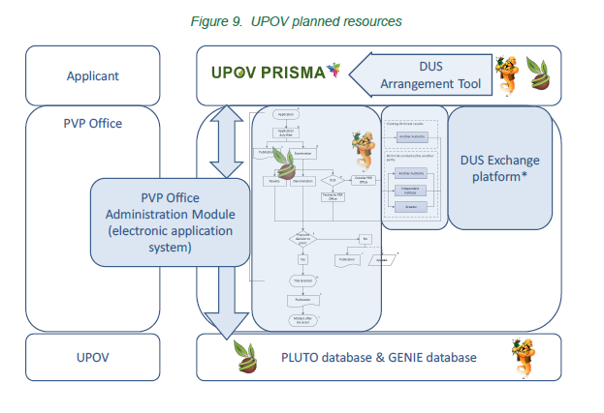

Rapid advances in machine translation technology have also provided new opportunities, which will be pursued as a matter of priority to reduce translation costs for UPOV documents in UPOV languages and to make UPOV materials available in a wider range of languages.

*International UPOV qualification*

In order to provide more impact in training and assistance from available resources, resources will be increasingly channeled to virtual training programs and re-usable materials, additional distance learning courses, video demonstrations, webinars and virtual practical guides, in order to reduce the need for *in situ* training and to increase outreach. Furthermore, in conjunction with relevant partners, it is proposed to develop an international curriculum leading to UPOV-recognized qualifications.

Use of the Chinese language in UPOV

The Council approved the program for the use of the Chinese language in UPOV and proposed resourcing, including the provision of interpretation services in the Chinese language at UPOV sessions in Geneva.

Adoption of documents

The Council adopted revised versions of the following documents:

UPOV/INF/6: Guidance for the preparation of laws based on the 1991 Act of the UPOV Convention UPOV/INF/16: Exchangeable Software

UPOV/INF/17: Guidelines for DNA-Profiling: Molecular Marker Selection and Database Construction (“BMT Guidelines”)

UPOV/INF/22: Software and Equipment Used by Members of the Union

UPOV/INF/23: UPOV Code System

TGP/5: Experience and Cooperation in DUS Testing, Section 2: UPOV Model Form for the Application for Plant Breeders’ Rights

UPOV/EXN/DEN: Explanatory Notes on Variety Denominations under the UPOV Convention

All adopted documents will be published in the UPOV Collection (see <http://www.upov.int/upov_collection/en/>).

Plant Variety Protection Statistics

The number of applications for plant variety protection increased from 21,265 in 2019 to 22,512 in 2020 (5.9 percent increase).

The number of titles issued decreased from 14,688 in 2019 to 13,873 in 2020 (5.5 percent decrease), resulting from a 4.5 percent decrease in the number of titles issued to residents (9,487 in 2020; 9,935 in 2019) and a 7.7 percent decrease in the number of titles issued to non-residents (4,386 in 2020; 9,753 in 2019).

The total of 141,034 titles in force in 2020 represented a 1.2 percent increase on figures for 2019 (139,360).

The following graphs indicate trends in applications filed and titles issued since 1986. Information is also provided on the 10 members of the Union receiving the largest number of applications in 2010, 2019 and 2020 and an analysis of applications by residence of breeders for the same years.











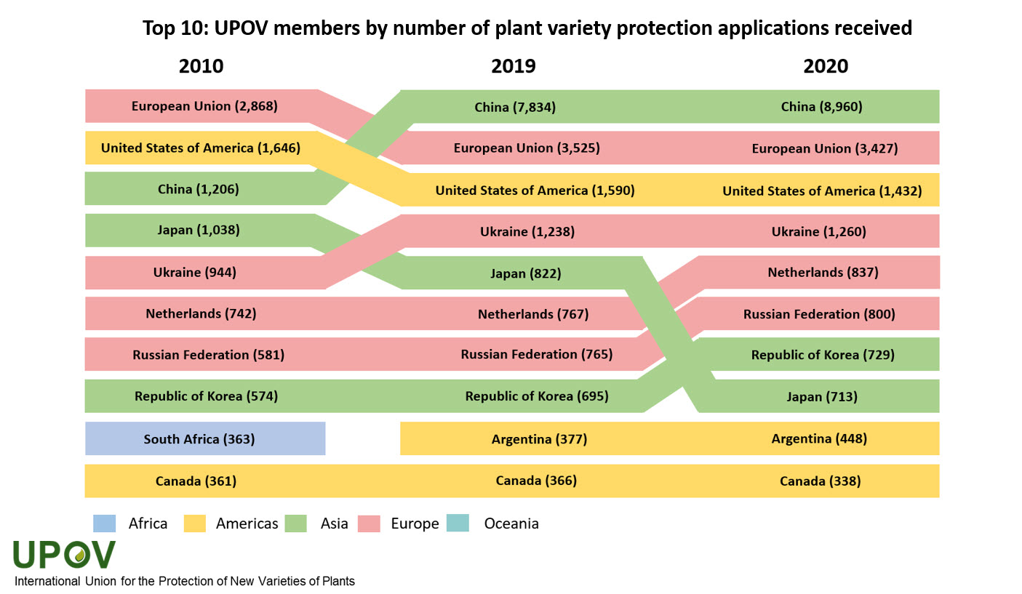

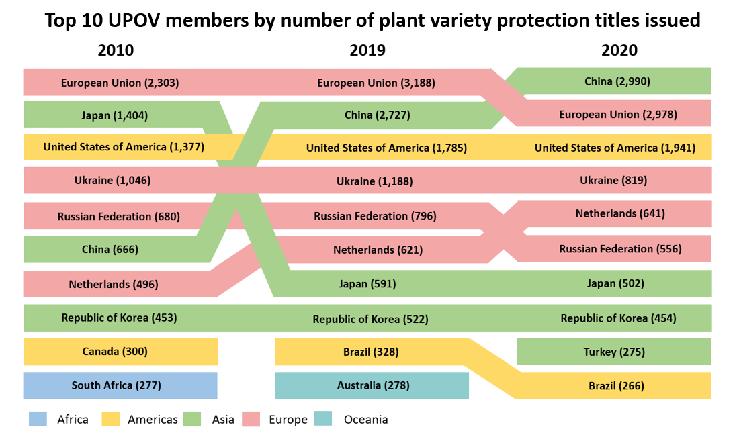

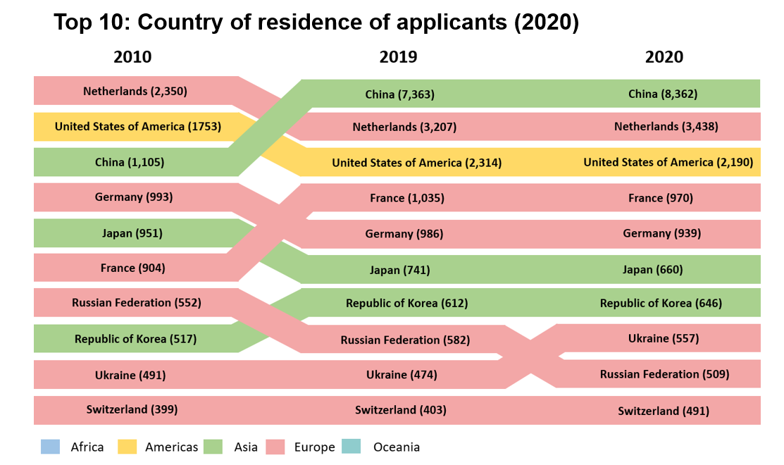

**NOTES TO EDITORS**

UPOV is an intergovernmental organization based in Geneva.

The purpose of UPOV is to provide and promote an effective system of plant variety protection, with the aim of encouraging the development of new varieties of plants, for the benefit of society.

UPOV has 77 members covering 96 States. The members of UPOV are:

African Intellectual Property Organization, Albania, Argentina, Australia, Austria, Azerbaijan, Belarus, Belgium, Bolivia (Plurinational State of), Bosnia and Herzegovina, Brazil, Bulgaria, Canada, Chile, China, Colombia, Costa Rica, Croatia, Czech Republic, Denmark, Dominican Republic, Ecuador, Egypt, Estonia, European Union, Finland, France, Georgia, Germany, Hungary, Iceland, Ireland, Israel, Italy, Japan, Jordan, Kenya, Kyrgyzstan, Latvia, Lithuania, Mexico, Montenegro, Morocco, Netherlands, New Zealand, Nicaragua, North Macedonia, Norway, Oman, Panama, Paraguay, Peru, Poland, Portugal, Republic of Korea, Republic of Moldova, Romania, Russian Federation, Saint Vincent and the Grenadines, Serbia, Singapore, Slovakia, Slovenia, South Africa, Spain, Sweden, Switzerland, Trinidad and Tobago, Tunisia, Turkey, Ukraine, United Kingdom, United Republic of Tanzania, United States of America, Uruguay, Uzbekistan and Viet Nam.

For further information about UPOV, please contact the UPOV Secretariat:

Tel: (+41-22) 338 9111 E-mail: upov.mail@upov.int

Website: https:www.upov.int

Social media

UPOV Twitter Twitter account: @UPOVint

UPOV LinkedIn LinkedIn account: <https://www.linkedin.com/company/upov-official>

[Appendices follow]

APPENDIX I

SEMINAR ON STRATEGIES THAT ADDRESS POLICIES

INVOLVING PLANT BREEDING AND PLANT VARIETY PROTECTION

Geneva, October 20, 2021 (by electronic means)

**Opening Remarks, Mr. Daren Tang, Secretary‑General, UPOV**

Mr. Marien Valstar, President of the UPOV Council,

Dear Participants, Dear Colleagues, Dear Friends,

It is a pleasure to be with you today and to open this seminar.

This year marks the 60th anniversary of UPOV’s foundation. Back in 1961, UPOV was created to recognize the importance of the protection of new plant varieties and to uphold the interests of plant breeders around the world.

Six decades on, I would like to highlight three policy pillars which capture the impact of UPOV’s work:

* First, transforming food production in a time of climate change.
* Second, spurring economic development through plant breeding and UPOV’s system of plant protection.
* And, third, bringing innovation and technology transfer to farmers.

It is important to remember that at the time UPOV was formed the only way to produce more food was to use more land. However, this link has now been superseded thanks to innovation. Since the 1960s, food production has increased nearly four-fold, while land use has expanded by only around 10 percent. This means we can feed more by using less.

It has been estimated that plant breeding and new plant varieties are currently responsible for around 90 per cent of cereal land productivity gains in Europe. And if plant breeding has delivered in the past, then it will be even more important to ensuring food security in the future. This is well understood by the agricultural sector. A recent survey from the World Farmers Organization found that over 70 per cent of farmers are utilizing improved plant varieties. Moreover, eight in ten farmers who use new plant varieties identified them as important factors in ensuring the sustainability of food systems and in combatting climate change.

This aligns with UPOV’s broader desire to accelerate progress towards the UN’s Sustainable Development Goals. UPOV has identified six SDGs to which plant breeding and the UPOV system directly contributes towards. From ending hunger, achieving food security and improved nutrition, to protecting terrestrial ecosystems and halting biodiversity loss – transforming food production is helping to deliver a fairer, greener and more sustainable world.

This brings me to the second pillar: economic development.

In my address to the UPOV Council following my appointment as Secretary-General last year, I referenced the impressive economic benefits of plant breeding and UPOV’s system of plant variety protection. Today, I want to discuss another important aspect of UPOV’s work – the support we provide to people and communities around the world.

I have three examples that I would like to share.

First, in Kenya, UPOV membership has ensured access to much sought after varieties of cut flower roses. Thanks to their growing popularity, Kenya has developed a $500 million cut-flower industry which, in turn, brings secure employment to around half a million Kenyans.

Second, in Viet Nam, thanks to plant breeding activities, the annual income of farmers has increased by over 24% since it joined UPOV in 2006. It is estimated that plant breeding has resulted in significant annual productivity increases for Viet Nam’s main staple crops such as rice and maize, with the increased productivity associated with plant breeding being equivalent to more than 2.5 per cent of Viet Nam’s GDP.

And finally, this year marks the tenth anniversary of Peru’s membership of UPOV. In that time, more than eighty new varieties of grapes and more than sixty new varieties of blueberries have been protected.

This has helped to turbo-charge Peru’s exports. For example, trade in fresh grapes is up almost ten-fold over the last decade, with blueberry exports up by a multiple of thirteen in the last five years alone.

This is how UPOV’s helps to lift up people and communities around the world – supporting job creation, business investment and economic growth. And in the context of a pandemic that continues to take a terrible toll – including on many livelihoods around the world – this work is as important today as ever.

The third pillar concerns innovation and technology transfer to farmers.

Through an effective Plant Variety Protection (PVP) system, UPOV stimulates the development of new plant varieties. And these new varieties represent one of the most effective ways of delivering new technology to farmers. It is a symbiotic relationship: UPOV enables plant breeders to protect their varieties and to obtain a return on their investment; with this income predicated on farmers choosing to grow more suitable varieties that match local and export needs.

Equally, the UPOV system continues to support the delivery of public goods. Take the UC Davis Public Strawberry Breeding Program. Over six decades, the program has developed more than 30 protected varieties, made strawberries a year-round crop in California, and boosted strawberry yield from just 6 tons per acre in the 1950s to 30 tons per acre today.

Thanks to the UC Davis program, Californian growers pay lower rates than others for their strawberries and get access to new varieties before growers elsewhere.

Not only do UC Davis varieties benefit domestic growers but they have been instrumental in the development of the strawberry industry in several UPOV members– for instance 70-90% of strawberries in Spain have been bred by UC Davis, which transferred the varieties and knowledge as a part of the PBR license process.

Dear Participants, Dear Colleagues, Dear Friends,

As you can see, the legal framework of protection offered by the UPOV system is as important today as it was 60 years ago. But while protection remains the cornerstone of UPOV’s work, its broader impact continues to be felt around the world.

From progressing sustainable solutions at a time when humanity faces a code red from climate change.

* To providing jobs and economic growth in developing and the least developed countries.
* To supporting agricultural innovation and technology transfer.
* Plant breeding and plant variety protection is making a real difference to people and communities on the ground.

Today, you will hear from speakers representing countries right around the world. While their experiences differ, in all cases UPOV’s work has an important role to play in realizing their future ambitions. On behalf of UPOV, I would like to thank all our speakers for their time today and I would like to thank everyone in the audience for your participation.

Please accept my best wishes for a lively, engaging and thought provoking seminar.

Thank you.

[Appendix II follows]

APPENDIX II

SEMINAR ON STRATEGIES THAT ADDRESS POLICIES

INVOLVING PLANT BREEDING AND PLANT VARIETY PROTECTION

Geneva, October 20, 2021 (by electronic means)

**Concluding Remarks, Mr. Marien Valstar, President of the UPOV Council**

Dear Participants,

We have heard today the following key messages:

Canada: PBR creates level playing field where private, public and or Public Private Partnerships (PPS) can operate in the marketplace.

China: showed the successful development of PVP in China, including a roadmap to implement UPOV91.

The EU: showed the many challenges we face globally (SDG’s) and the strategies that are being implemented to face these challenges, showing that plant breeding is a key element in reaching the goals.

Japan: highlighted improvements in its PVP and Seed Act and showed the initiative to establish e-PVP Asia, leading to more collaboration in the region.

Kenya: gave an overview of PVP in Kenya and showed the positive impact on food security, employment and farmers livelihood.

Mexico: gave insight into their plans to enhance agricultural productivity by promoting plant breeding and quality seeds, thereby including subsistence farmers in the process.

Norway: highlighted the importance of plant breeding for sustainable food systems, indicating that we need to consider farmers rights and plant breeders rights.

Peru: gave an overview of its national system, showing the result of a study that PVP contributed 6% to its Gross Domestic Product, and showed a program to encourage more development and research in Peru through PVP.

Sweden: indicated that plant breeding is a part of the solution to the global challenges we face, and asked how the UPOV community could assist in making plant breeding more accessible for ‘small breeders’’.

The USA: gave an overview of recent improvements in the Farm Bill, initiatives that foster urban agriculture and an initiative to invest more in agricultural research and development.

All contributors highlighted that plant breeding and improved varieties are an important part of the solution to key policy challenges. A solution that can help us to achieve important goals in food security, sustainable agriculture, economic development and improving livelihood of farmers, including smallholder farmers.

All contributors also gave insight in developments and initiatives in their countries or regions, indicating that a lot of work is done at national and regional levels to improve their systems and to promote plant breeding.

However, that does not mean that we now can rest. The speakers also indicated that there are improvements needed at the international level, including the need to ensure that improved varieties are reaching those farmers that have the most to gain from improved varieties.

Like all farmers, smallholder farmers worldwide need access to better varieties. There are different strategies to work towards that goal. I sincerely hope that our efforts to develop guidance concerning smallholder farmers in relation to private and non-commercial use will be helpful in clarifying that the UPOV system can bring benefits to smallholder farmers. Next week during we will discuss the way forward.

Another topic, that was mentioned frequently, was the impact of climate change and the need for agriculture to adapt and to mitigate climate change. It is clear that plant breeding and, therefore, UPOV has an important role to play here. We have had many presentations today that referred to this theme but there has been very limited time to learn about this in any depth. It seems to me that we need a further opportunity to explore this crucial topic and I would like to propose that consideration be given by UPOV to organizing a seminar next year, dedicated to this theme.

[End of Appendix II and of document]