E
International Union for the Protection of New Varieties of Plants

Council  Fifty-Fourth Ordinary Session  Geneva, October 30, 2020 | C/54/20.  Original: English  Date: October 30, 2020
DRAFT Press release
Document prepared by the Office of the Union
Disclaimer: this document does not represent UPOV policies or guidance
The Annex to this document contains a draft press release on the fifty-fourth ordinary session of the Council and decisions taken by the Council by correspondence in advance of the session.

The Council is invited to consider the draft press release, contained in the Annex to this document, subject to developments in the Council.

[Annex follows]

ANNEX

UPOV Press Release 127

Geneva, October 30, 2020

UPOV Council Holds its Annual Session

The Council of the International Union for the Protection of New Varieties of Plants (UPOV) held its fifty-fourth ordinary session by virtual means on October 30, 2020. The Council took decisions on the following matters at the session or by correspondence in advance of the session. The report of the session, with information on decisions taken by correspondence, is provided in documents C/54/21 and C/54/17 (see https://www.upov.int/meetings/en/details.jsp?meeting_id=55680)

Round-up of key developments:

Appointment of the Secretary-General

The Council appointed Mr. Daren Tang as the Secretary-General of UPOV for the period from October 30, 2020, to September 30, 2026.

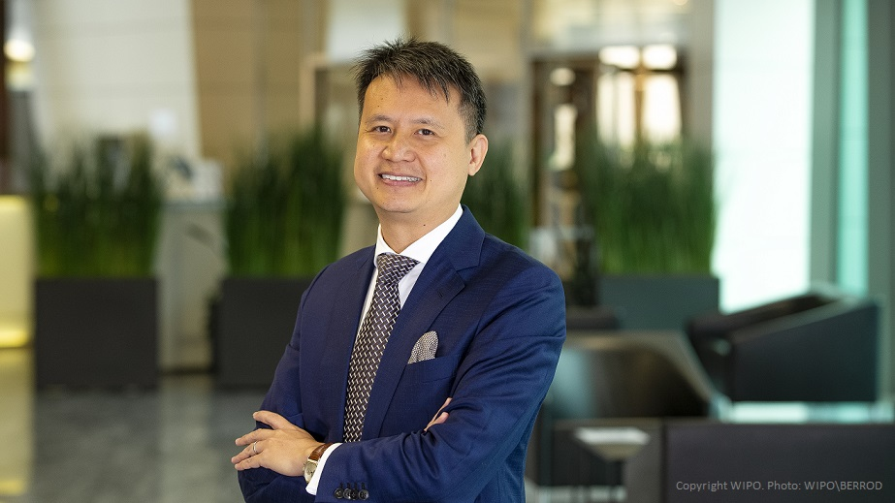

The intervention made by the Secretary-General is reproduced in the Appendix to this press release.

Note: the Agreement between the World Intellectual Property Organization and the International Union for the Protection of New Varieties of Plants (WIPO/UPOV Agreement, document UPOV/INF/8), signed on November 26, 1982, Article 4 provides as follows: “(1) The Council of UPOV shall appoint as Secretary-General of UPOV the Director General of WIPO.” The General Assembly of WIPO, at its fifty-second (28th extraordinary) session, conducted on May 7 and 8, 2020, in the form of a written procedure, appointed Mr. Daren Tang as the Director General of WIPO for the period from October 1, 2020, to September 30, 2026.

Extension of the appointment of the Vice Secretary-General

The Council extended the appointment of the Vice Secretary-General, Mr. Peter Button, from December 1, 2021, until November 30, 2022.

Events

The Council agreed to the organization of a seminar in the week of the UPOV sessions in 2021 to exchange information and experiences on strategies involving plant breeding and plant variety protection that address broad policy issues.

The CAJ agreed to propose to the Council to organize a seminar in the first half of 2021, to exchange information on matters concerning harvested material and unauthorized use of propagating material.

FAQ: How does the UPOV system support sustainable development?

The Council adopted the following FAQ:

HOW DOES THE UPOV SYSTEM SUPPORT SUSTAINABLE DEVELOPMENT?

The vision of the 2030 Agenda for Sustainable Development (see http://www.un.org/sustainabledevelopment/sustainable-development-goals/) includes a world where “food is sufficient, safe, affordable and nutritious”, there is “sustained and inclusive economic growth, social development, environmental protection and the eradication of poverty and hunger” and one in “which development and the application of technology are climate-sensitive, respect biodiversity and are resilient”.

World population is growing and urbanization increasing, which places greater demands on the quantity and quality of agricultural production. At the same time, conservation of biodiversity depends on sustainable agriculture and a halt or reversal to the expansion of agricultural land, while there are parallel demands on agricultural land for food and energy production. This means that there is a need to produce more from existing agricultural land, in a sustainable way.

The tremendous progress in agricultural productivity in various parts of the world is largely based on improved varieties, combined with improved farming practices. Breeding plant varieties with improved yield, more efficient use of nutrients, resistance to plant pests and diseases, salt and drought tolerance and better adaptation to climate change can sustainably increase productivity and product quality in agriculture, horticulture and forestry, whilst minimizing the pressure on the natural environment. At the same time, new varieties that are adapted to the environment in which they are grown increase the choice of healthy, tasty and nutritious food while generating a viable income for farmers.

The UPOV system of plant variety protection supports long-term investment in breeding and provides a framework for investment in the delivery of seed and other propagating material of varieties suited to farmers’ needs. UPOV was created in 1961 for the development of agriculture and, since that time, has proven to be an effective system for supporting various types of breeders: individuals, farmers, SMEs and larger breeding institutes/enterprises, in the private and public sectors.

From the outset, the UPOV system was conceived to deliver greatest progress in plant breeding and, therefore, to sustain greatest advances in agriculture for the benefit of farmers and society as a whole. This concept is enshrined in the “breeder’s exemption”, a key feature of the UPOV system since its creation. This exemption enables protected plant varieties to be available for further breeding by all types of breeders, thus recognizing that access to genetic resources is a prerequisite for any type of breeding.

Adoption of documents

The Council adopted revised versions of the following documents:

UPOV/INF/4 Financial Regulations and Rules of UPOV
UPOV/INF/16 Exchangeable Software (Revision)
UPOV/INF/22 Software and Equipment Used by Members of the Union
TGP/5 Experience and Cooperation in DUS Testing
Section 6: UPOV Report on Technical Examination and UPOV Variety Description
TGP/7 Development of Test Guidelines
TGP/14 Glossary of Terms Used in UPOV Documents
TGP/15 Guidance on the Use of Biochemical and Molecular Markers in the Examination of Distinctness, Uniformity and Stability (DUS)

All adopted documents will be published in the UPOV Collection (see http://www.upov.int/upov_collection/en/).

Election of the new Chairpersons

The Council elected the following as Chairpersons of the TWPs and the BMT for a term of three years ending with the fifty-seventh ordinary session of the Council, in 2023:

(a) Ms. Renée Cloutier (Canada) as Chairperson of the Technical Working Party for Agricultural Crops (TWA);
(b) Mr. Christopher Barnaby (New Zealand) as Chairperson of the Technical Working Party for Fruit Crops (TWF);
(c) Ms. Ashley Balchin (Canada) as Chairperson of the Technical Working Party for Ornamental Plants and Forest Trees (TWO);
(d) Ms. Marian van Leeuwen (Netherlands) as Chairperson of the Technical Working Party for Vegetables (TWV); and
(e) Ms. Beate Rücker (Germany) as Chairperson of the Working Group on Biochemical and Molecular Techniques, and DNA-Profiling in Particular (BMT).

Technical Working Party on Testing Methods and Techniques (TWM)

The Council approved the establishment and terms of reference for the TWM, to encompass the work of the Technical Working Party on Automation and Computer Programs (TWC) and the Working Group on Biochemical and Molecular Techniques, and DNA-Profiling in Particular (BMT), and elected Ms. Beate Rücker (Germany), as Chairperson of the TWM for a term of three years ending with the fifty-seventh ordinary session of the Council, in 2023.

Cooperation in the Examination of New Plant Varieties

The number of plant genera and species for which there were agreements between members of the Union for cooperation in the examination of distinctness, uniformity and stability increased from 2,016 (corrected) in 2019 to 2,071 in 2020 (3 percent increase).

Award of Gold Medal

The Secretary-General, on behalf of the Council, awarded a Gold Medal to Mr. Francis Gurry, former Secretary-General in recognition of his outstanding contribution to UPOV as Secretary-General from October 30, 2008 to September 30, 2020.

[photo to be added in final version]

Plant Variety Protection Statistics

The number of applications for plant variety protection increased from 19,681 in 2018 to 21,265 in 2019 (8 percent increase).

The number of titles issued increased from 13,274 in 2018 to 14,688 in 2019 (11 percent increase).

The total of 139,968 titles in force in 2019 represented a 7 percent increase on figures for 2018 (130,849).

The following graphs indicate trends in applications filed and titles issued since 1986. Information is also provided on the 10 members of the Union receiving the largest number of applications in 2009, 2018 and 2019 and an analysis of applications by residence of breeders for the same years.

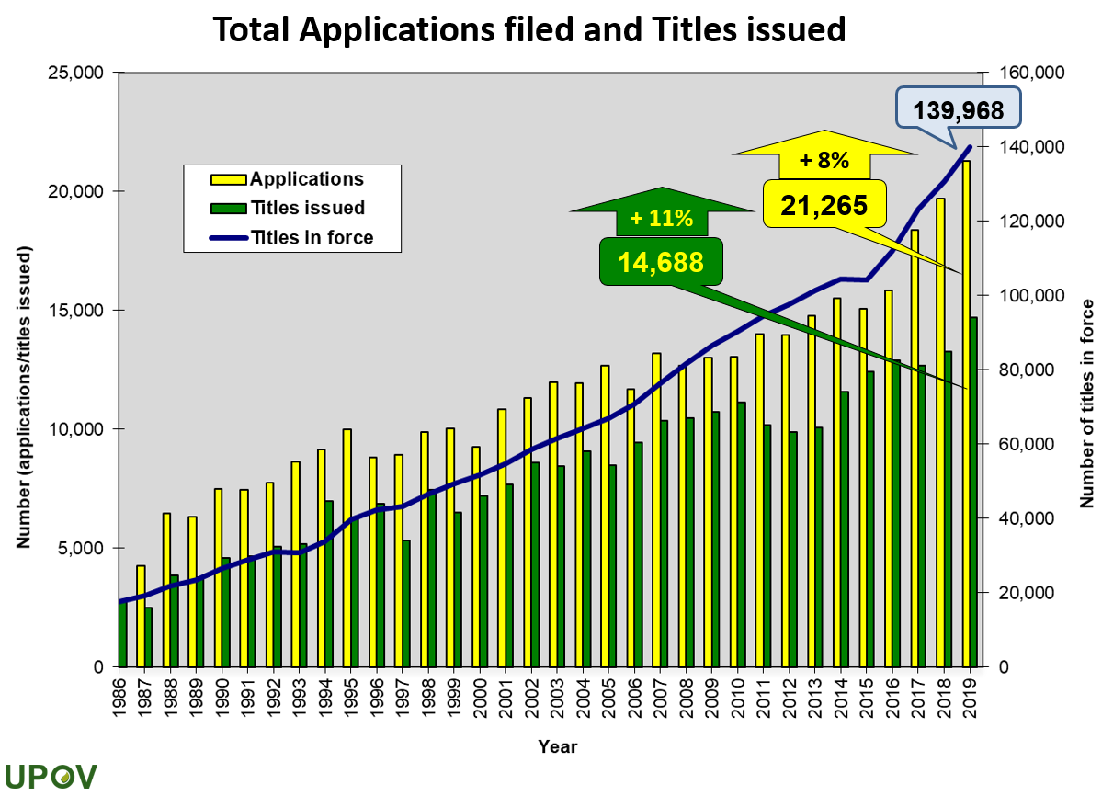

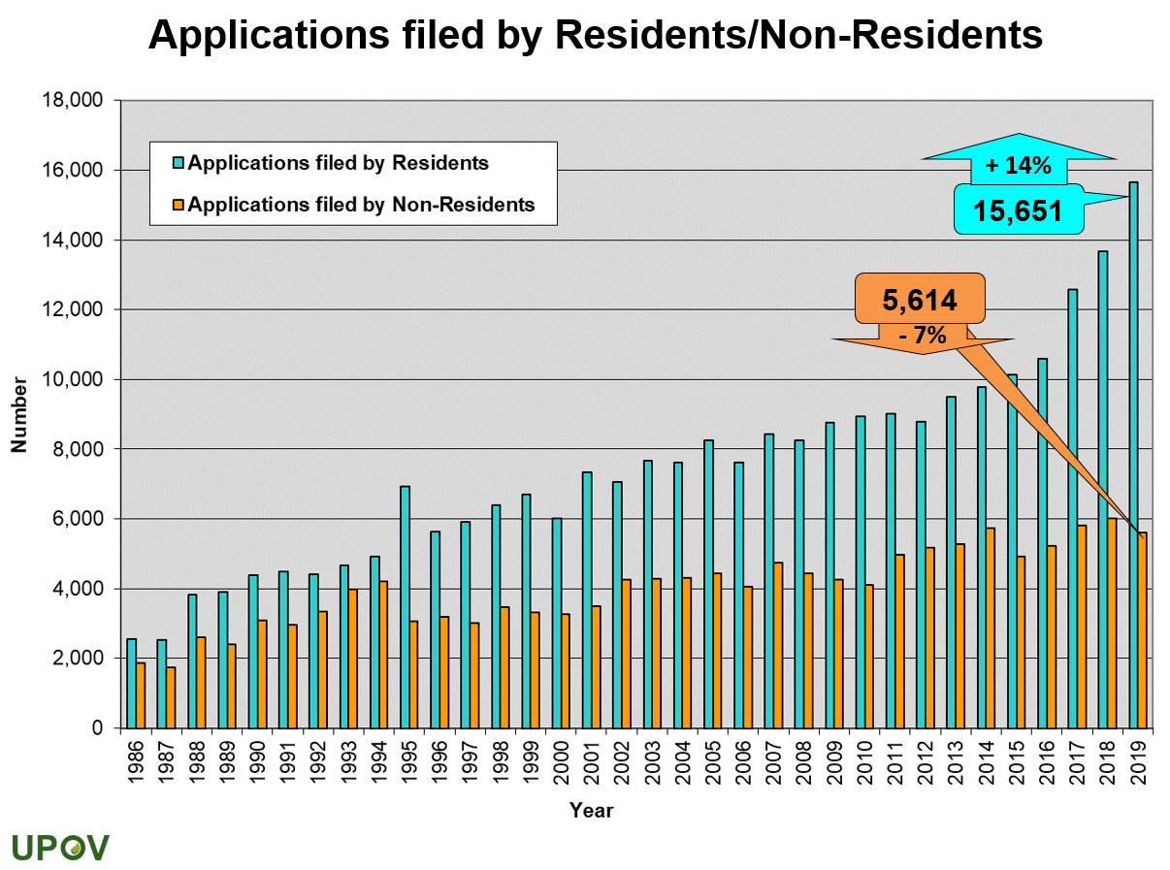

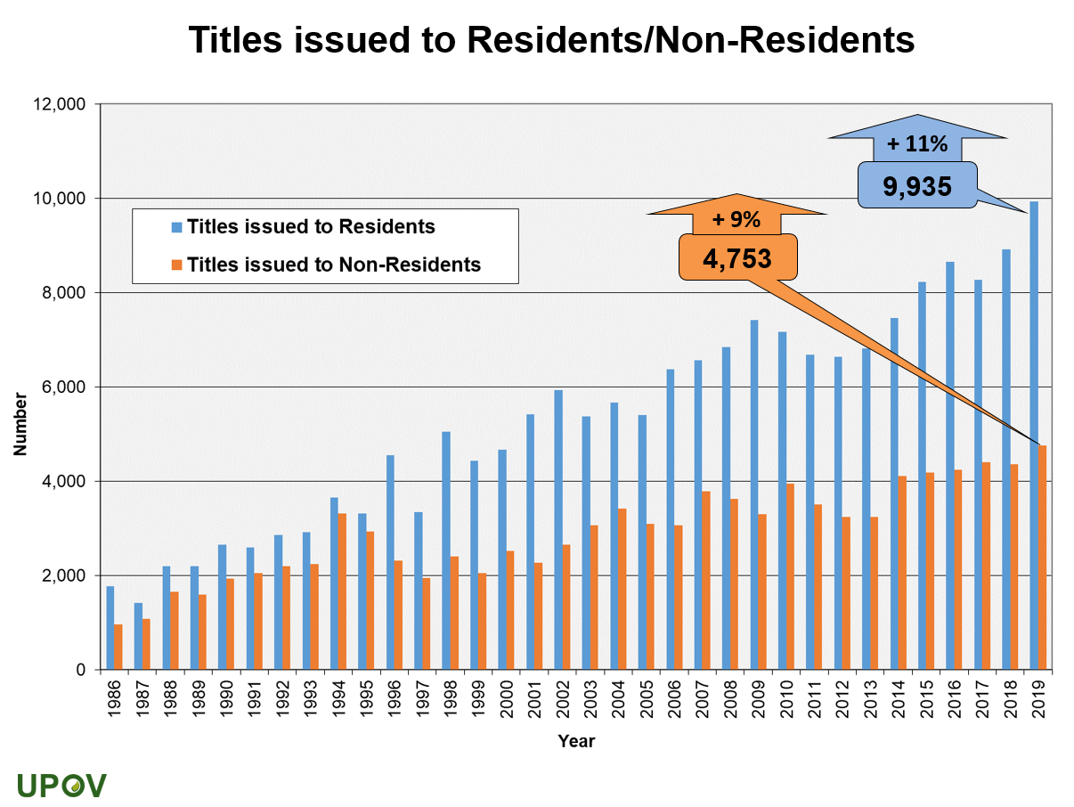

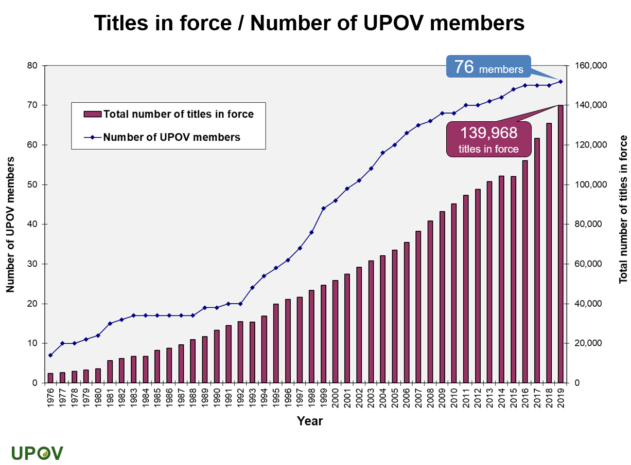
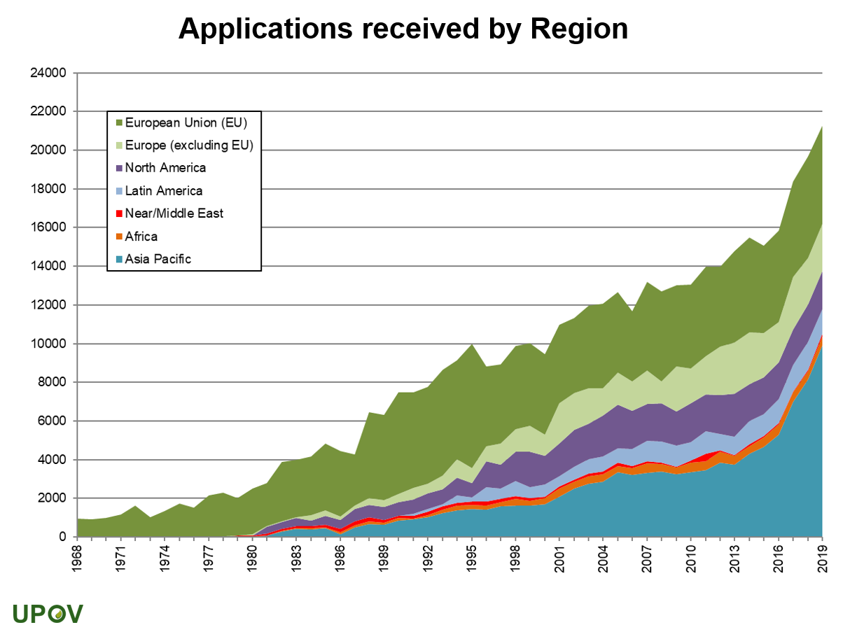

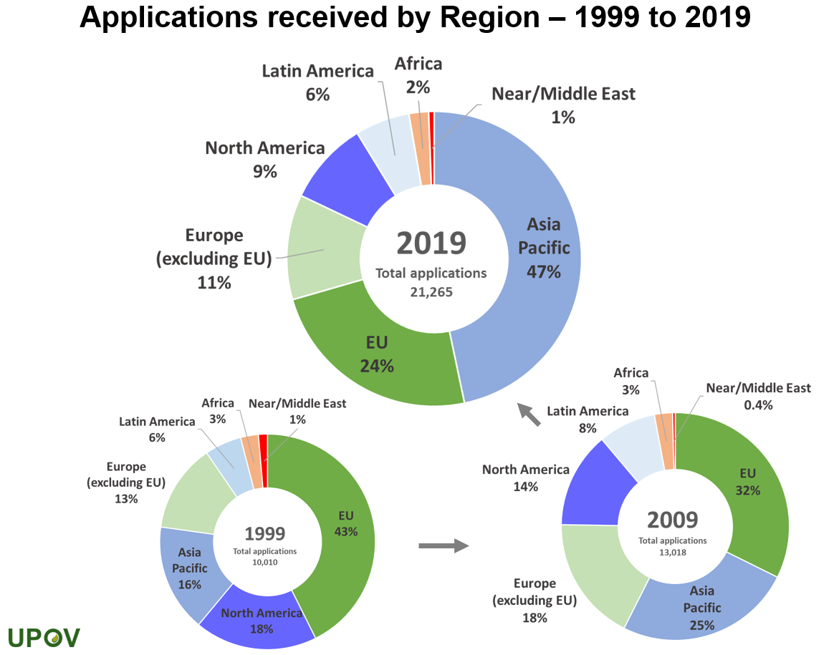

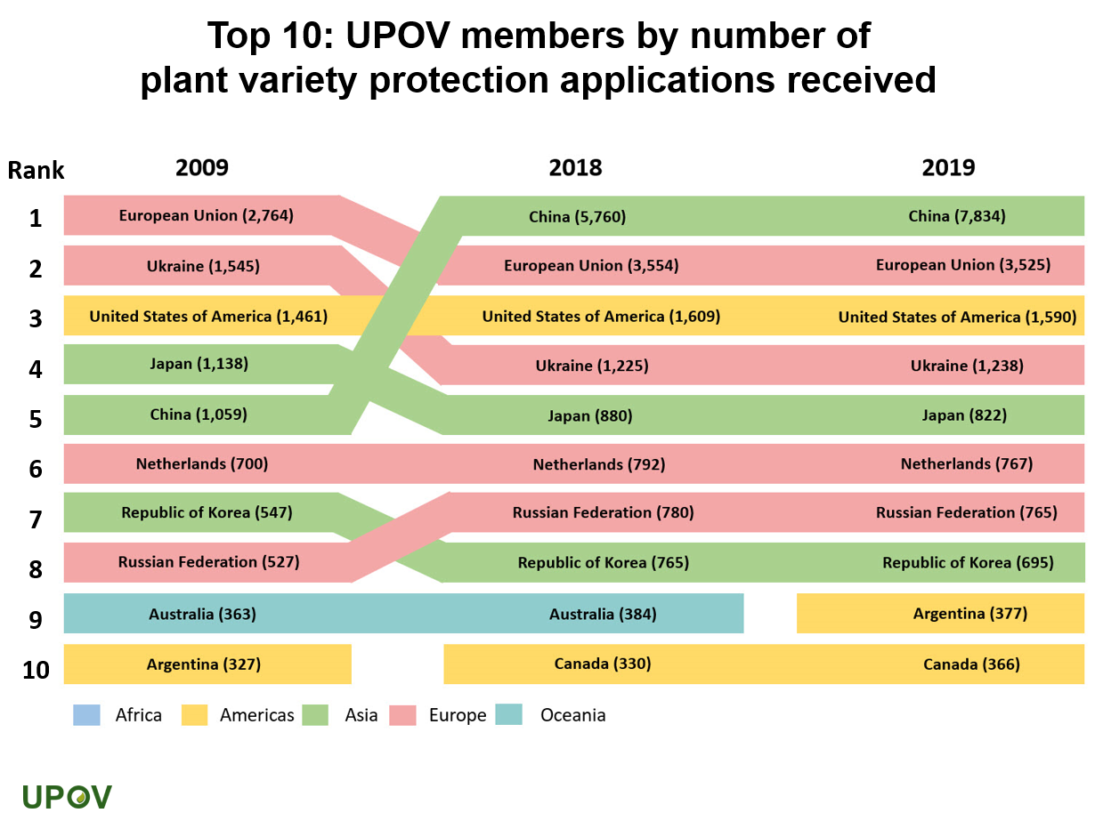

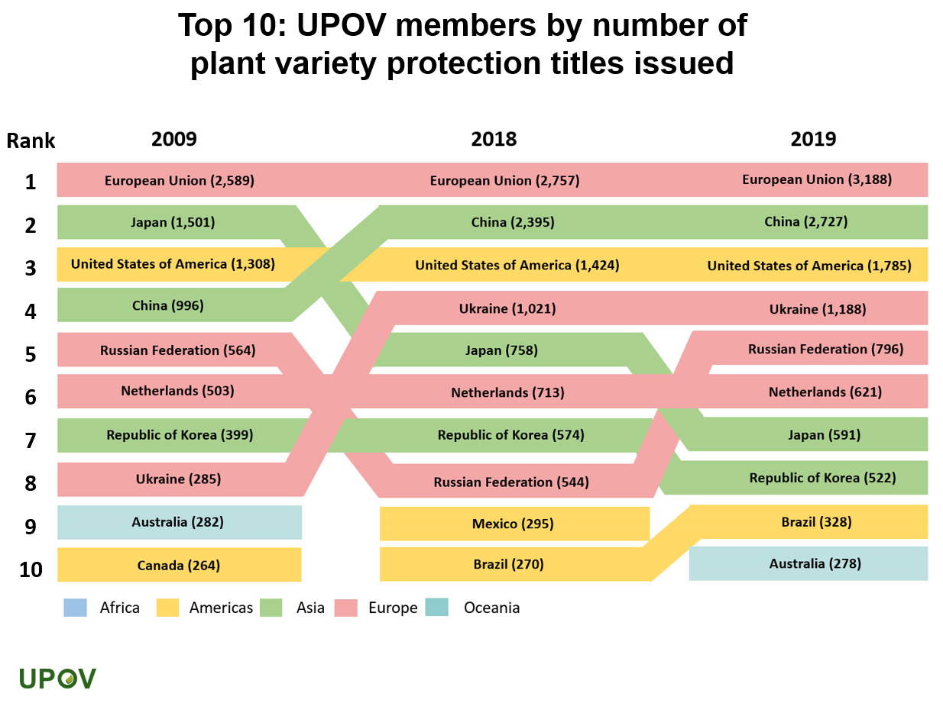

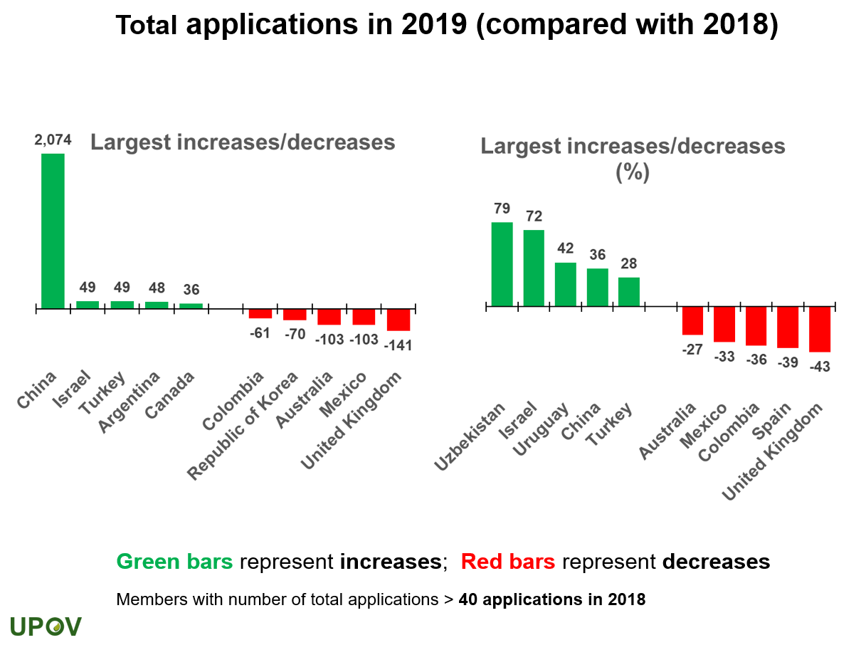

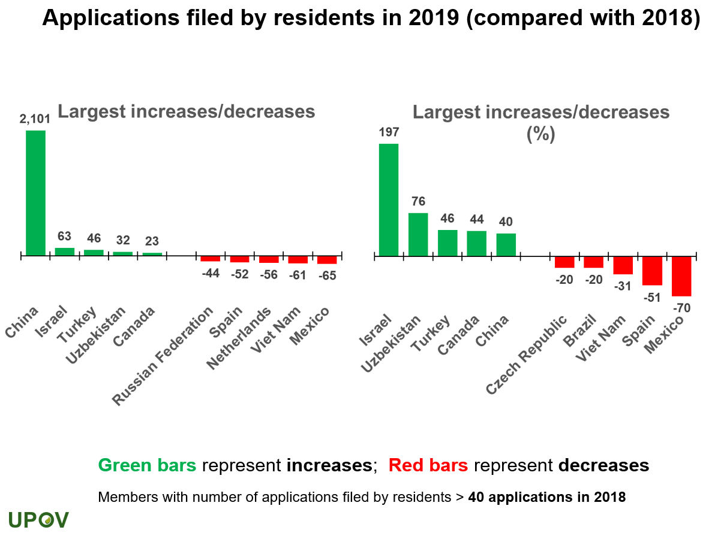

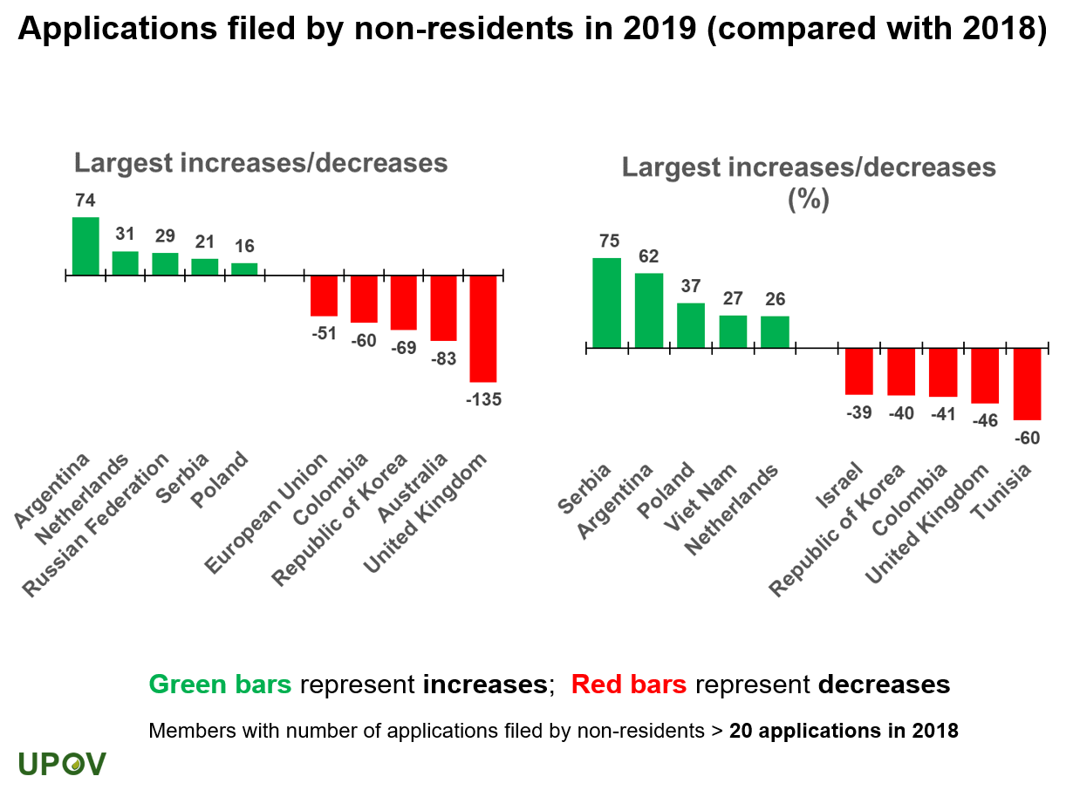

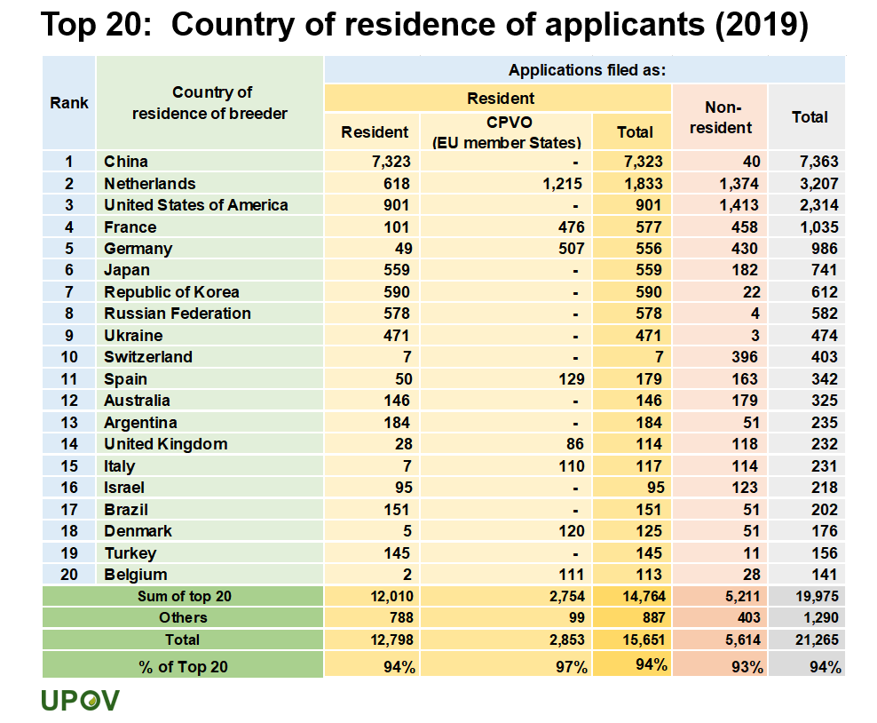

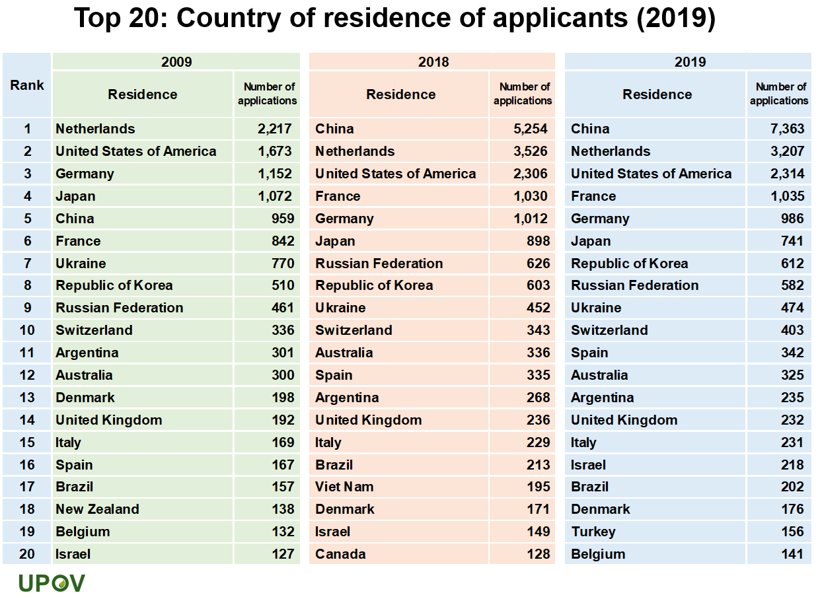

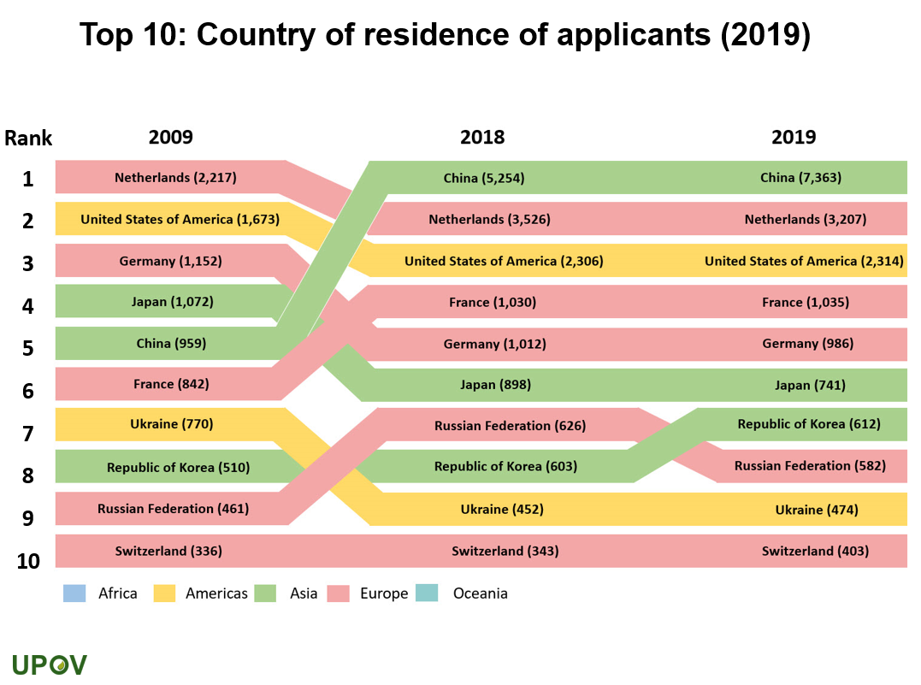

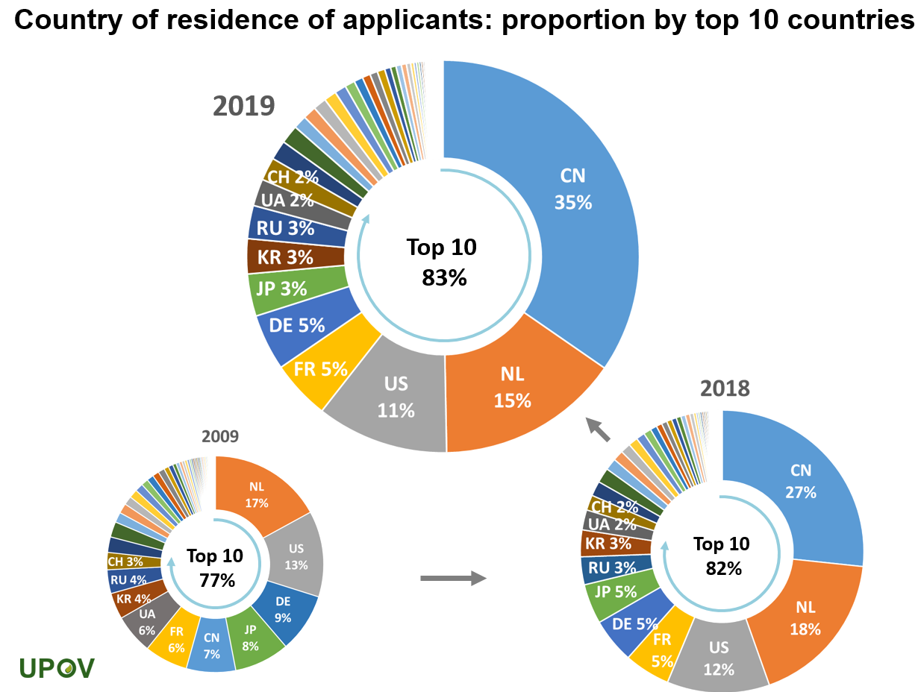

NOTES TO EDITORS

UPOV is an intergovernmental organization based in Geneva.

The purpose of UPOV is to provide and promote an effective system of plant variety protection, with the aim of encouraging the development of new varieties of plants, for the benefit of society.

UPOV has 76 members covering 95 States. The members of UPOV are:

African Intellectual Property Organization, Albania, Argentina, Australia, Austria, Azerbaijan, Belarus, Belgium, Bolivia (Plurinational State of), Bosnia and Herzegovina, Brazil, Bulgaria, Canada, Chile, China, Colombia, Costa Rica, Croatia, Czech Republic, Denmark, Dominican Republic, Ecuador, Egypt, Estonia, European Union, Finland, France, Georgia, Germany, Hungary, Iceland, Ireland, Israel, Italy, Japan, Jordan, Kenya, Kyrgyzstan, Latvia, Lithuania, Mexico, Montenegro, Morocco, Netherlands, New Zealand, Nicaragua, North Macedonia, Norway, Oman, Panama, Paraguay, Peru, Poland, Portugal, Republic of Korea, Republic of Moldova, Romania, Russian Federation, Serbia, Singapore, Slovakia, Slovenia, South Africa, Spain, Sweden, Switzerland, Trinidad and Tobago, Tunisia, Turkey, Ukraine, United Kingdom, United Republic of Tanzania, United States of America, Uruguay, Uzbekistan and Viet Nam.

For further information about UPOV, please contact the UPOV Secretariat:

Tel: (+41-22) 338 9111 E-mail: upov.mail@upov.int

Website: https:www.upov.int

Social media

Twitter account: @UPOVint
LinkedIn account: https://www.linkedin.com/company/upov-official

[Appendix follows]

APPENDIX

INTERVENTION TO THE UPOV COUNCIL BY THE SECRETARY-GENERAL

Fifty-Fourth Ordinary Session
October 30, 2020

Mr. Marien Valstar, President of the UPOV Council,
Distinguished Delegates,
Ladies and gentlemen,

I would like to express my sincere thanks to the UPOV Council for the honor that you have bestowed on me by appointing me as your Secretary-General.

The UPOV community – our community - has an exciting journey ahead. This is because plant breeding has a critical role to play in responding to the challenges we face today in making the world more sustainable. Our future needs to be greener – and plants are what make the world green.

The pandemic has also brought back the importance of our basic needs, particularly health and access to food. In going back to basics, countries have placed high priority on ensuring the continuing supply of seed. Simply put, without seed today, there will be no food tomorrow.

To achieve the 2030 Agenda for Sustainable Development, the world will need to rely on two key actors, farmers and plant breeders. For many plant breeders, the UPOV system of plant variety protection will be essential in delivering the varieties that farmers will need to meet the challenge.

New varieties of plants with features such as improved yield, resistance to pests and diseases, salt and drought tolerance, or better adaptation to climatic stress are key to increasing productivity and product quality. At the same time, new varieties can help reduce the pressure on the natural environment. Due to the continuous evolution of new pests and diseases as well as changes in climatic conditions and users’ needs, there is a constant demand by farmers and growers for new plant varieties.

Track record of UPOV

The UPOV system has risen to the challenge repeatedly, and we have a proven track record of delivering what farmers and society need as these evolve.

In Europe, a 2016 study has shown that:

• Without plant breeding, the European Union would have become a net importer in all major arable crops, including those it currently exports, such as wheat, potatoes, and other cereals. In fact, since 2000, plant breeding alone has enabled the EU to feed the equivalent of the populations of France and Germany for the past 15 years.

• Without plant breeding, the European Union would need an extra 19 million hectares of farm land to produce the same amount of food. This would have the same impact as deforesting an area of the Amazon the same size as Latvia.

Let me also share examples from other parts of the world.

In 1997, Kenya introduced PVP protection, and joined UPOV in 1999. Prior to 1997, there were only 38 new plant varieties as compared to 136 from 1997-2003. In the case of maize, the number of maize varieties increased from 7 to 60. Most of the new maize varieties are superior to the existing ones, particularly in yield, pest and disease tolerance, nutritional qualities, early maturity and tolerance to abiotic stresses. Since maize is a staple food for 80% of Kenyans, this has had a positive contribution to food security in the country.

Looking at Asia, a study in Viet Nam has linked productivity and environmental benefits to UPOV membership by comparing agriculture in Viet Nam before and after UPOV membership.

• In the period 1995-2005, before UPOV membership, increased yields in rice, corn (maize) and sweet potatoes were mainly through increased level of inputs – with no detectable increase due to plant breeding. In the 10-year period after UPOV membership, yields in rice, maize and sweet potato increased annually by 1.7%, 2.1% and 3.1%, respectively, thanks to plant breeding. Vietnamese farmers in 2016 were producing approximately 20% more on their arable land than before UPOV membership.

Importance for economic development

One other important aspect of our work is that we help provide farmers with a secure income, in turn guaranteeing their own food security.

Again, turning to Kenya, UPOV membership has provided access to elite varieties of roses that have enabled Kenya to develop a $500 million cut-flower industry employing 500,000 Kenyans.

In Colombia, the UPOV system of plant variety protection greatly boosted various industries, including floriculture. This was due to the entry of new businesses, which introduced new ornamental plant varieties and invested in Colombia. According to Asocolflores, the flower sector generates work in Colombia for over 200,000 people. This sector represented close to 5% of total Colombian exports during the last 10 years, making it the fourth most important line of foreign exchange for the country after oil, coffee and coal.

In Vietnam, since UPOV membership in 2006, the yearly income of farmers has increased by over 24%. The overall impact from plant breeding activities investments on the GDP has been calculated at around USD 5 billion, which is more than 2.5% of their GDP.

These amply demonstrate the value of our work in bringing investments, creating jobs and supporting the development aspirations of members, especially in developing country members, in different parts of the world.

Future effectiveness of the UPOV system

For the future, plant breeding has even greater challenges – to produce more from existing land while inputs are reduced. To achieve this formidable goal, plant variety protection will need to ensure that plant breeders can achieve a satisfactory return on the long-term investment that is required to produce new plant varieties. Therefore, it is essential that the UPOV system evolves to be fit for purpose as technology and needs evolve. The current discussions in UPOV on matters such as essentially derived varieties and harvested material are a good sign that UPOV is attuned and responsive to such developments.

Partnerships

The scale of the challenges are global and cross-cutting, while UPOV is a very small organization. This presents particular challenges for UPOV’s message to be heard. I see encouraging signs that UPOV is succeeding in delivering its message, particularly in the increasing number of countries that are working with the UPOV Office on the development of plant variety protection laws. At the same time, it is clear that partnerships will be increasingly important. We will need to continue working with UPOV members, with stakeholders and other organizations. I was particularly encouraged at the Consultative Committee yesterday to learn about the initiative that Oxfam, Plantum and Euroseeds brought to UPOV for discussion. I am delighted that UPOV is working closely with the World Farmers’ Organisation, particularly in the framework of the World Seed Partnership, because plant breeders and farmers are key players in the transformation of food systems.

I would like to take this opportunity to express my commitment, in my role as Secretary-General, to assist in improving UPOV’s outreach and enhancing partnerships. In talking about partnerships, I would like to emphasize my commitment as both Director General of WIPO and Secretary-General of UPOV to explore greater policy synergies across both organizations.

Harnessing technology

For the UPOV system to continue to be relevant, it is also essential for UPOV as an organization to adapt and evolve. I am excited to see the plans for UPOV to harness technology so that the plant variety protection system is efficient for UPOV members and for plant breeders, while contributing to the financial security of the organization.

The recent introduction of the UPOV PRISMA online application tool is an important step. The plans for supporting UPOV members in the form of electronic office management systems will be an equally major step for an efficient and effective system, which will also will facilitate cooperation. Neural machine translation technologies are another opportunity to improve the outreach and understanding of the UPOV system. The COVID-19 pandemic has had tragic consequences around the world and has highlighted the importance of innovation to respond to difficult circumstances. For example, we have seen how electronic communication technologies have the potential to increase the outreach we can achieve, particularly for a small organization such as UPOV.

Cooperation within UPOV

I believe that new technologies have the potential to transform the performance of UPOV as an organization and the system that it offers in order that we can play a full part in meeting global challenges. However, I would like to conclude by recalling and emphasizing a particular strength of UPOV, which is the commitment to cooperation between its members and the support of UPOV members for the work of the UPOV Office. The technologies that we introduce will only have value as long as they are built on that cooperation and serve to enhance that cooperation. This is something that must remain at the heart of our endeavors.

Conclusion

When I was about to embark on my UPOV journey, I was told that this was a family even more than a community. I am happy to confirm that this has very much been my experience. I look forward to being part of this UPOV family, and to work with all of you to help UPOV play an even more important role in addressing the global challenges of sustainability and sustenance, bringing colour to our homes and choice to our tables, improving the livelihood of farmers, and ultimately using our expertise to make a difference to the world.

Thank you.

[End of Appendix and of document]

The economic, social and environmental value of plant breeding in the European Union: An ex post evaluation and ex ante assessment HFFA Research GmbH (corresponding author: Steffen Noleppa) (2016)
The socio-economic benefits of UPOV membership in Viet Nam: An ex-post assessment on plant breeding and agricultural productivity after 10 years by HFFA Research GmbH (corresponding author: Steffen Noleppa) (2017) (https://www.upov.int/about/en/benefits_upov_system.html)
https://youtu.be/lwuXwN96O-Y
https://youtu.be/qnJLH4JVyP0

